

**+ Fourth Sunday in Lent**

**March 30th, 2025**

**10:00 a.m.**



**St. Andrew Lutheran Church**

**304 Morewood Ave.**

**Pittsburgh, PA 15213**

**412.682.3342**

[**St_andrewELCA@verizon.net**](mailto:St_andrewELCA@verizon.net)

[**www.standrewpittsburgh.org**](http://www.standrewpittsburgh.org)

**+ Fourth Sunday in Lent**

**Order for Worship**

*The psalm sets the tone for the Fourth Sunday in Lent: “Happy are they whose transgressions are forgiven, and whose sin is put away!” Happy are those who have “become the righteousness of God” in the merits of Christ Jesus. Happy are those for whom the forgiveness of God has “rolled away . . . the disgrace” of former times. Happy is the father at the return of his prodigal son. Happy are we that our sins are forgiven for Jesus’ sake. Rejoice!*

**Welcome to St. Andrew!**

* St. Andrew welcomes all who are seeking a place of healing, wholeness, and acceptance in a nurturing and faith-forming spiritual home. We are striving toward racial equity worldwide

and we seek to honor the lived experience of all individuals regardless of background. Our community embraces people of all ages, ethnicities, cultures, abilities, sexual orientations,

gender identities and expressions, and family constellations. Come and See!

* Worship Services are live-streamed to multiple online platforms. By attending worship, you agree that your image and voice may be broadcast.
* Everyone is invited to make a name tag at the black bookcase in the back of the worship space if they would like. There are stickers indicating pronouns on the bookcase if you would like to include them on your name tag.
* Children are invited to attend Little Church – Big Faith, a Bible lesson and activity, during worship (after the Prayer of the Day). The group returns to the worship space for the liturgy of Holy Communion.
* A nursery is available through the doors at the left side of the sanctuary and across from the doorway to the Social Hall. Look for a purple-colored room.
* Worship “toolkits” to help children engage with the service, along with “busy bags” for younger children, are available in the bookcase at the back of the sanctuary. Please feel free to take one to use with/for your children.
* Holy Communion is served with bread (gluten-free available) and wine or grape juice. The presiding minister will distribute the bread (host). Please consume this and then pick up an empty glass from the tray. The Communion Assistant will pour wine or grape juice into your glass. Please step to the side to consume the wine or grape juice. Feel free to kneel at the altar for prayer and reflection. As you return to your pew, glasses may be returned to the empty trays on either side of the center section.
* A restroom is available on the main level of the church, through the doors to the Social Hall and to the right in the main office.

*Abbreviations*

P: Pastor/Presiding Minister ***ELW*: *Evangelical Lutheran Worship* hymnal**

A: Assisting Minister ***ACS*: *All Creation Sings* hymnal**

L: Lector ***BB*: *Breaking Bread* hymnal**

**C: Congregation**

**Pre-Service Music** Emily Duque

**Welcome**

**Prelude** *Just As I Am* Bradbury/arr. Philip Keveren

**Gathering**

*The Holy Spirit calls us together as the people of God*

**Confession**

*Please rise as you are able. All may make the sign of the cross,*

*the sign that is marked at Baptism, as the presiding minister begins.*

P: Blessed be the holy Trinity, ☩ one God,

who forgives all our sin,

whose mercy endures forever.

**C: Amen.**

P: Let us return to God, confessing our sin in the assurance of God’s abiding love.

*Silence is kept for reflection.*

P: Compassionate One,

**you are slow to anger and abounding in steadfast love,**

**but our lives do not always reflect you** **and your love for the world.**

**We do not show others the tender compassion** **you have shown to us.**

**We do not welcome others with the hospitality** **you grant to all people.**

**We oppress others,** **even though you have set us free again and again.**

**We squander the abundant gifts of the earth.**

**Transform our lives** **and guide us again in the way of the cross.**

**Amen.**

P: Beloved in Christ,

God’s arms are always stretched open wide

to welcome the wandering ones home.

In ☩ Christ your sins are forgiven.

You have a place in God’s house forever.

**C: Amen.**

**Gathering Hymn Jesus, the Very Thought of You *ELW* 754**

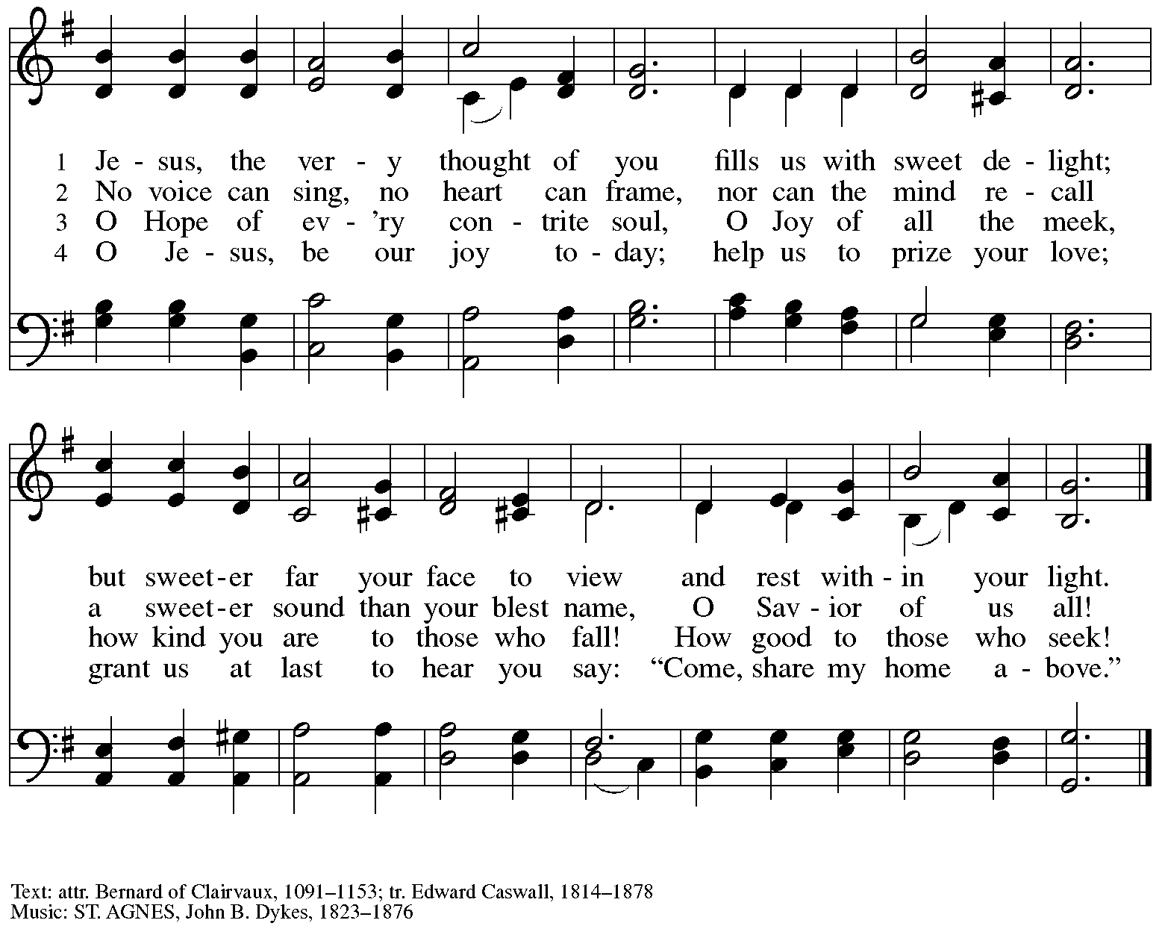

**Greeting**

P: The grace of our Lord Jesus Christ, the love of God,

and the communion of the Holy Spirit be with you all.

**C: And also with you.**

**Kyrie *ELW*** **152**

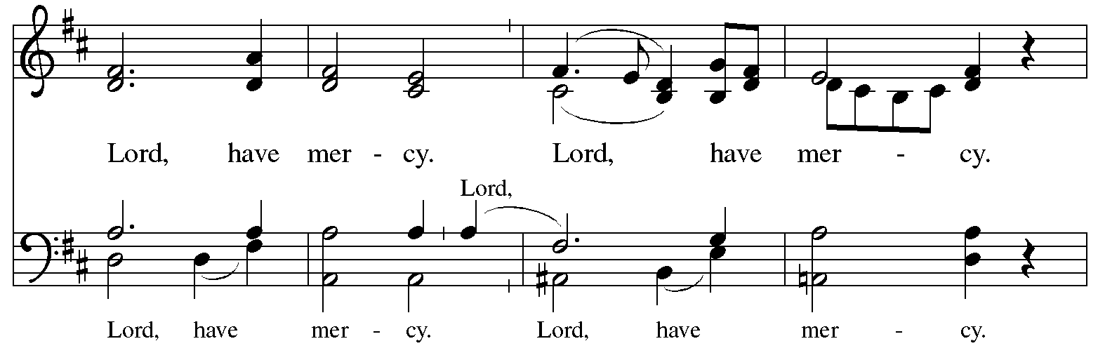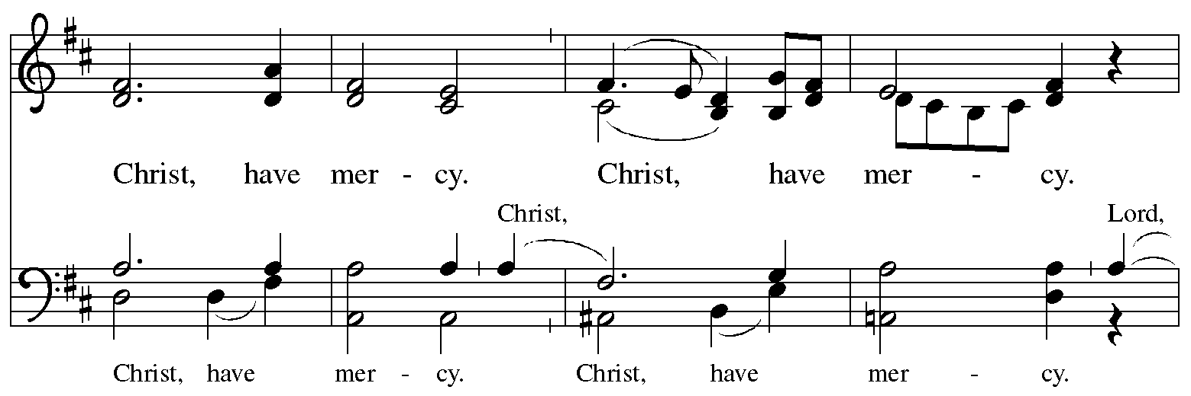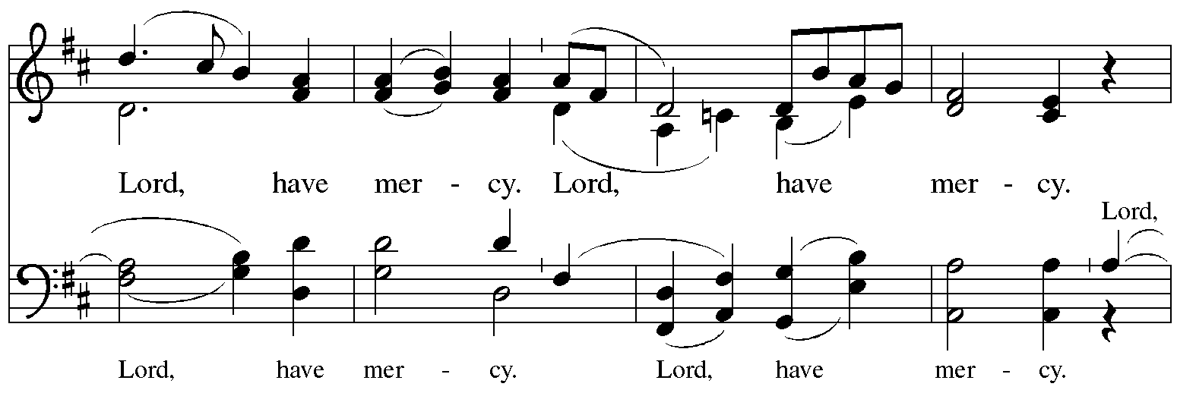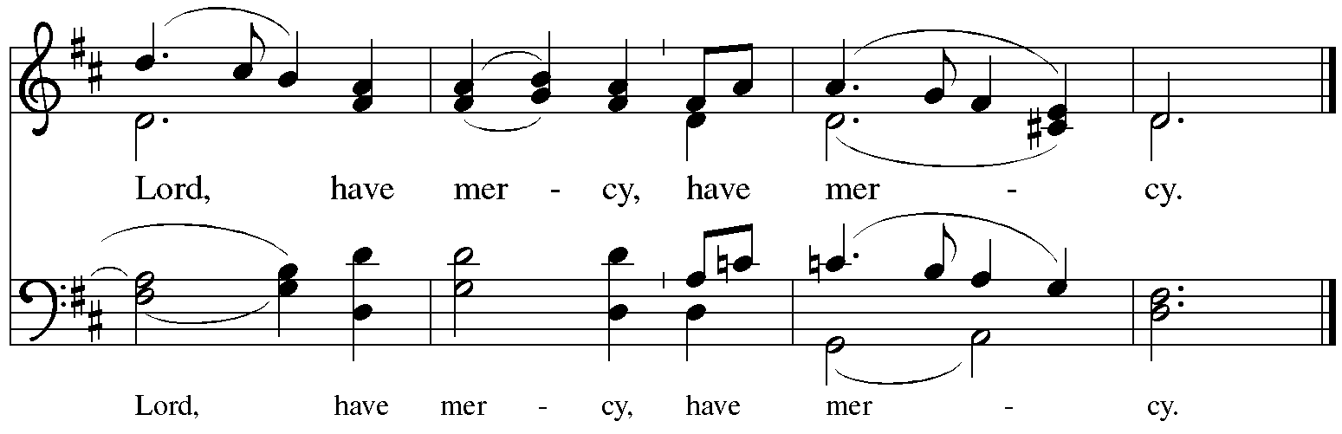

**Prayer of the Day**

P: The Lord be with you.

**C: And also with you.**

P: Let us pray.

God of compassion, you welcome the wayward, and you embrace us all with your mercy.

By our Baptism, clothe us with garments of your grace, and feed us at the table of your love, through Jesus Christ, our Savior and Lord, who lives and reigns with you and the Holy Spirit,

one God, now and forever.

**C: Amen.**

*Please be seated.*

*Children are invited to join the adult leader(s) at the side door for Little Church – Big Faith.*

*We ask that an additional adult from the congregation attend with the children.*



**Word**

*God speaks to us in Scripture reading, preaching, and song*

**First Reading** **– Joshua 5: 9-12**

9 The Lord said to Joshua, “Today I have rolled away from you the disgrace of Egypt.” And so that place is called Gilgal to this day.  
  
  10 While the Israelites were camped in Gilgal they kept the Passover in the evening on the fourteenth day of the month in the plains of Jericho. 11 On the day after the Passover, on that very day, they ate the produce of the land, unleavened cakes and roasted grain. 12 The manna ceased on the day they ate the produce of the land, and the Israelites no longer had manna; they ate the crops of the land of Canaan that year.

L: Word of God, word of life.

**C: Thanks be to God.**

**Psalm 32**

*The cantor will lead the singing of the psalm.*

*The congregation is invited to respond with the alternate verses in bold print,*

*and to join in singing the refrain.*

*Psalm Tone*

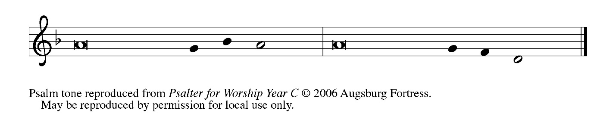

*Psalm Refrain*

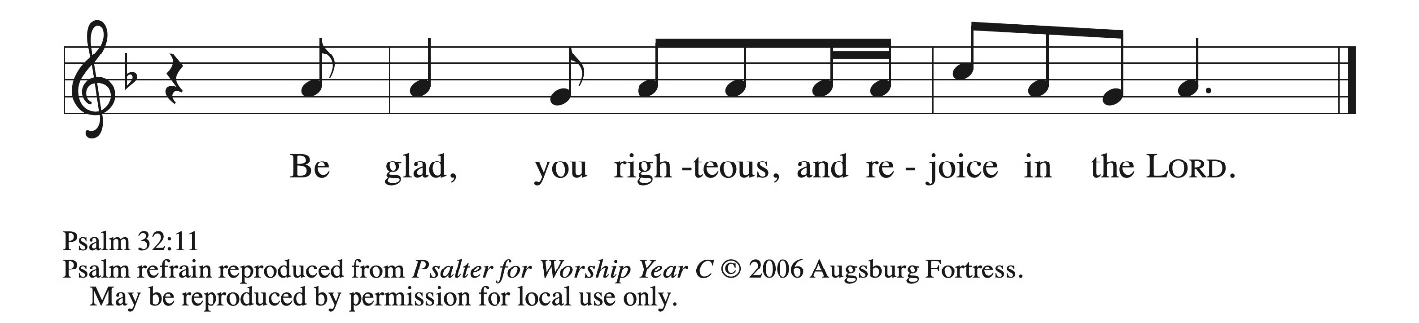

 1 Happy are they whose transgressions **|** are forgiven,  
  and whose sin is **|** put away!  
 2 **Happy are they to whom the Lord im- | putes no guilt,**  
  **and in whose spirit there | is no guile! R**  
 3 While I held my tongue, my bones with- **|** ered away,  
  because of my groaning **|** all day long.  
 4 **For your hand was heavy upon me | day and night;**  
  **my moisture was dried up as in the | heat of summer.**  
 5 Then I acknowledged my sin to you, and did not con- **|** ceal my guilt.  
  I said, “I will confess my transgressions to the Lord.” Then you forgave me the guilt **|** of my sin.  
 6 **Therefore all the faithful will make their prayers to you in | time of trouble;**  
  **when the great waters overflow, they | shall not reach them. R**  
 7 You are my hiding-place; you preserve **|** me from trouble;  
  you surround me with shouts **|** of deliverance.  
 8 **“I will instruct you and teach you in the way that | you should go;**  
  **I will guide you | with my eye.**  
 9 Do not be like horse or mule, which have no **|** understanding;  
  who must be fitted with bit and bridle, or else they will **|** not stay near you.”  
 10 **Great are the tribulations | of the wicked;**  
  **but mercy embraces those who trust | in the Lord.**  
 11 Be glad, you righteous, and rejoice **|** in the Lord;  
  shout for joy, all who are **|** true of heart.**R**

**Second Reading – 2 Corinthians 5: 16-21**

16 From now on, therefore, we regard no one from a human point of view; even though we once knew Christ from a human point of view, we no longer know him in that way. 17 So if anyone is in Christ, there is a new creation: everything old has passed away; look, new things have come into being! 18 All this is from God, who reconciled us to Godself through Christ, and has given us the ministry of reconciliation; 19 that is, in Christ God was reconciling the world to Godself, not counting their trespasses against them, and entrusting the message of reconciliation to us. 20 So we are ambassadors for Christ, since God is making God’s appeal through us; we entreat you on behalf of Christ: be reconciled to God. 21 For our sake God made the one who knew no sin to be sin, so that in him we might become the righteousness of God.

L: Word of God, word of life.

**C: Thanks be to God.**

*Please rise as you are able and join in singing the Gospel Acclamation.*

**Gospel Acclamation** *ELW* p. 189

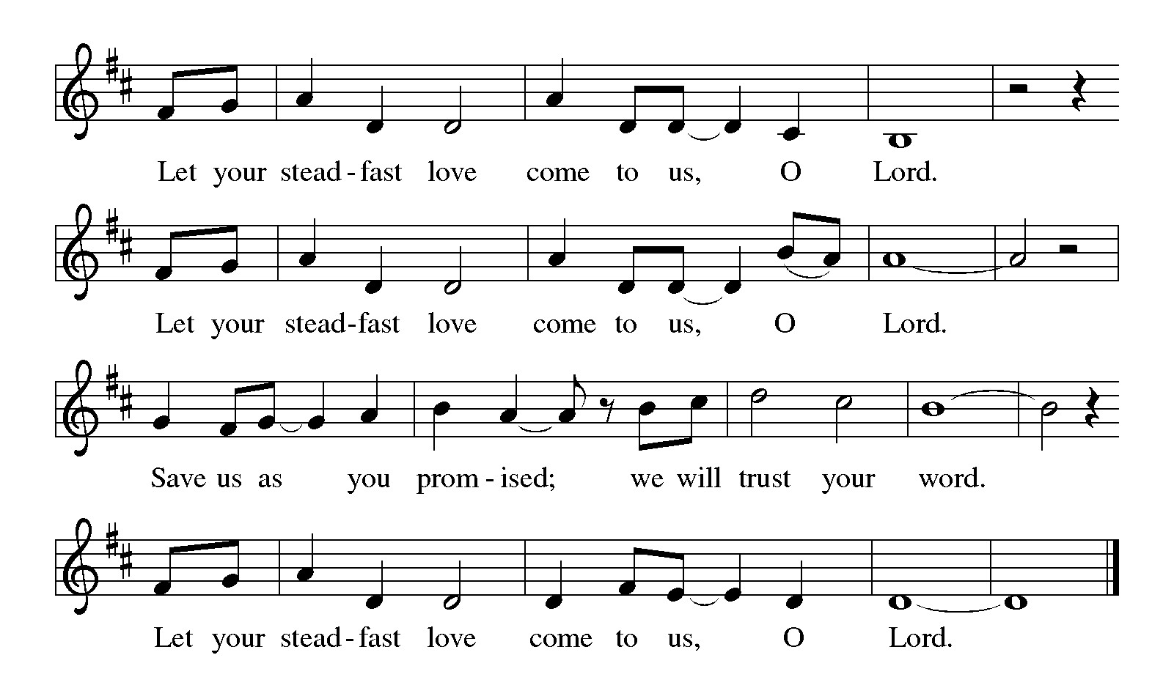

**Gospel – Luke 15: 1-3, 11b-32**

P: The holy Gospel according to St. Luke.

**C: Glory to you, O Lord.**

1 Now all the tax collectors and sinners were coming near to listen to [Jesus.] 2 And the Pharisees and the scribes were grumbling and saying, “This fellow welcomes sinners and eats with them.”  
  3 So he told them this parable: 11b “There was a man who had two sons. 12 The younger of them said to his father, ‘Father, give me the share of the wealth that will belong to me.’ So he divided his assets between them. 13 A few days later the younger son gathered all he had and traveled to a distant region, and there he squandered his wealth in dissolute living. 14 When he had spent everything, a severe famine took place throughout that region, and he began to be in need. 15 So he went and hired himself out to one of the citizens of that region, who sent him to his fields to feed the pigs. 16 He would gladly have filled his stomach with the pods that the pigs were eating, and no one gave him anything. 17 But when he came to his senses he said, ‘How many of my father’s hired hands have bread enough and to spare, but here I am dying of hunger! 18 I will get up and go to my father, and I will say to him, “Father, I have sinned against heaven and before you; 19 I am no longer worthy to be called your son; treat me like one of your hired hands.” ’ 20 So he set off and went to his father. But while he was still far off, his father saw him and was filled with compassion; he ran and put his arms around him and kissed him. 21 Then the son said to him, ‘Father, I have sinned against heaven and before you; I am no longer worthy to be called your son.’ 22 But the father said to his slaves, ‘Quickly, bring out a robe—the best one—and put it on him; put a ring on his finger and sandals on his feet. 23 And get the fatted calf and kill it, and let us eat and celebrate; 24 for this son of mine was dead and is alive again; he was lost and is found!’ And they began to celebrate.  
  25 “Now his elder son was in the field; and as he came and approached the house, he heard music and dancing. 26 He called one of the slaves and asked what was going on. 27 He replied, ‘Your brother has come, and your father has killed the fatted calf because he has got him back safe and sound.’ 28 Then he became angry and refused to go in. His father came out and began to plead with him. 29 But he answered his father, ‘Listen! For all these years I have been working like a slave for you, and I have never disobeyed your command; yet you have never given me even a young goat so that I might celebrate with my friends. 30 But when this son of yours came back, who has devoured your assets with prostitutes, you killed the fatted calf for him!’ 31 Then the father said to him, ‘Son, you are always with me, and all that is mine is yours. 32 But we had to celebrate and rejoice, because this brother of yours was dead and has come to life; he was lost and has been found.’ ”

P: The Gospel of the Lord.

**C: Praise to you, O Christ.**

*Please be seated.*

**Sermon**

*A time of silence for prayer and reflection follows the sermon.*

*As the hymn of the day begins, please rise as you are able.*

**Hymn of the Day Amazing Grace, How Sweet the Sound *ELW* 779**

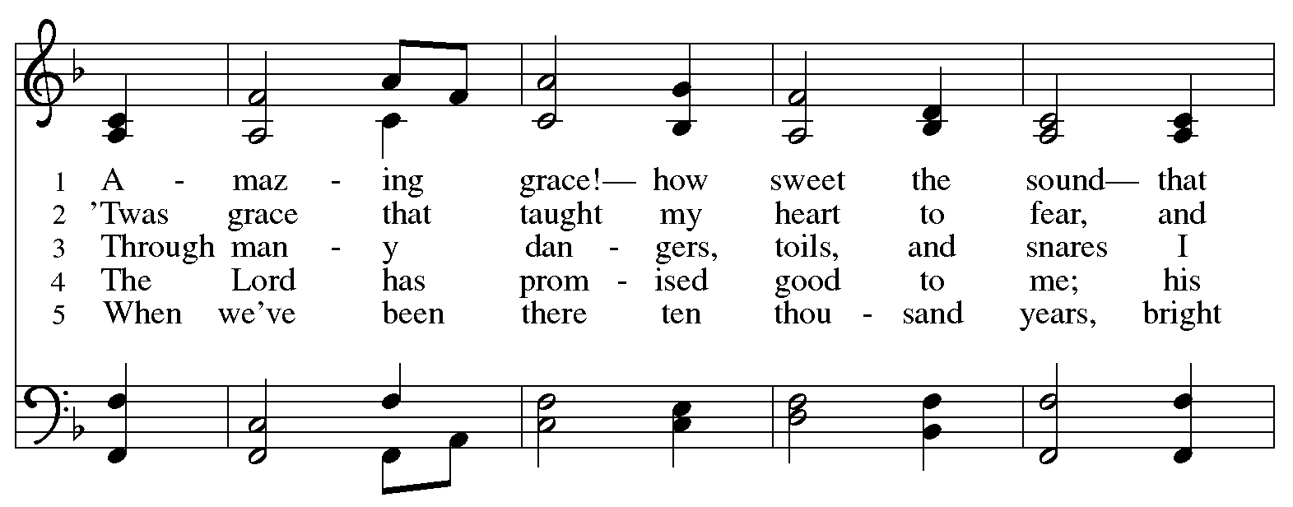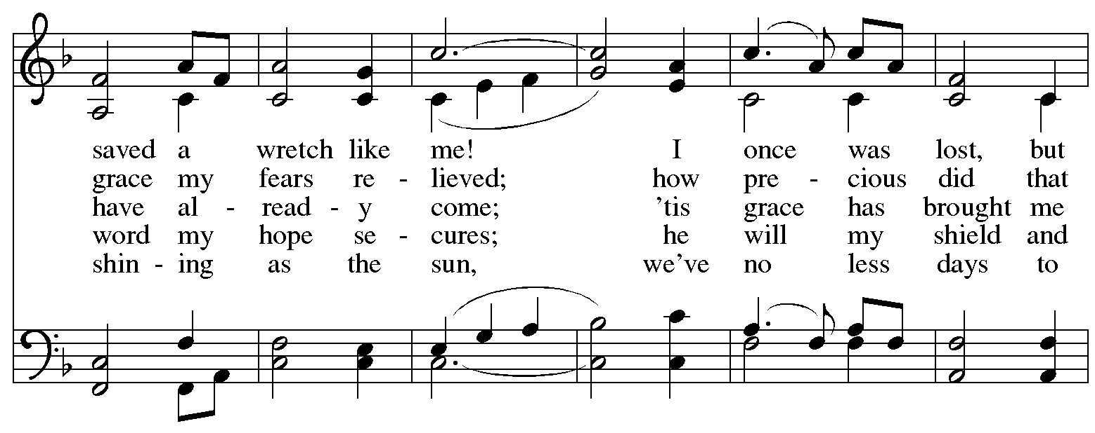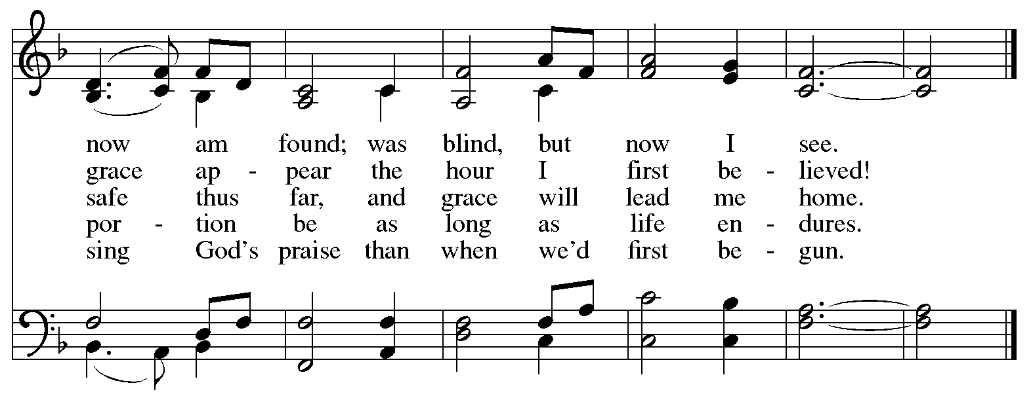

**Apostles’ Creed**

**C: I believe in God, the Father almighty,**

**creator of heaven and earth.**

**I believe in Jesus Christ, God’s only Son, our Lord,**

**who was conceived by the Holy Spirit,**

**born of the virgin Mary,**

**suffered under Pontius Pilate,**

**was crucified, died, and was buried;**

**he descended to the dead.\***

**On the third day he rose again;**

**he ascended into heaven,**

**he is seated at the right hand of the Father,**

**and he will come to judge the living and the dead.**

**I believe in the Holy Spirit,**

**the holy catholic church,**

**the communion of saints,**

**the forgiveness of sins,**

**the resurrection of the body,**

**and the life everlasting. Amen.**

*Or, “he descended into hell,” another translation of this text in widespread use.

**Prayers of the People**

A: Led by the Spirit, let us turn to God in prayer for the church, those in need,

and all God’s creation.

*After each petition*

A: Merciful God,

**C: receive our prayer.**

*The presiding minister concludes the prayers*

P: Receive the prayers of your people, O God, and draw all things together in your love,

in the name of Jesus, who leads us from death to life.

**C: Amen.**

**Peace**

*The presiding minister and the assembly greet one another in the peace of the risen Christ.*

P: The peace of Christ be with you always.

**C: And also with you.**

*The people may greet those around them with a sign of Christ’s peace and may say*

Peace be with you *or similar words. Please be mindful that not everyone will be comfortable with sharing the peace, so please seek consent before shaking hands or hugging. Other possible ways to share the peace include a simple bow with the verbal greeting of peace, or simply a verbal expression of peace. When the greetings of peace have concluded, please be seated.*

**Meal**

*God feeds us with the presence of Jesus Christ*

**Offering**

*We offer ourselves, our gifts, and our faithful service to God.* *As the offering is gathered for the mission of the church, including the care of those in need, the table is set for Holy Communion.*

**Music during the Offering**

*Softly and Tenderly Jesus Is Calling* arr. John Hellen

*As the gifts are brought forward for presentation,* *please rise as you are able.*

**Offertory Song Create in Me a Clean Heart *ELW* 188**

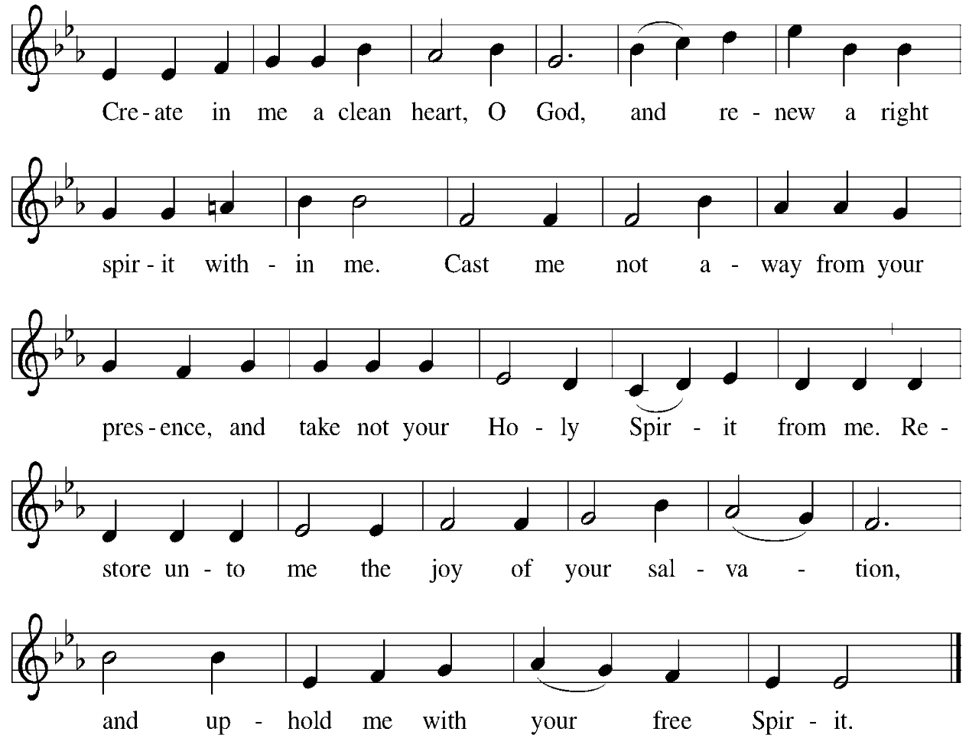

**Offertory Prayer**

A: Let us pray.

God our provider,

**C:** **you have not fed us with bread alone, but with words of grace and life.**

**Bless us and these your gifts, which we receive from your bounty,**

**through Jesus Christ our Lord. Amen.**

**Dialogue**

P: The Lord be with you.

**C: And also with you.**

P: Lift up your hearts.

**C: We lift them to the Lord.**

P: Let us give thanks to the Lord our God.

**C: It is right to give our thanks and praise.**

**Preface**

P: It is indeed right, our duty and our joy,

that we should at all times and in all places

give thanks and praise to you, almighty and merciful God,

through our Savior Jesus Christ;

You call your people to cleanse their hearts

and prepare with joy for the paschal feast,

that, renewed in the gift of baptism,

we may come to the fullness of your grace.

And so, with all the choirs of angels,

with the church on earth and the hosts of heaven,

we praise your name and join their unending hymn:

**Sanctus** *ELW* p. 190

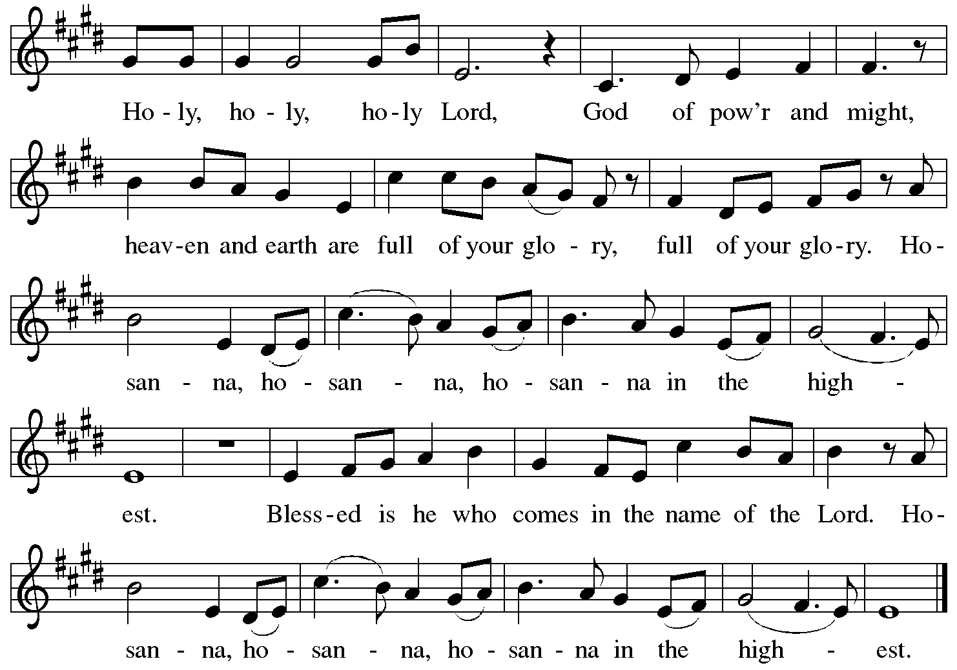

**Eucharistic Prayer**

P: Blessed are you, O God, of the universe … Do this for the remembrance of me.

With this bread and cup we remember our Lord’s Passover from death to life

as we proclaim the mystery of faith:

**C: Christ has died. Christ is risen. Christ will come again.**

P: O God of resurrection and new life … Grace our table with your presence.

**C: Come, Holy Spirit.**

P: Reveal yourself through the breaking of the bread … justice, peace, and love.

**C: Come, Holy Spirit.**

P: With your holy ones of all times and places …

… blessed and Holy Trinity, now and forever.

**C: Amen.**

**Lord’s Prayer**

P: Gathered as one by the Holy Spirit, let us pray as Jesus taught us.

**C: Our Father in heaven,**

**hallowed be your name,**

**your kingdom come,**

**your will be done,**

**on earth as in heaven.**

**Give us today our daily bread.**

**Forgive us our sins**

**as we forgive those**

**who sin against us.**

**Save us from the time of trial**

**and deliver us from evil.**

**For the kingdom, the power,**

**and the glory are yours,**

**now and forever. Amen.**

**Fraction and Invitation**

P: All who are hungry, come.

The feast of grace is ready.

***Agnus Dei /* Lamb of God** *ELW* p. 191

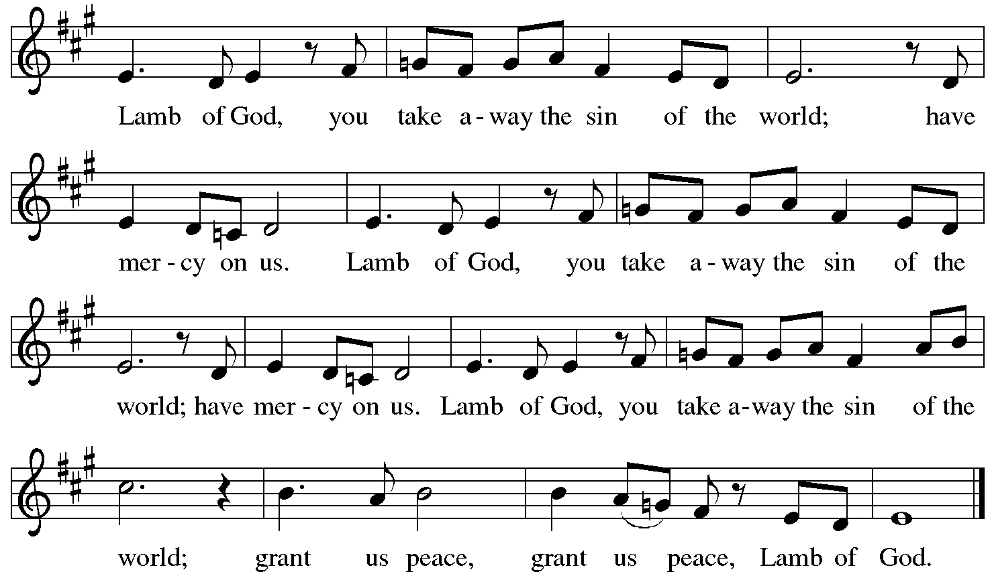

**

*Please be seated.*

**Holy Communion**

* *All who seek God and desire a deeper and stronger life in Christ are welcome to receive Holy Communion.*
* *Worshipers from the pulpit side will proceed forward first, followed by the center section, and then the lectern side.*
* *Please inform an usher if you would like the ministers to bring Communion to you.*
* *Holy Communion will be served with bread and wine (red) or grape juice (white).*
* *The presiding minister will first distribute the bread (host) to each communicant. Please indicate if you require a gluten-free host.*
* *Once you have consumed the bread, please pick up an empty glass from the tray next to the presiding minister. The Communion Assistant will pour wine from the chalice or grape juice from the cruet into your glass.*
* *Please step to the side to consume the wine or grape juice.*
* *Feel free to kneel at the altar rail for prayer after receiving the sacrament.*
* *As you return to your pew, glasses may be returned to the empty trays on the side of the center section.*
* *A blessing will be provided for anyone who does not yet receive the sacrament.*
* *All are invited to join in singing the hymns during Holy Communion.*

**Hymns during Holy Communion**

**Softly and Tenderly Jesus Is Calling *ELW* 608**

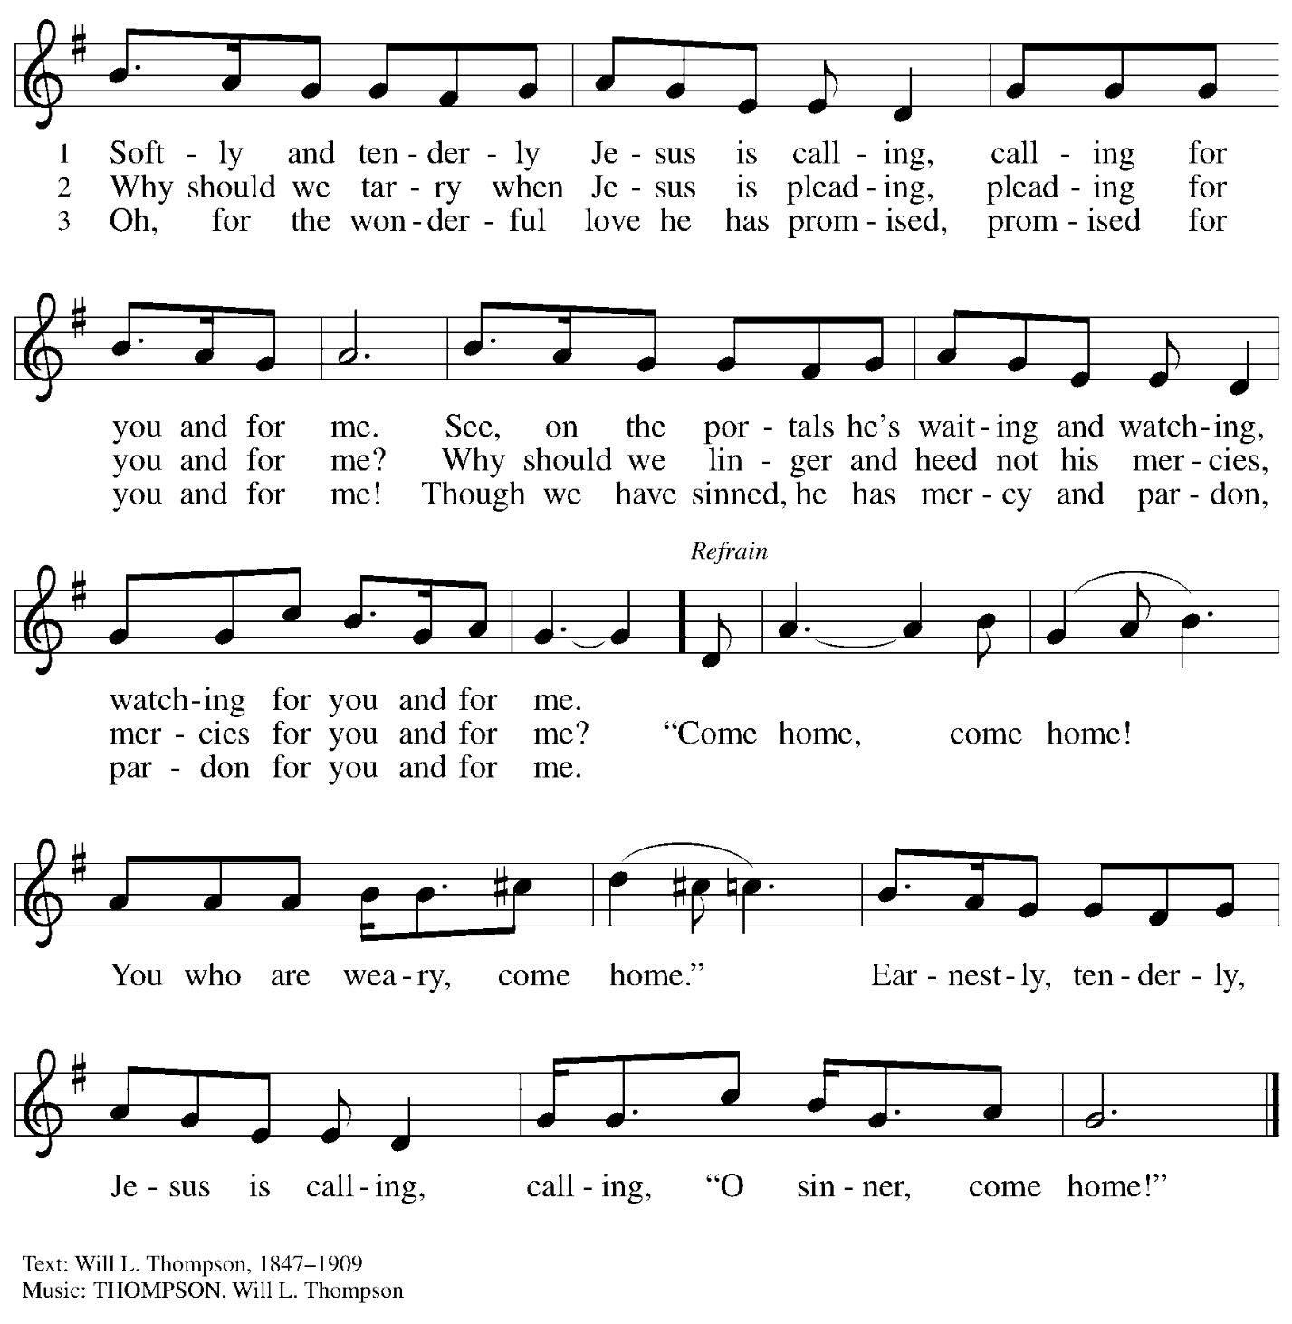

**Hymns during Holy Communion**

**God, When Human Bonds Are Broken *ELW* 603**

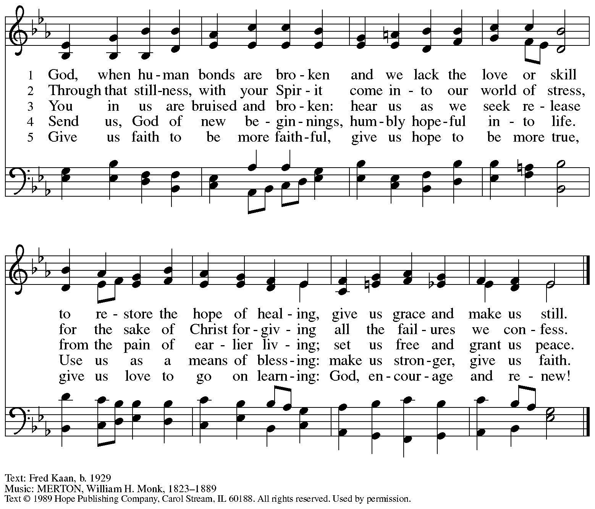

Reprinted under OneLicense.net #A-722139.

**Hymns during Holy Communion**

**You Have Called Us *BB* 648**

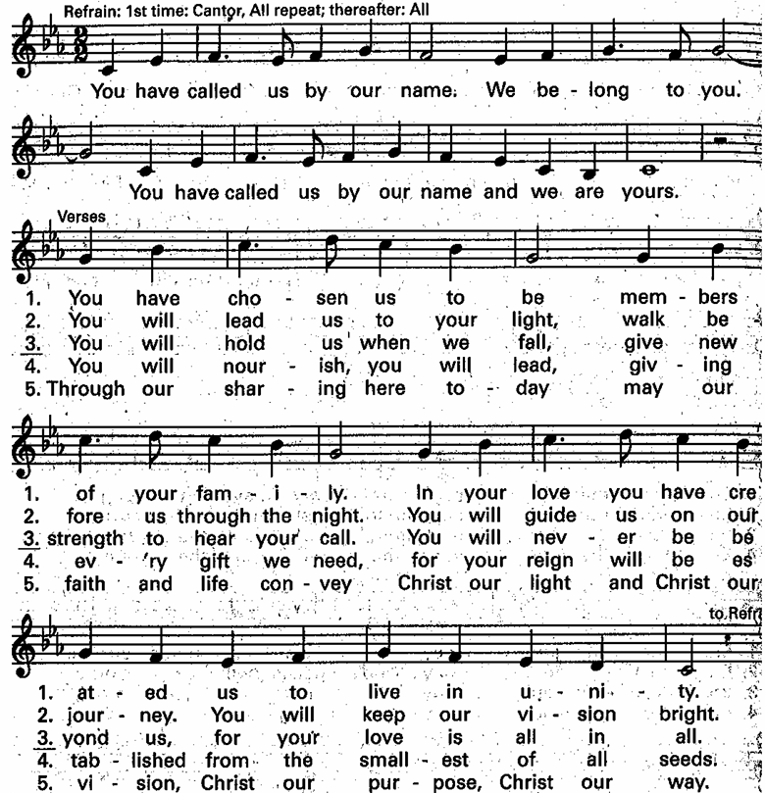

**Hymns during Holy Communion**

**Come, Thou Fount of Every Blessing *ELW* 807**

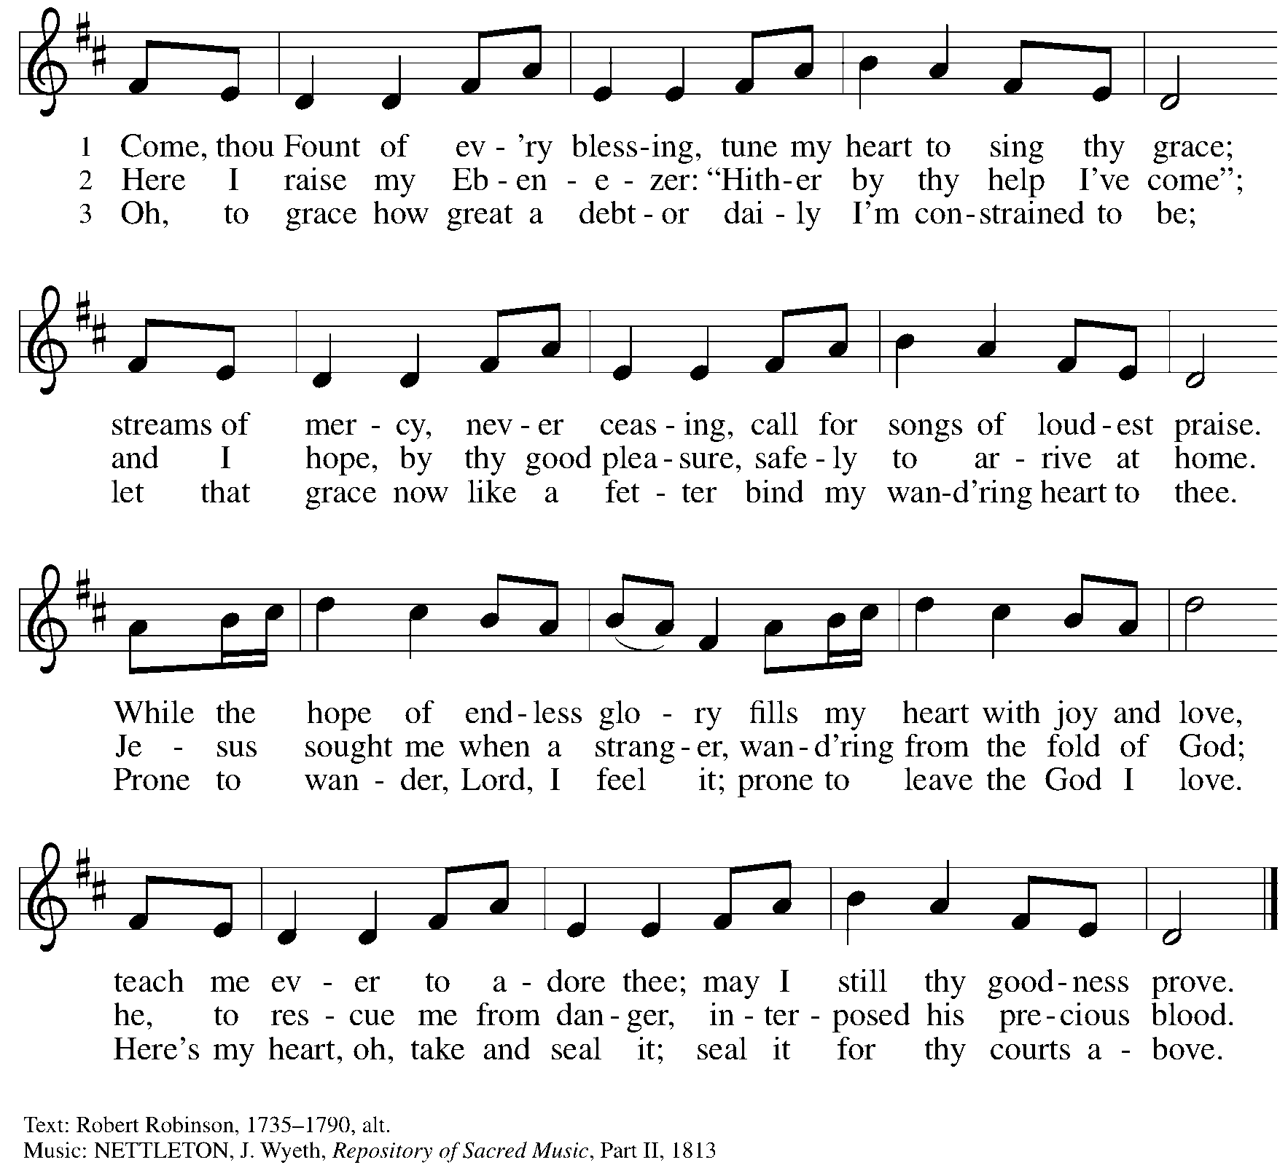

*When all have returned to their places, please rise as you are able.*

**Blessing**

P: The body and blood of our Lord Jesus Christ strengthen you and keep you in his grace.

**C: Amen.**

**Prayer**

A: Let us pray.

Compassionate God, you have fed us with the bread of heaven.

Sustain us in our Lenten pilgrimage:

may our fasting be hunger for justice;

our alms, a making of peace;

and our prayer, the song of grateful hearts,

through Jesus Christ, our Savior and Lord.

**C: Amen.**

*Please be seated.*

**Sending**

*God blesses us and sends us in mission to the world*

**Announcements**

*Please rise as you are able.*

**Benediction**

P: The Lord bless you and keep you.

The Lord’s face shine on you with grace and mercy.

The Lord look upon you with favor and ☩ give you peace.

**C: Amen.**

**Sending Hymn** *Following page*

**Dismissal**

P: Go in peace. Remember those in need.

**C: Thanks be to God!**

**Postlude**

**Sending Hymn Abide, O Dearest Jesus *ELW* 539**

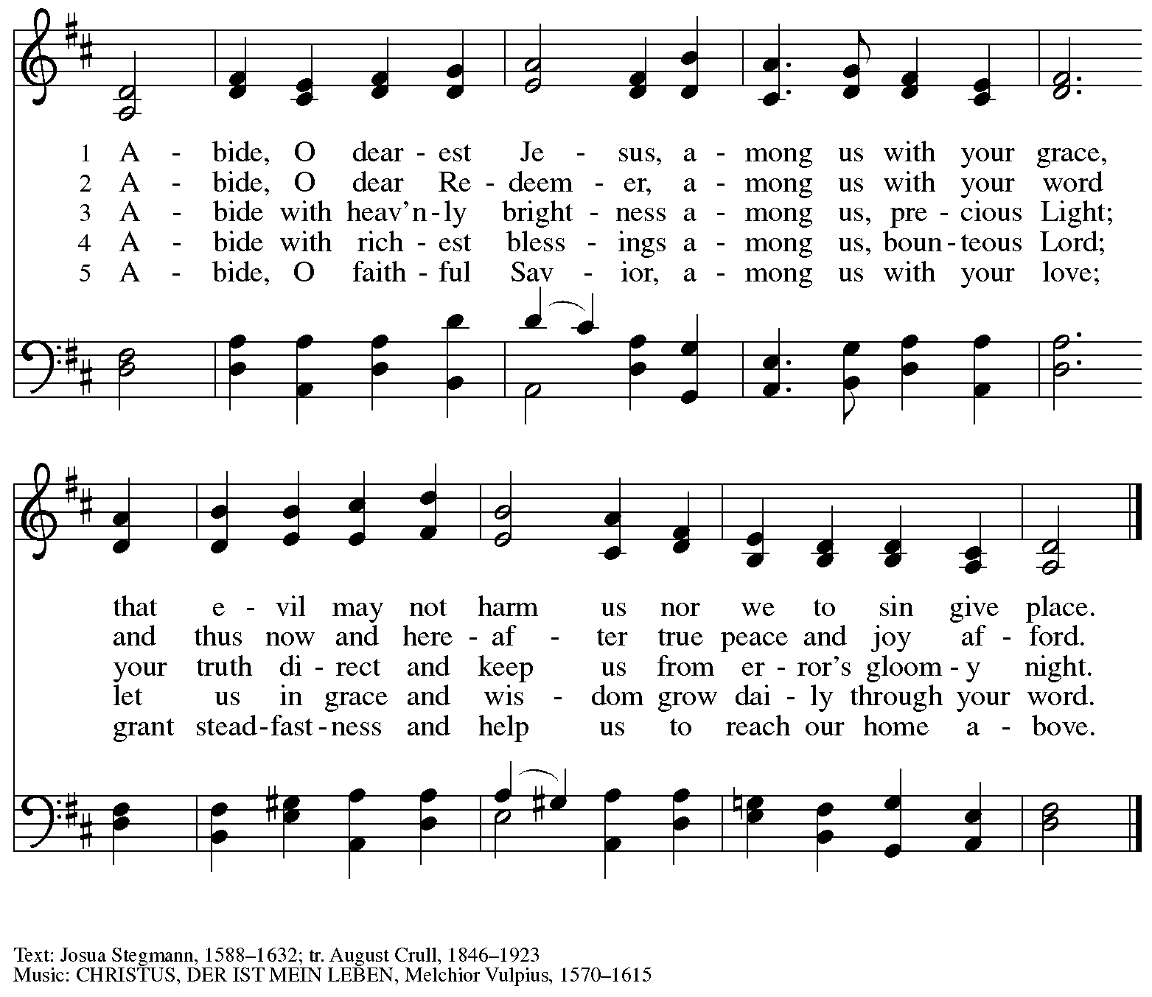

*Those serving in worship*

Altar Care Beverley Chapman

Assisting Minister Kathy Hays

Audio-Visual Ministers Kristen Asplin

Jason Galyardt

Cantor Miriam Bohlmann Kunz

Guitar and Voice on Pre-Service Music Emily Duque

Lector Alda Maria Gonzaga

Little Church – Big Faith Teacher Sue Gaugler

Minister of Music Laura Reynolds

Preaching Minister The Rev. Peter D. Asplin

Presiding Minister The Rev. Ross I. Carmichael

*Liturgy and Hymnody Acknowledgements*

From SundaysandSeasons.com. Copyright © 2025 Augsburg Fortress. All rights reserved. Reprinted under OneLicense.net # A-722139.

Used by permission of Augsburg Fortress.

The Scripture readings contained herein are from *New Revised Standard Version Updated Edition* of the Bible © 2021 National Council of Churches of Christ in the United States of America. Used by permission. All rights reserved worldwide.

**Kyrie** – Text: *Deutsche Messe* Franz Schubert, 1797-1828; adapt. Richard Proulx, b. 1937. Adapt. © 198, 1989 GIA Publications, Inc. 7404 S. Mason Ave., Chicago, IL 60638. [www.giamusic.com](http://www.giamusic.com). 800.442.3358. All rights reserved. Reprinted with permission under OneLicense.net # A-722139.

**Create in Me a Clean Heart** – Music: J. A. Freylinghausen, 1670-1739.

**You Have Called Us** – © 1995 Bernadette Farrell. Published by OCP Publications. All rights reserved. Reprinted with permission under OneLicense.net # A-722139.

*Please use the QR code below to link to St. Andrew’s Announcements online!*



**St. Andrew Lutheran Church Announcements**

**March 30th, 2025**

* **Welcome to Worship at St. Andrew on the + Fourth Sunday in Lent** –We are so glad you are here, and we offer a special welcome to all visitors and guests who are here for the first time! Worship attendees are invited to make a name tag at the back of the worship space. Little Church – Big Faith, a Bible lesson and activity for children, will take place after the prayer of the day. There are worship “toolkits” to help children engage with worship and “busy bags” for younger children available in the bookcase at the back of the sanctuary. Please feel free to take one to use with/for your children. All are invited to gather for coffee, other drinks, food, and conversation in the social hall after worship.
* **Thank You, Pastor Peter Asplin! – The Rev. Peter Asplin, St. Andrew member and Assistant to the Bishop of the Southwestern Pennsylvania Synod, will be the preaching minister at today’s service. We thank Pastor Peter for sharing the Word and his gifts with the congregation today!**
* **April Produce Distribution – First Tuesday of the Month, April 1st, from 5:30-7:00 p.m. –** St. Andrew partners with Greater Pittsburgh Community Food Bank to serve as a distribution site for fresh produce on the first Tuesday of every month. This month’s distribution will be on Tuesday, April 1st. We invite people of the congregation to help with the distribution from 5:30-7:00 p.m. and/or to help with unloading and setup during the day between 10:00 a.m. and 1:00 p.m.
* **The Legacy of Dr. Martin Luther King, Jr. – Seeking Justice, Restoring Community Event to Be Held at St. Andrew on Sunday, April 6th, Starting at 3:00 p.m. – Each year, our Southwestern Pennsylvania Synod of the Evangelical Lutheran Church in America (ELCA) has an event honoring the legacy of Dr. Martin Luther King, Jr. This year’s Ecumenical Service of Holy Communion and Call to Anti-racist Action will be at St. Andrew on Sunday, April 6th. The Rev. Dr. Dale B. Snyder of Bethel A.M.E church will be the guest preacher. We** gather to further God's vision for a just world where all are able to thrive, and honor the legacy of Dr. King's vision for a beloved community. Through education, worship, and conversation, we will learn the harmful legacy of urban renewal in southwestern Pennsylvania and explore how to dismantle harmful assumptions. Together, we will learn how to engage our communities to be rooted in mutuality, repentance, and repair. For more information, visit

[**swpasynod.org/calendar/mlk2025**](https://swpasynod.us19.list-manage.com/track/click?u=a23881a5c641ed10cd7f24da0&id=ad79b25734&e=23a8e9845f). Since we are hosting this large event, some people from St. Andrew are helping to lead worship, hospitality, cleanup, and setup, so we would appreciate additional contributions of food and drink items – please see the full list and signup here: <https://www.signupgenius.com/go/5080B4AAFAF2CABF85-55815706-synod>. If you can assist with hospitality or if you have questions please speak with Pat Lutz or Kelly Spanninger.

* **Community Ministry Meeting – Monday, April 7th, at 7:00 p.m. on Zoom – St. Andrew’s community ministry committee coordinates our local service ministries such as the outdoor Little Library, the pantry, produce distribution, shelter dinner, and various other activities. New participants are always welcome, and the next meeting is Monday, April 7th, at 7:00 p.m. on Zoom. Please contact** [PastorRCarmichael@gmail.com](mailto:PastorRCarmichael@gmail.com) **or** [community@standrewpittsburgh.org](mailto:community@standrewpittsburgh.org) **if you would like the link.**
* **Next Council Meeting – Saturday, April 12th, at 9:00 a.m. – St. Andrew’s congregation council meets once a month to guide the mission and general operations of the church. It is made up of 13 members of the congregation and the pastor. The next meeting of the council is Saturday, April 12th, at 9:00 a.m. We invite your prayers for St. Andrew’s council leaders!**
* **April Shelter Dinner for Guests of East End Cooperative Ministry – Third Thursday of the Month, April 17th, 6:30 p.m. –** Each month, people of St. Andrew provide dinner for guests of East End Cooperative Ministry (EECM), 6140 Station St. (East Liberty), 15206. This month’s shelter dinner is on Maundy Thursday, when St. Andrew will have worship at 7:00 p.m., so we invite you to prepare or purchase one menu item and bring it to the shelter by 6:00 p.m. If you would like to contribute, please sign up at <https://www.signupgenius.com/go/5080544AAAC22A1F58-55858396-shelter>.
* **The Services of Holy Week: Palm Sunday – Sunday of the Passion, April 13th through Easter Sunday, April 20th – With Palm Sunday, the Church enters into** contemplation of the passion, death, and resurrection of our Savior Jesus Christ. The services of Holy Week then continue with the service of the Triduum – the Great Three Days, one service that unfolds in three parts: Maundy Thursday, Good Friday, and the Vigil of Easter.

**The service schedule for Holy Week is**:

* + **Palm Sunday – Sunday of the Passion, April 13th, 10:00 a.m.** – On this day, worship begins with a procession with palm branches and features the story of Jesus’ passion. This year’s reading comes from Luke’s Gospel.
  + **Triduum – Maundy Thursday, April 17th, 7:00 p.m.** – The Church concludes the season of Lent with Confession and Forgiveness, receives Jesus’ command to love one another, remembers Christ’s example of such love in the washing of feet, and takes part in the sacrament of Holy Communion.
  + **Holy Week Service for Children – Friday, April 18th, 5:30 p.m.** – This service, designed for children up to sixth grade, follows the story of Holy Week with the last supper, Jesus’ washing of his disciples’ feet, his prayer in the garden, and the cross.
  + **Triduum –** **Good Friday, April 18th, 7:00 p.m.** – Service of Shadows and Stones. In relative darkness, we hear Gospel accounts of the crucifixion, sing prayerful, meditative hymns, and leave stones at the foot of the cross as we honor our crucified Savior.
  + **Triduum –** **The Vigil of Easter, April 19th, 5:00 p.m.** – The Vigil of Easter is a special service. Think of it as the people of God gathering around a campfire to tell their family’s stories of faith. The Church follows the history of God’s salvation through worship, word, sacrament, and song as we light the new fire and bless the Paschal candle, tell of God’s faithfulness throughout the ages, give thanks for the gift of Baptism, and move into the celebration of the resurrection with Holy Communion.
* **The Resurrection of our Lord – Easter Sunday, April 20th, 10:00 a.m.** – Worship with Holy Communion – We join the church throughout the world in proclaiming the good news of Christ’s resurrection!
* **Lenten Food Drive for St. Andrew’s Pantry** – One of the spiritual disciplines of the season of Lent is almsgiving – generous giving on behalf of neighbors in need. In the spirit of Lent, we are inviting people of the congregation to donate nonperishable food items to help replenish the congregation’s outdoor pantry. **Suggested items include**: Packs of chicken, tuna, or pork (any flavor); cans of Vienna sausage, potted meat, spam; cans of beef stew, beefaroni, ravioli; boxes of macaroni and cheese, stuffing, or mashed potatoes; cups of applesauce – any flavor; granola bars, rice Krispie treat bars; boxes of cookies or crackers; small bags or boxes of cereal – any kind; shelf stable milk; case of water; cans of vegetables and fruits. All canned items must have a pull tab to open.Items may be placed on the donation table in the social hall throughout the season of Lent.
* ***Life Renewed: Devotions for Lent 2025* Available at Church Entrances** – To assist with the spiritual discipline of prayer during Lent, St. Andrew offers a daily devotional booklet. This year’s is titled *Life Renewed*, and it contains a brief scripture reading, reflection/quote, and prayer for each day through the Vigil of Easter (April 19th). They are available at the church entrances – please take one to aid in your devotions this Lent!
* **Invitation to Pre-Service Music –** The people of St Andrew are gifted in so many ways.  We have much to be grateful for. Come share or experience the musical talents of our family on Sunday mornings. Arrive in-person 10 minutes before the service to rest in the sounds of musical offerings from musicians. If you sing or play an instrument, please consider sharing your gifts. Contact [timothy@touchwholeness.com](mailto:timothy@touchwholeness.com).
* ***Christ in Our Home* Devotional Booklets for April – June Available at Entrances** – This resource offers a daily Bible reading with a short reflection and prayer, along with additional readings and prayer topics for those who would like to expand their devotional practices. We encourage people of the congregation to take one for yourself, your family/household, or others!
* **Prayer Service with the Pittsburgh Compline Choir – Sundays at 8:00 p.m. at Heinz Chapel –** Compline was traditionally a monastic prayer service, and the Pittsburgh Compline Choir, a ministry of Lutheran Campus Ministry in Greater Pittsburgh, sings a choral version of compline rooted in this thousand-year-old tradition of scripture, song, and silence each Sunday at Heinz Chapel at 8:00 p.m. This service also streams on Facebook (Pittsburgh Compline Choir) and YouTube (The Pittsburgh Compline Choir). Heinz Chapel is located off of S. Bellefield Ave. in Oakland. For more information, please visit: [Pittsburgh Compline Choir](http://pittsburghcomplinechoir.org/).

**St. Andrew Feasibility Study Ongoing –**

**We Invite Your Input!**

This past weekend, consultants from Partners for Sacred Places, a nonprofit based in Philadelphia, were at St. Andrew to conduct interviews and share an update on our ongoing feasibility study to help prepare for a capital campaign.

Partners has also set up a survey in order to gather additional input and perspectives from the congregation, especially from anyone who has not been interviewed. This is an opportunity to share your thoughts and to help St. Andrew prepare for the future! The survey is available using the QR code below and it will close in two weeks. Thank you very much for your feedback!



**Flowers for Easter**

*St. Andrew will be ordering Lilies (6 inch, five bloom - $8.00 each)*

*Tulips (8 inch - $9.00 each))*

*Daffodils (6 inch - $5.25 each)*

*to decorate the worship space for Easter Sunday, April 20th,*

*and the Easter season.*

*If you would like to sponsor and dedicate flowers, please order using this form.*

Order by: Sunday, April 13th

*Orders may be submitted at the desk in the main office*

*or through the Sunday offering plates.*

*Please submit payment with order - Checks may be made payable to*:

St. Andrew Lutheran Church

Name __________________________________________

In Honor of __________________________________________

In Memory of __________________________________________

In Appreciation/Love for __________________________________________

Number of Lilies ________

Number of Tulips ________

Number of Daffodils ________