

**+ Third Sunday in Lent**

**March 23rd, 2025**

**10:00 a.m.**



**St. Andrew Lutheran Church**

**304 Morewood Ave.**

**Pittsburgh, PA 15213**

**412.682.3342**

[**St_andrewELCA@verizon.net**](mailto:St_andrewELCA@verizon.net)

[**www.standrewpittsburgh.org**](http://www.standrewpittsburgh.org)

**+ Third Sunday in Lent**

**Order for Worship**

*Warnings are plentiful and direct on the third Sunday in Lent. Cut it out or get cut down! The warnings are accompanied by God’s invitation to attentiveness: “Incline your ear, and come to me; listen, so that you may live.” The landowner’s ultimatum is forestalled by the gardener’s readiness to till the ground one more year. That is good news for all of us. Thanks be to God!*

**Welcome to St. Andrew!**

* St. Andrew welcomes all who are seeking a place of healing, wholeness, and acceptance in a nurturing and faith-forming spiritual home. We are striving toward racial equity worldwide

and we seek to honor the lived experience of all individuals regardless of background. Our community embraces people of all ages, ethnicities, cultures, abilities, sexual orientations,

gender identities and expressions, and family constellations. Come and See!

* Worship Services are live-streamed to multiple online platforms. By attending worship, you agree that your image and voice may be broadcast.
* Everyone is invited to make a name tag at the black bookcase in the back of the worship space if they would like. There are stickers indicating pronouns on the bookcase if you would like to include them on your name tag.
* Children are invited to attend Little Church – Big Faith, a Bible lesson and activity, during worship (after the Prayer of the Day). The group returns to the worship space for the liturgy of Holy Communion.
* A nursery is available through the doors at the left side of the sanctuary and across from the doorway to the Social Hall. Look for a purple-colored room.
* Worship “toolkits” to help children engage with the service, along with “busy bags” for younger children, are available in the bookcase at the back of the sanctuary. Please feel free to take one to use with/for your children.
* Holy Communion is served with bread (gluten-free available) and wine or grape juice. The presiding minister will distribute the bread (host). Please consume this and then pick up an empty glass from the tray. The Communion Assistant will pour wine or grape juice into your glass. Please step to the side to consume the wine or grape juice. Feel free to kneel at the altar for prayer and reflection. As you return to your pew, glasses may be returned to the empty trays on either side of the center section.
* A restroom is available on the main level of the church, through the doors to the Social Hall and to the right in the main office.

*Abbreviations*

P: Pastor/Presiding Minister ***ELW*: *Evangelical Lutheran Worship* hymnal**

A: Assisting Minister ***ACS*: *All Creation Sings* hymnal**

L: Lector ***W&P*: *Worship & Praise* hymnal**

**C: Congregation**

**Pre-Service Music** Maria Mangano

**Welcome**

**Prelude** *What Wondrous Love Is This* arr. John Carter

**Gathering**

*The Holy Spirit calls us together as the people of God*

**Confession**

*Please rise as you are able. All may make the sign of the cross,*

*the sign that is marked at Baptism, as the presiding minister begins.*

P: Blessed be the holy Trinity, ☩ one God,

who forgives all our sin,

whose mercy endures forever.

**C: Amen.**

P: Let us return to God, confessing our sin in the assurance of God’s abiding love.

*Silence is kept for reflection.*

P: Compassionate One,

**you are slow to anger and abounding in steadfast love,**

**but our lives do not always reflect you** **and your love for the world.**

**We do not show others the tender compassion** **you have shown to us.**

**We do not welcome others with the hospitality** **you grant to all people.**

**We oppress others,** **even though you have set us free again and again.**

**We squander the abundant gifts of the earth.**

**Transform our lives** **and guide us again in the way of the cross.**

**Amen.**

P: Beloved in Christ,

God’s arms are always stretched open wide

to welcome the wandering ones home.

In ☩ Christ your sins are forgiven.

You have a place in God’s house forever.

**C: Amen.**

**Gathering Hymn O Jesus, Joy of Loving Hearts *ELW* 658**

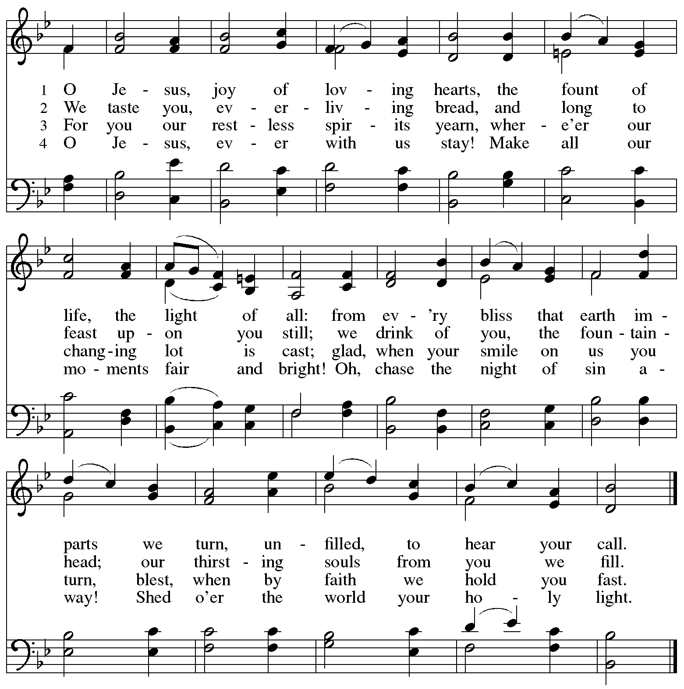

**Greeting**

P: The grace of our Lord Jesus Christ, the love of God,

and the communion of the Holy Spirit be with you all.

**C: And also with you.**

**Kyrie *ELW*** **152**

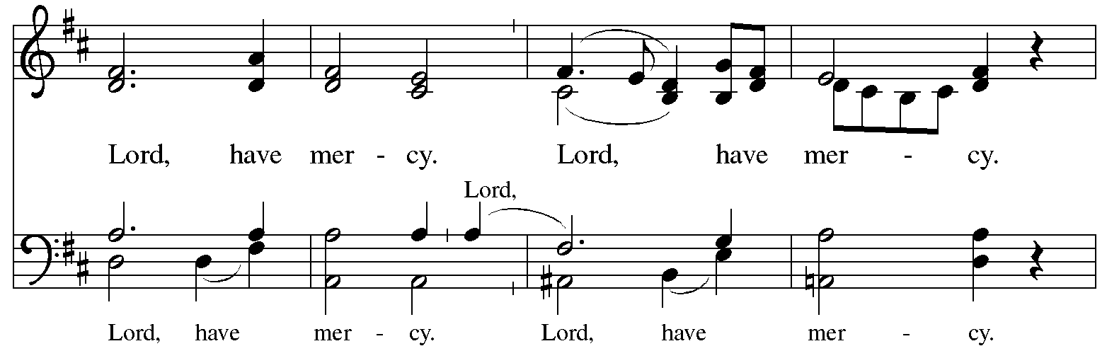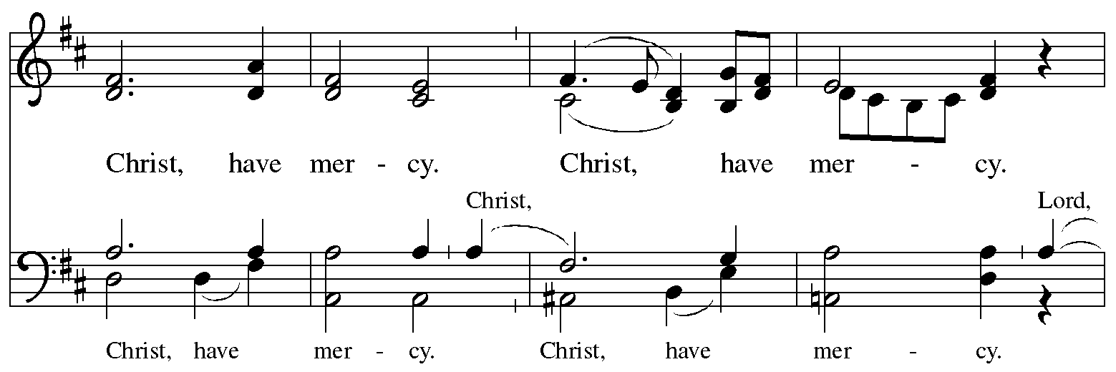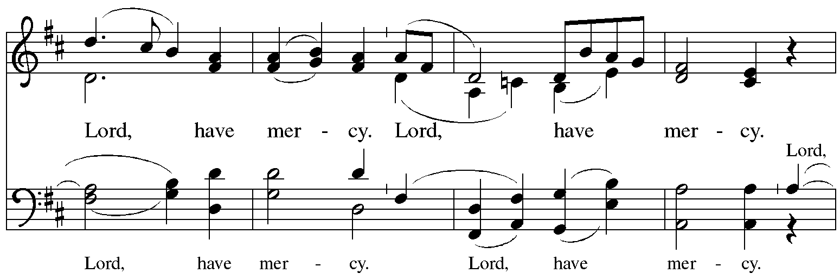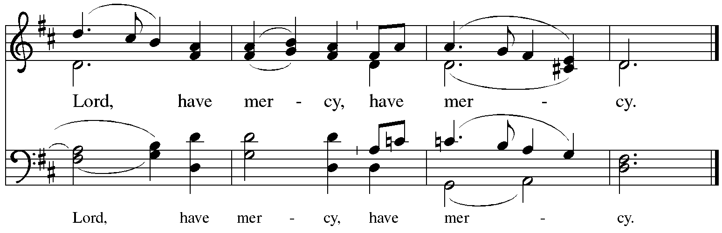

**Prayer of the Day**

P: The Lord be with you.

**C: And also with you.**

P: Let us pray.

Eternal God, your reign has broken into our troubled world

through the life, death, and resurrection of your Son. Help us to hear your word and obey it,

and bring your saving love to fruition in our lives, through Jesus Christ, our Savior and Lord, who lives and reigns with you and the Holy Spirit, one God, now and forever.

**C: Amen.**

*Please be seated.*

*Children are invited to join the adult leader(s) at the side door for Little Church – Big Faith.*

*We ask that an additional adult from the congregation attend with the children.*

**Word**

*God speaks to us in Scripture reading, preaching, and song*

**First Reading** **– Isaiah 55: 1-9**

 1 Hear, everyone who thirsts,  
  come to the waters;  
 and you who have no money,  
  come, buy and eat!  
 Come, buy wine and milk  
  without money and without price.  
 2 Why do you spend your money for that which is not bread,  
  and your earnings for that which does not satisfy?  
 Listen carefully to me, and eat what is good,  
  and delight yourselves in rich food.  
 3 Incline your ear, and come to me;  
  listen, so that you may live.  
 I will make with you an everlasting covenant,  
  my steadfast, sure love for David.  
 4 See, I made him a witness to the peoples,  
  a leader and commander for the peoples.  
 5 Now you shall call nations that you do not know,  
  and nations that do not know you shall run to you,  
 because of the Lord your God, the Holy One of Israel,  
  for the Lord has glorified you.  
  
 6 Seek the Lord while the Lord may be found,  
  call upon the Lord while the Lord is near;  
 7 let the wicked forsake their way,  
  and the unrighteous their thoughts;  
 let them return to the Lord, that the Lord may have mercy on them,  
  and to our God, for God will abundantly pardon.  
 8 For my thoughts are not your thoughts,  
  nor are your ways my ways, says the Lord.  
 9 For as the heavens are higher than the earth,  
  so are my ways higher than your ways  
  and my thoughts than your thoughts.

L: Word of God, word of life.

**C: Thanks be to God.**

**Psalm 63: 1-8**

*The cantor will lead the singing of the psalm.*

*The congregation is invited to respond with the alternate verses in bold print,*

*and to join in singing the refrain.*

*Psalm Tone*

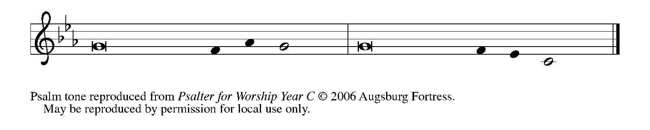

*Psalm Refrain*

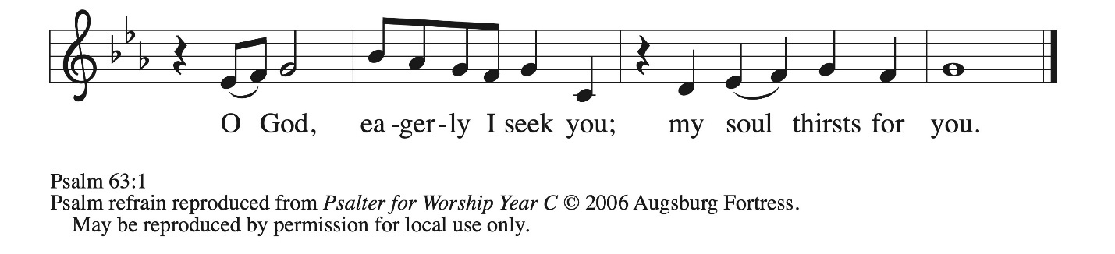

 1 O God, you are my God; eager- **|** ly I seek you;  
  my soul thirsts for you, my flesh faints for you, as in a dry and weary land where there **|** is no water.  
 2 **Therefore I have gazed upon you in your | holy place,**  
  **that I might behold your power | and your glory.**  
 3 For your steadfast love is better than **|** life itself;  
  my lips shall **|** give you praise.

 4 **So will I bless you as long | as I live**  
  **and lift up my hands | in your name. R**  
 5 My spirit is content, as with the rich- **|** est of foods,  
  and my mouth praises you with **|** joyful lips,  
 6 **when I remember you up- | on my bed,**  
  **and meditate on you in | the night watches.**  
 7 For you have **|** been my helper,  
  and under the shadow of your wings I **|** will rejoice.  
 8 **My whole being | clings to you;**  
  **your right hand | holds me fast. R**

**Second Reading – 1 Corinthians 10: 1-13**

1 I do not want you to be ignorant, kindred, that our ancestors were all under the cloud, and all passed through the sea, 2 and all were baptized into Moses in the cloud and in the sea, 3 and all ate the same spiritual food, 4 and all drank the same spiritual drink. For they drank from the spiritual rock that followed them, and the rock was Christ. 5 Nevertheless, God was not pleased with most of them, and they were struck down in the wilderness.  
  6 Now these things occurred as examples for us, so that we might not desire evil as they did.

7 Do not become idolaters as some of them did, as it is written, “The people sat down to eat and drink, and they rose up to play.” 8 We must not indulge in sexual immorality, as some of them did, and twenty-three thousand fell in a single day. 9 We must not put Christ to the test, as some of them did, and were destroyed by serpents. 10 And do not complain, as some of them did, and were destroyed by the destroyer. 11 These things happened to them to serve as an example, and they were written down to instruct us, on whom the ends of the ages have come. 12 So if you think you are standing, watch out that you do not fall. 13 No testing has overtaken you that is not common to everyone. God is faithful, and God will not let you be tested beyond your strength, but with the testing God will also provide the way out so that you may be able to endure it.

L: Word of God, word of life.

**C: Thanks be to God.**

*Please rise as you are able and join in singing the Gospel Acclamation.*

**Gospel Acclamation** *ELW* p. 189

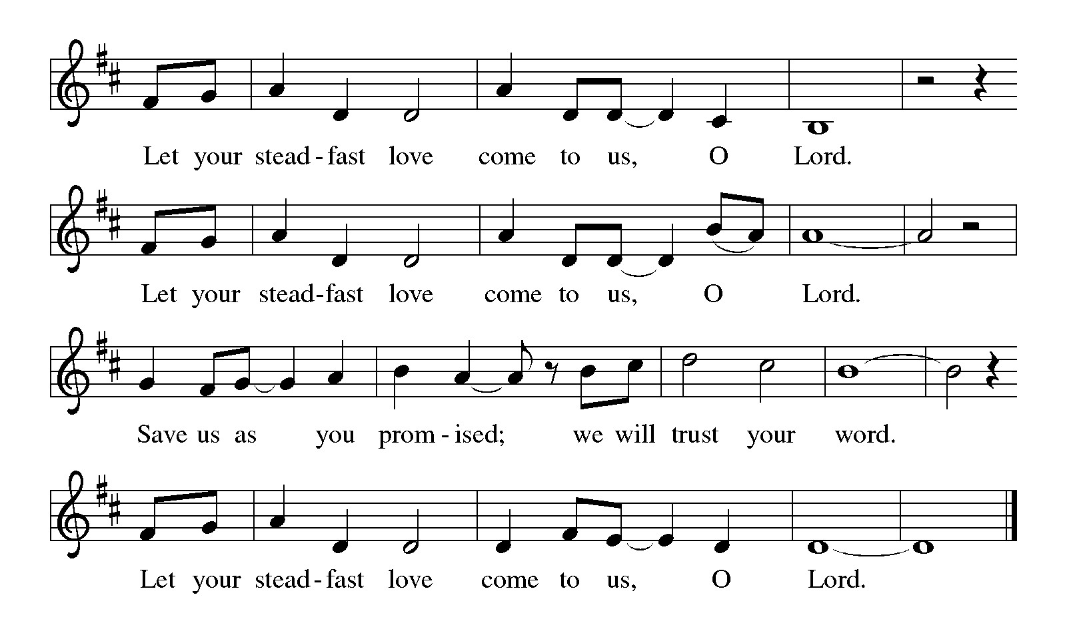

**Gospel – Luke 13: 1-9**

P: The holy Gospel according to St. Luke.

**C: Glory to you, O Lord.**

1 At that very time there were some present who told Jesus about the Galileans whose blood Pilate had mingled with their sacrifices. 2 [Jesus] asked them, “Do you think that because these Galileans suffered in this way they were worse sinners than all other Galileans? 3 No, I tell you, but unless you repent, you will all perish as they did. 4 Or those eighteen who were killed when the tower of Siloam fell on them—do you think that they were worse offenders than all the other people living in Jerusalem? 5 No, I tell you, but unless you repent, you will all perish just as they did.”  
  6 Then he told this parable: “A man had a fig tree planted in his vineyard; and he came looking for fruit on it and found none. 7 So he said to the man working the vineyard, ‘See here! For three years I have come looking for fruit on this fig tree, and still I find none. Cut it down! Why should it be wasting the soil?’ 8 He replied, ‘Sir, let it alone for one more year, until I dig around it and put manure on it. 9 If it bears fruit next year, well and good, but if not, you can cut it down.’ ”

P: The Gospel of the Lord.

**C: Praise to you, O Christ.**

*Please be seated.*

**Sermon**

*A time of silence for prayer and reflection follows the sermon.*

*As the hymn of the day begins, please rise as you are able.*

**Hymn of the Day Before the Waters Nourished Earth *ACS* 1049**

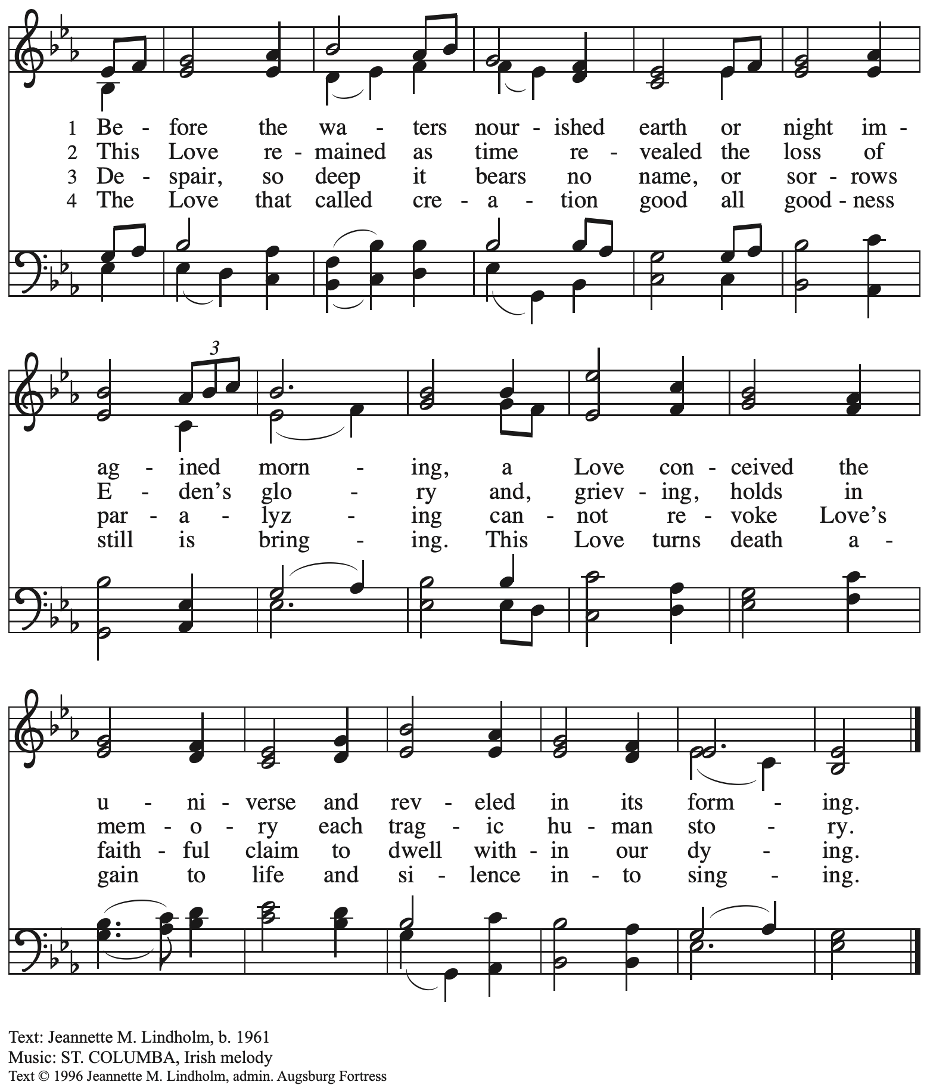

All rights reserved. Reprinted with permission under OneLicense.net # A-722139.

**Apostles’ Creed**

**C: I believe in God, the Father almighty,**

**creator of heaven and earth.**

**I believe in Jesus Christ, God’s only Son, our Lord,**

**who was conceived by the Holy Spirit,**

**born of the virgin Mary,**

**suffered under Pontius Pilate,**

**was crucified, died, and was buried;**

**he descended to the dead.\***

**On the third day he rose again;**

**he ascended into heaven,**

**he is seated at the right hand of the Father,**

**and he will come to judge the living and the dead.**

**I believe in the Holy Spirit,**

**the holy catholic church,**

**the communion of saints,**

**the forgiveness of sins,**

**the resurrection of the body,**

**and the life everlasting. Amen.**

*Or, “he descended into hell,” another translation of this text in widespread use.

**Prayers of the People**

A: Led by the Spirit, let us turn to God in prayer for the church, those in need,

and all God’s creation.

*After each petition*

A: Merciful God,

**C: receive our prayer.**

*The presiding minister concludes the prayers*

P: Receive the prayers of your people, O God, and draw all things together in your love,

in the name of Jesus, who leads us from death to life.

**C: Amen.**

**Peace**

*The presiding minister and the assembly greet one another in the peace of the risen Christ.*

P: The peace of Christ be with you always.

**C: And also with you.**

*The people may greet those around them with a sign of Christ’s peace and may say*

Peace be with you *or similar words. Please be mindful that not everyone will be comfortable with sharing the peace, so please seek consent before shaking hands or hugging. Other possible ways to share the peace include a simple bow with the verbal greeting of peace, or simply a verbal expression of peace. When the greetings of peace have concluded, please be seated.*

**

**Meal**

*God feeds us with the presence of Jesus Christ*

**Offering**

*We offer ourselves, our gifts, and our faithful service to God.*

*As the offering is gathered for the mission of the church, including the care of those in need,*

*the table is set for Holy Communion.*

*There are laminated giving cards in the pew racks that feature a QR code for anyone who would like to give online. Those who give using the QR code, as well as those who give regularly online or through their bank are encouraged to place the laminated card in the plate as an expression of your offering.*

**Music during the Offering** *Lamb of God* Paris/arr. Larson

**Children’s Choir Offering** African American Spiritual

*I’ve Got Peace Like a River*

*As the gifts are brought forward for presentation,* *please rise as you are able.*

**Offertory Song Create in Me a Clean Heart *ELW* 188**

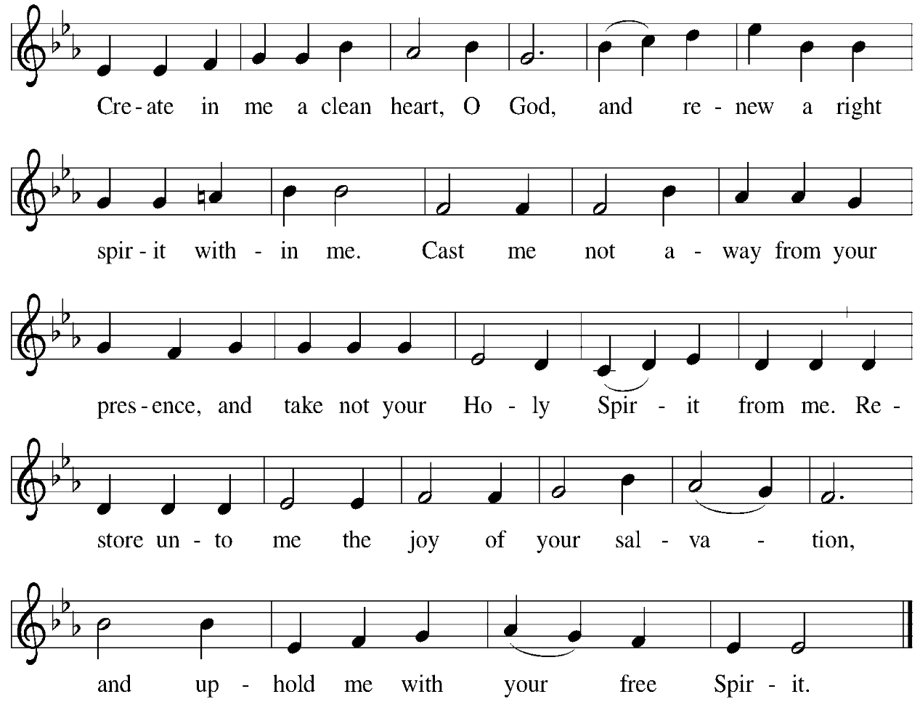

**Offertory Prayer**

A: Let us pray.

God our provider,

**C:** **you have not fed us with bread alone, but with words of grace and life.**

**Bless us and these your gifts, which we receive from your bounty,**

**through Jesus Christ our Lord. Amen.**

**Dialogue**

P: The Lord be with you.

**C: And also with you.**

P: Lift up your hearts.

**C: We lift them to the Lord.**

P: Let us give thanks to the Lord our God.

**C: It is right to give our thanks and praise.**

**Preface**

P: It is indeed right, our duty and our joy,

that we should at all times and in all places

give thanks and praise to you, almighty and merciful God,

through our Savior Jesus Christ;

You call your people to cleanse their hearts

and prepare with joy for the paschal feast,

that, renewed in the gift of baptism,

we may come to the fullness of your grace.

And so, with all the choirs of angels,

with the church on earth and the hosts of heaven,

we praise your name and join their unending hymn:

**Sanctus** *ELW* p. 190

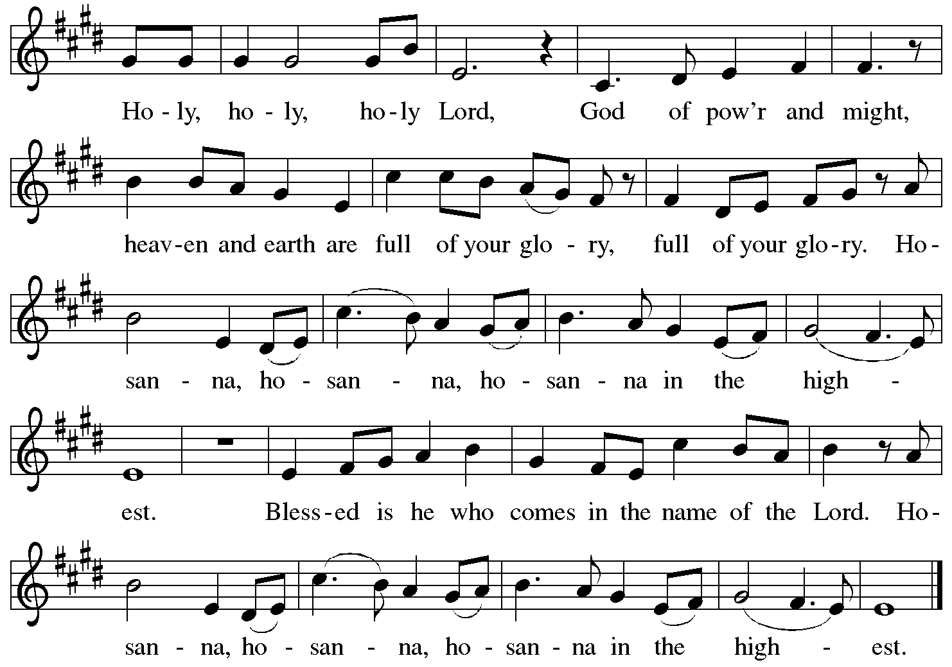

**Eucharistic Prayer**

P: Blessed are you, O God, of the universe …

… Do this for the remembrance of me.

With this bread and cup we remember our Lord’s Passover from death to life

as we proclaim the mystery of faith:

**C: Christ has died. Christ is risen. Christ will come again.**

P: O God of resurrection and new life … Grace our table with your presence.

**C: Come, Holy Spirit.**

P: Reveal yourself through the breaking of the bread … justice, peace, and love.

**C: Come, Holy Spirit.**

P: With your holy ones of all times and places …

… blessed and Holy Trinity, now and forever.

**C: Amen.**

**Lord’s Prayer**

P: Gathered as one by the Holy Spirit, let us pray as Jesus taught us.

**C: Our Father in heaven,**

**hallowed be your name,**

**your kingdom come,**

**your will be done,**

**on earth as in heaven.**

**Give us today our daily bread.**

**Forgive us our sins**

**as we forgive those**

**who sin against us.**

**Save us from the time of trial**

**and deliver us from evil.**

**For the kingdom, the power,**

**and the glory are yours,**

**now and forever. Amen.**

**Fraction and Invitation**

P: All who are hungry, come.

The feast of grace is ready.

***Agnus Dei /* Lamb of God** *ELW* p. 191

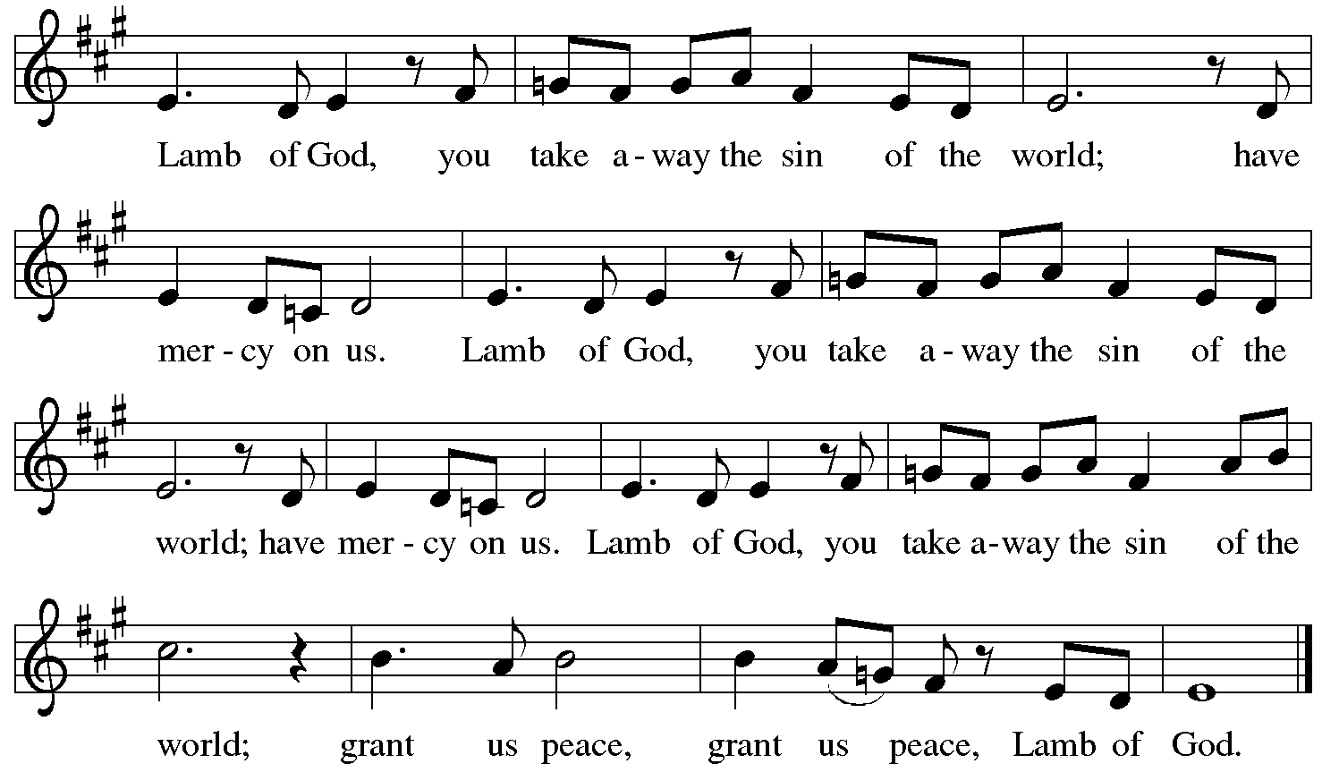

*Please be seated.*

**Holy Communion**

* *All who seek God and desire a deeper and stronger life in Christ are welcome to receive Holy Communion.*
* *Worshipers from the pulpit side will proceed forward first, followed by the center section, and then the lectern side.*
* *Please inform an usher if you would like the ministers to bring Communion to you.*
* *Holy Communion will be served with bread and wine (red) or grape juice (white).*
* *The presiding minister will first distribute the bread (host) to each communicant. Please indicate if you require a gluten-free host.*
* *Once you have consumed the bread, please pick up an empty glass from the tray next to the presiding minister. The Communion Assistant will pour wine from the chalice or grape juice from the cruet into your glass.*
* *Please step to the side to consume the wine or grape juice.*
* *Feel free to kneel at the altar rail for prayer after receiving the sacrament.*
* *As you return to your pew, glasses may be returned to the empty trays on the side of the center section.*
* *A blessing will be provided for anyone who does not yet receive the sacrament.*
* *All are invited to join in singing the hymns during Holy Communion.*

**Hymns during Holy Communion**

**Come to the Table *ELW* 481**

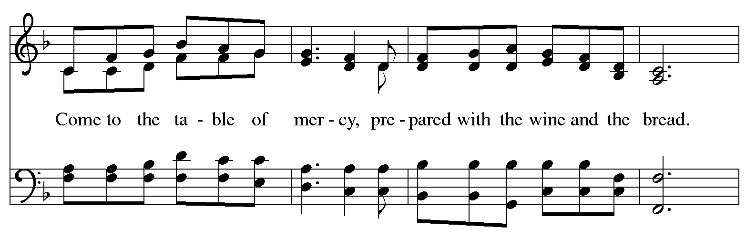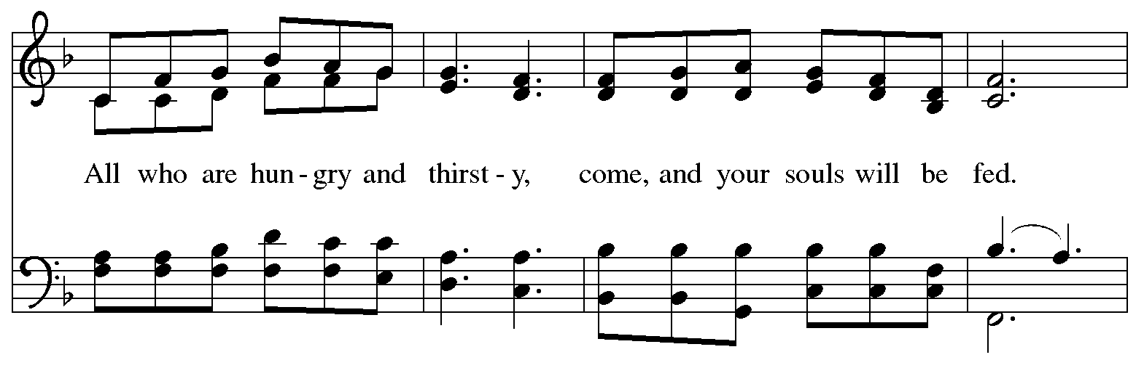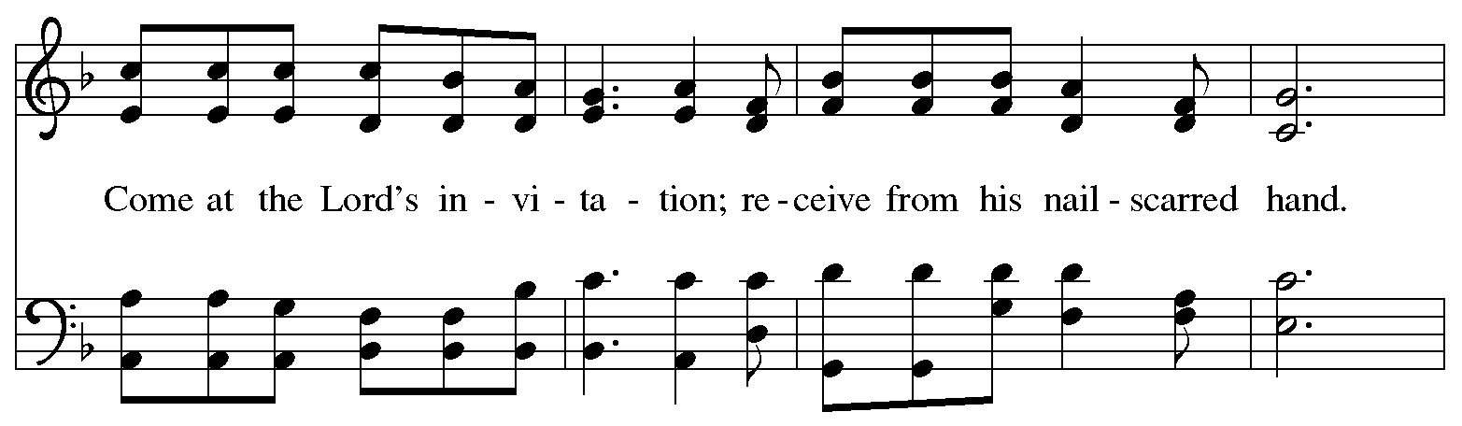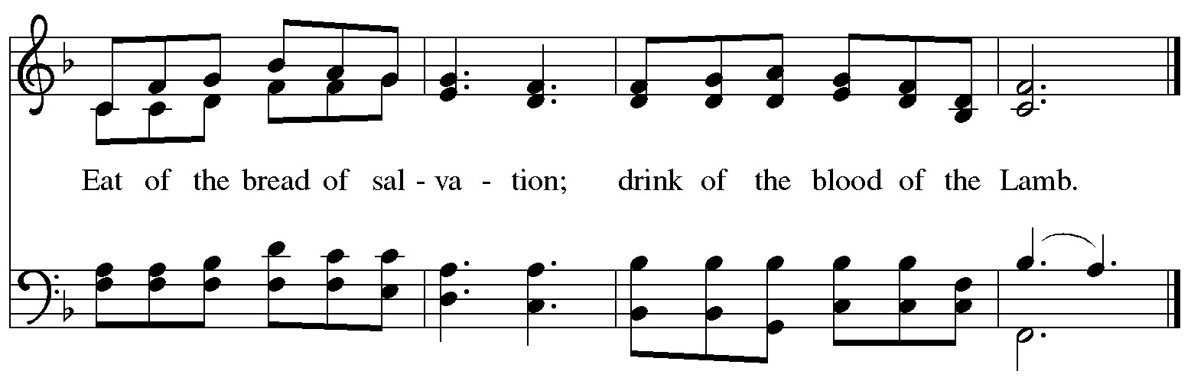

**Hymns during Holy Communion**

**Make Me a Channel of Your Peace *W&P* 95**

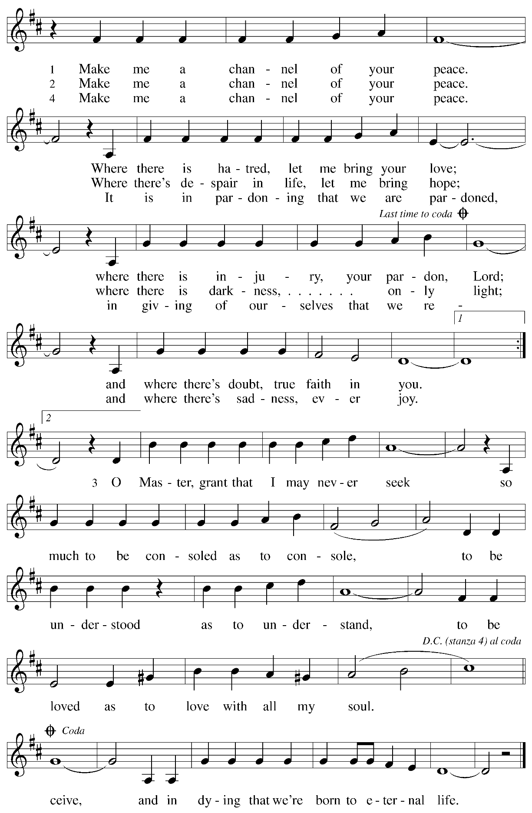

**Hymns during Holy Communion**

**There’s a Wideness in God’s Mercy *ELW* 587**

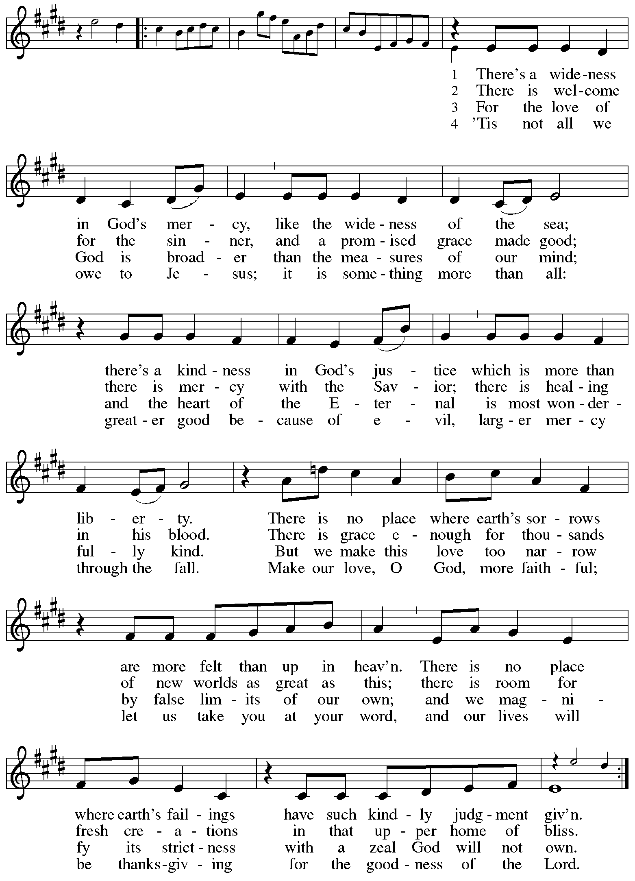

**Hymns during Holy Communion** Timothy Kocher-Hillmer

**You Gave Me Life**

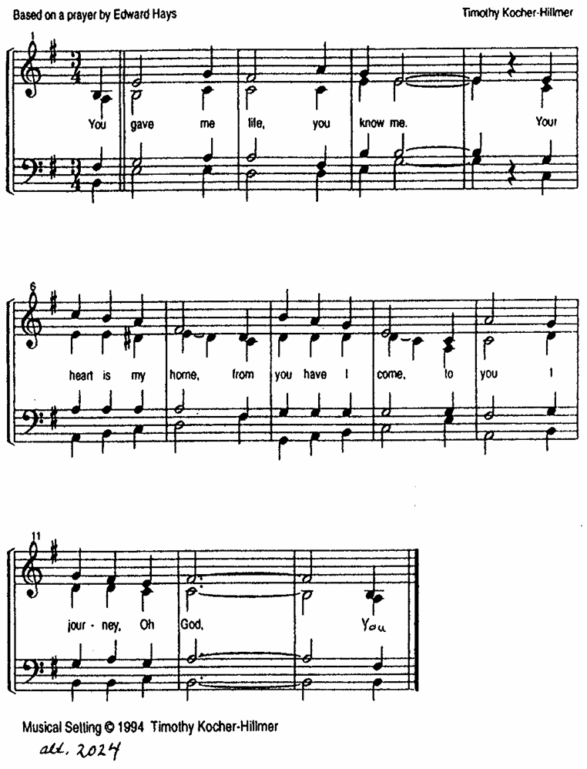

**Hymns during Holy Communion**

**Jesus, Keep Me Near the Cross *ELW* 335**

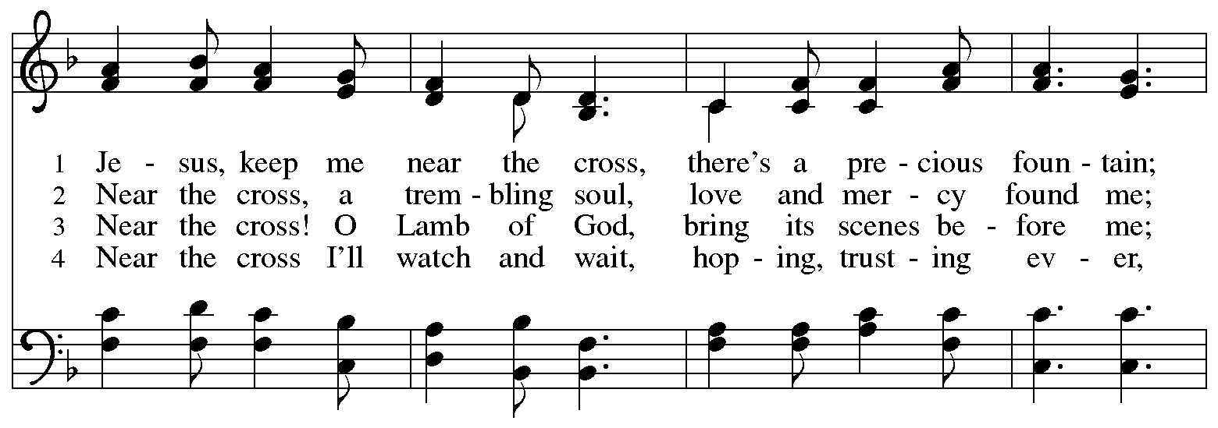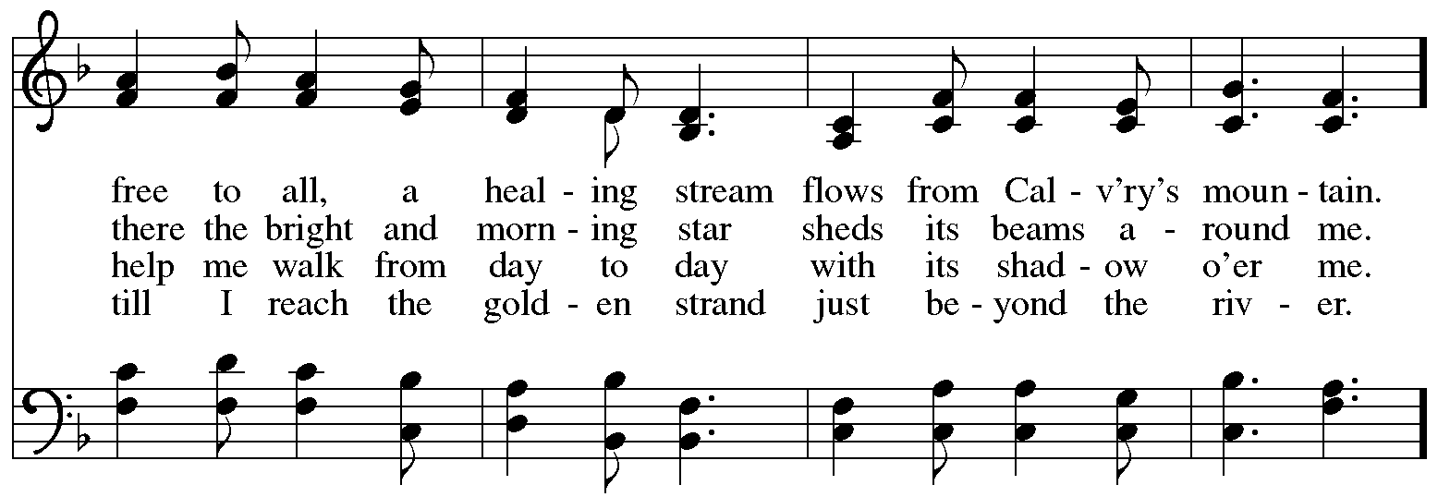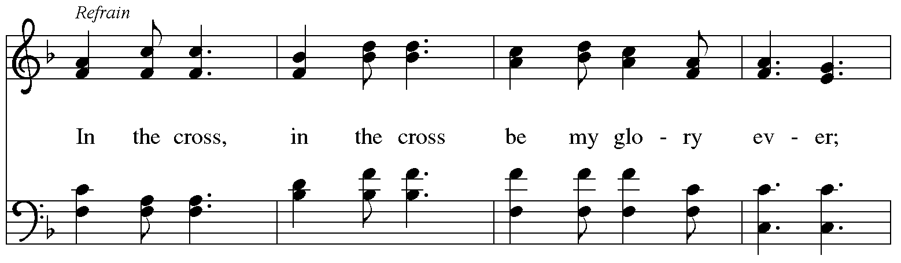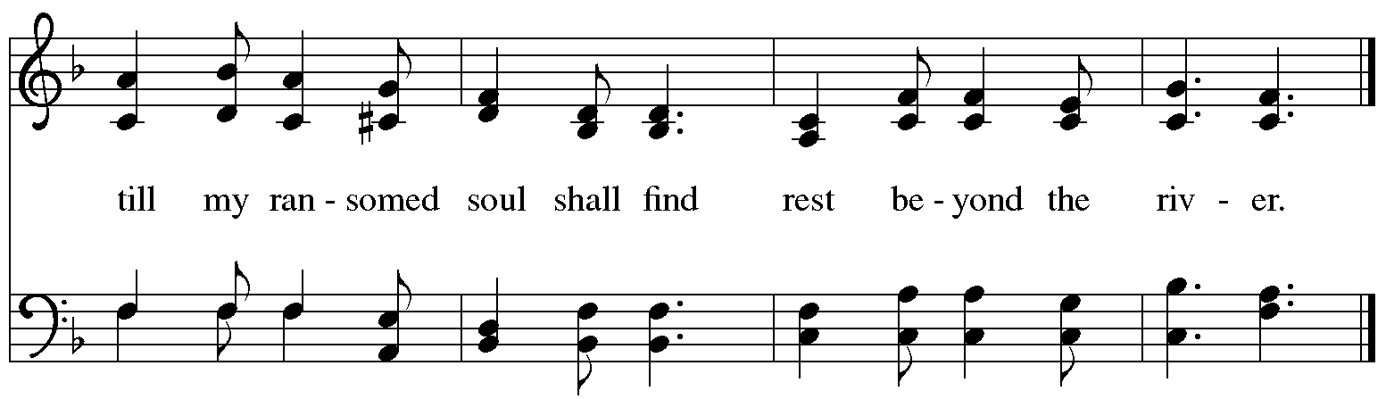

*When all have returned to their places, please rise as you are able.*

**Blessing**

P: The body and blood of our Lord Jesus Christ strengthen you and keep you in his grace.

**C: Amen.**

**Prayer**

A: Let us pray.

Compassionate God, you have fed us with the bread of heaven.

Sustain us in our Lenten pilgrimage:

may our fasting be hunger for justice;

our alms, a making of peace;

and our prayer, the song of grateful hearts,

through Jesus Christ, our Savior and Lord.

**C: Amen.**

*Please be seated.*

**Sending**

*God blesses us and sends us in mission to the world*

**Announcements**

*Please rise as you are able.*

**Benediction**

P: The Lord bless you and keep you.

The Lord’s face shine on you with grace and mercy.

The Lord look upon you with favor and ☩ give you peace.

**C: Amen.**

**Sending Hymn** *Following page*

**Dismissal**

P: Go in peace. Remember those in need.

**C: Thanks be to God!**

**Postlude**

**Sending Hymn Jesus Is a Rock in a Weary Land *ELW* 333**

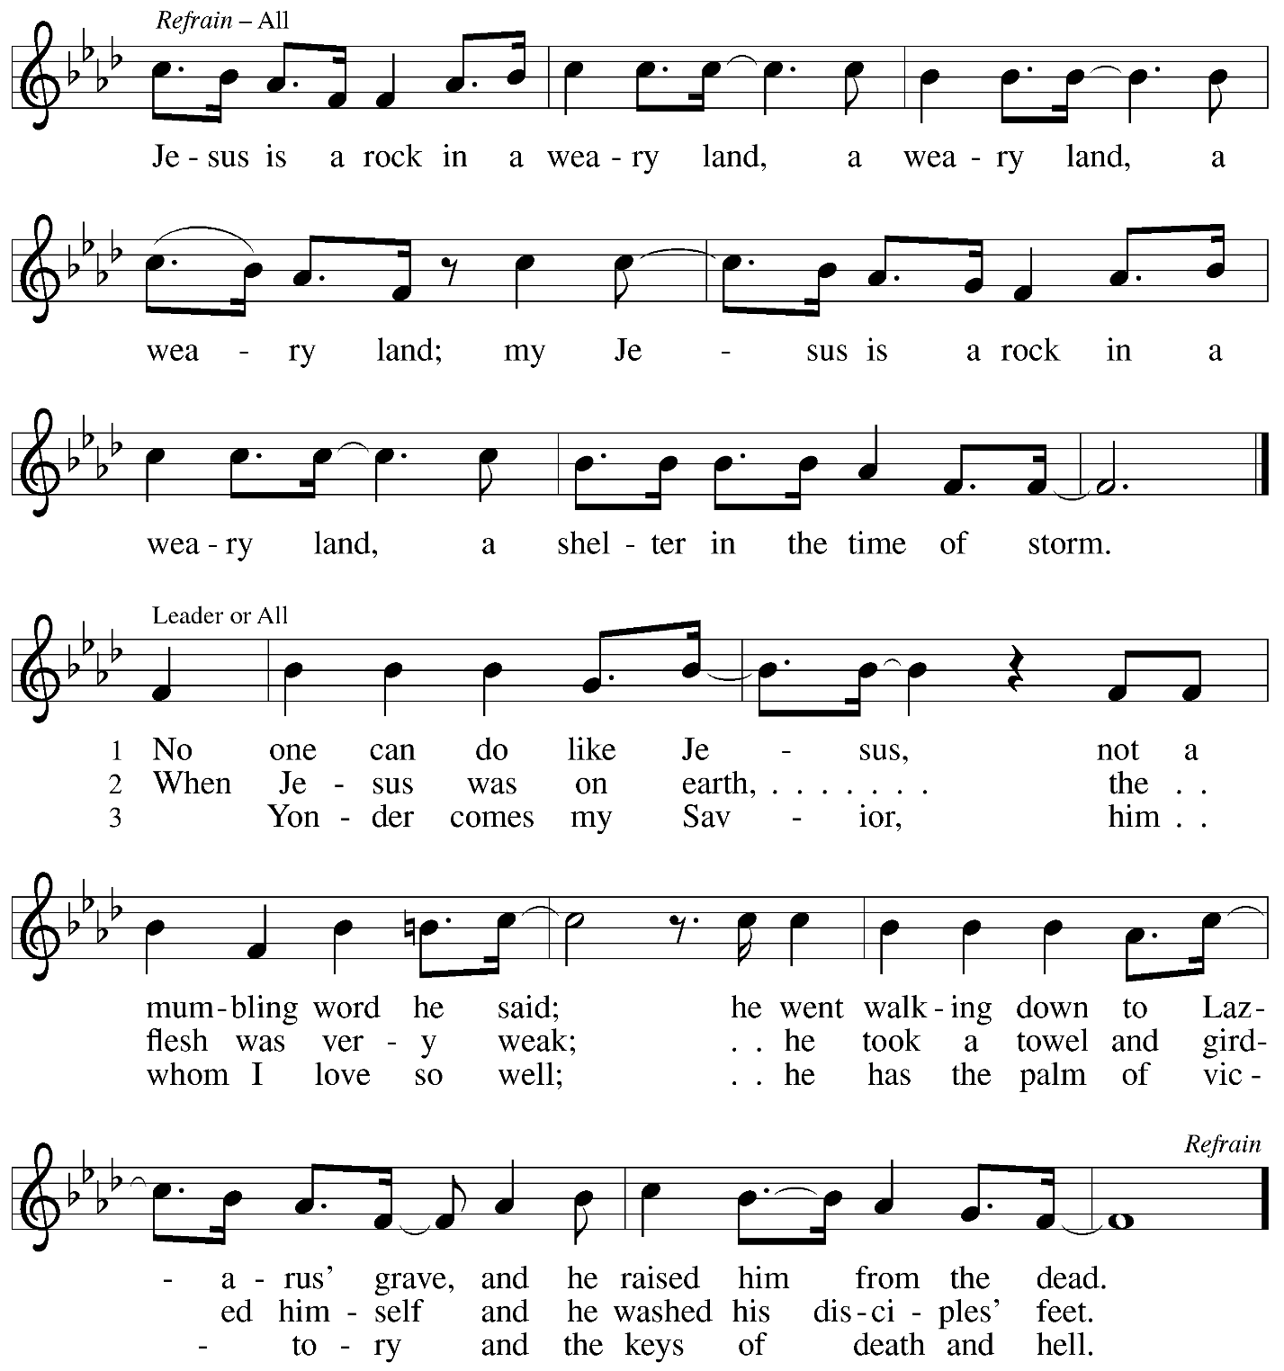

*Those serving in worship*

Altar Care Jodie Minor

Assisting Minister Jeff Denlinger

Audio-Visual Ministers David Rollinson

Jered Stratton

Cantor C.E. Pino

Clarinet on Pre-Service Music Maria Mangano

Lector Brennan Coleman

Little Church – Big Faith Teacher Emily Duque

Minister of Music Laura Reynolds

Presiding and Preaching Minister The Rev. Ross I. Carmichael

*Liturgy and Hymnody Acknowledgements*

From SundaysandSeasons.com. Copyright © 2025 Augsburg Fortress. All rights reserved. Reprinted under OneLicense.net # A-722139.

Used by permission of Augsburg Fortress.

The Scripture readings contained herein are from *New Revised Standard Version Updated Edition* of the Bible © 2021 National Council of Churches of Christ in the United States of America. Used by permission. All rights reserved worldwide.

**Kyrie** – Text: *Deutsche Messe* Franz Schubert, 1797-1828; adapt. Richard Proulx, b. 1937. Adapt. © 198, 1989 GIA Publications, Inc. 7404 S. Mason Ave., Chicago, IL 60638. [www.giamusic.com](http://www.giamusic.com). 800.442.3358. All rights reserved. Reprinted with permission under OneLicense.net # A-722139.

**Create in Me a Clean Heart** – Music: J. A. Freylinghausen, 1670-1739.

**Come to the Table** – Text: Claire Cloninger, b. 1942. Music: COME TO THE TABLE, Marty J. Nystrom, b. 1956. Text and music © 1991 Integrity’s Hosanna! Music (ASCAP), c/o Integrity Media, Inc., 1000 Cody Road, Mobile, AL 36695; and Juniper Landing, Music, admin. Word Music; and Word Music (ASCAP). All rights reserved. Reprinted with permission under OneLicense.net # A-722139.

**Make Me a Channel of Your Peace** – Text: Sebastian Temple Music: PRAYER OF ST. FRANCIS, Sebastian Temple. Text and music © 1967 OCP Publications. All rights reserved. Reprinted with permission under OneLicense.net # A-722139.

**There’s a Wideness in God’s Mercy** – Text: Frederick W. Faber, 1814-1863, alt. Music: ST. HELENA, Calvin Hampton, 1938-1984. Music © 1977 GIA Publications, Inc., 7404 S. Mason Ave., Chicago, IL 60638. [www.giamusic.com](http://www.giamusic.com). 800.442.3358. All rights reserved. Reprinted with permission under OneLicense.net # A-722139.

**Jesus, Keep Me Near the Cross** – Text: Fanny J. Crosby, 1820-1915. Music: NEAR THE CROSS, William H. Doane, 1832-1915.

*Please use the QR code below to link to St. Andrew’s Announcements online!*



**St. Andrew Lutheran Church Announcements**

**March 23rd, 2025**

* **Welcome to worship at St. Andrew on the + Third Sunday in Lent** –We are so glad you are here, and we offer a special welcome to all visitors and guests who are here for the first time! Worship attendees are invited to make a name tag at the back of the worship space. Little Church – Big Faith, a Bible lesson and activity for children, will take place after the prayer of the day. There are worship “toolkits” to help children engage with worship and “busy bags” for younger children available in the bookcase at the back of the sanctuary. Please feel free to take one to use with/for your children. All are invited to gather for coffee, other drinks, food, and conversation in the social hall after worship.
* **Congregational Meeting Today after Worship – This year’s spring congregational meeting will be held today after worship. The7is is an opportunity to review the past year in ministry, receive an update on the congregation’s end-of-year financial status, share updates on current initiatives, and look ahead toward upcoming events. Representatives from Partners for Sacred Places, with whom we are working on a feasibility study for a capital campaign, will be here. No absentee or proxy votes can be accepted so please plan to attend the meeting, in person or via Zoom (same as Sunday worship link).**
* **The Legacy of Dr. Martin Luther King, Jr. – Seeking Justice, Restoring Community Event to Be Held at St. Andrew on Sunday, April 6th, Starting at 3:00 p.m. – Each year, our Southwestern Pennsylvania Synod of the Evangelical Lutheran Church in America (ELCA) has an event honoring the legacy of Dr. Martin Luther King, Jr. This year’s Ecumenical Service of Holy Communion and Call to Anti-racist Action will be at St. Andrew on Sunday, April 6th. The Rev. Dr. Dale B. Snyder of Bethel A.M.E church will be the guest preacher. We** gather to further God's vision for a just world where all are able to thrive, and honor the legacy of Dr. King's vision for a beloved community. Through learning, worship, and conversation, we will learn the harmful legacy of urban renewal in southwestern Pennsylvania and explore how to dismantle harmful assumptions. Together, we will learn how to engage our communities to be rooted in mutuality, repentance, and repair. For more information, visit

[**swpasynod.org/calendar/mlk2025**](https://swpasynod.us19.list-manage.com/track/click?u=a23881a5c641ed10cd7f24da0&id=ad79b25734&e=23a8e9845f). Since we are hosting this large event, some people from St. Andrew are helping to lead worship, hospitality, cleanup, and setup, so we would appreciate additional contributions of food and drink items – please see the full list and signup here: <https://www.signupgenius.com/go/5080B4AAFAF2CABF85-55815706-synod>. If you can assist with hospitality or if you have questions please speak with Pat Lutz or Kelly Spanninger.

* **The Services of Holy Week: Palm Sunday – Sunday of the Passion, April 13th through Easter Sunday, April 20th – With Palm Sunday, the Church enters into** contemplation of the passion, death, and resurrection of our Savior Jesus Christ. The services of Holy Week then continue with the service of the Triduum – the Great Three Days, one service that unfolds in three parts: Maundy Thursday, Good Friday, and the Vigil of Easter. The service schedule for Holy Week is:
  + **Palm Sunday – Sunday of the Passion, April 13th, 10:00 a.m.** – On this day, worship begins with a procession with palm branches and features the story of Jesus’ passion. This year’s reading comes from Luke’s Gospel.
  + **Triduum – Maundy Thursday, April 17th, 7:00 p.m.** – The Church concludes the season of Lent with Confession and Forgiveness, receives Jesus’ command to love one another, remembers Christ’s example of such love in the washing of feet, and takes part in the sacrament of Holy Communion.
  + **Holy Week Service for Children – Friday, April 18th, 5:30 p.m.** – This service, designed for children up to sixth grade, follows the story of Holy Week with the last supper, Jesus’ washing of his disciples’ feet, his prayer in the garden, and the cross.
  + **Triduum –** **Good Friday, April 18th, 7:00 p.m.** – Service of Shadows and Stones. In relative darkness, we hear Gospel accounts of the crucifixion, sing prayerful, meditative hymns, and leave stones at the foot of the cross as we honor our crucified Savior.
  + **Triduum –** **The Vigil of Easter, April 19th, 5:00 p.m.** – The Vigil of Easter is a special service. Think of it as the people of God gathering around a campfire to tell their family’s stories of faith. The Church follows the history of God’s salvation through worship, word, sacrament, and song as we light the new fire and bless the Paschal candle, tell of God’s faithfulness throughout the ages, give thanks for the gift of Baptism, and move into the celebration of the resurrection with Holy Communion.
* **The Resurrection of our Lord – Easter Sunday, April 20th, 10:00 a.m.** – Worship with Holy Communion – We join the church throughout the world in proclaiming the good news of Christ’s resurrection!
* **Invitation to Pre-Service Music –** The people of St Andrew are gifted in so many ways.  We have much to be grateful for. Come share or experience the musical talents of our family on Sunday mornings. Arrive in-person 10 minutes before the service to rest in the sounds of musical offerings from musicians. If you sing or play an instrument, please consider sharing your gifts. Contact [timothy@touchwholeness.com](mailto:timothy@touchwholeness.com).
* **Lenten Food Drive for St. Andrew’s Pantry** – One of the spiritual disciplines of the season of Lent is almsgiving – generous giving on behalf of neighbors in need. In the spirit of Lent, we are inviting people of the congregation to donate nonperishable food items to help replenish the congregation’s outdoor pantry. **Suggested items include**: Packs of chicken, tuna, or pork (any flavor); cans of Vienna sausage, potted meat, spam; cans of beef stew, beefaroni, ravioli; boxes of macaroni and cheese, stuffing, or mashed potatoes; cups of applesauce – any flavor; granola bars, rice Krispie treat bars; boxes of cookies or crackers; small bags or boxes of cereal – any kind; shelf stable milk; case of water; cans of vegetables and fruits. All canned items must have a pull tab to open.Items may be placed on the donation table in the social hall throughout the season of Lent.
* ***Life Renewed: Devotions for Lent 2025* Available at Church Entrances** – Another of the spiritual disciplines for the season of Lent is prayer, so each year, the worship committee provides copies of a daily devotional booklet. This year’s is titled *Life Renewed*, and it contains a brief scripture reading, reflection/quote, and prayer for each day from Ash Wednesday (March 5th) to the Vigil of Easter (April 19th). They are available at the entrances to the building – please take one to aid in your devotions this Lent!
* ***Christ in Our Home* Devotional Booklets for April – June Now Available at Church Entrances** – This resource offers a daily Bible reading with a short reflection and prayer, along with additional readings and prayer topics for those who would like to expand their devotional practices. We encourage people of the congregation to take one for yourself, your family/household, or others!

**Flowers for Easter**

*St. Andrew will be ordering Lilies (6 inch, five bloom - $8.00 each)*

*Tulips (8 inch - $9.00 each))*

*Daffodils (6 inch - $5.25 each)*

*to decorate the worship space for Easter Sunday, April 20th,*

*and the Easter season.*

*If you would like to sponsor and dedicate flowers, please order using this form.*

Order by: Sunday, April 13th

*Orders may be submitted at the desk in the main office*

*or through the Sunday offering plates.*

*Please submit payment with order - Checks may be made payable to*:

St. Andrew Lutheran Church

Name __________________________________________

In Honor of __________________________________________

In Memory of __________________________________________

In Appreciation/Love for __________________________________________

Number of Lilies ________

Number of Tulips ________

Number of Daffodils ________