

**+ Second Sunday in Lent**

**March 16th, 2025**

**10:00 a.m.**



**St. Andrew Lutheran Church**

**304 Morewood Ave.**

**Pittsburgh, PA 15213**

**412.682.3342**

[**St_andrewELCA@verizon.net**](mailto:St_andrewELCA@verizon.net)

[**www.standrewpittsburgh.org**](http://www.standrewpittsburgh.org)

**+ Second Sunday in Lent**

**Order for Worship**

*Though we sometimes doubt and often resist God’s desire to protect and save us, our God persists. In holy baptism, God’s people have been called and gathered into a God-initiated relationship that will endure. Lent provides the church with a time and a tradition in which to seek God’s face again. Lent provides another occasion to behold the God of our salvation in the face of the Blessed One who “comes in the name of the Lord.”*

**Welcome to St. Andrew!**

* St. Andrew welcomes all who are seeking a place of healing, wholeness, and acceptance in a nurturing and faith-forming spiritual home. We are striving toward racial equity worldwide

and we seek to honor the lived experience of all individuals regardless of background. Our community embraces people of all ages, ethnicities, cultures, abilities, sexual orientations,

gender identities and expressions, and family constellations. Come and See!

* Worship Services are live-streamed to multiple online platforms. By attending worship, you agree that your image and voice may be broadcast.
* Everyone is invited to make a name tag at the black bookcase in the back of the worship space if they would like. There are stickers indicating pronouns on the bookcase if you would like to include them on your name tag.
* Children are invited to attend Little Church – Big Faith, a Bible lesson and activity, during worship (after the Prayer of the Day). The group returns to the worship space for the liturgy of Holy Communion.
* A nursery is available through the doors at the left side of the sanctuary and across from the doorway to the Social Hall. Look for a purple-colored room.
* Worship “toolkits” to help children engage with the service, along with “busy bags” for younger children, are available in the bookcase at the back of the sanctuary. Please feel free to take one to use with/for your children.
* Holy Communion is served with bread (gluten-free available) and wine or grape juice. The presiding minister will distribute the bread (host). Please consume this and then pick up an empty glass from the tray. The Communion Assistant will pour wine or grape juice into your glass. Please step to the side to consume the wine or grape juice. Feel free to kneel at the altar for prayer and reflection. As you return to your pew, glasses may be returned to the empty trays on either side of the center section.
* A restroom is available on the main level of the church, through the doors to the Social Hall and to the right in the main office.

*Abbreviations*

P: Pastor/Presiding Minister ***ELW*: *Evangelical Lutheran Worship* hymnal**

A: Assisting Minister ***ACS*: *All Creation Sings* hymnal**

L: Lector

**C: Congregation**

**Pre-Service Music**

**Welcome**

**Prelude** *Bring Peace to Earth Again* arr. Nancy Raabe

**Gathering**

*The Holy Spirit calls us together as the people of God*

**Confession**

*Please rise as you are able. All may make the sign of the cross,*

*the sign that is marked at Baptism, as the presiding minister begins.*

P: Blessed be the holy Trinity, ☩ one God,

who forgives all our sin,

whose mercy endures forever.

**C: Amen.**

P: Let us return to God, confessing our sin in the assurance of God’s abiding love.

*Silence is kept for reflection.*

P: Compassionate One,

**you are slow to anger and abounding in steadfast love,**

**but our lives do not always reflect you** **and your love for the world.**

**We do not show others the tender compassion** **you have shown to us.**

**We do not welcome others with the hospitality** **you grant to all people.**

**We oppress others,** **even though you have set us free again and again.**

**We squander the abundant gifts of the earth.**

**Transform our lives** **and guide us again in the way of the cross.**

**Amen.**

P: Beloved in Christ,

God’s arms are always stretched open wide

to welcome the wandering ones home.

In ☩ Christ your sins are forgiven.

You have a place in God’s house forever.

**C: Amen.**

**Gathering Hymn Blessed Be the God of Israel *ELW* 552**

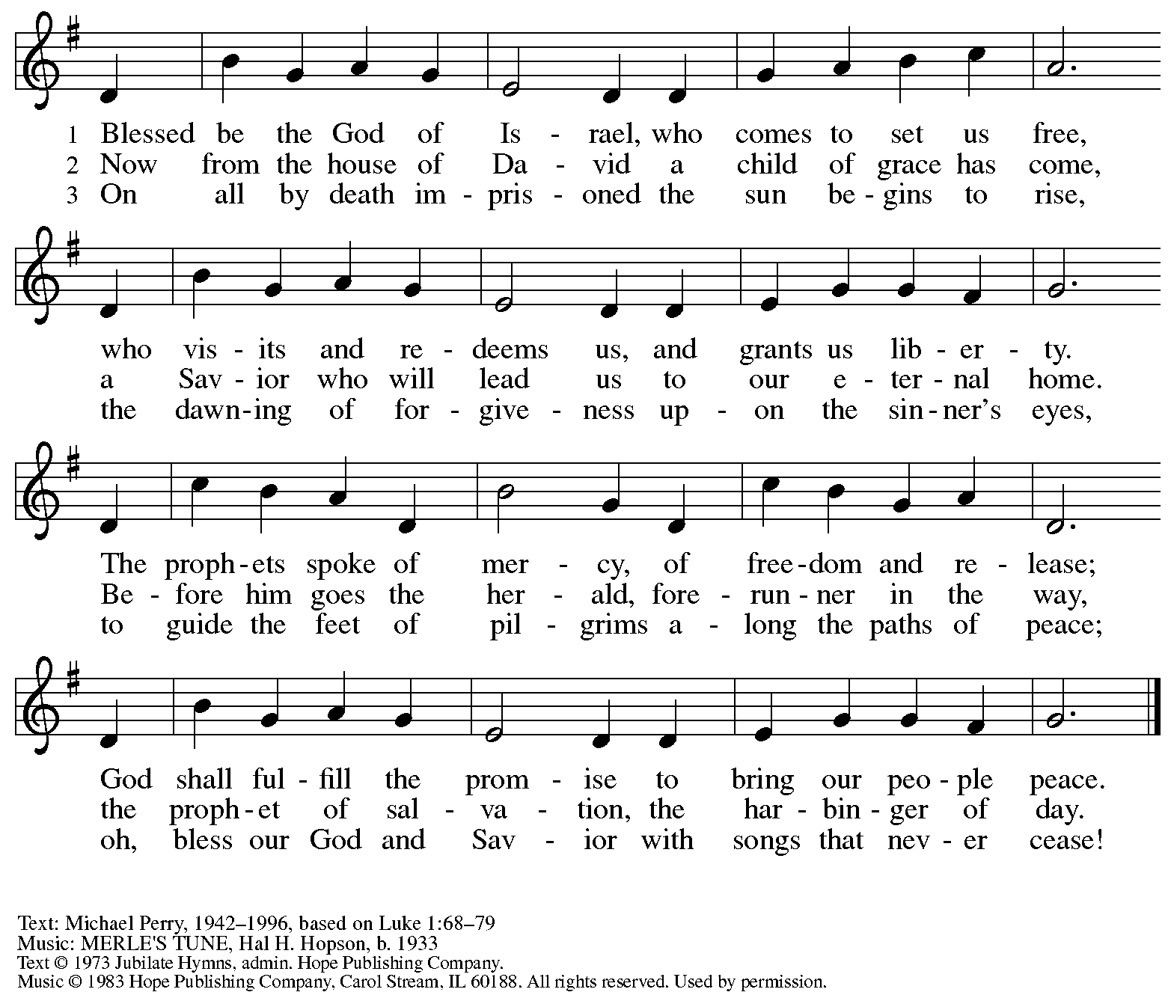

All rights reserved. Reprinted with permission under OneLicense.net # A-722139.

**Greeting**

P: The grace of our Lord Jesus Christ, the love of God,

and the communion of the Holy Spirit be with you all.

**C: And also with you.**

**Kyrie *ELW*** **152**

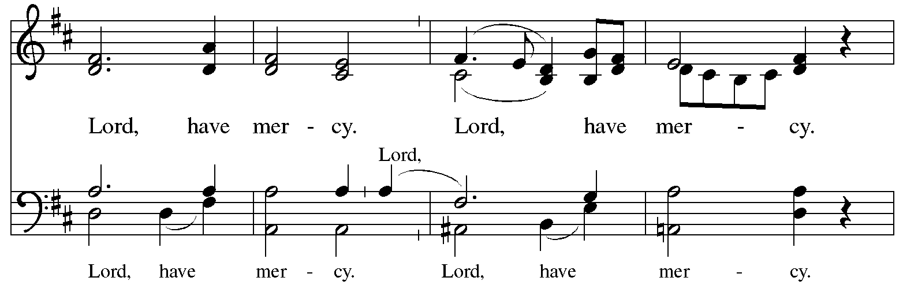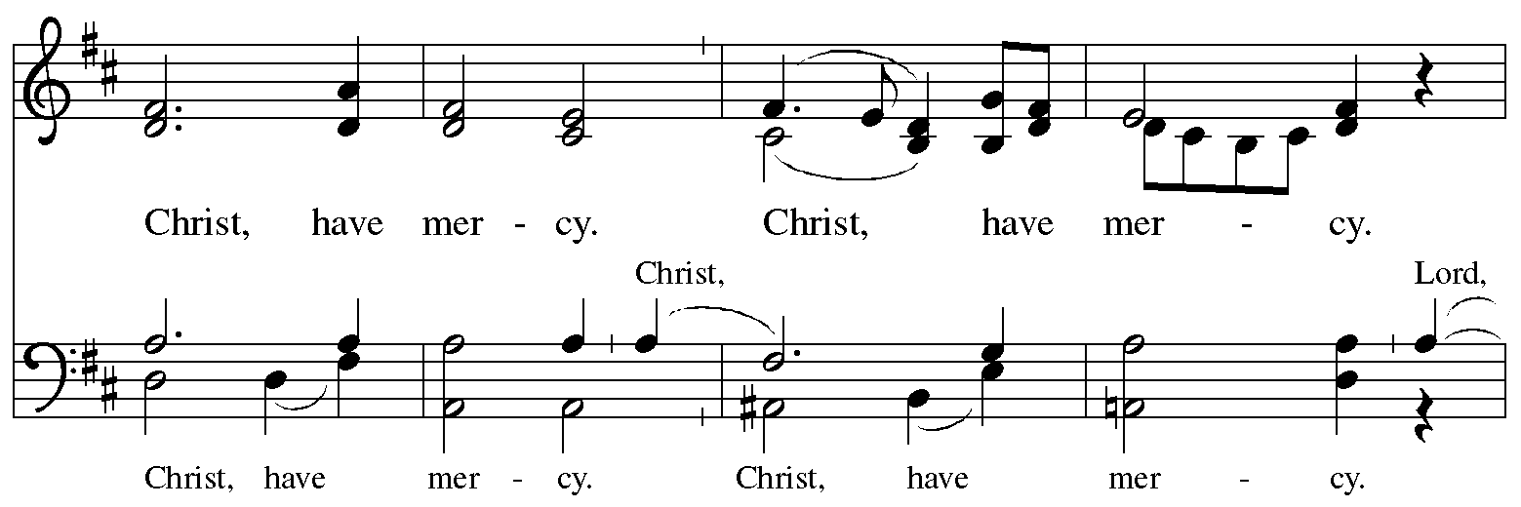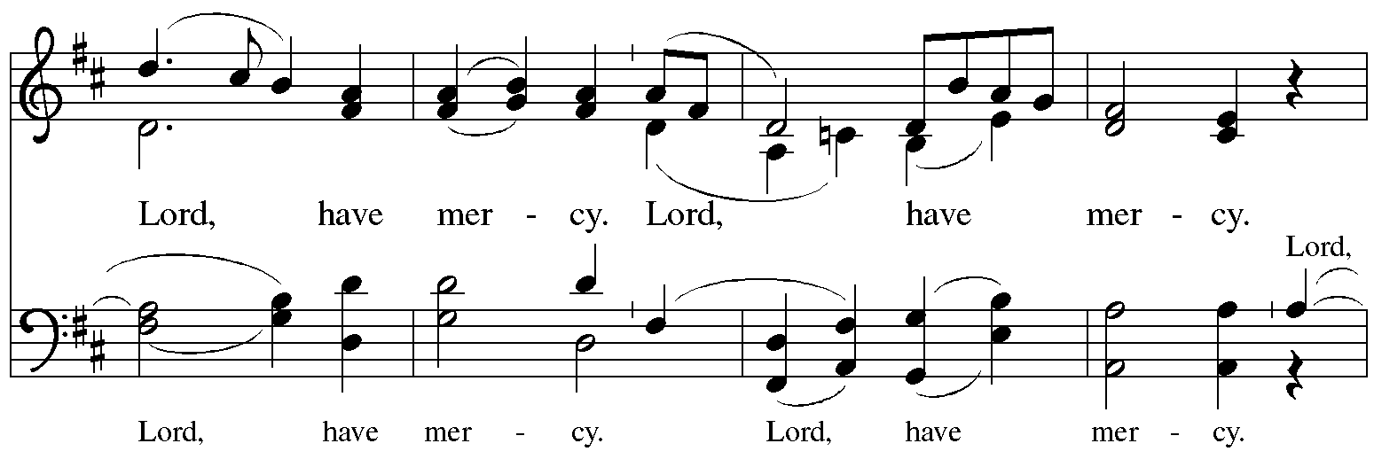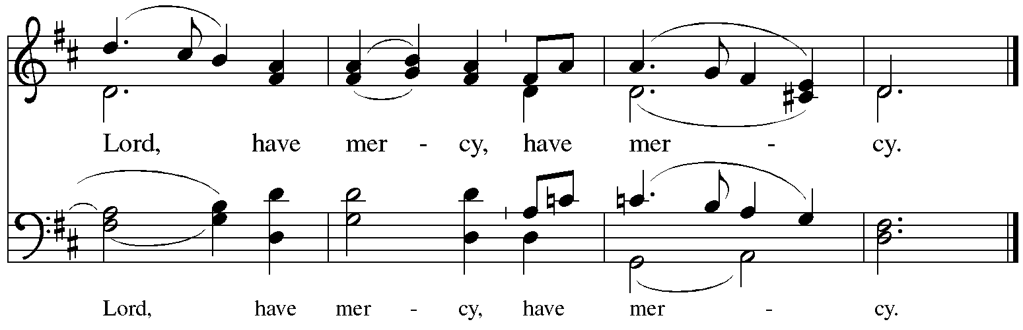

**Prayer of the Day**

P: The Lord be with you.

**C: And also with you.**

P: Let us pray.

God of the covenant, in the mystery of the cross you promise everlasting life to the world.

Gather all peoples into your arms, and shelter us with your mercy,

that we may rejoice in the life we share in your Son, Jesus Christ, our Savior and Lord,

who lives and reigns with you and the Holy Spirit, one God, now and forever.

**C: Amen.**

*Please be seated.*

*Children are invited to join the adult leader(s) at the side door for Little Church – Big Faith.*

*We ask that an additional adult from the congregation attend with the children.*

**Word**

*God speaks to us in Scripture reading, preaching, and song*

**First Reading** **– Genesis 15: 1-12, 17-18**

1 After these things the word of the Lord came to Abram in a vision, “Do not be afraid, Abram, I am your shield; your reward shall be very great.” 2 But Abram said, “O Lord God, what will you give me, for I continue childless, and the heir of my house is Eliezer of Damascus?” 3 And Abram said, “You have given me no offspring, so a slave born in my house is to be my heir.”

4 But the word of the Lord came to him, “This man shall not be your heir; no one but your very own issue shall be your heir.” 5 The Lord brought him outside and said, “Look toward heaven and count the stars, if you are able to count them.” Then God said to him, “So shall your descendants be.” 6 And he believed the Lord; and the Lord reckoned it to him as righteousness.  
  7 Then God said to him, “I am the Lord who brought you from Ur of the Chaldeans, to give you this land to possess.” 8 But he said, “O Lord God, how am I to know that I shall possess it?”

9 God said to him, “Bring me a heifer three years old, a female goat three years old, a ram three years old, a turtledove, and a young pigeon.” 10 He brought God all these and cut them in two, laying each half over against the other; but he did not cut the birds in two. 11 And when birds of prey came down on the carcasses, Abram drove them away.  
  12 As the sun was going down, a deep sleep fell upon Abram, and a deep and terrifying darkness descended upon him.  
  17 When the sun had gone down and it was dark, a smoking fire pot and a flaming torch passed between these pieces. 18 On that day the Lord made a covenant with Abram, saying, “To your descendants I give this land, from the river of Egypt to the great river, the river Euphrates.”

L: Word of God, word of life.

**C: Thanks be to God.**

**Psalm 27**

*The cantor will lead the singing of the psalm.*

*The congregation is invited to respond with the alternate verses in bold print,*

*and to join in singing the refrain.*

*Psalm Tone*

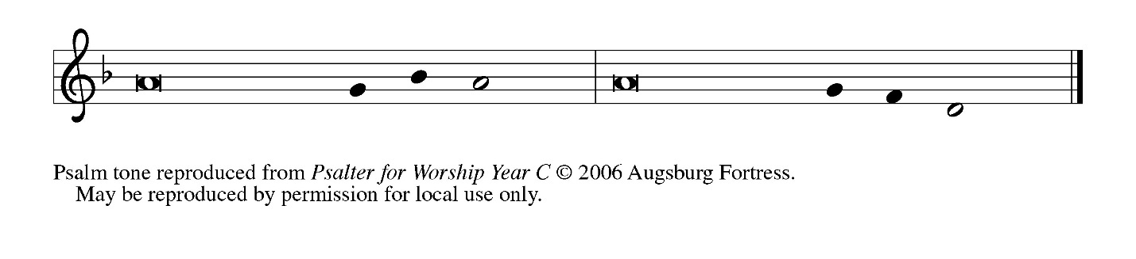

*Psalm Refrain*

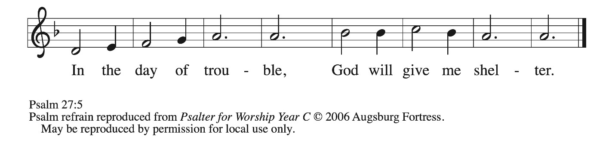

1 The Lord is my light and my salvation; whom then **|** shall I fear?  
  The Lord is the stronghold of my life; of whom shall I **|** be afraid?  
 2 **When evildoers close in against me to de- | vour my flesh,**  
  **they, my foes and my enemies, will stum- | ble and fall.**  
 3 Though an army encamp against me, my heart **|** will not fear.  
  Though war rise up against me, my trust will **|** not be shaken.  
 4 **One thing I ask of the Lord; one | thing I seek;**  
  **that I may dwell in the house of the Lord all the days of my life; to gaze upon the beauty of the Lord and to seek God | in the temple. R**  
 5 For in the day of trouble God will **|** give me shelter,  
  hide me in the hidden places of the sanctuary, and raise me high up- **|** on a rock.  
 6 **Even now my head is lifted up above my enemies | who surround me.**  
  **Therefore I will offer sacrifice in the sanctuary, sacrifices of rejoicing; I will sing and make music | to the Lord.**  
 7 Hear my voice, O Lord, **|** when I call;  
  have mercy on me and **|** answer me.  
 8 **My heart speaks your message— | “Seek my face.”**  
  **Your face, O Lord, | I will seek. R**  
 9 Hide not your face from me, turn not away from your ser- **|** vant in anger.  
  Cast me not away—you have been my helper; forsake me not, O God of **|** my salvation.  
 10 **Though my father and my moth- | er forsake me,**  
  **the Lord will | take me in.**  
 11 Teach me your **|** way, O Lord;  
  lead me on a level path, because of **|** my oppressors.  
 12 **Subject me not to the will | of my foes,**  
  **for they rise up against me, false witnesses | breathing violence.**  
 13 This I believe—that I will see the goodness **|** of the Lord  
  in the land **|** of the living!  
 14 **Wait for the Lord | and be strong.**  
  **Take heart and wait | for the Lord! R**

**Second Reading – Philippians 3: 17 – 4: 1**

17Kindred, join in imitating me, and observe those who live according to the example you have in us. 18 For many live as enemies of the cross of Christ; I have often told you of them, and now I tell you even with tears. 19 Their end is destruction; their god is the belly; and their glory is in their shame; their minds are set on earthly things. 20 But our citizenship is in heaven, and it is from there that we are expecting a Savior, the Lord Jesus Christ. 21 He will transform the body of our humiliation that it may be conformed to the body of his glory, by the power that also enables him to make all things subject to himself. 4:1 Therefore, my kindred, whom I love and long for, my joy and crown, stand firm in the Lord in this way, my beloved.

L: Word of God, word of life.

**C: Thanks be to God.**

*Please rise as you are able and join in singing the Gospel Acclamation.*



**Gospel Acclamation** *ELW* p. 189

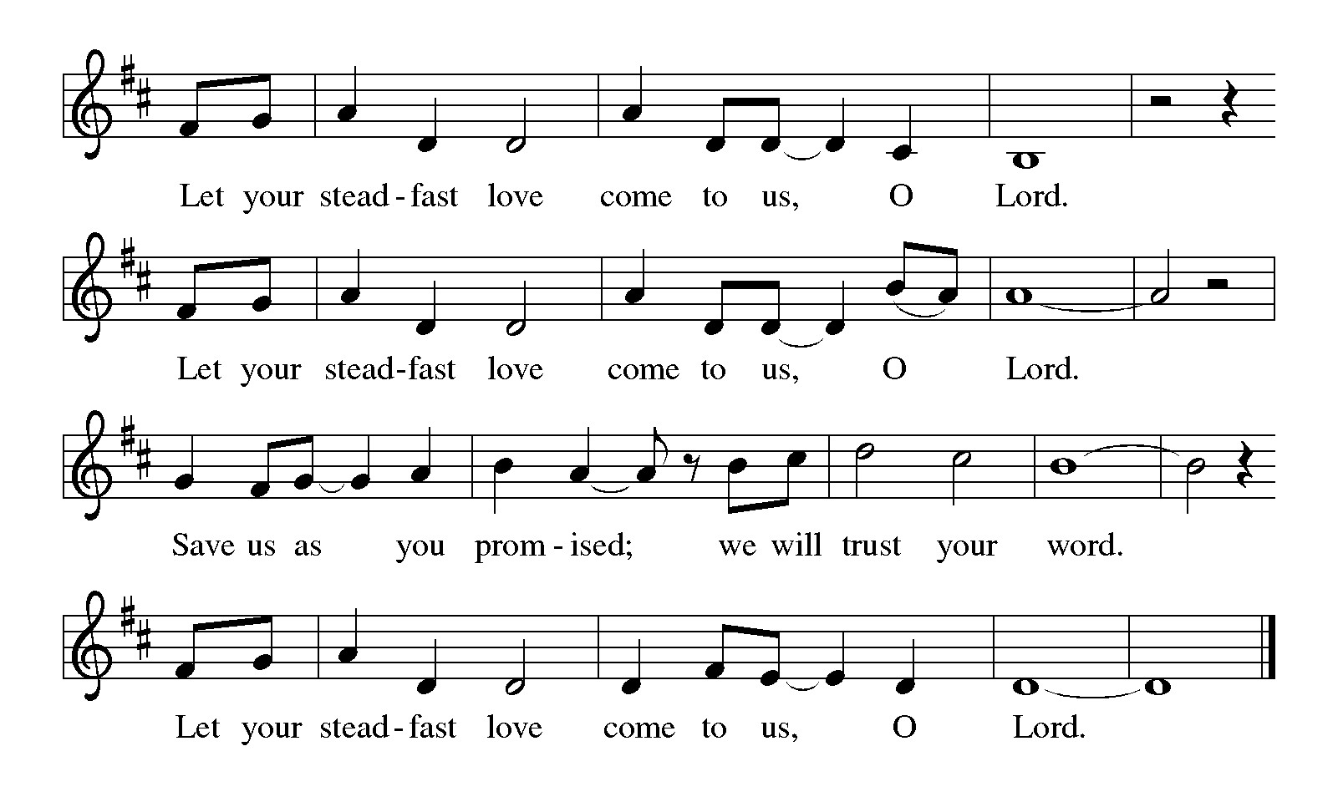

**Gospel – Luke 13: 31-35**

P: The holy Gospel according to St. Luke.

**C: Glory to you, O Lord.**

31 At that very hour some Pharisees came and said to [Jesus,] “Get away from here, for Herod wants to kill you.” 32 He said to them, “Go and tell that fox for me, ‘Listen, I am casting out demons and performing cures today and tomorrow, and on the third day I finish my work. 33 Yet today, tomorrow, and the next day I must be on my way, because it is impossible for a prophet to be killed outside of Jerusalem.’ 34 Jerusalem, Jerusalem, the city that kills the prophets and stones those who are sent to it! How often have I desired to gather your children together as a hen gathers her brood under her wings, and you were not willing! 35 See, your house is left to you. And I tell you, you will not see me until the time comes when you say, ‘Blessed is the one who comes in the name of the Lord.’ ”

P: The Gospel of the Lord.

**C: Praise to you, O Christ.**

*Please be seated.*

**Sermon**

*A time of silence for prayer and reflection follows the sermon.*

*As the hymn of the day begins, please rise as you are able.*

**Hymn of the Day All Who Love and Serve Your City *ELW* 724**

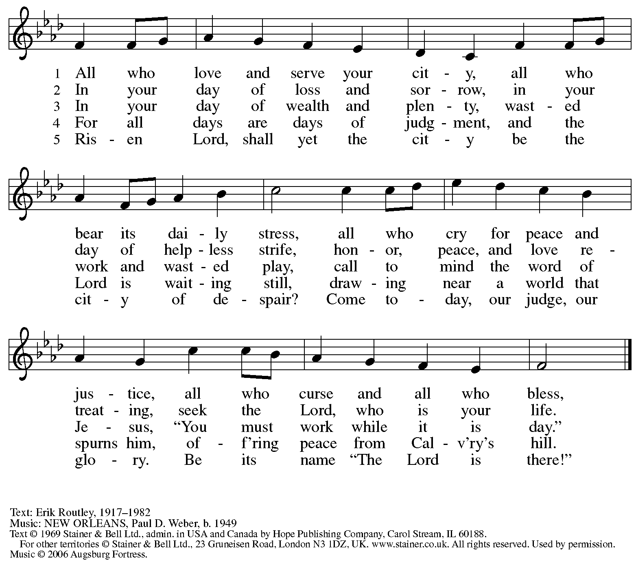

All rights reserved. Reprinted with permission under OneLicense.net # A-722139.

**Apostles’ Creed**

**C: I believe in God, the Father almighty,**

**creator of heaven and earth.**

**C: I believe in Jesus Christ, God’s only Son, our Lord,**

**who was conceived by the Holy Spirit,**

**born of the virgin Mary,**

**suffered under Pontius Pilate,**

**was crucified, died, and was buried;**

**he descended to the dead.\***

**On the third day he rose again;**

**he ascended into heaven,**

**he is seated at the right hand of the Father,**

**and he will come to judge the living and the dead.**

**I believe in the Holy Spirit,**

**the holy catholic church,**

**the communion of saints,**

**the forgiveness of sins,**

**the resurrection of the body,**

**and the life everlasting. Amen.**

*Or, “he descended into hell,” another translation of this text in widespread use.

**Prayers of the People**

A: Led by the Spirit, let us turn to God in prayer for the church, those in need,

and all God’s creation.

*After each petition*

A: Merciful God,

**C: receive our prayer.**

*The presiding minister concludes the prayers*

P: Receive the prayers of your people, O God, and draw all things together in your love,

in the name of Jesus, who leads us from death to life.

**C: Amen.**

**Peace**

*The presiding minister and the assembly greet one another in the peace of the risen Christ.*

P: The peace of Christ be with you always.

**C: And also with you.**

*The people may greet those around them with a sign of Christ’s peace and may say*

Peace be with you *or similar words. Please be mindful that not everyone will be comfortable with sharing the peace, so please seek consent before shaking hands or hugging. Other possible ways to share the peace include a simple bow with the verbal greeting of peace, or simply a verbal expression of peace. When the greetings of peace have concluded, please be seated.*

**Meal**

*God feeds us with the presence of Jesus Christ*

**Offering**

*We offer ourselves, our gifts, and our faithful service to God.* *As the offering is gathered for the mission of the church, including the care of those in need, the table is set for Holy Communion.*

**Quiet (Noisy) Offering**

*The monthly Noisy Offering becomes the Quiet Offering in the reserved season of Lent.*

*As children of the congregation carry buckets around the sanctuary, people of the congregation are invited to throw in their change as an offering. This month’s offering will support Casa San Jose, an organization proving support and services for immigrants and refugees in Pittsburgh.*

**Music during the Offering**

*The Old Rugged Cross* arr. Brent Edstrom

*As the gifts are brought forward for presentation,* *please rise as you are able.*

**Offertory Song Create in Me a Clean Heart *ELW* 188**

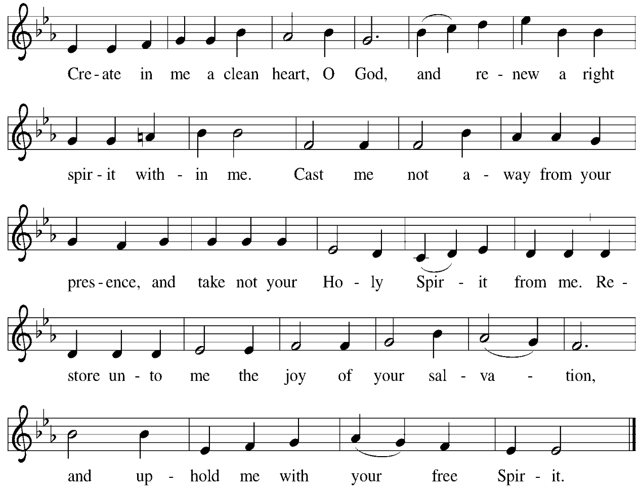

**Offertory Prayer**

A: Let us pray.

God our provider,

**C:** **you have not fed us with bread alone, but with words of grace and life.**

**Bless us and these your gifts, which we receive from your bounty,**

**through Jesus Christ our Lord. Amen.**

**Dialogue**

P: The Lord be with you.

**C: And also with you.**

P: Lift up your hearts.

**C: We lift them to the Lord.**

P: Let us give thanks to the Lord our God.

**C: It is right to give our thanks and praise.**

**Preface**

P: It is indeed right, our duty and our joy,

that we should at all times and in all places

give thanks and praise to you, almighty and merciful God,

through our Savior Jesus Christ;

You call your people to cleanse their hearts

and prepare with joy for the paschal feast,

that, renewed in the gift of baptism,

we may come to the fullness of your grace.

And so, with all the choirs of angels,

with the church on earth and the hosts of heaven,

we praise your name and join their unending hymn:

**Sanctus** *ELW* p. 190

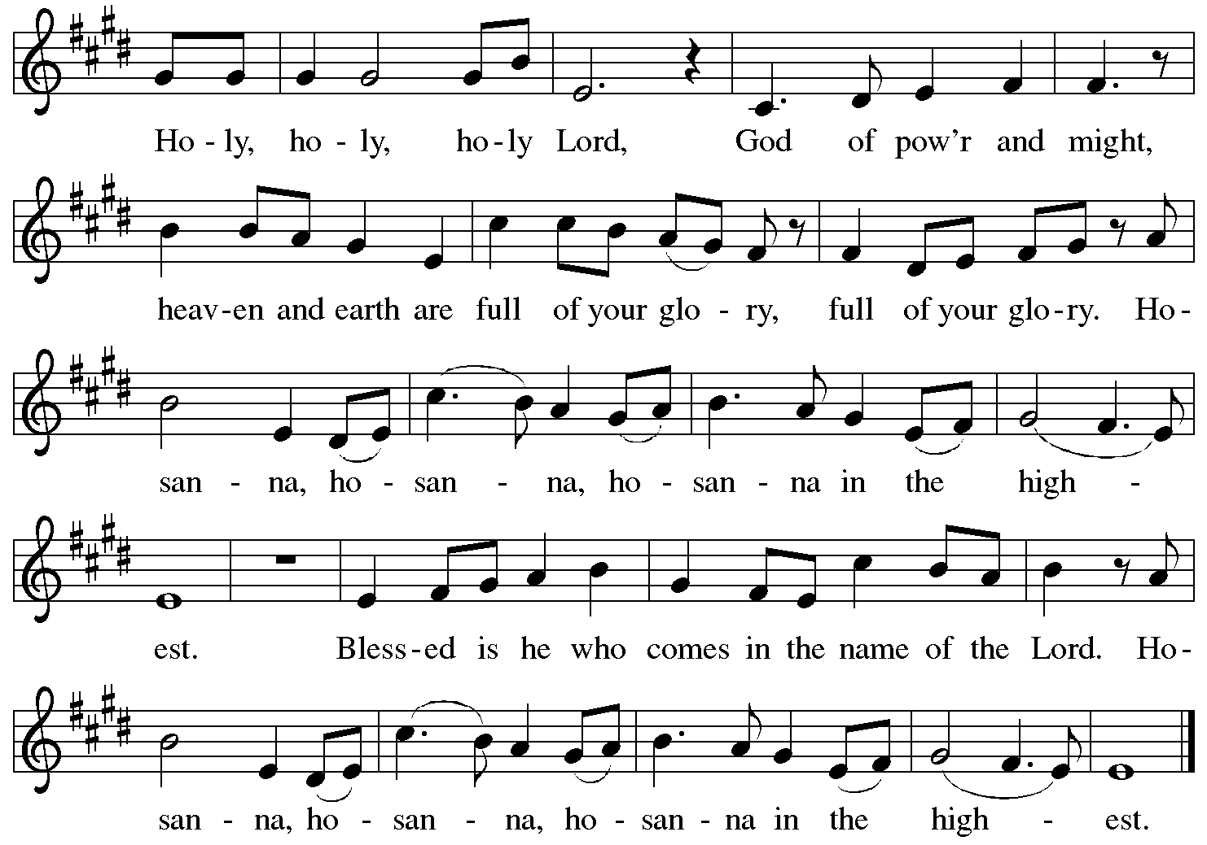

**Eucharistic Prayer**

P: Blessed are you, O God, of the universe … Do this for the remembrance of me.

With this bread and cup we remember our Lord’s Passover from death to life

as we proclaim the mystery of faith:

**C: Christ has died. Christ is risen. Christ will come again.**

P: O God of resurrection and new life … Grace our table with your presence.

**C: Come, Holy Spirit.**

P: Reveal yourself through the breaking of the bread … justice, peace, and love.

**C: Come, Holy Spirit.**

P: With your holy ones of all times and places …

… blessed and Holy Trinity, now and forever.

**C: Amen.**

**Lord’s Prayer**

P: Gathered as one by the Holy Spirit, let us pray as Jesus taught us.

**C: Our Father in heaven,**

**hallowed be your name,**

**your kingdom come,**

**your will be done,**

**on earth as in heaven.**

**Give us today our daily bread.**

**Forgive us our sins**

**as we forgive those**

**who sin against us.**

**Save us from the time of trial**

**and deliver us from evil.**

**For the kingdom, the power,**

**and the glory are yours,**

**now and forever. Amen.**

**Fraction and Invitation**

P: All who are hungry, come.

The feast of grace is ready.

***Agnus Dei /* Lamb of God** *ELW* p. 191

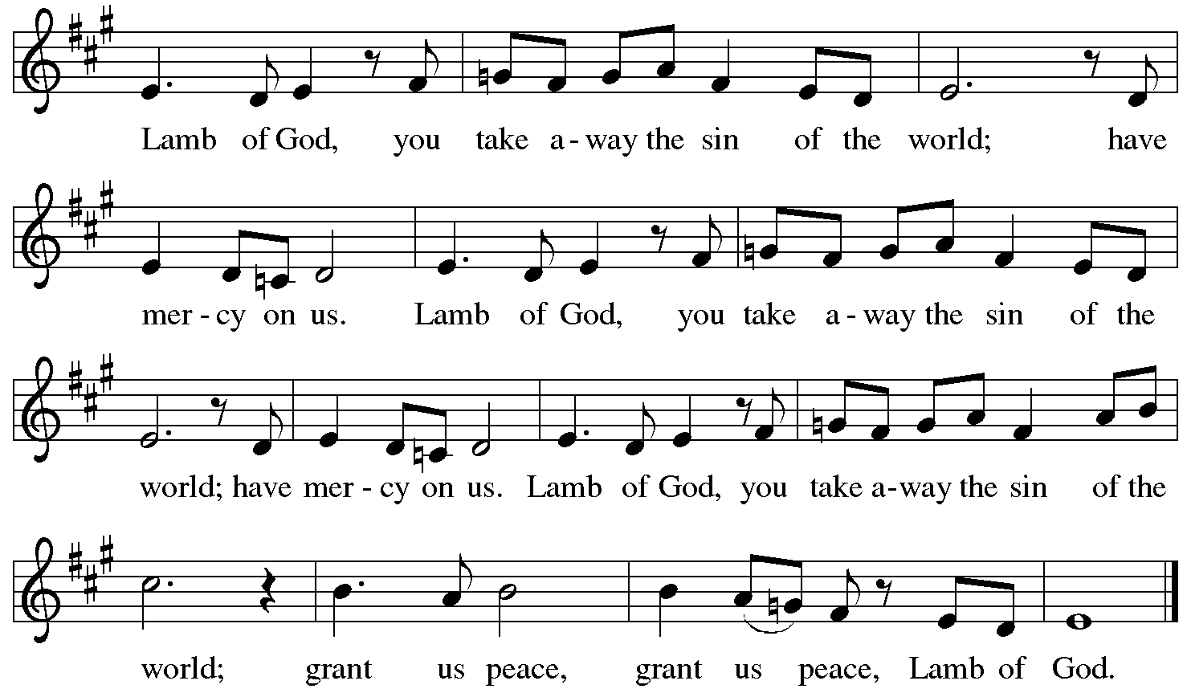

**

*Please be seated.*

**Holy Communion**

* *All who seek God and desire a deeper and stronger life in Christ are welcome to receive Holy Communion.*
* *Worshipers from the pulpit side will proceed forward first, followed by the center section, and then the lectern side.*
* *Please inform an usher if you would like the ministers to bring Communion to you.*
* *Holy Communion will be served with bread and wine (red) or grape juice (white).*
* *The presiding minister will first distribute the bread (host) to each communicant. Please indicate if you require a gluten-free host.*
* *Once you have consumed the bread, please pick up an empty glass from the tray next to the presiding minister. The Communion Assistant will pour wine from the chalice or grape juice from the cruet into your glass.*
* *Please step to the side to consume the wine or grape juice.*
* *Feel free to kneel at the altar rail for prayer after receiving the sacrament.*
* *As you return to your pew, glasses may be returned to the empty trays on the side of the center section.*
* *A blessing will be provided for anyone who does not yet receive the sacrament.*
* *All are invited to join in singing the hymns during Holy Communion.*

**Hymns during Holy Communion**

**The God of Abraham Praise *ELW* 831**

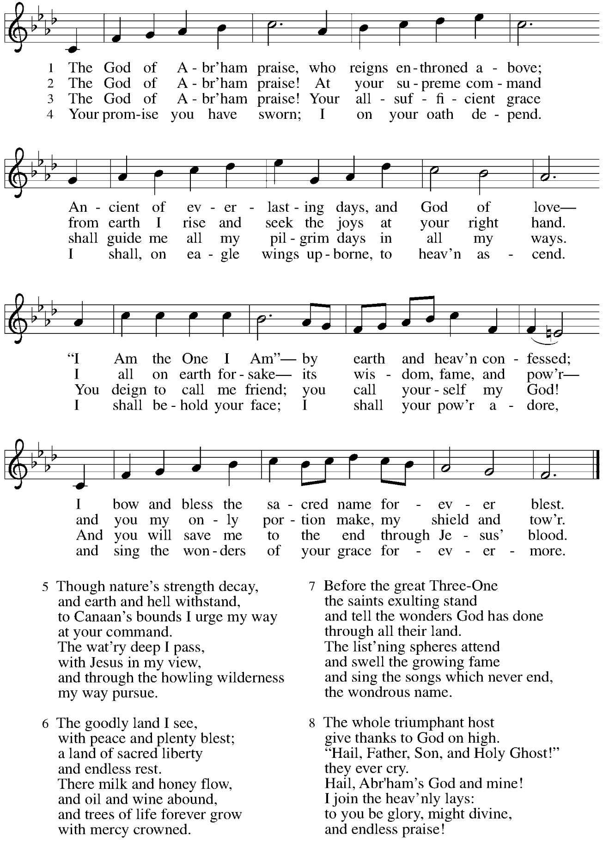

**Hymns during Holy Communion**

**Around You, O Lord Jesus *ELW* 468**

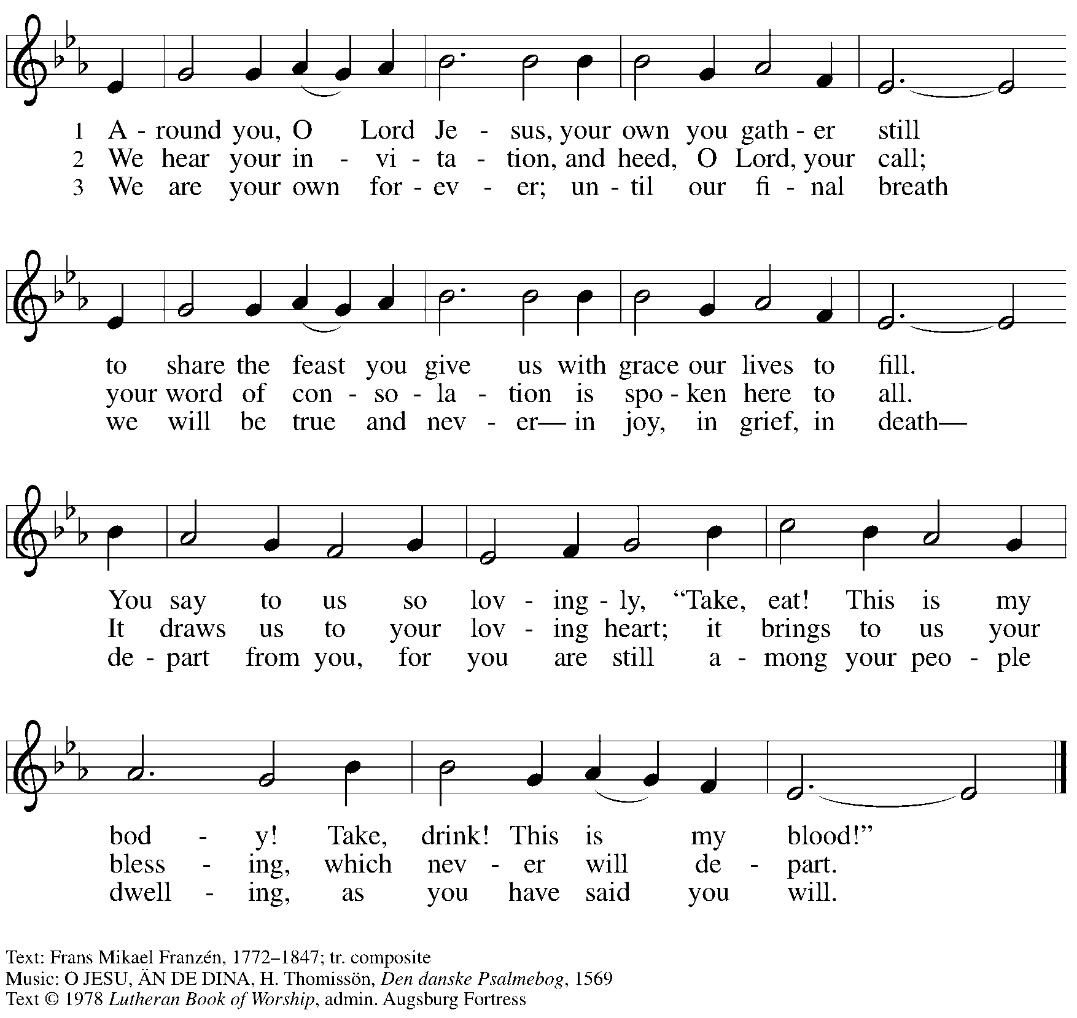

All rights reserved. Reprinted with permission under OneLicense.net # A-722139.

**Hymns during Holy Communion**

**As the Sun with Longer Journey *ELW* 329**

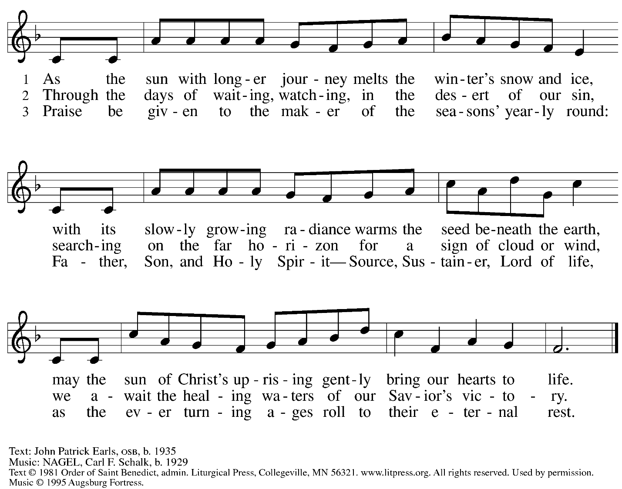

All rights reserved. Reprinted with permission under OneLicense.net # A-722139.

**Hymns during Holy Communion**

**Thy Holy Wings *ELW* 613**

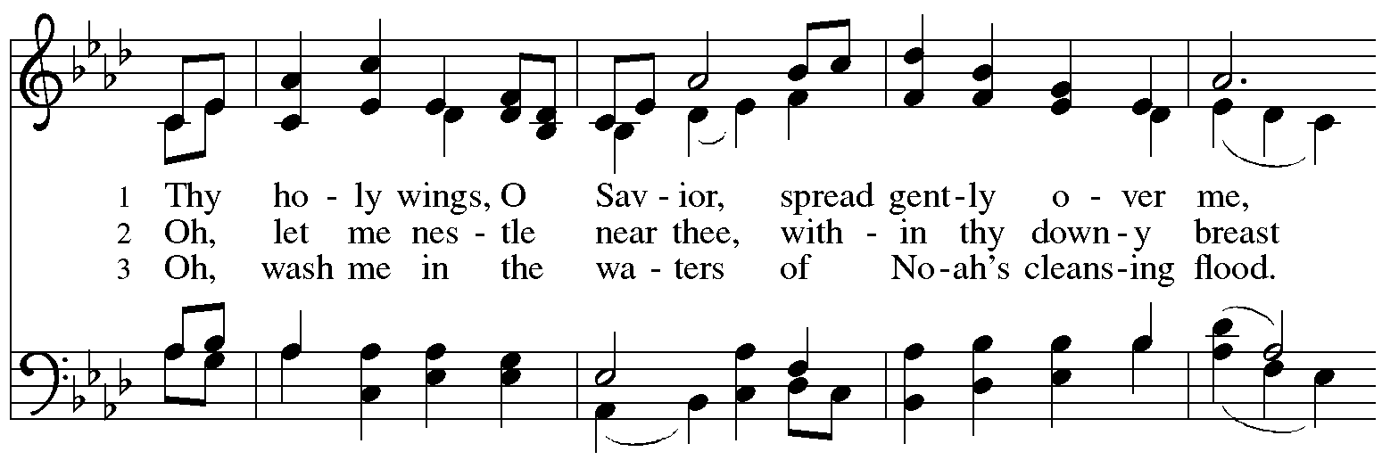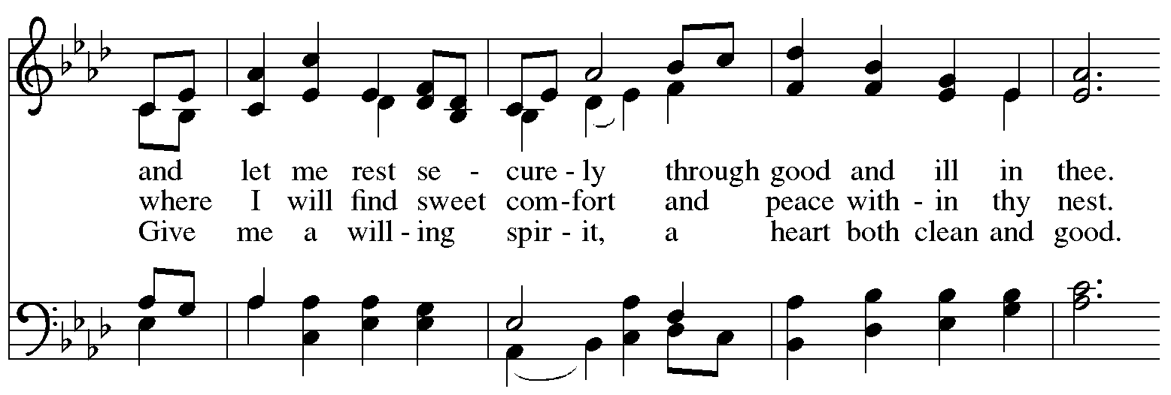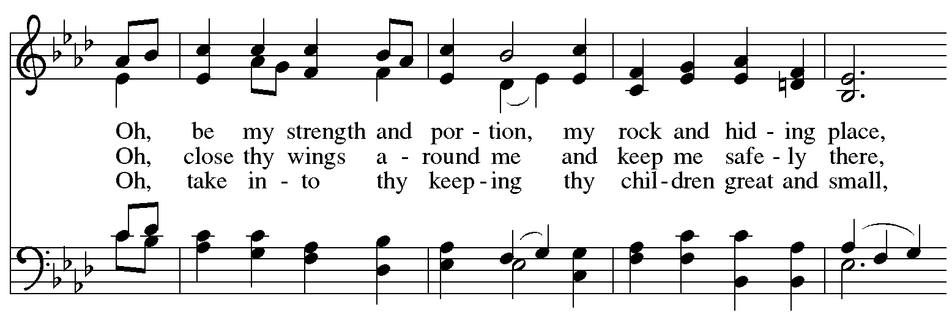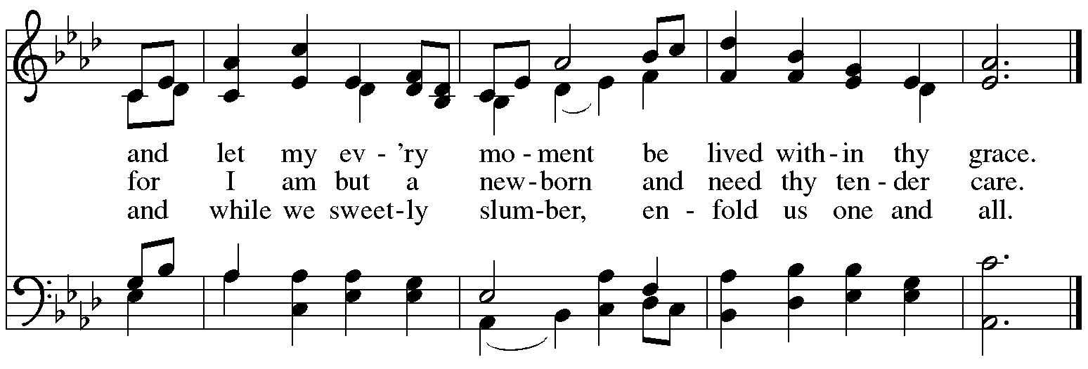

*When all have returned to their places, please rise as you are able.*

**Blessing**

P: The body and blood of our Lord Jesus Christ strengthen you and keep you in his grace.

**C: Amen.**

**Prayer**

A: Let us pray.

Compassionate God, you have fed us with the bread of heaven.

Sustain us in our Lenten pilgrimage:

may our fasting be hunger for justice;

our alms, a making of peace;

and our prayer, the song of grateful hearts,

through Jesus Christ, our Savior and Lord.

**C: Amen.**

*Please be seated.*

**Sending**

*God blesses us and sends us in mission to the world*

**Announcements**

*Please rise as you are able.*

**Benediction**

P: The Lord bless you and keep you.

The Lord’s face shine on you with grace and mercy.

The Lord look upon you with favor and ☩ give you peace.

**C: Amen.**

**Sending Hymn** *Following page*

**Dismissal**

P: Go in peace. Remember those in need.

**C: Thanks be to God!**

**Postlude**

**Sending Hymn Guide My Feet *ACS* 987**

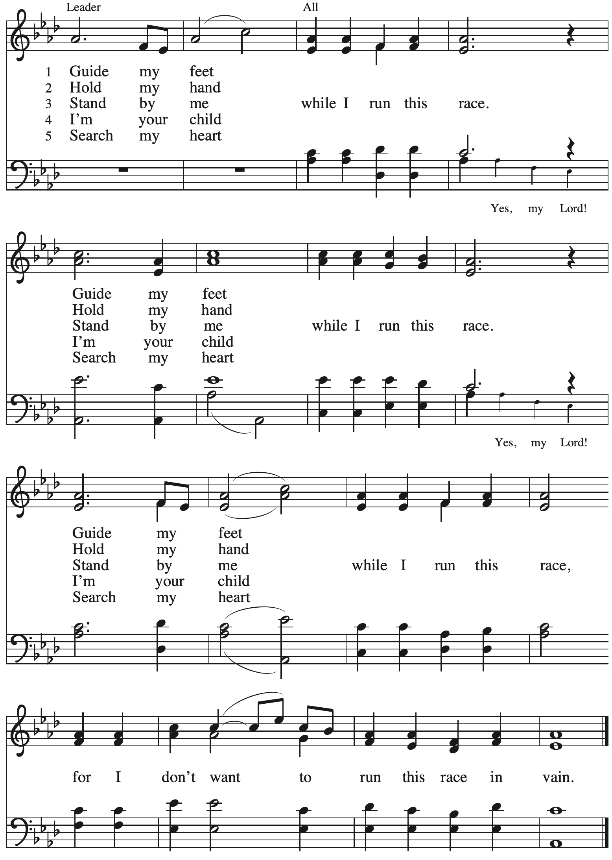

*Those serving in worship*

Altar Care Christy Ruhe

Assisting Minister Jimmi Kocher-Hillmer

Audio-Visual Ministers Joseph Paetz

Sarita

Cantor Timothy Kocher-Hillmer

Lector Lindsay Baxter

Little Church – Big Faith Teacher Emily Duque

Minister of Music Laura Reynolds

Presiding and Preaching Minister The Rev. Ross I. Carmichael

*Liturgy and Hymnody Acknowledgements*

From SundaysandSeasons.com. Copyright © 2025 Augsburg Fortress. All rights reserved. Reprinted under OneLicense.net # A-722139.

Used by permission of Augsburg Fortress.

The Scripture readings contained herein are from *New Revised Standard Version Updated Edition* of the Bible © 2021 National Council of Churches of Christ in the United States of America. Used by permission. All rights reserved worldwide.

**Kyrie** – Text: *Deutsche Messe* Franz Schubert, 1797-1828; adapt. Richard Proulx, b. 1937. Adapt. © 198, 1989 GIA Publications, Inc. 7404 S. Mason Ave., Chicago, IL 60638. [www.giamusic.com](http://www.giamusic.com). 800.442.3358. All rights reserved. Reprinted with permission under OneLicense.net # A-722139.

**Create in Me a Clean Heart** – Music: J. A. Freylinghausen, 1670-1739.

**The God of Abraham Praise** – Text: Thomas Olivers, 1725-1799, alt., based on the Yigdal, c. 14th century. Music: YIGDAL, Jewish melody; arr. Meyer Lyon, 1751-1797.

**Thy Holy Wings** – Text: Carolina Sandell Berg, 1832-1903, sts. 1, 3; Gracia Grindal, b. 1943, st. 2; tr. composite. Music: BRED DINA VIDA VINGAR, Swedish folk tune; arr. hymnal version. Text © 1983 Gracia Grindal, Selah Publishing Co., Inc., agent. [www.selahpub.com](http://www.selahpub.com). Arr. © 2006 Augsburg Fortress. All rights reserved. Reprinted with permission under OneLicense.net # A-722139.

**Guide My Feet** – Text: African American spiritual. Music: GUIDE MY FEET, African American spiritual; arr. *This Far by Faith*. Arr. © 1999 Augsburg Fortress. All rights reserved. Reprinted with permission under OneLicense.net # A-722139.

*Please use the QR code below to link to St. Andrew’s Announcements online!*



**St. Andrew Lutheran Church Announcements**

**March 16th, 2025**

* **Welcome to Worship at St. Andrew on the + Second Sunday in Lent** –We are so glad you are here, and we offer a special welcome to all visitors and guests who are here for the first time! Worship attendees are invited to make a name tag at the back of the worship space. Little Church – Big Faith, a Bible lesson and activity for children, will take place after the prayer of the day. There are worship “toolkits” to help children engage with worship and “busy bags” for younger children available in the bookcase at the back of the sanctuary. Please feel free to take one to use with/for your children. All are invited to gather for coffee, other drinks, food, and conversation in the social hall after worship.
* **“Quiet” (Noisy) Offering during Worship Today – On the third Sunday of each month, the children of St. Andrew lead the congregation in a Noisy Offering. During this more reserved season of Lent it becomes the “Quiet” Offering.** The children carry buckets around the congregation and people are invited to throw in their change, which then gets compiled in big metal buckets to be brought forward as an offering. These gifts support a different ministry or organization every month, and this month’s the offering will benefit Casa San Jose, a resource center primarily serving Pittsburgh’s Latino Community with weekly clinics, food pantries, summer camps, after school programs, and English classes. They are also a member of ISAC (Immigrant Services and Connections), a network of organizations helping refugees and immigrants thrive in Allegheny County. **For more information on their work, please visit** [Casa San Jose](https://www.casasanjose.org/).
* **Meet the Moment Ally Training with Casa San Jose – Today, March 16th, after Worship – In this time when** many are concerned for the well-being of our neighbors, St. Andrew has been preparing for potential assistance for those who are vulnerable and seeking to ensure the sanctity of worship for everyone in the community. Today, after worship, representatives from Casa San Jose will be here to lead the congregation in a Meet the Moment Training, a community-based workshop aimed at equipping individuals with the knowledge and tools to support immigrant families in the Pittsburgh region. These trainings provide practical guidance on how to take immediate action and make a difference in the lives of immigrant communities. Participants learn about critical issues affecting immigrant families and are empowered with resources and strategies to advocate for and assist those in need today. The sessions foster a supportive, hands-on environment to inspire local action and solidarity.
* **Concert Today – Bethel A.M.E Church Hosts The Pittsburgh Chapter of the Gospel Workshop of America, Sunday, March 16th, at 5:00 p.m. – Our friends at Bethel A.M.E. Church (2720 Webster Ave., 15219) will host this concert today at 5:00 p.m. There is no cost of admission – a free will offering will be collected.**
* **Shelter Dinner for Guests of East End Cooperative Ministry, Third Thursday of the Month – March 20th, 6:00 p.m. Arrival, 6:30 p.m. Dinner –** Each month, people of St. Andrew provide dinner for guests of East End Cooperative Ministry (EECM), 6140 Station St. (East Liberty), 15206. We invite you to prepare or purchase one menu item and bring it to the shelter by 6:00 p.m., or just come to help serve at 6:30 p.m. If you would like to contribute, please sign up here:

<https://www.signupgenius.com/go/5080544AAAC22A1F58-55360310-shelter>.

* **Bagged Lunches to Accompany EECM March Shelter Dinner on March 20th – Seeking Additional Donations! – East End Cooperative Ministry is hosting an additional 20 people this winter because of the shelter shortage and we have been asked to bring items for 20 bagged lunches on St. Andrew’s Shelter Dinner night, Thursday, March 20th.** **This month we only need 20 sandwiches and 20 soft fruits (any kind) – we have already received donations for the other items. Shelf-stable items can be left on the donation table in the Social Hall by Sunday, March 16th, or delivered to EECM on Thursday, March 20th. Please label “For EECM Lunches.” Sandwiches should be delivered to EECM any time on the 20th until 6:00 p.m. Please label “For St. Andrew bagged lunches.” Shelter staff will assemble the bagged lunches. Much work goes into shopping for and preparing the main meal each month, so we would greatly appreciate new participants and contributions for this effort! If you would like to help, please sign up at:**

<https://www.signupgenius.com/go/5080544AAAC22A1F58-55354631-baglunches>.

* **Congregational Meeting – Next Sunday, March 23rd, after Worship – Every year in February or March St. Andrew holds a meeting of the congregation. This meeting is an opportunity to review the past year in ministry, receive an update on the congregation’s end-of-year financial status, share updates on current initiatives, and look ahead toward upcoming events. This year’s meeting will be held after worship on Sunday, March 23rd. Representatives from Partners for Sacred Places, with whom we are working on a feasibility study for a capital campaign, will be here over that weekend. No absentee or proxy votes can be accepted so please plan to attend the meeting, in person or via Zoom (same as Sunday worship link).**
* **The Legacy of Dr. Martin Luther King, Jr. – Seeking Justice, Restoring Community Event to Be Held at St. Andrew on Sunday, April 6th, Starting at 3:00 p.m. – Each year, our Southwestern Pennsylvania Synod of the Evangelical Lutheran Church in America (ELCA) has an event honoring the legacy of Dr. Martin Luther King, Jr. This year’s Ecumenical Service of Holy Communion and Call to Anti-racist Action will be at St. Andrew on Sunday, April 6th. The Rev. Dr. Dale B. Snyder of Bethel A.M.E church will be the guest preacher. We** gather to further God's vision for a just world where all are able to thrive, and honor the legacy of Dr. King's vision for a beloved community. Through learning, worship, and conversation, we will learn the harmful legacy of urban renewal in southwestern Pennsylvania and explore how to dismantle harmful assumptions. Together, we will learn how to engage our communities to be rooted in mutuality, repentance, and repair. For more information, visit

[**swpasynod.org/calendar/mlk2025**](https://swpasynod.us19.list-manage.com/track/click?u=a23881a5c641ed10cd7f24da0&id=ad79b25734&e=23a8e9845f). Since we are hosting this event on behalf of the larger church, we would appreciate help with hospitality and worship that day. Please speak with Pat Lutz or Kelly Spanninger if you can assist with hospitality and with Pastor Ross or Minister of Music Laura to help with worship.

* **Invitation to Pre-Service Music –** The people of St Andrew are gifted in so many ways.  We have much to be grateful for. Come share or experience the musical talents of our family on Sunday mornings. Arrive in-person 10 minutes before the service to rest in the sounds of musical offerings from musicians. If you sing or play an instrument, please consider sharing your gifts. Contact [timothy@touchwholeness.com](mailto:timothy@touchwholeness.com).

* **Lenten Food Drive for St. Andrew’s Pantry** – One of the spiritual disciplines of the season of Lent is almsgiving – generous giving on behalf of neighbors in need. In the spirit of Lent, we are inviting people of the congregation to donate nonperishable food items to help replenish the congregation’s outdoor pantry. **Suggested items include**: Packs of chicken, tuna, or pork (any flavor); cans of Vienna sausage, potted meat, spam; cans of beef stew, beefaroni, ravioli; boxes of macaroni and cheese, stuffing, or mashed potatoes; cups of applesauce – any flavor; granola bars, rice Krispie treat bars; boxes of cookies or crackers; small bags or boxes of cereal – any kind; shelf stable milk; case of water; cans of vegetables and fruits. All canned items must have a pull tab to open.Items may be placed on the donation table in the social hall throughout the season of Lent.
* ***Life Renewed: Devotions for Lent 2025* Available at Church Entrances** – Another of the spiritual disciplines for the season of Lent is prayer, so each year, the worship committee provides copies of a daily devotional booklet. This year’s is titled *Life Renewed*, and it contains a brief scripture reading, reflection/quote, and prayer for each day from Ash Wednesday (March 5th) to the Vigil of Easter (April 19th). They are now available at the entrances to the building – please take one to aid in your devotions this Lent!
* ***Christ in Our Home* Devotional Booklets for April – June Now Available at Church Entrances** – This resource offers a daily Bible reading with a short reflection and prayer, along with additional readings and prayer topics for those who would like to expand their devotional practices. We encourage people of the congregation to take one for yourself, your family/household, or others!
* **Prayer Service with the Pittsburgh Compline Choir – Sundays at 8:00 p.m. at Heinz Chapel –** Compline was traditionally a monastic prayer service, and the Pittsburgh Compline Choir, a ministry of Lutheran Campus Ministry in Greater Pittsburgh, sings a choral version of compline rooted in this thousand-year-old tradition of scripture, song, and silence each Sunday at Heinz Chapel at 8:00 p.m. This service also streams on Facebook (Pittsburgh Compline Choir) and YouTube (The Pittsburgh Compline Choir). Heinz Chapel is located off of S. Bellefield Ave. in Oakland. For more information, please visit: [Pittsburgh Compline Choir](http://pittsburghcomplinechoir.org/).

**Flowers for Easter**

*St. Andrew will be ordering Lilies (6 inch, five bloom - $8.00 each)*

*Tulips (8 inch - $9.00 each))*

*Daffodils (6 inch - $5.25 each)*

*to decorate the worship space for Easter Sunday, April 20th,*

*and the Easter season.*

*If you would like to sponsor and dedicate flowers, please order using this form.*

Order by: Sunday, April 13th

*Orders may be submitted at the desk in the main office*

*or through the Sunday offering plates.*

*Please submit payment with order - Checks may be made payable to*:

St. Andrew Lutheran Church

Name __________________________________________

In Honor of __________________________________________

In Memory of __________________________________________

In Appreciation/Love for __________________________________________

Number of Lilies ________

Number of Tulips ________

Number of Daffodils ________