

**+ First Sunday in Lent**

**March 9th, 2025**

**10:00 a.m.**



**St. Andrew Lutheran Church**

**304 Morewood Ave.**

**Pittsburgh, PA 15213**

**412.682.3342**

[**St_andrewELCA@verizon.net**](mailto:St_andrewELCA@verizon.net)

[**www.standrewpittsburgh.org**](http://www.standrewpittsburgh.org)

**+ First Sunday in Lent**

**Order for Worship**

*The forty days called Lent offer an opportunity to return to the God who rescues, to receive the gifts of God’s grace, to believe with the heart and confess with the mouth the wonder of God’s love in Jesus, and to resist temptation at every turn. This is no small pilgrimage on which we have just embarked. It is a struggle Jesus knew. It is a struggle Jesus shares. The nearness of the Lord, in bread and wine, water and word, will uphold and sustain us.*

**Welcome to St. Andrew!**

* St. Andrew welcomes all who are seeking a place of healing, wholeness, and acceptance in a nurturing and faith-forming spiritual home. We are striving toward racial equity worldwide

and we seek to honor the lived experience of all individuals regardless of background. Our community embraces people of all ages, ethnicities, cultures, abilities, sexual orientations,

gender identities and expressions, and family constellations. Come and See!

* Worship Services are live-streamed to multiple online platforms. By attending worship, you agree that your image and voice may be broadcast.
* Everyone is invited to make a name tag at the black bookcase in the back of the worship space if they would like. There are stickers indicating pronouns on the bookcase if you would like to include them on your name tag.
* Children are invited to attend Little Church – Big Faith, a Bible lesson and activity, during worship (after the Prayer of the Day). The group returns to the worship space for the liturgy of Holy Communion.
* A nursery is available through the doors at the left side of the sanctuary and across from the doorway to the Social Hall. Look for a purple-colored room.
* Worship “toolkits” to help children engage with the service, along with “busy bags” for younger children, are available in the bookcase at the back of the sanctuary. Please feel free to take one to use with/for your children.
* Holy Communion is served with bread (gluten-free available) and wine or grape juice. The presiding minister will distribute the bread (host). Please consume this and then pick up an empty glass from the tray. The Communion Assistant will pour wine or grape juice into your glass. Please step to the side to consume the wine or grape juice. Feel free to kneel at the altar for prayer and reflection. As you return to your pew, glasses may be returned to the empty trays on either side of the center section.
* A restroom is available on the main level of the church, through the doors to the Social Hall and to the right in the main office.

*Abbreviations*

P: Pastor/Presiding Minister ***ELW*: *Evangelical Lutheran Worship* hymnal**

A: Assisting Minister ***ACS*: *All Creation Sings* hymnal**

L: Lector

**C: Congregation**

**Pre-Service Music** Matthew Tesch

**Welcome**

**Prelude** *You Gave Me Life* Timothy Kocher-Hillmer

Sung by Marit Bakken and Jered Stratton

Emily Duque

Timothy Kocher-Hillmer

**Gathering**

*The Holy Spirit calls us together as the people of God*

**Confession**

*Please rise as you are able. All may make the sign of the cross,*

*the sign that is marked at Baptism, as the presiding minister begins.*

P: Blessed be the holy Trinity, ☩ one God,

who forgives all our sin,

whose mercy endures forever.

**C: Amen.**

P: Let us return to God, confessing our sin in the assurance of God’s abiding love.

*Silence is kept for reflection.*

P: Compassionate One,

**you are slow to anger and abounding in steadfast love,**

**but our lives do not always reflect you** **and your love for the world.**

**We do not show others the tender compassion** **you have shown to us.**

**We do not welcome others with the hospitality** **you grant to all people.**

**We oppress others,** **even though you have set us free again and again.**

**We squander the abundant gifts of the earth.**

**Transform our lives** **and guide us again in the way of the cross.**

**Amen.**

P: Beloved in Christ,

God’s arms are always stretched open wide

to welcome the wandering ones home.

In ☩ Christ your sins are forgiven.

You have a place in God’s house forever.

**C: Amen.**

**Gathering Hymn O Lord, throughout These Forty Days *ELW* 319**

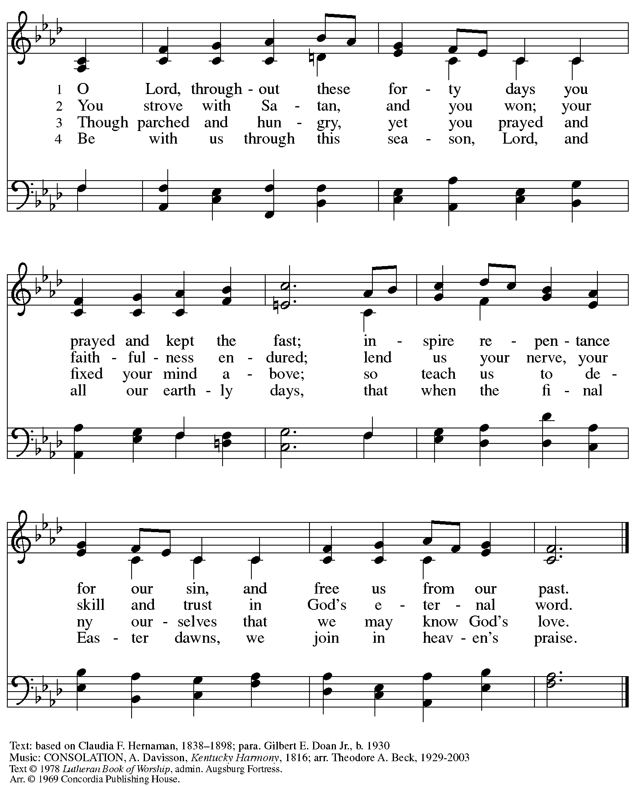

All rights reserved. Reprinted with permission under OneLicense.net # A-722139.

**Greeting**

P: The grace of our Lord Jesus Christ, the love of God,

and the communion of the Holy Spirit be with you all.

**C: And also with you.**

**Kyrie *ELW*** **152**

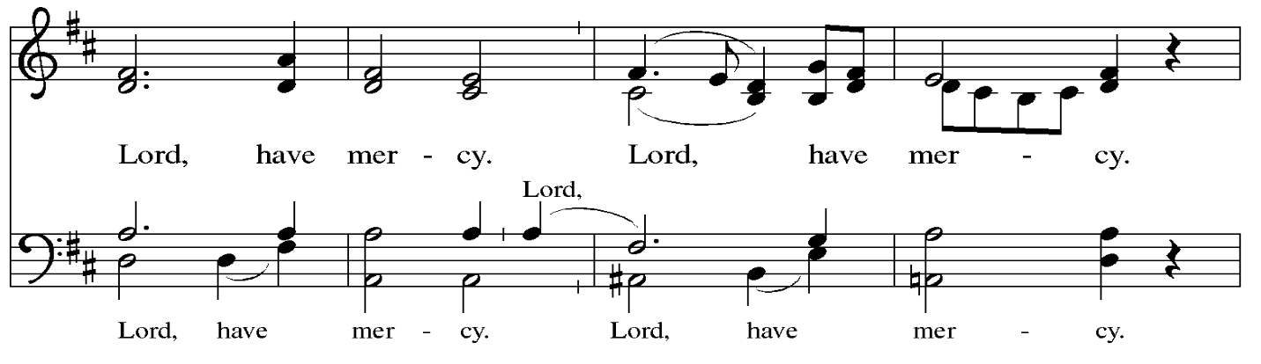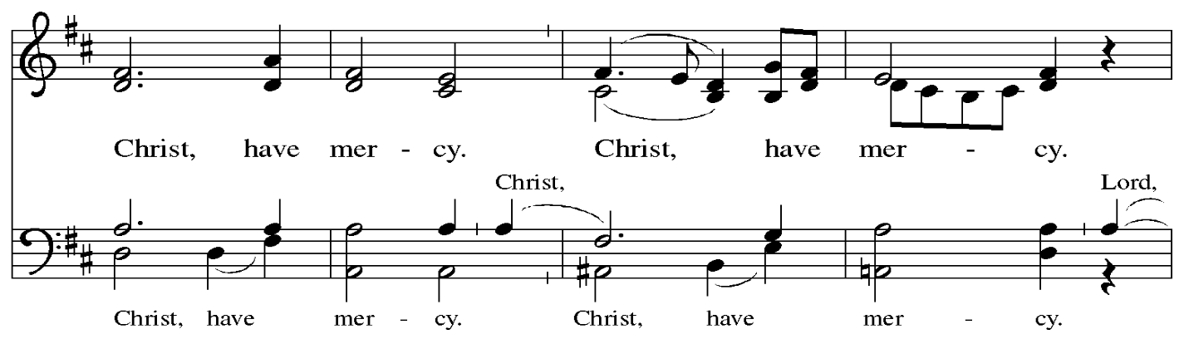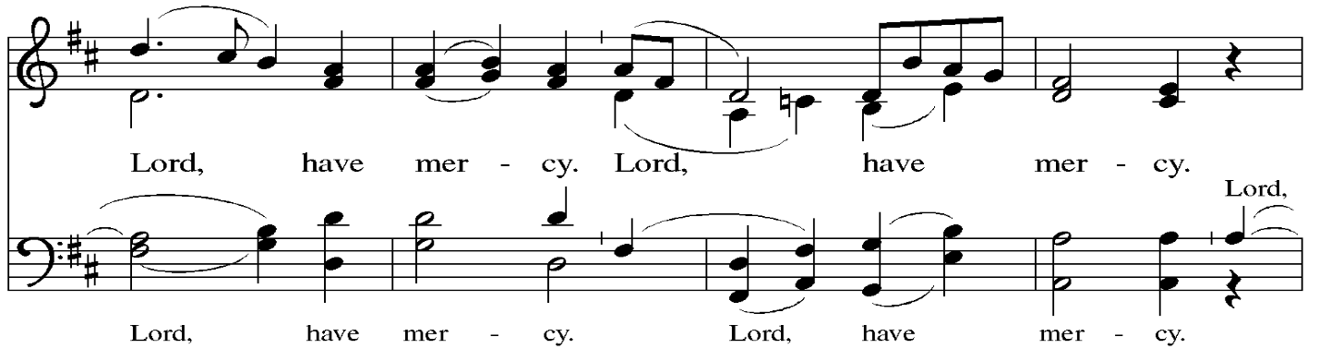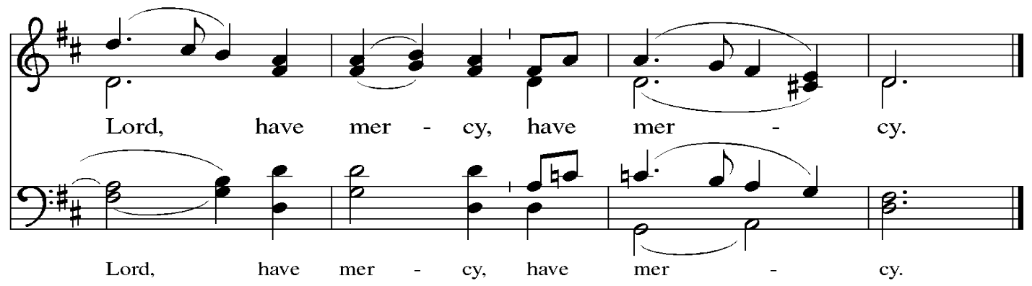

**Prayer of the Day**

P: The Lord be with you.

**C: And also with you.**

P: Let us pray.

O Lord God, you led your people through the wilderness and brought them to the promised land.

Guide us now, so that, following your Son, we may make our way safely through the wilderness

of this world toward the life only you can give, through Jesus Christ, our Savior and Lord,

who lives and reigns with you and the Holy Spirit, one God, now and forever.

**C: Amen.**

*Please be seated.*

*Children are invited to join the adult leader(s) at the side door for Little Church – Big Faith.*

*We ask that an additional adult from the congregation attend with the children.*

**Word**

*God speaks to us in Scripture reading, preaching, and song*

**First Reading** **–** **Deuteronomy 26: 1-11**

1 When you have come into the land that the Lord your God is giving you as an inheritance to possess, and you possess it and settle in it, 2 you shall take some of the first of all the fruit of the ground, which you harvest from the land that the Lord your God is giving you, and you shall put it in a basket and go to the place that the Lord your God will choose as a dwelling for God’s name. 3 You shall go to the priest who is in office at that time, and say to him, “Today I declare to the Lord your God that I have come into the land that the Lord swore to our ancestors to give us.” 4 When the priest takes the basket from your hand and sets it down before the altar of the Lord your God, 5 you shall make this response before the Lord your God: “A wandering Aramean was my ancestor; he went down into Egypt and lived there as an alien, few in number, and there he became a great nation, mighty and populous. 6 When the Egyptians treated us harshly and afflicted us, by imposing hard labor on us, 7 we cried to the Lord, the God of our ancestors; the Lord heard our voice and saw our affliction, our toil, and our oppression.

8 The Lord brought us out of Egypt with a mighty hand and an outstretched arm, with a terrifying display of power, and with signs and wonders; 9 and the Lord brought us into this place and gave us this land, a land flowing with milk and honey. 10 So now I bring the first of the fruit of the ground that you, O Lord, have given me.” You shall set it down before the Lord your God and bow down before the Lord your God. 11 Then you, together with the Levites and the aliens who reside among you, shall celebrate with all the bounty that the Lord your God has given to you and to your house.

L: Word of God, word of life.

**C: Thanks be to God.**

**Psalm 91: 1-2, 9-16**

*The cantor will lead the singing of the psalm.*

*The congregation is invited to respond with the alternate verses in bold print,*

*and to join in singing the refrain.*

*Psalm Tone*

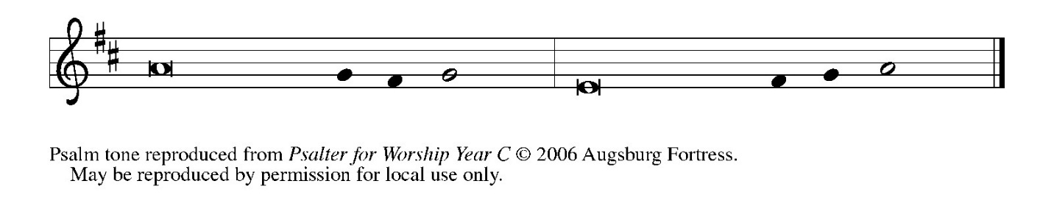

*Psalm Refrain*

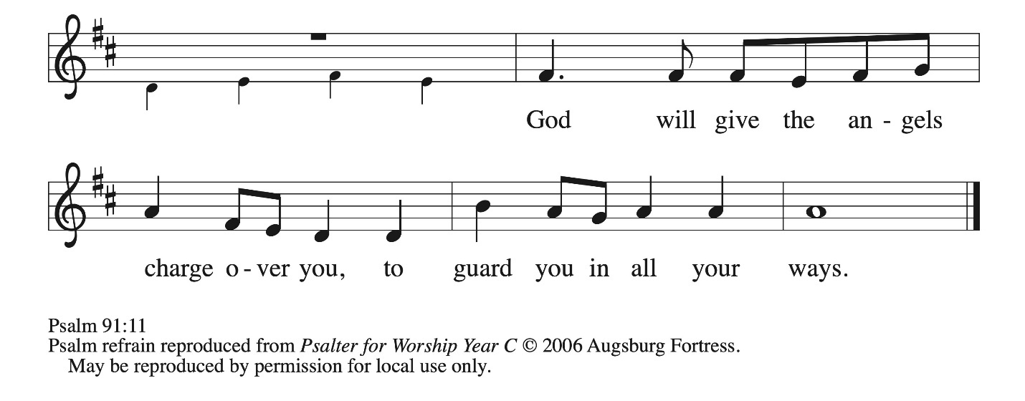  
 1 You who dwell in the shelter of **|** the Most High,  
  who abide in the shadow of **|** the Almighty—  
 2 **you will say to the Lord, “My refuge | and my stronghold,**  
  **my God in whom I | put my trust.” R**  
 9 Because you have made the **|** Lord your refuge,  
  and the Most High your **|** habitation,  
 10 **no evil | will befall you,**  
  **nor shall affliction come | near your dwelling.**  
 11 For God will give the angels charge **|** over you,  
  to guard you in **|** all your ways.  
 12 **Upon their hands they will | bear you up,**  
  **lest you strike your foot a- | gainst a stone. R**  
 13 You will tread upon the lion **|** cub and viper;  
  you will trample down the lion **|** and the serpent.

 14 **I will deliver those who | cling to me;**  
  **I will uphold them, because they | know my name.**  
 15 They will call me, and I will **|** answer them;  
  I will be with them in trouble; I will rescue and **|** honor them.  
 16 **With long life will I | satisfy them,**  
  **and show them | my salvation. R**

**Second Reading – Romans 10: 8b-13**

8b “The word is near you,  
  in your mouth and in your heart”  
(that is, the word of faith that we proclaim); 9 because if you confess with your mouth that Jesus is Lord and believe in your heart that God raised him from the dead, you will be saved. 10 For one believes with the heart, leading to righteousness, and one confesses with the mouth, leading to salvation. 11 The scripture says, “No one who believes will be put to shame.” 12 For there is no distinction between Jew and Greek; the same Lord is Lord of all and is generous to all who call on God. 13 For, “Everyone who calls on the name of the Lord shall be saved.”

L: Word of God, word of life.

**C: Thanks be to God.**

*Please rise as you are able and join in singing the Gospel Acclamation.*

**Gospel Acclamation** *ELW* p. 189

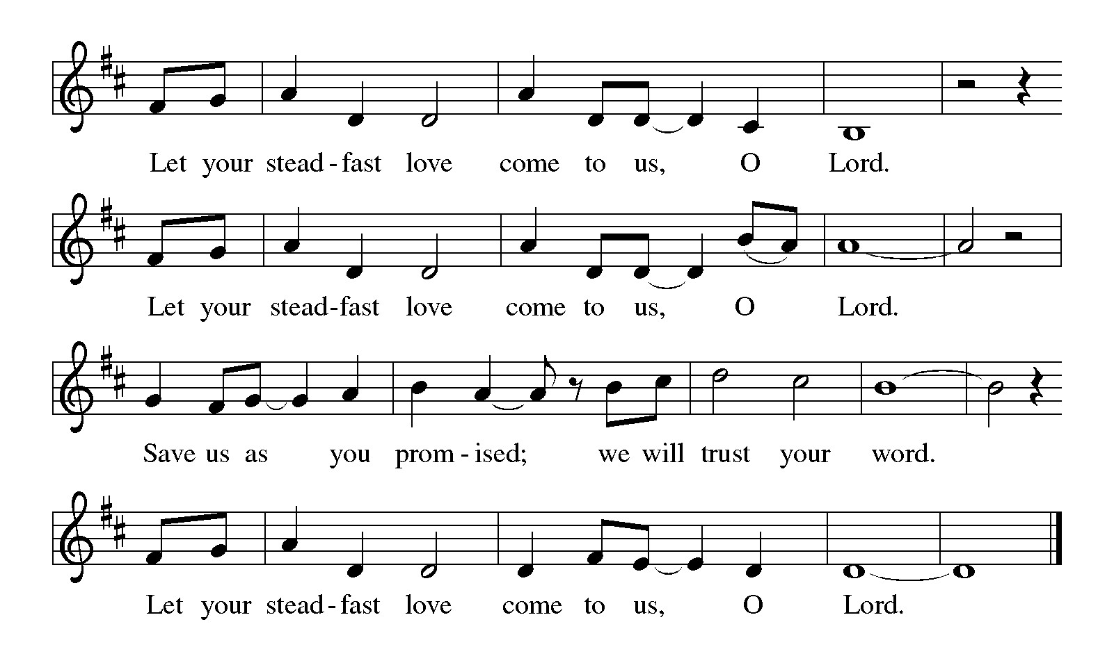

**Gospel – Luke 4: 1-13**

P: The holy Gospel according to St. Luke.

**C: Glory to you, O Lord.**

1 Jesus, full of the Holy Spirit, returned from the Jordan and was led by the Spirit in the wilderness, 2 where for forty days he was tested by the devil. He ate nothing at all during those days, and when they were over, he was famished. 3 The devil said to him, “If you are the Son of God, command this stone to become a loaf of bread.” 4 Jesus answered him, “It is written, ‘One does not live by bread alone.’ ”  
  5 Then the devil led him up and showed him in an instant all the kingdoms of the world. 6 And the devil said to him, “To you I will give all this authority their glory and their glory; for it has been given over to me, and I give it to anyone I please. 7 If you, then, will worship me, it will all be yours.” 8 Jesus answered him, “It is written,  
 ‘Worship the Lord your God,  
  and serve only the Lord.’ ”  
  9 Then the devil led him to Jerusalem, and placed him on the pinnacle of the temple, and said to him, “If you are the Son of God, throw yourself down from here, 10 for it is written,  
 ‘The Lord will command God’s angels concerning you,  
  to protect you,’  
11 and  
 ‘On their hands they will bear you up,  
  so that you will not dash your foot against a stone.’ ”  
12 Jesus answered him, “It is said, ‘Do not put the Lord your God to the test.’ ” 13 When the devil had finished every test, he departed from him until an opportune time.

P: The Gospel of the Lord.

**C: Praise to you, O Christ.**

*Please be seated.*

**Sermon**

*A time of silence for prayer and reflection follows the sermon.*

*As the hymn of the day begins, please rise as you are able.*



**Hymn of the Day As Your Spirit in the Desert *ACS* 923**

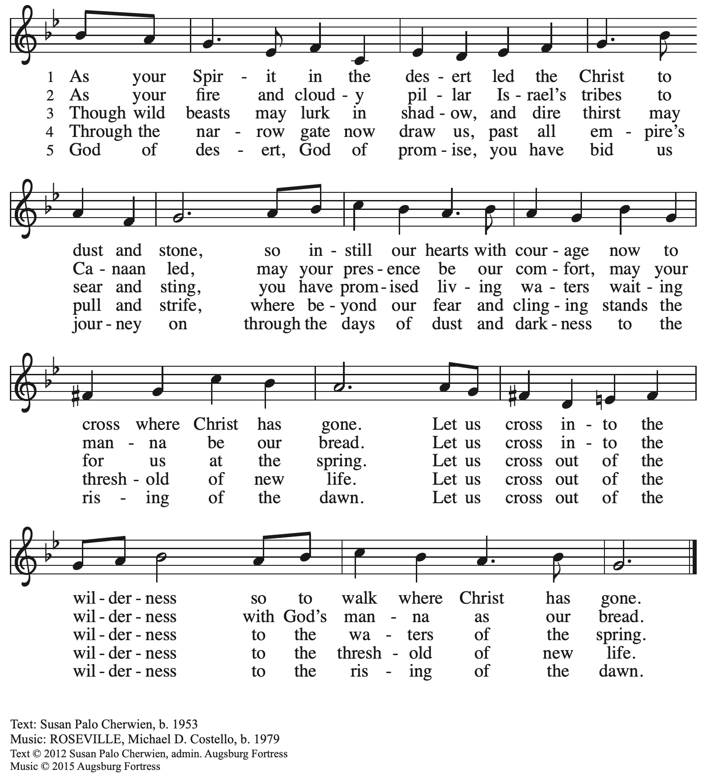

All rights reserved. Reprinted with permission under OneLicense.net # A-722139.

**Apostles’ Creed**

**C: I believe in God, the Father almighty,**

**creator of heaven and earth.**

**I believe in Jesus Christ, God’s only Son, our Lord,**

**who was conceived by the Holy Spirit,**

**born of the virgin Mary,**

**suffered under Pontius Pilate,**

**was crucified, died, and was buried;**

**he descended to the dead.\***

**On the third day he rose again;**

**he ascended into heaven,**

**he is seated at the right hand of the Father,**

**and he will come to judge the living and the dead.**

**I believe in the Holy Spirit,**

**the holy catholic church,**

**the communion of saints,**

**the forgiveness of sins,**

**the resurrection of the body,**

**and the life everlasting. Amen.**

*Or, “he descended into hell,” another translation of this text in widespread use.

**Prayers of the People**

A: Led by the Spirit, let us turn to God in prayer for the church, those in need,

and all God’s creation.

*After each petition*

A: Merciful God,

**C: receive our prayer.**

*The presiding minister concludes the prayers*

P: Receive the prayers of your people, O God, and draw all things together in your love,

in the name of Jesus, who leads us from death to life.

**C: Amen.**

**Peace**

*The presiding minister and the assembly greet one another in the peace of the risen Christ.*

P: The peace of Christ be with you always.

**C: And also with you.**

*The people may greet those around them with a sign of Christ’s peace and may say*

Peace be with you *or similar words. Please be mindful that not everyone will be comfortable with sharing the peace, so please seek consent before shaking hands or hugging. Other possible ways to share the peace include a simple bow with the verbal greeting of peace, or simply a verbal expression of peace. When the greetings of peace have concluded, please be seated.*

**Meal**

*God feeds us with the presence of Jesus Christ*

**Offering** *How Long, O God?* arr. Nancy Raabe

*We offer ourselves, our gifts, and our faithful service to God.*

*As the offering is gathered for the mission of the church, including the care of those in need,*

*the table is set for Holy Communion.*

**Music during the Offering**

*As the gifts are brought forward for presentation,* *please rise as you are able.*

**Offertory Song Create in Me a Clean Heart *ELW* 188**

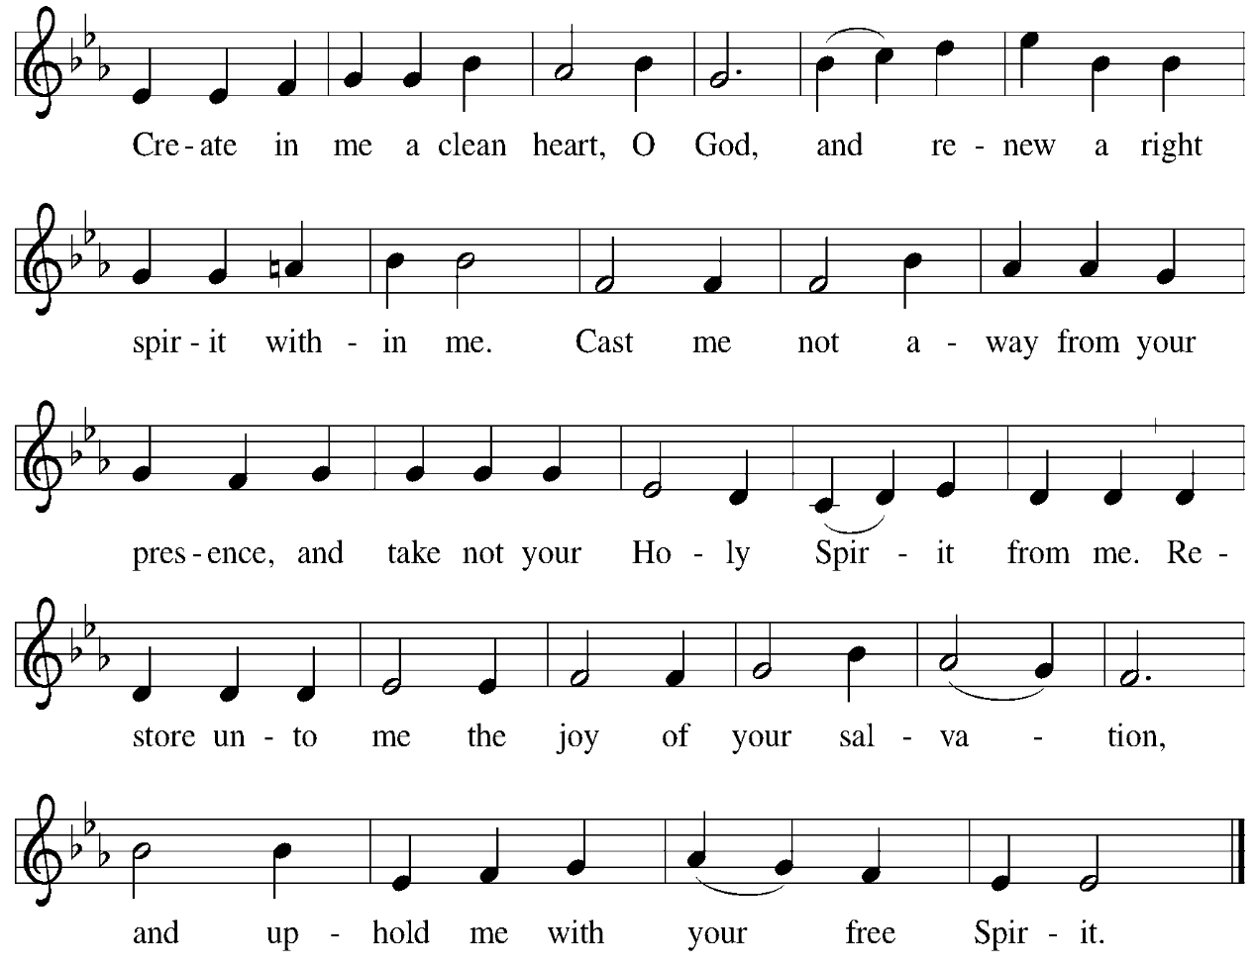

**Offertory Prayer**

A: Let us pray.

God our provider,

**C:** **you have not fed us with bread alone, but with words of grace and life.**

**Bless us and these your gifts, which we receive from your bounty,**

**through Jesus Christ our Lord. Amen.**

**Dialogue**

P: The Lord be with you.

**C: And also with you.**

P: Lift up your hearts.

**C: We lift them to the Lord.**

P: Let us give thanks to the Lord our God.

**C: It is right to give our thanks and praise.**

**Preface**

P: It is indeed right, our duty and our joy,

that we should at all times and in all places

give thanks and praise to you, almighty and merciful God,

through our Savior Jesus Christ;

You call your people to cleanse their hearts

and prepare with joy for the paschal feast,

that, renewed in the gift of baptism,

we may come to the fullness of your grace.

And so, with all the choirs of angels,

with the church on earth and the hosts of heaven,

we praise your name and join their unending hymn:

**Sanctus** *ELW* p. 190

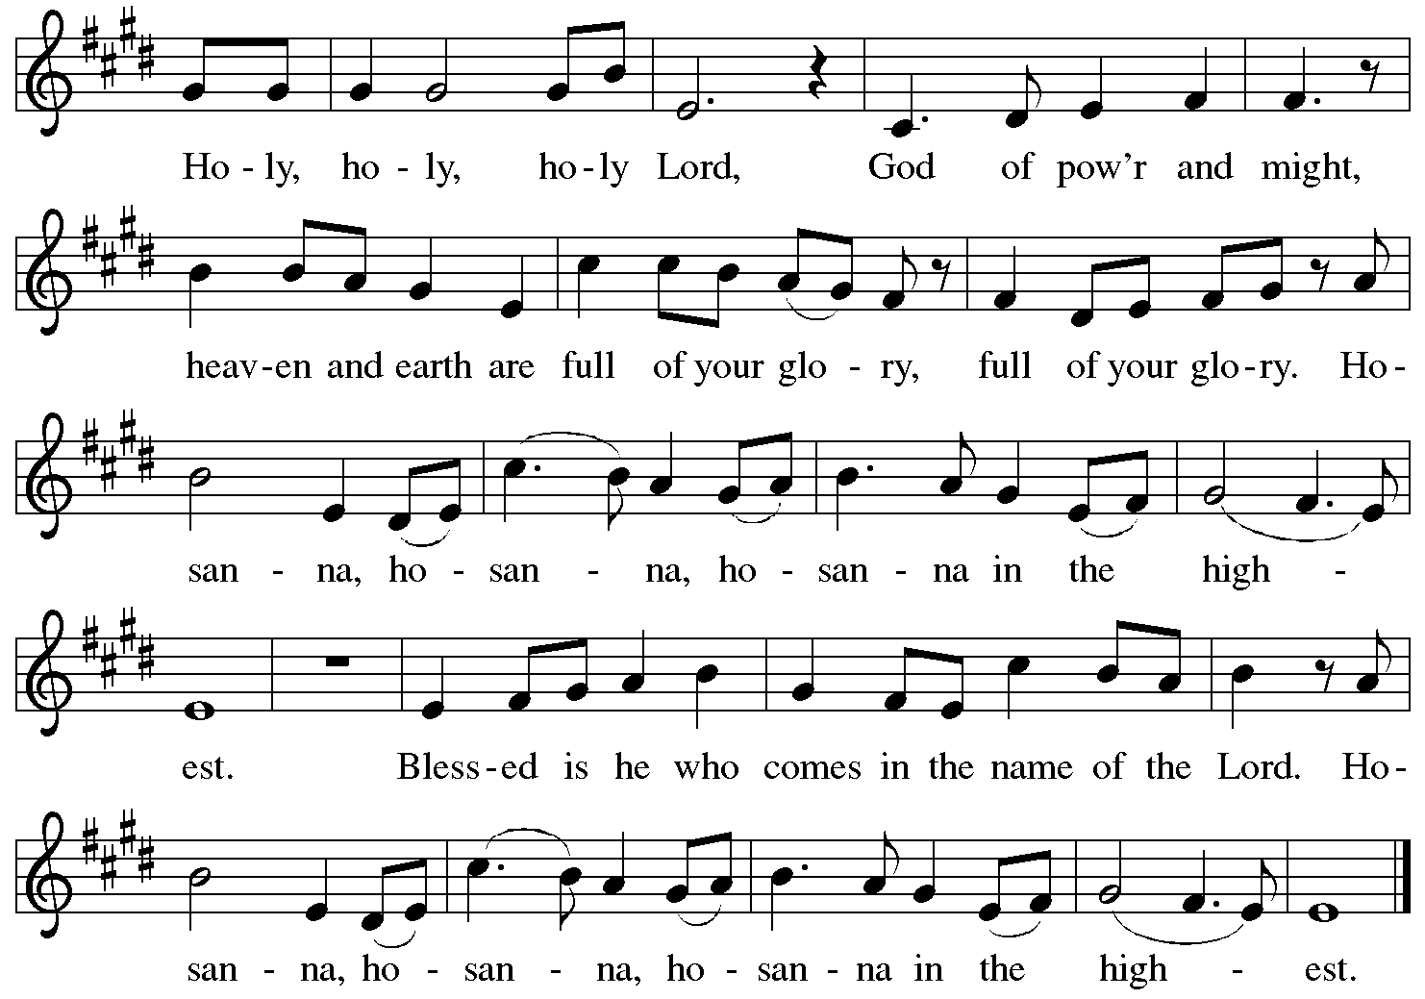

**Eucharistic Prayer**

P: Blessed are you, O God, of the universe … Do this for the remembrance of me.

With this bread and cup we remember our Lord’s Passover from death to life

as we proclaim the mystery of faith:

**C: Christ has died. Christ is risen. Christ will come again.**

P: O God of resurrection and new life … Grace our table with your presence.

**C: Come, Holy Spirit.**

P: Reveal yourself through the breaking of the bread … justice, peace, and love.

**C: Come, Holy Spirit.**

P: With your holy ones of all times and places …

… blessed and Holy Trinity, now and forever.

**C: Amen.**

**Lord’s Prayer**

P: Gathered as one by the Holy Spirit, let us pray as Jesus taught us.

**C: Our Father in heaven,**

**hallowed be your name,**

**your kingdom come,**

**your will be done,**

**on earth as in heaven.**

**Give us today our daily bread.**

**Forgive us our sins**

**as we forgive those**

**who sin against us.**

**Save us from the time of trial**

**and deliver us from evil.**

**For the kingdom, the power,**

**and the glory are yours,**

**now and forever. Amen.**

**Fraction and Invitation**

P: All who are hungry, come.

The feast of grace is ready.

***Agnus Dei /* Lamb of God** *ELW* p. 191

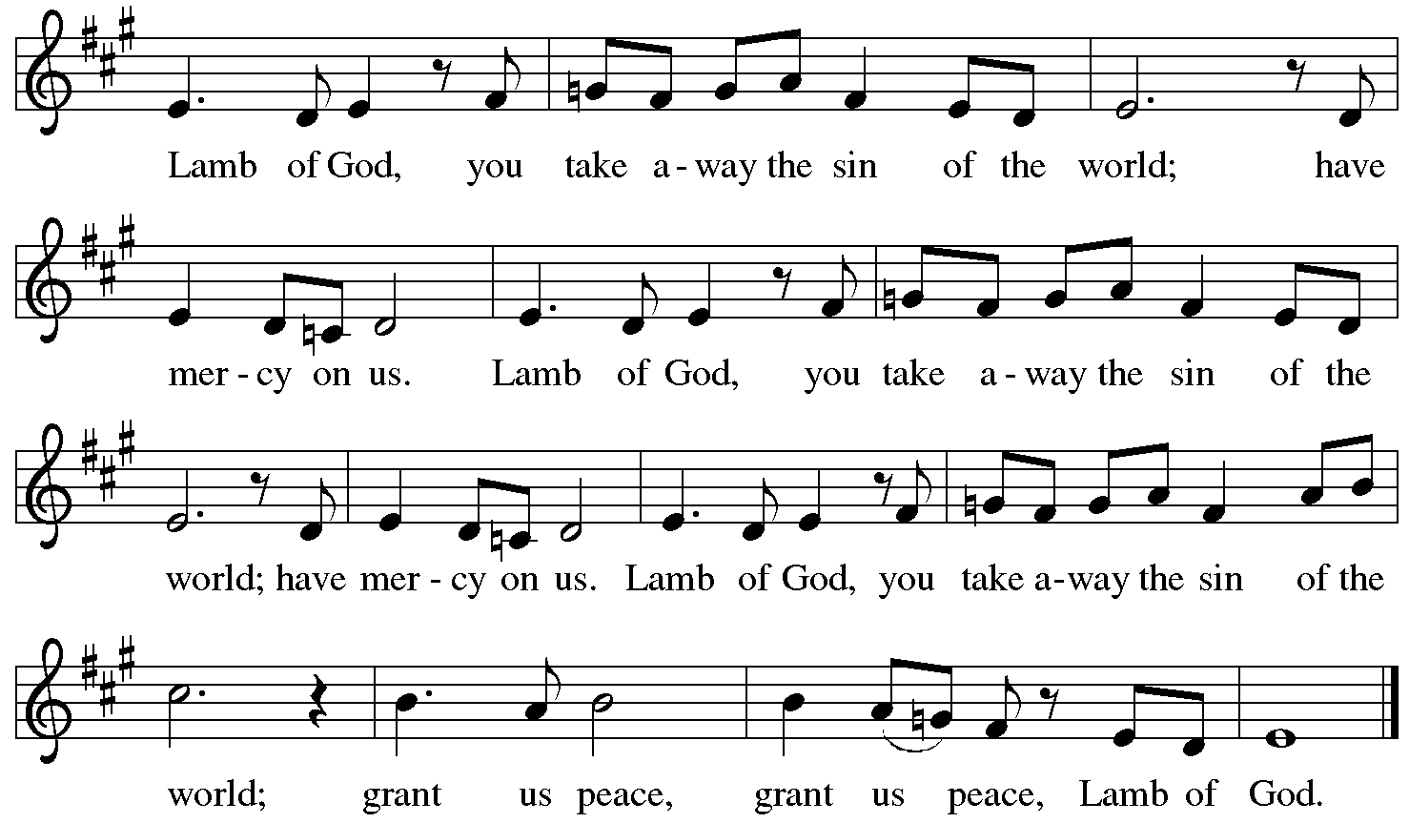

**

*Please be seated.*

**Holy Communion**

* *All who seek God and desire a deeper and stronger life in Christ are welcome to receive Holy Communion.*
* *Worshipers from the pulpit side will proceed forward first, followed by the center section, and then the lectern side.*
* *Please inform an usher if you would like the ministers to bring Communion to you.*
* *Holy Communion will be served with bread and wine (red) or grape juice (white).*
* *The presiding minister will first distribute the bread (host) to each communicant. Please indicate if you require a gluten-free host.*
* *Once you have consumed the bread, please pick up an empty glass from the tray next to the presiding minister. The Communion Assistant will pour wine from the chalice or grape juice from the cruet into your glass.*
* *Please step to the side to consume the wine or grape juice.*
* *Feel free to kneel at the altar rail for prayer after receiving the sacrament.*
* *As you return to your pew, glasses may be returned to the empty trays on the side of the center section.*
* *A blessing will be provided for anyone who does not yet receive the sacrament.*
* *All are invited to join in singing the hymns during Holy Communion.*

**Hymns during Holy Communion**

**Lord, Keep Us Steadfast in Your Word *ELW* 517**

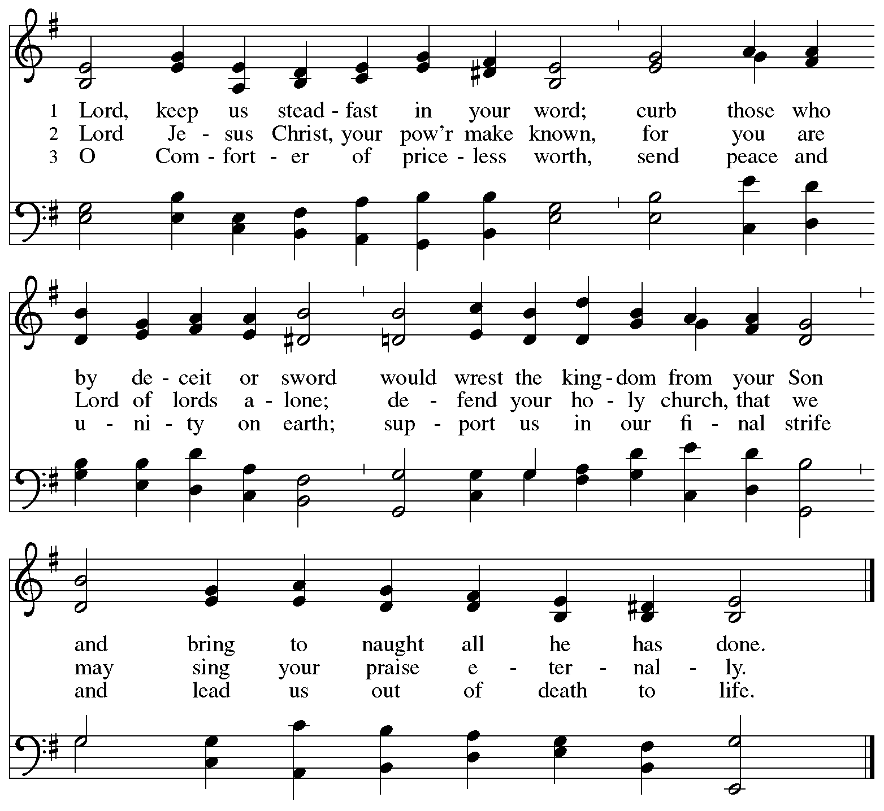



**Hymns during Holy Communion**

**When We Are Tested *ACS* 922**

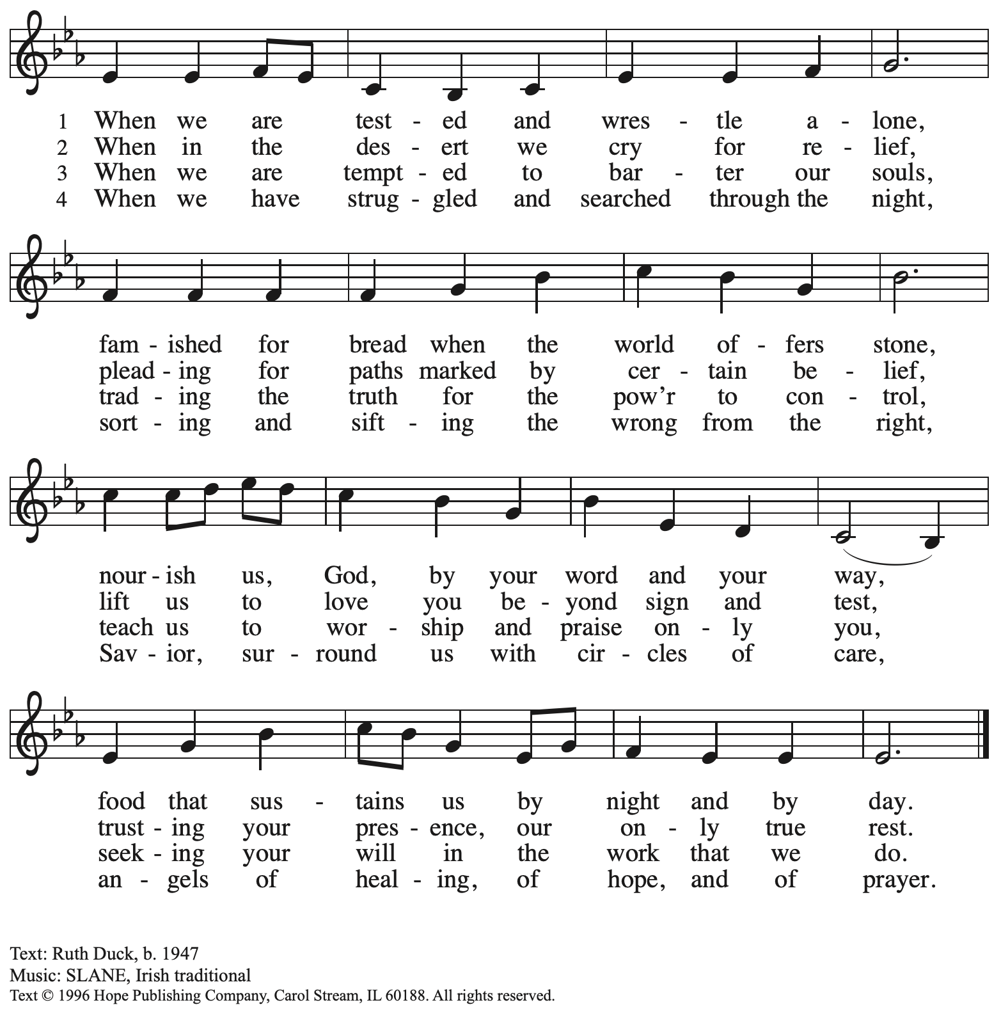

Reprinted with permission under OneLicense.net # A-722139.

**Hymns during Holy Communion**

**Bread of Life from Heaven *ELW* 474**

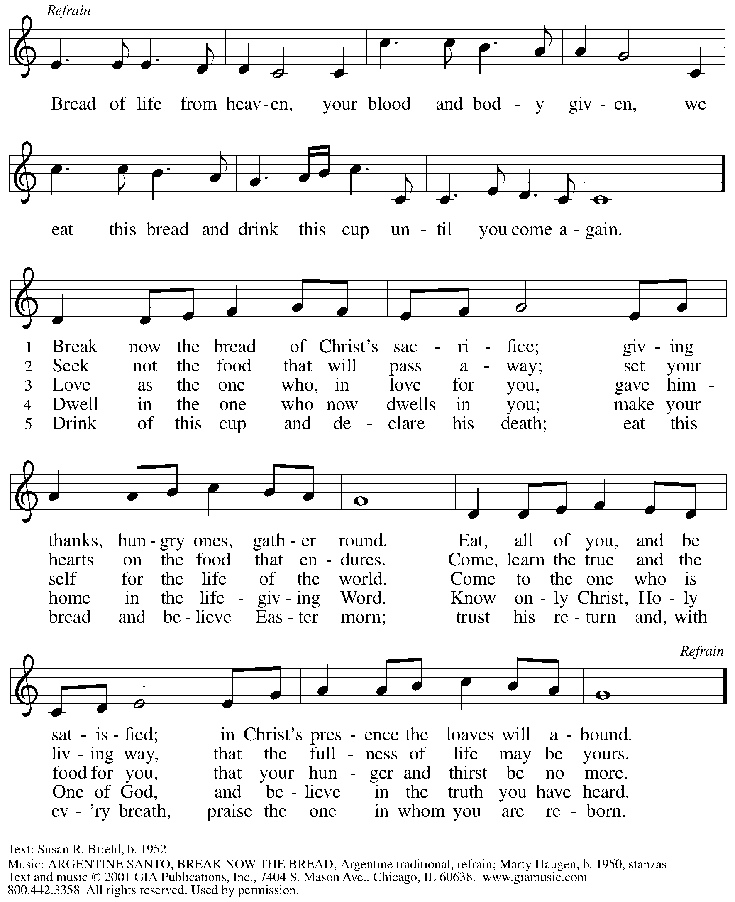

Reprinted under OneLicense.net # A-722139.

**Hymns during Holy Communion**

**Bless Now, O God, the Journey *ELW* 326**

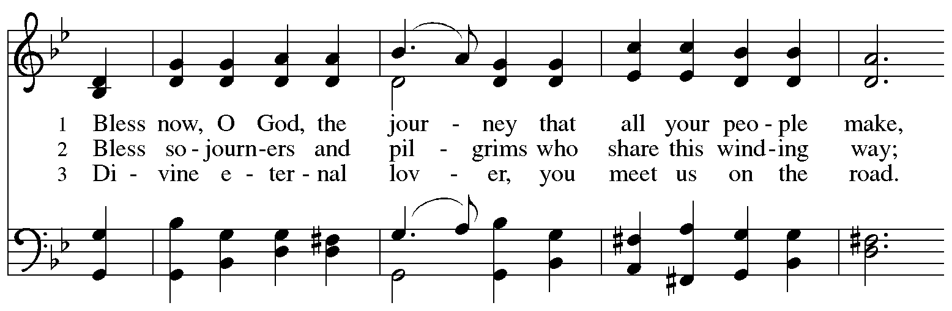

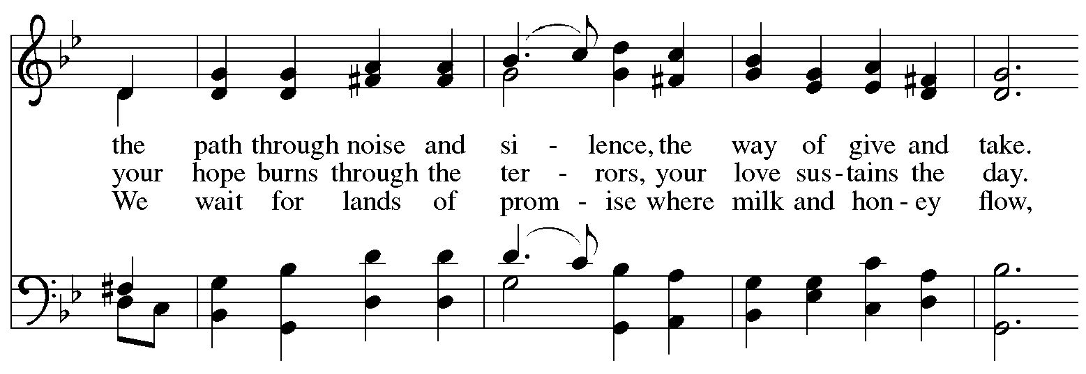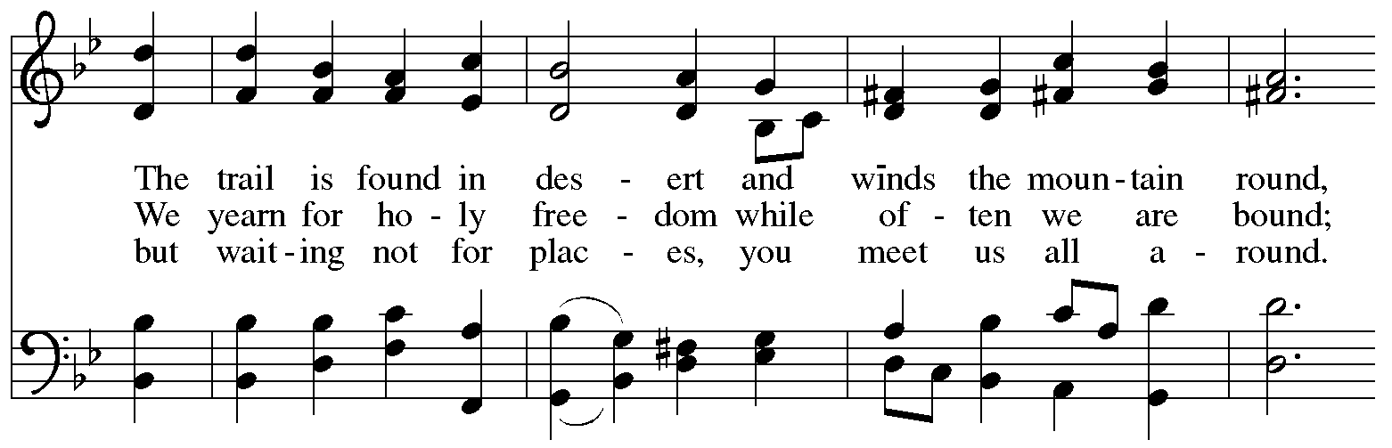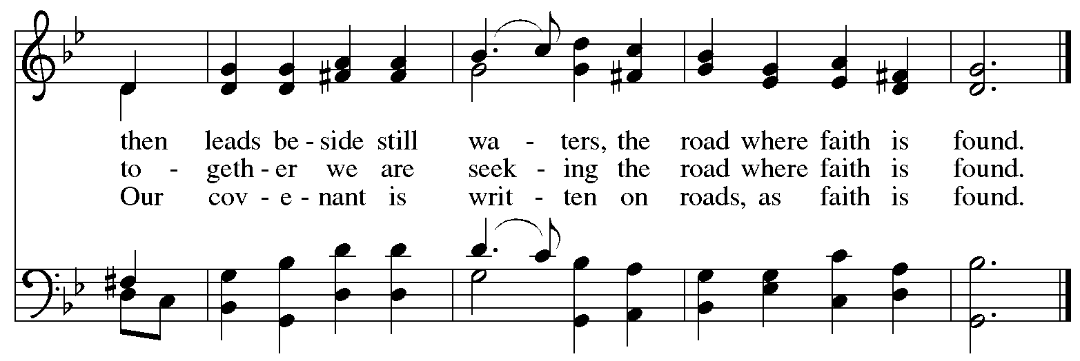

*When all have returned to their places, please rise as you are able.*

**Blessing**

P: The body and blood of our Lord Jesus Christ strengthen you and keep you in his grace.

**C: Amen.**

**Prayer**

A: Let us pray.

Compassionate God, you have fed us with the bread of heaven.

Sustain us in our Lenten pilgrimage:

may our fasting be hunger for justice;

our alms, a making of peace;

and our prayer, the song of grateful hearts,

through Jesus Christ, our Savior and Lord.

**C: Amen.**

*Please be seated.*

**Sending**

*God blesses us and sends us in mission to the world*

**Announcements**

*Please rise as you are able.*

**Benediction**

P: The Lord bless you and keep you.

The Lord’s face shine on you with grace and mercy.

The Lord look upon you with favor and ☩ give you peace.

**C: Amen.**

**Sending Hymn** *Following page*

**Dismissal**

P: Go in peace. Remember those in need.

**C: Thanks be to God.**

**Postlude**

**Sending Hymn I Want Jesus to Walk with Me *ELW* 325**

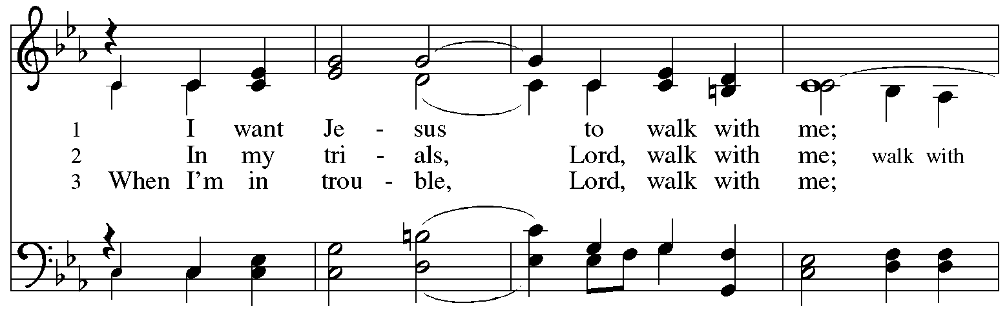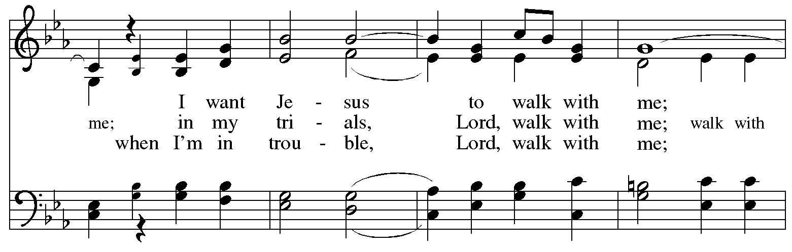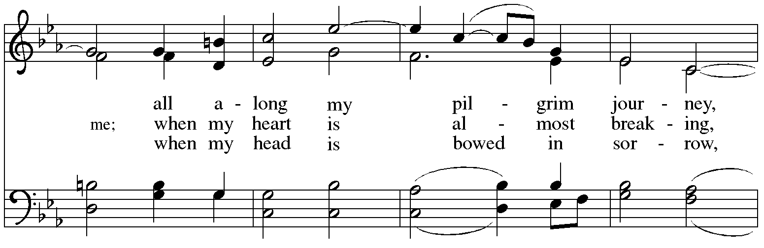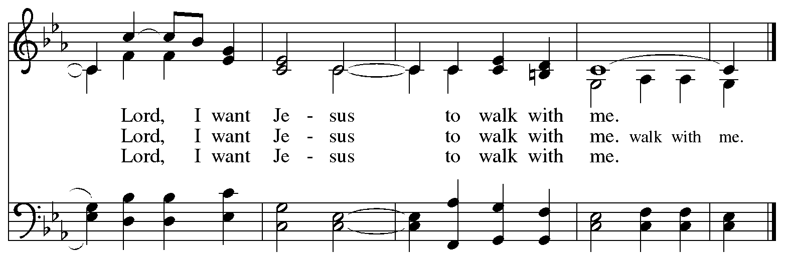

*Those serving in worship*

Altar Care Beverley Chapman

Assisting Minister Kathy Hays

Audio-Visual Ministers Kristen Asplin

Tyler Rietze

Cantor Ian Brown

Lector Michael Chapman

Little Church – Big Faith Teacher Maria Mangano

Pre-Service Music – Trombone Matthew Tesch

Minister of Music Laura Reynolds

Presiding and Preaching Minister The Rev. Ross I. Carmichael

*Liturgy and Hymnody Acknowledgements*

From SundaysandSeasons.com. Copyright © 2025 Augsburg Fortress. All rights reserved. Reprinted under OneLicense.net # A-722139.

Used by permission of Augsburg Fortress.

The Scripture readings contained herein are from *New Revised Standard Version Updated Edition* of the Bible © 2021 National Council of Churches of Christ in the United States of America. Used by permission. All rights reserved worldwide.

**Kyrie** – Text: *Deutsche Messe* Franz Schubert, 1797-1828; adapt. Richard Proulx, b. 1937. Adapt. © 198, 1989 GIA Publications, Inc. 7404 S. Mason Ave., Chicago, IL 60638. [www.giamusic.com](http://www.giamusic.com). 800.442.3358. All rights reserved. Reprinted with permission under OneLicense.net # A-722139.

**Create in Me a Clean Heart** – Music: J. A. Freylinghausen, 1670-1739.

**I Want Jesus to Walk with Me** – Text: African American spiritual. Music: SOJOURNER, African American spiritual; arr. hymnal version. Arr © 2006 Augsburg Fortress. All rights reserved. Reprinted with permission under OneLicense.net # A-722139.

*Please use the QR code below to link to St. Andrew’s Announcements online!*



**St. Andrew Lutheran Church Announcements**

**March 9th, 2025**

* **Welcome to worship at St. Andrew on the + First Sunday in Lent** –We are so glad you are here, and we offer a special welcome to all visitors and guests who are here for the first time! Worship attendees are invited to make a name tag at the back of the worship space. Little Church – Big Faith, a Bible lesson and activity for children, will take place after the prayer of the day. There are worship “toolkits” to help children engage with worship and “busy bags” for younger children available in the bookcase at the back of the sanctuary. Please feel free to take one to use with/for your children. All are invited to gather for coffee, other drinks, food, and conversation in the social hall after worship.
* **Community Ministry Meeting – Monday, March 10th, at 7:00 p.m. on Zoom – St. Andrew’s community ministry committee coordinates our local service ministries such as the outdoor Little Library, the pantry, produce distribution, shelter dinner, and various other activities. New participants are always welcome, and the next meeting is Monday, March 10th, at 7:00 p.m. on Zoom. Please contact** [PastorRCarmichael@gmail.com](mailto:PastorRCarmichael@gmail.com) **or** [community@standrewpittsburgh.org](mailto:community@standrewpittsburgh.org) **if you would like the link.**
* **Next Council Meeting – Saturday, March 15th, at 9:00 a.m. – St. Andrew’s congregation council meets once a month to guide the mission and general operations of the church. It is made up of 13 members of the congregation and the pastor. The next meeting of the council is Saturday, March 15th, at 9:00 a.m. We invite your prayers for St. Andrew’s council leaders!**
* **Know Your Rights as an Ally –** **Sunday, March 16th, after Worship** – In this time when many are concerned for the well-being of our neighbors, St. Andrew has been preparing for potential assistance for those who are vulnerable and to ensure the sanctity of worship for everyone in the community. On Sunday, March 16th, after worship, leaders from Casa San Jose, a local organization that is part of Pittsburgh’s ISAC (Immigrant Services and Connections) network, will be here to lead those interested from the congregation in a “Know Your Rights as an Ally” training. If you would like to learn more about Casa San Jose, please visit <https://www.casasanjose.org/>.
* **Shelter Dinner for Guests of East End Cooperative Ministry, Third Thursday of the Month – March 20th, 6:00 p.m. Arrival, 6:30 p.m. Dinner –** Each month, people of St. Andrew provide dinner for guests of East End Cooperative Ministry (EECM), 6140 Station St. (East Liberty), 15206. We invite you to prepare or purchase one menu item and bring it to the shelter by 6:00 p.m., or just come to help serve at 6:30 p.m. If you would like to contribute, please sign up here:

<https://www.signupgenius.com/go/5080544AAAC22A1F58-55360310-shelter>.

* **Bagged Lunches to Accompany EECM February Shelter Dinner on March 20th – Seeking Additional Donations! – East End Cooperative Ministry is hosting an additional 20 people this winter because of the shelter shortage and we have been asked to bring items for 20 bagged lunches on St. Andrew’s Shelter Dinner night, Thursday, March 20th.** **This month we only need 20 sandwiches and 20 soft fruits (any kind) – we have already received donations for the other items. Shelf-stable items can be left on the donation table in the Social Hall by Sunday, March 16th, or delivered to EECM on Thursday, March 20th. Please label “For EECM Lunches.” Sandwiches should be delivered to EECM any time on the 20th until 6:00 p.m. Please label “For St. Andrew bagged lunches.” Shelter staff will assemble the bagged lunches. Much work goes into shopping for and preparing the main meal each month, so we would greatly appreciate new participants and contributions for this effort! If you would like to help, please sign up at:**

<https://www.signupgenius.com/go/5080544AAAC22A1F58-55354631-baglunches>.

* **Congregational Meeting – Sunday, March 23rd, after Worship – Every year in February or March St. Andrew holds a meeting of the congregation. This meeting is an opportunity to review the past year in ministry, receive an update on the congregation’s end-of-year financial status, share updates on current initiatives, and look ahead toward upcoming events. This year’s meeting will be held after worship on Sunday, March 23rd. Representatives from Partners for Sacred Places, with whom we are working on a feasibility study for a capital campaign, will be here over that weekend. No absentee or proxy votes can be accepted so please plan to attend the meeting, in person or via Zoom (same as Sunday worship link).**
* **Lenten Food Drive for St. Andrew’s Pantry** – One of the spiritual disciplines of the season of Lent is almsgiving – generous giving on behalf of neighbors in need. In the spirit of Lent, we are inviting people of the congregation to donate nonperishable food items to help replenish the congregation’s outdoor pantry. **Suggested items include**: Packs of chicken, tuna, or pork (any flavor); cans of Vienna sausage, potted meat, spam; cans of beef stew, beefaroni, ravioli; boxes of macaroni and cheese, stuffing, or mashed potatoes; cups of applesauce – any flavor; granola bars, rice Krispie treat bars; boxes of cookies or crackers; small bags or boxes of cereal – any kind; shelf stable milk; case of water; cans of vegetables and fruits. All canned items must have a pull tab to open.Items may be placed on the donation table in the social hall throughout the season of Lent.
* ***Life Renewed: Devotions for Lent 2025* Available at Church Entrances** – Another of the spiritual disciplines for the season of Lent is prayer, so each year, the worship committee provides copies of a daily devotional booklet. This year’s is titled *Life Renewed*, and it contains a brief scripture reading, reflection/quote, and prayer for each day from Ash Wednesday (March 5th) to the Vigil of Easter (April 19th. They are now available at the entrances to the building – please take one to aid in your devotions this Lent!
* **Help Re-Stock Outdoor Little Library!** – If you are interested in stocking the little library that is on the Centre Avenue side of the church, there are extra books in the metal cabinet to the right of the dumbwaiter.  (There are currently some 10% off coupons for Half Price Books that are good throughout the year.)  The current stock of books are from the challenged or banned book lists.  Here are two lists:  (<https://www.ala.org/bbooks>) (<https://en.wikipedia.org/wiki/List_of_most_commonly_challenged_books_in_the_United_States>).
* **Prayer Service with the Pittsburgh Compline Choir – Sundays at 8:00 p.m. at Heinz Chapel –** Compline was traditionally a monastic prayer service, and the Pittsburgh Compline Choir, a ministry of Lutheran Campus Ministry in Greater Pittsburgh, sings a choral version of compline rooted in this thousand-year-old tradition of scripture, song, and silence each Sunday at Heinz Chapel at 8:00 p.m. This service also streams on Facebook (Pittsburgh Compline Choir) and YouTube (The Pittsburgh Compline Choir). Heinz Chapel is located off of S. Bellefield Ave. in Oakland. For more information, please visit: [Pittsburgh Compline Choir](http://pittsburghcomplinechoir.org/).