

**+ Transfiguration of our Lord**

**March 2nd, 2025**

**10:00 a.m.**



**St. Andrew Lutheran Church**

**304 Morewood Ave.**

**Pittsburgh, PA 15213**

**412.682.3342**

[**St_andrewELCA@verizon.net**](mailto:St_andrewELCA@verizon.net)

[**www.standrewpittsburgh.org**](http://www.standrewpittsburgh.org)

**+ The Transfiguration of our Lord**

**Order for Worship**

*Witnesses to the glory of God in the face of Jesus reflect that glory in the world. It was true for Moses. It was likely true for Peter, James, and John. We pray that it will be true of all of us who see God’s glory in the word and in the supper and who are being “transformed into the same image” by God’s Spirit.*

**Welcome to St. Andrew!**

* St. Andrew welcomes all who are seeking a place of healing, wholeness, and acceptance in a nurturing and faith-forming spiritual home. We are striving toward racial equity worldwide

and we seek to honor the lived experience of all individuals regardless of background. Our community embraces people of all ages, ethnicities, cultures, abilities, sexual orientations,

gender identities and expressions, and family constellations. Come and See!

* Worship Services are live-streamed to multiple online platforms. By attending worship, you agree that your image and voice may be broadcast.
* Everyone is invited to make a name tag at the black bookcase in the back of the worship space if they would like. There are stickers indicating pronouns on the bookcase if you would like to include them on your name tag.
* Children are invited to attend Little Church – Big Faith, a Bible lesson and activity, during worship (after the Prayer of the Day). The group returns to the worship space for the liturgy of Holy Communion.
* A nursery is available through the doors at the left side of the sanctuary and across from the doorway to the Social Hall. Look for a purple-colored room.
* Worship “toolkits” to help children engage with the service, along with “busy bags” for younger children, are available in the bookcase at the back of the sanctuary. Please feel free to take one to use with/for your children.
* Holy Communion is served with bread (gluten-free available) and wine or grape juice. The presiding minister will distribute the bread (host). Please consume this and then pick up an empty glass from the tray. The Communion Assistant will pour wine or grape juice into your glass. Please step to the side to consume the wine or grape juice. Feel free to kneel at the altar for prayer and reflection. As you return to your pew, glasses may be returned to the empty trays on either side of the center section.
* A restroom is available on the main level of the church, through the doors to the Social Hall and to the right in the main office.

*Abbreviations*

P: Pastor/Presiding Minister ***ELW*: *Evangelical Lutheran Worship* hymnal**

A: Assisting Minister ***ACS*: *All Creation Sings* hymnal**

L: Lector

**C: Congregation**

**Pre-Service Music** Marit Bakken and Jered Stratton

**Welcome**

**Prelude** *Reflection* Mark Hayes

**Gathering**

*The Holy Spirit calls us together as the people of God*

**Thanksgiving for Baptism**

*Please rise as you are able. All may make the sign of the cross,*

*the sign that is marked at Baptism, as the presiding minister begins.*

P: Blessed be the holy Trinity, ☩ one God,

the fountain of living water, the rock who gave us birth,

our light and our salvation.

**C: Amen.**

P: Joined to Christ in the waters of Baptism, we are clothed with God’s mercy and forgiveness. Let us give thanks for the gift of Baptism.

*Water may be poured into the font as the presiding minister gives thanks.*

P: We give you thanks, O God, for in the beginning you created us in your image and placed us in a well-watered garden. In the desert, you promised pools of water for the parched, and you gave us water from the rock. When we did not know the way, you sent the Good Shepherd to lead us to still waters. At the cross, you washed us from Jesus’ wounded side, and on this day, you shower us again with the water of life.

We praise you for your salvation through water, for the water in this font,

and for water everywhere, including the Allegheny, Monongahela, and Ohio rivers.

Bathe us in your forgiveness, grace, and love.

Satisfy all who thirst, and give us the life only you can give.

To you be given honor and praise

through ☩ Jesus Christ, our living water,

in the unity of the Holy Spirit, now and forever.

**C: Amen.**

**Gathering Hymn O Beauty Ever Ancient *ACS* 1100**

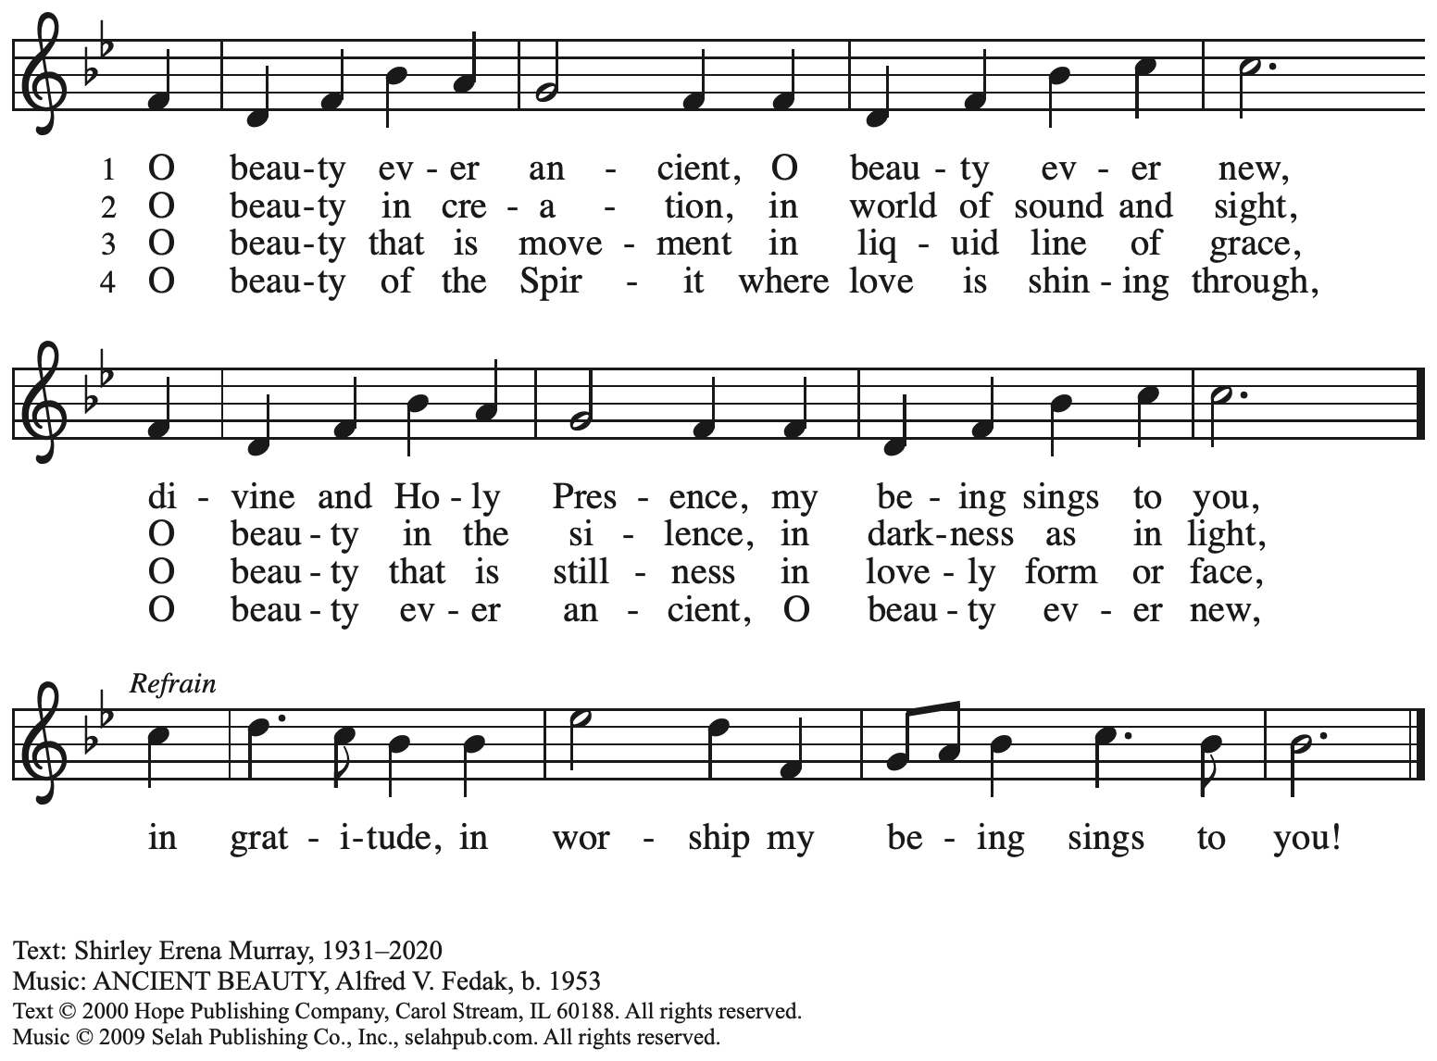

Reprinted with permission under OneLicense.net # A-722139.

**Greeting**

P: The grace of our Lord Jesus Christ, the love of God,

and the communion of the Holy Spirit be with you all.

**C: And also with you.**

**Kyrie** *ACS* p. 12

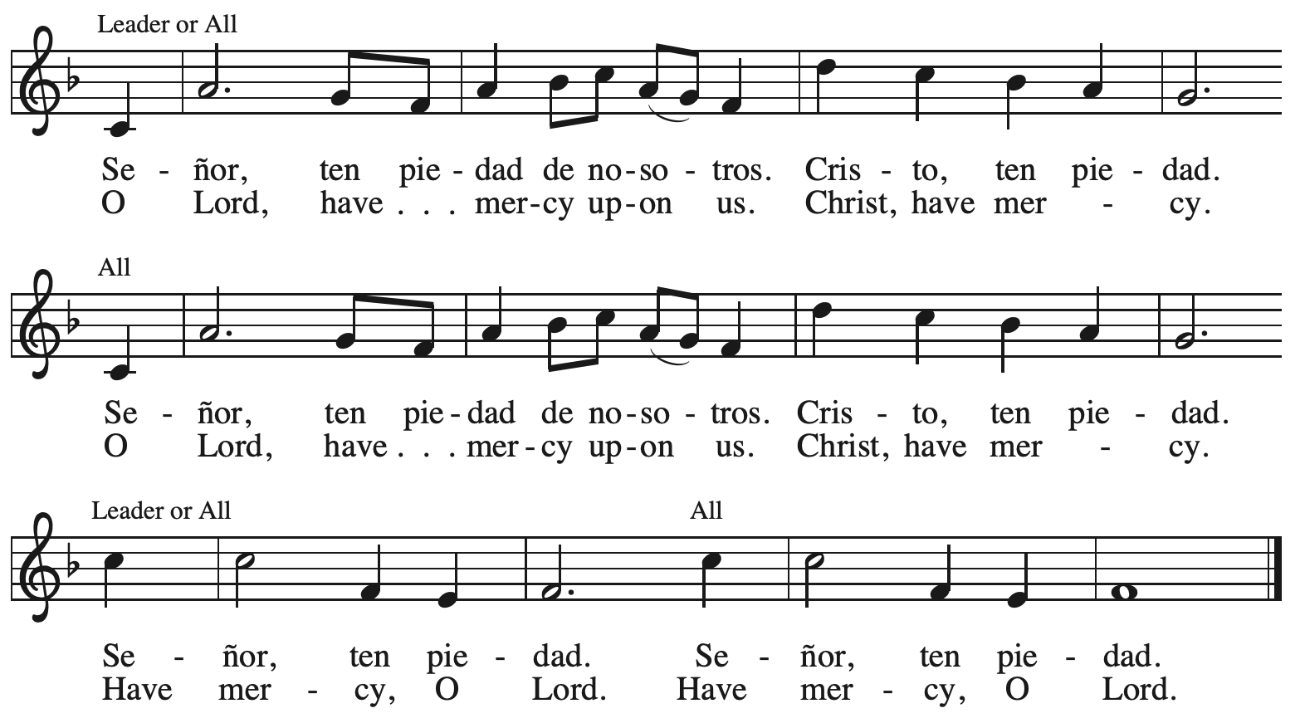



**Hymn of Praise** *ACS* p. 12

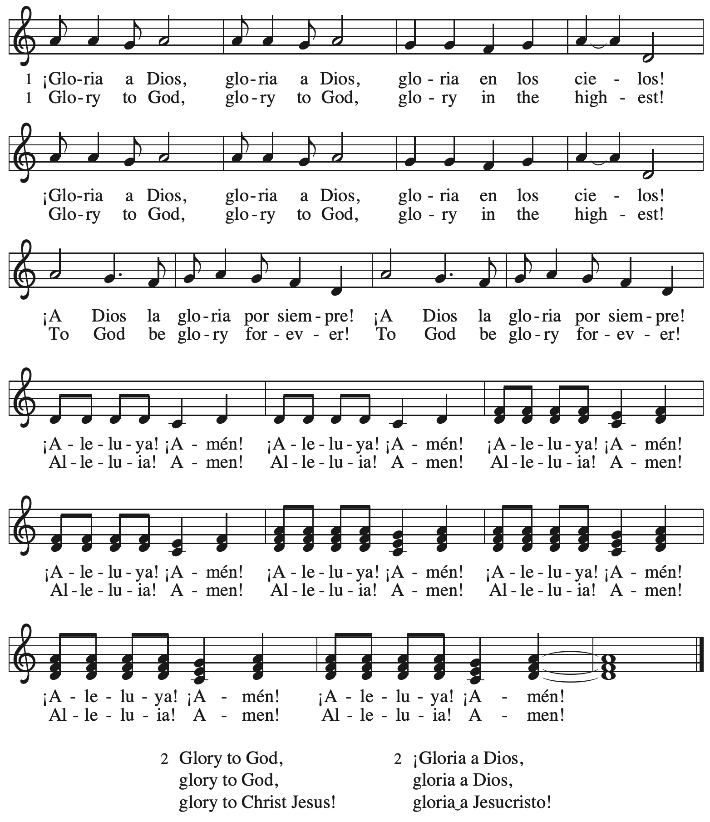

**Prayer of the Day**

P: The Lord be with you.

**C: And also with you.**

P: Let us pray.

Holy God, mighty and immortal,

you are beyond our knowing, yet we see your glory in the face of Jesus Christ.

Transform us into the likeness of your Son,

who renewed our humanity so that we may share in his divinity,

Jesus Christ our Lord, who lives and reigns with you and the Holy Spirit,

one God, now and forever.

**C: Amen.**

*Please be seated.*

**Word**

*God speaks to us in Scripture reading, preaching, and song*

**First Reading** **– Exodus 34: 29-35**

29 Moses came down from Mount Sinai. As he came down from the mountain with the two tablets of the covenant in his hand, Moses did not know that the skin of his face shone because he had been talking with God. 30 When Aaron and all the Israelites saw Moses, the skin of his face was shining, and they were afraid to come near him. 31 But Moses called to them; and Aaron and all the leaders of the congregation returned to him, and Moses spoke with them. 32 Afterward all the Israelites came near, and he gave them in commandment all that the Lord had spoken with him on Mount Sinai. 33 When Moses had finished speaking with them, he put a veil on his face;

34 but whenever Moses went in before the Lord to speak with the Lord, he would take the veil off, until he came out; and when he came out, and told the Israelites what he had been commanded, 35 the Israelites would see the face of Moses, that the skin of his face was shining; and Moses would put the veil on his face again, until he went in to speak with the Lord.

L: Word of God, word of life.

**C: Thanks be to God.**

**Psalm 99**

*The cantor will lead the singing of the psalm.*

*The congregation is invited to respond with the alternate verses in bold print,*

*and to join in singing the refrain.*

*Psalm Tone*

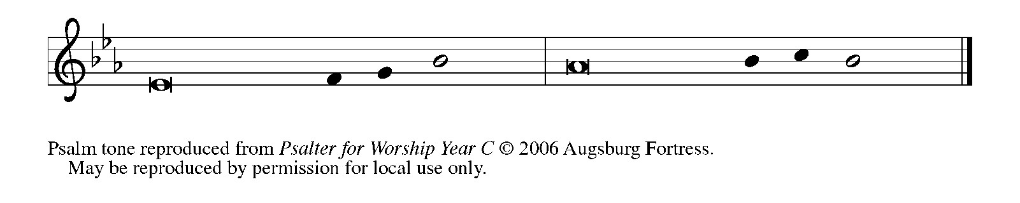



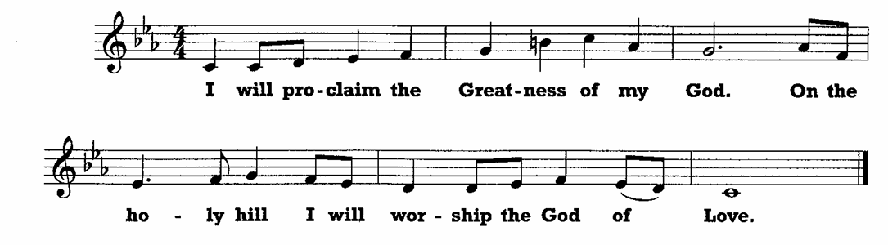

 1 The Lord is king; let the **|** people tremble.  
  The Lord is enthroned upon the cherubim; let **|** the earth shake.  
 2 **The Lord, | great in Zion,**  
  **is high a- | bove all peoples.**  
 3 Let them confess God’s name, which is **|** great and awesome;  
  God is the **|** Holy One.  
 4 **O mighty king, lover of justice, you have es- | tablished equity;**  
  **you have executed justice and righteous- | ness in Jacob. R**  
 5 Proclaim the greatness of the Lord and fall down be- **|** fore God’s footstool;  
  God is the **|** Holy One.  
 6 **Moses and Aaron among your priests, and Samuel among those who call upon your | name, O Lord,**  
  **they called upon you, and you | answered them,**  
 7 you spoke to them out of the pil- **|** lar of cloud;  
  they kept your testimonies and the decree **|** that you gave them.  
 8 **O Lord our God, you answered | them indeed;**  
  **you were a God who forgave them, yet punished them for their | evil deeds.**  
 9 Proclaim the greatness of the Lord and worship upon God’s **|** holy hill;  
  for the Lord our God is the **|** Holy One.**R**

**Second Reading – 2 Corinthians 3: 12 – 4: 2**

12 Since, then, we have such a hope, we act with complete frankness, 13 not like Moses, who put a veil over his face to keep the people of Israel from gazing at the end of the glory that was being set aside. 14 But their minds were hardened. Indeed, to this very day, when they hear the reading of the old covenant, that same veil is still there, it is not unveiled since in Christ it is set aside. 15 Indeed, to this very day whenever Moses is read, a veil lies over their minds; 16 but when one turns to the Lord, the veil is removed. 17 Now the Lord is the Spirit, and where the Spirit of the Lord is, there is freedom. 18 And all of us, with unveiled faces, seeing the glory of the Lord as though reflected in a mirror, are being transformed into the same image from one degree of glory to another; for this comes from the Lord, the Spirit.

4:1 Therefore, since it is by God’s mercy that we are engaged in this ministry, we do not lose heart. 2 We have renounced the shameful, underhanded ways; we refuse to practice cunning or to falsify God’s word; but by the open statement of the truth we commend ourselves to the conscience of everyone in the sight of God.

L: Word of God, word of life.

**C: Thanks be to God.**

*Please rise as you are ab and join in singing the Gospel Acclamation.*

**Gospel Acclamation** *ACS* p. 14

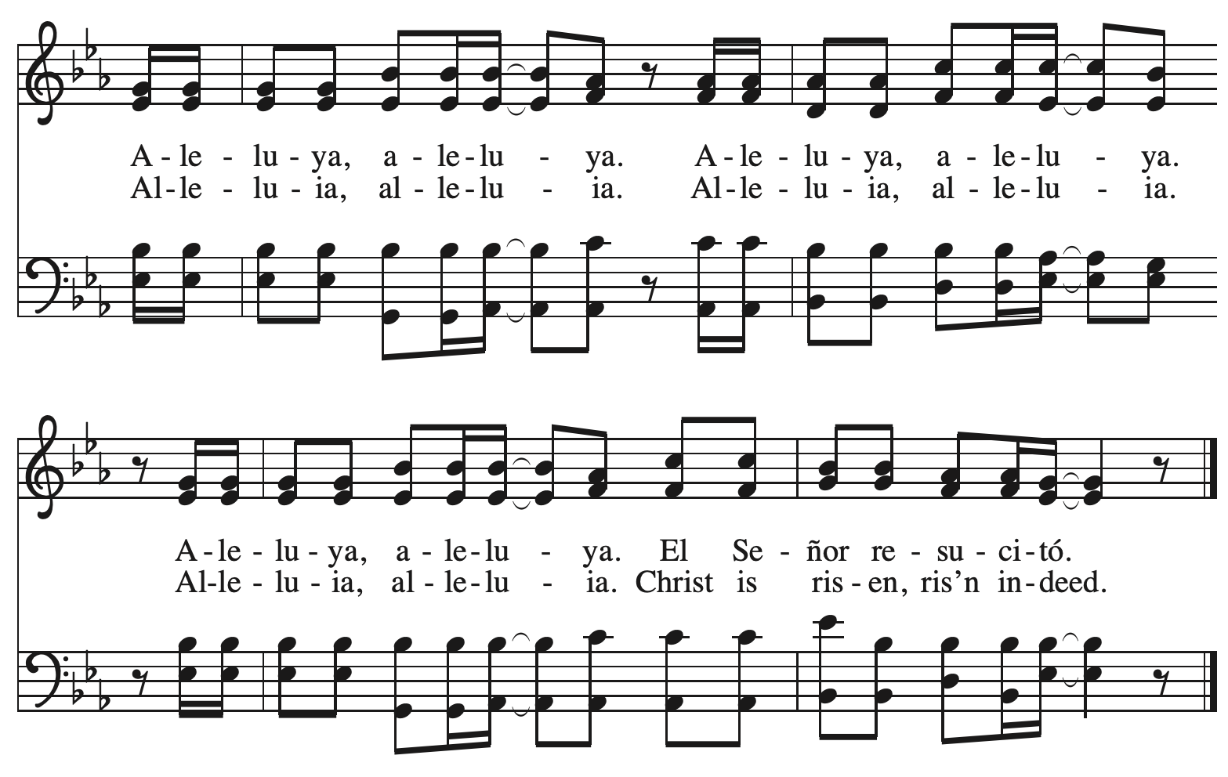

**Gospel – Luke 9: 28-36**

P: The holy Gospel according to St. Luke.

**C: Glory to you, O Lord.**

28 Now about eight days after these sayings Jesus took with him Peter and John and James, and went up on the mountain to pray. 29 And while he was praying, the appearance of his face changed, and his clothes became as bright as a flash of lightning. 30 Suddenly they saw two men, Moses and Elijah, talking to him. 31 They appeared in glory and were speaking about his exodus, which he was about to fulfill in Jerusalem. 32 Now Peter and his companions were weighed down with sleep; but as they awoke they saw his glory and the two men who stood with him. 33 Just as they were leaving him, Peter said to Jesus, “Master, it is good for us to be here; let us set up three tents, one for you, one for Moses, and one for Elijah”—not realizing what he was saying.

34 While he was saying this, a cloud came and overshadowed them; and they were terrified as they entered the cloud. 35 Then from the cloud came a voice that said, “This is my Son, my Chosen; listen to him!” 36 When the voice had spoken, Jesus was found alone. And they kept silent and in those days told no one any of the things they had seen.

P: The Gospel of the Lord.

**C: Praise to you, O Christ.**

*Please be seated.*

**Sermon**

*A time of silence for prayer and reflection follows the sermon.*

*As the hymn of the day begins, please rise as you are able.*

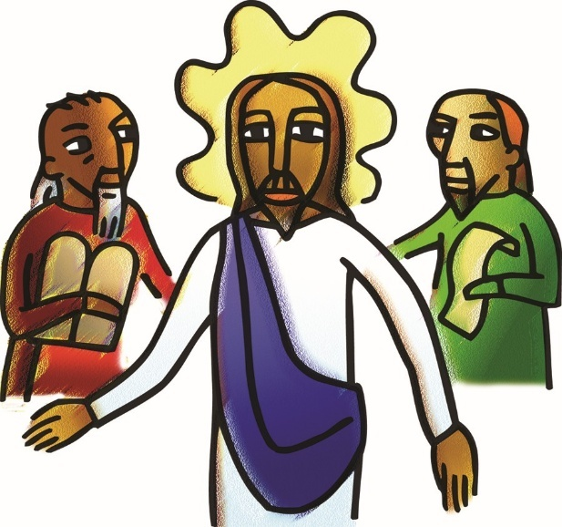

**Hymn of the Day Jesus on the Mountain Peak *ELW* 317**

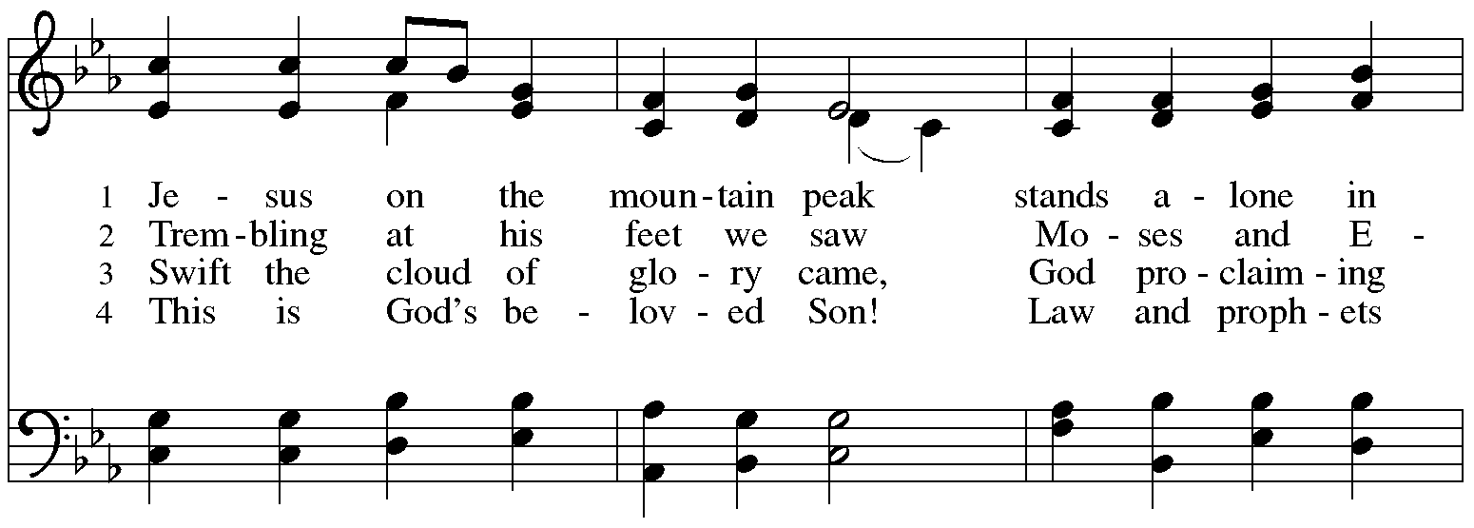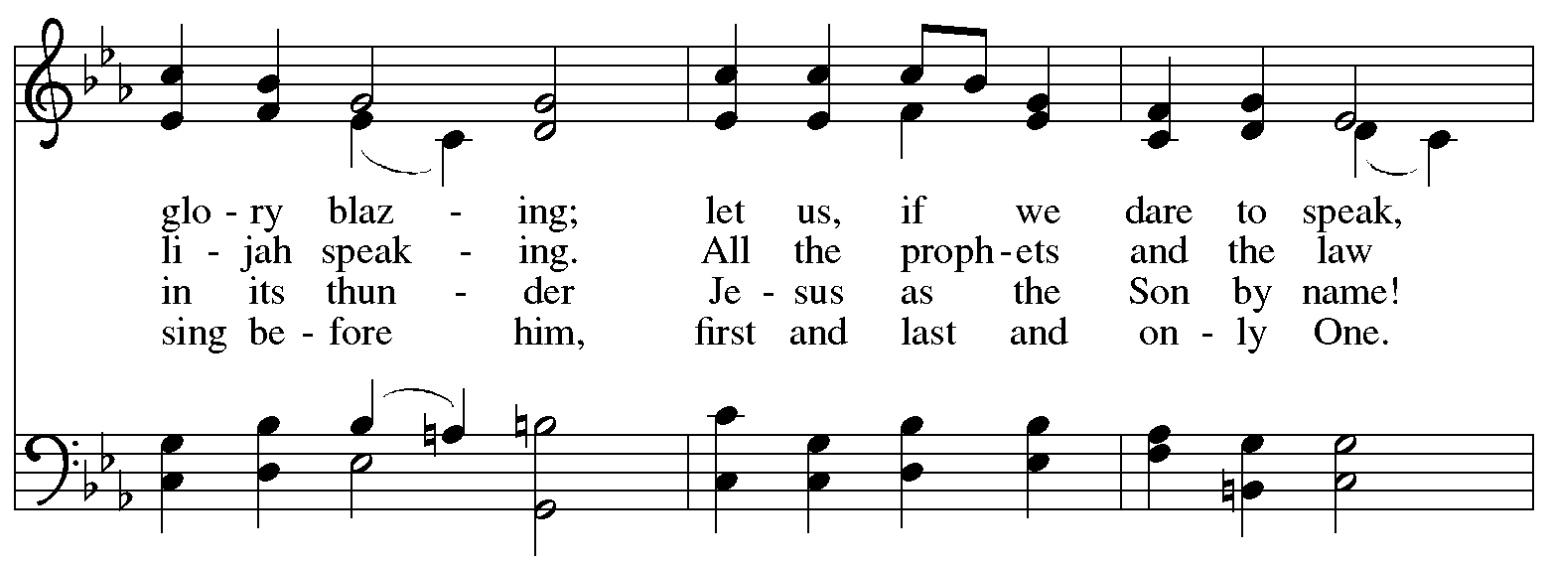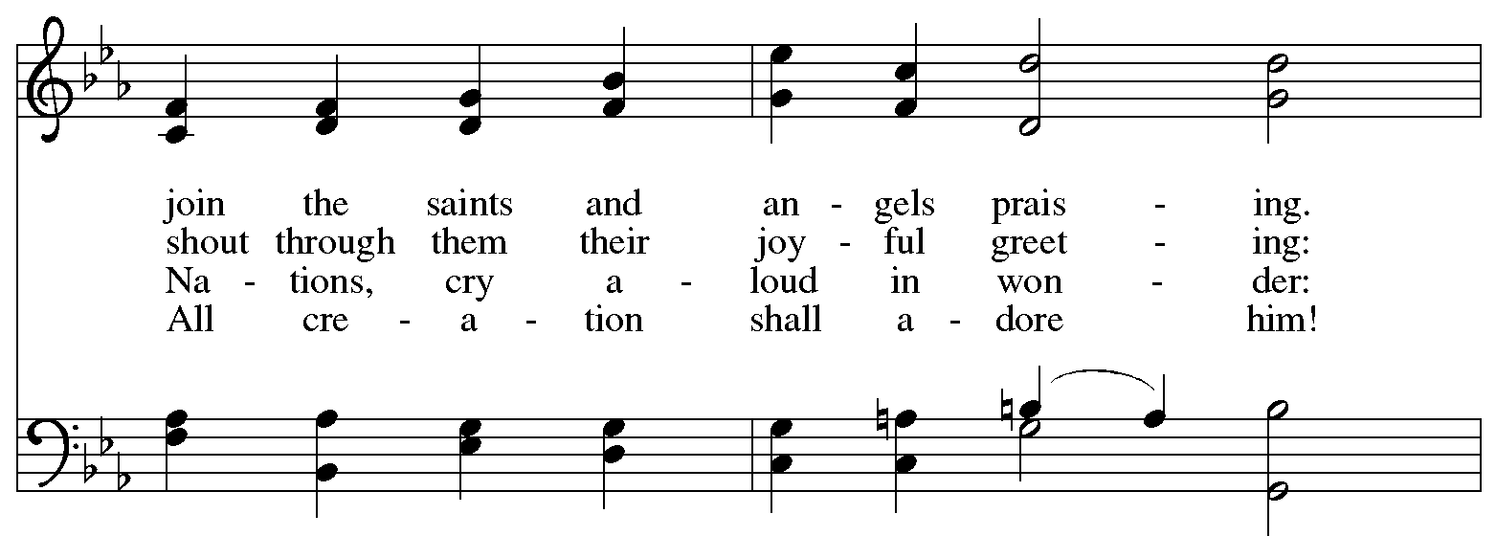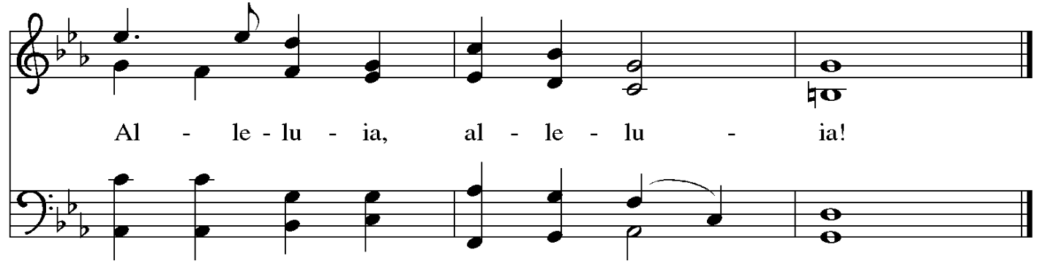

**Nicene Creed**

**C: We believe in one God,**

**the Father, the Almighty,**

**maker of heaven and earth,**

**of all that is, seen and unseen.**

**We believe in one Lord, Jesus Christ,**

**the only Son of God,**

**eternally begotten of the Father,**

**God from God, Light from Light,**

**true God from true God,**

**begotten, not made,**

**of one Being with the Father;**

**through him all things were made.**

**For us and for our salvation**

**he came down from heaven,**

**was incarnate of the Holy Spirit and the virgin Mary**

**and became truly human.**

**For our sake he was crucified under Pontius Pilate;**

**he suffered death and was buried.**

**On the third day he rose again**

**in accordance with the scriptures;**

**he ascended into heaven**

**and is seated at the right hand of the Father.**

**He will come again in glory to judge the living and the dead,**

**and his kingdom will have no end.**

**We believe in the Holy Spirit, the Lord, the giver of life,**

**who proceeds from the Father and the Son,\***

**who with the Father and the Son is worshiped and glorified,**

**who has spoken through the prophets.**

**We believe in one holy catholic and apostolic church.**

**We acknowledge one baptism for the forgiveness of sins.**

**We look for the resurrection of the dead,**

**and the life of the world to come. Amen.**

*Or, “who proceeds from the Father.” The phrase “and the Son” is a later addition to the creed.

**Prayers of the People**

A: Guided by the Holy Spirit, with the light of Christ shining upon us and all nations,

let us pray for the church, the world, and all creation.

*After each petition*

A: Gracious God,

**C: receive our prayer.**

*The presiding minister concludes the prayers*

P: We entrust these prayers to you, O God, in the sure and certain hope

that your promise is revealed among your people.

**C: Amen.**

**Peace**

*The presiding minister and the assembly greet one another in the peace of the risen Christ.*

P: The peace of Christ be with you always.

**C: And also with you.**

*The people may greet those around them with a sign of Christ’s peace and may say*

Peace be with you *or similar words. Please be mindful that not everyone will be comfortable with sharing the peace, so please seek consent before shaking hands or hugging. Other possible ways to share the peace include a simple bow with the verbal greeting of peace, or simply a verbal expression of peace. When the greetings of peace have concluded, please be seated.*

**Meal**

*God feeds us with the presence of Jesus Christ*

**Offering**

*We offer ourselves, our gifts, and our faithful service to God.*

*As the offering is gathered for the mission of the church, including the care of those in need,*

*the table is set for Holy Communion.*

**Reparations Offering**

*On the first Sunday of each month, St. Andrew invites people of the congregation to give a second offering for a reparations fund in acknowledgement of St. Andrew’s use of African American spiritual songs in our worship services. Please see the note in the announcements for more information.*

**Music during the Offering**

*Fairest Lord Jesus* arr. Brent Edstrom

*As the gifts are brought forward for presentation,* *please rise as you are able.*

**Offertory Song** **Cuando el pobre / When the Poor Ones *ELW*** **725**

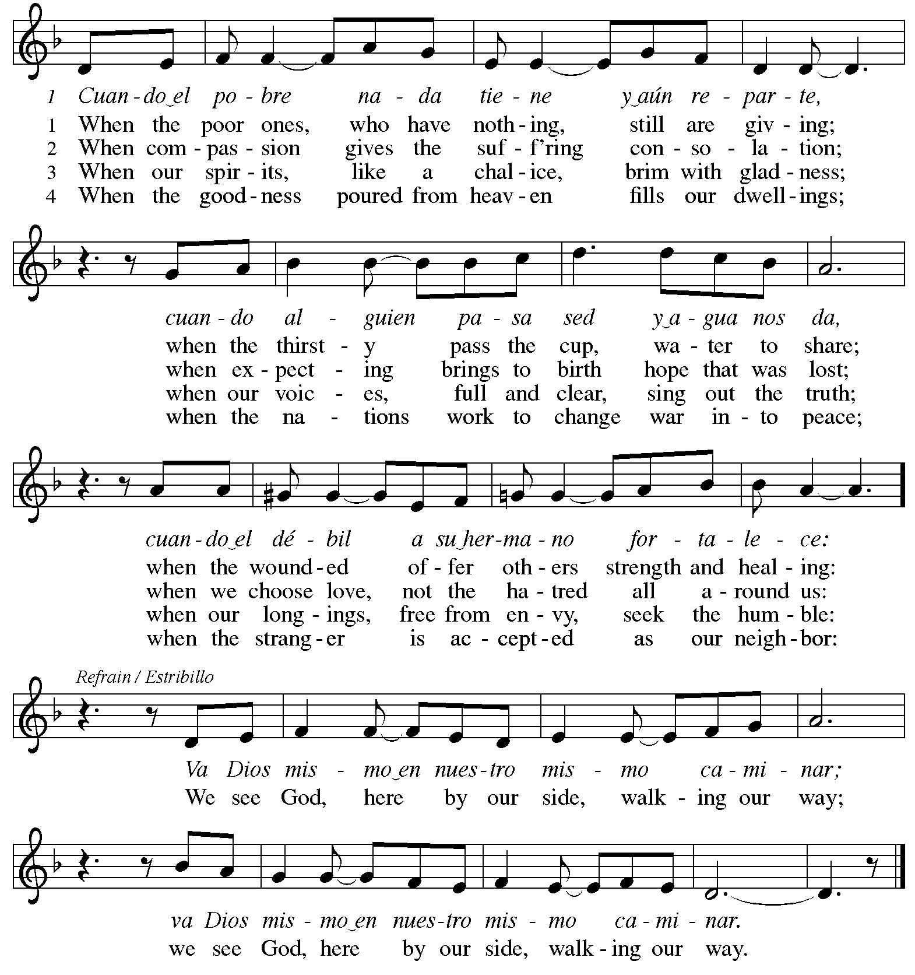

**Offertory Prayer**

A: Let us pray.

Holy God, gracious and merciful,

**C:** **you bring forth food from the earth and nourish your whole creation.**

**Turn our hearts toward those who hunger in any way, that all may know your care;**

**and prepare us now to feast on the bread of life, Jesus Christ, our Savior and Lord.**

**Amen.**

**Dialogue** *ACS* p. 20

P: The Lord be with you.

**C: And also with you.**

P: Lift up your hearts.

**C: We lift them to the Lord.**

P: Let us give thanks to the Lord our God.

**C: It is right to give our thanks and praise.**

**Preface** *ACS* p. 20

P: It is indeed right, our duty and our joy,

that we should at all times and in all places

give thanks and praise to you, almighty and merciful God,

through our Savior Jesus Christ;

who, sharing our life, lived among us to reveal your glory and love,

that our darkness should give way to your own brilliant light.

And so, with all the choirs of angels,

with the church on earth and the hosts of heaven,

we praise your name and join their unending hymn:

**Sanctus** *ACS* p. 20

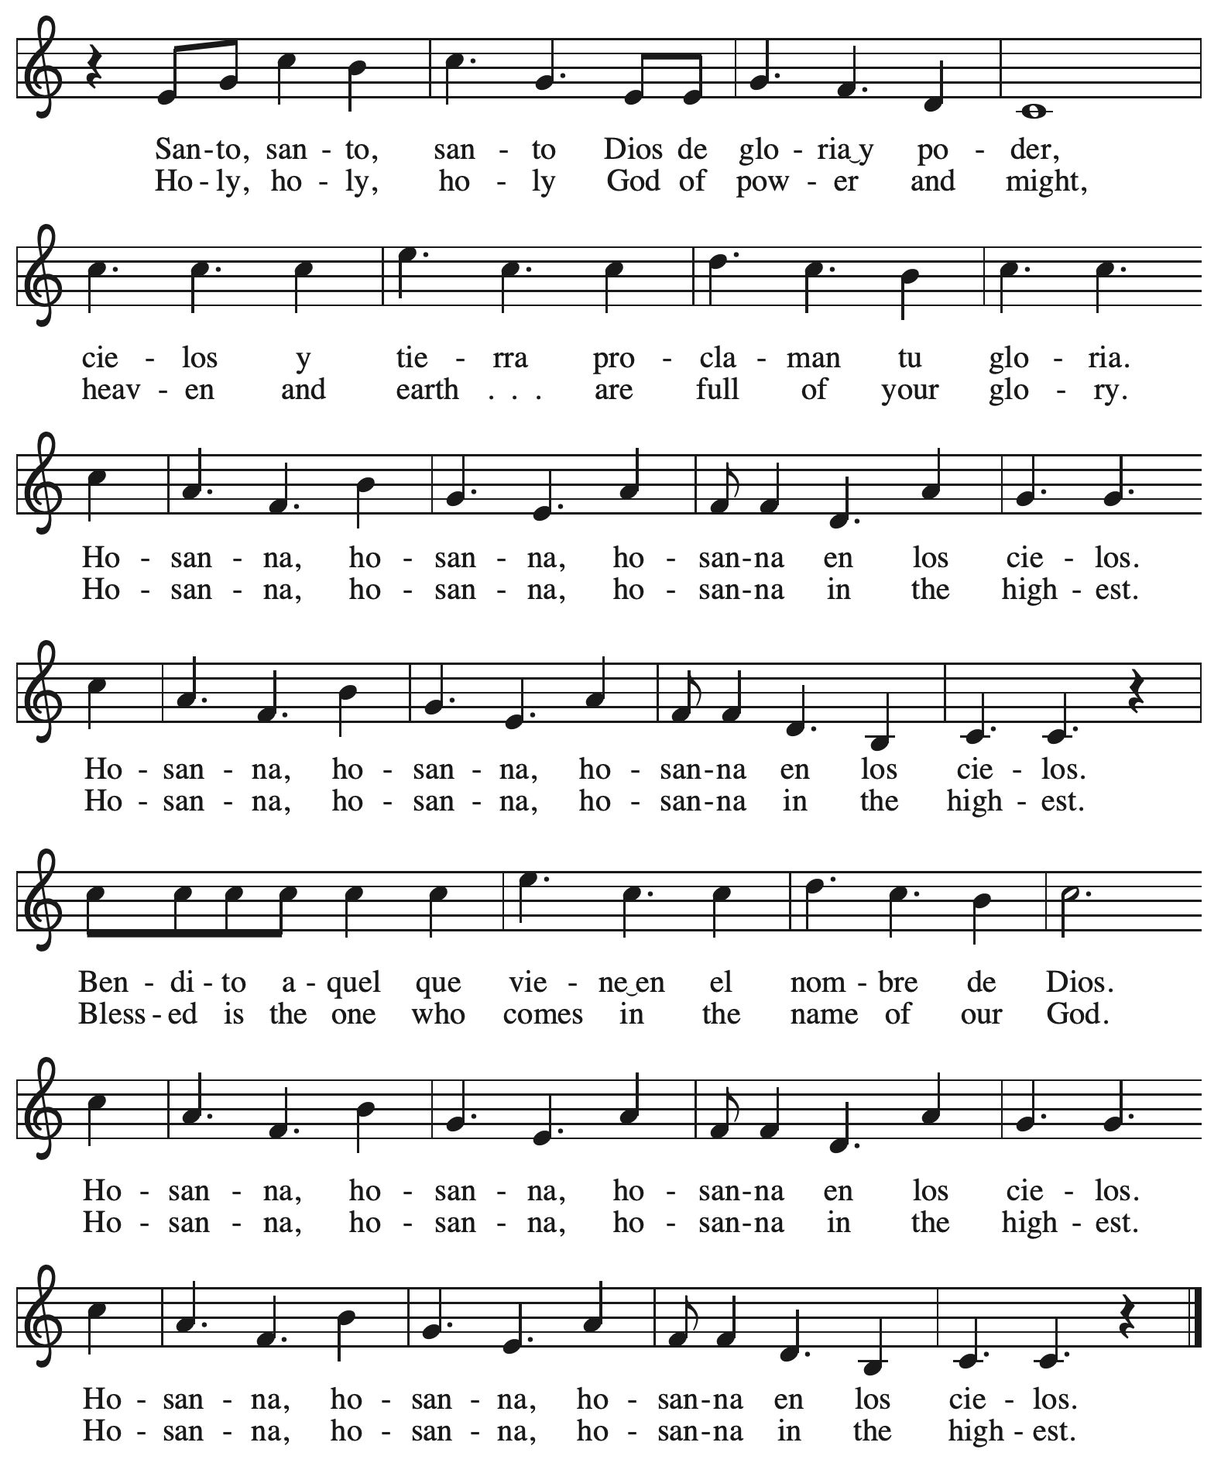

**Eucharistic Prayer** *ACS* p. 21

P: Holy God, you alone are holy … with every breath.

**C: We praise you, O God.**

P: Generations bless your faithfulness … into the future.

**C: We bless you, O God.**

P: We give you thanks for your dear Son … with us now.

**C: We thank you, O God.**

P: In the night in which he was betrayed … Do this for the remembrance of me.

Remembering his love for us

on the way, at the table, and to the end,

we proclaim the mystery of faith:

**C: Christ has died. Christ is risen. Christ will come again.**

P: We pray for the gift of your Spirit … in your church, without end.

**C: Amen.**

**Lord’s Prayer**

P: Gathered as one by the Holy Spirit, let us pray as Jesus taught us.

**C: Our Father in heaven,**

**hallowed be your name,**

**your kingdom come,**

**your will be done,**

**on earth as in heaven.**

**Give us today our daily bread.**

**Forgive us our sins**

**as we forgive those**

**who sin against us.**

**Save us from the time of trial**

**and deliver us from evil.**

**For the kingdom, the power,**

**and the glory are yours,**

**now and forever. Amen.**

**Fraction and Invitation**

P: The joy of the Lord is our strength.

Come and be nourished by the gifts of God.

***Agnus Dei /* Lamb of God** *ACS* p. 25

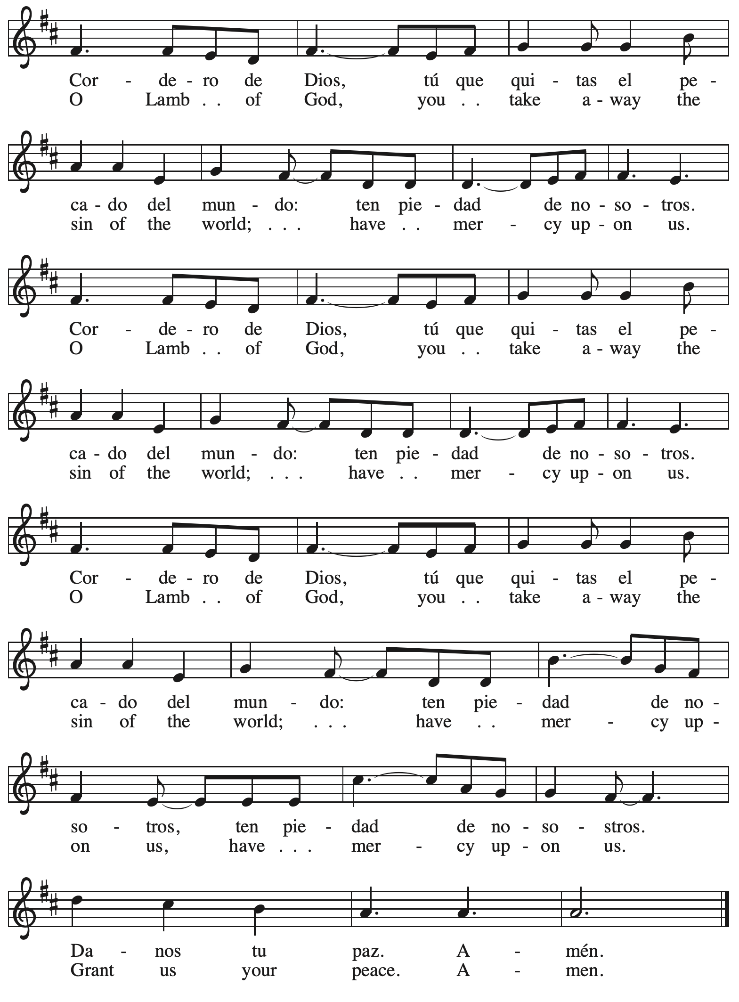

*Please be seated.*



**Holy Communion**

* *All who seek God and desire a deeper and stronger life in Christ are welcome to receive Holy Communion.*
* *Worshipers from the pulpit side will proceed forward first, followed by the center section, and then the lectern side.*
* *Please inform an usher if you would like the ministers to bring Communion to you.*
* *Holy Communion will be served with bread and wine/grape juice.*
* *The presiding minister will first distribute the bread (host) to each communicant. Please indicate if you require a gluten-free host.*
* *Once you have consumed the bread, please pick up an empty glass from the tray next to the presiding minister. The Communion Assistant will pour wine from the chalice or grape juice from the cruet into your glass.*
* *Please step to the side to consume the wine or grape juice.*
* *Feel free to kneel at the altar rail for prayer after receiving the sacrament.*
* *As you return to your pew, glasses may be returned to the empty trays on the side of the center section.*
* *A blessing will be provided for anyone who does not yet receive the sacrament.*
* *All are invited to join in singing the hymns during Holy Communion.*

**Hymns during Holy Communion**

**Come, Beloved of the Maker *ELW* 306**

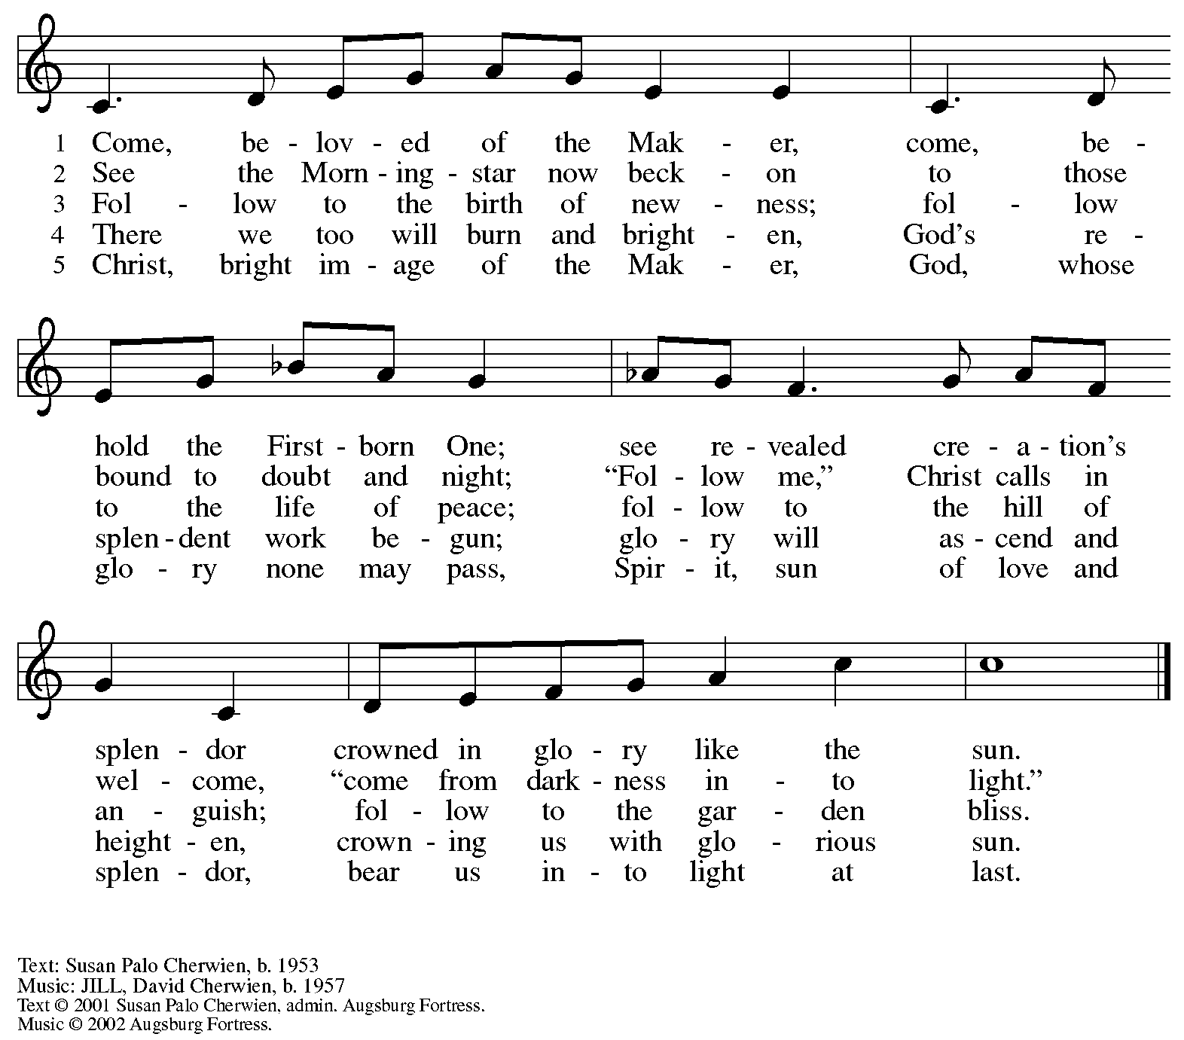

All rights reserved. Reprinted under OneLicense.net # A-722139.

**Hymns during Holy Communion**

**Dazzling Presence on the Mountain *ACS* 917**

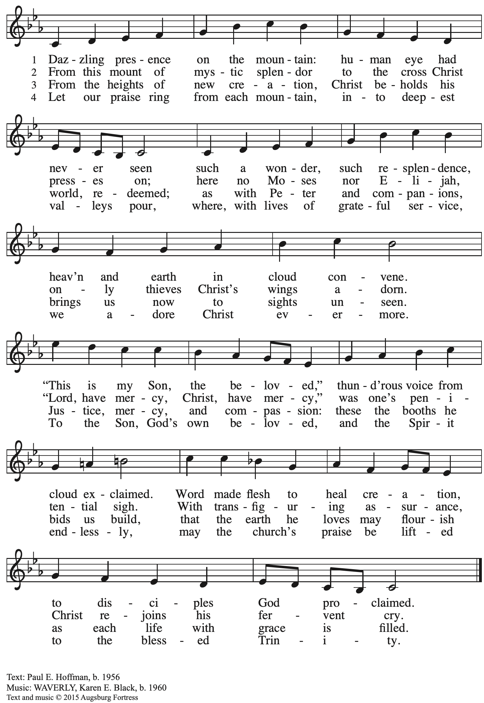

All rights reserved. Reprinted with permission under OneLicense.net # A-722139.

**Hymns during Holy Communion**

**Jesus, the Light of the World *ACS* 914**

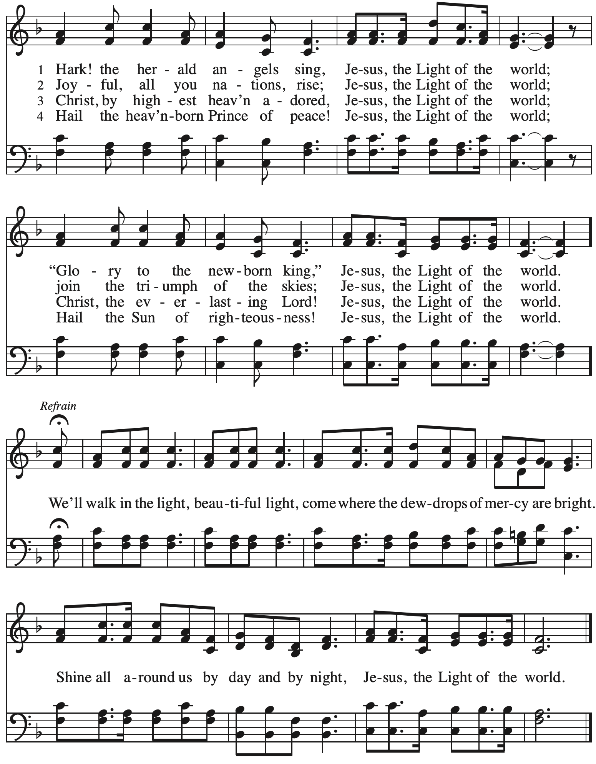

**Hymns during Holy Communion**

**Shine, Jesus, Shine *ELW* 671**

*No downloads were available for this hymn.*

*Please turn to hymn near the back of the ELW hymnal.*

*When all have returned to their places, please rise as you are able.*

**Blessing**

P: The body and blood of our Lord Jesus Christ strengthen you and keep you in his grace.

**C: Amen.**

**Prayer**

A: Let us pray.

O God, in this holy communion you have welcomed us into your presence,

nourished us with words of mercy, and fed us at your table. Amid the cares of this life, strengthen us to love you with all our heart, serve our neighbors with a willing spirit,

and honor the earth you have made; through Christ our Lord.

**C: Amen.**

*Please be seated.*

**Sending**

*God blesses us and sends us in mission to the world*

**Announcements**

*Please rise as you are able.*

**Benediction**

P: The holy Three, the holy One

increase your hope, strengthen your faith,

deepen your love, and ☩ grant you peace.

**C: Amen.**

*As the sending hymn begins, the ministers begin a procession toward the back of the church for the outdoor burning of the palms and burying of the Alleluias in preparation for Lent. The ashes from the palms will be used in the imposition of ashes at the start of the Lenten season on Ash Wednesday, March 5th. People of the congregation are invited to follow in procession and to gather on the accessible walkways for this brief conclusion to the service.*

**Sending Hymn Alleluia, Song of Gladness *ELW* 318**

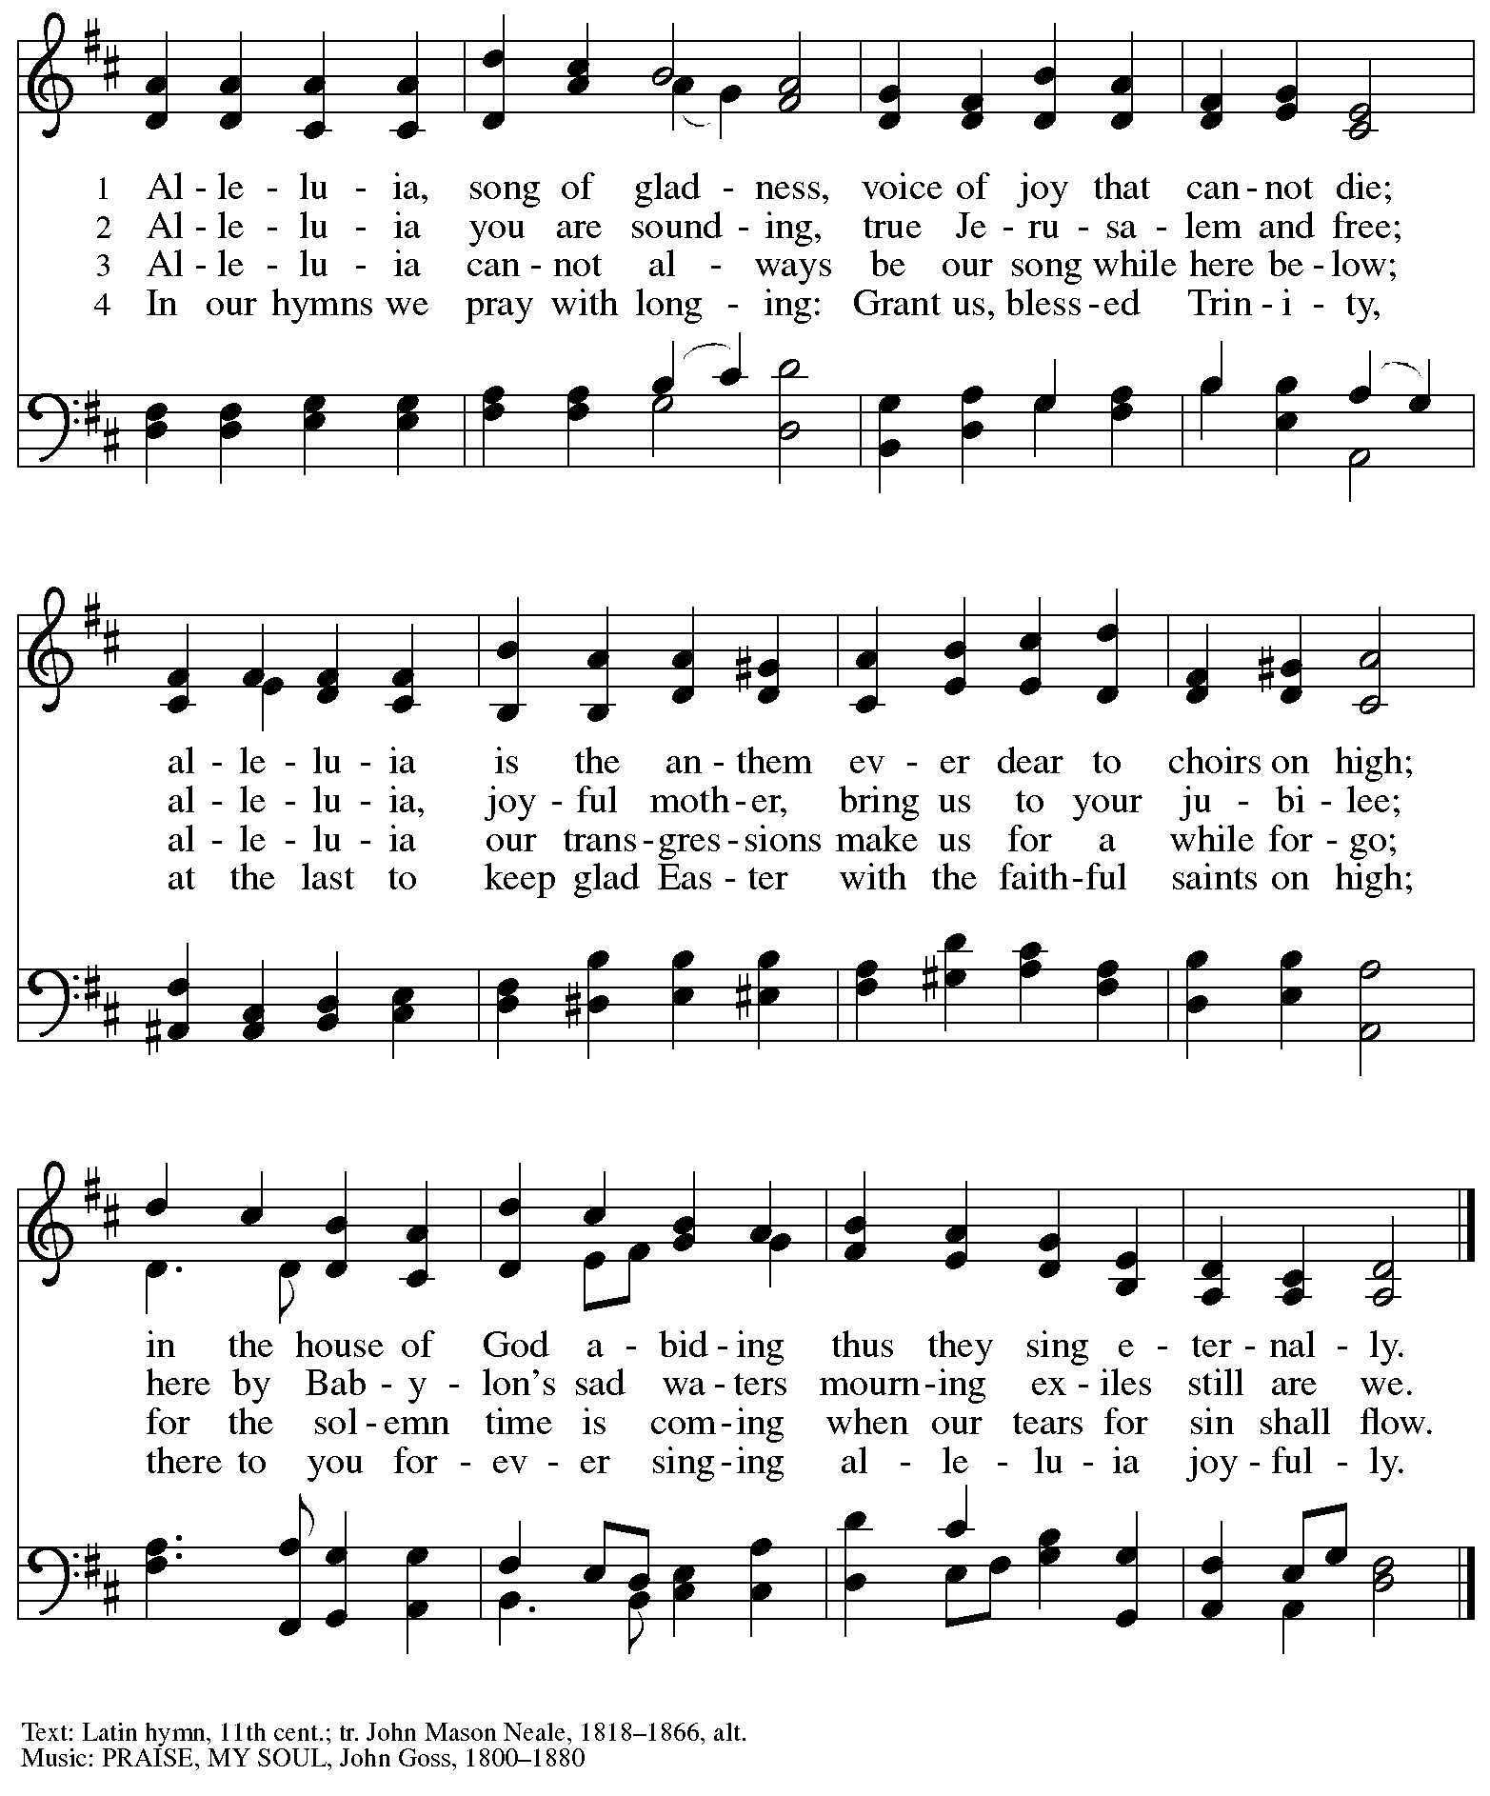

**Sealing of the Alleluia**

P: I heard a voice of a great multitude in heaven,

like the sound of many waters and like the sound of many thunderpeals, crying,

“Alleluia! For the Lord our God, the Almighty, reigns.” (Revelation 19: 1, 6)

**C: Alleluia! Alleluia! Amen.**

P: I heard a voice from heaven saying, “Blessed are the dead who from now on die in the Lord.”

“Yes,” says the Spirit, “they will rest from their labors.” (Revelation 14: 13)

So says the Church today of her Alleluia.

Today it dies, until it rises with Christ at his glorious resurrection.

**C: There is a time to be born, and a time to die;**

**a time to weep, and a time to laugh;**

**a time to mourn and a time to dance;**

**a time to keep silence, and a time to speak.**

(Eccl. 3: 2, 4, 7)

P: We bury our Alleluia now until that day when we celebrate in joy and gladness

the resurrection of our Lord Jesus Christ.

*As the Alleluias are placed in the box and sealed, the assembly sings slowly:*

**C: All glory, laud, and honor, to you redeemer king,**

**to whom the lips of children made sweet hosannas ring.**

**Burning of the Palms**

*A fire is lit for the burning of the palms.*

*Please observe a time of silence.*

*Once the fire is going and the palms are burning,*

*the presiding minister leads the congregation in prayer.*

**Prayer**

P: Beloved in Christ, let us ask God to bless these ashes,

which we will use as a sign of our repentance.

*Brief silence*

P: Lord God, bless the sinner who asks for your forgiveness,

and ☩ bless all who receive these ashes.

May we keep holy the Lenten season in preparation for the joy of Easter.

We ask this through Christ our Lord.

**C: Amen.**

**Benediction**

P: God, the source of glory,

God, the Word of life,

God, the Spirit of truth

☩ bless you now and forever.

**C: Amen.**

**Dismissal**

A: Go in peace. Christ is with you.

**C: Thanks be to God.**

*Those serving in worship*

Altar Care Jodie Minor

Assisting Minister Jeff Denlinger

Audio-Visual Ministers Jason Galyardt

Jered Stratton

Cantor The Rev. Erin Jones

Lector Kelly Spanninger

Little Church – Big Faith Teacher Emily Duque

Organ Jimmi Kocher-Hillmer

Pre-Service Music – Guitar Jered Stratton

Pre-Service Music – Piano Marit Bakken

Minister of Music Laura Reynolds

Presiding and Preaching Minister The Rev. Ross I. Carmichael

*Liturgy and Hymnody Acknowledgements*

From SundaysandSeasons.com. Copyright © 2025 Augsburg Fortress. All rights reserved. Reprinted under OneLicense.net # A-722139.

Used by permission of Augsburg Fortress.

The Scripture readings contained herein are from *New Revised Standard Version Updated Edition* of the Bible © 2021 National Council of Churches of Christ in the United States of America. Used by permission. All rights reserved worldwide.

**Jesus on the Mountain Peak** – Text: Brian A. Wren, b. 1936. Music: BETHOLD, Mark Sedio, b. 1954. Text © 1977, rev. 1995 Hope Publishing Company, Carol Stream, IL 60188. All rights reserved. Used by permission. Music © 2006 Augsburg Fortress. All rights reserved. Reprinted with permission under OneLicense.net # A-722139.

**Cuando el pobre / When the Poor Ones** – Text: José Antonio Olivar, b. 1939; tr. Martin A. Seltz, b. 1951. Music: EL CAMINO, Miguel Manzano, b. 1934. Text and music © 1971, 1998 J.A. Olivar, Miguel Manzano, and San Pablo Internacional – SSP, admin. OCP Publications, 5536 NE Hassalo, Portland, OR 97213. All rights reserved. Reprinted with permission under OneLicense.net # A-722139.

**Jesus, the Light of the World** – Text: Charles Wesley, 1707-1788, stanzas; George D. Elderkin, 1845-1928, refrain. Music: WE’LL WALK IN THE LIGHT, Traditional; arr. George D. Elderkin.

*Please use the QR code below to link to St. Andrew’s Announcements online!*



**St. Andrew Lutheran Church Announcements**

**March 2nd, 2025**

* **Welcome to worship at St. Andrew on the + Transfiguration of our Lord, March 2nd,** –We are so glad you are here, and we offer a special welcome to all visitors and guests who are here for the first time! Worship attendees are invited to make a name tag at the back of the worship space. Little Church – Big Faith, a Bible lesson and activity for children, will take place after the prayer of the day. There are worship “toolkits” to help children engage with worship and “busy bags” for younger children available in the bookcase at the back of the sanctuary. Please feel free to take one to use with/for your children. All are invited to gather for coffee, other drinks, food, and conversation in the social hall after worship.
* **Monthly Reparations Offering during Worship Today** – In Luke’s Gospel, Jesus tells a story about a compassionate Samaritan that suggests God’s people are called to work for healing and restoration for our neighbors, regardless of who or what caused them harm. In light of this, St. Andrew has made a commitment to reparations in regard to African American spiritual songs used in our worship. The text and music of most hymns is attributed to specific authors, with copyrights in place, usage reported, and royalties paid to those whose works are featured in worship. With African American spirituals, this is not possible. In response to many years of such uncredited use, St. Andrew invites the congregation to give a reparations offering. Funds received in worship will be donated to our siblings at Bethel AME Church, whose land and building were taken from them in the 1950s, to fund their development in the Hill District.
* **Pancake Brunch during Coffee Hour Today after Worship – Traditionally on Shrove Tuesday, the day before Ash Wednesday, Christians would clear out all the rich and fatty foods from their cupboards in preparation for the season of Lent and its spiritual discipline of fasting. Following this custom, St. Andrew used to hold a pancake dinner on Shrove Tuesday, but we have not done so since before the pandemic. We are re-introducing the practice and spirit of Shrove Tuesday after worship today. At the close of worship, we will have a brief outdoor liturgy for the burning of the palms and then proceed to the social hall for a meal together. We hope you will join in these activities as we prepare for the season of Lent, beginning on Ash Wednesday, March 5th.**
* **March Produce Distribution – First Tuesday of the Month, March 4th, from 5:30-7:00 p.m. –** St. Andrew partners with Greater Pittsburgh Community Food Bank to serve as a distribution site for fresh produce on the first Tuesday of every month. This month’s distribution will be on Tuesday, March 4th. We invite people of the congregation to help with the distribution from 5:30-7:00 p.m. and/or to help with unloading and setup during the day between 10:00 a.m. and 1:00 p.m.
* **Ash Wednesday Worship, March 5th:**
  + **Service for Children and Families – 5:30 p.m.**
  + **Service with Imposition of Ashes and Holy Communion – 7:00 p.m.**

The season of Lent, a time of repentance, spiritual practice, and baptismal reflection begins this year on March 5th. St. Andrew will offer two services that day. The first, at 5:30 p.m., will offer an introduction to the day and season designed for children through 6th grade. Imposition of Ashes will be available at that service as well as at the 7:00 p.m. service, which will also include the sacrament of Holy Communion. Blessings to all as we prepare for the season of Lent.

* **Lenten Food Drive for St. Andrew’s Pantry** – One of the spiritual disciplines of the season of Lent is almsgiving – generous giving on behalf of neighbors in need. In the spirit of Lent, we are inviting people of the congregation to donate nonperishable food items to help replenish the congregation’s outdoor pantry. **Suggested items include**: Packs of chicken, tuna, or pork (any flavor); cans of Vienna sausage, potted meat, spam; cans of beef stew, beefaroni, ravioli; boxes of macaroni and cheese, stuffing, or mashed potatoes; cups of applesauce – any flavor; granola bars, rice Krispie treat bars; boxes of cookies or crackers; small bags or boxes of cereal – any kind; shelf stable milk; case of water; cans of vegetables and fruits. All canned items must have a pull tab to open.Items may be placed on the donation table in the social hall throughout the season of Lent.
* ***Life Renewed: Devotions for Lent 2025* Available at Church Entrances** – Another of the spiritual disciplines for the season of Lent is prayer, so each year, the worship committee provides copies of a daily devotional booklet. This year’s is titled *Life Renewed*, and it contains a brief scripture reading, reflection/quote, and prayer for each day from Ash Wednesday (March 5th) to the Vigil of Easter (April 19th. They are now available at the entrances to the building – please take one to aid in your devotions this Lent!
* **Community Ministry Meeting – Monday, March 10th, at 7:00 p.m. on Zoom – St. Andrew’s community ministry committee coordinates our local service ministries such as the outdoor Little Library, the pantry, produce distribution, shelter dinner, and various other activities. New participants are always welcome, and the next meeting is Monday, March 10th, at 7:00 p.m. on Zoom. Please contact** [PastorRCarmichael@gmail.com](mailto:PastorRCarmichael@gmail.com) **or** [community@standrewpittsburgh.org](mailto:community@standrewpittsburgh.org) **if you would like the link.**
* **Next Council Meeting – Saturday, March 15th, at 9:00 a.m. – St. Andrew’s congregation council meets once a month to guide the mission and general operations of the church. It is made up of 13 members of the congregation and the pastor. The next meeting of the council is Saturday, March 15th, at 9:00 a.m. We invite your prayers for St. Andrew’s council leaders!**
* **Shelter Dinner for Guests of East End Cooperative Ministry, Third Thursday of the Month – March 20th, 6:00 p.m. Arrival, 6:30 p.m. Dinner –** Each month, people of St. Andrew provide dinner for guests of East End Cooperative Ministry (EECM), 6140 Station St. (East Liberty), 15206. We invite you to prepare or purchase one menu item and bring it to the shelter by 6:00 p.m., or just come to help serve at 6:30 p.m. If you would like to contribute, please sign up here:

<https://www.signupgenius.com/go/5080544AAAC22A1F58-55360310-shelter>.

* **Bagged Lunches to Accompany EECM February Shelter Dinner on March 20th – Seeking Additional Donations! – East End Cooperative Ministry is hosting an additional 20 people this winter because of the shelter shortage and we have been asked to bring items for 20 bagged lunches on St. Andrew’s Shelter Dinner night, Thursday, March 20th.** **This month we only need 20 sandwiches and 20 soft fruits (any kind) – we have already received donations for the other items. Shelf-stable items can be left on the donation table in the Social Hall by Sunday, March 16th, or delivered to EECM on Thursday, March 20th. Please label “For EECM Lunches.” Sandwiches should be delivered to EECM any time on the 20th until 6:00 p.m. Please label “For St. Andrew bagged lunches.” Shelter staff will assemble the bagged lunches. Much work goes into shopping for and preparing the main meal each month, so we would greatly appreciate new participants and contributions for this effort! If you would like to help, please sign up at:**

<https://www.signupgenius.com/go/5080544AAAC22A1F58-55354631-baglunches>.

* **Congregational Meeting – Sunday, March 23rd, after Worship – Every year in February or March St. Andrew holds a meeting of the congregation. This meeting is an opportunity to review the past year in ministry, receive an update on the congregation’s end-of-year financial status, share updates on current initiatives, and look ahead toward upcoming events. This year’s meeting will be held after worship on Sunday, March 23rd. Representatives from Partners for Sacred Places, with whom we are working on a feasibility study for a capital campaign, will be here over that weekend. No absentee or proxy votes can be accepted so please plan to attend the meeting, in person or via Zoom (same as Sunday worship link).**
* **Help Re-Stock Outdoor Little Library!** – If you are interested in stocking the little library that is on the Centre Avenue side of the church, there are extra books in the metal cabinet to the right of the dumbwaiter.  (There are currently some 10% off coupons for Half Price Books that are good throughout the year.)  The current stock of books are from the challenged or banned book lists.  Here are two lists:  (<https://www.ala.org/bbooks>) (<https://en.wikipedia.org/wiki/List_of_most_commonly_challenged_books_in_the_United_States>).
* **Compline Prayer Service with the Pittsburgh Compline Choir – Sundays at 8:00 p.m. at Heinz Chapel –** Compline was traditionally a monastic prayer service, and the Pittsburgh Compline Choir, a ministry of Lutheran Campus Ministry in Greater Pittsburgh, sings a choral version of compline rooted in this thousand-year-old tradition of scripture, song, and silence each Sunday at Heinz Chapel at 8:00 p.m. This service also streams on Facebook (Pittsburgh Compline Choir) and YouTube (The Pittsburgh Compline Choir). Heinz Chapel is located off of S. Bellefield Ave. in Oakland. For more information, please visit: [Pittsburgh Compline Choir](http://pittsburghcomplinechoir.org/).