****

**+ The Presentation of our Lord**

**February 2nd, 2025**

**10:00 a.m.**

******

**St. Andrew Lutheran Church**

**304 Morewood Ave.**

**Pittsburgh, PA 15213**

**412.682.3342**

[**St\_andrewELCA@verizon.net**](mailto:St_andrewELCA@verizon.net)

[**www.standrewpittsburgh.org**](http://www.standrewpittsburgh.org)

**+ The Presentation of our Lord**

**Order for Worship**

*The Presentation of Our Lord is referred to in some corners of the church as Candlemas because of an ancient tradition of blessing all the candles to be used in the church in the coming year at the mass celebrated on that day. It was a way of underscoring the truth of Simeon’s confession that this baby Jesus was “a light for revelation to the Gentiles” and a light for glory to Israel. Let the light of every candle in church be a little epiphany of the love of God for all people in the person of God’s son, Jesus, the light of the world.*

**Welcome to St. Andrew!**

* St. Andrew welcomes all who are seeking a place of healing, wholeness, and acceptance in a nurturing and faith-forming spiritual home. We are striving toward racial equity worldwide

and we seek to honor the lived experience of all individuals regardless of background. Our community embraces people of all ages, ethnicities, cultures, abilities, sexual orientations,

gender identities and expressions, and family constellations. Come and See!

* Worship Services are live-streamed to multiple online platforms. By attending worship, you agree that your image and voice may be broadcast.
* Everyone is invited to make a name tag at the black bookcase in the back of the worship space if they would like. There are stickers indicating pronouns on the bookcase if you would like to include them on your name tag.
* Children are invited to attend Little Church – Big Faith, a Bible lesson and activity, during worship (after the Prayer of the Day). The group returns to the worship space for the liturgy of Holy Communion.
* A nursery is available through the doors at the left side of the sanctuary and across from the doorway to the Social Hall. Look for a purple-colored room.
* Worship “toolkits” to help children engage with the service, along with “busy bags” for younger children, are available in the bookcase at the back of the sanctuary. Please feel free to take one to use with/for your children.
* Holy Communion is served with bread (gluten-free available) and wine or grape juice. The presiding minister will distribute the bread (host). Please consume this and then pick up an empty glass from the tray. The Communion Assistant will pour wine or grape juice into your glass. Please step to the side to consume the wine or grape juice. Feel free to kneel at the altar for prayer and reflection. As you return to your pew, glasses may be returned to the empty trays on either side of the center section.
* A restroom is available on the main level of the church, through the doors to the Social Hall and to the right in the main office.

*Abbreviations*

P: Pastor/Presiding Minister ***ELW*: *Evangelical Lutheran Worship* hymnal**

A: Assisting Minister ***ACS*: *All Creation Sings* hymnal**

L: Lector

**C: Congregation**

**Pre-Service Music**

**Welcome**

**Prelude** *Lord of the Dance* Shaker Melody

arr. John Ritter

St. Andrew Choir

**Gathering**

*The Holy Spirit calls us together as the people of God*

**Thanksgiving for Baptism**

*Please rise as you are able. All may make the sign of the cross,*

*the sign that is marked at Baptism, as the presiding minister begins.*

P: Blessed be the holy Trinity, ☩ one God,

the fountain of living water, the rock who gave us birth,

our light and our salvation.

**C: Amen.**

P: Joined to Christ in the waters of Baptism, we are clothed with God’s mercy and forgiveness. Let us give thanks for the gift of Baptism.

*Water may be poured into the font as the presiding minister gives thanks*

P: We give you thanks, O God, for in the beginning you created us in your image and placed us in a well-watered garden. In the desert, you promised pools of water for the parched, and you gave us water from the rock. When we did not know the way, you sent the Good Shepherd to lead us to still waters. At the cross, you washed us from Jesus’ wounded side, and on this day, you shower us again with the water of life.

We praise you for your salvation through water, for the water in this font,

and for all water everywhere, including the Allegheny, Monongahela, and Ohio rivers.

Bathe us in your forgiveness, grace, and love.

Satisfy all who thirst, and give us the life only you can give.

To you be given honor and praise

through ☩ Jesus Christ, our living water,

in the unity of the Holy Spirit, now and forever.

**C: Amen.**

**Gathering Hymn God Is Here! *ELW* 526**

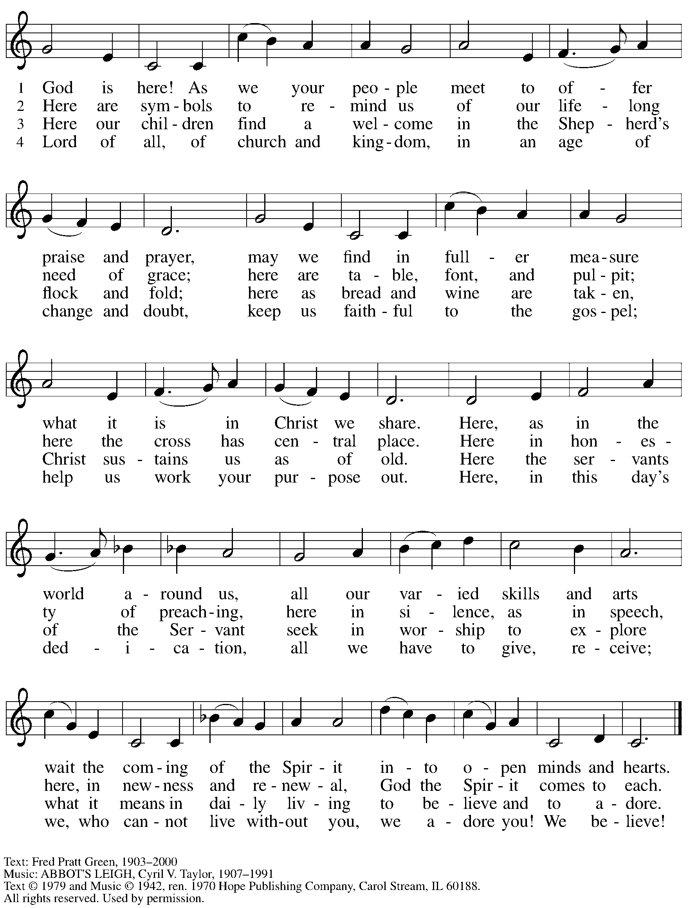

Reprinted under OneLicense.net # A-722139.

**Greeting**

P: The grace of our Lord Jesus Christ, the love of God,

and the communion of the Holy Spirit be with you all.

**C: And also with you.**

**Kyrie** *ACS* p. 12

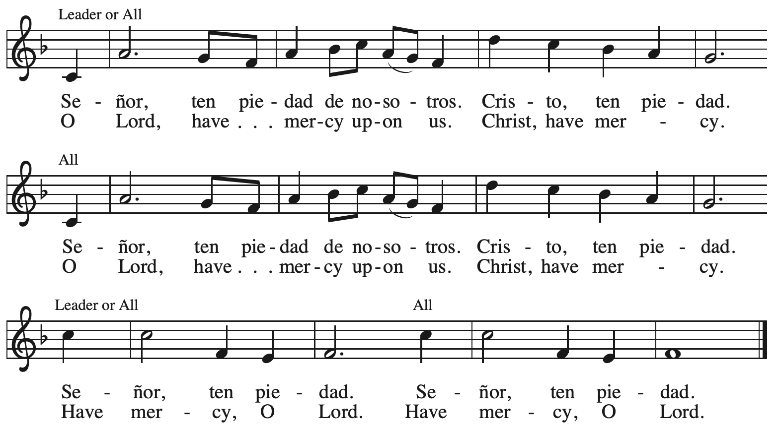

****

**Hymn of Praise** *ACS* p. 12

**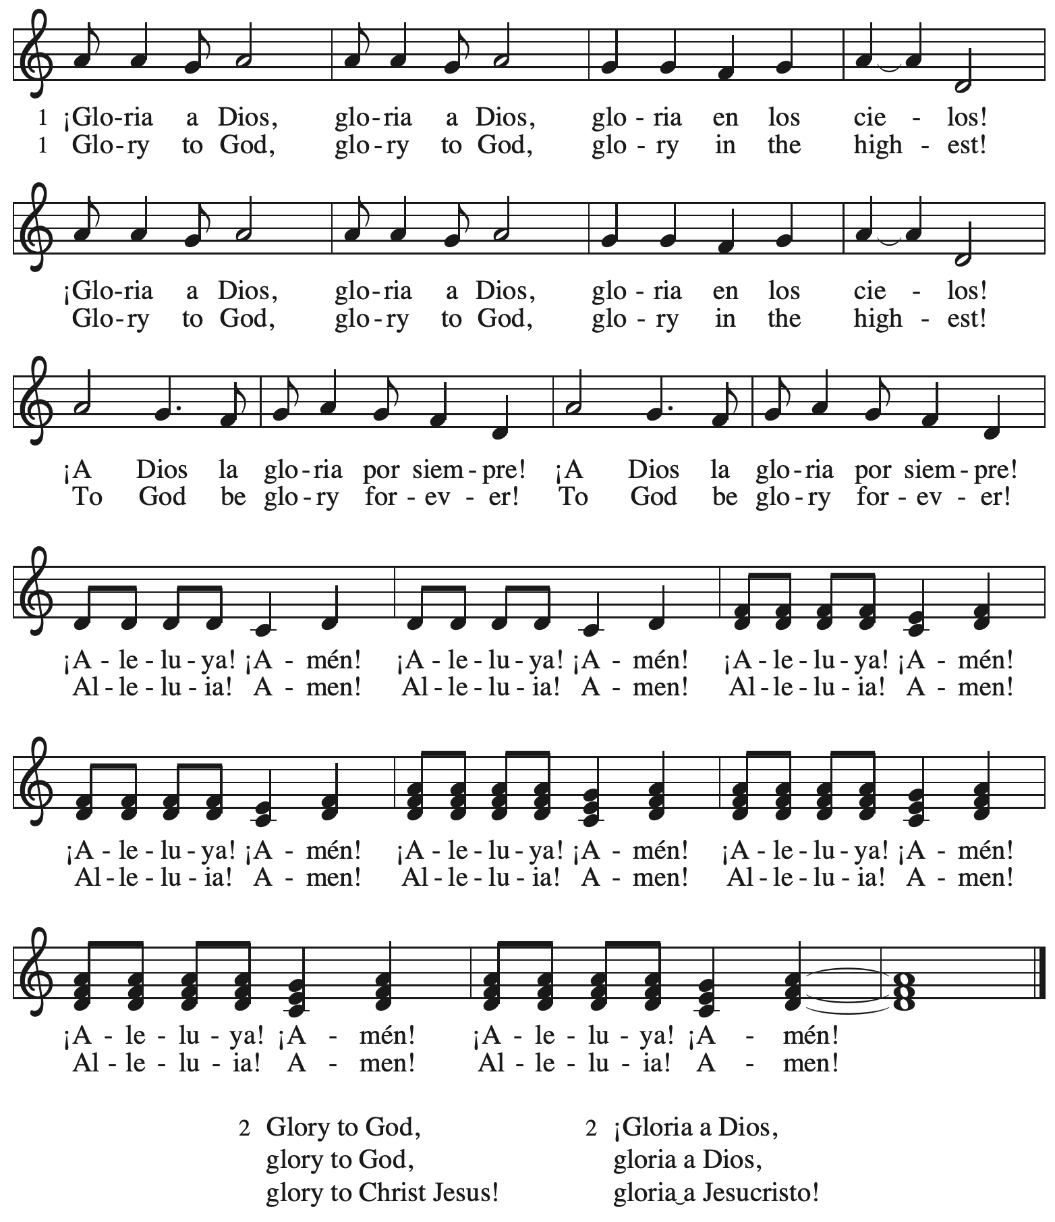**

**Prayer of the Day**

P: The Lord be with you.

**C: And also with you.**

P: Let us pray.

Almighty and ever-living God, your only-begotten Son was presented this day in the temple. May we be presented to you with clean and pure hearts by the same Jesus Christ, our great high priest, who lives and reigns with you and the Holy Spirit, one God, now and forever.

**C: Amen.**

*Please be seated.*

**Word**

*God speaks to us in Scripture reading, preaching, and song*

**First Reading** **–** **Malachi 3: 1-4**

1 See, I am sending my messenger to prepare the way before me, and the Lord whom you seek will suddenly come to his temple. The messenger of the covenant in whom you delight—indeed, he is coming, says the Lord of hosts. 2 But who can endure the day of his coming, and who can stand when he appears?  
  For he is like a refiner’s fire and like fullers’ soap; 3 he will sit as a refiner and purifier of silver, and he will purify the descendants of Levi and refine them like gold and silver, until they present offerings to the Lord in righteousness. 4 Then the offering of Judah and Jerusalem will be pleasing to the Lord as in the days of old and as in former years.

L: Word of God, word of life.

**C: Thanks be to God.**

**Psalm 84**

*The cantor will lead the singing of the psalm.*

*The congregation is invited to respond with the alternate verses in bold print,*

*and to join in singing the refrain.*

*Psalm Tone*

*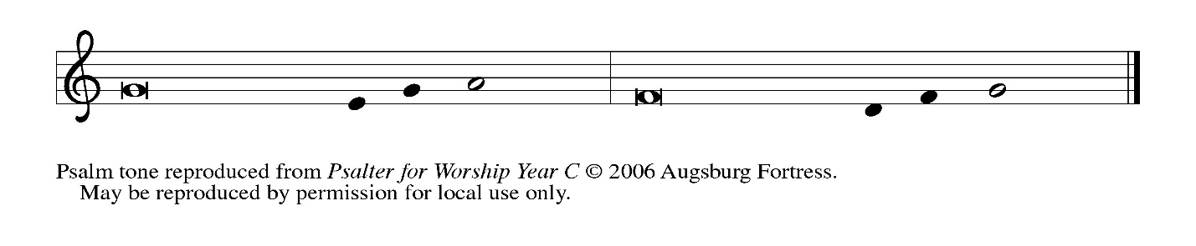*

*Psalm Refrain*

*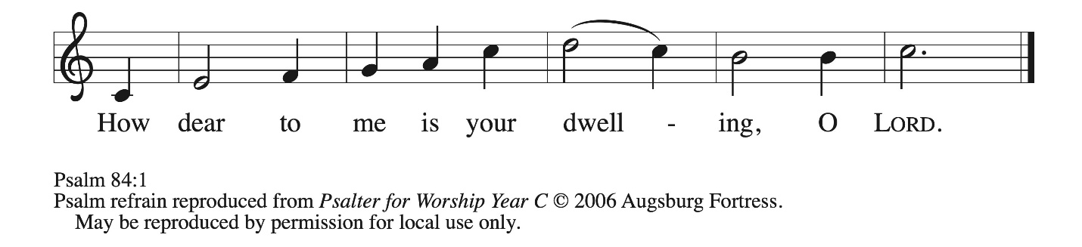*

1 How dear to me **|** is your dwelling,  
  O **|** Lord of hosts!  
 2 **My soul has a desire and longing for the courts | of the Lord;**  
  **my heart and my flesh rejoice in the | living God.**  
 3 Even the sparrow has found a home, and the swallow a nest where she may **|** lay her young,  
  by the side of your altars, O Lord of hosts, my king **|** and my God.  
 4 **Happy are they who dwell | in your house!**  
  **They will always be | praising you. R**  
 5 Happy are the people whose strength **|** is in you,  
  whose hearts are set on the **|** pilgrims’ way.  
 6 **Those who go through the balsam valley will find it a | place of springs,**  
  **for the early rains have covered it with | pools of water.**  
 7 They will climb from **|** height to height,  
  and the God of gods will be **|** seen in Zion.  
 8 **Lord God of hosts, | hear my prayer;**  
  **give ear, O | God of Jacob. R**  
 9 Behold our defend- **|** er, O God;  
  and look upon the face of **|** your anointed.  
 10 **For one day in your courts is better than a | thousand elsewhere.**  
  **I would rather stand at the threshold of the house of my God than dwell in the tents | of the wicked.**  
 11 For the Lord God is both sun and shield, bestowing **|** grace and glory;  
  no good thing will the Lord withhold from those who walk **|** with integrity.  
 12 **O | Lord of hosts,**  
  **happy are they who put their | trust in you! R**

**Second Reading – Hebrews 2: 14-18**

14 Since, therefore, the children share flesh and blood, [Jesus] himself likewise shared the same things, so that through death he might destroy the one who has the power of death, that is, the devil, 15 and free those who all their lives were held in slavery by the fear of death. 16 For it is clear that he did not come to help angels, but the descendants of Abraham. 17 Therefore he had to become like his siblings in every respect, so that he might be a merciful and faithful high priest in the service of God, to make a sacrifice of atonement for the sins of the people. 18 Because he himself was tested by what he suffered, he is able to help those who are being tested.

L: Word of God, word of life.

**C: Thanks be to God.**

*Please rise as you are able and join in singing the Gospel Acclamation.*

**Gospel Acclamation** *ACS* p. 14

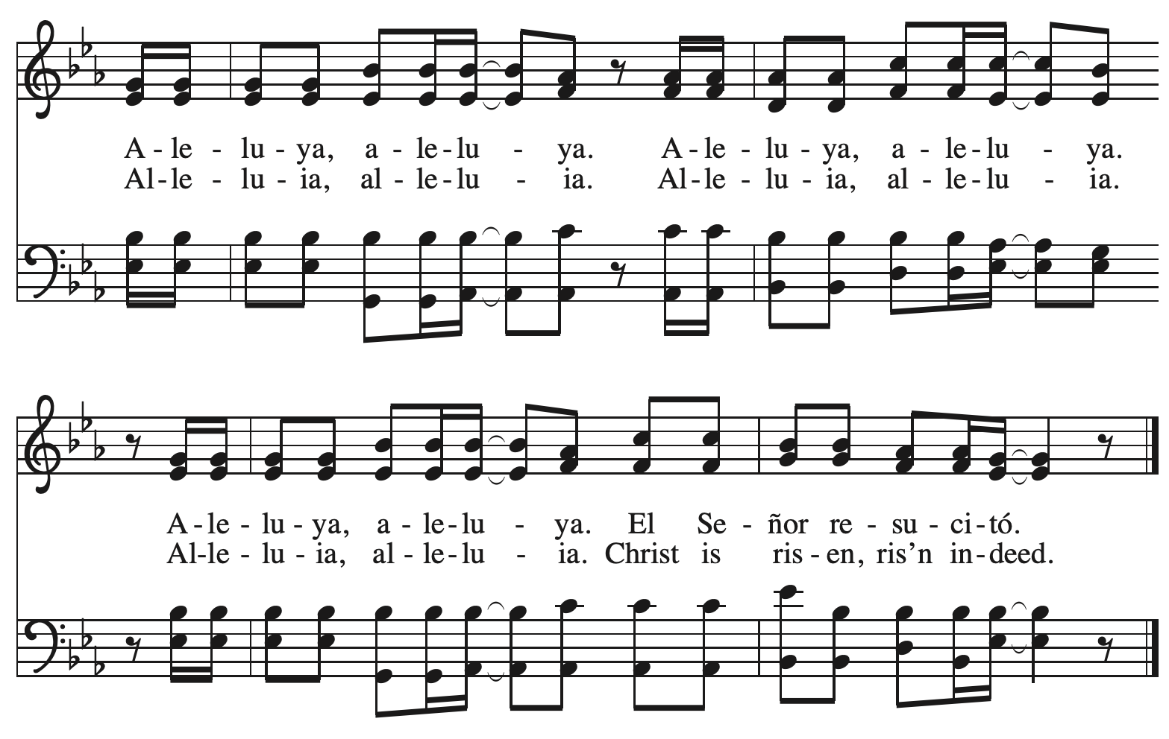

**Gospel – Luke 2: 22-40**

P: The holy Gospel according to St. Luke.

**C: Glory to you, O Lord.**

22 When the time came for their purification according to the law of Moses, [Mary and Joseph]

brought [Jesus] up to Jerusalem to present him to the Lord 23 (as it is written in the law of the Lord, “Every firstborn male shall be designated as holy to the Lord”), 24 and they offered a sacrifice according to what is stated in the law of the Lord, “a pair of turtledoves or two young pigeons.”  
  25 Now there was a man in Jerusalem whose name was Simeon; this man was righteous and devout, looking forward to the consolation of Israel, and the Holy Spirit rested on him. 26 It had been revealed to him by the Holy Spirit that he would not see death before he had seen the Lord’s Messiah. 27 Guided by the Spirit, Simeon came into the temple; and when the parents brought in the child Jesus, to do for him what was customary under the law, 28 Simeon took him in his arms and praised God, saying,  
 29 “Master, now you are dismissing your servant in peace,  
  according to your word;  
 30 for my eyes have seen your salvation,  
  31 which you have prepared in the presence of all peoples,  
 32 a light for revelation to the Gentiles  
  and for glory to your people Israel.”  
  33 And the child’s father and mother were amazed at what was being said about him. 34 Then Simeon blessed them and said to his mother Mary, “This child is destined for the falling and the rising of many in Israel, and to be a sign that will be opposed 35 so that the inner thoughts of many will be revealed—and a sword will pierce your own soul too.”  
  36 There was also a prophet, Anna the daughter of Phanuel, of the tribe of Asher. She was of a great age, having lived with her husband seven years after her marriage, 37 then as a widow to the age of eighty-four. She never left the temple but worshiped there with fasting and prayer night and day. 38 At that moment she came, and began to praise God and to speak about the child to all who were looking for the redemption of Jerusalem.  
  39 When they had finished everything required by the law of the Lord, they returned to Galilee, to their own town of Nazareth. 40 The child grew and became strong, filled with wisdom; and the favor of God was upon him.

P: The Gospel of the Lord.

**C: Praise to you, O Christ.**

*Please be seated.*

**Sermon**

*A time of silence for prayer and reflection follows the sermon.*

*As the hymn of the day begins, please rise as you are able.*

****

**Hymn of the Day In His Temple Now Behold Him *ELW* 417**

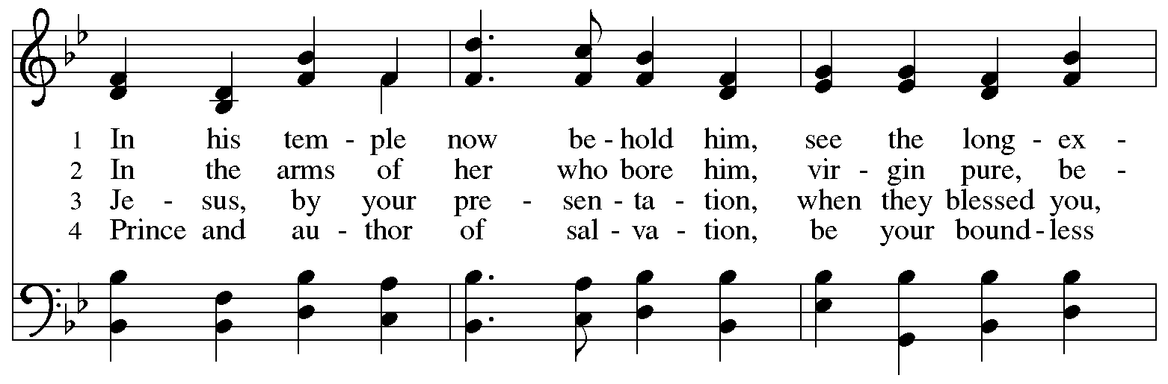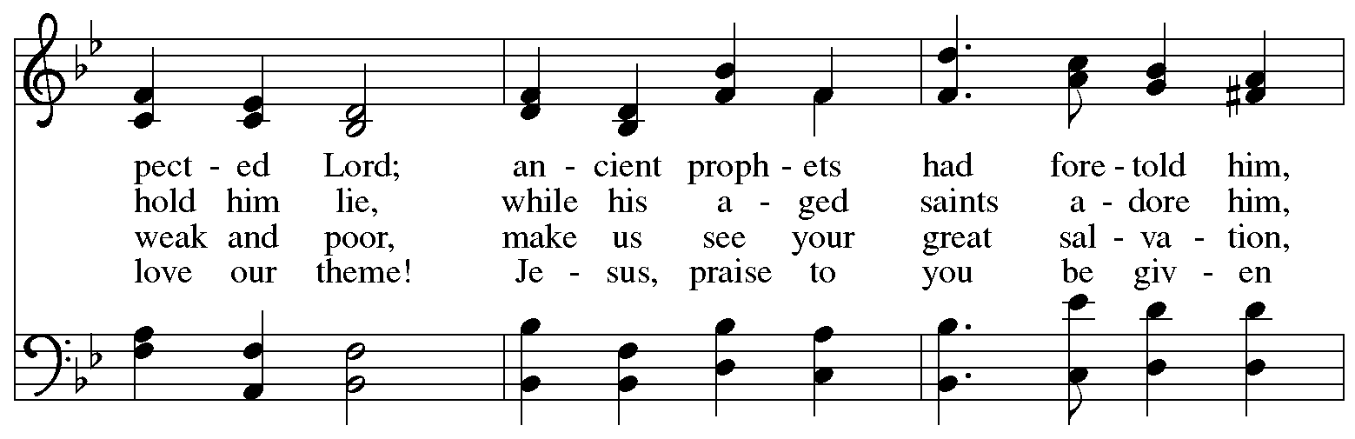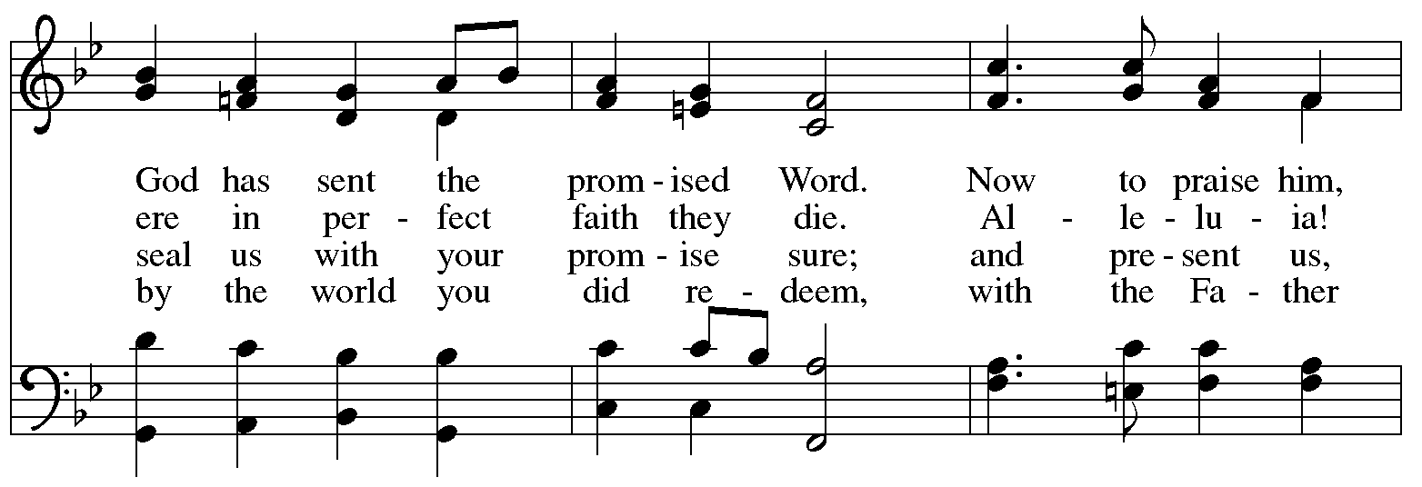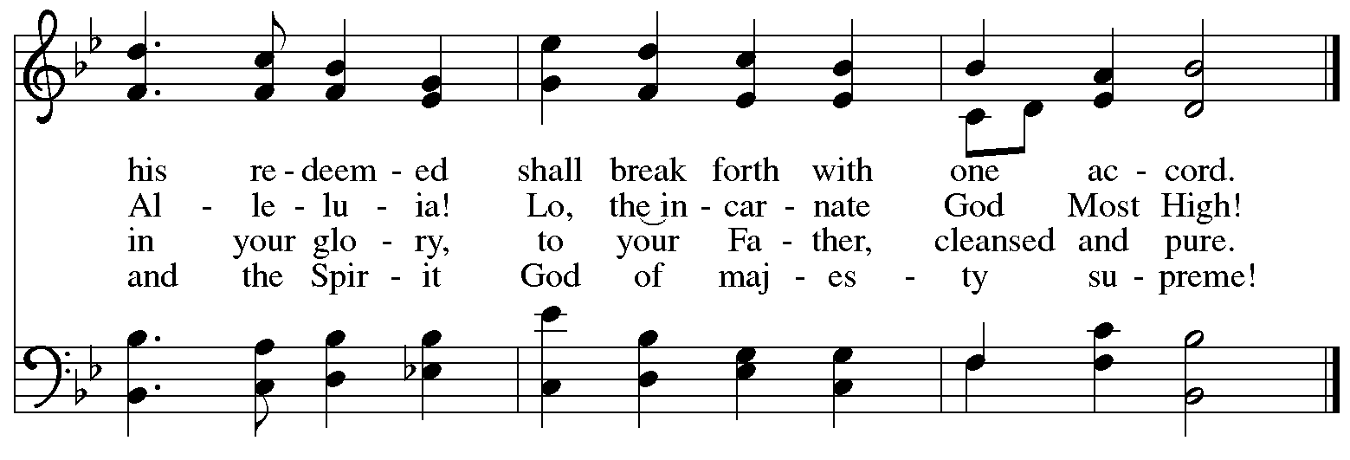

**Apostles’ Creed**

**C: I believe in God, the Father almighty,**

**creator of heaven and earth.**

**I believe in Jesus Christ, God’s only Son, our Lord,**

**who was conceived by the Holy Spirit,**

**born of the virgin Mary,**

**suffered under Pontius Pilate,**

**was crucified, died, and was buried;**

**he descended to the dead.\***

**On the third day he rose again;**

**he ascended into heaven,**

**he is seated at the right hand of the Father,**

**and he will come to judge the living and the dead.**

**I believe in the Holy Spirit,**

**the holy catholic church,**

**the communion of saints,**

**the forgiveness of sins,**

**the resurrection of the body,**

**and the life everlasting. Amen.**

\*Or, “he descended into hell,” another translation of this text in widespread use.

**Prayers of the People**

A: Guided by the Holy Spirit, with the light of Christ shining upon us and all nations,

let us pray for the church, the world, and all creation.

*After each petition*

A: Gracious God,

**C: receive our prayer.**

*The presiding minister concludes the prayers*

P: We entrust these prayers to you, O God, in the sure and certain hope that your promise is revealed among your people.

**C: Amen.**

**Peace**

*The presiding minister and the assembly greet one another in the peace of the risen Christ.*

P: The peace of Christ be with you always.

**C: And also with you.**

*The people may greet those around them with a sign of Christ’s peace and may say*

Peace be with you *or similar words. Please be mindful that not everyone will be comfortable with sharing the peace, so please seek consent before shaking hands or hugging. Other possible ways to share the peace include a simple bow with the verbal greeting of peace, or simply a verbal expression of peace.*

*When the greetings of peace have concluded, please be seated.*



**Meal**

*God feeds us with the presence of Jesus Christ*

**Offering**

*We offer ourselves, our gifts, and our faithful service to God.*

*As the offering is gathered for the mission of the church, including the care of those in need,*

*the table is set for Holy Communion.*

**Reparations Offering**

*On the first Sunday of each month, St. Andrew invites people of the congregation to give a second offering for a reparations fund in acknowledgement of St. Andrew’s use of African American spiritual songs in our worship services. Please see the note in the announcements for more information.*

**Music during the Offering**

*All Earth Is Hopeful* arr. Nancy Raabe

*As the gifts are brought forward for presentation, please rise as you are able.*

**Offertory Song Cuando el pobre / When the Poor Ones *ELW* 725**

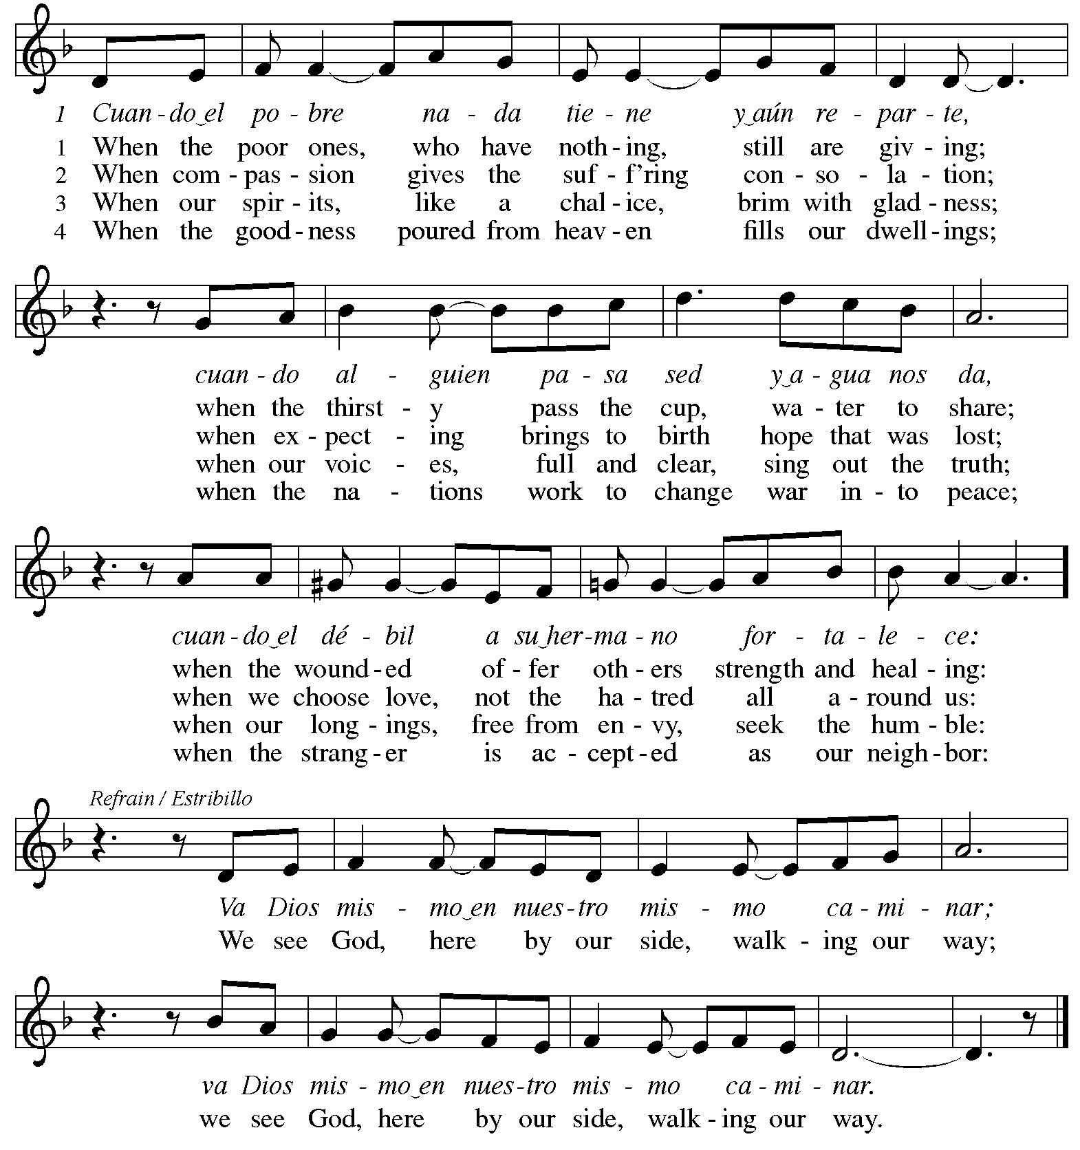



Reprinted under OneLicense.net # A-722139.

**Offertory Prayer**

A: Let us pray.

Holy God, gracious and merciful,

**C: you bring forth food from the earth and nourish your whole creation.**

**Turn our hearts toward those who hunger in any way, that all may know your care;**

**and prepare us now to feast on the bread of life, Jesus Christ, our Savior and Lord.**

**Amen.**

**Dialogue** *ACS* p. 20

P: The Lord be with you.

**C: And also with you.**

P: Lift up your hearts.

**C: We lift them to the Lord.**

P: Let us give thanks to the Lord our God.

**C: It is right to give our thanks and praise.**

**Preface** *ACS* p. 20

P: It is indeed right, our duty and our joy,

that we should at all times and in all places

give thanks and praise to you,

almighty and merciful God,

through our Savior Jesus Christ;

who on this day overcame death and the grave,

and by his glorious resurrection

opened to us the way of everlasting life.

And so, with all the choirs of angels,

with the church on earth and the hosts of heaven,

we praise your name and join their unending hymn:

**Sanctus** *ACS* p. 20

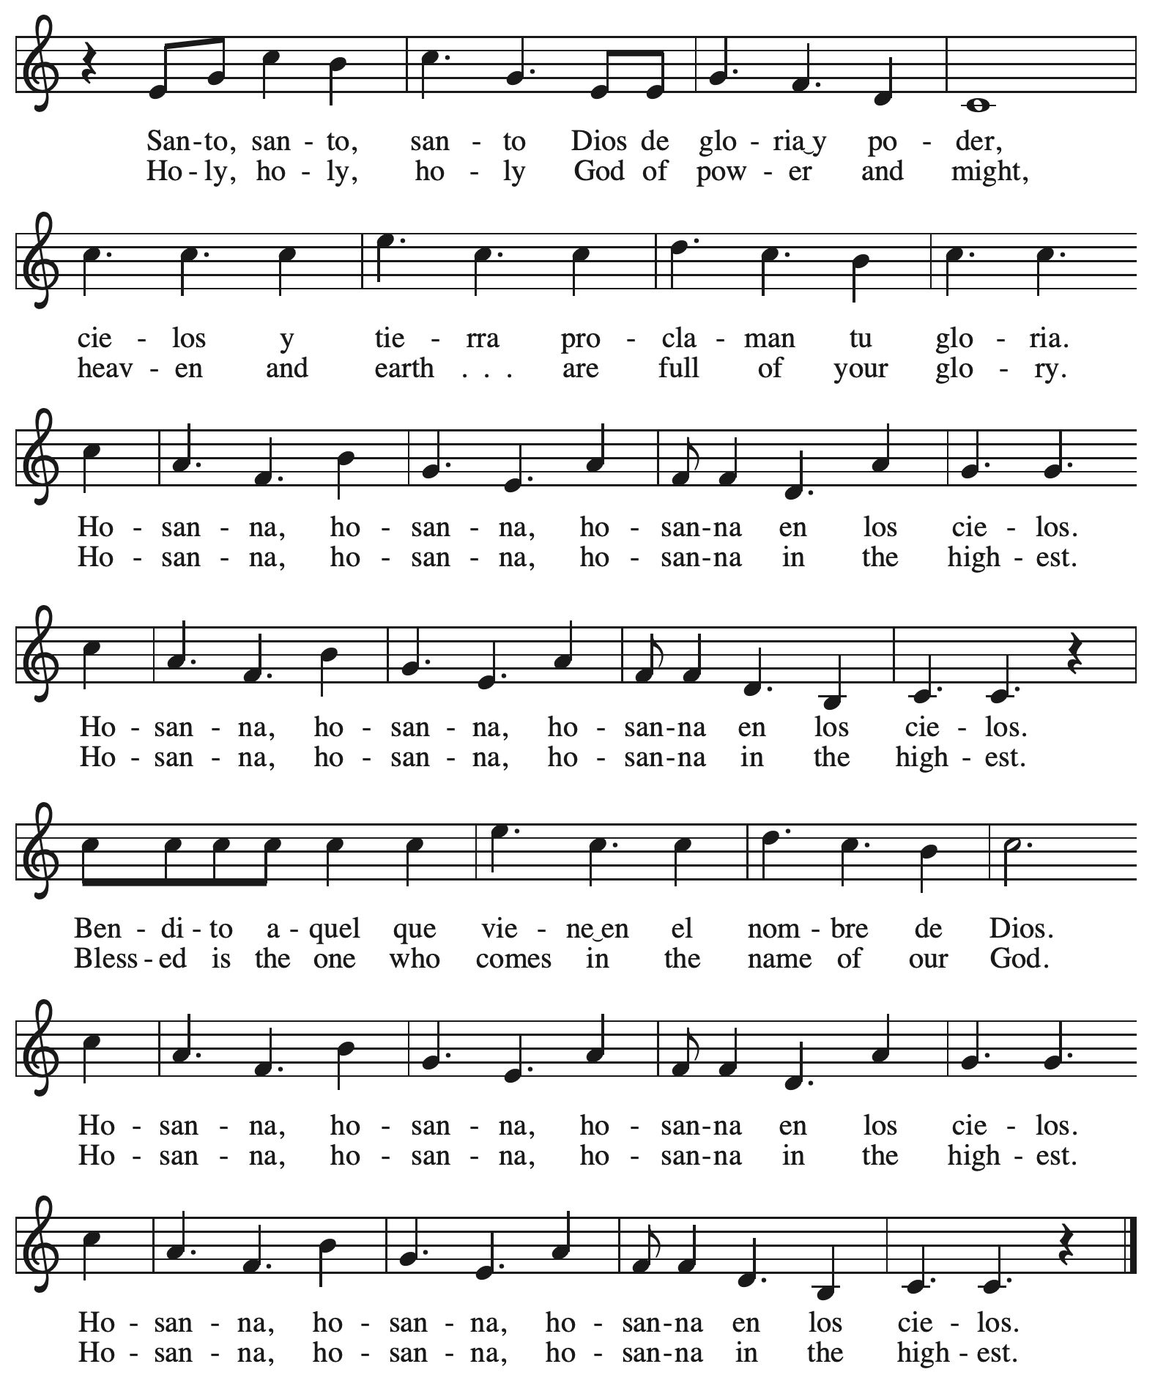

**Eucharistic Prayer** *ACS* p. 21

P: Holy God, you alone are holy … with every breath.

**C: We praise you, O God.**

P: Generations bless your faithfulness … into the future.

**C: We bless you, O God.**

P: We give you thanks for your dear Son … with us now.

**C: We thank you, O God.**

P: In the night in which he was betrayed … Do this for the remembrance of me.

Remembering his love for us

on the way, at the table, and to the end,

we proclaim the mystery of faith:

**C: Christ has died. Christ is risen. Christ will come again.**

P: We pray for the gift of your Spirit … in your church, without end.

**C: Amen.**

**Lord’s Prayer**

P: Gathered as one by the Holy Spirit, let us pray as Jesus taught us.

**C: Our Father in heaven,**

**hallowed be your name,**

**your kingdom come,**

**your will be done,**

**on earth as in heaven.**

**Give us today our daily bread.**

**Forgive us our sins**

**as we forgive those**

**who sin against us.**

**Save us from the time of trial**

**and deliver us from evil.**

**For the kingdom, the power,**

**and the glory are yours,**

**now and forever. Amen.**

**Fraction and Invitation**

P: The joy of the Lord is our strength.

Come and be nourished by the gifts of God.

***Agnus Dei /* Lamb of God** *ACS* p. 25

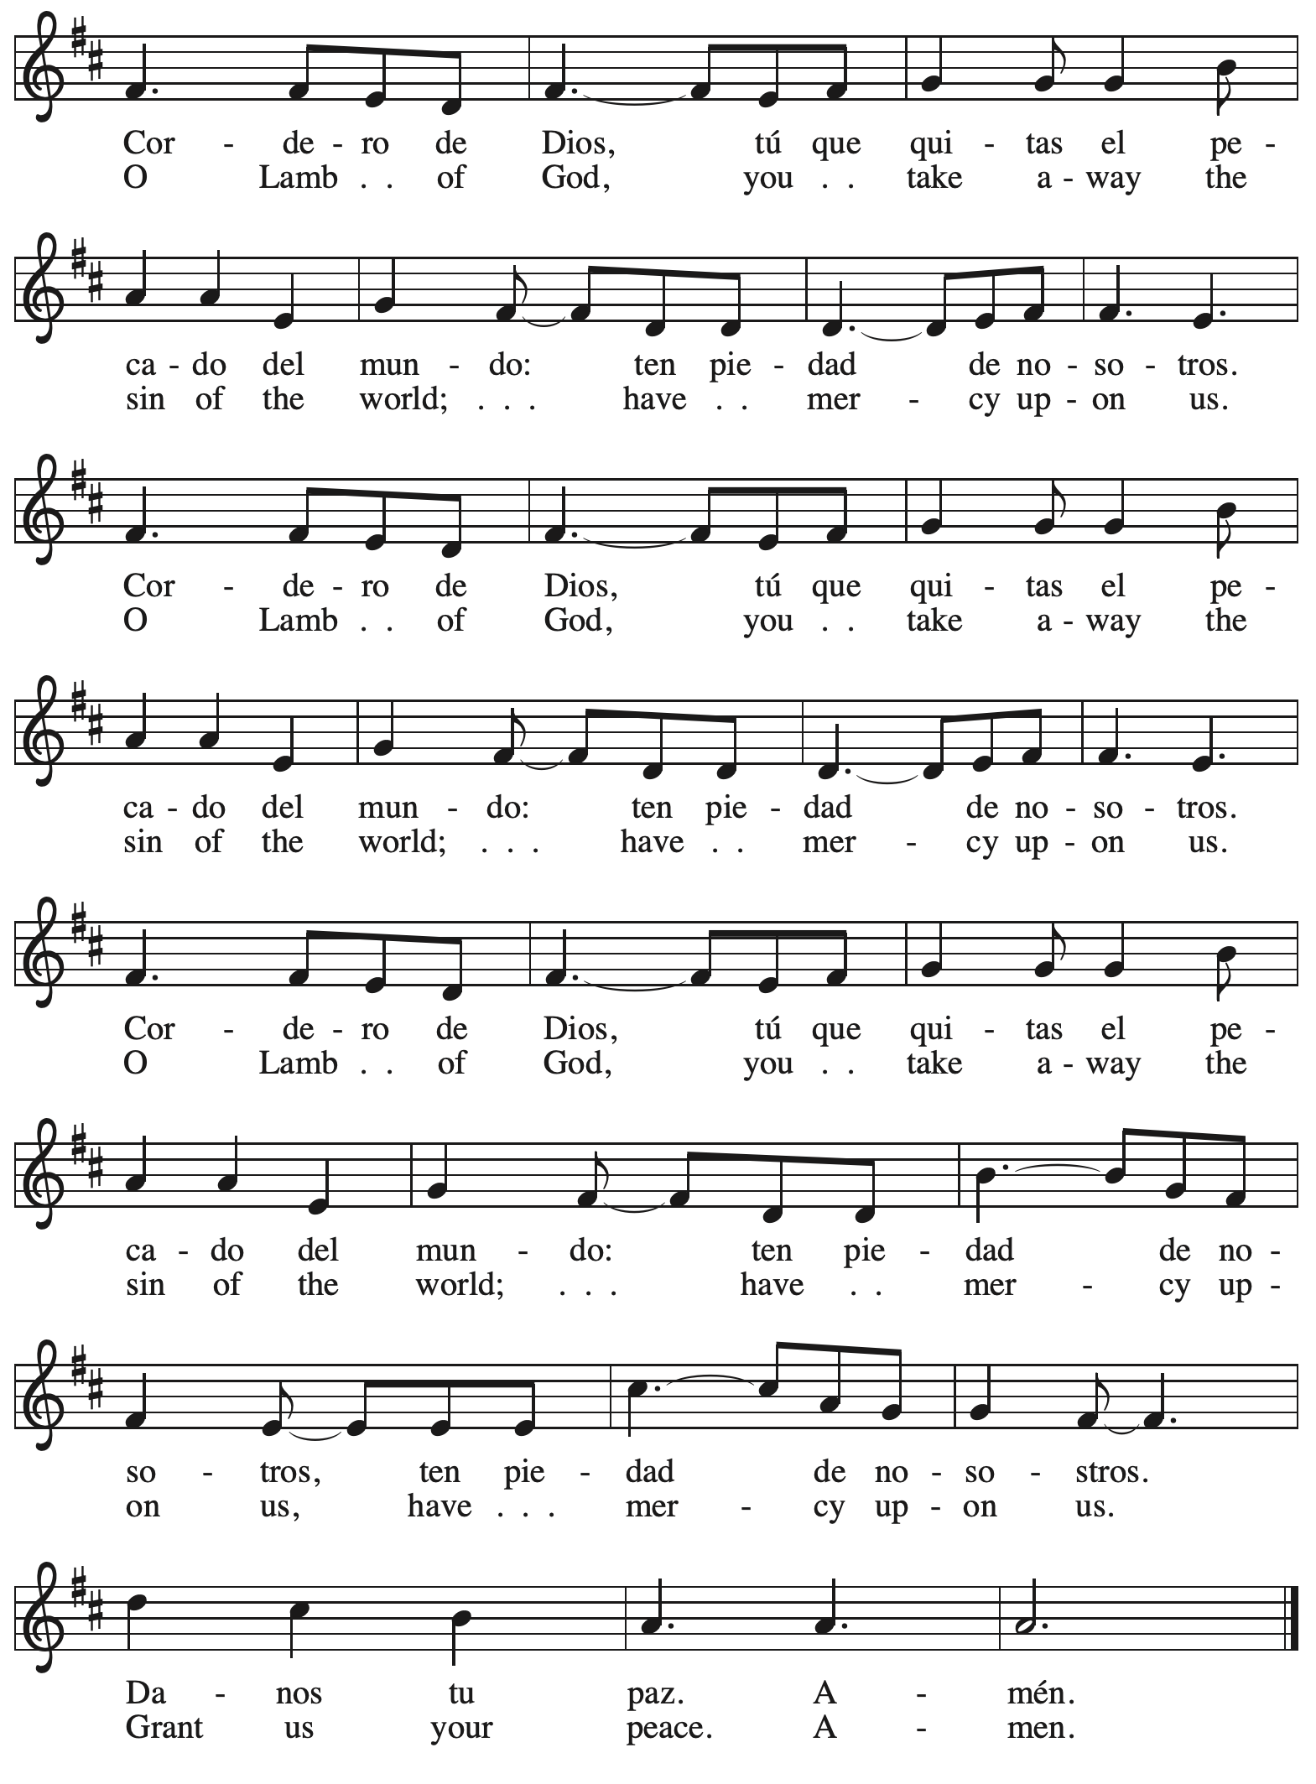

*Please be seated.*



**Holy Communion**

* *All who seek God and desire a deeper and stronger life in Christ are welcome to receive Holy Communion.*
* *Worshipers from the pulpit side will proceed forward first, followed by the center section, and then the lectern side.*
* *Please inform an usher if you would like the ministers to bring Communion to you.*
* *Holy Communion will be served with bread and wine/grape juice.*
* *The presiding minister will first distribute the bread (host) to each communicant. Please indicate if you require a gluten-free host.*
* *Once you have consumed the bread, please pick up an empty glass from the tray next to the presiding minister. The Communion Assistant will pour wine or grape juice into your glass. Please indicate if you would like grape juice.*
* *Please step to the side to consume the wine or grape juice.*
* *Feel free to kneel at the altar rail for prayer after receiving the sacrament.*
* *As you return to your pew, glasses may be returned to the empty tray on the side of the center section.*
* *A blessing will be provided for anyone who does not yet receive the sacrament.*
* *All are invited to join in singing the hymns during Holy Communion.*

**Hymns during Holy Communion**

**Where Shepherds Lately Knelt *ACS* 909**

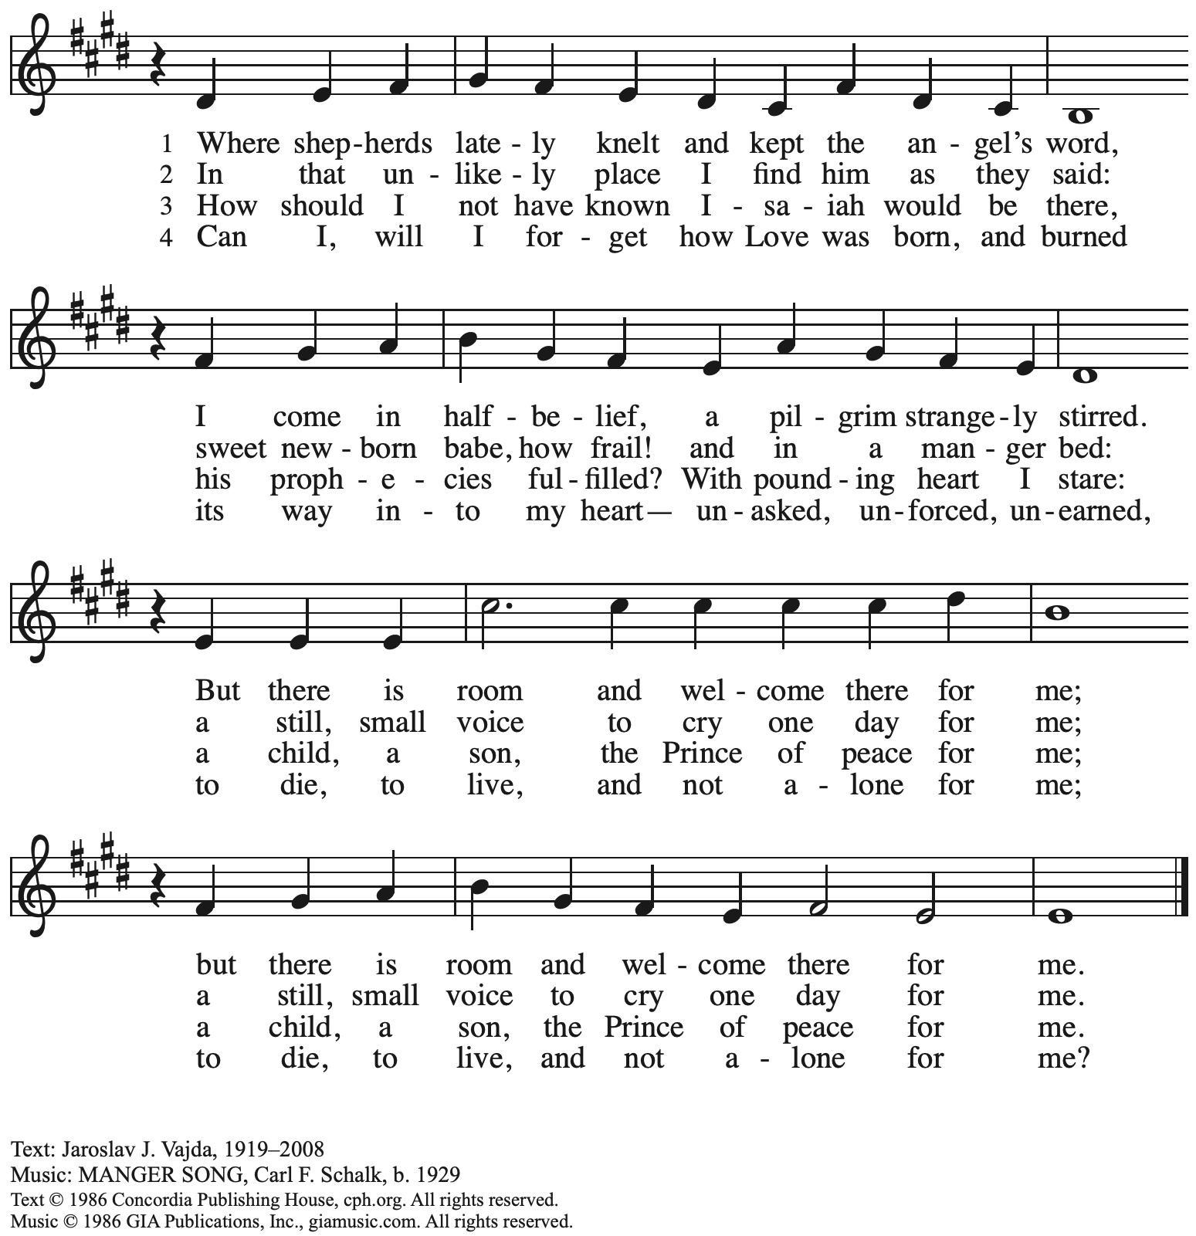

Reprinted with permission under OneLicense.net # A-722139.

**Hymns during Holy Communion**

**Let All Mortal Flesh Keep Silence *ELW* 490**

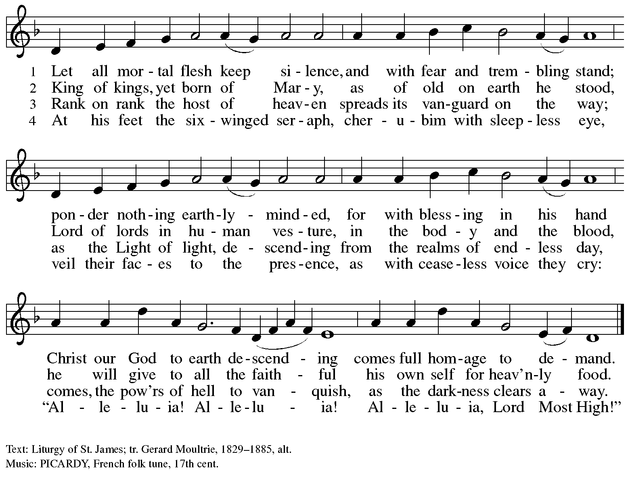

**Hymns during Holy Communion**

**In the Singing *ELW* 466**

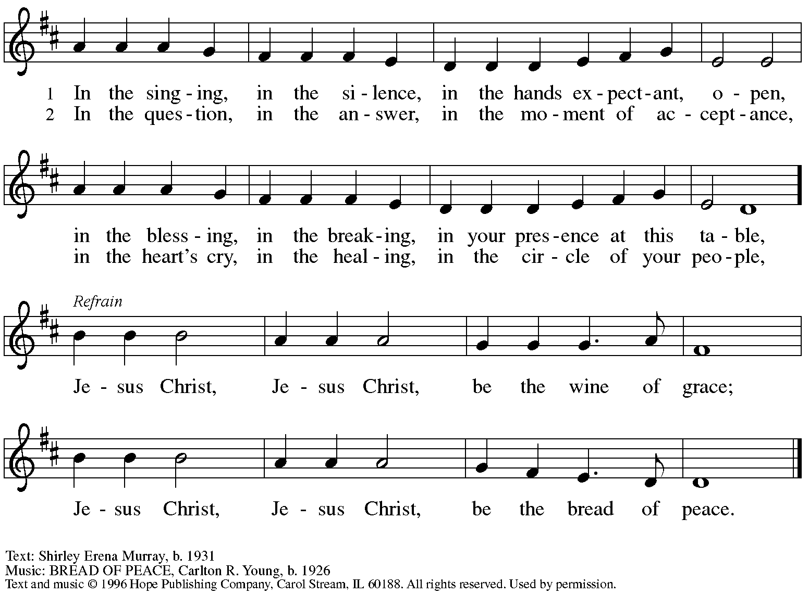

Reprinted under OneLicense.net # A-722139.

**Hymns during Holy Communion**

**Jesus, What a Wonderful Child *ELW* 297**

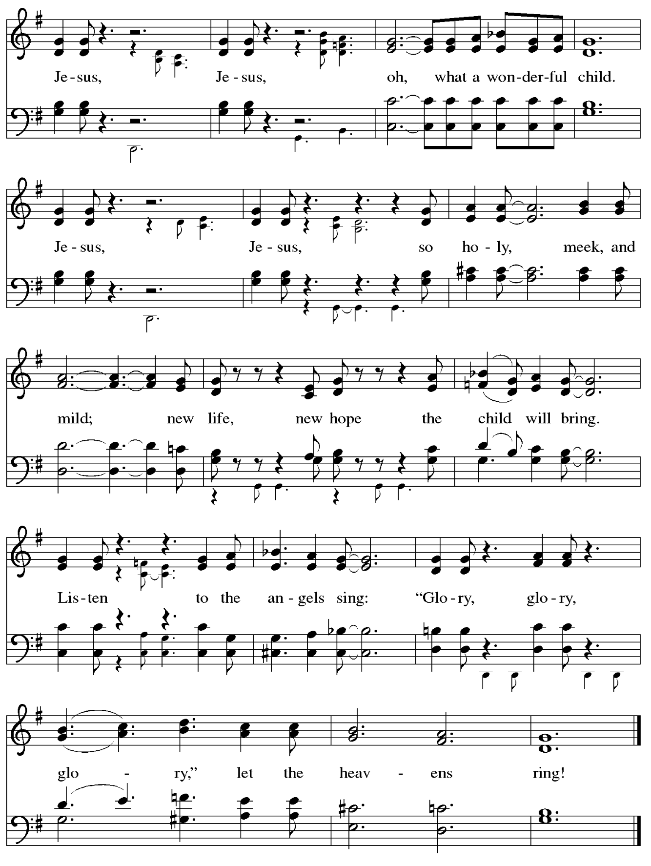

*When all have returned to their places, please rise as you are able.*

**Blessing**

P: The body and blood of our Lord Jesus Christ strengthen you and keep you in his grace.

**C: Amen.**

**Nunc Dimittis O Lord, Now Let Your Servant *ELW* 313**

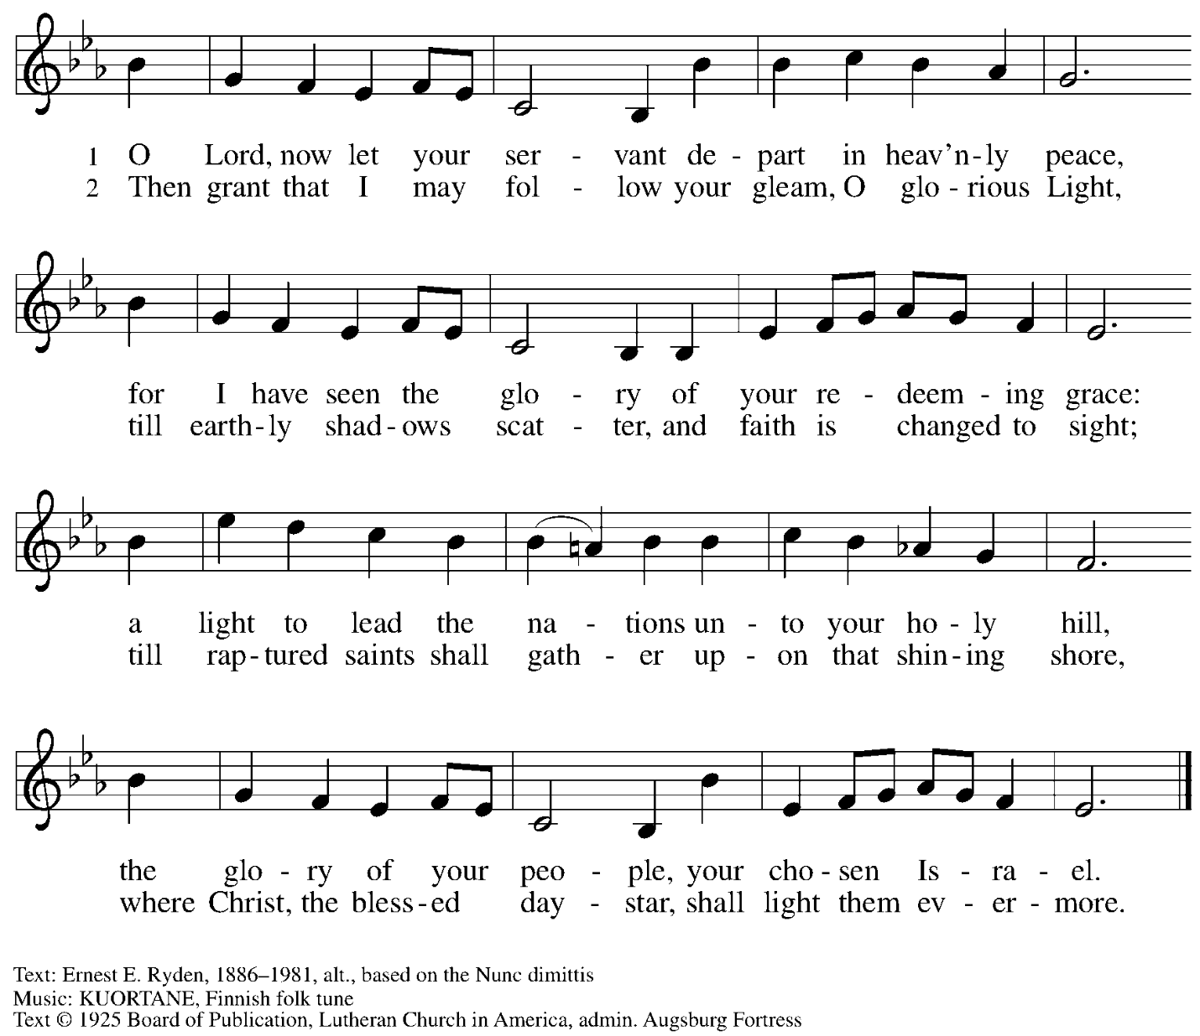

All rights reserved. Reprinted under OneLicense.net # A-722139.

**Prayer**

A: Let us pray.

O God, in this holy communion you have welcomed us into your presence,

nourished us with words of mercy, and fed us at your table. Amid the cares of this life, strengthen us to love you with all our heart, serve our neighbors with a willing spirit,

and honor the earth you have made; through Christ our Lord.

**C: Amen.**

*Please be seated.*

**Sending**

*God blesses us and sends us in mission to the world*

**Announcements**

*Please rise as you are able.*

**Benediction**

P: The holy Three,

the holy One

increase your hope,

strengthen your faith,

deepen your love,

and ☩ grant you peace.

**C: Amen.**

**Sending Hymn** *Following page*

**Dismissal**

A: Go in peace. Christ is with you.

**C: Thanks be to God!**

**Postlude**

**Sending Hymn I Want to Walk as a Child of the Light *ELW* 815**

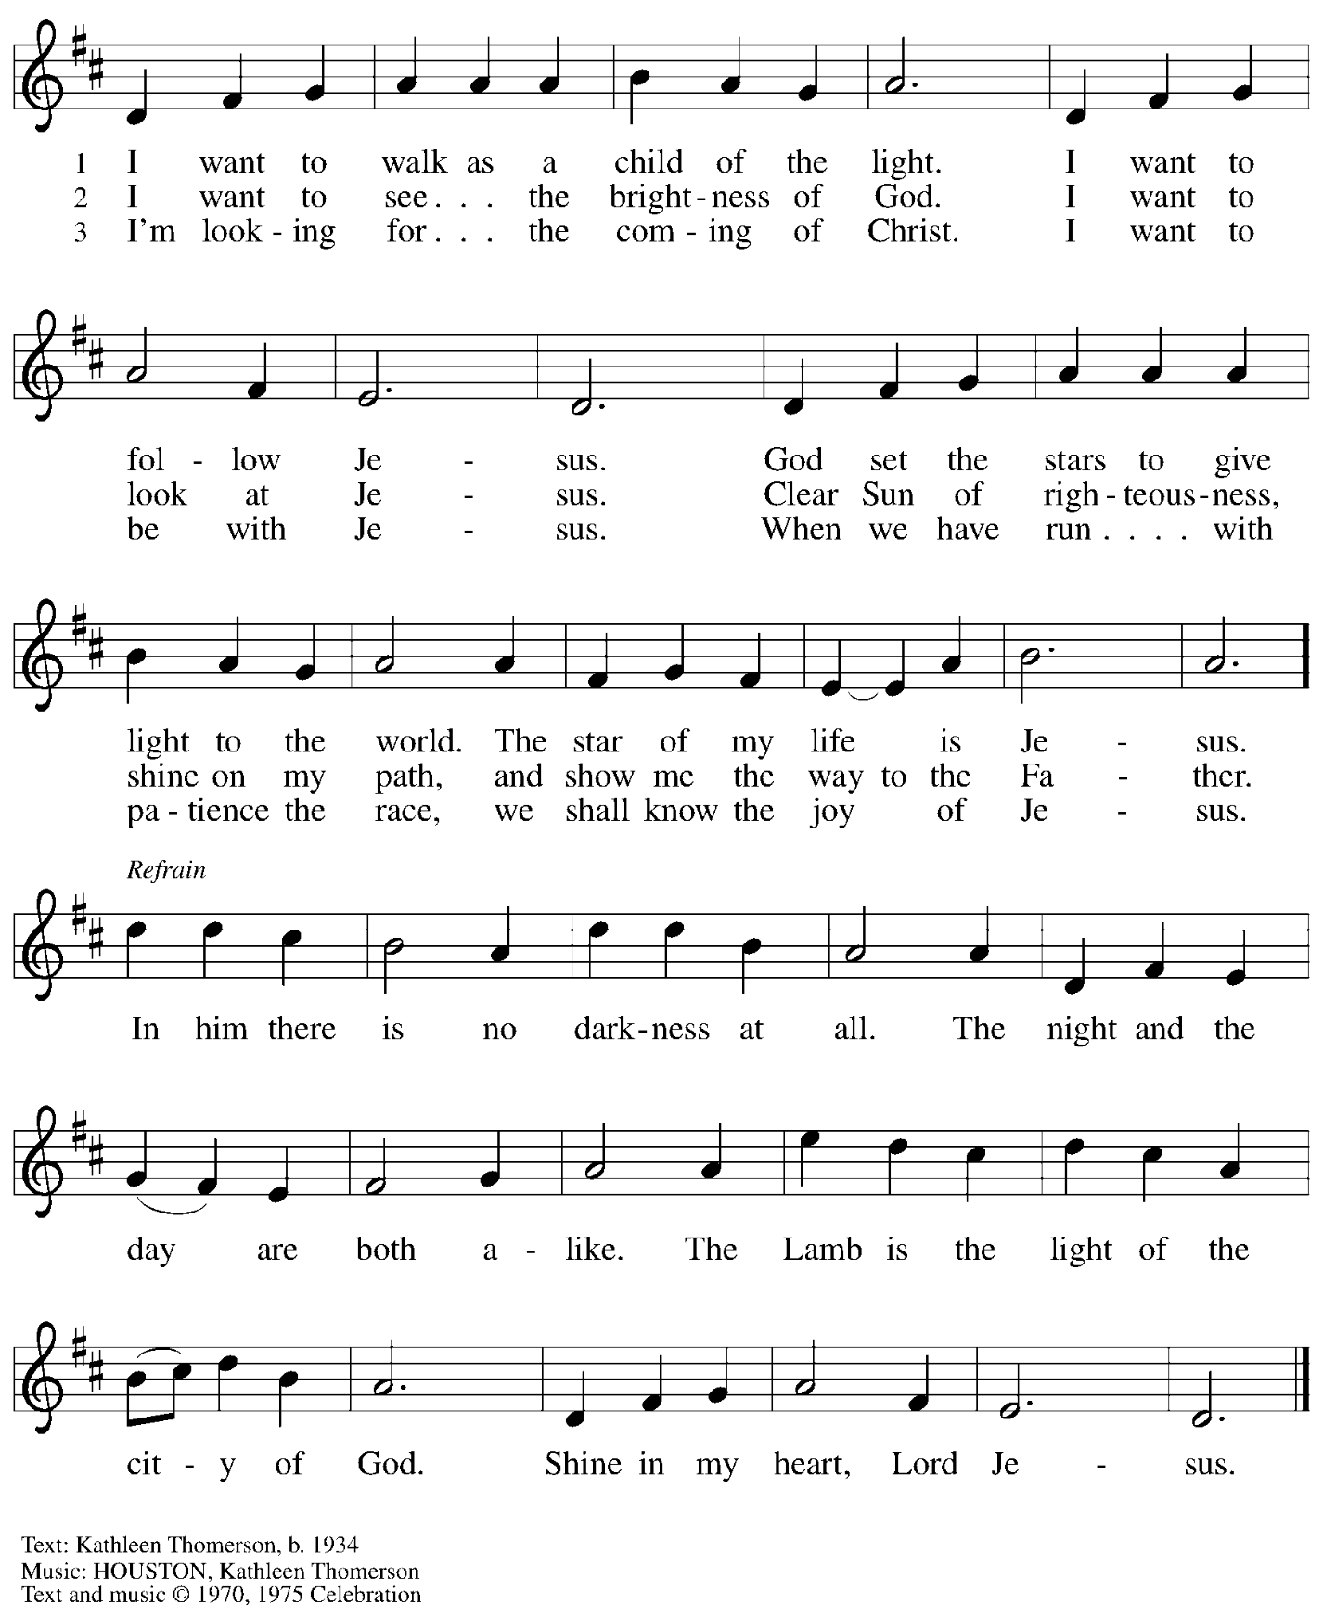

All rights reserved. Reprinted with permission under OneLicense.net # A-722139.

*Those serving in worship*

Altar Care Jodie Minor

Assisting Minister Timothy Kocher-Hillmer

Audio-Visual Ministers David Rollinson

Jered Stratton

Cantor Mandy Best

Lector Alda Maria Gonzaga

Little Church – Big Faith Teacher Ty Best

Vocalists Timothy Kocher-Hillmer

Maria Mangano and David Rollinson

Minister of Music Laura Reynolds

Preaching Minister Bishop Kurt F. Kusserow

Presiding Minister The Rev. Ross I. Carmichael

*Liturgy and Hymnody Acknowledgements*

From SundaysandSeasons.com. Copyright © 2025 Augsburg Fortress. All rights reserved. Reprinted under OneLicense.net # A-722139.

Used by permission of Augsburg Fortress.

The Scripture readings contained herein are from *New Revised Standard Version* of the Bible © 1989, Division of Christian Education of the National Council of Churches of Christ in the USA. Used by permission. All rights reserved.

**In His Temple Now Behold Him** – Text: Henry J. Pye, 1825-1903, alt. Music: REGENT SQUARE, Henry T. Smart, 1813-1879.

**Jesus, What a Wonderful Child** – African American traditional, alt. Music: African American traditional; arr. Jeffrey Radford, 1953-2002. Arr. from *The New Century Hymnal* (#136), © 1992 Pilgrim Press. All rights reserved. Reprinted with permission under OneLicense.net # A-722139.

*Please use the QR code below to link to St. Andrew’s Announcements online!*



**St. Andrew Lutheran Church Announcements**

**February 2nd, 2025**

* **Welcome to worship at St. Andrew on the + Presentation of our Lord, February 2nd** – We are thankful you are here, and we offer a special welcome to all visitors and guests here for the first time. Worship attendees are invited to make a name tag at the back of the worship space. Little Church – Big Faith, a Bible lesson and activity for children, will take place after the prayer of the day. There are also worship “toolkits” to help children engage with worship and “busy bags” for younger children available in the bookcase at the back of the sanctuary. Please feel free to take one to use with/for your children. All are invited to gather for coffee other drinks and food, and conversation in the social hall after worship.
* **Welcome Back, Bishop Kusserow! Bishop Kurt Kusserow of our local Southwestern Pennsylvania Synod is finishing his third and last term as bishop, having served in the role for almost 18 years. The bishop reached out to congregations extending the opportunity to share one more visit before he completes his service, and he will be preaching and distributing Holy Communion during worship today. We thank Bishop Kusserow for his presence, as well as his years of leadership in the synod, and we invite everyone to stay for an expanded Coffee Hour after worship to share conversations, thanksgivings, congratulations, and blessings with the bishop!**
* **Monthly Reparations Offering during Worship Today** – In Luke’s Gospel, Jesus tells a story about a compassionate Samaritan that suggests God’s people are called to work for healing and restoration for our neighbors, regardless of who or what caused them harm. In light of this, St. Andrew has made a commitment to reparations in regard to African American spiritual songs used in our worship. The text and music of most hymns is attributed to specific authors, with copyrights in place, usage reported, and royalties paid to those whose works are featured in worship. With African American spirituals, this is not possible. In response to many years of such uncredited use, St. Andrew invites the congregation to give a reparations offering. Funds received in worship will be donated to our siblings at Bethel AME Church, whose land and building were taken from them in the 1950s, to fund their development in the lower Hill District.
* **February Produce Distribution – First Tuesday of the Month, February 4th, from 5:30-7:00 p.m. –** St. Andrew partners with Greater Pittsburgh Community Food Bank to serve as a distribution site for fresh produce on the first Tuesday of every month. January’s distribution will be on Tuesday, February 4th. We invite people of the congregation to help with the distribution from 5:30-7:00 p.m. and/or to help with unloading and setup during the day between 10:00 a.m. and 1:00 p.m.
* **St.** **Olaf Lutheran College Choir Concert at East Liberty Presbyterian Church on Sunday, February 9th, at 7:30 p.m.** – St. Olaf College is a Lutheran-affiliated liberal arts school in Northfield, MN, and its choir will stop in Pittsburgh on its 2025 tour. The St. Olaf Choir, made up of 75 mixed voices, is “one of the nation’s premier a cappella ensembles, renowned for its artistry and beauty of sound.” They will perform at East Liberty Presbyterian Church, 116 S. Highland Ave., 15206 on Sunday, February 9th, at 7:30 p.m. Tickets are $35 or $10 for all students, and they are available at [stolaf.edu/tickets/choir](http://stolaf.edu/tickets/choir)or by calling 800-363-5487. For more information, please visit

[St. Olaf Choir at East Liberty Presbyterian Church (Pittsburgh, PA) Tickets, Sun, Feb 9, 2025 at 7:30 PM | Eventbrite](https://www.eventbrite.com/e/st-olaf-choir-at-east-liberty-presbyterian-church-pittsburgh-pa-tickets-1027252478817?aff=oddtdtcreator).

* **Shelter Dinner for Guests of East End Cooperative Ministry, Third Thursday of the Month – February 20th, 6:00 p.m. Arrival, 6:30 p.m. Dinner –** Each month, people of St. Andrew provide dinner for guests of East End Cooperative Ministry (EECM), 6140 Station St. (East Liberty), 15206. We invite you to prepare or purchase one menu item and bring it to the shelter by 6:00 p.m., or just come to help serve at 6:30 p.m. If you would like to contribute, please sign up here: [https://www.signupgenius.com/go/5080544AAAC22A1F58-54567228-shelter](https://www.signupgenius.com/go/5080544AAAC22A1F58-54567228-shelter" \t "_blank).
* **Bagged Lunches to Accompany February Shelter Dinner – Seeking Additional Donations! – East End Cooperative Ministry is hosting an additional 20 people this winter because of the shelter shortage and we have been asked to bring items for 20 bagged lunches on St. Andrew’s Shelter Dinner night, Thursday, February 20th. This month we only need 20 sandwiches and 20 soft fruits (any kind) – we have already received donations for the other items. Shelf-stable items can be left on the donation table in the Social Hall by Sunday, February 16th, or delivered to EECM on Thursday, February 20th. Please label “For EECM Lunches.” Sandwiches should be delivered to EECM any time on the 20th until 6:00 p.m. Please label “For St. Andrew bagged lunches.” Shelter staff will assemble the bagged lunches. Much work goes into shopping for and preparing the main meal each month, so we would greatly appreciate new participants and contributions for this effort! If you would like to help, please sign up at:**

[https://www.signupgenius.com/go/5080544AAAC22A1F58-54567666-bagged](https://www.signupgenius.com/go/5080544AAAC22A1F58-54567666-bagged" \t "_blank).

* **Support Those Affected by California Wildfires through Lutheran Disaster Response – With ongoing concern for everyone coping with wildfires in California, the Evangelical Lutheran Church in America’s Lutheran Disaster Response is working with the Southwest California synod to support affected communities. They offer a sample prayer and are accepting donations designated for “U.S. Wildfires.” For more information, or to donate, please see** [US Wildfires](https://www.elca.org/our-work/relief-and-development/lutheran-disaster-response/our-impact/us-wildfires?fbclid=IwY2xjawHsxdRleHRuA2FlbQIxMAABHTFXYAPv2xZ0mdENmcsSbNUS-vGVbJVcKn_NAa3mTRKBWtTeOI-mxAM4Dg_aem__Kv-QvoEB6MduGPk9PKFpw) (at [www.elca.org](http://www.elca.org)).
* ***Christ in Our Home* Devotional Booklets for January - March Available at Church Entrances** – This resource offers a daily Bible reading with a short reflection and prayer, along with additional readings and prayer topics for those who would like to expand their devotional practices. We encourage people of the congregation to take one for yourself, your family unit, or others!
* **Compline Prayer Service with the Pittsburgh Compline Choir – Sundays at 8:00 p.m. at Heinz Chapel –** Compline was traditionally a monastic prayer service, and the Pittsburgh Compline Choir, a ministry of Lutheran Campus Ministry in Greater Pittsburgh, sings a choral version of compline rooted in this thousand-year-old tradition of scripture, song, and silence each Sunday at Heinz Chapel at 8:00 p.m. This service also streams on Facebook (Pittsburgh Compline Choir) and YouTube (The Pittsburgh Compline Choir). Heinz Chapel is located off of S. Bellefield Ave. in Oakland. For more information, please visit: [Pittsburgh Compline Choir](http://pittsburghcomplinechoir.org/).