

**+ Seventh Sunday after Epiphany**

**February 23rd, 2025**

**10:00 a.m.**



**St. Andrew Lutheran Church**

**304 Morewood Ave.**

**Pittsburgh, PA 15213**

**412.682.3342**

[**St_andrewELCA@verizon.net**](mailto:St_andrewELCA@verizon.net)

[**www.standrewpittsburgh.org**](http://www.standrewpittsburgh.org)

**+ Seventh Sunday after Epiphany**

**Order for Worship**

*The theme of mercy runs throughout our readings this week. Joseph lives it in Egypt.*

*Jesus preaches it in the gospel. The Spirit guides us into merciful lives with the power of forgiveness to reconcile what is fractured and divided. Such merciful living is the baptismal blessing of having put on Christ. It is the gift of the life-giving Spirit. It is a reflection of God’s glory revealed in Christ.*

**Welcome to St. Andrew!**

* St. Andrew welcomes all who are seeking a place of healing, wholeness, and acceptance in a nurturing and faith-forming spiritual home. We are striving toward racial equity worldwide

and we seek to honor the lived experience of all individuals regardless of background. Our community embraces people of all ages, ethnicities, cultures, abilities, sexual orientations,

gender identities and expressions, and family constellations. Come and See!

* Worship Services are live-streamed to multiple online platforms. By attending worship, you agree that your image and voice may be broadcast.
* Everyone is invited to make a name tag at the black bookcase in the back of the worship space if they would like. There are stickers indicating pronouns on the bookcase if you would like to include them on your name tag.
* Children are invited to attend Little Church – Big Faith, a Bible lesson and activity, during worship (after the Prayer of the Day). The group returns to the worship space for the liturgy of Holy Communion.
* A nursery is available through the doors at the left side of the sanctuary and across from the doorway to the Social Hall. Look for a purple-colored room.
* Worship “toolkits” to help children engage with the service, along with “busy bags” for younger children, are available in the bookcase at the back of the sanctuary. Please feel free to take one to use with/for your children.
* Holy Communion is served with bread (gluten-free available) and wine or grape juice. The presiding minister will distribute the bread (host). Please consume this and then pick up an empty glass from the tray. The Communion Assistant will pour wine or grape juice into your glass. Please step to the side to consume the wine or grape juice. Feel free to kneel at the altar for prayer and reflection. As you return to your pew, glasses may be returned to the empty trays on either side of the center section.
* A restroom is available on the main level of the church, through the doors to the Social Hall and to the right in the main office.

*Abbreviations*

P: Pastor/Presiding Minister ***ELW*: *Evangelical Lutheran Worship* hymnal**

A: Assisting Minister ***ACS*: *All Creation Sings* hymnal**

L: Lector

**C: Congregation**

**Pre-Service Music**

**Welcome**

**Prelude**

**Gathering**

*The Holy Spirit calls us together as the people of God*

**Thanksgiving for Baptism**

*Please rise as you are able. All may make the sign of the cross,*

*the sign that is marked at Baptism, as the presiding minister begins.*

P: Blessed be the holy Trinity, ☩ one God,

the fountain of living water, the rock who gave us birth,

our light and our salvation.

**C: Amen.**

P: Joined to Christ in the waters of Baptism, we are clothed with God’s mercy and forgiveness. Let us give thanks for the gift of Baptism.

*Water may be poured into the font as the presiding minister gives thanks.*

P: We give you thanks, O God, for in the beginning you created us in your image and placed us in a well-watered garden. In the desert, you promised pools of water for the parched, and you gave us water from the rock. When we did not know the way, you sent the Good Shepherd to lead us to still waters. At the cross, you washed us from Jesus’ wounded side, and on this day, you shower us again with the water of life.

We praise you for your salvation through water, for the water in this font,

and for water everywhere, including the Allegheny, Monongahela, and Ohio rivers.

Bathe us in your forgiveness, grace, and love.

Satisfy all who thirst, and give us the life only you can give.

To you be given honor and praise

through ☩ Jesus Christ, our living water,

in the unity of the Holy Spirit, now and forever.

**C: Amen.**

**Gathering Hymn Lord of Glory, You Have Bought Us *ELW* 707**

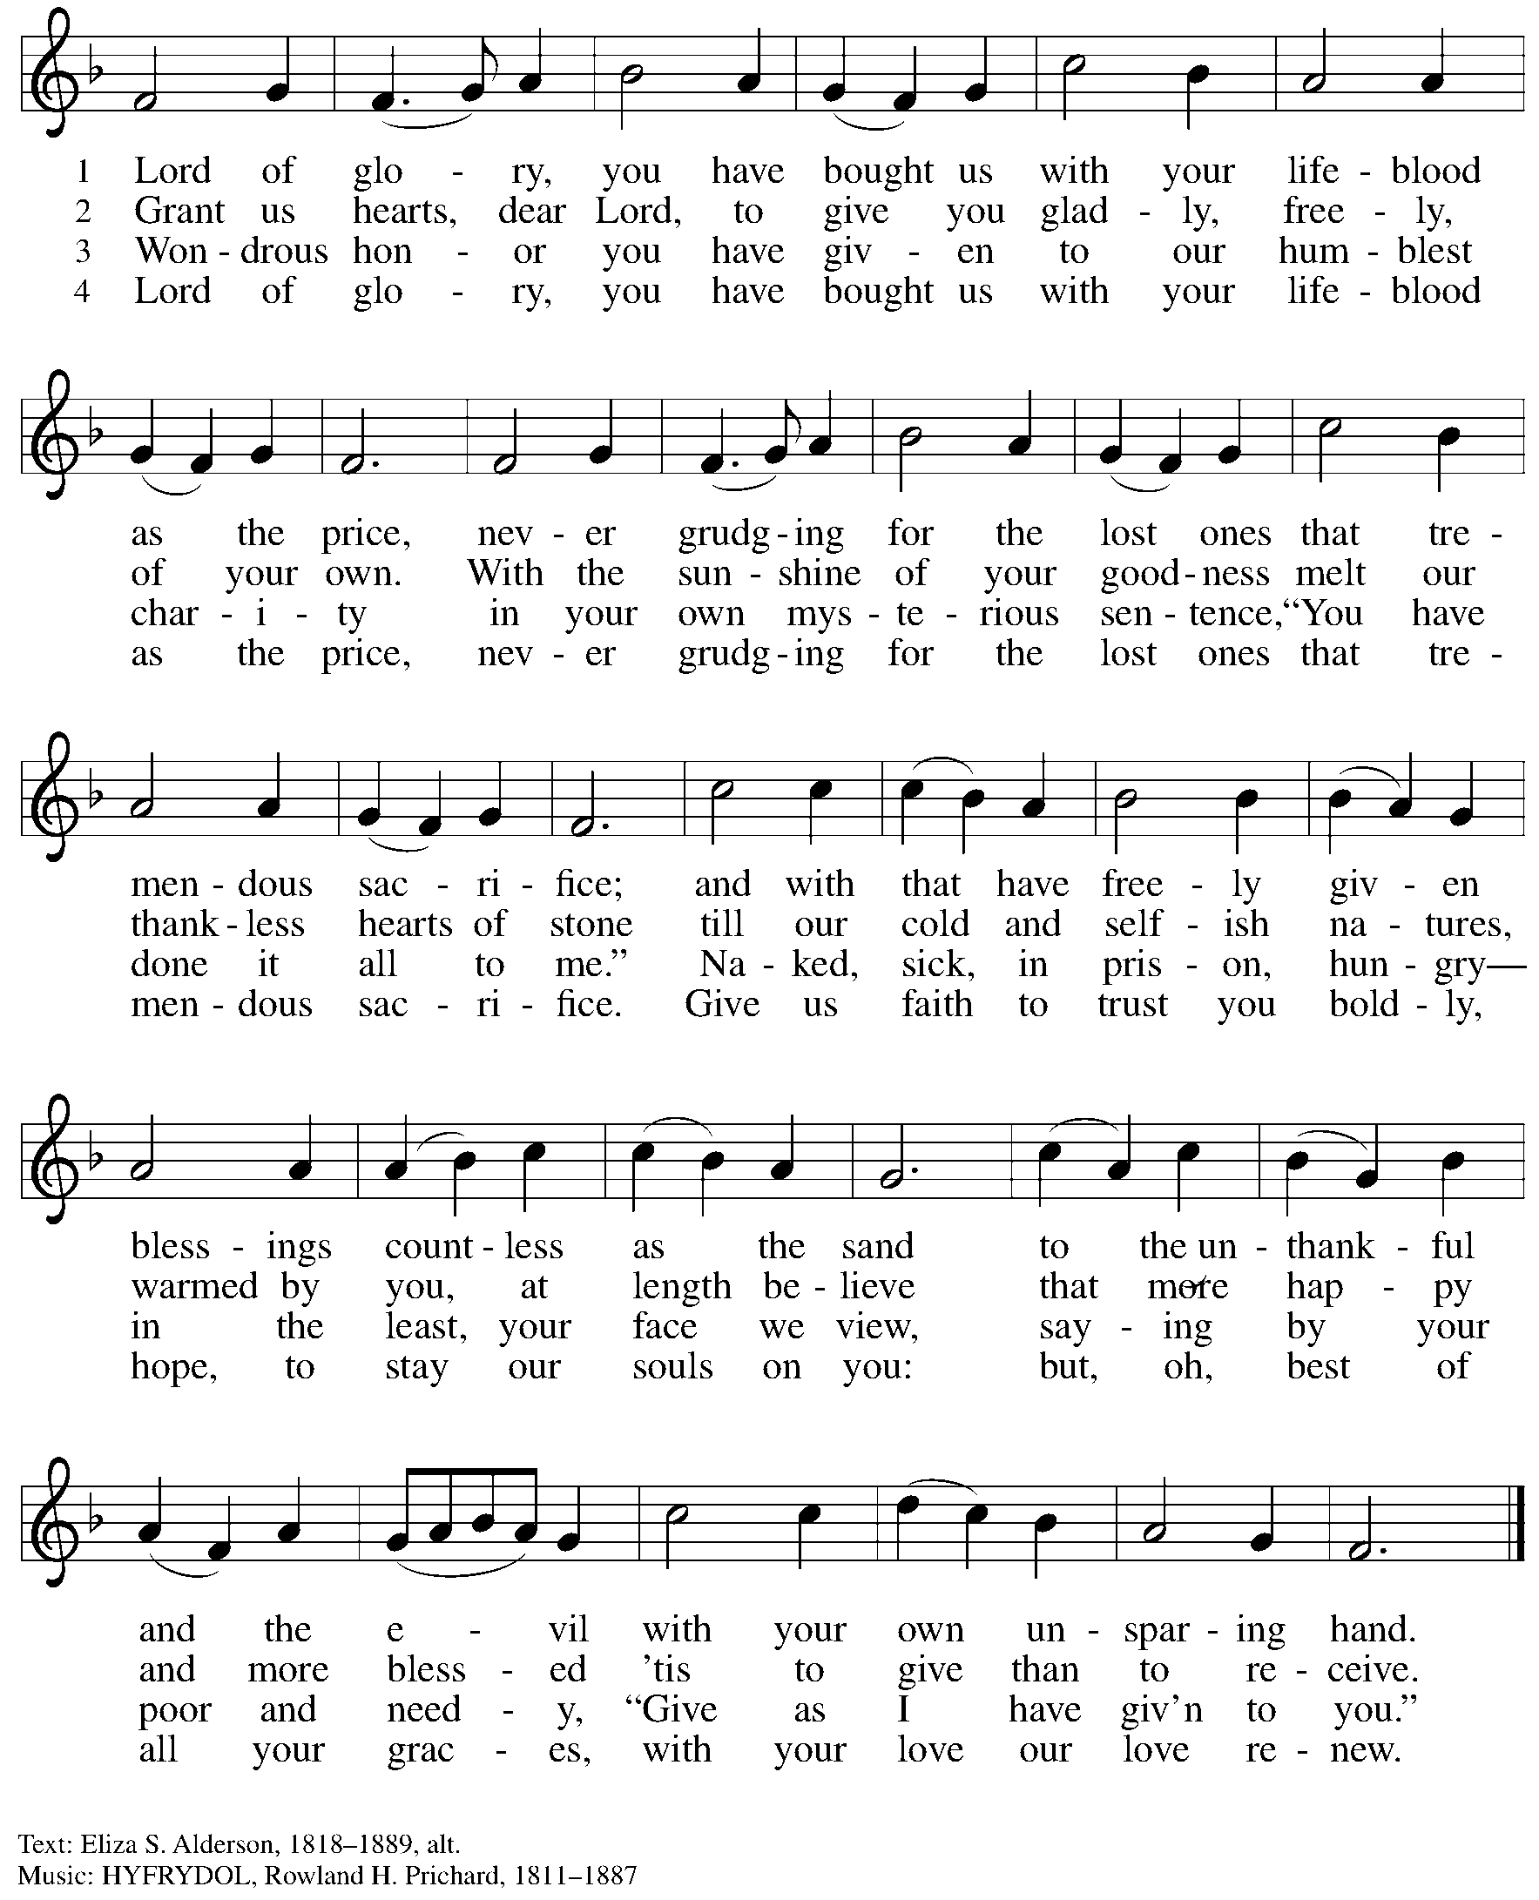

**Greeting**

P: The grace of our Lord Jesus Christ, the love of God,

and the communion of the Holy Spirit be with you all.

**C: And also with you.**

**Hymn of Praise** *ACS* p. 12

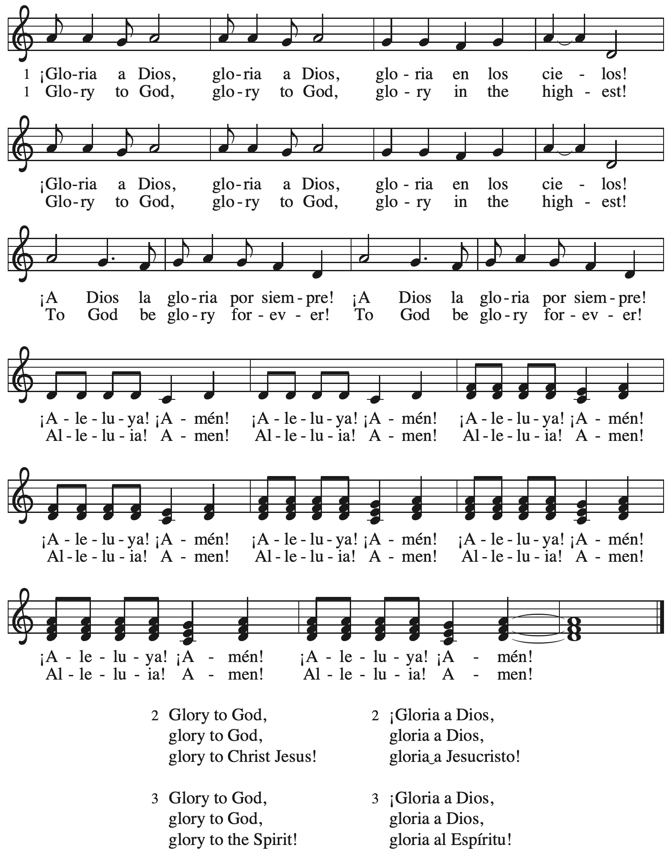

**Prayer of the Day**

P: The Lord be with you.

**C: And also with you.**

P: Let us pray.

O Lord Jesus, make us instruments of your peace, that where there is hatred, we may sow love,

where there is injury, pardon, and where there is despair, hope.

Grant, O divine one, that we may seek to console, to understand, and to love in your name,

for you live and reign with the Father and the Holy Spirit, one God, now and forever.

**C: Amen.**

*Please be seated.*

**Word**

*God speaks to us in Scripture reading, preaching, and song*

**First Reading** **– Genesis 45: 3-11, 15**

3 Joseph said to his brothers, “I am Joseph. Is my father still alive?” But his brothers could not answer him, so dismayed were they at his presence.  
  4 Then Joseph said to his brothers, “Come closer to me.” And they came closer. He said, “I am your brother, Joseph, whom you sold into Egypt. 5 And now do not be distressed, or angry with yourselves, because you sold me here; for God sent me before you to preserve life. 6 For the famine has been in the land these two years; and there are five more years in which there will be neither plowing nor harvest. 7 God sent me before you to preserve for you a remnant on earth, and to keep alive for you many survivors. 8 So it was not you who sent me here, but God; God has made me a father to Pharaoh, and lord of all his house and ruler over all the land of Egypt.

9 Hurry and go up to my father and say to him, ‘Thus says your son Joseph, God has made me lord of all Egypt; come down to me, do not delay. 10 You shall settle in the land of Goshen, and you shall be near me, you and your children and your children’s children, as well as your flocks, your herds, and all that you have. 11 I will provide for you there—since there are five more years of famine to come—so that you and your household, and all that you have, will not come to poverty.’” 15 And he kissed all his brothers and wept upon them; and after that his brothers talked with him.

L: Word of God, word of life.

**C: Thanks be to God.**

**Psalm 37: 1-11, 39-40**

*The cantor will lead the singing of the psalm.*

*The congregation is invited to respond with the alternate verses in bold print,*

*and to join in singing the refrain.*

*Psalm Tone*

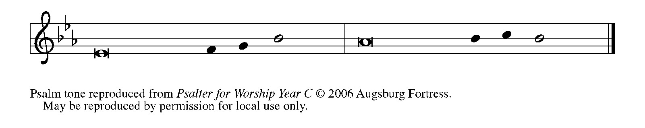

*Psalm Refrain*

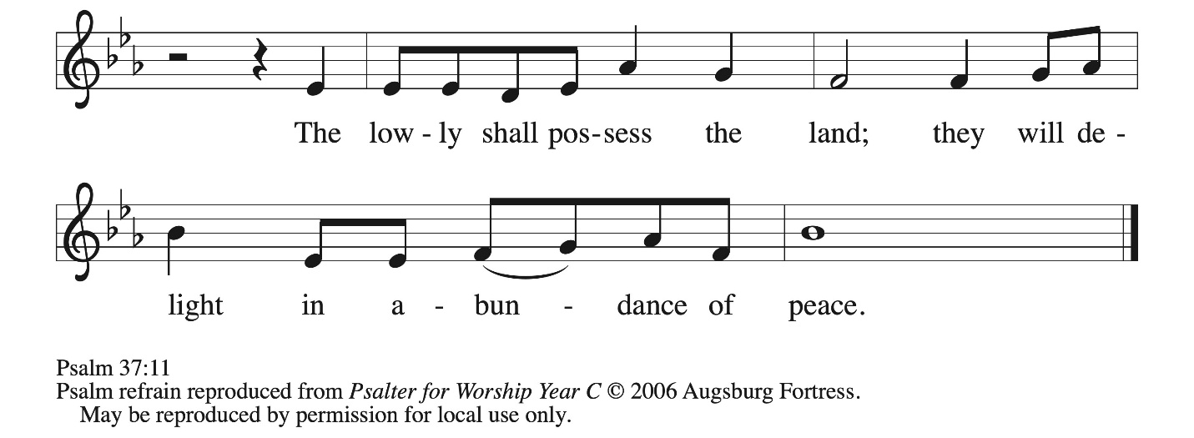

 1 Do not be provoked by **|** evildoers;  
  do not be jealous of those **|** who do wrong.  
 2 **For they shall soon wither | like the grass,**  
  **and like the green grass | fade away.**  
 3 Put your trust in the Lord **|** and do good;  
  dwell in the land and **|** find safe pasture.  
 4 **Take delight | in the Lord,**  
  **who shall give you your | heart’s desire. R**  
 5 Commit your way to the Lord; put your trust **|** in the Lord,  
  and see what **|** God will do.  
 6 **The Lord will make your vindication as clear | as the light**  
  **and the justice of your case like the | noonday sun.**  
 7 Be still before the Lord and wait **|** patiently.  
  Do not be provoked by the one who prospers, the one who succeeds in **|** evil schemes.  
 8 **Refrain from anger, leave | rage alone;**  
  **do not be provoked; it leads on- | ly to evil. R**  
 9 For evildoers shall **|** be cut off,  
  but those who hope in the Lord shall pos- **|** sess the land.  
 10 **In a little while the wicked shall | be no more;**  
  **even if you search out their place, they will | not be there.**  
 11 But the lowly shall pos- **|** sess the land;  
  they will delight in abun- **|** dance of peace.  
 39 **But the deliverance of the righteous comes from | you, O Lord;**  
  **you are their stronghold in | time of trouble.**  
 40 You, O Lord, will help them and **|** rescue them;  
  you will rescue them from the wicked and deliver them, because in you **|** they seek refuge.**R**

**Second Reading – 1 Corinthians 15: 35-38, 42-50**

35 But someone will ask, “How are the dead raised? With what kind of body do they come?”

36 Fool! What you sow does not come to life unless it dies. 37 And as for what you sow, you do not sow the body that is to be, but a bare seed, perhaps of wheat or of some other grain. 38 But God gives it a body as God has chosen, and to each kind of seed its own body.  
  42 So it is with the resurrection of the dead. What is sown is perishable, what is raised is imperishable. 43 It is sown in dishonor, it is raised in glory. It is sown in weakness, it is raised in power. 44 It is sown a physical body, it is raised a spiritual body. If there is a physical body, there is also a spiritual body. 45 Thus it is written, “The first human, Adam, became a living being”; the last Adam became a life-giving spirit. 46 But it is not the spiritual that is first, but the physical, and then the spiritual. 47 The first human was from the earth, a human of dust; the second human is from heaven. 48 As was the human of dust, so are those who are of the dust; and as is the human of heaven, so are those who are of heaven. 49 Just as we have borne the image of the human of dust, we will also bear the image of the human of heaven.  
  50 What I am saying, kindred, is this: flesh and blood cannot inherit the kingdom of God, nor does the perishable inherit the imperishable.

L: Word of God, word of life.

**C: Thanks be to God.**

*Please rise as you are able and join in singing the Gospel Acclamation.*



**Gospel Acclamation** *ACS* p. 14

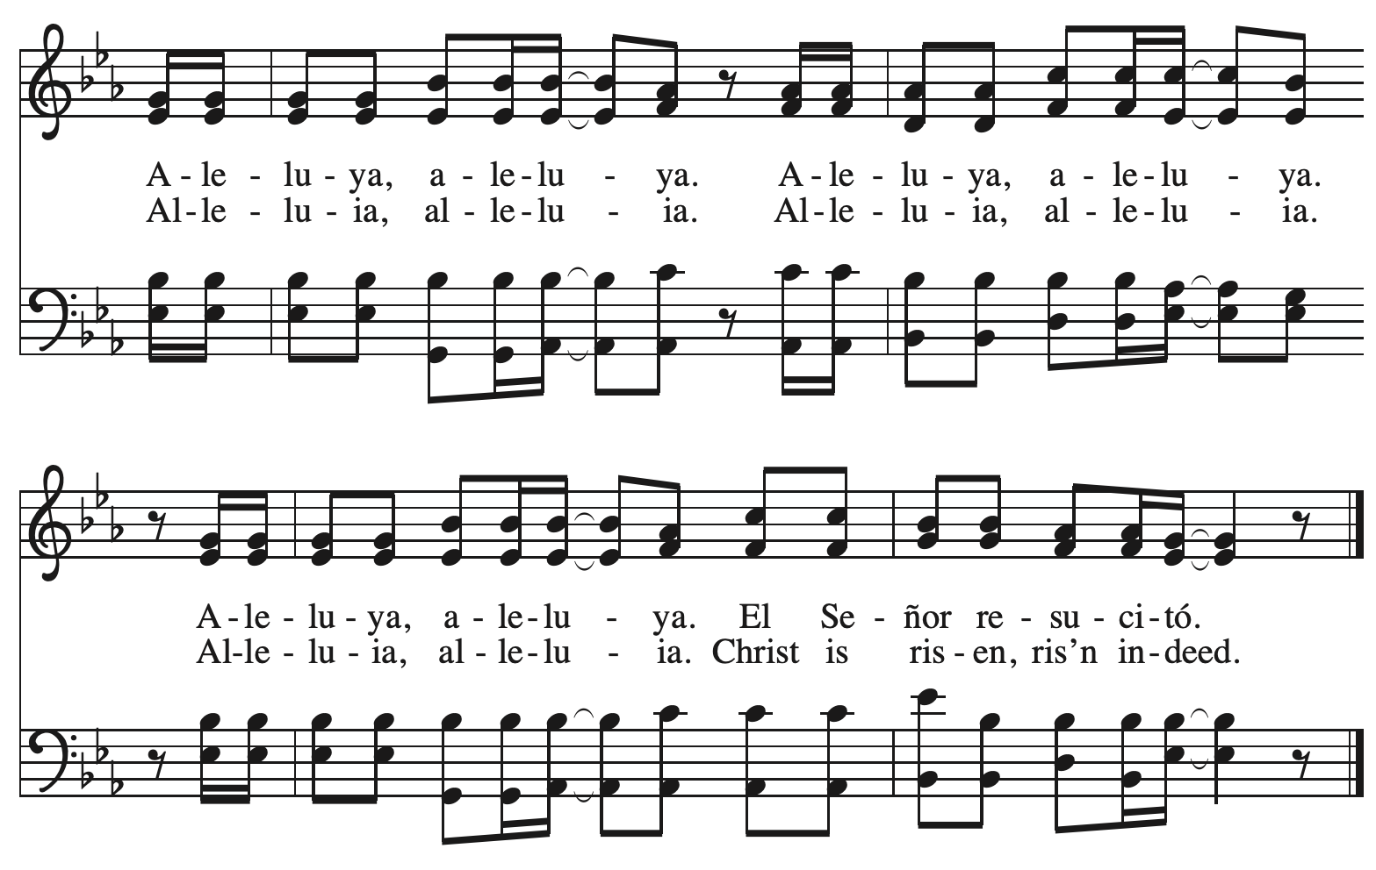

**Gospel – Luke 6: 27-38**

P: The holy Gospel according to St. Luke.

**C: Glory to you, O Lord.**

[Jesus said:] 27 “But I say to you that listen, Love your enemies, do good to those who hate you, 28 bless those who curse you, pray for those who abuse you. 29 If anyone strikes you on the cheek, offer the other also; and from anyone who takes away your coat do not withhold even

your shirt. 30 Give to everyone who begs from you; and if anyone takes away your goods, do not ask for them again. 31 Do to others as you would have them do to you.  
  32 “If you love those who love you, what credit is that to you? For even sinners love those who love them. 33 If you do good to those who do good to you, what credit is that to you? For even sinners do the same. 34 If you lend to those from whom you hope to receive, what credit is that to you? Even sinners lend to sinners, to receive as much again. 35 But love your enemies, do good, and lend, expecting nothing in return. Your reward will be great, and you will be children of the Most High; for God is kind to the ungrateful and the wicked. 36 Be merciful, just as your Father is merciful.  
  37 “Do not judge, and you will not be judged; do not condemn, and you will not be condemned. Forgive, and you will be forgiven; 38 give, and it will be given to you. A good measure, pressed down, shaken together, running over, will be put into your lap; for the measure you give will be the measure you get back.”

P: The Gospel of the Lord.

**C: Praise to you, O Christ.**

*Please be seated.*

**Sermon**

*A time of silence for prayer and reflection follows the sermon.*

*As the hymn of the day begins, please rise as you are able.*

**Hymn of the Day In All Our Grief *ELW* 615**

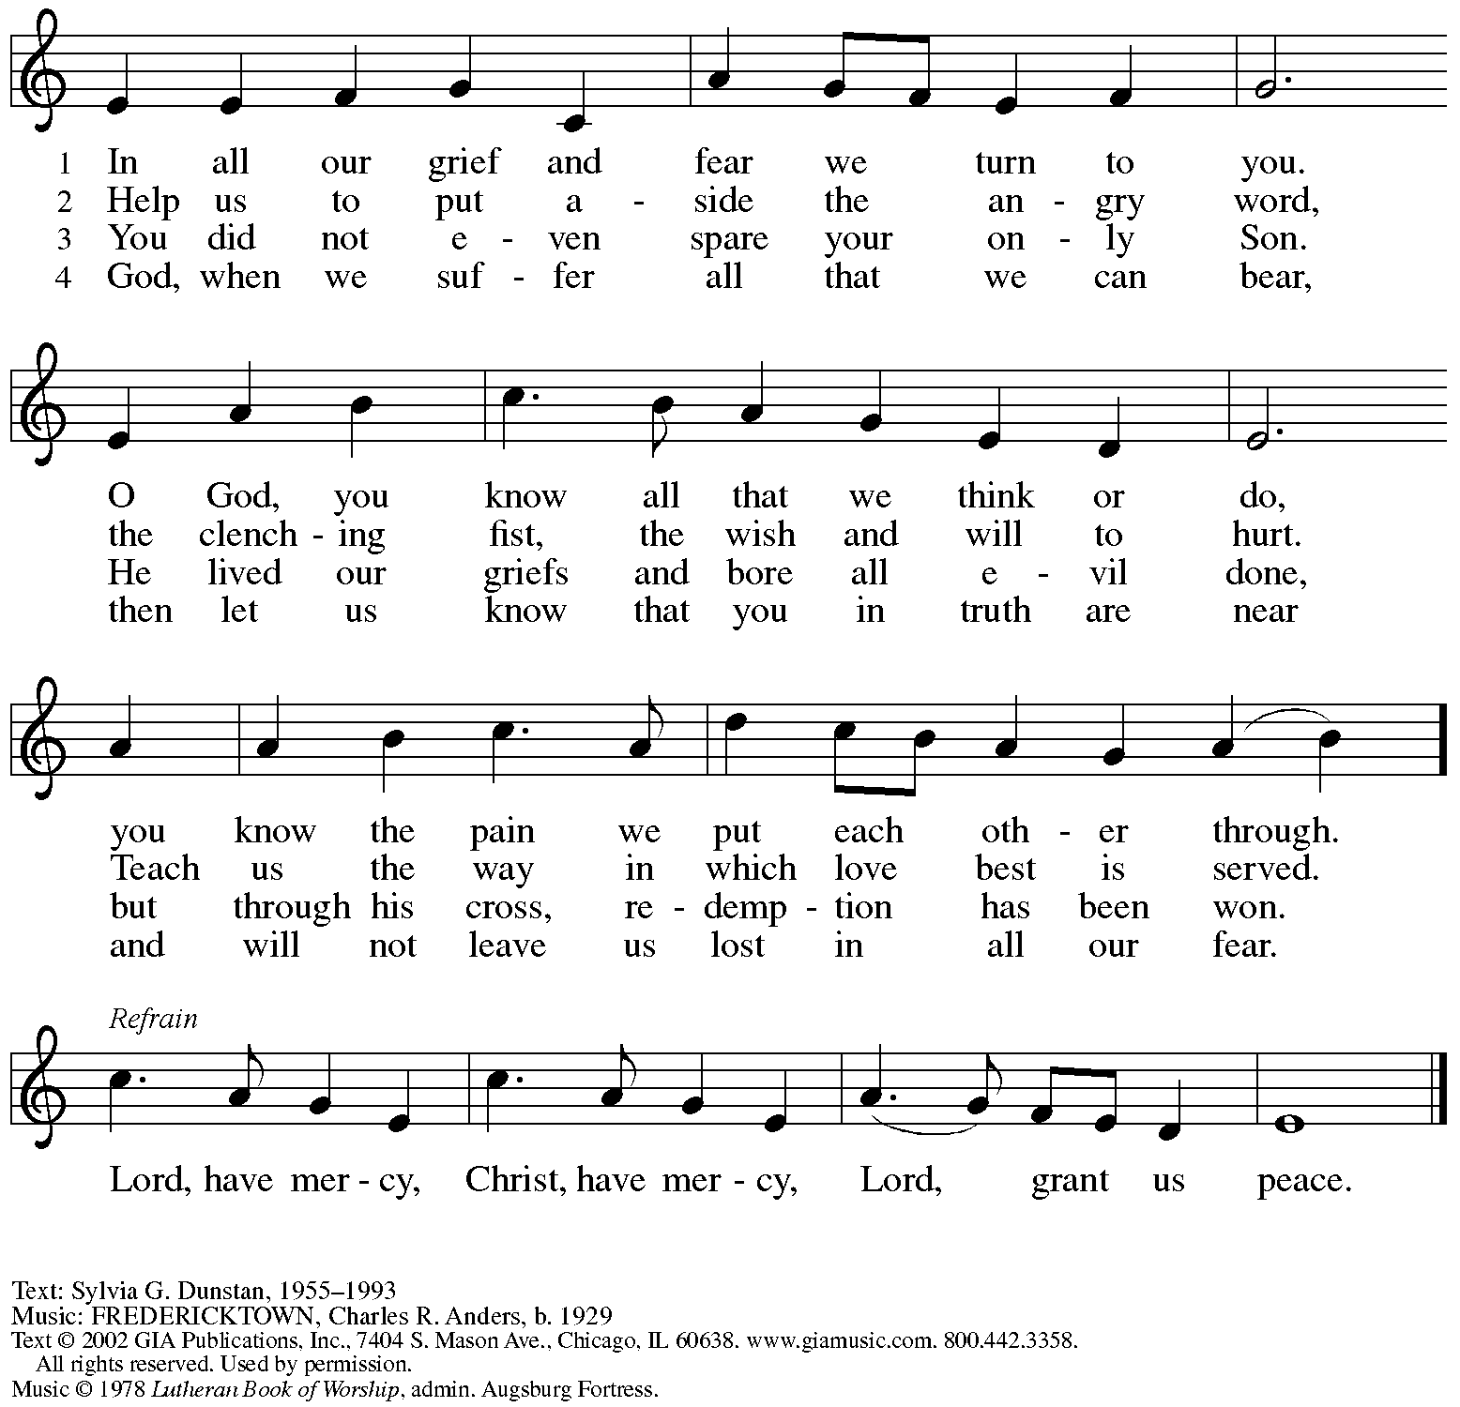

All rights reserved. Reprinted with permission under OneLicense.net # A-722139.

**Apostles’ Creed**

**C: I believe in God, the Father almighty,**

**creator of heaven and earth.**

**I believe in Jesus Christ, God’s only Son, our Lord,**

**who was conceived by the Holy Spirit,**

**born of the virgin Mary,**

**suffered under Pontius Pilate,**

**was crucified, died, and was buried;**

**he descended to the dead.\***

**On the third day he rose again;**

**he ascended into heaven,**

**he is seated at the right hand of the Father,**

**and he will come to judge the living and the dead.**

**I believe in the Holy Spirit,**

**the holy catholic church,**

**the communion of saints,**

**the forgiveness of sins,**

**the resurrection of the body,**

**and the life everlasting. Amen.**

*Or, “he descended into hell,” another translation of this text in widespread use.

**Prayers of the People**

A: Guided by the Holy Spirit, with the light of Christ shining upon us and all nations,

let us pray for the church, the world, and all creation.

*After each petition*

A: Gracious God,

**C: receive our prayer.**

*The presiding minister concludes the prayers*

P: We entrust these prayers to you, O God, in the sure and certain hope

that your promise is revealed among your people.

**C: Amen.**

**Peace**

*The presiding minister and the assembly greet one another in the peace of the risen Christ.*

P: The peace of Christ be with you always.

**C: And also with you.**

*The people may greet those around them with a sign of Christ’s peace and may say*

Peace be with you *or similar words. Please be mindful that not everyone will be comfortable with sharing the peace, so please seek consent before shaking hands or hugging. Other possible ways to share the peace include a simple bow with the verbal greeting of peace, or simply a verbal expression of peace. When the greetings of peace have concluded, please be seated.*

**Meal**

*God feeds us with the presence of Jesus Christ*



**Offering**

*We offer ourselves, our gifts, and our faithful service to God.*

*As the offering is gathered for the mission of the church, including the care of those in need,*

*the table is set for Holy Communion.*

**Music during the Offering**

*As the gifts are brought forward for presentation,* *please rise as you are able.*

**Offertory Song** **Cuando el pobre / When the Poor Ones *ELW*** **725**

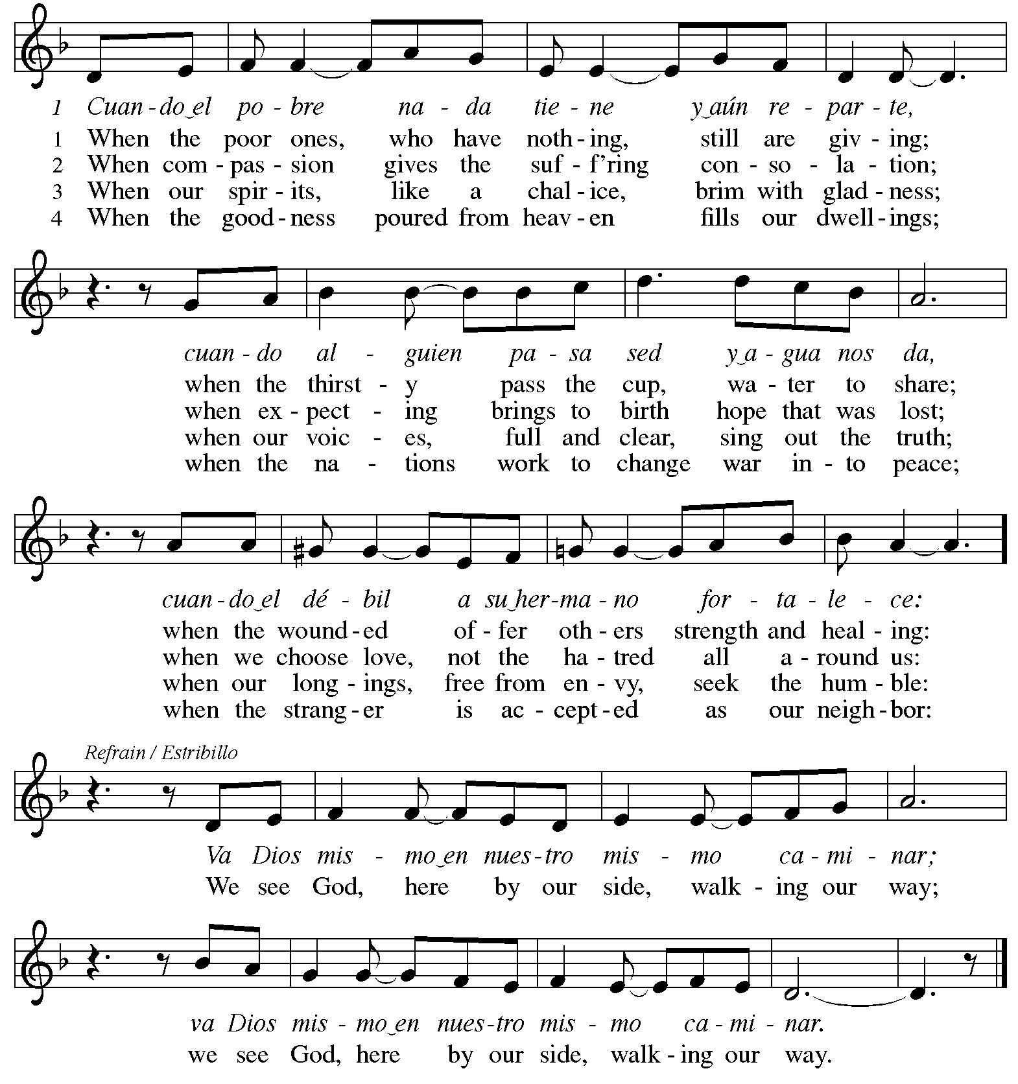

Reprinted under OneLicense.net # A-722139.

**Offertory Prayer**

A: Let us pray.

Holy God, gracious and merciful,

**C:** **you bring forth food from the earth and nourish your whole creation.**

**Turn our hearts toward those who hunger in any way, that all may know your care;**

**and prepare us now to feast on the bread of life, Jesus Christ, our Savior and Lord.**

**Amen.**

**Dialogue** *ACS* p. 20

P: The Lord be with you.

**C: And also with you.**

P: Lift up your hearts.

**C: We lift them to the Lord.**

P: Let us give thanks to the Lord our God.

**C: It is right to give our thanks and praise.**

**Preface** *ACS* p. 20

P: It is indeed right, our duty and our joy,

that we should at all times and in all places

give thanks and praise to you, almighty and merciful God,

through our Savior Jesus Christ;

who on this day overcame death and the grave

and by his glorious resurrection opened to us the way of everlasting life.

And so, with all the choirs of angels,

with the church on earth and the hosts of heaven,

we praise your name and join their unending hymn:

**Sanctus** *ACS* p. 20

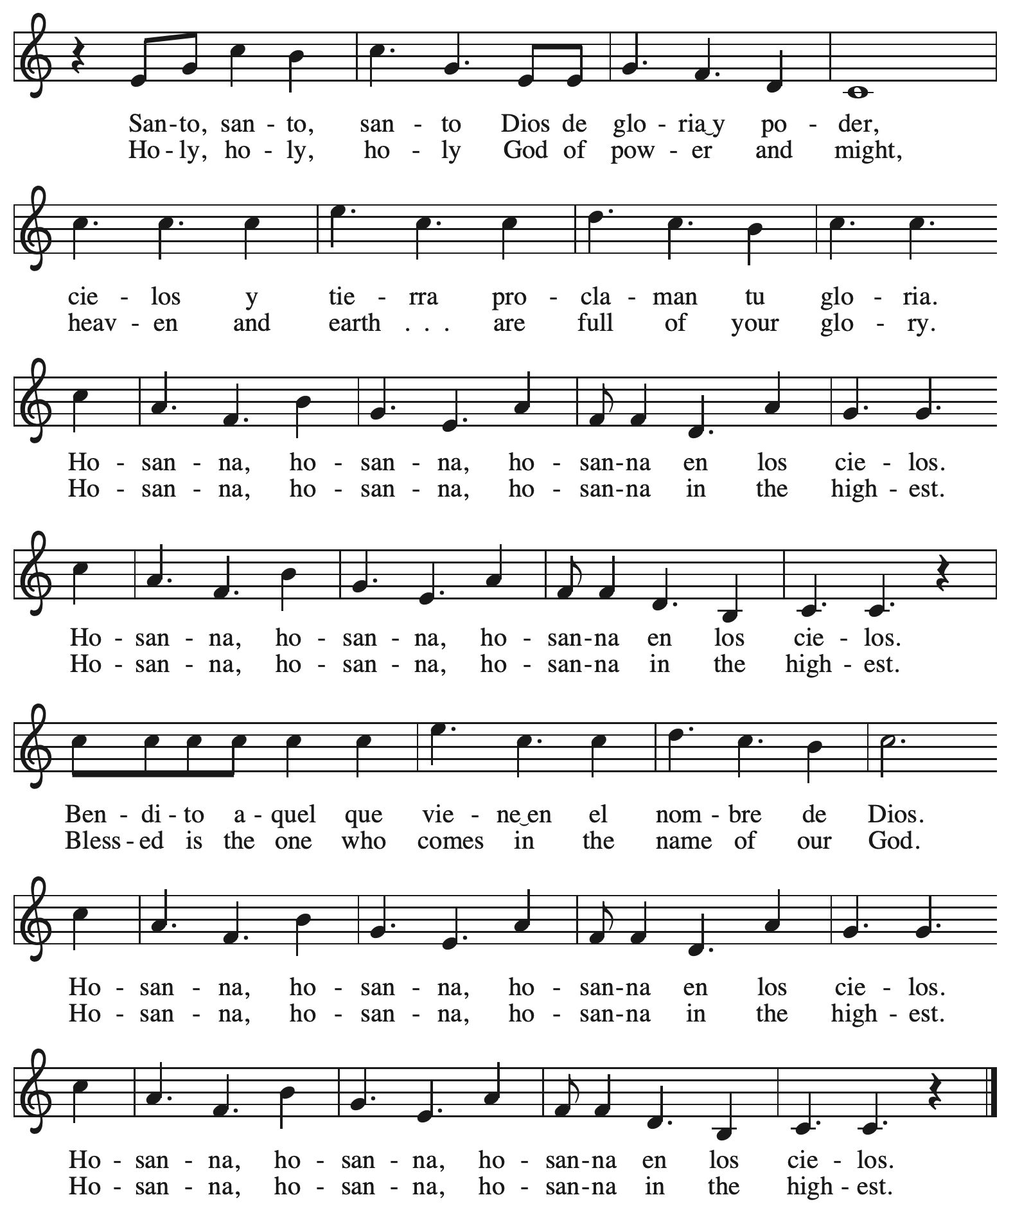

**Eucharistic Prayer** *ACS* p. 21

P: Holy God, you alone are holy … with every breath.

**C: We praise you, O God.**

P: Generations bless your faithfulness … into the future.

**C: We bless you, O God.**

P: We give you thanks for your dear Son … with us now.

**C: We thank you, O God.**

P: In the night in which he was betrayed … Do this for the remembrance of me.

Remembering his love for us

on the way, at the table, and to the end,

we proclaim the mystery of faith:

**C: Christ has died. Christ is risen. Christ will come again.**

P: We pray for the gift of your Spirit … in your church, without end.

**C: Amen.**

**Lord’s Prayer**

P: Gathered as one by the Holy Spirit, let us pray as Jesus taught us.

**C: Our Father in heaven,**

**hallowed be your name,**

**your kingdom come,**

**your will be done,**

**on earth as in heaven.**

**Give us today our daily bread.**

**Forgive us our sins**

**as we forgive those**

**who sin against us.**

**Save us from the time of trial**

**and deliver us from evil.**

**For the kingdom, the power,**

**and the glory are yours,**

**now and forever. Amen.**

**Fraction and Invitation**

P: The joy of the Lord is our strength.

Come and be nourished by the gifts of God.

***Agnus Dei /* Lamb of God** *ACS* p. 25

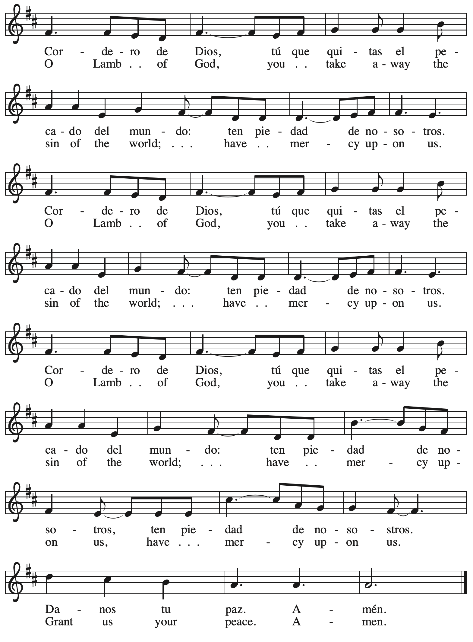

*Please be seated.*



**Holy Communion**

* *All who seek God and desire a deeper and stronger life in Christ are welcome to receive Holy Communion.*
* *Worshipers from the pulpit side will proceed forward first, followed by the center section, and then the lectern side.*
* *Please inform an usher if you would like the ministers to bring Communion to you.*
* *Holy Communion will be served with bread and wine/grape juice.*
* *The presiding minister will first distribute the bread (host) to each communicant. Please indicate if you require a gluten-free host.*
* *Once you have consumed the bread, please pick up an empty glass from the tray next to the presiding minister. The Communion Assistant will pour wine from the chalice or grape juice from the cruet into your glass.*
* *Please step to the side to consume the wine or grape juice.*
* *Feel free to kneel at the altar rail for prayer after receiving the sacrament.*
* *As you return to your pew, glasses may be returned to the empty trays on the side of the center section.*
* *A blessing will be provided for anyone who does not yet receive the sacrament.*
* *All are invited to join in singing the hymns during Holy Communion.*

**Hymns during Holy Communion**

**By Your Hand You Feed Your People *ELW* 469**

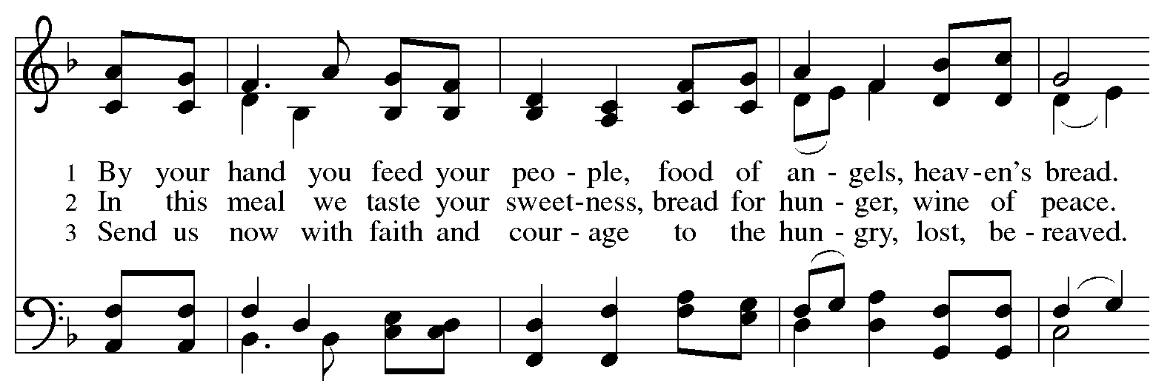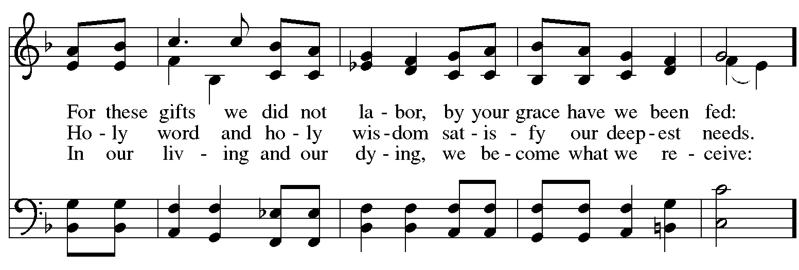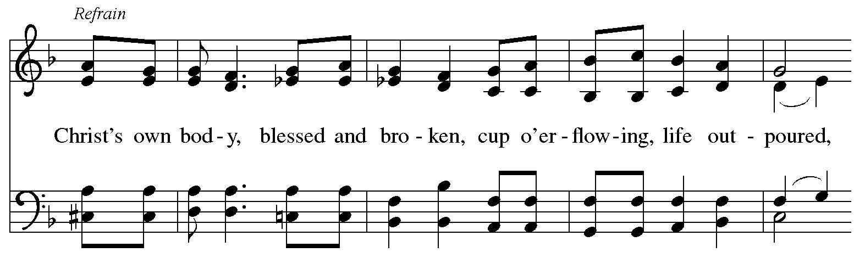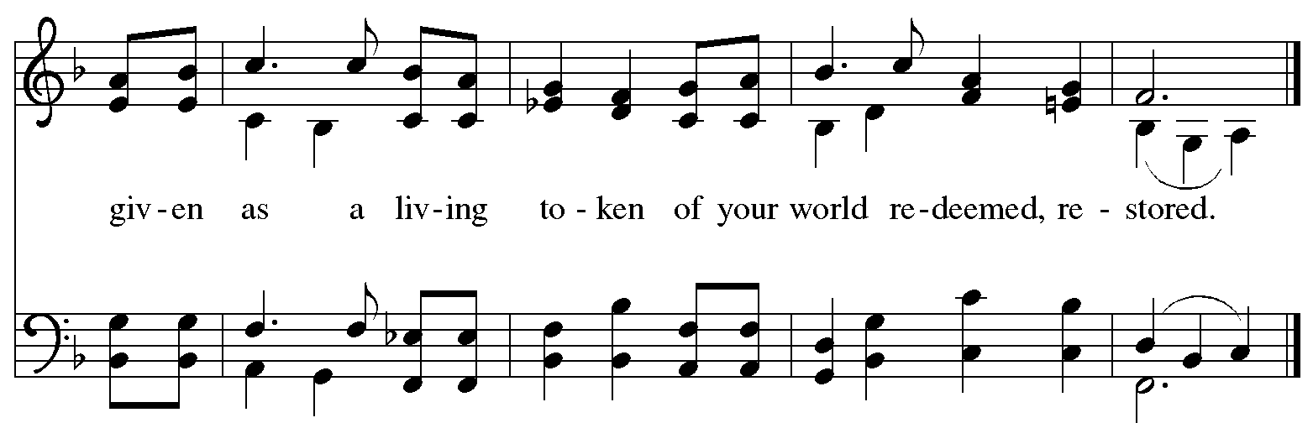

**Hymns during Holy Communion**

**Blest Be the Tie That Binds *ELW* 656**

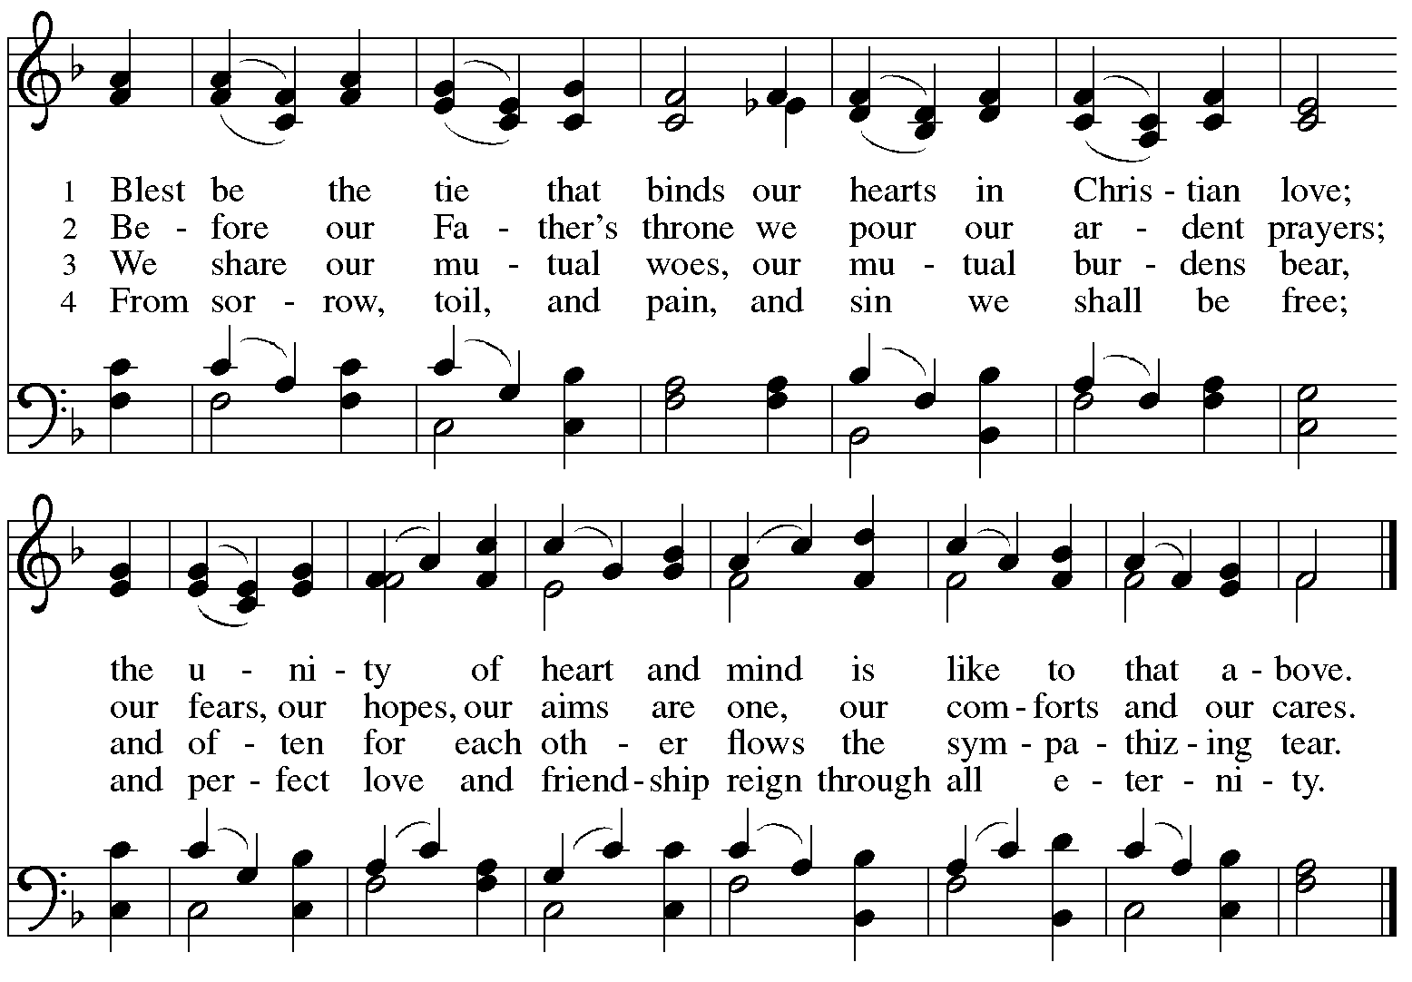

**Hymns during Holy Communion**

**Forgive Our Sins as We Forgive *ELW* 605**

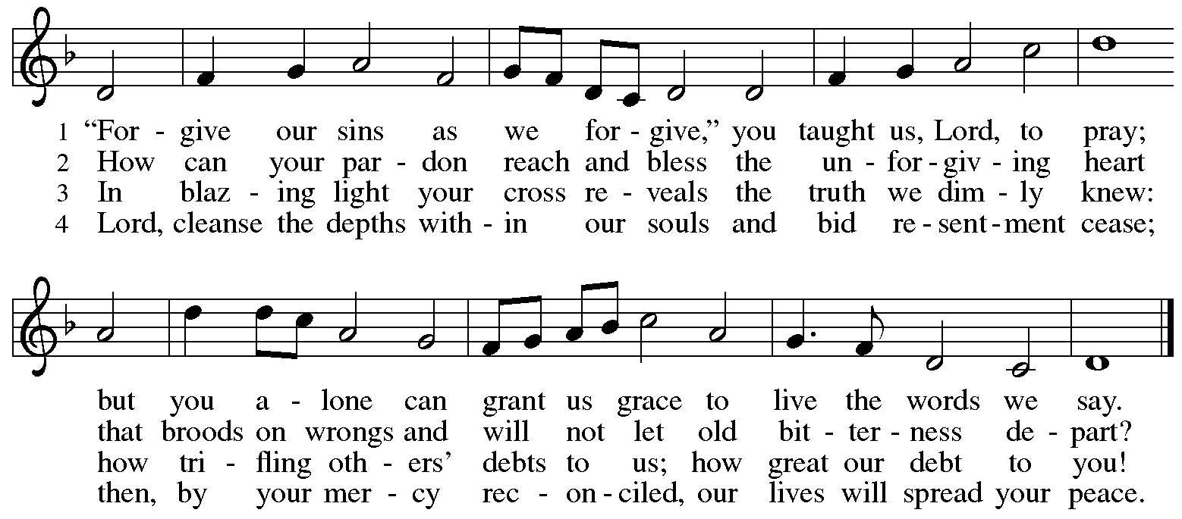

**Hymns during Holy Communion**

**God, When Human Bonds Are Broken *ELW* 603**

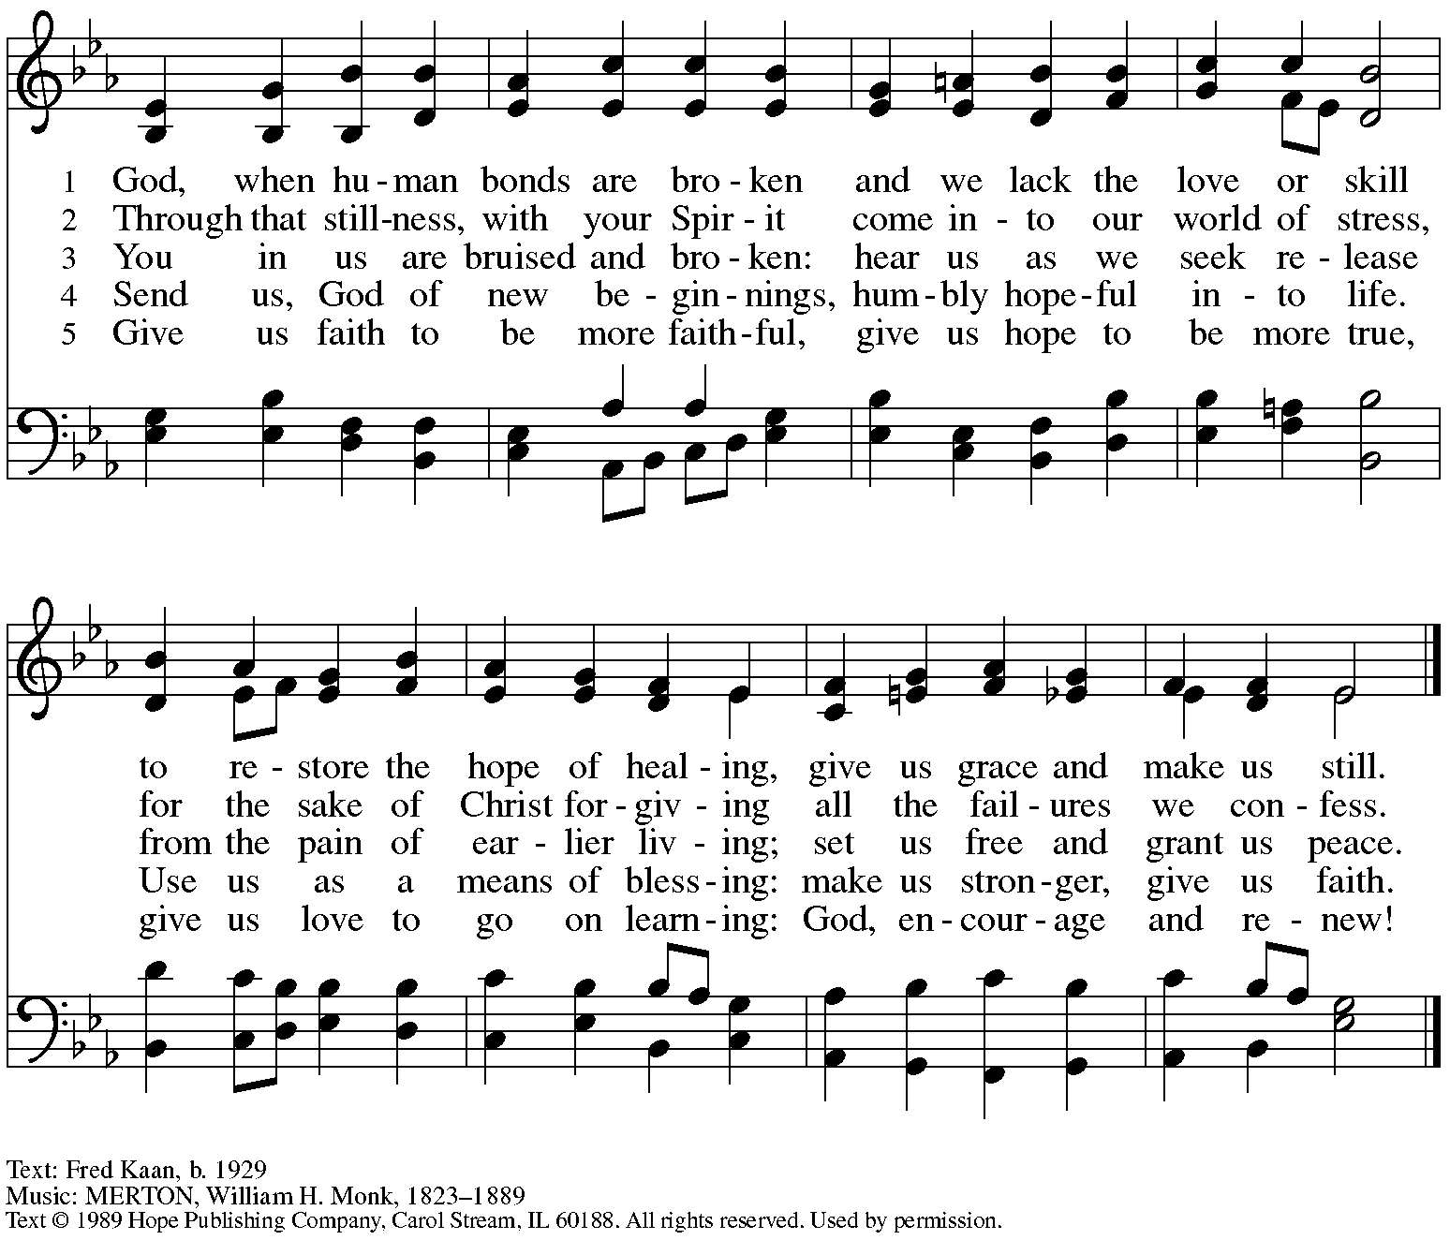

Reprinted under OneLicense.net # A-722139.

**Hymns during Holy Communion**

**Jesu, Jesu, Fill Us with Your Love *ELW* 708**

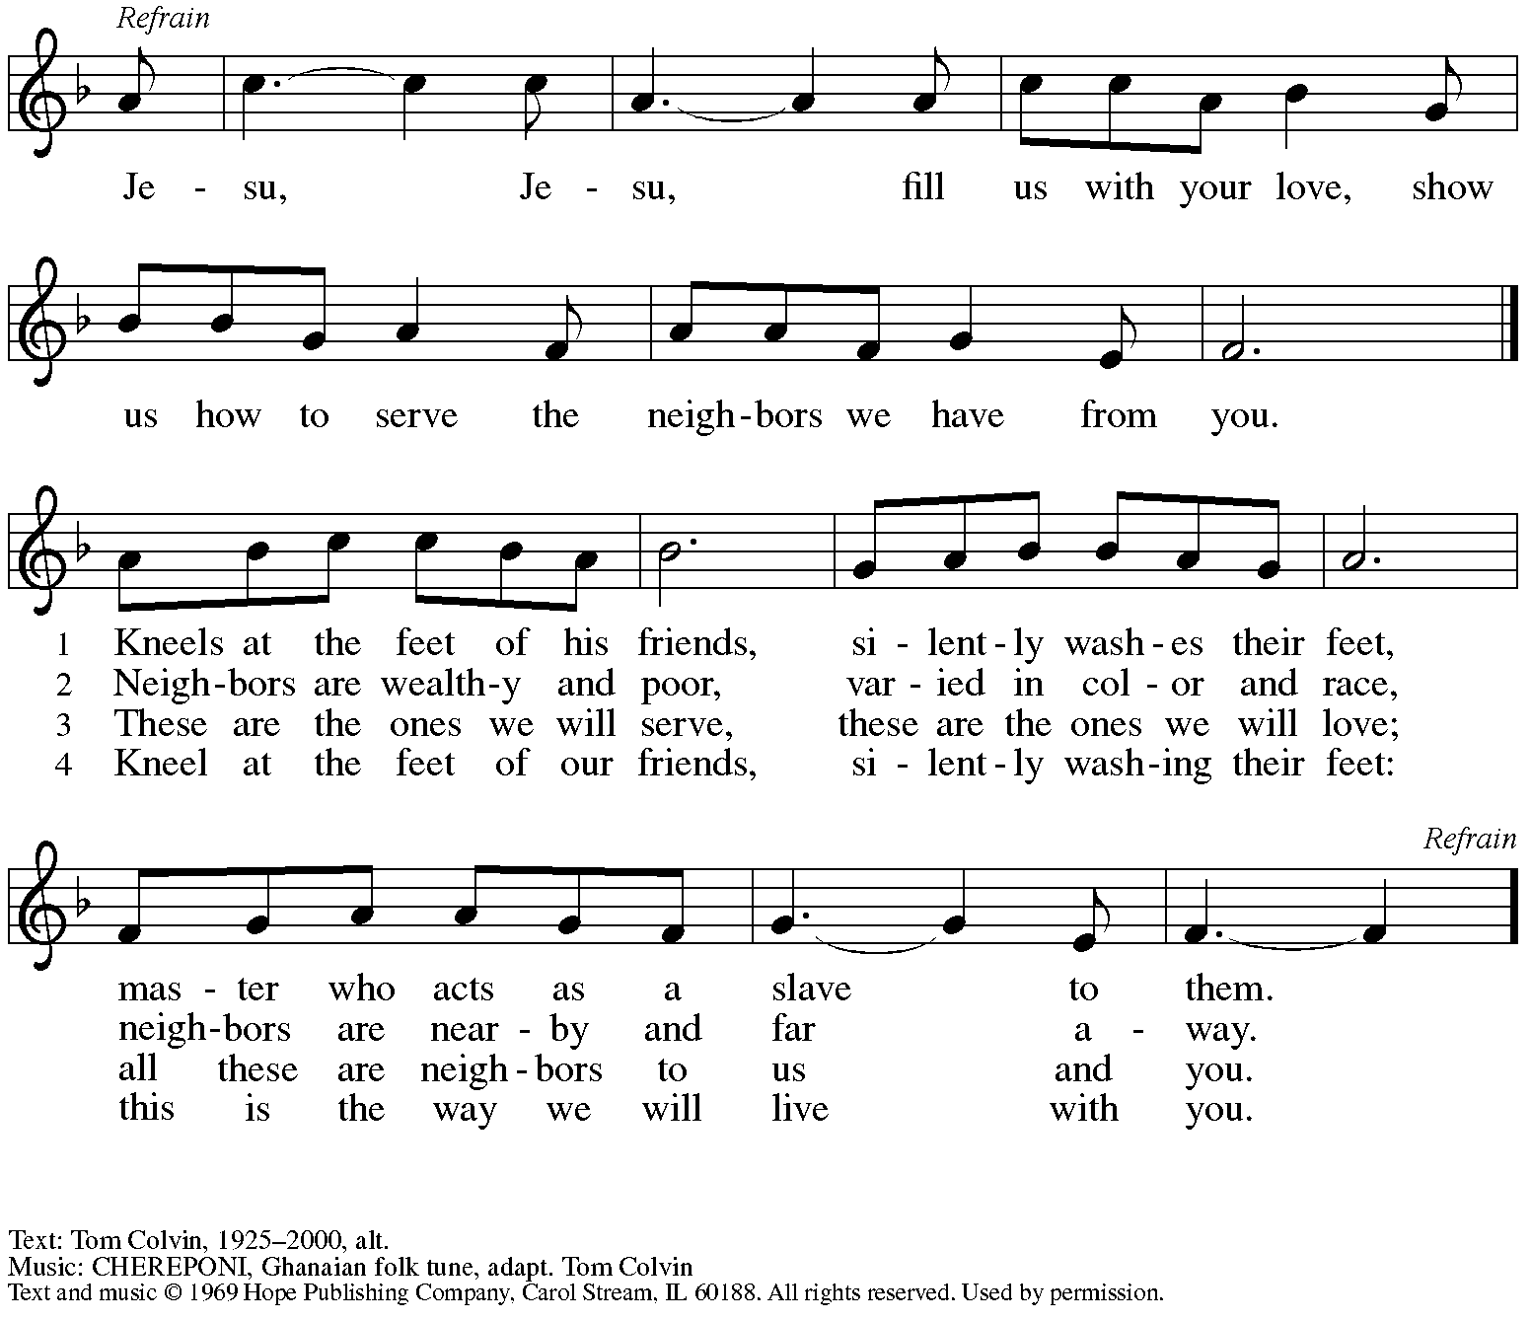

Reprinted under OneLicense.net # A-722139.

*When all have returned to their places, please rise as you are able.*

**Blessing**

P: The body and blood of our Lord Jesus Christ strengthen you and keep you in his grace.

**C: Amen.**

**Prayer**

A: Let us pray.

O God, in this holy communion you have welcomed us into your presence,

nourished us with words of mercy, and fed us at your table. Amid the cares of this life, strengthen us to love you with all our heart, serve our neighbors with a willing spirit,

and honor the earth you have made; through Christ our Lord.

**C: Amen.**

*Please be seated.*

**Sending**

*God blesses us and sends us in mission to the world*

**Announcements**

*Please rise as you are able.*

**Benediction**

P: The holy Three,

the holy One

increase your hope,

strengthen your faith,

deepen your love,

and ☩ grant you peace.

**C: Amen.**

**Sending Hymn** *Following page*

**Dismissal**

A: Go in peace. Christ is with you.

**C: Thanks be to God!**

**Postlude**

**Sending Hymn Build a Longer Table *ACS* 1062**

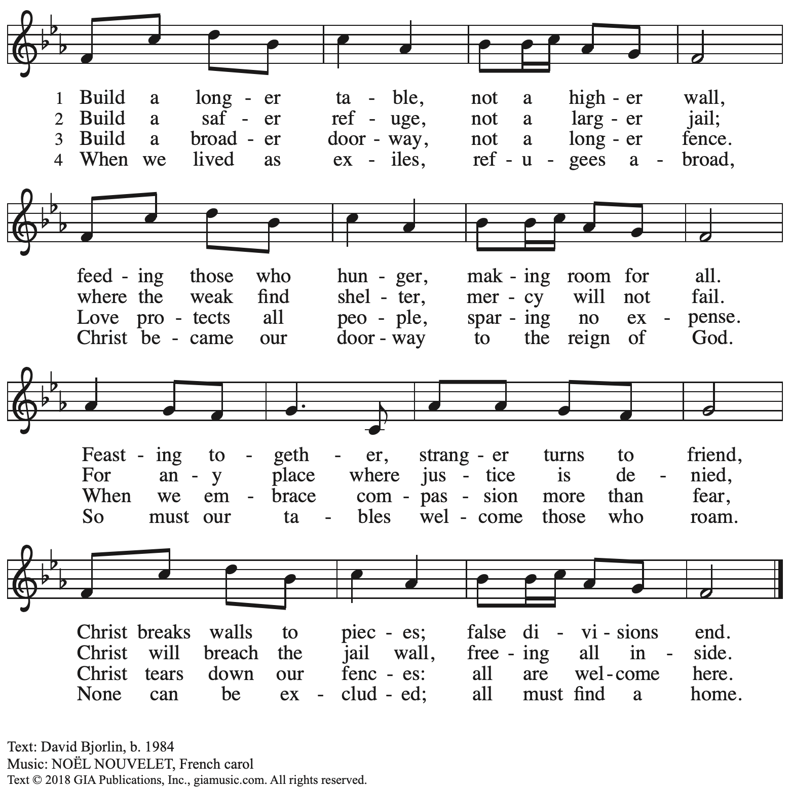

Reprinted with permission under OneLicense.net # A-722139.

*Those serving in worship*

Altar Care Beverley Chapman

Assisting Minister Colleen Cooke

Audio-Visual Ministers David Rollinson

Sarita

Cantor Emily Duque

Lector Lester Prince

Piano Jeff Denlinger

Presiding and Preaching Minister The Rev. Erin Jones

*Liturgy and Hymnody Acknowledgements*

From SundaysandSeasons.com. Copyright © 2025 Augsburg Fortress. All rights reserved. Reprinted under OneLicense.net # A-722139.

Used by permission of Augsburg Fortress.

The Scripture readings contained herein are from *New Revised Standard Version* of the Bible © 1989, Division of Christian Education of the National Council of Churches of Christ in the USA. Used by permission. All rights reserved.

**By Your Hand You Feed Your People** – Text: Susan R. Briehl, b. 1952. Music: CAMROSE, Marty Haugen, b. 1950. Text and music © 2002 GIA Publications, Inc. All rights reserved. Reprinted with permission under OneLicense.net # A-722139.

**Blest Be the Tie That Binds** – Text: John Fawcett, 1740-1817, alt. Music: DENNIS, Johann G. Nägeli, 1773-1836, adapt.

**Forgive Our Sins as We Forgive** – Text: Rosamond E. Herklots, 1905-1987, alt. Music: DETROIT, *The Sacred Harp*, Philadelphia, 1844. Text © Oxford University Press 1969. All rights reserved. Reprinted under OneLicense.net # A-722139.

*Please use the QR code below to link to St. Andrew’s Announcements online!*



**St. Andrew Lutheran Church Announcements**

**February 23rd, 2025**

* **Welcome to worship at St. Andrew on the + Seventh Sunday after Epiphany, February 23rd,** –We are so glad you are here, and we offer a special welcome to all visitors and guests who are here for the first time! Worship attendees are invited to make a name tag at the back of the worship space. Little Church – Big Faith, a Bible lesson and activity for children, will take place after the prayer of the day. There are worship “toolkits” to help children engage with worship and “busy bags” for younger children available in the bookcase at the back of the sanctuary. Please feel free to take one to use with/for your children. All are invited to gather for coffee, other drinks, food, and conversation in the social hall after worship.
* **Thank You to Pastor Erin Jones for Preaching and Leading Worship Today!** – Today’s worship leader is The Rev.Erin Jones, a member of St. Andrew and the Communications and Advocacy Engagement Manager for LAMPa – Lutheran Advocacy Ministry in Pennsylvania. We thank Pastor Erin for sharing her gifts with the congregation today!
* **Thank You to Jeff Denlinger for Leading Today’s Music on Piano!** – Today’s musician is Jeff Denlinger, a member of the St.Andrew congregation.We thank Jeff for sharing his gifts with the congregation this week, also!
* **Advocacy Basics – Today after Worship in the Sanctuary** – Part of our call as baptized Lutheran Christians is to strive for justice and peace and to participate and advocate in civic matters. While it is important to share our thoughts, it can be overwhelming to try to contact elected officials. To help make this easier, today after worship Colleen Cooke, the congregation council liaison for Evangelism and Advocacy, will share basic information about advocacy and how to find and contact your senators and representatives, both on the national level and here in PA. Please take a minute to get drinks and snacks and then gather back in the sanctuary for the presentation.
* **Speak Out Against PA Senate Bill 213 (SB213)** – This bill, recently proposed in the PA State Senate, is a legislative attack on trans and nonbinary rights, healthcare, and public inclusion. For a full description of what the bill proposes and an assessment of its dangers and potential harms to our siblings in Christ, along with a link to find and contact your state senator, please visit: [Call to Action: Stop SB213 – Defend Trans and Nonbinary Rights in Pennsylvania!  - QBurgh](https://qburgh.com/stop-sb213/).
* **Monthly Reparations Offering Next Sunday, March 2nd, during Worship** – In

Luke’s Gospel, Jesus tells a story about a compassionate Samaritan that suggests God’s people are called to work for healing and restoration for our neighbors, regardless of who or what caused them harm. In light of this, St. Andrew has made a commitment to reparations in regard to African American spiritual songs used in our worship. The text and music of most hymns is attributed to specific authors, with copyrights in place, usage reported, and royalties paid to those whose works are featured in worship. With African American spirituals, this is not possible. In response to many years of such uncredited use, St. Andrew invites the congregation to give a reparations offering. Funds received in worship will be donated to our siblings at Bethel AME Church, whose land and building were taken from them in the 1950s, to fund their development in the Hill District.

* **Pancake Brunch during Coffee Hour on Sunday, March 2nd – Please Plan to Stay after Worship – Traditionally on Shrove Tuesday, the day before Ash Wednesday, Christians would clear out all the rich and fatty foods from their cupboards in preparation for the season of Lent and its spiritual discipline of fasting. Following this custom, St. Andrew used to hold a pancake dinner on Shrove Tuesday, but we have not done so since before the pandemic. We are re-introducing the practice and spirit of Shrove Tuesday after worship next Sunday, March 2nd. At the close of worship, we will have a brief outdoor liturgy for the burning of the palms and then proceed to the social hall for a meal together. The hospitality committee will provide pancake mix (with gluten), sausage (non-vegan), gluten-free cupcakes and cookies, butter, syrup, coffee and tea. We ask people of the congregation to bring fruit, breakfast juices, and other gluten-free breakfast items. We hope you will join in these activities as we prepare for the season of Lent, beginning on Ash Wednesday, March 5th.**
* **March Produce Distribution – First Tuesday of the Month, March 4th, from 5:30-7:00 p.m. –** St. Andrew partners with Greater Pittsburgh Community Food Bank to serve as a distribution site for fresh produce on the first Tuesday of every month. The next distribution will be on Tuesday, March 4th. We invite people of the congregation to help with the distribution from 5:30-7:00 p.m. and/or to help with unloading and setup during the day between 10:00 a.m. and 1:00 p.m.
* **Ash Wednesday Worship, March 5th:**
  + **Service for Children and Families – 5:30 p.m.**
  + **Service with Imposition of Ashes and Holy Communion – 7:00 p.m.**

The season of Lent, a time of repentance, spiritual practice, and baptismal reflection begins this year on March 5th. St. Andrew will offer two services that day. The first, at 5:30 p.m., will offer an introduction to the day and season designed for children through 6th grade. Imposition of Ashes will be available at that service as well as at the 7:00 p.m. service, which will also include the sacrament of Holy Communion. Blessings to all as we prepare for the season of Lent.

* **Lenten Food Drive for St. Andrew’s Pantry** – One of the spiritual disciplines of the season of Lent is almsgiving – generous giving on behalf of neighbors in need. In the spirit of Lent, we are inviting people of the congregation to donate nonperishable food items to help replenish the congregation’s outdoor pantry. **Suggested items include**: Packs of chicken, tuna, or pork (any flavor); cans of Vienna sausage, potted meat, spam; cans of beef stew, beefaroni, ravioli; boxes of macaroni and cheese, stuffing, or mashed potatoes; cups of applesauce – any flavor; granola bars, rice Krispie treat bars; boxes of cookies or crackers; small bags or boxes of cereal – any kind; shelf stable milk; case of water; cans of vegetables and fruits. All canned items must have a pull tab to open.Items may be placed on the donation table in the social hall throughout the season of Lent.
* ***Life Renewed: Devotions for Lent 2025* Available at Church Entrances** – Another of the spiritual disciplines for the season of Lent is prayer, so each year, the worship committee provides copies of a daily devotional booklet. This year’s is titled *Life Renewed*, and it contains a brief scripture reading, reflection/quote, and prayer for each day from Ash Wednesday (March 5th) to the Vigil of Easter (April 19th. They are now available at the entrances to the building – please take one to aid in your devotions this Lent!
* **Re-Stock Outdoor Little Library!** – If you are interested in stocking the little library that is on the Centre Avenue side of the church, there are extra books in the metal cabinet to the right of the dumbwaiter.  (There are currently some 10% off coupons for Half Price Books that are good throughout the year.)  The current stock of books are from the challenged or banned book lists.  Here are two lists:  (<https://www.ala.org/bbooks>) (<https://en.wikipedia.org/wiki/List_of_most_commonly_challenged_books_in_the_United_States>).
* **Compline Prayer Service with the Pittsburgh Compline Choir – Sundays at 8:00 p.m. at Heinz Chapel –** Compline was traditionally a monastic prayer service, and the Pittsburgh Compline Choir, a ministry of Lutheran Campus Ministry in Greater Pittsburgh, sings a choral version of compline rooted in this thousand-year-old tradition of scripture, song, and silence each Sunday at Heinz Chapel at 8:00 p.m. This service also streams on Facebook (Pittsburgh Compline Choir) and YouTube (The Pittsburgh Compline Choir). Heinz Chapel is located off of S. Bellefield Ave. in Oakland. For more information, please visit: [Pittsburgh Compline Choir](http://pittsburghcomplinechoir.org/).