

**+ Sixth Sunday after Epiphany**

**February 16th, 2025**

**10:00 a.m.**



**St. Andrew Lutheran Church**

**304 Morewood Ave.**

**Pittsburgh, PA 15213**

**412.682.3342**

[**St_andrewELCA@verizon.net**](mailto:St_andrewELCA@verizon.net)

[**www.standrewpittsburgh.org**](http://www.standrewpittsburgh.org)

**+ Sixth Sunday after Epiphany**

**Order for Worship**

*Blessings and curses abound on the sixth Sunday after Epiphany.*

*We would do well to listen closely* *to whom the “blessed are” and “woe to” statements are directed and to find our place in the crowd among those who desire to touch Jesus.*

*The risen Christ stands among us in the mystery of the holy supper*

*with an invitation to live in him, and offers power to heal us all.*

**Welcome to St. Andrew!**

* St. Andrew welcomes all who are seeking a place of healing, wholeness, and acceptance in a nurturing and faith-forming spiritual home. We are striving toward racial equity worldwide

and we seek to honor the lived experience of all individuals regardless of background. Our community embraces people of all ages, ethnicities, cultures, abilities, sexual orientations,

gender identities and expressions, and family constellations. Come and See!

* Worship Services are live-streamed to multiple online platforms. By attending worship, you agree that your image and voice may be broadcast.
* Everyone is invited to make a name tag at the black bookcase in the back of the worship space if they would like. There are stickers indicating pronouns on the bookcase if you would like to include them on your name tag.
* Children are invited to attend Little Church – Big Faith, a Bible lesson and activity, during worship (after the Prayer of the Day). The group returns to the worship space for the liturgy of Holy Communion.
* A nursery is available through the doors at the left side of the sanctuary and across from the doorway to the Social Hall. Look for a purple-colored room.
* Worship “toolkits” to help children engage with the service, along with “busy bags” for younger children, are available in the bookcase at the back of the sanctuary. Please feel free to take one to use with/for your children.
* Holy Communion is served with bread (gluten-free available) and wine or grape juice. The presiding minister will distribute the bread (host). Please consume this and then pick up an empty glass from the tray. The Communion Assistant will pour wine or grape juice into your glass. Please step to the side to consume the wine or grape juice. Feel free to kneel at the altar for prayer and reflection. As you return to your pew, glasses may be returned to the empty trays on either side of the center section.
* A restroom is available on the main level of the church, through the doors to the Social Hall and to the right in the main office.

*Abbreviations*

P: Pastor/Presiding Minister ***ELW*: *Evangelical Lutheran Worship* hymnal**

A: Assisting Minister ***ACS*: *All Creation Sings* hymnal**

L: Lector ***W&P*: *Worship and Praise* hymnal**

**C: Congregation**

**Pre-Service Music** Timothy Kocher-Hillmer

**Welcome**

**Prelude** *What a Friend We Have in Jesus* arr. Philip Keveren

**Gathering**

*The Holy Spirit calls us together as the people of God*

**Thanksgiving for Baptism**

*Please rise as you are able. All may make the sign of the cross,*

*the sign that is marked at Baptism, as the presiding minister begins.*

P: Blessed be the holy Trinity, ☩ one God,

the fountain of living water, the rock who gave us birth,

our light and our salvation.

**C: Amen.**

P: Joined to Christ in the waters of Baptism, we are clothed with God’s mercy and forgiveness. Let us give thanks for the gift of Baptism.

*Water may be poured into the font as the presiding minister gives thanks.*

P: We give you thanks, O God, for in the beginning you created us in your image and placed us in a well-watered garden. In the desert, you promised pools of water for the parched, and you gave us water from the rock. When we did not know the way, you sent the Good Shepherd to lead us to still waters. At the cross, you washed us from Jesus’ wounded side, and on this day, you shower us again with the water of life.

We praise you for your salvation through water, for the water in this font,

and for water everywhere, including the Allegheny, Monongahela, and Ohio rivers.

Bathe us in your forgiveness, grace, and love.

Satisfy all who thirst, and give us the life only you can give.

To you be given honor and praise

through ☩ Jesus Christ, our living water,

in the unity of the Holy Spirit, now and forever.

**C: Amen.**

**Gathering Hymn Light Dawns on a Weary World *ELW* 726**

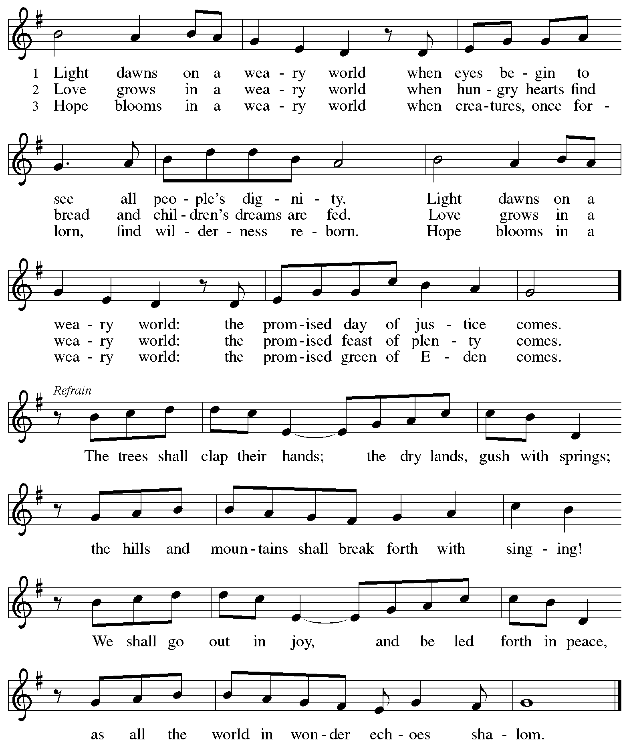

**Greeting**

P: The grace of our Lord Jesus Christ, the love of God,

and the communion of the Holy Spirit be with you all.

**C: And also with you.**

**Hymn of Praise** *ACS* p. 12

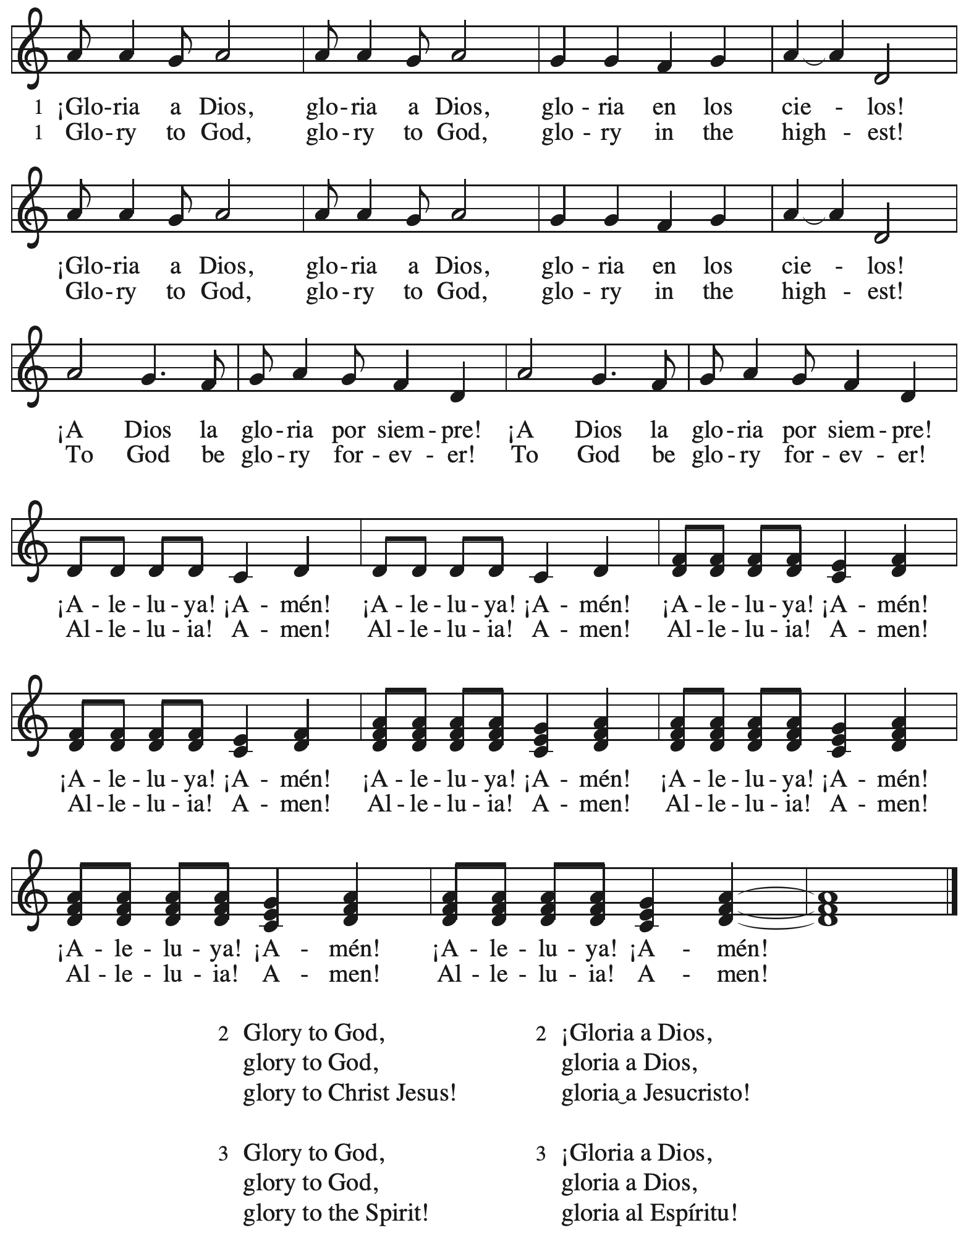

**Prayer of the Day**

P: The Lord be with you.

**C: And also with you.**

P: Let us pray. Living God, in Christ you make all things new.

Transform the poverty of our nature by the riches of your grace,

and in the renewal of our lives make known your glory,

through Jesus Christ, our Savior and Lord.

**C: Amen.**

*Please be seated.*

**Word**

*God speaks to us in Scripture reading, preaching, and song*

**First Reading** **–** **Jeremiah 17: 5-10**

 5 Thus says the Lord:  
 Cursed are those who trust in mere mortals  
  and make mere flesh their strength,  
  whose hearts turn away from the Lord.  
 6 They shall be like a shrub in the desert,  
  and shall not see when relief comes.  
 They shall live in the parched places of the wilderness,  
  in an uninhabited salt land.  
  
 7 Blessed are those who trust in the Lord,  
  whose trust is the Lord.  
 8 They shall be like a tree planted by water,  
  sending out its roots by the stream.  
 It shall not fear when heat comes,  
  and its leaves shall stay green;  
 in the year of drought it is not anxious,  
  and it does not cease to bear fruit.  
  
 9 The heart is devious above all else;  
  it is perverse—  
  who can understand it?  
 10 I the Lord test the mind  
  and search the heart,  
 to give to all according to their ways,  
  according to the fruit of their doings.

L: Word of God, word of life.

**C: Thanks be to God.**

**Psalm 1**

*The cantor will lead the singing of the psalm.*

*The congregation is invited to respond with the alternate verses in bold print,*

*and to join in singing the refrain.*

*Psalm Tone*

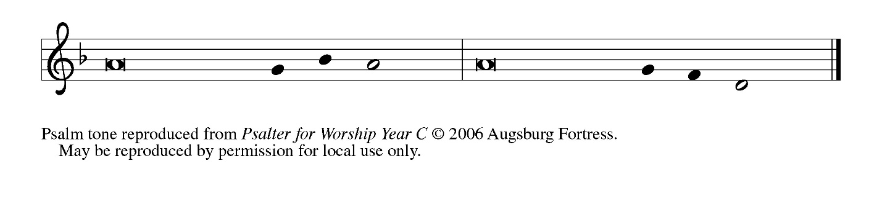

*Psalm Refrain*

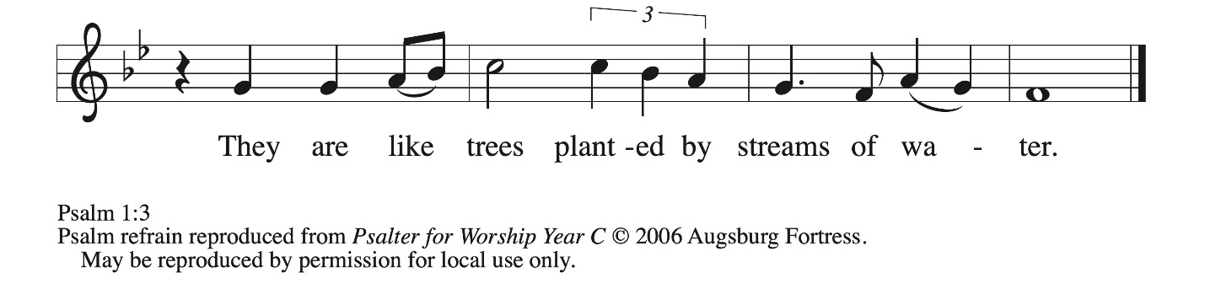

1 Happy are they who have not walked in the counsel **|** of the wicked,  
  nor lingered in the way of sinners, nor sat in the seats **|** of the scornful!  
 2 **Their delight is in the law | of the Lord,**  
  **and they meditate on God’s teaching | day and night. R**  
 3 They are like trees planted by streams of water, bearing fruit in due season, with leaves that **|** do not wither;  
  everything they **|** do shall prosper.  
 4 **It is not so | with the wicked;**  
  **they are like chaff which the wind | blows away.**  
 5 Therefore the wicked shall not stand upright when **|** judgment comes,  
  nor the sinner in the council **|** of the righteous.  
 6 **For the Lord knows the way | of the righteous,**  
  **but the way of the wicked shall | be destroyed. R**

**Second Reading – 1 Corinthians 15: 12-20**

12 Now if Christ is proclaimed as raised from the dead, how can some of you say there is no resurrection of the dead? 13 If there is no resurrection of the dead, then Christ has not been raised; 14 and if Christ has not been raised, then our proclamation has been in vain and your faith has been in vain. 15 We are even found to be misrepresenting God, because we testified of God that God raised Christ—whom God did not raise if it is true that the dead are not raised. 16 For if the dead are not raised, then Christ has not been raised. 17 If Christ has not been raised, your faith is futile and you are still in your sins. 18 Then those also who have died in Christ have perished.

19 If for this life only we have hoped in Christ, we are of all people most to be pitied.  
  20 But in fact Christ has been raised from the dead, the first fruits of those who have died.

L: Word of God, word of life.

**C: Thanks be to God.**

*Please rise as you are ab and join in singing the Gospel Acclamation.*

**Gospel Acclamation** *ACS* p. 14

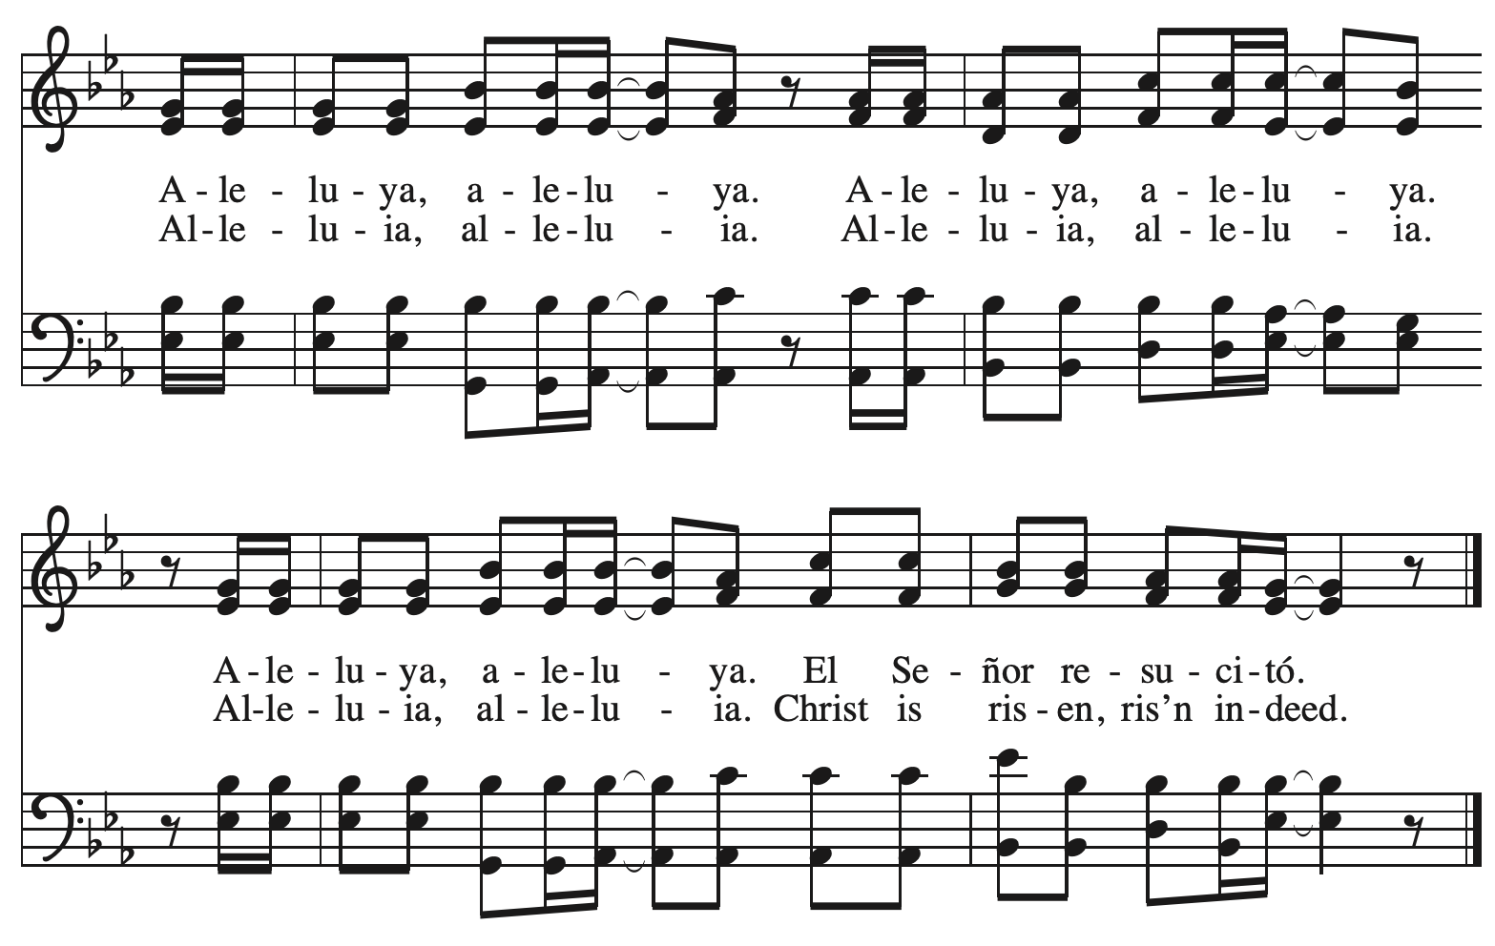

**Gospel – Luke 6: 17-26**

P: The holy Gospel according to St. Luke.

**C: Glory to you, O Lord.**

17 [Jesus] came down with [the twelve] and stood on a level place, with a great crowd of his disciples and a great multitude of people from all Judea, Jerusalem, and the coast of Tyre and Sidon.18 They had come to hear him and to be healed of their diseases; and those who were troubled with unclean spirits were cured. 19 And all in the crowd were trying to touch him, for power came out from him and healed all of them.  
  20 Then he looked up at his disciples and said:  
 “Blessed are you who are poor,  
  for yours is the kingdom of God.  
 21 “Blessed are you who are hungry now,  
  for you will be filled.  
 “Blessed are you who weep now,  
  for you will laugh.  
  22 “Blessed are you when people hate you, and when they exclude you, revile you, and defame you on account of the Son of Humanity.

23 Rejoice in that day and leap for joy, for surely your reward is great in heaven; for that is what their ancestors did to the prophets.  
 24 “But woe to you who are rich,  
  for you have received your consolation.  
 25 “Woe to you who are full now,  
  for you will be hungry.  
 “Woe to you who are laughing now,  
  for you will mourn and weep.  
  26 “Woe to you when all speak well of you, for that is what their ancestors did to the false prophets.”

P: The Gospel of the Lord.

**C: Praise to you, O Christ.**

*Please be seated.*

**Sermon**

*A time of silence for prayer and reflection follows the sermon.*

*As the hymn of the day begins, please rise as you are able.*



**Hymn of the Day O Christ, Your Heart, Compassionate *ELW* 722**

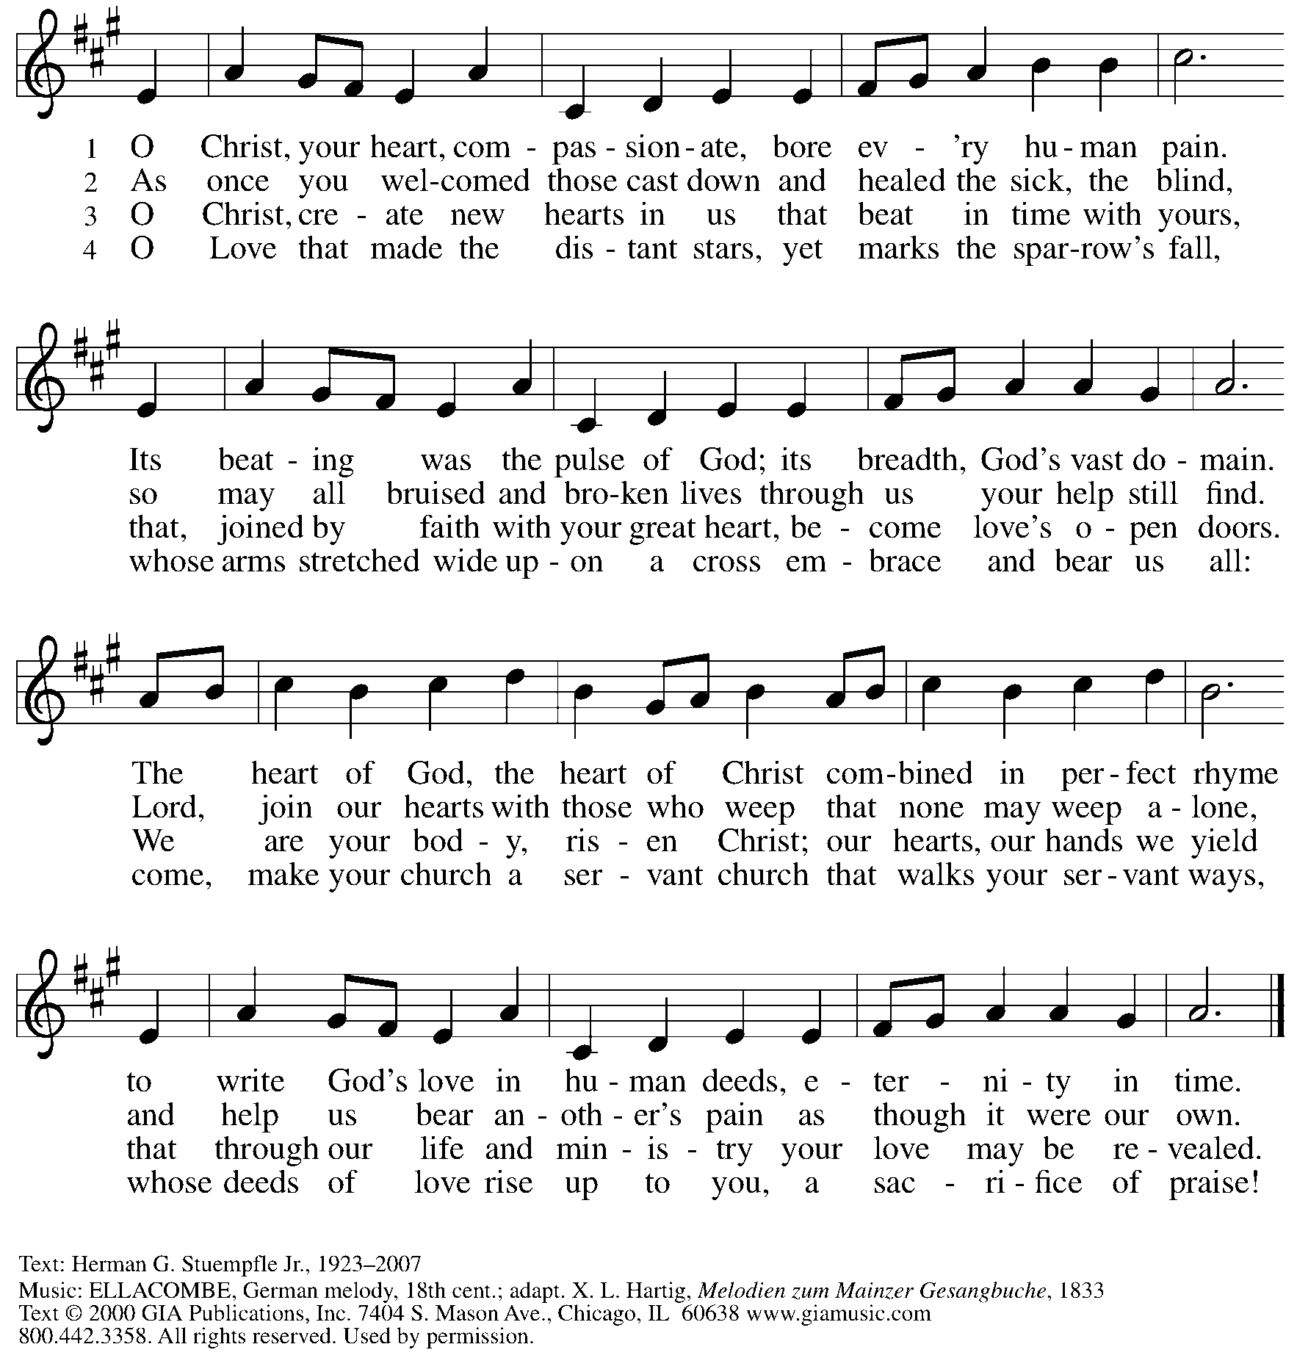

Reprinted under OneLicense.net # A-722139.

**Apostles’ Creed**

**C: I believe in God, the Father almighty,**

**creator of heaven and earth.**

**I believe in Jesus Christ, God’s only Son, our Lord,**

**who was conceived by the Holy Spirit,**

**born of the virgin Mary,**

**suffered under Pontius Pilate,**

**was crucified, died, and was buried;**

**he descended to the dead.\***

**On the third day he rose again;**

**he ascended into heaven,**

**he is seated at the right hand of the Father,**

**and he will come to judge the living and the dead.**

**I believe in the Holy Spirit,**

**the holy catholic church,**

**the communion of saints,**

**the forgiveness of sins,**

**the resurrection of the body,**

**and the life everlasting. Amen.**

*Or, “he descended into hell,” another translation of this text in widespread use.

**Prayers of the People**

A: Guided by the Holy Spirit, with the light of Christ shining upon us and all nations,

let us pray for the church, the world, and all creation.

*After each petition*

A: Gracious God,

**C: receive our prayer.**

*The presiding minister concludes the prayers*

P: We entrust these prayers to you, O God, in the sure and certain hope

that your promise is revealed among your people.

**C: Amen.**

**Peace**

*The presiding minister and the assembly greet one another in the peace of the risen Christ.*

P: The peace of Christ be with you always.

**C: And also with you.**

*The people may greet those around them with a sign of Christ’s peace and may say*

Peace be with you *or similar words. Please be mindful that not everyone will be comfortable with sharing the peace, so please seek consent before shaking hands or hugging. Other possible ways to share the peace include a simple bow with the verbal greeting of peace, or simply a verbal expression of peace. When the greetings of peace have concluded, please be seated.*

**Meal**

*God feeds us with the presence of Jesus Christ*



**Offering**

*We offer ourselves, our gifts, and our faithful service to God.*

*As the offering is gathered for the mission of the church, including the care of those in need,*

*the table is set for Holy Communion.*

**Noisy Offering**

*As children of the congregation carry buckets around the sanctuary, people of the congregation are invited to throw in their change as an offering. This month’s offering will support the Good Neighbor Fund administered by the chaplain’s office of Glad Run Lutheran Services.*

**Music during the Offering**

*I’ll Fly Away* arr. Brent Edstrom

*As the gifts are brought forward for presentation,* *please rise as you are able.*

**Offertory Song** **Cuando el pobre / When the Poor Ones *ELW*** **725**

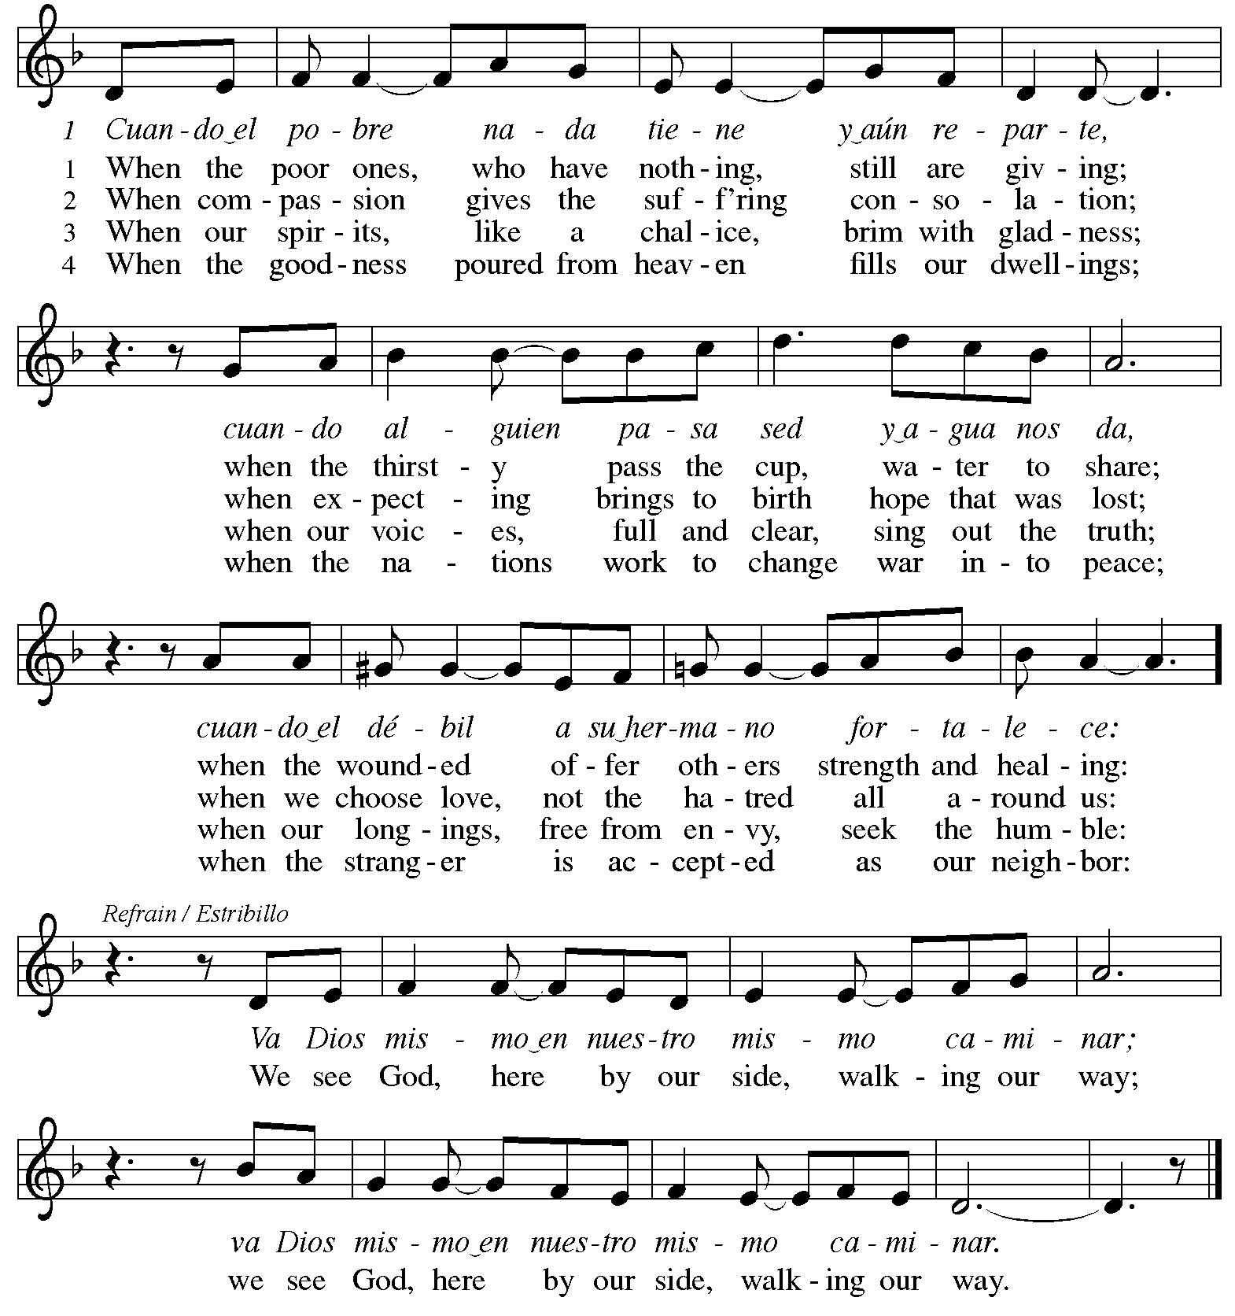

Reprinted under OneLicense.net # A-722139.

**Offertory Prayer**

A: Let us pray.

Holy God, gracious and merciful,

**C:** **you bring forth food from the earth and nourish your whole creation.**

**Turn our hearts toward those who hunger in any way, that all may know your care;**

**and prepare us now to feast on the bread of life, Jesus Christ, our Savior and Lord.**

**Amen.**

**Dialogue** *ACS* p. 20

P: The Lord be with you.

**C: And also with you.**

P: Lift up your hearts.

**C: We lift them to the Lord.**

P: Let us give thanks to the Lord our God.

**C: It is right to give our thanks and praise.**

**Preface** *ACS* p. 20

P: It is indeed right, our duty and our joy,

that we should at all times and in all places

give thanks and praise to you, almighty and merciful God,

through our Savior Jesus Christ;

who on this day overcame death and the grave

and by his glorious resurrection opened to us the way of everlasting life.

And so, with all the choirs of angels,

with the church on earth and the hosts of heaven,

we praise your name and join their unending hymn:

**Sanctus** *ACS* p. 20

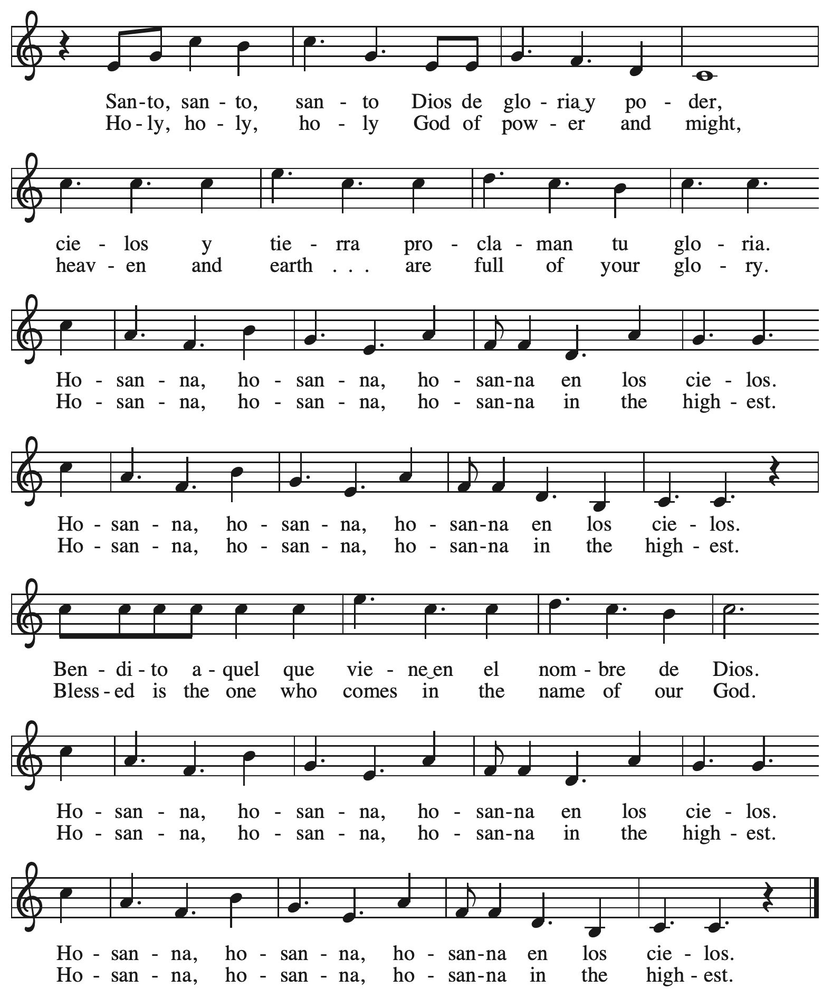

**Eucharistic Prayer** *ACS* p. 21

P: Holy God, you alone are holy … with every breath.

**C: We praise you, O God.**

P: Generations bless your faithfulness … into the future.

**C: We bless you, O God.**

P: We give you thanks for your dear Son … with us now.

**C: We thank you, O God.**

P: In the night in which he was betrayed … Do this for the remembrance of me.

Remembering his love for us

on the way, at the table, and to the end,

we proclaim the mystery of faith:

**C: Christ has died. Christ is risen. Christ will come again.**

P: We pray for the gift of your Spirit … in your church, without end.

**C: Amen.**

**Lord’s Prayer**

P: Gathered as one by the Holy Spirit, let us pray as Jesus taught us.

**C: Our Father in heaven,**

**hallowed be your name,**

**your kingdom come,**

**your will be done,**

**on earth as in heaven.**

**Give us today our daily bread.**

**Forgive us our sins**

**as we forgive those**

**who sin against us.**

**Save us from the time of trial**

**and deliver us from evil.**

**For the kingdom, the power,**

**and the glory are yours,**

**now and forever. Amen.**

**Fraction and Invitation**

P: The joy of the Lord is our strength.

Come and be nourished by the gifts of God.

***Agnus Dei /* Lamb of God** *ACS* p. 25

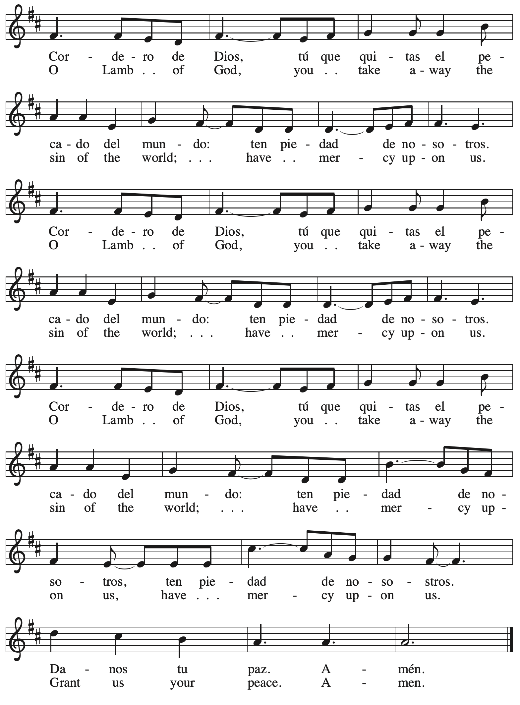

*Please be seated.*



**Holy Communion**

* *All who seek God and desire a deeper and stronger life in Christ are welcome to receive Holy Communion.*
* *Worshipers from the pulpit side will proceed forward first, followed by the center section, and then the lectern side.*
* *Please inform an usher if you would like the ministers to bring Communion to you.*
* *Holy Communion will be served with bread and wine/grape juice.*
* *The presiding minister will first distribute the bread (host) to each communicant. Please indicate if you require a gluten-free host.*
* *Once you have consumed the bread, please pick up an empty glass from the tray next to the presiding minister. The Communion Assistant will pour wine from the chalice or grape juice from the cruet into your glass.*
* *Please step to the side to consume the wine or grape juice.*
* *Feel free to kneel at the altar rail for prayer after receiving the sacrament.*
* *As you return to your pew, glasses may be returned to the empty trays on the side of the center section.*
* *A blessing will be provided for anyone who does not yet receive the sacrament.*
* *All are invited to join in singing the hymns during Holy Communion.*

**Hymns during Holy Communion**

**Let Justice Roll Like a River *W&P* 85**

=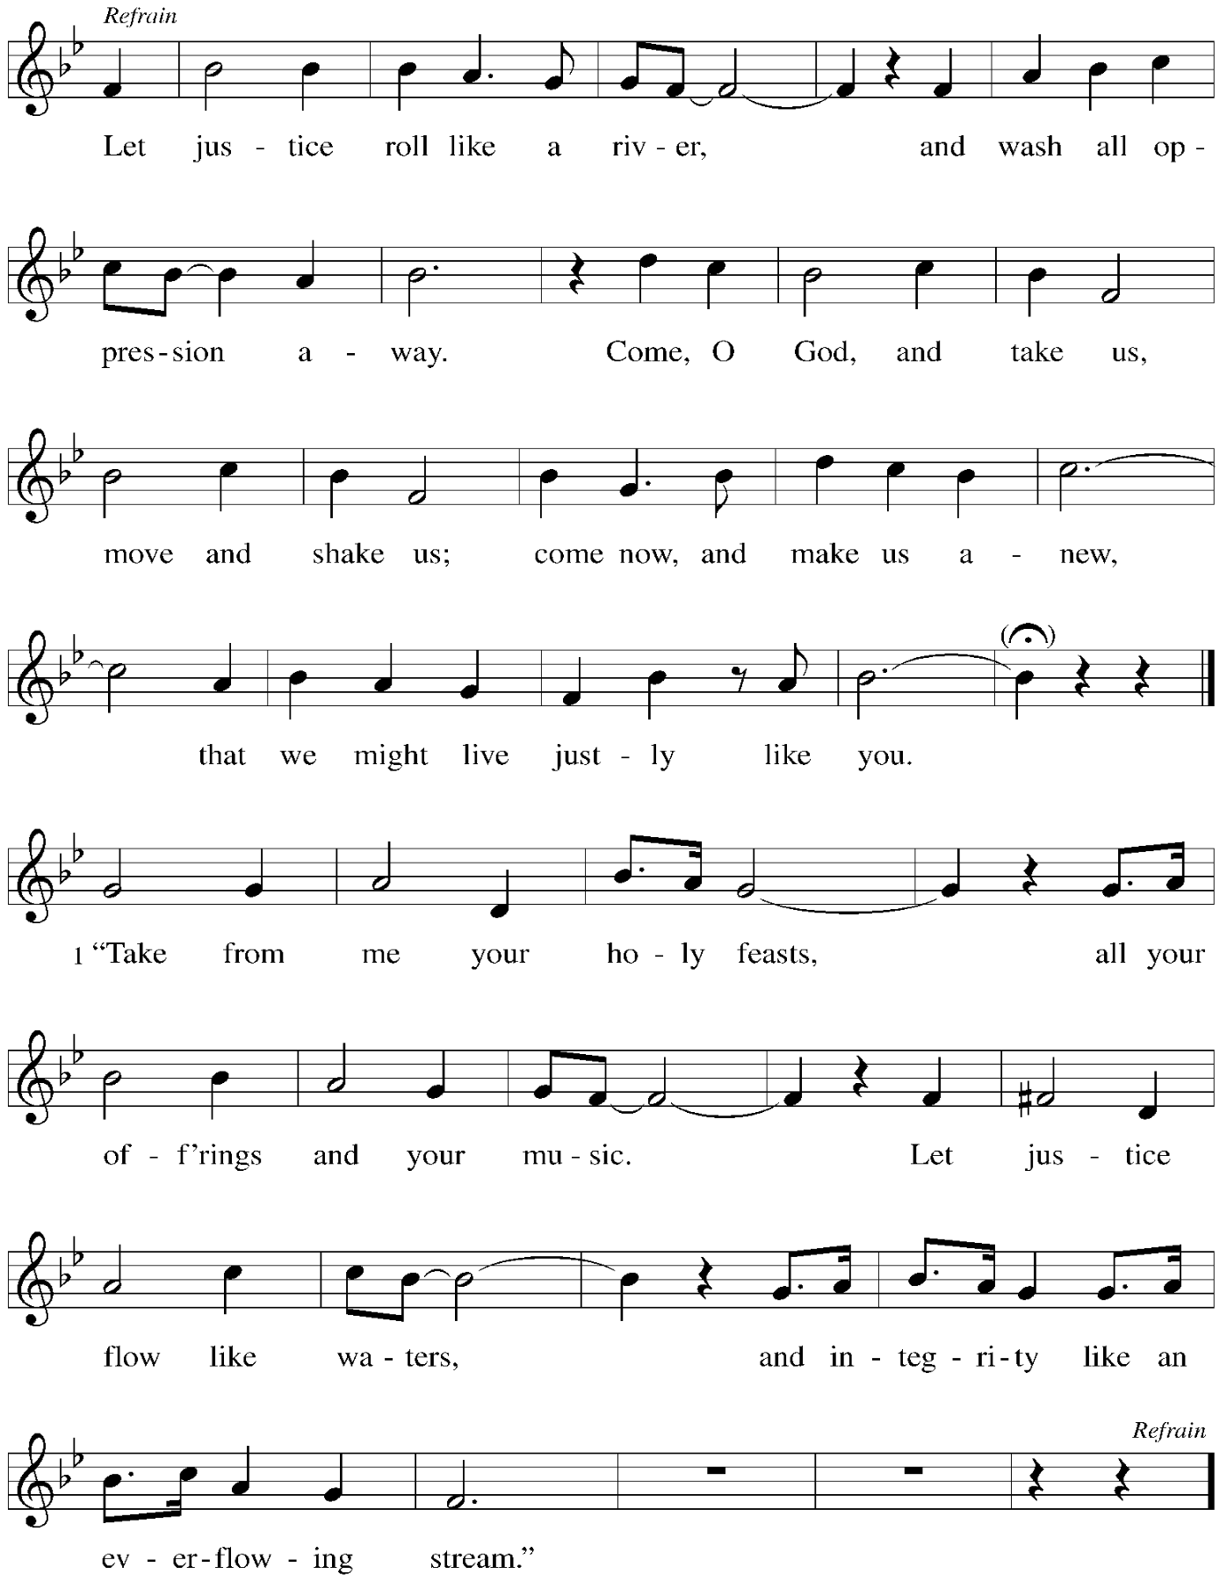

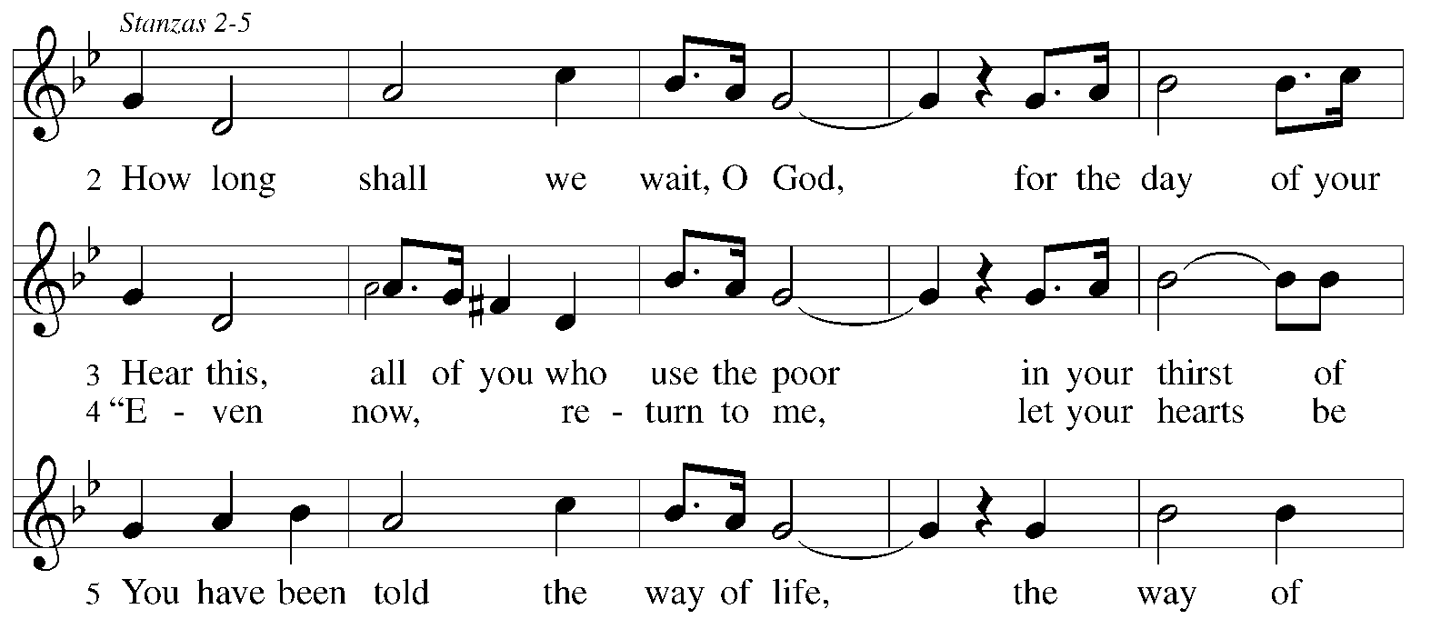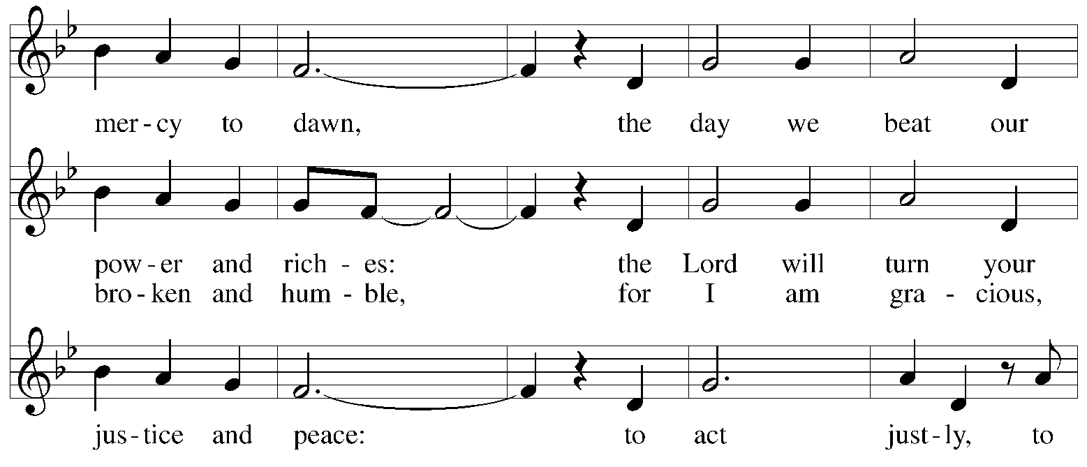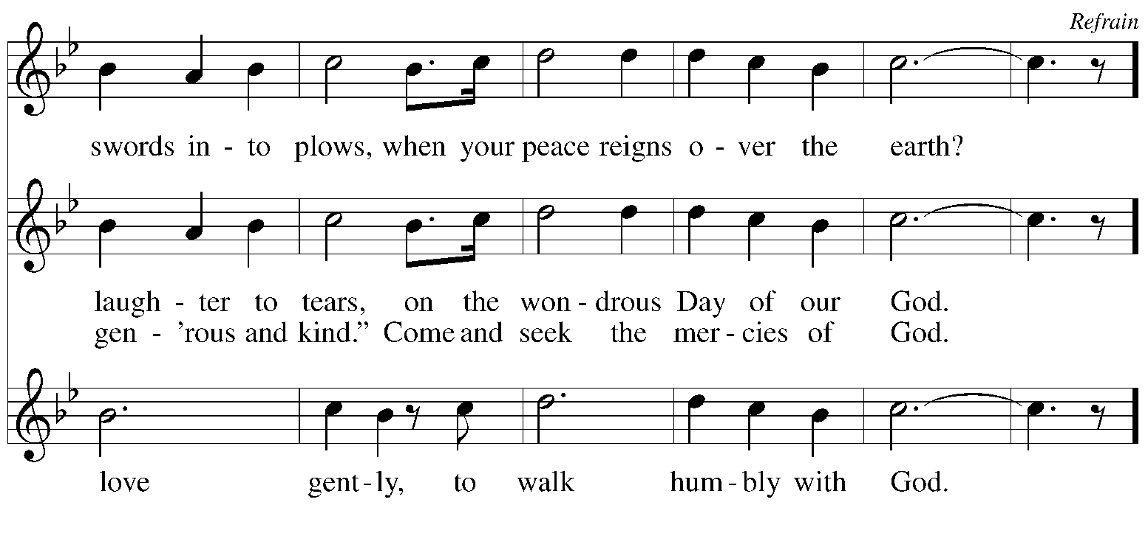

Text: Marty Haugen, b. 1950. Music: LET JUSTICE ROLL, Marty Haugen. Text and music © 1991 Gia Publications, Inc. All rights reserved. Reprinted with permission under OneLicense.net # A-722139.

**Hymns during Holy Communion**

**Let Not the Needy Be Forgotten *ACS* 1058**

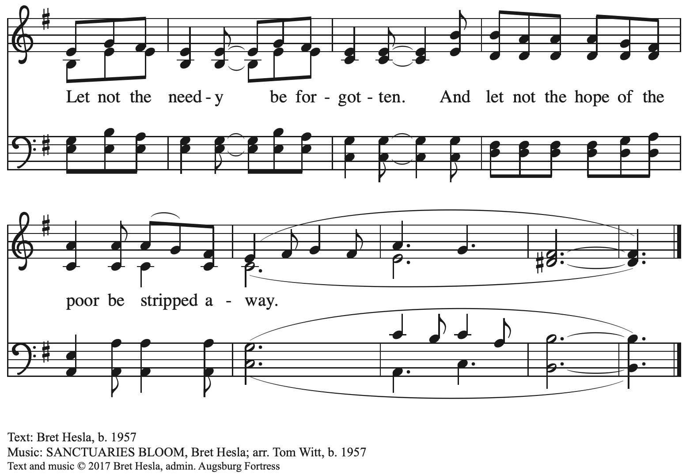

All rights reserved. Reprinted with permission under OneLicense.net # A-722139.

**Hymns during Holy Communion**

**All Who Love and Serve Your City *ELW* 724**

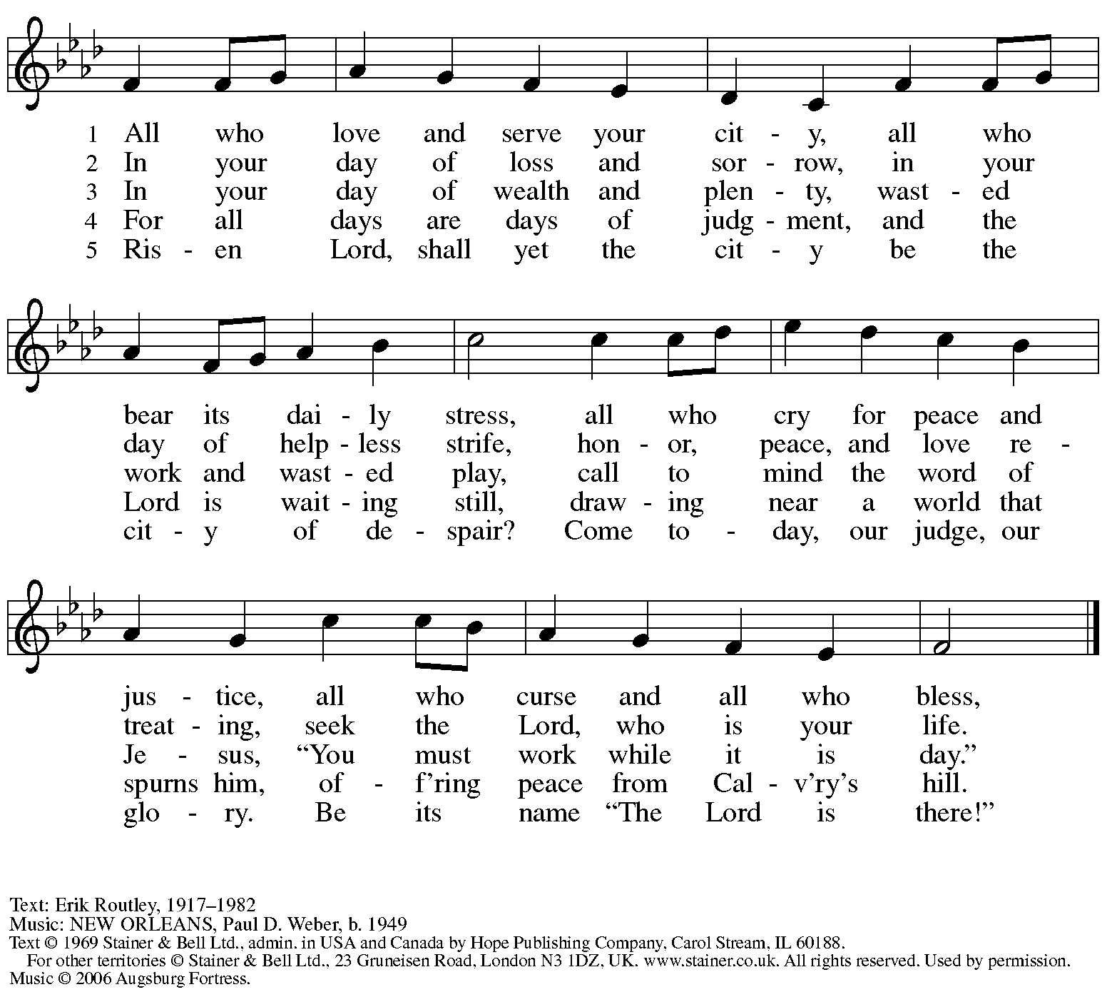

All rights reserved. Reprinted with permission under OneLicense.net # A-722139.

**Hymns during Holy Communion**

**Spirit, Open My Heart *ACS* 1053**

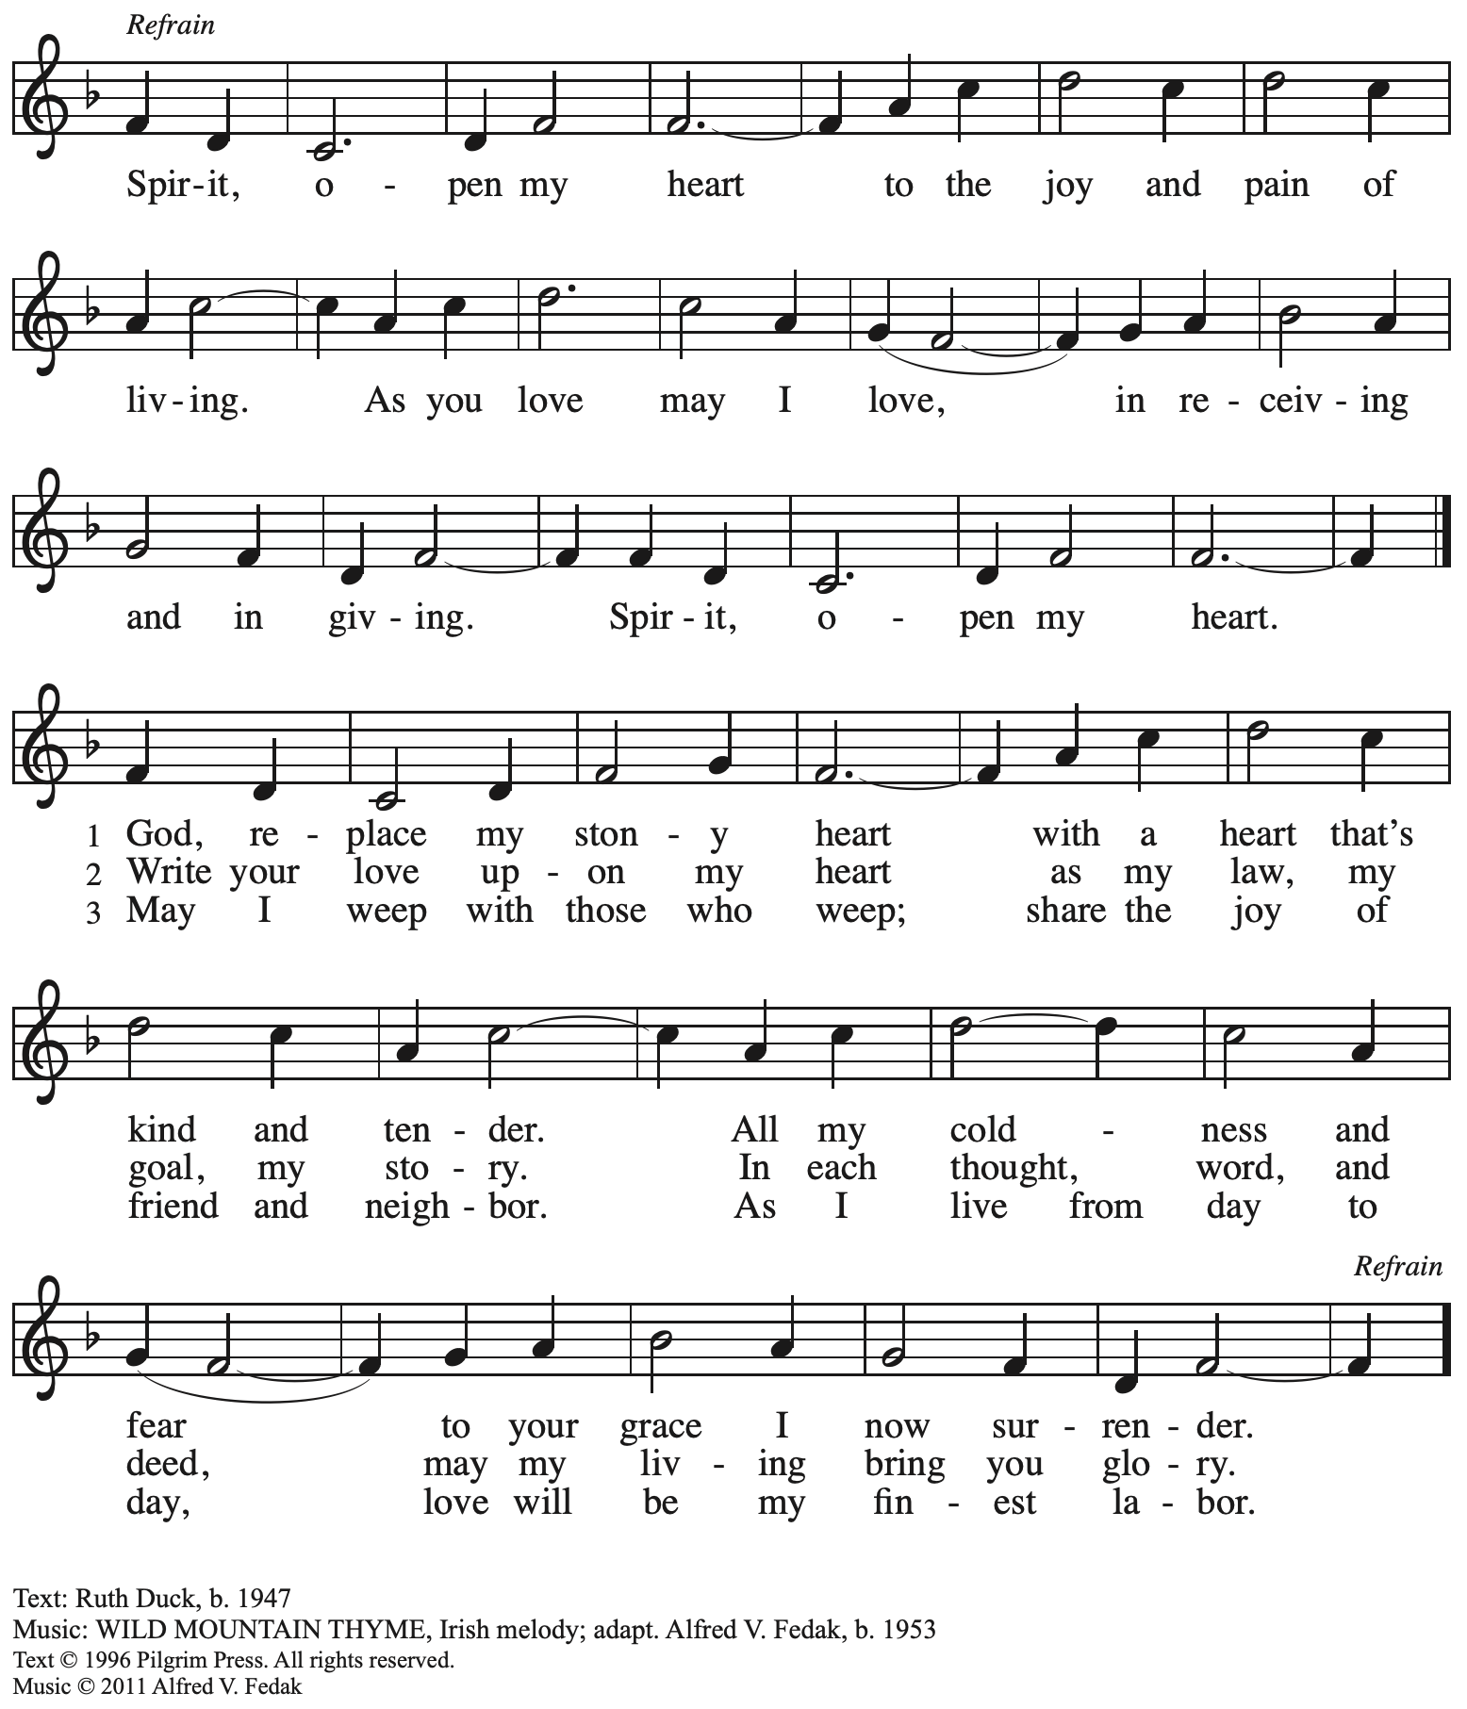

All rights reserved. Reprinted with permission under OneLicense.net # A-722139.

**Hymns during Holy Communion**

**Guide My Feet *ACS* 987**

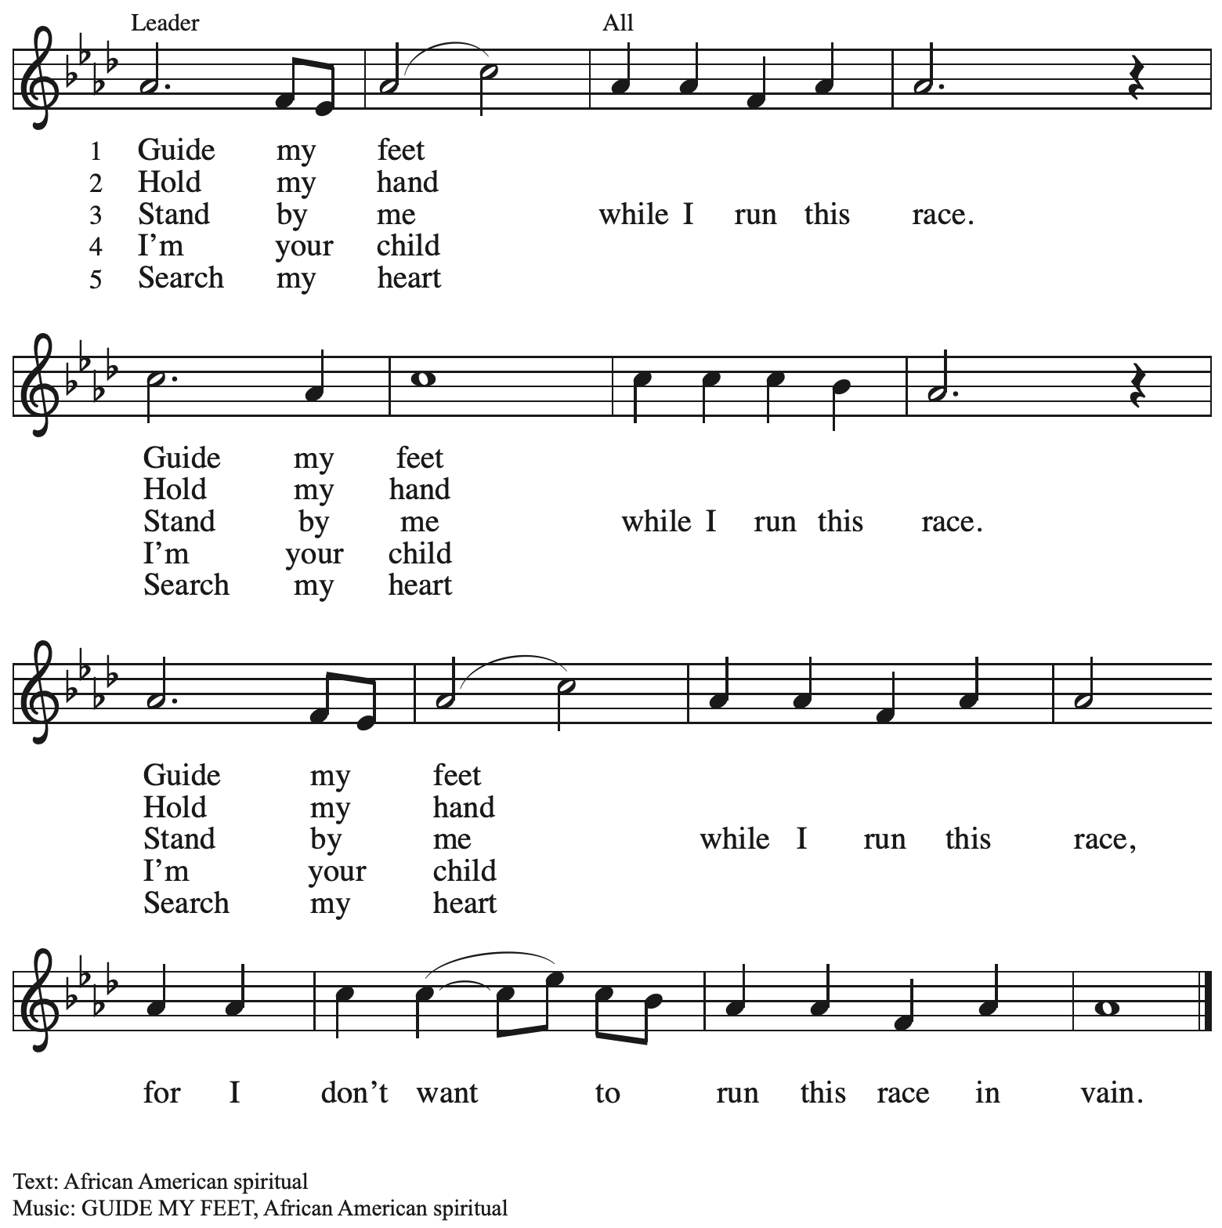

*When all have returned to their places, please rise as you are able.*

**Blessing**

P: The body and blood of our Lord Jesus Christ strengthen you and keep you in his grace.

**C: Amen.**

**Prayer**

A: Let us pray.

O God, in this holy communion you have welcomed us into your presence,

nourished us with words of mercy, and fed us at your table. Amid the cares of this life, strengthen us to love you with all our heart, serve our neighbors with a willing spirit,

and honor the earth you have made; through Christ our Lord.

**C: Amen.**

*Please be seated.*

**Sending**

*God blesses us and sends us in mission to the world*

**Announcements**

*Please rise as you are able.*

**Benediction**

P: The holy Three,

the holy One

increase your hope,

strengthen your faith,

deepen your love,

and ☩ grant you peace.

**C: Amen.**

**Sending Hymn** *Following page*

**Dismissal**

A: Go in peace. Christ is with you.

**C: Thanks be to God!**

**Postlude**

**Sending Hymn Canticle of the Turning *ELW* 723**

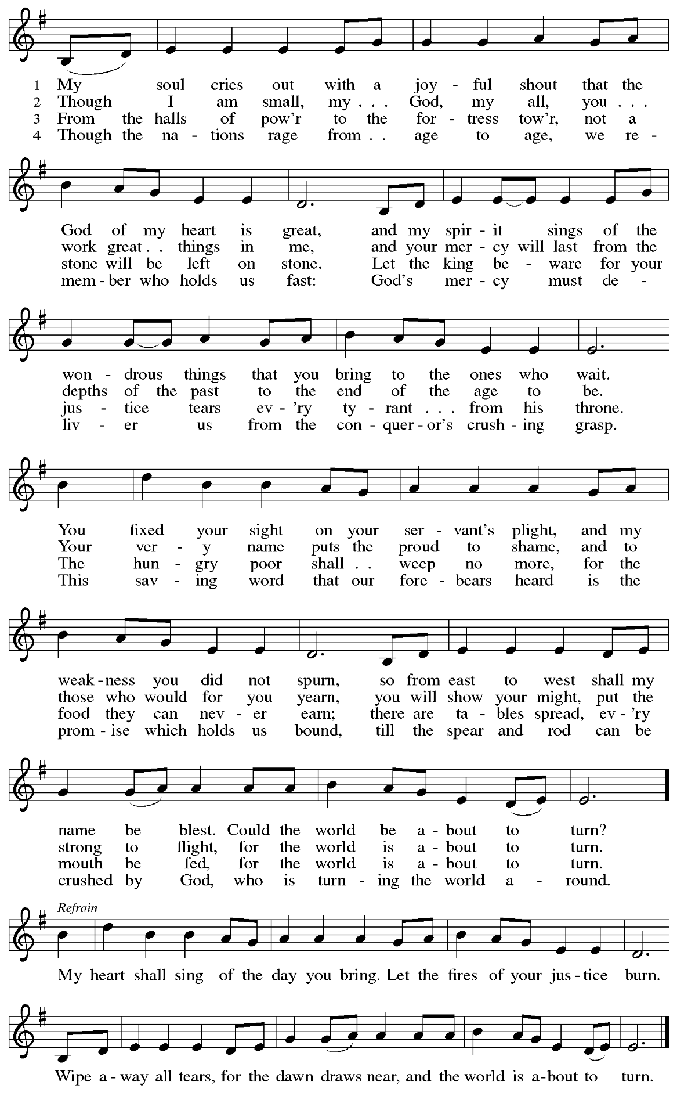

*Those serving in worship*

Altar Care Christy Ruhe

Assisting Minister Jimmi Kocher-Hillmer

Audio-Visual Ministers Joseph Paetz

Tyler Rietze

Cantor Jered Stratton

Lector Colleen Cooke

Minister of Music Laura Reynolds

Presiding and Preaching Minister The Rev. Ross I. Carmichael

*Liturgy and Hymnody Acknowledgements*

From SundaysandSeasons.com. Copyright © 2025 Augsburg Fortress. All rights reserved. Reprinted under OneLicense.net # A-722139.

Used by permission of Augsburg Fortress.

The Scripture readings contained herein are from *New Revised Standard Version* of the Bible © 1989, Division of Christian Education of the National Council of Churches of Christ in the USA. Used by permission. All rights reserved.

**Light Dawns on a Weary World**



Reprinted under OneLicense.net # A-722139.

**Canticle of** the **Turning**



All rights reserved. Reprinted with permission under OneLicense.net # A-722139.

*Please use the QR code below to link to St. Andrew’s Announcements online!*



**St. Andrew Lutheran Church Announcements**

**February 16th, 2025**

* **Welcome to worship at St. Andrew on the + Sixth Sunday after Epiphany, February 16th, 2025** –We are so glad you are here, and we offer a special welcome to all visitors and guests who are here for the first time! Worship attendees are invited to make a name tag at the back of the worship space. Little Church – Big Faith, a Bible lesson and activity for children, will take place after the prayer of the day. There are worship “toolkits” to help children engage with worship and “busy bags” for younger children available in the bookcase at the back of the sanctuary. Please feel free to take one to use with/for your children. All are invited to gather for coffee, other drinks, food, and conversation in the social hall after worship.
* **Noisy Offering during Worship Today** – **On the third Sunday of each month, St. Andrew’s children lead the congregation in a “Noisy” Offering, in which people are invited to throw their change into buckets that the children carry around the church and bring forward as an additional offering. Each month’s Noisy Offering supports a local, national, or international church-related or otherwise charitable organization. This month’s offering will go to the Good Neighbor Fund of Glade Run Lutheran Services,**

**a service ministry organization of our church. Overseen by the chaplain’s office, the Good Neighbor Fund provides direct service and resources to people in need, including utility assistance, rental deposits, co-pay support, job training, relief when leaving domestic violence situations, and more.**

* **Speak Out Against PA Senate Bill 213 (SB213)** – This recently proposed bill in the PA State Senate is a legislative attack on trans and nonbinary rights, healthcare, and public inclusion. For a full description of what the bill proposes and an assessment of its dangers and potential harms to our siblings in Christ, along with a link to find and contact your state senator, please see: [Call to Action: Stop SB213 – Defend Trans and Nonbinary Rights in Pennsylvania!  - QBurgh](https://qburgh.com/stop-sb213/).
* **Shelter Dinner for Guests of East End Cooperative Ministry, Third Thursday of the Month – February 20th, 6:00 p.m. Arrival, 6:30 p.m. Dinner –** Each month, people of St. Andrew provide dinner for guests of East End Cooperative Ministry (EECM), 6140 Station St. (East Liberty), 15206. We invite you to prepare or purchase one menu item and bring it to the shelter by 6:00 p.m., or just come to help serve at 6:30 p.m. If you would like to contribute, please sign up here:

<https://www.signupgenius.com/go/5080544AAAC22A1F58-54567228-shelter>.

* **Support Service Project at Proud Haven – Saturday, February 22nd – Proud** Haven is a safe space and homeless shelter for trans and gender nonconforming youth in Pittsburgh. They offer beds, clothes, hygiene items, food, and more, for free in their community closet. They are moving some things around right now and would love to have some help installing a few things, moving community closet items, and painting. The project, coordinated by local Scout Ada, is planned for Saturday, February 22nd. If you are interested in helping, and at all available, see Ada at coffee hour for more information and to sign up to help!
* **Pancake Brunch during Coffee Hour on Sunday, March 2nd – Please Plan to Stay after Worship – Traditionally on Shrove Tuesday, the day before Ash Wednesday, Christians would clear out all the rich and fatty foods from their cupboards in preparation for the season of Lent and its spiritual discipline of fasting. Following this custom, St. Andrew used to hold a pancake dinner on Shrove Tuesday, but we have not done so since before the pandemic. We would like to re-introduce the practice and the spirit of Shrove Tuesday after worship on Sunday, March 2nd. At the close of worship, we will have a brief outdoor liturgy for the burning of the palms and then proceed to the social hall for a meal together. The hospitality committee will provide pancake mix (with gluten), sausage (non-vegan), gluten-free cupcakes and cookies, butter, syrup, coffee and tea. We ask people of the congregation to bring fruit, breakfast juices, and other gluten-free breakfast items. We hope you will join in these activities as we prepare for the season of Lent, beginning on Ash Wednesday, March 5th.**
* **Ash Wednesday Worship, March 5th:**
  + **Service for Children and Families – 5:30 p.m.**
  + **Service with Imposition of Ashes and Holy Communion – 7:00 p.m.**

The season of Lent, a time of repentance, spiritual practice, and baptismal reflection, begins this year on March 5th. St. Andrew will offer two services that day. The first, at 5:30 p.m., will offer an introduction to the day and season designed for children through 6th grade. Imposition of Ashes will be available at that service as well as at the 7:00 p.m. service, which will also include the sacrament of Holy Communion. Blessings to all as we prepare for the season of Lent.

* **Help Re-Stock Outdoor Little Library!** – If you are interested in stocking the little library that is on the Centre Avenue side of the church, there are extra books in the metal cabinet to the right of the dumbwaiter.  (There are currently some 10% off coupons for Half Price Books that are good throughout the year.)  The current stock of books are from the challenged or banned book lists.  Here are two lists:  (<https://www.ala.org/bbooks>) (<https://en.wikipedia.org/wiki/List_of_most_commonly_challenged_books_in_the_United_States>).
* **Compline Prayer Service with the Pittsburgh Compline Choir – Sundays at 8:00 p.m. at Heinz Chapel –** Compline was traditionally a monastic prayer service, and the Pittsburgh Compline Choir, a ministry of Lutheran Campus Ministry in Greater Pittsburgh, sings a choral version of compline rooted in this thousand-year-old tradition of scripture, song, and silence each Sunday at Heinz Chapel at 8:00 p.m. This service also streams on Facebook (Pittsburgh Compline Choir) and YouTube (The Pittsburgh Compline Choir). Heinz Chapel is located off of S. Bellefield Ave. in Oakland. For more information, please visit: [Pittsburgh Compline Choir](http://pittsburghcomplinechoir.org/).