

**+ Fifth Sunday after Epiphany**

**February 9th, 2025**

**10:00 a.m.**



**St. Andrew Lutheran Church**

**304 Morewood Ave.**

**Pittsburgh, PA 15213**

**412.682.3342**

[**St_andrewELCA@verizon.net**](mailto:St_andrewELCA@verizon.net)

[**www.standrewpittsburgh.org**](http://www.standrewpittsburgh.org)

**+ Fifth Sunday after Epiphany**

**Order for Worship**

*The fifth Sunday after Epiphany continues to highlight unlikely instruments and circumstances appointed to reveal God’s glory. “Who will go for us?” God asks. A person of unclean lips, a former persecutor of the church of God, and three fishermen who couldn’t catch a thing.*

*More surprising still, perhaps, is that we are also called.*

**Welcome to St. Andrew!**

* St. Andrew welcomes all who are seeking a place of healing, wholeness, and acceptance in a nurturing and faith-forming spiritual home. We are striving toward racial equity worldwide

and we seek to honor the lived experience of all individuals regardless of background. Our community embraces people of all ages, ethnicities, cultures, abilities, sexual orientations,

gender identities and expressions, and family constellations. Come and See!

* Worship Services are live-streamed to multiple online platforms. By attending worship, you agree that your image and voice may be broadcast.
* Everyone is invited to make a name tag at the black bookcase in the back of the worship space if they would like. There are stickers indicating pronouns on the bookcase if you would like to include them on your name tag.
* Children are invited to attend Little Church – Big Faith, a Bible lesson and activity, during worship (after the Prayer of the Day). The group returns to the worship space for the liturgy of Holy Communion.
* A nursery is available through the doors at the left side of the sanctuary and across from the doorway to the Social Hall. Look for a purple-colored room.
* Worship “toolkits” to help children engage with the service, along with “busy bags” for younger children, are available in the bookcase at the back of the sanctuary. Please feel free to take one to use with/for your children.
* Holy Communion is served with bread (gluten-free available) and wine or grape juice. The presiding minister will distribute the bread (host). Please consume this and then pick up an empty glass from the tray. The Communion Assistant will pour wine or grape juice into your glass. Please step to the side to consume the wine or grape juice. Feel free to kneel at the altar for prayer and reflection. As you return to your pew, glasses may be returned to the empty trays on either side of the center section.
* A restroom is available on the main level of the church, through the doors to the Social Hall and to the right in the main office.

*Abbreviations*

P: Pastor/Presiding Minister ***ELW*: *Evangelical Lutheran Worship* hymnal**

A: Assisting Minister ***ACS*: *All Creation Sings* hymnal**

L: Lector

**C: Congregation**

**Pre-Service Music** Jeff Denlinger

**Welcome**

**Prelude** *I Surrender All* arr. Philip Keveren

**Gathering**

*The Holy Spirit calls us together as the people of God*

**Thanksgiving for Baptism**

*Please rise as you are able. All may make the sign of the cross,*

*the sign that is marked at Baptism, as the presiding minister begins.*

P: Blessed be the holy Trinity, ☩ one God,

the fountain of living water, the rock who gave us birth,

our light and our salvation.

**C: Amen.**

P: Joined to Christ in the waters of Baptism, we are clothed with God’s mercy and forgiveness. Let us give thanks for the gift of Baptism.

*Water may be poured into the font as the presiding minister gives thanks*

P: We give you thanks, O God, for in the beginning you created us in your image and placed us in a well-watered garden. In the desert, you promised pools of water for the parched, and you gave us water from the rock. When we did not know the way, you sent the Good Shepherd to lead us to still waters. At the cross, you washed us from Jesus’ wounded side, and on this day, you shower us again with the water of life.

We praise you for your salvation through water, for the water in this font,

and for all water everywhere, including the Allegheny, Monongahela, and Ohio rivers.

Bathe us in your forgiveness, grace, and love.

Satisfy all who thirst, and give us the life only you can give.

To you be given honor and praise

through ☩ Jesus Christ, our living water,

in the unity of the Holy Spirit, now and forever.

**C: Amen.**

**Gathering Hymn Making Their Way *ACS* 979**

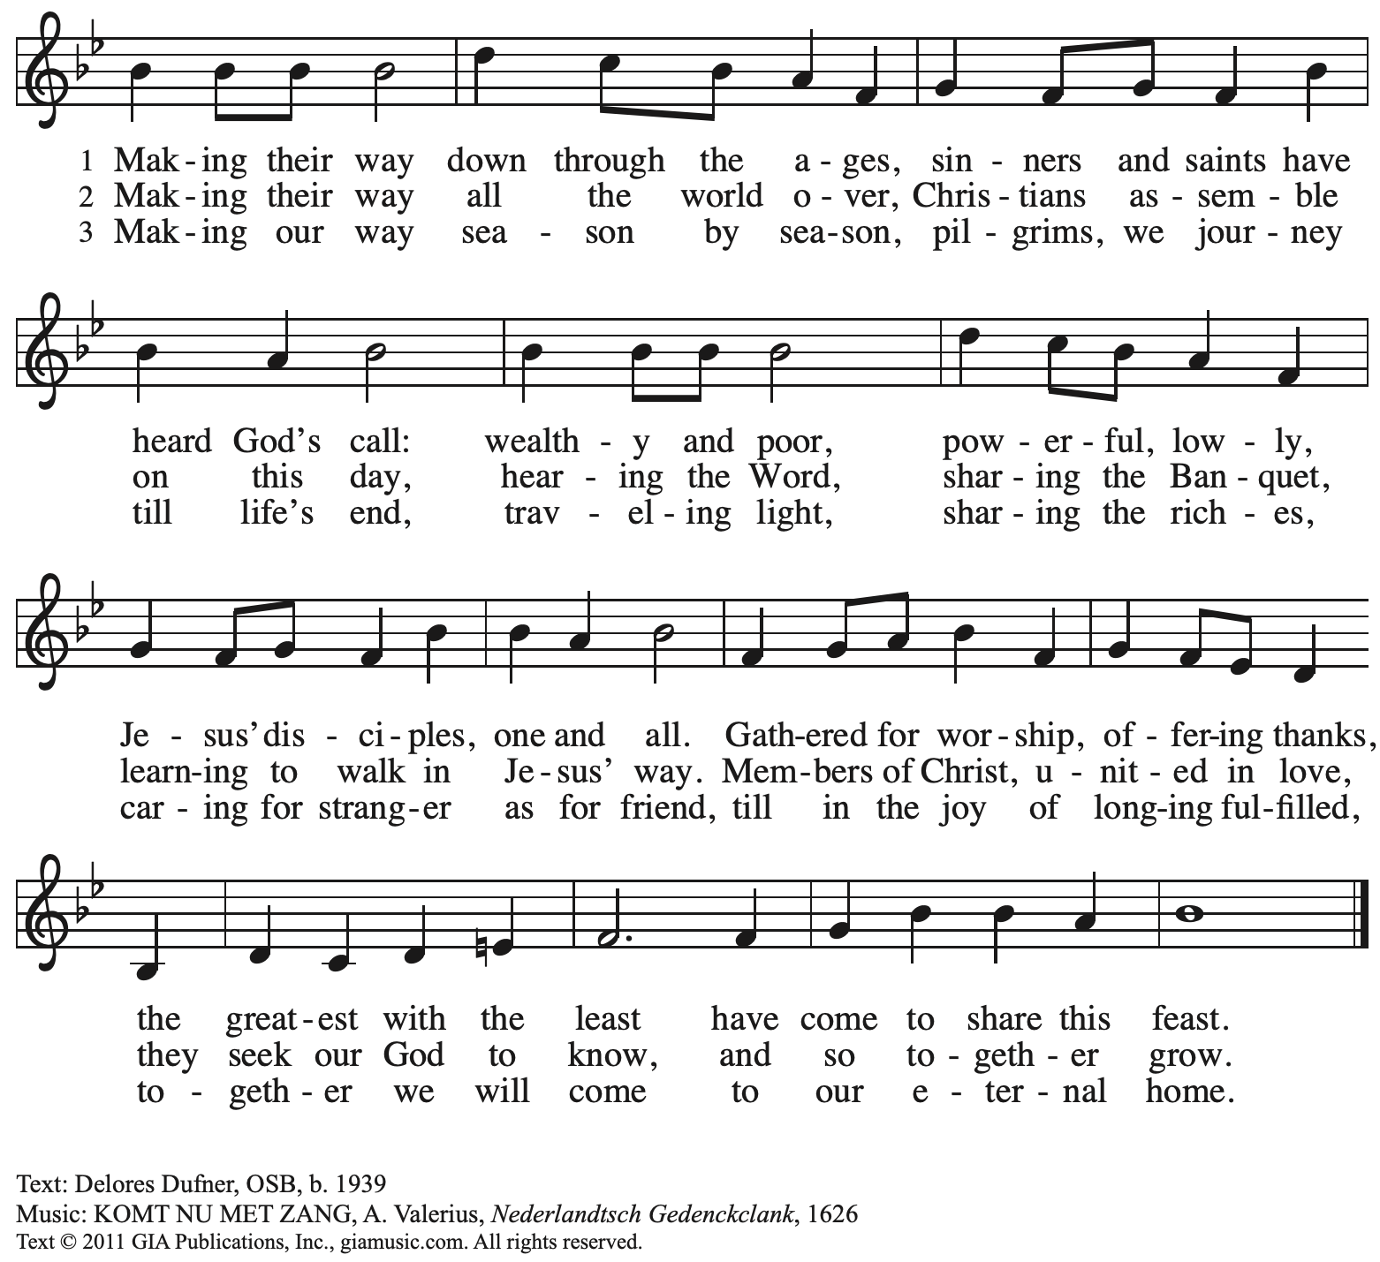

Reprinted with permission under OneLicense.net # A-722139.

**Greeting**

P: The grace of our Lord Jesus Christ, the love of God,

and the communion of the Holy Spirit be with you all.

**C: And also with you.**

**Hymn of Praise** *ACS* p. 12

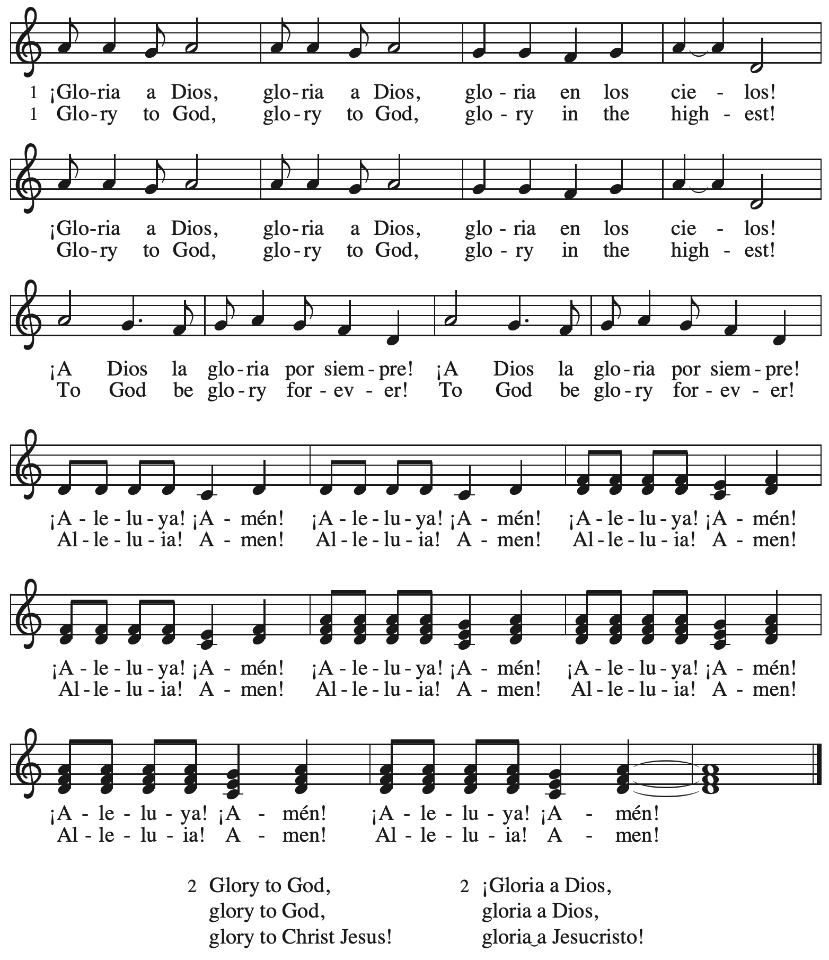

**Prayer of the Day**

P: The Lord be with you.

**C: And also with you.**

P: Let us pray.

Most holy God, the earth is filled with your glory, and before you angels and saints stand in awe. Enlarge our vision to see your power at work in the world, and by your grace make us heralds

of your Son, Jesus Christ, our Savior and Lord.

**C: Amen.**

*Please be seated.*

**Word**

*God speaks to us in Scripture reading, preaching, and song*

**First Reading** **–** **Isaiah 6: 1-8**

1 In the year that King Uzziah died, I saw the Lord sitting on a throne, high and lofty; and the hem of his robe filled the temple. 2 Seraphs were in attendance above him; each had six wings: with two they covered their faces, and with two they covered their feet, and with two they flew. 3 And one called to another and said:  
 “Holy, holy, holy is the Lord of hosts;  
 the whole earth is full of the Lord’s glory.”  
4 The pivots on the thresholds shook at the voices of those who called, and the house filled with smoke. 5 And I said: “Woe is me! I am lost, for I am a man of unclean lips, and I live among a people of unclean lips; yet my eyes have seen the King, the Lord of hosts!”  
  6 Then one of the seraphs flew to me, holding a live coal that had been taken from the altar with a pair of tongs. 7 The seraph touched my mouth with it and said: “Now that this has touched your lips, your guilt has departed and your sin is blotted out.” 8 Then I heard the voice of the Lord saying, “Whom shall I send, and who will go for us?” And I said, “Here am I; send me!”

L: Word of God, word of life.

**C: Thanks be to God.**

**Psalm 138**

*The cantor will lead the singing of the psalm.*

*The congregation is invited to respond with the alternate verses in bold print,*

*and to join in singing the refrain.*

*Psalm Tone*

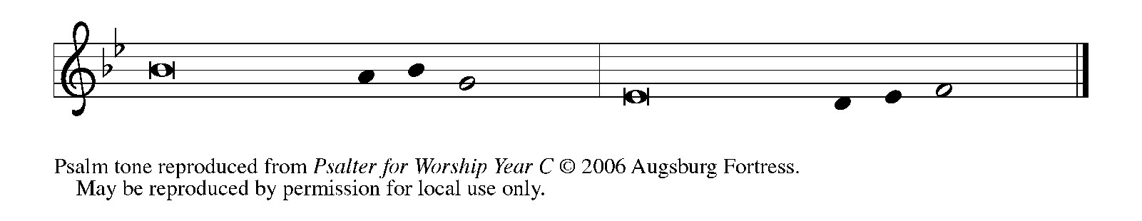

*Psalm Refrain*

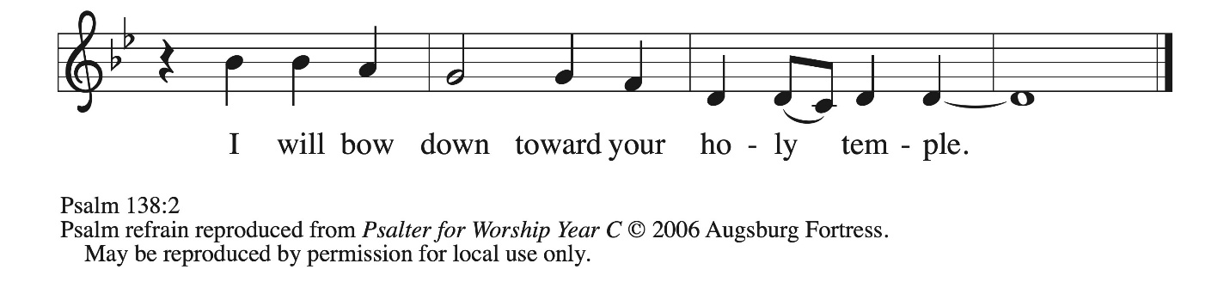

1 I will give thanks to you, O Lord, with **|** my whole heart;  
  before the gods I will **|** sing your praise.  
 2 **I will bow down toward your holy temple and praise your name, because of your steadfast | love and faithfulness;**  
  **for you have glorified your name and your word a- | bove all things. R**  
 3 When I called, you **|** answered me;  
  you increased my **|** strength within me.  
 4 **All the rulers of the earth will praise | you, O Lord,**  
  **when they have heard the words | of your mouth.**  
 5 They will sing of the ways **|** of the Lord,  
  that great is the glory **|** of the Lord.  
 6 **The Lord is high, yet cares | for the lowly,**  
  **perceiving the haughty | from afar. R**  
 7 Though I walk in the midst of trouble, you **|** keep me safe;  
  you stretch forth your hand against the fury of my enemies; your right **|** hand shall save me.  
 8 **You will make good your pur- | pose for me;**  
  **O Lord, your steadfast love endures forever; do not abandon the works | of your hands. R**

**Second Reading – 1 Corinthians 15: 1-11**

1 Now I would remind you, kindred, of the good news that I proclaimed to you, which you in turn received, in which also you stand, 2 through which also you are being saved, if you hold firmly to the message that I proclaimed to you—unless you have come to believe in vain.  
  3 For I handed on to you as of first importance what I in turn had received: that Christ died for our sins in accordance with the scriptures, 4 and that he was buried, and that he was raised on the third day in accordance with the scriptures, 5 and that he appeared to Cephas, then to the twelve.

6 Then he appeared to more than five hundred siblings at one time, most of whom are still alive, though some have died. 7 Then he appeared to James, then to all the apostles. 8 Last of all, as to one untimely born, he appeared also to me. 9 For I am the least of the apostles, unfit to be called an apostle, because I persecuted the church of God. 10 But by the grace of God I am what I am, and God’s grace toward me has not been in vain. On the contrary, I worked harder than any of them—though it was not I, but the grace of God that is with me. 11 Whether then it was I or they, so we proclaim and so you have come to believe.

L: Word of God, word of life.

**C: Thanks be to God.**

*Please rise as you are able and join in singing the Gospel Acclamation.*

**Gospel Acclamation** *ACS* p. 14

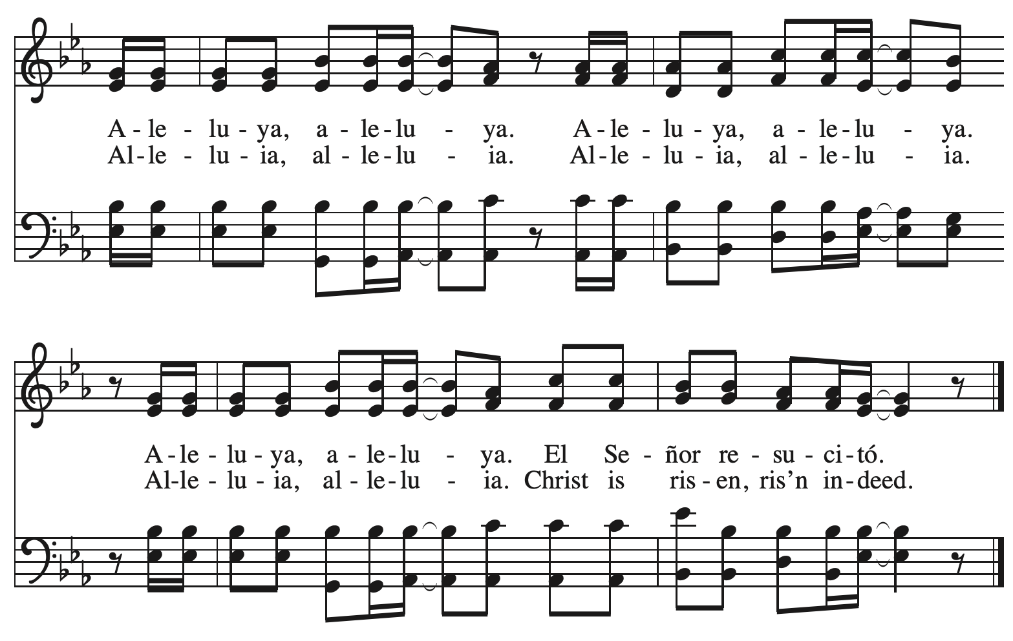

**Gospel – Luke 5: 1-11**

P: The holy Gospel according to St. Luke.

**C: Glory to you, O Lord.**

1 Once while Jesus was standing beside the lake of Gennesaret, and the crowd was pressing in on him to hear the word of God, 2 he saw two boats there at the shore of the lake; the fishermen had gone out of them and were washing their nets. 3 He got into one of the boats, the one belonging to Simon, and asked him to put out a little way from the shore. Then he sat down and taught the crowds from the boat. 4 When he had finished speaking, he said to Simon, “Put out into the deep water and let down your nets for a catch.” 5 Simon answered, “Master, we have worked all night long but have caught nothing. Yet if you say so, I will let down the nets.” 6 When they had done this, they caught so many fish that their nets were beginning to break. 7 So they signaled their partners in the other boat to come and help them. And they came and filled both boats, so that they began to sink. 8 But when Simon Peter saw it, he fell down at Jesus’ knees, saying, “Go away from me, Lord, for I am a sinful man!” 9 For he and all who were with him were amazed at the catch of fish that they had taken; 10 and so also were James and John, sons of Zebedee,

who were partners with Simon. Then Jesus said to Simon, “Do not be afraid; from now on you will be catching people.” 11 When they had brought their boats to shore, they left everything and followed him.

P: The Gospel of the Lord.

**C: Praise to you, O Christ.**

*Please be seated.*

**Sermon**

*A time of silence for prayer and reflection follows the sermon.*

*As the hymn of the day begins, please rise as you are able.*



**Hymn of the Day Here I Am, Lord *ELW* 574**

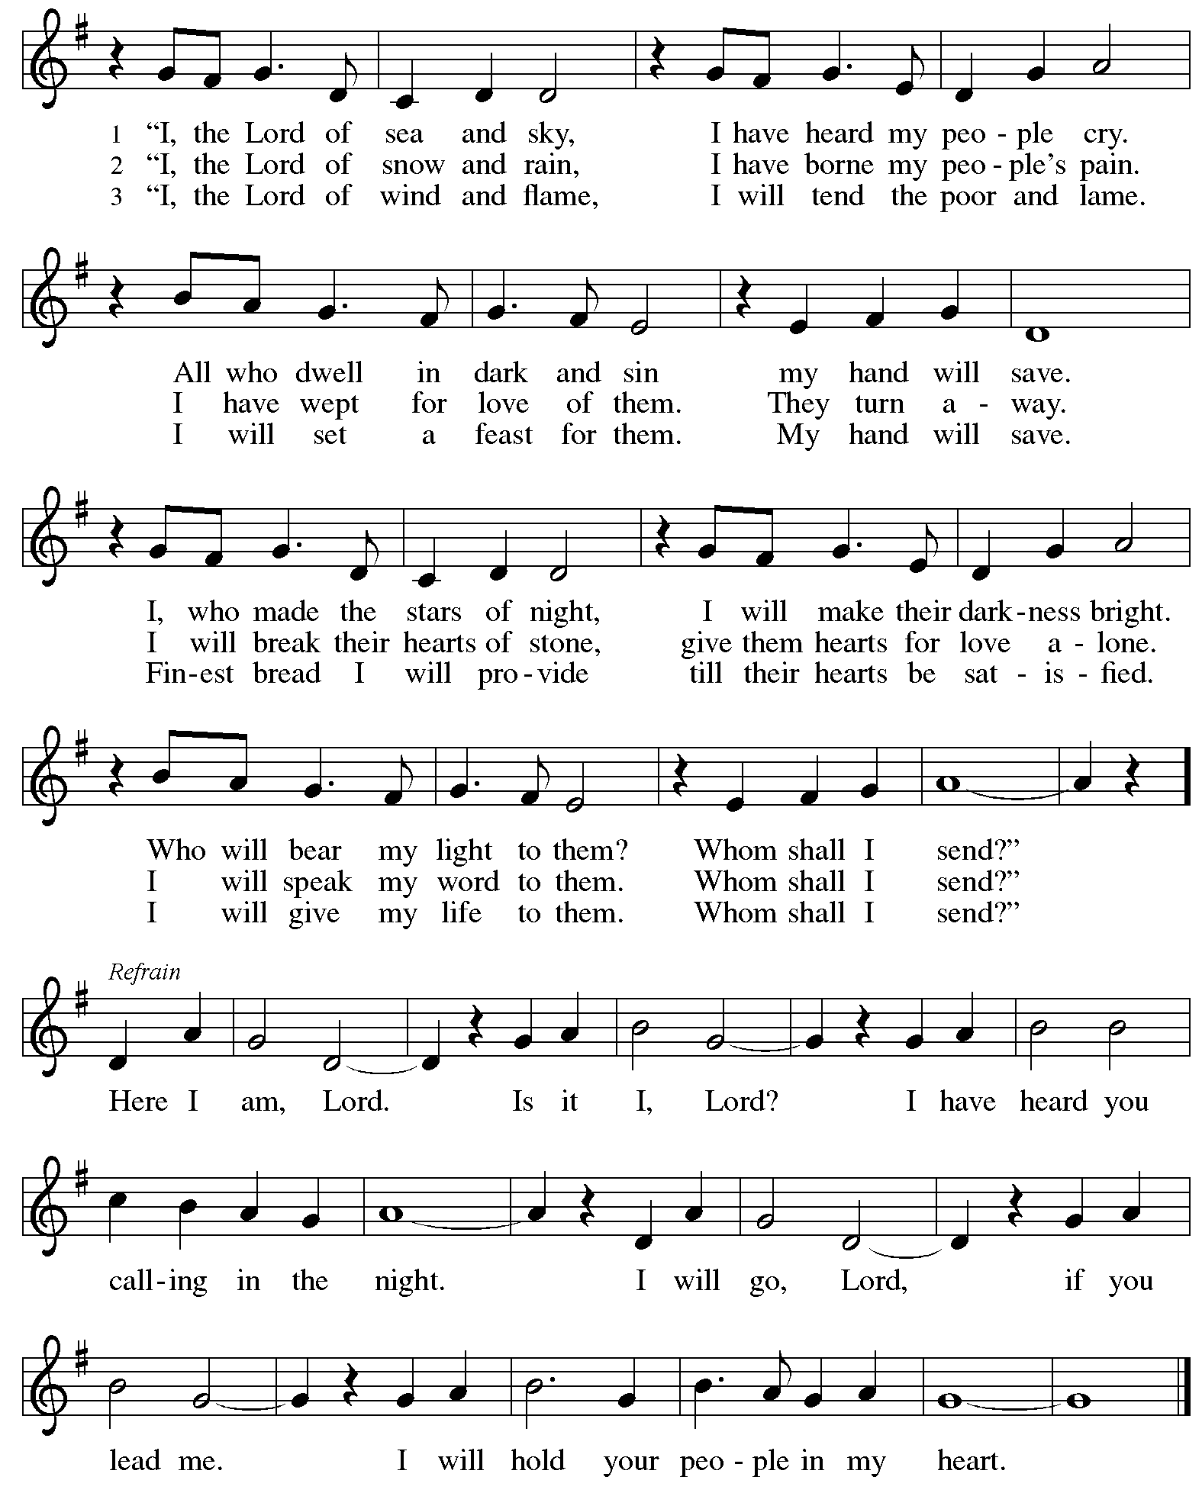

**Apostles’ Creed**

**C: I believe in God, the Father almighty,**

**creator of heaven and earth.**

**I believe in Jesus Christ, God’s only Son, our Lord,**

**who was conceived by the Holy Spirit,**

**born of the virgin Mary,**

**suffered under Pontius Pilate,**

**was crucified, died, and was buried;**

**he descended to the dead.\***

**On the third day he rose again;**

**he ascended into heaven,**

**he is seated at the right hand of the Father,**

**and he will come to judge the living and the dead.**

**I believe in the Holy Spirit,**

**the holy catholic church,**

**the communion of saints,**

**the forgiveness of sins,**

**the resurrection of the body,**

**and the life everlasting. Amen.**

*Or, “he descended into hell,” another translation of this text in widespread use.

**Prayers of the People**

A: Guided by the Holy Spirit, with the light of Christ shining upon us and all nations,

let us pray for the church, the world, and all creation.

*After each petition*

A: Gracious God,

**C: receive our prayer.**

*The presiding minister concludes the prayers*

P: We entrust these prayers to you, O God, in the sure and certain hope that your promise is revealed among your people.

**C: Amen.**

**Peace**

*The presiding minister and the assembly greet one another in the peace of the risen Christ.*

P: The peace of Christ be with you always.

**C: And also with you.**

*The people may greet those around them with a sign of Christ’s peace and may say*

Peace be with you *or similar words. Please be mindful that not everyone will be comfortable with sharing the peace, so please seek consent before shaking hands or hugging. Other possible ways to share the peace include a simple bow with the verbal greeting of peace, or simply a verbal expression of peace.*

*When the greetings of peace have concluded, please be seated.*



**Meal**

*God feeds us with the presence of Jesus Christ*

**Offering**

*We offer ourselves, our gifts, and our faithful service to God.*

*As the offering is gathered for the mission of the church, including the care of those in need,*

*the table is set for Holy Communion.*

**Music during the Offering**

*Ye Servants of God* arr. Craig Courtney

*As the gifts are brought forward for presentation, please rise as you are able.*

**Offertory Song Cuando el pobre / When the Poor Ones *ELW* 725**

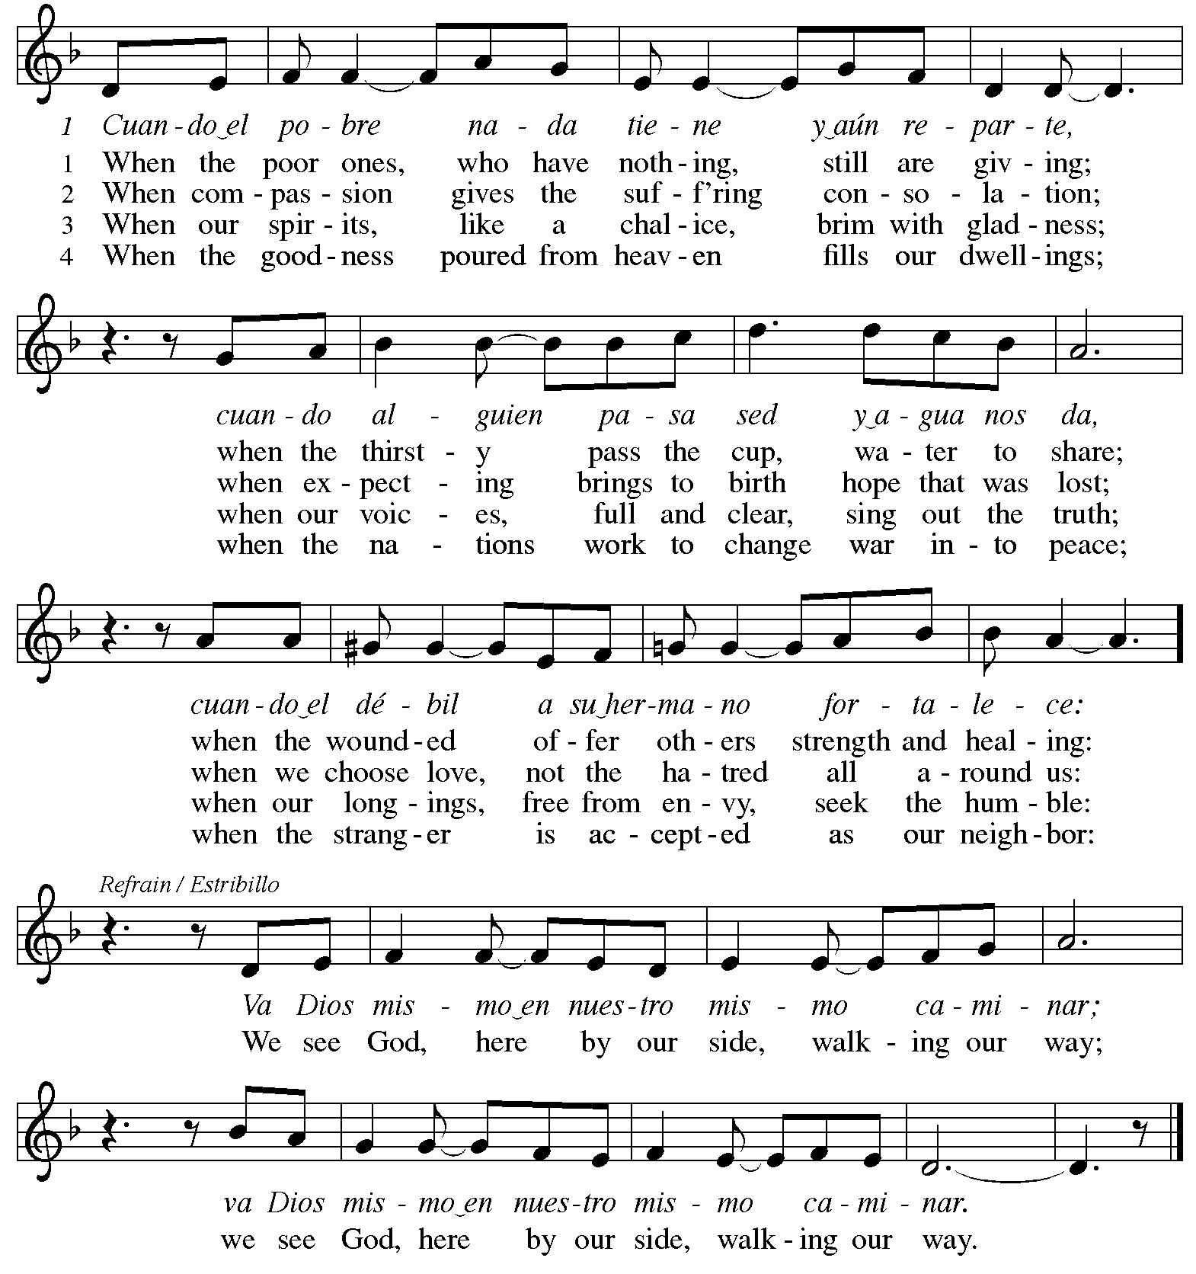



Reprinted under OneLicense.net # A-722139.

**Offertory Prayer**

A: Let us pray.

Holy God, gracious and merciful,

**C: you bring forth food from the earth and nourish your whole creation.**

**Turn our hearts toward those who hunger in any way, that all may know your care;**

**and prepare us now to feast on the bread of life, Jesus Christ, our Savior and Lord.**

**Amen.**

**Dialogue** *ACS* p. 20

P: The Lord be with you.

**C: And also with you.**

P: Lift up your hearts.

**C: We lift them to the Lord.**

P: Let us give thanks to the Lord our God.

**C: It is right to give our thanks and praise.**

**Preface** *ACS* p. 20

P: It is indeed right, our duty and our joy,

that we should at all times and in all places

give thanks and praise to you,

almighty and merciful God,

through our Savior Jesus Christ;

who on this day overcame death and the grave,

and by his glorious resurrection

opened to us the way of everlasting life.

And so, with all the choirs of angels,

with the church on earth and the hosts of heaven,

we praise your name and join their unending hymn:

**Sanctus** *ACS* p. 20

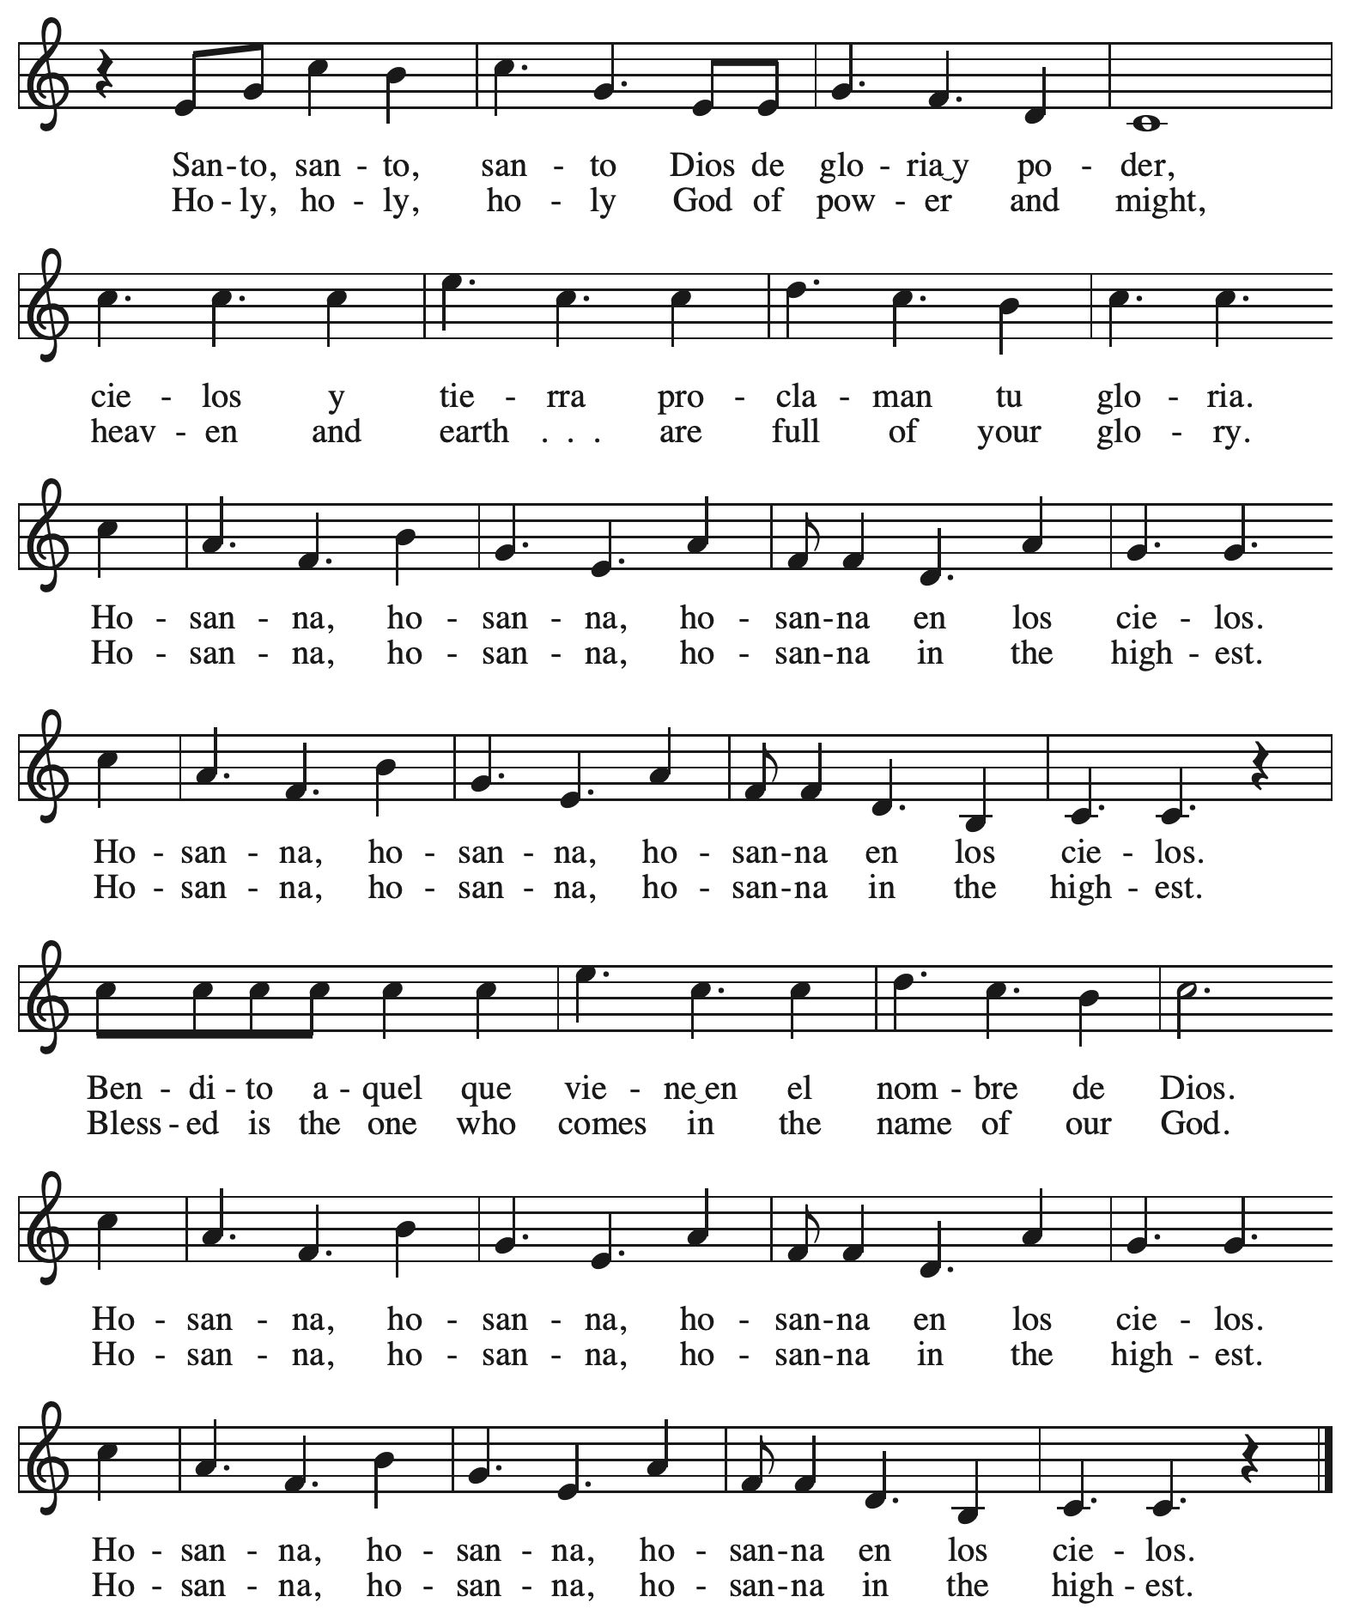

**Eucharistic Prayer** *ACS* p. 21

P: Holy God, you alone are holy … with every breath.

**C: We praise you, O God.**

P: Generations bless your faithfulness … into the future.

**C: We bless you, O God.**

P: We give you thanks for your dear Son … with us now.

**C: We thank you, O God.**

P: In the night in which he was betrayed … Do this for the remembrance of me.

Remembering his love for us

on the way, at the table, and to the end,

we proclaim the mystery of faith:

**C: Christ has died. Christ is risen. Christ will come again.**

P: We pray for the gift of your Spirit … in your church, without end.

**C: Amen.**

**Lord’s Prayer**

P: Gathered as one by the Holy Spirit, let us pray as Jesus taught us.

**C: Our Father in heaven,**

**hallowed be your name,**

**your kingdom come,**

**your will be done,**

**on earth as in heaven.**

**Give us today our daily bread.**

**Forgive us our sins**

**as we forgive those**

**who sin against us.**

**Save us from the time of trial**

**and deliver us from evil.**

**For the kingdom, the power,**

**and the glory are yours,**

**now and forever. Amen.**

**Fraction and Invitation**

P: The joy of the Lord is our strength.

Come and be nourished by the gifts of God.

***Agnus Dei /* Lamb of God** *ACS* p. 25

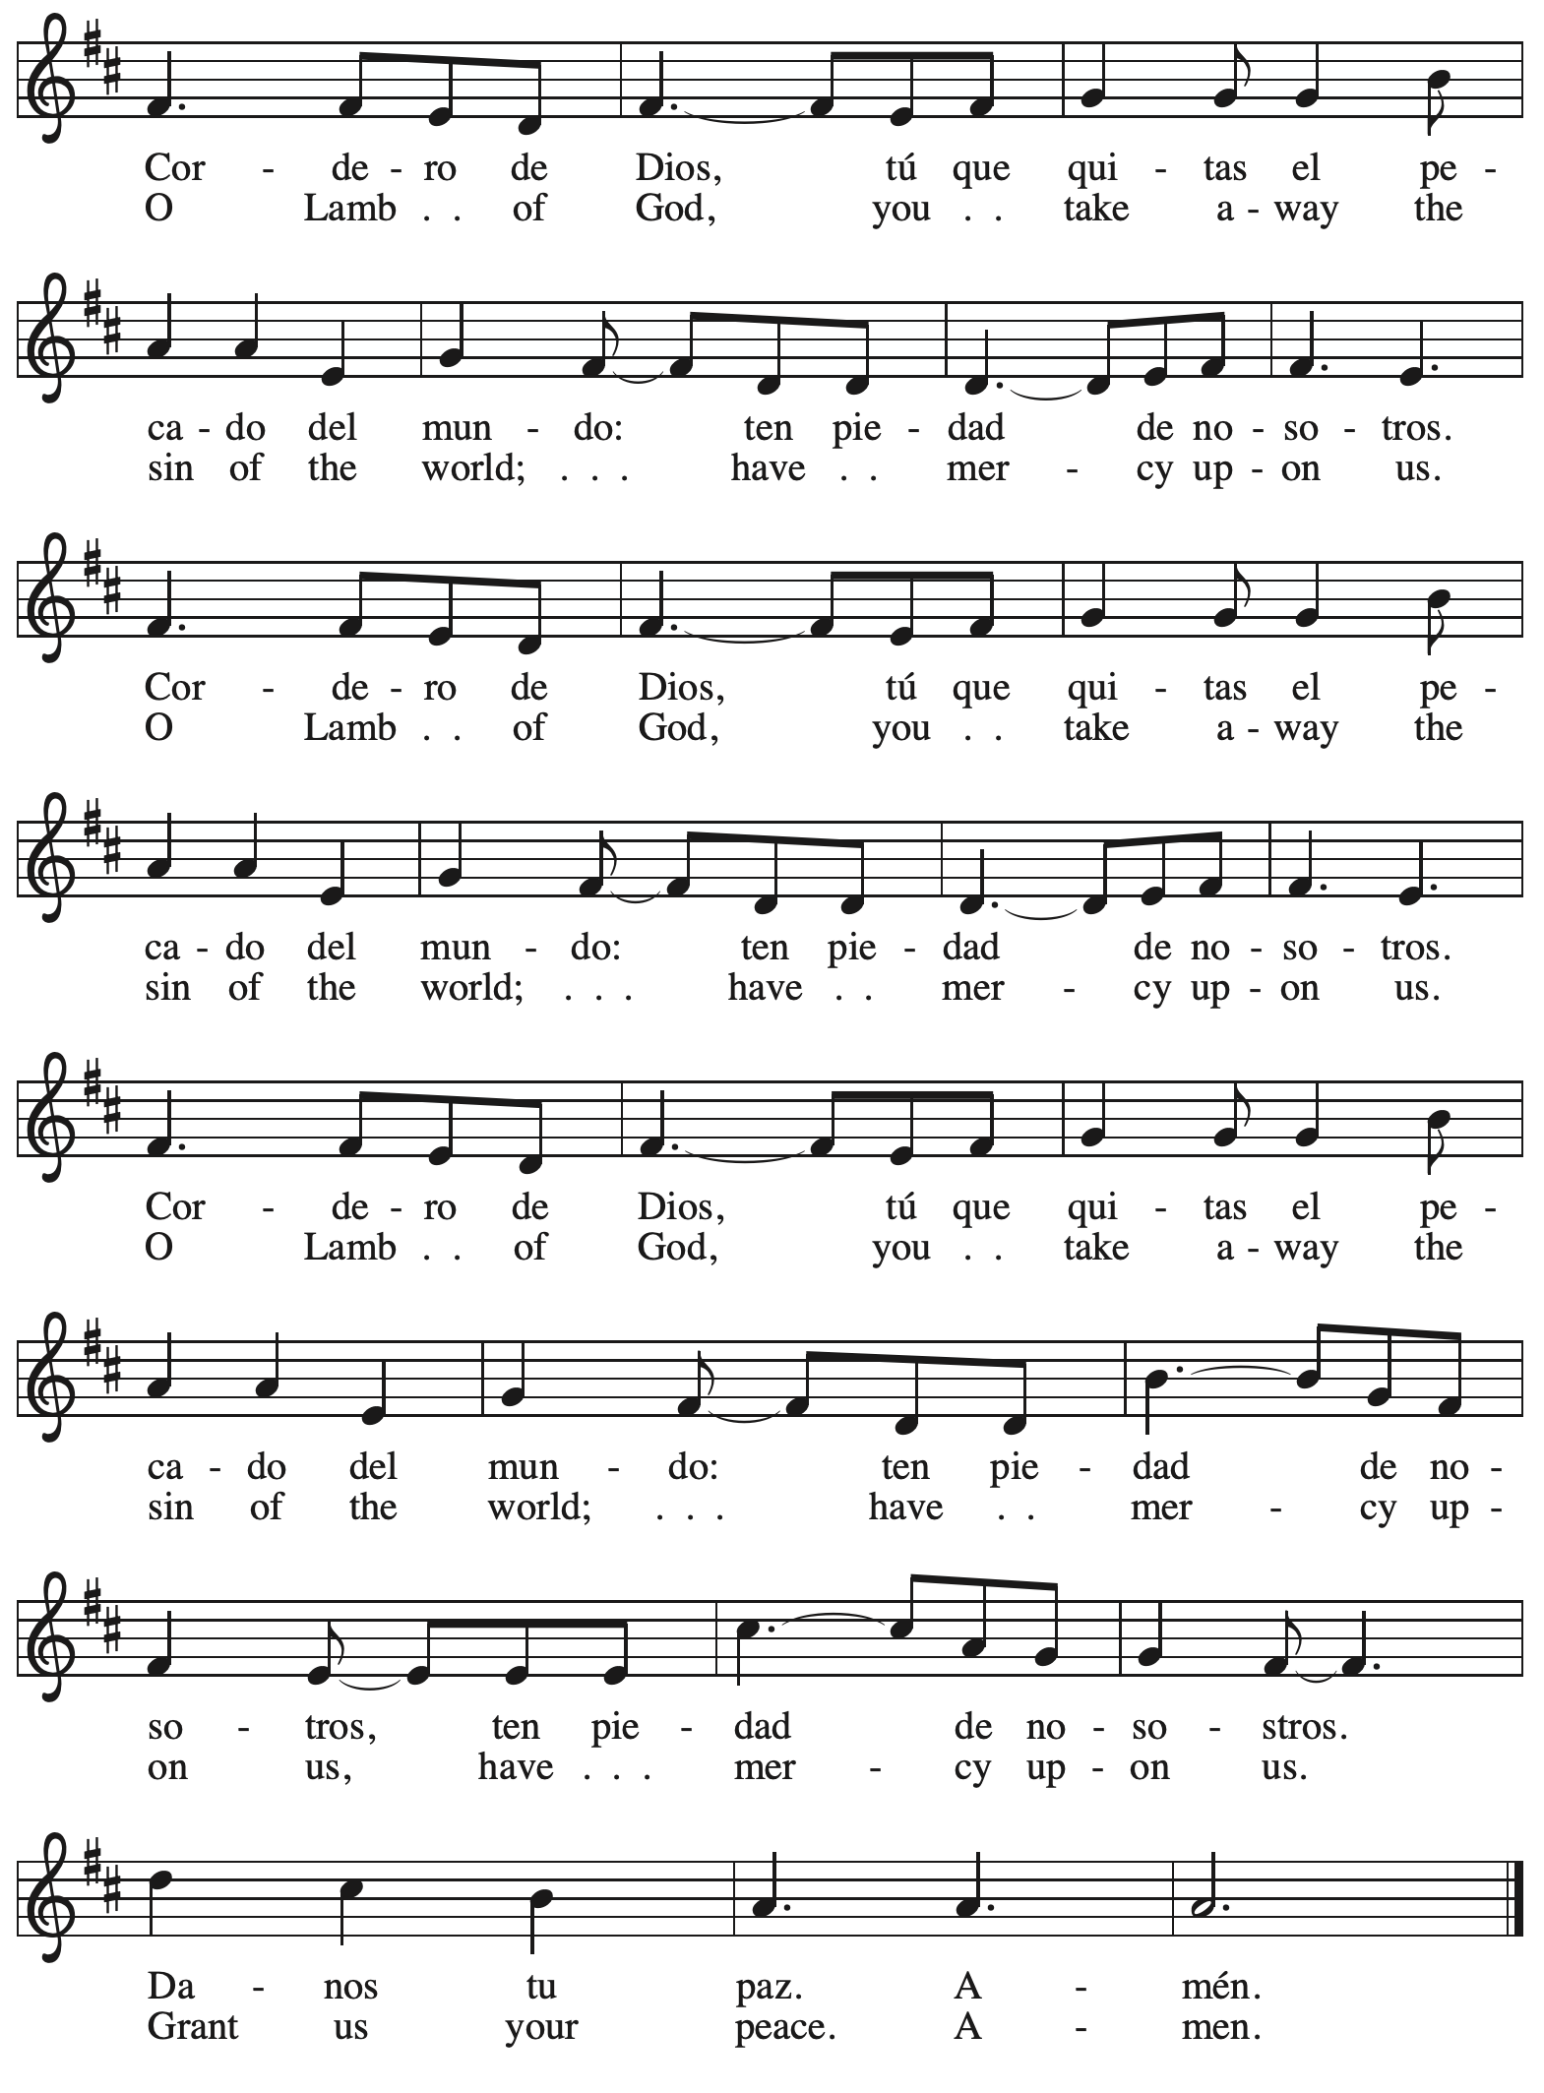

*Please be seated.*



**Holy Communion**

* *All who seek God and desire a deeper and stronger life in Christ are welcome to receive Holy Communion.*
* *Worshipers from the pulpit side will proceed forward first, followed by the center section, and then the lectern side.*
* *Please inform an usher if you would like the ministers to bring Communion to you.*
* *Holy Communion will be served with bread and wine/grape juice.*
* *The presiding minister will first distribute the bread (host) to each communicant. Please indicate if you require a gluten-free host.*
* *Once you have consumed the bread, please pick up an empty glass from the tray next to the presiding minister. The Communion Assistant will pour wine from the chalice or grape juice from the cruet into your glass.*
* *Please step to the side to consume the wine or grape juice.*
* *Feel free to kneel at the altar rail for prayer after receiving the sacrament.*
* *As you return to your pew, glasses may be returned to the empty trays on either side of the center section.*
* *A blessing will be provided for anyone who does not yet receive the sacrament.*
* *All are invited to join in singing the hymns during Holy Communion.*

**Hymns during Holy Communion**

**How Clear Is Our Vocation, Lord *ELW* 580**

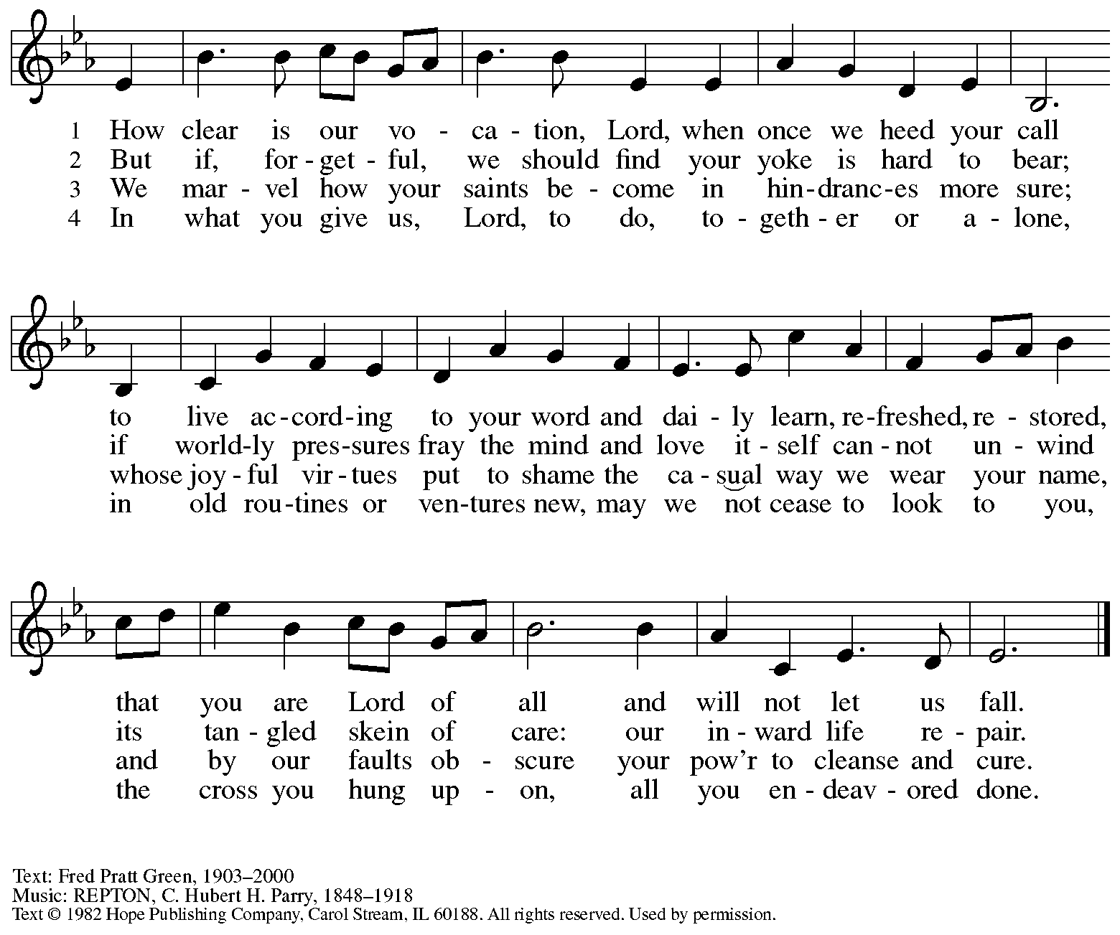

Reprinted under OneLicense.net # A-722139.

**Hymns during Holy Communion**

**We Place upon Your Table, Lord *ELW* 467**

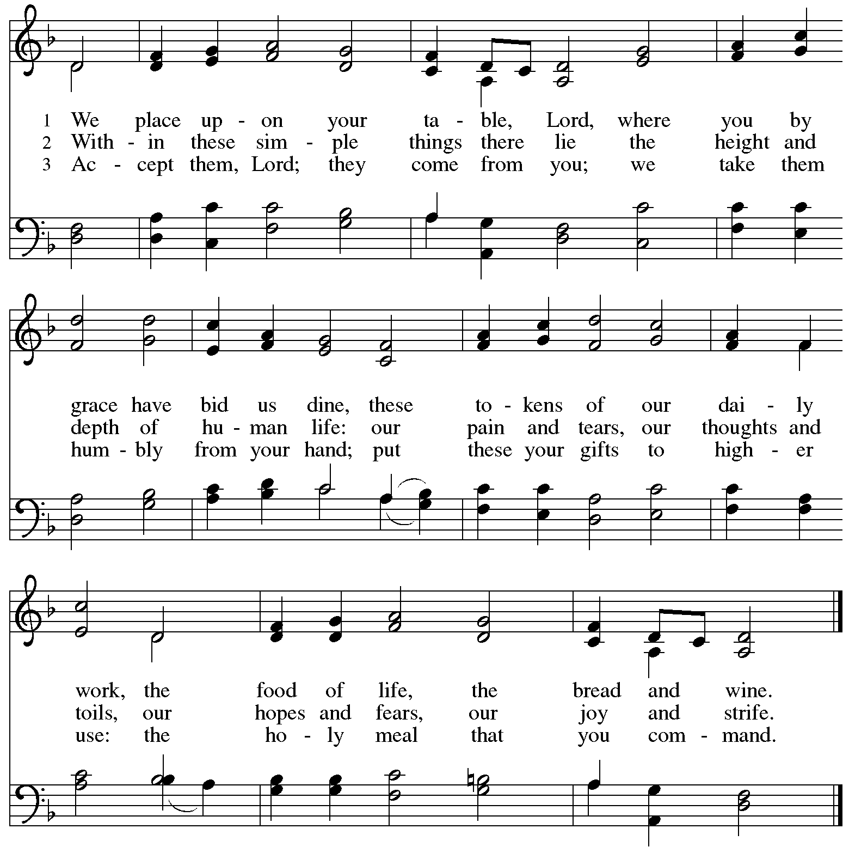

**Hymns during Holy Communion**

**Jesus, tawa pano – Jesus, We Are Gathered *ELW* 529**

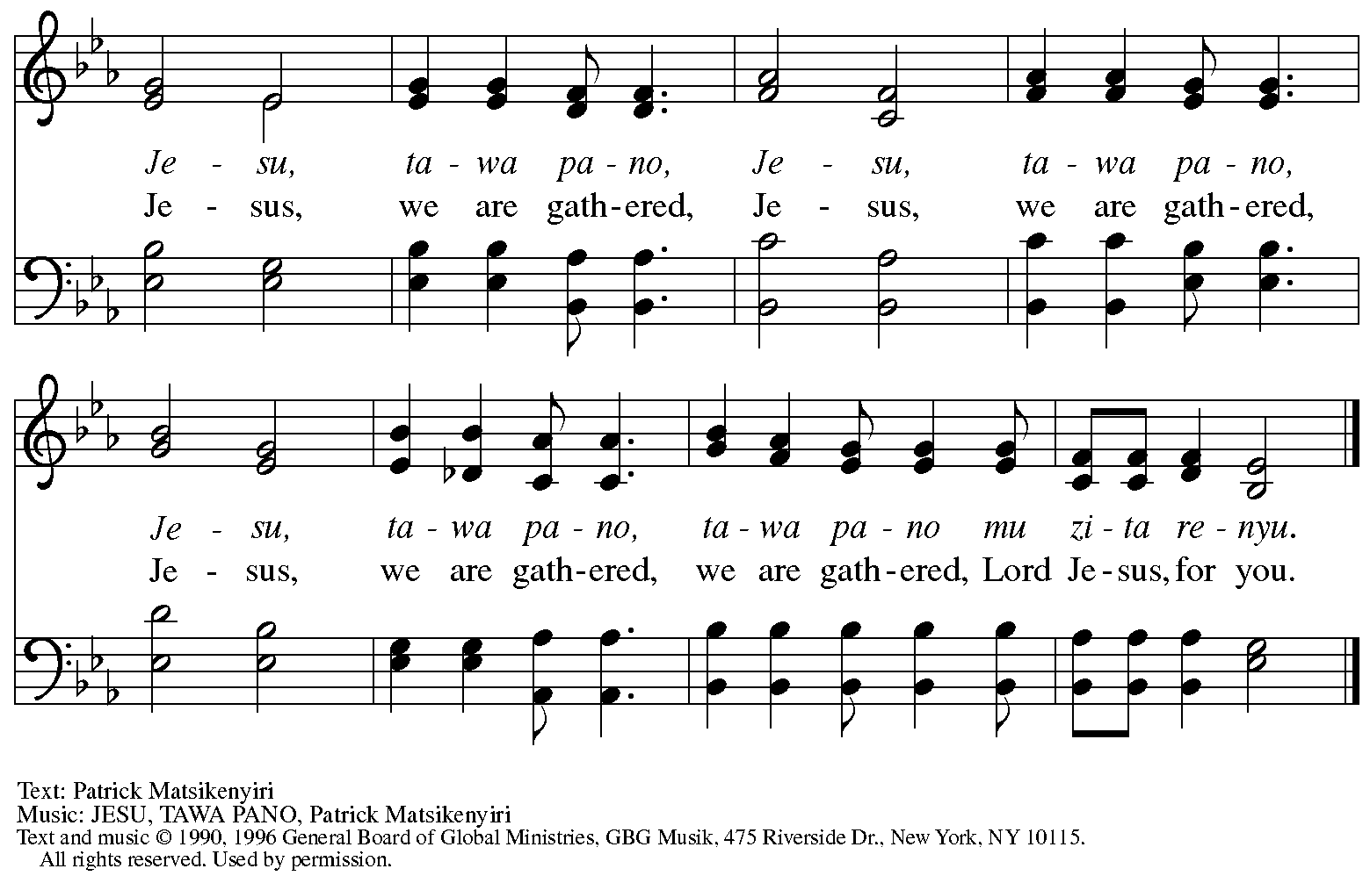

Reprinted under OneLicense.net # A-722139.

**Hymns during Holy Communion**

**Will You Come and Follow Me *ELW* 798**

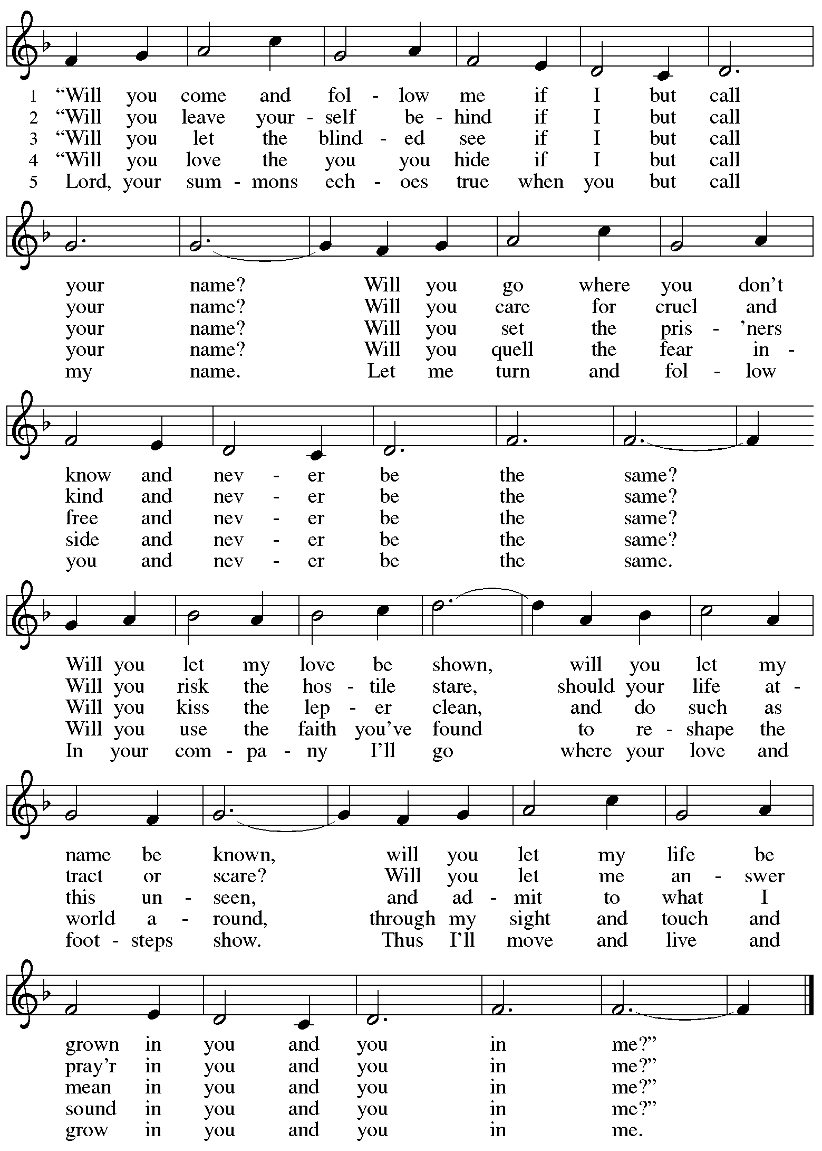

*When all have returned to their places, please rise as you are able.*

**Blessing**

P: The body and blood of our Lord Jesus Christ strengthen you and keep you in his grace.

**C: Amen.**

**Prayer**

A: Let us pray.

O God, in this holy communion you have welcomed us into your presence,

nourished us with words of mercy, and fed us at your table. Amid the cares of this life, strengthen us to love you with all our heart, serve our neighbors with a willing spirit,

and honor the earth you have made; through Christ our Lord.

**C: Amen.**

*Please be seated.*

**Sending**

*God blesses us and sends us in mission to the world*

**Announcements**

*Please rise as you are able.*

**Benediction**

P: The holy Three,

the holy One

increase your hope,

strengthen your faith,

deepen your love,

and ☩ grant you peace.

**C: Amen.**

**Sending Hymn** *Following page*

**Dismissal**

P: Go in peace. Christ is with you.

**C: Thanks be to God!**

**Postlude**

**Sending Hymn Holy, Holy, Holy, Lord God Almighty! *ELW* 413**

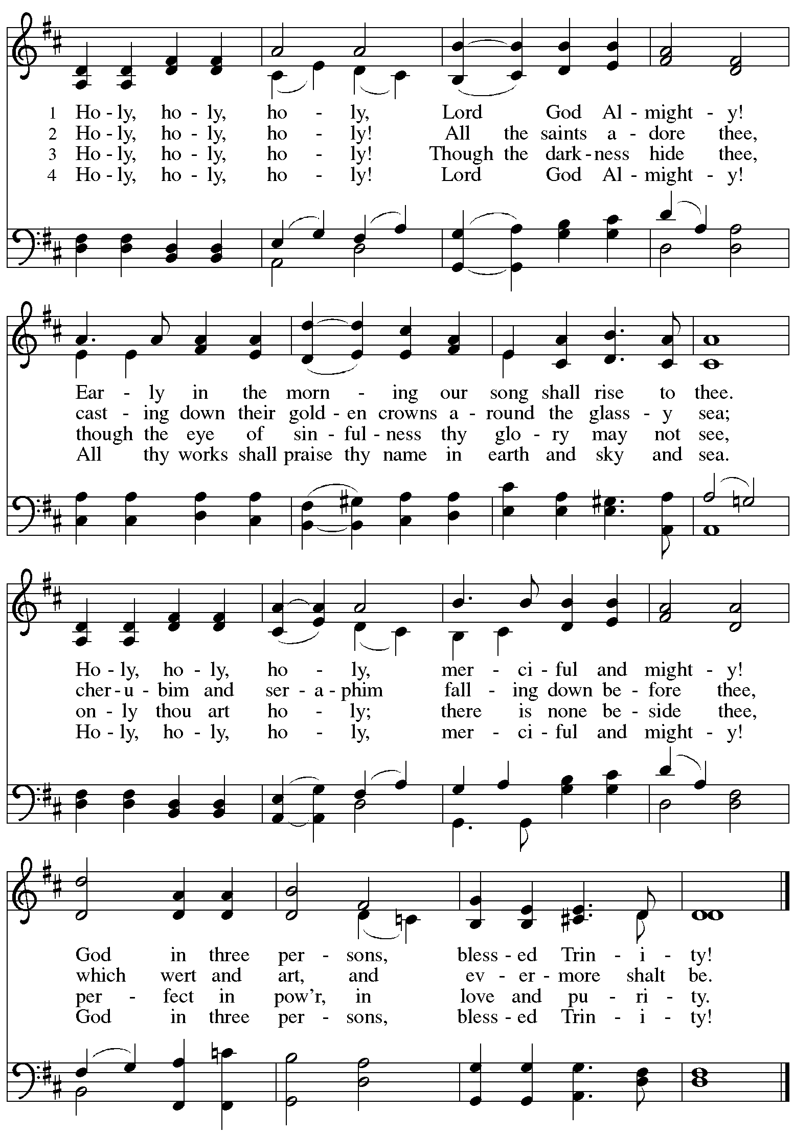

*Those serving in worship*

Altar Care Jodie Minor

Assisting Minister Colleen Cooke

Audio-Visual Ministers Jason Galyardt

Joseph Paetz

Cantor Marit Bakken

Lector The Rev. Dr. Paul F. Koch

Little Church – Big Faith Teacher Sue Gaugler

Piano Jeff Denlinger

Minister of Music Laura Reynolds

Presiding and Preaching Minister The Rev. Ross I. Carmichael

*Liturgy and Hymnody Acknowledgements*

From SundaysandSeasons.com. Copyright © 2025 Augsburg Fortress. All rights reserved. Reprinted under OneLicense.net # A-722139.

Used by permission of Augsburg Fortress.

The Scripture readings contained herein are from *New Revised Standard Version* of the Bible © 1989, Division of Christian Education of the National Council of Churches of Christ in the USA. Used by permission. All rights reserved.

**Will You Come and Follow Me**



Reprinted under OneLicense.net # A-722139.

**Holy, Holy, Holy, Lord God Almighty!**



*Please use the QR code below to link to St. Andrew’s Announcements online!*



**St. Andrew Lutheran Church Announcements**

**February 9th, 2025**

* **Welcome to worship at St. Andrew on the Fifth Sunday after Epiphany, February 9th, 2025** – We are so glad you are here, and we offer a special welcome to all guests who are gathered here or online! Little Church – Big Faith, a Bible lesson and activity for children, will take place after the prayer of the day. There are also worship “toolkits” to help children engage with worship and “busy bags” for younger children available in the bookcase at the back of the sanctuary. Please feel free to take one to use with/for your children. All are invited to gather for coffee, other drinks, food, and conversation in the social hall after worship.
* **St.** **Olaf Lutheran College Choir Concert at East Liberty Presbyterian Church on Sunday, February 9th, at 7:30 p.m.** – St. Olaf College is a Lutheran-affiliated liberal arts school in Northfield, MN, and its choir will stop in Pittsburgh on its 2025 tour. The St. Olaf Choir, made up of 75 mixed voices, is “one of the nation’s premier a cappella ensembles, renowned for its artistry and beauty of sound.” They will perform at East Liberty Presbyterian Church, 116 S. Highland Ave., 15206 on Sunday, February 9th, at 7:30 p.m. Tickets are $35 or $10 for all students, and they are available at [stolaf.edu/tickets/choir](http://stolaf.edu/tickets/choir)or by calling 800-363-5487. For more information, please visit

[St. Olaf Choir at East Liberty Presbyterian Church (Pittsburgh, PA) Tickets, Sun, Feb 9, 2025 at 7:30 PM | Eventbrite](https://www.eventbrite.com/e/st-olaf-choir-at-east-liberty-presbyterian-church-pittsburgh-pa-tickets-1027252478817?aff=oddtdtcreator).

* **Community Ministry Meeting – Monday, February 10th, at 7:00 p.m. on Zoom – St. Andrew’s community ministry committee coordinates our local service ministries such as the outdoor Little Library, the pantry, produce distribution, shelter dinner, and various other activities. New participants are always welcome, and the next meeting is Monday, February 10th, at 7:00 p.m. on Zoom. Please contact** [PastorRCarmichael@gmail.com](mailto:PastorRCarmichael@gmail.com) **or** [community@standrewpittsburgh.org](mailto:community@standrewpittsburgh.org) **if you would like the link.**
* **Next Council Meeting – Saturday, February 15th, at 9:00 a.m. – St. Andrew’s congregation council meets once a month to guide the mission and general operations of the church. It is made up of 13 members of the congregation and the pastor. The next meeting of the council is Saturday, February 15th, at 9:00 a.m. We invite your prayers for St. Andrew’s council leaders!**
* **Noisy Offering – Sunday, February 16th during Worship – On the third Sunday of each month, St. Andrew’s children lead the congregation in a “Noisy” Offering, in which people are invited to throw their change into buckets that the children carry around the church and bring forward as an additional offering. Each month’s Noisy Offering supports a local, national, or international church-related or otherwise charitable organization. This month’s offering will go to the Good Neighbor Fund of Glade Run Lutheran Services, a service ministry organization of our church. Overseen by the chaplain’s office, the Good Neighbor Fund provides direct service and resources to people in need, including utility assistance, rental deposits, co-pay support, job training, relief when leaving domestic violence situations, and more.**
* **Shelter Dinner for Guests of East End Cooperative Ministry, Third Thursday of the Month – February 20th, 6:00 p.m. Arrival, 6:30 p.m. Dinner –** Each month, people of St. Andrew provide dinner for guests of East End Cooperative Ministry (EECM), 6140 Station St. (East Liberty), 15206. We invite you to prepare or purchase one menu item and bring it to the shelter by 6:00 p.m., or just come to help serve at 6:30 p.m. If you would like to contribute, please sign up here:

<https://www.signupgenius.com/go/5080544AAAC22A1F58-54567228-shelter>.

* **Pancake Brunch during Coffee Hour on Sunday, March 2nd – Please Plan to Stay after Worship – Traditionally on Shrove Tuesday, the day before Ash Wednesday, Christians would clear out all the rich and fatty foods from their cupboards in preparation for the season of Lent and its spiritual discipline of fasting. Following this custom, St. Andrew used to hold a pancake dinner on Shrove Tuesday, but we have not done so since before the pandemic. We would like to re-introduce the practice and the spirit of Shrove Tuesday after worship on Sunday, March 2nd. At the close of worship, we will have a brief outdoor liturgy for the burning of the palms and then proceed to the social hall for a meal together. The hospitality committee will provide pancake mix (with gluten), sausage (non-vegan), gluten-free cupcakes and cookies, butter, syrup, coffee and tea. We ask people of the congregation to bring fruit, breakfast juices, and other gluten-free breakfast items. We hope you will join in these activities as we prepare for the season of Lent, beginning on Ash Wednesday, March 5th.**
* **Compline Prayer Service with the Pittsburgh Compline Choir – Sundays at 8:00 p.m. at Heinz Chapel –** Compline was traditionally a monastic prayer service, and the Pittsburgh Compline Choir, a ministry of Lutheran Campus Ministry in Greater Pittsburgh, sings a choral version of compline rooted in this thousand-year-old tradition of scripture, song, and silence each Sunday at Heinz Chapel at 8:00 p.m. This service also streams on Facebook (Pittsburgh Compline Choir) and YouTube (The Pittsburgh Compline Choir). Heinz Chapel is located off of S. Bellefield Ave. in Oakland. For more information, please visit: [Pittsburgh Compline Choir](http://pittsburghcomplinechoir.org/).