

**+ Third Sunday after Epiphany**

**January 26th, 2025**

**10:00 a.m.**



**St. Andrew Lutheran Church**

**304 Morewood Ave.**

**Pittsburgh, PA 15213**

**412.682.3342**

[**St_andrewELCA@verizon.net**](mailto:St_andrewELCA@verizon.net)

[**www.standrewpittsburgh.org**](http://www.standrewpittsburgh.org)

**+ Third Sunday after Epiphany**

**Order for Worship**

*God’s glory is revealed in the reading of scripture.*

*People stand at attention. People weep. People prostrate themselves in prayer.*

*The unity of the church is another reflection of God’s glory.*

*Most gloriously, the promises of God are fulfilled in the person of Jesus Christ.*

*Gather round. Listen. Glimpse the glory of God.*

**Welcome to St. Andrew!**

* St. Andrew welcomes all who are seeking a place of healing, wholeness, and acceptance in a nurturing and faith-forming spiritual home. We are striving toward racial equity worldwide

and we seek to honor the lived experience of all individuals regardless of background. Our community embraces people of all ages, ethnicities, cultures, abilities, sexual orientations,

gender identities and expressions, and family constellations. Come and See!

* Worship Services are live-streamed to multiple online platforms. By attending worship, you agree that your image and voice may be broadcast.
* Everyone is invited to make a name tag at the black bookcase in the back of the worship space if they would like. There are stickers indicating pronouns on the bookcase if you would like to include them on your name tag.
* Children are invited to attend Little Church – Big Faith, a Bible lesson and activity, during worship (after the Prayer of the Day). The group returns to the worship space for the liturgy of Holy Communion.
* A nursery is available through the doors at the left side of the sanctuary and across from the doorway to the Social Hall. Look for a purple-colored room.
* Worship “toolkits” to help children engage with the service, along with “busy bags” for younger children, are available in the bookcase at the back of the sanctuary. Please feel free to take one to use with/for your children.
* Holy Communion is served with bread (gluten-free available) and wine or grape juice. The presiding minister will distribute the bread (host). Please consume this and then pick up an empty glass from the tray. The Communion Assistant will pour wine or grape juice into your glass. Please step to the side to consume the wine or grape juice. Feel free to kneel at the altar for prayer and reflection. As you return to your pew, glasses may be returned to the empty trays on either side of the center section.
* A restroom is available on the main level of the church, through the doors to the Social Hall and to the right in the main office.

*Abbreviations*

P: Pastor/Presiding Minister ***ELW*: *Evangelical Lutheran Worship* hymnal**

A: Assisting Minister ***ACS*: *All Creation Sings* hymnal**

L: Lector ***W&P*: *Worship and Praise* hymnal**

**C: Congregation**

**Pre-Service Music**

**Welcome**

**Prelude**

**Gathering**

*The Holy Spirit calls us together as the people of God*

**Thanksgiving for Baptism**

*Please rise as you are able. All may make the sign of the cross,*

*the sign that is marked at Baptism, as the presiding minister begins.*

P: Blessed be the holy Trinity, ☩ one God,

the fountain of living water, the rock who gave us birth,

our light and our salvation.

**C: Amen.**

P: Joined to Christ in the waters of Baptism, we are clothed with God’s mercy and forgiveness. Let us give thanks for the gift of Baptism.

*Water may be poured into the font as the presiding minister gives thanks*

P: We give you thanks, O God, for in the beginning you created us in your image and placed us in a well-watered garden. In the desert, you promised pools of water for the parched, and you gave us water from the rock. When we did not know the way, you sent the Good Shepherd to lead us to still waters. At the cross, you washed us from Jesus’ wounded side, and on this day, you shower us again with the water of life.

We praise you for your salvation through water, for the water in this font,

and for all water everywhere, including the Allegheny, Monongahela, and Ohio rivers.

Bathe us in your forgiveness, grace, and love.

Satisfy all who thirst, and give us the life only you can give.

To you be given honor and praise

through Jesus Christ, our living water,

in the unity of the Holy Spirit, now and forever.

**C: Amen.**

**Gathering Hymn This is the Day *W&P* 141**

**This is the day, this is the day**

**that the Lord has made, that the Lord has made;**

**we will rejoice, we will rejoice**

**and be glad in it, and be glad in it.**

**This is the day that the Lord has made;**

**we will rejoice and be glad in it.**

**This is the day, this the day that the Lord has made.**

Text – Psalm 118: 24. Music: Les Garrett. Music © 1967, 1980 Scripture in Song, a division of Integrity Music, Inc. All rights reserved. Reprinted with permission under OneLicense.net # A-722139.



**Greeting**

P: The grace of our Lord Jesus Christ, the love of God,

and the communion of the Holy Spirit be with you all.

**C: And also with you.**

**Hymn of Praise** *ACS* p. 12

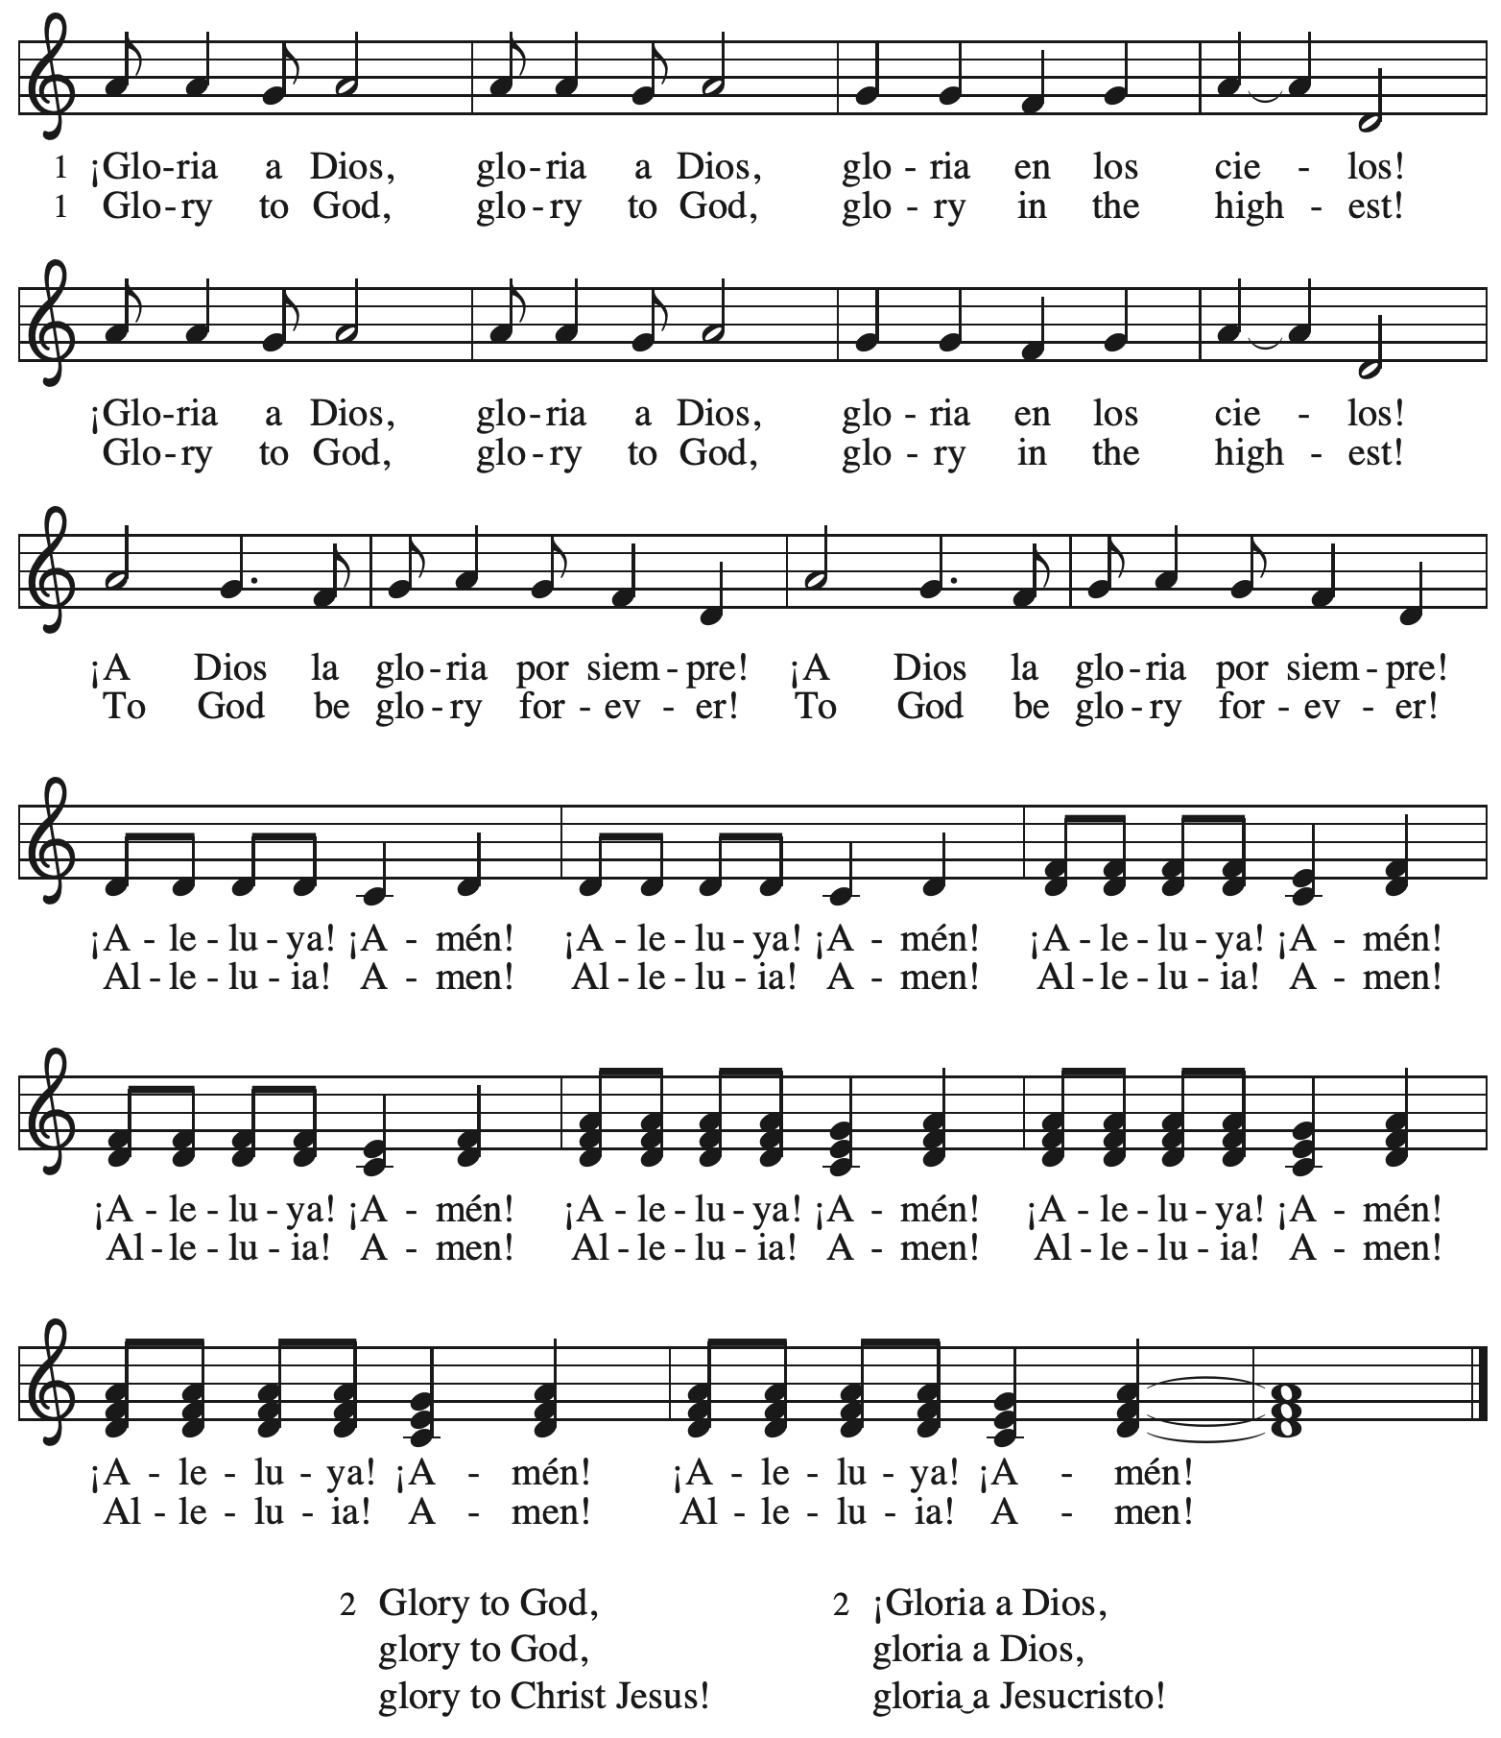

**Prayer of the Day**

P: The Lord be with you.

**C: And also with you.**

P: Let us pray.

Blessed Lord God,

you have caused the holy scriptures to be written for the nourishment of your people.

Grant that we may hear them, read, mark, learn, and inwardly digest them, that,

comforted by your promises, we may embrace and forever hold fast to the hope of eternal life, through your Son, Jesus Christ our Lord.

**C: Amen.**

*Please be seated.*

**Word**

*God speaks to us in Scripture reading, preaching, and song*

**First Reading** **– Nehemiah 8: 1-3, 5-6, 8-10**

1 All the people [of Israel] gathered together into the square before the Water Gate. They told the scribe Ezra to bring the book of the law of Moses, which the Lord had given to Israel.

2 Accordingly, the priest Ezra brought the law before the assembly, both men and women and all who could hear with understanding. This was on the first day of the seventh month. 3 He read from it facing the square before the Water Gate from early morning until midday, in the presence of the men and the women and those who could understand; and the ears of all the people were attentive to the book of the law.

5 And Ezra opened the book in the sight of all the people, for he was standing above all the people; and when he opened it, all the people stood up. 6 Then Ezra blessed the Lord, the great God, and all the people answered, “Amen, Amen,” lifting up their hands. Then they bowed their heads and worshiped the Lord with their faces to the ground.

8 So they read from the book, from the law of God, with interpretation. They gave the sense, so that the people understood the reading.

9 And Nehemiah, who was the governor, and Ezra the priest and scribe, and the Levites who taught the people said to all the people, “This day is holy to the Lord your God; do not mourn or weep.” For all the people wept when they heard the words of the law. 10 Then he said to them, “Go your way, eat the fat and drink sweet wine and send portions of them to those for whom nothing is prepared, for this day is holy to our Lord; and do not be grieved, for the joy of the Lord is your strength.”

L: Word of God, word of life.

**C: Thanks be to God.**

**Psalm 19**

*The cantor will lead the singing of the psalm.*

*The congregation is invited to respond with the alternate verses in bold print,*

*and to join in singing the refrain.*

*Psalm Tone*

**

*Psalm Refrain*

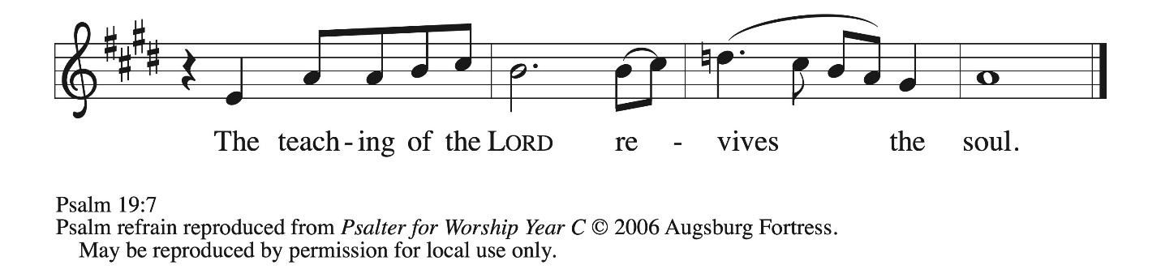

1 The heavens declare the glo- **|** ry of God,  
  and the sky proclaims its **|** maker’s handiwork.  
 2 **One day tells its tale | to another,**  
  **and one night imparts knowledge | to another.**  
 3 Although they have no **|** words or language,  
  and their voices **|** are not heard,  
 4 **their sound has gone out into all lands, and their message to the ends | of the world,**  
  **where God has pitched a tent | for the sun.**  
 5 It comes forth like a bridegroom out **|** of his chamber;  
  it rejoices like a champion to **|** run its course.  
 6 **It goes forth from the uttermost edge of the heavens and runs about to the end of | it again;**  
  **nothing is hidden from its | burning heat. R**  
 7 The teaching of the Lord is perfect and re- **|** vives the soul;  
  the testimony of the Lord is sure and gives wisdom **|** to the simple.  
 8 **The statutes of the Lord are just and re- | joice the heart;**  
  **the commandment of the Lord is clear and gives light | to the eyes.**  
 9 The fear of the Lord is clean and en- **|** dures forever;  
  the judgments of the Lord are true and righteous **|** altogether.  
 10 **More to be desired are they than gold, more than | much fine gold,**  
  **sweeter far than honey, than honey | in the comb. R**  
 11 By them also is your ser- **|** vant enlightened,  
  and in keeping them there is **|** great reward.  
 12 **Who can detect one’s | own offenses?**  
  **Cleanse me from my | secret faults.**  
 13 Above all, keep your servant from presumptuous sins; let them not get dominion **|** over me;  
  then shall I be whole and sound, and innocent of a **|** great offense.  
 14 **Let the words of my mouth and the meditation of my heart be acceptable | in your sight,**  
  **O Lord, my strength and | my redeemer. R**

**Second Reading – 1 Corinthians 12: 12-31a**

12 For just as the body is one and has many members, and all the members of the body, though many, are one body, so it is with Christ. 13 For in the one Spirit we were all baptized into one body—Jews or Greeks, slaves or free—and we were all made to drink of one Spirit.  
  14 Indeed, the body does not consist of one member but of many. 15 If the foot would say, “Because I am not a hand, I do not belong to the body,” that would not make it any less a part of the body. 16 And if the ear would say, “Because I am not an eye, I do not belong to the body,” that would not make it any less a part of the body. 17 If the whole body were an eye, where would the hearing be? If the whole body were hearing, where would the sense of smell be? 18 But as it is, God arranged the members in the body, each one of them, as God chose. 19 If all were a single member, where would the body be? 20 As it is, there are many members, yet one body. 21 The eye cannot say to the hand, “I have no need of you,” nor again the head to the feet, “I have no need of you.” 22 On the contrary, the members of the body that seem to be weaker are indispensable, 23 and those members of the body that we think less honorable we clothe with greater honor, and our less respectable members are treated with greater respect; 24 whereas our more respectable members do not need this. But God has so arranged the body, giving the greater honor to the inferior member, 25 that there may be no dissension within the body, but the members may have the same care for one another. 26 If one member suffers, all suffer together with it; if one member is honored, all rejoice together with it.  
  27 Now you are the body of Christ and individually members of it. 28 And God has appointed in the church first apostles, second prophets, third teachers; then deeds of power, then gifts of healing, forms of assistance, forms of leadership, various kinds of tongues. 29 Are all apostles? Are all prophets? Are all teachers? Do all work miracles? 30 Do all possess gifts of healing? Do all speak in tongues? Do all interpret? 31a But strive for the greater gifts.

L: Word of God, word of life.

**C: Thanks be to God.**

*Please rise as you are able and join in singing the Gospel Acclamation.*

**Gospel Acclamation** *ACS* p. 14

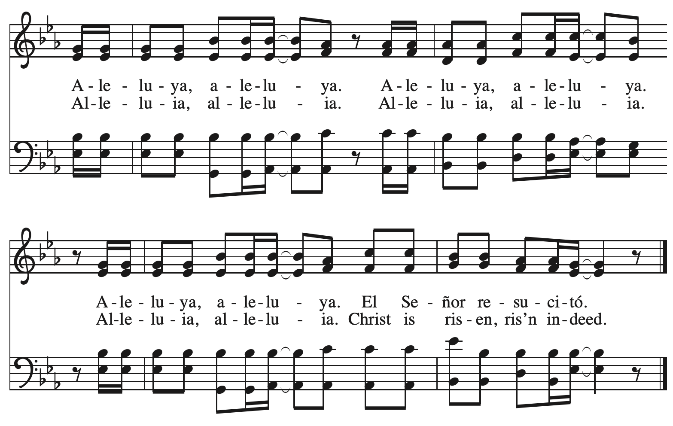

**Gospel – Luke 4: 14-21**

P: The holy Gospel according to St. Luke.

**C: Glory to you, O Lord.**

14 Then Jesus, filled with the power of the Spirit, returned to Galilee, and a report about him spread through all the surrounding country. 15 He began to teach in their synagogues and was praised by everyone.  
  
  16 When he came to Nazareth, where he had been brought up, he went to the synagogue on the sabbath day, as was his custom. He stood up to read, 17 and the scroll of the prophet Isaiah was given to him. He unrolled the scroll and found the place where it was written:  
 18 “The Spirit of the Lord is upon me,  
  because the Lord has anointed me  
   to bring good news to the poor.  
 The Lord has sent me to proclaim release to the captives  
  and recovery of sight to the blind,  
   to let the oppressed go free,  
 19 to proclaim the year of the Lord’s favor.”  
20 And he rolled up the scroll, gave it back to the attendant, and sat down. The eyes of all in the synagogue were fixed on him. 21 Then he began to say to them, “Today this scripture has been fulfilled in your hearing.”

P: The Gospel of the Lord.

**C: Praise to you, O Christ.**

*Please be seated.*

**Sermon**

*A time of silence for prayer and reflection follows the sermon.*

*As the hymn of the day begins, please rise as you are able.*

**Hymn of the Day Let Streams of Living Justice *ELW* 710**

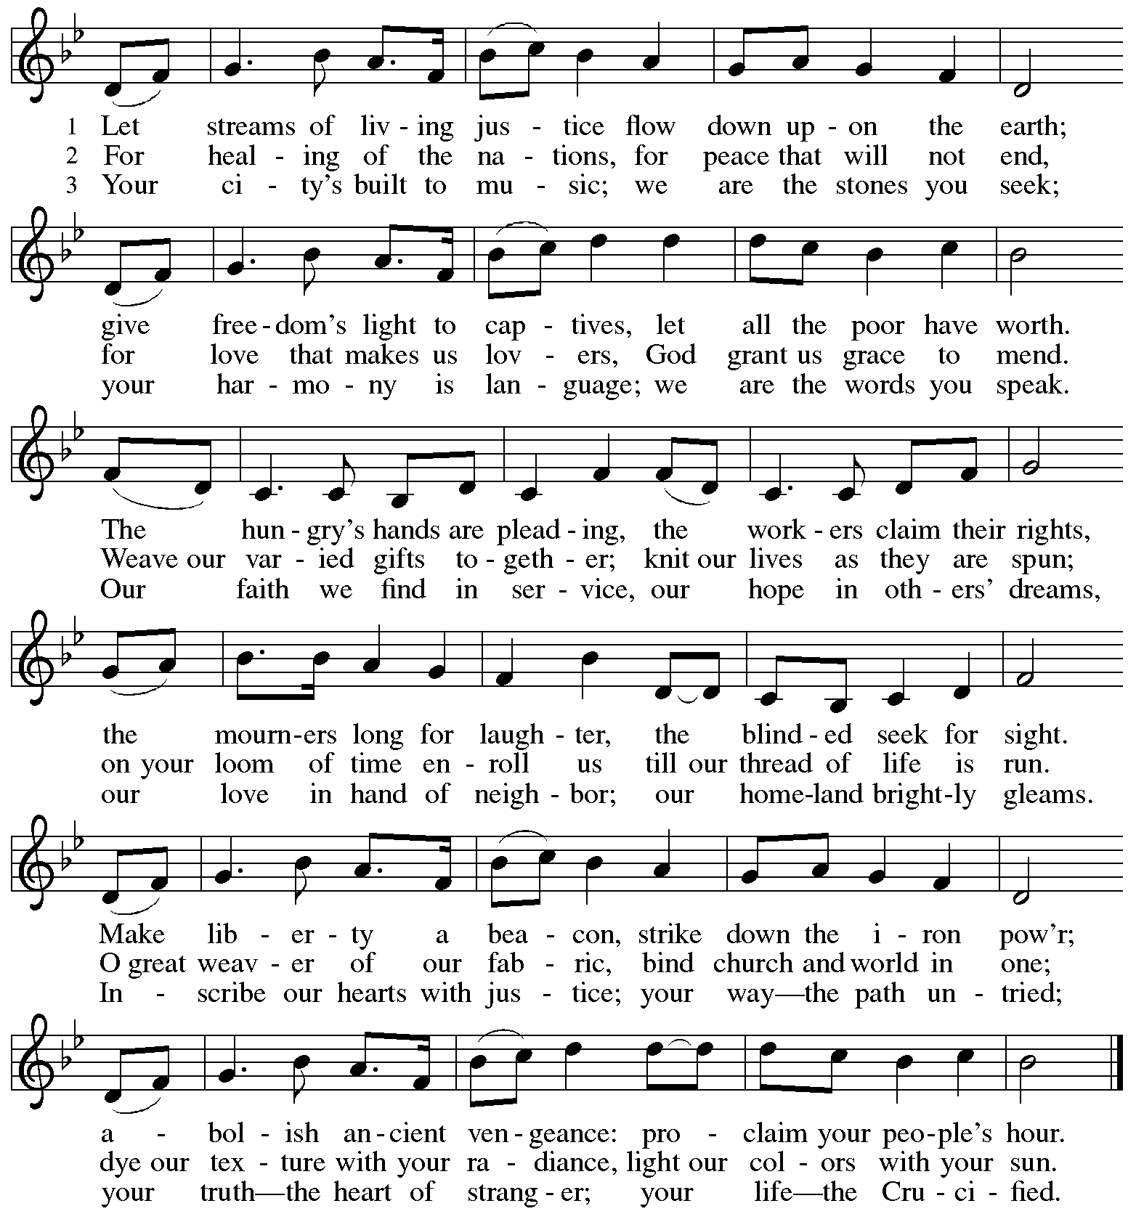

**Apostles’ Creed**

**C: I believe in God, the Father almighty,**

**creator of heaven and earth.**

**I believe in Jesus Christ, God’s only Son, our Lord,**

**who was conceived by the Holy Spirit,**

**born of the virgin Mary,**

**suffered under Pontius Pilate,**

**was crucified, died, and was buried;**

**he descended to the dead.\***

**On the third day he rose again;**

**he ascended into heaven,**

**he is seated at the right hand of the Father,**

**and he will come to judge the living and the dead.**

**I believe in the Holy Spirit,**

**the holy catholic church,**

**the communion of saints,**

**the forgiveness of sins,**

**the resurrection of the body,**

**and the life everlasting. Amen.**

*Or, “he descended into hell,” another translation of this text in widespread use.

**Prayers of the People**

A: Guided by the Holy Spirit, with the light of Christ shining upon us and all nations,

let us pray for the church, the world, and all creation.

*After each petition*

A: Gracious God,

**C: receive our prayer.**

*The presiding minister concludes the prayers*

P: We entrust these prayers to you, O God, in the sure and certain hope

that your promise is revealed among your people.

**C: Amen.**

**Peace**

*The presiding minister and the assembly greet one another in the peace of the risen Christ.*

P: The peace of Christ be with you always.

**C: And also with you.**

*The people may greet those around them with a sign of Christ’s peace and may say*

Peace be with you *or similar words. Please be mindful that not everyone will be comfortable with sharing the peace, so please seek consent before shaking hands or hugging. Other possible ways to share the peace include a simple bow with the verbal greeting of peace, or simply a verbal expression of peace.*

*When the greetings of peace have concluded, please be seated.*



**Meal**

*God feeds us with the presence of Jesus Christ*

**Offering**

*We offer ourselves, our gifts, and our faithful service to God.*

*As the offering is gathered for the mission of the church, including the care of those in need,*

*the table is set for Holy Communion.*

**Music during the Offering**

*As the gifts are brought forward for presentation, please rise as you are able.*

**Offertory Song Cuando el pobre / When the Poor Ones *ELW* 725**

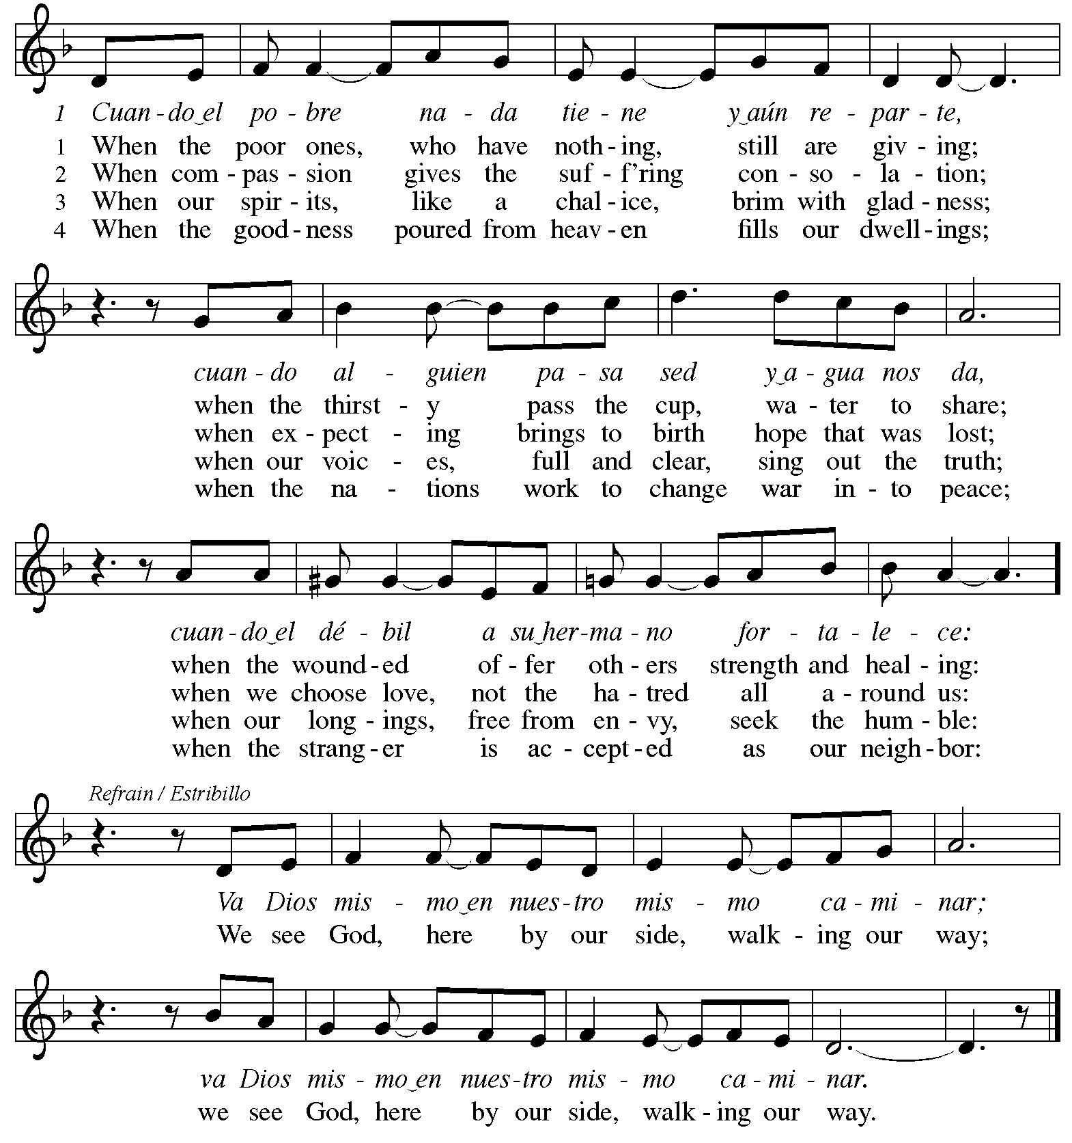



Reprinted under OneLicense.net # A-722139.

**Offertory Prayer**

A: Let us pray.

Holy God, gracious and merciful,

**C: you bring forth food from the earth and nourish your whole creation.**

**Turn our hearts toward those who hunger in any way, that all may know your care;**

**and prepare us now to feast on the bread of life, Jesus Christ, our Savior and Lord.**

**Amen.**

**Dialogue** *ACS* p. 20

P: The Lord be with you.

**C: And also with you.**

P: Lift up your hearts.

**C: We lift them to the Lord.**

P: Let us give thanks to the Lord our God.

**C: It is right to give our thanks and praise.**

**Preface** *ACS* p. 20

P: It is indeed right, our duty and our joy,

that we should at all times and in all places

give thanks and praise to you,

almighty and merciful God,

through our Savior Jesus Christ;

who on this day overcame death and the grave,

and by his glorious resurrection

opened to us the way of everlasting life.

And so, with all the choirs of angels,

with the church on earth and the hosts of heaven,

we praise your name and join their unending hymn:

**Sanctus** *ACS* p. 20

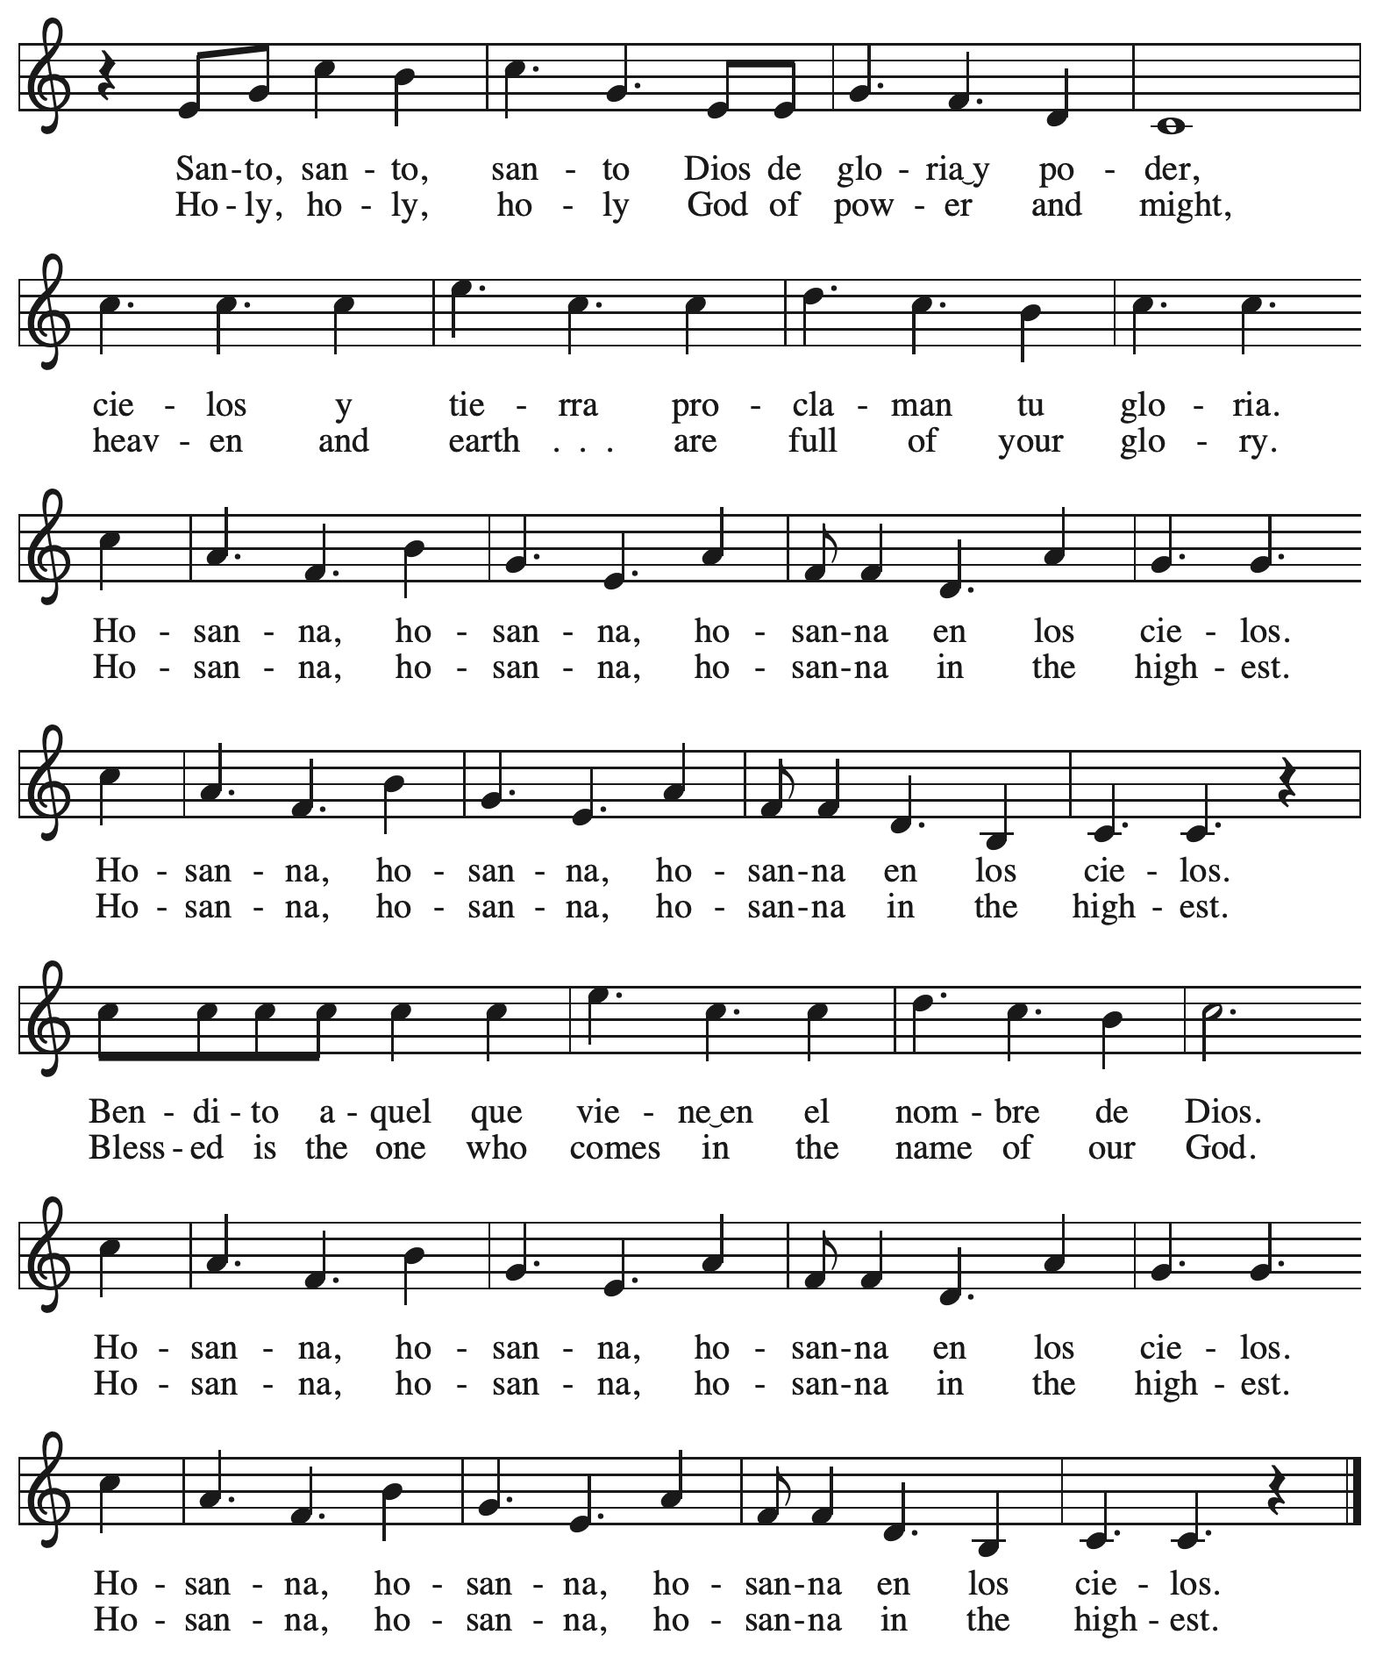

**Eucharistic Prayer**

P: Holy one, the beginning and the end, the giver of life, …

… Do this for the remembrance of me.

Let us proclaim the mystery of faith.

**C: Christ has died. Christ is risen. Christ will come again.**

P: With this bread and cup …

… We look with hope for his coming.

**C: Come, Lord Jesus.**

P: Holy God, we long for your Spirit …

… Bring the gift of peace on earth.

**C: Come, Holy Spirit.**

P: All praise and glory are yours …

… one God, now and forever.

**C: Amen.**

**Lord’s Prayer**

P: Gathered as one by the Holy Spirit, let us pray as Jesus taught us.

**C: Our Father in heaven,**

**hallowed be your name,**

**your kingdom come,**

**your will be done,**

**on earth as in heaven.**

**Give us today our daily bread.**

**Forgive us our sins**

**as we forgive those**

**who sin against us.**

**Save us from the time of trial**

**and deliver us from evil.**

**For the kingdom, the power,**

**and the glory are yours,**

**now and forever. Amen.**

**Fraction and Invitation**

P: The joy of the Lord is our strength.

Come and be nourished by the gifts of God.

***Agnus Dei /* Lamb of God** *ACS* p. 25

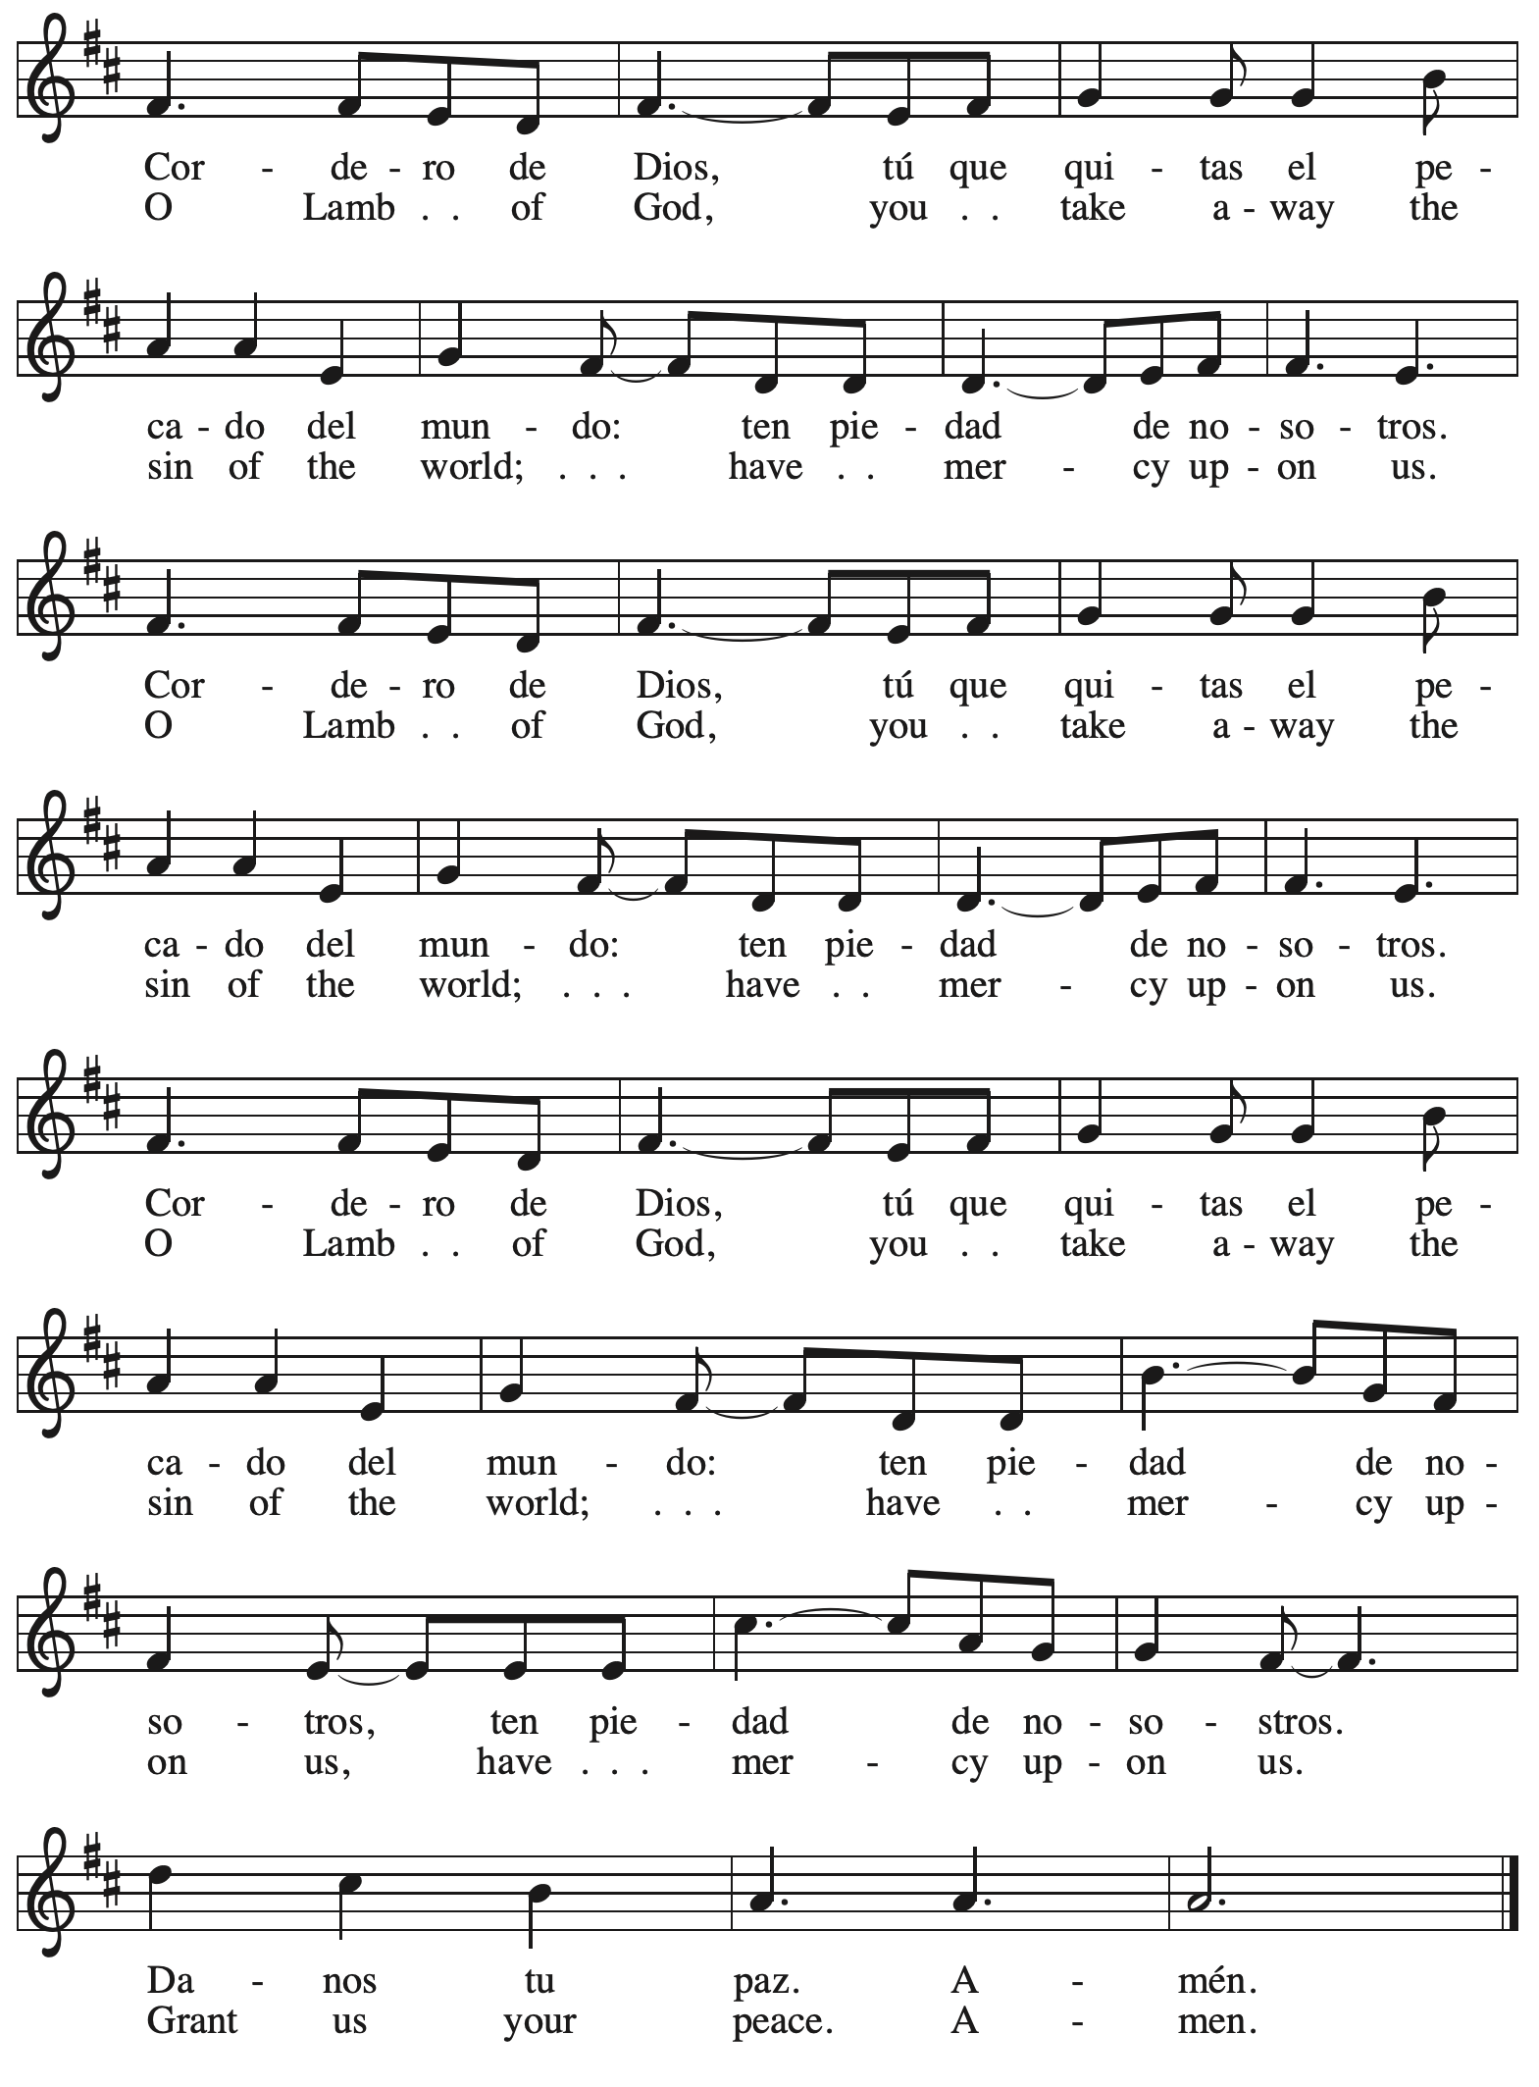

*Please be seated.*



**Holy Communion**

* *All who seek God and desire a deeper and stronger life in Christ are welcome to receive Holy Communion.*
* *Worshipers from the pulpit side will proceed forward first, followed by the center section, and then the lectern side.*
* *Please inform an usher if you would like the ministers to bring Communion to you.*
* *Holy Communion will be served with bread and wine/grape juice.*
* *The presiding minister will first distribute the bread (host) to each communicant. Please indicate if you require a gluten-free host.*
* *Once you have consumed the bread, please pick up an empty glass from the tray next to the presiding minister. The Communion Assistant will pour wine or grape juice into your glass. Please indicate if you would like grape juice.*
* *Please step to the side to consume the wine or grape juice.*
* *Feel free to kneel at the altar rail for prayer after receiving the sacrament.*
* *As you return to your pew, glasses may be returned to the empty tray on the side of the center section.*
* *A blessing will be provided for anyone who does not yet receive the sacrament.*
* *All are invited to join in singing the hymns during Holy Communion.*

**Hymns during Holy Communion**

**O God of Mercy, God of Light *ELW* 714**

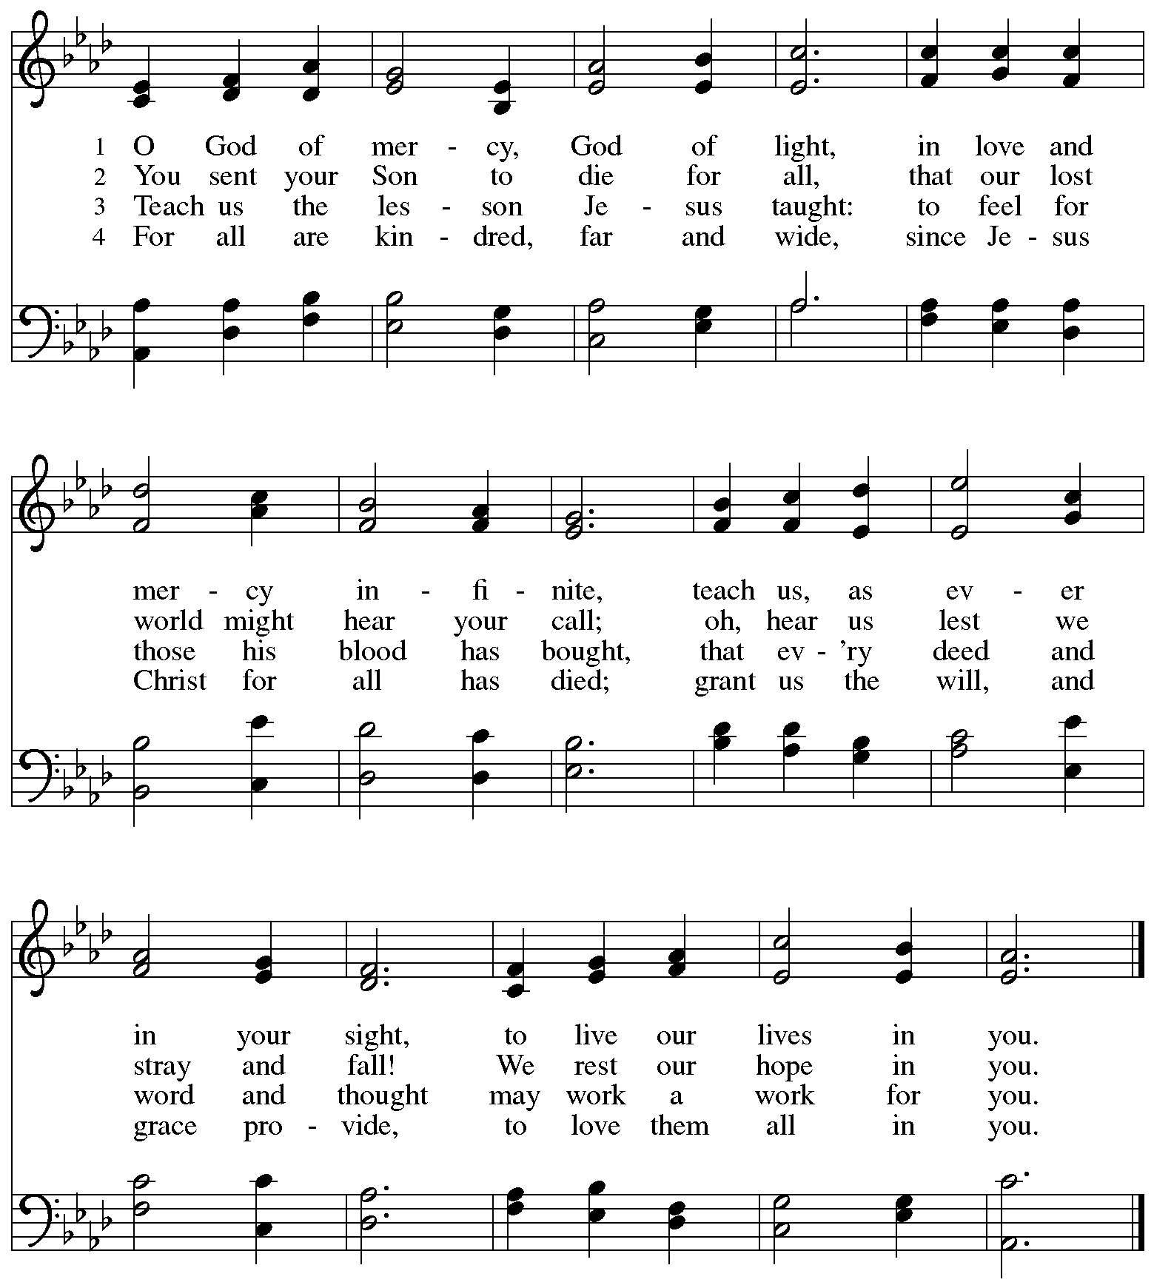

**Hymns during Holy Communion**

**Hark, the Glad Sound! *ELW* 239**

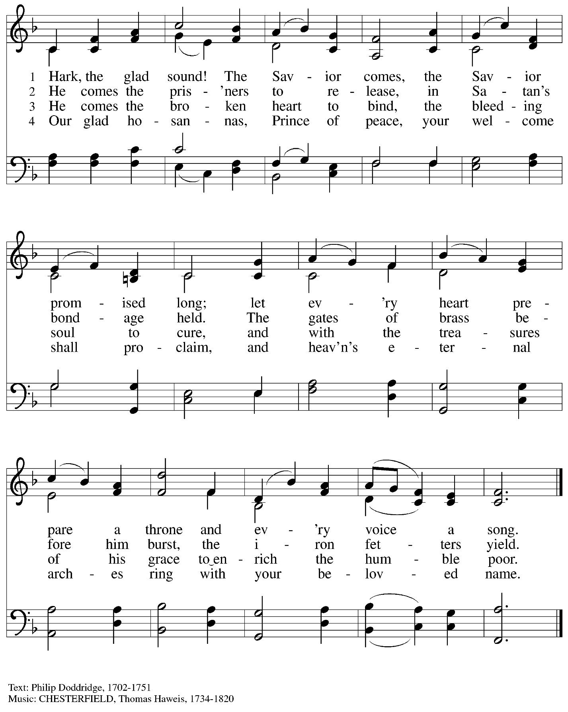

**Hymns during Holy Communion**

**One Bread, One Body *ELW* 496**

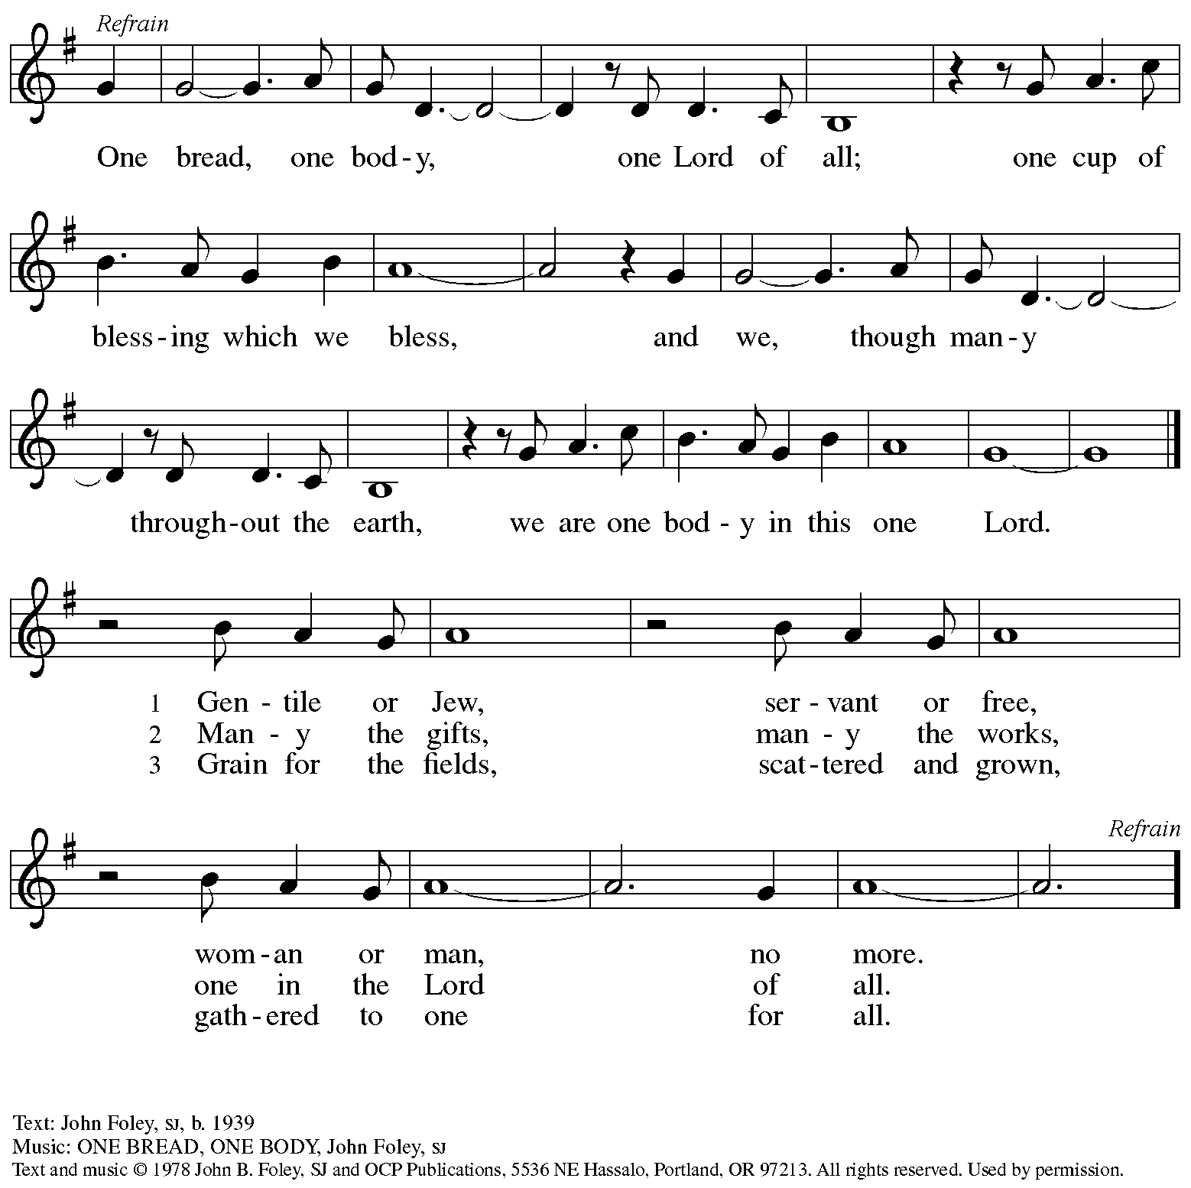

Reprinted with permission under OneLicense.net # A-722139.

**Hymns during Holy Communion**

**Oh, for a Thousand Tongues to Sing *ELW* 886**

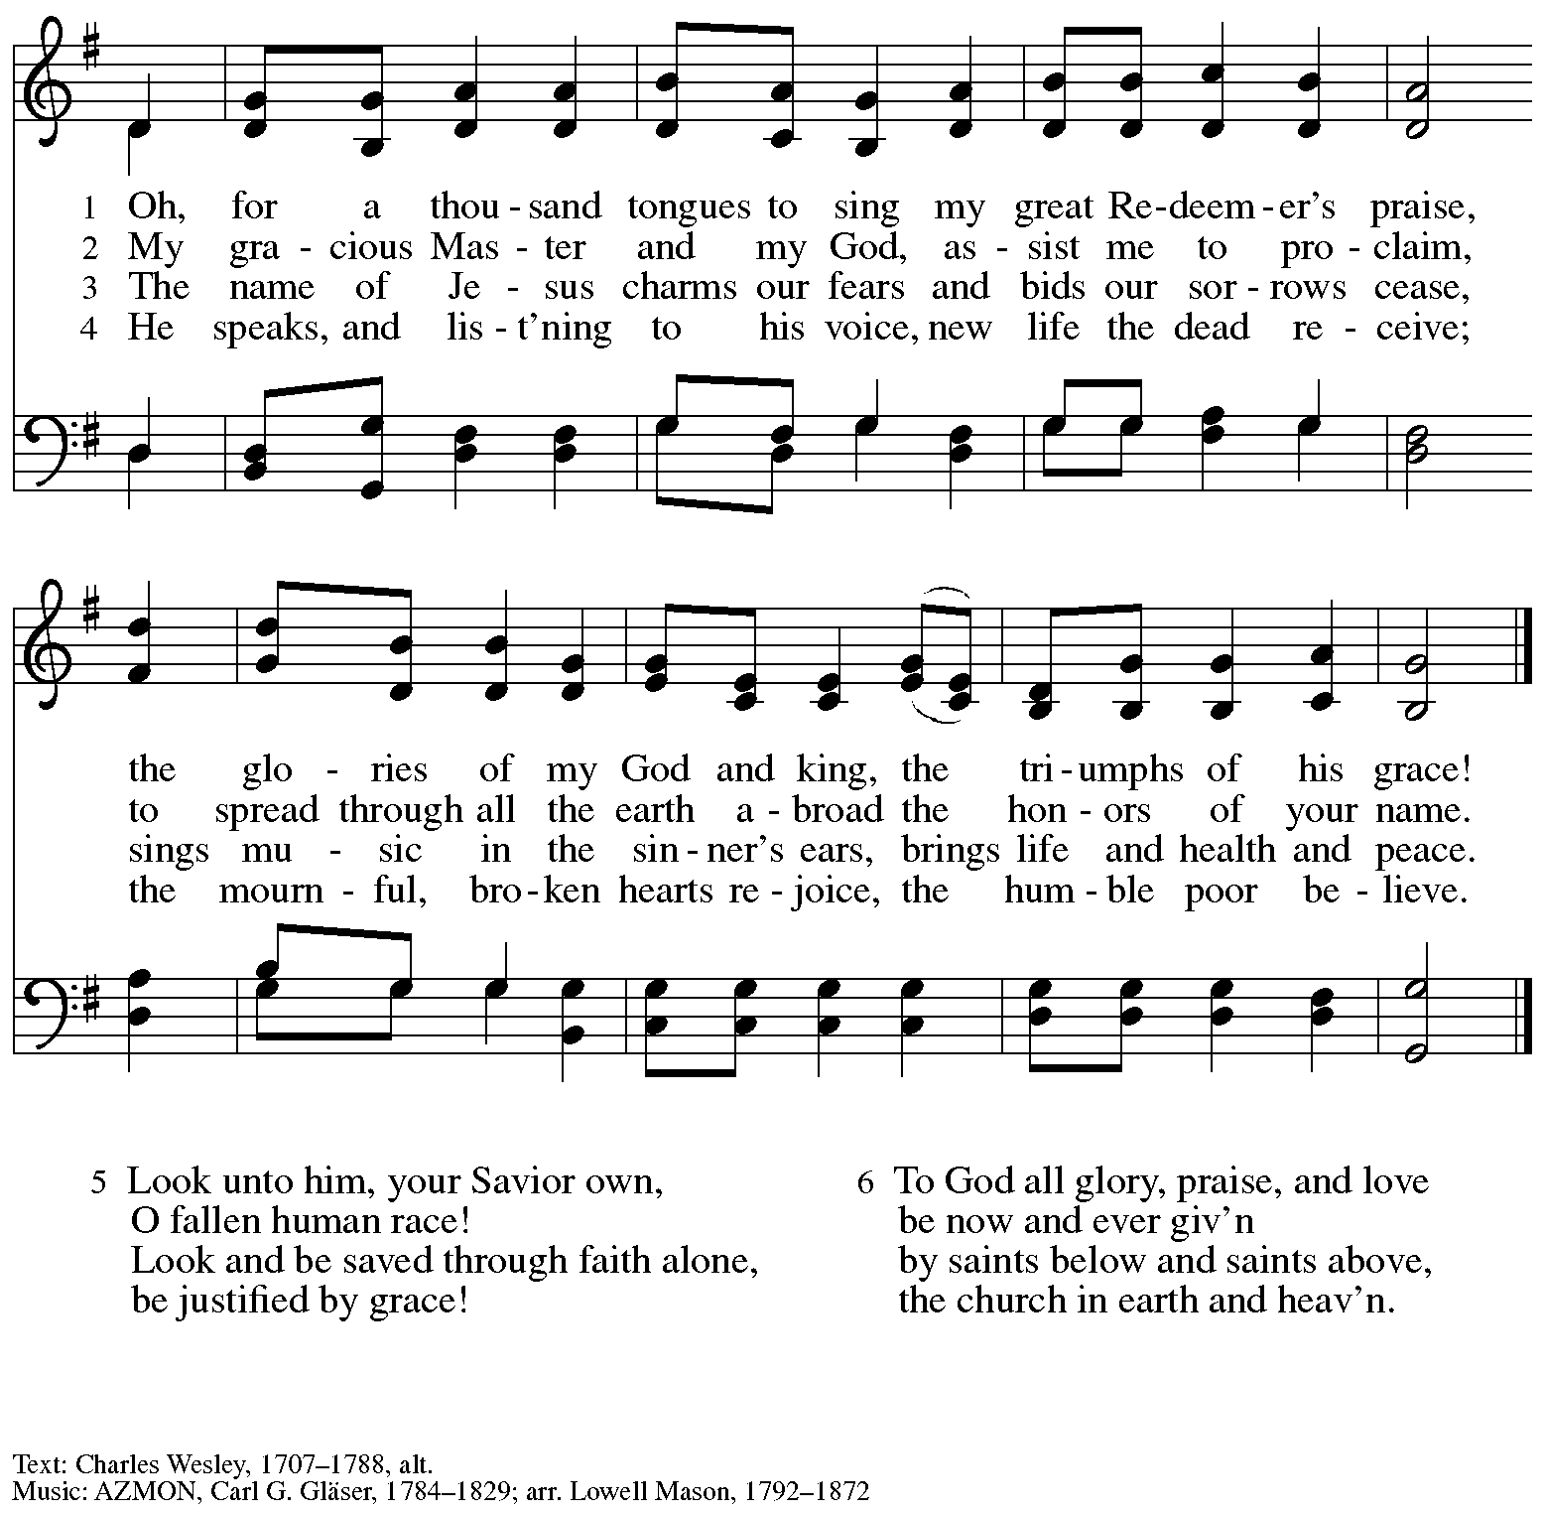

*When all have returned to their places, please rise as you are able.*

**Blessing**

P: The body and blood of our Lord Jesus Christ strengthen you and keep you in his grace.

**C: Amen.**

**Prayer**

A: Let us pray.

O God, in this holy communion you have welcomed us into your presence,

nourished us with words of mercy, and fed us at your table. Amid the cares of this life, strengthen us to love you with all our heart, serve our neighbors with a willing spirit,

and honor the earth you have made; through Christ our Lord.

**C: Amen.**

*Please be seated.*

**Sending**

*God blesses us and sends us in mission to the world*

**Announcements**

*Please rise as you are able.*

**Benediction**

P: The holy Three,

the holy One

increase your hope,

strengthen your faith,

deepen your love,

and ☩ grant you peace.

**C: Amen.**

**Sending Hymn** *Following page*

**Dismissal**

A: Go in peace. Christ is with you.

**C: Thanks be to God!**

**Postlude**

**Sending Hymn Arise, Your Light Has Come! *ELW* 314**

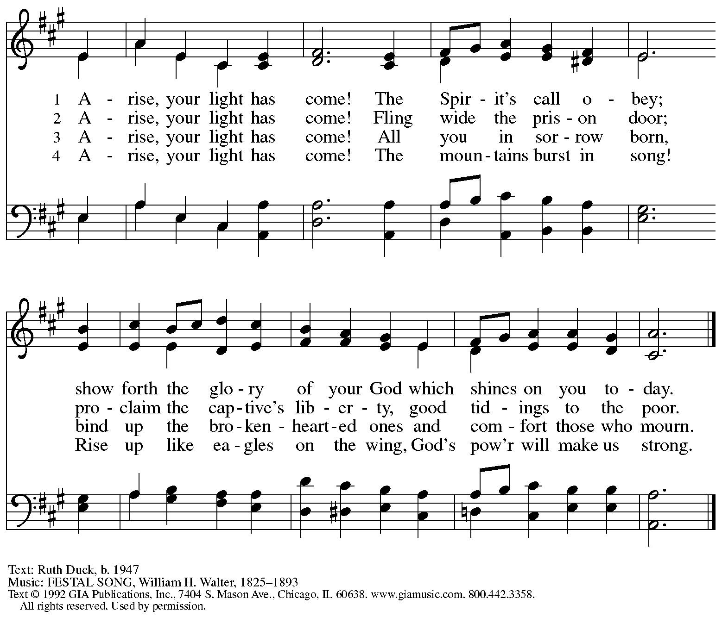

Reprinted with permission under OneLicense.net # A-722139.

*Those serving in worship*

Altar Care Jodie Minor

Assisting Minister Jeff Denlinger

Audio-Visual Ministers Joseph Paetz

Sarita

Cantor David Rollinson

Lector Brennan Coleman

Little Church – Big Faith Teacher Emily Duque

Minister of Music Laura Reynolds

Presiding and Preaching Minister The Rev. Ross I. Carmichael

*Liturgy and Hymnody Acknowledgements*

From SundaysandSeasons.com. Copyright © 2025 Augsburg Fortress. All rights reserved. Reprinted under OneLicense.net # A-722139.

Used by permission of Augsburg Fortress.

The Scripture readings contained herein are from *New Revised Standard Version* of the Bible © 1989, Division of Christian Education of the National Council of Churches of Christ in the USA. Used by permission. All rights reserved.

**Let Streams of Living Justice** – Text: William Whitla, b. 1934. Music: THAXTED, Gustav Holst, 1874-1934. Text © 1989 William Whitla. All rights reserved. Reprinted with permission of the hymnwriter.

**O God of Mercy, God of Light**



All rights reserved. Reprinted with permission under OneLicense.net # A-722139.

*Please use the QR code below to link to St. Andrew’s Announcements online!*



**St. Andrew Lutheran Church Announcements**

**January 26th, 2025**

* **Welcome to worship at St. Andrew on the Third Sunday after Epiphany, January 26th** – We are thankful you are here, and we offer a special welcome to all visitors and guests here for the first time. Worship attendees are invited to make a name tag at the back of the worship space. Little Church – Big Faith, a Bible lesson and activity for children, will take place after the prayer of the day. There are also worship “toolkits” to help children engage with worship and “busy bags” for younger children available in the bookcase at the back of the sanctuary. Please feel free to take one to use with/for your children. All are invited to gather for coffee other drinks and food, and conversation in the social hall after worship.
* **Bishop Kusserow Visting St. Andrew Next Sunday, February 2nd – Bishop Kurt Kusserow is finishing his third term, having served nearly 18 years in leadership of our local Southwestern Pennsylvania Synod. He is visiting local congregations and will be preaching at St. Andrew next Sunday, February 2nd. We invite everyone to be present that day to give thanks for Bishop Kusserow’s leadership and to wish him well as he leaves office. We will have a special expanded coffee hour after worship next Sunday on the occasion of his visit.**
* **Monthly Reparations Offering Next Sunday, February 2nd, during Worship** – In Luke’s Gospel, Jesus tells a story about a compassionate Samaritan, which suggests that God’s people are called to work for healing and restoration for our neighbors, regardless of who or what caused them harm. In light of this, St. Andrew has made a commitment to reparations in regard to African American spiritual songs used in our worship. The text and music of most hymns is attributed to specific authors, with copyrights in place, usage reported, and royalties paid to those whose works are featured in worship. With African American spirituals, this is not possible. In response to many years of such uncredited use, St. Andrew invites the congregation to give a reparations offering. Funds received in worship will be donated to our siblings at Bethel AME Church, whose land and building were taken from them in the 1950s, to fund their development in the Hill District.
* **February Produce Distribution – First Tuesday of the Month, February 4th, from 5:30-7:00 p.m. –** St. Andrew partners with Greater Pittsburgh Community Food Bank to serve as a distribution site for fresh produce on the first Tuesday of every month. January’s distribution will be on Tuesday, February 4th. We invite people of the congregation to help with the distribution from 5:30-7:00 p.m. and/or to help with unloading and setup during the day between 10:00 a.m. and 1:00 p.m.
* **St.** **Olaf Lutheran College Choir Concert at East Liberty Presbyterian Church on Sunday, February 9th, at 7:30 p.m.** – St. Olaf College is a Lutheran-affiliated liberal arts school in Northfield, MN, and its choir will stop in Pittsburgh on its 2025 tour. The St. Olaf Choir, made up of 75 mixed voices, is “one of the nation’s premier a cappella ensembles, renowned for its artistry and beauty of sound.” They will perform at East Liberty Presbyterian Church, 116 S. Highland Ave., 15206 on Sunday, February 9th, at 7:30 p.m. Tickets are $35 or $10 for all students, and they are available at [stolaf.edu/tickets/choir](http://stolaf.edu/tickets/choir)or by calling 800-363-5487. For more information, please visit

[St. Olaf Choir at East Liberty Presbyterian Church (Pittsburgh, PA) Tickets, Sun, Feb 9, 2025 at 7:30 PM | Eventbrite](https://www.eventbrite.com/e/st-olaf-choir-at-east-liberty-presbyterian-church-pittsburgh-pa-tickets-1027252478817?aff=oddtdtcreator).

* **Shelter Dinner for Guests of East End Cooperative Ministry, Third Thursday of the Month – February 20th, 6:00 p.m. Arrival, 6:30 p.m. Dinner –** Each month, people of St. Andrew provide dinner for guests of East End Cooperative Ministry (EECM), 6140 Station St. (East Liberty), 15206. We invite you to prepare or purchase one menu item and bring it to the shelter by 6:00 p.m., or just come to help serve at 6:30 p.m. If you would like to contribute, please sign up here: <https://www.signupgenius.com/go/5080544AAAC22A1F58-54567228-shelter>.
* **Bagged Lunches to Accompany EECM February Shelter Dinner on February 20th – Seeking Additional Donations! – East End Cooperative Ministry is hosting an additional 20 people this winter because of the shelter shortage and we have been asked to bring items for 20 bagged lunches on St. Andrew’s Shelter Dinner night, Thursday, February 20th.** **This month we only need 20 sandwiches and 20 soft fruits (any kind) – we have already received donations for the other items. Shelf-stable items can be left on the donation table in the Social Hall by Sunday, February 16th, or delivered to EECM on Thursday, February 20th. Please label “For EECM Lunches.” Sandwiches should be delivered to EECM any time on the 20th until 6:00 p.m. Please label “For St. Andrew bagged lunches.” Shelter staff will assemble the bagged lunches. Much work goes into shopping for and preparing the main meal each month, so we would greatly appreciate new participants and contributions for this effort! If you would like to help, please sign up at:**

<https://www.signupgenius.com/go/5080544AAAC22A1F58-54567666-bagged>.

* **Support Those Affected by California Wildfires through Lutheran Disaster Response – With ongoing concern for everyone coping with wildfires in California, the Evangelical Lutheran Church in America’s Lutheran Disaster Response is working with the Southwest California synod to support affected communities. They offer a sample prayer and are accepting donations designated for “U.S. Wildfires.” For more information, or to donate, please see** [US Wildfires](https://www.elca.org/our-work/relief-and-development/lutheran-disaster-response/our-impact/us-wildfires?fbclid=IwY2xjawHsxdRleHRuA2FlbQIxMAABHTFXYAPv2xZ0mdENmcsSbNUS-vGVbJVcKn_NAa3mTRKBWtTeOI-mxAM4Dg_aem__Kv-QvoEB6MduGPk9PKFpw) (at [www.elca.org](http://www.elca.org)).
* **Save the Date – Local “Rivers of Delight” Singing Group to Hold Concert at St. Andrew on Saturday, March 8th, at 3:00 p.m. – Rivers of Delight is a group of local singers that formed to bring to life the** choral music of 18th century New England, the first large body of music composed in the English-speaking Americas. Their program will present the music with some explanation of its history and cultural context and run for about an hour. The composers were amateurs trained in the singing schools that were instituted in an effort to improve congregational singing in the Puritan churches, so this is (mostly) sacred music. The schools created a movement that spread through the New England settlements, drawing young people with its offer of a chance to socialize and relax after their hard day’s work. In the 19th century, this repertoire contributed to the great American folk tradition of harmony singing known as shape note or Sacred Harp singing. For examples of the group’s singing, please visit <https://youtube.com/playlist?list=PLIhWyvtanBKr2uwUmr1NNqvV1CGfcFbr-&si=e2cxi_BnFN0U8axF>.
* **Updated Coffee Hour Signups** – We have recently introduced changes to coffee hour hospitality: Now there will be two signup slots each week, one for setup and making coffee and one for cleanup. The link now describes in greater detail what is involved in each part, which should make it clearer and easier for people to serve. Thank you to all who have been working on these updates. Please see the updated link at <https://www.signupgenius.com/go/5080B4AAFAF2CABF85-47069030-coffee>.
* **Help Re-Stock Outdoor Little Library!** – If you are interested in stocking the little library that is on the Centre Avenue side of the church, there are extra books in the metal cabinet to the right of the dumbwaiter (There are currently some 10% off coupons for Half Price Books that are good throughout the year). The current stock of books are from the challenged or banned book lists. Here are two lists: (<https://www.ala.org/bbooks>) (<https://en.wikipedia.org/wiki/List_of_most_commonly_challenged_books_in_the_United_States>).
* ***Christ in Our Home* Devotional Booklets for January - March Available at Church Entrances** – This resource offers a daily Bible reading with a short reflection and prayer, along with additional readings and prayer topics for those who would like to expand their devotional practices. We encourage people of the congregation to take one for yourself, your family unit, or others!
* **Compline Prayer Service with the Pittsburgh Compline Choir – Sundays at 8:00 p.m. at Heinz Chapel –** Compline was traditionally a monastic prayer service, and the Pittsburgh Compline Choir, a ministry of Lutheran Campus Ministry in Greater Pittsburgh, sings a choral version of compline rooted in this thousand-year-old tradition of scripture, song, and silence each Sunday at Heinz Chapel at 8:00 p.m. This service also streams on Facebook (Pittsburgh Compline Choir) and YouTube (The Pittsburgh Compline Choir). Heinz Chapel is located off of S. Bellefield Ave. in Oakland. For more information, please visit: [Pittsburgh Compline Choir](http://pittsburghcomplinechoir.org/).