

**+ Second Sunday after Epiphany**

**January 19th, 2025**

**10:00 a.m.**



**St. Andrew Lutheran Church**

**304 Morewood Ave.**

**Pittsburgh, PA 15213**

**412.682.3342**

[**St_andrewELCA@verizon.net**](mailto:St_andrewELCA@verizon.net)

[**www.standrewpittsburgh.org**](http://www.standrewpittsburgh.org)

**+ Second Sunday after Epiphany**

**Order for Worship**

*The Sundays after Epiphany continue to celebrate the revelation of God’s glory to us as it was made known to the magi and to those on Jordan’s banks at Jesus’ baptism—today using wedding imagery. Our God rejoices over God’s people as those being married rejoice over one another. By the power of the Spirit there are gifts galore for everyone. In Christ Jesus the best wine is saved for last. Taste and see.*

**Welcome to St. Andrew!**

* St. Andrew welcomes all who are seeking a place of healing, wholeness, and acceptance in a nurturing and faith-forming spiritual home. We are striving toward racial equity worldwide

and we seek to honor the lived experience of all individuals regardless of background. Our community embraces people of all ages, ethnicities, cultures, abilities, sexual orientations,

gender identities and expressions, and family constellations. Come and See!

* Worship Services are live-streamed to multiple online platforms. By attending worship, you agree that your image and voice may be broadcast.
* Everyone is invited to make a name tag at the black bookcase in the back of the worship space if they would like. There are stickers indicating pronouns on the bookcase if you would like to include them on your name tag.
* Children are invited to attend Little Church – Big Faith, a Bible lesson and activity, during worship (after the Prayer of the Day). The group returns to the worship space for the liturgy of Holy Communion.
* A nursery is available through the doors at the left side of the sanctuary and across from the doorway to the Social Hall. Look for a purple-colored room.
* Worship “toolkits” to help children engage with the service, along with “busy bags” for younger children, are available in the bookcase at the back of the sanctuary. Please feel free to take one to use with/for your children.
* Holy Communion is served with bread (gluten-free available) and wine or grape juice. The presiding minister will distribute the bread (host). Please consume this and then pick up an empty glass from the tray. The Communion Assistant will pour wine or grape juice into your glass. Please step to the side to consume the wine or grape juice. Feel free to kneel at the altar for prayer and reflection. As you return to your pew, glasses may be returned to the empty trays on either side of the center section.
* A restroom is available on the main level of the church, through the doors to the Social Hall and to the right in the main office.

*Abbreviations*

P: Pastor/Presiding Minister ***ELW*: *Evangelical Lutheran Worship* hymnal**

A: Assisting Minister ***ACS*: *All Creation Sings* hymnal**

L: Lector

**C: Congregation**

**Pre-Service Music** Jimmi Kocher-Hillmer

**Welcome**

**Prelude** *Spirit, Open My Heart* arr. Bob Moore

**Gathering**

*The Holy Spirit calls us together as the people of God*

**Thanksgiving for Baptism**

*Please rise as you are able. All may make the sign of the cross,*

*the sign that is marked at Baptism, as the presiding minister begins.*

P: Blessed be the holy Trinity, ☩ one God,

the fountain of living water, the rock who gave us birth,

our light and our salvation.

**C: Amen.**

P: Joined to Christ in the waters of Baptism, we are clothed with God’s mercy and forgiveness. Let us give thanks for the gift of Baptism.

*Water may be poured into the font as the presiding minister gives thanks*

P: We give you thanks, O God, for in the beginning you created us in your image and placed us in a well-watered garden. In the desert, you promised pools of water for the parched, and you gave us water from the rock. When we did not know the way, you sent the Good Shepherd to lead us to still waters. At the cross, you washed us from Jesus’ wounded side, and on this day, you shower us again with the water of life.

We praise you for your salvation through water, for the water in this font,

and for all water everywhere, including the Allegheny, Monongahela, and Ohio rivers.

Bathe us in your forgiveness, grace, and love.

Satisfy all who thirst, and give us the life only you can give.

To you be given honor and praise

through ☩ Jesus Christ, our living water,

in the unity of the Holy Spirit, now and forever.

**C: Amen.**

**Gathering Hymn *ELW* 523**

**Vamos todos al banquete / Let Us Go Now to the Banquet**

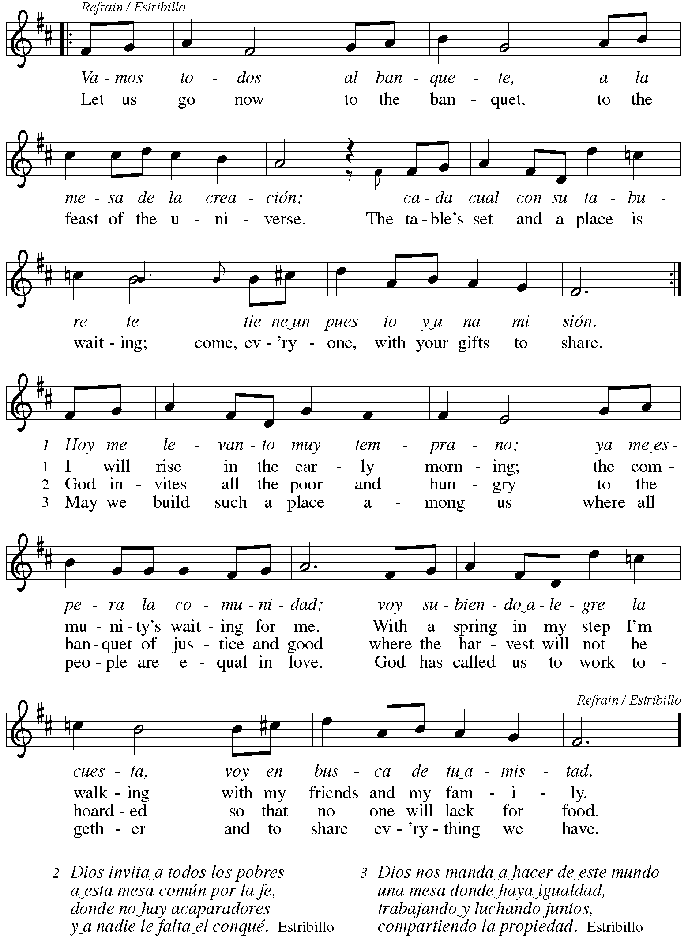

**Greeting**

P: The grace of our Lord Jesus Christ, the love of God,

and the communion of the Holy Spirit be with you all.

**C: And also with you.**

**Hymn of Praise** *ACS* p. 12

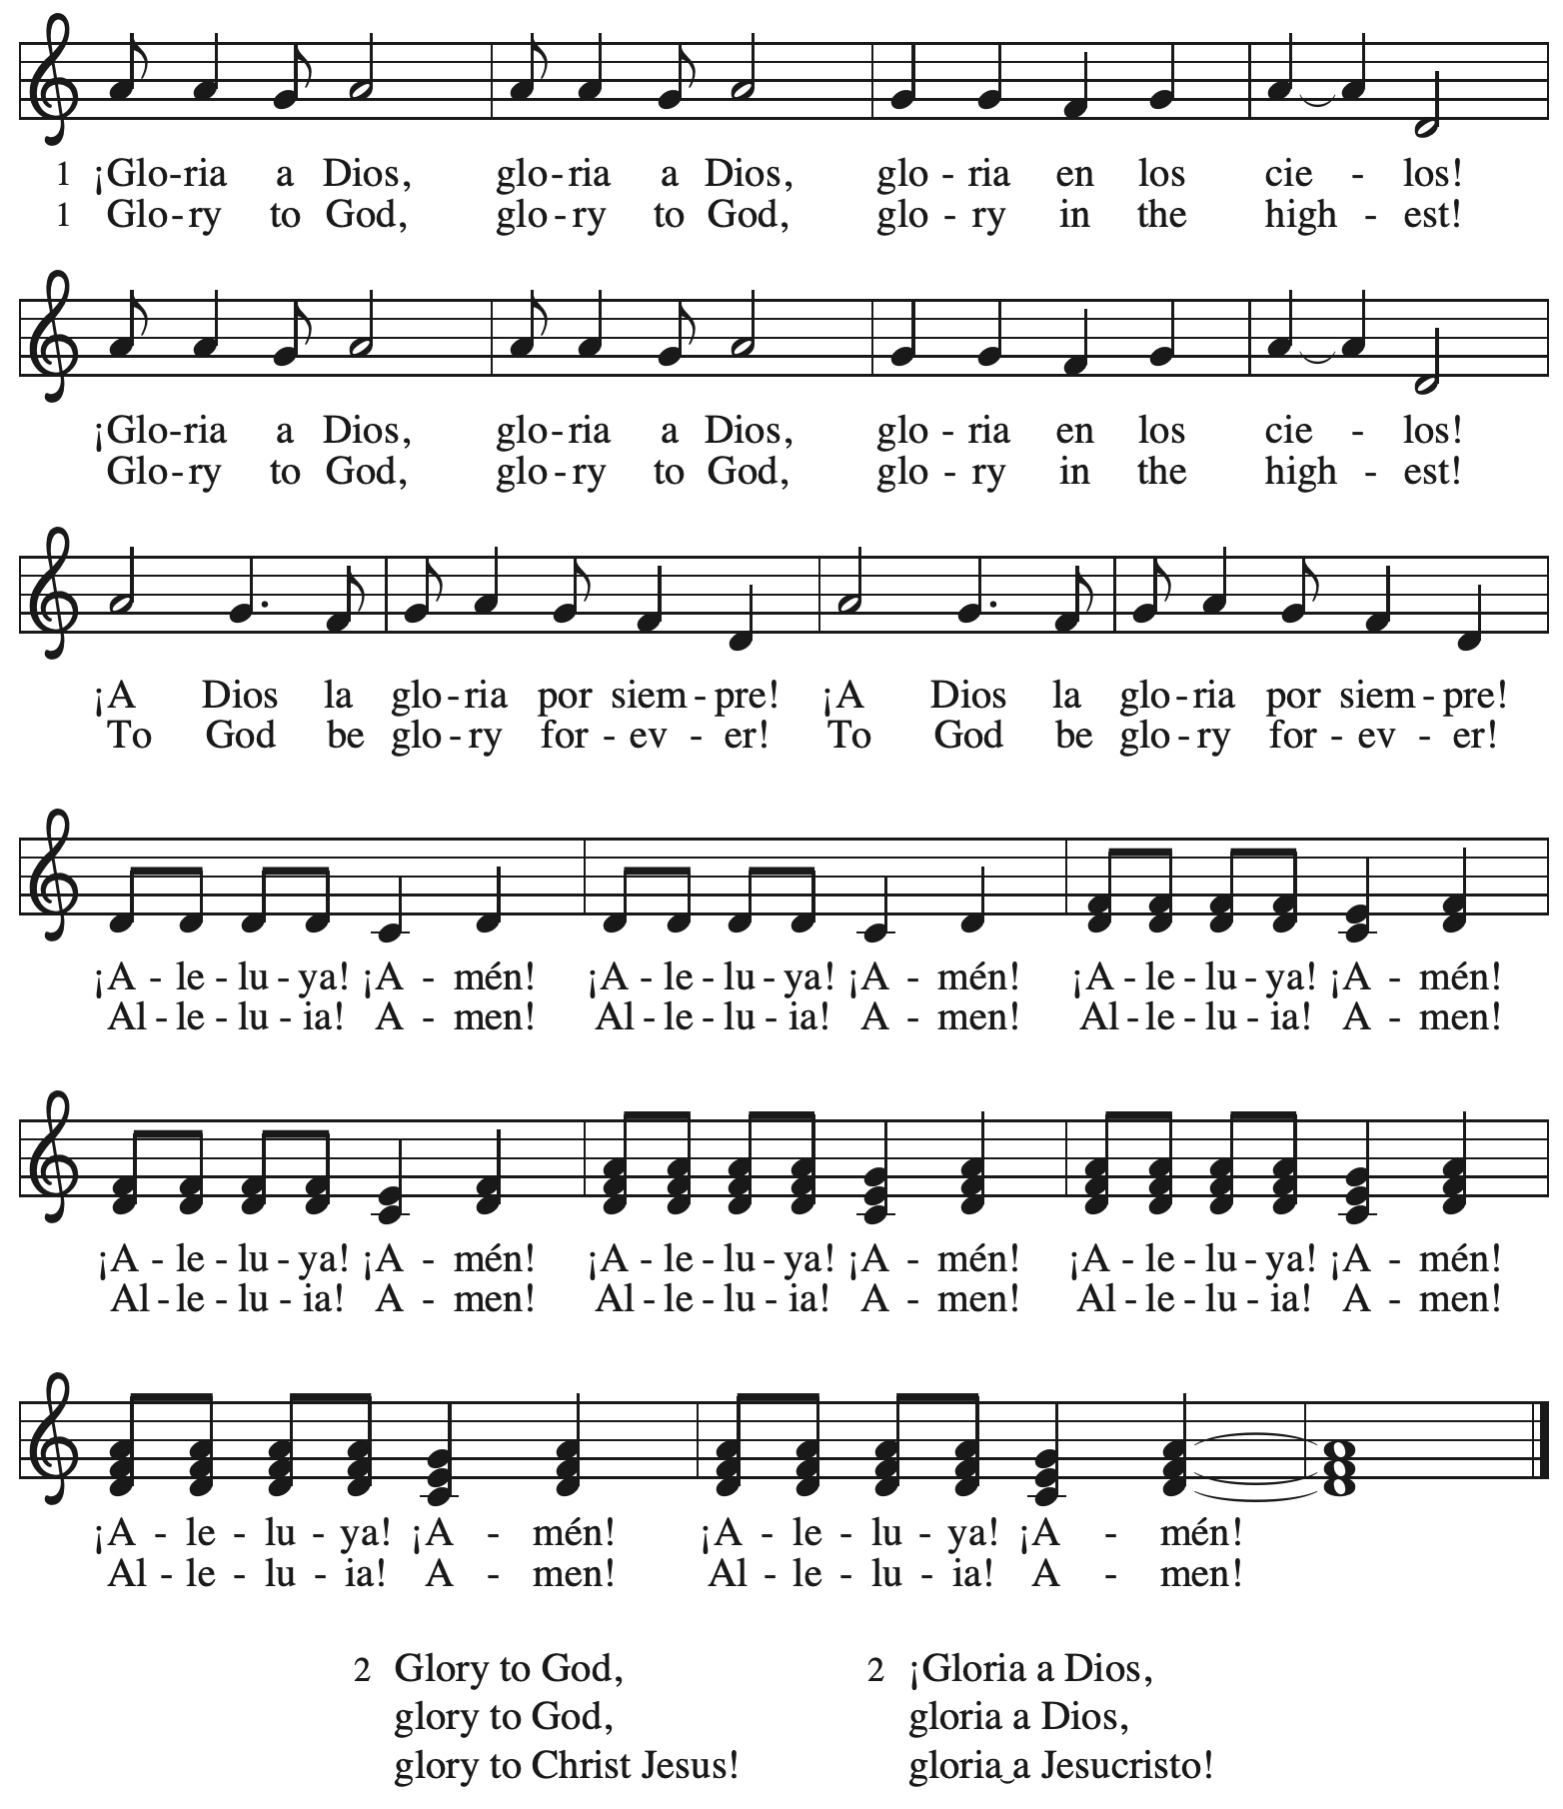

**Prayer of the Day**

P: The Lord be with you.

**C: And also with you.**

P: Let us pray.

Lord God, source of every blessing,

you showed forth your glory and led many to faith by the works of your Son,

who brought gladness and salvation to his people. Transform us by the Spirit of his love,

that we may find our life together in him, Jesus Christ, our Savior and Lord.

**C: Amen.**

*Please be seated.*

**Word**

*God speaks to us in Scripture reading, preaching, and song*

**First Reading** **– Isaiah 62: 1-5**

 1 For Zion’s sake I will not keep silent,  
  and for Jerusalem’s sake I will not rest,  
 until her vindication shines out like the dawn,  
  and her salvation like a burning torch.  
 2 The nations shall see your vindication,  
  and all the kings your glory;  
 and you shall be called by a new name  
  that the mouth of the Lord will give.  
 3 You shall be a crown of beauty in the hand of the Lord,  
  and a royal diadem in the hand of your God.  
 4 You shall no more be termed Forsaken,  
  and your land shall no more be termed Desolate;  
 but you shall be called My Delight Is in Her,  
  and your land Married;  
 for the Lord delights in you,  
  and your land shall be married.  
 5 For as a young man marries a young woman,  
  so shall your builder marry you,  
 and as the bridegroom rejoices over the bride,  
  so shall your God rejoice over you.

L: Word of God, word of life.

**C: Thanks be to God.**

**Psalm 36: 5-10**

*The cantor will lead the singing of the psalm.*

*The congregation is invited to respond with the alternate verses in bold print,*

*and to join in singing the refrain.*

*Psalm Tone*

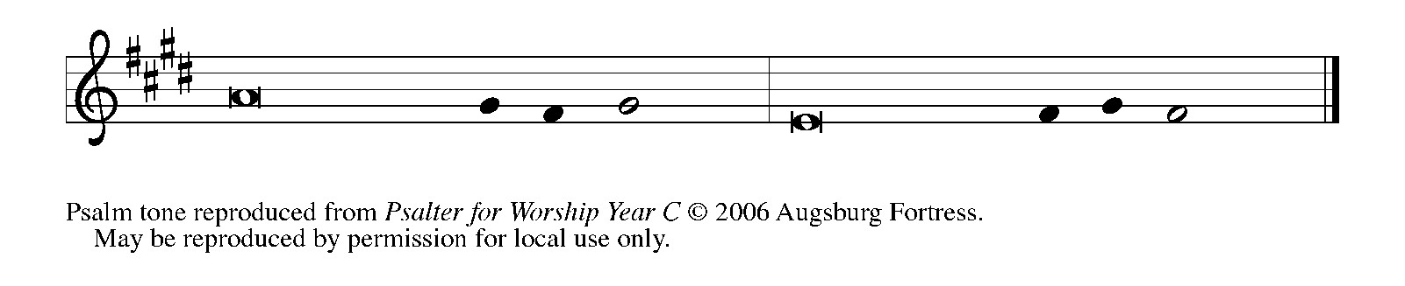

*Psalm Refrain*

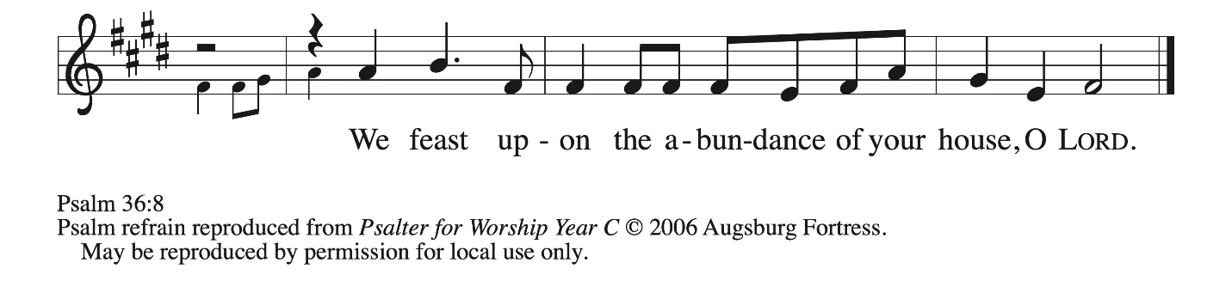

5 Your love, O Lord, reaches **|** to the heavens,  
  and your faithfulness **|** to the clouds.  
 6 **Your righteousness is like the strong mountains, your justice like | the great deep;**  
  **you save humankind and ani- | mals, O Lord. R**  
 7 How priceless is your **|** love, O God!  
  All people take refuge under the shadow **|** of your wings.  
 8 **They feast upon the abundance | of your house;**  
  **you give them drink from the river of | your delights.**  
 9 For with you is the **|** well of life,  
  and in your light **|** we see light.  
 10 **Continue your lovingkindness to | those who know you,**  
  **and your favor to those who are | true of heart. R**

**Second Reading – 1 Corinthians 12: 1-11**

1 Now concerning spiritual gifts, kindred, I do not want you to be uninformed. 2 You know that when you were pagans, you were enticed and led astray to idols that could not speak.

3 Therefore I want you to understand that no one speaking by the Spirit of God ever says “Let Jesus be cursed!” and no one can say “Jesus is Lord” except by the Holy Spirit.  
  4 Now there are varieties of gifts, but the same Spirit; 5 and there are varieties of services, but the same Lord; 6 and there are varieties of activities, but it is the same God who activates all of them in everyone. 7 To each is given the manifestation of the Spirit for the common good. 8 To one is given through the Spirit the utterance of wisdom, and to another the utterance of knowledge according to the same Spirit, 9 to another faith by the same Spirit, to another gifts of healing by the one Spirit, 10 to another the working of miracles, to another prophecy, to another the discernment of spirits, to another various kinds of tongues, to another the interpretation of tongues. 11 All these are activated by one and the same Spirit, who allots to each one individually just as the Spirit chooses.

L: Word of God, word of life.

**C: Thanks be to God.**

*Please rise as you are able and join in singing the Gospel Acclamation.*

**Gospel Acclamation** *ACS* p. 14

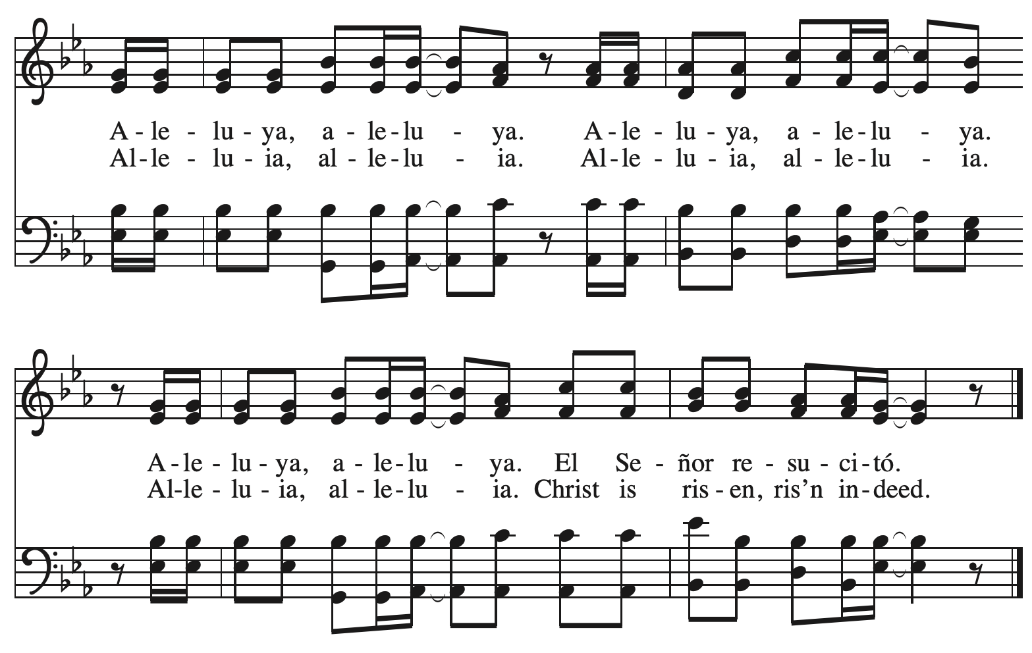

**Gospel – John 2: 1-11**

P: The holy Gospel according to St. John.

**C: Glory to you, O Lord.**

1 On the third day there was a wedding in Cana of Galilee, and the mother of Jesus was there.

2 Jesus and his disciples had also been invited to the wedding. 3 When the wine gave out, the mother of Jesus said to him, “They have no wine.” 4 And Jesus said to her, “Woman, what concern is that to you and to me? My hour has not yet come.” 5 His mother said to the servants, “Do whatever he tells you.” 6 Now standing there were six stone water jars for the Jewish rites of purification, each holding twenty or thirty gallons. 7 Jesus said to them, “Fill the jars with water.” And they filled them up to the brim. 8 He said to them, “Now draw some out, and take it to the chief steward.” So they took it. 9 When the steward tasted the water that had become wine, and did not know where it came from (though the servants who had drawn the water knew), the steward called the bridegroom 10 and said to him, “Everyone serves the good wine first, and then the inferior wine after the guests have become drunk. But you have kept the good wine until now.” 11 Jesus did this, the first of his signs, in Cana of Galilee, and revealed his glory; and his disciples believed in him.

P: The Gospel of the Lord.

**C: Praise to you, O Christ.**

*Please be seated.*

**Sermon**

*A time of silence for prayer and reflection follows the sermon.*

*As the hymn of the day begins, please rise as you are able.*



**Hymn of the Day Jesus, Come! For We Invite You *ELW* 312**

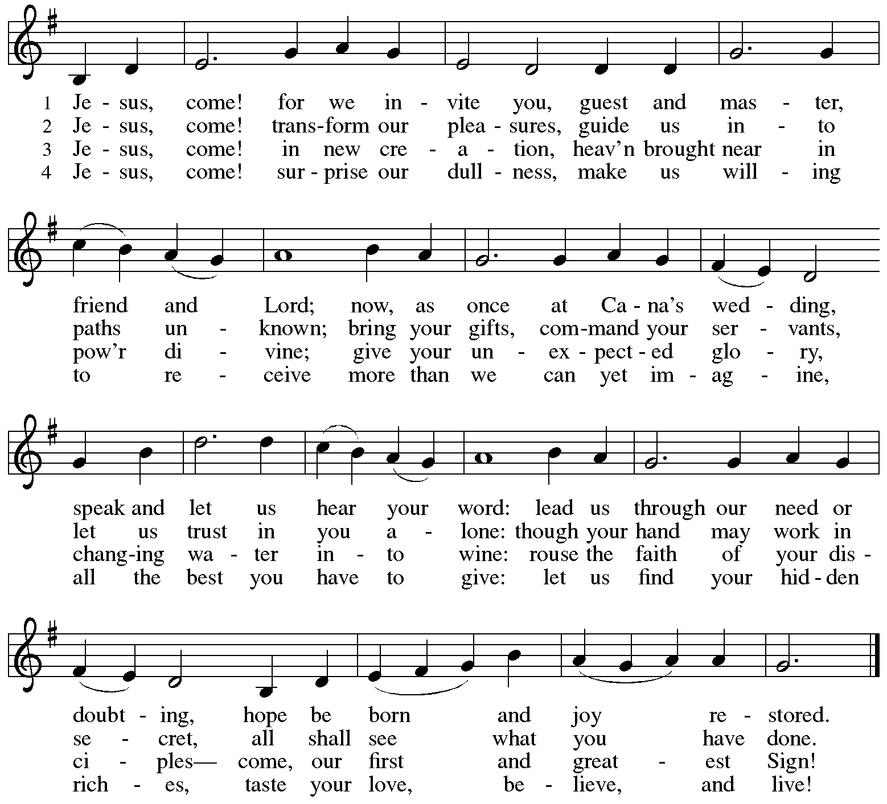



All rights reserved. Reprinted with permission under OneLicense.net # A-722139.

**Apostles’ Creed**

**C: I believe in God, the Father almighty,**

**creator of heaven and earth.**

**I believe in Jesus Christ, God’s only Son, our Lord,**

**who was conceived by the Holy Spirit,**

**born of the virgin Mary,**

**suffered under Pontius Pilate,**

**was crucified, died, and was buried;**

**he descended to the dead.\***

**On the third day he rose again;**

**he ascended into heaven,**

**he is seated at the right hand of the Father,**

**and he will come to judge the living and the dead.**

**I believe in the Holy Spirit,**

**the holy catholic church,**

**the communion of saints,**

**the forgiveness of sins,**

**the resurrection of the body,**

**and the life everlasting. Amen.**

*Or, “he descended into hell,” another translation of this text in widespread use.

**Prayers of the People**

A: Guided by the Holy Spirit, with the light of Christ shining upon us and all nations,

let us pray for the church, the world, and all creation.

*After each petition*

A: Gracious God,

**C: receive our prayer.**

*The presiding minister concludes the prayers*

P: We entrust these prayers to you, O God, in the sure and certain hope that your promise is revealed among your people.

**C: Amen.**

**Peace**

*The presiding minister and the assembly greet one another in the peace of the risen Christ.*

P: The peace of Christ be with you always.

**C: And also with you.**

*The people may greet those around them with a sign of Christ’s peace and may say*

Peace be with you *or similar words. Please be mindful that not everyone will be comfortable with sharing the peace, so please seek consent before shaking hands or hugging. Other possible ways to share the peace include a simple bow with the verbal greeting of peace, or simply a verbal expression of peace.*

*When the greetings of peace have concluded, please be seated.*

**Meal**

*God feeds us with the presence of Jesus Christ*



**Offering**

*We offer ourselves, our gifts, and our faithful service to God.*

*As the offering is gathered for the mission of the church, including the care of those in need,*

*the table is set for Holy Communion.*

**Noisy Offering**

*As children of the congregation carry buckets around the sanctuary, people of the congregation are invited to throw in their change as an offering. This month’s offering will support Global Refuge, a Lutheran organization supporting immigrants, asylum seekers, and refugees rebuilding their lives in the United States.*

**Music during the Offering**

*How Firm a Foundation* arr. Brent Eldstrom

*As the gifts are brought forward for presentation, please rise as you are able.*

**Offertory Song** **Cuando el pobre / When the Poor Ones *ELW* 725**

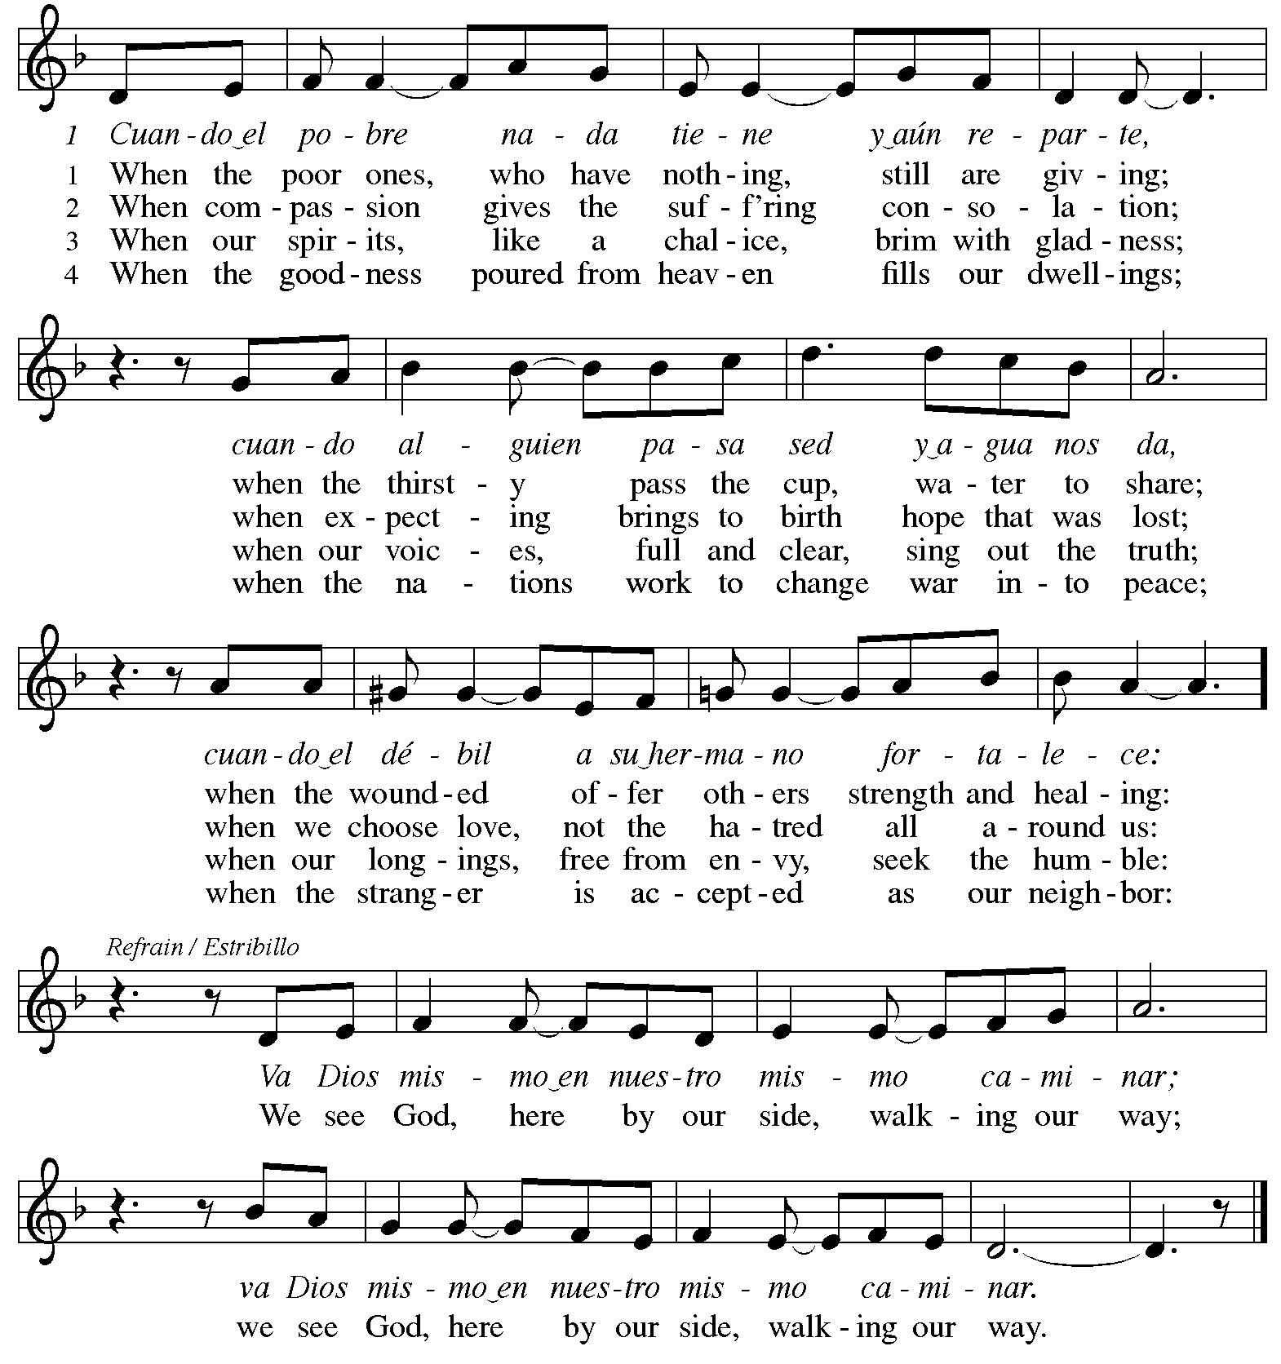



Reprinted under OneLicense.net # A-722139.

**Offertory Prayer**

A: Let us pray.

Holy God, gracious and merciful,

**C: you bring forth food from the earth and nourish your whole creation.**

**Turn our hearts toward those who hunger in any way, that all may know your care;**

**and prepare us now to feast on the bread of life, Jesus Christ, our Savior and Lord.**

**Amen.**

**Dialogue** *ACS* p. 20

P: The Lord be with you.

**C: And also with you.**

P: Lift up your hearts.

**C: We lift them to the Lord.**

P: Let us give thanks to the Lord our God.

**C: It is right to give our thanks and praise.**

**Preface** *ACS* p. 20

P: It is indeed right, our duty and our joy …

that we should at all times and in all places

give thanks and praise to you, almighty and merciful God,

through our Savior Jesus Christ.

By the leading of a star he was shown forth to all nations;

in the waters of the Jordan you proclaimed him your beloved Son;

and in the miracle of water turned to wine he revealed your glory.

And so, with all the choirs of angels,

with the church on earth and the hosts of heaven,

we praise your name and join their unending hymn:

**Sanctus** *ACS* p. 20

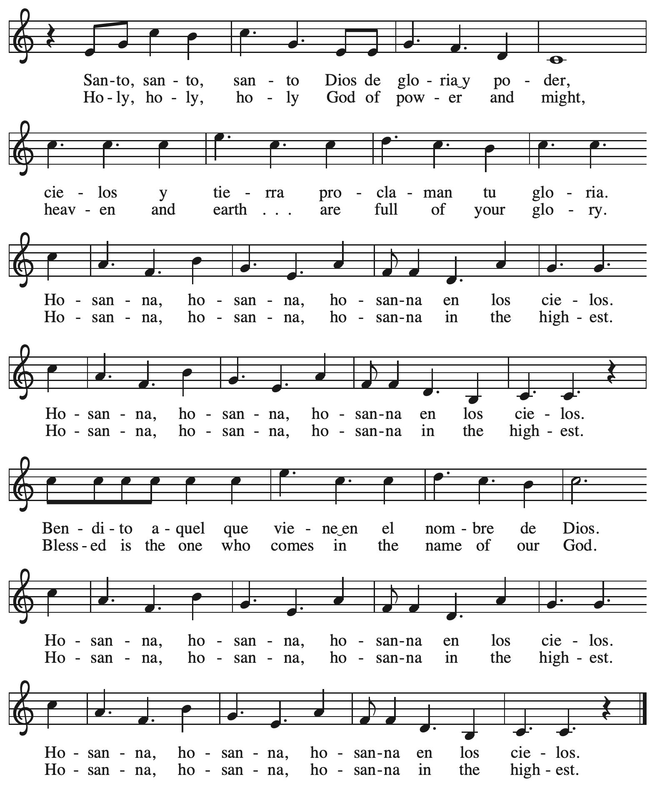

**Eucharistic Prayer** *ACS* p. 21

P: Holy God, you alone are holy … with every breath.

**C: We praise you, O God.**

P: Generations bless your faithfulness … into the future.

**C: We bless you, O God.**

P: We give you thanks for your dear Son … with us now.

**C: We thank you, O God.**

P: In the night in which he was betrayed … Do this for the remembrance of me.

Remembering his love for us

on the way, at the table, and to the end,

we proclaim the mystery of faith:

**C: Christ has died. Christ is risen. Christ will come again.**

P: We pray for the gift of your Spirit … in your church, without end.

**C: Amen.**

**Lord’s Prayer**

P: Gathered as one by the Holy Spirit, let us pray as Jesus taught us.

**C: Our Father in heaven,**

**hallowed be your name,**

**your kingdom come,**

**your will be done,**

**on earth as in heaven.**

**Give us today our daily bread.**

**Forgive us our sins**

**as we forgive those**

**who sin against us.**

**Save us from the time of trial**

**and deliver us from evil.**

**For the kingdom, the power,**

**and the glory are yours,**

**now and forever. Amen.**

**Fraction and Invitation**

P: The joy of the Lord is our strength.

Come and be nourished by the gifts of God.

***Agnus Dei /* Lamb of God** *ACS* p. 25

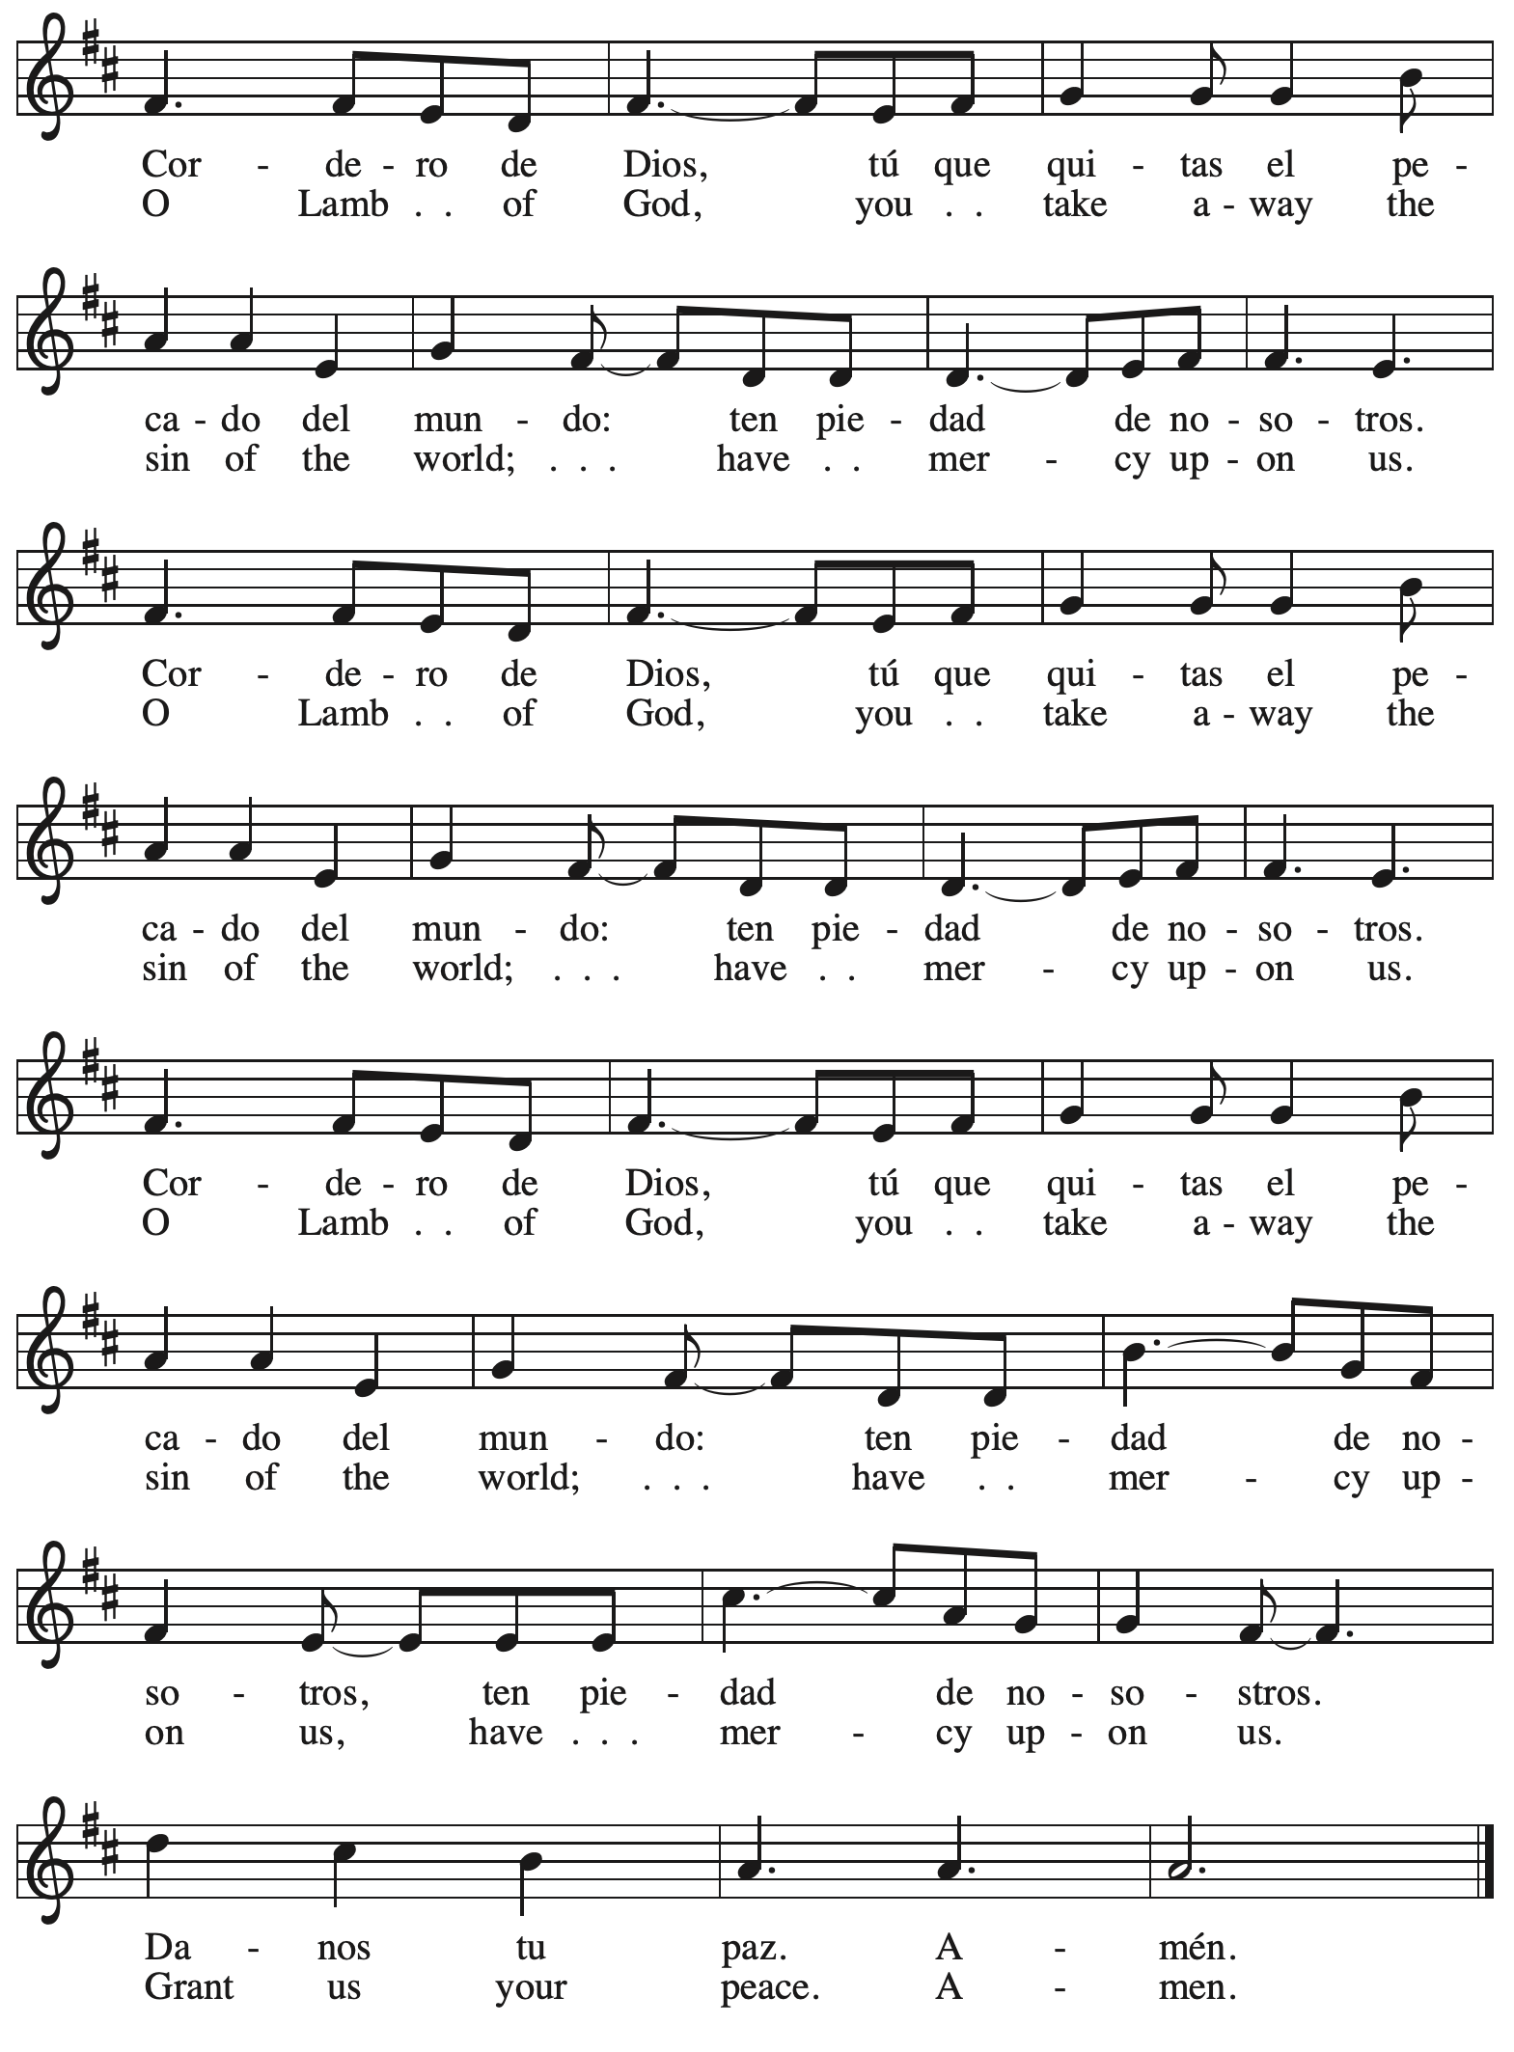

*Please be seated.*



**Holy Communion**

* *All who seek God and desire a deeper and stronger life in Christ are welcome to receive Holy Communion.*
* *Worshipers from the pulpit side will proceed forward first, followed by the center section, and then the lectern side.*
* *Please inform an usher if you would like the ministers to bring Communion to you.*
* *Holy Communion will be served with bread and wine/grape juice.*
* *The presiding minister will first distribute the bread (host) to each communicant. Please indicate if you require a gluten-free host.*
* *Once you have consumed the bread, please pick up an empty glass from the tray next to the presiding minister. The Communion Assistant will pour wine or grape juice into your glass. Please indicate if you would like grape juice.*
* *Please step to the side to consume the wine or grape juice.*
* *Feel free to kneel at the altar rail for prayer after receiving the sacrament.*
* *As you return to your pew, glasses may be returned to the empty trays on the side of the center section.*
* *A blessing will be provided for anyone who does not yet receive the sacrament.*
* *All are invited to join in singing the hymns during Holy Communion.*

**Hymns during Holy Communion**

**Soul, Adorn Yourself with Gladness *ELW* 488**

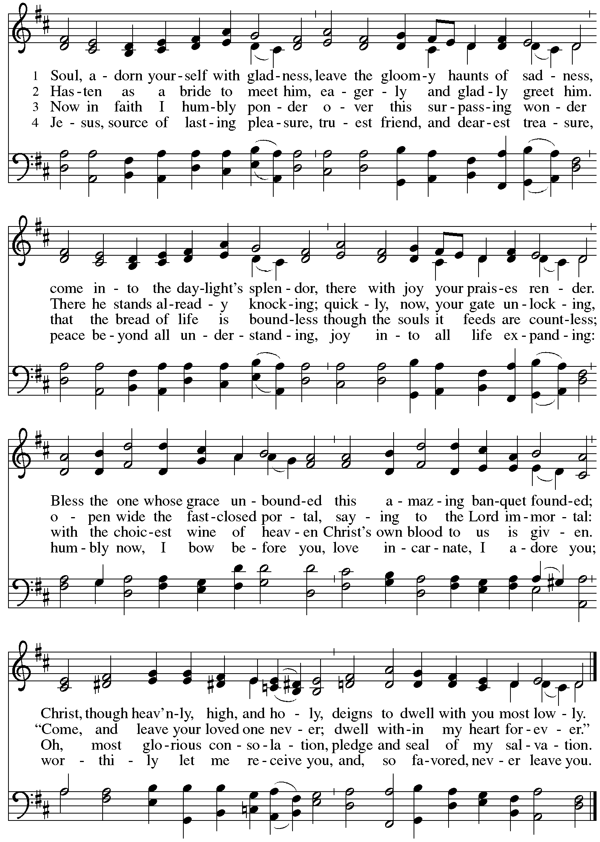

**Hymns during Holy Communion**

**Come, Share the Spirit *ACS* 1045**

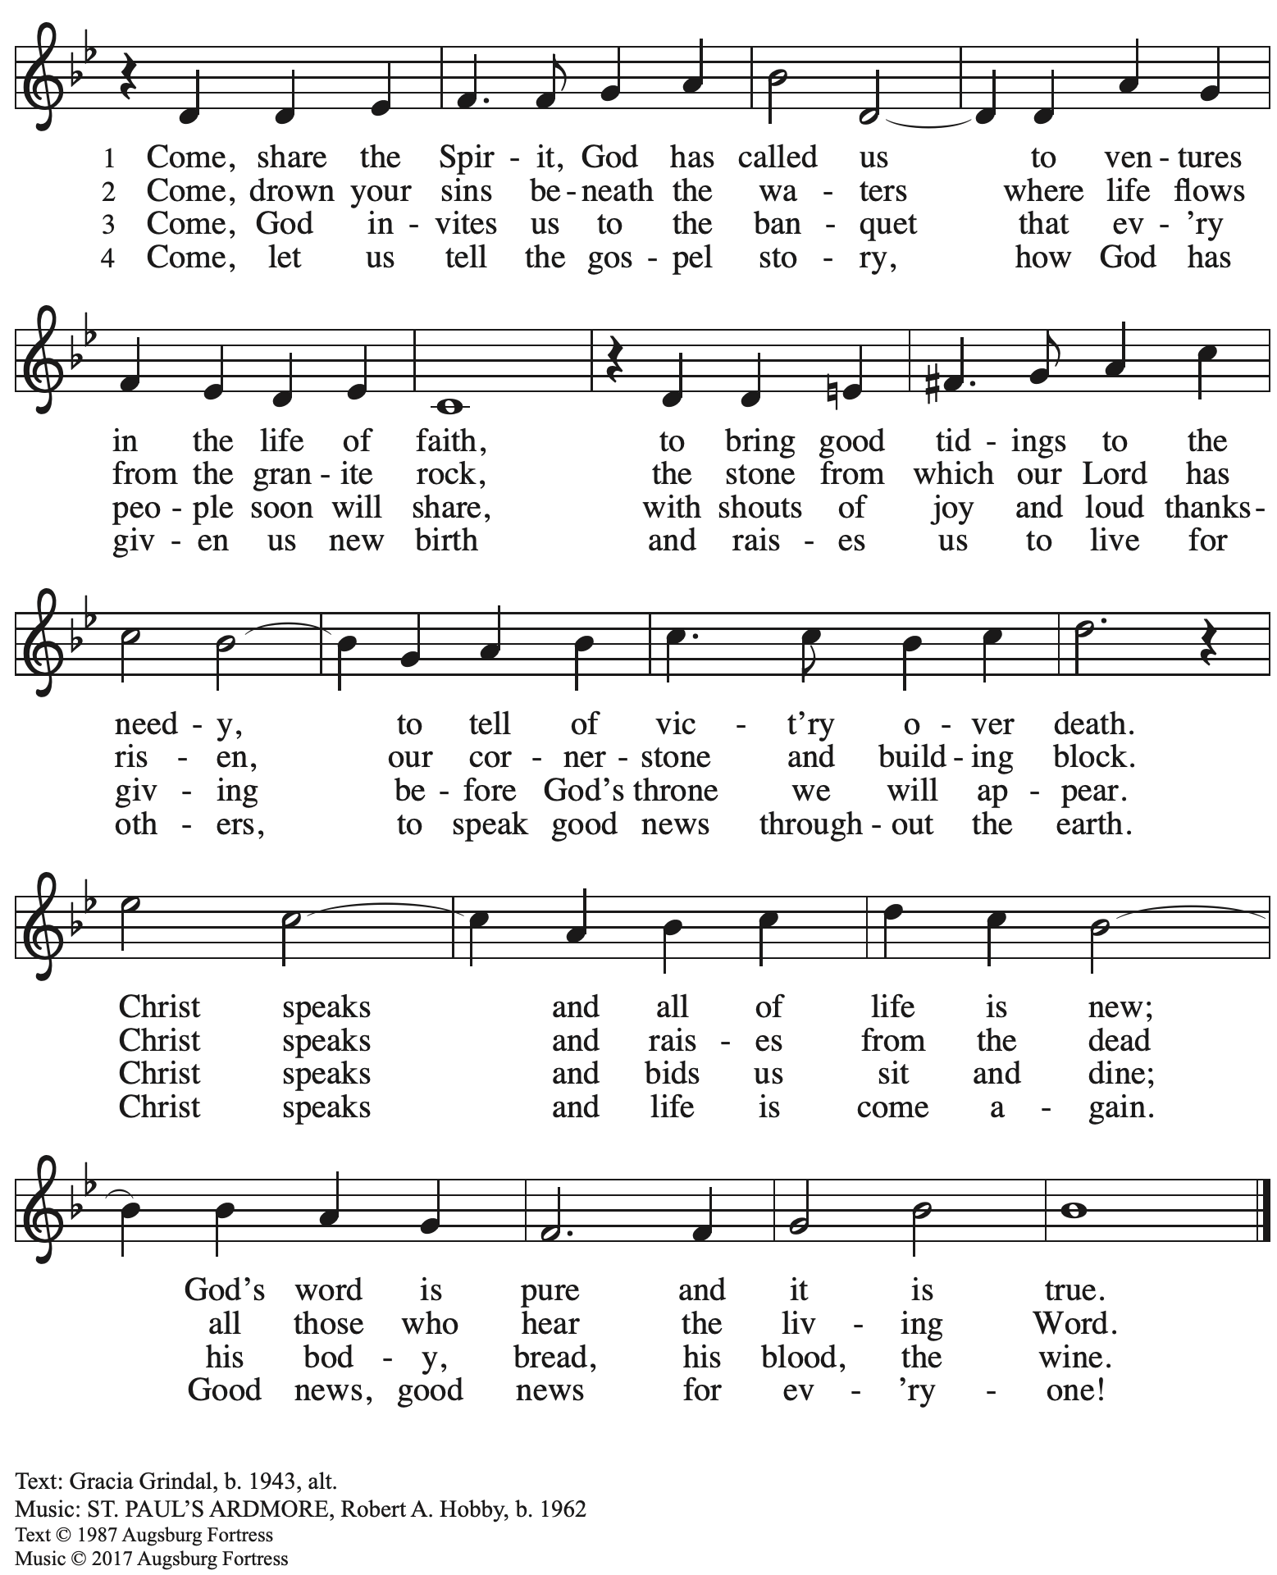

All rights reserved. Reprinted with permission under OneLicense.net # A-722139.

**Hymns during Holy Communion**

**What Feast of Love *ELW* 487**

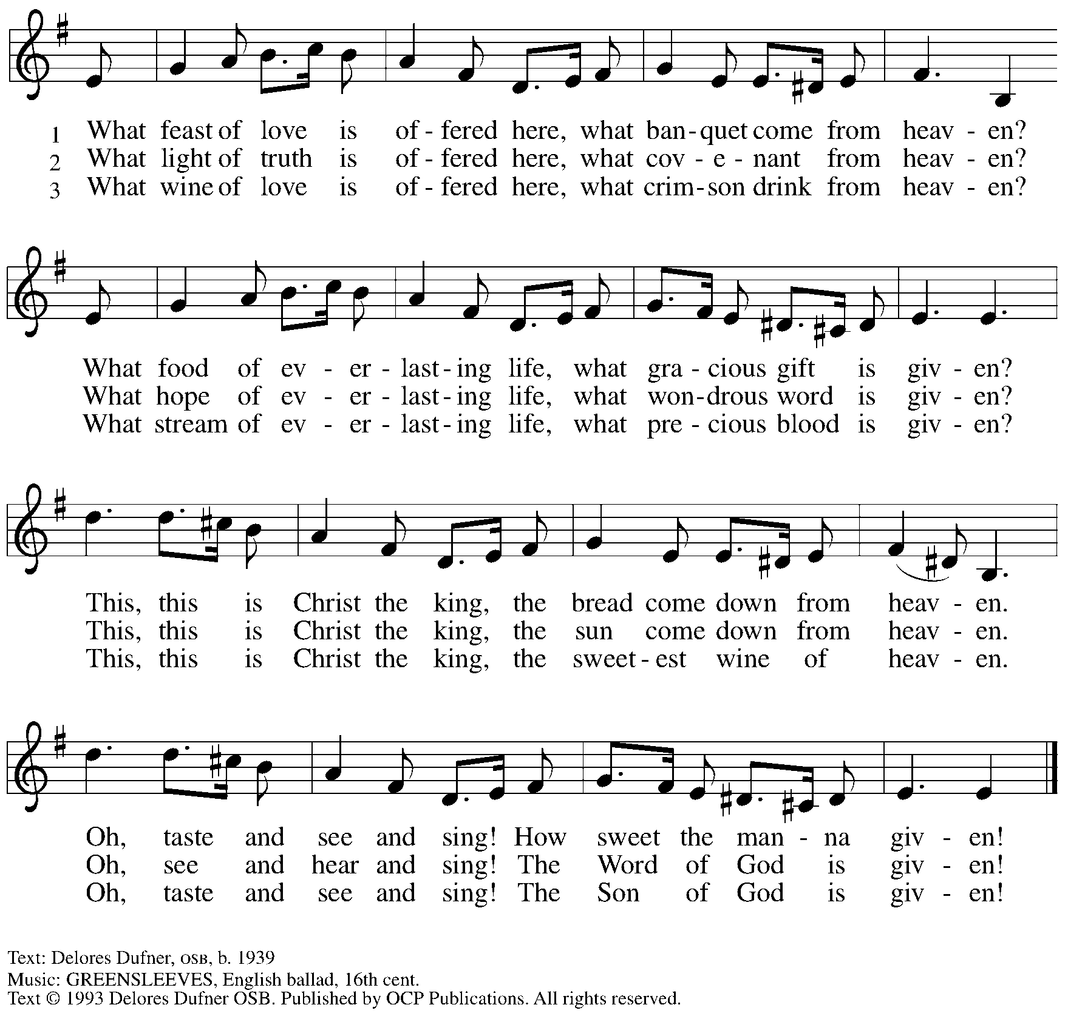

Reprinted with permission under OneLicense.net # A-722139.

**Hymns during Holy Communion**

**Christ, Be Our Light *ELW* 715**

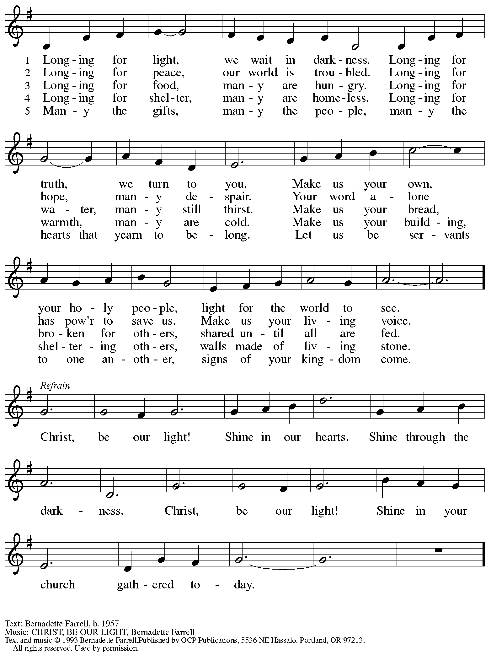

Reprinted under OneLicense.net # A-722139.

*When all have returned to their places, please rise as you are able.*

**Blessing**

P: The body and blood of our Lord Jesus Christ strengthen you and keep you in his grace.

**C: Amen.**

**Prayer**

A: Let us pray.

O God, in this holy communion you have welcomed us into your presence,

nourished us with words of mercy, and fed us at your table. Amid the cares of this life, strengthen us to love you with all our heart, serve our neighbors with a willing spirit,

and honor the earth you have made; through Christ our Lord.

**C: Amen.**

*Please be seated.*

**Sending**

*God blesses us and sends us in mission to the world*

**Announcements**

Please rise as you are able.

**Benediction**

P: The holy Three, the holy One

increase your hope,

strengthen your faith,

deepen your love,

and ☩ grant you peace.

**C: Amen.**

**Sending Hymn** *Following page*

**Dismissal**

P: Go in peace. Christ is with you.

**C: Thanks be to God!**

**Postlude**

**Sending Hymn God of Grace and God of Glory *ELW* 705**

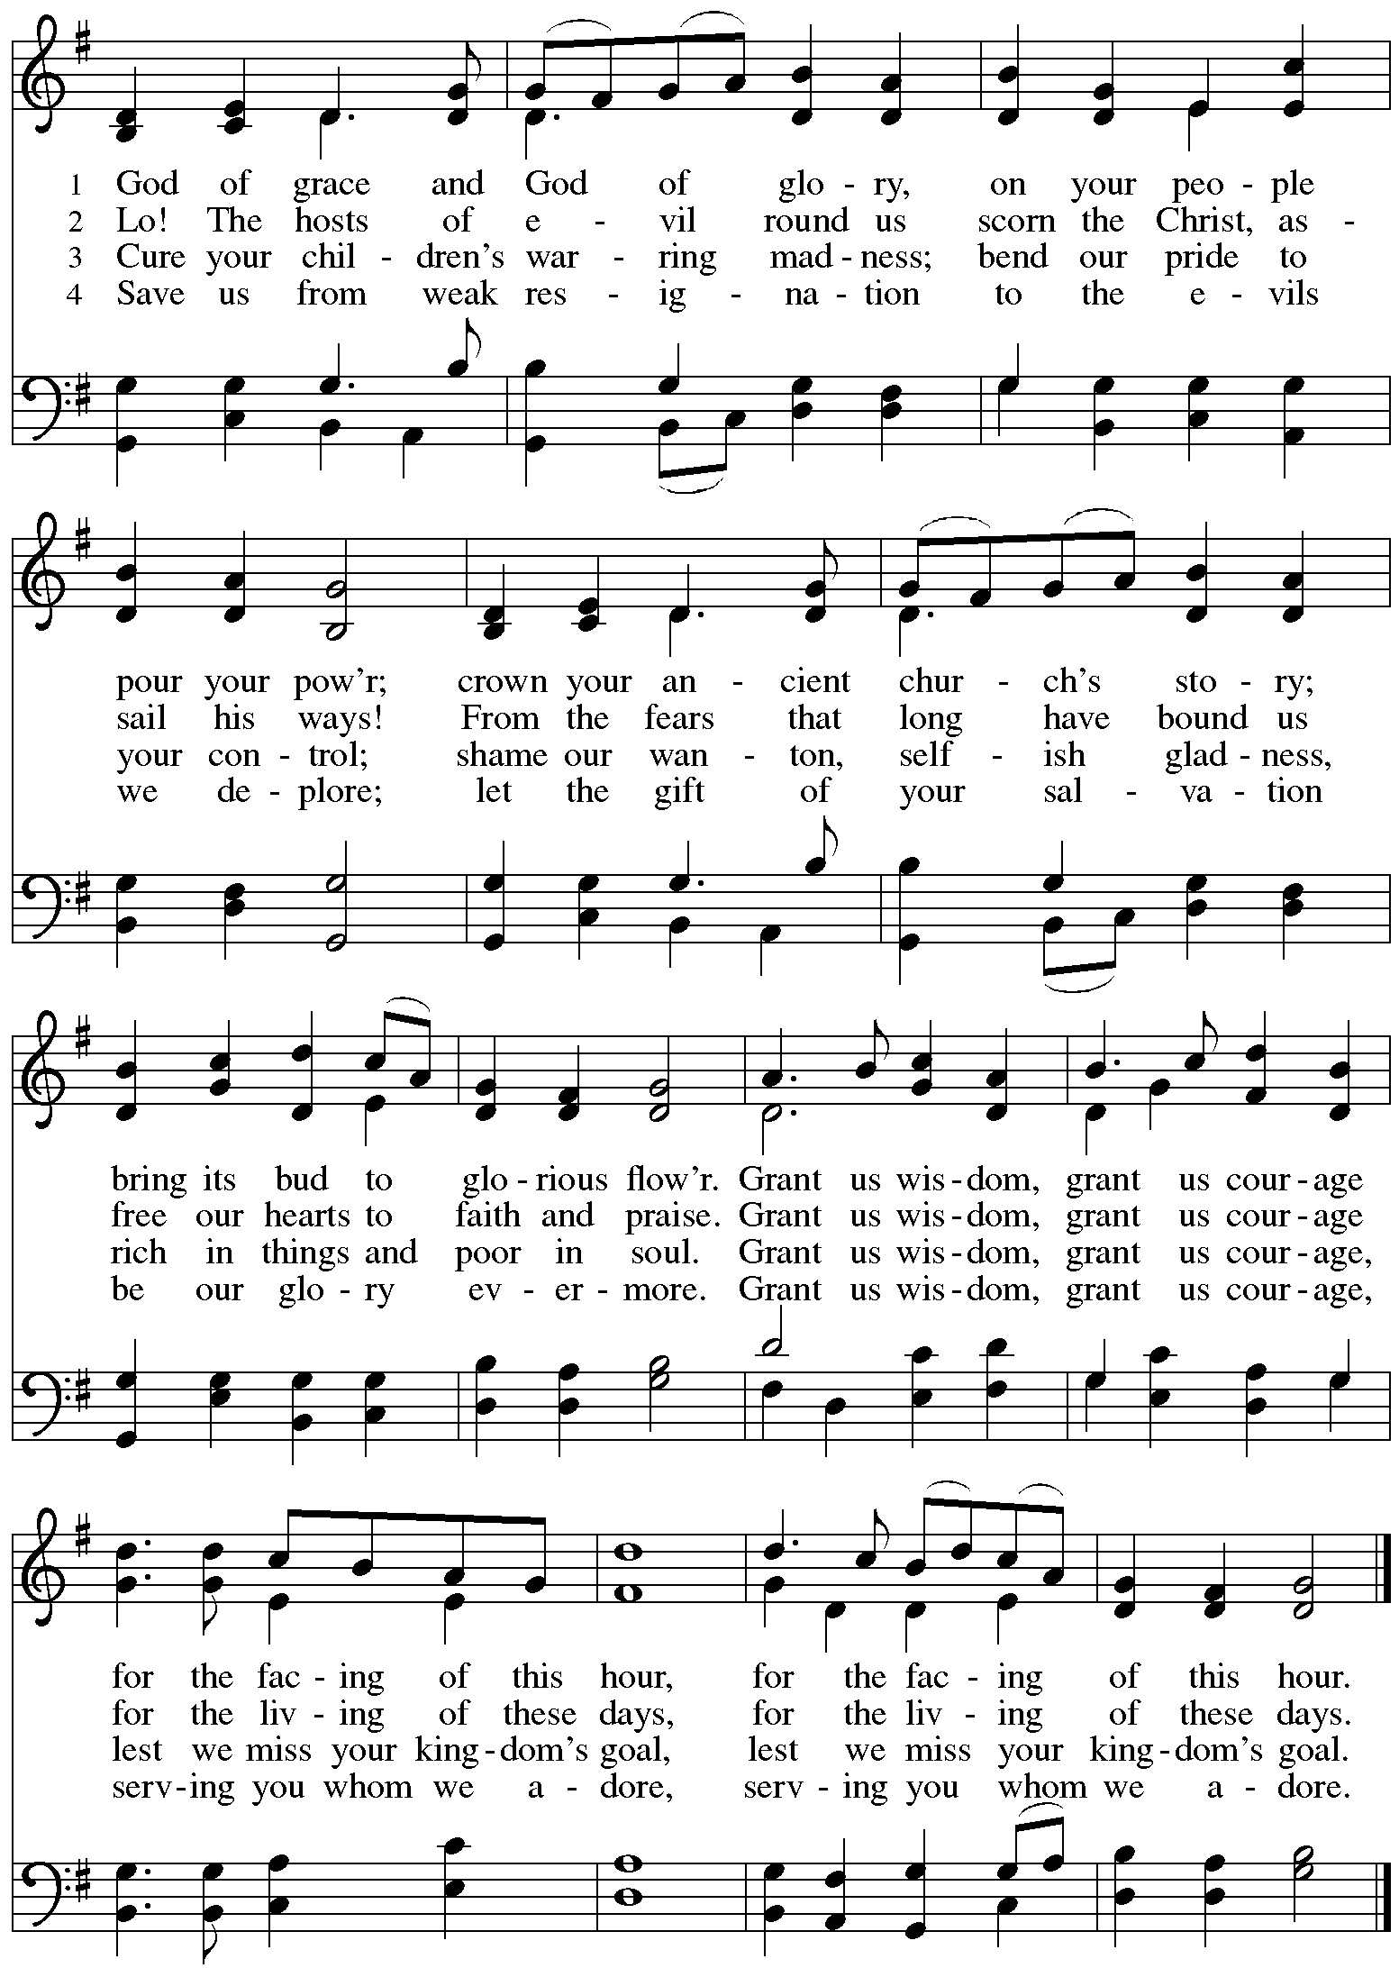

*Those serving in worship*

Altar Care Christy Ruhe

Assisting Minister Kathy Hays

Audio-Visual Ministers Kristen Asplin

Tyler Rietze

Cantor Joy Givens

Lector Lindsay Baxter

Little Church – Big Faith Teacher Sue Gaugler

Organ Jimmi Kocher-Hillmer

Minister of Music Laura Reynolds

Presiding and Preaching Minister The Rev. Ross I. Carmichael

*Liturgy and Hymnody Acknowledgements*

From SundaysandSeasons.com. Copyright © 2025 Augsburg Fortress. All rights reserved. Reprinted under OneLicense.net # A-722139.

Used by permission of Augsburg Fortress.

The Scripture readings contained herein are from *New Revised Standard Version* of the Bible © 1989, Division of Christian Education of the National Council of Churches of Christ in the USA. Used by permission. All rights reserved.

**Vamos todos al banquete – Let Us Go Now to the Banquet** – Text: Guillermo Cuéllar b. 1955, *Misa popular salvadoreña*; tr. Bret Hesla, b. 1957 and William Dexheimer Pharris, b. 1956. Music: VAMOS TODOS AL BANQUETE, Guillermo Cuéllar b. 1955. Text and music © 1994, 1996 GIA Publications, Inc., 7404 S. Mason Ave., Chicago, IL 60638. [www.giamusic.com](http://www.giamusic.com). 800.442.3358. All rights reserved. Reprinted with permission under OneLicense.net # A-722139.

**Soul, Adorn Yourself with Gladness** – Text: Johann Franck, 1618-1677; tr. *Lutheran Book of Worship*. Music: SCHMÜCKE DICH, Johann Crüger. 1598-1662. Text © 1978 *Lutheran Book of Worship*, admin. Augsburg Fortress. All rights reserved. Reprinted with permission under OneLicense.net # A-722139.

**God of Grace and God of Glory** – Text: Harry E. Fosdick, 1878-1969. Music: CWM RHONDA, John Hughes, 1973-1932.

*Please use the QR code below to link to St. Andrew’s Announcements online!*



**St. Andrew Lutheran Church Announcements**

**January 19th, 2025**

* **Welcome to worship at St. Andrew on the Second Sunday after Epiphany, January 19th** – We are thankful you are here, and we offer a special welcome to all visitors and guests here for the first time. Worship attendees are invited to make a name tag at the back of the worship space. Little Church – Big Faith, a Bible lesson and activity for children, will take place after the prayer of the day. There are also worship “toolkits” to help children engage with worship and “busy bags” for younger children available in the bookcase at the back of the sanctuary. Please feel free to take one to use with/for your children. All are invited to gather for coffee, other drinks, food, and conversation in the social hall after worship.
* **Noisy Offering during Worship Today – On the third Sunday of each month, the children of St. Andrew lead us in a Noisy Offering.** The children carry buckets around the congregation and people are invited to throw in their change, which then gets compiled in big metal buckets and is brought forward as an offering. These gifts support a different ministry or organization each month, and this month’s offering will support Global Refuge, a Lutheran organization that supports and empowers immigrants, asylum seekers, and refugees who are rebuilding their lives in the United States. For more information, please visit [Global Refuge | Welcome & hope since 1939](https://www.globalrefuge.org/).
* **Support Those Affected by California Wildfires through Lutheran Disaster Response – With ongoing concern for everyone coping with wildfires in California, the Evangelical Lutheran Church in America’s Lutheran Disaster Response is working with the Southwest California synod to support affected communities. They offer a sample prayer and are accepting donations designated for “U.S. Wildfires.” For more information, or to donate, please see** [US Wildfires](https://www.elca.org/our-work/relief-and-development/lutheran-disaster-response/our-impact/us-wildfires?fbclid=IwY2xjawHsxdRleHRuA2FlbQIxMAABHTFXYAPv2xZ0mdENmcsSbNUS-vGVbJVcKn_NAa3mTRKBWtTeOI-mxAM4Dg_aem__Kv-QvoEB6MduGPk9PKFpw) (at [www.elca.org](http://www.elca.org)).
* **Bible Book Club Starts a New Book, *Traveling Mercies* by Anne Lamott, with First Discussion on Wednesday, January 22nd at 7:00 p.m. on Zoom – St. Andrew hosts a Bible Book Club to discuss various works related to Scripture, theology, and faith in daily life. Our next book is *Traveling Mercies* by Anne Lamott, the first discussion of which will be Wednesday, January 22nd. New participants are always welcome – if you would like the Zoom link or need assistance locating the book please contact Pastor Ross at** [PastorRCarmichael@gmail.com](mailto:PastorRCarmichael@gmail.com)**.**
* **Bishop Kusserow Visting St. Andrew on Sunday, February 2nd – Bishop Kurt Kusserow is finishing his third term, having served nearly 18 years in leadership of our local Southwestern Pennsylvania Synod of the Evangelical Lutheran Church in America. He is visiting congregations in what may be called a “farewell tour,” and he will be preaching at St. Andrew on Sunday, February 2nd. We invite everyone to be present that day to give thanks for Bishop Kusserow’s leadership and to wish him well as he leaves office. We will have a special expanded coffee hour after worship that day.**
* **Save the Date – Local “Rivers of Delight” Singing Group to Hold Concert at St. Andrew on Saturday, March 8th, at 3:00 p.m. – Rivers of Delight is a group of local singers that formed to bring to life the** choral music of 18th century New England, the first large body of music composed in the English-speaking Americas. Their program will present the music with some explanation of its history and cultural context and run for about an hour. The composers whose music the group sings were amateurs trained in the singing schools that were instituted in an effort to improve congregational singing in the Puritan churches, so it is (mostly) sacred music. The schools created a movement that spread through the New England settlements, drawing young people with its offer of a chance to socialize and relax after their hard day’s work. Though the lyrics are usually serious, even gloomy, the music was designed to be fun to sing and tends toward the exuberant. In the 19th century, this repertoire contributed to the great American folk tradition of harmony singing known as shape note or Sacred Harp singing. For examples of the group’s singing, please visit <https://youtube.com/playlist?list=PLIhWyvtanBKr2uwUmr1NNqvV1CGfcFbr-&si=e2cxi_BnFN0U8axF>.
* **Updated Coffee Hour Signups** – We have recently introduced changes to coffee hour hospitality: Now there will be two signup slots each week, one for setup and making coffee and one for cleanup. The link now describes in greater detail what is involved in each part, which should make it clearer and easier for people to serve. Thank you to all who have been working on these updates. Please see the updated link at <https://www.signupgenius.com/go/5080B4AAFAF2CABF85-47069030-coffee>.
* **Help Re-Stock Outdoor Little Library!** – If you are interested in stocking the little library that is on the Centre Avenue side of the church, there are extra books in the metal cabinet to the right of the dumbwaiter (There are currently some 10% off coupons for Half Price Books that are good throughout the year). The current stock of books are from the challenged or banned book lists. Here are two lists: (<https://www.ala.org/bbooks>) (<https://en.wikipedia.org/wiki/List_of_most_commonly_challenged_books_in_the_United_States>).
* ***Christ in Our Home* Devotional Booklets for January - March Available at Church Entrances** – This resource offers a daily Bible reading with a short reflection and prayer, along with additional readings and prayer topics for those who would like to expand their devotional practices. We encourage people of the congregation to take one for yourself, your family unit, or others!
* **Compline Prayer Service with the Pittsburgh Compline Choir – Sundays at 8:00 p.m. at Heinz Chapel –** Compline was traditionally a monastic prayer service, and the Pittsburgh Compline Choir, a ministry of Lutheran Campus Ministry in Greater Pittsburgh, sings a choral version of compline rooted in this thousand-year-old tradition of scripture, song, and silence each Sunday at Heinz Chapel at 8:00 p.m. This service also streams on Facebook (Pittsburgh Compline Choir) and YouTube (The Pittsburgh Compline Choir). Heinz Chapel is located off of S. Bellefield Ave. in Oakland. For more information, please visit: [Pittsburgh Compline Choir](http://pittsburghcomplinechoir.org/).