

**+ Second Sunday of Christmas /**

**The Epiphany of our Lord**

**January 5th, 2025**

**10:00 a.m.**



**St. Andrew Lutheran Church**

**304 Morewood Ave.**

**Pittsburgh, PA 15213**

**412.682.3342**

[**St_andrewELCA@verizon.net**](mailto:St_andrewELCA@verizon.net)

[**www.standrewpittsburgh.org**](http://www.standrewpittsburgh.org)

**+ Second Sunday of Christmas**

**Order for Worship**

*Within this week’s gospel reading from John and its poetic and profound words lies the simple message that God is revealed in a human person. Though we may try to understand how the Word existed with God from the beginning of time, the wonder we celebrate at Christmas is that the Word continues to dwell among us. Christ comes among us in the gathered assembly, the scriptures, the waters of new birth, and the bread and the wine. Through these ordinary gifts we receive the fullness of God’s grace and truth.*

**Welcome to St. Andrew!**

* St. Andrew welcomes all who are seeking a place of healing, wholeness, and acceptance in a nurturing and faith-forming spiritual home. We are striving toward racial equity worldwide

and we seek to honor the lived experience of all individuals regardless of background. Our community embraces people of all ages, ethnicities, cultures, abilities, sexual orientations,

gender identities and expressions, and family constellations. Come and See!

* Worship Services are live-streamed to multiple online platforms. By attending worship, you agree that your image and voice may be broadcast.
* Everyone is invited to make a name tag at the black bookcase in the back of the worship space if they would like. There are stickers indicating pronouns on the bookcase if you would like to include them on your name tag.
* Children are invited to attend Little Church – Big Faith, a Bible lesson and activity, during worship (after the Prayer of the Day). The group returns to the worship space for the liturgy of Holy Communion.
* A nursery is available through the doors at the left side of the sanctuary and across from the doorway to the Social Hall. Look for a purple-colored room.
* Worship “toolkits” to help children engage with the service, along with “busy bags” for younger children, are available in the bookcase at the back of the sanctuary. Please feel free to take one to use with/for your children.
* Holy Communion is served with bread (gluten-free available) and wine or grape juice. The presiding minister will distribute the bread (host). Please consume this and then pick up an empty glass from the tray. The Communion Assistant will pour wine or grape juice into your glass. Please step to the side to consume the wine or grape juice. Feel free to kneel at the altar for prayer and reflection. As you return to your pew, glasses may be returned to the empty trays on either side of the center section.
* A restroom is available on the main level of the church, through the doors to the Social Hall and to the right in the main office.

*Abbreviations*

P: Pastor/Presiding Minister ***ELW*: *Evangelical Lutheran Worship* hymnal**

A: Assisting Minister ***ACS*: *All Creation Sings* hymnal**

L: Lector

**C: Congregation**

**Pre-Service Music** Mangano Rollinson Duo

**Welcome**

**Prelude** *Hark! The Herald Angels Sing* Andrew

**Gathering**

*The Holy Spirit calls us together as the people of God*

**Confession and Forgiveness**

*Please rise as you are able. All may make the sign of the cross,*

*the sign that is marked at Baptism, as the presiding minister begins.*

P: Blessed be the holy Trinity, ☩ one God,

whose steadfast love is everlasting.

**C: Amen.**

P: Let us confess our sin in the presence of God and of one another.

*Silence is kept for reflection*

P: God with us,

**we confess that we have turned away** **those seeking refuge,**

**claiming there is no room when we have plenty to offer.**

**We have made power and wealth our idols,**

**while you show us true glory: a baby in a manger.**

**We have overlooked the shepherds,** **expecting good news in finer packaging.**

**Too often, we have valued violence** **instead of your peace.**

**Turn us from our ways to your ways.**

**Grant us the grace to begin again.**

**Free us from all that keeps us bound,** **and forgive our sin,**

**through Jesus Christ, who gives himself for us.**

**Amen.**

P: Hear the good news and rejoice!

You are God’s chosen ones,

holy and beloved,

☩ forgiven in Christ,

and freed to respond in joy.

**C: Amen.**

**Gathering Hymn Once in Royal David’s City *ELW* 269**

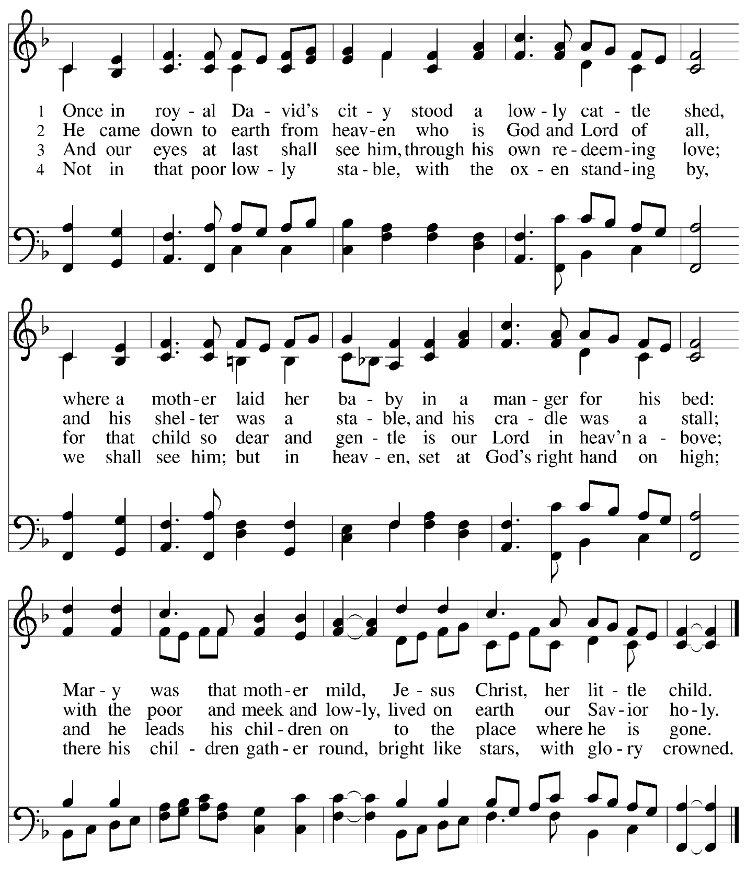



**Greeting**

P: The grace of our Lord Jesus Christ, the love of God,

and the communion of the Holy Spirit be with you all.

**C: And also with you.**

**Kyrie** *ELW* p. 147

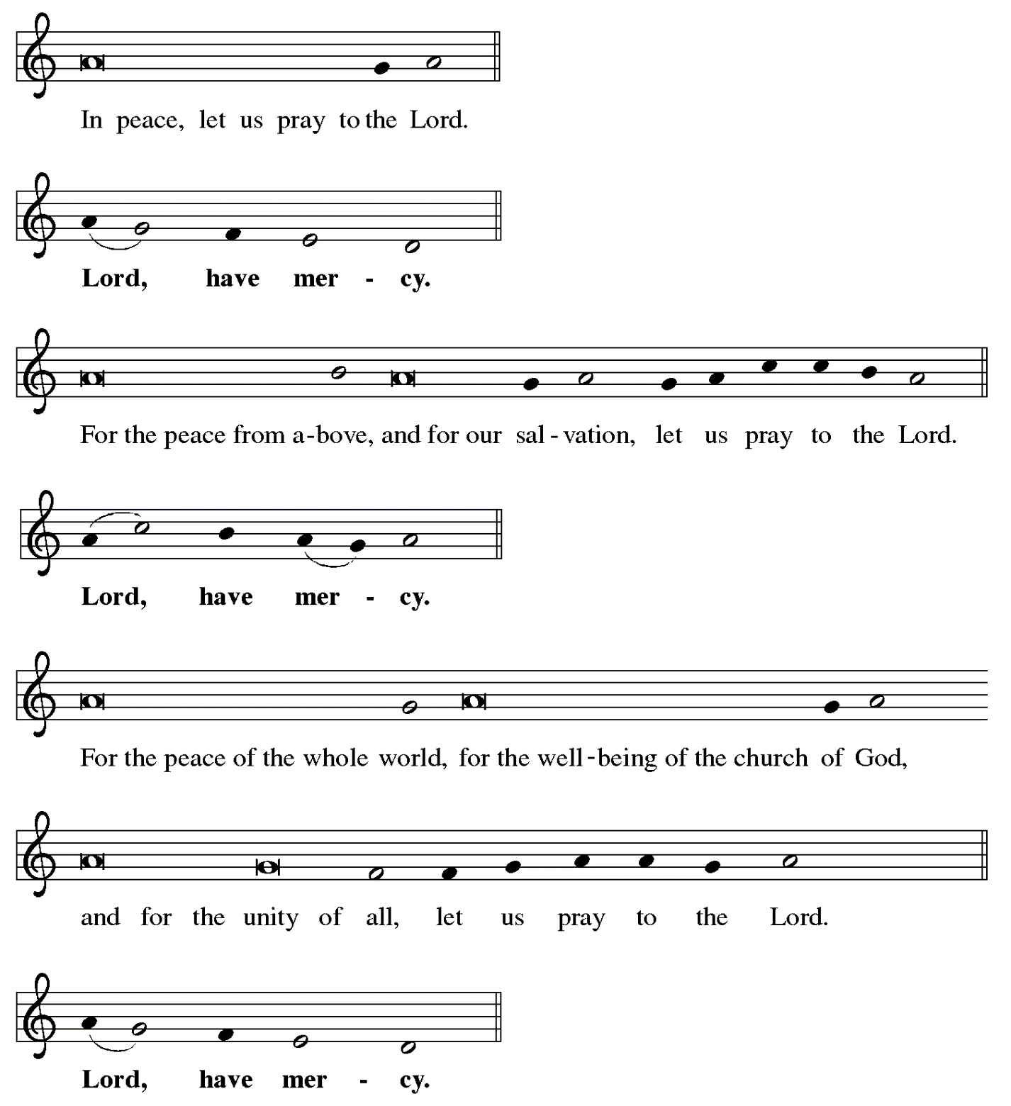

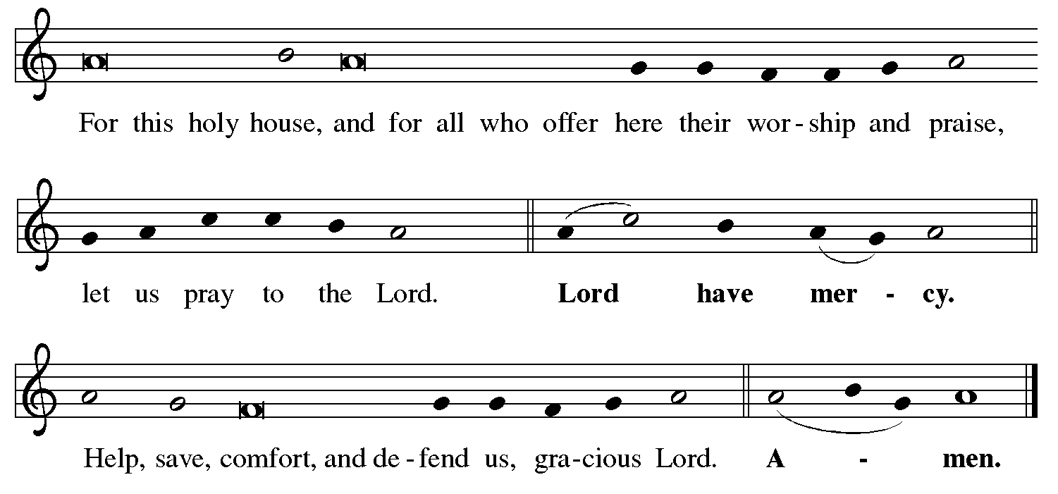



**Hymn of Praise Angels We Have Heard on High *ELW* 289**

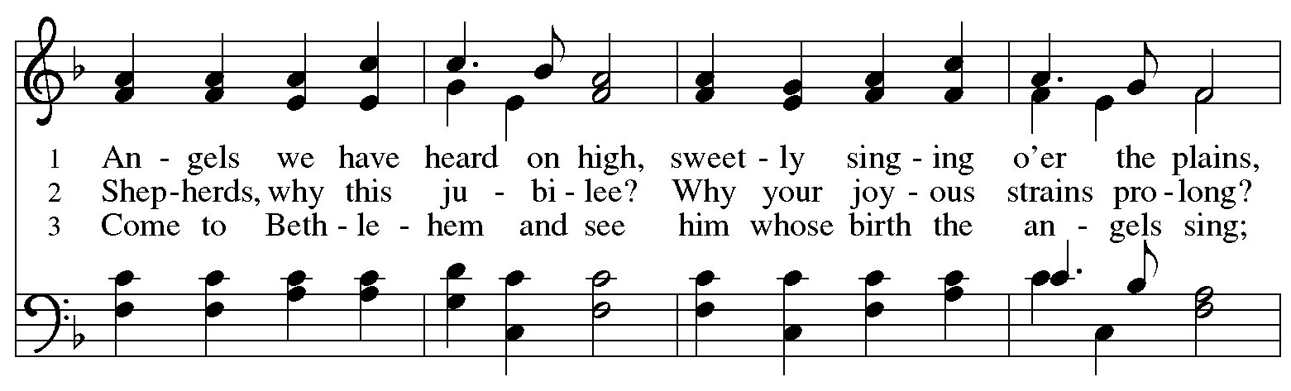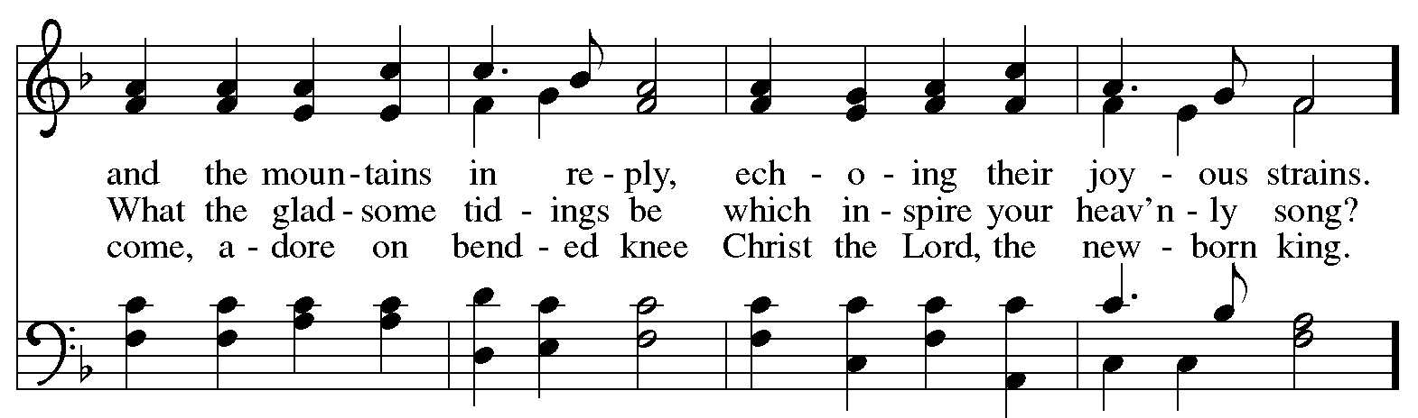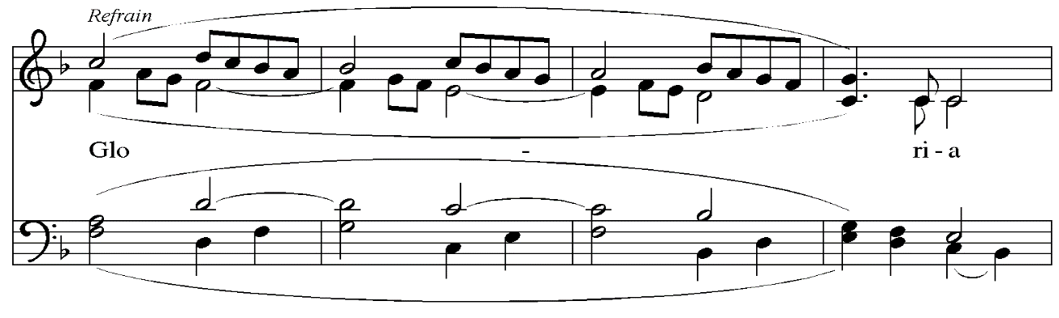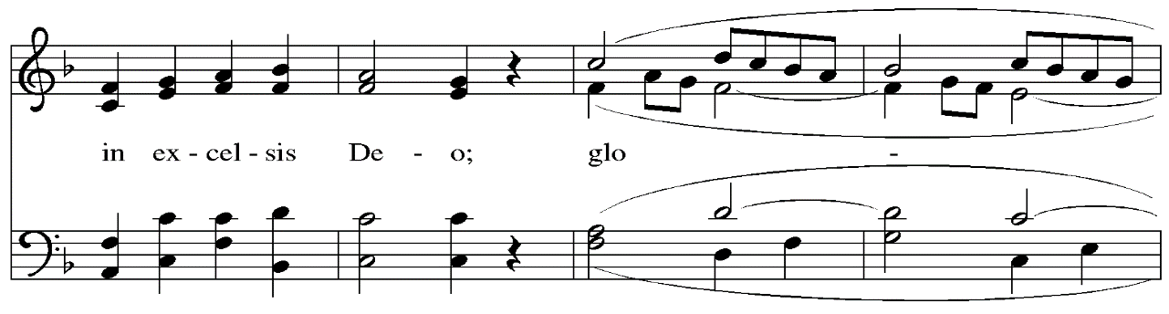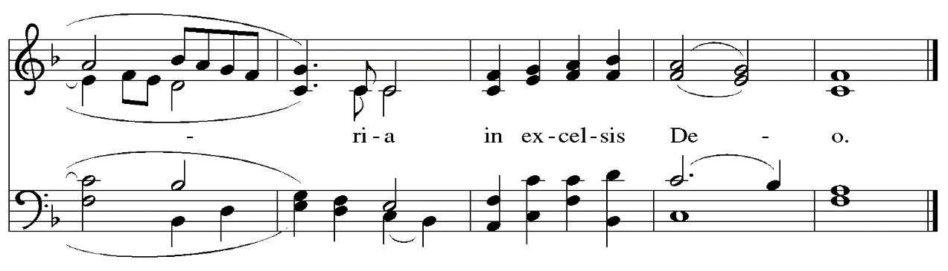

**Prayer of the Day**

P: The Lord be with you.

**C: And also with you.**

P: Let us pray.

Almighty God, you have filled all the earth with the light of your incarnate Word.

By your grace empower us to reflect your light in all that we do,

through Jesus Christ, our Savior and Lord,

who lives and reigns with you and the Holy Spirit,

one God, now and forever.

**C: Amen.**

*Please be seated.*

**Word**

*God speaks to us in Scripture reading, preaching, and song*

**First Reading** **– Jeremiah 31: 7-14**

 7 Thus says the Lord:  
 Sing aloud with gladness for Jacob,  
  and raise shouts for the chief of the nations;  
 proclaim, give praise, and say,  
  “Save, O Lord, your people,  
  the remnant of Israel.”  
 8 See, I am going to bring them from the land of the north,  
  and gather them from the farthest parts of the earth,  
 among them the blind and the lame,  
  those with child and those in labor, together;  
  a great company, they shall return here.  
 9 With weeping they shall come,  
  and with consolations I will lead them back,  
 I will let them walk by brooks of water,  
  in a straight path in which they shall not stumble;  
 for I have become a father to Israel,  
  and Ephraim is my firstborn.  
  
 10 Hear the word of the Lord, O nations,  
  and declare it in the coastlands far away;  
 say, “The one who scattered Israel will gather him,  
  and will keep him as a shepherd a flock.”  
 11 For the Lord has ransomed Jacob,  
  and has redeemed him from hands too strong for him.

12 They shall come and sing aloud on the height of Zion,  
  and they shall be radiant over the goodness of the Lord,  
 over the grain, the wine, and the oil,  
  and over the young of the flock and the herd;  
 their life shall become like a watered garden,  
  and they shall never languish again.  
 13 Then shall the young women rejoice in the dance,  
  and the young men and the old shall be merry.  
 I will turn their mourning into joy,  
  I will comfort them, and give them gladness for sorrow.  
 14 I will give the priests their fill of fatness,  
  and my people shall be satisfied with my bounty, says the LORD.

L: Word of God, word of life.

**C: Thanks be to God.**

**Psalm 147: 12-20**

*The cantor will lead the singing of the psalm.*

*The congregation is invited to respond with the alternate verses in bold print,*

*and to join in singing the refrain.*

*Psalm Tone*

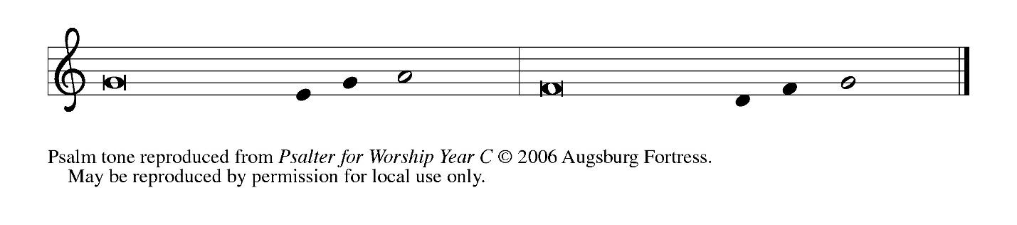

*Psalm Refrain*

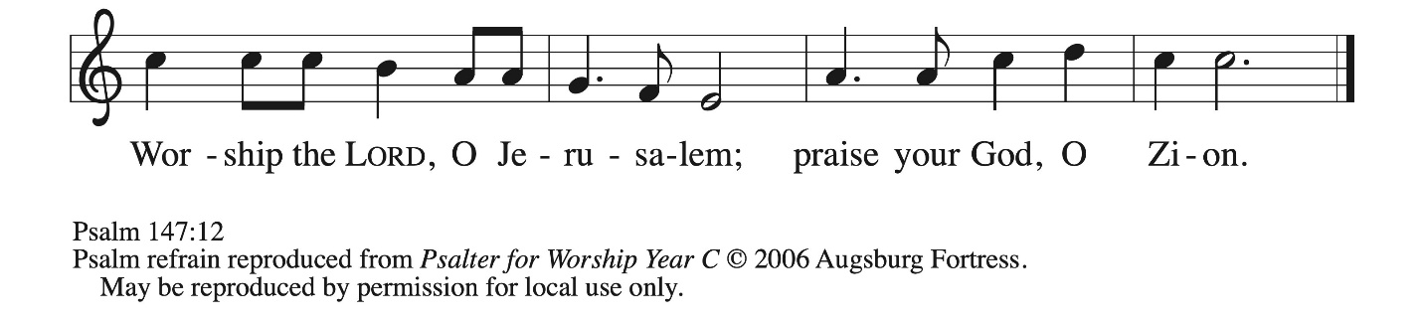

 12 Worship the Lord, **|** O Jerusalem;  
  praise your **|** God, O Zion,  
 13 **who has strengthened the bars | of your gates**  
  **and has blessed your chil- | dren within you.**  
 14 God has established peace **|** on your borders  
  and satisfies you with the **|** finest wheat.  
 15 **God sends out a command | to the earth,**  
  **a word that runs | very swiftly. R**  
 16 God gives **|** snow like wool,  
  scattering **|** frost like ashes.  
 17 **God scatters | hail like bread crumbs.**  
  **Who can stand a- | gainst God’s cold?**  
 18 The Lord sends forth the **|** word and melts them;  
  the wind blows, and the **|** waters flow.  
 19 **God declares the | word to Jacob,**  
  **statutes and judg- | ments to Israel.**  
 20 The Lord has not done so to any **|** other nation;  
  they do not know God’s judgments. **|** Hallelujah!**R**

**Second Reading – Ephesians 1: 3-14**

3 Blessed be the God and Father of our Lord Jesus Christ, who has blessed us in Christ with every spiritual blessing in the heavenly places, 4 just as God chose us in Christ before the foundation of the world to be holy and blameless before God in love. 5 God destined us for adoption as God’s children through Jesus Christ, according to the good pleasure of God’s will, 6 to the praise of God’s glorious grace that God freely bestowed on us in the Beloved. 7 In [Christ] we have redemption through his blood, the forgiveness of our trespasses, according to the riches of his grace 8 that he lavished on us. With all wisdom and insight 9 God has made known to us the mystery of God’s will, according to God’s good pleasure that God set forth in Christ, 10 as a plan for the fullness of time, to gather up all things in him, things in heaven and things on earth. 11 In Christ we have also obtained an inheritance, having been destined according to the purpose of the one who accomplishes all things according to God’s counsel and will, 12 so that we, who were the first to set our hope on Christ, might live for the praise of his glory. 13 In [Christ] you also, when you had heard the word of truth, the gospel of your salvation, and had believed in him, were marked with the seal of the promised Holy Spirit; 14 this is the pledge of our inheritance toward redemption as God’s own people, to the praise of God’s glory.

L: Word of God, word of life.

**C: Thanks be to God.**

*Please rise as you are able and join in singing the Gospel Acclamation.*

**Gospel Acclamation** *ELW* p. 151

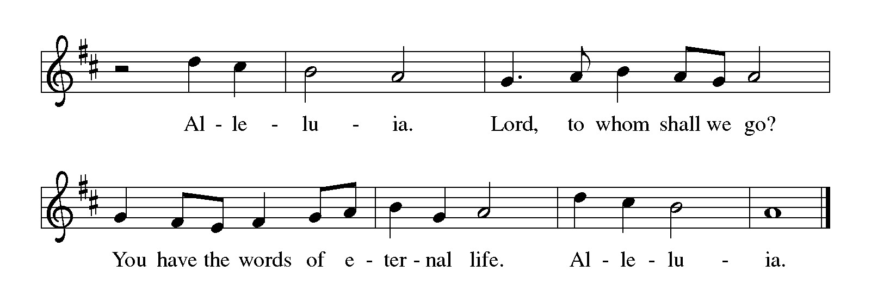

**Gospel – John 1: [1-9] 10-18**

P: The holy Gospel according to St. John.

**C: Glory to you, O Lord.**

[1 In the beginning was the Word, and the Word was with God, and the Word was God. 2 He was in the beginning with God. 3 All things came into being through him, and without him not one thing came into being. What has come into being 4 in him was life, and the life was the light of all people. 5 The light shines in the darkness, and the darkness did not overcome it.  
  6 There was a man sent from God, whose name was John. 7 He came as a witness to testify to the light, so that all might believe through him. 8 He himself was not the light, but he came to testify to the light. 9 The true light, which enlightens everyone, was coming into the world.]  
  10 He was in the world, and the world came into being through him; yet the world did not know him. 11 He came to what was his own, and his own people did not accept him. 12 But to all who received him, who believed in his name, he gave power to become children of God, 13 who were born, not of blood or of the will of the flesh or of the will of humanity, but of God.  
  14 And the Word became flesh and lived among us, and we have seen his glory, the glory as of a father’s only son, full of grace and truth. 15 (John testified to him and cried out, “This was he of whom I said, ‘He who comes after me ranks ahead of me because he was before me.’ ”) 16 From his fullness we have all received, grace upon grace. 17 The law indeed was given through Moses; grace and truth came through Jesus Christ. 18 No one has ever seen God. It is God the only Son, who is close to the Father’s heart, who has made him known.

P: The Gospel of the Lord.

**C: Praise to you, O Christ.**

*Please be seated.*

**Sermon**

*A time of silence for prayer and reflection follows the sermon.*

*As the hymn of the day begins, please rise as you are able.*

**Hymn of the Day The Word Who Sang Light into Creation *ACS* 973**

**Palabra que fue luz el primer día**

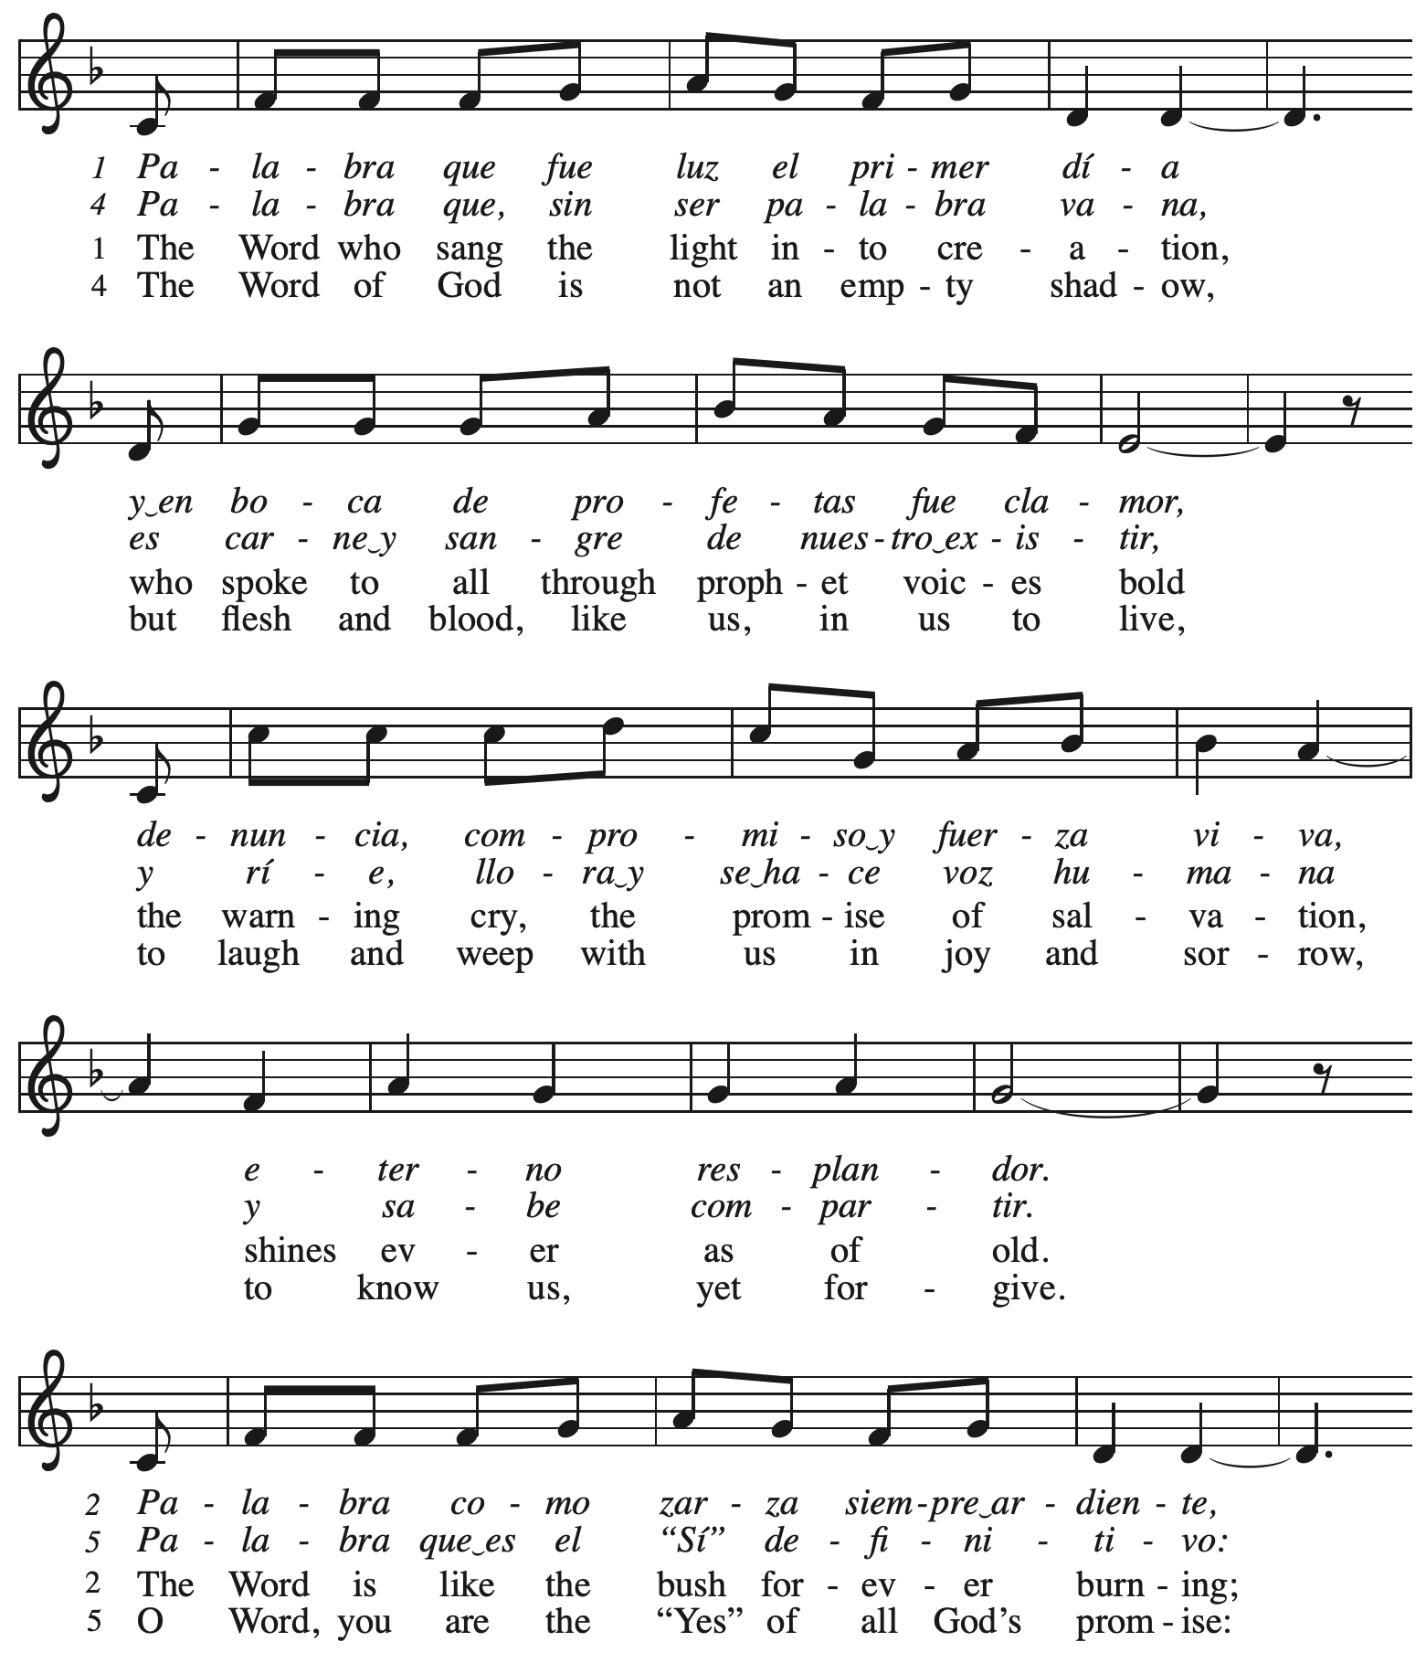

*Continued*

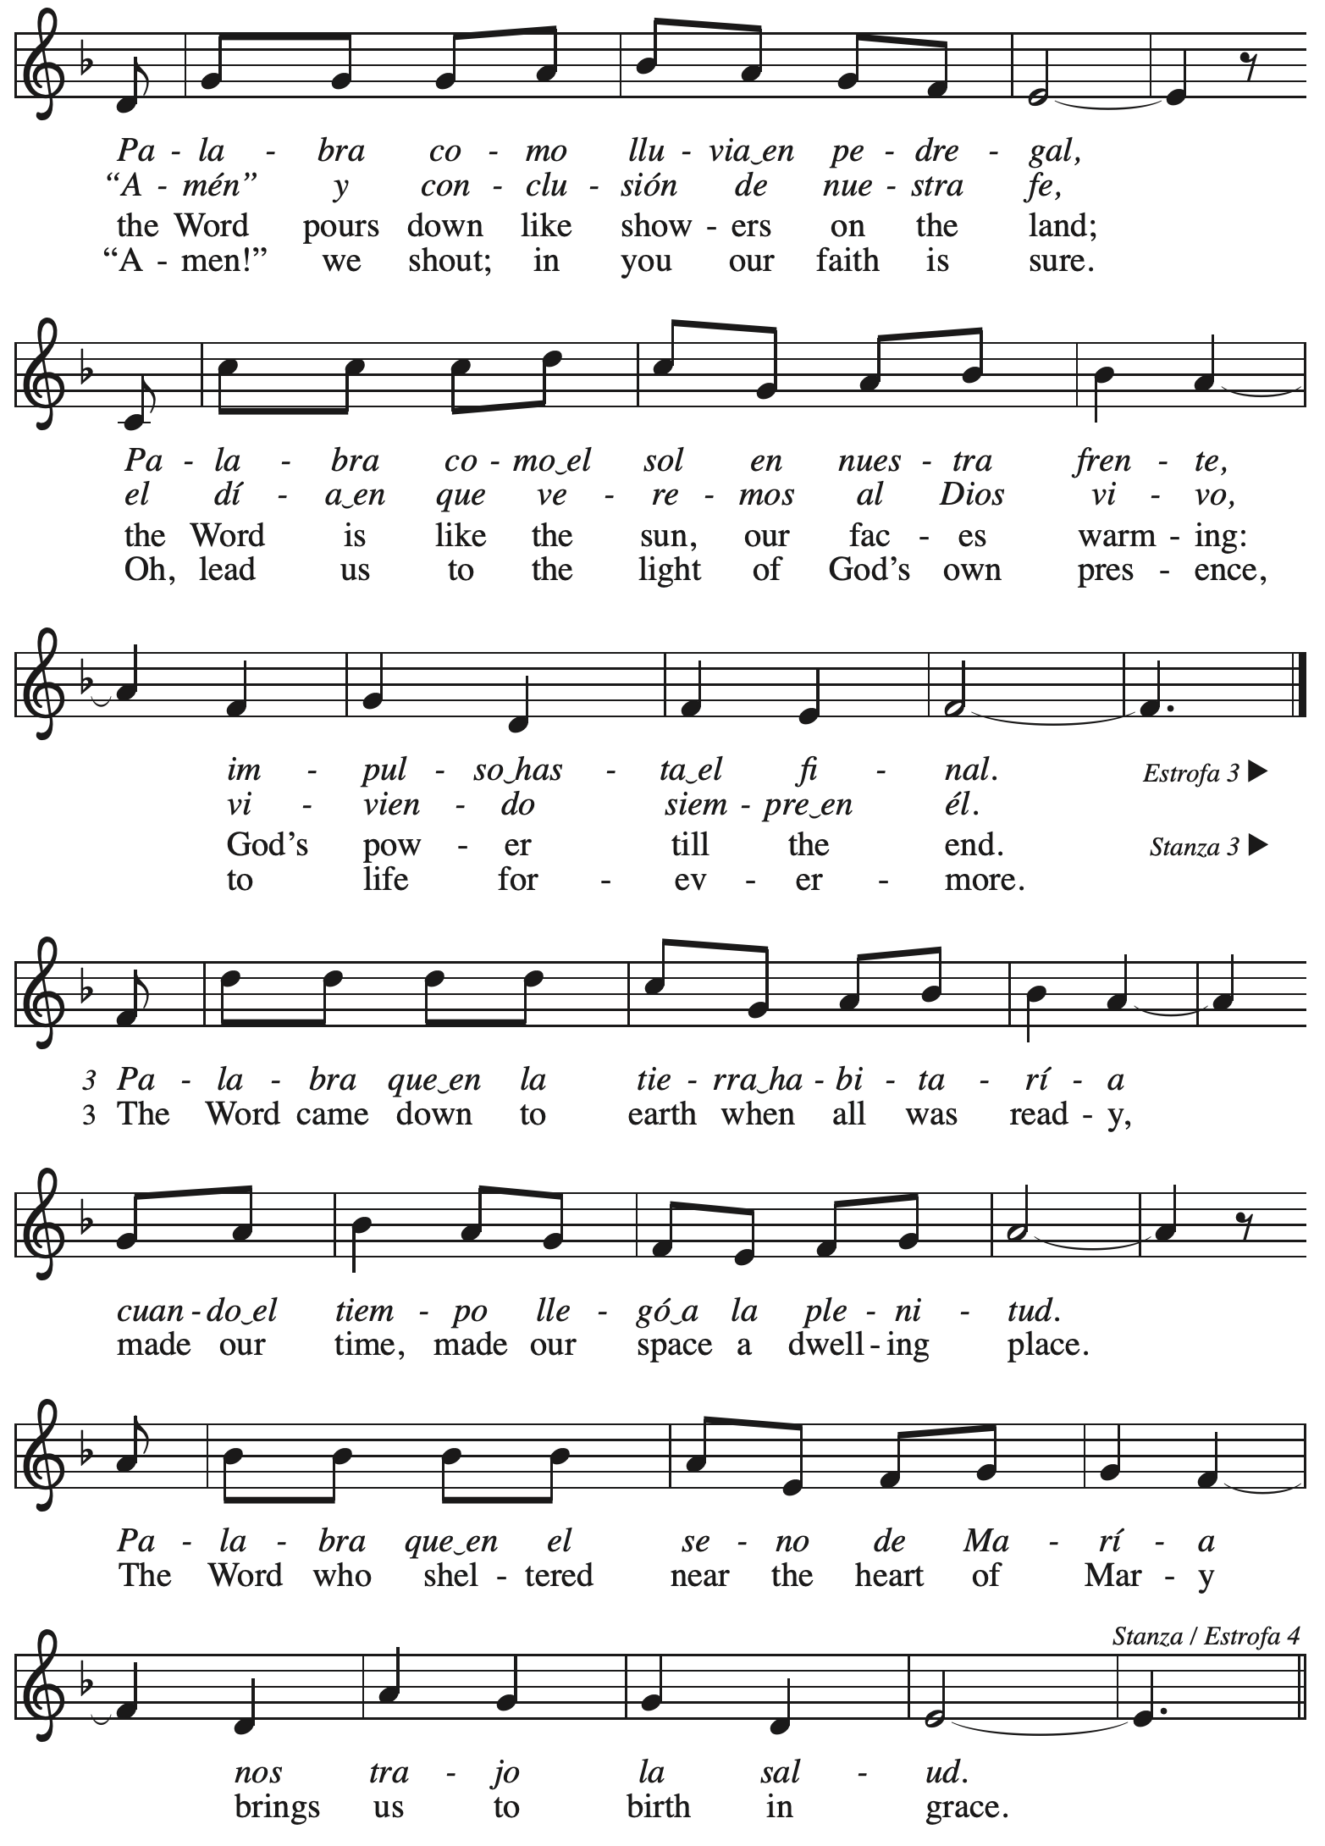

**Nicene Creed**

P: Rejoicing in the good news of Christ’s birth, we confess our faith:

**C: We believe in one God,**

**the Father, the Almighty,**

**maker of heaven and earth,**

**of all that is, seen and unseen.**

**C: We believe in one Lord, Jesus Christ,**

**the only Son of God,**

**eternally begotten of the Father,**

**God from God, Light from Light,**

**true God from true God,**

**begotten, not made,**

**of one Being with the Father;**

**through him all things were made.**

**For us and for our salvation**

**he came down from heaven,**

**was incarnate of the Holy Spirit and the virgin Mary**

**and became truly human.**

**For our sake he was crucified under Pontius Pilate;**

**he suffered death and was buried.**

**On the third day he rose again**

**in accordance with the scriptures;**

**he ascended into heaven**

**and is seated at the right hand of the Father.**

**He will come again in glory to judge the living and the dead,**

**and his kingdom will have no end.**

**We believe in the Holy Spirit, the Lord, the giver of life,**

**who proceeds from the Father and the Son,\***

**who with the Father and the Son is worshiped and glorified,**

**who has spoken through the prophets.**

**We believe in one holy catholic and apostolic church.**

**We acknowledge one baptism for the forgiveness of sins.**

**We look for the resurrection of the dead,**

**and the life of the world to come. Amen.**

*Or, “who proceeds from the Father.” The phrase “and the Son” is a later addition to the creed.

**Prayers of the People**

A: Trusting in God’s good news of great joy for all people, we offer our prayers for the church,

those in need, and the world God so loves.

*After each petition*

A: God of grace,

**C: receive our prayer.**

*The presiding minister concludes the prayers*

P: Rejoicing in your Word made flesh among us, we commend these prayers to you, O God,

trusting in your love and grace made known to us in Jesus Christ, our Savior.

**C: Amen.**

**Peace**

*The presiding minister and the assembly greet one another in the peace of the risen Christ.*

P: The peace of Christ be with you always.

**C: And also with you.**

*The people may greet those around them with a sign of Christ’s peace and may say*

Peace be with you *or similar words. Please be mindful that not everyone will be comfortable with sharing the peace, so please seek consent before shaking hands or hugging. Other possible ways to share the peace include a simple bow with the verbal greeting of peace, or simply a verbal expression of peace.*

*When the greetings of peace have concluded, please be seated.*



**Meal**

*God feeds us with the presence of Jesus Christ*

**Offering**

*We offer ourselves, our gifts, and our faithful service to God.*

*As the offering is gathered for the mission of the church, including the care of those in need,*

*the table is set for Holy Communion.*

**Reparations Offering**

*On the first Sunday of each month, St. Andrew invites people of the congregation to consider a donation to a second collection for a reparations fund in acknowledgement of St. Andrew’s use of African American spiritual songs in our worship services. Please see the note in the announcements for more information.*

**Music during the Offering** *Joy to the World* Kai

*As the gifts are brought forward for presentation, please rise as you are able.*

**Offertory Song In the Bleak Midwinter *ELW* 294**

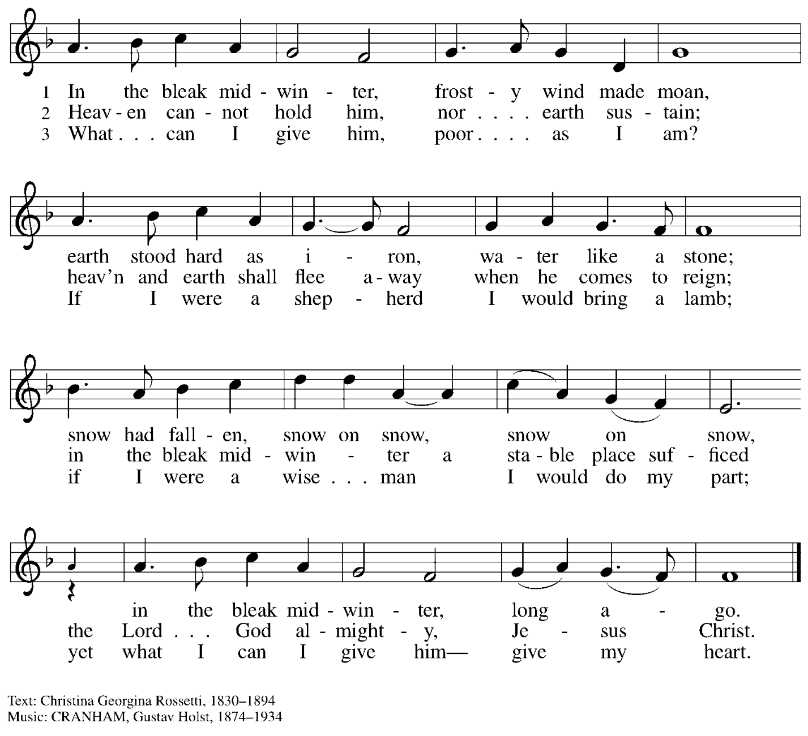

**Offertory Prayer**

A: Let us pray.

Good and loving God,

**C: we rejoice in the birth of Jesus,**

**who came among the poor to bring the riches of his grace.**

**As you have blessed us with your gifts, let them be a blessing for others.**

**With the trees of the field, with all earth and heaven,**

**we shout for joy at the coming of your Son, Jesus Christ our Lord. Amen.**

**Dialogue** ELW p. 152



**Preface** *(Sung)*

P: It is indeed right, our duty and our joy,

that we should at all times and in all places

give thanks and praise to you, almighty and merciful God,

through our Savior Jesus Christ.

In the wonder and mystery of the Word made flesh

you have opened the eyes of faith

to a new and radiant vision of your glory,

that beholding the God made visible,

we may be drawn to love the God whom we cannot see.

And so, with all the choirs of angels,

With the church on earth and the hosts of heaven,

we praise your name and join their unending hymn:

**Sanctus** *ELW* p. 153



**Eucharistic Prayer**

P: Holy one, the beginning and the end, the giver of life, …

… Do this for the remembrance of me.

Let us proclaim the mystery of faith.

**C: Christ has died. Christ is risen. Christ will come again.**

P: With this bread and cup …

… We look with hope for his coming.

**C: Come, Lord Jesus.**

P: Holy God, we long for your Spirit …

… Bring the gift of peace on earth.

**C: Come, Holy Spirit.**

P: All praise and glory are yours …

… one God, now and forever.

**C: Amen.**

**Lord’s Prayer**

P: Gathered as one by the Holy Spirit, let us pray as Jesus taught us.

**C: Our Father in heaven,**

**hallowed be your name,**

**your kingdom come,**

**your will be done,**

**on earth as in heaven.**

**Give us today our daily bread.**

**Forgive us our sins**

**as we forgive those**

**who sin against us.**

**Save us from the time of trial**

**and deliver us from evil.**

**For the kingdom, the power,**

**and the glory are yours,**

**now and forever. Amen.**

**Fraction and Invitation**

P: Glory to God in the highest!

Come to the table of peace.

***Agnus Dei /* Lamb of God** *ELW* p. 154



*Please be seated.*



**Holy Communion**

* *All who seek God and desire a deeper and stronger life in Christ are welcome to receive Holy Communion.*
* *Worshipers from the pulpit side will proceed forward first, followed by the center section, and then the lectern side.*
* *Please inform an usher if you would like the ministers to bring Communion to you.*
* *Holy Communion will be served with bread and wine/grape juice.*
* *The presiding minister will first distribute the bread (host) to each communicant. Please indicate if you require a gluten-free host.*
* *Once you have consumed the bread, please pick up an empty glass from the tray next to the presiding minister. The Communion Assistant will pour wine from the chalice or grape juice from the cruet into your glass.*
* *Please step to the side to consume the wine or grape juice.*
* *Feel free to kneel at the altar rail for prayer after receiving the sacrament.*
* *As you return to your pew, glasses may be returned to the empty trays on the side of the center section.*
* *A blessing will be provided for anyone who does not yet receive the sacrament.*
* *All are invited to join in singing the hymns during Holy Communion.*

**Hymns during Holy Communion**

**The Bells of Christmas *ELW* 298**

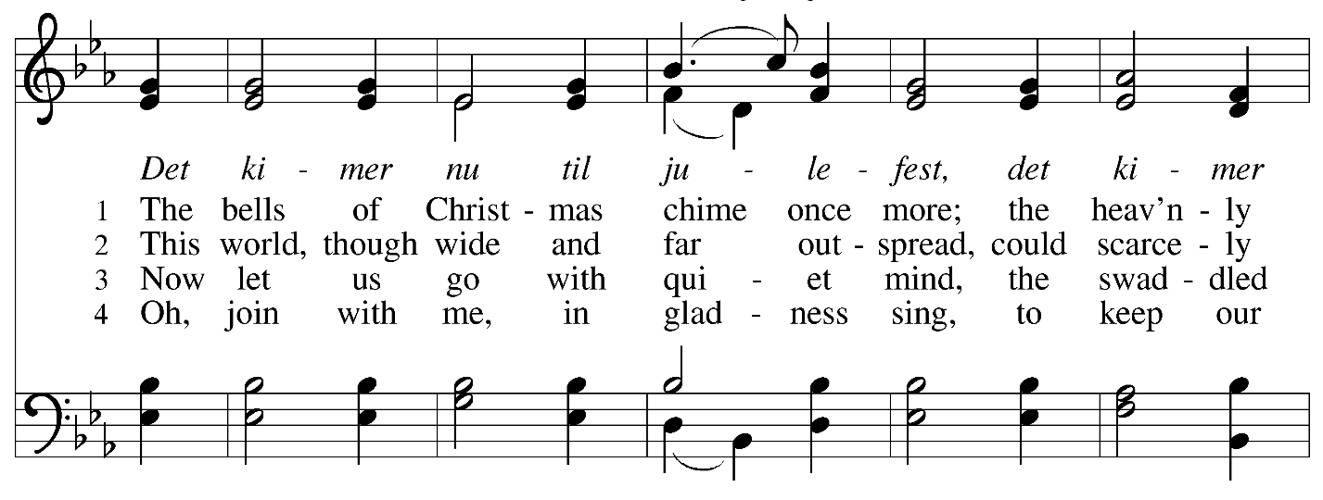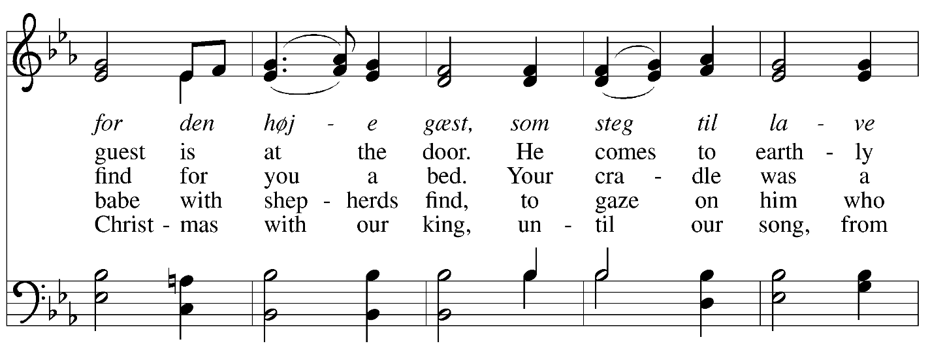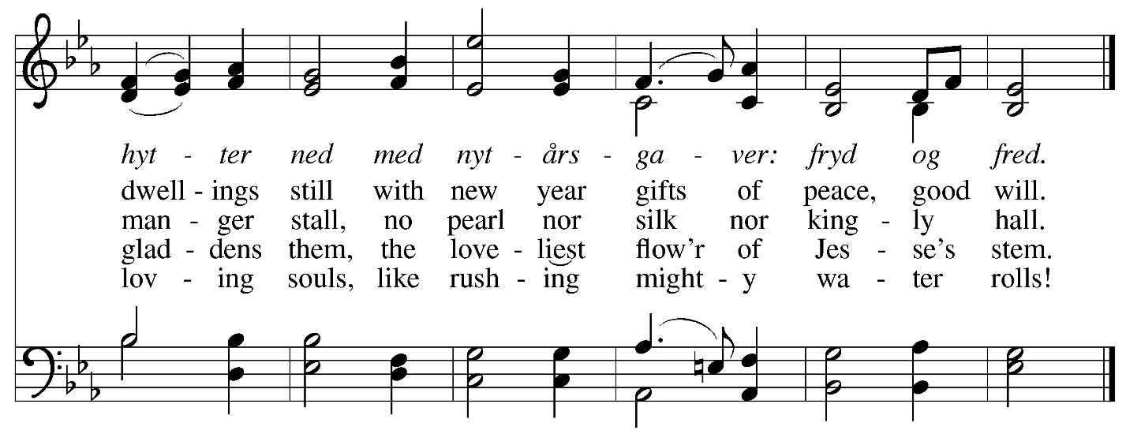

**Hymns during Holy Communion**

**Lo, How a Rose E’er Blooming *ELW* 272**

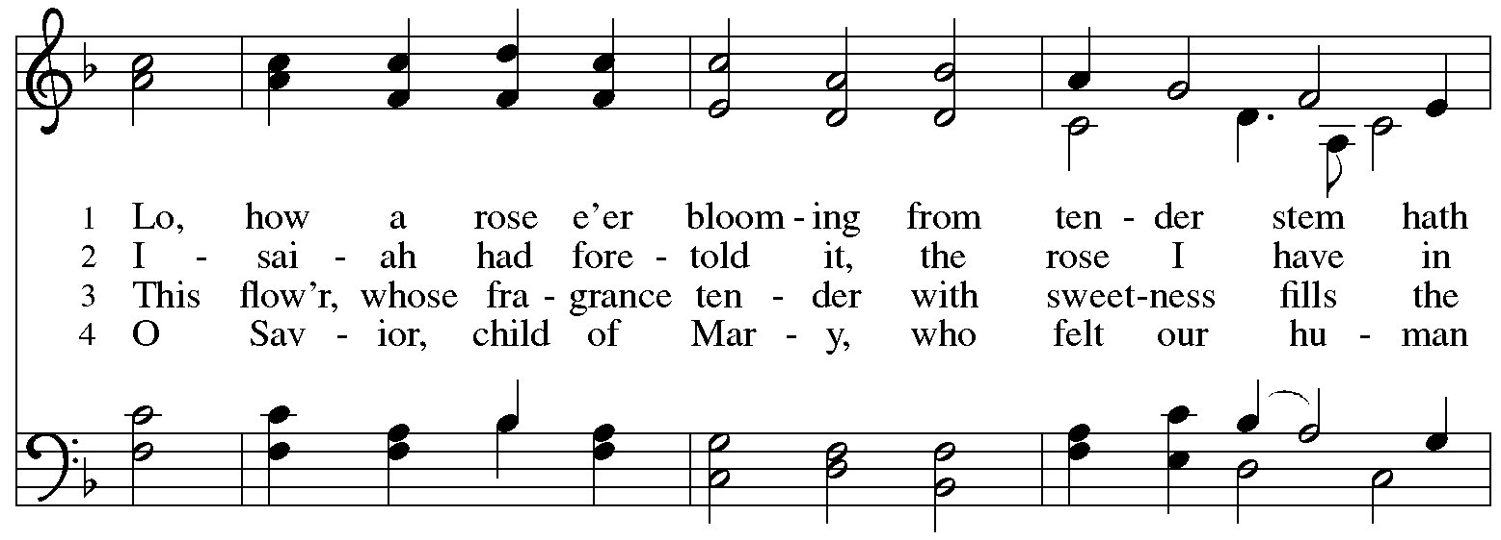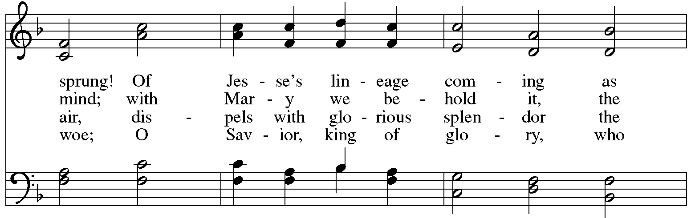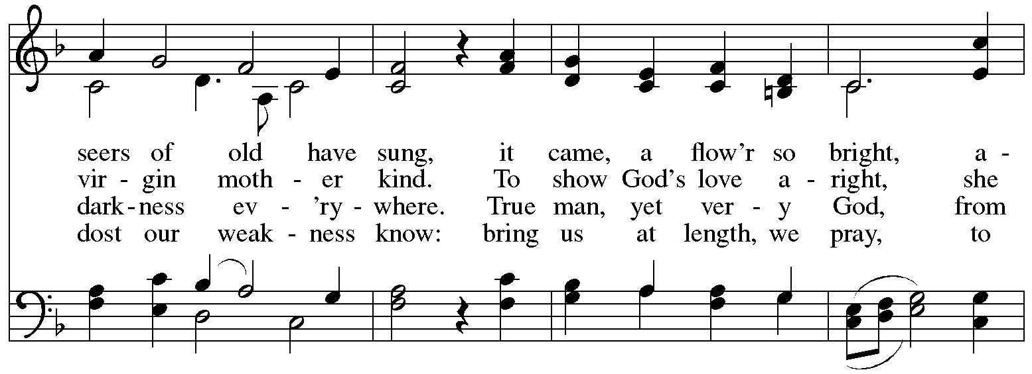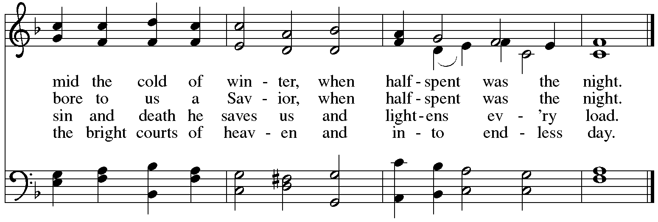

**Hymns during Holy Communion**

**What Child Is This *ELW* 296**

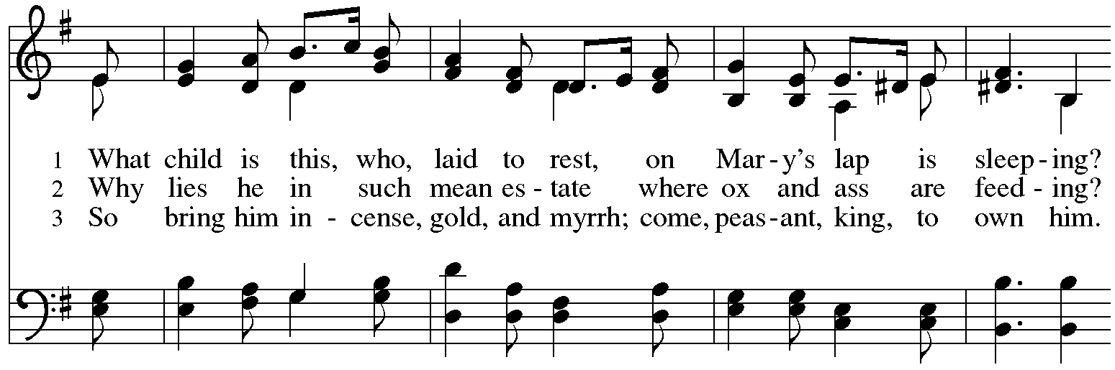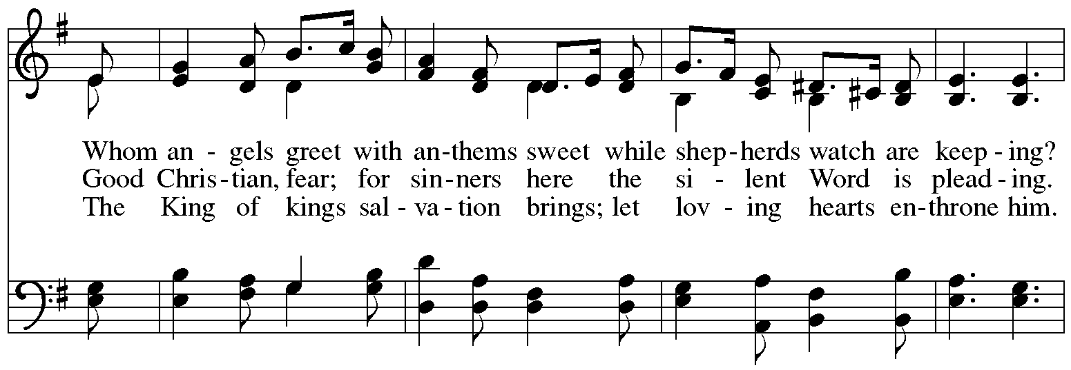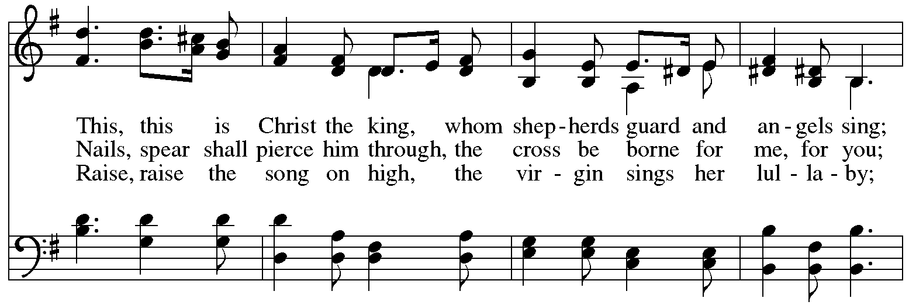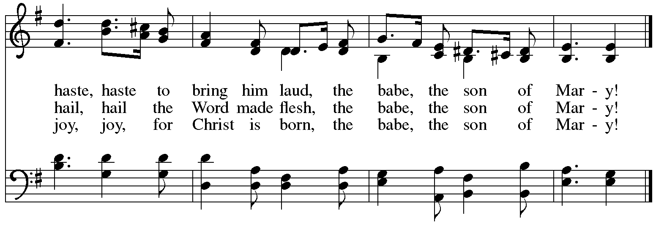

**Hymns during Holy Communion**

**Jesus, the Light of the World *ACS* 914**

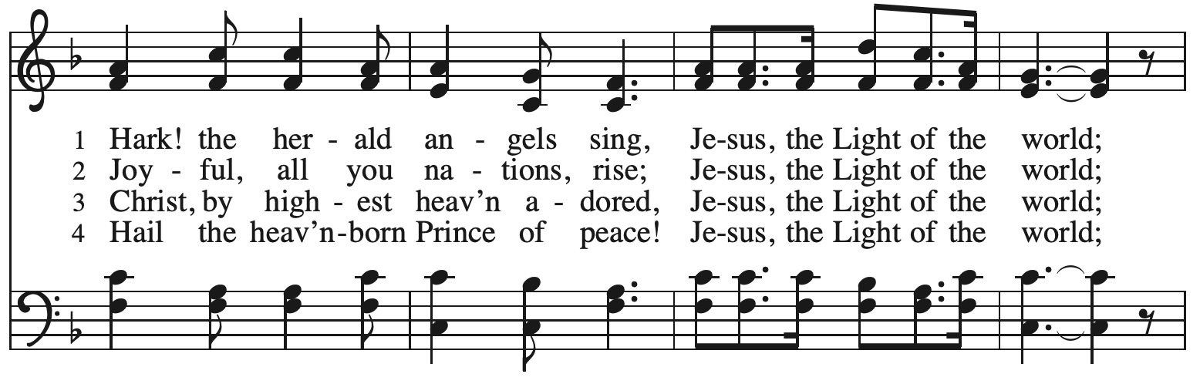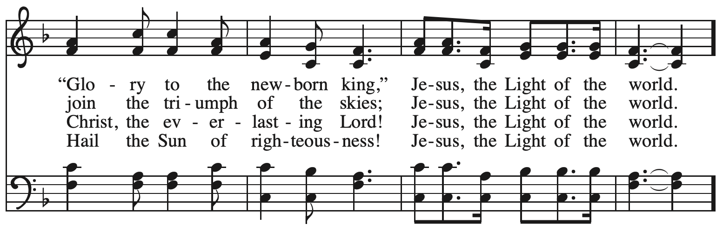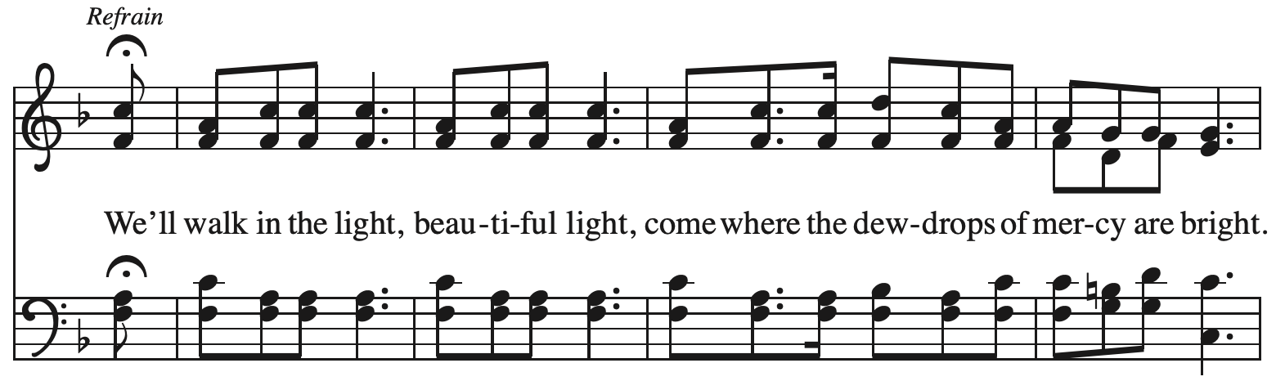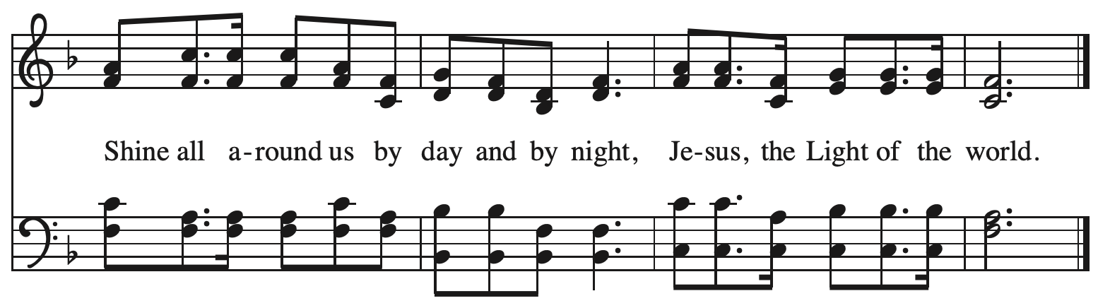



*When all have returned to their places, please rise as you are able.*

**Blessing**

P: The body and blood of our Lord Jesus Christ strengthen you and keep you in his grace.

**C: Amen.**

**Prayer**

A: Let us pray.

Radiant God, you have brought us your salvation,

and in this meal, we have feasted on your grace.

May your Word take flesh in us, that we may be your holy people,

revealing your glory made known to us in Jesus Christ, our Savior and Lord.

**C: Amen.**

*Please be seated.*

**Sending**

*God blesses us and sends us in mission to the world*

**Announcements**

*Please rise as you are able.*

**Epiphany Gospel – Matthew 2: 1-12**

P: The holy Gospel according to St. Matthew.

**C: Glory to you, O Lord.**

1 In the time of King Herod, after Jesus was born in Bethlehem of Judea, magi from the East came to Jerusalem, 2 asking, “Where is the child who has been born king of the Jews? For we observed his star at its rising, and have come to pay him homage.” 3 When King Herod heard this, he was frightened, and all Jerusalem with him; 4 and calling together all the chief priests and scribes of the people, he inquired of them where the Messiah was to be born. 5 They told him, “In Bethlehem of Judea; for so it has been written by the prophet:  
 6 ‘And you, Bethlehem, in the land of Judah,  
  are by no means least among the rulers of Judah;  
 for from you shall come a ruler  
  who is to shepherd my people Israel.’ ”  
  7 Then Herod secretly called for the magi and learned from them the exact time when the star had appeared. 8 Then he sent them to Bethlehem, saying, “Go and search diligently for the child; and when you have found him, bring me word so that I may also go and pay him homage.”

9 When they had heard the king, they set out; and there, ahead of them, went the star that they had seen at its rising, until it stopped over the place where the child was. 10 When they saw that the star had stopped, they were overwhelmed with joy. 11 On entering the house, they saw the child with Mary his mother; and they knelt down and paid him homage. Then, opening their treasure chests, they offered him gifts of gold, frankincense, and myrrh. 12 And having been warned in a dream not to return to Herod, they left for their own country by another road.

P: The Gospel of the Lord.

**C: Praise to you, O Christ.**

**Prayer**

P: The Lord be with you.

**C: And also with you.**

P: O God, you revealed your Son to the nations by the leading of a star. Lead us now by faith

to know your presence in our lives, and bring us at last to the full vision of your glory,

through your Son, Jesus Christ, our Savior and Lord, who lives and reigns

with you and the Holy Spirit, one God, now and forever.

**C: Amen.**

**Benediction**

P: God bless you and keep you,

☩ Jesus grant you grace and truth,

and the Spirit send peace upon your hearts,

now and forever.

**C: Amen.**

**Sending Hymn *Following page***

**Dismissal**

A: Go in peace. Share the good news!

**C: Thanks be to God!**

**Postlude**

**Sending Hymn Brightest and Best of the Stars *ELW* 303**

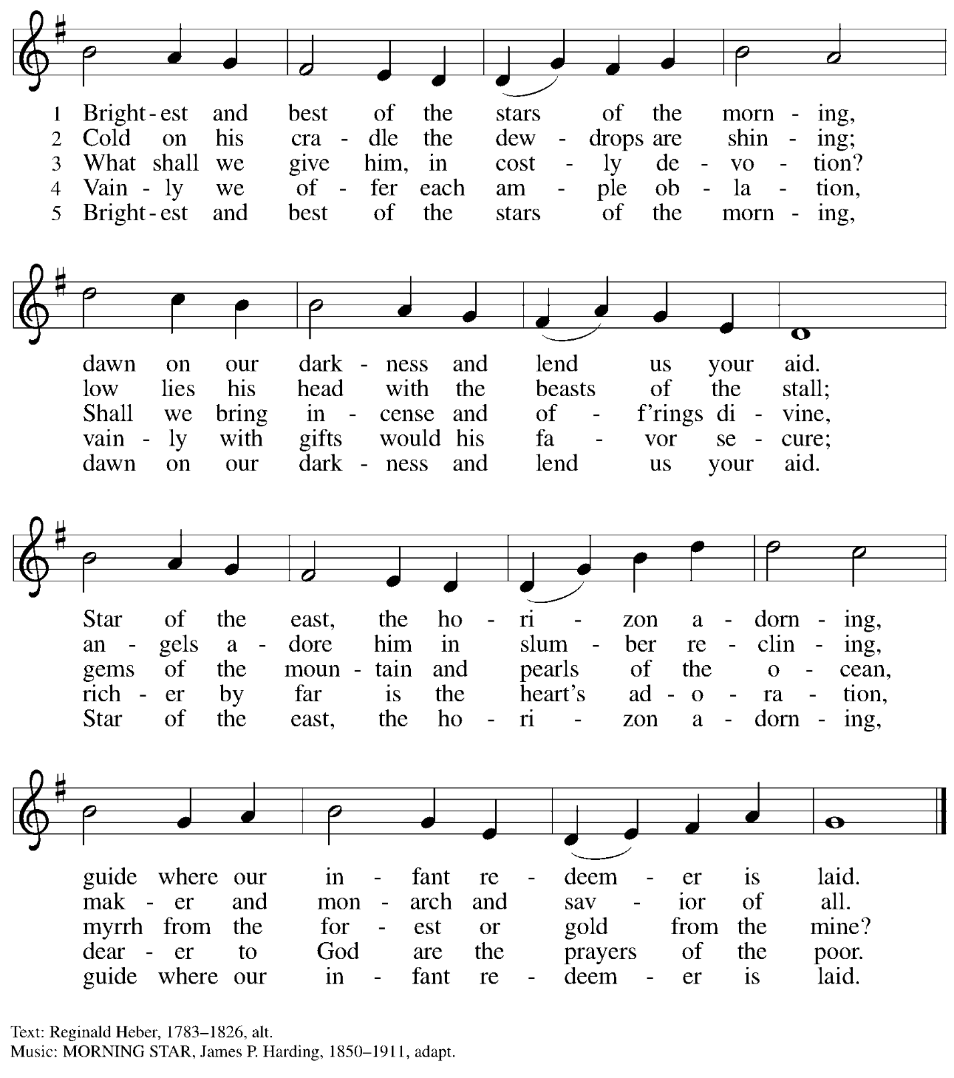

*Those serving in worship*

Altar Care Christy Ruhe

Assisting Minister Colleen Cooke

Audio-Visual Minister Sarita

David Rollinson

Cantor Miriam Bohlmann Kunz

Clarinet Maria Mangano

Euphonium David Rollinson

Lector Sue Gaugler

Little Church – Big Faith Teacher Ty Best

Piano Andrew

Trumpet Kai

Minister of Music Laura Reynolds

Presiding and Preaching Minister The Rev. Ross I. Carmichael

*Liturgy and Hymnody Acknowledgements*

From SundaysandSeasons.com. Copyright © 2025 Augsburg Fortress. All rights reserved. Reprinted under OneLicense.net # A-722139.

Used by permission of Augsburg Fortress.

The Scripture readings contained herein are from *New Revised Standard Version* of the Bible © 1989, Division of Christian Education of the National Council of Churches of Christ in the USA. Used by permission. All rights reserved.

**Angels We Have Heard on High** – Text: French carol; tr. H. F. Hemy, *The Crown of Jesus Music*, 1864. Music: GLORIA, French carol; arr. Edward F. Barnes, 1881-1958.

**Palabra que fue luz el primer día - The Word Who Sang Light into Creation** – Alberto Taulé, 1932-2007; tr. Martin A. Seltz, b. 1951. Music: PALABRA VIVA, Alberto Taulé. Text and music © 1982, 2000, Alberto Taulé. Published by OCP, 5536 N Hassalo, Portland, OR 97213. All rights reserved. Reprinted with permission under One License.net # A-722139.

**Lo, How a Rose E’er Blooming**



**What Child Is This**



*Please use the QR code below to link to St. Andrew’s Announcements online!*



**St. Andrew Lutheran Church Announcements**

**January 5th, 2024**

* **Welcome to worship at St. Andrew on the Second Sunday of Christmas, January 5th, 2024** – **+ The Epiphany of our Lord (Jan. 6th) will also be observed during worship today** – We are so glad you are here, and we offer a special welcome to all guests who are gathered here or online! There are worship “toolkits” to help children engage with worship and “busy bags” for younger children available in the bookcase at the back of the sanctuary. Please feel free to take one to use with/for your children.
* **Monthly Reparations Offering Today during Worship** – Jesus’ parable from Luke’s Gospel about a compassionate Samaritan provides an example of how God's people are called to work for healing and repair for our neighbors, regardless of who or what caused them harm. In light of this, St. Andrew has made a commitment to reparations in regard to African American spiritual songs used in our worship. The text and music of most hymns is attributed to specific authors, with copyrights in place, usage reported, and royalties paid to those whose works are featured in worship. With African American spirituals, this is not possible. In response to many years of such uncredited use, St. Andrew invites the congregation to give a reparations offering. Funds received in worship will be donated to our siblings at Bethel AME Church, whose land and building were taken from them in the 1950s, to fund their development in the lower Hill District.
* **January Produce Distribution – First Tuesday of the Month, January 7th, 2025, from 5:30-7:00 p.m. –** St. Andrew partners with Greater Pittsburgh Community Food Bank to serve as a distribution site for fresh produce on the first Tuesday of every month. January’s distribution will be on Tuesday, January 7th. We invite people of the congregation to help with the distribution from 5:30-7:00 p.m. and/or to help with unloading and setup during the day between 10:00 a.m. and 1:00 p.m.
* **Bible Book Club Resumes Wednesday, January 8th –** The group is reading *On the Road with Saint Augustine: A Real-World Spirituality for Restless Hearts* by James K.A. Smith. Anyone who would like to join in the discussions is welcome. Please contact Pastor Ross for the Zoom link. Our next book will be *Traveling Mercies* by Anne Lamott.
* **Shelter Dinner for Guests of East End Cooperative Ministry, Third Thursday of the Month – January 16th, 2025, 6:00 p.m. Arrival, 6:30 p.m. Dinner –** Each month, people of St. Andrew provide dinner for guests of East End Cooperative Ministry (EECM), 6140 Station St. (East Liberty), 15206. We invite you to prepare or purchase one menu item and bring it to the shelter by 6:00 p.m., or just come to help serve at 6:30 p.m. If you would like to contribute, please sign up here: <https://www.signupgenius.com/go/5080544AAAC22A1F58-54144529-shelter>.
* **Bagged Lunches to Accompany January Shelter Dinner – Seeking Additional Donations! – East End Cooperative Ministry is hosting an additional 20 people this winter because of the shelter shortage and we have been asked to bring items for 20 bagged lunches on St. Andrew’s Shelter Dinner night, Thursday, January 16th. Bagged lunches will include sandwiches, individual bags of chips, individually wrapped desserts, and fruit cups with soft fruit for those with dental sensitivities. Shelf-stable items can be left on the donation table in the Social Hall by Sunday, January 12th, or delivered to EECM on Thursday, January 16th. Please label “For EECM Lunches.” Sandwiches should be delivered to EECM any time on the 16th until 6:00 p.m. Please label “For St. Andrew bagged lunches. Shelter staff will assemble the bagged lunches. Much work goes into shopping for and preparing the main meal each month, so we would greatly appreciate new participants and contributions for this effort! If you would like to help, please sign up at** <https://www.signupgenius.com/go/5080544AAAC22A1F58-54144594-baglunch>.
* ***Christ in Our Home* Devotional Booklets for January - March Available at Church Entrances** – This resource offers a daily Bible reading with a short reflection and prayer, along with additional readings and prayer topics for those who would like to expand their devotional practices. We encourage people of the congregation to take one for yourself, your family unit, or others!