

**+ The Baptism of our Lord**

**January 12th, 2025**

**10:00 a.m.**



**St. Andrew Lutheran Church**

**304 Morewood Ave.**

**Pittsburgh, PA 15213**

**412.682.3342**

[**St_andrewELCA@verizon.net**](mailto:St_andrewELCA@verizon.net)

[**www.standrewpittsburgh.org**](http://www.standrewpittsburgh.org)

**+ The Baptism of our Lord**

**Order for Worship**

*Today’s festival rejoices in God’s blessings. The church recalls and celebrates our adoption as God’s children, the gift of the Holy Spirit, and the promised company of almighty God when we “pass through the waters … the rivers … fire.” On this day the heavens open again on this assembly, and we receive the gift of God’s Beloved, Jesus, in Word, wine, and bread.*

**Welcome to St. Andrew!**

* St. Andrew welcomes all who are seeking a place of healing, wholeness, and acceptance in a nurturing and faith-forming spiritual home. We are striving toward racial equity worldwide

and we seek to honor the lived experience of all individuals regardless of background. Our community embraces people of all ages, ethnicities, cultures, abilities, sexual orientations,

gender identities and expressions, and family constellations. Come and See!

* Worship Services are live-streamed to multiple online platforms. By attending worship, you agree that your image and voice may be broadcast.
* Everyone is invited to make a name tag at the black bookcase in the back of the worship space if they would like. There are stickers indicating pronouns on the bookcase if you would like to include them on your name tag.
* Children are invited to attend Little Church – Big Faith, a Bible lesson and activity, during worship (after the Prayer of the Day). The group returns to the worship space for the liturgy of Holy Communion.
* A nursery is available through the doors at the left side of the sanctuary and across from the doorway to the Social Hall. Look for a purple-colored room.
* Worship “toolkits” to help children engage with the service, along with “busy bags” for younger children, are available in the bookcase at the back of the sanctuary. Please feel free to take one to use with/for your children.
* Holy Communion is served with bread (gluten-free available) and wine or grape juice. The presiding minister will distribute the bread (host). Please consume this and then pick up an empty glass from the tray. The Communion Assistant will pour wine or grape juice into your glass. Please step to the side to consume the wine or grape juice. Feel free to kneel at the altar for prayer and reflection. As you return to your pew, glasses may be returned to the empty trays on either side of the center section.
* A restroom is available on the main level of the church, through the doors to the Social Hall and to the right in the main office.

*Abbreviations*

P: Pastor/Presiding Minister ***ELW*: *Evangelical Lutheran Worship* hymnal**

A: Assisting Minister ***ACS*: *All Creation Sings* hymnal**

L: Lector

**C: Congregation**

**Pre-Service Music**

**Welcome**

**Prelude**

**Gathering**

*The Holy Spirit calls us together as the people of God*

**Thanksgiving for Baptism**

*Please rise as you are able. All may make the sign of the cross,*

*the sign that is marked at Baptism, as the presiding minister begins.*

P: Blessed be the holy Trinity, ☩ one God,

the fountain of living water, the rock who gave us birth,

our light and our salvation.

**C: Amen.**

P: Joined to Christ in the waters of Baptism, we are clothed with God’s mercy and forgiveness. Let us give thanks for the gift of Baptism.

*Water may be poured into the font as the presiding minister gives thanks.*

P: We give you thanks, O God, for in the beginning you created us in your image and placed us in a well-watered garden. In the desert, you promised pools of water for the parched, and you gave us water from the rock. When we did not know the way, you sent the Good Shepherd to lead us to still waters. At the cross, you washed us from Jesus’ wounded side, and on this day, you shower us again with the water of life.

We praise you for your salvation through water, for the water in this font,

and for water everywhere, including the Allegheny, Monongahela, and Ohio rivers.

Bathe us in your forgiveness, grace, and love.

Satisfy all who thirst, and give us the life only you can give.

To you be given honor and praise

through ☩ Jesus Christ, our living water,

in the unity of the Holy Spirit, now and forever.

**C: Amen.**

**Gathering Hymn Songs of Thankfulness and Praise *ELW* 310**

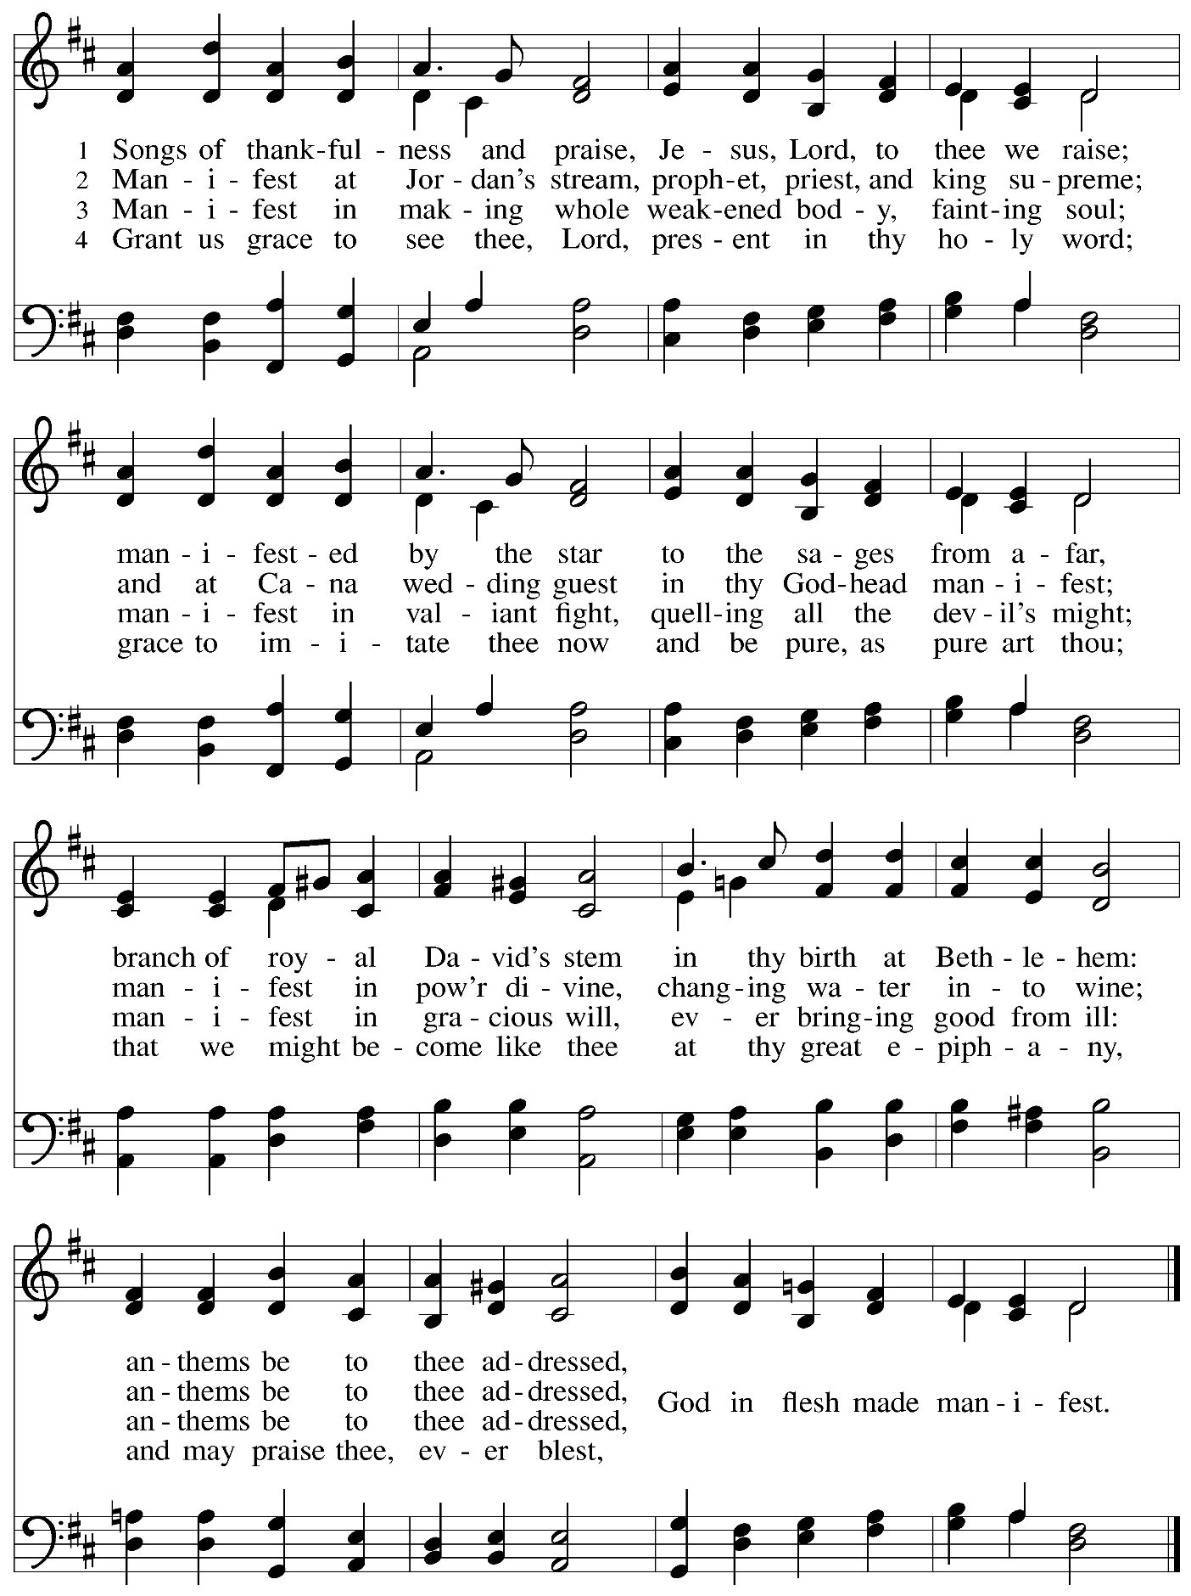

**Greeting**

P: The grace of our Lord Jesus Christ, the love of God,

and the communion of the Holy Spirit be with you all.

**C: And also with you.**

**Kyrie** *ACS* p. 12

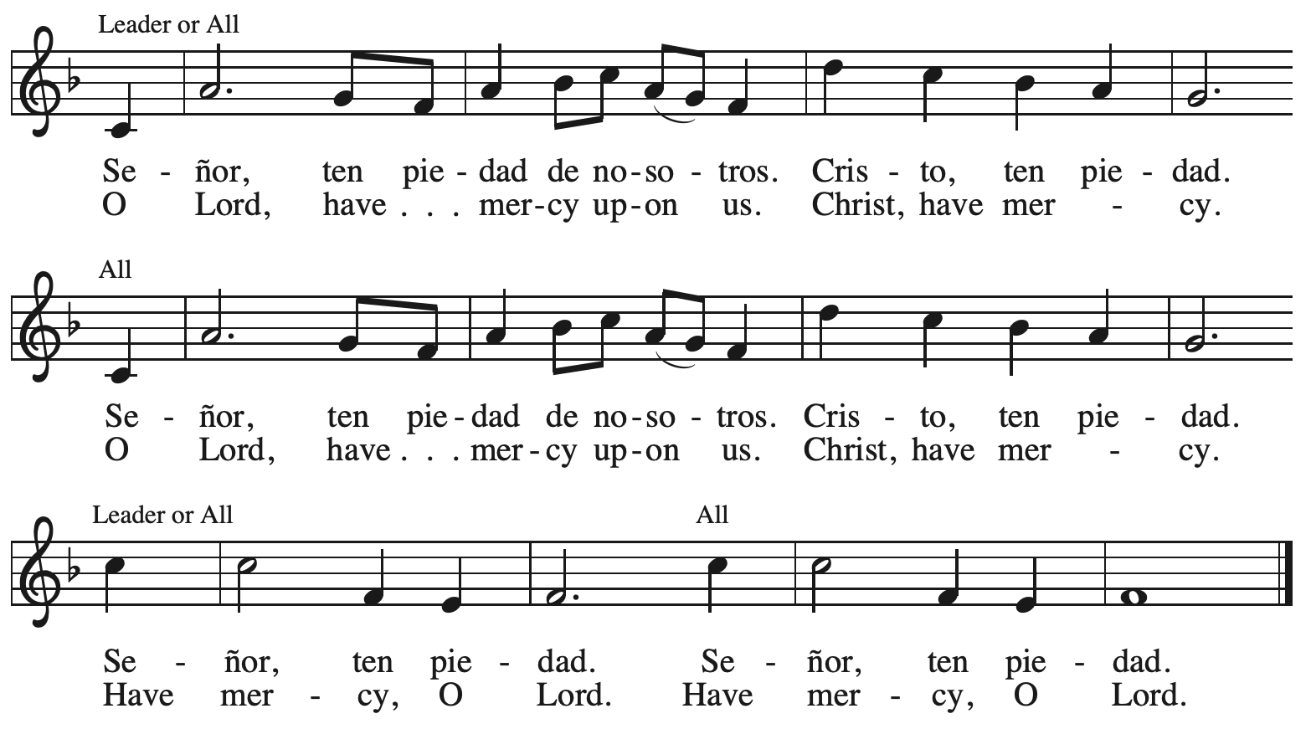



**Hymn of Praise** *ACS* p. 12

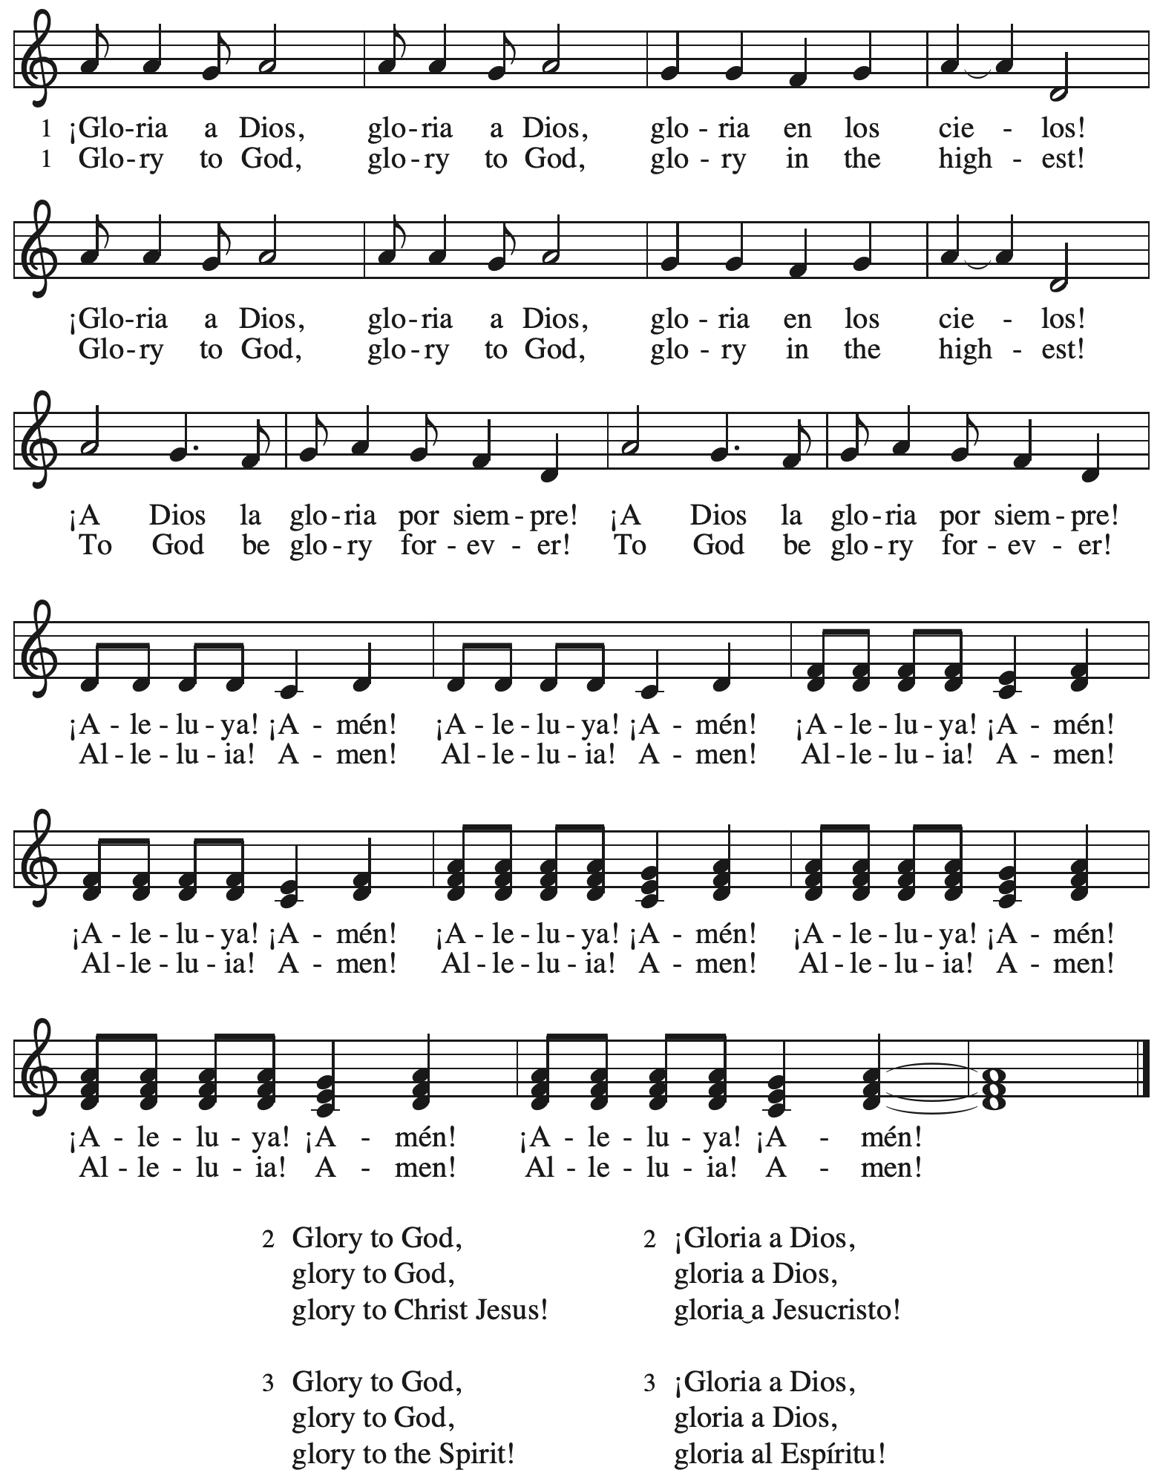

**Prayer of the Day**

P: The Lord be with you.

**C: And also with you.**

P: Let us pray.

Almighty God,

you anointed Jesus at his baptism with the Holy Spirit and revealed him as your beloved Son.

Keep all who are born of water and the Spirit faithful in your service,

that we may rejoice to be called children of God,

through Jesus Christ, our Savior and Lord,

who lives and reigns with you and the Holy Spirit,

one God, now and forever.

**C: Amen.**

*Please be seated.*

**Word**

*God speaks to us in Scripture reading, preaching, and song*

**First Reading** **– Isaiah 43: 1-7**

 1 But now thus says the Lord,  
  the one who created you, O Jacob,  
  the one who formed you, O Israel:  
 Do not fear, for I have redeemed you;  
  I have called you by name, you are mine.  
 2 When you pass through the waters, I will be with you;  
  and through the rivers, they shall not overwhelm you;  
 when you walk through fire you shall not be burned,  
  and the flame shall not consume you.  
 3 For I am the Lord your God,  
  the Holy One of Israel, your Savior.  
 I give Egypt as your ransom,  
  Ethiopia and Seba in exchange for you.  
 4 Because you are precious in my sight,  
  and honored, and I love you,  
 I give people in return for you,  
  nations in exchange for your life.  
 5 Do not fear, for I am with you;  
  I will bring your offspring from the east,  
  and from the west I will gather you;  
 6 I will say to the north, “Give them up,”  
  and to the south, “Do not withhold;  
 bring my sons from far away  
  and my daughters from the end of the earth—  
 7 everyone who is called by my name,  
  whom I created for my glory,  
  whom I formed and made.”

L: Word of God, word of life.

**C: Thanks be to God.**

**Psalm 29**

*The cantor will lead the singing of the psalm.*

*The congregation is invited to respond with the alternate verses in bold print,*

*and to join in singing the refrain.*

*Psalm Tone*

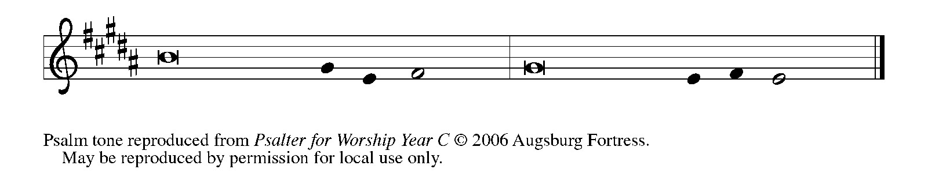

*Psalm Refrain*

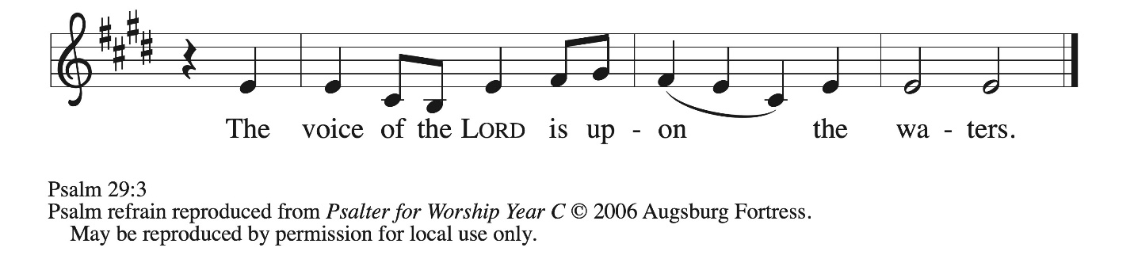

1 Ascribe to the **|** Lord, you gods,  
  ascribe to the Lord glo- **|** ry and strength.  
 2 **Ascribe to the Lord the glory | due God’s name;**  
  **worship the Lord in the beau- | ty of holiness.**  
 3 The voice of the Lord is upon the waters; the God of **|** glory thunders;  
  the Lord is upon the **|** mighty waters.  
 4 **The voice of the Lord is a pow- | erful voice;**  
  **the voice of the Lord is a | voice of splendor. R**  
 5 The voice of the Lord breaks the **|** cedar trees;  
  the Lord breaks the ce- **|** dars of Lebanon;  
 6 **the Lord makes Lebanon skip | like a calf,**  
  **and Mount Hermon like a | young wild ox.**  
 7 The voice **|** of the Lord  
  bursts forth in **|** lightning flashes.  
 8 **The voice of the Lord | shakes the wilderness;**  
  **the Lord shakes the wilder- | ness of Kadesh. R**  
 9 The voice of the Lord makes the oak trees writhe and strips the **|** forests bare.  
  And in the temple of the Lord all are **|** crying, “Glory!”  
 10 **The Lord sits enthroned a- | bove the flood;**  
  **the Lord sits enthroned as king for- | evermore.**  
 11 O Lord, give strength **|** to your people;  
  give them, O Lord, the bless- **|** ings of peace.**R**

**Second Reading – Acts 8: 14-17**

14 Now when the apostles at Jerusalem heard that Samaria had accepted the word of God, they sent Peter and John to them. 15 The two went down and prayed for them that they might receive the Holy Spirit 16 (for as yet the Spirit had not come upon any of them; they had only been baptized in the name of the Lord Jesus). 17 Then Peter and John laid their hands on them, and they received the Holy Spirit.

L: Word of God, word of life.

**C: Thanks be to God.**

*Please rise as you are ab and join in singing the Gospel Acclamation.*

**Gospel Acclamation** *ACS* p. 14

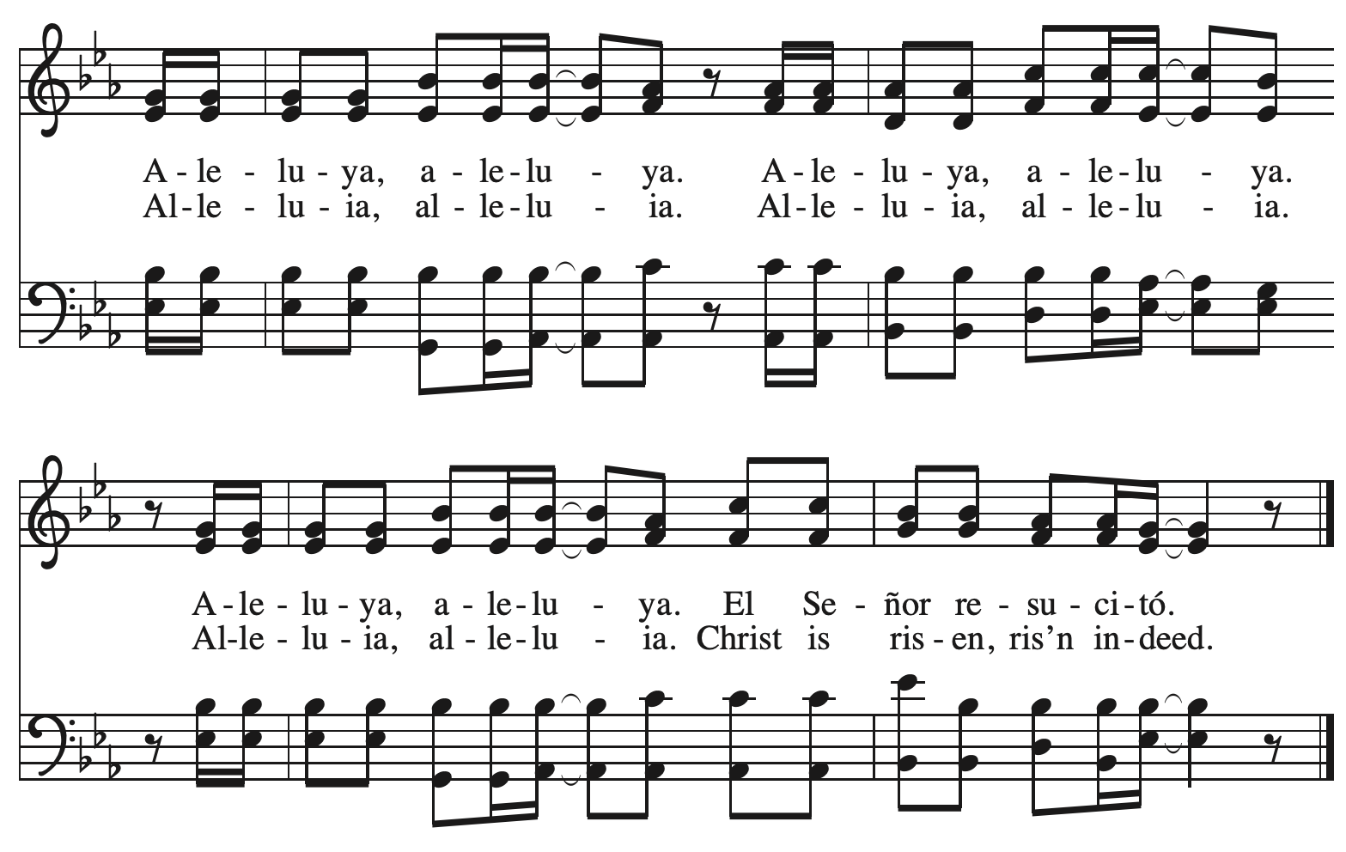

**Gospel – Luke 3: 15-17, 21-22**

P: The holy Gospel according to St. Luke.

**C: Glory to you, O Lord.**

15 As the people were filled with expectation, and all were questioning in their hearts concerning John, whether he might be the Messiah, 16 John answered all of them by saying, “I baptize you with water; but one who is more powerful than I is coming; I am not worthy to untie the thong of his sandals. He will baptize you with the Holy Spirit and fire. 17 His winnowing fork is in his hand, to clear his threshing floor and to gather the wheat into his granary; but the chaff he will burn with unquenchable fire.”  
  
  21 Now when all the people were baptized, and when Jesus also had been baptized and was praying, the heaven was opened, 22 and the Holy Spirit descended upon him in bodily form like a dove. And a voice came from heaven, “You are my Son, the Beloved; with you I am well pleased.”

P: The Gospel of the Lord.

**C: Praise to you, O Christ.**

*Please be seated.*

**Sermon**

*A time of silence for prayer and reflection follows the sermon.*

*As the hymn of the day begins, please rise as you are able.*



**Hymn of the Day When Jesus Came to Jordan *ELW* 305**

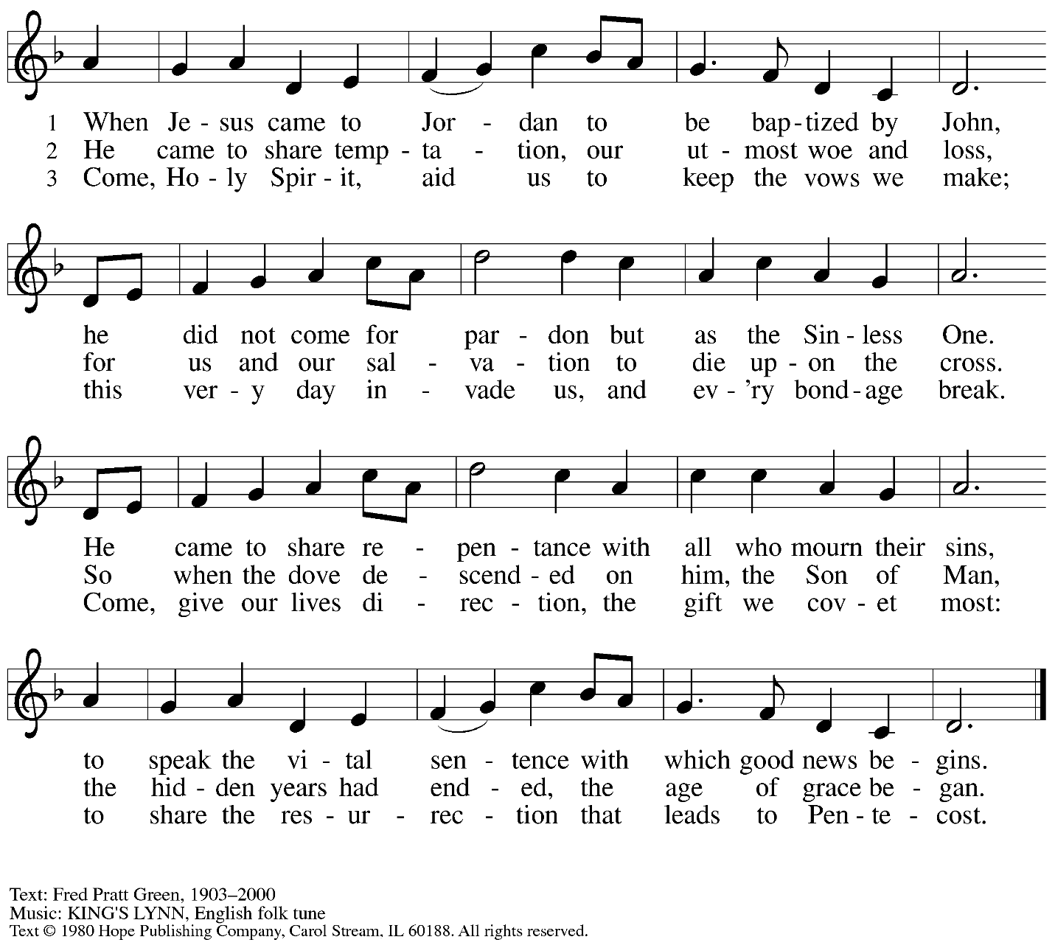

Reprinted with permission under OneLicense.net # A-722139.

**Apostles’ Creed**

**C: I believe in God, the Father almighty,**

**creator of heaven and earth.**

**I believe in Jesus Christ, God’s only Son, our Lord,**

**who was conceived by the Holy Spirit,**

**born of the virgin Mary,**

**suffered under Pontius Pilate,**

**was crucified, died, and was buried;**

**he descended to the dead.\***

**On the third day he rose again;**

**he ascended into heaven,**

**he is seated at the right hand of the Father,**

**and he will come to judge the living and the dead.**

**I believe in the Holy Spirit,**

**the holy catholic church,**

**the communion of saints,**

**the forgiveness of sins,**

**the resurrection of the body,**

**and the life everlasting. Amen.**

*Or, “he descended into hell,” another translation of this text in widespread use.

**Prayers of the People**

A: Guided by the Holy Spirit, with the light of Christ shining upon us and all nations,

let us pray for the church, the world, and all creation.

*After each petition*

A: Gracious God,

**C: receive our prayer.**

*The presiding minister concludes the prayers*

P: We entrust these prayers to you, O God, in the sure and certain hope

that your promise is revealed among your people.

**C: Amen.**

**Peace**

*The presiding minister and the assembly greet one another in the peace of the risen Christ.*

P: The peace of Christ be with you always.

**C: And also with you.**

*The people may greet those around them with a sign of Christ’s peace and may say*

Peace be with you *or similar words. Please be mindful that not everyone will be comfortable with sharing the peace, so please seek consent before shaking hands or hugging. Other possible ways to share the peace include a simple bow with the verbal greeting of peace, or simply a verbal expression of peace. When the greetings of peace have concluded, please be seated.*

**Meal**

*God feeds us with the presence of Jesus Christ*

**Offering**

*We offer ourselves, our gifts, and our faithful service to God.*

*As the offering is gathered for the mission of the church, including the care of those in need,*

*the table is set for Holy Communion.*

**Music during the Offering**

*As the gifts are brought forward for presentation,* *please rise as you are able.*

**Offertory Song** **Cuando el pobre / When the Poor Ones *ELW*** **725**

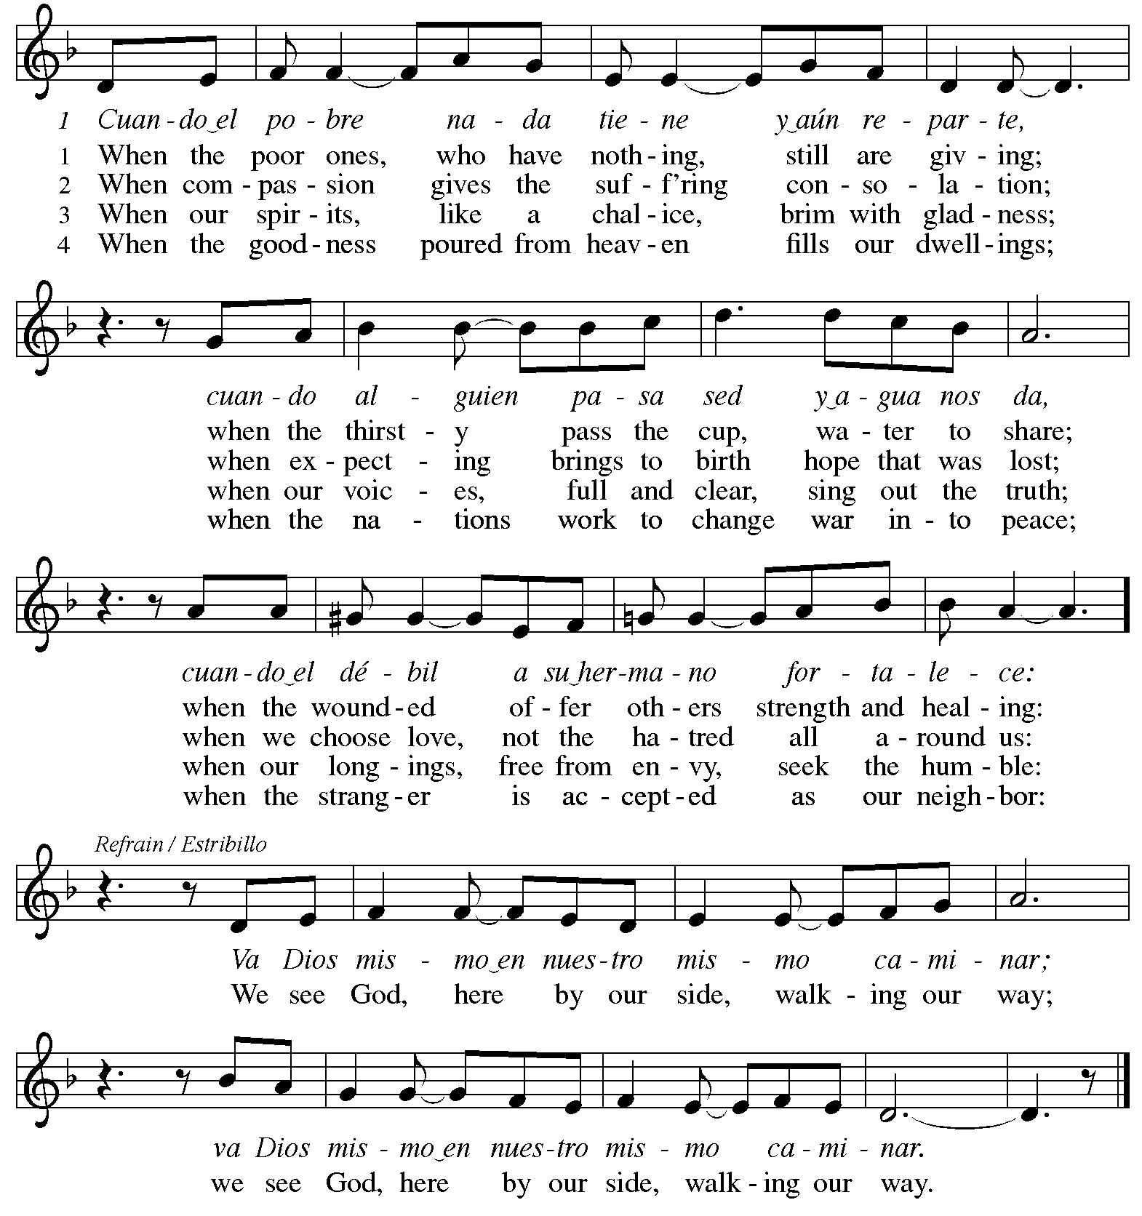

**Offertory Prayer**

A: Let us pray.

Holy God, gracious and merciful,

**C:** **you bring forth food from the earth and nourish your whole creation.**

**Turn our hearts toward those who hunger in any way, that all may know your care;**

**and prepare us now to feast on the bread of life, Jesus Christ, our Savior and Lord.**

**Amen.**

**Dialogue** *ACS* p. 20

P: The Lord be with you.

**C: And also with you.**

P: Lift up your hearts.

**C: We lift them to the Lord.**

P: Let us give thanks to the Lord our God.

**C: It is right to give our thanks and praise.**

**Preface** *ACS* p. 20

P: It is indeed right, our duty and our joy,

that we should at all times and in all places

give thanks and praise to you, almighty and merciful God,

through our Savior Jesus Christ.

By the leading of a star he was shown forth to all nations;

in the waters of the Jordan you proclaimed him your beloved Son;

and in the miracle of water turned to wine he revealed your glory.

And so, with all the choirs of angels,

with the church on earth and the hosts of heaven,

we praise your name and join their unending hymn:

**Sanctus** *ACS* p. 20

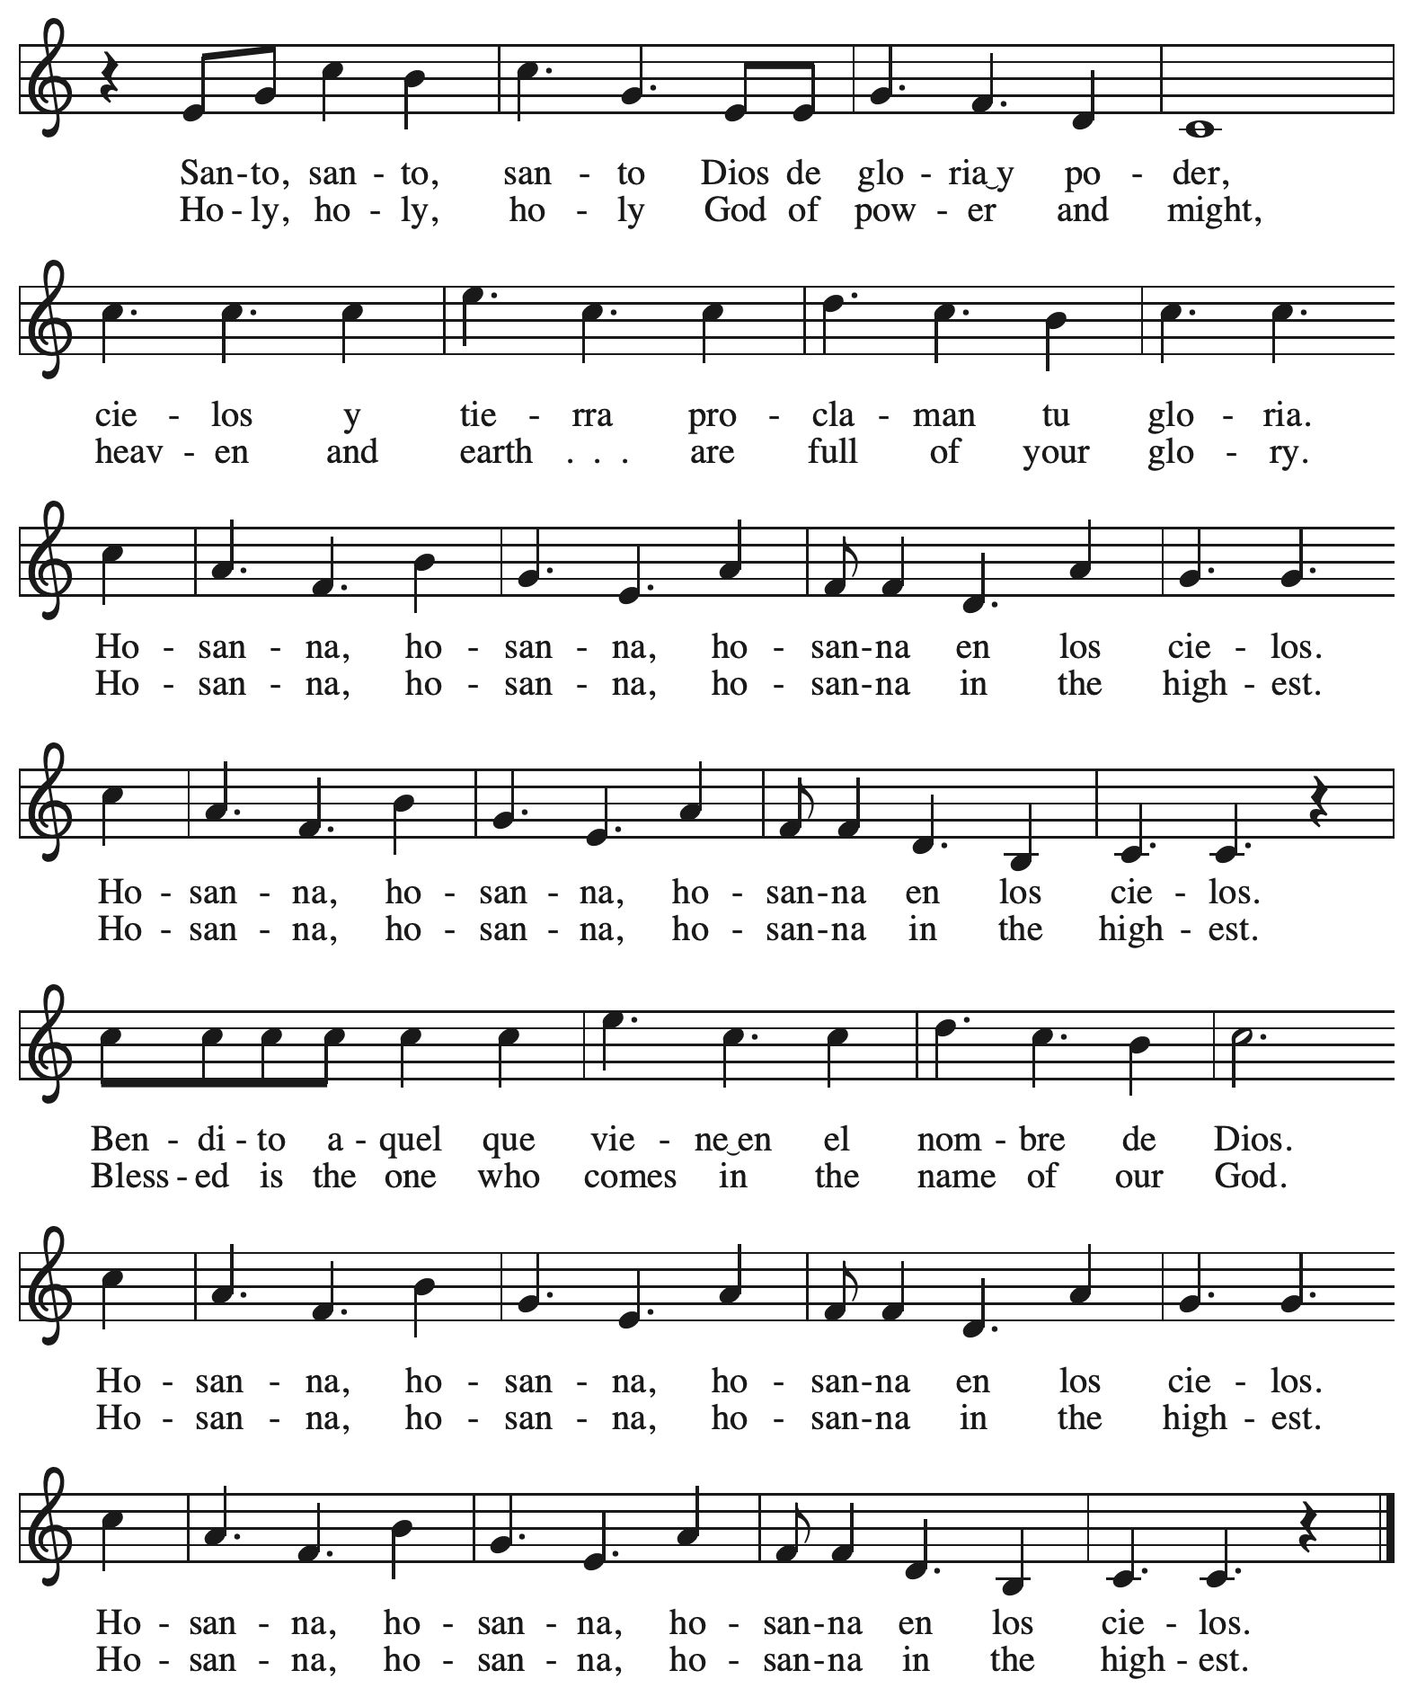

**Eucharistic Prayer** *ACS* p. 21

P: Holy God, you alone are holy … with every breath.

**C: We praise you, O God.**

P: Generations bless your faithfulness … into the future.

**C: We bless you, O God.**

P: We give you thanks for your dear Son … with us now.

**C: We thank you, O God.**

P: In the night in which he was betrayed … Do this for the remembrance of me.

Remembering his love for us

on the way, at the table, and to the end,

we proclaim the mystery of faith:

**C: Christ has died. Christ is risen. Christ will come again.**

P: We pray for the gift of your Spirit … in your church, without end.

**C: Amen.**

**Lord’s Prayer**

P: Gathered as one by the Holy Spirit, let us pray as Jesus taught us.

**C: Our Father in heaven,**

**hallowed be your name,**

**your kingdom come,**

**your will be done,**

**on earth as in heaven.**

**Give us today our daily bread.**

**Forgive us our sins**

**as we forgive those**

**who sin against us.**

**Save us from the time of trial**

**and deliver us from evil.**

**For the kingdom, the power,**

**and the glory are yours,**

**now and forever. Amen.**

**Fraction and Invitation**

P: The joy of the Lord is our strength.

Come and be nourished by the gifts of God.

***Agnus Dei /* Lamb of God** *ACS* p. 25

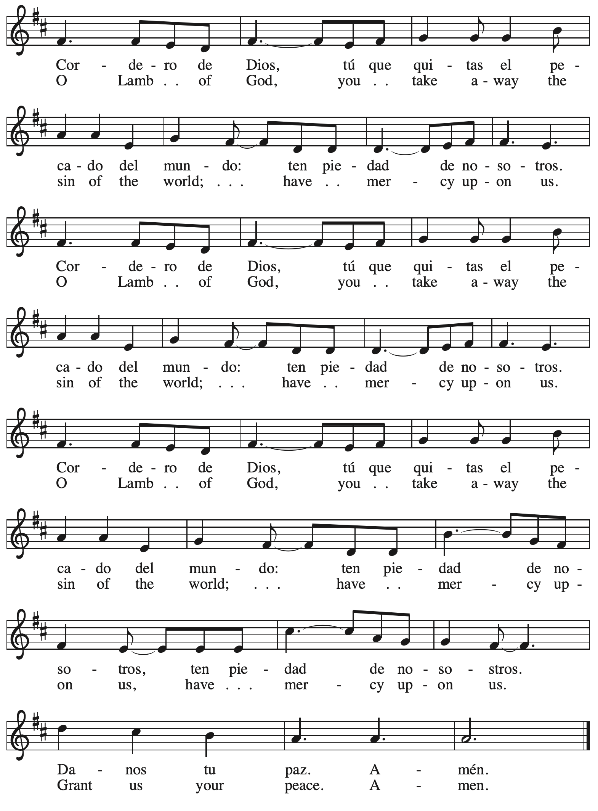

*Please be seated.*

**Holy Communion**

* *All who seek God and desire a deeper and stronger life in Christ are welcome to receive Holy Communion.*
* *Worshipers from the pulpit side will proceed forward first, followed by the center section, and then the lectern side.*
* *Please inform an usher if you would like the ministers to bring Communion to you.*
* *Holy Communion will be served with bread and wine/grape juice.*
* *The presiding minister will first distribute the bread (host) to each communicant. Please indicate if you require a gluten-free host.*
* *Once you have consumed the bread, please pick up an empty glass from the tray next to the presiding minister. The Communion Assistant will pour wine from the chalice or grape juice from the cruet into your glass.*
* *Please step to the side to consume the wine or grape juice.*
* *Feel free to kneel at the altar rail for prayer after receiving the sacrament.*
* *As you return to your pew, glasses may be returned to the empty trays on the side of the center section.*
* *A blessing will be provided for anyone who does not yet receive the sacrament.*
* *All are invited to join in singing the hymns during Holy Communion.*

**Hymns during Holy Communion**

**Come, Beloved of the Maker *ELW* 306**

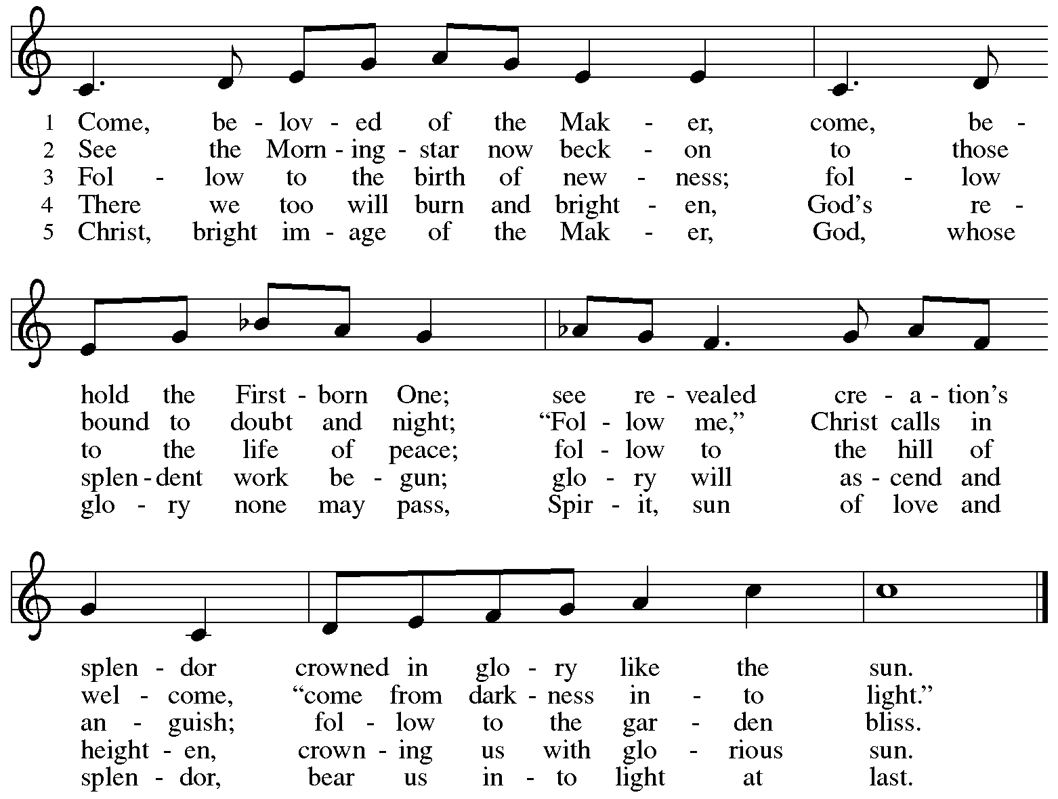

**Hymns during Holy Communion**

**Come Down, O Love Divine *ELW* 804**

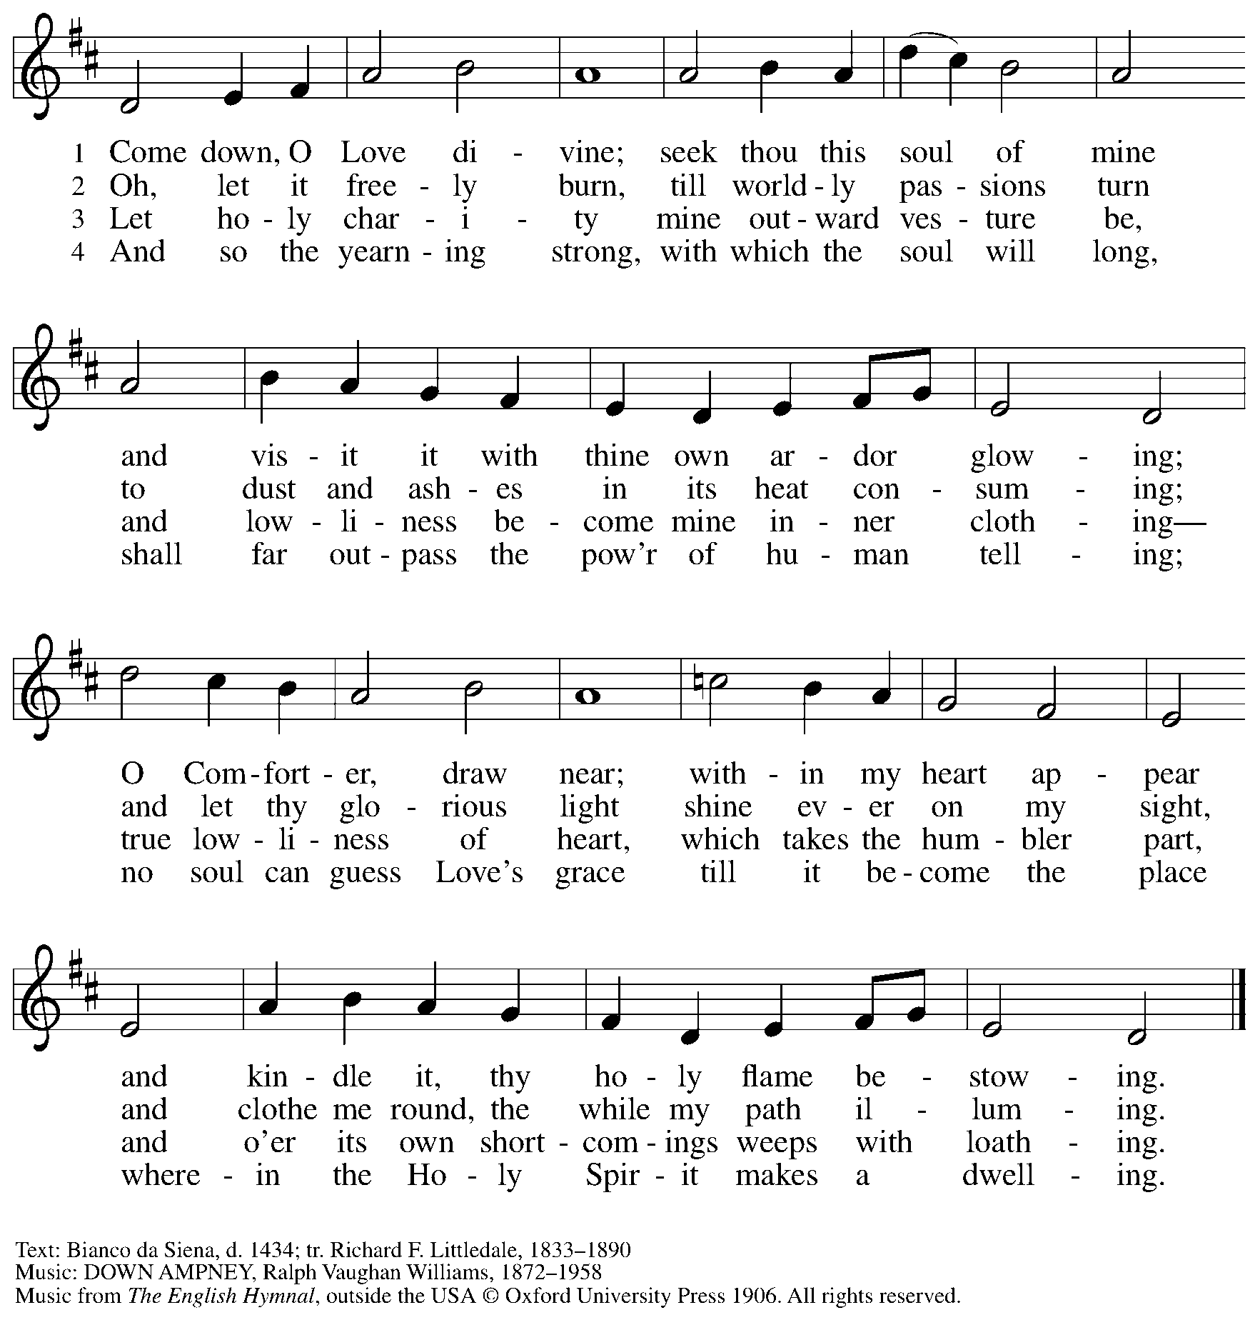

Reprinted with permission under OneLicense.net # A-722139.

**Hymns during Holy Communion**

**Crashing Waters at Creation *ELW* 455**

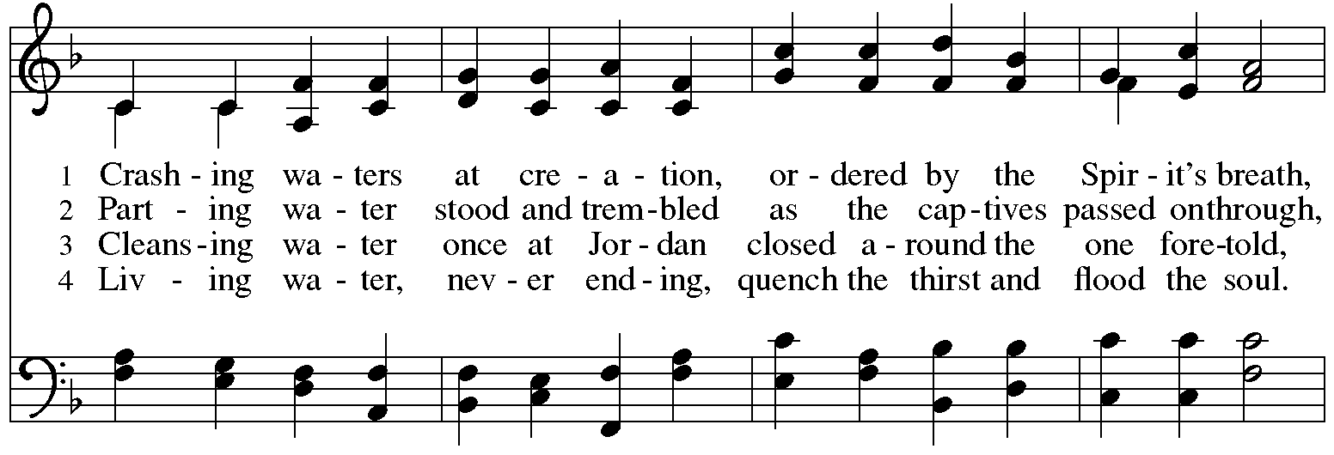

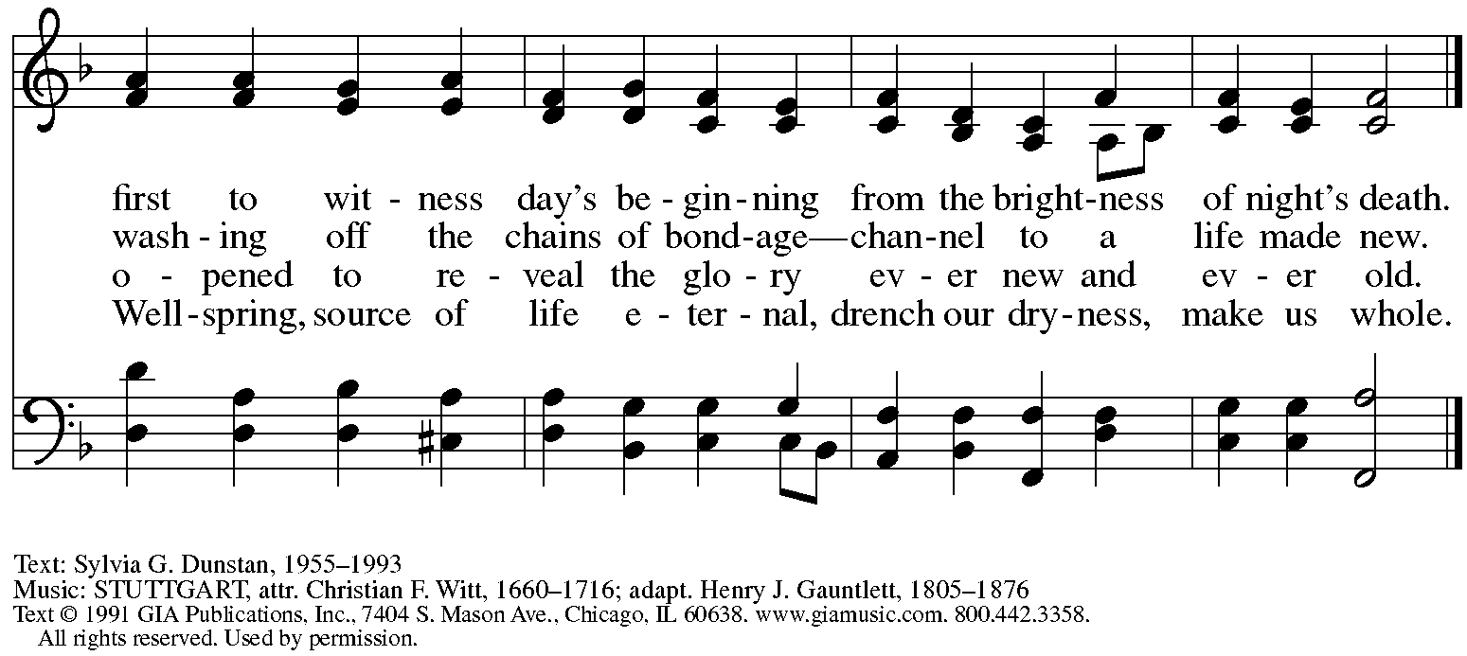

Reprinted under OneLicense.net # A-722139.

**Hymns during Holy Communion**

**Wade in the Water *ELW* 459**

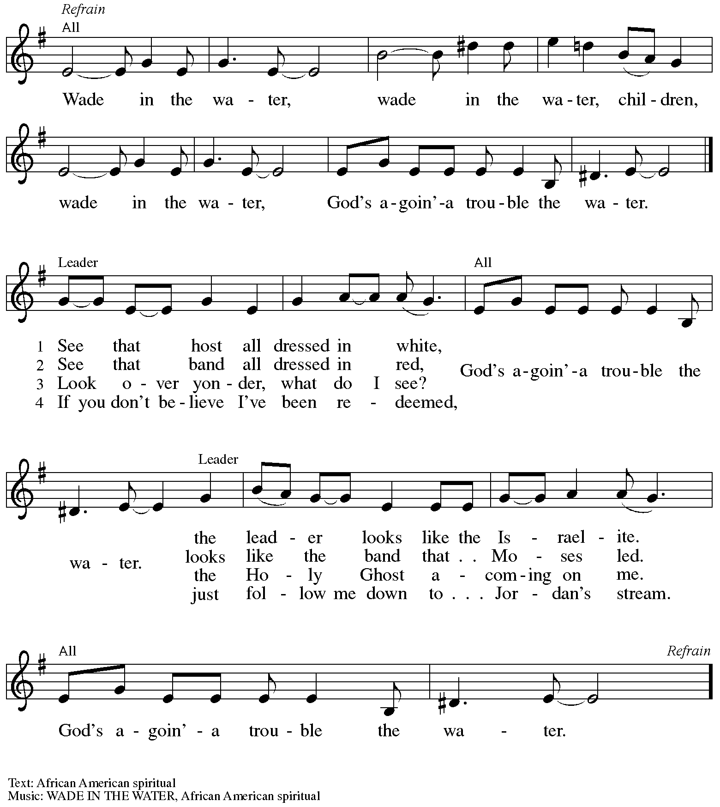

*When all have returned to their places, please rise as you are able.*

**Blessing**

P: The body and blood of our Lord Jesus Christ strengthen you and keep you in his grace.

**C: Amen.**

**Prayer**

A: Let us pray.

O God, in this holy communion you have welcomed us into your presence,

nourished us with words of mercy, and fed us at your table. Amid the cares of this life, strengthen us to love you with all our heart, serve our neighbors with a willing spirit,

and honor the earth you have made; through Christ our Lord.

**C: Amen.**

*Please be seated.*

**Sending**

*God blesses us and sends us in mission to the world*

**Announcements**

*Please rise as you are able.*

**Benediction**

P: The holy Three,

the holy One

increase your hope,

strengthen your faith,

deepen your love,

and ☩ grant you peace.

**C: Amen.**

**Sending Hymn** *Following page*

**Dismissal**

P: Go in peace. Christ is with you.

**C: Thanks be to God!**

**Postlude**

**Sending Hymn Baptized and Set Free *ELW* 453**

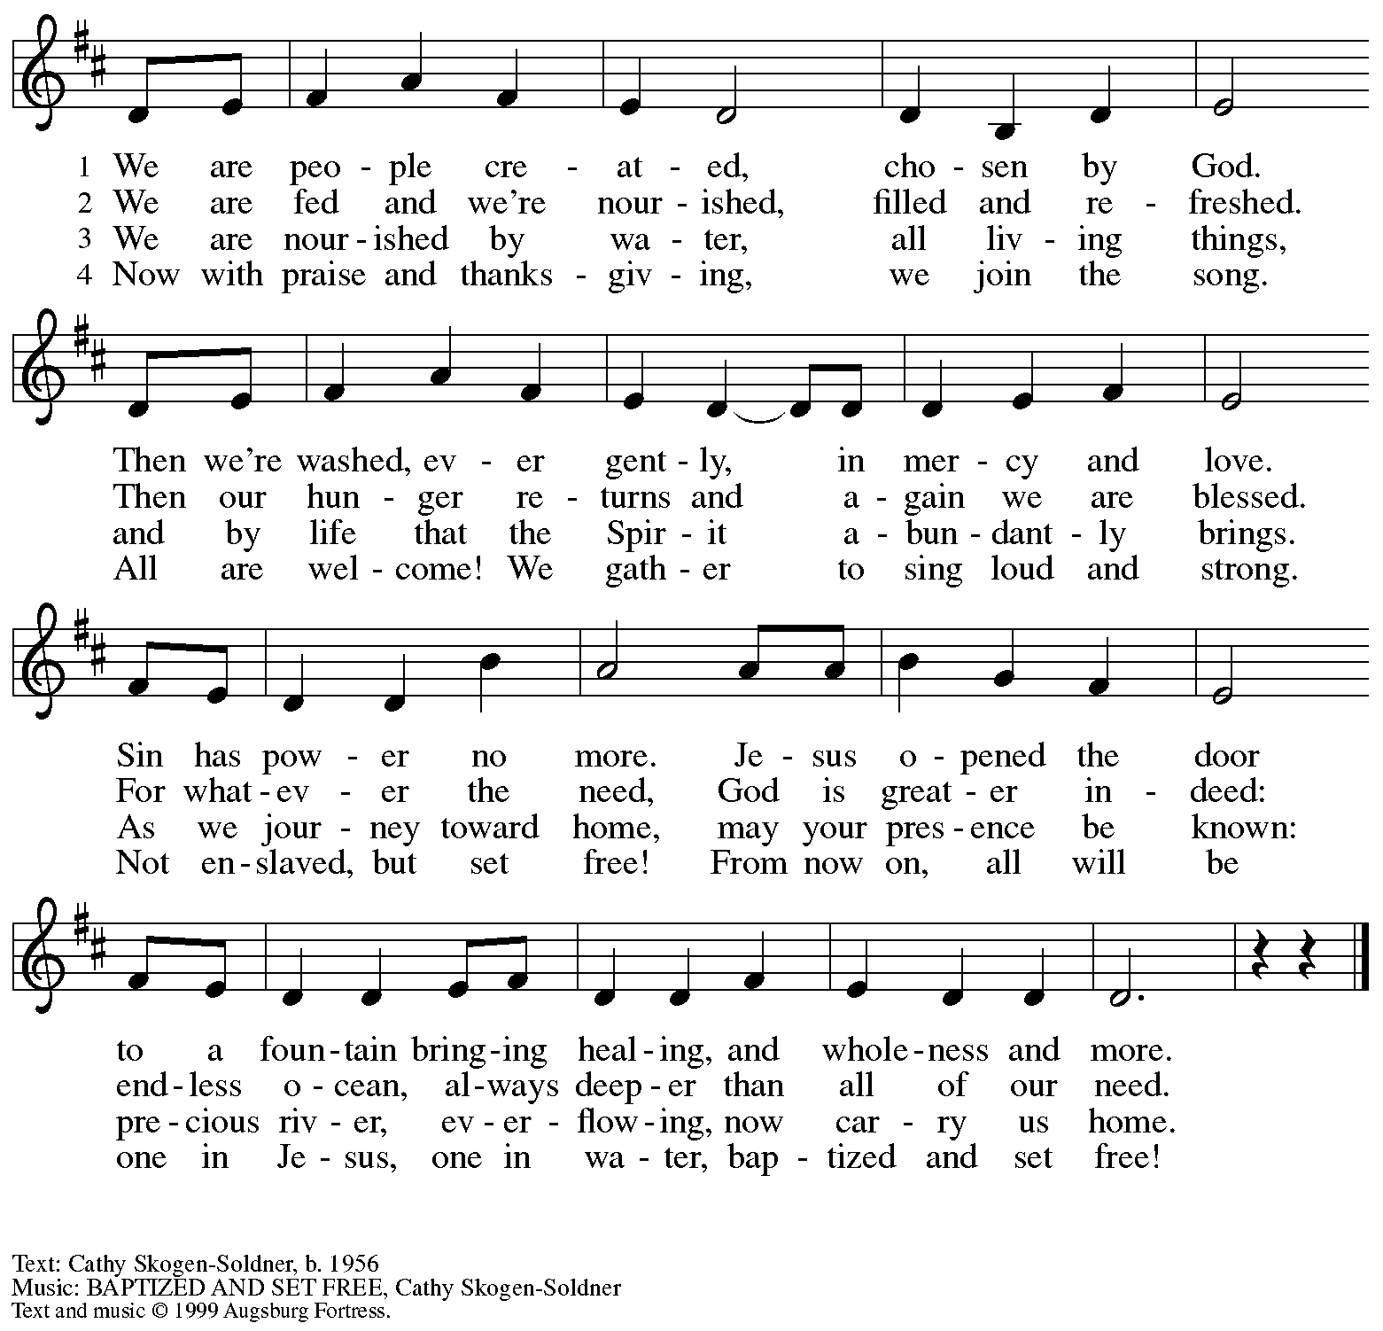

All rights reserved. Reprinted with permission under OneLicense.net # A-722139.

*Those serving in worship*

Altar Care Beverley Chapman

Assisting Minister Jimmi Kocher-Hillmer

Audio-Visual Ministers Jason Galyardt

Jered Stratton

Cantor Ian Brown

Lector Michael Chapman

Little Church – Big Faith Teacher Emily Duque

Minister of Music Laura Reynolds

Presiding and Preaching Minister The Rev. Ross I. Carmichael

*Liturgy and Hymnody Acknowledgements*

From SundaysandSeasons.com. Copyright © 2025 Augsburg Fortress. All rights reserved. Reprinted under OneLicense.net # A-722139.

Used by permission of Augsburg Fortress.

The Scripture readings contained herein are from *New Revised Standard Version* of the Bible © 1989, Division of Christian Education of the National Council of Churches of Christ in the USA. Used by permission. All rights reserved.

**Songs of Thankfulness and Praise** – Text: Christopher Wordsworth, 1807-1885, alt. Music: SALZBURG, Jakob Hintze, 1622-1702; arr. Johann Sebastian Bach, 1685-1750.

**Cuando el pobre / When the Poor Ones** – Text: José Antonio Olivar, b. 1939; tr. Martin A. Seltz, b. 1951. Music: EL CAMINO, Miguel Manzano, b. 1934. Text and music © 1971, 1998 J.A. Olivar, Miguel Manzano, and San Pablo Internacional – SSP, admin. OCP Publications, 5536 NE Hassalo, Portland, OR 97213. All rights reserved. Reprinted with permission under OneLicense.net # A-722139.

**Come, Beloved of the Maker** – Text: Susan Palo Cherwien, b. 1953. Music: JILL, David Cherien, b. 1957. Text © 2001 Susan Palo Cherwien, admin. Augsburg Fortress. Music © 2002 Augsburg Fortress. All rights reserved. Reprinted with permission under OneLicense.net # A-722139.

**I Bind unto Myself Today** – Text: att. Patrick, 372-466; para. Cecil Frances Alexander, 1818-1895. Music: ST. PATRICK’S BREASTPLATE, sts. 1-3, 5: Irish melody. DEIRDRE, st. 4, Irish melody.

*Please use the QR code below to link to St. Andrew’s Announcements online!*



**St. Andrew Lutheran Church Announcements**

**January 12th, 2025**

* **Welcome to worship at St. Andrew on the + Baptism of our Lord, January 12th, 2025** –We are so glad you are here, and we offer a special welcome to all visitors and guests who are here for the first time! Worship attendees are invited to make a name tag at the back of the worship space. Little Church – Big Faith, a Bible lesson and activity for children, will take place after the prayer of the day. There are worship “toolkits” to help children engage with worship and “busy bags” for younger children available in the bookcase at the back of the sanctuary. Please feel free to take one to use with/for your children. All are invited to gather for coffee, other drinks, food, and conversation in the social hall after worship.
* **Community Ministry Meeting – Monday, January 13th, via Zoom – St. Andrew’s community ministry team leads the congregation’s outreach and service to the community through initiatives like the food pantry and little library and the produce distribution. We continue to look for new opportunities to serve and invite others to share in the conversation. The group meets once a month via Zoom, and the next meeting is on Monday, January 13th, at 7:00 p.m. Please contact Pastor Ross as** [PastorRCarmichael@gmail.com](mailto:PastorRCarmichael@gmail.com) **if you would like the link!**
* **Shelter Dinner for Guests of East End Cooperative Ministry, Third Thursday of the Month – January 16th, 2025, 6:00 p.m. Arrival, 6:30 p.m. Dinner –** Each month, people of St. Andrew provide dinner for guests of East End Cooperative Ministry (EECM), 6140 Station St. (East Liberty), 15206. We invite you to prepare or purchase one menu item and bring it to the shelter by 6:00 p.m., or just come to help serve at 6:30 p.m. If you would like to contribute, please sign up here: <https://www.signupgenius.com/go/5080544AAAC22A1F58-54144529-shelter>.
* **Bagged Lunches to Accompany January Shelter Dinner – Seeking Additional Donations! – East End Cooperative Ministry is hosting an additional 20 people this winter because of the shelter shortage and we have been asked to bring items for 20 bagged lunches on St. Andrew’s Shelter Dinner night, Thursday, January 16th. Bagged lunches will include sandwiches, individual bags of chips, individually wrapped desserts, and fruit cups with soft fruit for those with dental sensitivities. Shelf-stable items can be left on the donation table in the Social Hall by Sunday, January 12th, or delivered to EECM on Thursday, January 16th. Please label “For EECM Lunches.” Sandwiches should be delivered to EECM any time on the 16th until 6:00 p.m. Please label “For St. Andrew bagged lunches. Shelter staff will assemble the bagged lunches. Much work goes into shopping for and preparing the main meal each month, so we would greatly appreciate new participants and contributions for this effort! If you would like to help, please sign up at** <https://www.signupgenius.com/go/5080544AAAC22A1F58-54144594-baglunch>.
* **Congregation Council Retreat – Saturday, January 18th, 9:00 a.m. – 2:00 p.m. – The first meeting of St. Andrew’s newly elected congregation council will be the retreat on Saturday, January 18th. We welcome Tyler Rietze and Colleen Cooke to the council, as well as David Rollinson, Kelly Spanninger, and Hal Wilcox to renewed terms. Please keep the council in prayer as we plan for a feasibility study, renovations to the building, and a possible capital campaign later in the year in addition to other ministries!**
* **Help Re-Stock Outdoor Little Library!** – If you are interested in stocking the little library that is on the Centre Avenue side of the church, there are extra books in the metal cabinet to the right of the dumbwaiter.  (There are currently some 10% off coupons for Half Price Books that are good throughout the year.)  The current stock of books are from the challenged or banned book lists.  Here are two lists:  (<https://www.ala.org/bbooks>) (<https://en.wikipedia.org/wiki/List_of_most_commonly_challenged_books_in_the_United_States>).
* ***Christ in Our Home* Devotional Booklets for January - March Available at Church Entrances** – This resource offers a daily Bible reading with a short reflection and prayer, along with additional readings and prayer topics for those who would like to expand their devotional practices. We encourage people of the congregation to take one for yourself, your family unit, or others!