

**+ First Sunday of Christmas**

**December 29th, 2024**

**10:00 a.m.**



**St. Andrew Lutheran Church**

**304 Morewood Ave.**

**Pittsburgh, PA 15213**

**412.682.3342**

[**St_andrewELCA@verizon.net**](mailto:St_andrewELCA@verizon.net)

[**www.standrewpittsburgh.org**](http://www.standrewpittsburgh.org)

**+ First Sunday of Christmas**

**Order for Worship**

*On the first Sunday of Christmas we find the boy Samuel and the boy Jesus, both in the temple, both growing in wisdom and stature and in favor with God and humankind.*

*We too have returned to the house of God “to sing psalms, hymns, and spiritual songs to God,” who has gifted us with a savior.*

*As the festival continues, “let the peace of Christ rule in your hearts.”*

*It is Christmas, still.*

**Welcome to St. Andrew!**

* St. Andrew welcomes all who are seeking a place of healing, wholeness, and acceptance in a nurturing and faith-forming spiritual home. We are striving toward racial equity worldwide

and we seek to honor the lived experience of all individuals regardless of background. Our community embraces people of all ages, ethnicities, cultures, abilities, sexual orientations,

gender identities and expressions, and family constellations. Come and See!

* Worship Services are live-streamed to multiple online platforms. By attending worship, you agree that your image and voice may be broadcast.
* Everyone is invited to make a name tag at the black bookcase in the back of the worship space if they would like. There are stickers indicating pronouns on the bookcase if you would like to include them on your name tag.
* A nursery is available through the doors at the left side of the sanctuary and across from the doorway to the Social Hall. Look for a purple-colored room.
* Worship “toolkits” to help children engage with the service, along with “busy bags” for younger children, are available in the bookcase at the back of the sanctuary. Please feel free to take one to use with/for your children.
* Holy Communion is served with bread (gluten-free available) and wine or grape juice. The presiding minister will distribute the bread (host). Please consume this and then pick up an empty glass from the tray. The Communion Assistant will pour wine or grape juice into your glass. Please step to the side to consume the wine or grape juice. Feel free to kneel at the altar for prayer and reflection. As you return to your pew, glasses may be returned to the empty trays on either side of the center section.
* A restroom is available on the main level of the church, through the doors to the Social Hall and to the right in the main office.

*Abbreviations*

P: Pastor/Presiding Minister ***ELW*: *Evangelical Lutheran Worship* hymnal**

A: Assisting Minister ***ACS*: *All Creation Sings* hymnal**

L: Lector

**Pre-Service Music**

**Welcome**

**Prelude** *The First Noel* Lloyd Larson

Vocalists – Heather Englander, The Rev. Melissa L. Stoller

**Gathering**

*The Holy Spirit calls us together as the people of God*

**Confession and Forgiveness**

*Please rise as you are able. All may make the sign of the cross,*

*the sign that is marked at Baptism, as the presiding minister begins.*

P: Blessed be the holy Trinity, ☩ one God,

whose steadfast love is everlasting.

**C: Amen.**

Let us confess our sin in the presence of God and of one another.

*Silence is kept for reflection*

P: God-with-us,

**we confess that we have turned away** **those seeking refuge,**

**claiming there is no room when we have plenty to offer.**

**We have made power and wealth our idols,**

**while you show us true glory: a baby in a manger.**

**We have overlooked the shepherds,** **expecting good news in finer packaging.**

**Too often, we have valued violence** **instead of your peace.**

**Turn us from our ways to your ways.**

**Grant us the grace to begin again.**

**Free us from all that keeps us bound,** **and forgive our sin,**

**through Jesus Christ, who gives himself for us.**

**Amen.**

P: Hear the good news and rejoice!

You are God’s chosen ones,

holy and beloved,

☩ forgiven in Christ,

and freed to respond in joy.

**C: Amen.**

**Gathering Hymn Angels from the Realms of Glory *ELW* 275**

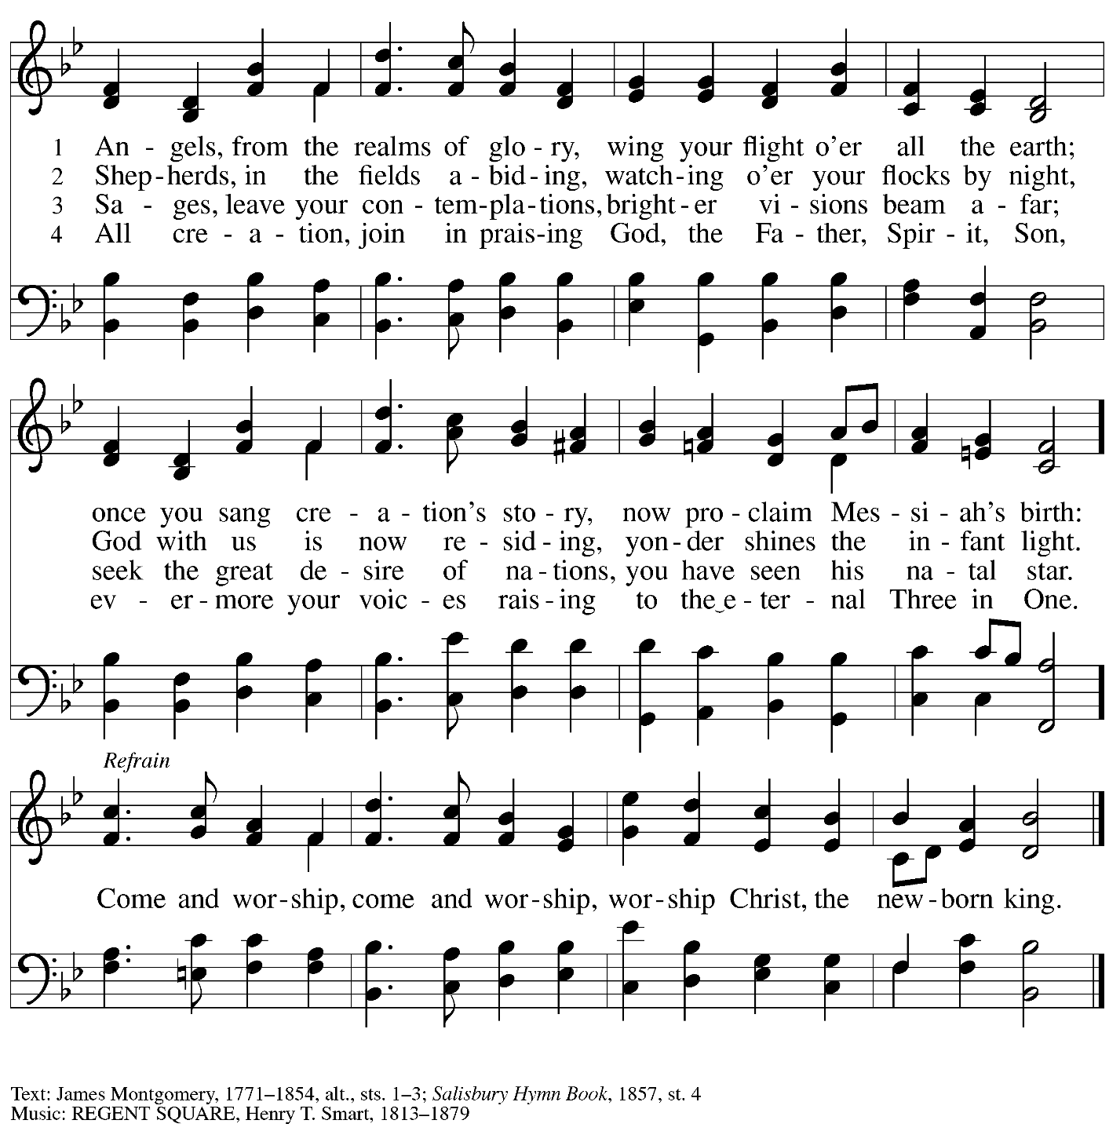

**Greeting**

P: The grace of our Lord Jesus Christ, the love of God,

and the communion of the Holy Spirit be with you all.

**C: And also with you.**

**Kyrie** *ELW* p. 147

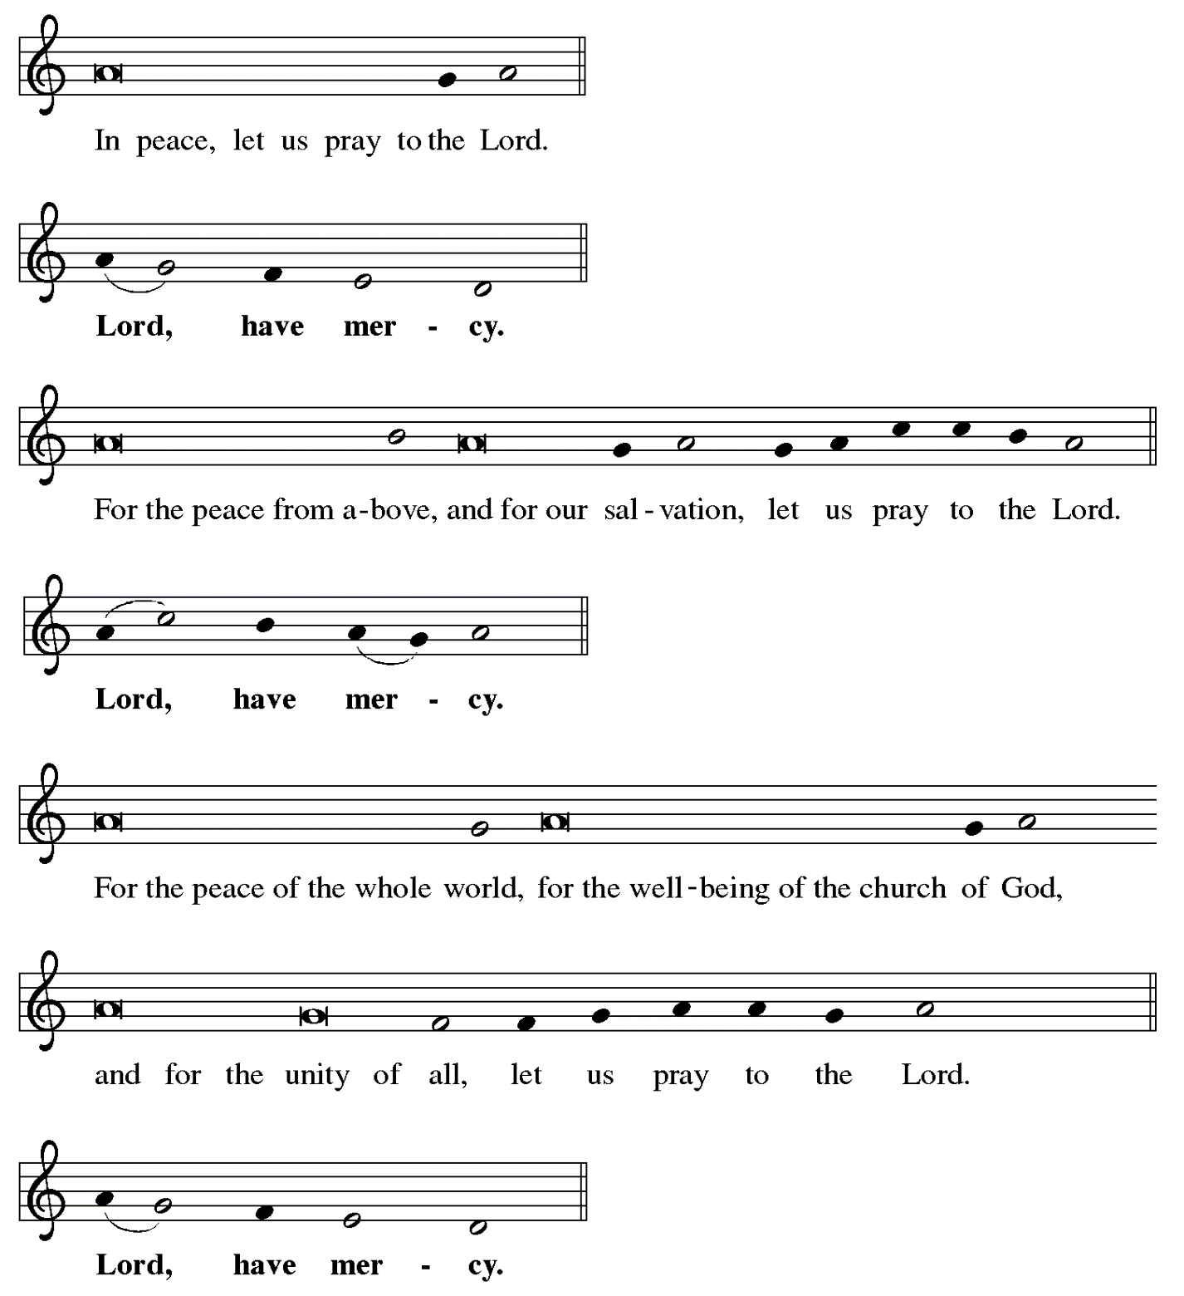

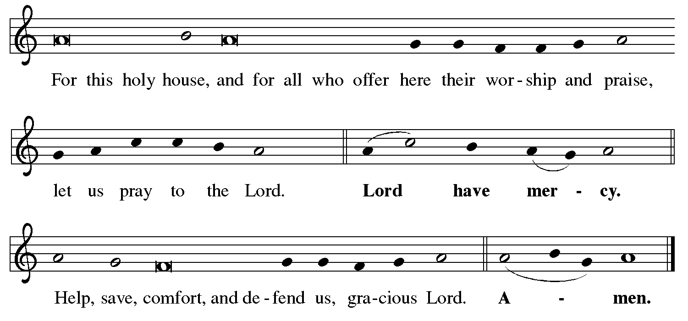

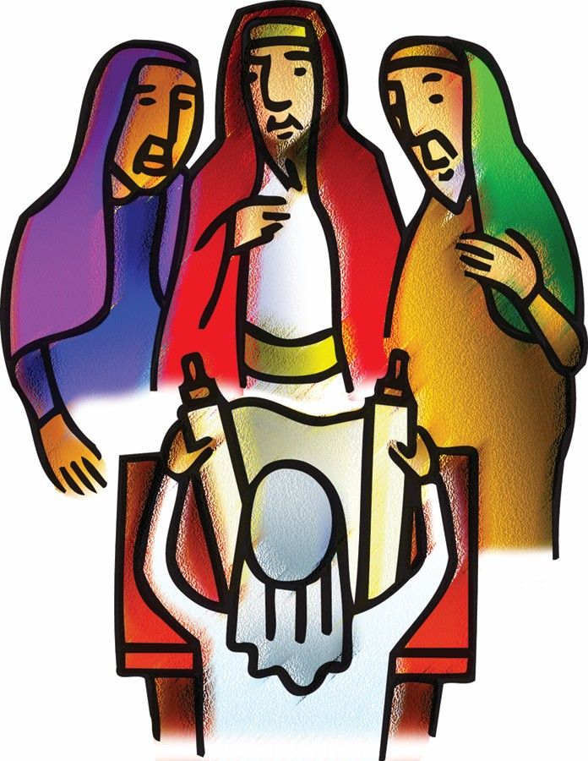

**Hymn of Praise Angels We Have Heard on High *ELW* 289**

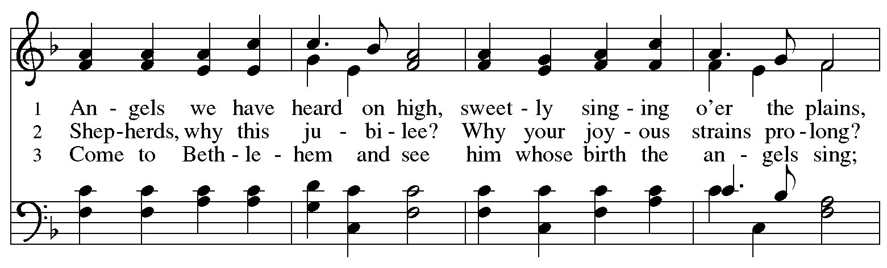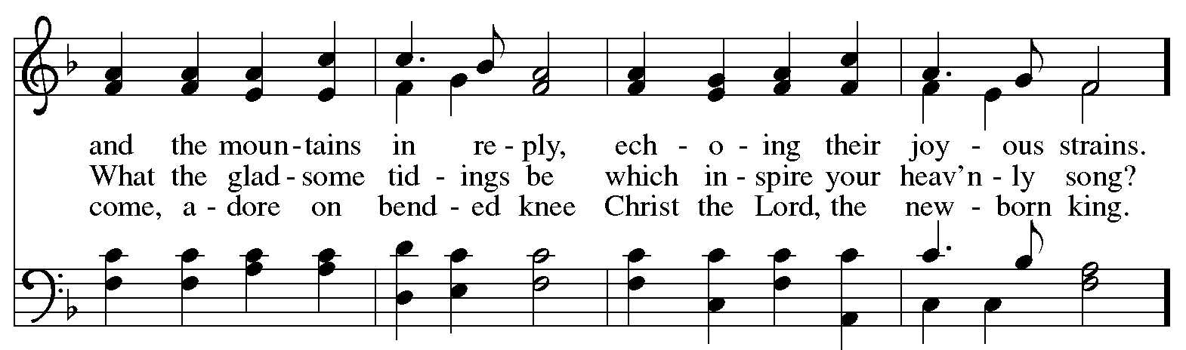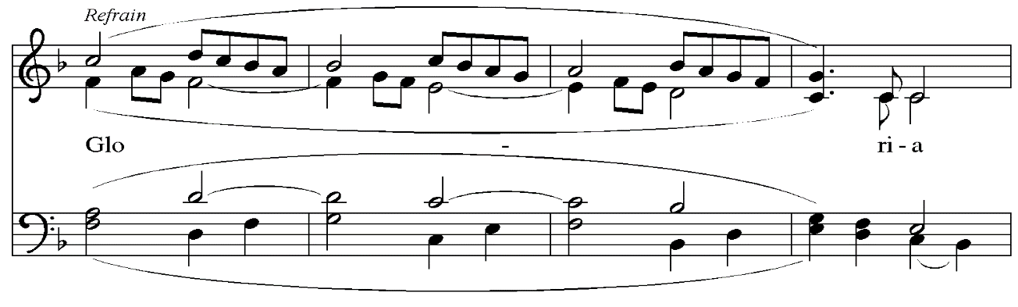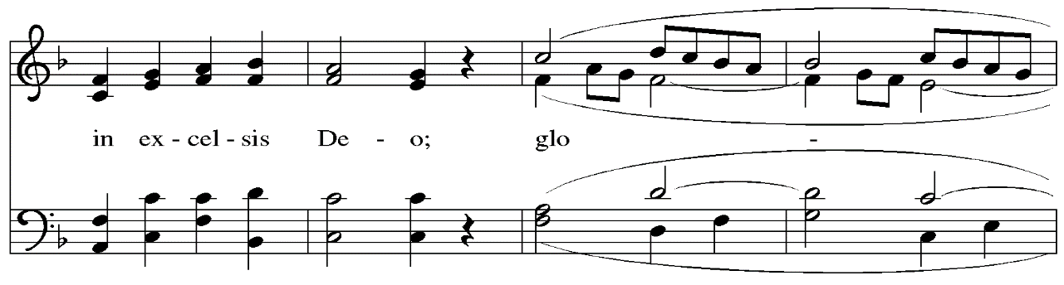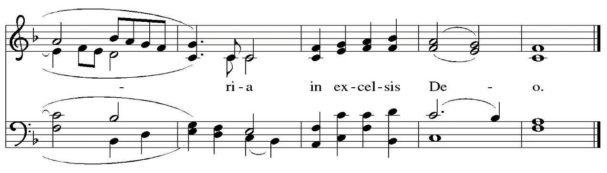

**Prayer of the Day**

P: The Lord be with you.

**C: And also with you.**

P: Let us pray.

Shine into our hearts the light of your wisdom, O God,

and open our minds to the knowledge of your word,

that in all things we may think and act according to your good will

and may live continually in the light of your Son, Jesus Christ,

who lives and reigns with you and the Holy Spirit,

one God, now and forever.

**C: Amen.**

*Please be seated.*

**Word**

*God speaks to us in Scripture reading, preaching, and song*

**First Reading** **– 1 Samuel 2: 18-20, 26**

18 Samuel was ministering before the Lord, a boy wearing a linen ephod. 19 His mother used to make for him a little robe and take it to him each year, when she went up with her husband to offer the yearly sacrifice. 20 Then Eli would bless Elkanah and his wife, and say, “May the

Lord repay you with children by this woman for the gift that she made to the Lord”; and then they would return to their home.  
  26 Now the boy Samuel continued to grow both in stature and in favor with the Lord and with the people.

L: Word of God, word of life.

**C: Thanks be to God.**

**Psalm 148**

*The cantor will lead the singing of the psalm.*

*The congregation is invited to respond with the alternate verses in bold print,*

*and to join in singing the refrain.*

*Psalm Tone*

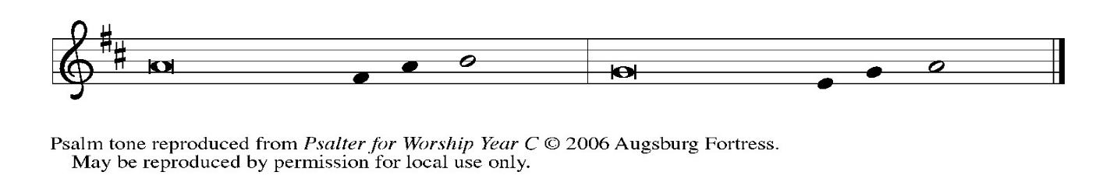

*Psalm Refrain*

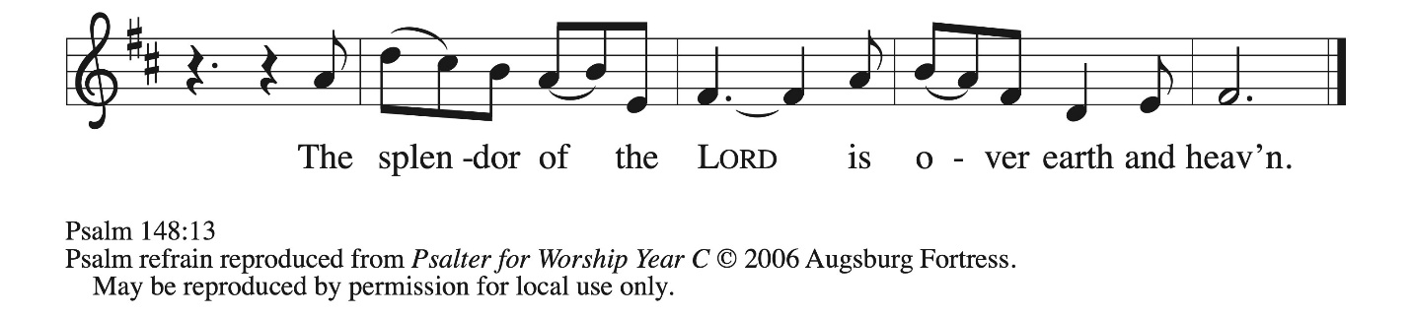

 1 Hallelujah! Praise the Lord **|** from the heavens;  
  praise God **|** in the heights.  
 2 **Praise the Lord, | all you angels;**  
  **sing praise, all you | hosts of heaven.**  
 3 Praise the Lord, **|** sun and moon;  
  sing praise, all you **|** shining stars.  
 4 **Praise the Lord, heav- | en of heavens,**  
  **and you waters a- | bove the heavens.**  
 5 Let them praise the name **|** of the Lord,  
  who commanded, and they **|** were created,  
 6 **who made them stand fast forev- | er and ever,**  
  **giving them a law that shall not | pass away. R**  
 7 Praise the Lord **|** from the earth,  
  you sea monsters **|** and all deeps;  
 8 **fire and hail, | snow and fog,**  
  **tempestuous wind, do- | ing God’s will;**  
 9 mountains **|** and all hills,  
  fruit trees **|** and all cedars;  
 10 **wild beasts | and all cattle,**  
  **creeping things and | flying birds;**  
 11 sovereigns of the earth **|** and all peoples,  
  princes and all rulers **|** of the world;  
 12 **young | men and maidens,**  
  **old and | young together. R**  
 13 Let them praise the name **|** of the Lord,  
  whose name only is exalted, whose splendor is over **|** earth and heaven.  
 14 **The Lord has raised up strength for the people and praise for all | faithful servants,**  
  **the children of Israel, a people who are near the Lord. | Hallelujah! R**

**Second Reading – Colossians 3: 12-17**

12 As God’s chosen ones, holy and beloved, clothe yourselves with compassion, kindness, humility, meekness, and patience. 13 Bear with one another and, if anyone has a complaint against another, forgive each other; just as the Lord has forgiven you, so you also must forgive.

14 Above all, clothe yourselves with love, which binds everything together in perfect harmony. 15 And let the peace of Christ rule in your hearts, to which indeed you were called in the one body. And be thankful. 16 Let the word of Christ dwell in you richly; teach and admonish one another in all wisdom; and with gratitude in your hearts sing psalms, hymns, and spiritual songs to God. 17 And whatever you do, in word or deed, do everything in the name of the Lord Jesus, giving thanks to God the Father through him.

L: Word of God, word of life.

**C: Thanks be to God.**

*Please rise as you are able and join in singing the Gospel Acclamation.*

**Gospel Acclamation** *ELW* p. 151

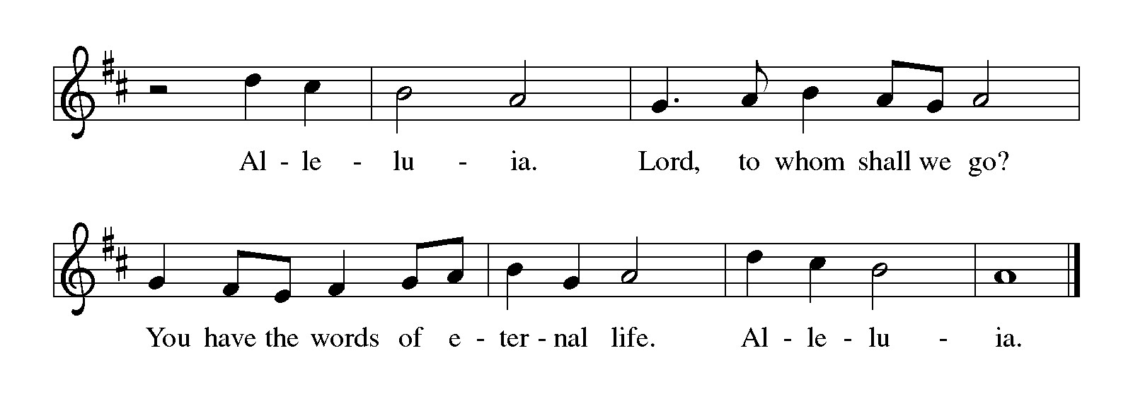

**Gospel – Luke 2: 41-52**

P: The holy Gospel according to St. Luke.

**C: Glory to you, O Lord.**

41 Now every year [Jesus’] parents went to Jerusalem for the festival of the Passover. 42 And when he was twelve years old, they went up as usual for the festival. 43 When the festival was ended and they started to return, the boy Jesus stayed behind in Jerusalem, but his parents did not know it. 44 Assuming that he was in the group of travelers, they went a day’s journey. Then they started to look for him among their relatives and friends. 45 When they did not find him, they returned to Jerusalem to search for him. 46 After three days they found him in the temple, sitting among the teachers, listening to them and asking them questions. 47 And all who heard him were amazed at his understanding and his answers. 48 When his parents saw him they were astonished; and his mother said to him, “Child, why have you treated us like this? Look, your father and I have been searching for you in great anxiety.” 49 He said to them, “Why were you searching for me? Did you not know that I must be in my Father’s house?” 50 But they did not understand what he said to them. 51 Then he went down with them and came to Nazareth, and was obedient to them. His mother treasured all these things in her heart.  
  52 And Jesus increased in wisdom and in years, and in divine and human favor.

P: The Gospel of the Lord.

**C: Praise to you, O Christ.**

*Please be seated.*

**Sermon**

*A time of silence for prayer and reflection follows the sermon.*

*As the hymn of the day begins, please rise as you are able.*

**Hymn of the Day Jesus, What a Wonderful Child *ELW* 297**

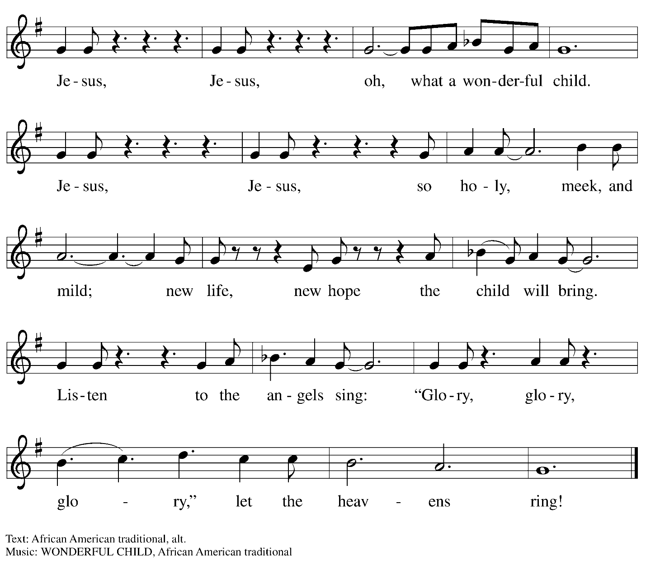

**Nicene Creed**

P: Rejoicing in the good news of Christ’s birth, we confess our faith:

**C: We believe in one God,**

**the Father, the Almighty,**

**maker of heaven and earth,**

**of all that is, seen and unseen.**

**C: We believe in one Lord, Jesus Christ,**

**the only Son of God,**

**eternally begotten of the Father,**

**God from God, Light from Light,**

**true God from true God,**

**begotten, not made,**

**of one Being with the Father;**

**through him all things were made.**

**For us and for our salvation**

**he came down from heaven,**

**was incarnate of the Holy Spirit and the virgin Mary**

**and became truly human.**

**For our sake he was crucified under Pontius Pilate;**

**he suffered death and was buried.**

**On the third day he rose again**

**in accordance with the scriptures;**

**he ascended into heaven**

**and is seated at the right hand of the Father.**

**He will come again in glory to judge the living and the dead,**

**and his kingdom will have no end.**

**We believe in the Holy Spirit, the Lord, the giver of life,**

**who proceeds from the Father and the Son,\***

**who with the Father and the Son is worshiped and glorified,**

**who has spoken through the prophets.**

**We believe in one holy catholic and apostolic church.**

**We acknowledge one baptism for the forgiveness of sins.**

**We look for the resurrection of the dead,**

**and the life of the world to come. Amen.**

*Or, “who proceeds from the Father.” The phrase “and the Son” is a later addition to the creed.

**Prayers of the People**

P: Trusting in God’s good news of great joy for all people, we offer our prayers for the church,

those in need, and the world God so loves.

*After each petition*

P: God of grace,

**C: receive our prayer.**

*The presiding minister concludes the prayers*

P: Rejoicing in your Word made flesh among us, we commend these prayers to you, O God,

trusting in your love and grace made known to us in Jesus Christ, our Savior.

**C: Amen.**

**Peace**

*The presiding minister and the assembly greet one another in the peace of the risen Christ.*

P: The peace of Christ be with you always.

**C: And also with you.**

*The people may greet those around them with a sign of Christ’s peace and may say*

Peace be with you *or similar words. Please be mindful that not everyone will be comfortable with sharing the peace, so please seek consent before shaking hands or hugging. Other possible ways to share the peace include a simple bow with the verbal greeting of peace, or simply a verbal expression of peace.*

*When the greetings of peace have concluded, please be seated.*



**Meal**

*God feeds us with the presence of Jesus Christ*

**Offering**

*We offer ourselves, our gifts, and our faithful service to God.*

*As the offering is gathered for the mission of the church, including the care of those in need,*

*the table is set for Holy Communion.*

**Music during the Offering**

*Angels We Have Heard on High* arr. Melody Bober

Piano – Sarita

*As the gifts are brought forward for presentation, please rise as you are able.*

**Offertory Song In the Bleak Midwinter *ELW* 294**

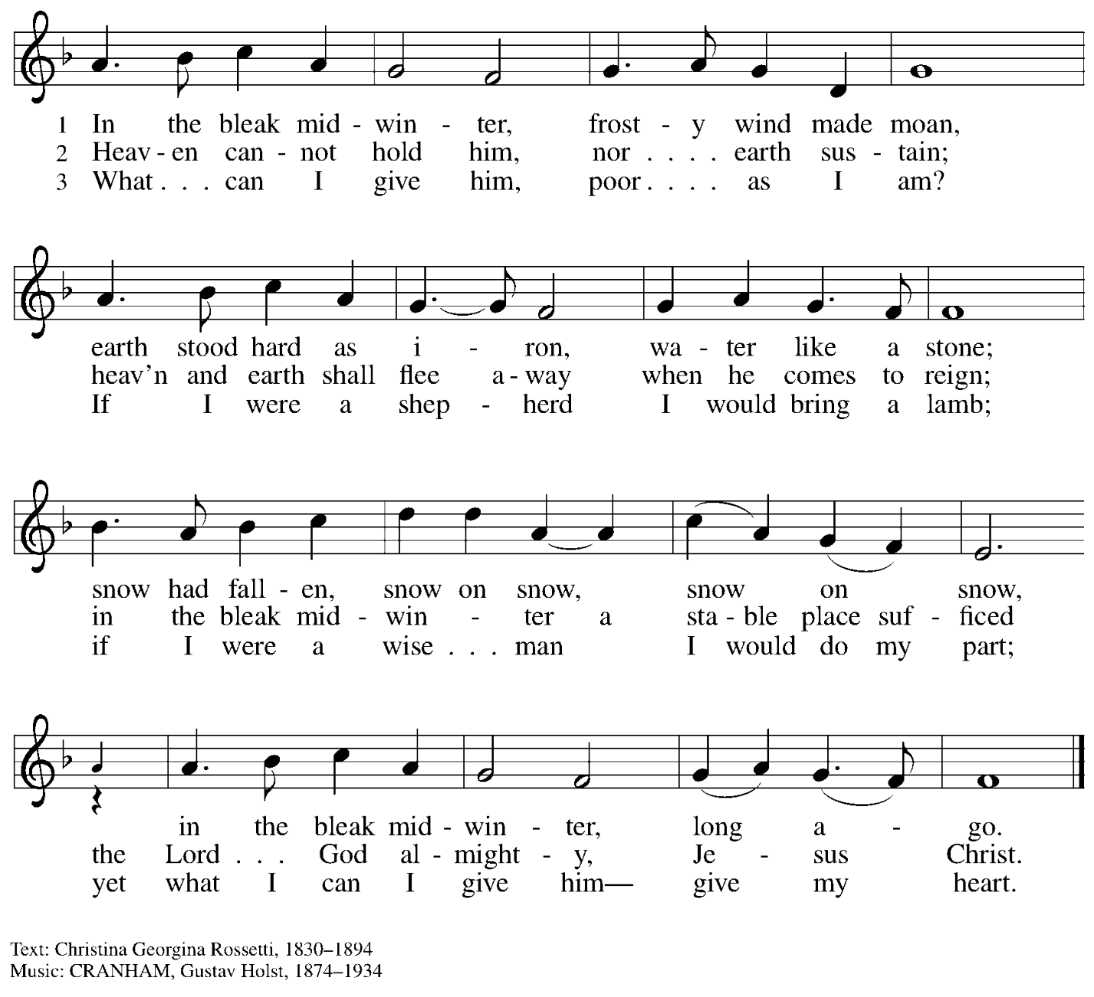

**Offertory Prayer**

P: Let us pray. Good and loving God,

**C: we rejoice in the birth of Jesus,**

**who came among the poor to bring the riches of his grace.**

**As you have blessed us with your gifts, let them be a blessing for others.**

**With the trees of the field, with all earth and heaven,**

**we shout for joy at the coming of your Son, Jesus Christ our Lord. Amen.**

**Dialogue** ELW p. 152



**Preface** *(Sung)*

P: It is indeed right, our duty and our joy … we praise your name and join their unending hymn:

**Sanctus** *ELW* p. 153



**Eucharistic Prayer**

P: Holy one, the beginning and the end, the giver of life, …

… Do this for the remembrance of me.

Let us proclaim the mystery of faith.

**C: Christ has died. Christ is risen. Christ will come again.**

P: With this bread and cup …

… We look with hope for his coming.

**C: Come, Lord Jesus.**

P: Holy God, we long for your Spirit …

… Bring the gift of peace on earth.

**C: Come, Holy Spirit.**

P: All praise and glory are yours …

… one God, now and forever.

**C: Amen.**

**Lord’s Prayer**

P: Gathered as one by the Holy Spirit, let us pray as Jesus taught us.

**C: Our Father in heaven,**

**hallowed be your name,**

**your kingdom come,**

**your will be done,**

**on earth as in heaven.**

**Give us today our daily bread.**

**Forgive us our sins**

**as we forgive those**

**who sin against us.**

**Save us from the time of trial**

**and deliver us from evil.**

**For the kingdom, the power,**

**and the glory are yours,**

**now and forever. Amen.**

**Fraction and Invitation**

P: Glory to God in the highest!

Come to the table of peace.

***Agnus Dei /* Lamb of God** *ELW* p. 154



*Please be seated.*

**Holy Communion**

* *All who seek God and desire a deeper and stronger life in Christ are welcome to receive Holy Communion.*
* *Worshipers from the pulpit side will proceed forward first, followed by the center section, and then the lectern side.*
* *Please inform an usher if you would like the ministers to bring Communion to you.*
* *Holy Communion will be served with bread and wine/grape juice.*
* *The presiding minister will first distribute the bread (host) to each communicant. Please indicate if you require a gluten-free host.*
* *Once you have consumed the bread, please pick up an empty glass from the tray next to the presiding minister. The Communion Assistant will pour wine from the chalice or grape juice from the cruet into your glass.*
* *Please step to the side to consume the wine or grape juice.*
* *Feel free to kneel at the altar rail for prayer after receiving the sacrament.*
* *As you return to your pew, glasses may be returned to the empty trays on either side of the center section.*
* *A blessing will be provided for anyone who does not yet receive the sacrament.*
* *All are invited to join in singing the hymns during Holy Communion.*

**Hymns during Holy Communion**

**Love Has Come *ELW* 292**

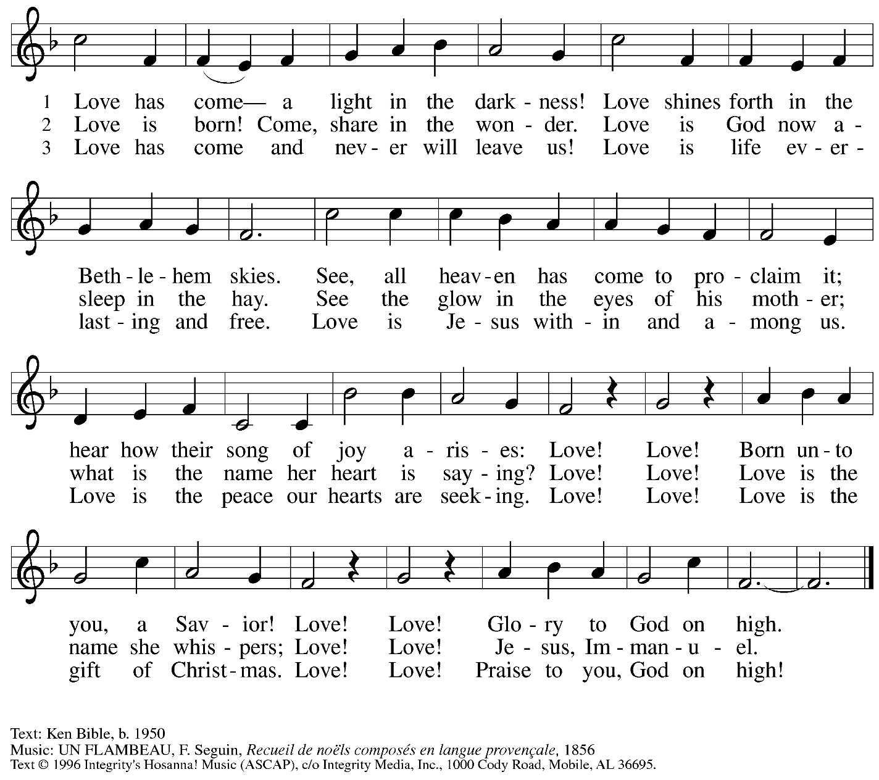

All rights reserved. Reprinted with permission under OneLicense.net # A-722139.

**Hymns during Holy Communion**

**Cold December Flies Away *ELW* 299**

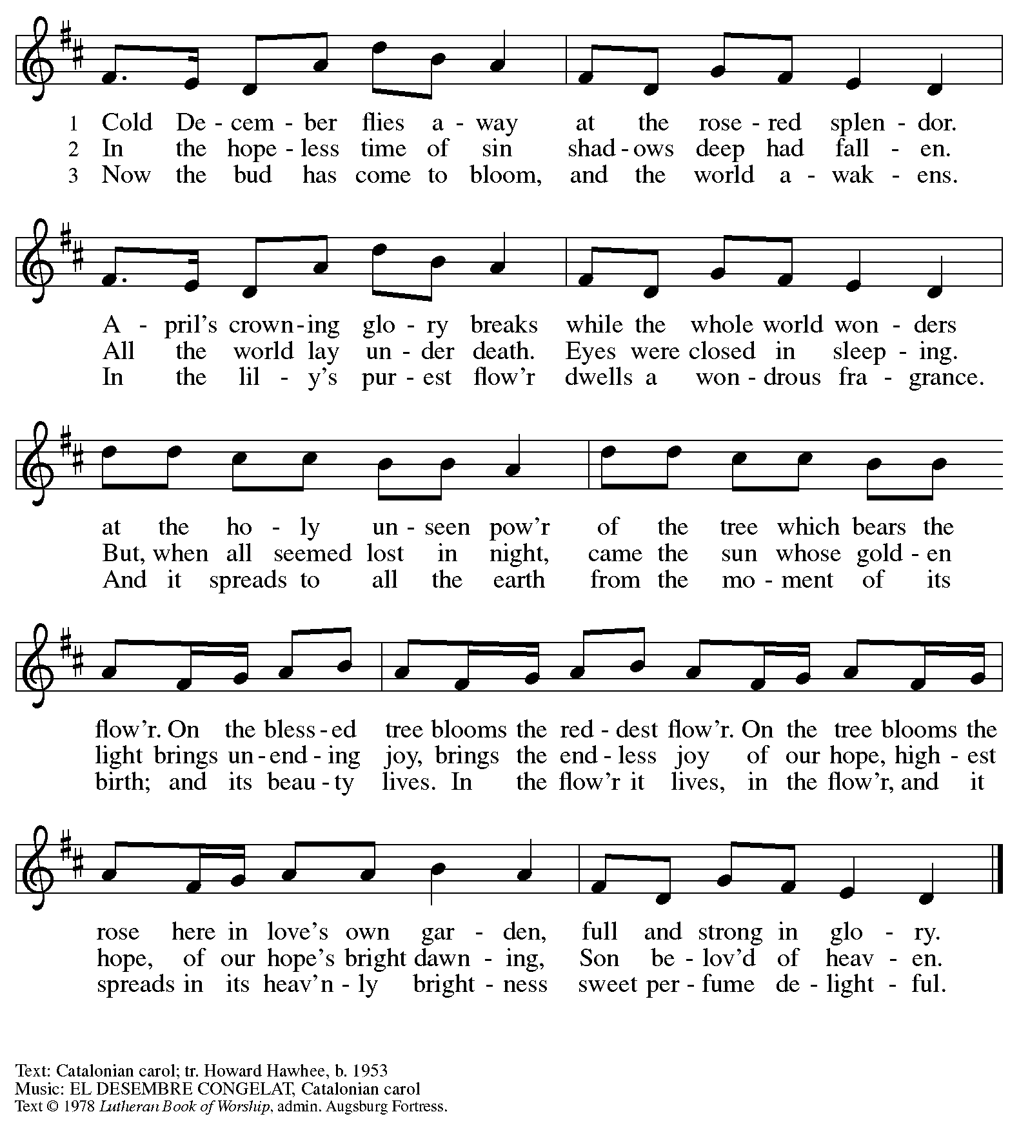

All rights reserved. Reprinted with permission under OneLicense.net # A-722139.

**Hymns during Holy Communion**

**Peace Came to Earth *ELW* 285**

**1 Peace came to earth at last that chosen night**

**when angels clove the sky with song and light**

**and God embodied love and sheathed his might--**

**Who could but gasp: Immanuel!**

**Who could but sing: Immanuel!**

**2 And who could be the same for having held**

**the infant in their arms, and later felt**

**the wounded hands and side, all doubts dispelled--**

**Who could but sigh: Immanuel!**

**Who could but shout: Immanuel!**

**3 You show the Father none has ever seen,**

**in flesh and blood you bore our griefs and pains,**

**in bread and wine you visit us again--**

**Who could but see Immanuel!**

**Who could but thrill: Immanuel!**

**4 How else could I have known you, O my God!**

**How else could I have loved you, O my God!**

**How else could I embrace you, O my God!**

**Who could but pray: Immanuel!**

**Who could but praise Immanuel!**

Text: Jaroslav J. Vajda, b. 1919

Text © 1984 Concordia Publishing House. All rights reserved. Reprinted with permission under OneLicense.net # A-722139.

**Hymns during Holy Communion**

**Good Christian Friends, Rejoice *ELW* 288**

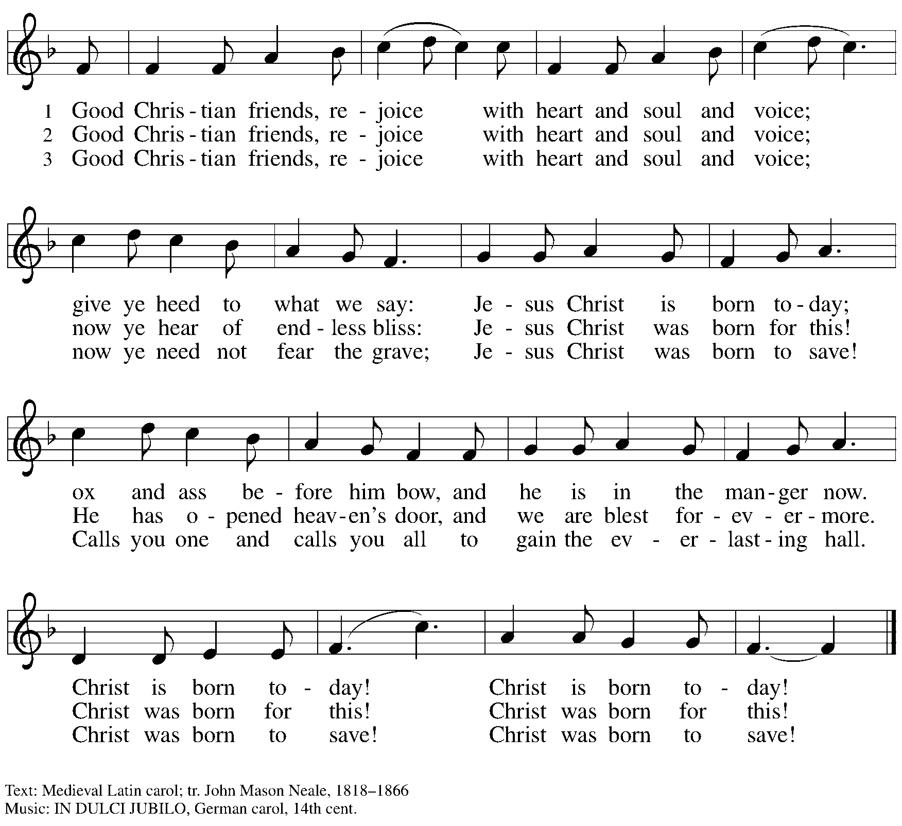

*When all have returned to their places, please rise as you are able.*

**Blessing**

P: The body and blood of our Lord Jesus Christ strengthen you and keep you in his grace.

**C: Amen.**

**Prayer**

P: Let us pray.

Radiant God, you have brought us your salvation,

and in this meal, we have feasted on your grace.

May your Word take flesh in us, that we may be your holy people,

revealing your glory made known to us in Jesus Christ, our Savior and Lord.

**C: Amen.**

**Sending**

*God blesses us and sends us in mission to the world*

**Benediction**

P: God bless you and keep you,

☩ Jesus grant you grace and truth,

and the Spirit send peace upon your hearts,

now and forever.

**C: Amen.**

**Sending Hymn Go Tell It on the Mountain** *Following page*

**Dismissal**

P: Go in peace. Share the good news!

**C: Thanks be to God!**

**Postlude**

**Sending Hymn Go Tell It on the Mountain *ELW* 290**

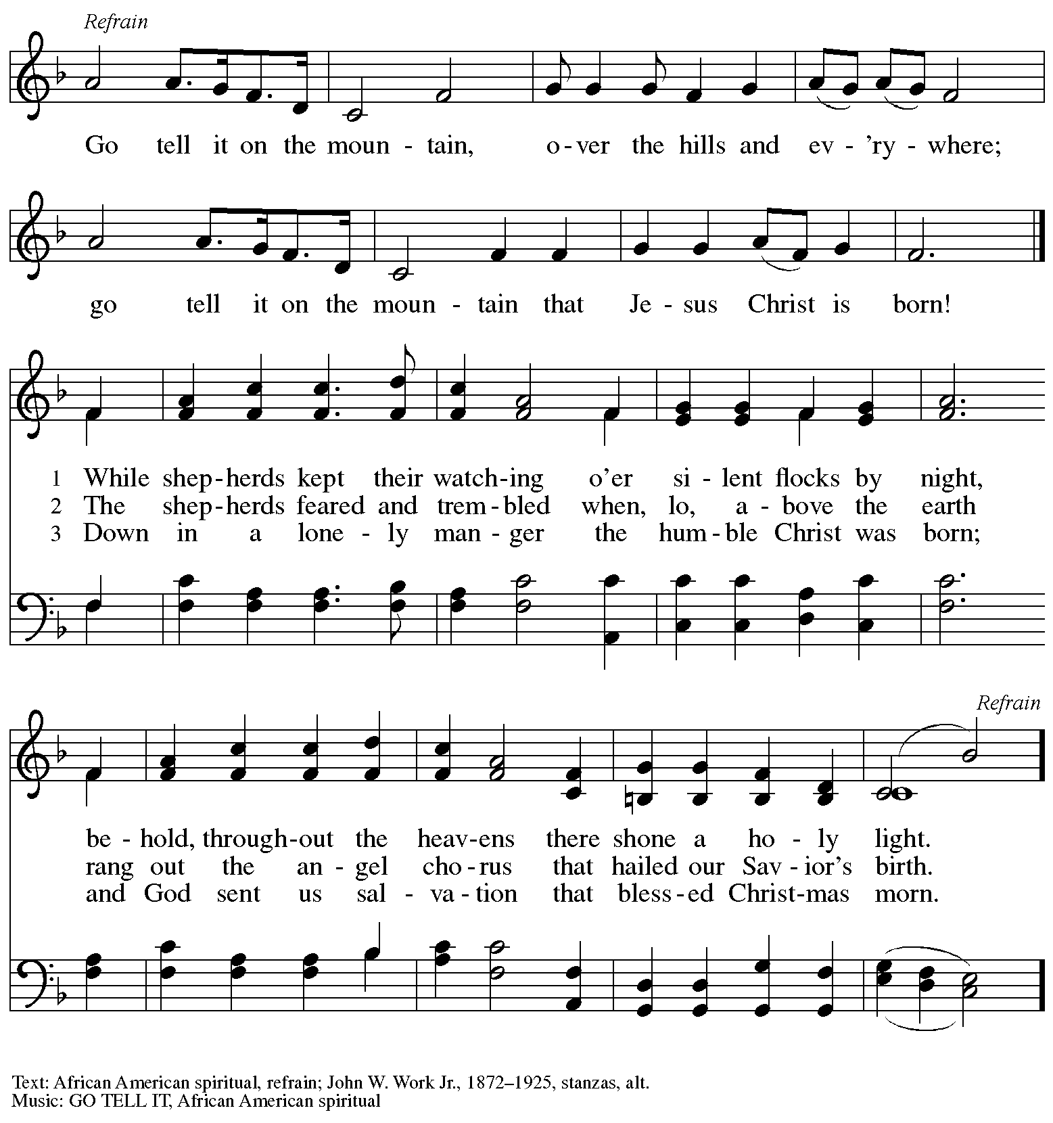

*Those serving in worship*

Altar Care Jodie Minor

Assisting Minister Jeff Denlinger

Audio-Visual Minister Kristen Asplin

Tyler Rietze

Cantor Ian Brown

Lector Alda Maria Gonzaga

Piano during Offering Sarita

Vocalists Heather Englander

The Rev. Melissa L. Stoller

Minister of Music Laura Reynolds

Presiding and Preaching Minister The Rev. Ross I. Carmichael

*Liturgy and Hymnody Acknowledgements*

From SundaysandSeasons.com. Copyright © 2023 Augsburg Fortress. All rights reserved. Reprinted under OneLicense.net # A-722139.

Used by permission of Augsburg Fortress.

**Angels We Have Heard on High** – Text: French carol; tr. H. F. Hemy, *The Crown of Jesus Music*, 1864. Music: GLORIA, French carol; arr. Edward F. Barnes, 1881-1958.

*Please use the QR code below to link to St. Andrew’s Announcements online!*



**St. Andrew Lutheran Church Announcements**

**December 29th, 2024**

* **Welcome to worship at St. Andrew on the First Sunday of Christmas, December 29th, 2024** –We are so glad you are here, and we offer a special welcome to all guests who are gathered here or online! There are worship “toolkits” to help children engage with worship and “busy bags” for younger children available in the bookcase at the back of the sanctuary. Please feel free to take one to use with/for your children.
* **Little Church – Big Faith Will Not Meet during Worship This Week**
* **January Produce Distribution – First Tuesday of the Month, January 7th, 2025, from 5:30-7:00 p.m. –** St. Andrew partners with Greater Pittsburgh Community Food Bank to serve as a distribution site for fresh produce on the first Tuesday of every month. January’s distribution will be on Tuesday, January 7th. We invite people of the congregation to help with the distribution from 5:30-7:00 p.m. and/or to help with unloading and setup during the day between 10:00 a.m. and 1:00 p.m.
* **Bible Book Club Resumes Wednesday, January 8th –** The group is currently reading *On the Road with Saint Augustine: A Real-World Spirituality for Restless Hearts* by James K.A. Smith. Anyone who would like to join in the discussions is welcome - please contact Pastor Ross for the Zoom link. Our next book will be *Traveling Mercies* by Anne Lamott.
* **Shelter Dinner for Guests of East End Cooperative Ministry, Third Thursday of the Month – January 16th, 2025, 6:00 p.m. Arrival, 6:30 p.m. Dinner –** Each month, people of St. Andrew provide dinner for guests of East End Cooperative Ministry (EECM), 6140 Station St. (East Liberty), 15206. We invite you to prepare or purchase one menu item and bring it to the shelter by 6:00 p.m., or just come to help serve at 6:30 p.m. If you would like to contribute, please sign up here: <https://www.signupgenius.com/go/5080544AAAC22A1F58-54144529-shelter>.
* **Bagged Lunches to Accompany January Shelter Dinner – Seeking Additional Donations! – East End Cooperative Ministry is hosting an additional 20 people this winter because of the shelter shortage and we have been asked to bring items for 20 bagged lunches on St. Andrew’s Shelter Dinner night, Thursday, January 16th. Bagged lunches will include sandwiches, individual bags of chips, individually wrapped desserts, and fruit cups with soft fruit for those with dental sensitivities. Shelf-stable items can be left on the donation table in the Social Hall by Sunday, January 12th, or delivered to EECM on Thursday, January 16th. Please label “For EECM Lunches.” Sandwiches should be delivered to EECM any time on the 16th until 6:00 p.m. Please label “For St. Andrew bagged lunches. Shelter staff will assemble the bagged lunches. Much work goes into shopping for and preparing the main meal each month, so we would greatly appreciate new participants and contributions for this effort! If you would like to help, please sign up at** <https://www.signupgenius.com/go/5080544AAAC22A1F58-54144594-baglunch>.
* ***Christ in Our Home* Devotional Booklets for January - March Available at Church Entrances** – This resource offers a daily Bible reading with a short reflection and prayer, along with additional readings and prayer topics for those who would like to expand their devotional practices. We encourage people of the congregation to take one for yourself, your family unit, or others!