

**+ Fourth Sunday of Advent**

**December 22, 2024**



**St. Andrew Lutheran Church**

**304 Morewood Ave.**

**Pittsburgh, PA 15213**

[**St_andrewELCA@verizon.net**](mailto:St_andrewELCA@verizon.net)

[**www.standrewpittsburgh.org**](http://www.standrewpittsburgh.org)

**+ Fourth Sunday of Advent**

**Order for Worship**

*Cradle and cross are inextricably connected on the fourth Sunday of Advent. Between a lovely tribute to the little town of Bethlehem and Mary’s magnificent song of praise, the letter to the Hebrews reminds us in no uncertain terms that Christ’s advent is for “the offering of the body of Jesus Christ once for all.” It is the kind of tension in which the church always lives as when in holy communion—with high delight—“we proclaim the Lord’s death.”*

**Welcome to St. Andrew!**

* St. Andrew welcomes all who are seeking a place of healing, wholeness, and acceptance in a nurturing and faith-forming spiritual home. We are striving toward racial equity worldwide

and we seek to honor the lived experience of all individuals regardless of background. Our community embraces people of all ages, ethnicities, cultures, abilities, sexual orientations,

gender identities and expressions, and family constellations. Come and See!

* Worship Services are live-streamed to multiple online platforms. By attending worship, you agree that your image and voice may be broadcast.
* Everyone is invited to make a name tag at the black bookcase in the back of the worship space if they would like. There are stickers indicating pronouns on the bookcase if you would like to include them on your name tag.
* Children are invited to attend Little Church – Big Faith, a Bible lesson and activity, during worship (after the Prayer of the Day). The group returns to the worship space for the liturgy of Holy Communion.
* A nursery is available through the doors at the left side of the sanctuary and across from the doorway to the Social Hall. Look for a purple-colored room.
* Worship “toolkits” to help children engage with the service, along with “busy bags” for younger children, are available in the bookcase at the back of the sanctuary. Please feel free to take one to use with/for your children.
* Holy Communion is served with bread (gluten-free available) and wine or grape juice. The presiding minister will distribute the bread (host). Please consume this and then pick up an empty glass from the tray. The Communion Assistant will pour wine or grape juice into your glass. Please step to the side to consume the wine or grape juice. Feel free to kneel at the altar for prayer and reflection. As you return to your pew, glasses may be returned to the empty trays on either side of the center section.
* A restroom is available on the main level of the church, through the doors to the Social Hall and to the right in the main office.

*Abbreviations*

P: Pastor/Presiding Minister ***ELW*: *Evangelical Lutheran Worship* hymnal**

A: Assisting Minister ***ACS*: *All Creation Sings* hymnal**

L: Lector

**C: Congregation**

**Pre-Service Music**

**Welcome**

**Prelude** *Breath of Heaven* Grant and Eaton

*During the prelude, individuals from the congregation will come forward to light the candle(s)*

*of the Advent wreath corresponding to the four Sundays of Advent.*

**Gathering**

*The Holy Spirit calls us together as the people of God*

**Confession and Forgiveness**

*Please rise as you are able. All may make the sign of the cross,*

*the sign that is marked at Baptism, as the presiding minister begins.*

P: Blessed be the holy Trinity, ☩ one God,

alive in the world, reviving creation, arriving soon.

**C: Amen.**

P: Let us confess our sin in the presence of God and of one another.

*Silence is kept for reflection*

P: God of mercy,

**C: we confess that we have sinned.**

**We have trusted earthly powers and human authority alone.**

**We have grown fearful. We cling to false comforts.**

P: God of might,

**C: we confess that we have sinned.**

**We have turned away from our neighbors. We have trusted false promises.**

P: God in our midst,

**C: we confess that we have sinned.**

**We plead: come to us. Bring your mercy to birth in us. Amen.**

P: A righteous branch springs forth: it is Christ the Lord, our Savior,

in whom we have forgiveness, life, and mercy.

By the power of the Holy Spirit, receive the grace and forgiveness of God

through ☩ Christ Jesus, whose day draws near.

**C: Amen.**

**Gathering Hymn O Come, O Come, Emmanuel *ELW* 257**

**v. 1-2, 6-8**

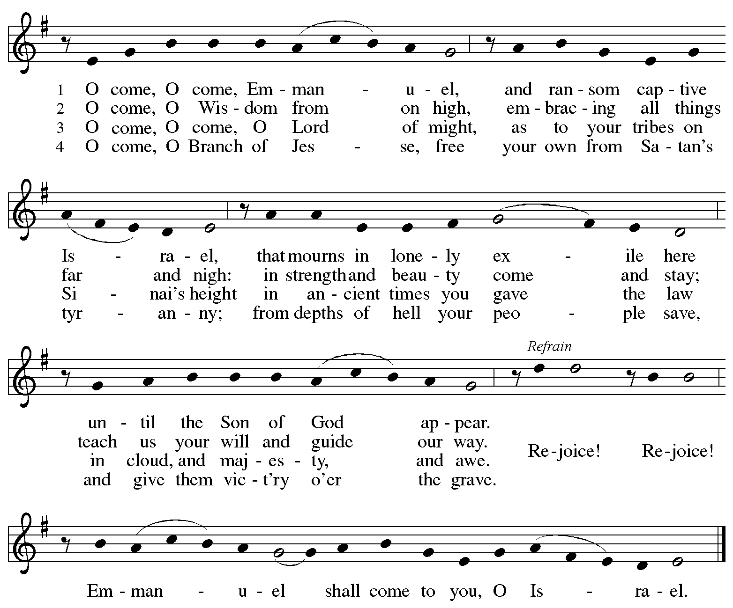

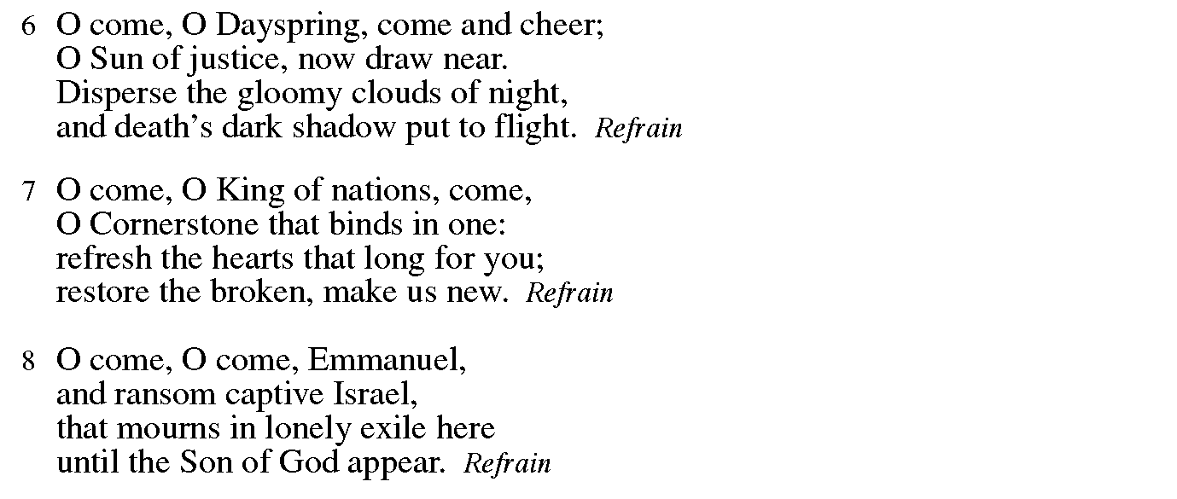

**Greeting**

P: The grace of our Lord Jesus Christ, the love of God,

and the communion of the Holy Spirit be with you all.

**C: And also with you.**

**Kyrie** *ELW* p. 147

*The cantor leads the singing of the Kyrie, with the congregation joining in the responses in bold.*

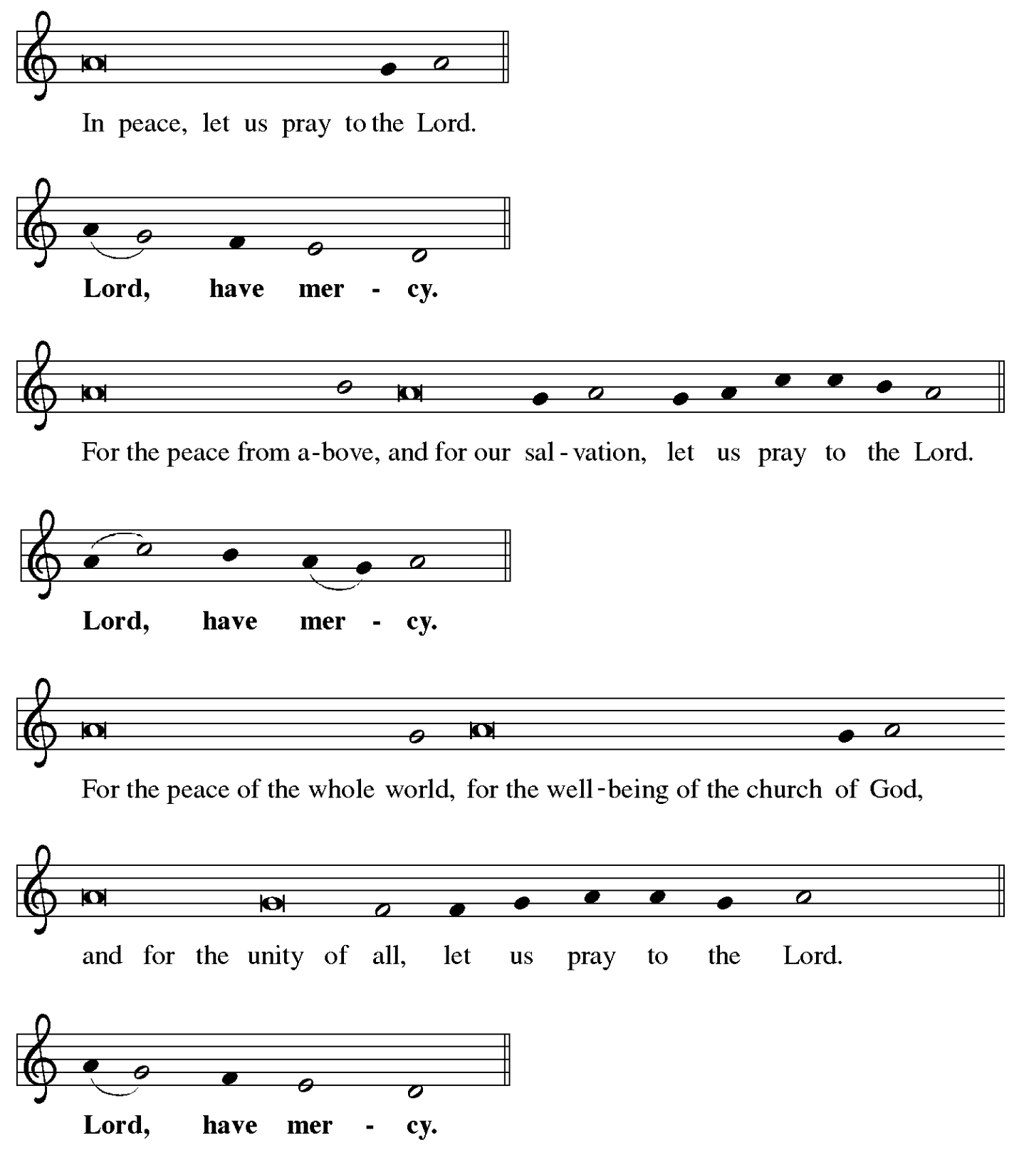

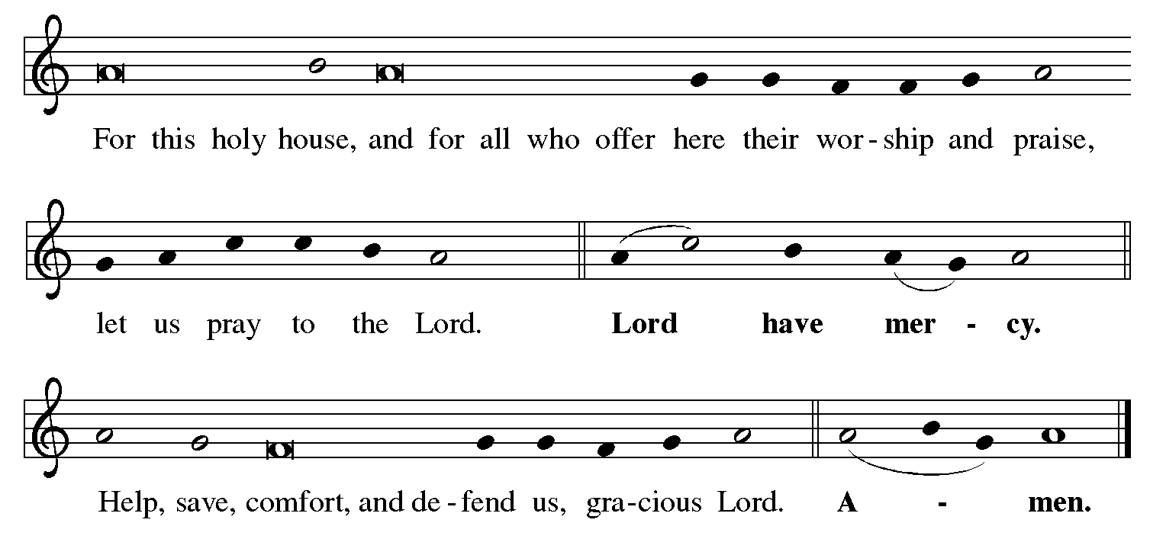

**Prayer of the Day**

P: The Lord be with you.

**C: And also with you.**

P: Stir up your power, Lord Christ, and come.

With your abundant grace and might, free us from the sin that binds us,

that we may receive you in joy and serve you always,

for you live and reign with the Father and the Holy Spirit,

one God, now and forever.

**C: Amen.**

*Please be seated.*

*Children are invited to join the adult leaders at the door for Little Church – Big Faith.*

*We ask that one additional adult from the congregation attend with the children.*

**Word**

*God speaks to us in Scripture reading, preaching, and song*

**First Reading** **–** **Micah 5: 2-5a**

 2 But you, O Bethlehem of Ephrathah,  
  who are one of the little clans of Judah,  
 from you shall come forth for me  
  one who is to rule in Israel,  
 whose origin is from of old,  
  from ancient days.

 3 Therefore he shall give them up until the time  
  when she who is in labor has brought forth;  
 then the rest of his kindred shall return  
  to the people of Israel.  
 4 And he shall stand and feed his flock in the strength of the Lord,  
  in the majesty of the name of the Lord his God.  
 And they shall live secure, for now he shall be great  
  to the ends of the earth;  
 5a and he shall be the one of peace.

L: Word of God, word of life.

**C: Thanks be to God.**

**Luke 1: 46b-55** *Holy Is God’s Name* John Michael Talbot

*The Magnificat, Mary’s song of praise to God from Luke 1 :46b-55, is appointed in place of a psalm today. This version of the Magnificat will be sung by two vocalists.*

**Second Reading – Hebrews 10: 5-10**

5 Consequently, when Christ came into the world, he said,  
 “Sacrifices and offerings you have not desired,  
  but a body you have prepared for me;  
 6 in burnt offerings and sin offerings  
  you have taken no pleasure.  
 7 Then I said, ‘See, God, I have come to do your will, O God’  
  (in the scroll of the book it is written of me).”  
8 When he said above, “You have neither desired nor taken pleasure in sacrifices and offerings and burnt offerings and sin offerings” (these are offered according to the law), 9 then he added, “See, I have come to do your will.” He abolishes the first in order to establish the second. 10 And it is by God’s will that we have been sanctified through the offering of the body of Jesus Christ once for all.

L: Word of God, word of life.

**C: Thanks be to God.**

*Please rise as you are able and join in singing the Gospel Acclamation.*

**Gospel Acclamation** *ELW* p. 188

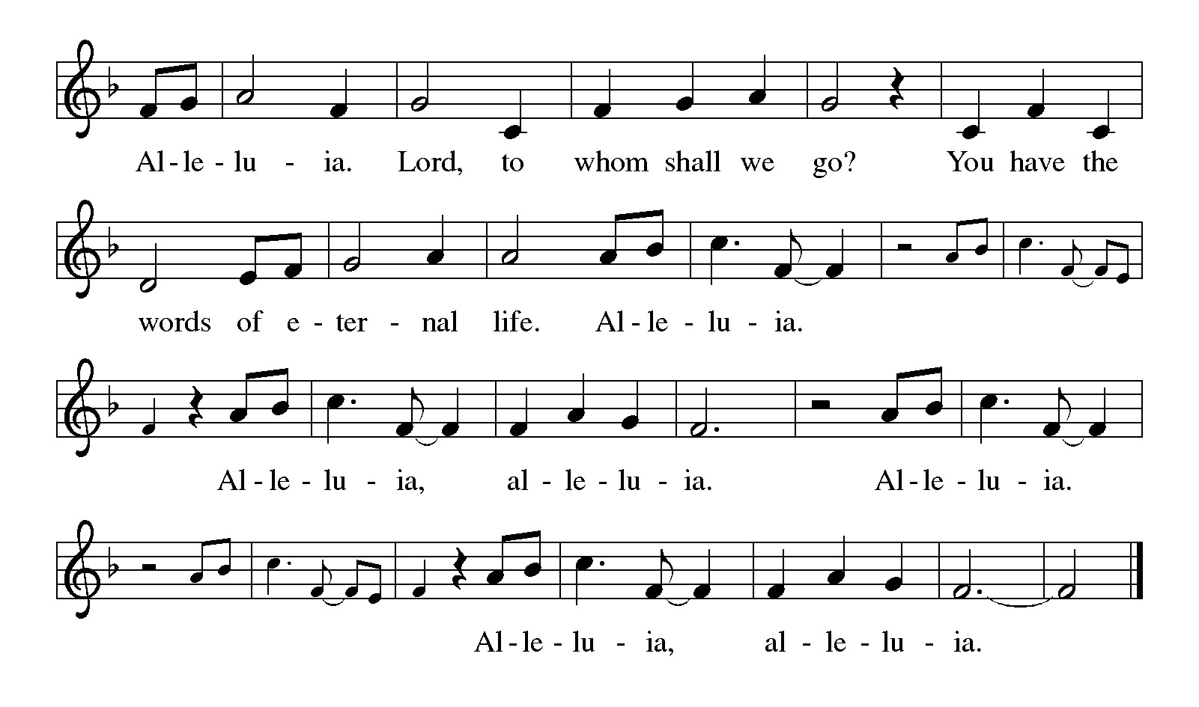

*The Magnificat appointed in the place of the psalm is also the conclusion of today’s Gospel reading. When we reach the text “And Mary said,” the congregation is invited to join in proclaiming Mary’s song of praise through the hymn “Filled with Hope and Gratitude.”*

**Gospel – Luke 1: 39-45 [46-55]**

P: The holy Gospel according to St. Luke.

**C: Glory to you, O Lord.**

39 In those days Mary set out and went with haste to a Judean town in the hill country, 40 where she entered the house of Zechariah and greeted Elizabeth. 41 When Elizabeth heard Mary’s greeting, the child leaped in her womb. And Elizabeth was filled with the Holy Spirit 42 and exclaimed with a loud cry, “Blessed are you among women, and blessed is the fruit of your womb. 43 And why has this happened to me, that the mother of my Lord comes to me? 44 For as soon as I heard the sound of your greeting, the child in my womb leaped for joy. 45 And blessed is she who believed that there would be a fulfillment of what was spoken to her by the Lord.”

And Mary said,

**Hymn of the Day Filled with Hope and Gratitude** *Following page*

**Hymn of the Day Filled with Hope and Gratitude *ACS* 907**

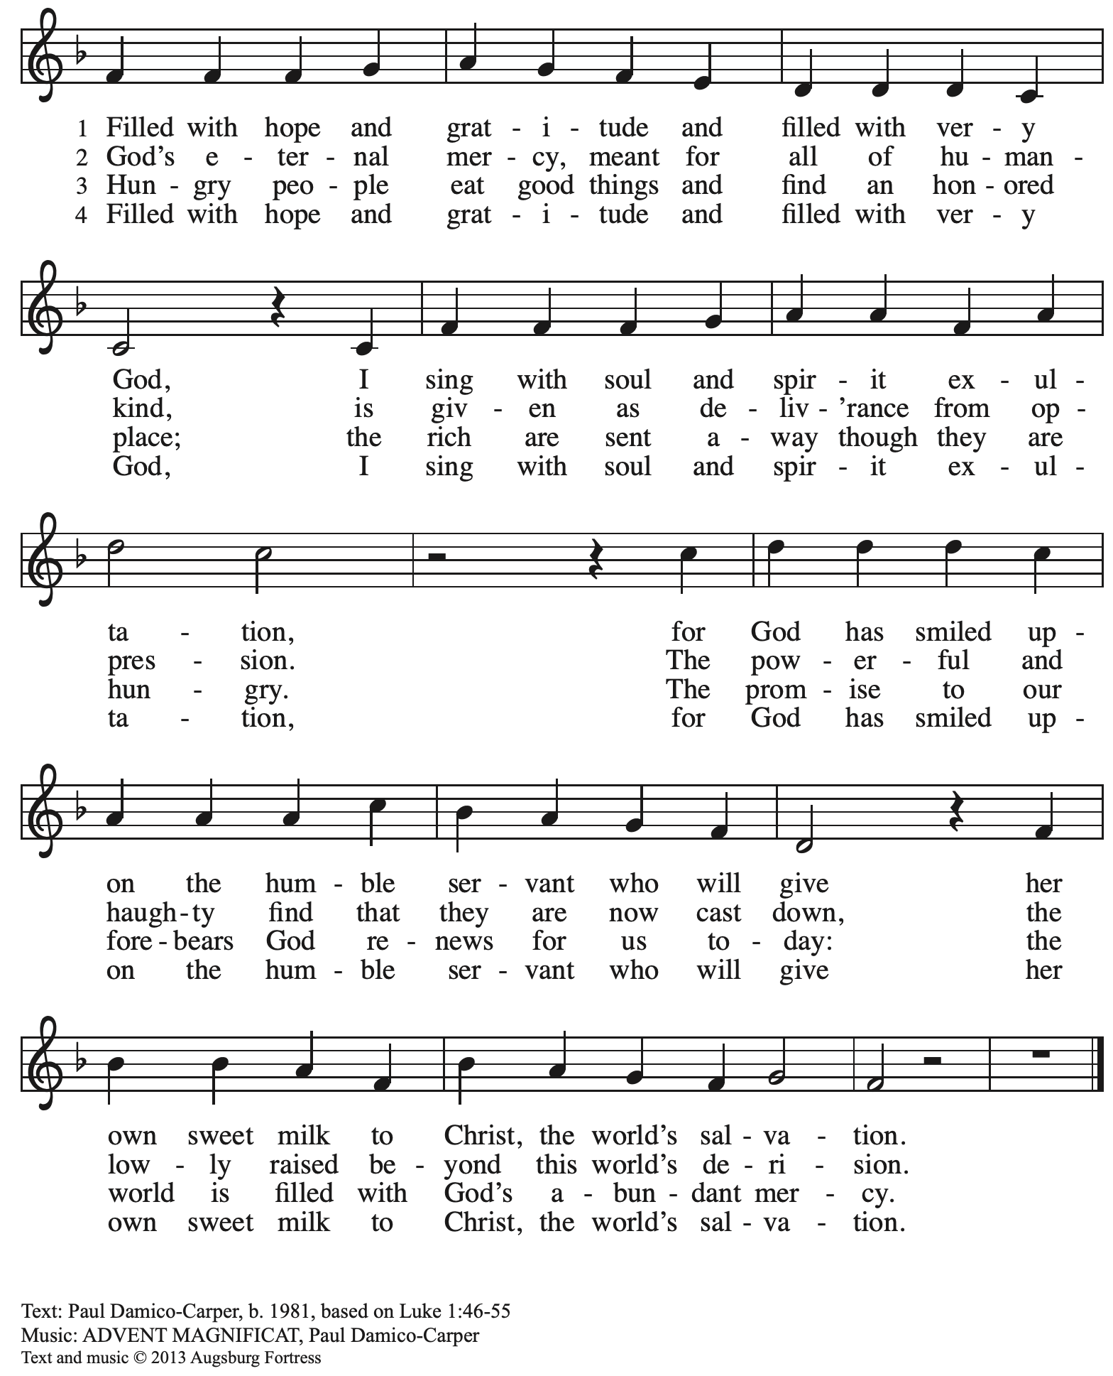

All rights reserved. Reprinted with permission under OneLicense.net # A-722139.

P: The Gospel of the Lord.

**C: Praise to you, O Christ.**

*Please be seated.*

**Sermon**

*A time of silence for prayer and reflection follows the sermon.*

*Worship continues with the prayers of the people – please rise as you are able.*

**Prayers of the People**

A: As we prepare for Emmanuel, God with us,

let us pray for the church, creation, and all who long for God’s presence.

*After each petition*

A: Merciful God

**C: receive our prayer.**

*The presiding minister concludes the prayers*

P: Savior of the nations, come, and receive these prayers and the pleas of our hearts,

in the name of Jesus Christ, our Savior.

**C: Amen.**

**Peace**

*The presiding minister and the assembly greet one another in the peace of the risen Christ.*

P: The peace of Christ be with you always.

**C: And also with you.**

*The people may greet those around them with a sign of Christ’s peace and may say*

Peace be with you *or similar words. Please be mindful that not everyone will be comfortable with sharing the peace, so please seek consent before shaking hands or hugging. Other possible ways to share the peace include a simple bow with the verbal greeting of peace, or simply a verbal expression of peace.*

*When the greetings of peace have concluded, please be seated.*

**Meal**

*God feeds us with the presence of Jesus Christ*

**Offering**

*We offer ourselves, our gifts and our faithful service to God.* *As the offering is gathered for the mission of the church, including the care of those in need, the table is set for Holy Communion.*

*There are laminated giving cards in the pew racks that feature a QR code for anyone who would like to give online. Those who give using the QR code, as well as those who give regularly online or through their bank are encouraged to place the laminated card in the plate as an expression of your offering.*

**Music during the Offering**

*Comfort, Comfort Now My People / Now the Heavens Start to Whisper*

arr. Sylvia Oines

*As the gifts are brought forward for presentation, please rise as you are able.*

**Offertory Song As the Grains of Wheat *ELW* 465**

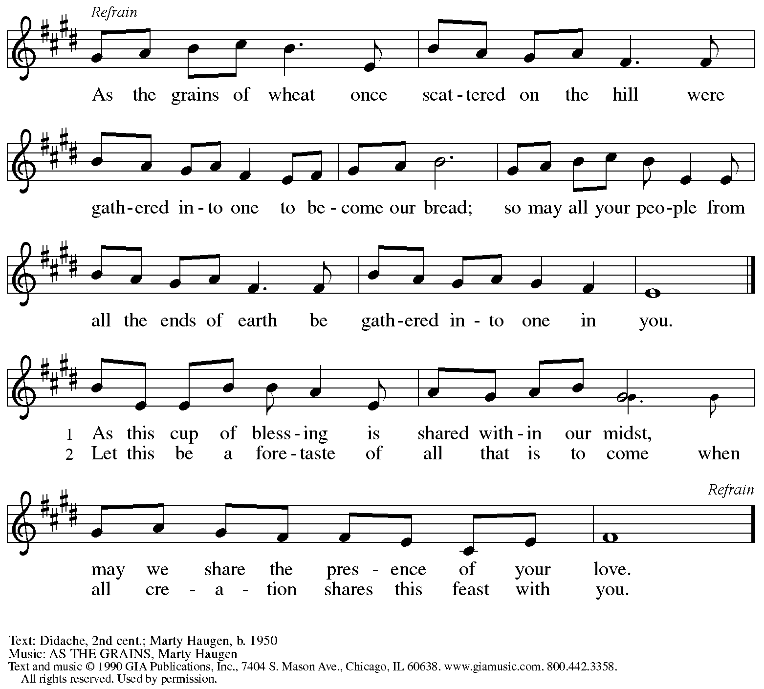

Reprinted under OneLicense.net # A-722139.

**Offertory Prayer**

A: Let us pray.

God of abundance,

**C:** **we bring before you the precious fruits of your creation,**

**and with them our very lives.**

**Teach us patience and hope as we care for all those in need**

**until the coming of your Son, our Savior and Lord**

**Amen.**

**Dialogue**

P: The Lord be with you.

**C: And also with you.**

P: Lift up your hearts.

**C: We lift them to the Lord.**

P: Let us give thanks to the Lord our God.

**C: It is right to give our thanks and praise.**

**Preface**

P: It is indeed right, our duty and our joy …

that we should at all times and in all places

give thanks and praise to you, almighty and merciful God,

through our Savior Jesus Christ.

You comforted your people with the promise of the Redeemer,

through whom you will also make all things new

in the day when he comes to judge the world in righteousness.

And so, with all the choirs of angels,

with the church on earth and the hosts of heaven,

we praise your name and join their unending hymn:

**Sanctus** *ELW* p. 190

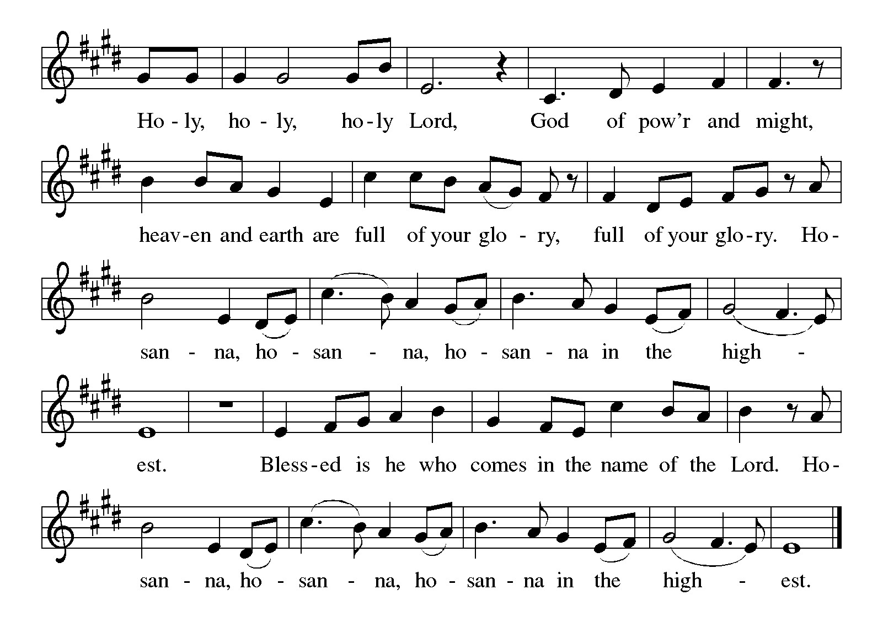

**Eucharistic Prayer**

P: Holy One, the beginning and the end, the giver of life …

…Do this for the remembrance of me.

Let us proclaim the mystery of faith:

**C: Christ has died.**

**Christ is risen.**

**Christ will come again.**

P: With this bread and cup

we remember your Word dwelling among us …

… We look with hope for his coming.

**C: Come, Lord Jesus.**

P: Holy God, we long for your Spirit …

… Bring the gift of peace on earth.

**C: Come, Holy Spirit.**

P: All praise and glory are yours,

Holy One of Israel,

Word of God Incarnate,

Power of the Most High,

one God, now and forever.

**C: Amen.**

**Lord’s Prayer**

P: Gathered as one by the Holy Spirit, let us pray as Jesus taught us.

**C: Our Father in heaven,**

**hallowed be your name,**

**your kingdom come,**

**your will be done,**

**on earth as in heaven.**

**Give us today our daily bread.**

**Forgive us our sins**

**as we forgive those**

**who sin against us.**

**Save us from the time of trial**

**and deliver us from evil.**

**For the kingdom, the power,**

**and the glory are yours,**

**now and forever. Amen.**

**Fraction and Invitation**

P: God feeds us with tender mercy. Come to the table, where Christ comes to us once again.



***Agnus Dei /* Lamb of God** *ELW* p. 191

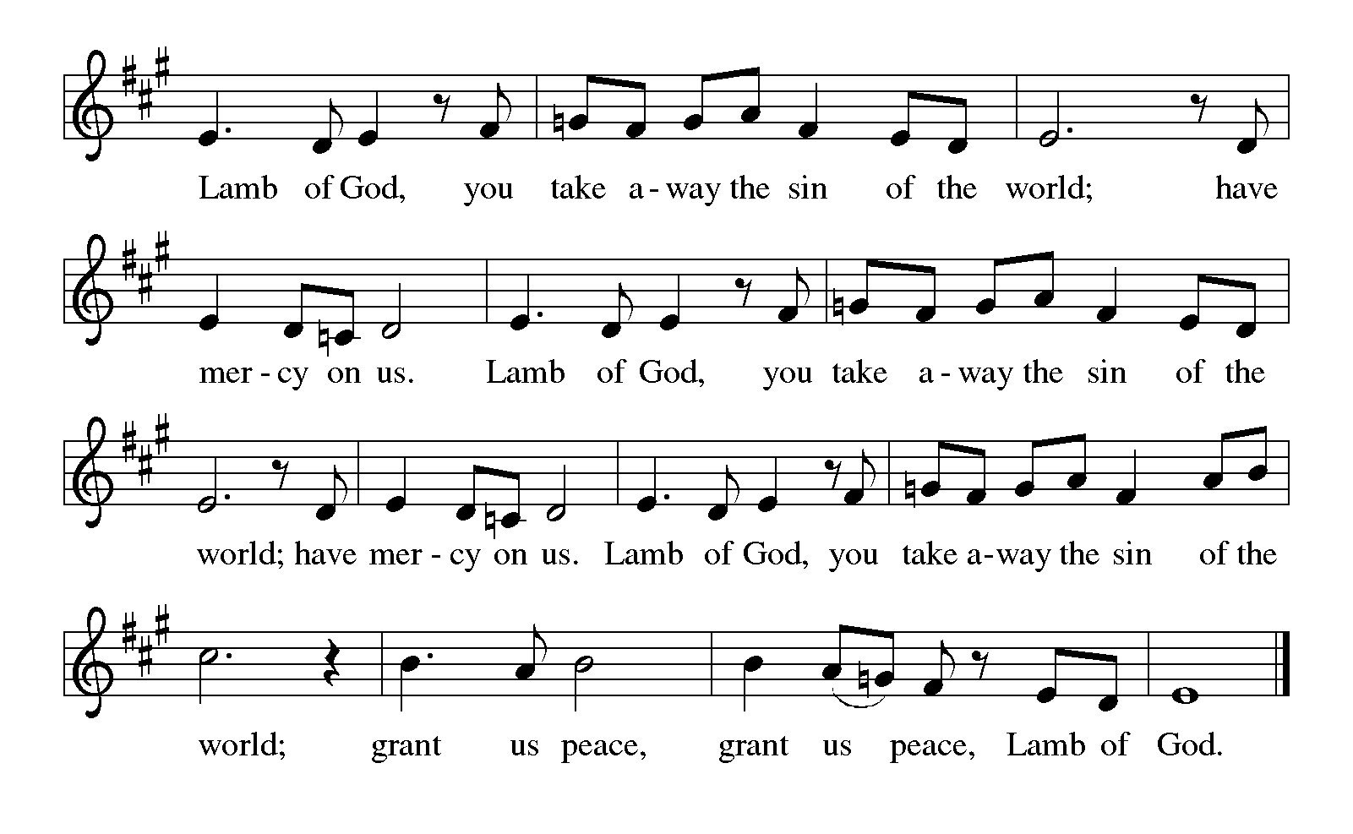

*Please be seated.*

**Holy Communion**

* *All who seek God and desire a deeper and stronger life in Christ are welcome to receive Holy Communion.*
* *Worshipers from the pulpit side will proceed forward first, followed by the center section, and then the lectern side.*
* *Please inform an usher if you would like the ministers to bring Communion to you.*
* *Holy Communion will be served with bread and wine/grape juice.*
* *The presiding minister will first distribute the bread (host) to each communicant. Please indicate if you require a gluten-free host.*
* *Once you have consumed the bread, please pick up an empty glass from the tray next to the presiding minister. The Communion Assistant will pour wine from the chalice or grape juice from the cruet into your glass.*
* *Please step to the side to consume the wine or grape juice.*
* *Feel free to kneel at the altar rail for prayer after receiving the sacrament.*
* *As you return to your pew, glasses may be returned to the empty trays on either side of the center section.*
* *A blessing will be provided for anyone who does not yet receive the sacrament.*
* *All are invited to join in singing the hymns during Holy Communion.*

**Hymns during Holy Communion**

**Lost in the Night *ELW* 243**

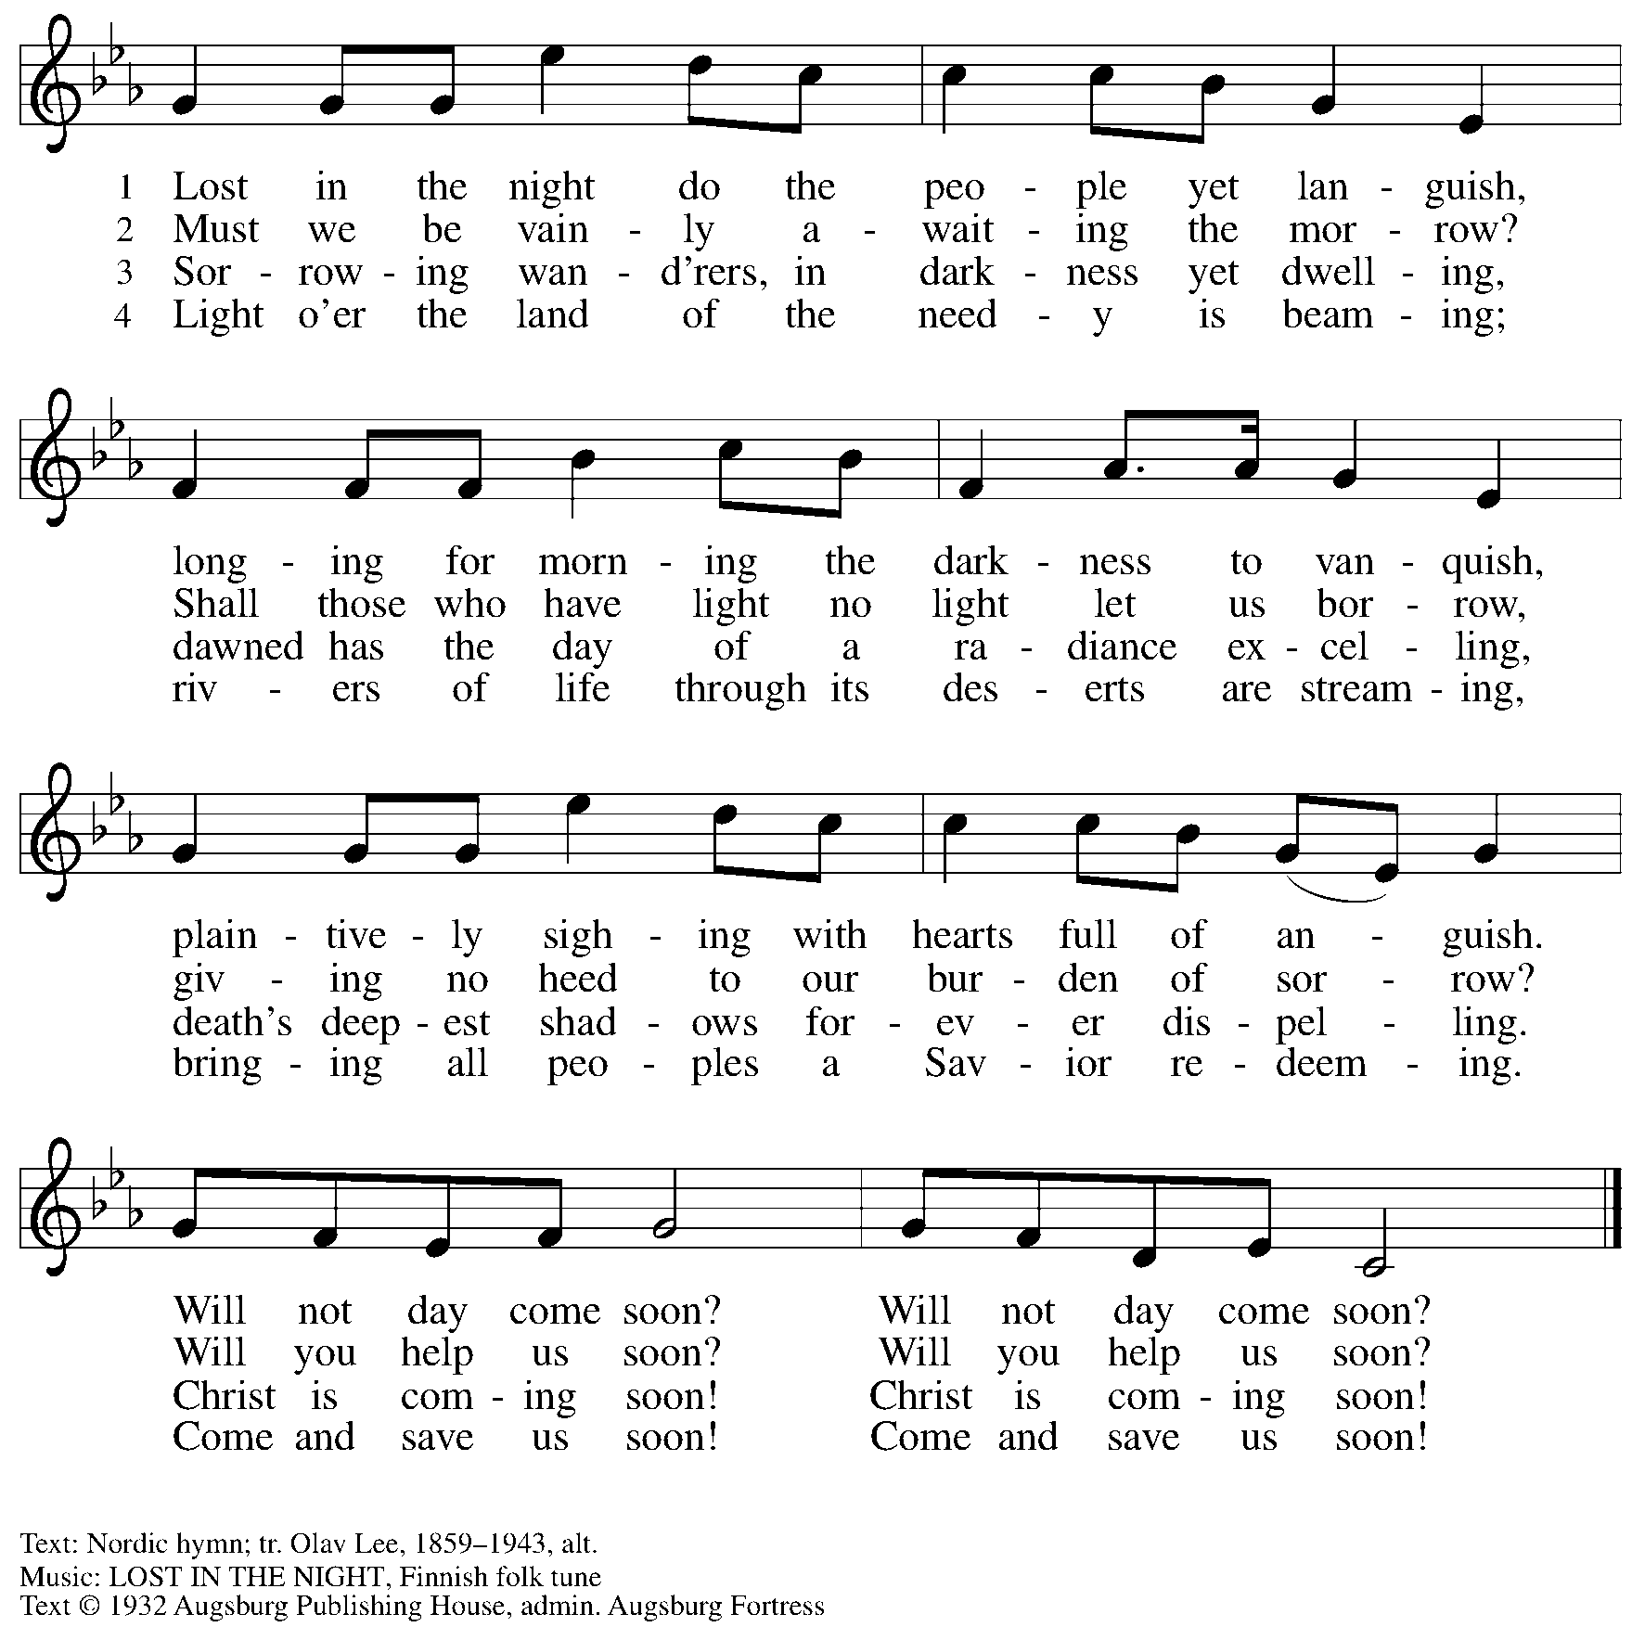

All rights reserved. Reprinted with permission under OneLicense.net # A-722139.

**Hymns during Holy Communion**

**Unexpected and Mysterious *ELW* 258**

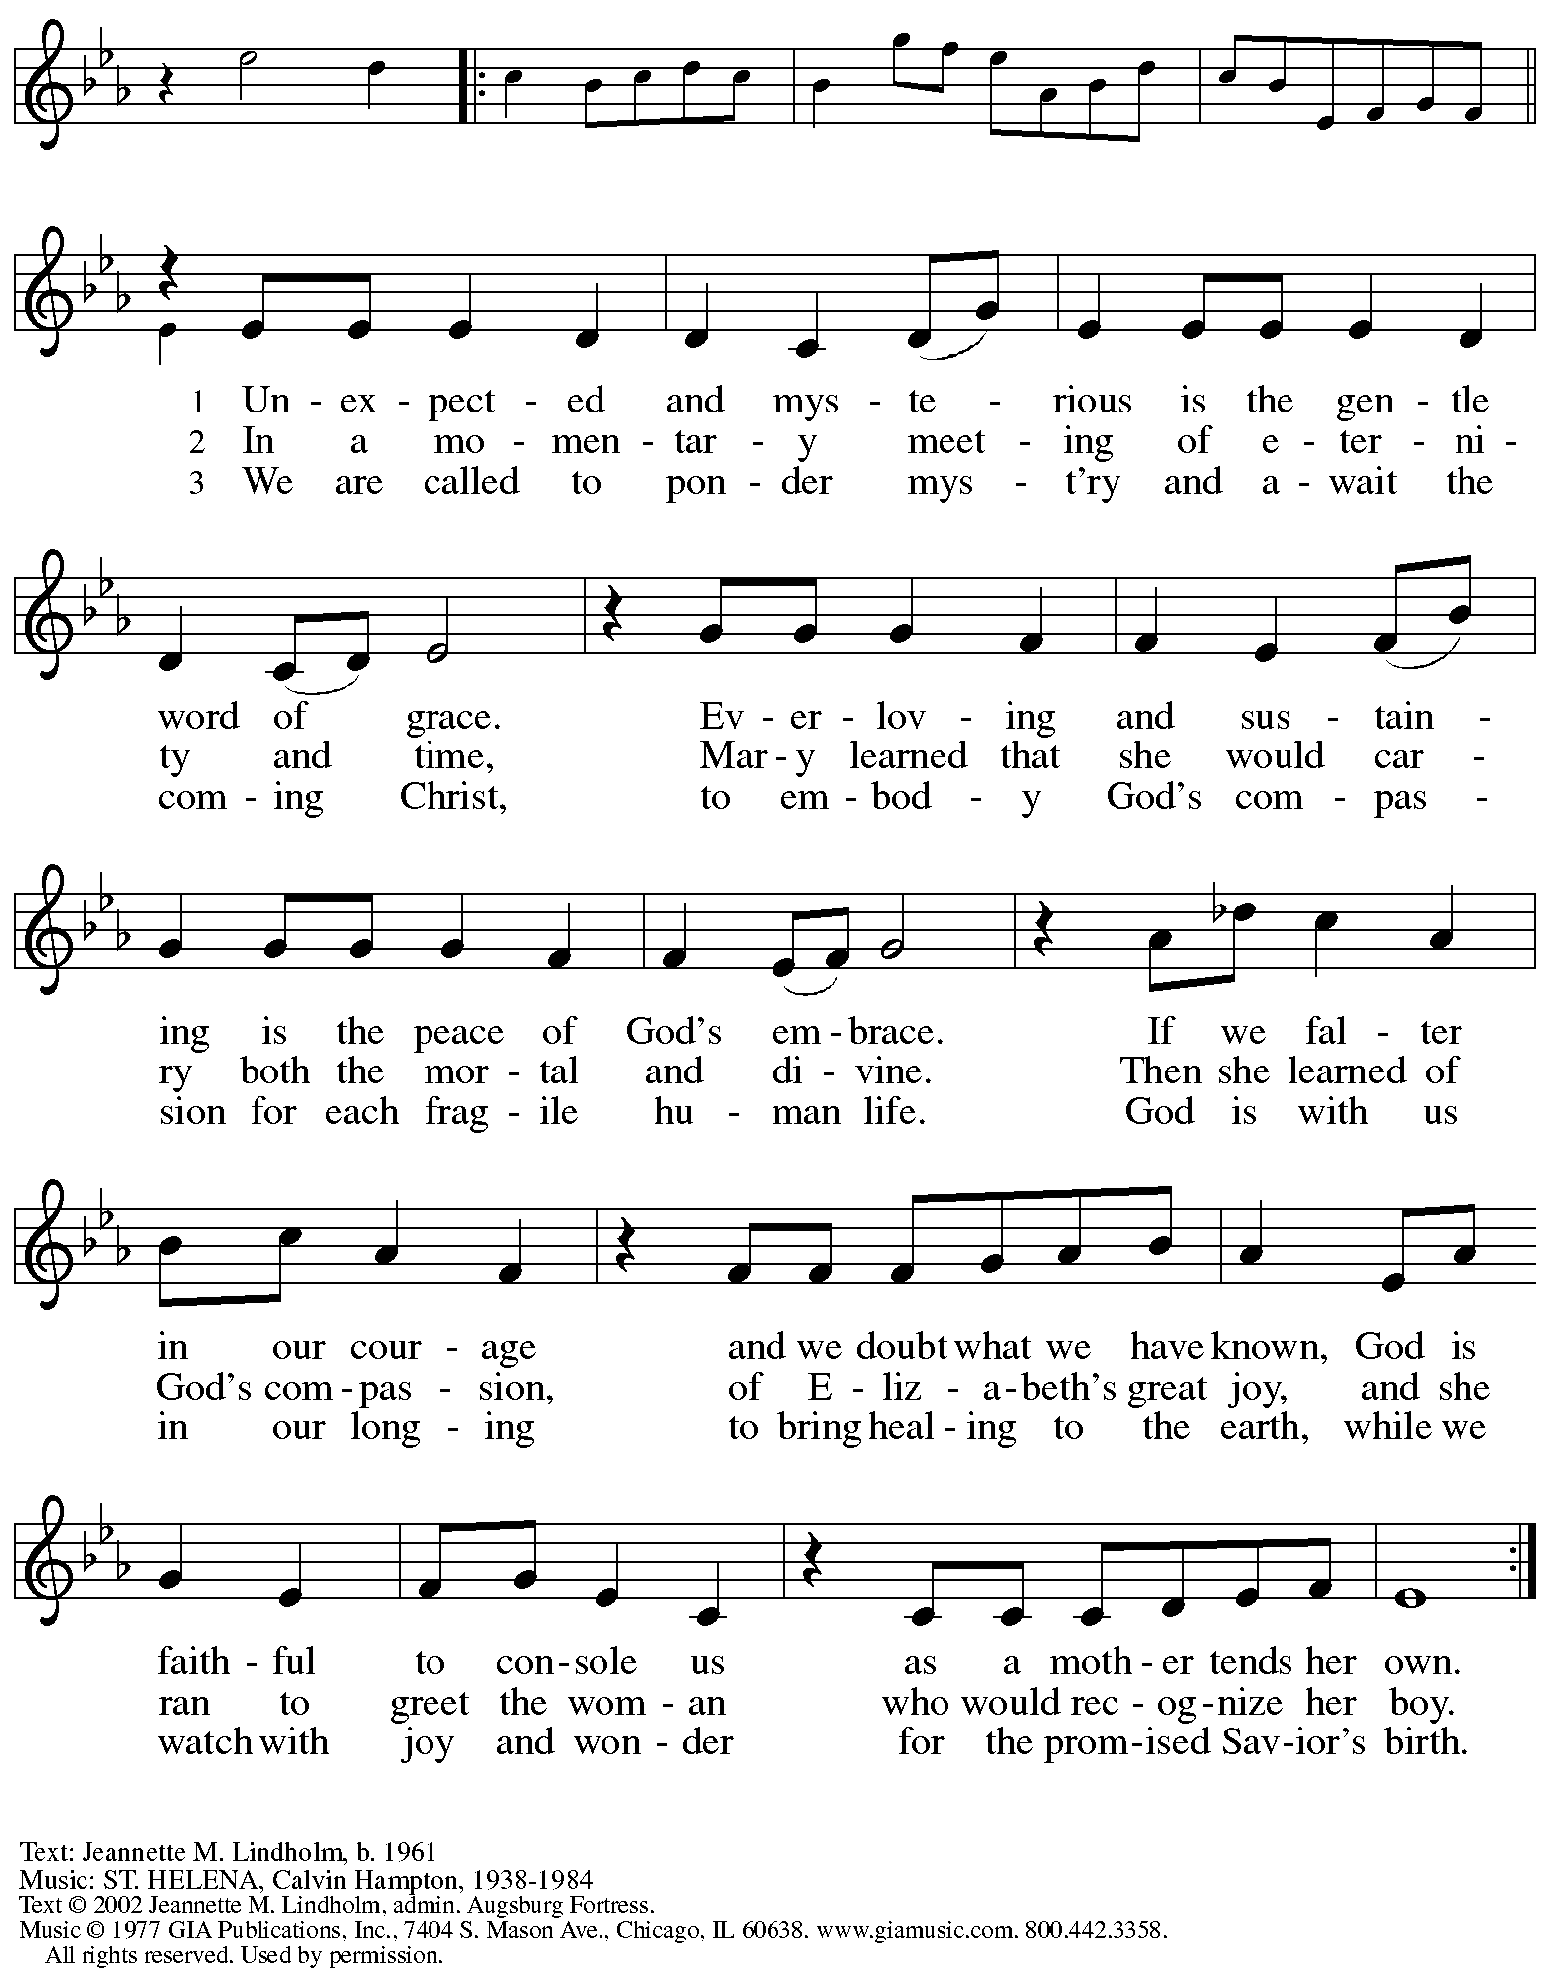

Reprinted under OneLicense.net # A-722139.

**Hymns during Holy Communion**

**You, Dear Lord – *Tú, Señor, que brillas* *ELW* 702**

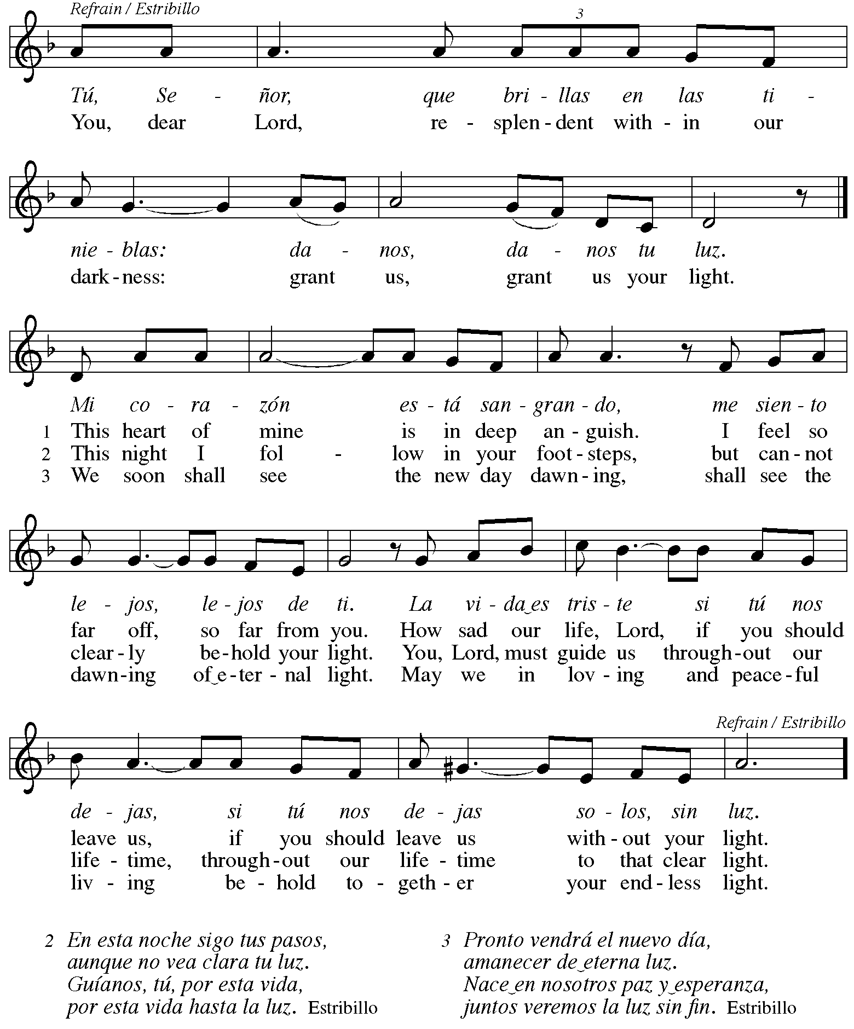

**Hymns during Holy Communion**

**Savior of the Nations, Come *ELW* 263**

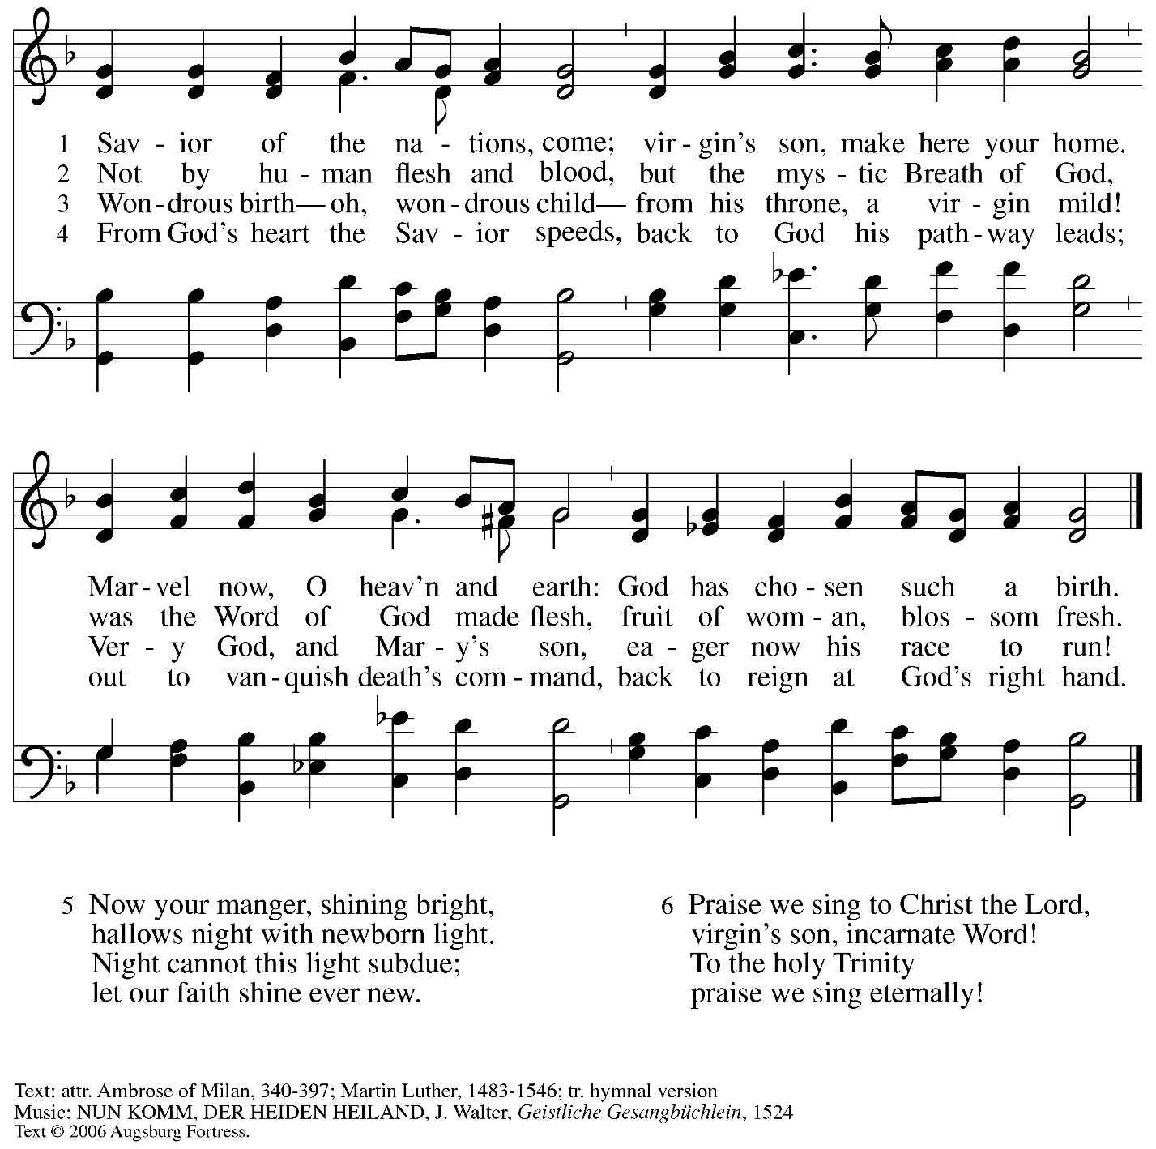

All rights reserved. Reprinted with permission under OneLicense.net # A-722139.

*When all have returned to their places, please rise as you are able.*

**Blessing**

P: The body and blood of our Lord Jesus Christ strengthen you and keep you in his grace.

**C: Amen.**

**Prayer**

A: Let us pray.

God for whom we wait,

in this meal you give us a foretaste of that day when the hungry will be fed with good things. Send us forth to make known your deeds and to proclaim the greatness of your name,

through Jesus Christ, our Savior and Lord.

**C: Amen.**

*Please be seated.*

**Sending**

*God blesses us and sends us in mission to the world*

**Announcements**

*Please rise as you are able.*

**Benediction**

P: God of endings and beginnings,

God in the darkness and in the light,

God, our hope for the journey,

☩ bless and keep you now and forever.

**C: Amen.**

**Sending Hymn** *Following page*

**Dismissal**

A: Go in peace. Prepare the way for Emmanuel.

**C: Thanks be to God.**

**Postlude**

**Sending Hymn Soon and Very Soon *ELW* 439**

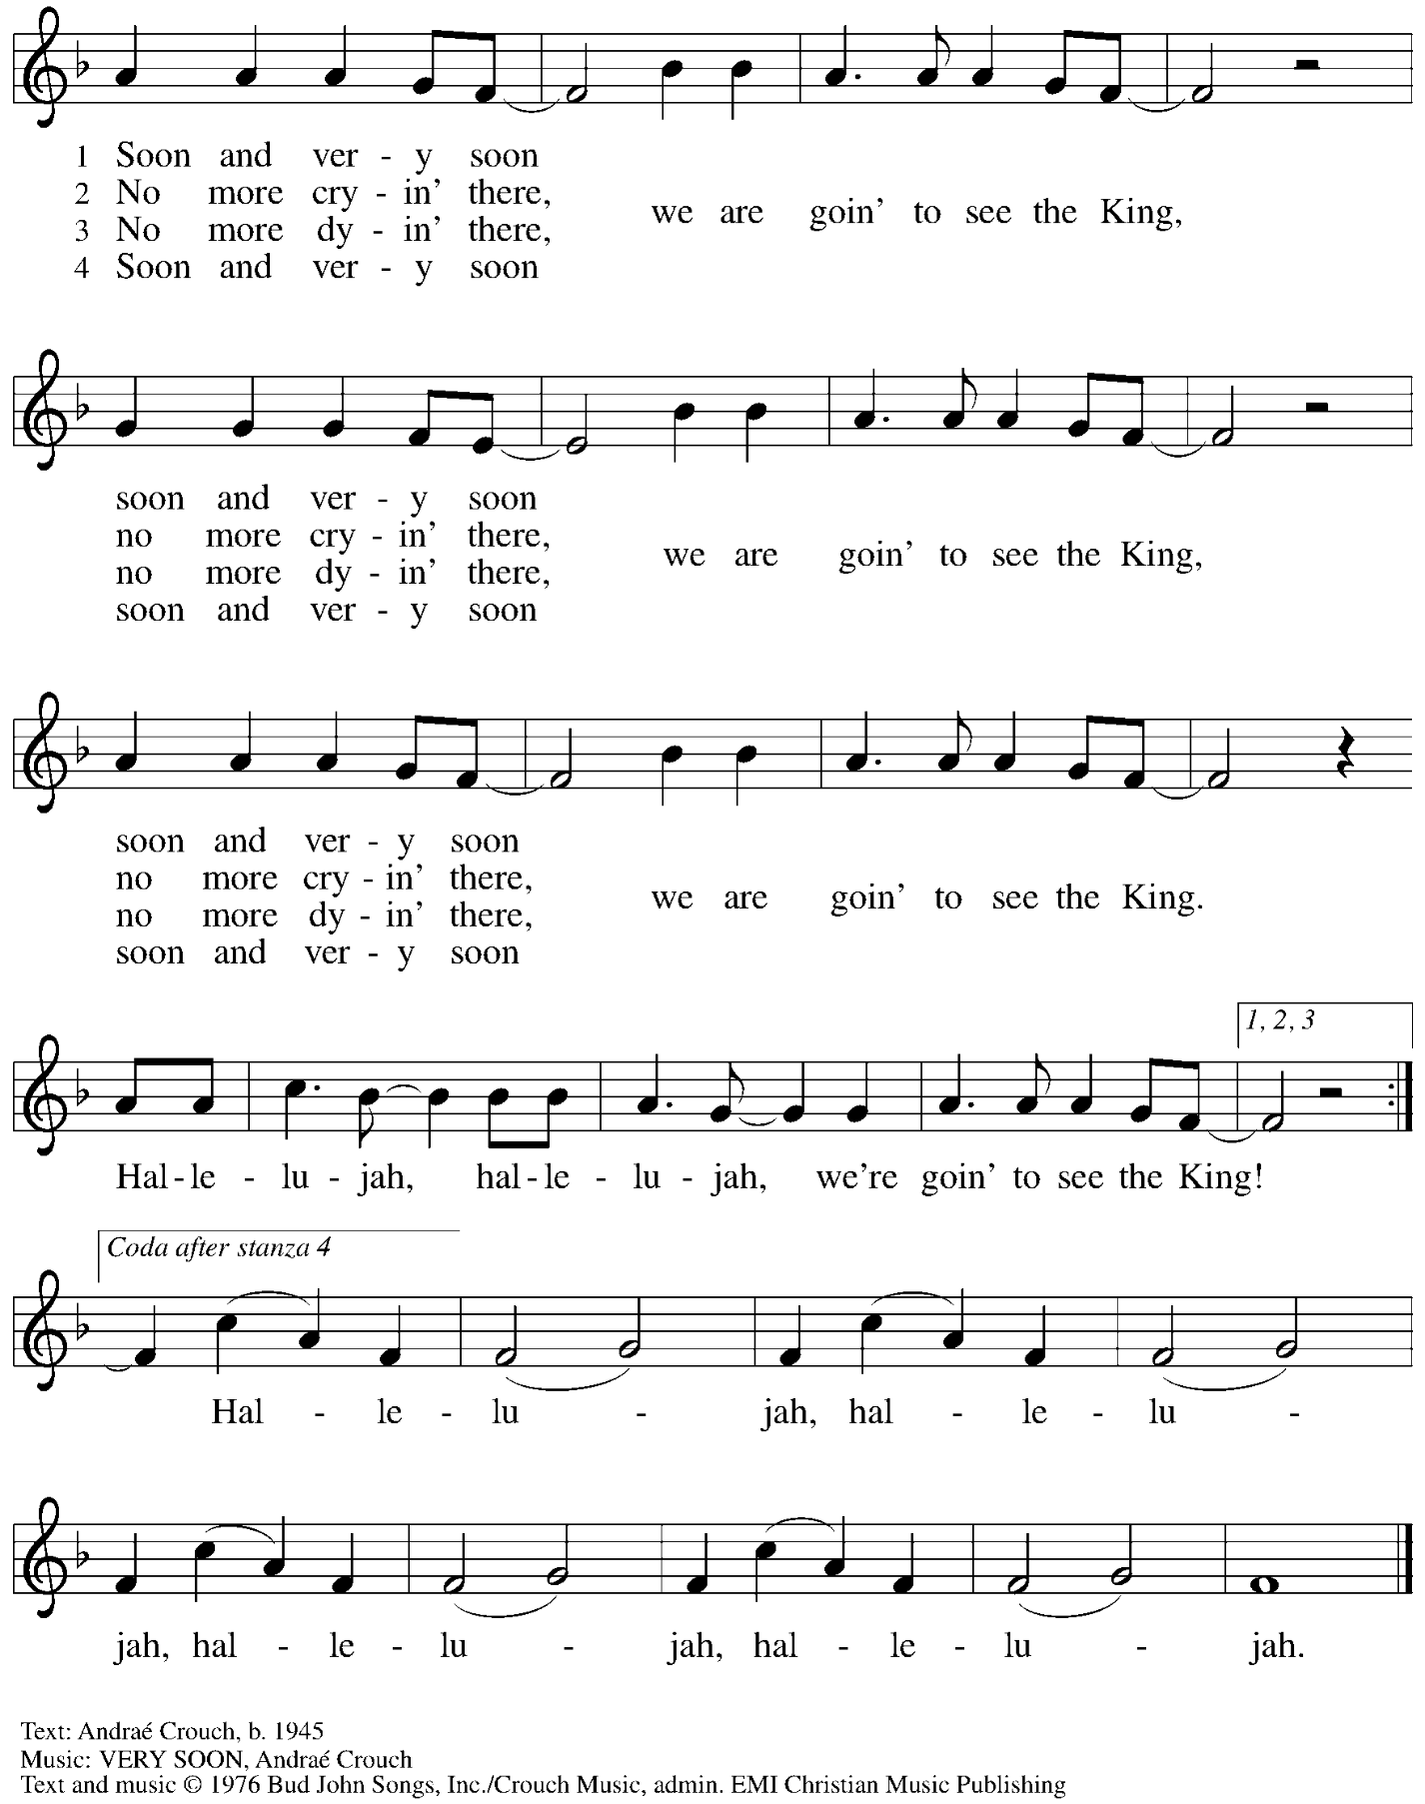

All rights reserved. Reprinted with permission under CCLI # 11561207.

*Those serving in worship today*

Altar Care Christy Ruhe

Assisting Minister Kathy Hays

Audio-Visual Ministers Kristen Asplin

Jason Galyardt

Cantor C.E. Pino

Lector Lindsay Baxter

Little Church – Big Faith Emily Duque

Vocalists Emily Duque

The Rev. Erin Jones

Minister of Music Laura Reynolds

Preaching and Presiding Minister Pastor Ross Carmichael

*Liturgy and Hymnody Acknowledgements*

From SundaysandSeasons.com. Copyright © 2024 Augsburg Fortress. All rights reserved. Reprinted under OneLicense.net # A-722139.

Used by permission of Augsburg Fortress.

The Scripture readings contained herein are from *New Revised Standard Version* of the Bible © 1989, Division of Christian Education of the National Council of Churches of Christ in the USA. Used by permission. All rights reserved.

**O Come, O Come, Emmanuel** – Text: *Psalteriolum Cantionum Catholicarum*, Köln, 1710; tr. composite. Music: VENI, EMMANUEL, French processional, 15th cent. Text sts. 2, 6, 7 © 1997 Augsburg Fortress. All rights reserved. Reprinted with permission under OneLicense.net # A-722139.

**You, Dear Lord – *Tú, Señor, que brillas*** – Text: Anonymous; tr. Fred Pratt Green, 1903-2000. Music: TÚ, SEÑOR, Gerhard M. Cartford, b. 1923. English text © 1982 Hope Publishing Company, Carol Stream, IL 60188. Music © Lutheran World Federation. All rights reserved. Reprinted with permission under OneLicense.net # A-722139.

*Please use the QR code below to link to St. Andrew’s announcements online!*



**St. Andrew Lutheran Church Announcements**

**December 22nd, 2024**

* **Welcome to Worship at St. Andrew on the Fourth Sunday of Advent, December 22nd, 2024** –We are thankful you are here, and we offer a special welcome to all visitors and guests here for the first time. Worship attendees are invited to make a name tag at the back of the worship space. Little Church – Big Faith, a Bible lesson and activity for children, will take place after the prayer of the day. There are also worship “toolkits” to help children engage with worship and “busy bags” for younger children available in the bookcase at the back of the sanctuary. Please feel free to take one to use with/for your children. All are invited to gather for coffee other drinks and food, and conversation in the social hall after worship.
* **Decorate for the Christmas Season after Worship Today – St**. Andrew invites everyone in the congregation to stay after worship today to help decorate the church for the Christmas season!
* **Worship on Christmas Eve – Tuesday, December 24th, 7:00 p.m. – St. Andrew celebrates the Nativity of our Lord with a service on Christmas Eve, December 24th, at 7:00 p.m. Come for carols, candle-lighting, and Communion as we praise God for the birth of Christ!**
* **Coffee Hour Signups Available** –One way that St. Andrew builds community is by sharing conversation over food and drinks at coffee hour after worship on Sundays. We invite people of the congregation to sign up to coordinate coffee hour each week, which includes brewing the coffee; setting out cups, napkins, food items, and cold drinks; and cleaning up afterward. Everything needed is at St. Andrew and instructions are available. Please sign up to host coffee hour here: <https://www.signupgenius.com/go/5080B4AAFAF2CABF85-47069030-coffee>.
* **New *Christ in Our Home* Devotional Booklets (January – March 2025) Available at Church Entrances – *Christ in Our Home* is a booklet of devotions that includes Scripture, a brief reflection, and prayer for each day. The new edition for January – March 2025 is available at the various church entrances. Please feel free to take one for yourself or others!**