

**+ Third Sunday of Advent**

**December 15, 2024**



**St. Andrew Lutheran Church**

**304 Morewood Ave.**

**Pittsburgh, PA 15213**

[**St_andrewELCA@verizon.net**](mailto:St_andrewELCA@verizon.net)

[**www.standrewpittsburgh.org**](http://www.standrewpittsburgh.org)

**+ Third Sunday of Advent**

**Order for Worship**

*Christ’s presence in our midst in the wonder of the holy supper is cause for singing.*

*The nearness of the God in prayer, in every circumstance, is cause for rejoicing.*

*The coming of one “more powerful” than John, even with a winnowing fork in hand,*

*is good news—and cause for exultation—for us who are being saved.*

*Great joy is the tone for the third Sunday of Advent.*

**Welcome to St. Andrew!**

* St. Andrew welcomes all who are seeking a place of healing, wholeness, and acceptance in a nurturing and faith-forming spiritual home. We are striving toward racial equity worldwide

and we seek to honor the lived experience of all individuals regardless of background. Our community embraces people of all ages, ethnicities, cultures, abilities, sexual orientations,

gender identities and expressions, and family constellations. Come and See!

* Worship Services are live-streamed to multiple online platforms. By attending worship, you agree that your image and voice may be broadcast.
* Everyone is invited to make a name tag at the black bookcase in the back of the worship space if they would like. There are stickers indicating pronouns on the bookcase if you would like to include them on your name tag.
* Children are invited to attend Little Church – Big Faith, a Bible lesson and activity, during worship (after the Prayer of the Day). The group returns to the worship space for the liturgy of Holy Communion.
* A nursery is available through the doors at the left side of the sanctuary and across from the doorway to the Social Hall. Look for a purple-colored room.
* Worship “toolkits” to help children engage with the service, along with “busy bags” for younger children, are available in the bookcase at the back of the sanctuary. Please feel free to take one to use with/for your children.
* Holy Communion is served with bread (gluten-free available) and wine or grape juice. The presiding minister will distribute the bread (host). Please consume this and then pick up an empty glass from the tray. The Communion Assistant will pour wine or grape juice into your glass. Please step to the side to consume the wine or grape juice. Feel free to kneel at the altar for prayer and reflection. As you return to your pew, glasses may be returned to the empty trays on either side of the center section.
* A restroom is available on the main level of the church, through the doors to the Social Hall and to the right in the main office.

*Abbreviations*

P: Pastor/Presiding Minister ***ELW*: *Evangelical Lutheran Worship* hymnal**

A: Assisting Minister ***ACS*: *All Creation Sings* hymnal**

L: Lector

**C: Congregation**

**Pre-Service Music**

**Welcome**

**Prelude** *O Come, O Come, Emmanuel* arr. Steve Dunn

*During the prelude, individuals from the congregation will come forward to light the candle(s)*

*of the Advent wreath corresponding to the four Sundays of Advent.*

**Gathering**

*The Holy Spirit calls us together as the people of God*

**Confession and Forgiveness**

*Please rise as you are able. All may make the sign of the cross,*

*the sign that is marked at Baptism, as the presiding minister begins.*

P: Blessed be the holy Trinity, ☩ one God,

alive in the world, reviving creation, arriving soon.

**C: Amen.**

P: Let us confess our sin in the presence of God and of one another.

*Silence is kept for reflection*

P: God of mercy,

**C: we confess that we have sinned.**

**We have trusted earthly powers and human authority alone.**

**We have grown fearful. We cling to false comforts.**

P: God of might,

**C: we confess that we have sinned.**

**We have turned away from our neighbors. We have trusted false promises.**

P: God in our midst,

**C: we confess that we have sinned.**

**We plead: come to us. Bring your mercy to birth in us. Amen.**

P: A righteous branch springs forth: it is Christ the Lord, our Savior,

in whom we have forgiveness, life, and mercy.

By the power of the Holy Spirit, receive the grace and forgiveness of God

through ☩ Christ Jesus, whose day draws near.

**C: Amen.**

**Gathering Hymn Fling Wide the Door *ELW* 259**

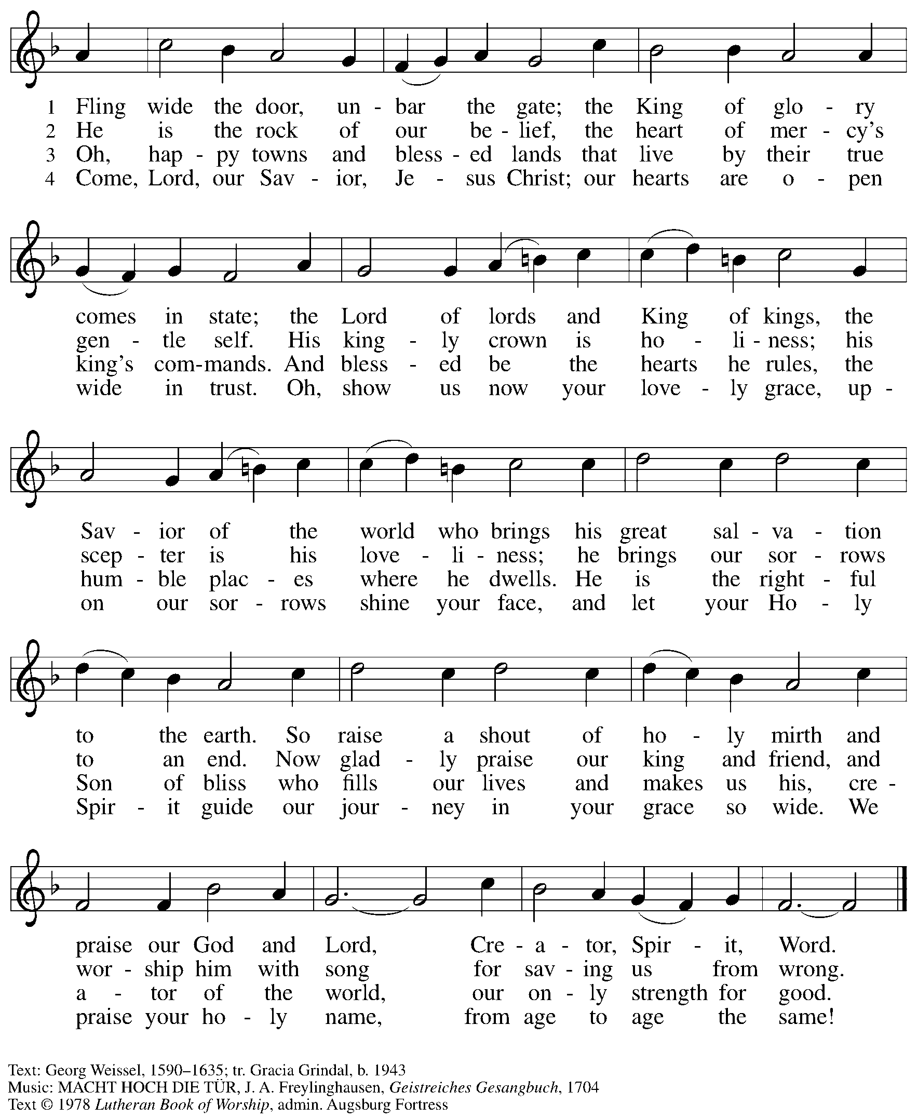

All rights reserved. Reprinted with permission under OnelIcense.net # A-722139.

**Greeting**

P: The grace of our Lord Jesus Christ, the love of God,

and the communion of the Holy Spirit be with you all.

**C: And also with you.**

**Kyrie** *ELW* p. 147

*The cantor leads the singing of the Kyrie, with the congregation joining in the responses in bold.*

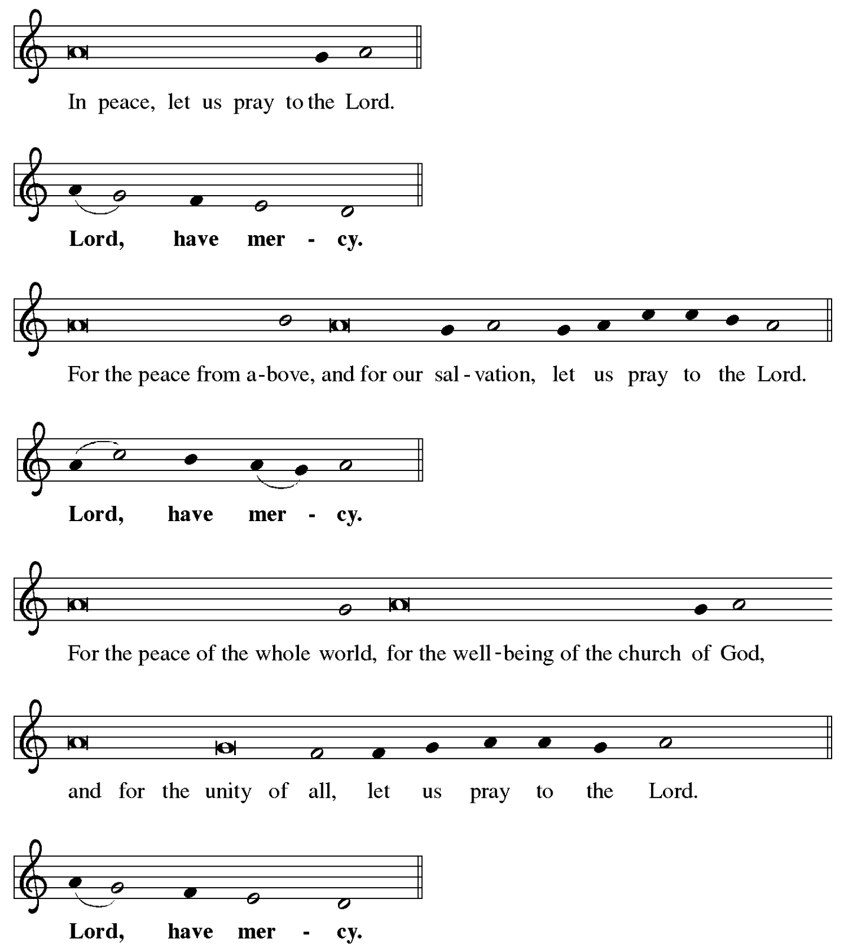

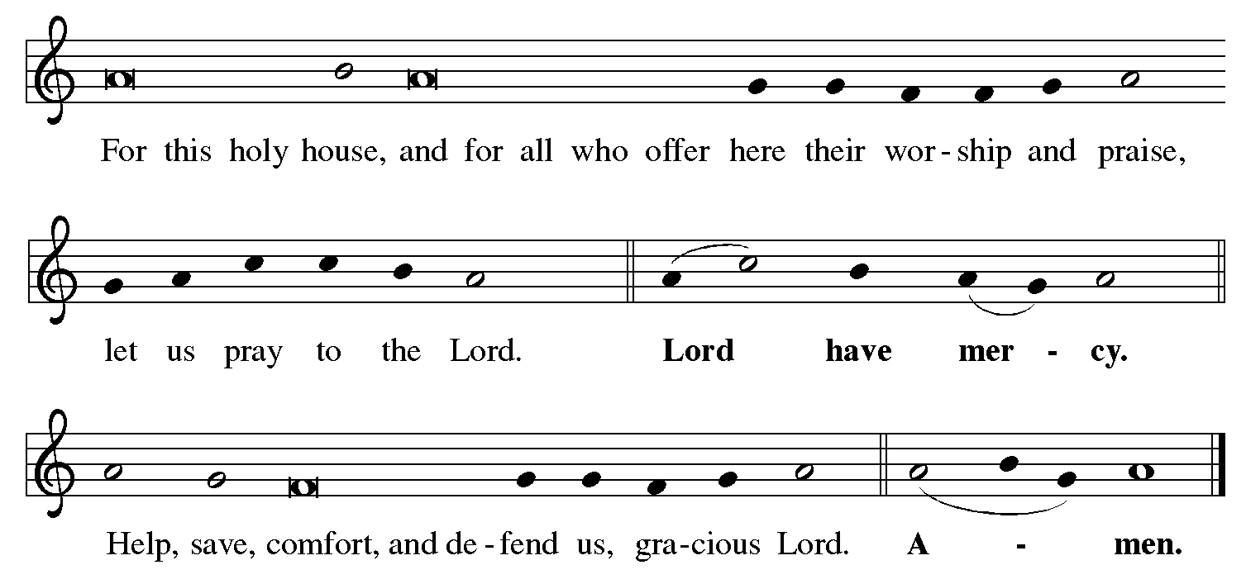

**Prayer of the Day**

P: The Lord be with you.

**C: And also with you.**

P: Stir up the wills of your faithful people, Lord God, and open us to the preaching of John,

that, rejoicing in your salvation, we may bring forth the fruits of repentance;

through Jesus Christ, our Savior and Lord, who lives and reigns with you and the Holy Spirit, one God, now and forever.

**C: Amen.**

*Please be seated.*

*Children are invited to join the adult leaders at the door for Little Church – Big Faith.*

*We ask that one additional adult from the congregation attend with the children.*

**Word**

*God speaks to us in Scripture reading, preaching, and song*

**First Reading** **–** **Zephaniah 3: 14-20**

14 Sing aloud, O daughter Zion;  
  shout, O Israel!  
 Rejoice and exult with all your heart,  
  O daughter Jerusalem!  
 15 The Lord has taken away the judgments against you,  
  the Lord has turned away your enemies.  
 The king of Israel, the Lord, is in your midst;  
  you shall fear disaster no more.  
 16 On that day it shall be said to Jerusalem:  
 Do not fear, O Zion;  
  do not let your hands grow weak.  
 17 The Lord, your God, is in your midst,  
  a warrior who gives victory;  
 God will rejoice over you with gladness,  
  God will renew you in God’s love;  
 God will exult over you with loud singing  
  18 as on a day of festival.  
 I will remove disaster from you,  
  so that you will not bear reproach for it.  
 19 I will deal with all your oppressors  
  at that time.  
 And I will save the lame  
  and gather the outcast,  
 and I will change their shame into praise  
  and renown in all the earth.  
 20 At that time I will bring you home,  
  at the time when I gather you;  
 for I will make you renowned and praised  
  among all the peoples of the earth,  
 when I restore your fortunes  
  before your eyes, says the Lord.

L: Word of God, word of life.

**C: Thanks be to God.**

**Isaiah 12: 2-6 Surely God Is My Salvation** *Following page*

*In place of the psalm today, the appointed text is Isaiah 12: 2-6.*

*The congregation will sing Surely God Is My Salvation – ACS 926,*

*a paraphrase of the Isaiah text.*



**Isaiah 12: 2-6 Surely God Is My Salvation *ACS* 926**

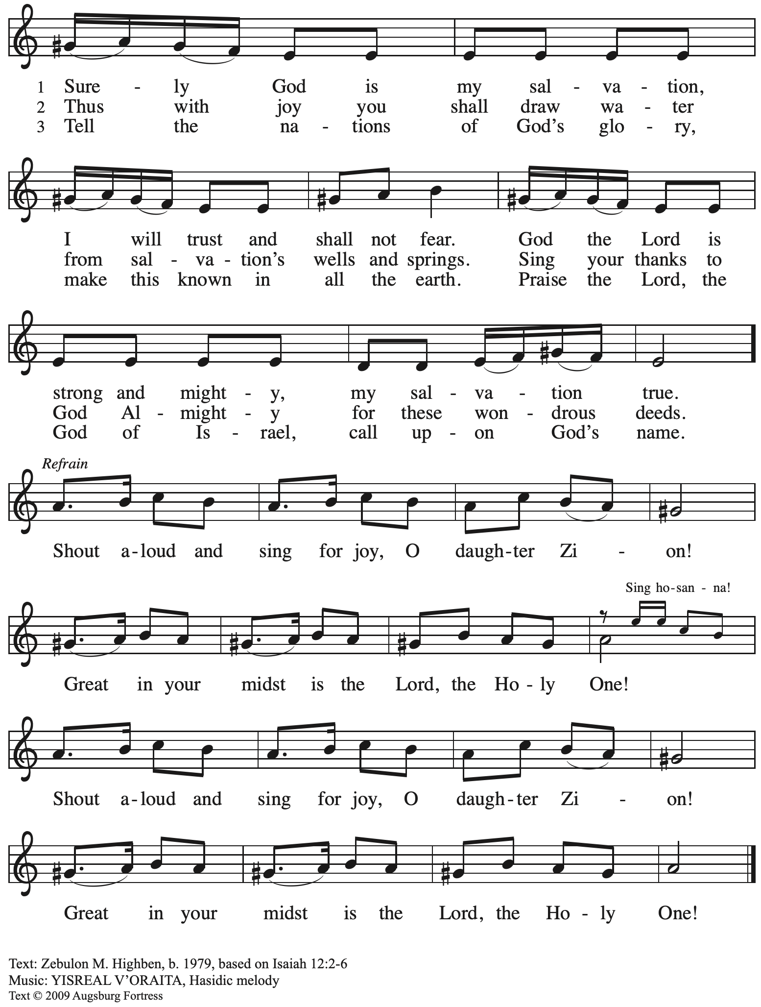

All rights reserved. Reprinted with permission under OneLicense.net # A-722139.

**Second Reading – Philippians 4: 4-7**

4 Rejoice in the Lord always; again I will say, Rejoice. 5 Let your gentleness be known to everyone. The Lord is near. 6 Do not worry about anything, but in everything by prayer and supplication with thanksgiving let your requests be made known to God. 7 And the peace of God, which surpasses all understanding, will guard your hearts and your minds in Christ Jesus.

L: Word of God, word of life.

**C: Thanks be to God.**

*Please rise as you are able and join in singing the Gospel Acclamation.*

**Gospel Acclamation** *ELW* p. 188

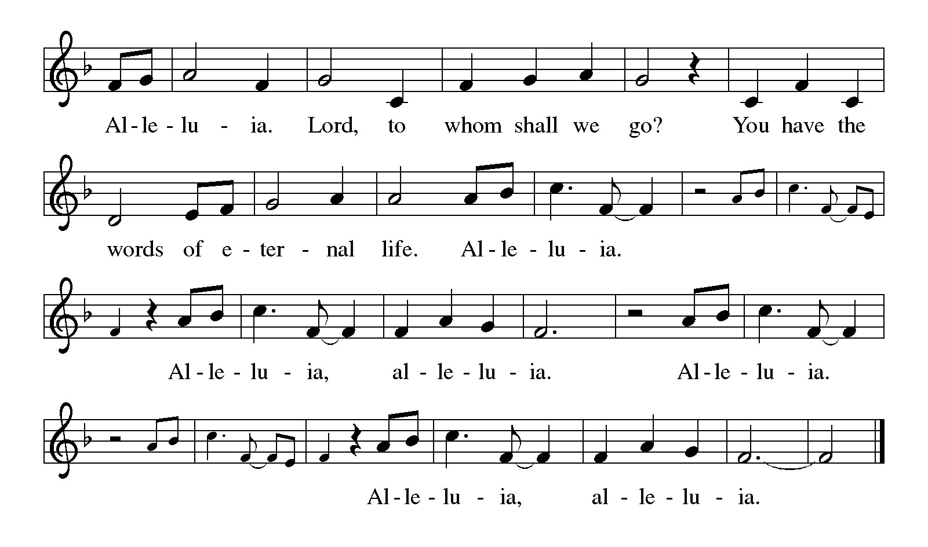

**Gospel – Luke 3: 7-18**

P: The holy Gospel according to St. Luke.

**C: Glory to you, O Lord.**

7 John said to the crowds that came out to be baptized by him, “You brood of vipers! Who warned you to flee from the wrath to come? 8 Bear fruits worthy of repentance. Do not begin to say to yourselves, ‘We have Abraham as our ancestor’; for I tell you, God is able from these stones to raise up children to Abraham. 9 Even now the ax is lying at the root of the trees; every tree therefore that does not bear good fruit is cut down and thrown into the fire.”  
  10 And the crowds asked him, “What then should we do?” 11 In reply he said to them, “Whoever has two coats must share with anyone who has none; and whoever has food must do likewise.” 12 Even tax collectors came to be baptized, and they asked him, “Teacher, what should we do?” 13 He said to them, “Collect no more than the amount prescribed for you.” 14 Soldiers also asked him, “And we, what should we do?” He said to them, “Do not extort money from anyone by threats or false accusation, and be satisfied with your wages.”  
  15 As the people were filled with expectation, and all were questioning in their hearts concerning John, whether he might be the Messiah, 16 John answered all of them by saying, “I baptize you with water; but one who is more powerful than I is coming; I am not worthy to untie the thong of his sandals. He will baptize you with the Holy Spirit and fire. 17 His winnowing fork is in his hand, to clear his threshing floor and to gather the wheat into his granary; but the chaff he will burn with unquenchable fire.”  
  18 So, with many other exhortations, he proclaimed the good news to the people.

P: The Gospel of the Lord.

**C: Praise to you, O Christ.**

*Please be seated.*

**Sermon**

*A time of silence for prayer and reflection follows the sermon.*

*When the Hymn of the Day begins, please rise as you are able.*

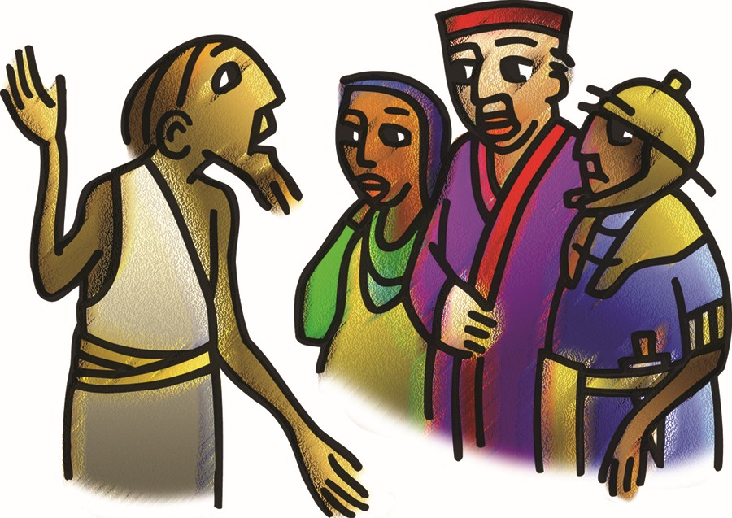

**Hymn of the Day Awake! Awake, and Greet the New Morn *ELW* 242**

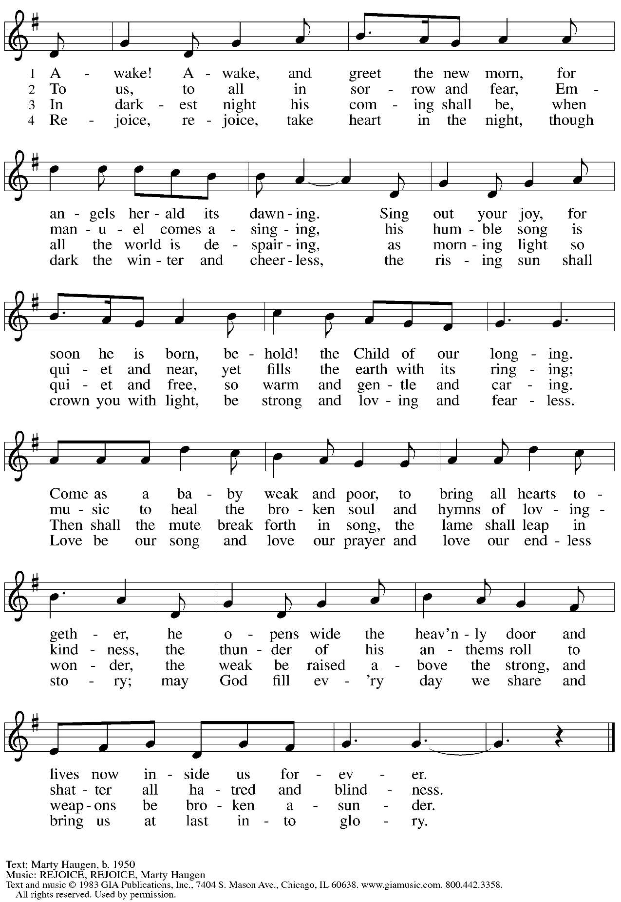

Reprinted under OneLicense.net # A-722139.

**Prayers of the People**

A: As we prepare for Emmanuel, God with us,

let us pray for the church, creation, and all who long for God’s presence.

*After each petition*

A: Merciful God

**C: receive our prayer.**

*The presiding minister concludes the prayers*

P: Savior of the nations, come, and receive these prayers and the pleas of our hearts,

in the name of Jesus Christ, our Savior.

**C: Amen.**

**Peace**

*The presiding minister and the assembly greet one another in the peace of the risen Christ.*

P: The peace of Christ be with you always.

**C: And also with you.**

*The people may greet those around them with a sign of Christ’s peace and may say*

Peace be with you *or similar words. Please be mindful that not everyone will be comfortable with sharing the peace, so please seek consent before shaking hands or hugging. Other possible ways to share the peace include a simple bow with the verbal greeting of peace, or simply a verbal expression of peace.*

*When the greetings of peace have concluded, please be seated.*

**Meal**

*God feeds us with the presence of Jesus Christ*

**Offering**

*We offer ourselves, our gifts and our faithful service to God.*

*As the offering is gathered for the mission of the church, including the care of those in need,*

*the table is set for Holy Communion.*

*There are laminated giving cards in the pew racks that feature a QR code for anyone who would like to give online. Those who give using the QR code, as well as those who give regularly online or through their bank are encouraged to place the laminated card in the plate as an expression of your offering.*

**Noisy Offering**

*As children of the congregation carry buckets around the sanctuary, people of the congregation are invited to throw in their change as an offering. This month’s Noisy Offering will benefit JFCS Pittsburgh.*

**Music during the Offering**

*Comfort, Comfort Now My People*arr. Ellen Colman

*As the gifts are brought forward for presentation, please rise as you are able.*

**Offertory Song As the Grains of Wheat *ELW* 465**

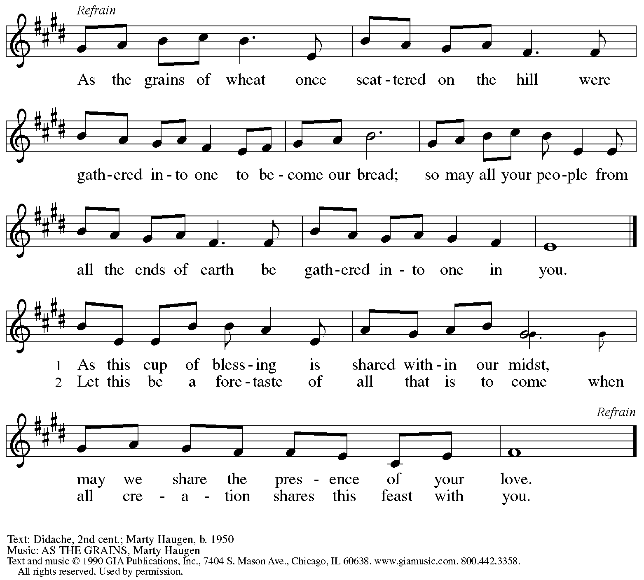

Reprinted under OneLicense.net # A-722139.

**Musical Offering** *This Little Light of Mine* Children’s Choir

**Offertory Prayer**

A: Let us pray.

God of abundance,

**C:** **we bring before you the precious fruits of your creation,**

**and with them our very lives.**

**Teach us patience and hope as we care for all those in need**

**until the coming of your Son, our Savior and Lord**

**Amen.**

**Dialogue**

P: The Lord be with you.

**C: And also with you.**

P: Lift up your hearts.

**C: We lift them to the Lord.**

P: Let us give thanks to the Lord our God.

**C: It is right to give our thanks and praise.**

**Preface**

P: It is indeed right, our duty and our joy,

that we should at all times and in all places

give thanks and praise to you, almighty and merciful God,

through our Savior Jesus Christ.

You comforted your people with the promise of the Redeemer,

through whom you will also make all things new

in the day when he comes to judge the world in righteousness.

And so, with all the choirs of angels,

with the church on earth and the hosts of heaven,

we praise your name and join their unending hymn:

**Sanctus** *ELW* p. 190

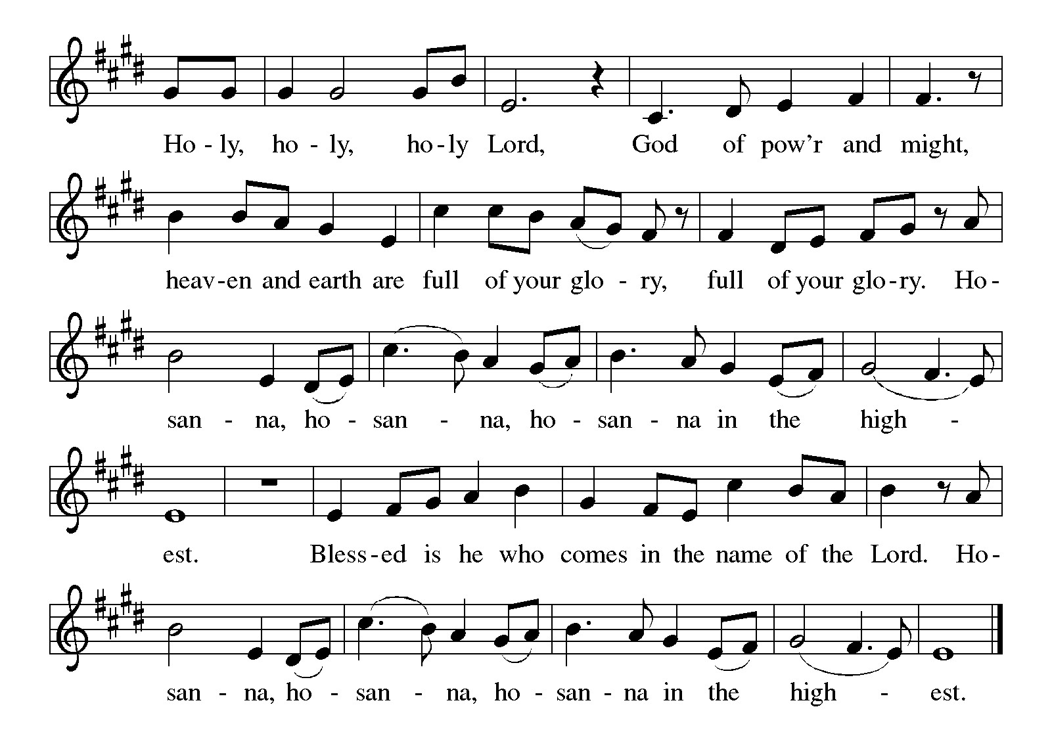

**Eucharistic Prayer**

P: Holy One, the beginning and the end, the giver of life …

…Do this for the remembrance of me.

Let us proclaim the mystery of faith:

**C: Christ has died.**

**Christ is risen.**

**Christ will come again.**

P: With this bread and cup

we remember your Word dwelling among us …

… We look with hope for his coming.

**C: Come, Lord Jesus.**

P: Holy God, we long for your Spirit …

… Bring the gift of peace on earth.

**C: Come, Holy Spirit.**

P: All praise and glory are yours,

Holy One of Israel,

Word of God Incarnate,

Power of the Most High,

one God, now and forever.

**C: Amen.**

**Lord’s Prayer**

P: Gathered as one by the Holy Spirit, let us pray as Jesus taught us.

**C: Our Father in heaven,**

**hallowed be your name,**

**your kingdom come,**

**your will be done,**

**on earth as in heaven.**

**Give us today our daily bread.**

**Forgive us our sins**

**as we forgive those**

**who sin against us.**

**Save us from the time of trial**

**and deliver us from evil.**

**For the kingdom, the power,**

**and the glory are yours,**

**now and forever. Amen.**

**Fraction and Invitation**

P: God feeds us with tender mercy.

Come to the table, where Christ comes to us once again.



***Agnus Dei /* Lamb of God** *ELW* p. 191

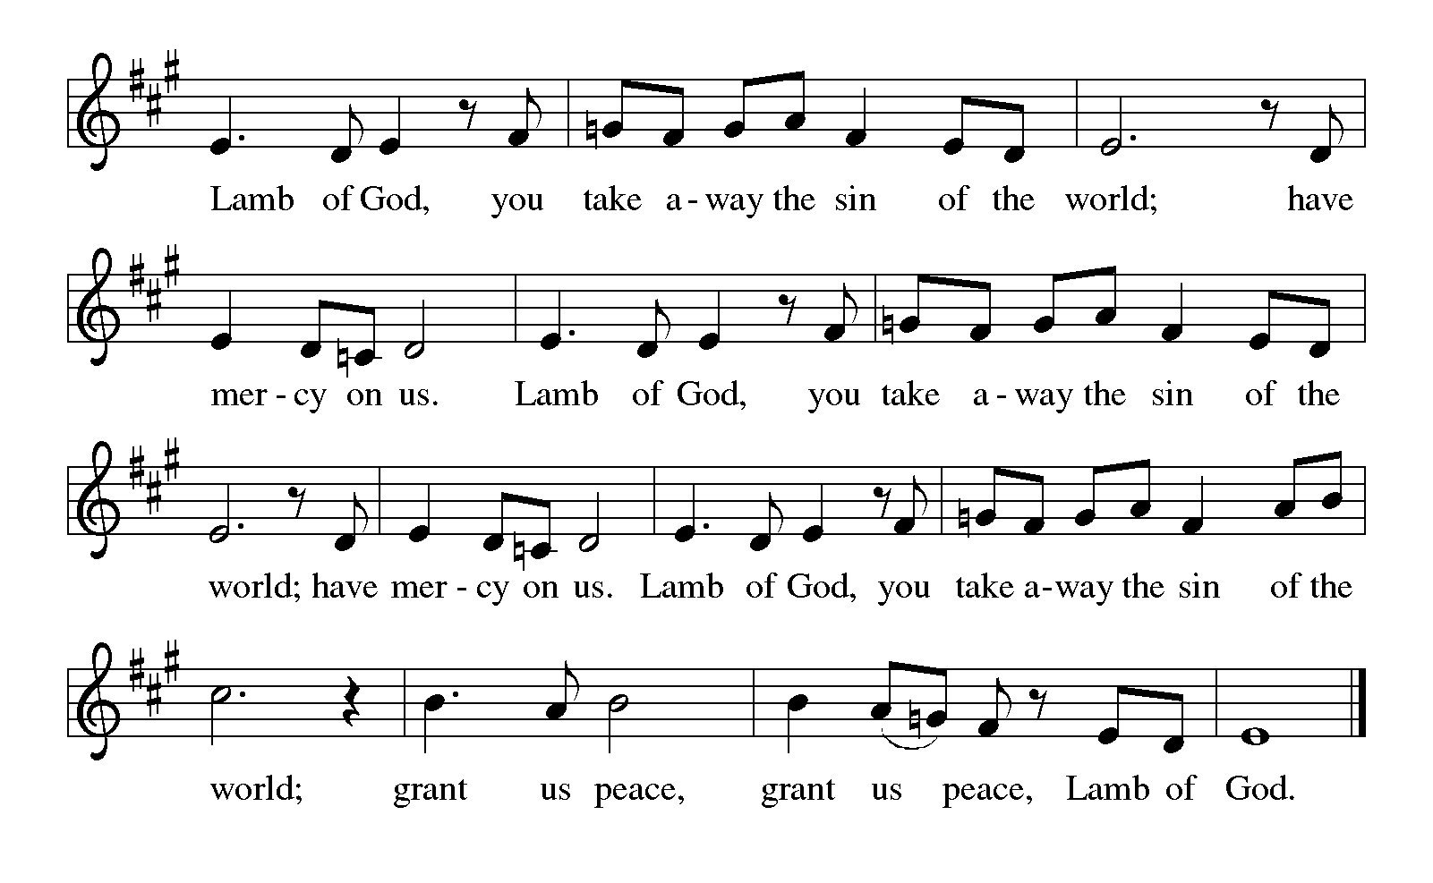

*Please be seated.*

**Holy Communion**

* *All who seek God and desire a deeper and stronger life in Christ are welcome to receive Holy Communion.*
* *Worshipers from the pulpit side will proceed forward first, followed by the center section, and then the lectern side.*
* *Please inform an usher if you would like the ministers to bring Communion to you.*
* *Holy Communion will be served with bread and wine/grape juice.*
* *The presiding minister will first distribute the bread (host) to each communicant. Please indicate if you require a gluten-free host.*
* *Once you have consumed the bread, please pick up an empty glass from the tray next to the presiding minister. The Communion Assistant will pour wine from the chalice or grape juice from the cruet into your glass.*
* *Please step to the side to consume the wine or grape juice.*
* *Feel free to kneel at the altar rail for prayer after receiving the sacrament.*
* *As you return to your pew, glasses may be returned to the empty trays on either side of the center section.*
* *A blessing will be provided for anyone who does not yet receive the sacrament.*
* *All are invited to join in singing the hymns during Holy Communion.*

**Hymns during Holy Communion**

**In Thee Is Gladness *ELW* 867**

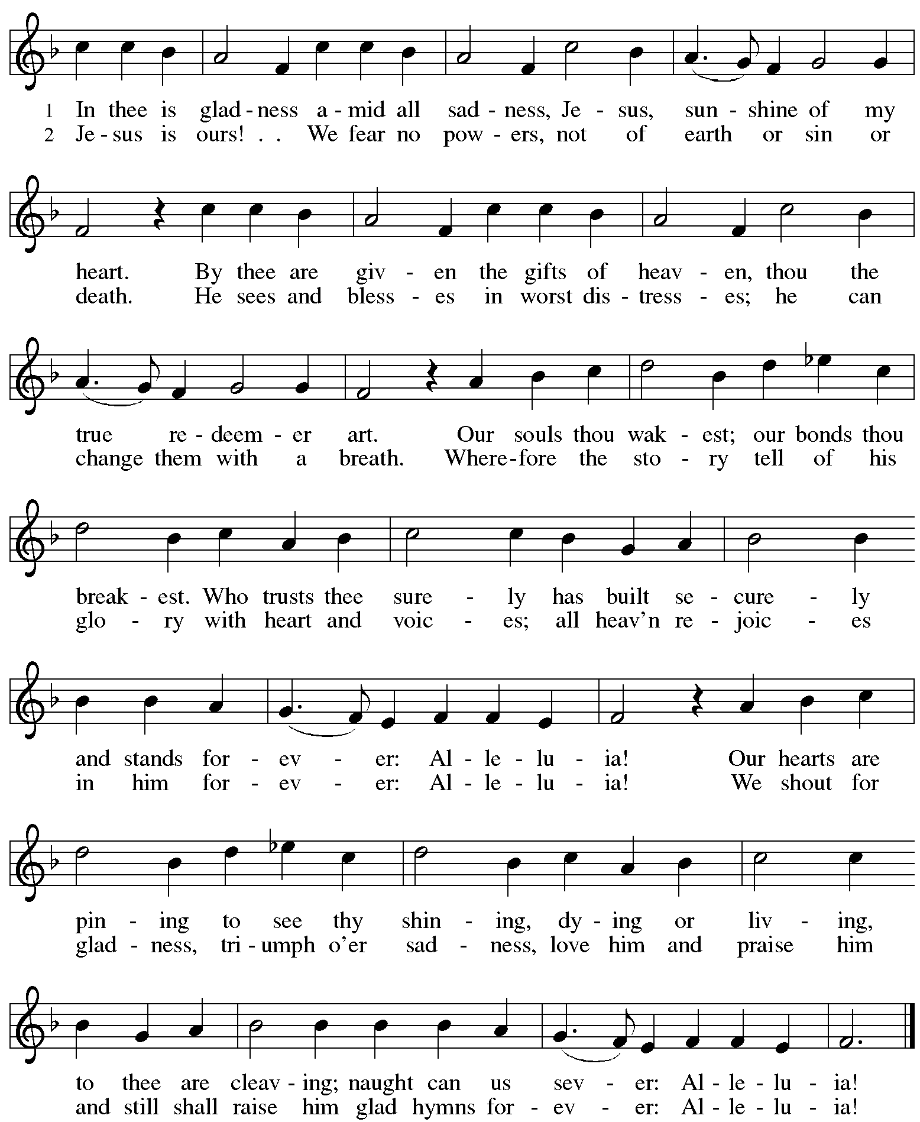

**Hymns during Holy Communion**

**As the Dark Awaits the Dawn *ELW* 261**

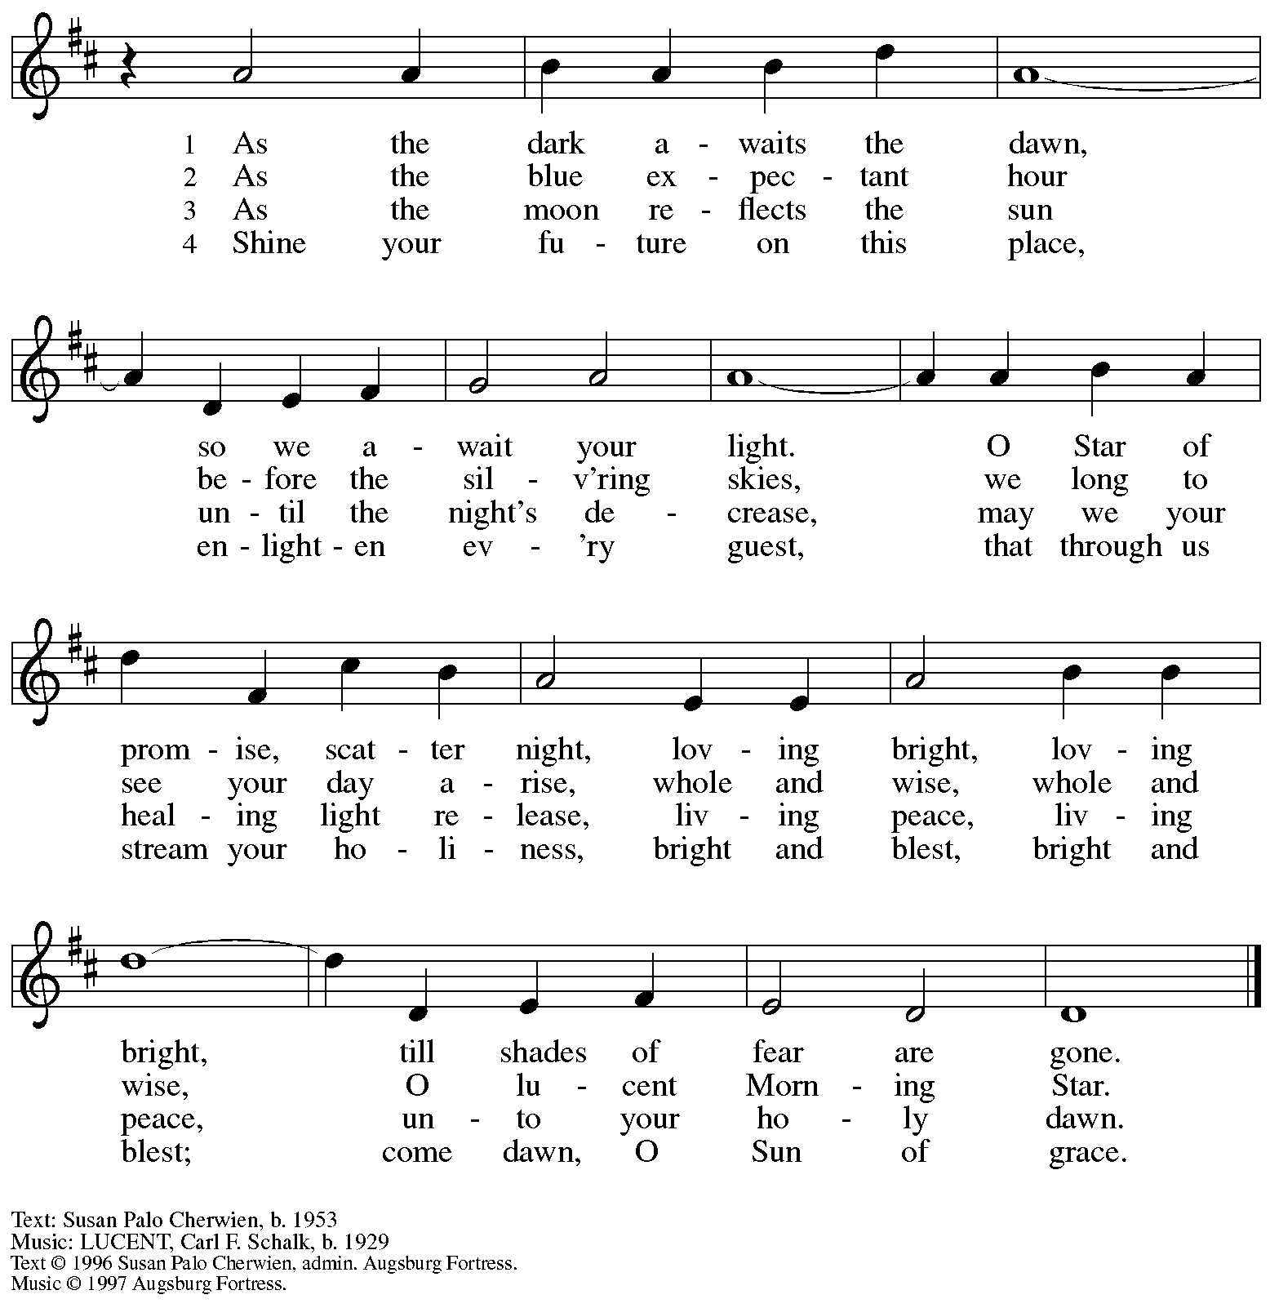

All rights reserved. Reprinted with permission under OneLicense.net # A-722139.

**Hymns during Holy Communion**

**We Are Waiting for Jesus *ACS* 905**

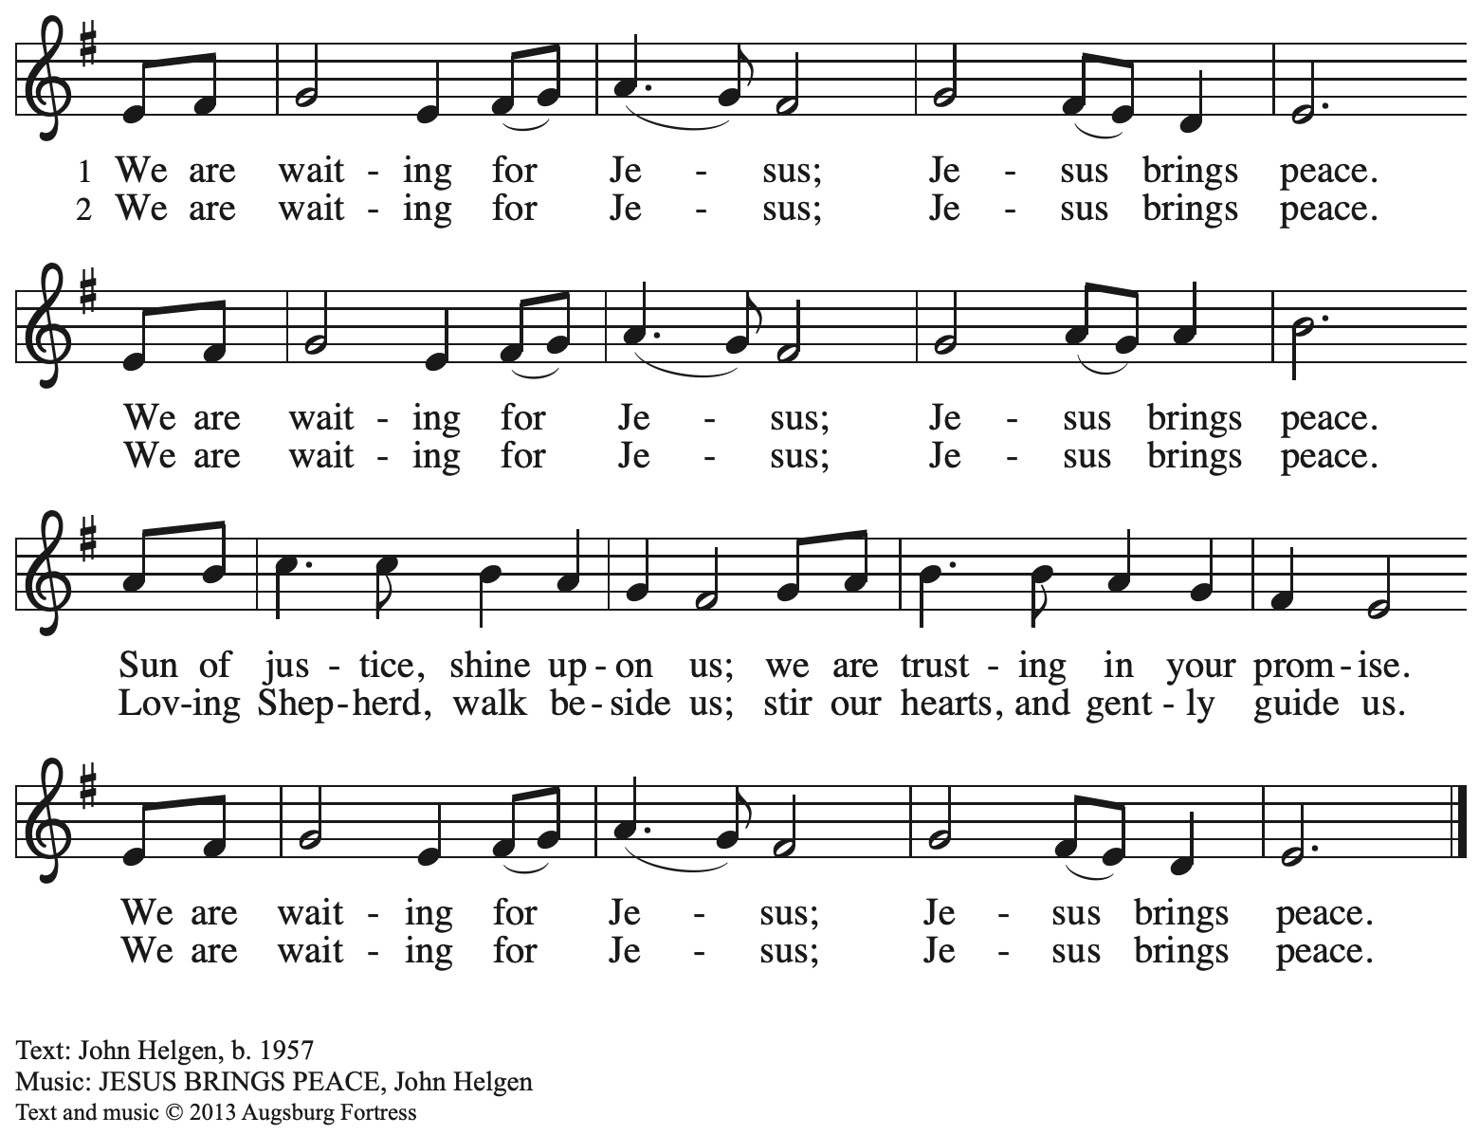

All rights reserved. Reprinted with permission under OneLicense.net # A-722139.

**Hymns during Holy Communion**

**Come, Thou Long-Expected Jesus *ELW* 254**

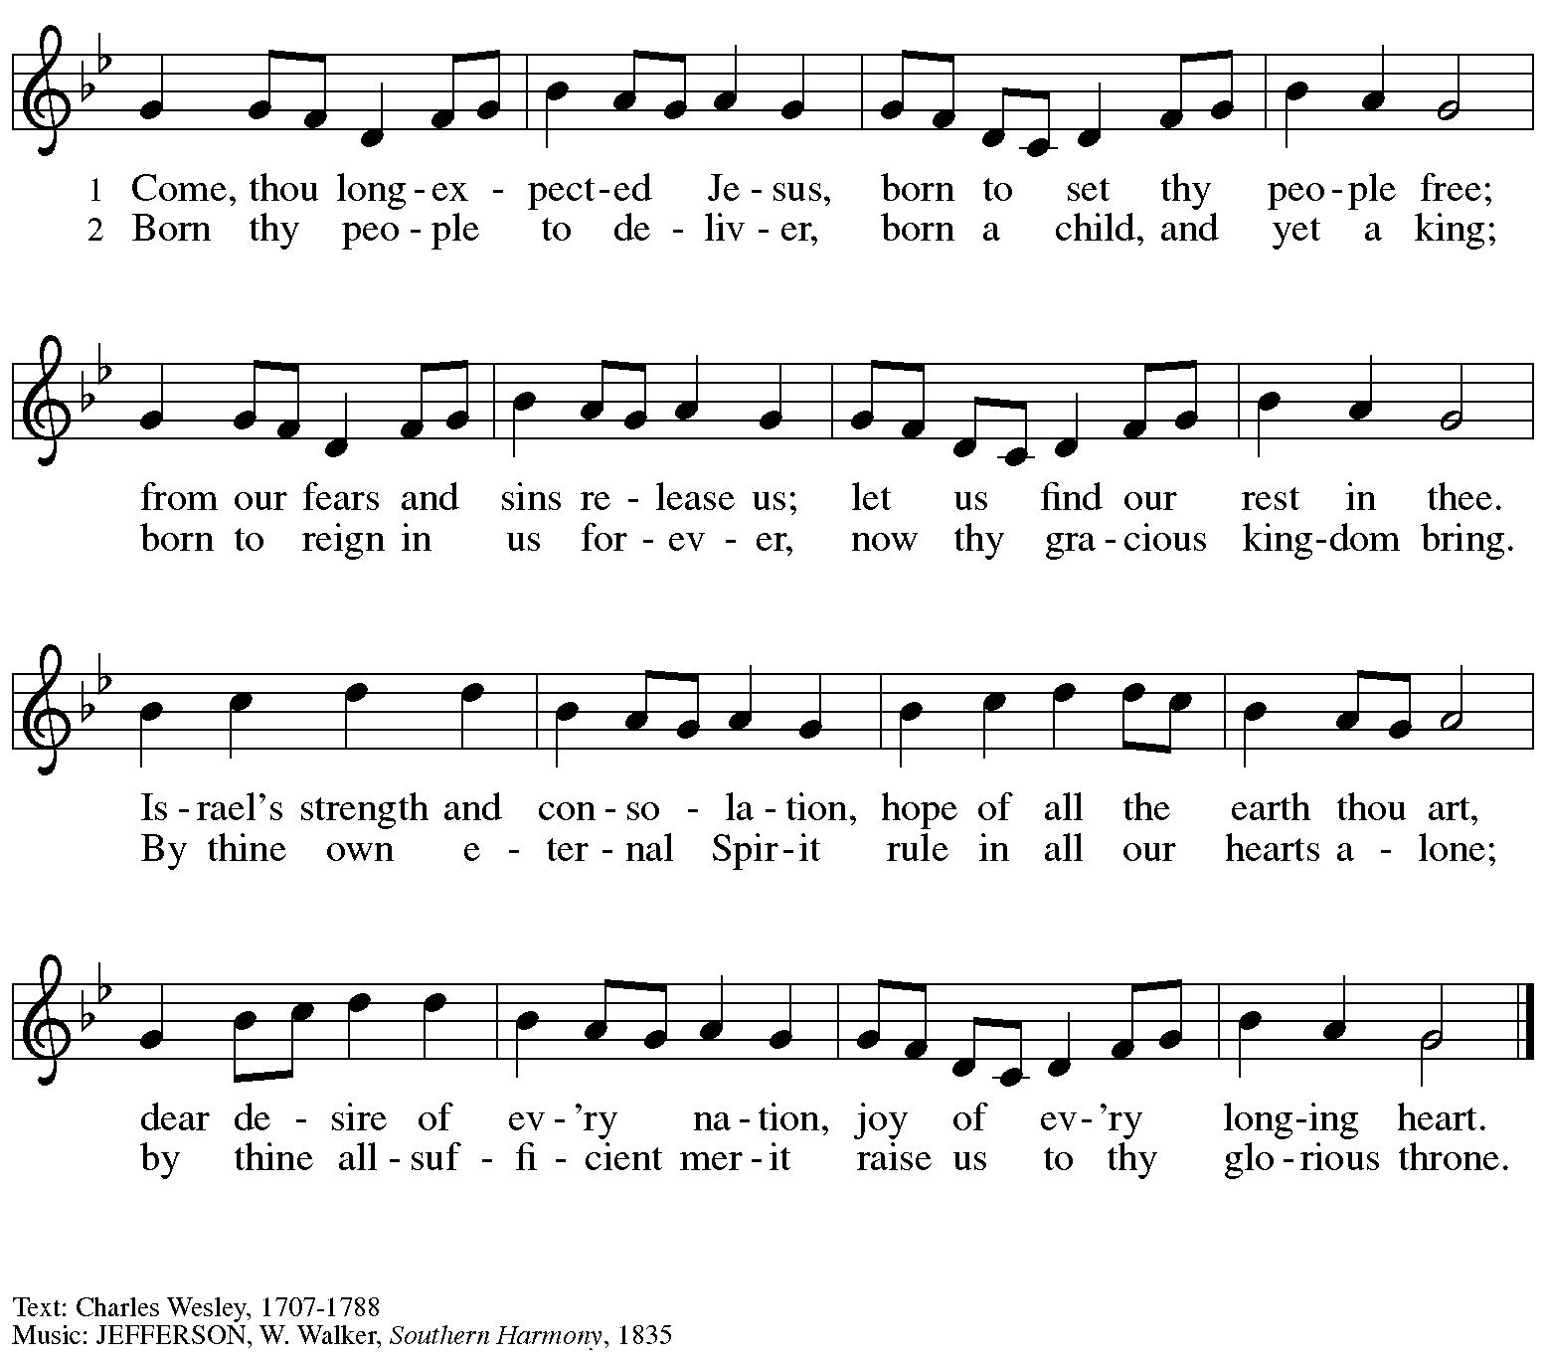

*When all have returned to their places, please rise as you are able.*

**Blessing**

P: The body and blood of our Lord Jesus Christ strengthen you and keep you in his grace.

**C: Amen.**

**Prayer**

A: Let us pray.

God for whom we wait,

in this meal you give us a foretaste of that day when the hungry will be fed with good things. Send us forth to make known your deeds and to proclaim the greatness of your name,

through Jesus Christ, our Savior and Lord.

**C: Amen.**

*Please be seated.*

**Sending**

*God blesses us and sends us in mission to the world*

**Announcements**

*Please rise as you are able.*

**Benediction**

P: God of endings and beginnings,

God in the darkness and in the light,

God, our hope for the journey,

☩ bless and keep you now and forever.

**C: Amen.**

**Sending Hymn** *Following page*

**Dismissal**

A: Go in peace. Prepare the way for Emmanuel.

**C: Thanks be to God.**

**Postlude**

**Sending Hymn Praise the One Who Breaks the Darkness *ELW* 843**

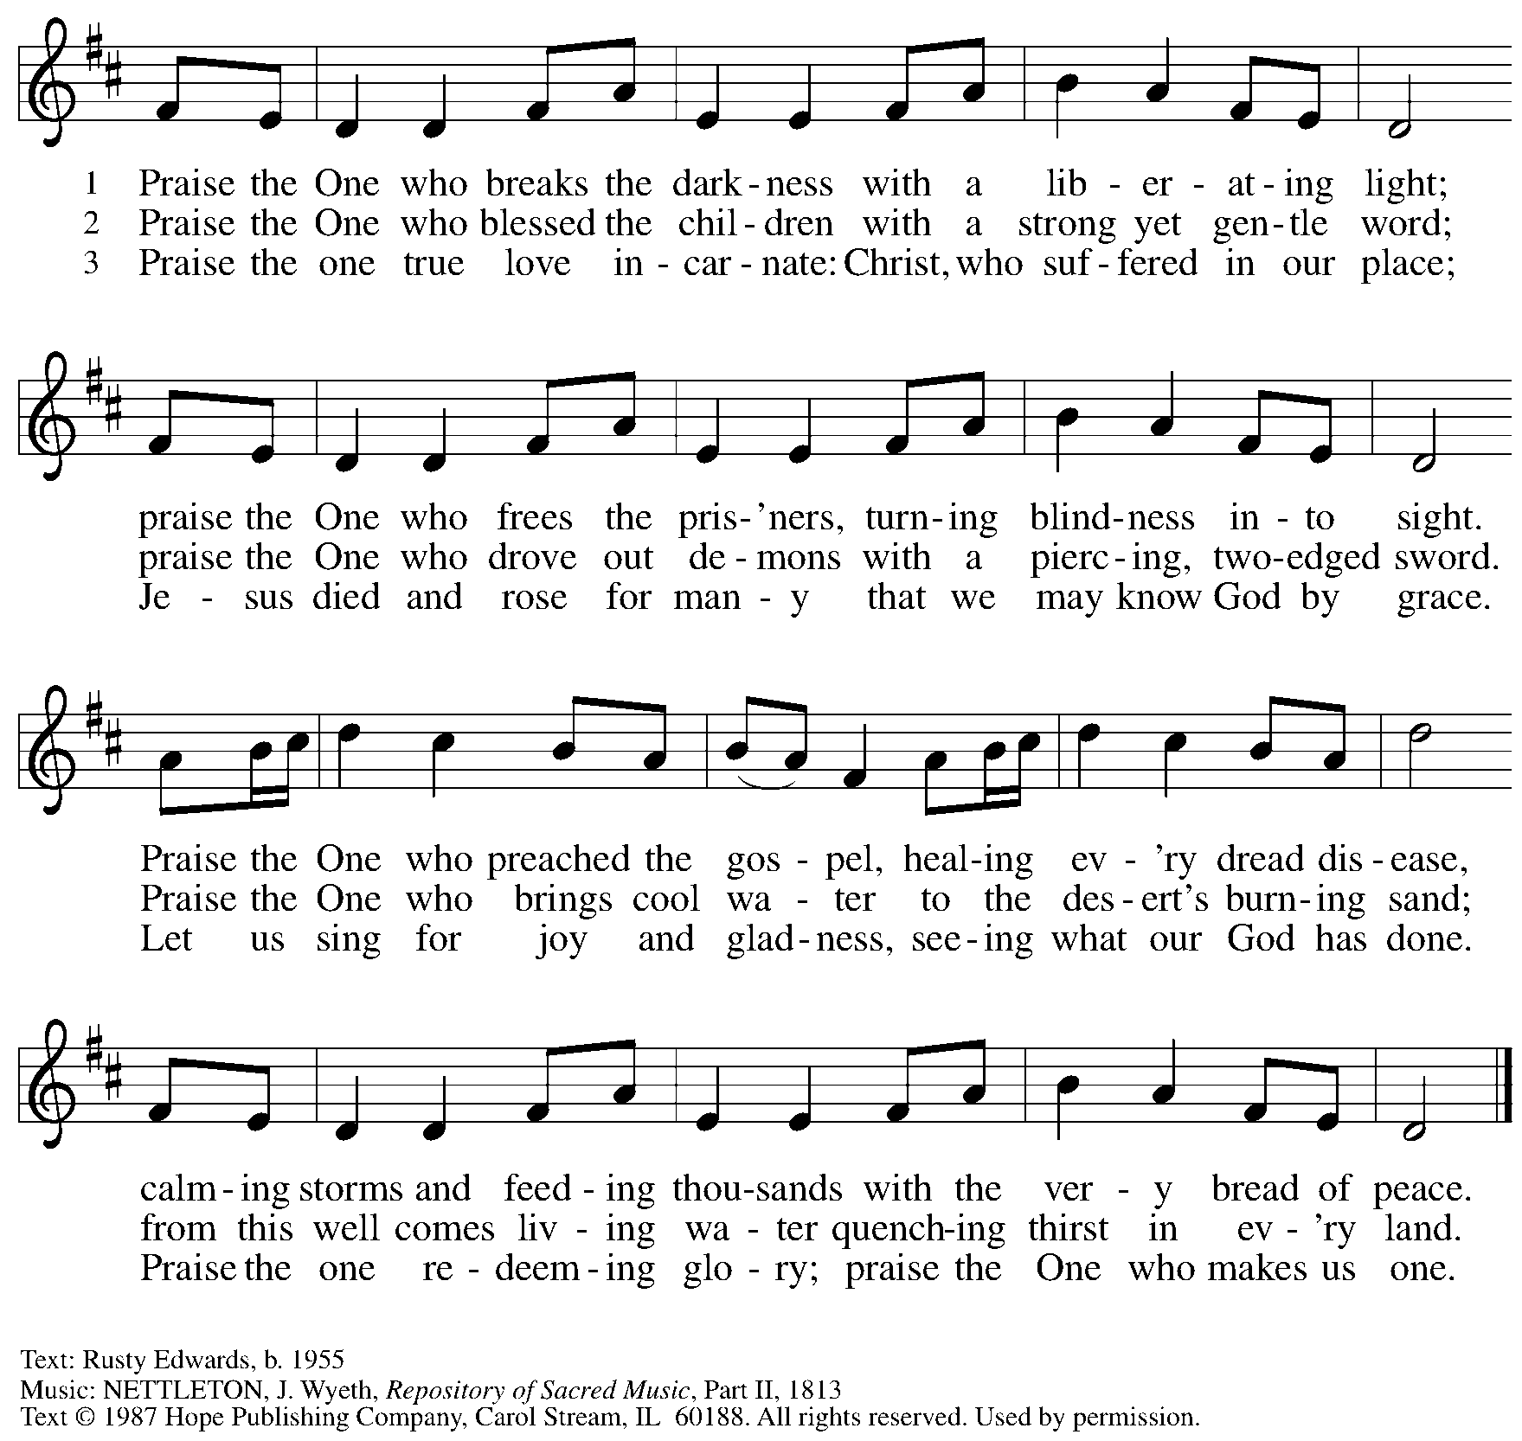

Reprinted under OneLicense.net # A-722139.

*Those serving in worship today*

Altar Care Beverley Chapman

Assisting Minister Jimmi Kocher-Hillmer

Audio-Visual Ministers David Rollinson

Jered Stratton

Cantor Emily Duque

Lector Michael Chapman

Little Church – Big Faith Teacher Maria Mangano

Prelude Instrumentalists Jimmi and Timothy Kocher-Hillmer

Maria Mangano

Prelude Soloist Amos

Minister of Music Laura Reynolds

Preaching and Presiding Minister Pastor Ross Carmichael

*Liturgy and Hymnody Acknowledgements*

From SundaysandSeasons.com. Copyright © 2024 Augsburg Fortress. All rights reserved. Reprinted under OneLicense.net # A-722139.

Used by permission of Augsburg Fortress.

The Scripture readings contained herein are from *New Revised Standard Version* of the Bible © 1989, Division of Christian Education of the National Council of Churches of Christ in the USA. Used by permission. All rights reserved.

*Please use the QR code below to link to St. Andrew’s announcements online!*



**St. Andrew Lutheran Church Announcements**

**December 15th, 2024**

* **Welcome to Worship at St. Andrew on the Third Sunday of Advent, December 15th, 2024** –We are thankful you are here, and we offer a special welcome to all visitors and guests here for the first time. Worship attendees are invited to make a name tag at the back of the worship space. Little Church – Big Faith, a Bible lesson and activity for children, will take place after the prayer of the day. There are also worship “toolkits” to help children engage with worship and “busy bags” for younger children available in the bookcase at the back of the sanctuary. Please feel free to take one to use with/for your children. All are invited to gather for coffee, other drinks, food, and conversation in the social hall after worship.
* **Noisy Offering during Worship Today – On the third Sunday of each month, the children of St. Andrew lead us in a Noisy Offering.** The children carry buckets around the congregation and people are invited to throw in their change, which then gets compiled in big metal buckets and is brought forward as an offering. These gifts support a different ministry or organization each month, and this month’s Noisy Offering will be given to JFCS Pittsburgh. For more information on their work, please visit:

<https://www.jfcspgh.org/>.

* **Holiday Gifts for Bethesda Lutheran Services and JFCS Are Due Today, December 15th! Thank you to everyone in the congregation who has donated!**
* **Shelter Dinner for Guests of East End Cooperative Ministry – Thursday, December 19th, 6:30 p.m. –** Each month, people of St. Andrew provide dinner for guests of East End Cooperative Ministry, 6140 Station St. (East Liberty), 15206. We invite you to prepare or purchase one menu item and bring it to the shelter by 6:00 p.m., or just come to help serve at 6:30 p.m. If you would like to contribute, please sign up here:

<https://www.signupgenius.com/go/5080544AAAC22A1F58-53490586-shelter>.

* **Panel Discussion – Thou Shalt Not Kill: Dietrich Bonhoeffer’s Conflicted Pacifism – Thursday, December 19th, 6:30-9:30 p.m. at Pittsburgh Theological Seminary, 616 N. Highland Ave., 15206 – With this fall’s study of Lutheran pastor Dietrich Bonhoeffer’s theology sponsored by Lutheran Advocacy Ministry in Pennsylvania (LAMPa), a new movie release about Bonhoeffer’s life, and much debate over how he is being interpreted and used politically, the church has seen a renewed interest in Bonhoeffer’s life and work. Pittsburgh Theological Seminary will host a panel discussion on Thursday, December 19th, from 6:30-9:30 p.m.** Beatrice Institute—in collaboration with the Bruderhof community—invites you to join the conversation this semester as we interrogate the tension in Christian ethics between a preference for non-violence and the responsibility to protect the innocent. (Seeing the movie is not necessary for attending!).

**More information is available here:** [Winter Salon: Thou Shalt Not Kill? Dietrich Bonhoeffer’s Conflicted Pacifism — Beatrice Institute](https://beatriceinstitute.org/public-events/winter-salon).

* **Stay after Worship Next Sunday, December 22nd to Help Decorate for the Christmas Season! – St**. Andrew invites everyone in the congregation to stay after worship next Sunday, December 22nd, the Fourth Sunday of Advent, to help decorate the church for the Christmas season!
* **The Nativity of our Lord: Christmas Eve, Tuesday, December 24th – Worship with Holy Communion, 7:00 p.m. – St. Andrew will celebrate Christmas with one service of carols, candlelight, and Holy Communion at 7:00 p.m. on Christmas Eve, Tuesday, December 24th.**
* **Coffee Hour Signups Available** –One way that St. Andrew builds community is by sharing conversation over food and drinks at coffee hour after worship on Sundays. We invite people of the congregation to sign up to coordinate coffee hour each week, which includes brewing the coffee; setting out cups, napkins, food items, and cold drinks; and cleaning up afterward. Everything needed is at St. Andrew and instructions are available. Please sign up to host coffee hour here: <https://www.signupgenius.com/go/5080B4AAFAF2CABF85-47069030-coffee>.
* **New *Christ in Our Home* Devotional Booklets (Janaury – March 2025) Available at Church Entrances – *Christ in Our Home* is a booklet of devotions that includes Scripture, a brief reflection, and prayer for each day. The new edition for January – March 2025 is available at the various church entrances. There are still some booklets for December remaining, too. Please feel free to take one for yourself or others!**
* **Compline Prayer Service with the Pittsburgh Compline Choir, 8:00 p.m. at Heinz Chapel – Tonight’s Service is the Last Service of the Semester –** Compline was traditionally a monastic prayer service, and the Pittsburgh Compline Choir, a ministry of Lutheran Campus Ministry in Greater Pittsburgh, sings a choral version of compline rooted in this thousand-year-old tradition of scripture, song, and silence each Sunday at Heinz Chapel at 8:00 p.m. This service also streams on Facebook (Pittsburgh Compline Choir) and YouTube (The Pittsburgh Compline Choir). Heinz Chapel is located off of S. Bellefield Ave. in Oakland. For more information, please visit: [Pittsburgh Compline Choir](http://pittsburghcomplinechoir.org/).