

**+ Second Sunday of Advent**

**December 8, 2024**



**St. Andrew Lutheran Church**

**304 Morewood Ave.**

**Pittsburgh, PA 15213**

[**St_andrewELCA@verizon.net**](mailto:St_andrewELCA@verizon.net)

[**www.standrewpittsburgh.org**](http://www.standrewpittsburgh.org)

**+ Second Sunday of Advent**

**Order for Worship**

*Forerunners and messengers advance the advent of our God.*

*While John the baptizer’s voice in the wilderness may be the principal focus of the day, Malachi’s prophecy could as easily herald the coming Christ as forerunner of the Lord of hosts. Finally, all the baptized are called to participate in the sharing of the gospel.*

*In so doing we prepare the way for the coming of Jesus*

*and assist all people in capturing a vision of the salvation of God*

**Welcome to St. Andrew!**

* St. Andrew Lutheran congregation welcomes all who are seeking a place of healing and wholeness – a nurturing, faith-forming spiritual home. Our community embraces people of all ages, ethnicities, cultures, abilities, sexual orientations, gender identities and expressions, and family constellations. Come and See!
* Worship Services are live-streamed to multiple online platforms. By attending worship, you agree that your image and voice may be broadcast.
* Everyone is invited to make a name tag at the black bookcase in the back of the worship space if they would like. There are stickers indicating pronouns on the bookcase if you would like to include them on your name tag.
* Children are invited to attend Little Church – Big Faith, a Bible lesson and activity, during worship (after the Prayer of the Day). The group returns to the worship space for the liturgy of Holy Communion.
* A nursery is available through the doors at the left side of the sanctuary and across from the doorway to the Social Hall. Look for a purple-colored room.
* Worship “toolkits” to help children engage with the service, along with “busy bags” for younger children, are available in the bookcase at the back of the sanctuary. Please feel free to take one to use with/for your children.
* Holy Communion is served with bread (gluten-free available) and wine or grape juice. The presiding minister will distribute the bread (host). Please consume this and then pick up an empty glass from the tray. The Communion Assistant will pour wine or grape juice into your glass. Please step to the side to consume the wine or grape juice. Feel free to kneel at the altar for prayer and reflection. As you return to your pew, glasses may be returned to the empty trays on either side of the center section.
* A restroom is available on the main level of the church, through the doors to the Social Hall and to the right in the main office.

*Abbreviations*

P: Pastor/Presiding Minister ***ELW*: *Evangelical Lutheran Worship* hymnal**

A: Assisting Minister ***ACS*: *All Creation Sings* hymnal**

L: Lector

**C: Congregation**

**Pre-Service Music**

**Welcome**

**Prelude**

*During the prelude, individuals from the congregation will come forward to light the candle(s)*

*of the Advent wreath corresponding to the four Sundays of Advent.*

**Gathering**

*The Holy Spirit calls us together as the people of God*

**Confession and Forgiveness**

*Please rise as you are able. All may make the sign of the cross,*

*the sign that is marked at Baptism, as the presiding minister begins.*

P: Blessed be the holy Trinity, ☩ one God,

alive in the world, reviving creation, arriving soon.

**C: Amen.**

P: Let us confess our sin in the presence of God and of one another.

*Silence is kept for reflection*

P: God of mercy,

**C: we confess that we have sinned.**

**We have trusted earthly powers and human authority alone.**

**We have grown fearful. We cling to false comforts.**

P: God of might,

**C: we confess that we have sinned.**

**We have turned away from our neighbors. We have trusted false promises.**

P: God in our midst,

**C: we confess that we have sinned.**

**We plead: come to us. Bring your mercy to birth in us. Amen.**

P: A righteous branch springs forth: it is Christ the Lord, our Savior,

in whom we have forgiveness, life, and mercy.

By the power of the Holy Spirit, receive the grace and forgiveness of God

through ☩ Christ Jesus, whose day draws near.

**C: Amen.**

**Gathering Hymn Hark! A Thrilling Voice Is Sounding *ELW* 246**

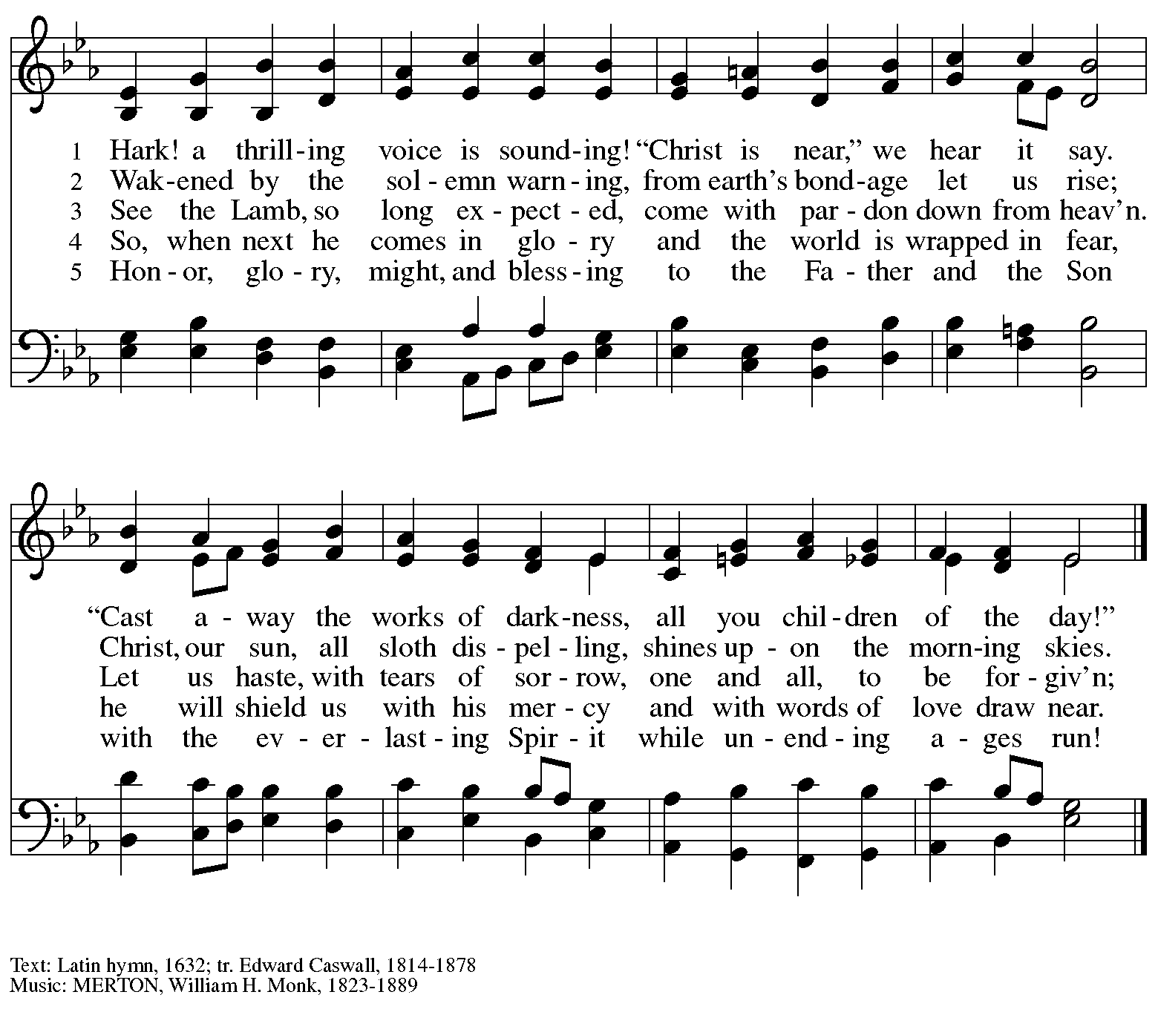

**Greeting**

P: The grace of our Lord Jesus Christ, the love of God,

and the communion of the Holy Spirit be with you all.

**C: And also with you.**

**Kyrie** *ELW* p. 147

*The cantor leads the singing of the Kyrie, with the congregation joining in the responses in bold.*

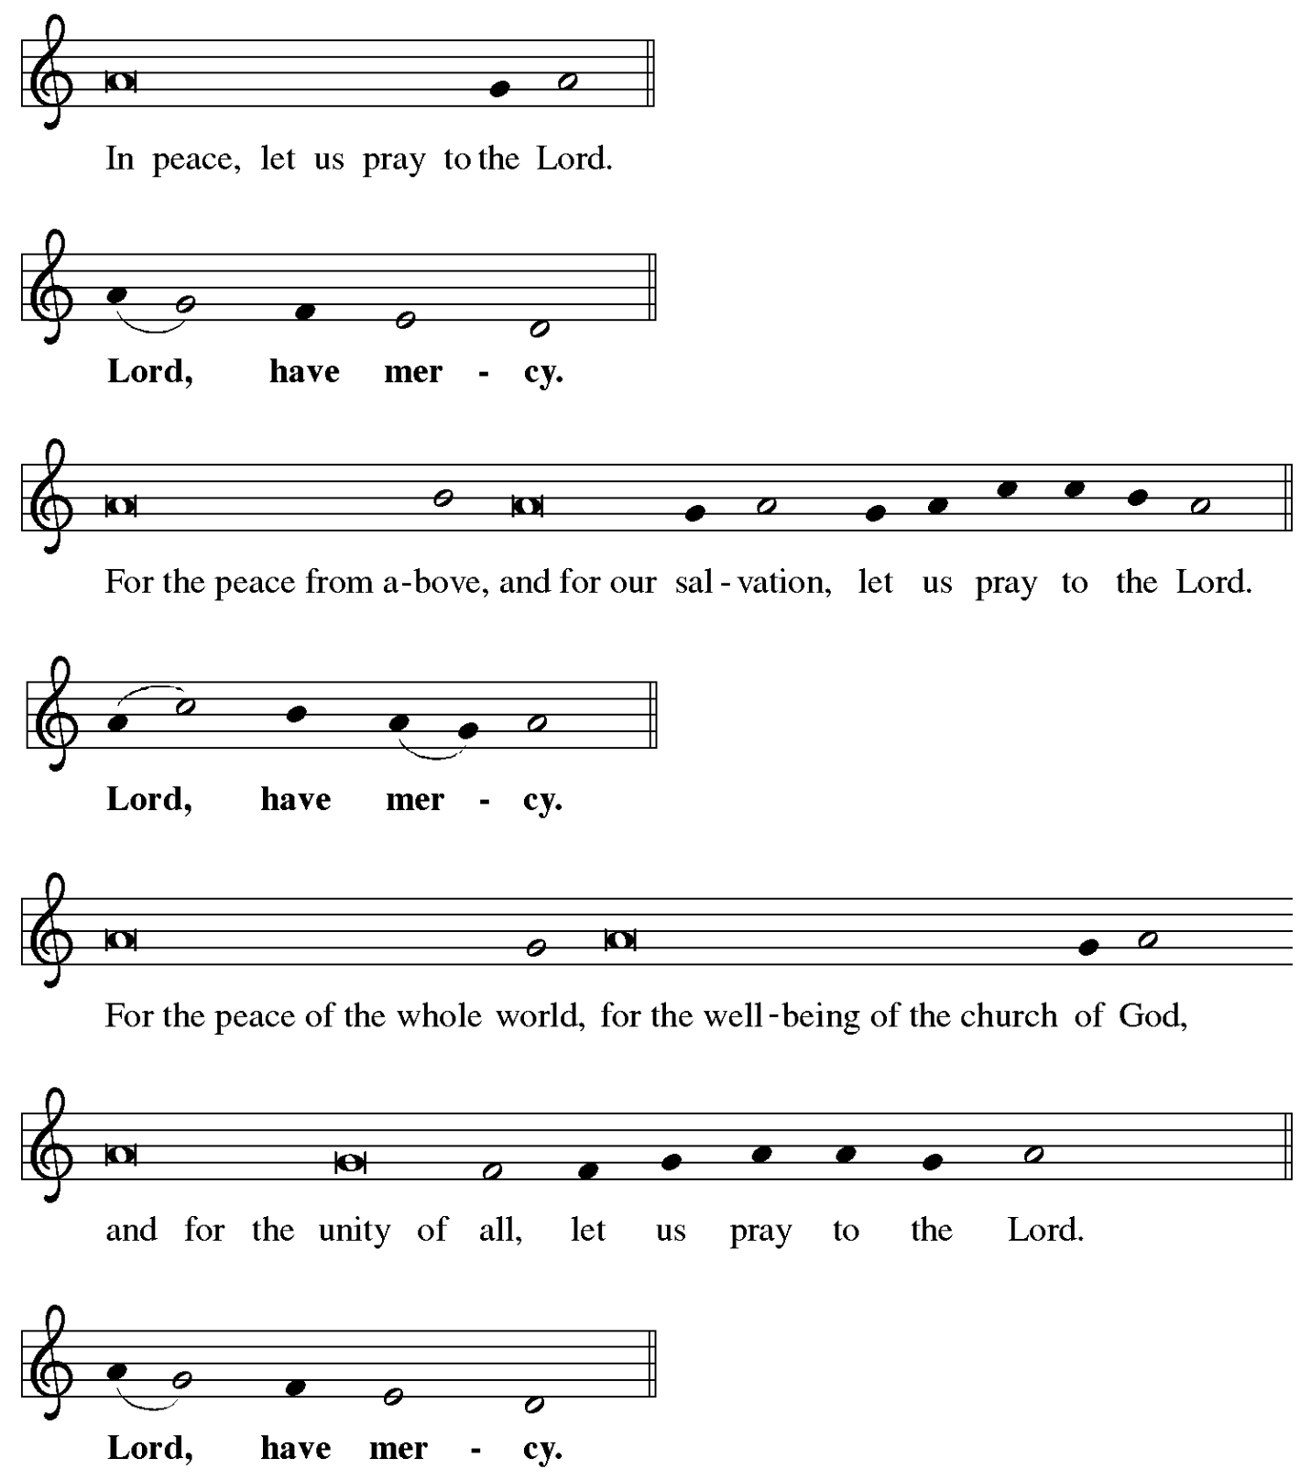

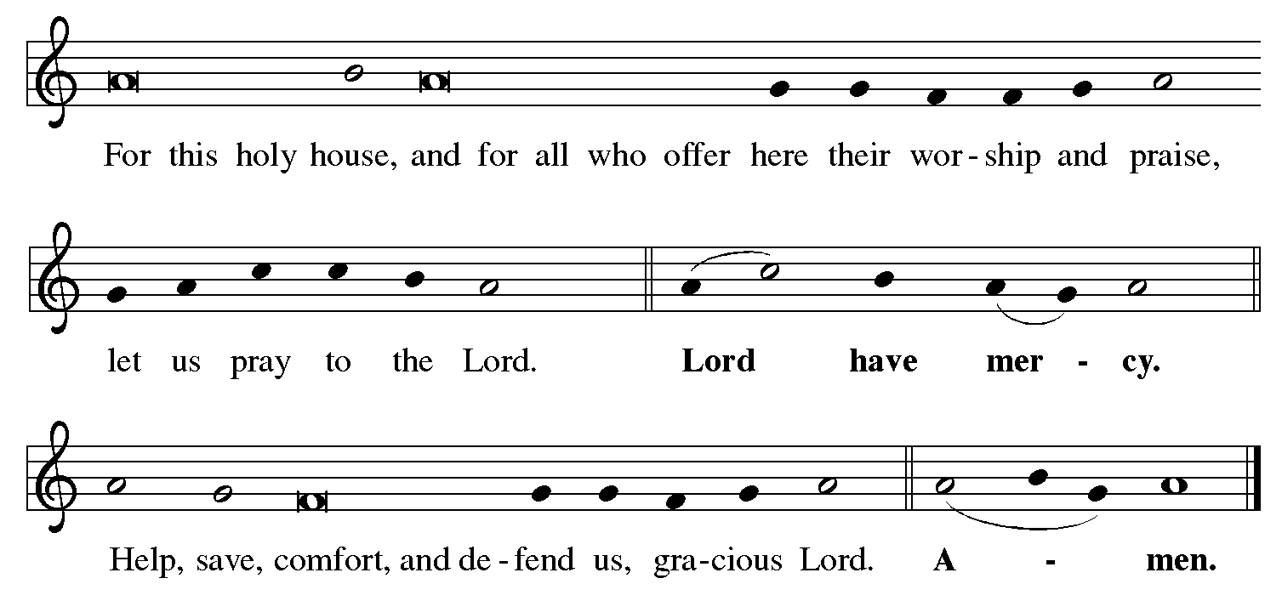

**Prayer of the Day**

P: The Lord be with you.

**C: And also with you.**

P: Stir up our hearts, Lord God, to prepare the way of your only Son.

By his coming give to all the people of the world knowledge of your salvation;

through Jesus Christ, our Savior and Lord,

who lives and reigns with you and the Holy Spirit,

one God, now and forever.

**C: Amen.**

*Please be seated.*

*Children are invited to join the adult leaders at the door and for Little Church – Big Faith.*

*We ask that one additional adult from the congregation attend with the children.*

**Word**

*God speaks to us in Scripture reading, preaching, and song*

**First Reading** **–** **Malachi 3: 1-4**

1 See, I am sending my messenger to prepare the way before me, and the Lord whom you seek will suddenly come to his temple. The messenger of the covenant in whom you delight—indeed, he is coming, says the Lord of hosts. 2 But who can endure the day of his coming, and who can stand when he appears?  
  For he is like a refiner’s fire and like fullers’ soap; 3 he will sit as a refiner and purifier of silver, and he will purify the descendants of Levi and refine them like gold and silver, until they present offerings to the Lord in righteousness. 4 Then the offering of Judah and Jerusalem will be pleasing to the Lord as in the days of old and as in former years.

L: Word of God, word of life.

**C: Thanks be to God.**

**Luke 1: 68-79 Blessed Be the God of Israel *ELW* 250**

*In place of the psalm today, the appointed text is Luke 1: 68-79, the song of Zechariah.*

*The congregation will sing Blessed Be the God of Israel – ELW 250,*

*a paraphrase of Luke’s Gospel text.*

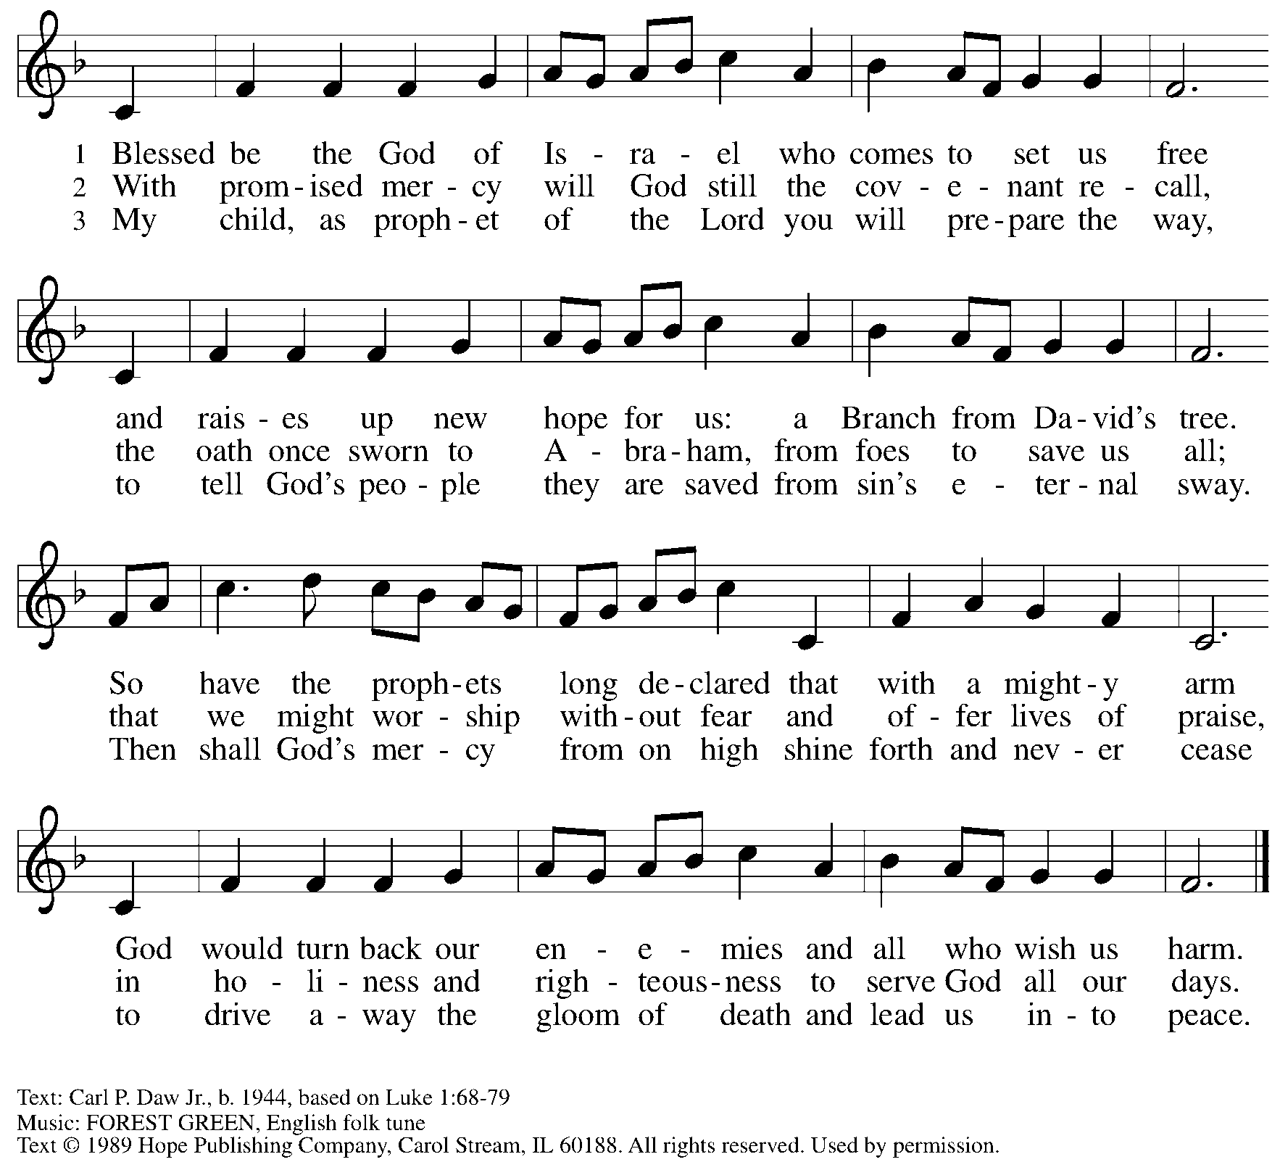

Reprinted with permission under OneLicense.net # 722139,

**Second Reading – Philippians 1: 3-11**

3 I thank my God every time I remember you, 4 constantly praying with joy in every one of my prayers for all of you, 5 because of your sharing in the gospel from the first day until now. 6 I am confident of this, that the one who began a good work among you will bring it to completion by the day of Jesus Christ. 7 It is right for me to think this way about all of you, because you hold me in your heart, for all of you share in God’s grace with me, both in my imprisonment and in the defense and confirmation of the gospel. 8 For God is my witness, how I long for all of you with the compassion of Christ Jesus. 9 And this is my prayer, that your love may overflow more and more with knowledge and full insight 10 to help you to determine what is best, so that in the day of Christ you may be pure and blameless, 11 having produced the harvest of righteousness that comes through Jesus Christ for the glory and praise of God.

L: Word of God, word of life.

**C: Thanks be to God.**

*Please rise as you are able and join in singing the Gospel Acclamation.*

**Gospel Acclamation** *ELW* p. 188

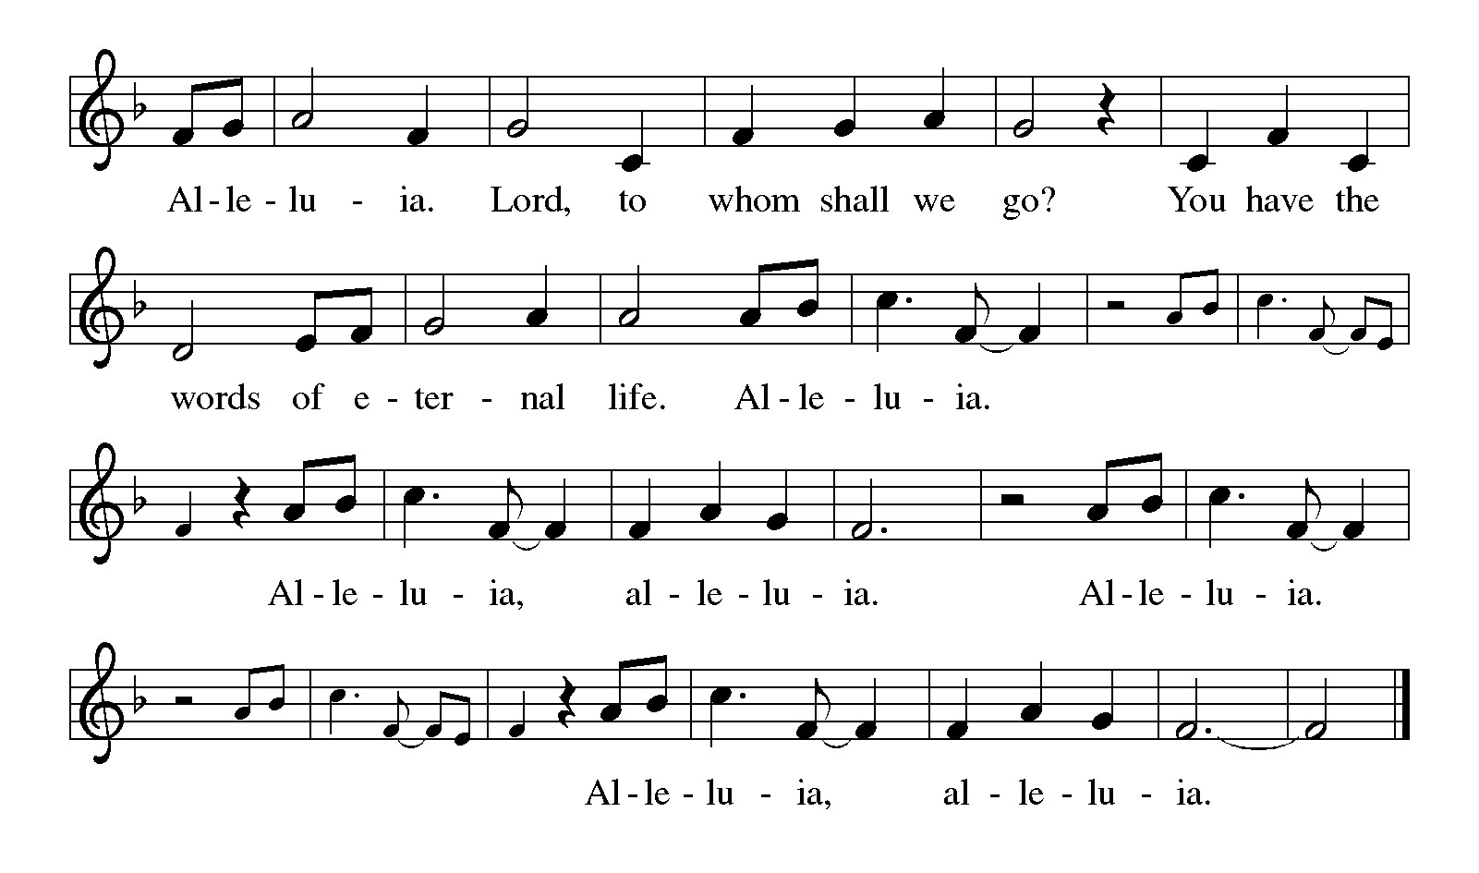

**Gospel – Luke 3: 1-6**

P: The holy Gospel according to St. Luke.

**C: Glory to you, O Lord.**

1 In the fifteenth year of the reign of Emperor Tiberius, when Pontius Pilate was governor of Judea, and Herod was ruler of Galilee, and his brother Philip ruler of the region of Ituraea and Trachonitis, and Lysanias ruler of Abilene, 2 during the high priesthood of Annas and Caiaphas, the word of God came to John son of Zechariah in the wilderness. 3 He went into all the region around the Jordan, proclaiming a baptism of repentance for the forgiveness of sins, 4 as it is written in the book of the words of the prophet Isaiah,  
 “The voice of one crying out in the wilderness:  
 ‘Prepare the way of the Lord,  
  make the Lord’s paths straight.  
 5 Every valley shall be filled,  
  and every mountain and hill shall be made low,  
 and the crooked shall be made straight,  
  and the rough ways made smooth;  
 6 and all flesh shall see the salvation of God.’ ”

P: The Gospel of the Lord.

**C: Praise to you, O Christ.**

*Please be seated.*

**Sermon**

*A time of silence for prayer and reflection follows the sermon.*

*When the Hymn of the Day begins, please rise as you are able.*

**Hymn of the Day** **On Jordan’s Banks the Baptist’s Cry** *Following page*



**Hymn of the Day On Jordan’s Banks the Baptist’s Cry *ELW* 249**

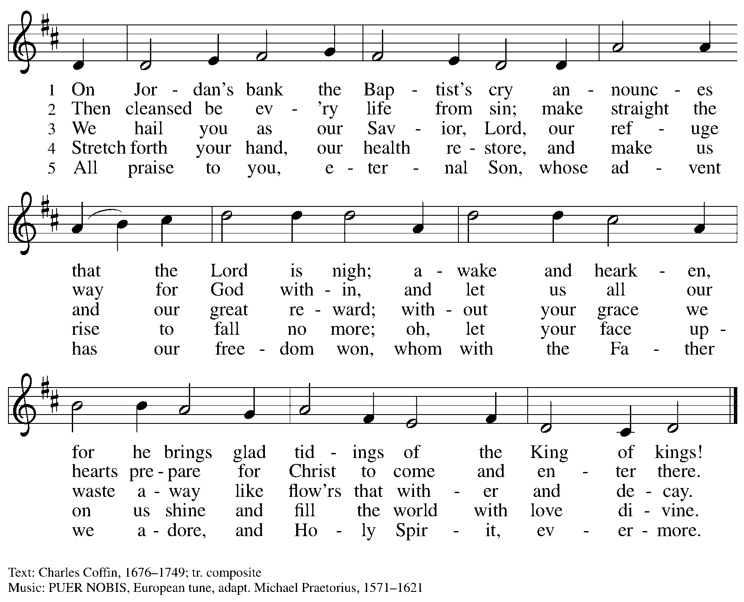

**Prayers of the People**

A: As we prepare for Emmanuel, God with us,

let us pray for the church, creation, and all who long for God’s presence.

*After each petition*

A: Merciful God

**C: receive our prayer.**

*The presiding minister concludes the prayers*

P: Savior of the nations, come, and receive these prayers and the pleas of our hearts,

in the name of Jesus Christ, our Savior.

**C: Amen.**

**Peace**

*The presiding minister and the assembly greet one another in the peace of the risen Christ.*

P: The peace of Christ be with you always.

**C: And also with you.**

*The people may greet those around them with a sign of Christ’s peace and may say*

Peace be with you *or similar words. Please be mindful that not everyone will be comfortable with sharing the peace, so please seek consent before shaking hands or hugging. Other possible ways to share the peace include a simple bow with the verbal greeting of peace, or simply a verbal expression of peace.*

*When the greetings of peace have concluded, please be seated.*

**Meal**

*God feeds us with the presence of Jesus Christ*



**Offering**

*We offer ourselves, our gifts and our faithful service to God.*

*As the offering is gathered for the mission of the church, including the care of those in need,*

*the table is set for Holy Communion.*

*There are laminated giving cards in the pew racks that feature a QR code for anyone who would like to give online. Those who give using the QR code, as well as those who give regularly online or through their bank are encouraged to place the laminated card in the plate as an expression of your offering.*

**Music during the Offering**

*All Earth Is Hopeful* arr. N. Raabe

*As the gifts are brought forward for presentation, please rise as you are able.*

**Offertory Song As the Grains of Wheat *ELW* 465**

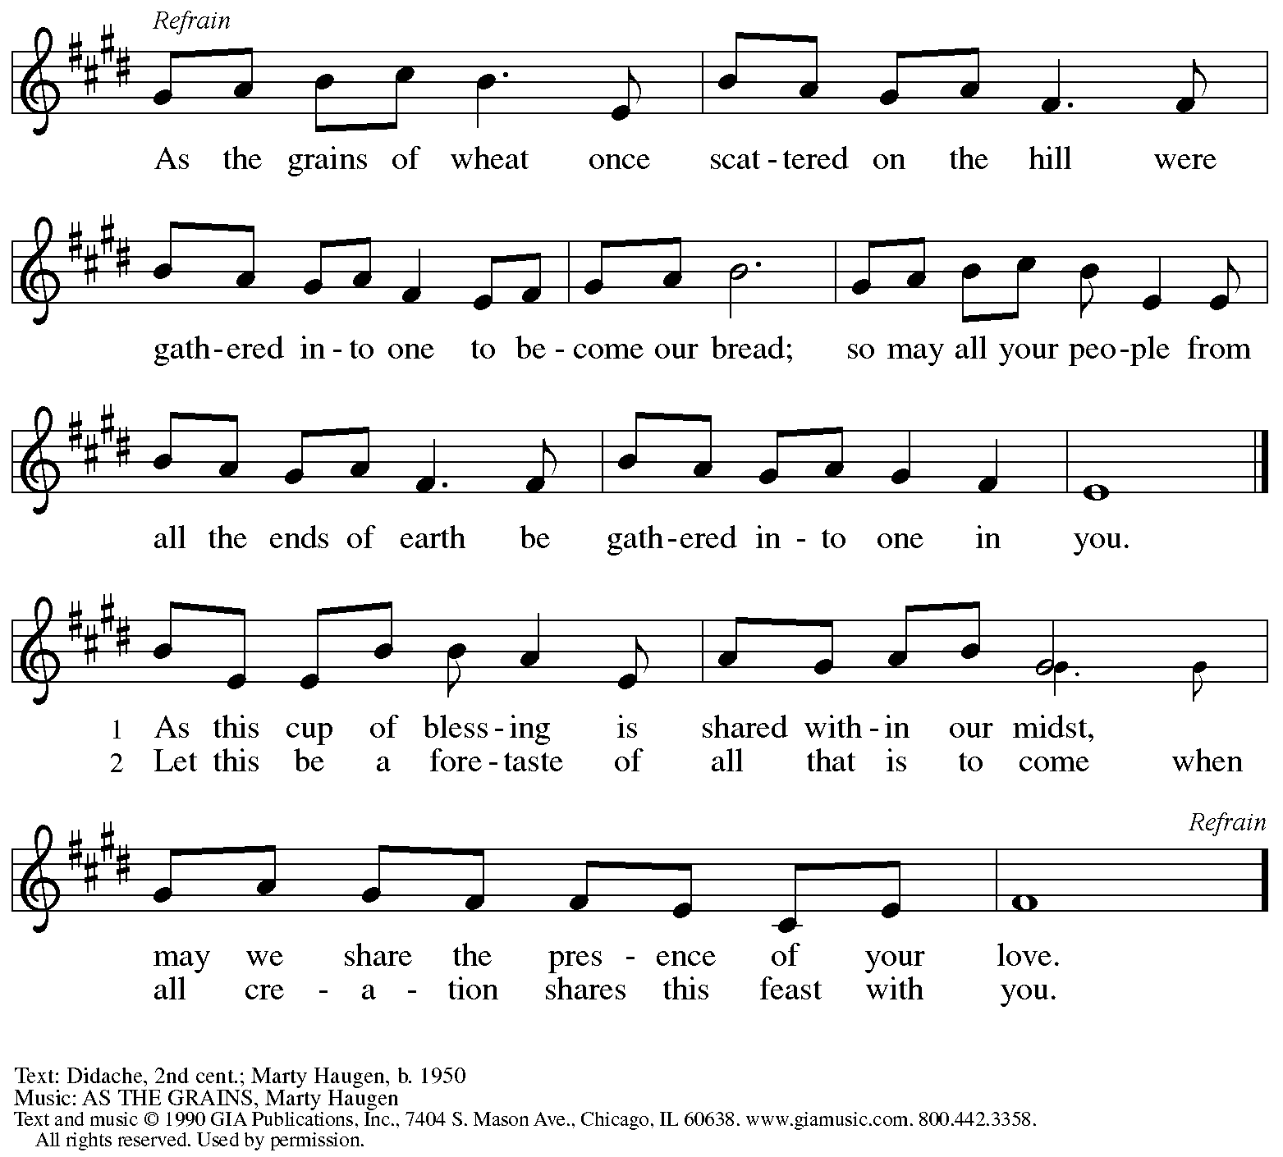

Reprinted under OneLicense.net # A-722139.

**Offertory Prayer**

A: Let us pray.

God of abundance,

**C:** **we bring before you the precious fruits of your creation,**

**and with them our very lives.**

**Teach us patience and hope as we care for all those in need**

**until the coming of your Son, our Savior and Lord**

**Amen.**

**Dialogue**

P: The Lord be with you.

**C: And also with you.**

P: Lift up your hearts.

**C: We lift them to the Lord.**

P: Let us give thanks to the Lord our God.

**C: It is right to give our thanks and praise.**

**Preface**

P: It is indeed right, our duty and our joy …

… we praise your name and join their unending hymn:

**Sanctus** *ELW* p. 190

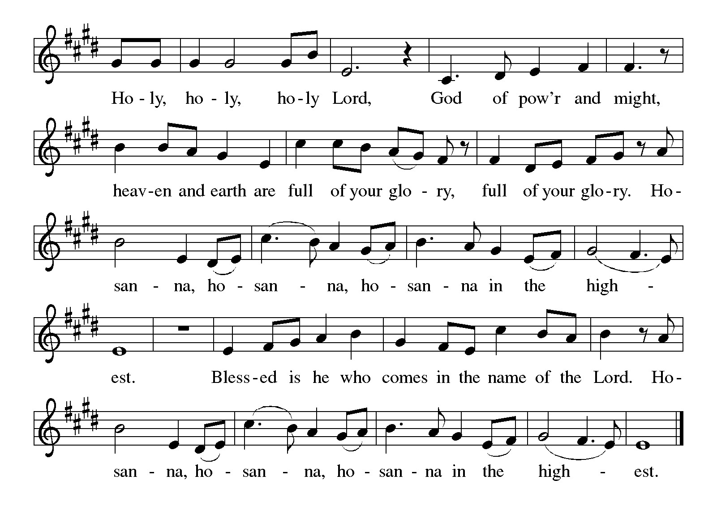

**Eucharistic Prayer**

P: Holy One, the beginning and the end, the giver of life …

…Do this for the remembrance of me.

Let us proclaim the mystery of faith:

**C: Christ has died.**

**Christ is risen.**

**Christ will come again.**

P: With this bread and cup

we remember your Word dwelling among us …

… We look with hope for his coming.

**C: Come, Lord Jesus.**

P: Holy God, we long for your Spirit …

… Bring the gift of peace on earth.

**C: Come, Holy Spirit.**

P: All praise and glory are yours,

Holy One of Israel,

Word of God Incarnate,

Power of the Most High,

one God, now and forever.

**C: Amen.**

**Lord’s Prayer**

P: Gathered as one by the Holy Spirit, let us pray as Jesus taught us.

**C: Our Father in heaven,**

**hallowed be your name,**

**your kingdom come,**

**your will be done,**

**on earth as in heaven.**

**Give us today our daily bread.**

**Forgive us our sins**

**as we forgive those**

**who sin against us.**

**Save us from the time of trial**

**and deliver us from evil.**

**For the kingdom, the power,**

**and the glory are yours,**

**now and forever. Amen.**

**Fraction and Invitation**

P: God feeds us with tender mercy. Come to the table, where Christ comes to us once again.

***Agnus Dei /* Lamb of God** *ELW* p. 191

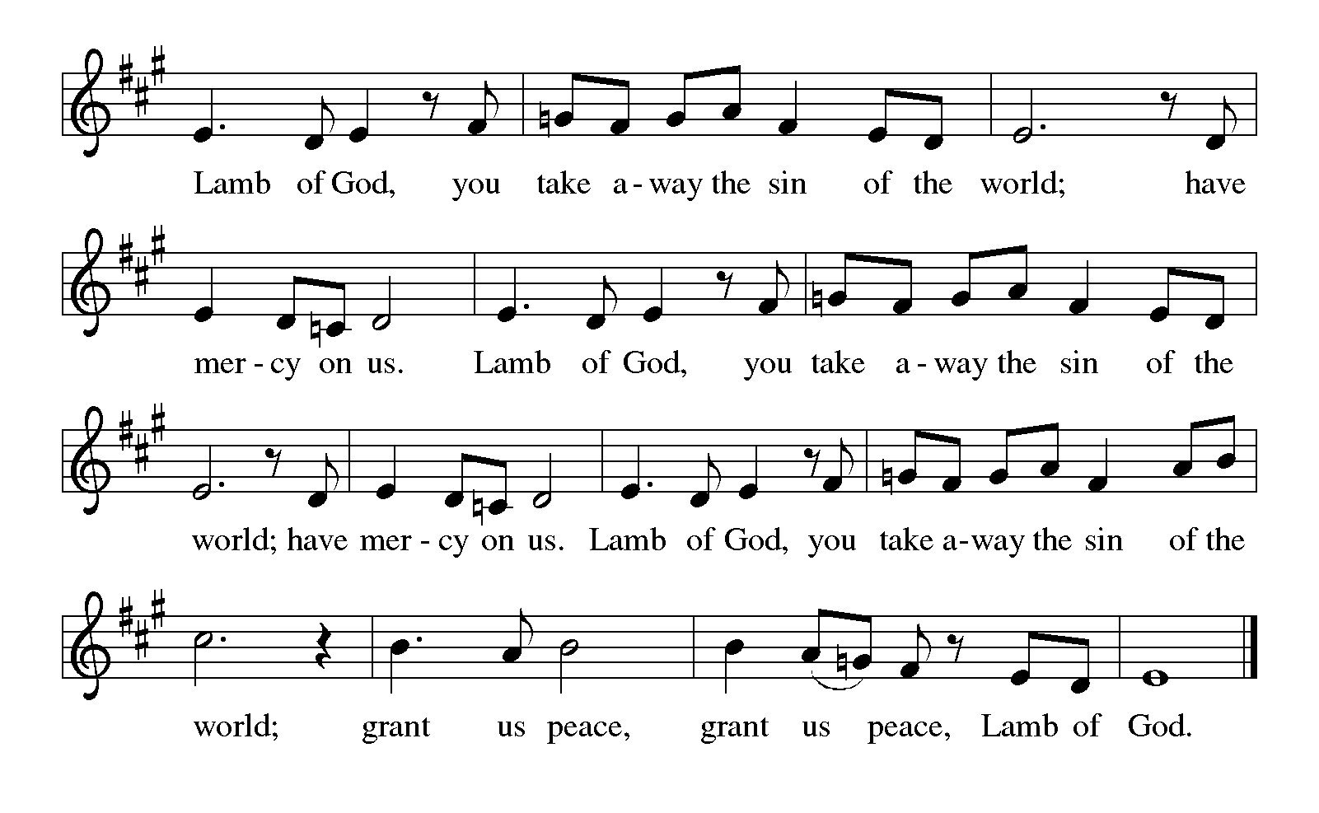

*Please be seated.*

**Holy Communion**

* *All who seek God and desire a deeper and stronger life in Christ are welcome to receive Holy Communion.*
* *Worshipers from the pulpit side will proceed forward first, followed by the center section, and then the lectern side.*
* *Please inform an usher if you would like the ministers to bring Communion to you.*
* *Holy Communion will be served with bread and wine/grape juice.*
* *The presiding minister will first distribute the bread (host) to each communicant. Please indicate if you require a gluten-free host.*
* *Once you have consumed the bread, please pick up an empty glass from the tray next to the presiding minister. The Communion Assistant will pour wine from the chalice or grape juice from the cruet into your glass.*
* *Please step to the side to consume the wine or grape juice.*
* *Feel free to kneel at the altar rail for prayer after receiving the sacrament.*
* *As you return to your pew, glasses may be returned to the empty tray on the side of the center section.*
* *A blessing will be provided for anyone who does not yet receive the sacrament.*
* *All are invited to join in singing the hymns during Holy Communion.*

**Hymns during Holy Communion**

**Comfort, Comfort Now My People *ELW* 256**

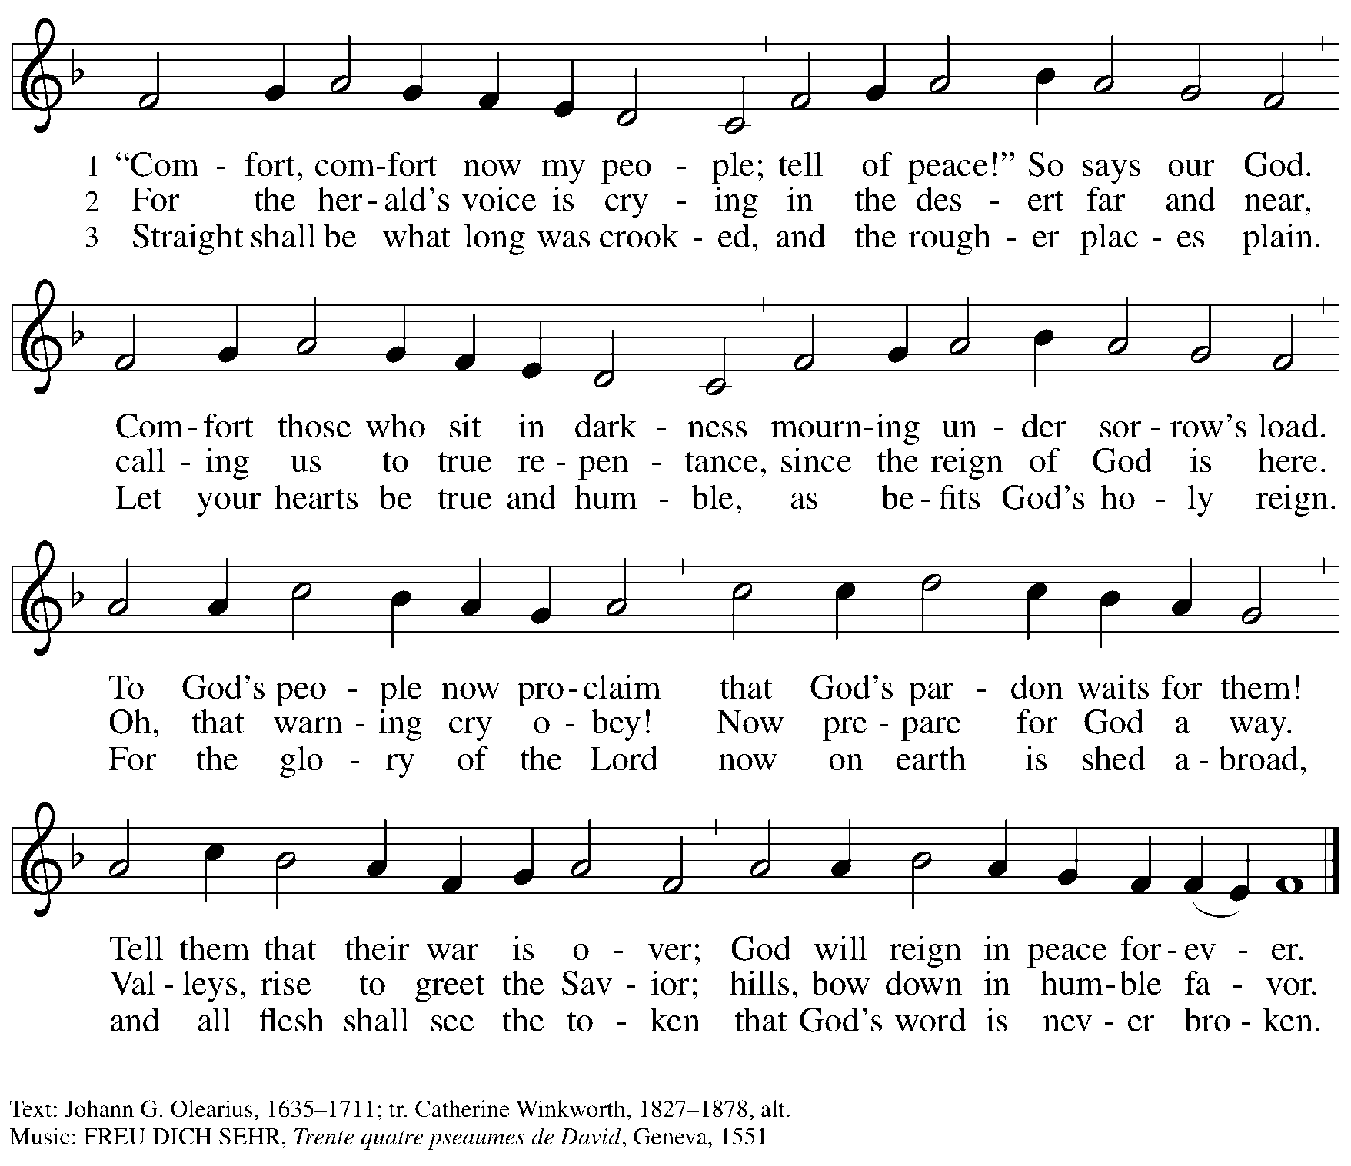

**Hymns during Holy Communion**

**Wait for the Lord *ELW* 262**

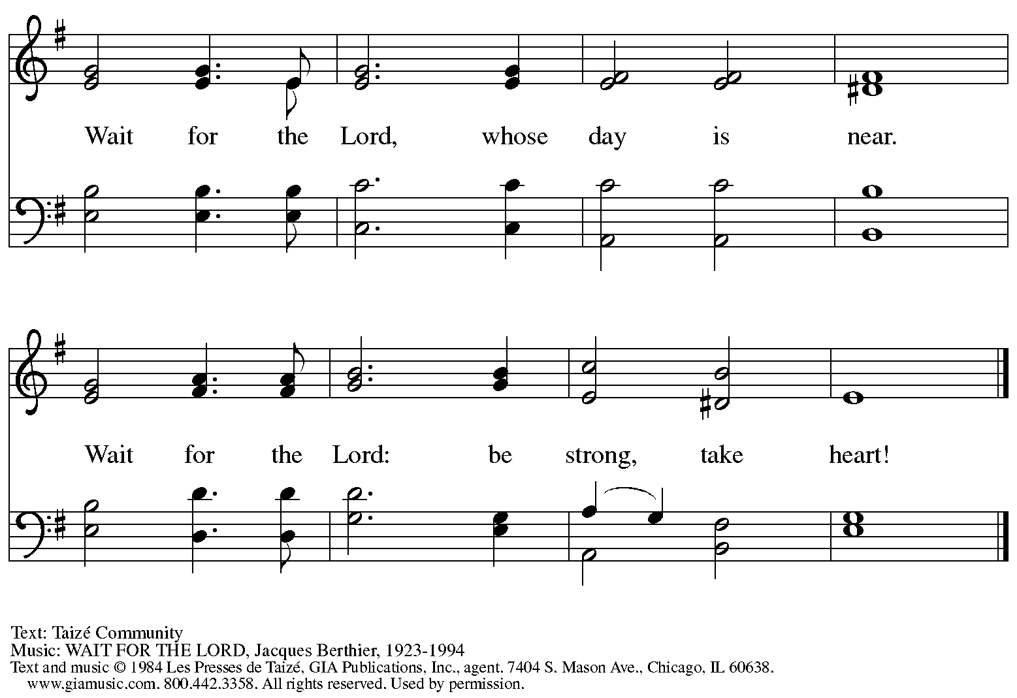

Reprinted under OneLicense.net # A-722139.

**Hymns during Holy Communion**

**O Lord, How Shall I Meet You *ELW* 241**

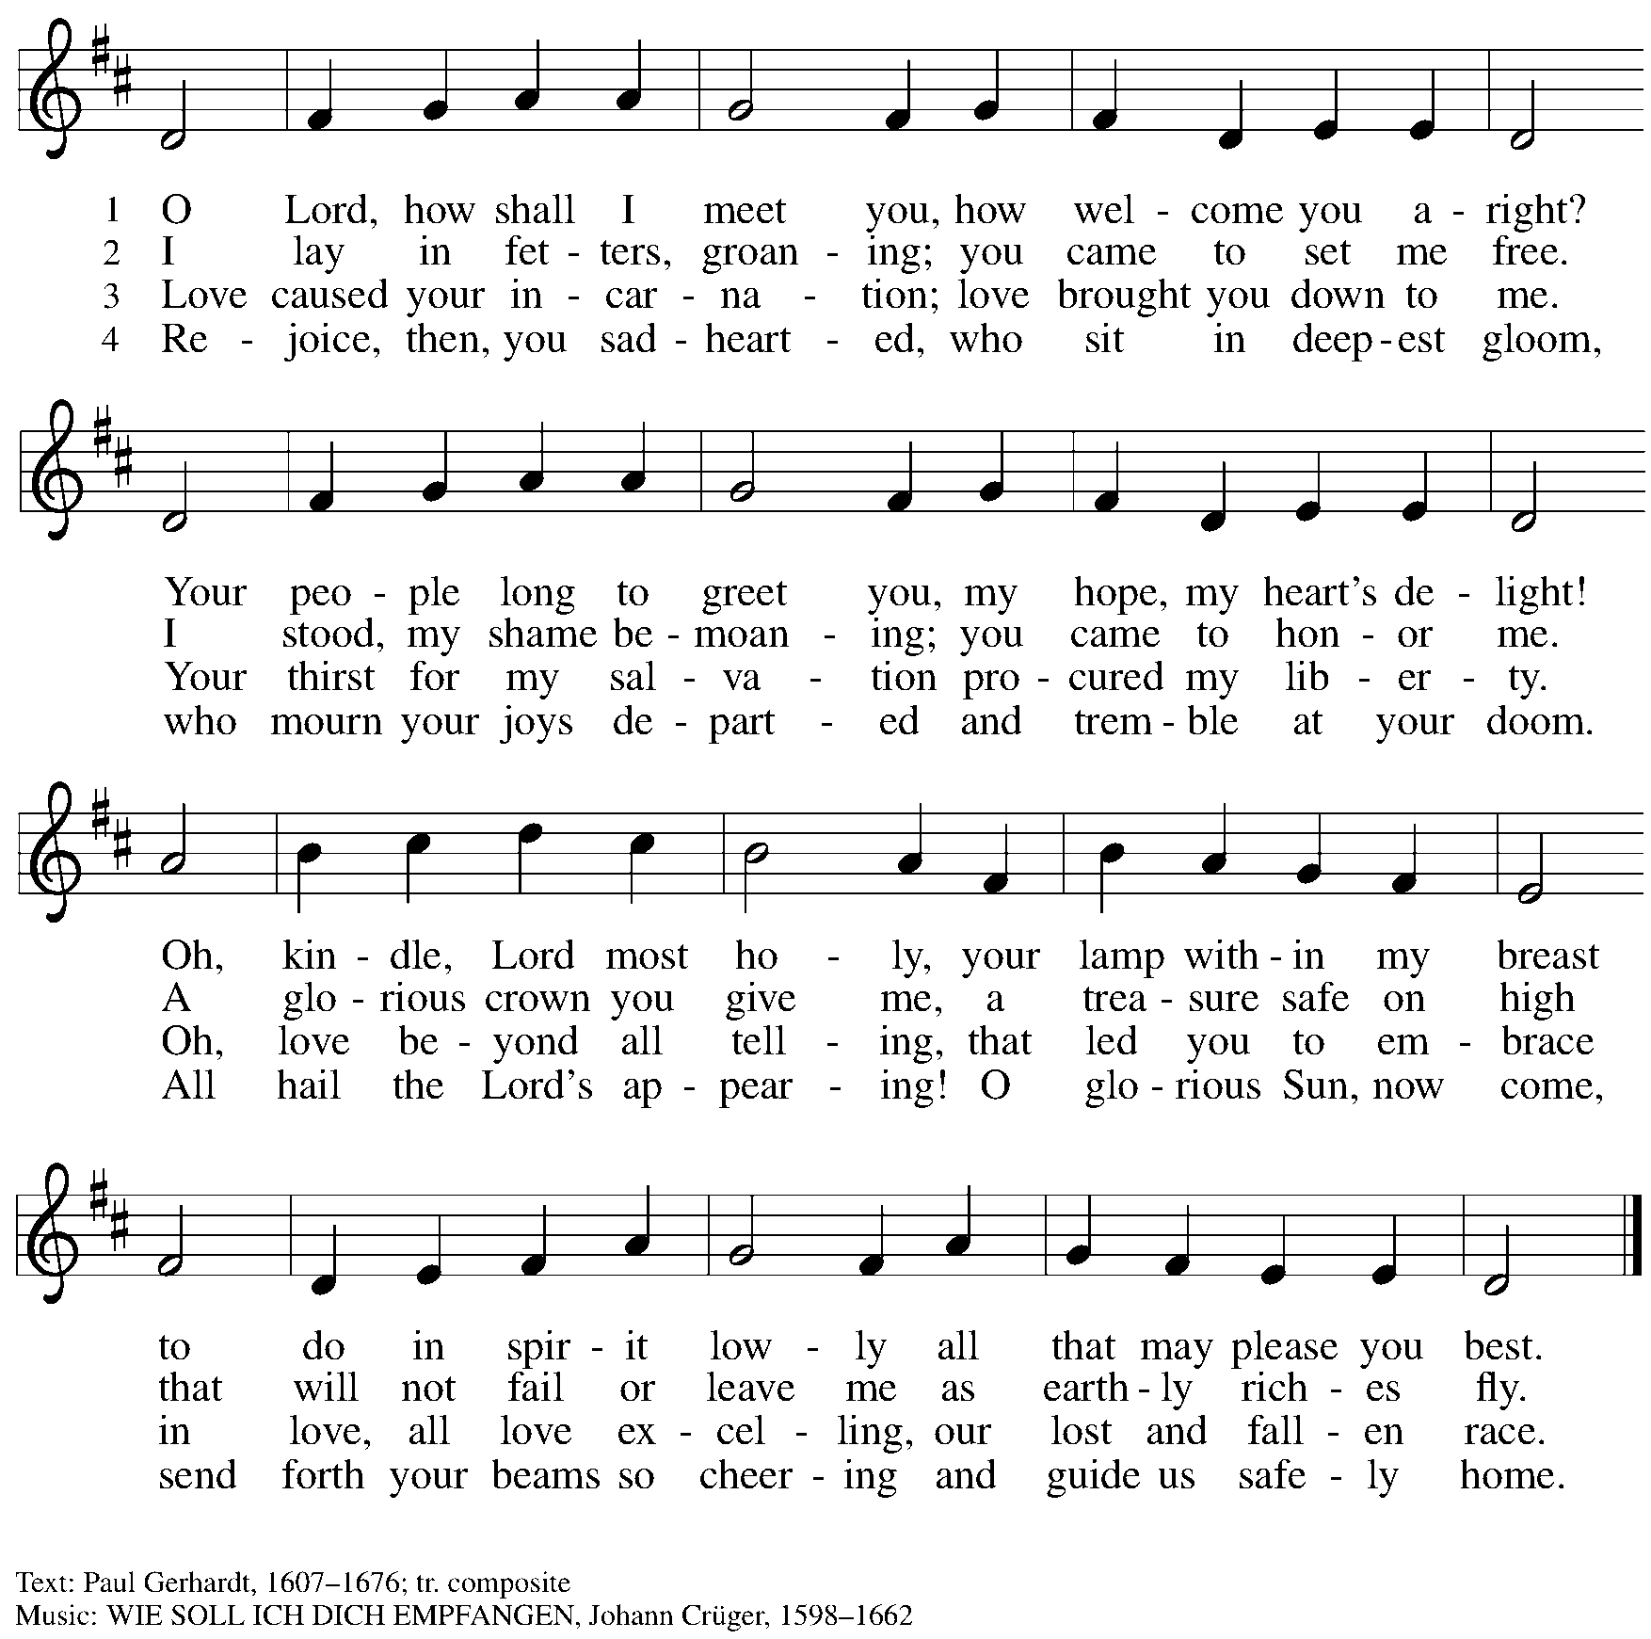

**Hymns during Holy Communion**

**Rejoice, Rejoice, Believers *ELW* 244**

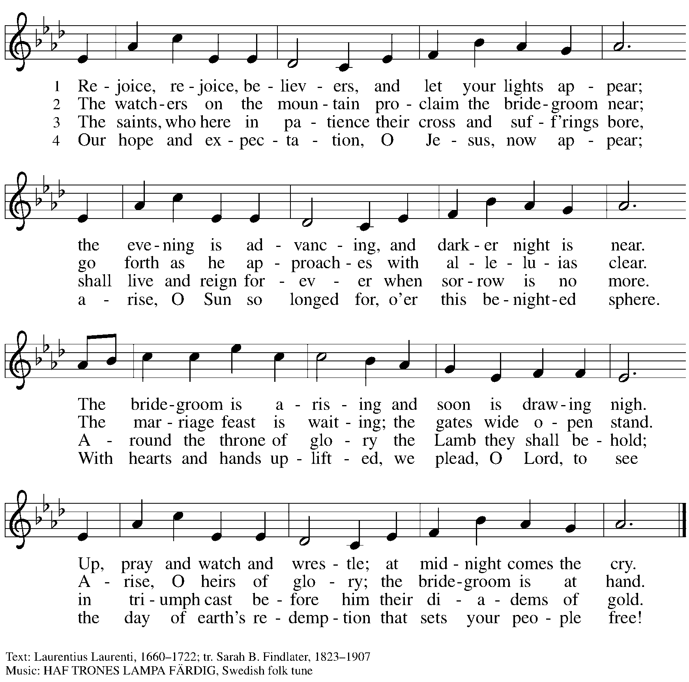

*When all have returned to their places, please rise as you are able.*

**Blessing**

P: The body and blood of our Lord Jesus Christ strengthen you and keep you in his grace.

**C: Amen.**

**Prayer**

A: Let us pray.

God for whom we wait,

in this meal you give us a foretaste of that day when the hungry will be fed with good things. Send us forth to make known your deeds and to proclaim the greatness of your name,

through Jesus Christ, our Savior and Lord.

**C: Amen.**

*Please be seated.*

**Sending**

*God blesses us and sends us in mission to the world*

**Announcements**

*Please rise as you are able.*

**Benediction**

P: God of endings and beginnings,

God in the darkness and in the light,

God, our hope for the journey,

☩ bless and keep you now and forever.

**C: Amen.**

**Sending Hymn Prepare the Royal Highway** *Following page*

**Dismissal**

A: Go in peace. Prepare the way for Emmanuel.

**C: Thanks be to God.**

**Postlude** *Wake, Awake, for Night Is Flying* Nicolai / arr. Unke

**Sending Hymn Prepare the Royal Highway *ELW* 264**

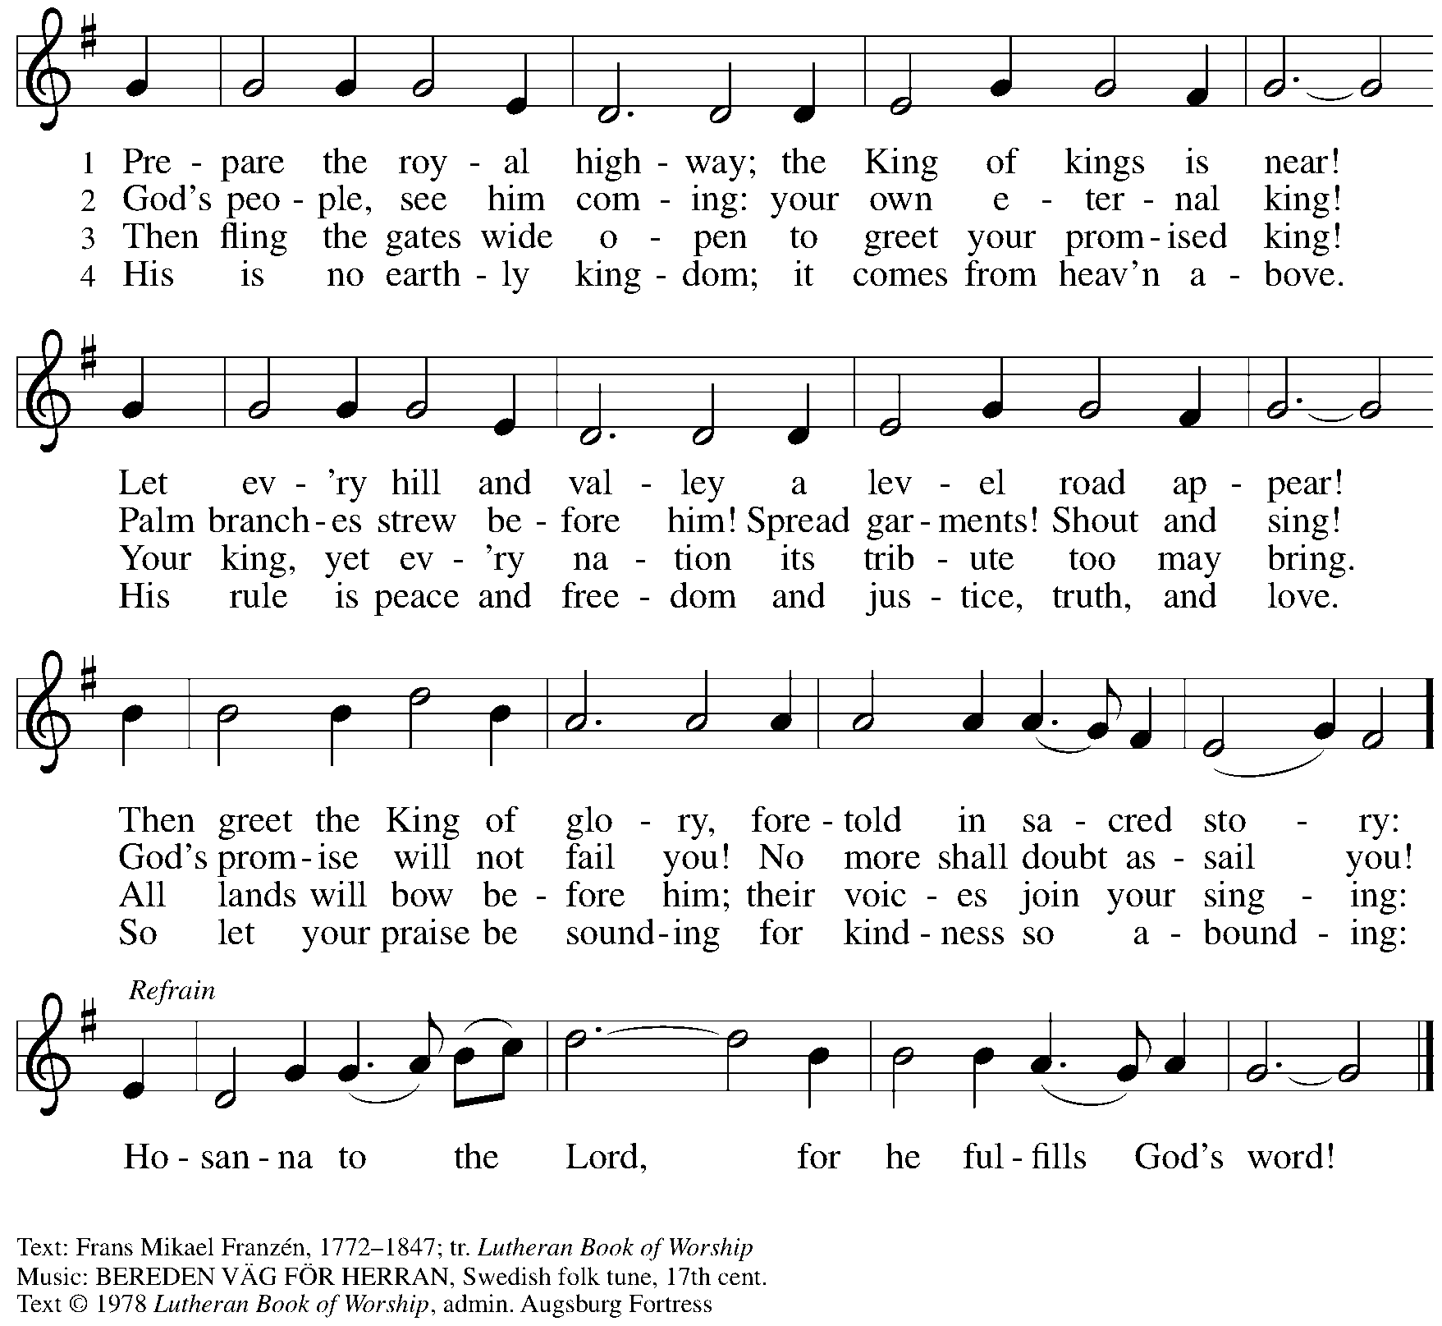

All rights reserved. Reprinted with permission under OneLicense.net # A-722139.

*Those serving in worship today*

Altar Care Christy Ruhe

Assisting Minister Colleen Cooke

Audio-Visual Ministers Joseph Paetz

Sarita

Cantor The Rev. Erin Jones

Lector Lester Prince

Little Church – Big Faith Teacher Sue Gaugler

Minister of Music Laura Reynolds

Preaching and Presiding Minister Pastor Ross Carmichael

*Liturgy and Hymnody Acknowledgements*

From SundaysandSeasons.com. Copyright © 2024 Augsburg Fortress. All rights reserved. Reprinted under OneLicense.net # A-722139.

Used by permission of Augsburg Fortress.

The Scripture readings contained herein are from *New Revised Standard Version* of the Bible © 1989, Division of Christian Education of the National Council of Churches of Christ in the USA. Used by permission. All rights reserved.

*Please use the QR code below to link to St. Andrew’s announcements online!*



**St. Andrew Lutheran Church Announcements**

**December 8th, 2024**

* **Welcome to Worship at St. Andrew on the Second Sunday of Advent, December 8th, 2024** –We are thankful you are here, and we offer a special welcome to all visitors and guests here for the first time. Worship attendees are invited to make a name tag at the back of the worship space. Little Church – Big Faith, a Bible lesson and activity for children, will take place after the prayer of the day. There are also worship “toolkits” to help children engage with worship and “busy bags” for younger children available in the bookcase at the back of the sanctuary. Please feel free to take one to use with/for your children.
* **Meeting of the Congregation – Today, December 8th, after Worship – The annual meeting of the congregation will be held today after worship. Please plan to stay for the discussion!**
* **Noisy Offering during Worship Next Week, December 15th – On the third Sunday of each month, the children of St. Andrew lead us in a Noisy Offering.** The children will carry buckets around the congregation and people are invited to throw in their change, which then gets compiled in big metal buckets and is brought forward as an offering. These gifts support a different ministry or organization each month, and this month’s Noisy Offering will be given to JFCS Pittsburgh. For more information on their work, please visit: <https://www.jfcspgh.org/>.
* **Shelter Dinner for Guests of East End Cooperative Ministry – Thursday, December 19th, 6:30 p.m. –** Each month, people of St. Andrew provide dinner for guests of East End Cooperative Ministry, 6140 Station St. (East Liberty), 15206. We invite you to prepare or purchase one menu item and bring it to the shelter by 6:00 p.m., or just come to help serve at 6:30 p.m. If you would like to contribute, please sign up here:

<https://www.signupgenius.com/go/5080544AAAC22A1F58-53490586-shelter>.

* **Panel Discussion – Thou Shalt Not Kill: Dietrich Bonhoeffer’s Conflicted Pacifism – Thursday, December 19th, 6:30-9:30 p.m. at Pittsburgh Theological Seminary, 616 N. Highland Ave., 15206 – With this fall’s study of Lutheran pastor Dietrich Bonhoeffer’s theology sponsored by Lutheran Advocacy Ministry in Pennsylvania (LAMPa), a new movie release about Bonhoeffer’s life, and much debate over how he is being interpreted and used politically, the church has seen a renewed interest in Bonhoeffer’s life and work. Pittsburgh Theological Seminary will host a panel discussion on Thursday, December 19th, from 6:30-9:30 p.m.** Beatrice Institute—in collaboration with the Bruderhof community—invites you to join the conversation this semester as we interrogate the tension in Christian ethics between a preference for non-violence and the responsibility to protect the innocent. (Seeing the movie is not necessary for attending!).

**More information is available here:** [Winter Salon: Thou Shalt Not Kill? Dietrich Bonhoeffer’s Conflicted Pacifism — Beatrice Institute](https://beatriceinstitute.org/public-events/winter-salon).

* **Stay after Worship on Sunday, December 22nd to Help Decorate for the Christmas Season! – St**. Andrew invites everyone in the congregation to stay after worship next Sunday, December 22nd, the Fourth Sunday of Advent, to help decorate the church for the Christmas season!
* **The Nativity of our Lord: Christmas Eve, Tuesday, December 24th – Worship with Holy Communion, 7:00 p.m. – St. Andrew will celebrate Christmas with one service of carols, candlelight, and Holy Communion at 7:00 p.m. on Christmas Eve, Tuesday, December 24th.**
* **Coffee Hour Signups Available** –One way that St. Andrew builds community is by sharing conversation over food and drinks at coffee hour after worship on Sundays. We invite people of the congregation to sign up to coordinate coffee hour each week, which includes brewing the coffee; setting out cups, napkins, food items, and cold drinks; and cleaning up afterward. Everything needed is at St. Andrew and instructions are available. Please sign up to host coffee hour here: <https://www.signupgenius.com/go/5080B4AAFAF2CABF85-47069030-coffee>.
* **New *Christ in Our Home* Devotional Booklets (January - March) Available at Church Entrances – *Christ in Our Home* is a booklet of devotions that includes Scripture, a brief reflection, and prayer for each day. The current and new editions are both available at the church entrances. Please feel free to take one for yourself or others!**
* **Compline Prayer Service with the Pittsburgh Compline Choir – Sundays at 8:00 p.m. at Heinz Chapel –** Compline was traditionally a monastic prayer service, and the Pittsburgh Compline Choir, a ministry of Lutheran Campus Ministry in Greater Pittsburgh, sings a choral version of compline rooted in this thousand-year-old tradition of scripture, song, and silence each Sunday at Heinz Chapel at 8:00 p.m. This service also streams on Facebook (Pittsburgh Compline Choir) and YouTube (The Pittsburgh Compline Choir). Heinz Chapel is located off of S. Bellefield Ave. in Oakland. For more information, please visit: [Pittsburgh Compline Choir](http://pittsburghcomplinechoir.org/).
* **Holiday Gift-Giving Opportunities through Bethesda Lutheran Services and JFCS –**

**Each year, St. Andrew chooses an organization to partner with to provide holiday gifts for children in need. This year the congregation will work with Bethesda Lutheran Services and JFCS.**

* **JFCS has set up a gift registry with** Learning Express in Wexford (buying

as locally as possible). This is the link to the registry: <https://learningexpress.com/wexford/giftr/registry/view/uid/FF5129350614/>. Gifts can be ordered directly on the LE website, and Joy Givens will pick everything up from the store, so anyone who orders can mark "pick up" from Wexford at checkout and will not have to worry about going to get items themselves.

* JFCS – St. Andrew will also collect new winter hats, mittens/gloves,

and packages of socks and underwear of all sizes in the social hall until Sunday, December 15th. JFCS has 160 kids on their list, 114 of whom are age 5 or older, so the need is great!

* **JFCS –** The JFCS Bridge Builders gift distribution event will take place on

Monday, December 16th, hopefully at the Carnegie Library's downtown

branch on Smithfield Street. We will invite parents to come and "shop" for

their children. We hope to offer one toy and hat/gloves set per child, new

packages of socks and underwear, and used books (which are already

being supplied). We will also assemble gift bags for families that are not able to get downtown and deliver them during that week. Anyone who wants to volunteer to staff our free store and/or deliver gifts should email Joy Givens at [jgivens@jfcspgh.org](mailto:jgivens@jfcspgh.org). Bridge Builders is a mentoring and enrichment program for locally resettled refugee and immigrant children, and Joy is happy to talk with anyone about what they do and who we serve!

* **Bethesda – Please see the full Bethesda Residential Wish List page printed**

**at the back of the bulletin. Donations will be accepted through Sunday,**

**December 15th.**