

**+ Reign of Christ**

**November 24, 2024**



**St. Andrew Lutheran Church**

**304 Morewood Ave.**

**Pittsburgh, PA 15213**

[**St_andrewELCA@verizon.net**](mailto:St_andrewELCA@verizon.net)

[**www.standrewpittsburgh.org**](http://www.standrewpittsburgh.org)

**+ Reign of Christ**

**Order for Worship**

*Even after Israel had experienced the vagaries of kings, the people still longed for a true king to set things right. He would have the king’s title of Anointed One (Messiah); he would be the “one like a human being” (Son of Humanity) given dominion in Daniel’s vision. Jesus is given these titles, even though he is nothing like an earthly king. His authority comes from the truth to which he bears witness, and those who recognize the truth voluntarily listen to him. We look forward to the day he is given dominion, knowing his victory will be the nonviolent victory of love.*

**Welcome to St. Andrew!**

* St. Andrew Lutheran congregation welcomes all who are seeking a place of healing and wholeness – a nurturing, faith-forming spiritual home. Our community embraces people of all ages, ethnicities, cultures, abilities, sexual orientations, gender identities and expressions, and family constellations. Come and See!
* Worship Services are live-streamed to multiple online platforms. By attending worship, you agree that your image and voice may be broadcast.
* Everyone is invited to make a name tag at the black bookcase in the back of the worship space if they would like. There are stickers indicating pronouns on the bookcase if you would like to include them on your name tag.
* Children are invited to attend Little Church – Big Faith, a Bible lesson and activity, during worship (after the Prayer of the Day). The group returns to the worship space for the liturgy of Holy Communion.
* A nursery is available through the doors at the left side of the sanctuary and across from the doorway to the Social Hall. Look for a purple-colored room.
* Worship “toolkits” to help children engage with the service, along with “busy bags” for younger children, are available in the bookcase at the back of the sanctuary. Please feel free to take one to use with/for your children.
* Holy Communion is served with bread (gluten-free available) and wine or grape juice. The presiding minister will distribute the bread (host). Please consume this and then pick up an empty glass from the tray. The Communion Assistant will pour wine or grape juice into your glass. Please step to the side to consume the wine or grape juice. Feel free to kneel at the altar for prayer and reflection. As you return to your pew, glasses may be returned to the empty trays on either side of the center section.
* A restroom is available on the main level of the church, through the doors to the Social Hall and to the right in the main office.

*Abbreviations*

P: Pastor/Presiding Minister ***ELW*: *Evangelical Lutheran Worship* hymnal**

A: Assisting Minister ***ACS*: *All Creation Sings* hymnal**

L: Lector

**C: Congregation**

**Pre-Service Music**

**Welcome**

**Prelude**  *Fairest Lord Jesus* arr. P. Keveren

**Gathering**

*The Holy Spirit calls us together as the people of God*

**Confession and Forgiveness**

*Please rise as you are able. All may make the sign of the cross,*

*the sign that is marked at Baptism, as the presiding minister begins.*

P: Blessed be the holy Trinity, ☩ one God,

our refuge, our rock, our beginning and our end.

**C: Amen.**

P: Let us bring our confession before the one who loves us and has freed us from our sin.

*Silence is kept for reflection*

P: Eternal One, robed in majesty and mercy,

**C: we confess that sin has taken hold of us**

**and we have given in to its power.**

**We are disturbed in spirit and our hearts cannot rest.**

**Unbind us and set us free.**

**Lead us again to the waters of rebirth,**

**that we may live just and generous lives,**

**for the good of your world**

**and the care of our neighbors,**

**following in the servant way of Jesus Christ, our Savior.**

**Amen.**

**P:** These words are trustworthy and true:

Jesus bore our sin once, for all, on the cross,

swallowing up death forever.

For his sake, you are ☩ forgiven,

and God remembers your sin no more.

Let your heart be glad again

and rejoice in your salvation.

**C: Amen.**

**Gathering Hymn Crown Him with Many Crowns *ELW* 855**

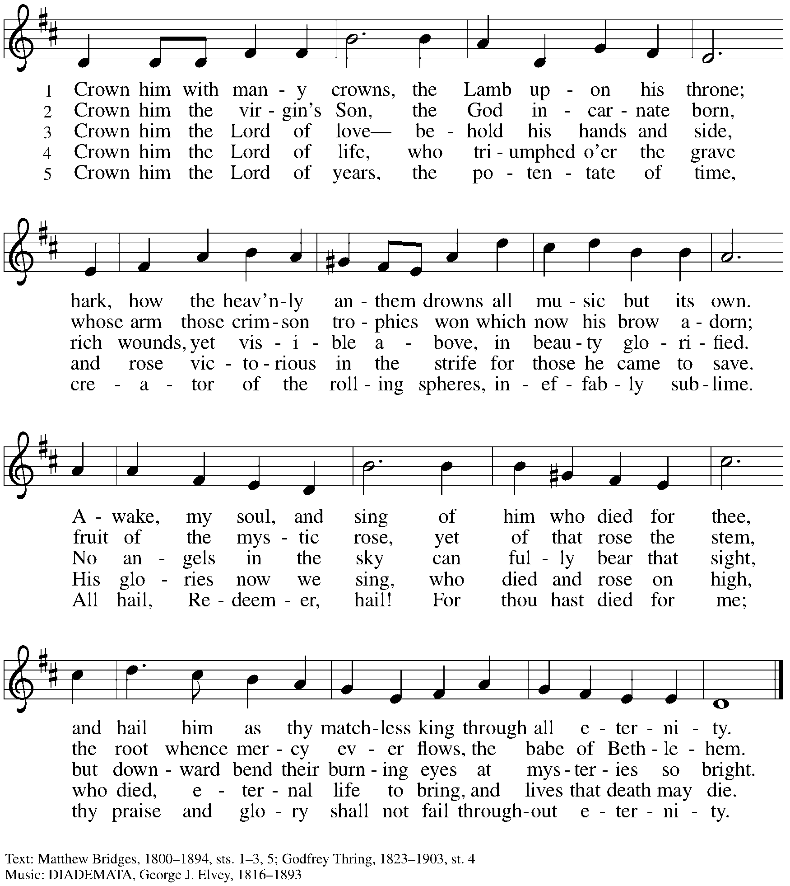

**Greeting**

P: The grace of our Lord Jesus Christ, the love of God,

and the communion of the Holy Spirit be with you all.

**C: And also with you.**

**Kyrie** *ACS* p. 31

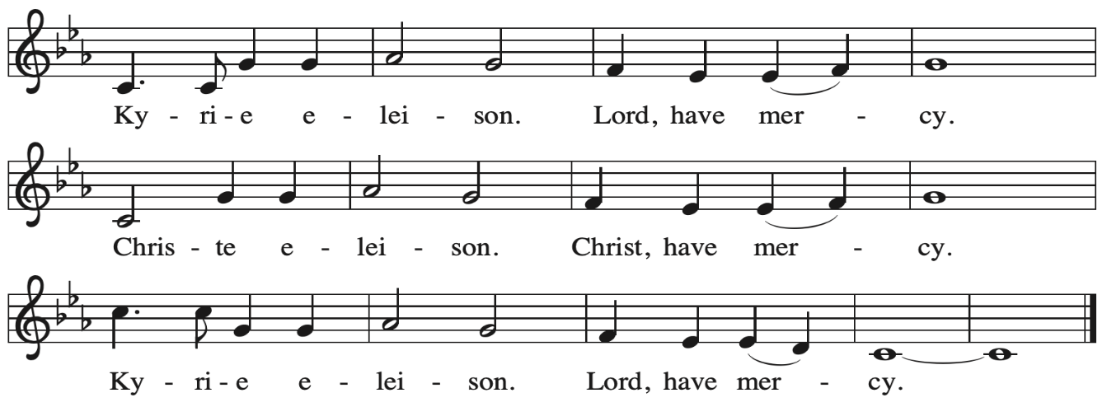



**Hymn of Praise** *ELW* p. 187

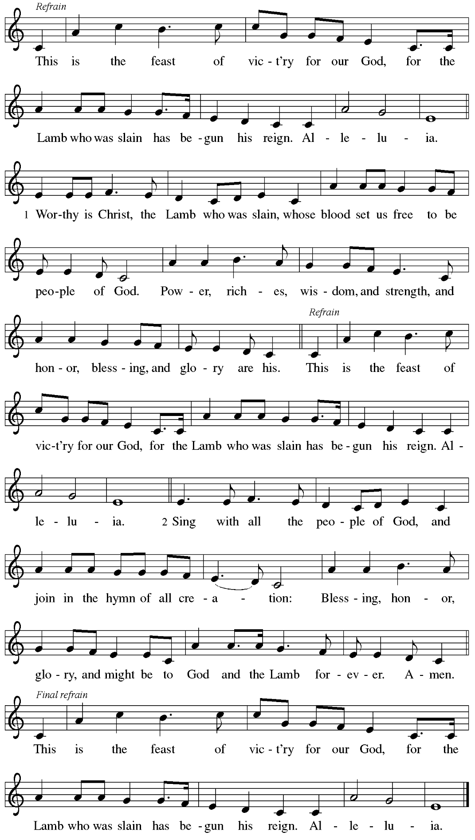

**Prayer of the Day**

P: The Lord be with you.

**C: And also with you.**

P: Let us pray.

Almighty and ever-living God,

you anointed your beloved Son to be priest and sovereign forever.

Grant that all the people of the earth, now divided by the power of sin,

may be united by the glorious and gentle rule of Jesus Christ,

our Savior and Lord, who lives and reigns with you and the Holy Spirit,

one God, now and forever.

**C: Amen.**

*Please be seated.*

*Children are invited to join the adult leaders at the door for Little Church – Big Faith.*

*We ask that one additional adult from the congregation attend with the children.*

**Word**

*God speaks to us in Scripture reading, preaching, and song*

**First Reading** **–** **Daniel 7: 9-10, 13-14**

9 As I watched,  
 thrones were set in place,  
  and an Ancient One took his throne,  
 his clothing was white as snow,  
  and the hair of his head like pure wool;  
 his throne was fiery flames,  
  and its wheels were burning fire.  
 10 A stream of fire issued  
  and flowed out from his presence.  
 A thousand thousands served him,  
  and ten thousand times ten thousand stood attending him.  
 The court sat in judgment,  
  and the books were opened.  
13 As I watched in the night visions,  
 I saw one like a human being  
  coming with the clouds of heaven.  
 And he came to the Ancient One  
  and was presented before him.  
 14 To him was given dominion  
  and glory and kingship,  
 that all peoples, nations, and languages  
  should serve him.  
 His dominion is an everlasting dominion  
  that shall not pass away,  
 and his kingship is one  
  that shall never be destroyed.

L: Word of God, word of life.

**C: Thanks be to God.**

**Psalm 93**

*The cantor will lead the singing of the psalm.*

*The congregation is invited to respond with the alternate verses in bold print,*

*and to join in singing the refrain.*

*Psalm tone*

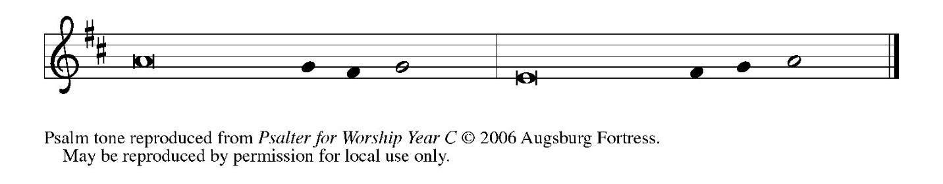

*Psalm refrain*

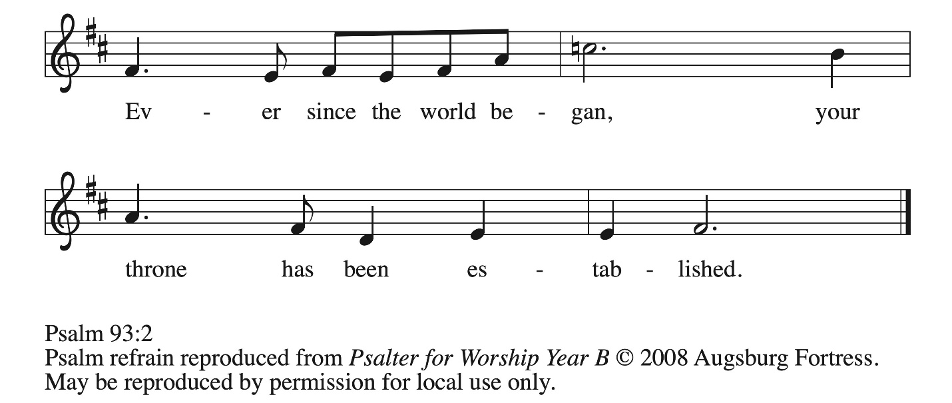

1 The Lord is king, robed in majesty; the Lord is robed in majesty and **|** armed with strength.  
  The Lord has made the world so sure that it can- **|** not be moved.  
 2 **Ever since the world began, your throne has | been established;**  
  **you are from | everlasting. R**  
 3 The waters have lifted up, O Lord, the waters have lifted **|** up their voice;  
  the waters have lifted up their **|** pounding waves.  
 4 **Mightier than the sound of many waters, mightier than the breakers | of the sea,**  
  **mightier is the Lord who | dwells on high.**  
 5 Your testimonies are **|** very sure,  
  and holiness befits your house, O Lord, forever and for- **|** evermore.**R**

**Second Reading – Revelation 1: 4b-8**

4b Grace to you and peace from the one who is and who was and who is to come, and from the seven spirits who are before God’s throne, 5 and from Jesus Christ, the faithful witness, the firstborn of the dead, and the ruler of the kings of the earth.  
  To him who loves us and freed us from our sins by his blood, 6 and made us to be a kingdom, priests serving his God and Father, to him be glory and dominion forever and ever. Amen.  
 7 Look! He is coming with the clouds;  
  every eye will see him,  
 even those who pierced him;  
  and on his account all the tribes of the earth will wail.  
So it is to be. Amen.  
  8 “I am the Alpha and the Omega,” says the Lord God, who is and who was and who is to come, the Almighty.

L: Word of God, word of life.

**C: Thanks be to God.**

*Please rise as you are able and join in speaking the Gospel Acclamation.*

**Gospel Acclamation** *ACS* p. 33

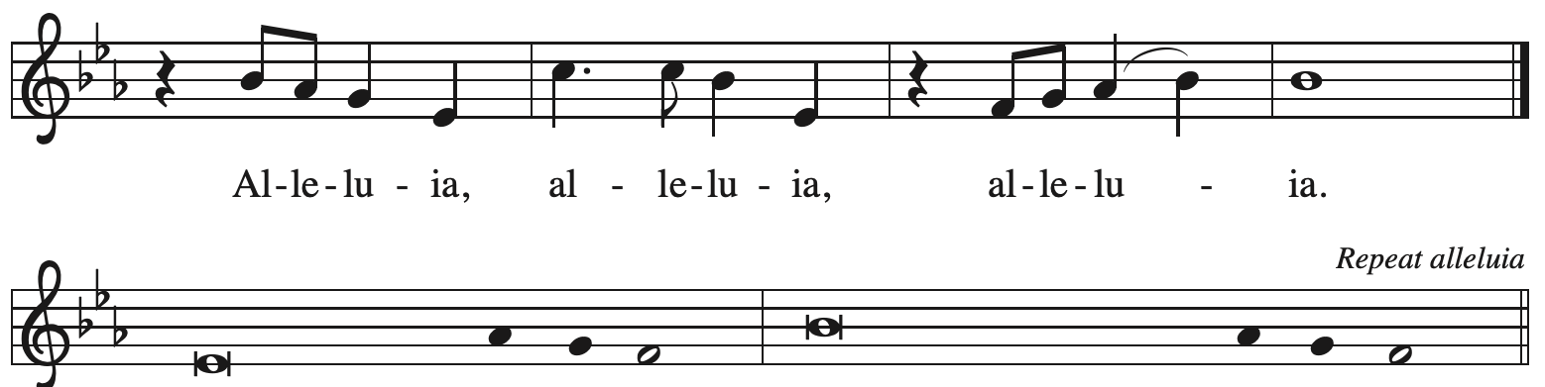

Blessed is the one Blessed is the coming

who comes in the name | of the Lord. kingdom of our an-  | cestor David.

**Gospel – John 18: 33-37**

P: The holy Gospel according to St. John.

**C: Glory to you, O Lord.**

33 Pilate entered the headquarters again, summoned Jesus, and asked him, “Are you the King of the Jews?” 34 Jesus answered, “Do you ask this on your own, or did others tell you about me?”

35 Pilate replied, “I am not a Jew, am I? Your own nation and the chief priests have handed you over to me. What have you done?” 36 Jesus answered, “My kingdom is not from this world. If my kingdom were from this world, my followers would be fighting to keep me from being handed over to the Jews. But as it is, my kingdom is not from here.” 37 Pilate asked him, “So you are a king?” Jesus answered, “You say that I am a king. For this I was born, and for this I came into the world, to testify to the truth. Everyone who belongs to the truth listens to my voice.”

P: The Gospel of the Lord.

**C: Praise to you, O Christ.**

*Please be seated.*

**Sermon**

*A time of silence for prayer and reflection follows the sermon.*

*When the Hymn of the Day begins, please rise as you are able.*

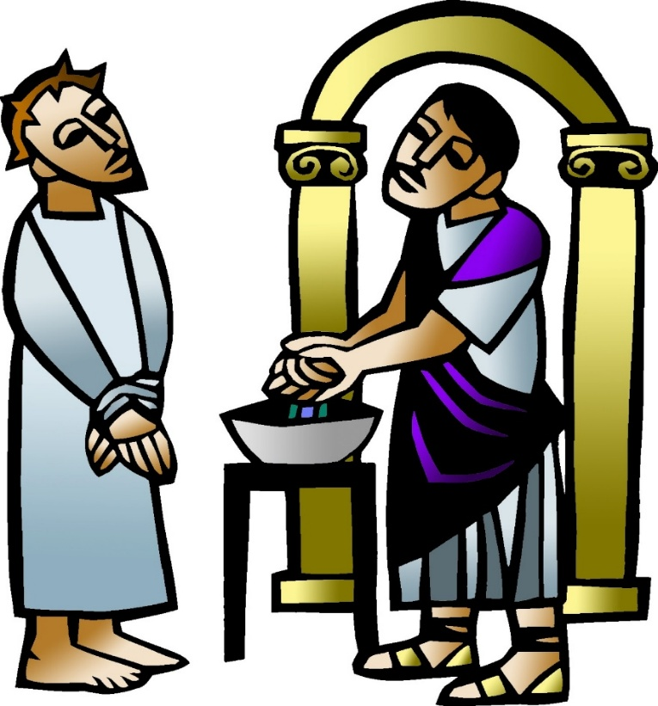

**Hymn of the Day O Christ, What Can It Mean for Us *ELW* 431**

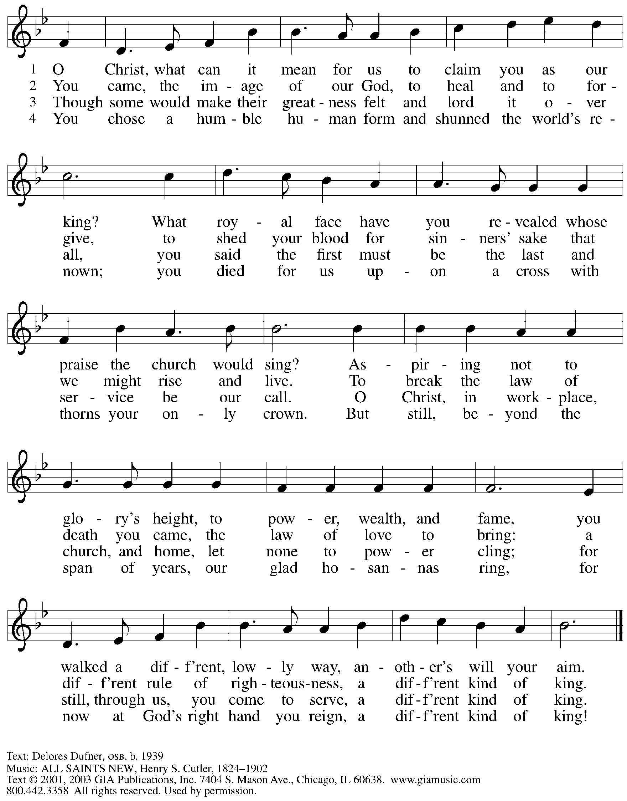

All rights reserved. Reprinted with permission under OneLicense.net # A-722139.

**Nicene Creed**

*Profession of our faith using the Nicene Creed, one of the Christian Church’s*

*three ecumenical creeds, unites us with siblings in Christ around the world.*

**We believe in one God,**

**the Father, the Almighty,**

**maker of heaven and earth,**

**of all that is, seen and unseen.**

**We believe in one Lord, Jesus Christ,**

**the only Son of God,**

**eternally begotten of the Father,**

**God from God, Light from Light,**

**true God from true God,**

**begotten, not made,**

**of one Being with the Father;**

**through him all things were made.**

**For us and for our salvation**

**he came down from heaven,**

**was incarnate of the Holy Spirit and the virgin Mary**

**and became truly human.**

**For our sake he was crucified under Pontius Pilate;**

**he suffered death and was buried.**

**On the third day he rose again**

**in accordance with the scriptures;**

**he ascended into heaven**

**and is seated at the right hand of the Father.**

**He will come again in glory to judge the living and the dead,**

**and his kingdom will have no end.**

**We believe in the Holy Spirit, the Lord, the giver of life,**

**who proceeds from the Father and the Son,\***

**who with the Father and the Son is worshiped and glorified,**

**who has spoken through the prophets.**

**We believe in one holy catholic and apostolic church.**

**We acknowledge one baptism for the forgiveness of sins.**

**We look for the resurrection of the dead,**

**and the life of the world to come. Amen.**

*Or, “who proceeds from the Father.” The phrase “and the Son” is a later addition to the creed.

**Prayers of the People**

A: Trusting in God’s abundant love for all the world,

let us pray for our neighbors, the church, and all creation.

*After each petition*

A: God of mercy,

**C: receive our prayer.**

*The presiding minister concludes the prayers*

P: We offer our prayers to you, gracious God,

trusting in your boundless love for all you have made,

through Jesus Christ, our Savior.

**C: Amen.**

**Peace**

*The presiding minister and the assembly greet one another in the peace of the risen Christ.*

P: The peace of Christ be with you always.

**C: And also with you.**

*The people may greet those around them with a sign of Christ’s peace and may say*

Peace be with you *or similar words. Please be mindful that not everyone will be comfortable with sharing the peace, so please seek consent before shaking hands or hugging. Other possible ways to share the peace include a simple bow with the verbal greeting of peace, or simply a verbal expression of peace.*

*When the greetings of peace have concluded, please be seated.*

**Meal**

*God feeds us with the presence of Jesus Christ*

**Offering**

*We offer ourselves, our gifts and our faithful service to God.*

*As the offering is gathered for the mission of the church, including the care of those in need,*

*the table is set for Holy Communion.*

*There are laminated giving cards in the pew racks that feature a QR code for anyone who would like to give online. Those who give using the QR code, as well as those who give regularly online or through their bank are encouraged to place the laminated card in the plate as an expression of your offering.*

**Music during the Offering**

*All Hail the Power of Jesus’ Name* arr. C.E. Walz

*As the gifts are brought forward for presentation, please rise as you are able.*

**Offertory Song We Are an Offering *ELW* 692**

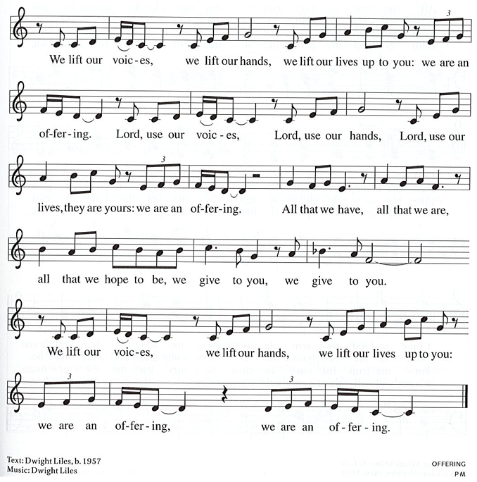

All rights reserved. Reprinted with permission under CCLI # 11561207.

**Offertory Prayer**

A: Let us pray.

Holy God,

**C:** **the earth is yours and everything in it, yet you have chosen to dwell among your peoples**

**and share your abundance. Come among us now in these gifts of bread and wine,**

**and strengthen us to be your body for the world, through Jesus Christ, our Lord.**

**Amen.**

**Dialogue**

P: The Lord be with you.

**C: And also with you.**

P: Lift up your hearts.

**C: We lift them to the Lord.**

P: Let us give thanks to the Lord our God.

**C: It is right to give our thanks and praise.**

**Preface**

P: It is indeed right, our duty and our joy …

… we praise your name and join their unending hymn:

**Sanctus** *ACS* p. 36

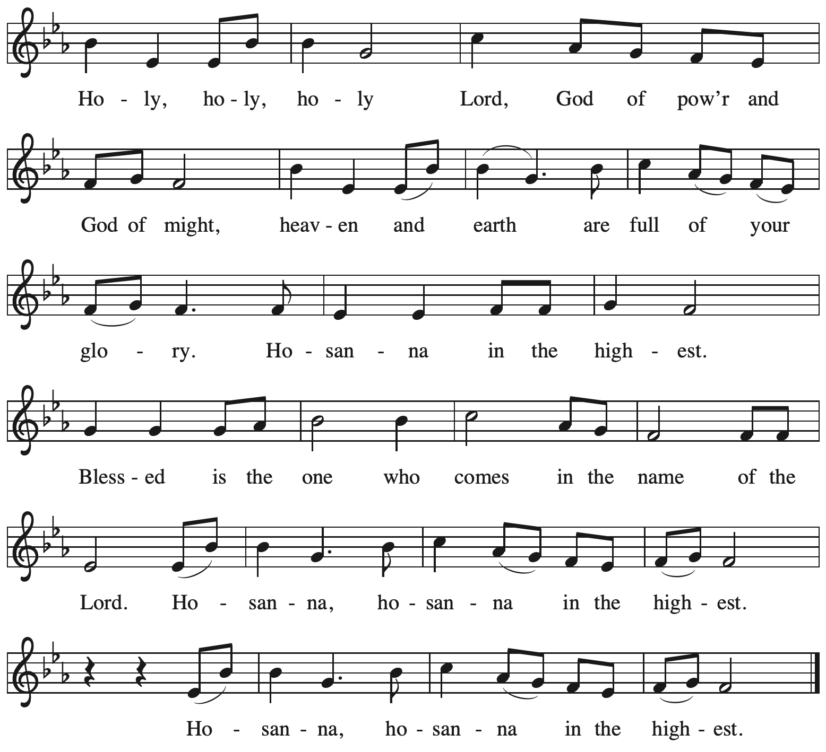

**Eucharistic Prayer**

P: We bless you, O God, Sovereign of all things …

… we praise your majestic power, saying,

Blessing and glory to you, O God:

**C: Blessing and glory to you, O God.**

P: O Christ Jesus …

… we laud your supreme mercy, saying,

Wisdom and thanks to you, O God:

**C: Wisdom and thanks to you, O God.**

P: On the night in which he was betrayed …

… We acclaim the Reign of Christ, saying,

Honor to you, O God:

**C: Honor to you, O God.**

P: O Spirit, our supreme Defender …

… we plead for your surpassing grace, saying,

Power and might to you, O God:

**C: Power and might to you, O God.**

P: O God the Father …

… we praise you today, tomorrow, and forever.

**C: Amen. Amen. Amen.**

**Lord’s Prayer**

P: Gathered as one by the Holy Spirit, let us pray as Jesus taught us.

**C: Our Father in heaven,**

**hallowed be your name,**

**your kingdom come,**

**your will be done,**

**on earth as in heaven.**

**Give us today our daily bread.**

**Forgive us our sins**

**as we forgive those**

**who sin against us.**

**Save us from the time of trial**

**and deliver us from evil.**

**For the kingdom, the power,**

**and the glory are yours,**

**now and forever. Amen.**

**Fraction and Invitation**

P: Behold, God is making all things new.

Come, take part in the new creation.

***Agnus Dei /* Lamb of God** *ACS* p. 40

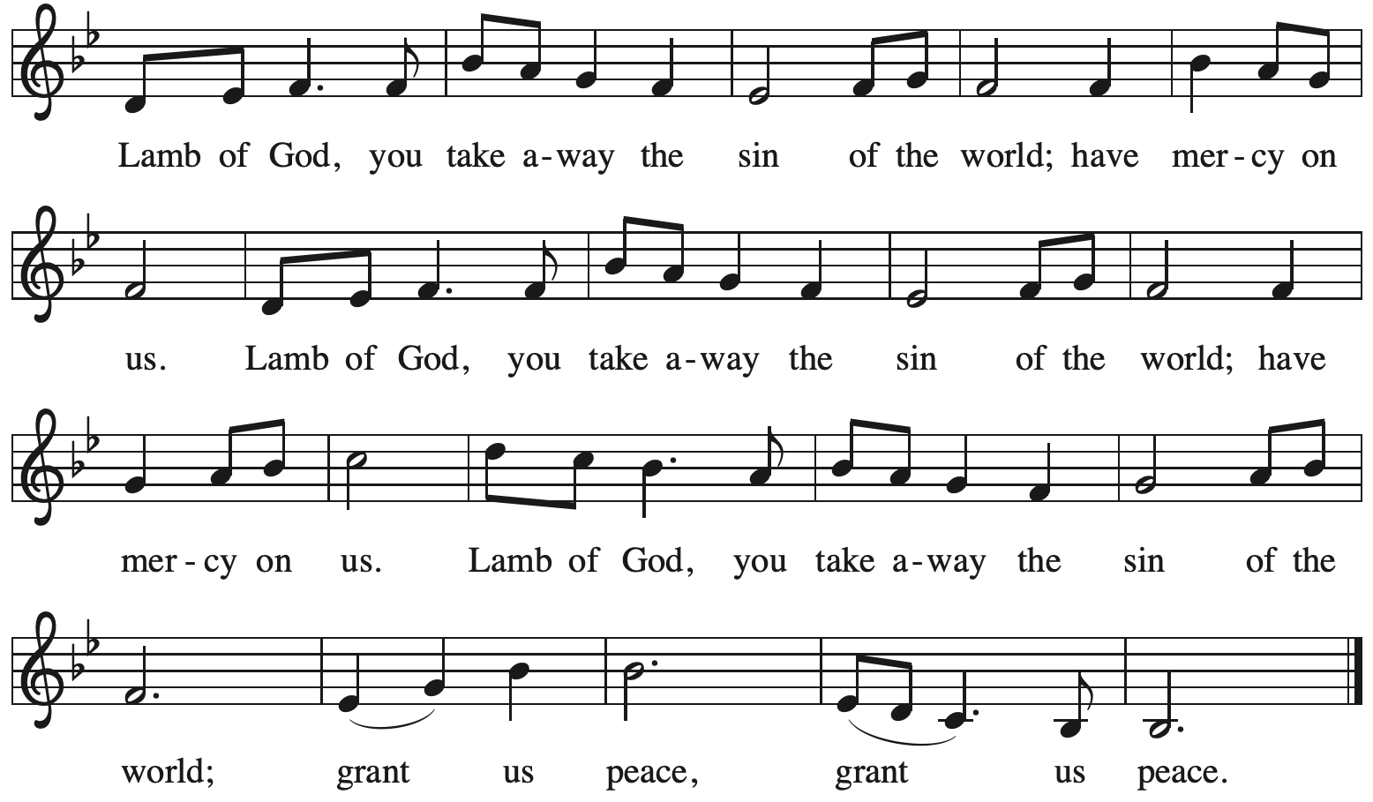

*Please be seated.*

**Holy Communion**

* *All who seek God and desire a deeper and stronger life in Christ are welcome to receive Holy Communion.*
* *Worshipers from the pulpit side will proceed forward first, followed by the center section, and then the lectern side.*
* *Please inform an usher if you would like the ministers to bring Communion to you.*
* *Holy Communion will be served with bread and wine/grape juice.*
* *The presiding minister will first distribute the bread (host) to each communicant. Please indicate if you require a gluten-free host.*
* *Once you have consumed the bread, please pick up an empty glass from the tray next to the presiding minister. The Communion Assistant will pour wine from the chalice or grape juice from the cruet into your glass.*
* *Please step to the side to consume the wine or grape juice.*
* *Feel free to kneel at the altar rail for prayer after receiving the sacrament.*
* *As you return to your pew, glasses may be returned to the empty trays on either side of the center section.*
* *A blessing will be provided for anyone who does not yet receive the sacrament.*
* *All are invited to join in singing the hymns during Holy Communion.*

**Hymns during Holy Communion**

**Christ Is the Life *ACS* 927**

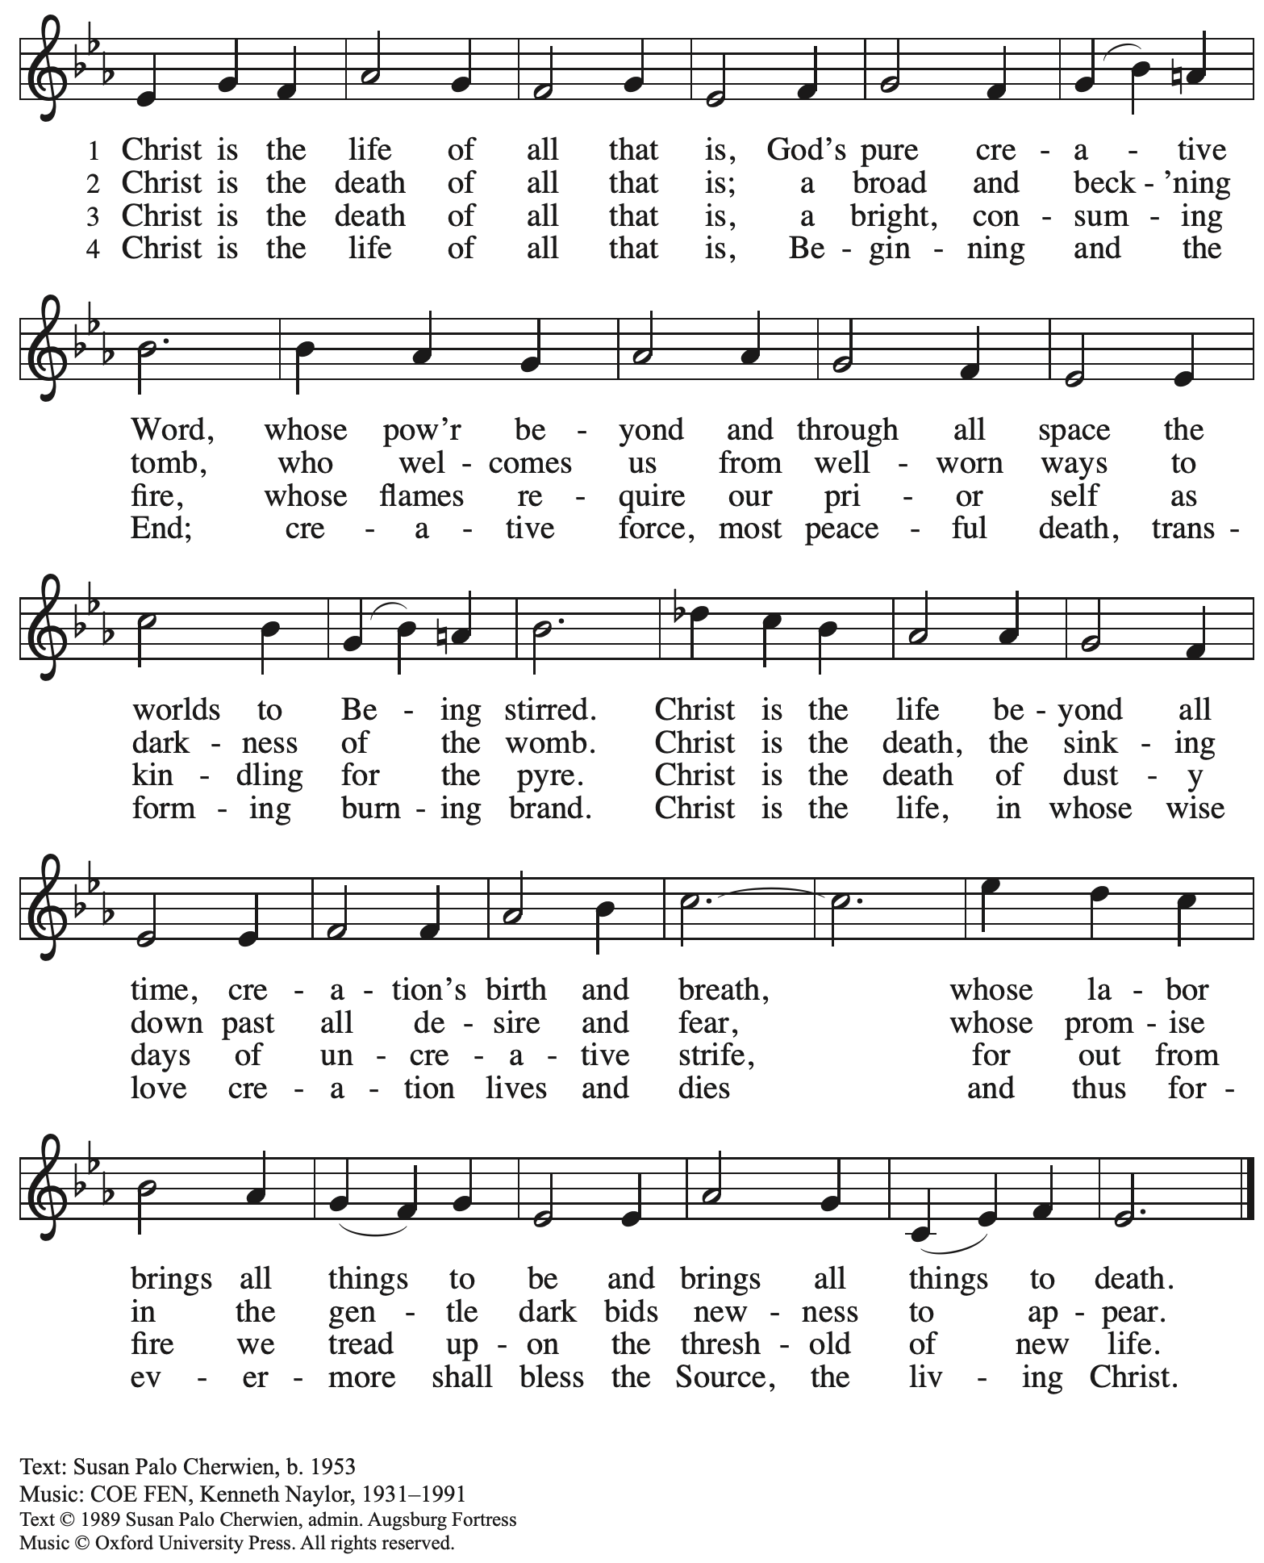

Reprinted with permission under OneLicense.net # A-722139.

**Hymns during Holy Communion**

**The Head That Once Was Crowned *ELW* 432**

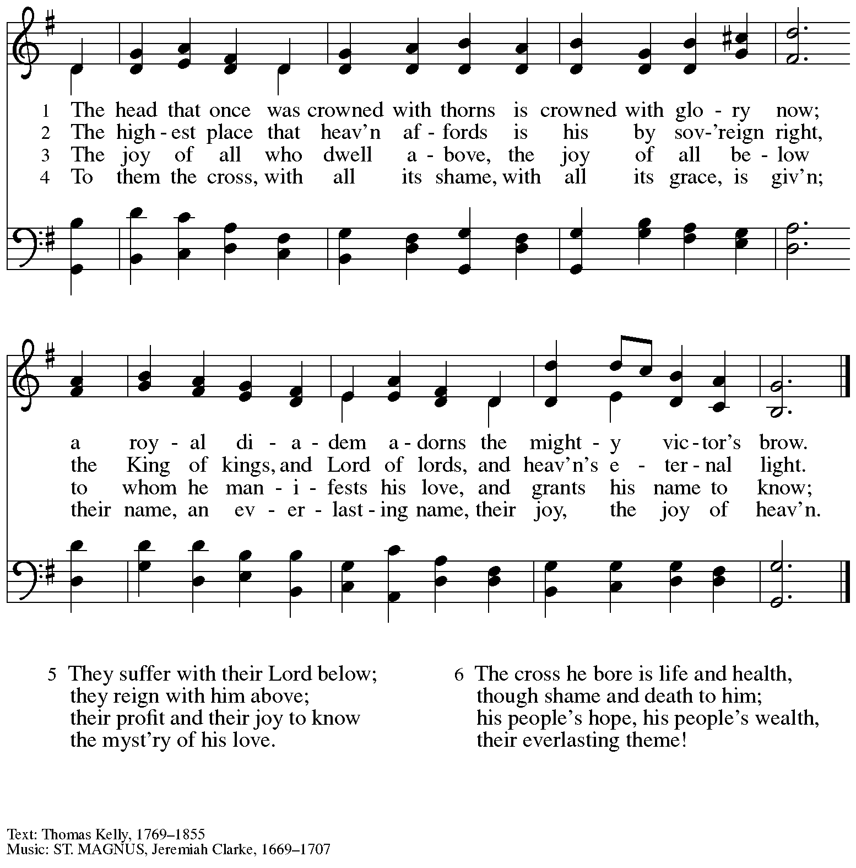

**Hymns during Holy Communion**

**Before You, Lord, We Bow *ELW* 893**

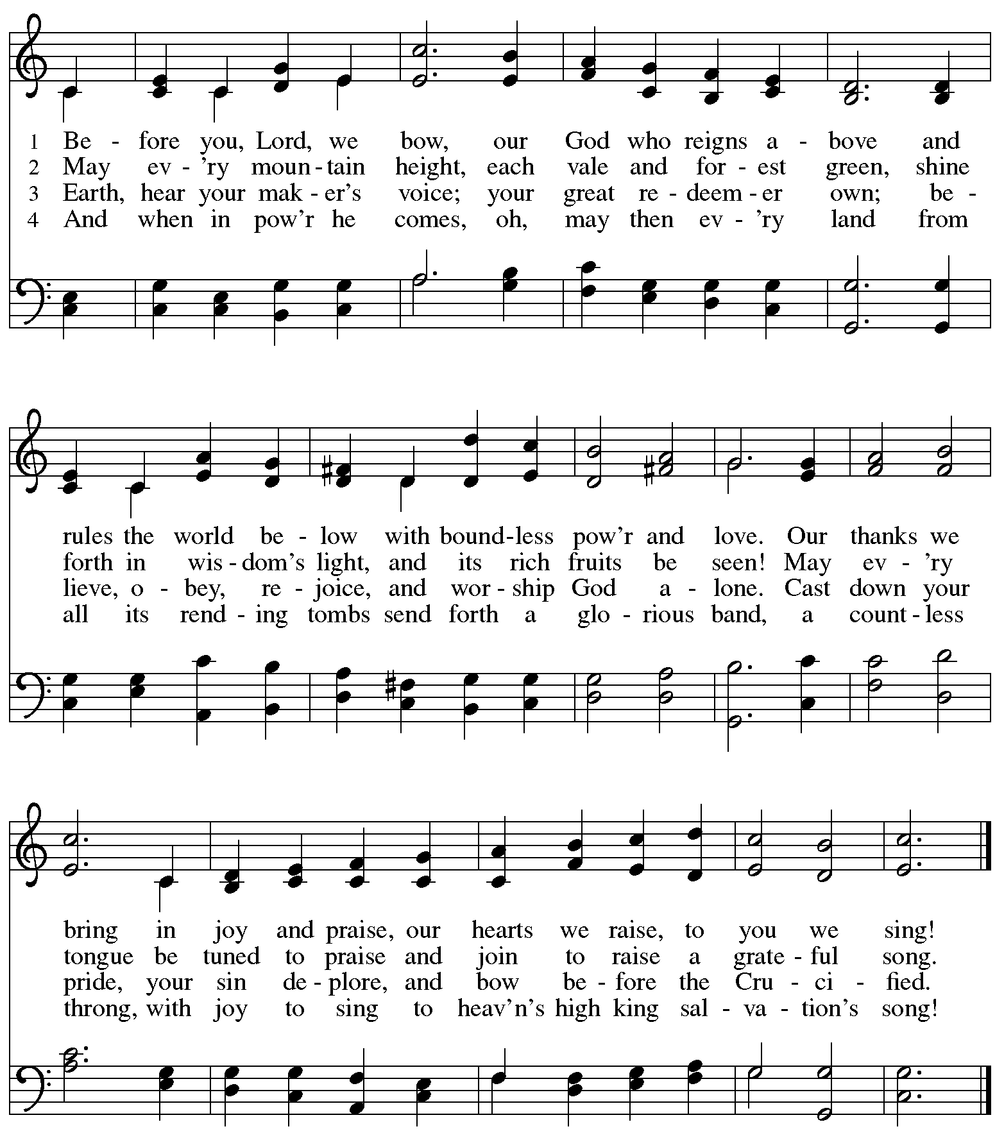

**Hymns during Holy Communion**

**Beautiful Savior *ELW* 838**

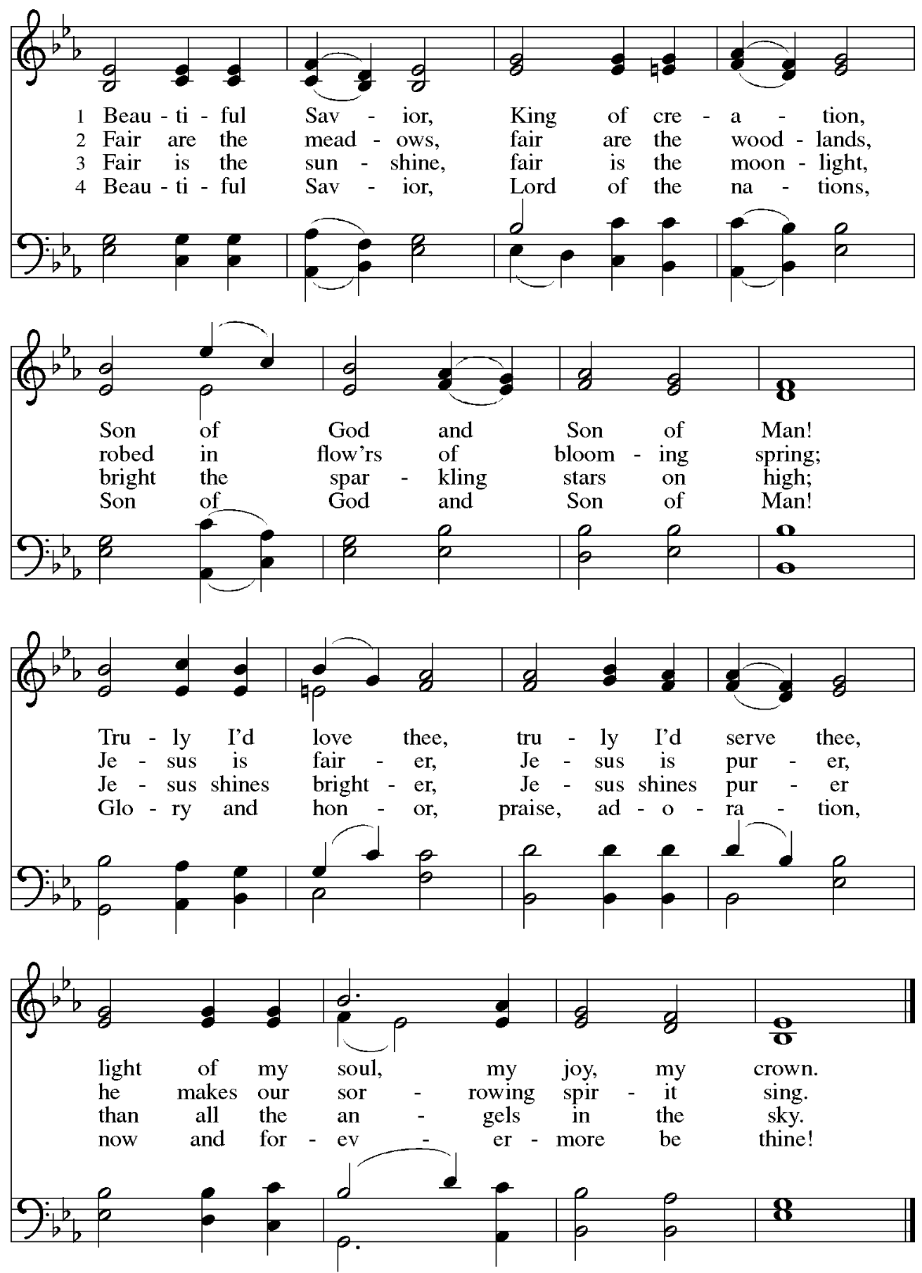

*When all have returned to their places, please rise as you are able.*

**Blessing**

P: The body and blood of our Lord Jesus Christ strengthen you and keep you in his grace.

**C: Amen.**

**Prayer**

A: Let us pray.

Blessed Jesus,

at this table, you have been for us both host and meal.

Now send us forth to extend our tables and share your gifts

until that day when all feast together at your heavenly banquet,

through Jesus Christ, our Savior and Lord.

**C: Amen.**

*Please be seated.*

**Sending**

*God blesses us and sends us in mission to the world*

**Announcements**

*Please rise as you are able.*

**Benediction**

P: God, the Alpha and the Omega, the beginning and the end,

who has written your name in the book of life,

☩ bless you and keep you in grace and peace,

from this time forth and forevermore.

**C: Amen.**

**Sending Hymn** *Following page*

**Dismissal**

L: Go in peace. Serve the Lord.

**C: Thanks be to God.**

**Postlude** *Jesus Shall Reign* arr. L. Shackley

**Sending Hymn Lift High the Cross *ELW* 660**

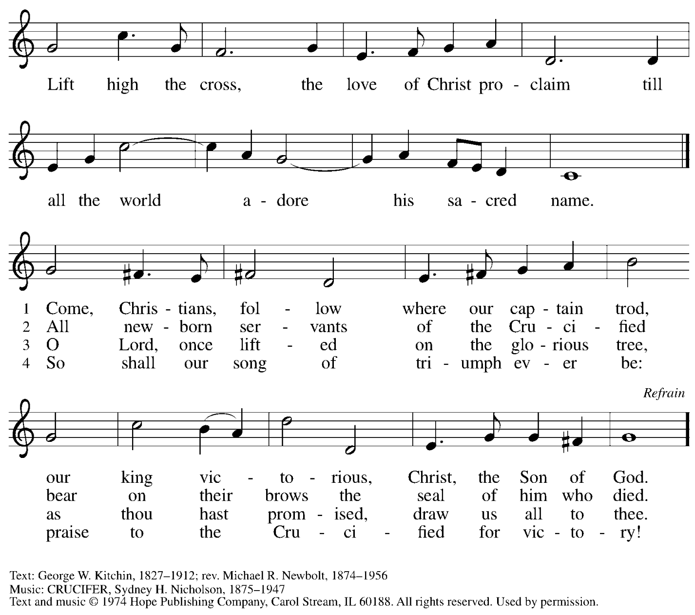

Reprinted under OneLicense.net # A-722139.

*Those serving in worship today*

Altar Care Jodie Minor

Assisting Minister Jeff Denlinger

Audio-Visual Ministers Kristen Asplin

Jared Stratton

Cantor Marit Bakken

Lector Alda Maria Gonzaga

Little Church – Big Faith Teacher Emily Duque

Organ Jimmi Kocher-Hillmer

Minister of Music Laura Reynolds

Preaching and Presiding Minister Pastor Ross Carmichael

*Liturgy and Hymnody Acknowledgements*

From SundaysandSeasons.com. Copyright © 2024 Augsburg Fortress. All rights reserved. Reprinted under OneLicense.net # A-722139.

Used by permission of Augsburg Fortress.

The Scripture readings contained herein are from *New Revised Standard Version* of the Bible © 1989, Division of Christian Education of the National Council of Churches of Christ in the USA. Used by permission. All rights reserved.

Eucharistic Prayer adapted from: *For the Reign of Christ the King* – Ramshaw, Gail. *Pray, Praise, and Give Thanks: A Collection of Litanies, Laments, and Thanksgivings at Font and Table.* Minneapolis: Augsburg Fortress, 2017. p.. 60-61.

**Beautiful Savior** – Text: *Gesangbuch*, Münster, 1677; tr. Joseph A. Seiss, 1823-1904. Music: SCHÖNSTER HERR, JESU, Silesian folk tune, 19th cent.

*Please use the QR code below to link to St. Andrew’s announcements online!*



**St. Andrew Lutheran Church Announcements**

**November 24th, 2024**

* **Welcome to Worship at St. Andrew on Reign of Christ Sunday, November 24th, 2024** –We are so glad you are here, and we offer a special welcome to all visitors and guests who are here for the first time! Worship attendees are invited to make a name tag at the back of the worship space. Little Church – Big Faith, a Bible lesson and activity for children, will take place after the prayer of the day. There are also worship “toolkits” to help children engage with worship and “busy bags” for younger children available in the bookcase at the back of the sanctuary. Please feel free to take one to use with/for your children. All are invited to gather for coffee other drinks and food, and conversation in the social hall after worship.
* **Interfaith Thanksgiving Service – Tuesday, November 26th at 7:00 p.m. at Nearby First Unitarian Church – Join members of Pittsburgh’s various faith communities in a gathering to reconnect us with each other! Light refreshments will be served. First Unitarian is located at 605 Morewood Avenue – please feel free to park at St. Andrew!**
* **Holiday Gift-Giving Opportunities through Bethesda Lutheran Services and JFCS –**

**Each year, St. Andrew chooses an organization to partner with to provide holiday gifts for children in need. This year the congregation will work with Bethesda Lutheran Services and JFCS.**

* **JFCS has set up a gift registry with** Learning Express in Wexford (buying

as locally as possible). This is the link to the registry: <https://learningexpress.com/wexford/giftr/registry/view/uid/FF5129350614/>. Gifts can be ordered directly on the LE website, and Joy Givens will pick everything up from the store, so anyone who orders can mark "pick up" from Wexford at checkout and will not have to worry about going to get items themselves.

* JFCS – St. Andrew will also collect new winter hats, mittens/gloves,

and packages of socks and underwear of all sizes in the social hall until Sunday, December 15th. JFCS has 160 kids on their list, 114 of whom are age 5 or older, so the need is great!

* **JFCS –** The JFCS Bridge Builders gift distribution event will take place on

Monday, December 16th, hopefully at the Carnegie Library's downtown

branch on Smithfield Street. We will invite parents to come and "shop" for

their children. We hope to offer one toy and hat/gloves set per child, new

packages of socks and underwear, and used books (which are already

being supplied). We will also assemble gift bags for families that are not able to get downtown and deliver them during that week. Anyone who wants to volunteer to staff our free store and/or deliver gifts should email Joy Givens at [jgivens@jfcspgh.org](mailto:jgivens@jfcspgh.org). Bridge Builders is a mentoring and enrichment program for locally resettled refugee and immigrant children, and Joy is happy to talk with anyone about what they do and who we serve!

* **Bethesda – Please see the full Bethesda Residential Wish List page printed**

**at the back of the bulletin. Donations will be accepted through Sunday,**

**December 15th.**

* **Holiday Card Get-Together and Recipe Swap – Sunday, December 1st, after Coffee Hour until 2:30 p.m. – Bring your holiday cards or small crafts and gather to hang out, chat, and work on cards or crafts. Holiday playlists and snacks are also welcome. Feel free to get lunch and join the group afterwards. Bring copies of a favorite recipe or two to share as well!**
* **December Produce Distribution – First Tuesday of the Month, December 3th, 2024, from 5:30-7:00 p.m. – St. Andrew partners with Greater Pittsburgh Community Food Bank to serve as a distribution site for fresh produce on the first Tuesday of every month. The next distribution will be on Tuesday, December 3rd. We invite people of the congregation to help with the distribution from 5:30-7:00 p.m., help with unloading and setup during the day between 10:00 a.m. and 1:00 p.m.**
* **Renaissance City Choir Concert – Saturday, December 7th, 7:00 p.m. – Renaissance City Choir, a local LGBTQIA+ choir, will perform their holiday concert, “A Very Ruby Holiday,” on Saturday, December 7th at 7:00 p.m. at East Liberty Presbyterian Church, 116 S. Highland Ave., 15206. All are invited to stay for a cookie social after the concert.** Accessibility questions may be directed to: [accessibility@rccpittsburgh.com](mailto:accessibility@rccpittsburgh.com).

Ticketing questions to: [marketing@rccpittsburgh.com](mailto:marketing@rccpittsburgh.com).

Tickets at: <https://www.ticketleap.events/tickets/rccpittsburgh/a-very-ruby-holiday>.

* **Annual Meeting of the Congregation – Sunday, December 8th, after Worship –** Each year, St. Andrew holds an annual meeting of the congregation to discuss and approve a budget for mission and ministry in the upcoming year and to elect leaders to serve on the congregation council. This year's meeting will be held on Sunday, December 8th, after worship. Zoom access will be via the regular worship link. According to the constitution, no proxy or absentee votes can be accepted, so please plan to be here for the meeting! Look for additional information for the meeting, including the proposed budget, soon.
* **Shelter Dinner for Guests of East End Cooperative Ministry – Thursday, December 19th, 6:30 p.m. –** Each month, on the third Thursday, people of St. Andrew provide dinner for guests of East End Cooperative Ministry, 6140 Station St. (East Liberty), 15206. We invite you to prepare or purchase one menu item and bring it to the shelter by 6:00 p.m., or just come to help serve at 6:30 p.m.
* **Coffee Hour Signups Available** – We invite people of the congregation to sign up to coordinate coffee hour each week, which includes brewing the coffee; setting out cups, napkins, food items, and cold drinks; and cleaning up afterward. Everything needed is at St. Andrew and instructions are available. Please sign up to host coffee hour here: <https://www.signupgenius.com/go/5080B4AAFAF2CABF85-47069030-coffee>.
* ***Christ in Our Home* Devotional Booklets (October – December) Available at Church Entrances – *Christ in Our Home* is a booklet of devotions that includes Scripture, a brief reflection, and prayer for each day. The October – December edition is available at the various church entrances. Please feel free to take one for yourself or others!**
* **Compline Prayer Service with the Pittsburgh Compline Choir – Sundays at 8:00 p.m. at Heinz Chapel –** Compline was traditionally a monastic prayer service, and the Pittsburgh Compline Choir, a ministry of Lutheran Campus Ministry in Greater Pittsburgh, sings a choral version of compline rooted in this thousand-year-old tradition of scripture, song, and silence each Sunday at Heinz Chapel at 8:00 p.m. This service also streams on Facebook (Pittsburgh Compline Choir) and YouTube (The Pittsburgh Compline Choir). Heinz Chapel is located off of S. Bellefield Ave. in Oakland. For more information, please visit: [Pittsburgh Compline Choir](http://pittsburghcomplinechoir.org/).