

**+ Twenty-Sixth Sunday after Pentecost**

**November 17, 2024**



**St. Andrew Lutheran Church**

**304 Morewood Ave.**

**Pittsburgh, PA 15213**

[**St_andrewELCA@verizon.net**](mailto:St_andrewELCA@verizon.net)

[**www.standrewpittsburgh.org**](http://www.standrewpittsburgh.org)

**+ Twenty-Sixth Sunday after Pentecost**

**Order for Worship**

*November begins with All Saints Day and ends in or near Advent, when we anticipate Christ’s coming again. It is fitting, then, that the readings today tell of the final resurrection and the end time. In the turmoil of hope, fear, and disbelief that these predictions provoke in us, Hebrews sounds a note of confident trust. Christ makes a way for us where there is no way, and we walk it confidently, our hearts and bodies washed in baptismal water, trusting the one who has promised forgiveness. The more we see the last day approaching, the more important it is to meet together to provoke one another to love.*

**Welcome to St. Andrew!**

* St. Andrew Lutheran congregation welcomes all who are seeking a place of healing and wholeness – a nurturing, faith-forming spiritual home. Our community embraces people of all ages, ethnicities, cultures, abilities, sexual orientations, gender identities and expressions, and family constellations. Come and See!
* Worship Services are live-streamed to multiple online platforms. By attending worship, you agree that your image and voice may be broadcast.
* Everyone is invited to make a name tag at the black bookcase in the back of the worship space if they would like. There are stickers indicating pronouns on the bookcase if you would like to include them on your name tag.
* Children are invited to attend Little Church – Big Faith, a Bible lesson and activity, during worship (after the Prayer of the Day). The group returns to the worship space for the liturgy of Holy Communion.
* A nursery is available through the doors at the left side of the sanctuary and across from the doorway to the Social Hall. Look for a purple-colored room.
* Worship “toolkits” to help children engage with the service, along with “busy bags” for younger children, are available in the bookcase at the back of the sanctuary. Please feel free to take one to use with/for your children.
* Holy Communion is served with bread (gluten-free available) and wine or grape juice. The presiding minister will distribute the bread (host). Please consume this and then pick up an empty glass from the tray. The Communion Assistant will pour wine or grape juice into your glass. Please step to the side to consume the wine or grape juice. Feel free to kneel at the altar for prayer and reflection. As you return to your pew, glasses may be returned to the empty trays on either side of the center section.
* A restroom is available on the main level of the church, through the doors to the Social Hall and to the right in the main office.

*Abbreviations*

P: Pastor/Presiding Minister ***ELW*: *Evangelical Lutheran Worship* hymnal**

A: Assisting Minister ***ACS*: *All Creation Sings* hymnal**

L: Lector

**C: Congregation**

**Pre-Service Music**

**Welcome**

**Prelude** *Jesus Loves Me* A. Warner

*Played on piano by Elyse*

**Gathering**

*The Holy Spirit calls us together as the people of God*

**Confession and Forgiveness**

*Please rise as you are able. All may make the sign of the cross,*

*the sign that is marked at Baptism, as the presiding minister begins.*

P: Blessed be the holy Trinity, ☩ one God,

our refuge, our rock, our beginning and our end.

**C: Amen.**

P: Let us bring our confession before the one who loves us and has freed us from our sin.

*Silence is kept for reflection*

P: Eternal One, robed in majesty and mercy,

**C: we confess that sin has taken hold of us**

**and we have given in to its power.**

**We are disturbed in spirit and our hearts cannot rest.**

**Unbind us and set us free.**

**Lead us again to the waters of rebirth,**

**that we may live just and generous lives,**

**for the good of your world**

**and the care of our neighbors,**

**following in the servant way of Jesus Christ, our Savior.**

**Amen.**

**P:** These words are trustworthy and true:

Jesus bore our sin once, for all, on the cross,

swallowing up death forever.

For his sake, you are ☩ forgiven,

and God remembers your sin no more.

Let your heart be glad again

and rejoice in your salvation.

**C: Amen.**

**Gathering Hymn God of Grace and God of Glory *ELW* 705**

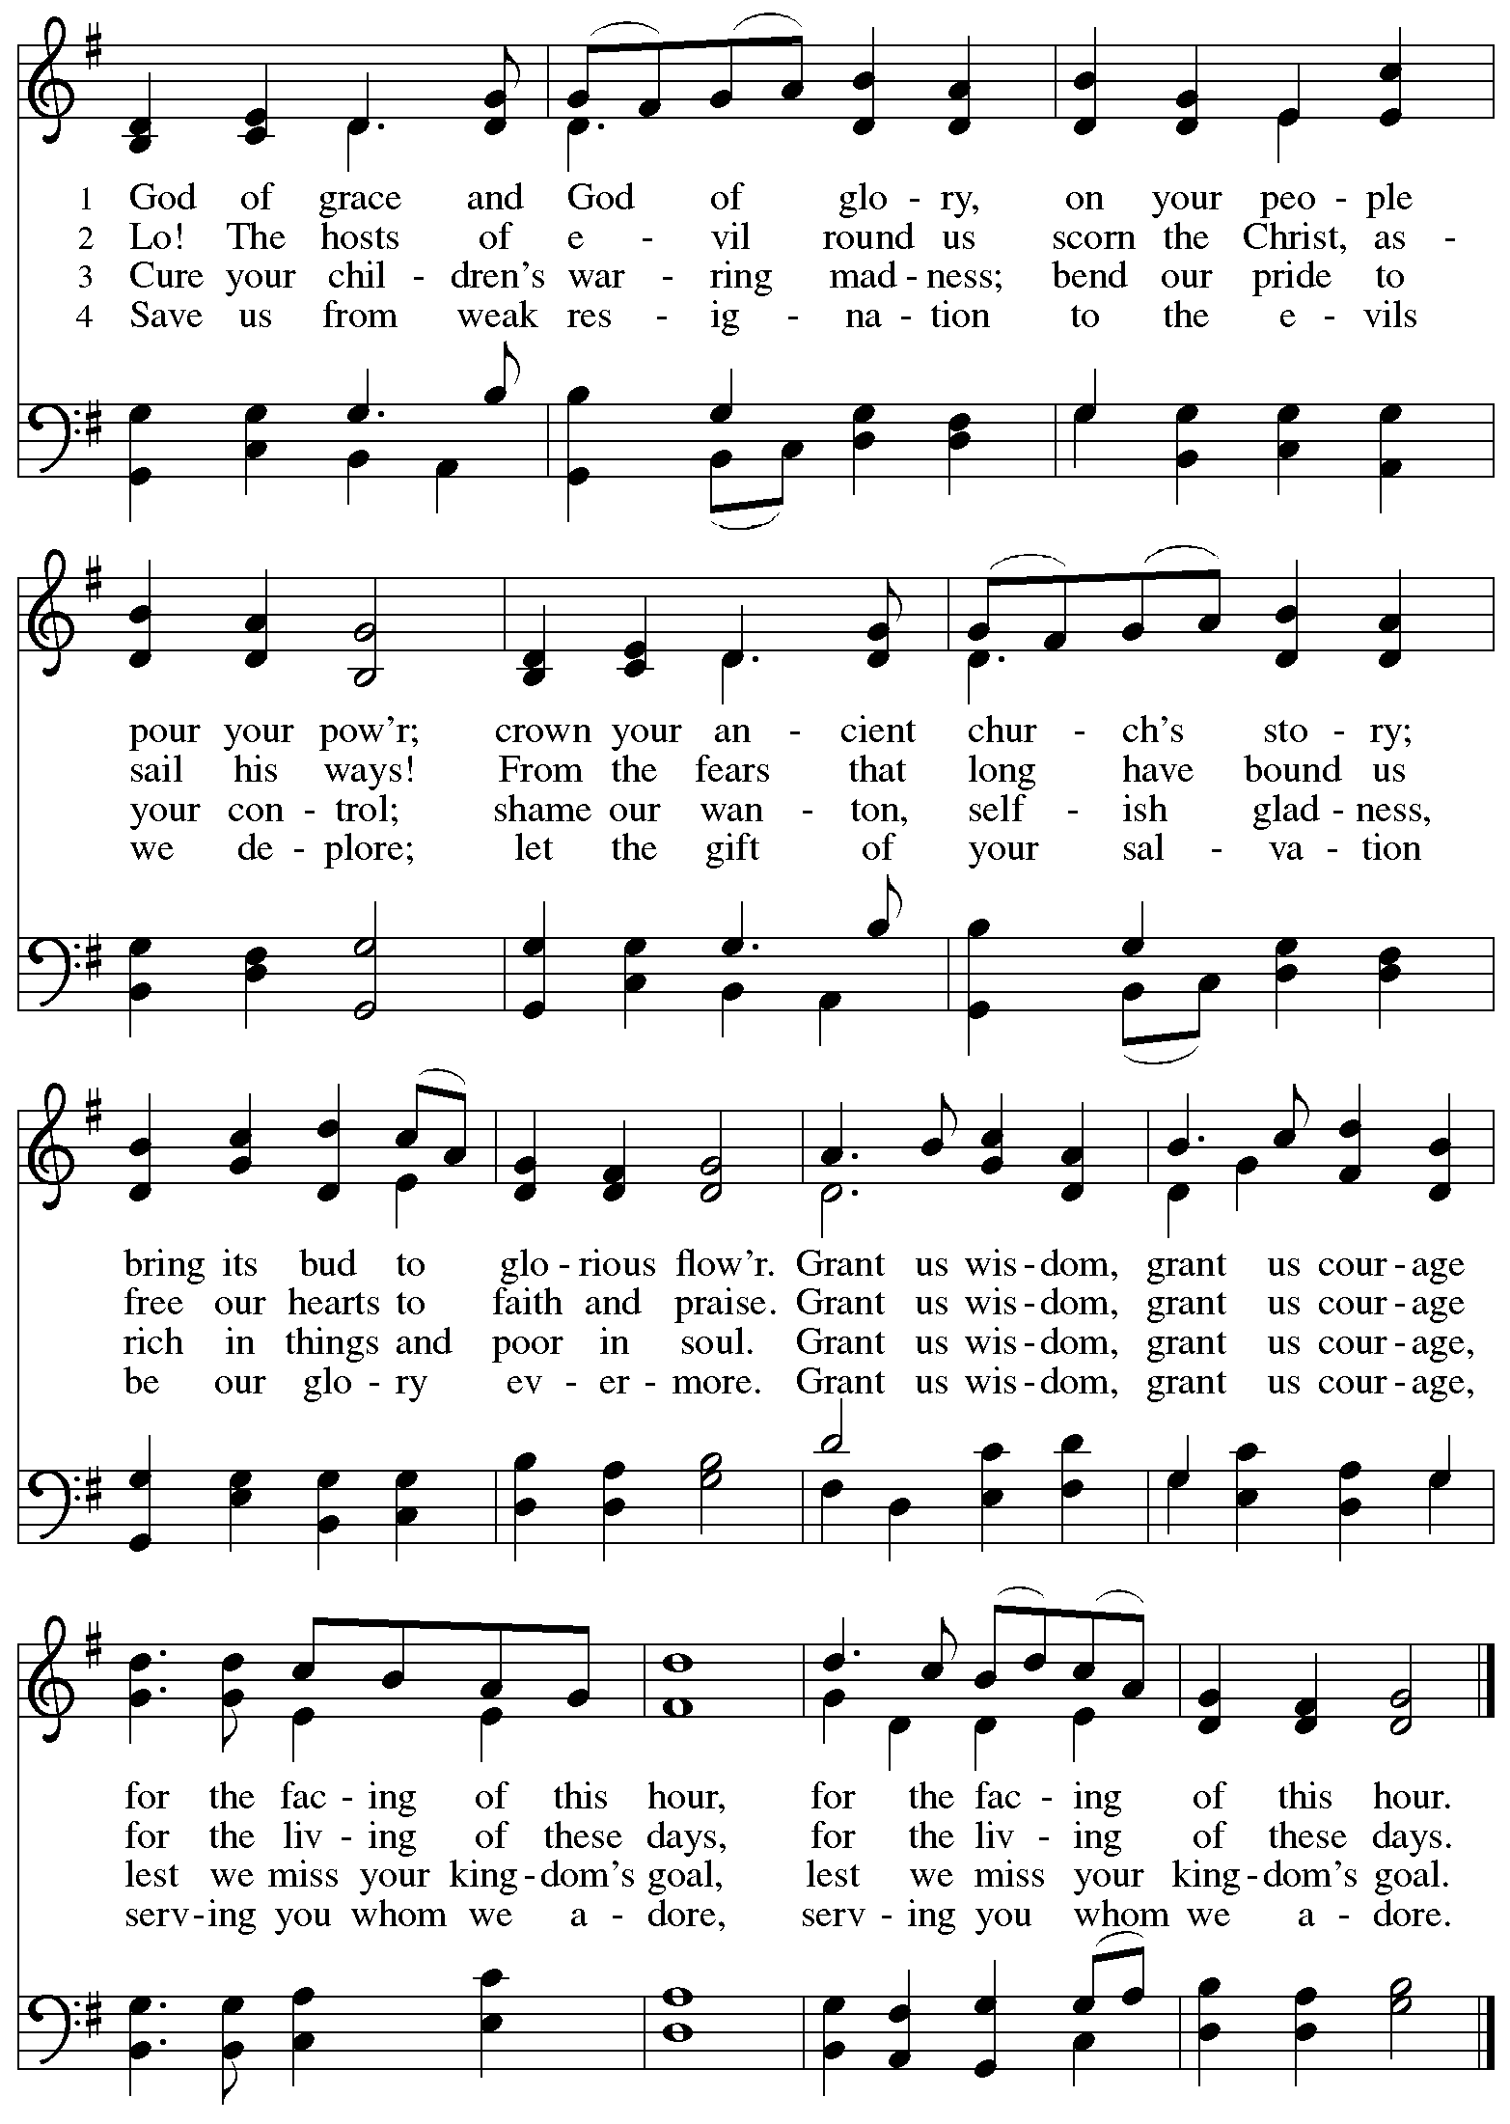

**Greeting**

P: The grace of our Lord Jesus Christ, the love of God,

and the communion of the Holy Spirit be with you all.

**C: And also with you.**

**Hymn of Praise** *ACS* p. 31

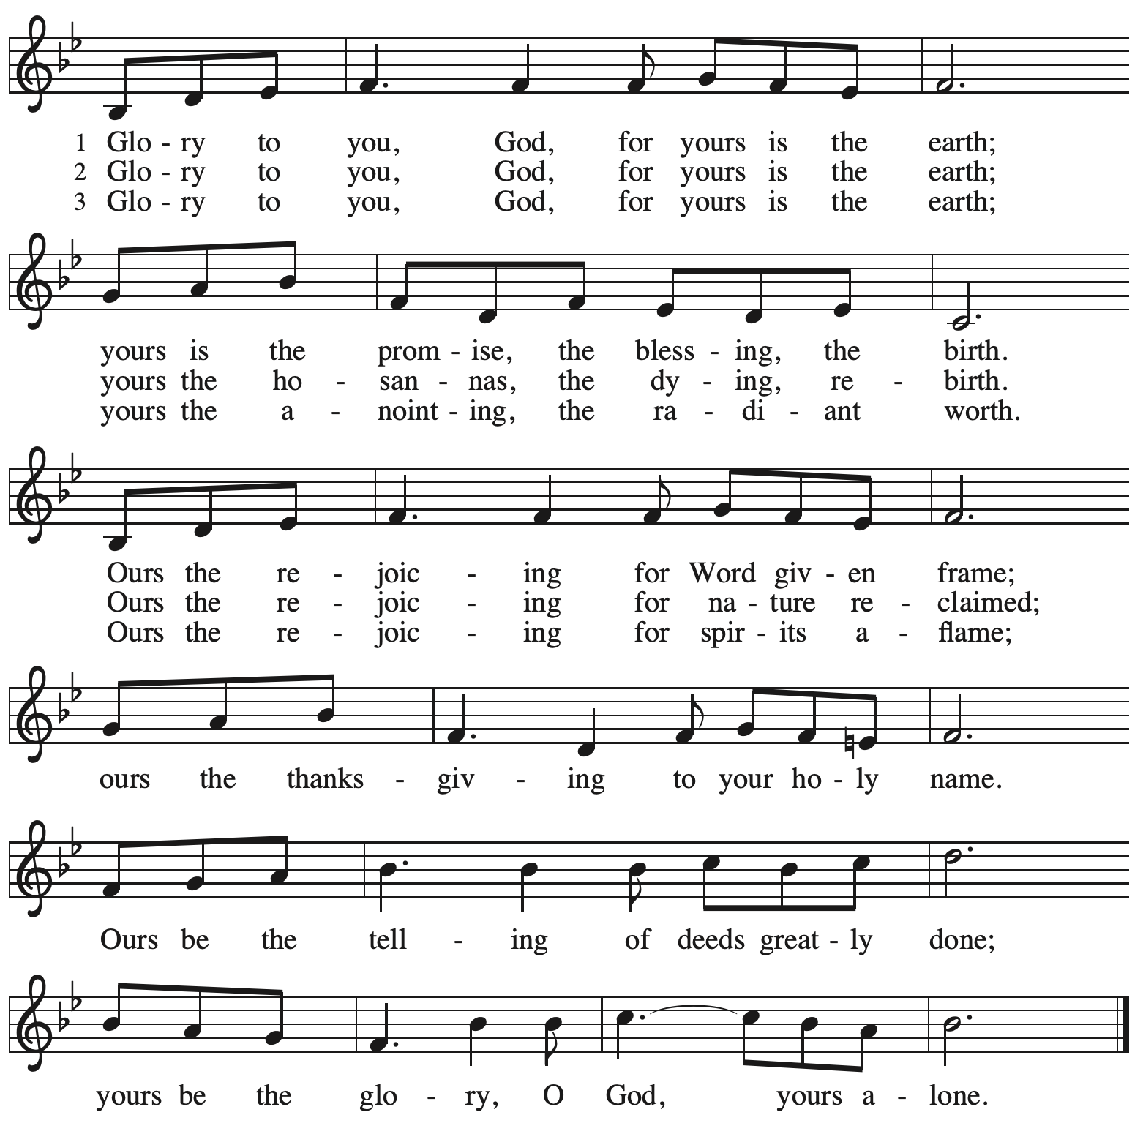

**Prayer of the Day**

P: The Lord be with you.

**C: And also with you.**

P: Almighty God, your sovereign purpose brings salvation to birth.

Give us faith to be steadfast amid the tumults of this world,

trusting that your kingdom comes and your will is done

through your Son, Jesus Christ, our Savior and Lord.

**C: Amen.**

*Please be seated.*

*Children are invited to join the adult leaders at the door and for Little Church – Big Faith.*

*We ask that one additional adult from the congregation attend with the children.*

**Word**

*God speaks to us in Scripture reading, preaching, and song*

**First Reading** **–** **Daniel 12: 1-3**

1 “At that time Michael, the great prince, the protector of your people, shall arise. There shall be a time of anguish, such as has never occurred since nations first came into existence. But at that time your people shall be delivered, everyone who is found written in the book. 2 Many of those who sleep in the dust of the earth shall awake, some to everlasting life, and some to shame and everlasting contempt. 3 Those who are wise shall shine like the brightness of the sky, and those who lead many to righteousness, like the stars forever and ever.”

L: Word of God, word of life.

**C: Thanks be to God.**

**Psalm 16**

*The cantor will lead the singing of the psalm.*

*The congregation is invited to respond with the alternate verses in bold print,*

*and to join in singing the refrain.*

*Psalm tone*

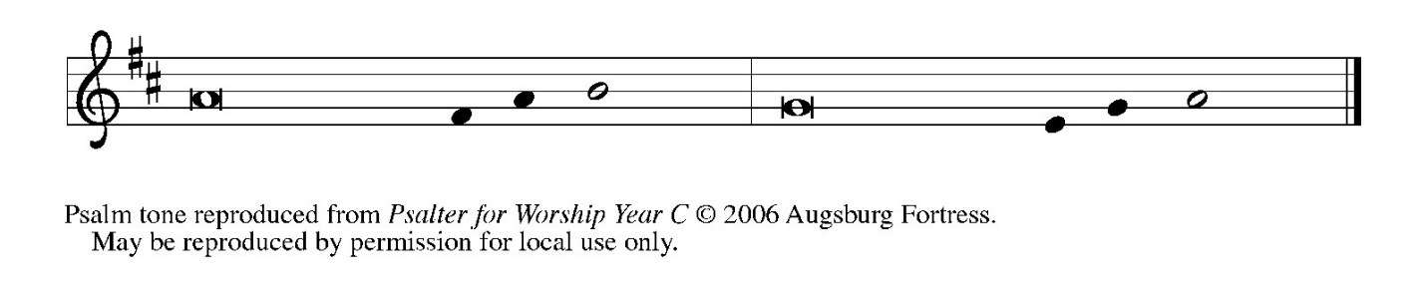

*Psalm refrain*

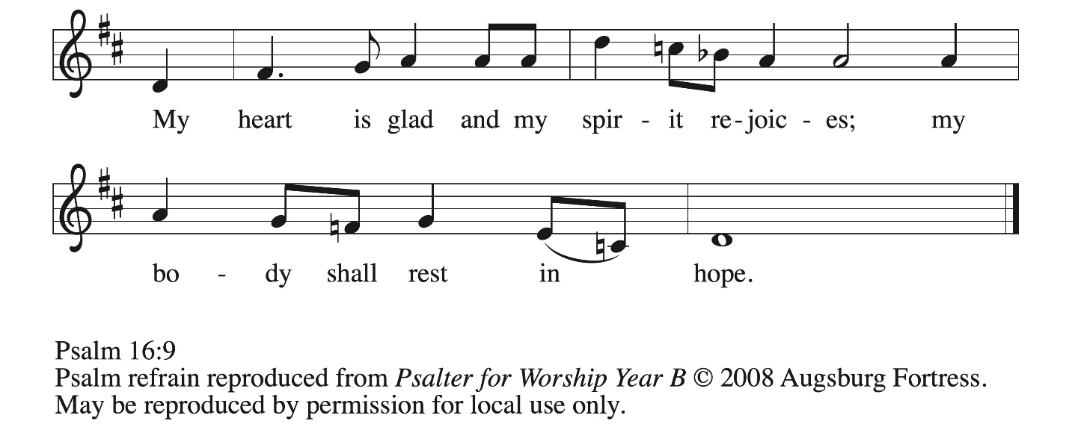

1 Protect me, O God, for I take ref- **|** uge in you;  
  I have said to the Lord, “You are my Lord, my good a- **|** bove all other.”  
 2 **All my delight is in the godly that are | in the land,**  
  **upon those who are noble a- | mong the people.**  
 3 But those who run after **|** other gods  
  shall have their troubles **|** multiplied.  
 4 **I will not pour out drink offerings | to such gods,**  
  **never take their names up- | on my lips. R**  
 5 O Lord, you are my portion **|** and my cup;  
  it is you who up- **|** hold my lot.  
 6 **My boundaries enclose a | pleasant land;**  
  **indeed, I have a | rich inheritance.**  
 7 I will bless the Lord who **|** gives me counsel;  
  my heart teaches me night **|** after night.  
 8 **I have set the Lord al- | ways before me;**  
  **because God is at my right hand, I shall | not be shaken. R**  
 9 My heart, therefore, is glad, and my spir- **|** it rejoices;  
  my body also shall **|** rest in hope.  
 10 **For you will not abandon me | to the grave,**  
  **nor let your holy one | see the pit.**  
 11 You will show me the **|** path of life;  
  in your presence there is fullness of joy, and in your right hand are pleasures for- **|** evermore.**R**

**Second Reading – Hebrews 10: 11-25**

11 Every priest stands day after day at his service, offering again and again the same sacrifices that can never take away sins.

12 But when Christ had offered for all time a single sacrifice for sins, “he sat down at the right hand of God,” 13 and since then has been waiting “until his enemies would be made a footstool for his feet.” 14 For by a single offering he has perfected for all time those who are sanctified. 15 And the Holy Spirit also testifies to us, for after saying,  
 16 “This is the covenant that I will make with them  
  after those days, says the Lord:  
 I will put my laws in their hearts,  
  and I will write them on their minds,”  
17 he also adds,  
 “I will remember their sins and their lawless deeds no more.”  
18 Where there is forgiveness of these, there is no longer any offering for sin.  
  
  19 Therefore, my friends, since we have confidence to enter the sanctuary by the blood of Jesus, 20 by the new and living way that he opened for us through the curtain (that is, through his flesh), 21 and since we have a great priest over the house of God, 22 let us approach with a true heart in full assurance of faith, with our hearts sprinkled clean from an evil conscience and our bodies washed with pure water. 23 Let us hold fast to the confession of our hope without wavering, for the one who has promised is faithful. 24 And let us consider how to provoke one another to love and good deeds, 25 not neglecting to meet together, as is the habit of some, but encouraging one another, and all the more as you see the Day approaching.

L: Word of God, word of life.

**C: Thanks be to God.**

*Please rise as you are able and join in speaking the Gospel Acclamation.*

**Gospel Acclamation** *ACS* p. 33

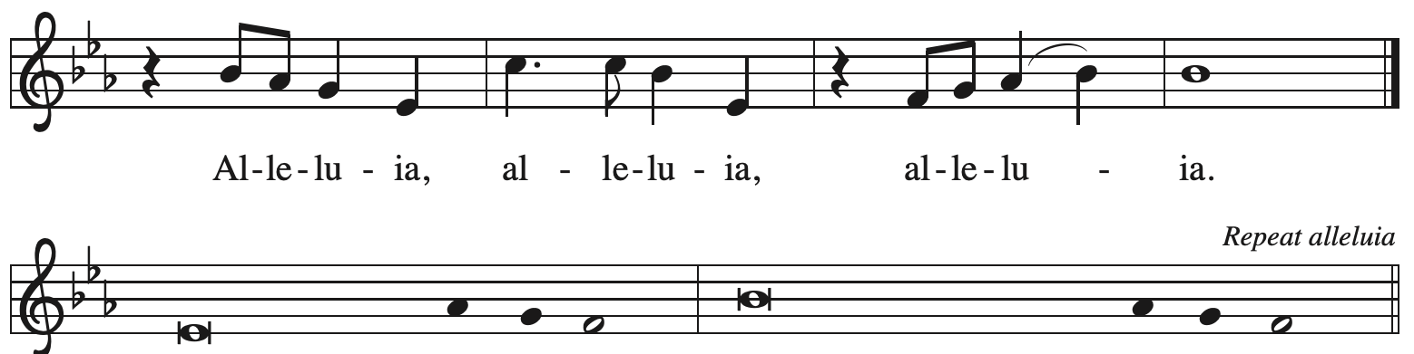

Be alert | at all times, praying you may have the strength to come before the | Son of Humanity.

**Gospel – Mark 13: 1-8**

P: The holy Gospel according to St. Mark.

**C: Glory to you, O Lord.**

1 As [Jesus] came out of the temple, one of his disciples said to him, “Look, Teacher, what large stones and what large buildings!” 2 Then Jesus asked him, “Do you see these great buildings? Not one stone will be left here upon another; all will be thrown down.”  
  3 When he was sitting on the Mount of Olives opposite the temple, Peter, James, John, and Andrew asked him privately, 4 “Tell us, when will this be, and what will be the sign that all these things are about to be accomplished?” 5 Then Jesus began to say to them, “Beware that no one leads you astray. 6 Many will come in my name and say, ‘I am he!’ and they will lead many astray. 7 When you hear of wars and rumors of wars, do not be alarmed; this must take place, but the end is still to come. 8 For nation will rise against nation, and kingdom against kingdom; there will be earthquakes in various places; there will be famines. This is but the beginning of the birth pangs.”

P: The Gospel of the Lord.

**C: Praise to you, O Christ.**

*Please be seated.*

**Sermon**

*A time of silence for prayer and reflection follows the sermon.*

*When the Hymn of the Day begins, please rise as you are able.*



**Hymn of the Day God Alone Be Praised *ACS* 1023**

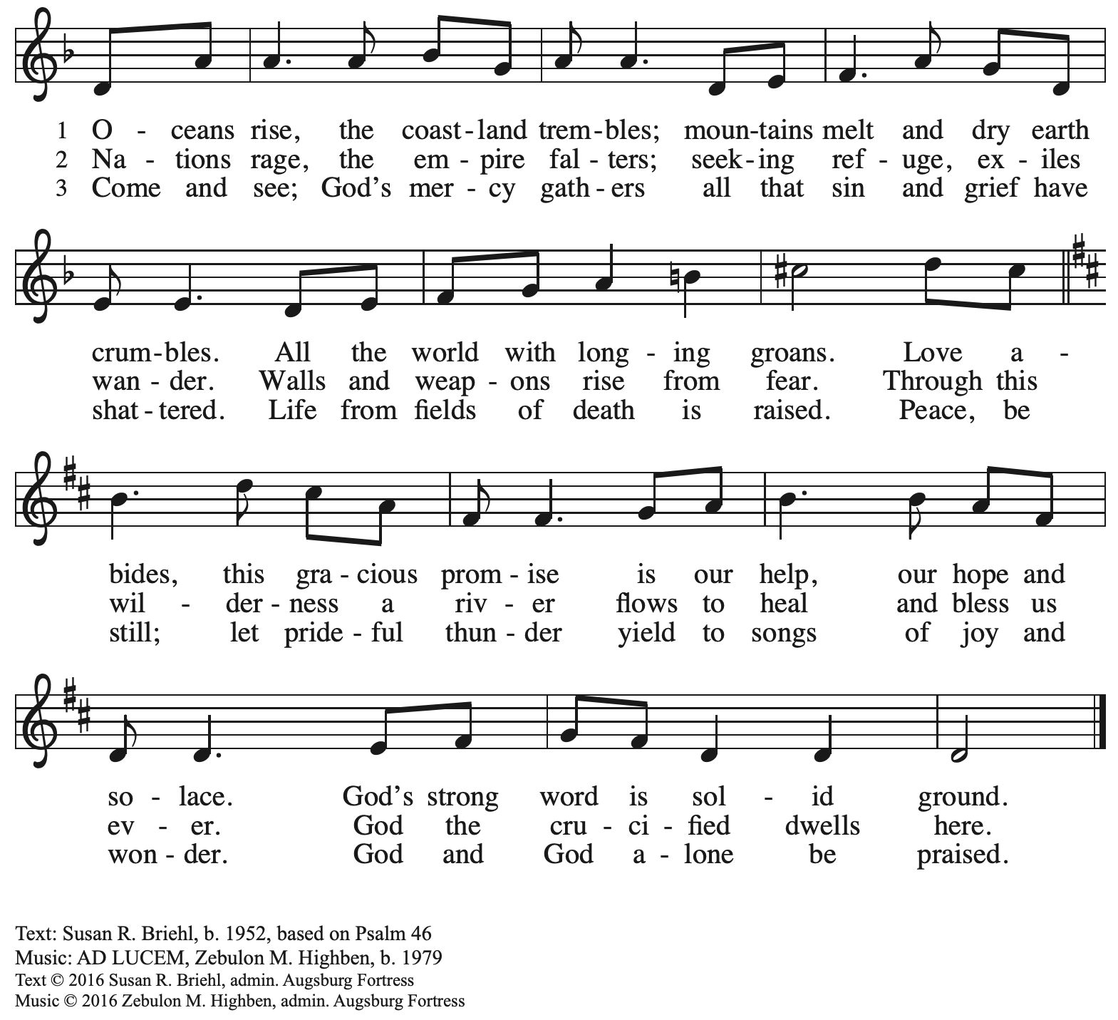

All rights reserved. Reprinted with permission under OneLicense.net # A-722139.

**Apostles’ Creed**

*Profession of our faith using the Apostles’ Creed, one of the Christian Church’s three*

*ecumenical creeds, unites us with siblings in Christ around the world.*

**C: I believe in God, the Father almighty,**

**creator of heaven and earth.**

**C: I believe in Jesus Christ, God’s only Son, our Lord,**

**who was conceived by the Holy Spirit,**

**born of the virgin Mary,**

**suffered under Pontius Pilate,**

**was crucified, died, and was buried;**

**he descended to the dead.\***

**On the third day he rose again;**

**he ascended into heaven,**

**he is seated at the right hand of the Father,**

**and he will come to judge the living and the dead.**

**I believe in the Holy Spirit,**

**the holy catholic church,**

**the communion of saints,**

**the forgiveness of sins,**

**the resurrection of the body,**

**and the life everlasting. Amen.**

*Or, “he descended into hell,” another translation of this text in widespread use.

**Prayers of the People**

A: Trusting in God’s abundant love for all the world,

let us pray for our neighbors, the church, and all creation.

*After each petition*

A: God of mercy,

**C: receive our prayer.**

*The presiding minister concludes the prayers*

P: We offer our prayers to you, gracious God,

trusting in your boundless love for all you have made,

through Jesus Christ, our Savior.

**C: Amen.**

**Peace**

*The presiding minister and the assembly greet one another in the peace of the risen Christ.*

P: The peace of Christ be with you always.

**C: And also with you.**

*The people may greet those around them with a sign of Christ’s peace and may say*

Peace be with you *or similar words. Please be mindful that not everyone will be comfortable with sharing the peace, so please seek consent before shaking hands or hugging. Other possible ways to share the peace include a simple bow with the verbal greeting of peace, or simply a verbal expression of peace.*

*When the greetings of peace have concluded, please be seated.*

**Meal**

*God feeds us with the presence of Jesus Christ*



**Offering**

*We offer ourselves, our gifts and our faithful service to God.*

*As the offering is gathered for the mission of the church, including the care of those in need,*

*the table is set for Holy Communion.*

*There are laminated giving cards in the pew racks that feature a QR code for anyone who would like to give online. Those who give using the QR code, as well as those who give regularly online or through their bank are encouraged to place the laminated card in the plate as an expression of your offering.*

**Noisy Offering**

*As children of the congregation carry buckets around the sanctuary, people of the congregation are invited to throw in their change as an offering. This month’s Noisy Offering will benefit Bethesda Lutheran Services, a church-affiliated service ministry organization that serves children, youth, and families with mental and behavioral health services.*

**Music during the Offering**

*Just a Closer Walk with Thee* J. Edstrom

*As the gifts are brought forward for presentation, please rise as you are able.*

**Offertory Song We Are an Offering *ELW* 692**

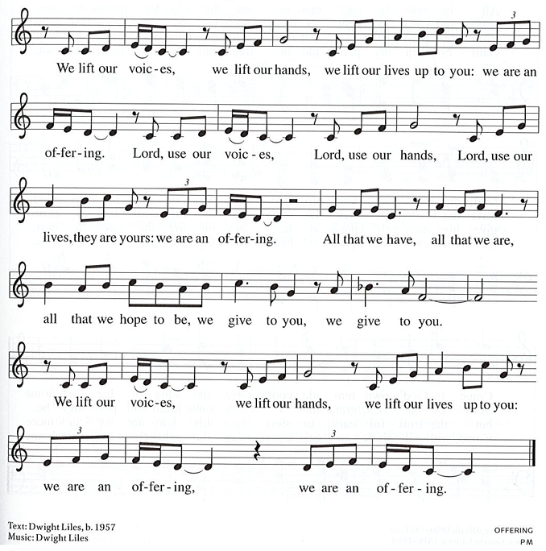

All rights reserved. Reprinted under CCLI # 11561207.

**Offertory Prayer**

A: Let us pray.

Holy God,

**C:** **the earth is yours and everything in it, yet you have chosen to dwell among your peoples**

**and share your abundance. Come among us now in these gifts of bread and wine,**

**and strengthen us to be your body for the world, through Jesus Christ, our Lord. Amen.**

**Dialogue**

P: The Lord be with you.

**C: And also with you.**

P: Lift up your hearts.

**C: We lift them to the Lord.**

P: Let us give thanks to the Lord our God.

**C: It is right to give our thanks and praise.**

**Preface**

P: It is indeed right, our duty and our joy …

… we praise your name and join their unending hymn:

**Sanctus** *ACS* p. 36

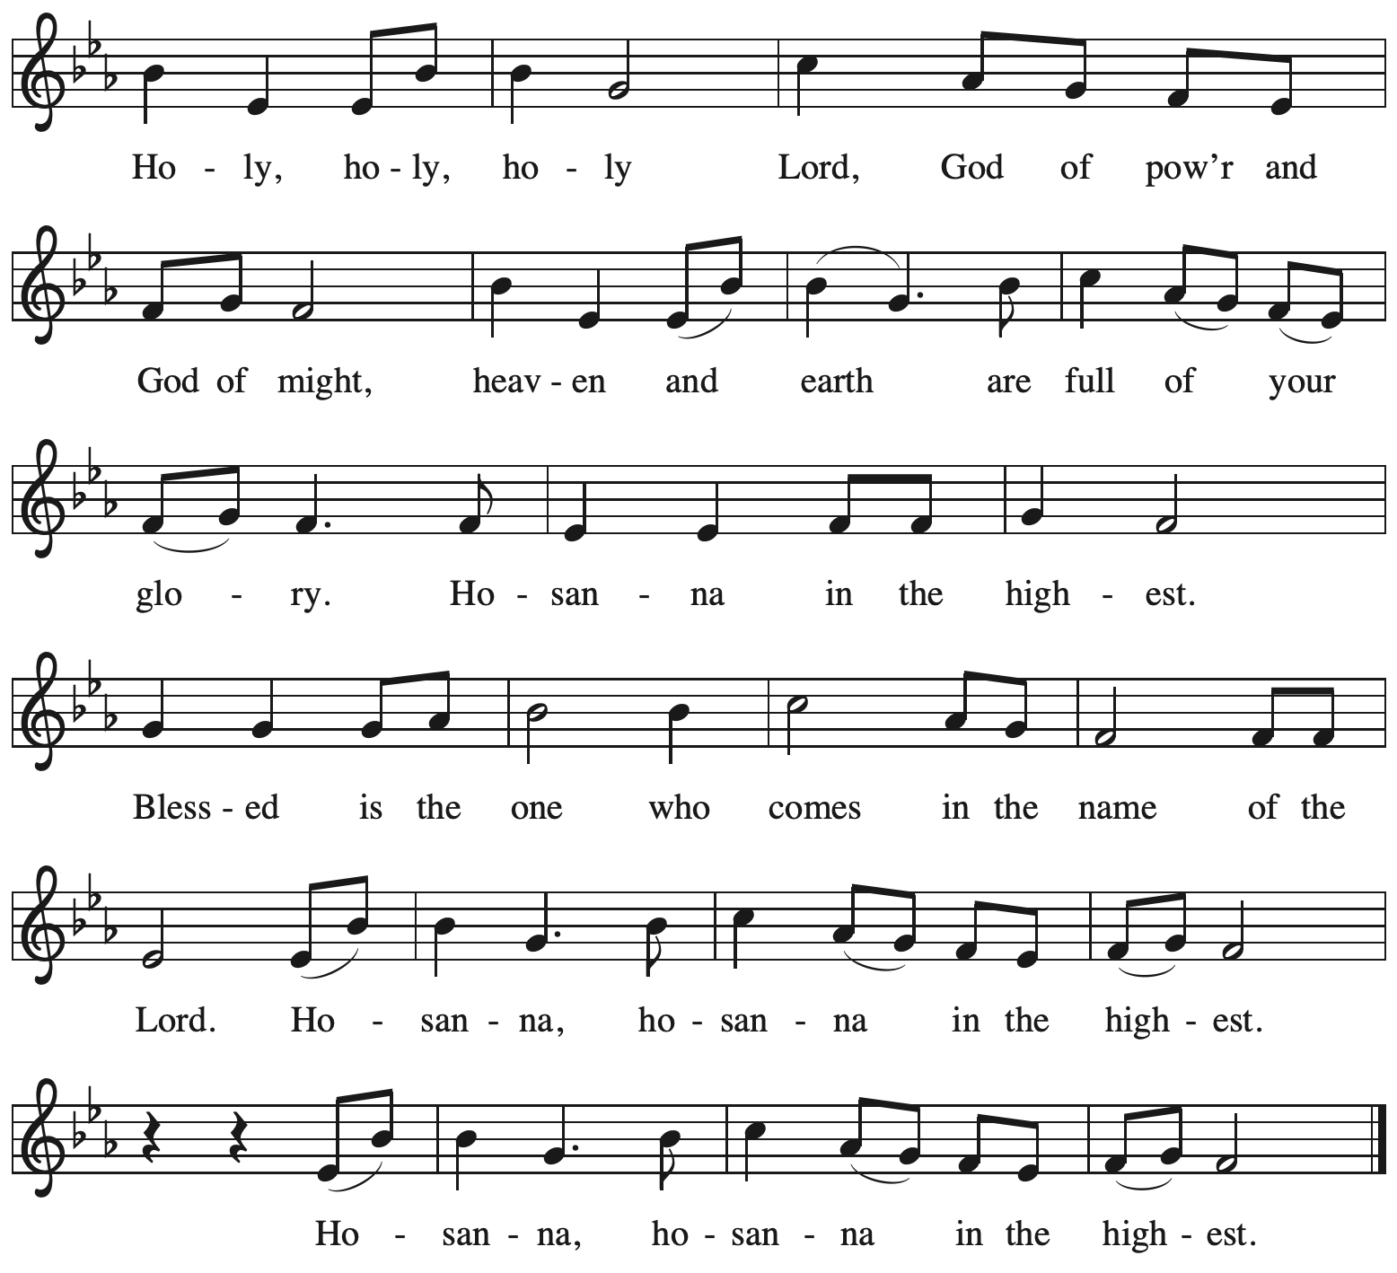

**Eucharistic Prayer**

P: O God triune …

…join in the ancient song:

The earth is full of your glory.

**C: The earth is full of your glory.**

P: O God triune …

… we mortals sing our song:

The earth is full of your glory.

**C: The earth is full of your glory.**

P: We praise you for the heart of Jesus …

… we your children unite in this song:

The earth is full of your glory.

**C: The earth is full of your glory.**

P: O God triune …

… to praise you again:

The earth is full of your glory.

**C: The earth is full of your glory.**

P: Amen and Amen.

**C: Amen and amen.**

**Lord’s Prayer**

P: Gathered as one by the Holy Spirit, let us pray as Jesus taught us.

**C: Our Father in heaven,**

**hallowed be your name,**

**your kingdom come,**

**your will be done,**

**on earth as in heaven.**

**Give us today our daily bread.**

**Forgive us our sins**

**as we forgive those**

**who sin against us.**

**Save us from the time of trial**

**and deliver us from evil.**

**For the kingdom, the power,**

**and the glory are yours,**

**now and forever. Amen.**

**Fraction and Invitation**

P: Behold, God is making all things new. Come, take part in the new creation.

***Agnus Dei /* Lamb of God** *ACS* p. 40

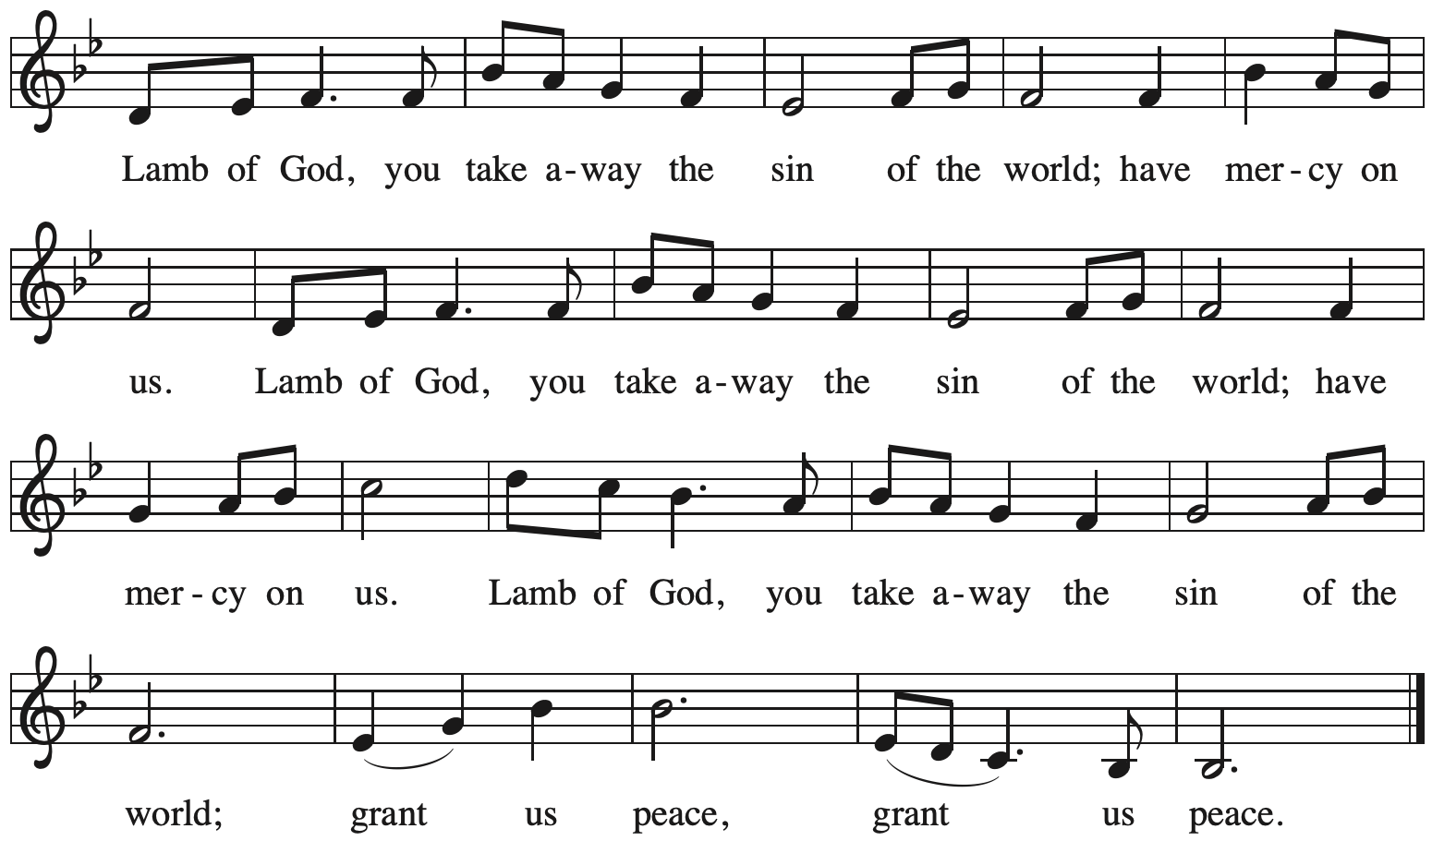

*Please be seated.*

**Holy Communion**

* *All who seek God and desire a deeper and stronger life in Christ are welcome to receive Holy Communion.*
* *Worshipers from the pulpit side will proceed forward first, followed by the center section, and then the lectern side.*
* *Please inform an usher if you would like the ministers to bring Communion to you.*
* *Holy Communion will be served with bread and wine/grape juice.*
* *The presiding minister will first distribute the bread (host) to each communicant. Please indicate if you require a gluten-free host.*
* *Once you have consumed the bread, please pick up an empty glass from the tray next to the presiding minister. The Communion Assistant will pour wine from the chalice or grape juice from the cruet into your glass.*
* *Please step to the side to consume the wine or grape juice.*
* *Feel free to kneel at the altar rail for prayer after receiving the sacrament.*
* *As you return to your pew, glasses may be returned to the empty trays on either side of the center section.*
* *A blessing will be provided for anyone who does not yet receive the sacrament.*
* *All are invited to join in singing the hymns during Holy Communion.*

**Hymns during Holy Communion**

**All My Hope on God Is Founded *ELW* 757**

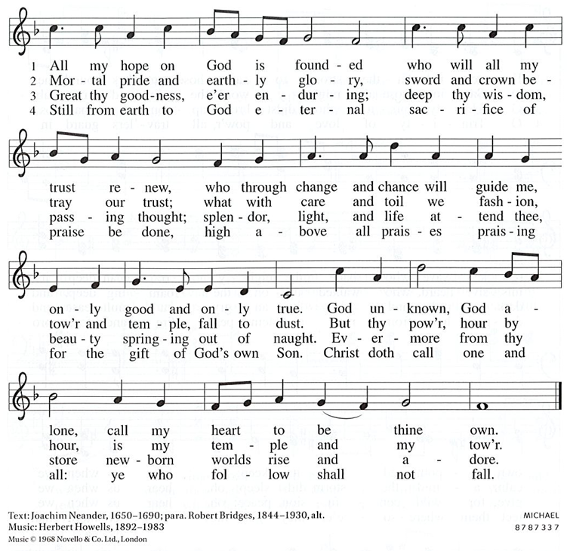

All rights reserved. Reprinted with permission under CCLI # 11561207.

**Hymns during Holy Communion**

**When Pain of the World Surrounds Us *ELW* 704**

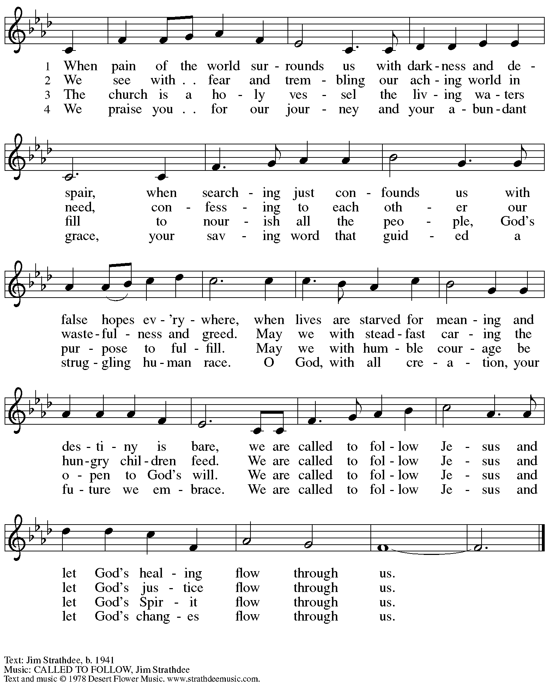

All rights reserved. Reprinted with permission under OneLicense.net # A-722139.

**Hymns during Holy Communion**

**Though the Earth Shall Change *ACS* 1035**

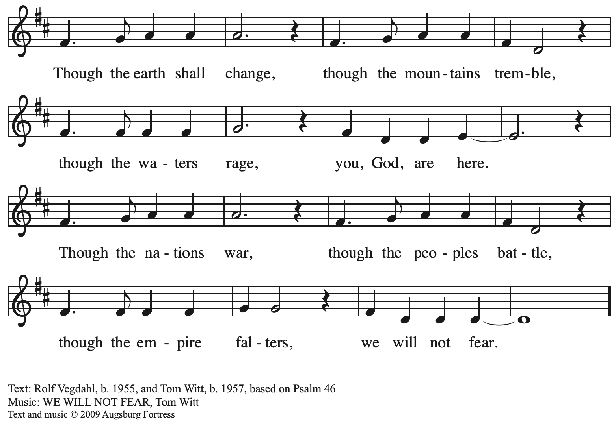

All rights reserved. Reprinted with permission under OneLicense.net # A-722139.

**Hymns during Holy Communion**

**All Who Love and Serve Your City *ELW* 724**

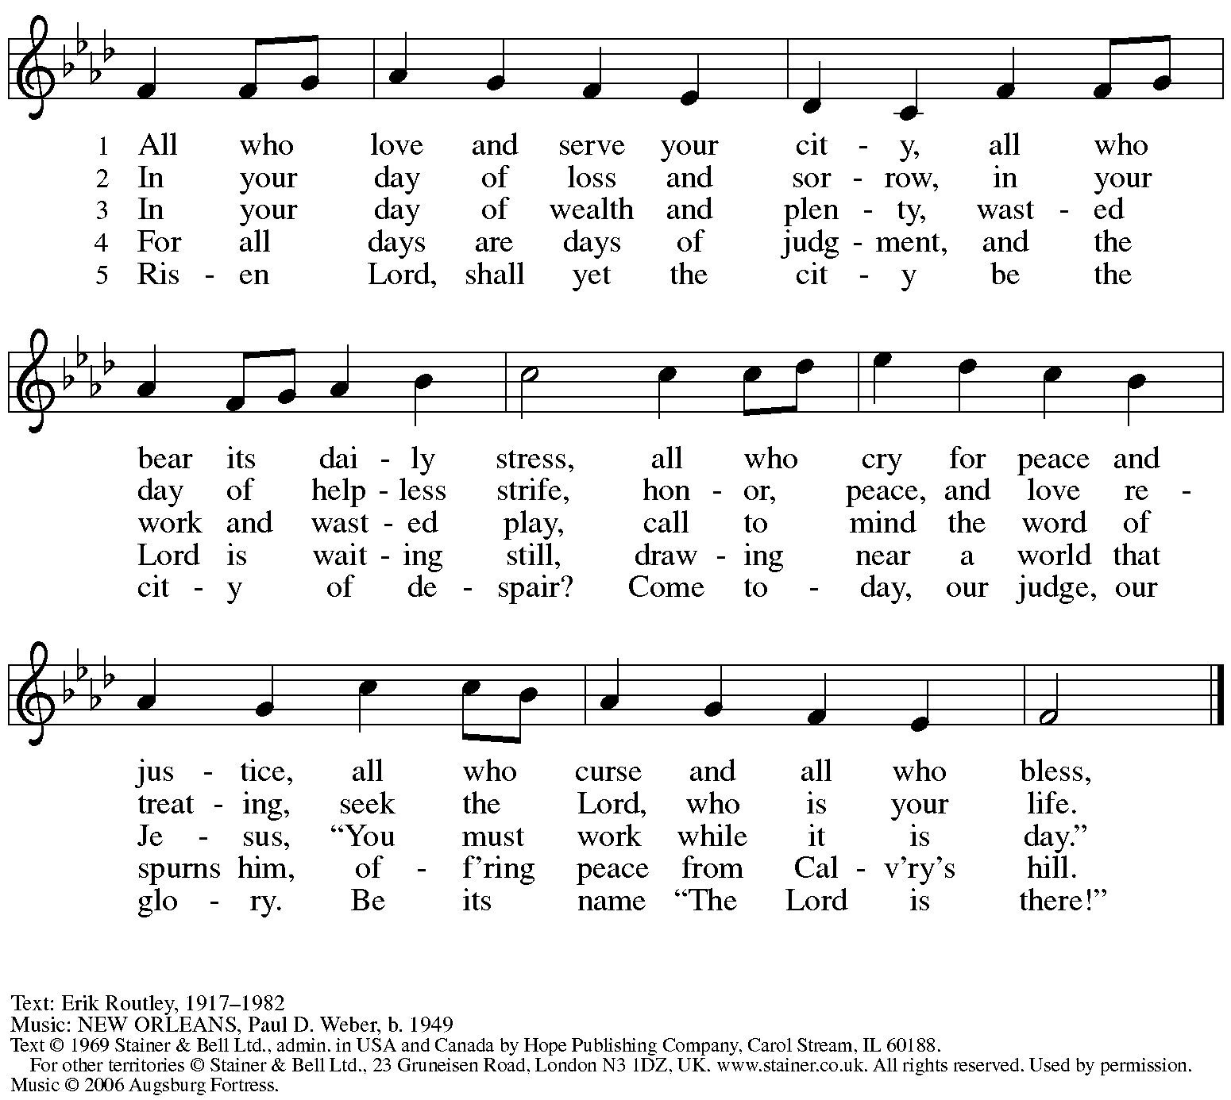

All rights reserved. Reprinted with permission under OneLicense.net # A-722139.

*When all have returned to their places, please rise as you are able.*

**Blessing**

P: The body and blood of our Lord Jesus Christ strengthen you and keep you in his grace.

**C: Amen.**

**Prayer**

A: Let us pray.

Blessed Jesus, at this table, you have been for us both host and meal.

Now send us forth to extend our tables and share your gifts

until that day when all feast together at your heavenly banquet,

through Jesus Christ, our Savior and Lord.

**C: Amen.**

*Please be seated.*

**Sending**

*God blesses us and sends us in mission to the world*

**Announcements**

*Please rise as you are able.*

**Benediction**

P: God, the Alpha and the Omega, the beginning and the end,

who has written your name in the book of life,

☩ bless you and keep you in grace and peace,

from this time forth and forevermore.

**C: Amen.**

**Sending Hymn** *Following page*

**Dismissal**

A: Go in peace. Serve the Lord.

**C: Thanks be to God.**

**Postlude**

**Sending Hymn Let Streams of Living Justice *ELW* 710**

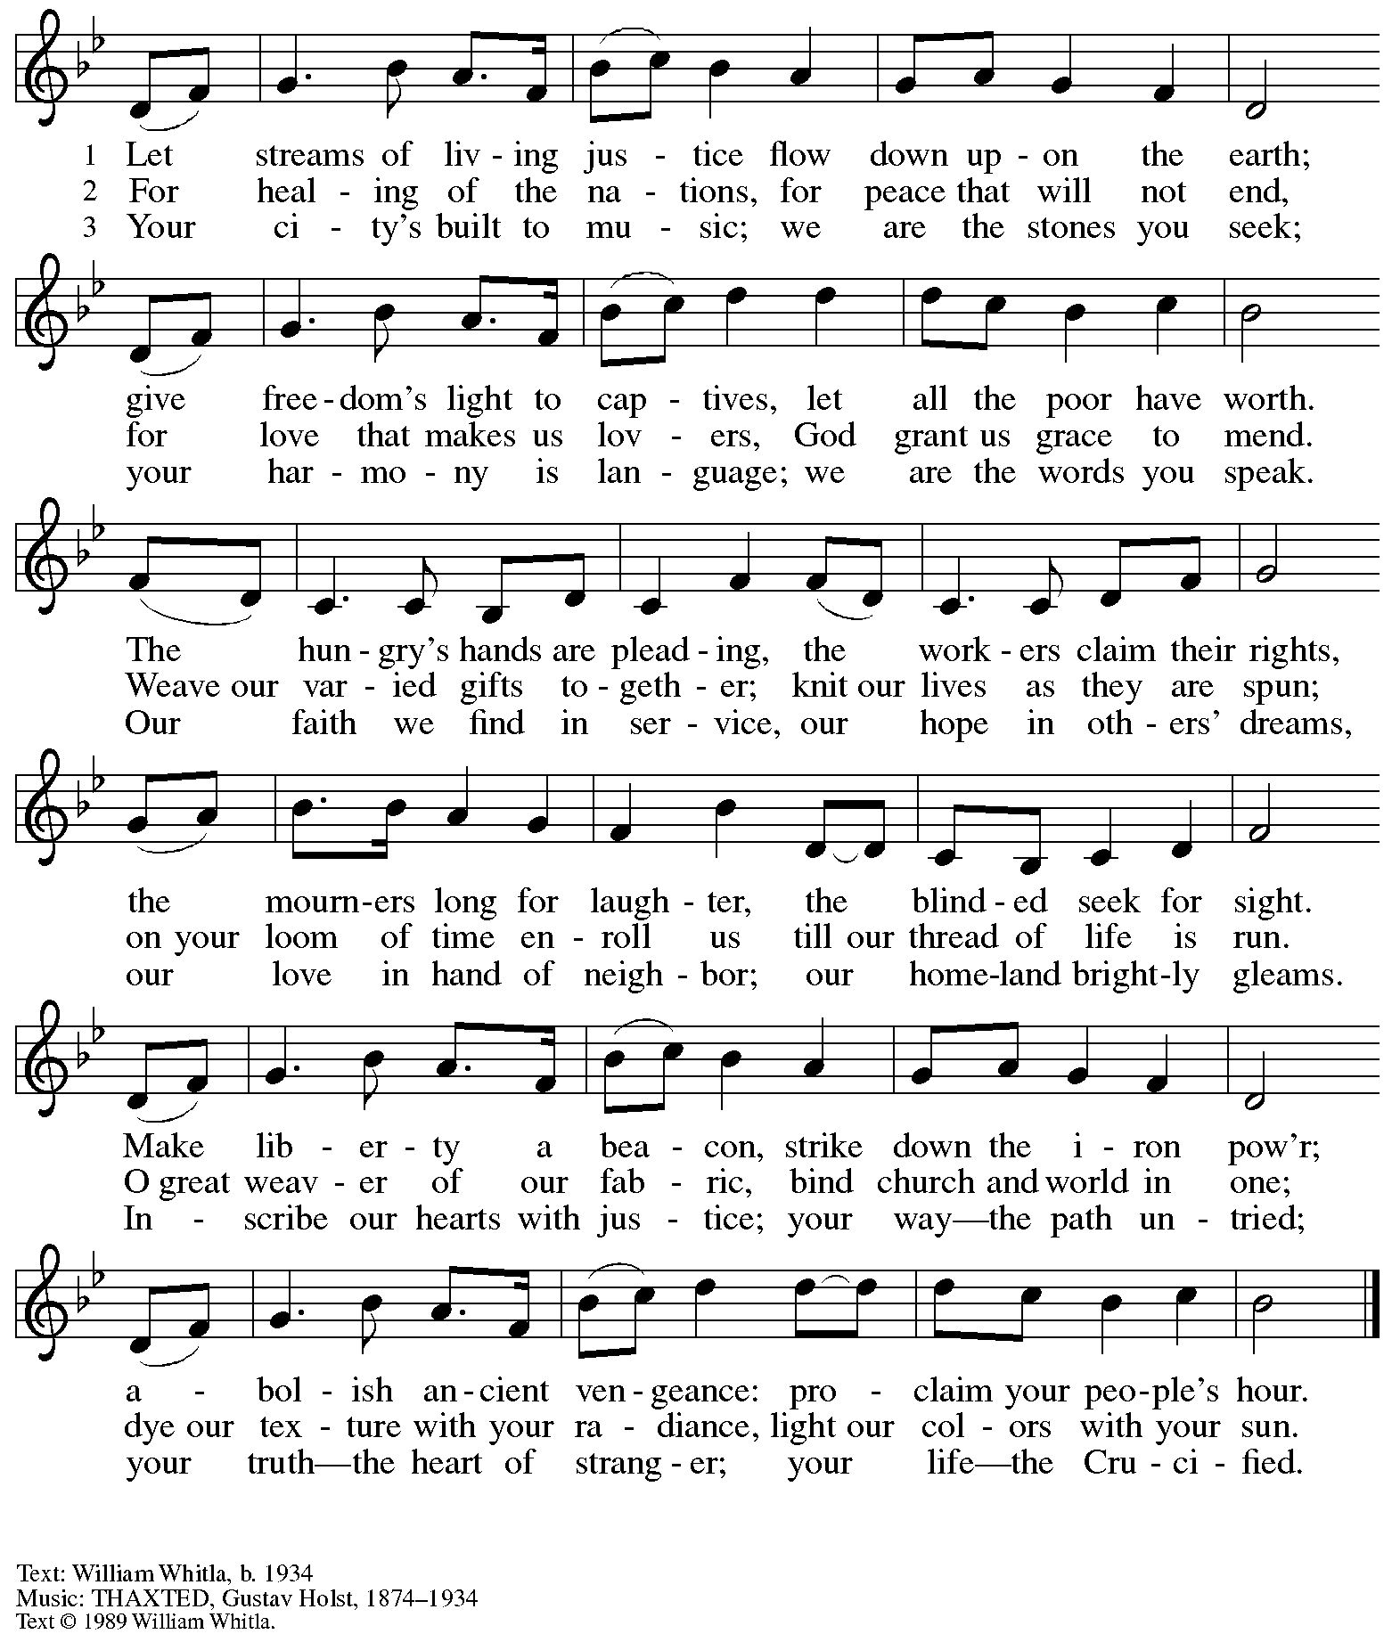

Reprinted with permission of the hymnwriter, William Whitla.

*Those serving in worship today*

Altar Care Christy Ruhe

Assisting Minister Kathy Hays

Audio-Visual Ministers David Rollinson

Sarita

Cantor Mandy Best

Lector Kelly Spanninger

Little Church – Big Faith Teacher Maria Mangano

Minister of Music Laura Reynolds

Preaching and Presiding Minister Pastor Ross Carmichael

*Liturgy and Hymnody Acknowledgements*

From SundaysandSeasons.com. Copyright © 2024 Augsburg Fortress. All rights reserved. Reprinted under OneLicense.net # A-722139.

Used by permission of Augsburg Fortress.

The Scripture readings contained herein are from *New Revised Standard Version* of the Bible © 1989, Division of Christian Education of the National Council of Churches of Christ in the USA. Used by permission. All rights reserved.

**God of Grace and God of Glory** – Text: Harry E. Fosdick, 1878-1969. Music: CWM RHONDDA, John Hughes, 1873-1932.

*Please use the QR code below to link to St. Andrew’s announcements online!*



**St. Andrew Lutheran Church Announcements**

**November 17th, 2024**

* **Welcome to Worship at St. Andrew on the Twenty-Sixth Sunday after Pentecost, November 17th, 2024** –We are so glad you are here, and we offer a special welcome to all visitors and guests here for the first time! Worship attendees are invited to make a name tag at the back of the worship space. Little Church – Big Faith, a Bible lesson and activity for children, will take place after the prayer of the day. There are also worship “toolkits” to help children engage with worship and “busy bags” for younger children available in the bookcase at the back of the sanctuary. Please feel free to take one to use with/for your children. All are invited to gather for coffee other drinks and food, and conversation in the social hall after worship.
* **Noisy Offering during Worship Today – On the third Sunday of each month, the children of St. Andrew lead us in a Noisy Offering.** The children carry buckets around the congregation and people are invited to throw in their change, which then gets compiled in big metal buckets and brought forward as an offering. These gifts support a different ministry or organization each month, and this month’s Noisy Offering will be donated to Bethesda Lutheran Services, a service ministry organization affiliated with the Evangelical Lutheran Church in America and our Southwestern Pennsylvania Synod, whose mission is to “provide bright futures for children, youth, and families, through individualized mental and behavioral health services provided in a residential, school, or community setting. For more information, visit [www.bethesda1919.org](http://www.bethesda1919.org).
* **Shelter Dinner for Guests of East End Cooperative Ministry – Thursday, November 21st, 6:30 p.m. –** Each month, people of St. Andrew provide dinner for guests of East End Cooperative Ministry, 6140 Station St. (East Liberty), 15206. We invite you to prepare or purchase one menu item and bring it to the shelter by 6:00 p.m., or just come to help serve at 6:30 p.m. If you would like to contribute, please sign up here:

<https://www.signupgenius.com/go/5080544AAAC22A1F58-52627894-shelter>.

* **Interfaith Thanksgiving Service – Tuesday, November 26th at 7:00 p.m. at Nearby First Unitarian Church – Join members of Pittsburgh’s various faith communities in a gathering to reconnect us with each other! Light refreshments will be served. First Unitarian is located at 605 Morewood Avenue – please feel free to park at St. Andrew!**
* **Holiday Gift-Giving Opportunities through Bethesda Lutheran Services and JFCS –**

**Each year, St. Andrew chooses an organization to partner with to provide holiday gifts for children in need. This year the congregation will work with Bethesda Lutheran Services and JFCS.**

* **JFCS has set up a gift registry with** Learning Express in Wexford (buying

as locally as possible). This is the link to the registry: <https://learningexpress.com/wexford/giftr/registry/view/uid/FF5129350614/>. Gifts can be ordered directly on the LE website, and Joy Givens will pick everything up from the store, so anyone who orders can mark "pick up" from Wexford at checkout and will not have to worry about going to get items themselves.

* JFCS – St. Andrew will also collect new winter hats, mittens/gloves,

and packages of socks and underwear of all sizes in the social hall until Sunday, December 15th. JFCS has 160 kids on their list, 114 of whom are age 5 or older, so the need is great!

* **JFCS –** The JFCS Bridge Builders gift distribution event will take place on

Monday, December 16th, hopefully at the Carnegie Library's downtown

branch on Smithfield Street. We will invite parents to come and "shop" for

their children. We hope to offer one toy and hat/gloves set per child, new

packages of socks and underwear, and used books (which are already

being supplied). We will also assemble gift bags for families that are not able to get downtown and deliver them during that week. Anyone who wants to volunteer to staff our free store and/or deliver gifts should email Joy Givens at [jgivens@jfcspgh.org](mailto:jgivens@jfcspgh.org). Bridge Builders is a mentoring and enrichment program for locally resettled refugee and immigrant children, and Joy is happy to talk with anyone about what they do and who we serve!

* **Bethesda – Please see the full Bethesda Residential Wish List page printed**

**at the back of the bulletin. Donations will be accepted through Sunday,**

**December 15th.**

* **Coffee Hour Signups Available** –One way that St. Andrew builds community is by sharing conversation over food and drinks at coffee hour after worship on Sundays. We invite people of the congregation to sign up to coordinate coffee hour each week, which includes brewing the coffee; setting out cups, napkins, food items, and cold drinks; and cleaning up afterward. Everything needed is at St. Andrew and instructions are available. Please sign up to host coffee hour here: <https://www.signupgenius.com/go/5080B4AAFAF2CABF85-47069030-coffee>.
* ***Christ in Our Home* Devotional Booklets (October – December) Available at Church Entrances – *Christ in Our Home* is a booklet of devotions that includes Scripture, a brief reflection, and prayer for each day. The new edition for October – December is now available at the various church entrances. Please feel free to take one for yourself or others!**
* **Compline Prayer Service with the Pittsburgh Compline Choir – Sundays at 8:00 p.m. at Heinz Chapel –** Compline was traditionally a monastic prayer service, and the Pittsburgh Compline Choir, a ministry of Lutheran Campus Ministry in Greater Pittsburgh, sings a choral version of compline rooted in this thousand-year-old tradition of scripture, song, and silence each Sunday at Heinz Chapel at 8:00 p.m. This service also streams on Facebook (Pittsburgh Compline Choir) and YouTube (The Pittsburgh Compline Choir). Heinz Chapel is located off of S. Bellefield Ave. in Oakland. For more information, please visit: [Pittsburgh Compline Choir](http://pittsburghcomplinechoir.org/).