

**+ First Sunday of Advent**

**December 1, 2024**



**St. Andrew Lutheran Church**

**304 Morewood Ave.**

**Pittsburgh, PA 15213**

[**St_andrewELCA@verizon.net**](mailto:St_andrewELCA@verizon.net)

[**www.standrewpittsburgh.org**](http://www.standrewpittsburgh.org)

**+ First Sunday of Advent**

**Order for Worship**

*A new church year begins with the season of Advent, a time of waiting, preparing, and hopeful expectation. God’s people have always lived in expectation, but expectation of divine revelation finds specific, repeated enunciation in the texts appointed for these four weeks. The ancients anticipated a “righteous Branch to spring up for David.” The Thessalonians awaited “the coming of our Lord Jesus with all the saints.” Jesus’ contemporaries hoped for the time “to stand before the Son of Humanity.” With them we await God’s coming among us: As Jesus, Emmanuel, “God with us” at Christmas, in the second coming, and the advent of Christ in word and meal.*

**Welcome to St. Andrew!**

* St. Andrew Lutheran congregation welcomes all who are seeking a place of healing and wholeness – a nurturing, faith-forming spiritual home. Our community embraces people of all ages, ethnicities, cultures, abilities, sexual orientations, gender identities and expressions, and family constellations. Come and See!
* Worship Services are live-streamed to multiple online platforms. By attending worship, you agree that your image and voice may be broadcast.
* Everyone is invited to make a name tag at the black bookcase in the back of the worship space if they would like. There are stickers indicating pronouns on the bookcase if you would like to include them on your name tag.
* Children are invited to attend Little Church – Big Faith, a Bible lesson and activity, during worship (after the Prayer of the Day). The group returns to the worship space for the liturgy of Holy Communion.
* A nursery is available through the doors at the left side of the sanctuary and across from the doorway to the Social Hall. Look for a purple-colored room.
* Worship “toolkits” to help children engage with the service, along with “busy bags” for younger children, are available in the bookcase at the back of the sanctuary. Please feel free to take one to use with/for your children.
* Holy Communion is served with bread (gluten-free available) and wine or grape juice. The presiding minister will distribute the bread (host). Please consume this and then pick up an empty glass from the tray. The Communion Assistant will pour wine or grape juice into your glass. Please step to the side to consume the wine or grape juice. Feel free to kneel at the altar for prayer and reflection. As you return to your pew, glasses may be returned to the empty trays on either side of the center section.
* A restroom is available on the main level of the church, through the doors to the Social Hall and to the right in the main office.

*Abbreviations*

P: Pastor/Presiding Minister ***ELW*: *Evangelical Lutheran Worship* hymnal**

A: Assisting Minister ***ACS*: *All Creation Sings* hymnal**

L: Lector

**C: Congregation**

**Pre-Service Music**

**Welcome**

**Prelude**

*During the prelude, individuals from the congregation will come forward to light the candle(s)*

*of the Advent wreath corresponding to the four Sundays of Advent.*

**Gathering**

*The Holy Spirit calls us together as the people of God*

**Confession and Forgiveness**

*Please rise as you are able. All may make the sign of the cross,*

*the sign that is marked at Baptism, as the presiding minister begins.*

P: Blessed be the holy Trinity, ☩ one God,

alive in the world, reviving creation, arriving soon.

**C: Amen.**

P: Let us confess our sin in the presence of God and of one another.

*Silence is kept for reflection*

P: God of mercy,

**C: we confess that we have sinned.**

**We have trusted earthly powers and human authority alone.**

**We have grown fearful. We cling to false comforts.**

P: God of might,

**C: we confess that we have sinned.**

**We have turned away from our neighbors. We have trusted false promises.**

P: God in our midst,

**C: we confess that we have sinned.**

**We plead: come to us. Bring your mercy to birth in us. Amen.**

P: A righteous branch springs forth: it is Christ the Lord, our Savior,

in whom we have forgiveness, life, and mercy.

By the power of the Holy Spirit, receive the grace and forgiveness of God

through ☩ Christ Jesus, whose day draws near.

**C: Amen.**

**Gathering Hymn Now the Heavens Start to Whisper *ACS* 901**

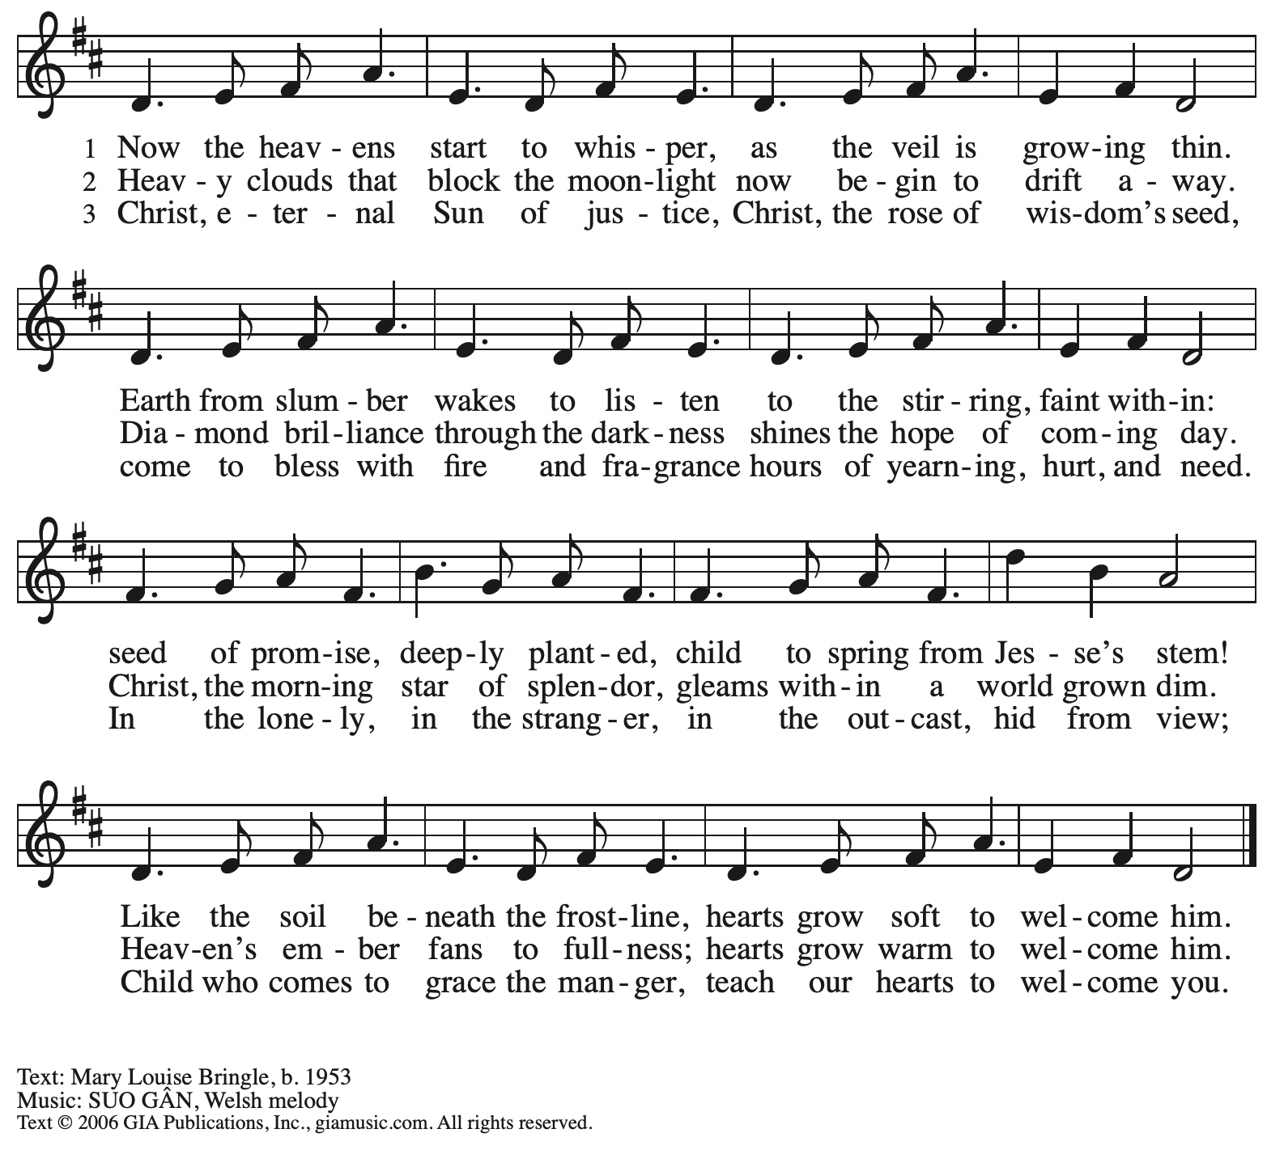

Reprinted with permission under OneLicense.net # A-722139.

**Greeting**

P: The grace of our Lord Jesus Christ, the love of God,

and the communion of the Holy Spirit be with you all.

**C: And also with you.**

**Kyrie** *ELW* p. 147

*The cantor leads the singing of the Kyrie, with the congregation joining in the responses in bold.*

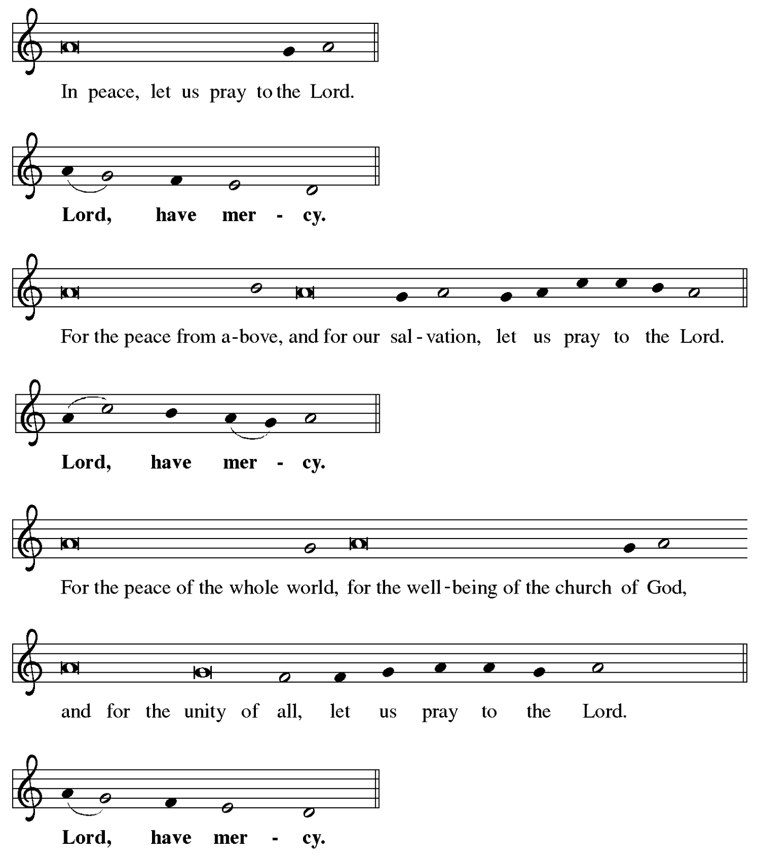

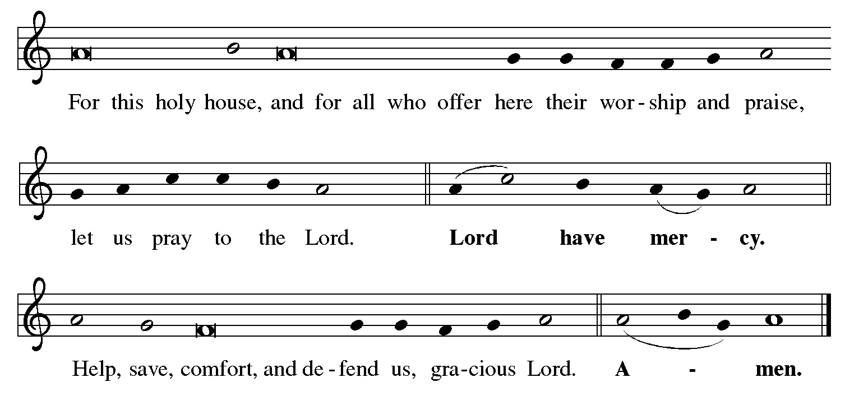

**Prayer of the Day**

P: The Lord be with you.

**C: And also with you.**

P: Stir up your power, Lord Christ, and come.

By your merciful protection alert us to the threatening dangers of our sins,

and redeem us for your life of justice,

for you live and reign with the Father and the Holy Spirit,

one God, now and forever.

**C: Amen.**

*Please be seated.*

*Children are invited to join the adult leaders at the door and for Little Church – Big Faith.*

*We ask that one additional adult from the congregation attend with the children.*

**Word**

*God speaks to us in Scripture reading, preaching, and song*

**First Reading** **–** **Jeremiah 33: 14-16**

14 The days are surely coming, says the Lord, when I will fulfill the promise I made to the house of Israel and the house of Judah. 15 In those days and at that time I will cause a righteous Branch to spring up for David; and he shall execute justice and righteousness in the land. 16 In those days Judah will be saved and Jerusalem will live in safety. And this is the name by which it will be called: “The Lord is our righteousness.”

L: Word of God, word of life.

**C: Thanks be to God.**

**Psalm 25: 1-10**

*The cantor will lead the singing of the psalm.*

*The congregation is invited to respond with the alternate verses in bold print,*

*and to join in singing the refrain.*

*Psalm tone*

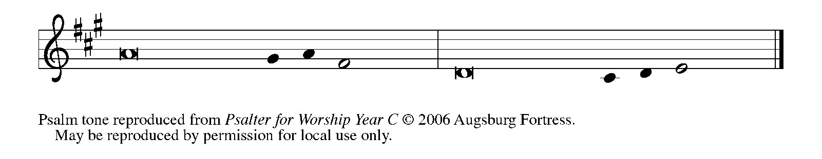

*Psalm refrain*

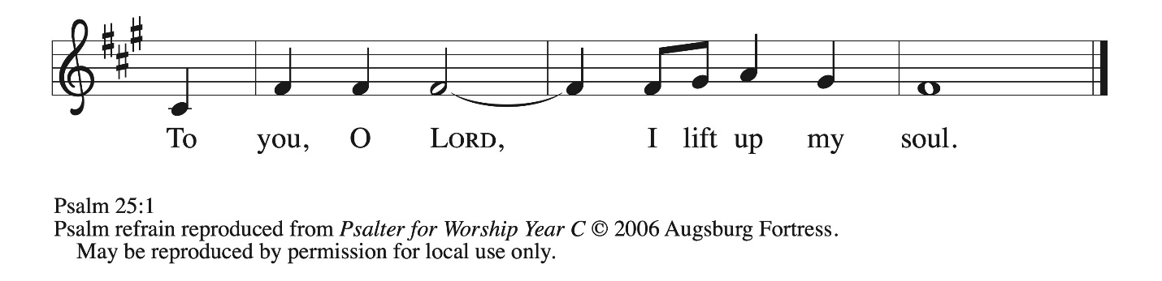

 1 To **|** you, O Lord,  
  I lift **|** up my soul.  
 2 **My God, I put my trust in you; let me not be | put to shame,**  
  **nor let my enemies triumph | over me.**  
 3 Let none who look to you be **|** put to shame;  
  rather let those be put to shame **|** who are treacherous.  
 4 **Show me your | ways, O Lord,**  
  **and teach | me your paths. R**

5 Lead me in your | truth and teach me,  
  for you are the God of my salvation; in you have I trusted all | the day long. **6 Remember, O Lord, your compas- | sion and love,  
  for they are from | everlasting. R** 7 Remember not the sins of my youth and | my transgressions;  
  remember me according to your steadfast love and for the sake of your good- | ness, O Lord. **8 You are gracious and up- | right, O Lord;  
  therefore you teach sinners | in your way.** 9 You lead the low- | ly in justice  
  and teach the low- | ly your way. **10 All your paths, O Lord, are steadfast | love and faithfulness  
  to those who keep your covenant and your | testimonies. R**

**Second Reading – 1 Thessalonians 3: 9-13**

9 How can we thank God enough for you in return for all the joy that we feel before our God because of you? 10 Night and day we pray most earnestly that we may see you face to face and restore whatever is lacking in your faith.  
  11 Now may our God and Father himself and our Lord Jesus direct our way to you. 12 And may the Lord make you increase and abound in love for one another and for all, just as we abound in love for you. 13 And may God so strengthen your hearts in holiness that you may be blameless before our God and Father at the coming of our Lord Jesus with all his saints.

L: Word of God, word of life.

**C: Thanks be to God.**

*Please rise as you are able and join in speaking the Gospel Acclamation.*

**Gospel Acclamation**  *ELW* p. 188

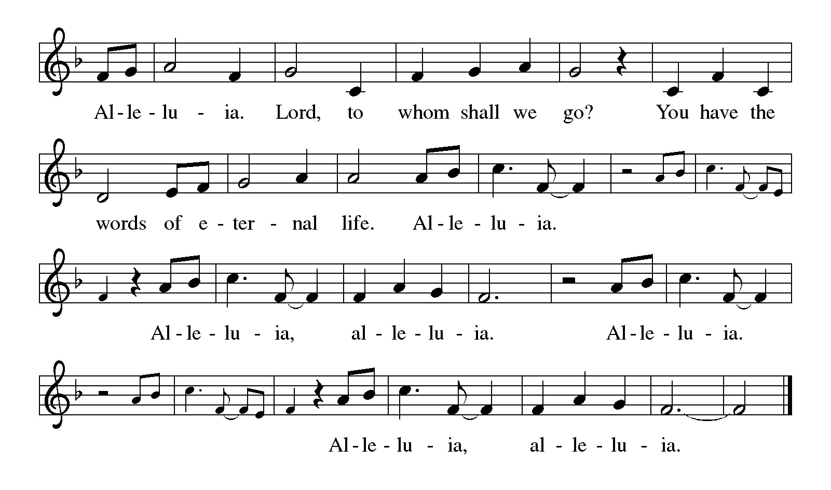

**Gospel – Luke 21: 25-36**

P: The holy Gospel according to St. Luke.

**C: Glory to you, O Lord.**

[Jesus said:] 25 “There will be signs in the sun, the moon, and the stars, and on the earth distress among nations confused by the roaring of the sea and the waves. 26 People will faint from fear and foreboding of what is coming upon the world, for the powers of the heavens will be shaken. 27 Then they will see ‘the Son of Humanity coming in a cloud’ with power and great glory. 28 Now when these things begin to take place, stand up and raise your heads, because your redemption is drawing near.”  
  29 Then he told them a parable: “Look at the fig tree and all the trees; 30 as soon as they sprout leaves you can see for yourselves and know that summer is already near. 31 So also, when you see these things taking place, you know that the kingdom of God is near. 32 Truly I tell you, this generation will not pass away until all things have taken place. 33 Heaven and earth will pass away, but my words will not pass away.  
  34 “Be on guard so that your hearts are not weighed down with dissipation and drunkenness and the worries of this life, and that day does not catch you unexpectedly, 35 like a trap. For it will come upon all who live on the face of the whole earth. 36 Be alert at all times, praying that you may have the strength to escape all these things that will take place, and to stand before the Son of Humanity.

P: The Gospel of the Lord.

**C: Praise to you, O Christ.**

*Please be seated.*

**Sermon**

*A time of silence for prayer and reflection follows the sermon.*

*When the Hymn of the Day begins, please rise as you are able.*



**Hymn of the Day Wake, Awake, for Night Is Flying *ELW* 436**

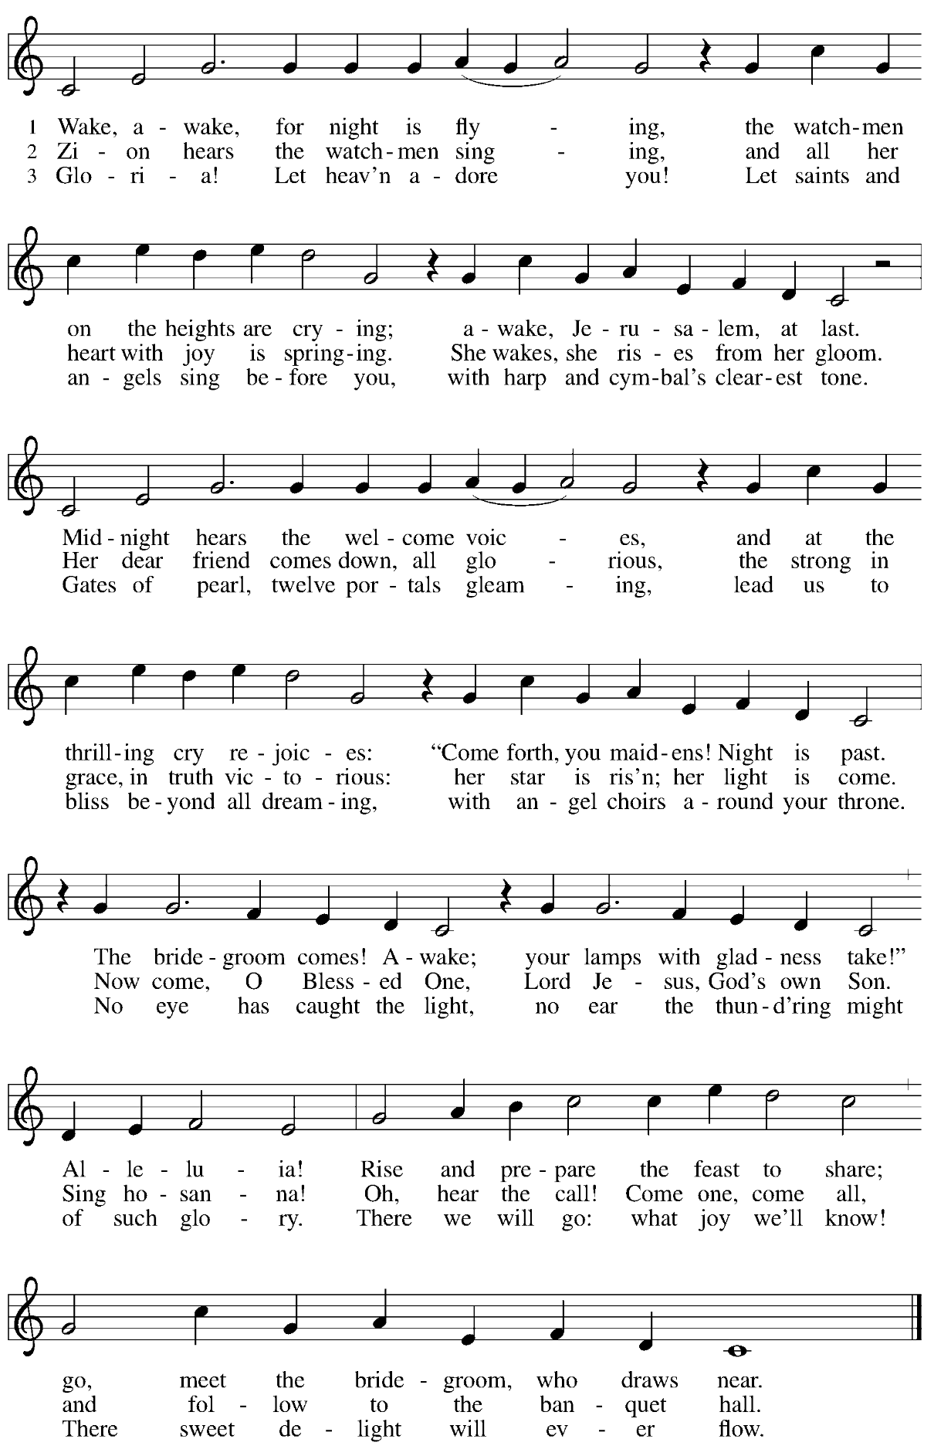

**Prayers of the People**

A: As we prepare for Emmanuel, God with us,

let us pray for the church, creation, and all who long for God’s presence.

*After each petition*

A: Merciful God,

**C: receive our prayer.**

*The presiding minister concludes the prayers*

P: Savior of the nations, come, and receive these prayers and the pleas of our hearts,

in the name of Jesus Christ, our Savior.

**C: Amen.**

**Peace**

*The presiding minister and the assembly greet one another in the peace of the risen Christ.*

P: The peace of Christ be with you always.

**C: And also with you.**

*The people may greet those around them with a sign of Christ’s peace and may say*

Peace be with you *or similar words. Please be mindful that not everyone will be comfortable with sharing the peace, so please seek consent before shaking hands or hugging. Other possible ways to share the peace include a simple bow with the verbal greeting of peace, or simply a verbal expression of peace.*

*When the greetings of peace have concluded, please be seated.*

**Meal**

*God feeds us with the presence of Jesus Christ*

**Offering**

*We offer ourselves, our gifts and our faithful service to God.*

*As the offering is gathered for the mission of the church, including the care of those in need,*

*the table is set for Holy Communion.*

*There are laminated giving cards in the pew racks that feature a QR code for anyone who would like to give online. Those who give using the QR code, as well as those who give regularly online or through their bank are encouraged to place the laminated card in the plate as an expression of your offering.*

**Reparations Offering**

*On the first Sunday of each month, St. Andrew invites people of the congregation to consider a donation to a second collection for a reparations fund in acknowledgement of St. Andrew’s use of African American spiritual songs in our worship services. Please see the note in the announcements for more information.*

**Music during the Offering**

*As the gifts are brought forward for presentation, please rise as you are able.*

**Offertory Song As the Grains of Wheat *ELW* 465**

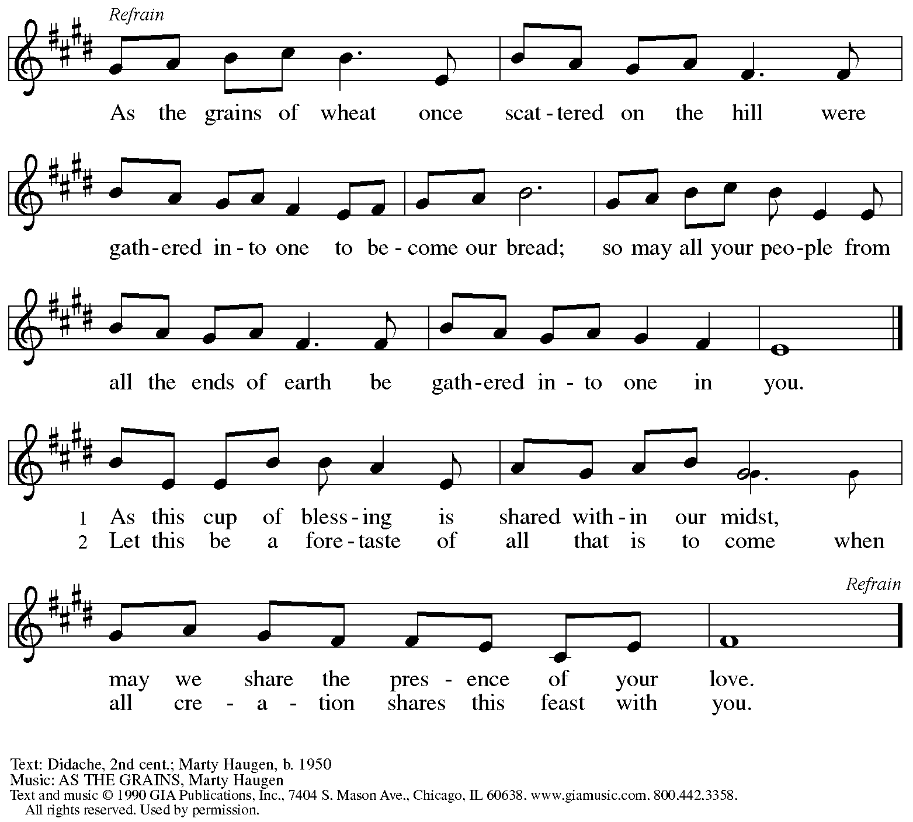

Reprinted under OneLicense.net # A-722139.

**Offertory Prayer**

A: Let us pray.

God of abundance,

**C:** **we bring before you**

**the precious fruits of your creation,**

**and with them our very lives.**

**Teach us patience and hope**

**as we care for all those in need**

**until the coming of your Son,**

**our Savior and Lord**

**Amen.**

**Dialogue**

P: The Lord be with you.

**C: And also with you.**

P: Lift up your hearts.

**C: We lift them to the Lord.**

P: Let us give thanks to the Lord our God.

**C: It is right to give our thanks and praise.**

**Preface**

P: It is indeed right, our duty and our joy,

that we should at all times and in all places

give thanks and praise to you, almighty and merciful God,

through our Savior Jesus Christ.

You comforted your people with the promise of the Redeemer,

through whom you will also make all things new

in the day when he comes to judge the world in righteousness.

And so, with all the choirs of angels,

with the church on earth and the hosts of heaven,

we praise your name and join their unending hymn:

**Sanctus** *ELW* p. 190

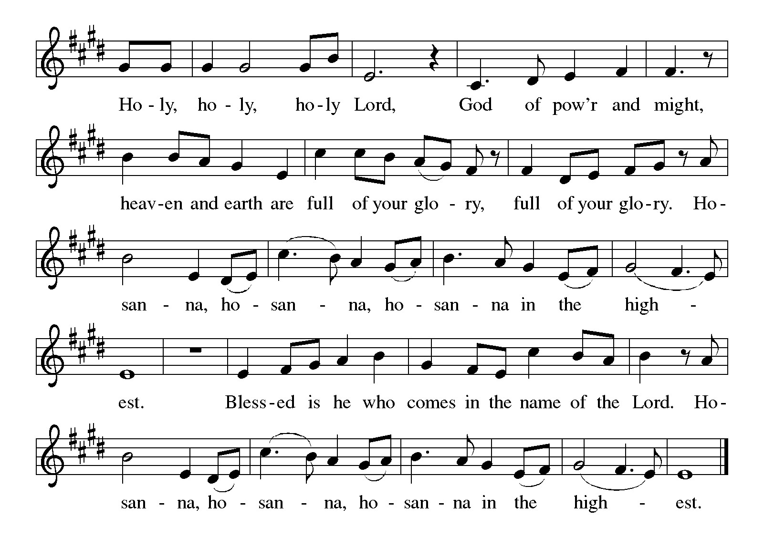

**Eucharistic Prayer**

P: Holy One, the beginning and the end, the giver of life …

…Do this for the remembrance of me.

Let us proclaim the mystery of faith:

**C: Christ has died.**

**Christ is risen.**

**Christ will come again.**

P: With this bread and cup

we remember your Word dwelling among us …

… We look with hope for his coming.

**C: Come, Lord Jesus.**

P: Holy God, we long for your Spirit …

… Bring the gift of peace on earth.

**C: Come, Holy Spirit.**

P: All praise and glory are yours,

Holy One of Israel,

Word of God Incarnate,

Power of the Most High,

one God, now and forever.

**C: Amen.**

**Lord’s Prayer**

P: Gathered as one by the Holy Spirit, let us pray as Jesus taught us.

**C: Our Father in heaven,**

**hallowed be your name,**

**your kingdom come,**

**your will be done,**

**on earth as in heaven.**

**Give us today our daily bread.**

**Forgive us our sins**

**as we forgive those**

**who sin against us.**

**Save us from the time of trial**

**and deliver us from evil.**

**For the kingdom, the power,**

**and the glory are yours,**

**now and forever. Amen.**

**Fraction and Invitation**

P: God feeds us with tender mercy.

Come to the table, where Christ comes to us once again.



***Agnus Dei /* Lamb of God** *ELW* p. 191

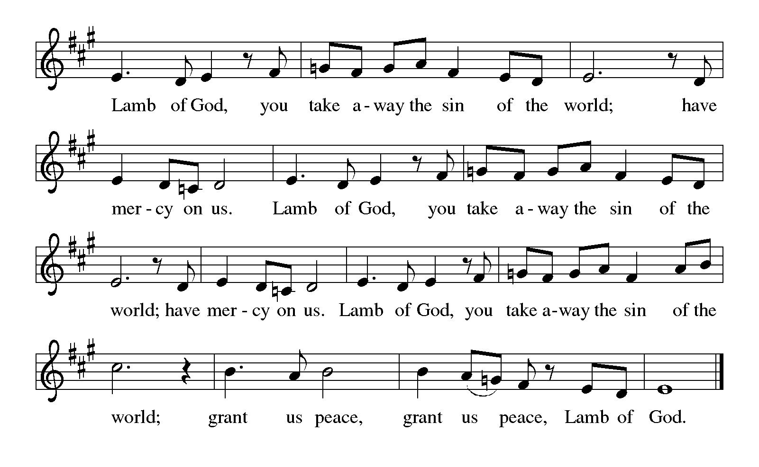

*Please be seated.*

**Holy Communion**

* *All who seek God and desire a deeper and stronger life in Christ are welcome to receive Holy Communion.*
* *Worshipers from the pulpit side will proceed forward first, followed by the center section, and then the lectern side.*
* *Please inform an usher if you would like the ministers to bring Communion to you.*
* *Holy Communion will be served with bread and wine/grape juice.*
* *The presiding minister will first distribute the bread (host) to each communicant. Please indicate if you require a gluten-free host.*
* *Once you have consumed the bread, please pick up an empty glass from the tray next to the presiding minister. The Communion Assistant will pour wine from the chalice or grape juice from the cruet into your glass.*
* *Please step to the side to consume the wine or grape juice.*
* *Feel free to kneel at the altar rail for prayer after receiving the sacrament.*
* *As you return to your pew, glasses may be returned to the empty trays on the side of the center section.*
* *A blessing will be provided for anyone who does not yet receive the sacrament.*
* *All are invited to join in singing the hymns during Holy Communion.*

**Hymns during Holy Communion**

**Each Winter as the Year Grows Older *ELW* 252**

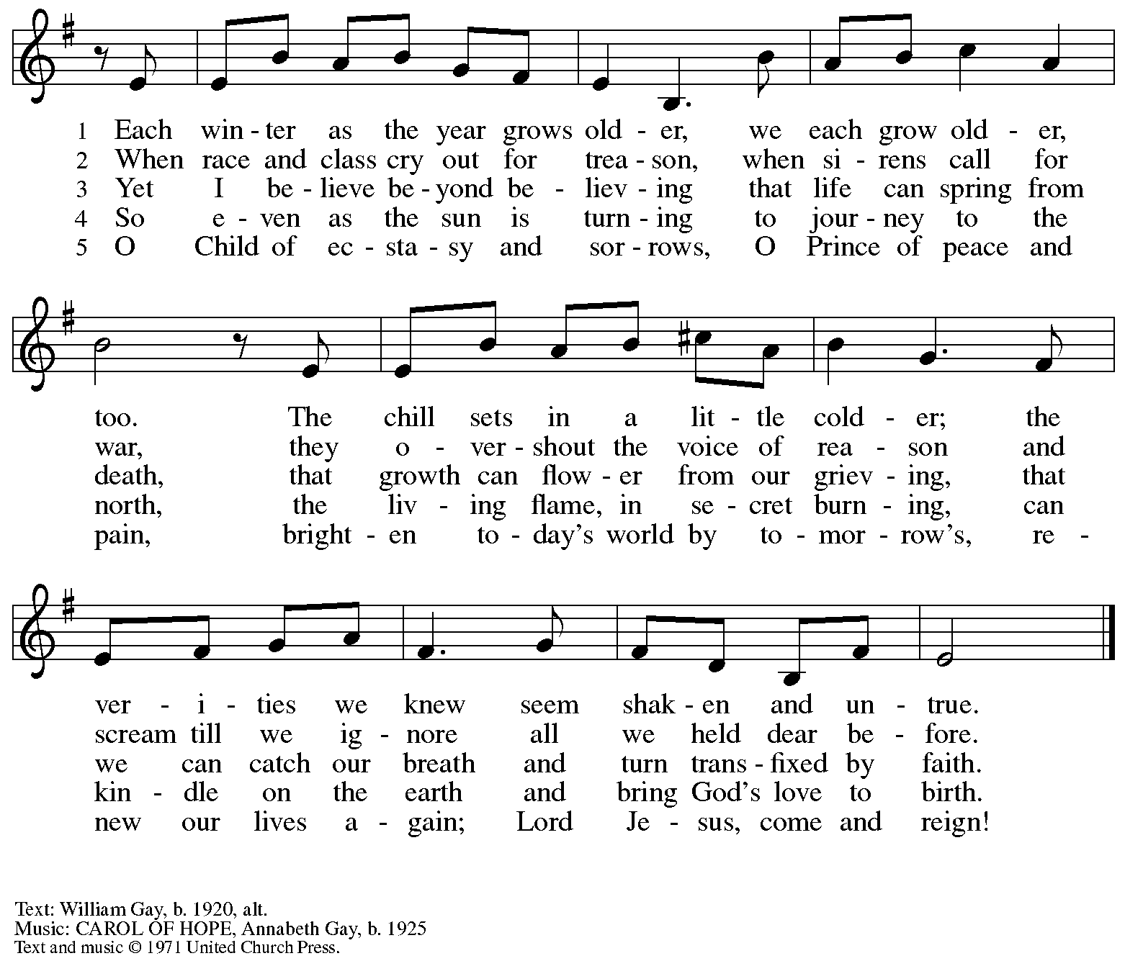

All rights reserved. Reprinted with permission under OneLicense.net # A-722139.

**Hymns during Holy Communion**

**There Is a Longing in Our Hearts *ACS* 1078**

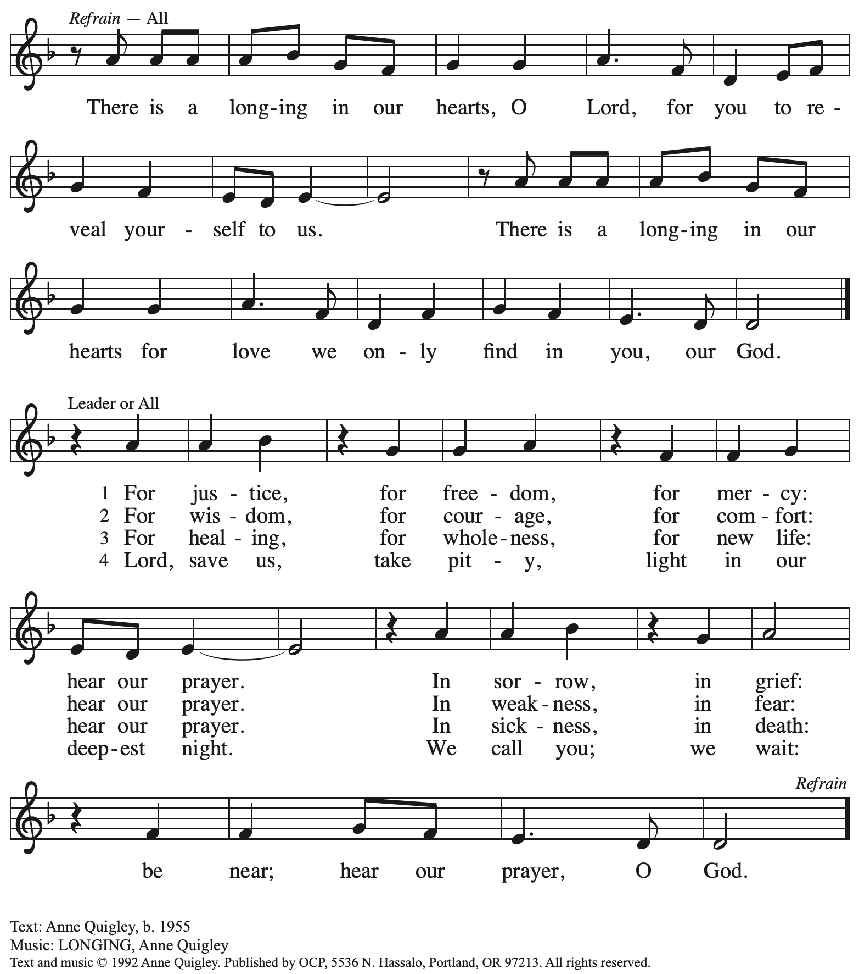

Reprinted with permission under OneLicense.net # A-722139.

**Hymns during Holy Communion**

**Come Now, O God *ACS* 902**

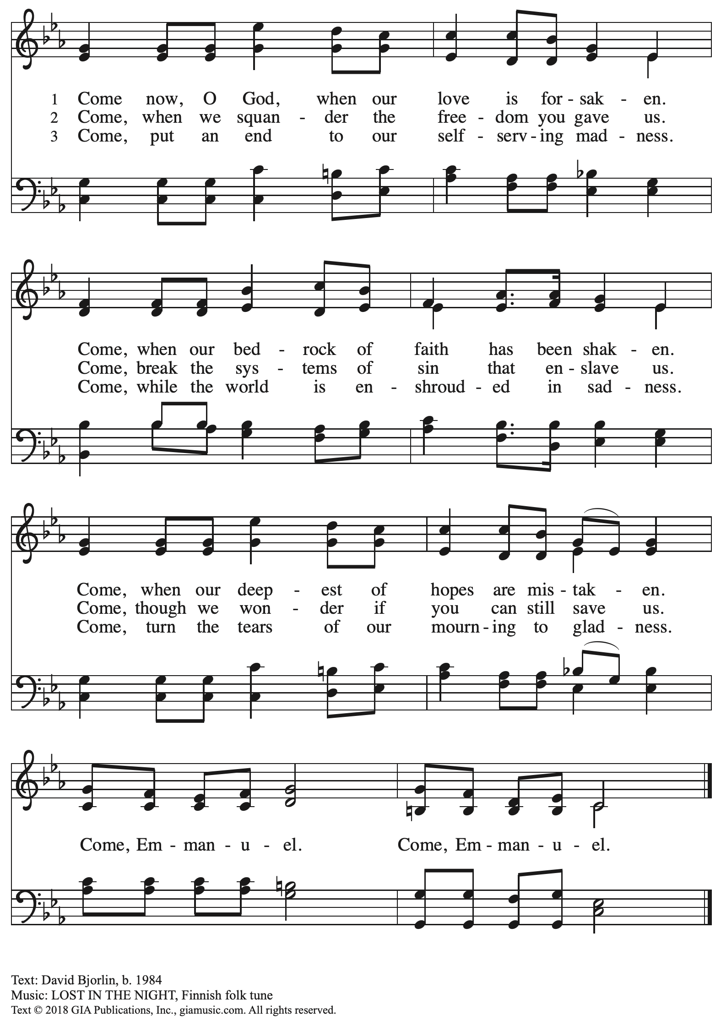

Reprinted with permission under OneLicense.net # A-722139.

**Hymns during Holy Communion**

**Canticle of the Turning *ELW* 723**

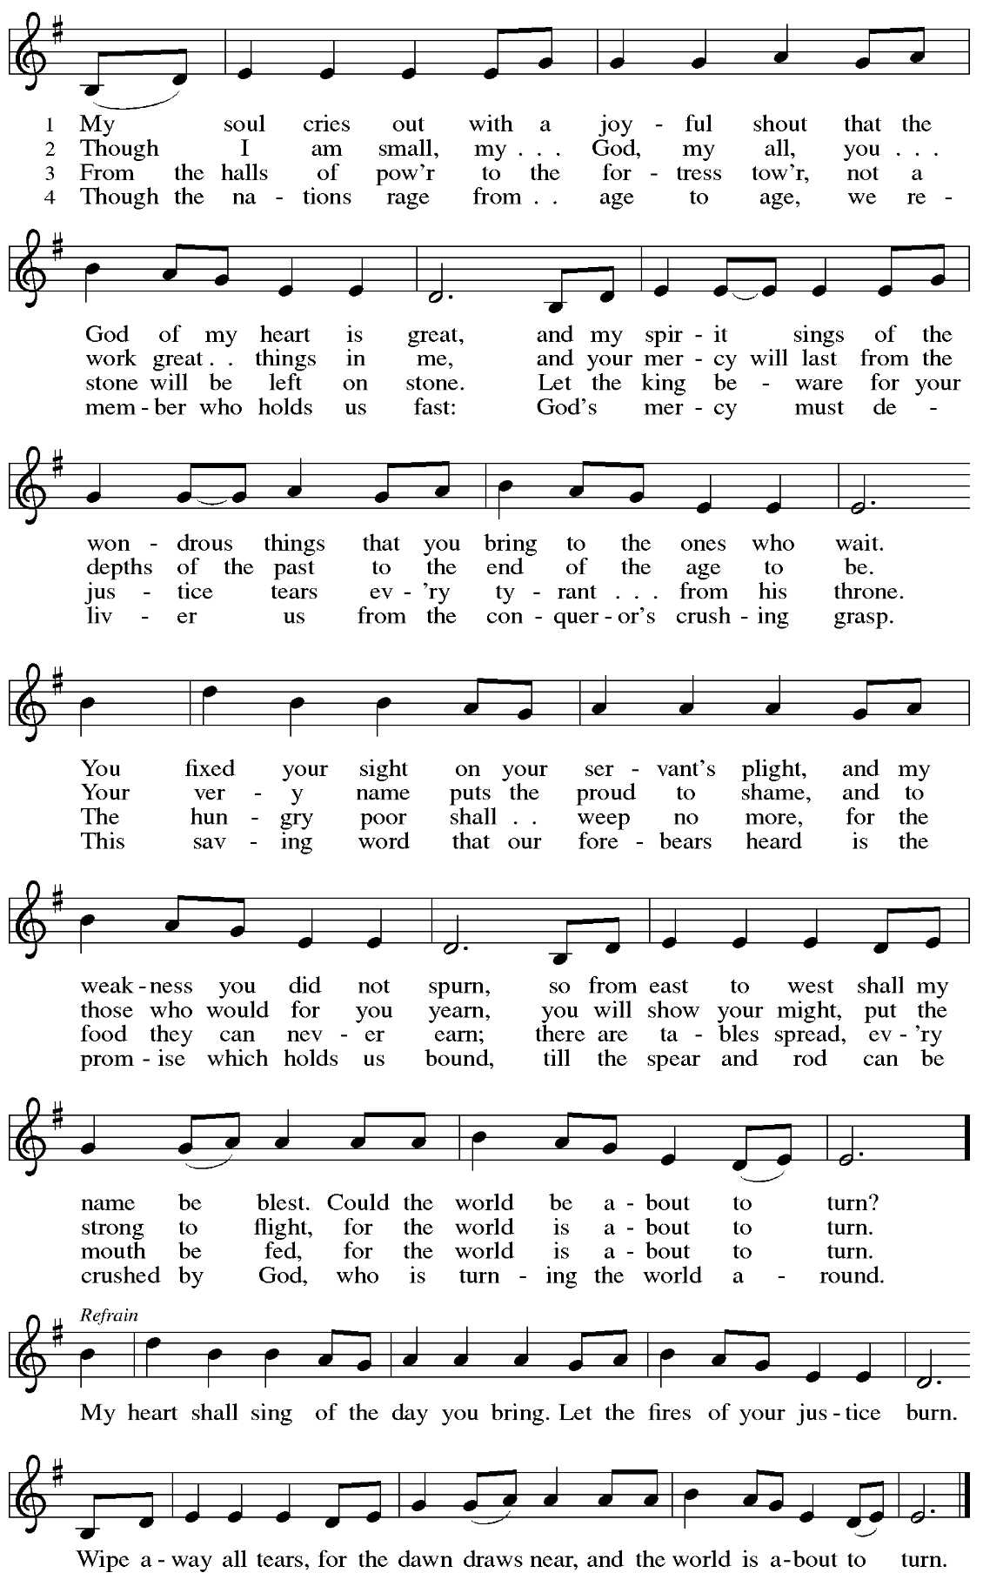

*When all have returned to their places, please rise as you are able.*

**Blessing**

P: The body and blood of our Lord Jesus Christ strengthen you and keep you in his grace.

**C: Amen.**

**Prayer**

A: Let us pray.

God for whom we wait,

in this meal you give us a foretaste of that day when the hungry will be fed with good things. Send us forth to make known your deeds and to proclaim the greatness of your name,

through Jesus Christ, our Savior and Lord.

**C: Amen.**

*Please be seated.*

**Sending**

*God blesses us and sends us in mission to the world*

**Announcements**

*Please rise as you are able.*

**Benediction**

P: God of endings and beginnings,

God in the darkness and in the light,

God, our hope for the journey,

☩ bless and keep you now and forever.

**C: Amen.**

**Sending Hymn** *Following page*

**Dismissal**

A: Go in peace. Prepare the way for Emmanuel.

**C: Thanks be to God.**

**Postlude**

**Sending Hymn Toda la tierra / All Earth Is Hopeful *ELW* 262**

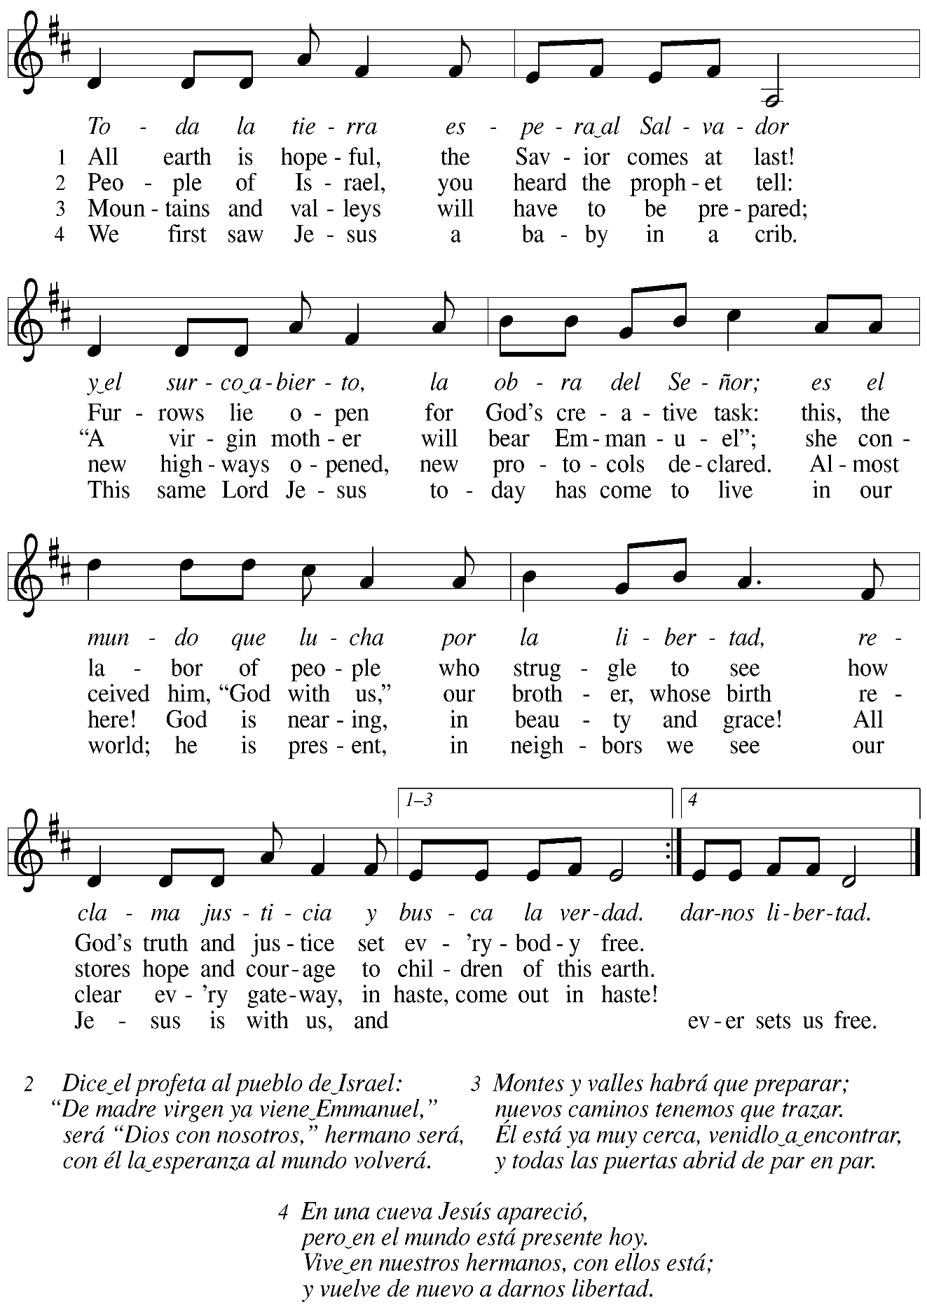

*Those serving in worship today*

Altar Care Jodie Minor

Assisting Minister Timothy Kocher-Hillmer

Audio-Visual Ministers Jason Galyardt

Tyler Rietze

Cantor Jered Stratton

Lector Colleen Cooke

Little Church – Big Faith Teacher Emily Duque

Piano Jeff Denlinger

Preaching and Presiding Minister Pastor Ross Carmichael

*Liturgy and Hymnody Acknowledgements*

From SundaysandSeasons.com. Copyright © 2024 Augsburg Fortress. All rights reserved. Reprinted under OneLicense.net # A-722139.

Used by permission of Augsburg Fortress.

The Scripture readings contained herein are from *New Revised Standard Version* of the Bible © 1989, Division of Christian Education of the National Council of Churches of Christ in the USA. Used by permission. All rights reserved.

**Wake, Awake, for Night Is Flying** – Text: Philipp Nicolai, 1556-1608; tr. composite. Music: WACHET AUF, Philipp Nicolai. Text © 1999 Augsburg Fortress. All rights reserved. Reprinted with permission under OneLicense.net #A-722139.

**Canticle of the Turning** – Text: Rory Cooney, b. 1952, based on the Magnificat. Music: STAR OF COUNTY DOWN, Irish traditional. Text © 1990 GIA Publications, Inc., 7404 S. Mason Ave., Chicago, IL 60638. [www.giamusic.com](http://www.giamusic.com). 800.442.3358. All rights reserved. Reprinted with permission under OneLicense.net # A-722139.

**Toda la tierra / All Earth Is Hopeful** – Text: Alberto Taulé, b. 1932; tr. Madeleine Forell Marshall, b. 1946. Music: TODA LA TIERRA, Alberto Taulé. Spanish text and tune © 1993 and English text © 1995 Centro de Pastoral Litúrgica, admin. OCP Publications, 5536 NE Hassalo, Portland, OR 97213. All rights reserved. Reprinted with permission under OneLicense.net # A-722139.

*Please use the QR code below to link to St. Andrew’s announcements online!*



**St. Andrew Lutheran Church Announcements**

**December 1st, 2024**

* **Welcome to Worship at St. Andrew on the First Sunday of Advent, December 1st, 2024** –We are thankful you are here, and we offer a special welcome to all visitors and guests here for the first time. Worship attendees are invited to make a name tag at the back of the worship space. Little Church – Big Faith, a Bible lesson and activity for children, will take place after the prayer of the day. There are also worship “toolkits” to help children engage with worship and “busy bags” for younger children available in the bookcase at the back of the sanctuary. Please feel free to take one to use with/for your children. All are invited to gather for coffee other drinks and food, and conversation in the social hall after worship.
* **Monthly Reparations Offering Today during Worship** – Jesus’ parable from Luke’s Gospel about a compassionate Samaritan provides an example of how God's people are called to work for healing and repair for our neighbors, independent of who or what caused harm. In light of this, St. Andrew has made a commitment to reparations in regard to African American spiritual songs used in our worship. The text and music of most hymns is attributed to specific authors, with copyrights in place, usage reported, and royalties paid to those whose works are featured in worship. With African American spirituals, this is not possible. In response to many years of such uncredited use, St. Andrew invites the congregation to give a reparations offering. Funds received in worship will be donated to our siblings at Bethel AME Church, whose land and building were taken from them in the 1950s, to fund their development in the lower Hill District.
* **Holiday Card Get-Together and Recipe Swap – Today, after Coffee Hour until 2:00 p.m. – Bring your holiday cards or small crafts and gather to hang out, chat, and work on cards or crafts. Holiday playlists and snacks are also welcome. Feel free to get lunch and join the group afterwards. Bring copies of a favorite recipe or two to share as well!**
* **December Produce Distribution – First Tuesday of the Month, December 3rd, 2024, from 5:30-7:00 p.m. – St. Andrew partners with Greater Pittsburgh Community Food Bank to serve as a distribution site for fresh produce on the first Tuesday of every month. This month’s distribution will be Tuesday, December 3rd. We invite people of the congregation to help with the distribution from 5:30-7:00 p.m., help with unloading and setup during the day between 10:00 a.m. and 1:00 p.m.**
* **Renaissance City Choir Concert – Saturday, December 7th, 7:00 p.m. – Renaissance City Choir, a local LGBTQIA+ choir, will perform their holiday concert, “A Very Ruby Holiday,” on Saturday, December 7th at 7:00 p.m. at East Liberty Presbyterian Church, 116 S. Highland Ave., 15206. All are invited to stay for a cookie social after the concert.** Accessibility questions may be directed to: [accessibility@rccpittsburgh.com](mailto:accessibility@rccpittsburgh.com).

Ticketing questions to: [marketing@rccpittsburgh.com](mailto:marketing@rccpittsburgh.com).

Tickets at: <https://www.ticketleap.events/tickets/rccpittsburgh/a-very-ruby-holiday>.

* **Choir Rehearsal – Sunday, December 8th, at 9:00 a.m.**
* **Annual Meeting of the Congregation – Next Sunday December 8th, after Worship – Each** year, St. Andrew holds an annual meeting of the congregation to discuss and approve a budget for mission and ministry in the upcoming year and to elect leaders to serve on the congregation council. This year's meeting will be held next Sunday, December 8th, after worship. Zoom access will be via the regular worship link. According to the constitution, no proxy or absentee votes can be accepted, so please plan to be here for the meeting!
* **Shelter Dinner for Guests of East End Cooperative Ministry – Thursday, December 19th, 6:30 p.m. –** Each month, people of St. Andrew provide dinner for guests of East End Cooperative Ministry, 6140 Station St. (East Liberty), 15206. We invite you to prepare or purchase one menu item and bring it to the shelter by 6:00 p.m., or just come to help serve at 6:30 p.m. If you would like to contribute, please sign up here:

<https://www.signupgenius.com/go/5080544AAAC22A1F58-53490586-shelter>.

* **Coffee Hour Signups Available** –One way that St. Andrew builds community is by sharing conversation over food and drinks at coffee hour after worship on Sundays. We invite people of the congregation to sign up to coordinate coffee hour each week, which includes brewing the coffee; setting out cups, napkins, food items, and cold drinks; and cleaning up afterward. Everything needed is at St. Andrew and instructions are available. Please sign up to host coffee hour here: <https://www.signupgenius.com/go/5080B4AAFAF2CABF85-47069030-coffee>.
* **New *Christ in Our Home* Devotional Booklets (January - March) Available at Church Entrances – *Christ in Our Home* is a booklet of devotions that includes Scripture, a brief reflection, and prayer for each day. The current and new editions are both available at the church entrances. Please feel free to take one for yourself or others!**
* **Compline Prayer Service with the Pittsburgh Compline Choir – Sundays at 8:00 p.m. at Heinz Chapel –** Compline was traditionally a monastic prayer service, and the Pittsburgh Compline Choir, a ministry of Lutheran Campus Ministry in Greater Pittsburgh, sings a choral version of compline rooted in this thousand-year-old tradition of scripture, song, and silence each Sunday at Heinz Chapel at 8:00 p.m. Heinz Chapel is located off of S. Bellefield Ave. in Oakland. For more information, please visit: [Pittsburgh Compline Choir](http://pittsburghcomplinechoir.org/).
* **Holiday Gift-Giving Opportunities through Bethesda Lutheran Services and JFCS –**

**Each year, St. Andrew chooses an organization to partner with to provide holiday gifts for children in need. This year the congregation will work with Bethesda Lutheran Services and JFCS.**

* **JFCS has set up a gift registry with** Learning Express in Wexford (buying

as locally as possible). This is the link to the registry: <https://learningexpress.com/wexford/giftr/registry/view/uid/FF5129350614/>. Gifts can be ordered directly on the LE website, and Joy Givens will pick everything up from the store, so anyone who orders can mark "pick up" from Wexford at checkout and will not have to worry about going to get items themselves.

* JFCS – St. Andrew will also collect new winter hats, mittens/gloves,

and packages of socks and underwear of all sizes in the social hall until Sunday, December 15th. JFCS has 160 kids on their list, 114 of whom are age 5 or older, so the need is great!

* **JFCS –** The JFCS Bridge Builders gift distribution event will take place on

Monday, December 16th, hopefully at the Carnegie Library's downtown

branch on Smithfield Street. We will invite parents to come and "shop" for

their children. We hope to offer one toy and hat/gloves set per child, new

packages of socks and underwear, and used books (which are already

being supplied). We will also assemble gift bags for families that are not able to get downtown and deliver them during that week. Anyone who wants to volunteer to staff our free store and/or deliver gifts should email Joy Givens at [jgivens@jfcspgh.org](mailto:jgivens@jfcspgh.org). Bridge Builders is a mentoring and enrichment program for locally resettled refugee and immigrant children, and Joy is happy to talk with anyone about what they do and who we serve!

* **Bethesda – Please see the full Bethesda Residential Wish List page printed**

**at the back of the bulletin. Donations will be accepted through Sunday,**

**December 15th.**