

**+ Twenty-First Sunday after Pentecost**

**October 13, 2024**



**St. Andrew Lutheran Church**

**304 Morewood Ave.**

**Pittsburgh, PA 15213**

[**St_andrewELCA@verizon.net**](mailto:St_andrewELCA@verizon.net)

[**www.standrewpittsburgh.org**](http://www.standrewpittsburgh.org)

**+ Twenty-First Sunday after Pentecost**

**Order for Worship**

*The rich man who comes to ask Jesus what he should do to inherit eternal life seems to be a good person, sincere in his asking. Mark’s gospel is alone in saying that Jesus looked on him and loved him. Out of love, not as judgment, Jesus offers him an open door to life: sell all you own and give it to the poor. Our culture bombards us with the message that we will find life by consuming. Our assemblies counter this message with the invitation to find life by divesting for the sake of the other.*

**Welcome to St. Andrew!**

* St. Andrew Lutheran congregation welcomes all who are seeking a place of healing and wholeness – a nurturing, faith-forming spiritual home. Our community embraces people of all ages, ethnicities, cultures, abilities, sexual orientations, gender identities and expressions, and family constellations. Come and See!
* Worship Services are live-streamed to multiple online platforms. By attending worship, you agree that your image and voice may be broadcast.
* Everyone is invited to make a name tag at the black bookcase in the back of the worship space. There are stickers indicating pronouns on the bookcase if you would like to include them on your name tag.
* Children are invited to attend Little Church – Big Faith, a Bible lesson and activity, during worship (after the Prayer of the Day). The group returns to the worship space for the liturgy of Holy Communion.
* A nursery is available through the doors at the left side of the sanctuary and across from the doorway to the Social Hall. Look for a purple-colored room.
* Worship “toolkits” to help children engage with the service, along with “busy bags” for younger children, are available in the bookcase at the back of the sanctuary. Please feel free to take one to use with/for your children.
* Holy Communion is served with bread (gluten-free available) and wine or grape juice. The presiding minister will distribute the bread (host). Please consume this and then pick up an empty glass from the tray. The Communion Assistant will pour wine or grape juice into your glass. Please step to the side to consume the wine or grape juice. Feel free to kneel at the altar for prayer and reflection. As you return to your pew, glasses may be returned to the empty trays on either side of the center section.
* A restroom is available on the main level of the church, through the doors to the Social Hall and to the right in the main office.

*Abbreviations*

P: Pastor/Presiding Minister ***ELW*: *Evangelical Lutheran Worship* hymnal**

A: Assisting Minister ***ACS*: *All Creation Sings* hymnal**

L: Lector ***HS*: *Hymnal Supplement* (GIA Publications)**

**C: Congregation**

**Pre-Service Music**

**Welcome**

**Prelude** *Great Is Thy Faithfulness* arr. Shackley

**Gathering**

*The Holy Spirit calls us together as the people of God*

**Thanksgiving for Baptism**

*Please rise as you are able. All may make the sign of the cross, the sign that is marked at Baptism, as the presiding minister begins.*

P: In the name of the one God who creates, ☩ redeems, and sanctifies us and all creation,

whose voice reverberated in the burning bush,

whose image reflects our sacred belonging and purpose.

**C: Amen.**

P: Joined to Christ in the waters of Baptism, we are held close by God’s endless compassion,

which flows like an unfailing stream. God’s gift of water is for all God’s beloved people,

a means for washing, cleansing, healing, restoring, playing, and nurturing. Let us give thanks for the gift of Baptism.

*Silence is kept for reflection*

P: Gracious God,

we give thanks for your breath that hovered over the waters and spoke life into being.

We remember the great flood in which you proclaimed your promise

through the brilliant colors of the rainbow,

and the seas that split open our thirst for power, dominance, and control.

We thank you for the One who transformed water into wine,

who sought to share all your gifts with those the world had disenfranchised.

We pray in gratitude for your gift of Baptism and for this water,

in which your Word proclaims that you, me, we all are your beloved children,

and assures us that nothing can separate us from your love in Christ Jesus.

Cleanse our fears. Drown our divisions. Let us die to a life that pulls us away from your faithful, persistent love and let us rise to a new life that says yes to your ways of love and grace.

To you be given honor and praise, through Jesus Christ, our living water,

in the unity of the Holy Spirit, now and forever.

**C: Amen.**

**Gathering Hymn God, We Gather as Your People *ACS* 1038**

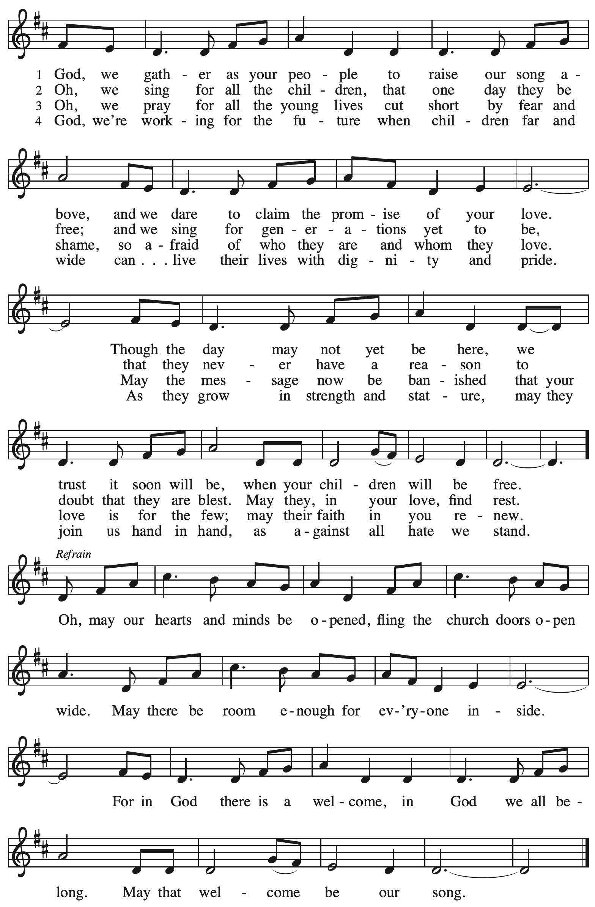

**Greeting**

P: The grace of our Lord Jesus Christ, the love of God,

and the communion of the Holy Spirit be with you all.

**C: And also with you.**

**Hymn of Praise** *ELW* p. 204

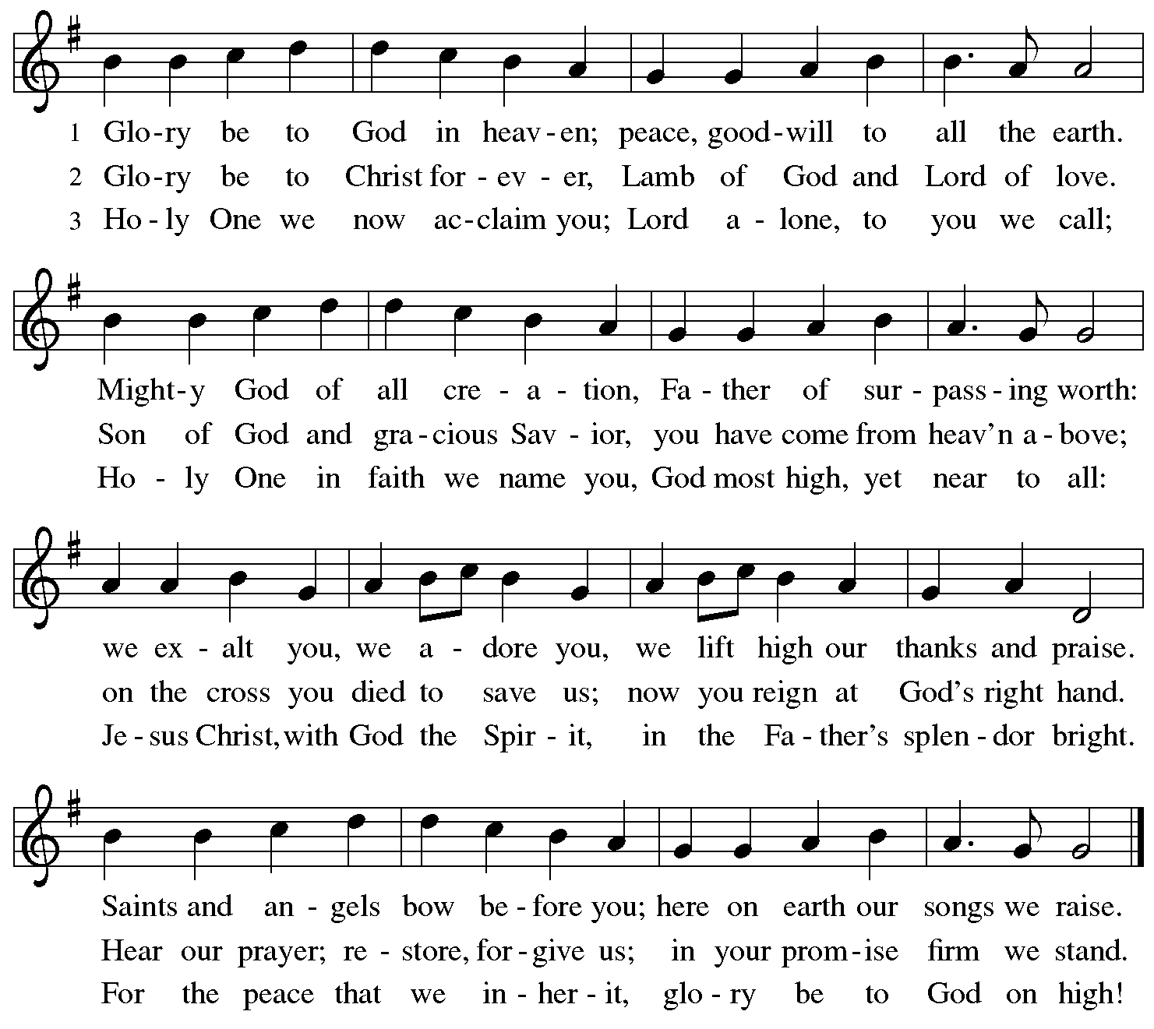

**Prayer of the Day**

P: The Lord be with you.

**C: And also with you.**

P: Let us pray.

Almighty and ever-living God,

You have promised through your Son to be with your church forever.

We give you thanks for those who founded this community of believers

and for the signs of your presence in this congregation.

Increase in us the spirit of faith and love,

that, remembering what lies behind and reaching out to what lies ahead,

we may follow the way of your commandments, and receive the crown of everlasting joy,

through Jesus Christ, our Savior and Lord,

who lives and reigns with you and the Holy Spirit,

one God, now and forever.

**C: Amen.**

*Please be seated.*

*Children are invited to join the adult leaders at the door and move to the office for Little Church – Big Faith. We ask that one additional adult from the congregation attend with the children.*

**Word**

*God speaks to us in Scripture reading, preaching, and song*

**First Reading** **–** **Amos 5: 6-7, 10-15**

 6Seek the Lord and live,  
  or the Lord will break out against the house of Joseph like fire,  
  and it will devour Bethel, with no one to quench it.  
 7Ah, you that turn justice to wormwood,  
  and bring righteousness to the ground!

 10They hate the one who reproves in the gate,  
  and they abhor the one who speaks the truth.  
 11Therefore because you trample on the poor  
  and take from them levies of grain,  
 you have built houses of hewn stone,  
  but you shall not live in them;  
 you have planted pleasant vineyards,  
  but you shall not drink their wine.  
 12For I know how many are your transgressions,  
  and how great are your sins—  
 you who afflict the righteous, who take a bribe,  
  and push aside the needy in the gate.  
 13Therefore the prudent will keep silent in such a time;  
  for it is an evil time.

14Seek good and not evil,  
  that you may live;  
 and so the Lord, the God of hosts, will be with you,  
  just as you have said.  
 15Hate evil and love good,  
  and establish justice in the gate;  
 it may be that the Lord, the God of hosts,  
  will be gracious to the remnant of Joseph.

L: Word of God, word of life.

**C: Thanks be to God.**

**Psalm 90: 12-17**

*Today’s psalm will be sung and led by the cantor,*

*with the congregation invited to respond with the alternate verses in bold type and the refrain.*

*Psalm tone*



*Psalm refrain*



12So teach us to num- **|** ber our days  
  that we may apply our **|** hearts to wisdom.

13**Return, O Lord; how long | will you tarry?**  
  **Be gracious | to your servants. R**  
 14Satisfy us by your steadfast love **|** in the morning;  
  so shall we rejoice and be glad **|** all our days.  
 15**Make us glad as many days as you af- | flicted us**  
  **and as many years as we suf- | fered adversity.**  
 16Show your ser- **|** vants your works,  
  and your splendor **|** to their children.  
 17**May the graciousness of the Lord our God | be upon us;**  
  **prosper the work of our hands; pros- | per our handiwork. R**

**Second Reading – Hebrews 4: 12-16**

12Indeed, the word of God is living and active, sharper than any two-edged sword, piercing until it divides soul from spirit, joints from marrow; it is able to judge the thoughts and intentions of the heart. 13And before God no creature is hidden, but all are naked and laid bare to the eyes of the one to whom we must render an account.  
  
 14Since, then, we have a great high priest who has passed through the heavens, Jesus, the Son of God, let us hold fast to our confession. 15For we do not have a high priest who is unable to sympathize with our weaknesses, but we have one who in every respect has been tested as we are, yet without sin. 16Let us therefore approach the throne of grace with boldness, so that we may receive mercy and find grace to help in time of need.

L: Word of God, word of life.

**C: Thanks be to God.**

*Please rise as you are able and join in speaking the Gospel Acclamation.*

**Gospel Acclamation** *ELW* p. 205

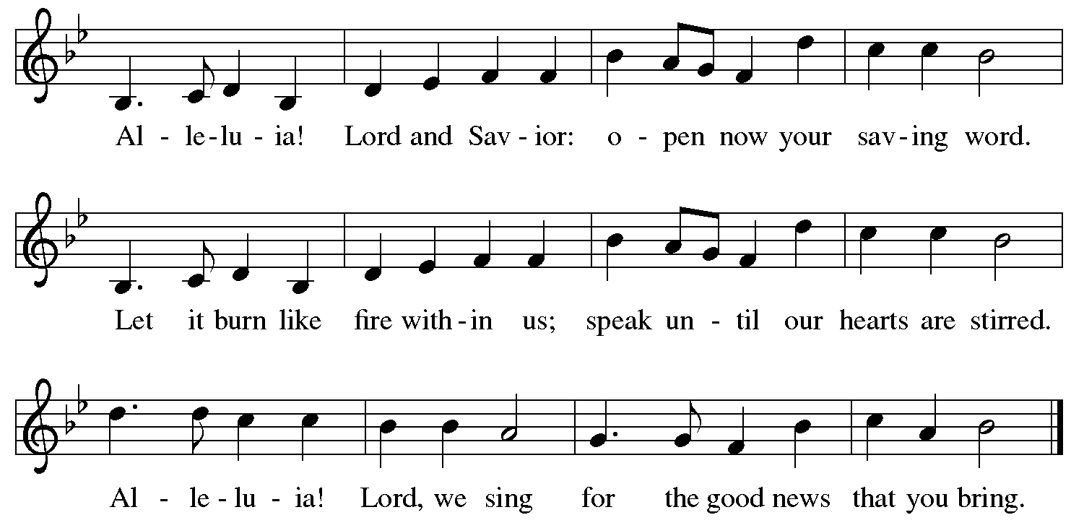

**Gospel – Mark 10: 17-31**

P: The holy Gospel according to St. Mark.

**C: Glory to you, O Lord.**

17As [Jesus] was setting out on a journey, a man ran up and knelt before him, and asked him, “Good Teacher, what must I do to inherit eternal life?” 18Jesus said to him, “Why do you call me good? No one is good but God alone. 19You know the commandments: ‘You shall not murder; You shall not commit adultery; You shall not steal; You shall not bear false witness; You shall not defraud; Honor your father and mother.’ ” 20He said to him, “Teacher, I have kept all these since my youth.” 21Jesus, looking at him, loved him and said, “You lack one thing; go, sell what you own, and give the money to the poor, and you will have treasure in heaven; then come, follow me.” 22When he heard this, he was shocked and went away grieving, for he had many possessions.

 23Then Jesus looked around and said to his disciples, “How hard it will be for those who have wealth to enter the kingdom of God!” 24And the disciples were perplexed at these words. But Jesus said to them again, “Children, how hard it is to enter the kingdom of God! 25It is easier for a camel to go through the eye of a needle than for someone who is rich to enter the kingdom of God.” 26They were greatly astounded and said to one another, “Then who can be saved?” 27Jesus looked at them and said, “For mortals it is impossible, but not for God; for God all things are possible.”  
 28Peter began to say to him, “Look, we have left everything and followed you.” 29Jesus said, “Truly I tell you, there is no one who has left house or brothers or sisters or mother or father or children or fields, for my sake and for the sake of the good news, 30who will not receive a hundredfold now in this age—houses, brothers and sisters, mothers and children, and fields, with persecutions—and in the age to come eternal life. 31But many who are first will be last, and the last will be first.”

P: The Gospel of the Lord.

**C: Praise to you, O Christ.**

*Please be seated.*

**Sermon**

*A time of silence for prayer and reflection follows the sermon.*

*When the hymn of the day begins, please rise as you are able.*

**Hymn of the Day Faith Begins by Letting Go *ACS* 1004**

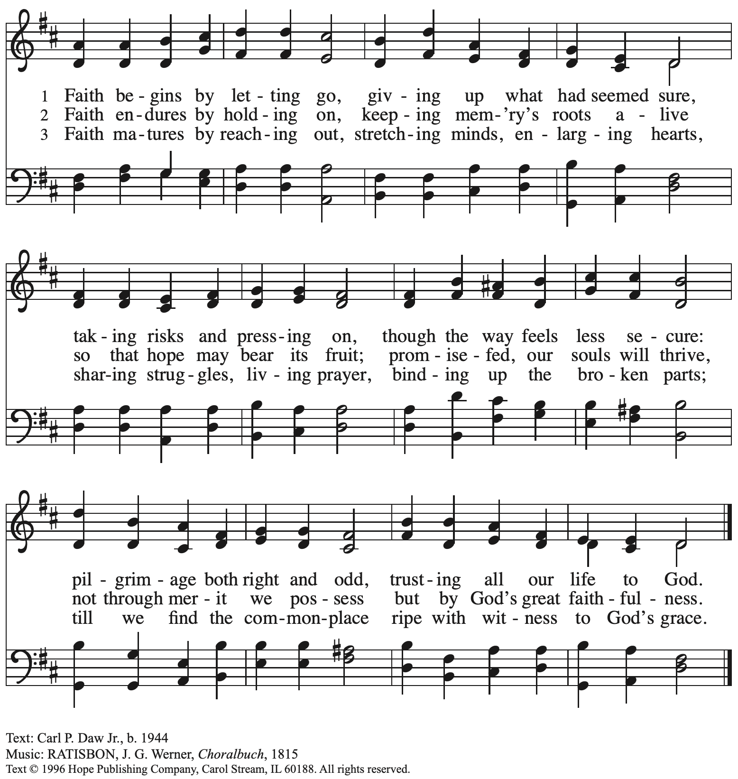

Reprinted with permission under OneLicense.net # A-722139.

**Nicene Creed**

*Profession of our faith using the Nicene Creed, one of the Christian Church’s*

*three ecumenical creeds, unites us with siblings in Christ around the world.*

**C: We believe in one God,**

**the Father, the Almighty,**

**maker of heaven and earth,**

**of all that is, seen and unseen.**

**We believe in one Lord, Jesus Christ,**

**the only Son of God,**

**eternally begotten of the Father,**

**God from God, Light from Light,**

**true God from true God,**

**begotten, not made,**

**of one Being with the Father;**

**through him all things were made.**

**For us and for our salvation**

**he came down from heaven,**

**was incarnate of the Holy Spirit and the virgin Mary**

**and became truly human.**

**For our sake he was crucified under Pontius Pilate;**

**he suffered death and was buried.**

**On the third day he rose again**

**in accordance with the scriptures;**

**he ascended into heaven**

**and is seated at the right hand of the Father.**

**He will come again in glory to judge the living and the dead,**

**and his kingdom will have no end.**

**We believe in the Holy Spirit, the Lord, the giver of life,**

**who proceeds from the Father and the Son,\***

**who with the Father and the Son is worshiped and glorified,**

**who has spoken through the prophets.**

**We believe in one holy catholic and apostolic church.**

**We acknowledge one baptism for the forgiveness of sins.**

**We look for the resurrection of the dead,**

**and the life of the world to come. Amen.**

*Or, “who proceeds from the Father.” The phrase “and the Son” is a later addition to the creed.

**Prayers of the People**

A: Drawn together by the power of the Holy Spirit, we pray for the church,

those in need, and all of God’s creation.

*After each petition*

A: Merciful God,

**C: receive our prayer.**

*The presiding minister concludes the prayers*

P: We entrust these and all our prayers to you, holy God,

in the name of your beloved, Jesus Christ, our Savior.

**C: Amen.**

**Peace**

*The presiding minister and the assembly greet one another in the peace of the risen Christ.*

P: The peace of Christ be with you always.

**C: And also with you.**

*The people may greet those around them with a sign of Christ’s peace and may say*

Peace be with you *or similar words. Please be mindful that not everyone will be comfortable with sharing the peace, so please seek consent before shaking hands or hugging. Other possible ways to share the peace include a simple bow with the verbal greeting of peace, or simply a verbal expression of peace. When the greetings of peace have concluded, please be seated.*

**Meal**

*God feeds us with the presence of Jesus Christ*

**Offering**

*We offer ourselves, our gifts and our faithful service to God.* *As the offering is gathered for the mission of the church, including the care of those in need, the table is set for Holy Communion.*

*There are laminated giving cards in the pew racks that feature a QR code for anyone who would like to give online. Those who give using the QR code, as well as those who give regularly online or through their bank are encouraged to place the laminated card in the plate as an expression of your offering.*

**Music during the Offering**

*The Plowshare Prayer* S. LaJoye

*As the gifts are brought forward for presentation, please rise as you are able.*

**Offertory Song Accept, O Lord, the Gifts We Bring *ELW* 491**

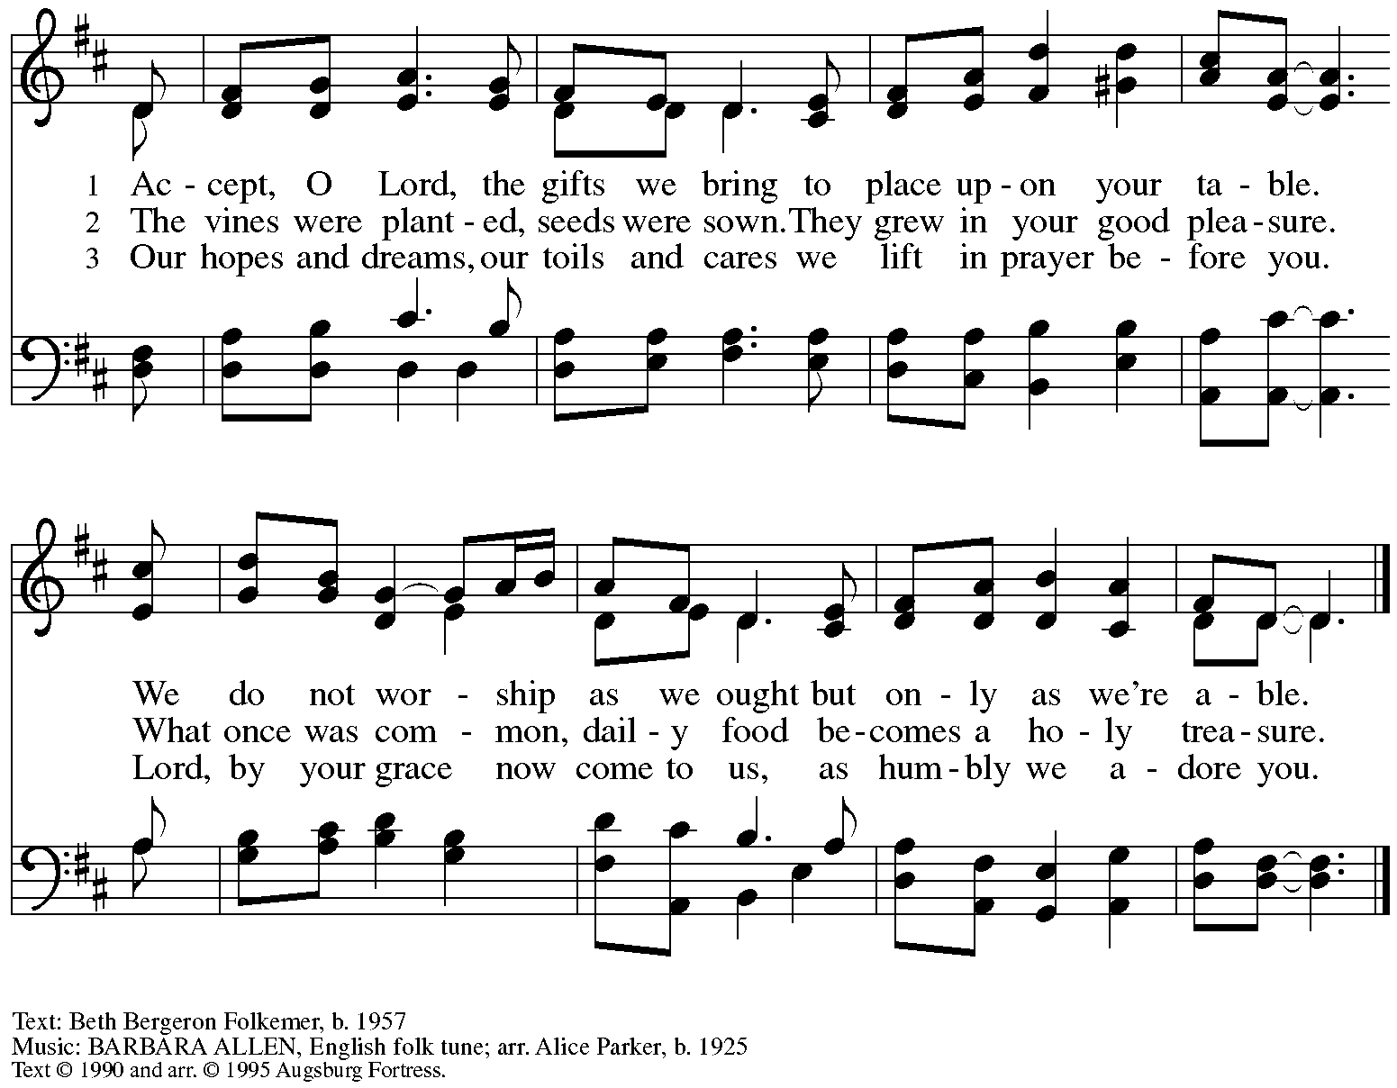

All rights reserved. Reprinted under OneLicense.net # A-722139.

**Offertory Prayer**

A: Let us pray.

Blessed are you,

**C:** **O God, source of all creation.**

**By these gifts and with our lives,**

**help us to serve one another and all in need,**

**through Jesus Christ, our Savior and Lord.**

**Amen.**

**Dialogue**

P: The Lord be with you.

**C: And also with you.**

P: Lift up your hearts.

**C: We lift them to the Lord.**

P: Let us give thanks to the Lord our God.

**C: It is right to give our thanks and praise.**

**Preface**

P: It is indeed right, our duty and our joy …

… we praise your name and join their unending hymn:

**Sanctus** *ELW* p. 207

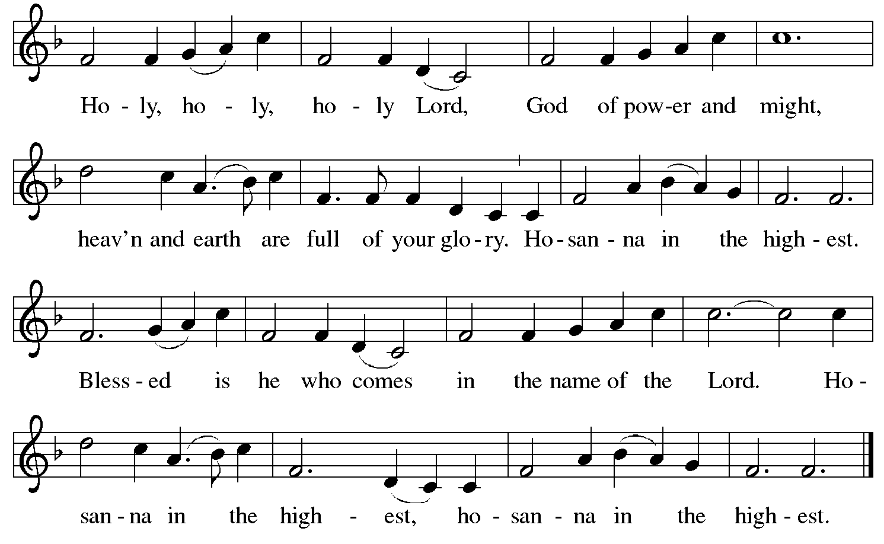

**Eucharistic Prayer**

P: Blessed are you, O God …

… Do this for the remembrance of me.

As often as we eat this bread and drink this cup

we proclaim the Lord’s death until he comes.

**C: Christ has died.**

**Christ is risen.**

**Christ will come again.**

P: Pour out your Holy Spirit …

… power of the Most High, now and forever.

**C: Amen.**

**Lord’s Prayer**

P: Gathered as one by the Holy Spirit, let us pray as Jesus taught us.

**C: Our Father in heaven,**

**hallowed be your name,**

**your kingdom come,**

**your will be done,**

**on earth as in heaven.**

**Give us today our daily bread.**

**Forgive us our sins**

**as we forgive those**

**who sin against us.**

**Save us from the time of trial**

**and deliver us from evil.**

**For the kingdom, the power,**

**and the glory are yours,**

**now and forever. Amen.**

**Fraction and Invitation**



***Agnus Dei /* Lamb of God** *ELW* p. 208

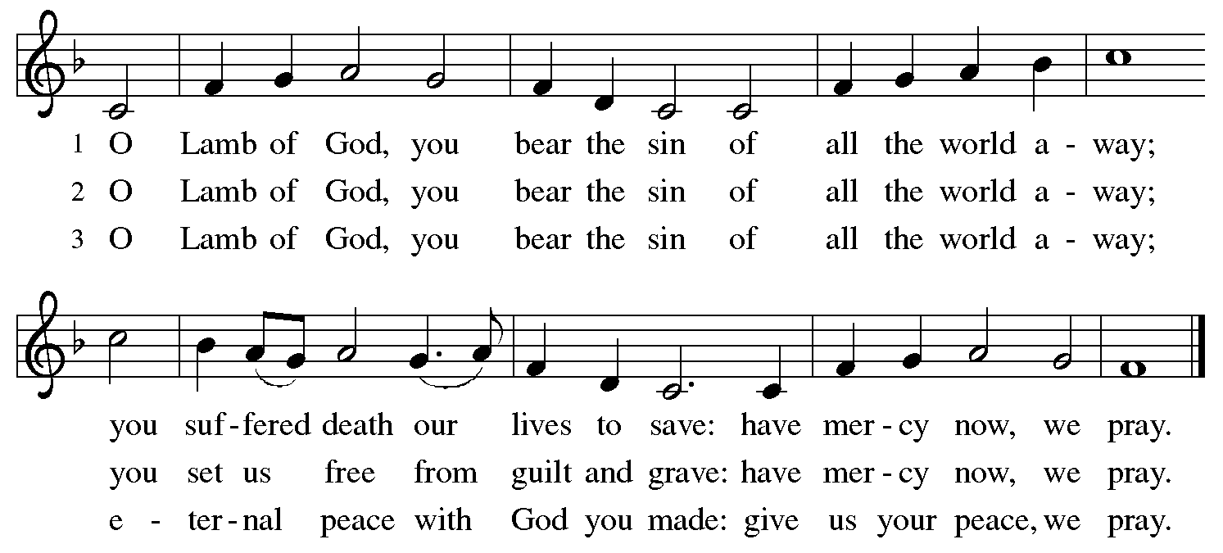

*Please be seated. As people of the assembly line up for Communion, you will see poster boards against the wall to your left. Each person is invited to take a notecard and write a word or phrase that expresses your thanksgiving to God for St. Andrew and our communal life together. These thanksgivings can then be posted before coming forward to receive Holy Communion.*

**Holy Communion**

* *All who seek God and desire a deeper and stronger life in Christ are welcome to receive Holy Communion.*
* *Worshipers from the pulpit side will proceed forward first, followed by the center section, and then the lectern side.*
* *Please inform an usher if you would like the ministers to bring Communion to you.*
* *Holy Communion will be served with bread and wine/grape juice.*
* *The presiding minister will first distribute the bread (host) to each communicant. Please indicate if you require a gluten-free host.*
* *Once you have consumed the bread, please pick up an empty glass from the tray next to the presiding minister. The Communion Assistant will pour wine from the chalice or grape juice from the cruet into your glass.*
* *Please step to the side to consume the wine or grape juice.*
* *Feel free to kneel at the altar rail for prayer after receiving the sacrament.*
* *As you return to your pew, glasses may be returned to the empty trays on either side of the center section.*
* *A blessing will be provided for anyone who does not yet receive the sacrament.*
* *All are invited to join in singing the hymns during Holy Communion.*

**Hymns during Holy Communion**

**Commonwealth Is God’s Commandment *ACS* 1036**

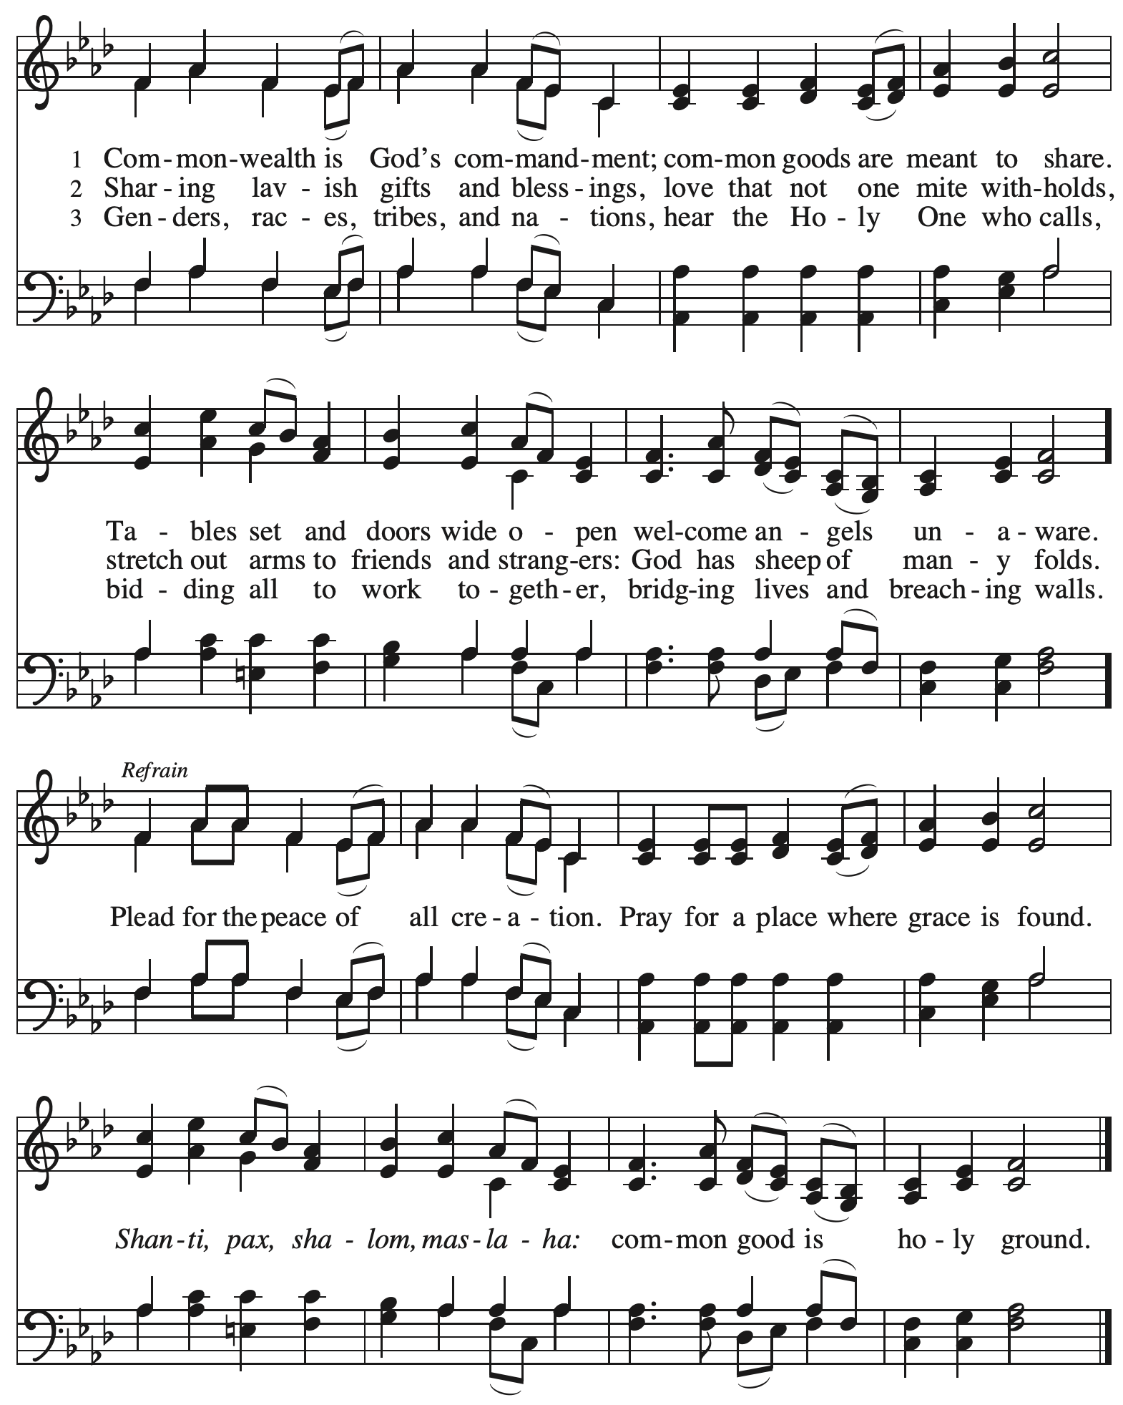

This hymn’s refrain includes words meaning *peace* from other religious traditions. Shanti (Sanskrit) is pronounced “shan-tee” and is used in Hindu and Buddhist traditions. Pax (Latin) is pronounced “pahks.” Shalom (Hebrew) is pronounced “shuh-lohm” and means peace, wholeness. Maslaha (Arabic) is pronounced “muhs-lah-hah” and means reconciliation.

**Hymns during Holy Communion**

**God Is Love *ACS* 1041**

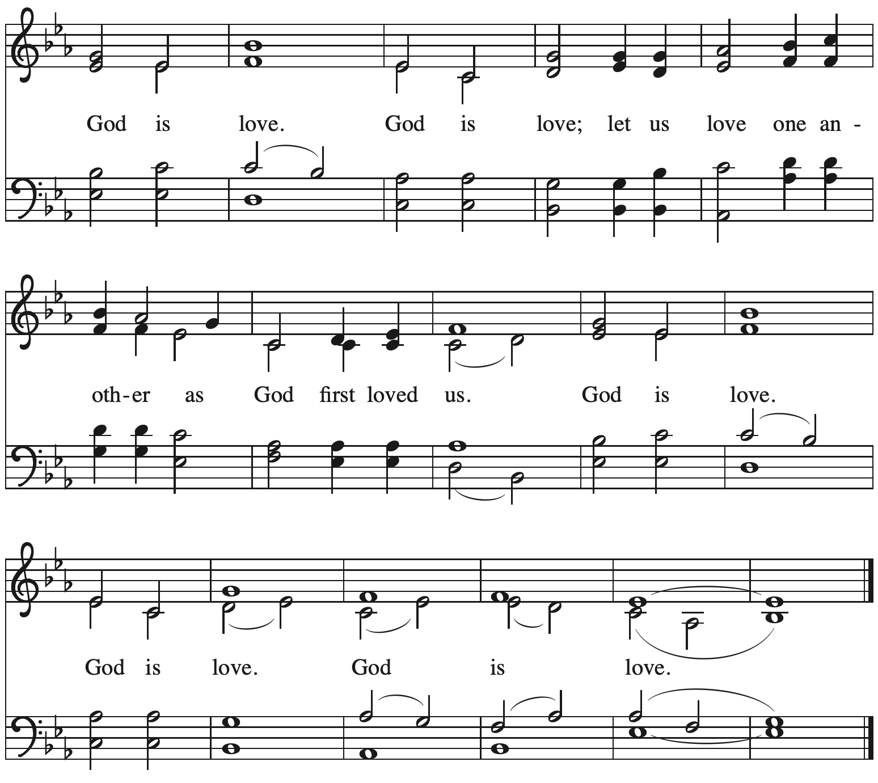



All rights reserved. Reprinted with permission under OneLicense.net # A-722139.

**Hymns during Holy Communion**

**Rise, O Church, Like Christ Arisen *ELW* 548**

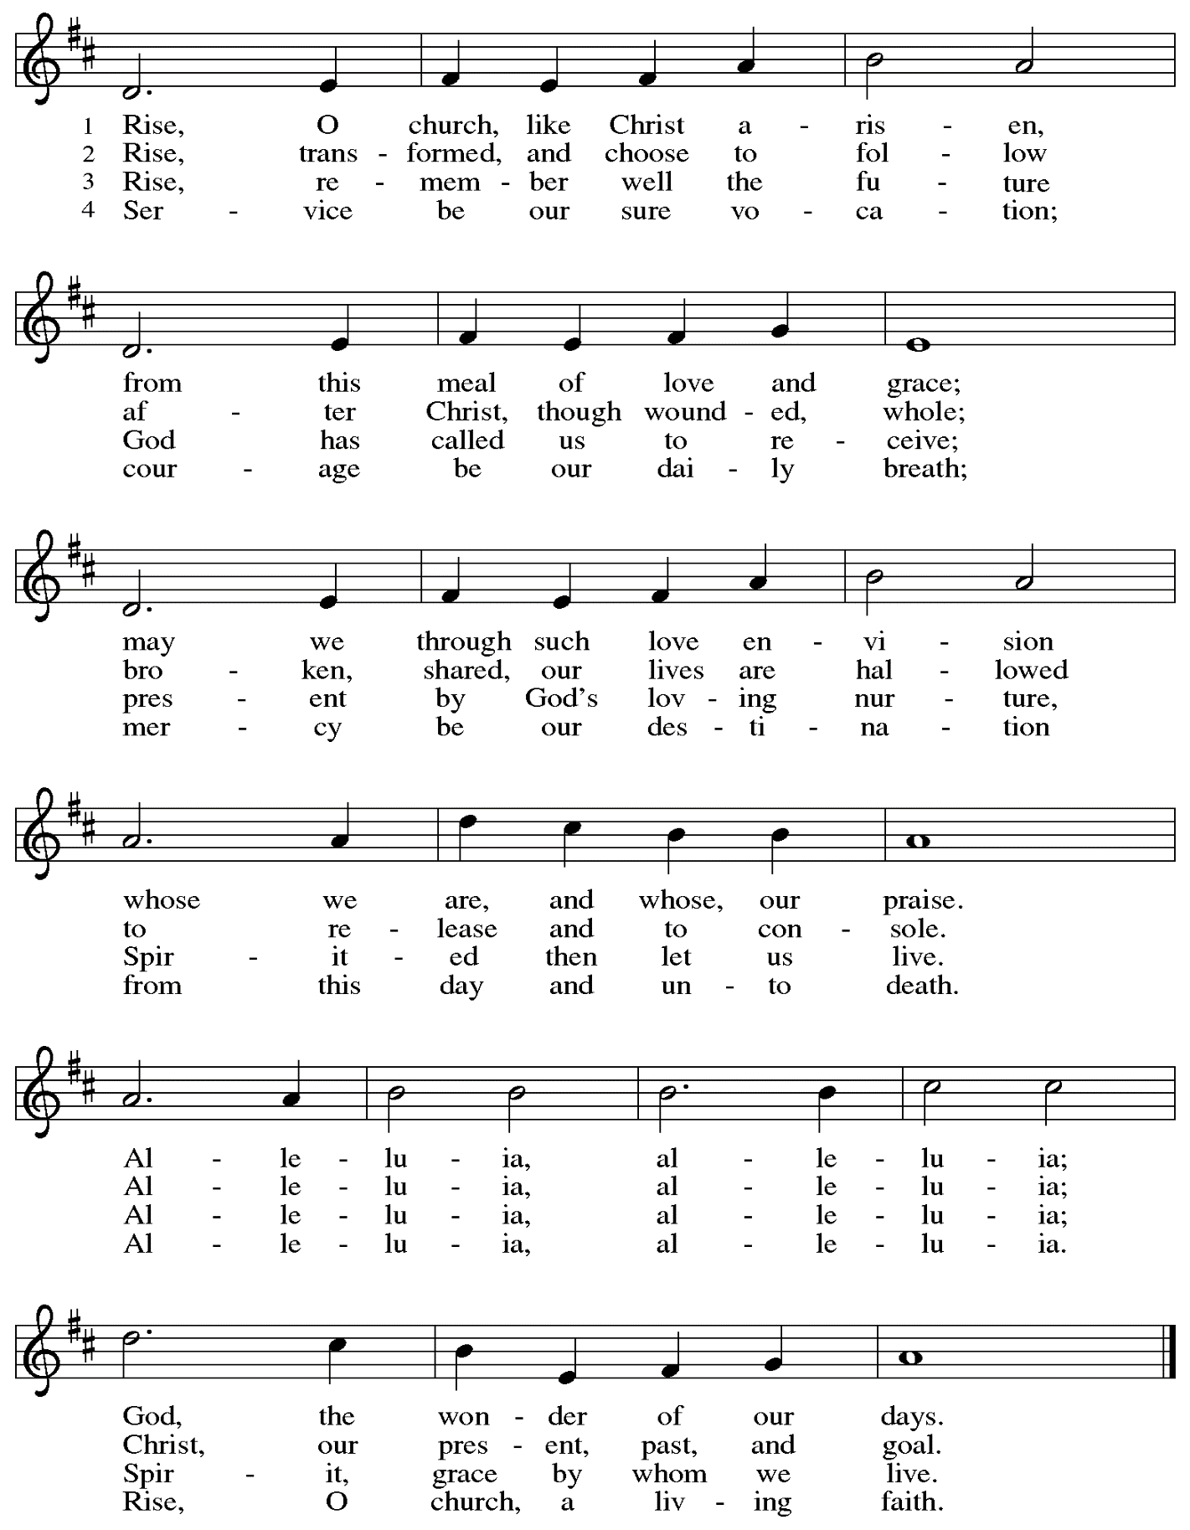

**Hymns during Holy Communion**

**Light Dawns on a Weary World *ELW* 726**

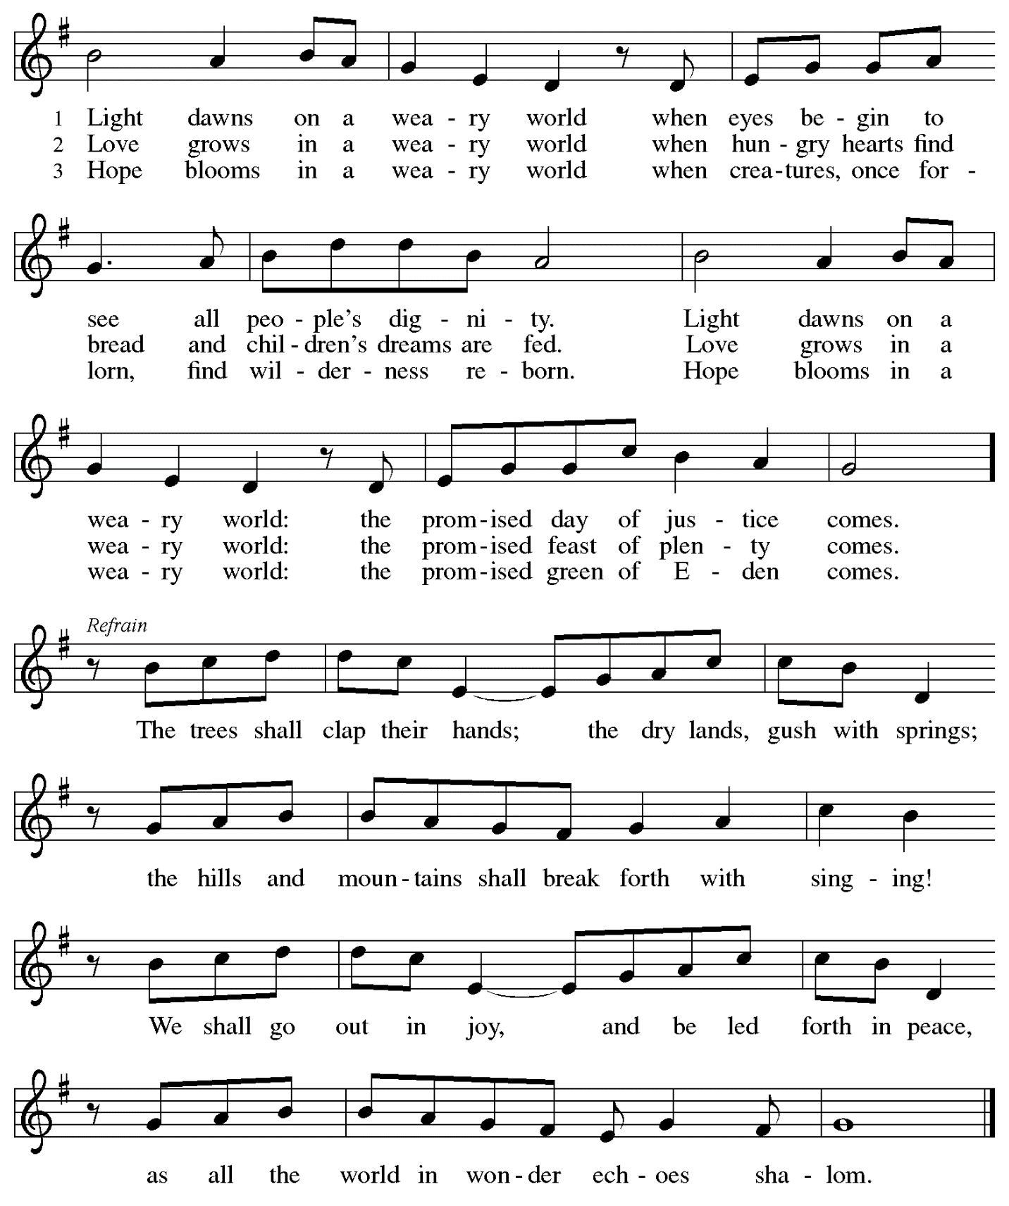

**Hymns during Holy Communion *ELW* 583**

**Toma, oh Dios, mi violuntad – Take My Life, That I May Be**

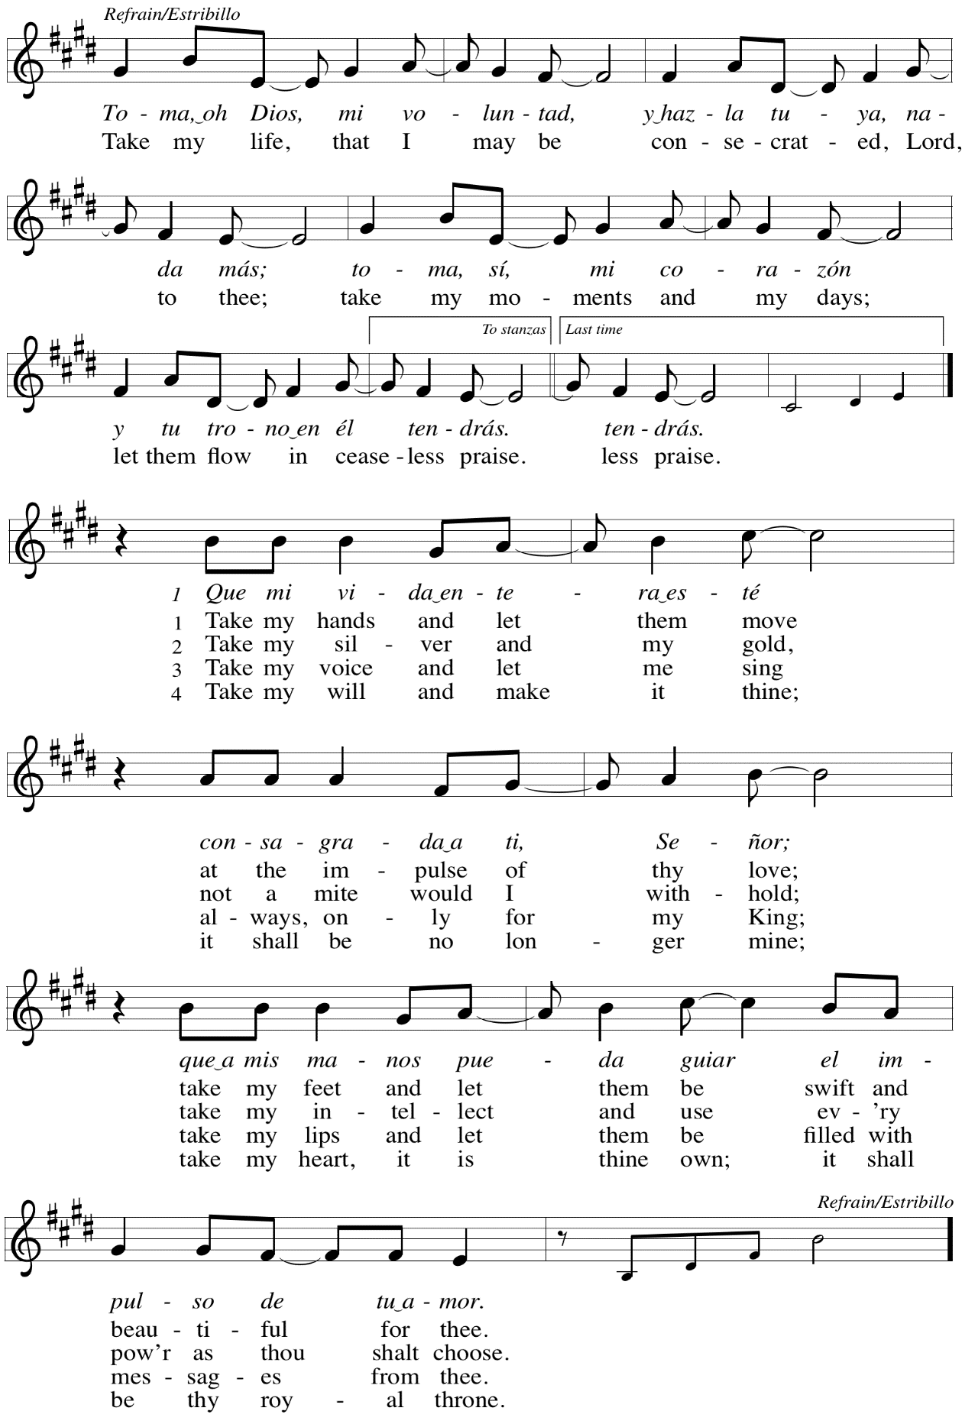

*When all have returned to their places, please rise as you are able.*

**Blessing**

P: May you deeply trust in the one who has fed and nourished us at his table,

our Savior Jesus Christ. May his gifts urge you forward with renewed strength and life,

to be God’s love in, to, and for the world.

**C: Amen.**

**Prayer**

A: Let us pray.

Holy God, you have welcomed us to this meal

and fed us at your table with your gifts of grace and life.

We thank you for the opportunity to serve and be served

by those you have brought alongside us in our journey of faith,

for our beloved siblings of all gender identities and expressions,

sexual orientations, ages, cultures and ethnicities, gifts, talents, and abilities.

Turn our thanks into action. Grant us freedom and courage as we follow in the way of your Son, the Christ, our redeemer, with the guidance of your Spirit.

**C: Amen.**

*Please be seated.*

**Sending**

*God blesses us and sends us in mission to the world*

**Announcements**

*Please rise as you are able.*

**Thanksgiving for St. Andrew’s Anniversary**

**Reading – Psalm 84: 1-4**

1How lovely is your dwelling place,  
 O LORD of hosts!  
 2My soul longs, indeed it faints  
 for the courts of the LORD;  
 my heart and my flesh sing for joy  
 to the living God.  
 3Even the sparrow finds a home,  
 and the swallow a nest for herself,  
 where she may lay her young,  
 at your altars, O LORD of hosts,  
 my King and my God.  
 4Happy are those who live in your house,  
 ever singing your praise.

**Reading – 1 Kings 8: 22-24, 27-30**

22Then Solomon stood before the altar of the LORD in the presence of all the assembly of Israel, and spread out his hands to heaven. 23He said, "O LORD, God of Israel, there is no God like you in heaven above or on earth beneath, keeping covenant and steadfast love for your servants who walk before you with all their heart, 24the covenant that you kept for your servant my father David as you declared to him; you promised with your mouth and have this day fulfilled with your hand.

27But will God indeed dwell on the earth? Even heaven and the highest heaven cannot contain you, much less this house that I have built! 28Regard your servant's prayer and his plea, O LORD my God, heeding the cry and the prayer that your servant prays to you today; 29that your eyes may be open night and day toward this house, the place of which you said, 'My name shall be there,' that you may heed the prayer that your servant prays toward this place. 30Hear the plea of your servant and of your people Israel when they pray toward this place; O hear in heaven your dwelling place; heed and forgive.

**Litany of Thanksgiving**

P: Praise God, from whom all blessings flow!

**C: Praise God, all creatures here below!**

P: God has blessed us and brought us to this time.

**C: God has blessed us and brought us to this place.**

P: God has caused God’s name to dwell in our midst.

**C: God has stirred our hearts and made us glad.**

P: God has been revealed to us through the Word.

**C: God has shown us the way, the truth, and the life.**

P: God has nurtured and fed us.

**C: God has shown us continuous love and grace.**

P: God has gathered us in loving community with one another.

**C: God has made us witnesses in the world.**

P: Thanks be to God for 133 years!

**C: Thanks be to God forevermore!**

*All are invited to join in singing the congregational refrain,*

*a verse sung on special occasions at St. Andrew for many years.*

**Congregational Refrain *HS* 808**



Text: Jaroslav J. Vajda, b. 1919. Music: RIVERSIDE, Irregular; Carl F. Schalk, b. 1929. Text and music © 1987 GIA Publications, Inc. All rights reserved. Reprinted with permission under OneLicense.net # A-722139.

**Benediction**

P: Go forth in peace and with the courage of faith.

Love God with all your heart, with all your soul, and with all your mind,

and love your neighbor as yourself. Whatever you do in word or deed,

do everything in the name of the Lord Jesus, giving thanks to God through him.

The God of hope fill you with all joy and peace in believing,

so that you may abound in hope by the power of the Holy Spirit.

God almighty,

God most merciful,

☩ bless you and keep you,

now and forever.

**C: Amen.**

**Sending Hymn** *Following page*

**Dismissal**

A: Go in peace. Serve the Lord.

**C: Thanks be to God.**

**Postlude** *All Are Welcome*

**Sending Hymn All Are Welcome *ELW* 641**

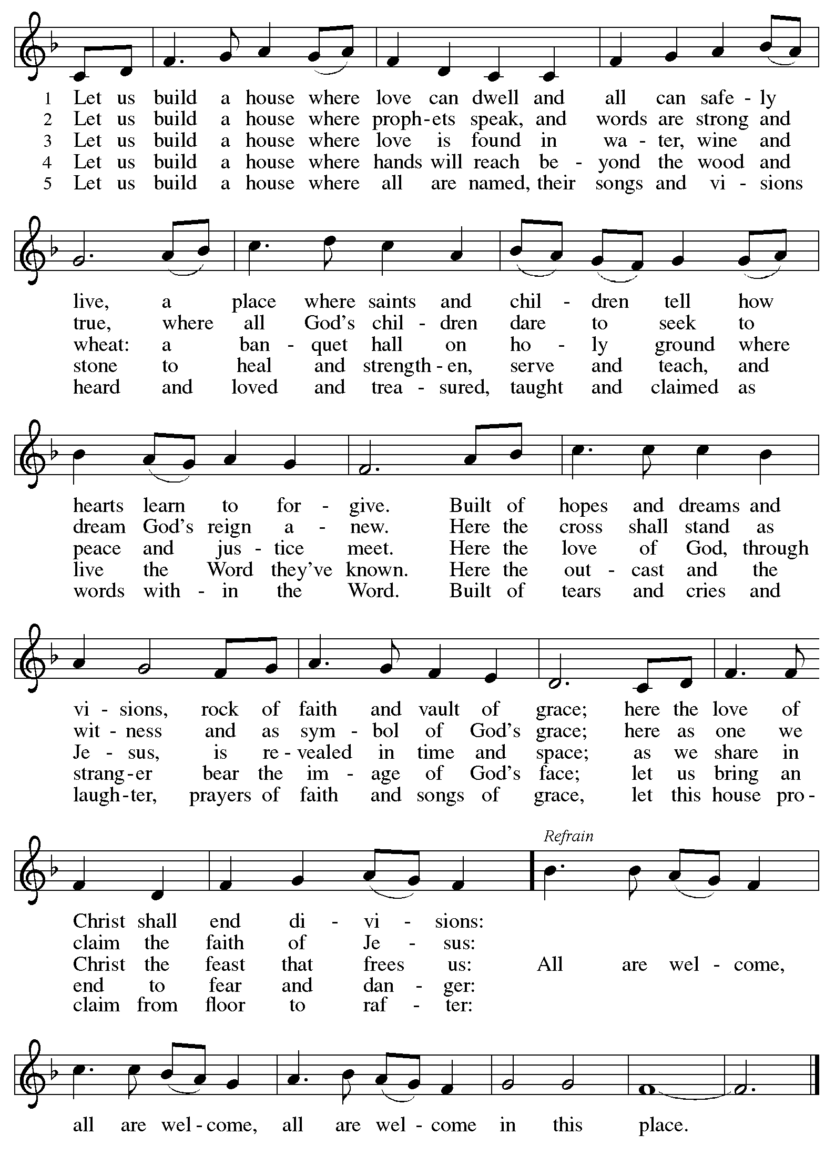

*Those serving in worship today*

Altar Care Jodie Minor

Assisting Minister Colleen Cooke

Audio-Visual Ministers Kristen Asplin

Tyler Rietze

Cantor Jered Stratton

Clarinet Maria Mangano

Lector Lindsay Baxter

Vocalist The Rev. Erin Jones

Minister of Music Laura Reynolds

Pastors Emeriti The Rev. Janet B. Grill

The Rev. Keith E. Grill

Preaching and Presiding Minister Pastor Ross Carmichael

*Liturgy and Hymnody Acknowledgements*

From SundaysandSeasons.com. Copyright © 2024 Augsburg Fortress. All rights reserved. Reprinted under OneLicense.net # A-722139.

Used by permission of Augsburg Fortress.

The Scripture readings contained herein are from *New Revised Standard Version* of the Bible © 1989, Division of Christian Education of the National Council of Churches of Christ in the USA. Used by permission. All rights reserved.

Elements of today’s worship come from *Roll Down Justice* - Reconciling in Christ Sunday 2024 from ReconcilingWorks. It is adapted from several sources, including Dr. Marcia McFee’s “Roll Down Justice” from the *Worship Design Studio*. The worship outline was crated by David Horton, Word and Service intern for ReconcilingWorks and edited by Deacon Liz Colver and Rev. Heather Thonvold.

The Litany of Thanksgiving is based on “Litany for the Anniversary of a Church” by The Rev. Thomas L. Weitzel, *Evangelical Lutheran Church in America*. <https://www.liturgybytlw.com/OccChs/ChAnnv.html>.

**God, We Gather as Your People**



All rights reserved. Reprinted with permission under OneLicense.net # A-722139.

**Commonwealth Is God’s Commandment**



Reprinted with permission under OneLicense.net # A-722139.

**Rise, O Church, Like Christ Arisen**



All rights reserved. Reprinted with permission under OneLicense.net # A-722139.

**Light Dawns on a Weary World**



Reprinted under OneLicense.net # A-722139.

**Toma, oh Dios, mi voluntad – Take My Life, That I May Be**



All rights reserved. Reprinted with permission under OneLicense.net # A-722139.

**All Are Welcome**



Reprinted under OneLicense.net # A-722139.

*Please use the QR code below to link to St. Andrew’s announcements online!*



**St. Andrew Lutheran Church Announcements**

**October 13th, 2024**

* **Welcome to Worship at St. Andrew as We Celebrate the Church’s 133rd Anniversary and 28th Anniversary as a Reconciling in Christ Congregation** –We are so glad you are here on this special day and we offer a special welcome to all visitors and guests connecting for the first time!

St. Andrew was officially organized as a congregation on **October 12th, 1891, and we give thanks to God for so many years of grace and ministry, in which the Gospel of Jesus has been proclaimed and people have come to know and experience God’s love! Essential to the congregation’s identity is our Reconciling in Christ designation, our commitment to publicly share our welcome and inclusion of LGBTQIA+ individuals and families, and of all God’s people, in the life of the congregation, church, and society. St. Andrew became a Reconciling in Christ congregation on October 6th, 1996.**

***Today we invite you to consider a word or short phrase that expresses what you would like to celebrate about St. Andrew and the role it has played in your life of faith and/or in connecting you with God and others. We will invite everyone to write and share these offerings of thanksgiving on one of several poster boards as we come forward for Holy Communion!***

Worship attendees are invited to make a name tag at the back of the worship space. Little Church – Big Faith, a Bible lesson and activity for children, will take place after the prayer of the day. There are also worship “toolkits” to help children engage with worship and “busy bags” for younger children available in the bookcase at the back of the sanctuary. Please feel free to take one to use with/for your children. All are invited to gather for an **expanded coffee hour with sandwiches and soup** in the social hall after worship.

* **Congregational Meeting after Worship Today, October 13th – St. Andrew will hold a congregational meeting after worship today, October 13th. The purpose will be to update the congregation on the plan to repair the roof and to discuss next steps toward a capital campaign, including a recommendation from the council for a resource assessment/feasibility study. As we give thanks for 133 years of God’s blessings, we encourage you to be a part of this meeting as we look with hope toward the future of St. Andrew!**
* **Support Days for Girls – Pittsburgh: Collecting Supplies in October!** – Earlier in the year, St. Andrew shared an opportunity from LAMPa to call for Pennsylvania to provide menstrual hygiene products in public spaces as a crucial step in addressing educational, gender, and economic inequity. As a local follow-up, St. Andrew has connected with Days for Girls – Pittsburgh, which helps to provide education and access to feminine hygiene products for people in need. As an expression of our church’s “God’s Work, Our Hands” commitment, St. Andrew will be collecting items to make Days for Girls’ hygiene kits. Throughout October, we are collecting women’s underwear (new),

sizes medium and large (5, 6, 7), 100% cotton (please avoid white); washcloths, 100%

cotton (please avoid white); bar soap (hotel-size); containers of laundry detergent pods (“free and clear” of scents); and packing supplies such as 5/8-inch ribbon and packing

tape. Items may be placed in the collection bin located in the social hall anytime until

October 27th.

* **Coffee Hour Signups Available** –One way that St. Andrew builds community is by sharing conversation over food and drinks at coffee hour after worship on Sundays. We invite people of the congregation to sign up to coordinate coffee hour each week, which includes brewing the coffee; setting out cups, napkins, food items, and cold drinks; and cleaning up afterward. Everything needed is at St. Andrew and instructions are available.

Please sign up to host coffee hour here: <https://www.signupgenius.com/go/5080B4AAFAF2CABF85-47069030-coffee>.

* **First Unitarian Church Hosts Conversations on Documentaries about the Rise of Christian Nationalism – Sundays, October 13th and 20th at 6:00 p.m. – Our neighbors at First Unitarian Church (605 Morewood Avenue) invite people of the community to gather for learning and conversation based on these documentary films:**
  + **October 13th – *Prayer for Armageddon***
  + **October 20th – *God and Country***

**Lessons from Dietrich Bonhoeffer in a House Divided and a World on Fire – Wednesdays, October 16th, 23rd, and 30th** – Join in three more sessions on the life and theology of Dietrich Bonhoeffer, and the lessons we can use as we live at the intersection of faith and civic life today. Bonhoeffer was a Lutheran pastor and theologian living in Nazi Germany, who eventually joined the resistance and was arrested and killed before the end of WWII. This curriculum was compiled by Dr. Lori Brandt Hale, an internationally renowned Bonhoeffer scholar. Lutheran Advocacy Ministry in Pennsylvania (LAMPa) is bringing this curriculum to congregations to inspire deeper conversation and discernment about our discipleship. Pastor Erin Jones, staff at LAMPa and member of St. Andrew, leads these sessions. The participant workbook and other materials are available here:

[Bonhoeffer Curriculum Available Now! - LAMPa (lutheranadvocacypa.org)](https://standrewpittsburgh.us20.list-manage.com/track/click?u=08ed12533ff01695f3bedb110&id=b21d27b8d1&e=32a5352e21).

**Zoom Link**: <https://us02web.zoom.us/j/86521390682?pwd=IQUJNKZzWznWObQxrQ3homsZlsLnon.1>

Meeting ID: 865 2139 0682

Passcode: 962169

* **Shelter Dinner for Guests of East End Cooperative Ministry – Thursday, October 17th, 6:30 p.m. –** Each month, people of St. Andrew provide dinner for guests of East End Cooperative Ministry, 6140 Station St. (East Liberty), 15206. We invite you to prepare or purchase one menu item and bring it to the shelter by 6:00 p.m., or just come to help serve at 6:30 p.m. If you would like to contribute, please sign up here:

<https://www.signupgenius.com/go/5080544AAAC22A1F58-51622132-shelter>.

* ***Families of Young Children – Let’s Talk* – Thursday, October 17th, 9:00 p.m. – Zoom Event with Southwestern Pennsylvania Synod – Parents and guardians of children from Pre-K – 6th grade are invited to gather for conversation about questions like “How do I answer my kids’ tough questions?” and “What are some ways I could start talking about faith with my kids?” Join Pastor Erin Evans and Pastor Jess Felici for a talk about kids and faith, get new resources, and find a community of support wider than your local congregation.** [**Zoom Link >>**](https://swpasynod.us19.list-manage.com/track/click?u=a23881a5c641ed10cd7f24da0&id=7b621b7ee0&e=23a8e9845f)
* **Public Lectures and Panel Discussion – *Hope in a Divided World: Bonhoeffer’s This-World Christianity as Antidote to Christian Nationalism* at United Lutheran Seminary’s Gettysburg Campus Has Been Postponed until Next Year.**
* **Welcoming Refugees Workshop at St. Andrew – Saturday, October 26th, 3:00-4:30 p.m. – How do we best welcome our refugee neighbors? News stories about the treatment of refugees (primarily from Haiti) in Springfield, OH and Charleroi, PA have raised concerns for our migrant neighbors’ safety and well-being, along with desire for the church to respond with welcome, hospitality, and support. Joy Givens, a St. Andrew member who works locally with resettled refugee youth and their families, will lead a conversation on the fundamentals of refugee resettlement (and a larger look at forcibly displaced persons worldwide); the basics of trauma-informed care and cultural humility (which can apply to anyone, not just refugees); and how we can apply trauma-informed care and cultural humility as new neighbors and friends. We will meet from 3:00-4:30 p.m. on Saturday, October 26th. Please plan to take part in this important and timely conversation!**
* **Lutheran Disaster Response Seeks Support in Response to Hurricanes Helene and Milton – If you would like to support their efforts, please** donate here: <https://tinyurl.com/mtrbxxw2>.
* **Compline Prayer Service with the Pittsburgh Compline Choir – Sundays at 8:00 p.m. at Heinz Chapel –** Compline was traditionally a monastic prayer service, and the Pittsburgh Compline Choir, a ministry of Lutheran Campus Ministry in Greater Pittsburgh, sings a choral version of compline rooted in this thousand-year-old tradition of scripture, song, and silence each Sunday at Heinz Chapel at 8:00 p.m. This service also streams on Facebook (Pittsburgh Compline Choir) and YouTube (The Pittsburgh Compline Choir). Heinz Chapel is located off of S. Bellefield Ave. in Oakland.