

**+ Eighteenth Sunday after Pentecost**

**September 22, 2024**



**St. Andrew Lutheran Church**

**304 Morewood Ave.**

**Pittsburgh, PA 15213**

[**St_andrewELCA@verizon.net**](mailto:St_andrewELCA@verizon.net)

[**www.standrewpittsburgh.org**](http://www.standrewpittsburgh.org)

**+ Eighteenth Sunday after Pentecost**

**Order for Worship**

*Today in the second reading we hear James warn against selfish ambition, while the disciples quarrel over which one of them is the greatest. Jesus tells them the way to be great is to serve. Then, to illustrate, he puts in front of them a flesh-and-blood child. We are called to welcome the children God puts in front of us, to make room for them in daily interaction, and to give them a place of honor in the assembly.*

**Welcome to St. Andrew!**

* St. Andrew Lutheran congregation welcomes all who are seeking a place of healing and wholeness – a nurturing, faith-forming spiritual home. Our community embraces people of all ages, ethnicities, cultures, abilities, sexual orientations, gender identities and expressions, and family constellations. Come and See!
* Worship Services are live-streamed to multiple online platforms. By attending worship, you agree that your image and voice may be broadcast.
* Everyone is invited to make a name tag at the black bookcase in the back of the worship space if they would like. There are stickers indicating pronouns on the bookcase if you would like to include them on your name tag.
* Children are invited to attend Little Church – Big Faith, a Bible lesson and activity, during worship (after the Prayer of the Day). The group returns to the worship space for the liturgy of Holy Communion.
* A nursery is available through the doors at the left side of the sanctuary and across from the doorway to the Social Hall. Look for a purple-colored room.
* Worship “toolkits” to help children engage with the service, along with “busy bags” for younger children, are available in the bookcase at the back of the sanctuary. Please feel free to take one to use with/for your children.
* Holy Communion is served with bread (gluten-free available) and wine or grape juice. The presiding minister will distribute the bread (host). Please consume this and then pick up an empty glass from the tray. The Communion Assistant will pour wine or grape juice into your glass. Please step to the side to consume the wine or grape juice. Feel free to kneel at the altar for prayer and reflection. As you return to your pew, glasses may be returned to the empty trays on either side of the center section.
* A restroom is available on the main level of the church, through the doors to the Social Hall and to the right in the main office.

*Abbreviations*

P: Pastor/Presiding Minister ***ELW*: *Evangelical Lutheran Worship* hymnal**

A: Assisting Minister ***ACS*: *All Creation Sings* hymnal**

L: Lector ***W&P*: *Worship & Praise***

**C: Congregation**

**Pre-Service Music**

**Welcome**

**Prelude** *Lord, Whose Love in Humble Service* arr. J. Carter

**Gathering**

*The Holy Spirit calls us together as the people of God*

**Confession and Forgiveness**

*Please rise as you are able.*

*All may make the sign of the cross, the sign that is marked at Baptism,*

*as the presiding minister begins.*

P: Blessed be the holy Trinity, ☩ one God,

who forgives all our sin,

whose mercy endures forever.

**C: Amen.**

P: Let us confess our sin and come to God for healing.

*Silence is kept for reflection*

P: Gracious God,

**C: have mercy on us.**

**We confess that we have honored you with our lips,**

**but our hearts have been far from you.**

**The cravings at war within us cause conflicts and disputes.**

**In our desire to be first**

**we make distinctions among ourselves.**

**We place the needs of the poor and the suffering last.**

**In your great mercy, forgive us our sins.**

**Draw near to us with grace in time of need,**

**and turn us to follow in the way of Jesus Christ,**

**our Savior and Lord. Amen.**

**P:** God promises to forgive our iniquity

and remember our sin no more.

By grace you have been saved.

In the name of ☩ Jesus Christ,

the source of all healing, your sins are forgiven.

**C: Amen.**

**Gathering Hymn Come and Seek the Ways of Wisdom *ACS* 971**

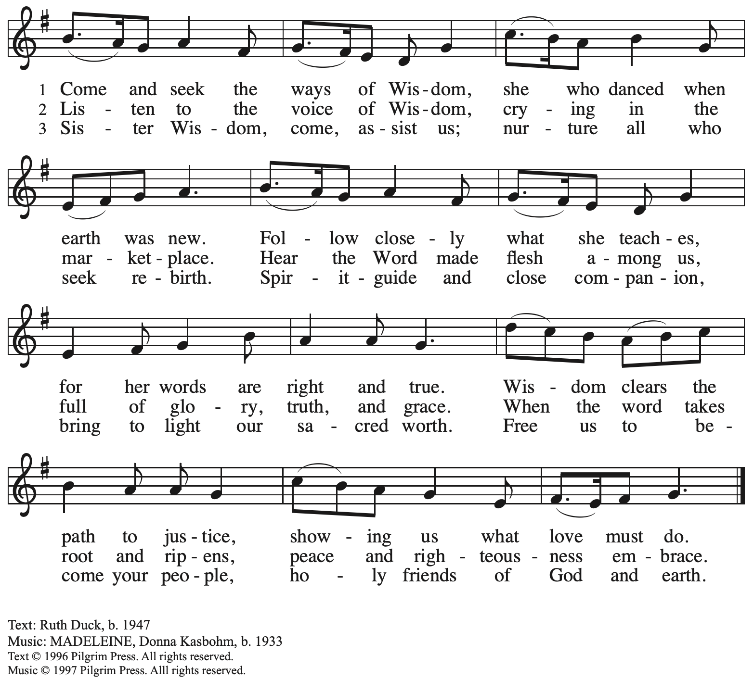

Reprinted with permission under OneLicense.net # A-722139.

**Greeting**

P: The grace of our Lord Jesus Christ, the love of God,

and the communion of the Holy Spirit be with you all.

**C: And also with you.**

**Hymn of Praise** *ELW* p. 204

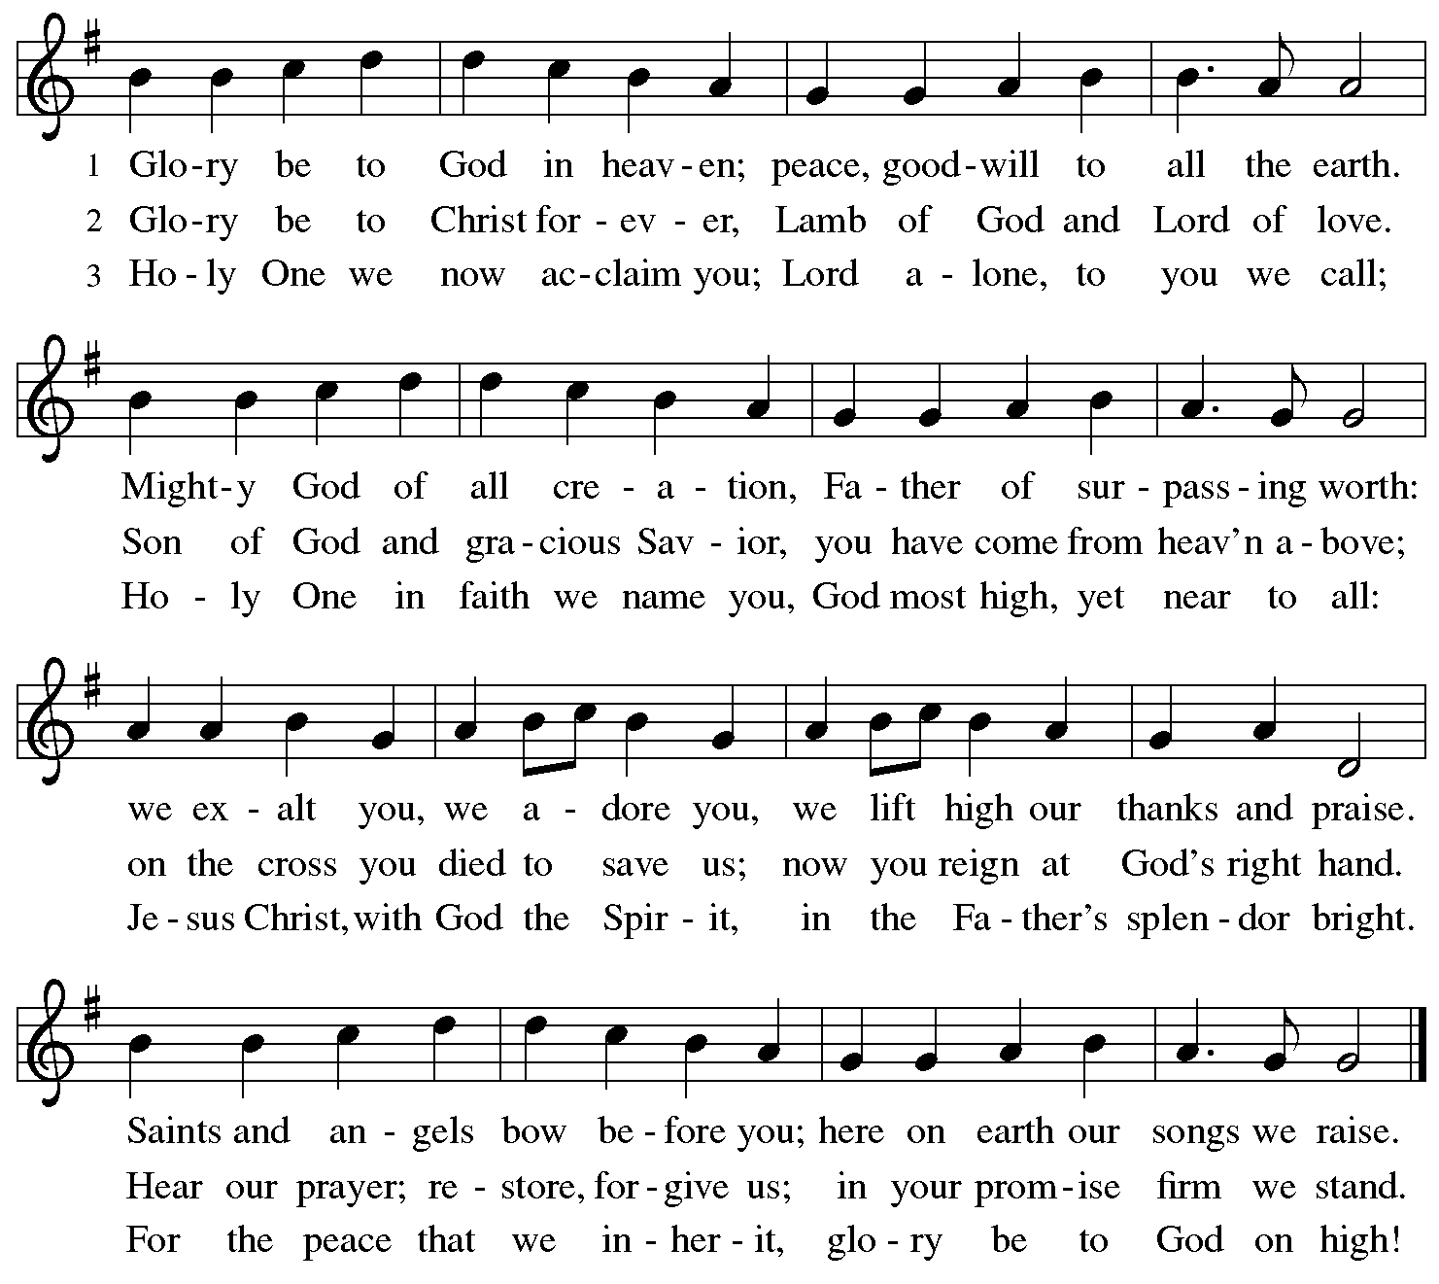

**Prayer of the Day**

P: The Lord be with you.

**C: And also with you.**

P: Let us pray.

O God, our teacher and guide,

you draw us to yourself and welcome us as beloved children.

Help us to lay aside all envy and selfish ambition,

that we may walk in your ways of wisdom and understanding

as servants of your Son, Jesus Christ, our Savior and Lord.

**C: Amen.**

*Please be seated.*

*Children are invited to join the adult leaders at the door and move to the office for Little Church – Big Faith. We ask that one additional adult from the congregation attend with the children.*

**Word**

*God speaks to us in Scripture reading, preaching, and song*

**First Reading** **–** **Jeremiah 11: 18-20**

18It was the Lord who made it known to me, and I knew;  
  then you showed me their evil deeds.  
 19But I was like a gentle lamb  
  led to the slaughter.  
 And I did not know it was against me  
  that they devised schemes, saying,  
 “Let us destroy the tree with its fruit,  
  let us cut him off from the land of the living,  
  so that his name will no longer be remembered!”  
 20But you, O Lord of hosts, who judge righteously,  
  who try the heart and the mind,  
 let me see your retribution upon them,  
  for to you I have committed my cause.

L: Word of God, word of life.

**C: Thanks be to God.**

**Psalm 54**

*The cantor will lead the singing of the psalm.*

*The congregation is invited to respond with the alternate verses in bold print,*

*and to join in singing the refrain.*

*Psalm tone*



*Psalm refrain*



1Save me, O God, **|** by your name;  
  in your might, de- **|** fend my cause.  
 2**Hear my | prayer, O God;**  
  **give ear to the words | of my mouth.**  
 3For strangers have risen up against me, and the ruthless have **|** sought my life,  
  those who have no re- **|** gard for God.  
 4**Behold, God | is my helper;**  
  **it is the Lord who sus- | tains my life. R**  
 5Render evil to those who **|** spy on me;  
  in your faithful- **|** ness, destroy them.  
 6**I will offer you a | freewill sacrifice**  
  **and praise your name, O Lord, for | it is good.**  
 7For you have rescued me from **|** every trouble,  
  and my eye looks down **|** on my enemies.**R**

**Second Reading – James 3: 13 – 4: 3, 7-8a**

13Who is wise and understanding among you? Show by your good life that your works are done with gentleness born of wisdom. 14But if you have bitter envy and selfish ambition in your hearts, do not be boastful and false to the truth. 15Such wisdom does not come down from above, but is earthly, unspiritual, devilish. 16For where there is envy and selfish ambition, there will also be disorder and wickedness of every kind. 17But the wisdom from above is first pure, then peaceable, gentle, willing to yield, full of mercy and good fruits, without a trace of partiality or hypocrisy. 18And a harvest of righteousness is sown in peace for those who make peace.4:  
  
 1Those conflicts and disputes among you, where do they come from? Do they not come from your cravings that are at war within you? 2You want something and do not have it; so you commit murder. And you covet something and cannot obtain it; so you engage in disputes and conflicts. You do not have, because you do not ask. 3You ask and do not receive, because you ask wrongly, in order to spend what you get on your pleasures. 7Submit yourselves therefore to God. Resist the devil, and he will flee from you. 8aDraw near to God, and God will draw near to you.

L: Word of God, word of life.

**C: Thanks be to God.**

*Please rise as you are able and join in speaking the Gospel Acclamation.*

**Gospel Acclamation** *ELW* p. 205

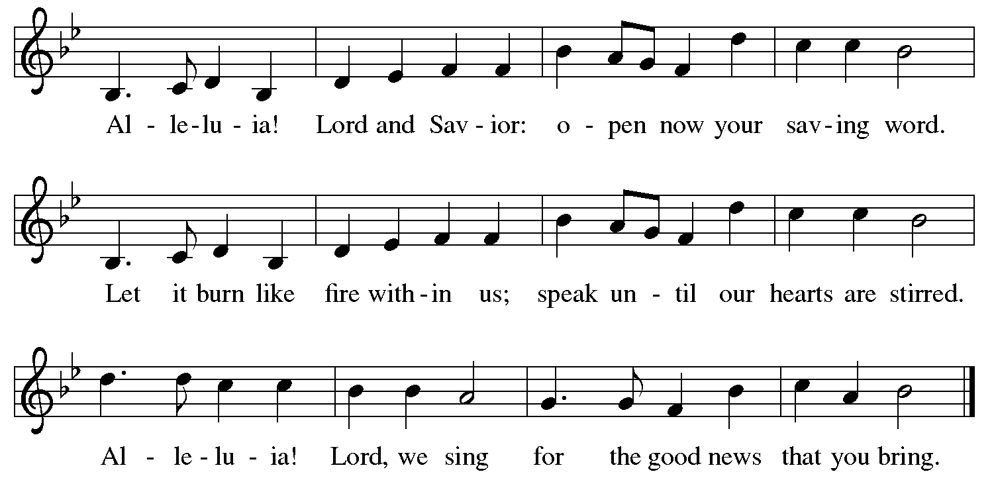

**Gospel – Mark 9: 30-37**

P: The holy Gospel according to St. Mark.

**C: Glory to you, O Lord.**

30[Jesus and the disciples went on] and passed through Galilee. He did not want anyone to know it;31for he was teaching his disciples, saying to them, “The Son of Humanity is to be betrayed into human hands, and they will kill him, and three days after being killed, he will rise again.”

32But they did not understand what he was saying and were afraid to ask him.  
 33Then they came to Capernaum; and when he was in the house he asked them, “What were you arguing about on the way?” 34But they were silent, for on the way they had argued with one another who was the greatest. 35He sat down, called the twelve, and said to them, “Whoever wants to be first must be last of all and servant of all.” 36Then he took a little child and put it among them; and taking it in his arms, he said to them, 37“Whoever welcomes one such child in my name welcomes me, and whoever welcomes me welcomes not me but the one who sent me.”

P: The Gospel of the Lord.

**C: Praise to you, O Christ.**

*Please be seated.*

**Sermon**

*A time of silence for prayer and reflection follows the sermon.*

*When the hymn of the day begins, please rise as you are able.*

**Hymn of the Day Lord, Whose Love in Humble Service *ELW* 712**

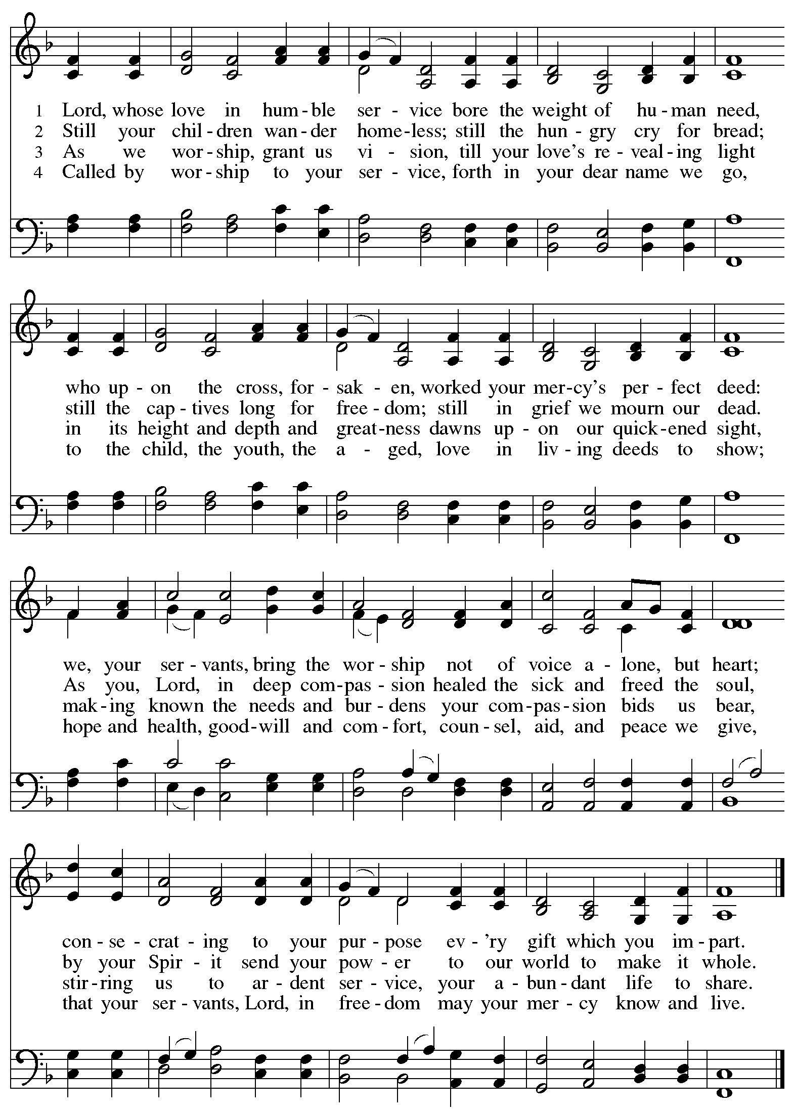

**Apostles’ Creed**

*Profession of our faith using the Apostles’ Creed, one of the Christian Church’s three ecumenical creeds, unites us with siblings in Christ around the world.*

**C: I believe in God, the Father almighty,**

**creator of heaven and earth.**

**I believe in Jesus Christ, God’s only Son, our Lord,**

**who was conceived by the Holy Spirit,**

**born of the virgin Mary,**

**suffered under Pontius Pilate,**

**was crucified, died, and was buried;**

**he descended to the dead.\***

**On the third day he rose again;**

**he ascended into heaven,**

**he is seated at the right hand of the Father,**

**and he will come to judge the living and the dead.**

**I believe in the Holy Spirit,**

**the holy catholic church,**

**the communion of saints,**

**the forgiveness of sins,**

**the resurrection of the body,**

**and the life everlasting. Amen.**

*Or, “he descended into hell,” another translation of this text in widespread use.

**Prayers of the People**

A: Drawn together by the power of the Holy Spirit,

we pray for the church, those in need, and all of God’s creation.

*After each petition*

A: Merciful God,

**C: receive our prayer.**

*The presiding minister concludes the prayers*

P: We entrust these and all our prayers to you, holy God,

in the name of your beloved, Jesus Christ, our Savior.

**C: Amen.**

**Peace**

*The presiding minister and the assembly greet one another in the peace of the risen Christ.*

P: The peace of Christ be with you always.

**C: And also with you.**

*The people may greet those around them with a sign of Christ’s peace and may say*

Peace be with you *or similar words. Please be mindful that not everyone will be comfortable with sharing the peace, so please seek consent before shaking hands or hugging. Other possible ways to share the peace include a simple bow with the verbal greeting of peace, or simply a verbal expression of peace.*

*When the greetings of peace have concluded, please be seated.*



**Meal**

*God feeds us with the presence of Jesus Christ*

**Offering**

*We offer ourselves, our gifts and our faithful service to God.*

*There are laminated giving cards in the pew racks that feature a QR code for anyone who would like to give online. Those who give using the QR code, as well as those who give regularly online or through their bank are encouraged to place the laminated card in the plate as an expression of your offering.*

*As the offering is gathered for the mission of the church, including the care of those in need,*

*the table is set for Holy Communion.*

**Music during the Offering**

*Praise to the Lord, the Almighty* arr. J. Carter

*As the gifts are brought forward for presentation, please rise as you are able.*

**Offertory Song Accept, O Lord, the Gifts We Bring *ELW* 691**

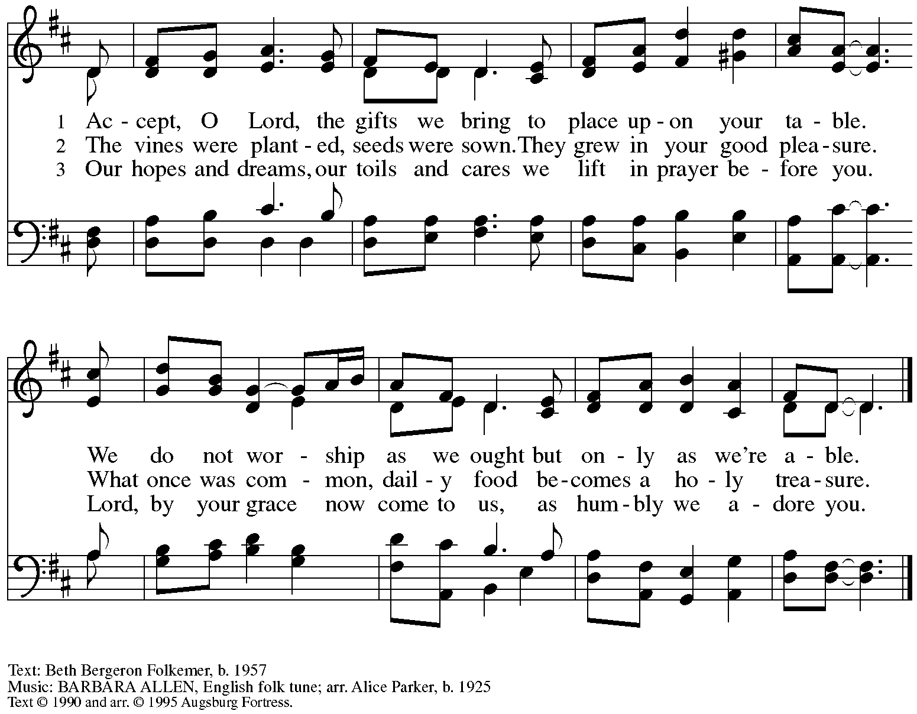

All rights reserved. Reprinted with permission under OneLicense.net # A-722139.

**Offertory Prayer**

A: Let us pray.

Blessed are you,

**C:** **O God, source of all creation.**

**By these gifts and with our lives,**

**help us to serve one another and all in need,**

**through Jesus Christ, our Savior and Lord.**

**Amen.**

**Dialogue**

P: The Lord be with you.

**C: And also with you.**

P: Lift up your hearts.

**C: We lift them to the Lord.**

P: Let us give thanks to the Lord our God.

**C: It is right to give our thanks and praise.**

**Preface**

P: It is indeed right, our duty and our joy …

… we praise your name and join in adoring song:

**Sanctus** *ELW* p. 207

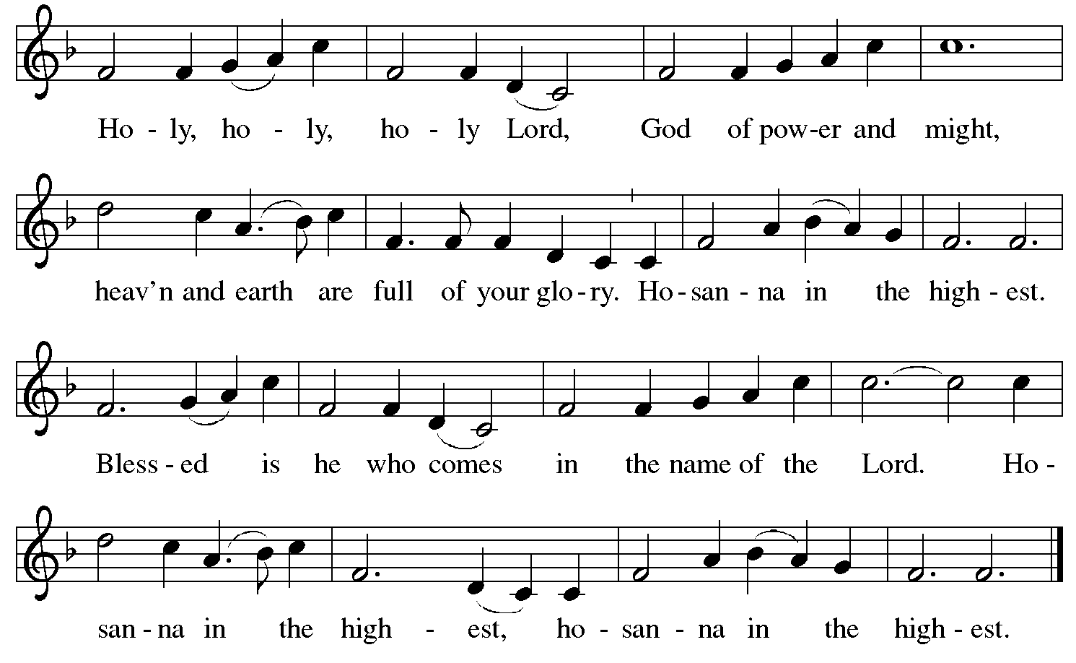

**Eucharistic Prayer**

P: Blessed are you, O God …

… Do this for the remembrance of me.

As often as we eat this bread and drink this cup

we proclaim the Lord’s death until he comes.

**C: Christ has died.**

**Christ is risen.**

**Christ will come again.**

P: Pour out your Holy Spirit …

… power of the Most High,

now and forever.

**C: Amen.**

**Lord’s Prayer**

P: Gathered as one by the Holy Spirit, let us pray as Jesus taught us.

**C: Our Father in heaven,**

**hallowed be your name,**

**your kingdom come,**

**your will be done,**

**on earth as in heaven.**

**Give us today our daily bread.**

**Forgive us our sins**

**as we forgive those**

**who sin against us.**

**Save us from the time of trial**

**and deliver us from evil.**

**For the kingdom, the power,**

**and the glory are yours,**

**now and forever. Amen.**

**Fraction and Invitation**

***Agnus Dei /* Lamb of God** *ELW* p. 208

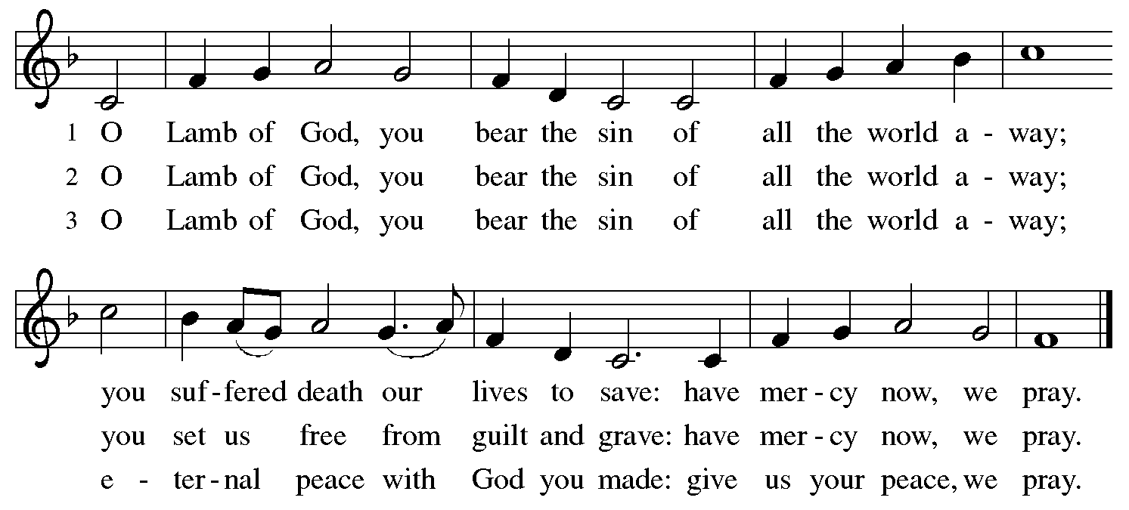

*Please be seated.*

**Holy Communion**

* *All who seek God and desire a deeper and stronger life in Christ are welcome to receive Holy Communion.*
* *Worshipers from the pulpit side will proceed forward first, followed by the center section, and then the lectern side.*
* *Please inform an usher if you would like the ministers to bring Communion to you.*
* *Holy Communion will be served with bread and wine/grape juice.*
* *The presiding minister will first distribute the bread (host) to each communicant. Please indicate if you require a gluten-free host.*
* *Once you have consumed the bread, please pick up an empty glass from the tray next to the presiding minister. The Communion Assistant will pour wine from the chalice or grape juice from the cruet into your glass.*
* *Please step to the side to consume the wine or grape juice.*
* *Feel free to kneel at the altar rail for prayer after receiving the sacrament.*
* *As you return to your pew, glasses may be returned to the empty trays on either side of the center section.*
* *A blessing will be provided for anyone who does not yet receive the sacrament.*
* *All are invited to join in singing the hymns during Holy Communion.*

**Hymns during Holy Communion**

**Signs and Wonders *ELW* 672**

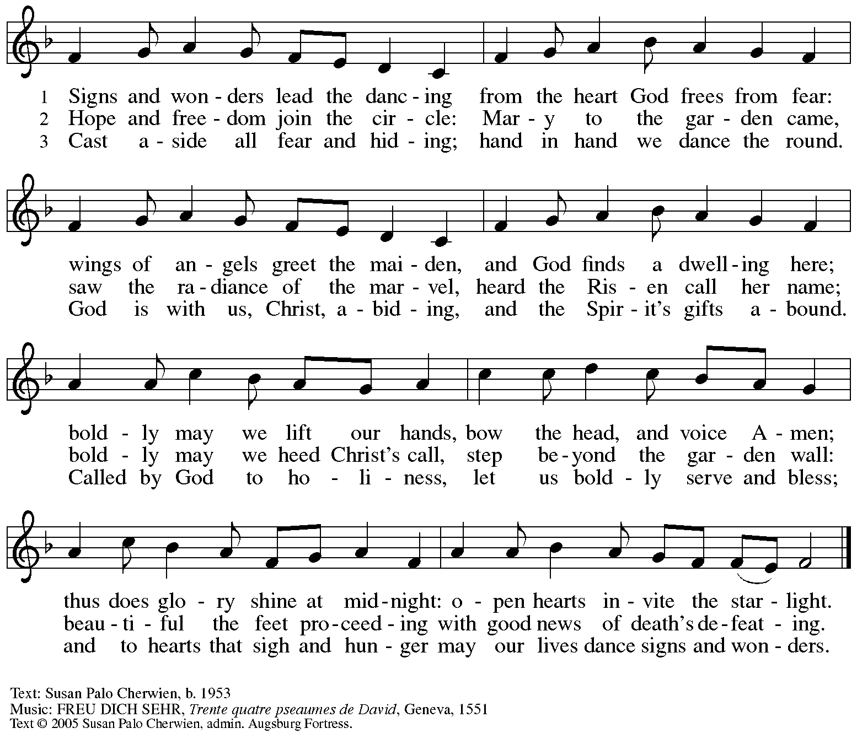

All rights reserved. Reprinted with permission under OneLicense.net # A-722139.

**Hymns during Holy Communion**

**Jesus Lives, My Sure Defense *ELW* 621**

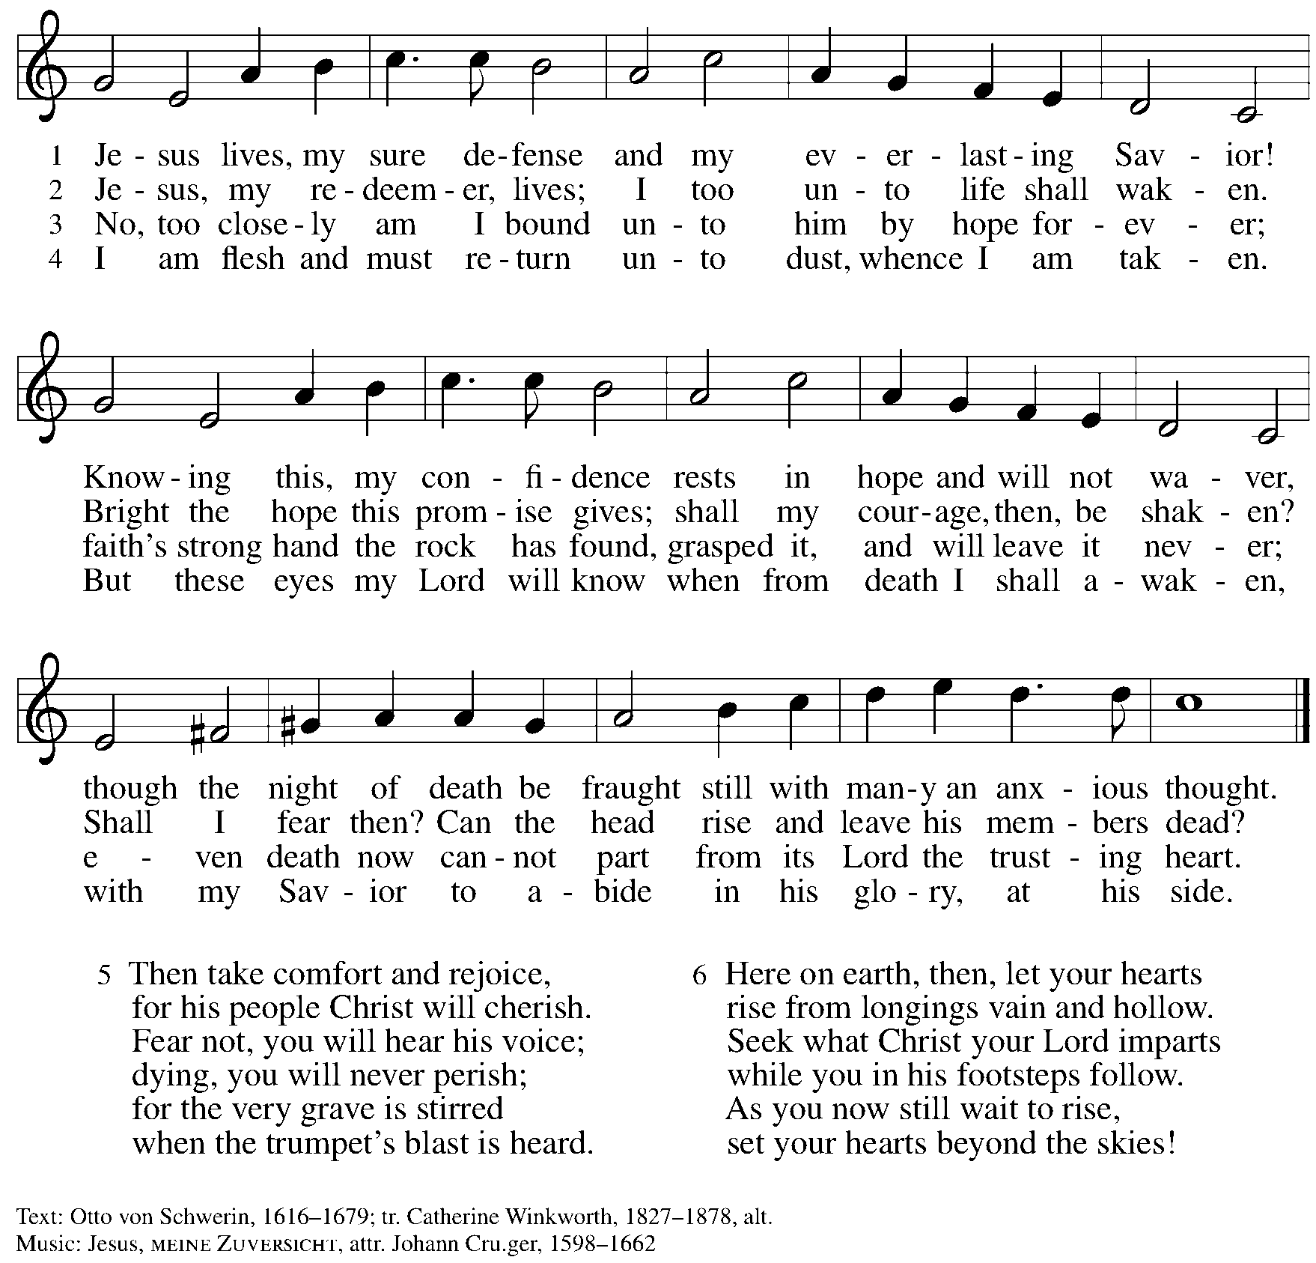

**Hymns during Holy Communion**

**Faith Begins by Letting Go *ACS* 1004**

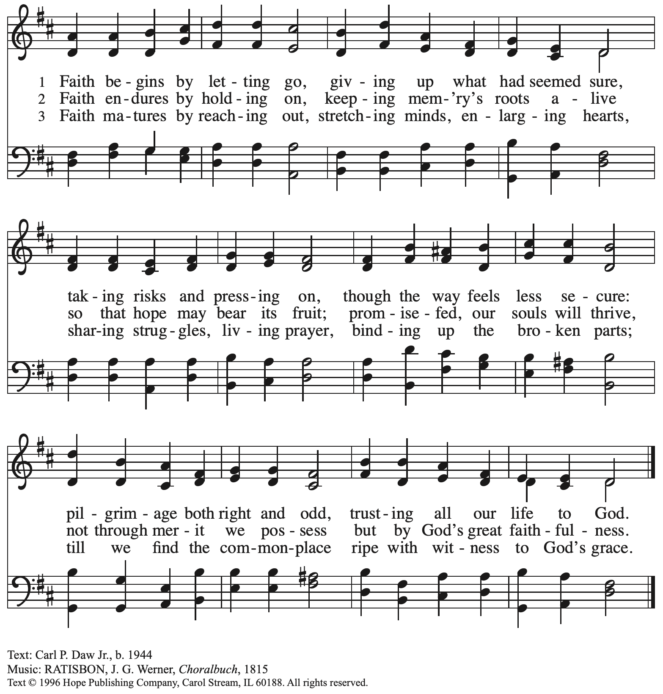

Reprinted under OneLIcense.net # A-722139.

**Hymns during Holy Communion**

**Make Me a Servant *W&P* 96**

**Make me a servant, humble and meek.**

**Lord, let me lift up those who are weak.**

**And may the prayer of my heart always be:**

**Make me a servant, make me a servant,**

**make me a servant today.**

Text and music Kelly Willard. Text and tune © 1982 Willing Heart Music, (admin. Marantha! Music c/o The Copyright Company) and Maranatha! Music (admin. The Copyright Company). All rights reserved. Reprinted with permission under OneLicense.net # A722139.

*When all have returned to their places, please rise as you are able.*

**Blessing**

P: The body and blood of our Lord Jesus Christ strengthen you and keep you in his grace.

**C: Amen.**

**Prayer**

A: Let us pray.

Holy God, you have welcomed us to this meal

and fed us at your table with your gifts of grace and life.

Send us now to welcome others and to be at peace with one another,

through Jesus Christ our Lord.

**C: Amen.**

*Please be seated.*

**Sending**

*God blesses us and sends us in mission to the world*

**Announcements**

*Please rise as you are able.*

**Benediction**

P: God almighty,

God most merciful,

☩ bless you, keep you,

and give you peace.

**C: Amen.**

**Sending Hymn I Want to Walk as a Child of the Light *ELW* 815**

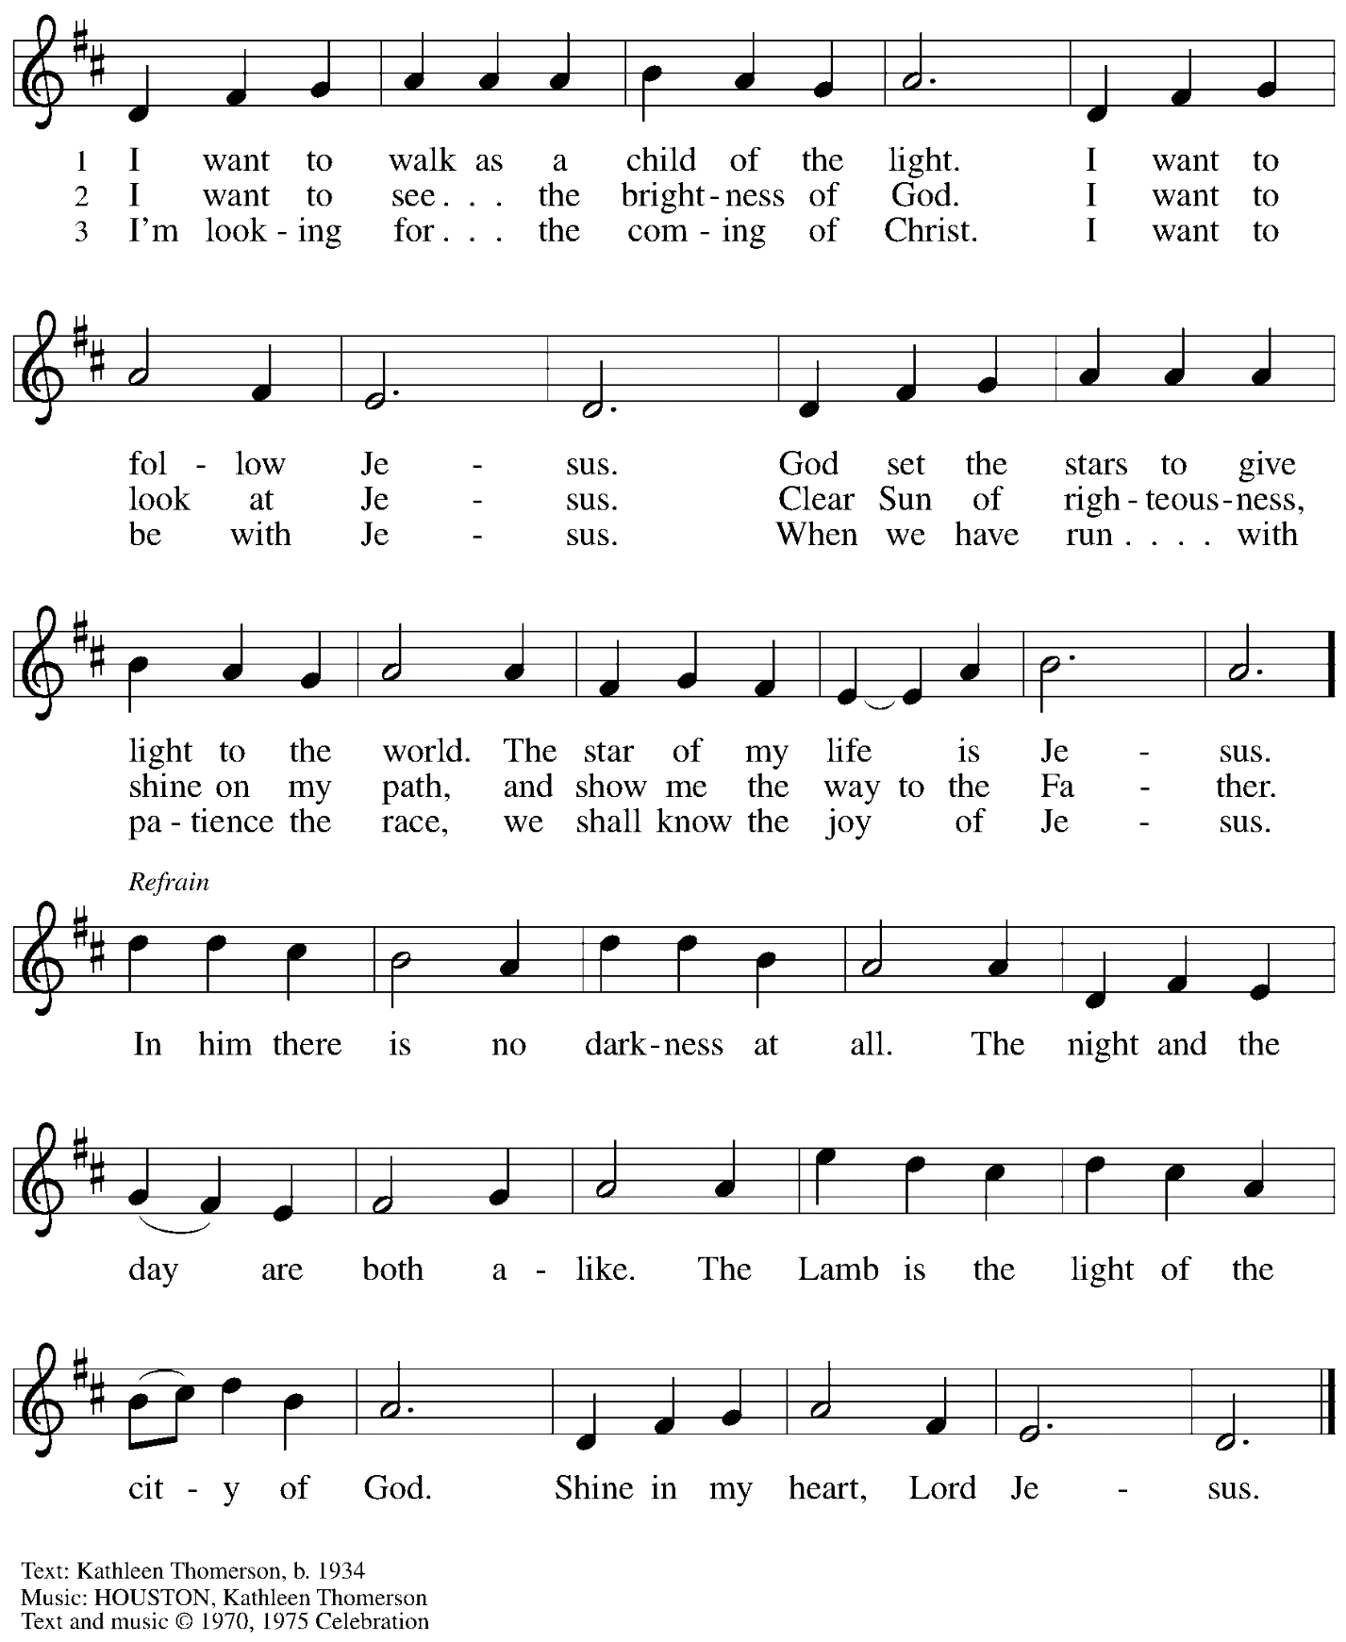

All rights reserved. Reprinted with permission under OneLicense.net # A-722139.

**Dismissal**

A: Go in peace. Serve the Lord.

**C: Thanks be to God.**

**Postlude** *How Firm a Foundation* arr. C. Courtney

*Those serving in worship today*

Altar Care Christy Ruhe

Assisting Minister Jeff Denlinger

Audio-Visual Minister Tyler Rietze

Joseph Paetz

Cantor David Rollinson

Lector Kelly Spanninger

Minister of Music Laura Reynolds

Preaching and Presiding Minister Pastor Ross Carmichael

*Liturgy and Hymnody Acknowledgements*

From SundaysandSeasons.com. Copyright © 2024 Augsburg Fortress. All rights reserved. Reprinted under OneLicense.net # A-722139.

Used by permission of Augsburg Fortress.

The Scripture readings contained herein are from *New Revised Standard Version* of the Bible © 1989, Division of Christian Education of the National Council of Churches of Christ in the USA. Used by permission. All rights reserved.

**Lord, Whose Love in Humble Service**



All rights reserved. Reprinted with permission under OneLicense.net # A-722139.

*Please use the QR code below to link to St. Andrew’s announcements online!*



**St. Andrew Lutheran Church Announcements**

**September 22nd, 2024**

* **Welcome to Worship at St. Andrew on the Eighteenth Sunday after Pentecost, September 22nd, 2024** –We are so glad you are here, and we offer a special welcome to all visitors and guests connecting for the first time! Worship attendees are invited to make a name tag at the back of the worship space. Little Church – Big Faith, a Bible lesson and activity for children, will take place after the prayer of the day. There are also worship “toolkits” to help children engage with worship and “busy bags” for younger children available in the bookcase at the back of the sanctuary. Please feel free to take one to use with/for your children. All are invited to gather for coffee, other drinks, food, and conversation in the social hall after worship.
* **Lessons from Dietrich Bonhoeffer in a House Divided and a World on Fire – Wednesdays at 7:00 p.m., starting September 25th** – Join us for six weeks as we explore the life and theology of Dietrich Bonhoeffer, and the lessons we can use as we live at the intersection of faith and civic life today. Bonhoeffer was a Lutheran pastor and theologian living in Nazi Germany, who eventually joined the resistance and was arrested and killed before the end of WWII. This curriculum was compiled by Dr. Lori Brandt Hale, an internationally renowned Bonhoeffer scholar. Lutheran Advocacy Ministry in Pennsylvania (LAMPa) is bringing this curriculum to congregations to inspire deeper conversation and discernment about our discipleship. Pastor Erin Jones, staff at LAMPa and member of St. Andrew, will lead us in these sessions. The Zoom link is in your Friday “This Week at St. Andrew” email - if you are not yet on the mailing list, please see Pastor Ross and he will get you the link. If anyone would like to look ahead at the participant workbook or other materials in preparation for the study, please visit:

[Bonhoeffer Curriculum Available Now! - LAMPa (lutheranadvocacypa.org)](https://standrewpittsburgh.us20.list-manage.com/track/click?u=08ed12533ff01695f3bedb110&id=b21d27b8d1&e=32a5352e21)

* **October Produce Distribution – First Tuesday of the Month, October 1st, 2024, from 5:30-7:00 p.m. – St. Andrew partners with Greater Pittsburgh Community Food Bank to serve as a distribution site for fresh produce on the first Tuesday of every month. This month’s distribution will be Tuesday, October 1st. We invite people of the congregation to help with the distribution from 5:30-7:00 p.m., help with unloading and setup during the day between 10:00 a.m. and 1:00 p.m.**
* **Coffee Hour Signups Available** –One way that St. Andrew builds community is by sharing conversation over food and drinks at coffee hour after worship on Sundays. We invite people of the congregation to sign up to coordinate coffee hour each week, which includes brewing the coffee; setting out cups, napkins, food items, and cold drinks; and cleaning up afterward. Everything needed is at St. Andrew and instructions are available. Please sign up to host coffee hour here: [https://www.signupgenius.com/go/5080B4AAFAF2CABF85-47069030-coffee](https://standrewpittsburgh.us20.list-manage.com/track/click?u=08ed12533ff01695f3bedb110&id=026745d57d&e=32a5352e21).
* **Worship and Conversation with Members of Our Companion Church in Madagascar – Various Dates – The Tulear Synod of the Malagasy Lutheran Church in Madagascar is the companion synod of our Southwestern Pennsylvania Synod. A companion synod arrangement fosters relationships among the global church partners and encourages mutual prayer and support. President (Bishop) Modeste Razafimahatratra will lead a delegation from Madagascar as they visit the Pittsburgh region soon. All are invited to join these guests for worship and conversation at various locations:**
  + **Saturday, September 28th, 5:00 p.m. – Hope Lutheran Church in Cranberry**
  + **Sunday, September 29th, 9:00 a.m. – St. Paul, Lutheran, Zelienople**
  + **Sunday, September 29th, 10:45 a.m. – Zion Lutheran Church in Harmony**
  + **Wednesday, October 2nd, 6:00 p.m. – Trinity Lutheran Church in Latrobe**
  + **Saturday, October 5th, 5:30 p.m. – Trinity Lutheran Church in Butler**
  + **Sunday, October 6th, 10:15 a.m. – St. Peter’s Lutheran Church – Evans City**

***Note time, format and RSVP information varies for each location. For full details on each event, visit*** [https://www.swpasynod.org/stories/madagascar2024](https://www.swpasynod.org/stories/madagascar2024%20)**.**

* **Support Days for Girls – Pittsburgh: Collecting Supplies in October!** – Earlier in the year, St. Andrew shared an opportunity from LAMPa to call for Pennsylvania to provide menstrual hygiene products in public spaces as a crucial step in addressing educational, gender, and economic inequity. As a local follow-up, St. Andrew has connected with Days for Girls – Pittsburgh, which helps to provide education and access to feminine hygiene products for people in need. As an expression of our church’s “God’s Work, Our Hands” commitment, St. Andrew will be collecting items to make Days for Girls’ hygiene kits. Starting on October 6th, we will be collecting women’s underwear, mostly size medium and large, washcloths, hotel-size soap, fragrance-free detergent pods, and packing supplies such as 5/8-inch ribbon and packing tape. Items may be placed in the collection bin located in the social hall anytime until October 27th.
* **First Unitarian Church Hosts Three Conversations on Documentaries about the Rise of Christian Nationalism – Sundays, October 6th, 13th, and 20th at 6:00 p.m. – Our neighbors at First Unitarian Church (605 Morewood Avenue) invite people of the community to gather for learning and conversation based on three documentary films:**
  + **October 6th – *Bad Faith: Christian Nationalism’s Unholy War on Democracy***
  + **October 13th – *Prayer for Armageddon***
  + **October 20th – *God and Country***
* **Public Lectures and Panel Discussion – *Hope in a Divided World: Bonhoeffer’s This-World Christianity as an Antidote to Christian Nationalism* – Saturday, October 19th, 10:00 a.m. – Join LAMPa and United Lutheran Seminary’s “Kindling Faith” for a weekend of discovering how Dietrich Bonhoeffer’s theology and legacy help the Church and people of faith to authentically and humbly act at the intersection of civic life and faith, in contrast and response to the forces of Christian Nationalism. While the event takes place at United Lutheran Seminary in Gettysburg, the lectures and panel discussion on Saturday, October 19th will be live-streamed. For full details on the whole event, please visit:** [https://conta.cc/4e1kSk6](https://conta.cc/4e1kSk6?fbclid=IwZXh0bgNhZW0CMTAAAR1KPeQlBiMGqmv5WE1baqA61aUvME9Jp5YwwQaSD_4HWpujbdDeYTWFRgg_aem_vddRCgZKyrCMid0MkGgiRw).
* **Celebrate St. Andrew’s 133rd Anniversary and Reconciling in Christ Sunday during Worship on October 13th, 10:00 a.m. – St. Andrew was officially organized as a congregation on October 12, 1891 – We give thanks to God for so many years of goodness, grace, and ministry, in which the Gospel of Jesus has been proclaimed and people have come to know and experience God’s love! Essential to the congregation’s identity is our Reconciling in Christ designation, in which we publicly share our welcome and inclusion of LGBTQIA+ individuals and families, and of all God’s people, in the life of the congregation, church, and society. In worship on Sunday, October 13th, we will celebrate St. Andrew’s 133rd anniversary and renew our commitment to live our faith together as a Reconciling in Christ congregation!**
* **New *Christ in Our Home* Devotional Booklets (October – December) Available at Church Entrances – *Christ in Our Home* is a booklet of devotions that includes Scripture, a brief reflection, and prayer for each day. The new edition for October – December is now available at the various church entrances. There are still several copies left for September, too – Please feel free to take one for yourself or others!**