

**+ Thirteenth Sunday after Pentecost**

**August 18, 2024**



**St. Andrew Lutheran Church**

**304 Morewood Ave.**

**Pittsburgh, PA 15213**

[**St_andrewELCA@verizon.net**](mailto:St_andrewELCA@verizon.net)

[**www.standrewpittsburgh.org**](http://www.standrewpittsburgh.org)

**+ Thirteenth Sunday after Pentecost**

**Order for Worship**

*Wisdom prepares a feast, sets her table, and invites all to come and eat her bread and drink her wine. The first chapter of John’s gospel owes much to the biblical tradition that imagined Wisdom as existing before anything was created and having a role in the work of creation. Christ, the wisdom of God (1 Cor. 1:24), today invites us to eat his flesh and drink his blood. John’s gospel includes no account of the institution of the Lord’s supper, but here we can't help hearing Jesus’ words as an invitation to the meal of bread and wine we share.*

**Welcome to St. Andrew!**

* St. Andrew Lutheran congregation welcomes all who are seeking a place of healing and wholeness – a nurturing, faith-forming spiritual home. Our community embraces people of all ages, ethnicities, cultures, abilities, sexual orientations, gender identities and expressions, and family constellations. Come and See!
* Worship Services are live-streamed to multiple online platforms. By attending worship, you agree that your image and voice may be broadcast.
* Everyone is invited to make a name tag at the black bookcase in the back of the worship space if they would like. There are stickers indicating pronouns on the bookcase if you would like to include them on your name tag.
* A nursery is available through the doors at the left side of the sanctuary and across from the doorway to the Social Hall. Look for a purple-colored room.
* Worship “toolkits” to help children engage with the service, along with “busy bags” for younger children, are available in the bookcase at the back of the sanctuary. Please feel free to take one to use with/for your children.
* Holy Communion is served with bread (gluten-free available) and wine or grape juice. The presiding minister will distribute the bread (host). Please consume this and then pick up an empty glass from the tray. The Communion Assistant will pour wine or grape juice into your glass. Please step to the side to consume the wine or grape juice. Feel free to kneel at the altar for prayer and reflection. As you return to your pew, glasses may be returned to the empty trays on either side of the center section.
* A restroom is available on the main level of the church, through the doors to the Social Hall and to the right in the main office.

*Abbreviations*

P: Pastor/Presiding Minister ***ELW*: *Evangelical Lutheran Worship* hymnal**

A: Assisting Minister ***ACS*: *All Creation Sings* hymnal**

L: Lector ***WOV*: *With One Voice* hymnal**

**C: Congregation**

**Pre-Service Music**

**Welcome**

**Prelude** *Soul, Adorn Yourself with Gladness* arr. N. Raabe

**Gathering**

*The Holy Spirit calls us together as the people of God*

**Confession and Forgiveness**

*Please rise as you are able.*

*All may make the sign of the cross, the sign that is marked at Baptism,*

*as the presiding minister begins.*

P: Blessed be the holy Trinity, ☩ one God,

who looks upon us in compassion,

forgives our sin,

and heals our lives.

**C: Amen.**

P: Let us confess our sin in the presence of God and of one another.

*Silence is kept for reflection*

P: Have mercy,

**C: O God, for we have sinned against you and our neighbors,**

**by what we have done and by what we have failed to do.**

**In your compassion, cleanse us of our sin and take away our guilt.**

**Create in us a new heart** **and give us a steadfast spirit.**

**Do not cast us away, but fill us with your Holy Spirit,**

**and restore your joy within us. Amen.**

**P:** By water and the Holy Spirit God gives you a new birth,

and through the death and resurrection of ☩ Jesus Christ,

God forgives you all your sins.

The God of mercy and might strengthen you in all goodness

and keep you in eternal life.

**C: Amen.**

**Gathering Hymn Come and Seek the Ways of Wisdom *ACS* 971**

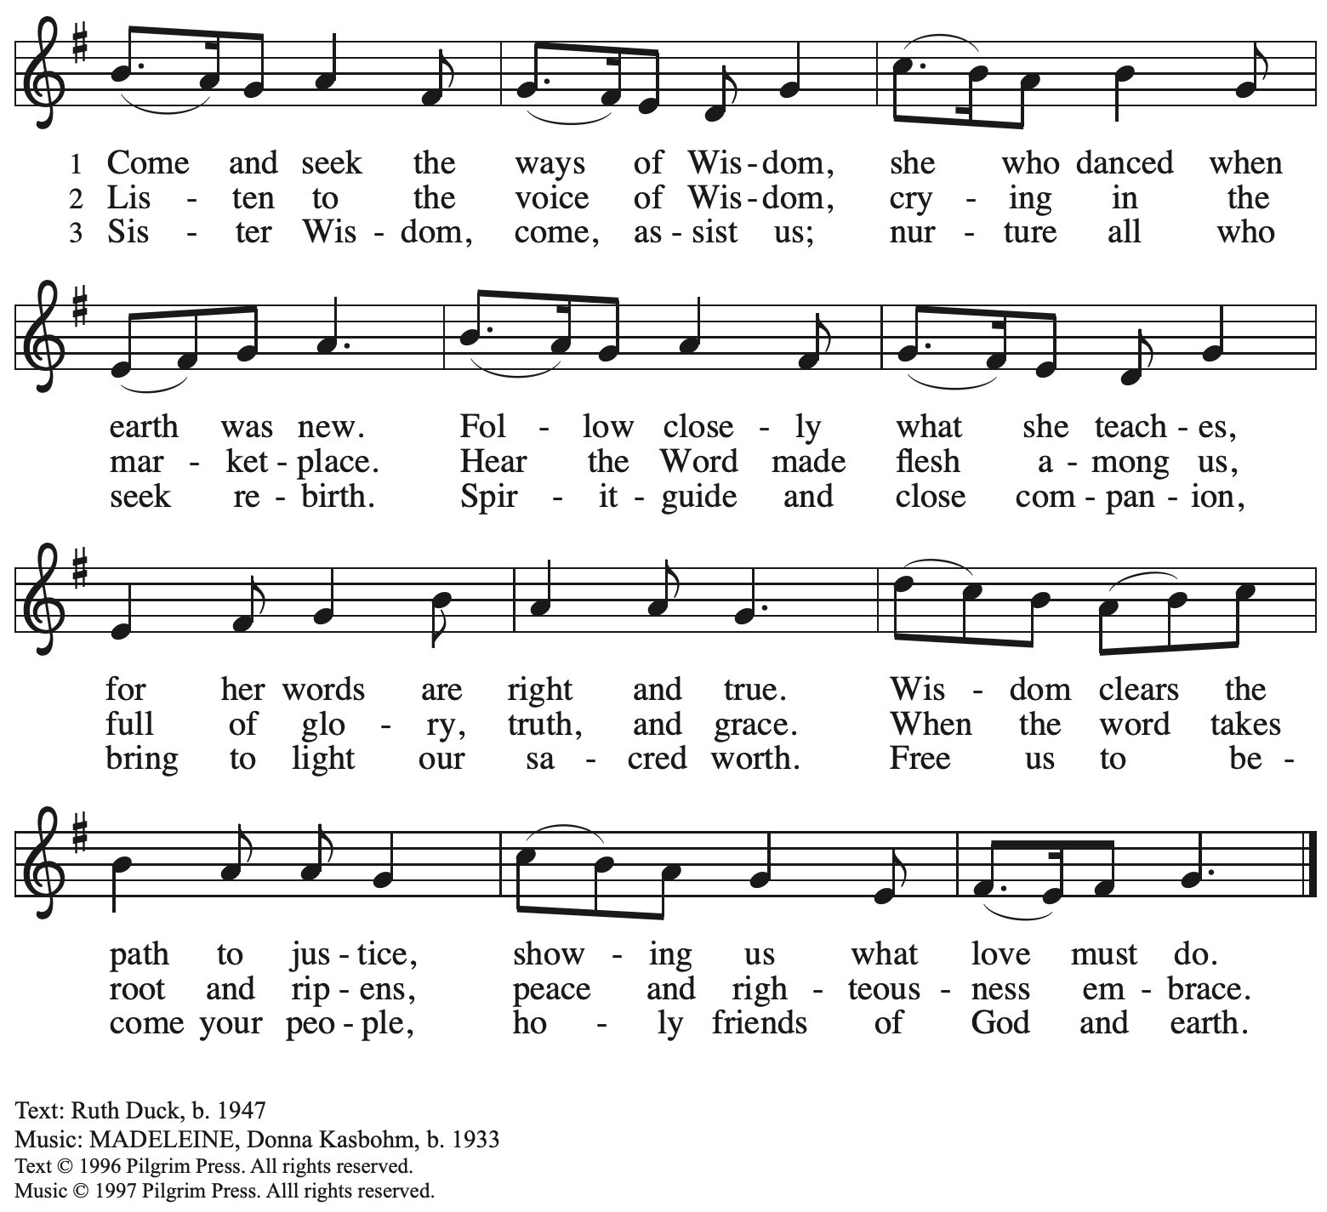

Reprinted with permission under OneLicense.net # A-722139.

**Greeting**

P: The grace of our Lord Jesus Christ, the love of God,

and the communion of the Holy Spirit be with you all.

**C: And also with you.**

**Hymn of Praise** *WOV* p. 29-30





**Prayer of the Day**

P: Let us pray.

Ever-loving God, your Son gives himself as living bread for the life of the world.

Fill us with such a knowledge of his presence that we may be strengthened and sustained

by his risen life to serve you continually, through Jesus Christ, our Savior and Lord.

**C: Amen.**

*Please be seated.*

**Word**

*God speaks to us in Scripture reading, preaching, and song*

**First Reading** **–** **Proverbs 9: 1-6**

 1 Wisdom has built her house,  
  she has hewn her seven pillars.  
 2 She has slaughtered her animals, she has mixed her wine,  
  she has also set her table.  
 3 She has sent out her servant-girls, she calls  
  from the highest places in the town,  
 4 “You that are simple, turn in here!”  
  To those without sense she says,  
 5 “Come, eat of my bread  
  and drink of the wine I have mixed.  
 6 Lay aside immaturity, and live,  
  and walk in the way of insight.”

L: Word of God, word of life.

**C: Thanks be to God.**

**Psalm 34: 9-14**

*Today’s psalm will be spoken and led by the cantor, with the congregation invited to respond with the alternate verses in bold type.*

9 Fear the Lord, you saints of the Lord,  
  for those who fear the Lord lack nothing.  
 10 **The lions are in want and suffer hunger,**  
  **but those who seek the Lord lack nothing that is good.**  
 11 Come, children, and listen to me;  
  I will teach you reverence for the Lord.  
 12 **Who among you takes pleasure in life**  
  **and desires long life to enjoy prosperity?**  
 13 Keep your tongue from evil  
  and your lips from lying words.  
 14 **Turn from evil and do good;**  
  **seek peace and pursue it.**

**Second Reading – Ephesians 5: 15-20**

15 Be careful then how you live, not as unwise people but as wise, 16 making the most of the time, because the days are evil. 17 So do not be foolish, but understand what the will of the Lord is.

18 Do not get drunk with wine, for that is debauchery; but be filled with the Spirit, 19 as you sing psalms and hymns and spiritual songs among yourselves, singing and making melody to the Lord in your hearts, 20 giving thanks to God the Father at all times and for everything in the name of our Lord Jesus Christ.

L: Word of God, word of life.

**C: Thanks be to God.**

*Please rise as you are able and join in speaking the Gospel Acclamation.*

**Gospel Acclamation** *WOV* p. 31



**Gospel – John 6: 51-58**

P: The holy Gospel according to St. John.

**C: Glory to you, O Lord.**

[Jesus said,] 51 “I am the living bread that came down from heaven. Whoever eats of this bread will live forever; and the bread that I will give for the life of the world is my flesh.”  
  52 The Jews then disputed among themselves, saying, “How can this man give us his flesh to eat?” 53 So Jesus said to them, “Very truly, I tell you, unless you eat the flesh of the Son of Humanity and drink his blood, you have no life in you. 54 Those who eat my flesh and drink my blood have eternal life, and I will raise them up on the last day; 55 for my flesh is true food and my blood is true drink. 56 Those who eat my flesh and drink my blood abide in me, and I in them. 57 Just as the living Father sent me, and I live because of the Father, so whoever eats me will live because of me. 58 This is the bread that came down from heaven, not like that which your ancestors ate, and they died. But the one who eats this bread will live forever.”

P: The Gospel of the Lord.

**C: Praise to you, O Christ.**

*Please be seated.*

**Sermon**

*A time of silence for prayer and reflection follows the sermon.*

*When the hymn of the day begins, please rise as you are able.*

**Hymn of the Day By Your Hand You Feed Your People *ELW* 469**

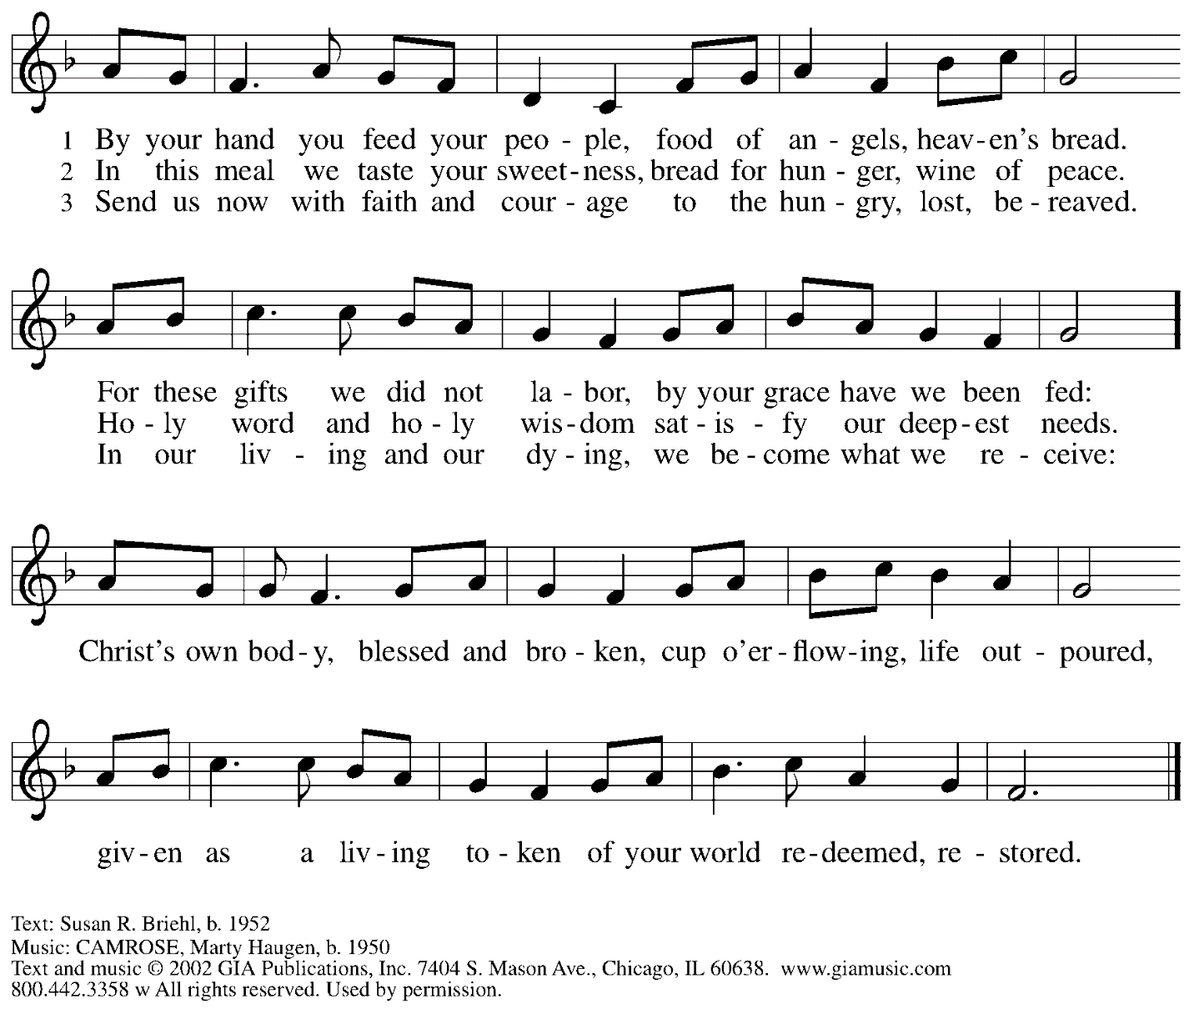

Reprinted under OneLicense.net # A-722139.

**Prayers of the People**

A: Rooted in God’s abundant love for the world, let us pray for our neighbors,

the church, and all of God’s creation.

*After each petition*

A: Merciful God,

**C: receive our prayer.**

*The presiding minister concludes the prayers*

P: We offer our prayers to you, gracious God,

trusting in your boundless love for all you have made,

through Jesus Christ our Savior.

**C: Amen.**

**Peace**

*The presiding minister and the assembly greet one another in the peace of the risen Christ.*

P: The peace of Christ be with you always.

**C: And also with you.**

*The people may greet those around them with a sign of Christ’s peace and may say*

Peace be with you *or similar words. Please be mindful that not everyone will be comfortable with sharing the peace, so please seek consent before shaking hands or hugging. Other possible ways to share the peace include a simple bow with the verbal greeting of peace, or simply a verbal expression of peace.*

*When the greetings of peace have concluded, please be seated.*

**Meal**

*God feeds us with the presence of Jesus Christ*

**Offering**

*We offer ourselves, our gifts, and our faithful service to God.*

*As the offering is gathered for the mission of the church, including the care of those in need,*

*the table is set for Holy Communion.*

**Noisy Offering**

*As children of the congregation carry buckets around the sanctuary, people of the congregation are invited to throw in their change as an offering. Today’s Noisy Offering will support LAMPa – Lutheran Advocacy Ministry in Pennsylvania, which works from a Lutheran perspective on behalf of biblical values of “peacemaking, hospitality to strangers, care for creation, and concern for people living in poverty and struggling with hunger and disease.”*

**Music during the Offering**

*Praise to the Lord, the Almighty* arr. B. Edstrom

*As the gifts are brought forward for presentation, please rise as you are able.*

**Offertory Song** *WOV* p. 35



All rights reserved. Reprinted under OneLicense.net # A-722139.

**Offertory Prayer**

A: Let us pray.

Jesus, Bread of life,

**C: you have set this table with your very self,**

**and called us to the feast of plenty.**

**Gather what has been sown among us,**

**and strengthen us in this meal.**

**Make us to be what we receive here,**

**your body for the life of the world.**

**Amen.**

**Dialogue**

P: The Lord be with you.

**C: And also with you.**

P: Lift up your hearts.

**C: We lift them to the Lord.**

P: Let us give thanks to the Lord our God.

**C: It is right to give our thanks and praise.**

**Preface**

P: It is indeed right, our duty and our joy …

… we praise your name and join in adoring song:

**Sanctus** *WOV* p. 36



**Eucharistic Prayer**

P: Holy, mighty, and merciful Lord …

… to whom, with you and the Holy Spirit,

be all honor and glory, now and forever.

**C: Amen.**

**Lord’s Prayer**

P: Gathered as one by the Holy Spirit, let us pray as Jesus taught us.

**C: Our Father in heaven,**

**hallowed be your name,**

**your kingdom come,**

**your will be done,**

**on earth as in heaven.**

**Give us today our daily bread.**

**Forgive us our sins**

**as we forgive those**

**who sin against us.**

**Save us from the time of trial**

**and deliver us from evil.**

**For the kingdom, the power,**

**and the glory are yours,**

**now and forever. Amen.**

**Fraction and Invitation**

P: Jesus offers us living bread.

Come, receive these gifts, that Christ may abide in you.

***Agnus Dei /* Lamb of God** *WOV* p. 39



*Please be seated.*

**Holy Communion**

* *All who seek God and desire a deeper and stronger life in Christ are welcome to receive Holy Communion.*
* *Worshipers from the pulpit side will proceed forward first, followed by the center section, and then the lectern side.*
* *Please inform an usher if you would like the ministers to bring Communion to you.*
* *Holy Communion will be served with bread and wine/grape juice.*
* *The presiding minister will first distribute the bread (host) to each communicant. Please indicate if you require a gluten-free host.*
* *Once you have consumed the bread, please pick up an empty glass from the tray next to the presiding minister. The Communion Assistant will pour wine from the chalice or grape juice from the cruet into your glass.*
* *Please step to the side to consume the wine or grape juice.*
* *Feel free to kneel at the altar rail for prayer after receiving the sacrament.*
* *As you return to your pew, glasses may be returned to the empty trays on either side of the center section.*
* *A blessing will be provided for anyone who does not yet receive the sacrament.*
* *All are invited to join in singing the hymns during Holy Communion.*

**Hymns during Holy Communion**

**Bread of Life from Heaven *ELW* 474**

**v. 1-4**

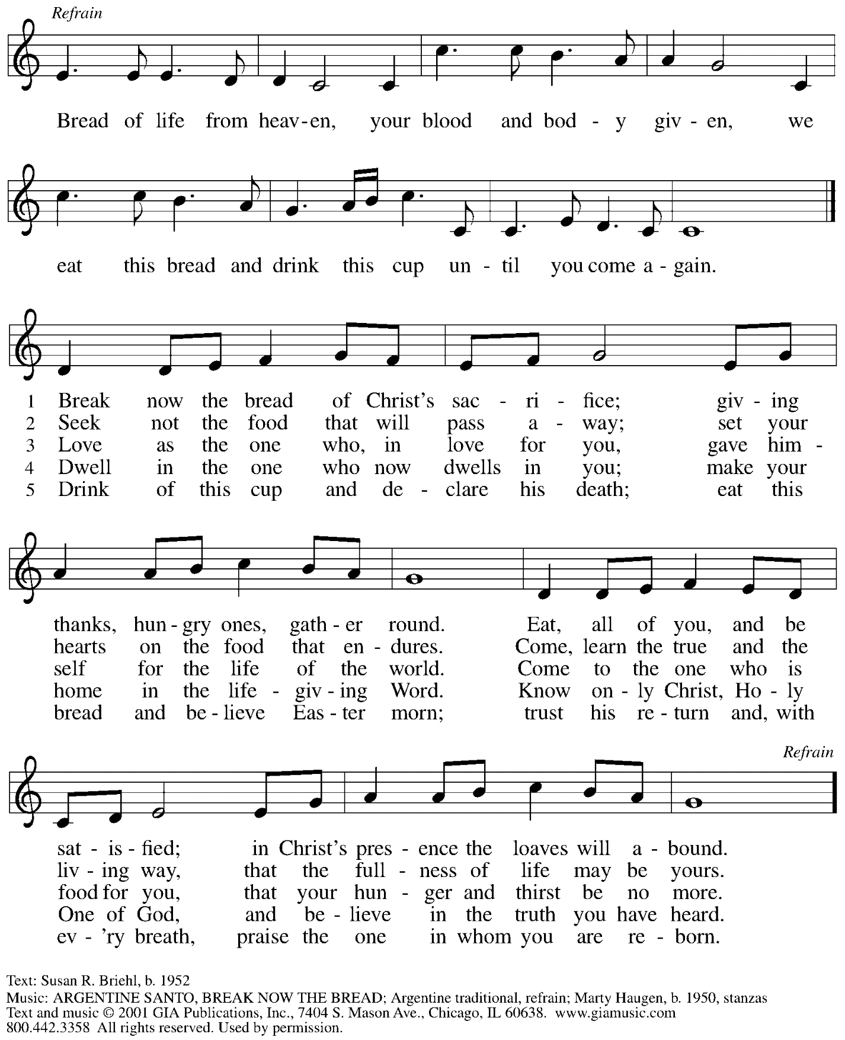

All rights reserved. Reprinted under OneLIcense.net # A-722139.

**Hymns during Holy Communion**

**We Who Once Were Dead**  ***ELW* 495**

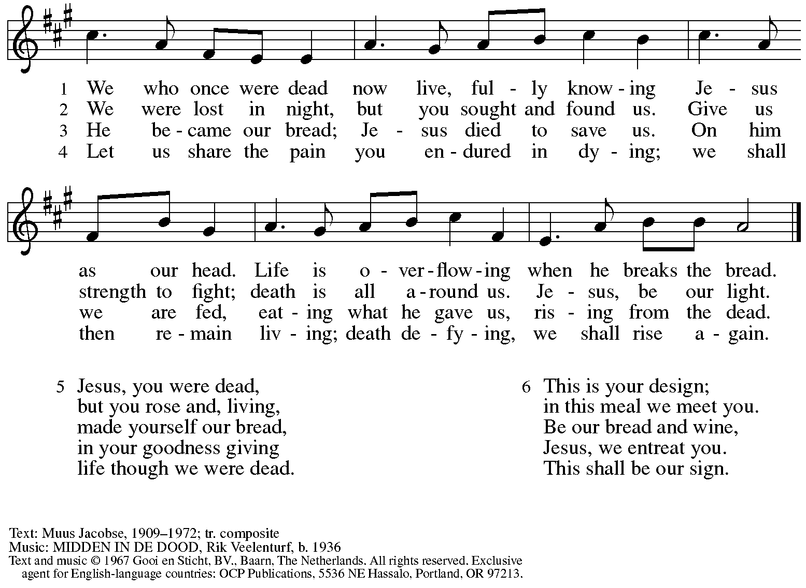

Reprinted with permission under OneLicense.net # A-722139.

**Hymns during Holy Communion**

**We Eat the Bread of Teaching *ELW* 518**

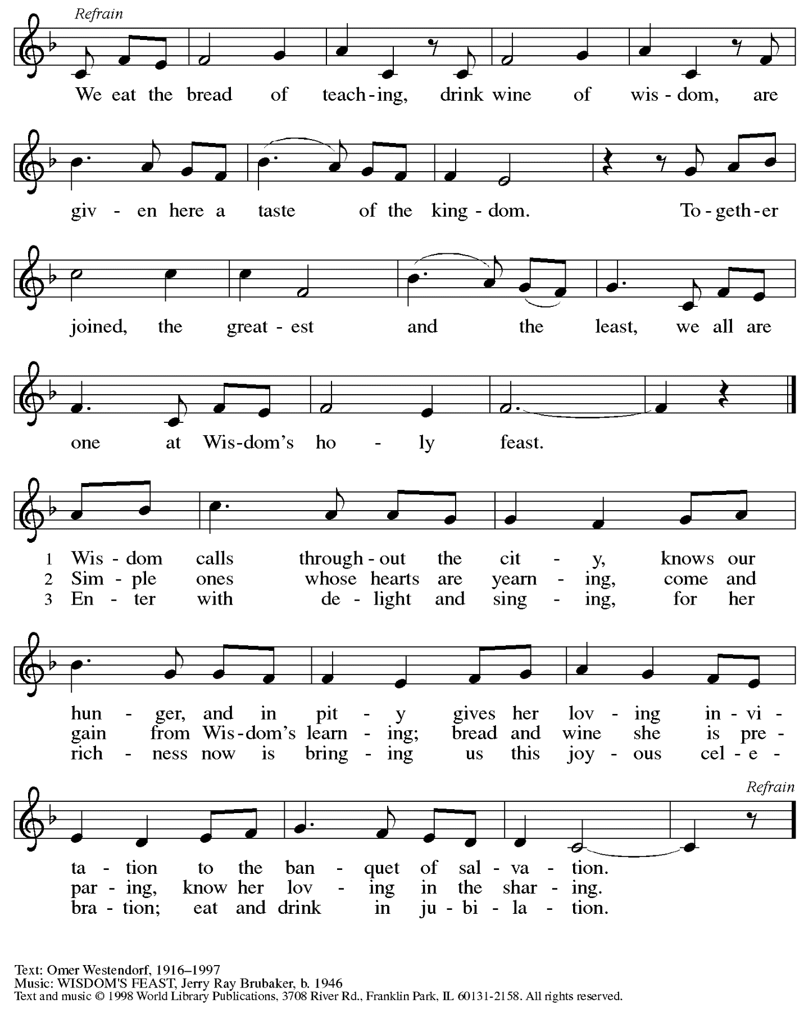

Reprinted with permission under OneLicense.net # A-722139.

*When all have returned to their places, please rise as you are able.*

**Blessing**

P: The body and blood of our Lord Jesus Christ strengthen you and keep you in his grace.

**C: Amen.**

**Prayer**

A: Let us pray. Almighty God,

you provide the true bread from heaven, your Son, Jesus Christ, our Lord.

Grant that we who have received the sacrament of his body and blood

may abide in Christ and he in us, that we may be filled with the power

of his endless life, now and forever.

**C: Amen.**

*Please be seated.*

**Sending**

*God blesses us and sends us in mission to the world*

**Announcements**

*Please rise as you are able.*

**Benediction**

P: The blessing of God,

who provides for us, feeds us, and accompanies us,

☩ be upon you, now and forever.

**C: Amen.**

**Sending Hymn** *Following page*

**Hallellujah! We Sing Your Praises – Haleluya! Pelo tsa rona**

**Dismissal**

A: Go in peace. Serve the Lord.

**C: Thanks be to God.**

**Postlude** *We’ve Come This Far by Faith* A.A. Goodson

**Sending Hymn *ELW* 535**

**Hallellujah! We Sing Your Praises – Haleluya! Pelo tsa rona**

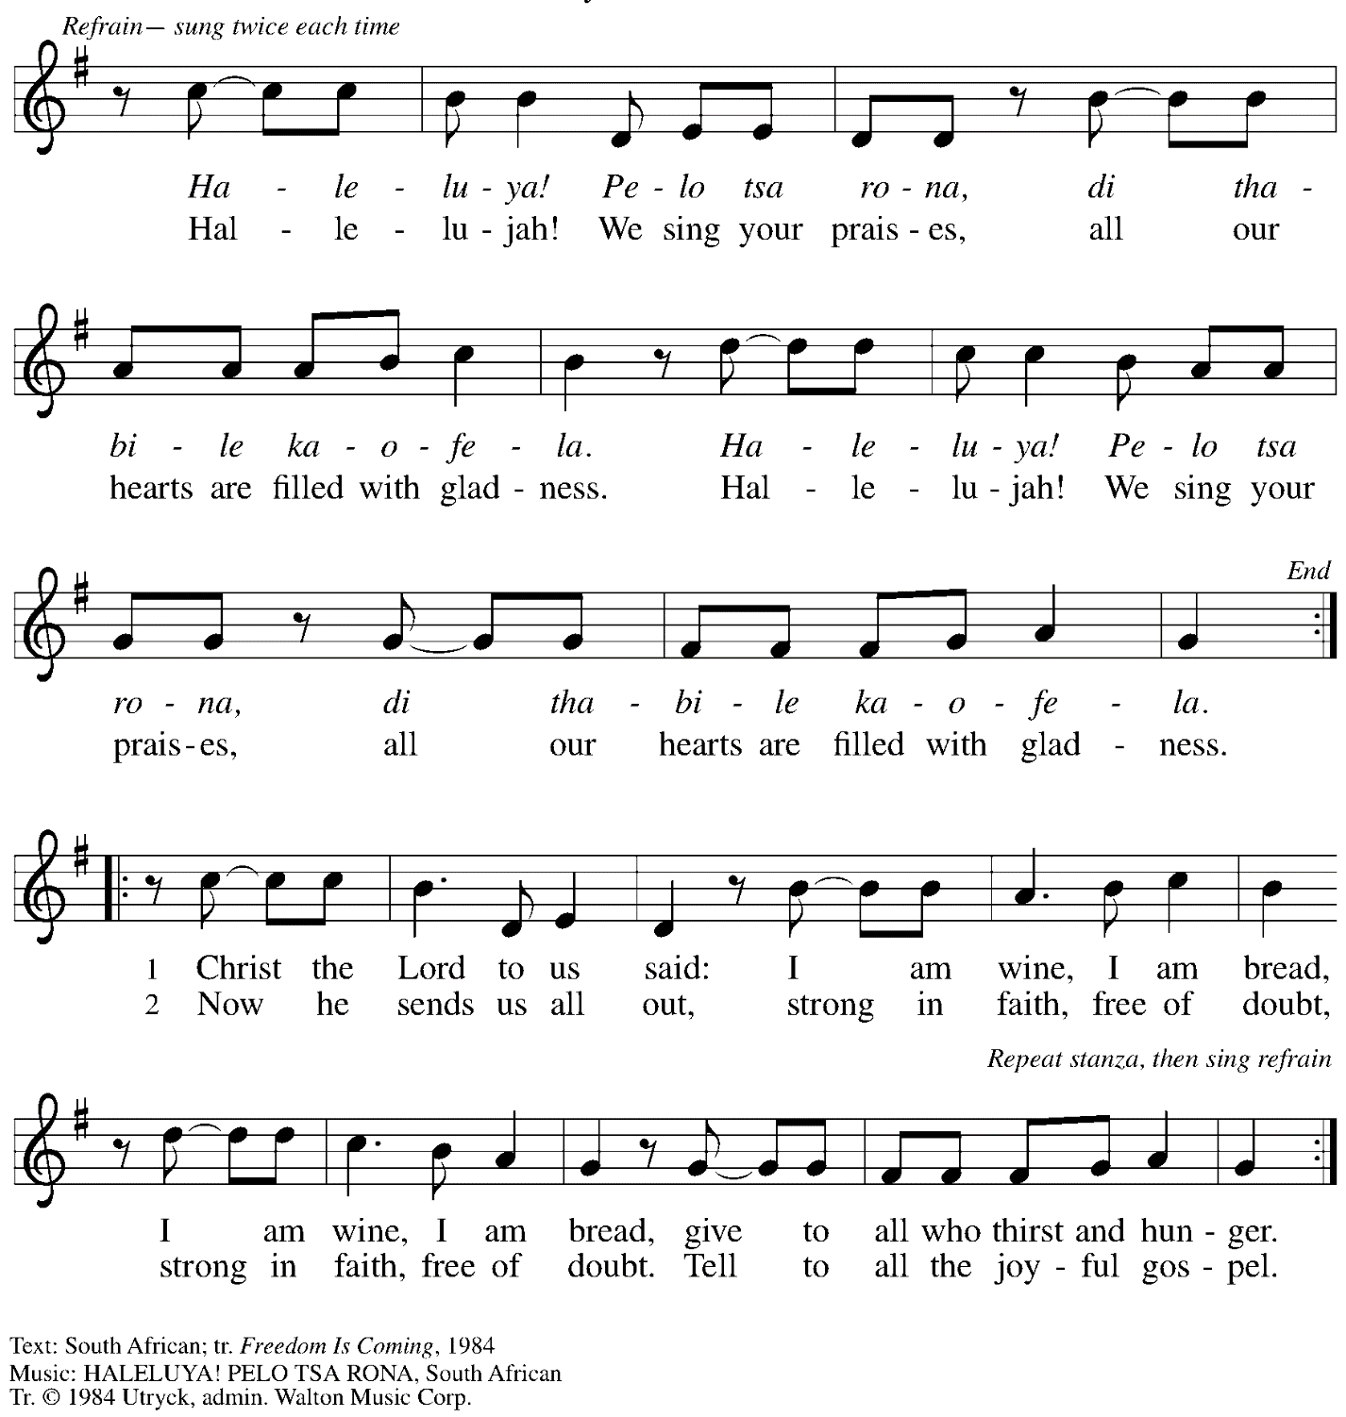

All rights reserved. Reprinted with permission under OneLicense.net # A-722139.

*Those serving in worship today*

Altar Care Beverley Chapman

Assisting Minister Jeff Denlinger

Audio-Visual Ministers Joseph Paetz

Jason Galyardt

Cantor Jered Stratton

Lector Michael Chapman

Minister of Music Laura Reynolds

Pastor The Rev. Ross I. Carmichael

Presiding Minister at Holy Communion The Rev. Dr. Paul F. Koch

*Liturgy and Hymnody Acknowledgements*

From SundaysandSeasons.com. Copyright © 2024 Augsburg Fortress. All rights reserved. Reprinted under OneLicense.net # A-722139.

Used by permission of Augsburg Fortress.

The Scripture readings contained herein are from *New Revised Standard Version* of the Bible © 1989, Division of Christian Education of the National Council of Churches of Christ in the USA. Used by permission. All rights reserved.

*Please use the QR code below to link to St. Andrew’s announcements online!*



**St. Andrew Lutheran Church Announcements**

**August 18th, 2024**

* **Welcome to Worship at St. Andrew on the Thirteenth Sunday after Pentecost, August 18th, 2024** –We are so glad you are here, and we offer a special welcome to all visitors and guests connecting for the first time! Worship attendees are invited to make a name tag at the back of the worship space if you would like. There are worship “toolkits” to help children engage with worship and “busy bags” for younger children available in the bookcase at the back of the sanctuary. Please feel free to take one to use with/for your children. All are invited to gather for coffee, other drinks, food, and conversation in the social hall after worship.
* **Celebrate Pastor Paul Koch and his 54th Anniversary of Ordination Today, August 18th** – The Rev. Dr. Paul F. Koch of St. Andrew celebrated the 54th anniversary of his ordination to the Ministry of Word and Sacrament on August 9th. Because the milestone of his 50th anniversary came during the pandemic, we were not able to properly share our joy and blessings with him on the occasion. Pastor Paul will preside at Holy Communion during worship today, and we invite everyone to stay after the service for a special coffee hour with a cake to help him celebrate this anniversary! We give thanks to God for Pastor Paul and Sharon and the blessing that their ministry has been to the church and still is!
* **Noisy Offering during Worship Today –** On the third Sunday of each month, St. Andrew invites the children of the congregation to lead us in a “noisy offering.” Children carry buckets around the congregation and people are invited to throw in their change, which then gets compiled in big metal buckets and is brought forward as an offering to support various ministries. This month’s Noisy Offering will support LAMPa – Lutheran Advocacy Ministry in Pennsylvania, our commonwealth’s public policy office of the Evangelical Lutheran Church in America (ELCA). LAMPa’s advocacy “works for change in public policy based on the experience of Lutheran ministries, programs, and projects around the world and in communities across the United States.” They work on behalf of the biblical values of “peacemaking, hospitality to strangers, care for creation, and concern for people living in poverty and struggling with hunger and disease.” To learn more, please see [Lutheran Advocacy Ministry in Pennsylvania (lutheranadvocacypa.org)](https://www.lutheranadvocacypa.org/).
* **Represent St. Andrew and ReconcilingWorks at Main Street Market Night in Munhall on Friday, August 23rd, 5:00-9:00 p.m.** – As a Reconciling in Christ (RIC) congregation that intentionally welcomes and affirms LGBTQIA+ individuals and families, St. Andrew seeks to share our welcome, and that of other RIC congregations around the Pittsburgh area. St. Andrew will have another opportunity to do this on Friday, August 23rd, when Munhall is hosting another of its Main Street Market Nights. The event runs from 5:00 - 9:00 p.m., and we invite people of the congregation to represent St. Andrew at a table/booth for any portion of that event. Please see Kathy Hays or Pastor Ross if you would like to participate!
* **Potluck Meal and Hymn Sing with Bethel AME Church – Saturday, September 7th, 5:00 p.m.! – St. Andrew’s worship committee has been in conversation with Pastor Snyder and other leaders of Bethel AME, and we invite people of our congregations to gather informally on Saturday, September 7th, to share a potluck meal and sing hymns from our respective traditions together. Come share in a time of conversation and community and join with our siblings in Christ in praising God!**
* **Little Church – Big Faith to Resume during Worship after Labor Day – Little Church – Big Faith, a Bible story and activity that takes place during Sunday worship, is an important part of St. Andrew’s ministry for children in the congregation. It has been on hiatus for the summer, but we plan to resume weekly activities after Labor Day. Please watch for more detailed announcements in the weeks ahead.**
* **Lessons from Dietrich Bonhoeffer in a House Divided and a World on Fire – Wednesdays at 7:00 p.m., Starting September 25th, via Zoom** – Join us for six weeks as we explore the life and theology of Dietrich Bonhoeffer, and the lessons we can use as we live at the intersection of faith and civic life today. Bonhoeffer was a Lutheran pastor and theologian living in Nazi Germany, who eventually joined the resistance and was arrested and killed before the end of WWII. This curriculum was compiled by Dr. Lori Brandt Hale, an internationally renowned Bonhoeffer scholar and president of the International Bonhoeffer Society - English Language Section. Lutheran Advocacy Ministry in Pennsylvania is a partner in distributing to congregations to inspire deeper conversation and discernment about how we live as disciples. Pastor Erin Jones, staff at LAMPa and member of St. Andrew, will facilitate and lead us in these sessions.
* **Lutheran Campus Ministry in Greater Pittsburgh “BBQ Bash” Event on Friday, September 27th, 5:00-8:00 p.m. – Our church’s local campus ministry invites you to its second annual fundraiser to enjoy an evening of great food and friends to support its ministry. The event will be held at Rose Barn at North Park, 10280 Pearce Mill Rd., Allison Park 15101. The evening will feature food and drinks, a silent auction, and music. Cost is $60 per person. To register, please visit** <lucpgh.com> **or use the direct link,** [Donate (paypal.com)](https://www.paypal.com/donate?campaign_id=ZNAUMEB8ZJN4Y)**.**
* **Latest Updates on Sumud: The Evangelical Lutheran Church in America (ELCA)’s Initiative for Justice in Palestine and Israel – Sumud, which means “steadfastness,” is the ELCA’s collective response to the ongoing crisis in the Holy Land. To learn more or to sign up for the latest advocacy action alerts, please visit** <https://www.elca.org/Our-Work/Publicly-Engaged-Church/Sumud>**.**
* **Seeking Help with Upkeep of Church Grounds** – Part of our call to hospitality for our neighbors is offering a beautiful and inviting presence and space in the community. A few members of the congregation spend a great deal of time and energy maintaining the plants and garden areas around the church, and they are in need of additional help. We are seeking people to help with upkeep of the church grounds, especially in pulling weeds along the sidewalks and stairs, picking up garbage, and cleaning up leaves as needed. These tasks can be flexible according to one’s schedule. Please speak with Pat (Evangelism) or Hal (Property) if you would like to contribute, or contact them at [evangelism@standrewpittsburgh.org](mailto:evangelism@standrewpittsburgh.org) or [property@standrewpittsburgh.org](mailto:property@standrewpittsburgh.org). Thank you, and thanks to Lester, Cynthia, Hal, Jimmi and Timothy for all they do for the outdoor spaces at the church!
* **Coffee Hour Signups Available** –One way that St. Andrew builds community is by sharing conversation over food and drinks at coffee hour after worship on Sundays. We invite people of the congregation to sign up to coordinate coffee hour each week, which includes brewing the coffee; setting out cups, napkins, food items, and cold drinks; and cleaning up afterward. Everything needed is at St. Andrew and instructions are available. Please sign up to host coffee hour here: <https://www.signupgenius.com/go/5080B4AAFAF2CABF85-47069030-coffee>.
* ***Christ in Our Home* Devotional Booklets (July – September) Available at Church Entrances – *Christ in Our Home* is a booklet of devotions that includes Scripture, a brief reflection, and prayer for each day. The July – September edition is available at the various church entrances. Please feel free to take one for yourself or others!**