

**+ Ninth Sunday after Pentecost**

**July 21, 2024**



**St. Andrew Lutheran Church**

**304 Morewood Ave.**

**Pittsburgh, PA 15213**

[**St_andrewELCA@verizon.net**](mailto:St_andrewELCA@verizon.net)

[**www.standrewpittsburgh.org**](http://www.standrewpittsburgh.org)

**+ Ninth Sunday after Pentecost**

**Order for Worship**

*Mark’s Gospel emphasizes how intense the press of the crowd is on Jesus and his disciples, and how great the needs of the people. Yet in this text, Jesus advises his disciples to get away and rest, to take care of themselves. Sometimes we think that when others are in great need we should not think of ourselves at all; but Jesus also honors the caregivers’ need. We are sent from Christ’s table to care for others and for ourselves*

**Welcome to St. Andrew!**

* St. Andrew Lutheran congregation welcomes all who are seeking a place of healing and wholeness – a nurturing, faith-forming spiritual home. Our community embraces people of all ages, ethnicities, cultures, abilities, sexual orientations, gender identities and expressions, and family constellations. Come and See!
* Worship Services are live streamed to multiple online platforms. By attending worship, you agree that your image and voice may be broadcast.
* Everyone is invited to make a name tag at the black bookcase in the back of the worship space if they would like. There are stickers indicating pronouns on the bookcase if you would like to include them on your name tag.
* A nursery is available through the doors at the left side of the sanctuary and across from the doorway to the Social Hall. Look for a purple-colored room.
* Worship “toolkits” to help children engage with the service, along with “busy bags” for younger children, are available in the bookcase at the back of the sanctuary. Please feel free to take one to use with/for your children.
* Holy Communion is served with bread (gluten-free available) and wine or grape juice. The presiding minister will distribute the bread (host). Please consume this and then pick up an empty glass from the tray. The Communion Assistant will pour wine or grape juice into your glass. Please step to the side to consume the wine or grape juice. Feel free to kneel at the altar for prayer and reflection. As you return to your pew, glasses may be returned to the empty trays on either side of the center section.
* A restroom is available on the main level of the church, through the doors to the Social Hall and to the right in the main office.

*Abbreviations*

P: Pastor/Presiding Minister ***ELW*: *Evangelical Lutheran Worship* hymnal**

A: Assisting Minister ***ACS*: *All Creation Sings* hymnal**

L: Lector

**C: Congregation**

**Pre-Service Music**

**Welcome**

**Prelude** *The Lord’s My Shepherd* arr. L. Larson

**Gathering**

*The Holy Spirit calls us together as the people of God*

**Confession and Forgiveness**

*Please rise as you are able.*

*All may make the sign of the cross, the sign that is marked at Baptism,*

*as the presiding minister begins.*

P: Blessed be the holy Trinity, ☩ one God,

who looks upon us in compassion,

forgives our sin,

and heals our lives.

**C: Amen.**

P: Let us confess our sin in the presence of God and of one another.

*Silence is kept for reflection*

P: Have mercy,

**C: O God, for we have sinned against you and our neighbors,**

**by what we have done and by what we have failed to do.**

**In your compassion, cleanse us of our sin and take away our guilt,**

**Create in us a new heart** **and give us a steadfast spirit.**

**Do not cast us away, but fill us with your Holy Spirit,**

**and restore your joy within us. Amen.**

**P:** By water and the Holy Spirit God gives you a new birth,

and through the death and resurrection of ☩ Jesus Christ,

God forgives you all your sins.

The God of mercy and might strengthen you in all goodness

and keep you in eternal life.

**C: Amen.**

**Gathering Hymn O Day of Rest and Gladness *ELW* 521**

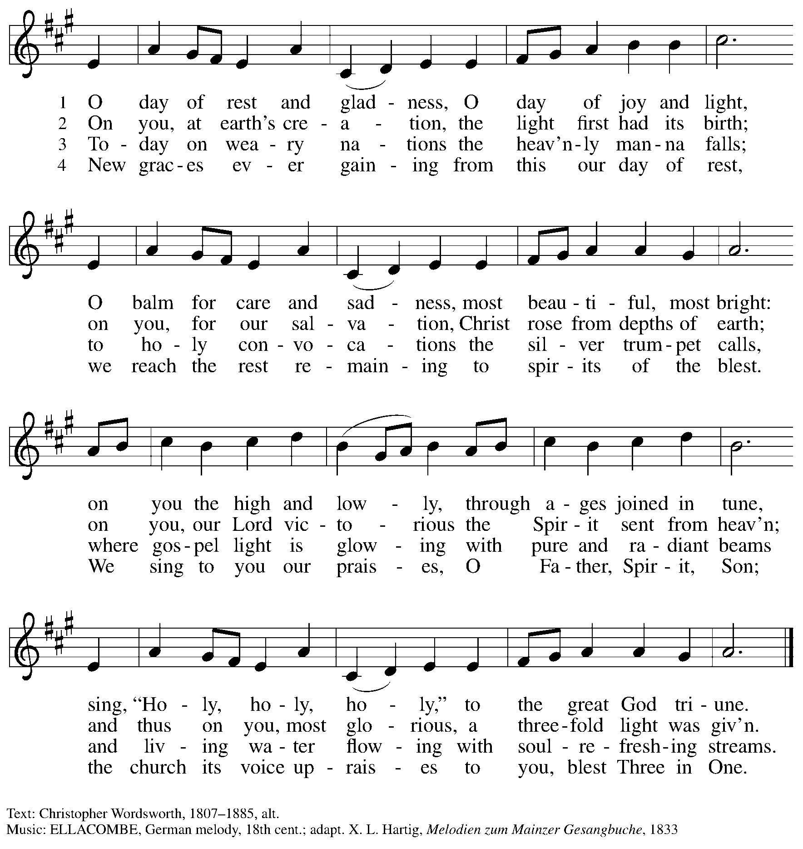

**Greeting**

P: The grace of our Lord Jesus Christ, the love of God,

and the communion of the Holy Spirit be with you all.

**C: And also with you.**

**Prayer of the Day**

P: Let us pray.

O God, powerful and compassionate, you shepherd your people,

faithfully feeding and protecting us. Heal each of us, and make us a whole people,

that we may embody the justice and peace of your Son, Jesus Christ, our Savior and Lord.

**C: Amen.**

*Please be seated.*

**Word**

*God speaks to us in Scripture reading, preaching, and song*

**First Reading** **–** **Jeremiah 23: 1-6**

1 Woe to the shepherds who destroy and scatter the sheep of my pasture! says the Lord.

2 Therefore thus says the Lord, the God of Israel, concerning the shepherds who shepherd my people: It is you who have scattered my flock, and have driven them away, and you have not attended to them. So I will attend to you for your evil doings, says the Lord. 3 Then I myself will gather the remnant of my flock out of all the lands where I have driven them, and I will bring them back to their fold, and they shall be fruitful and multiply. 4 I will raise up shepherds over them who will shepherd them, and they shall not fear any longer, or be dismayed, nor shall any be missing, says the Lord.  
  
  5 The days are surely coming, says the Lord, when I will raise up for David a righteous Branch, and he shall reign as king and deal wisely, and shall execute justice and righteousness in the land. 6 In his days Judah will be saved and Israel will live in safety. And this is the name by which he will be called: “The Lord is our righteousness.”

L: Word of God, word of life.

**C: Thanks be to God.**

**Psalm 23 My Shepherd, You Supply My Need** *Following page*

*The congregation is invited to join in singing “My Shepherd, You Supply My Need,”*

*a paraphrase of Psalm 23.*

**Psalm 23 My Shepherd, You Supply My Need *ELW* 782**

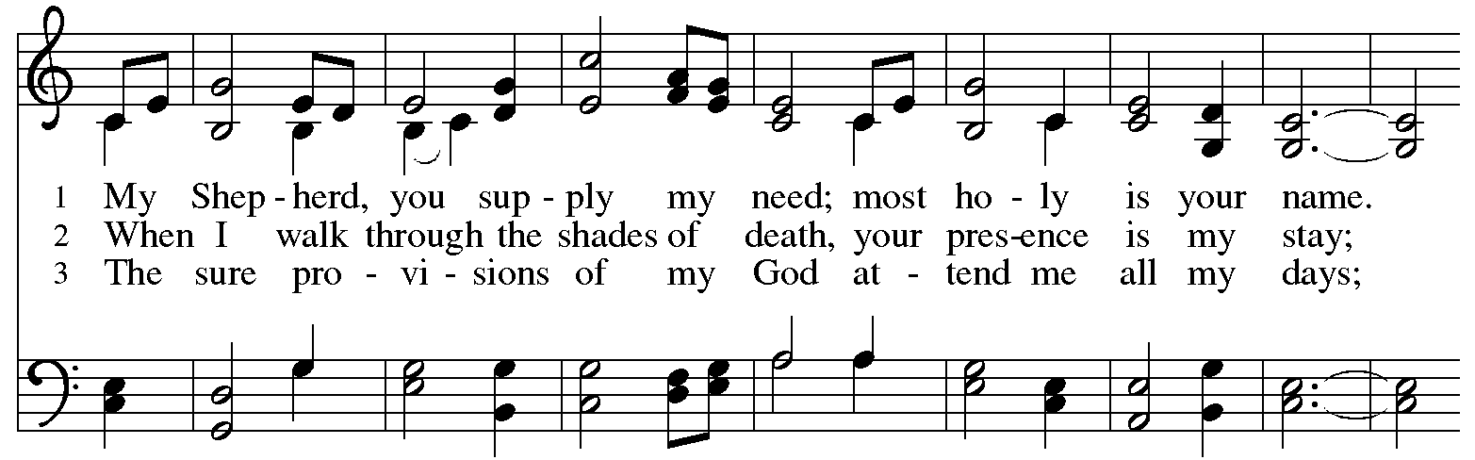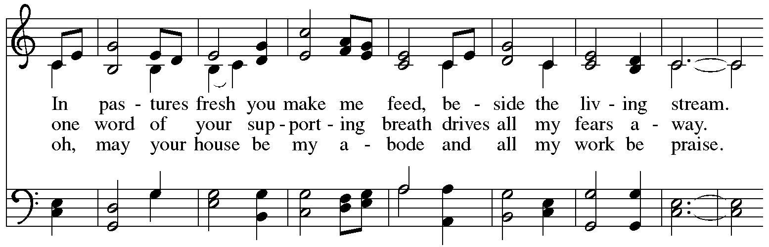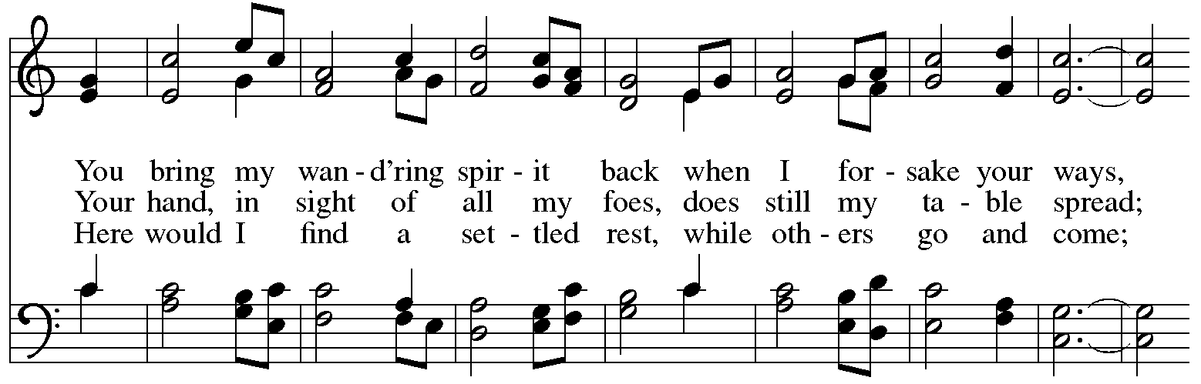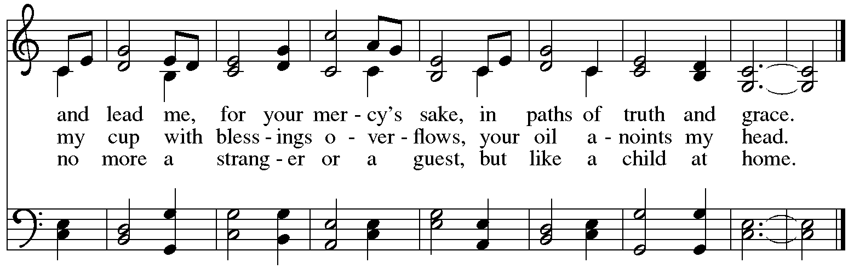

**Second Reading – Ephesians 2: 11-22**

11 Remember that at one time you Gentiles by birth, called “the uncircumcision” by those who are called “the circumcision”—a physical circumcision made in the flesh by human hands—12 remember that you were at that time without Christ, being aliens from the commonwealth of Israel, and strangers to the covenants of promise, having no hope and without God in the world. 13 But now in Christ Jesus you who once were far off have been brought near by the blood of Christ. 14 For he is our peace; in his flesh he has made both groups into one and has broken down the dividing wall, that is, the hostility between us. 15 He has abolished the law with its commandments and ordinances, that he might create in himself one new humanity in place of the two, thus making peace, 16 and might reconcile both groups to God in one body through the cross, thus putting to death that hostility through it. 17 So he came and proclaimed peace to you who were far off and peace to those who were near; 18 for through him both of us have access in one Spirit to the Father. 19 So then you are no longer strangers and aliens, but you are citizens with the saints and also members of the household of God, 20 built upon the foundation of the apostles and prophets, with Christ Jesus himself as the cornerstone. 21 In him the whole structure is joined together and grows into a holy temple in the Lord; 22 in whom you also are built together spiritually into a dwelling place for God.

L: Word of God, word of life.

**C: Thanks be to God.**

*Please rise as you are able and join in speaking the Gospel Acclamation.*

**Gospel Acclamation**

**C: Alleluia. My sheep hear my voice. I know them, and they follow me. Alleluia.**

**Gospel – Mark 6: 30-34, 53-56**

P: The holy Gospel according to St. Mark.

**C: Glory to you, O Lord.**

30 The apostles gathered around Jesus, and told him all that they had done and taught. 31 He said to them, “Come away to a deserted place all by yourselves and rest a while.” For many were coming and going, and they had no leisure even to eat. 32 And they went away in the boat to a deserted place by themselves. 33 Now many saw them going and recognized them, and they hurried there on foot from all the towns and arrived ahead of them. 34 As he went ashore, he saw a great crowd; and he had compassion for them, because they were like sheep without a shepherd; and he began to teach them many things.  
  
  53 When they had crossed over, they came to land at Gennesaret and moored the boat. 54 When they got out of the boat, people at once recognized him, 55 and rushed about that whole region and began to bring the sick on mats to wherever they heard he was. 56 And wherever he went, into villages or cities or farms, they laid the sick in the marketplaces, and begged him that they might touch even the fringe of his cloak; and all who touched it were healed.

P: The Gospel of the Lord.

**C: Praise to you, O Christ.**

*Please be seated.*

**Sermon**

*A time of silence for prayer and reflection follows the sermon.*

*When the hymn of the day begins, please rise as you are able.*

**Hymn of the Day I Heard the Voice of Jesus Say *ELW* 611**

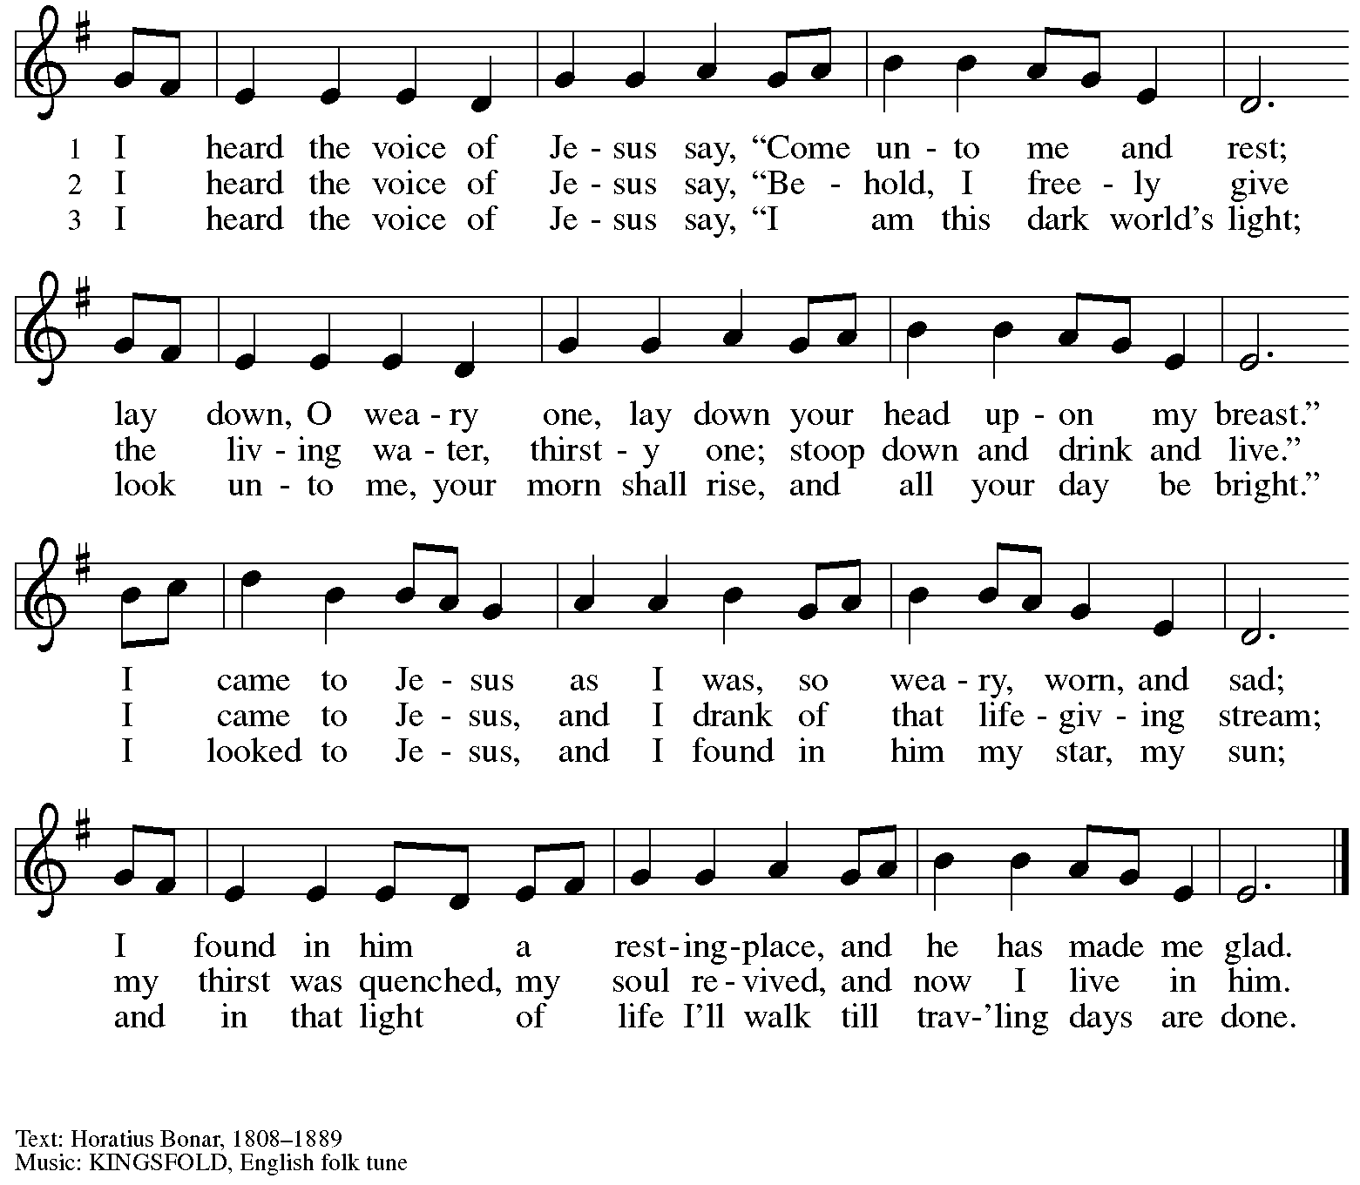

**Prayers of the People**

A: Rooted in God’s abundant love for the world, let us pray for our neighbors,

the church, and all of God’s creation.

*After each petition*

A: Merciful God,

**C: receive our prayer.**

*The presiding minister concludes the prayers*

P: We offer our prayers to you, gracious God,

trusting in your boundless love for all you have made,

through Jesus Christ our Savior.

**C: Amen.**

**Peace**

*The presiding minister and the assembly greet one another in the peace of the risen Christ.*

P: The peace of Christ be with you always.

**C: And also with you.**

*The people may greet those around them with a sign of Christ’s peace and may say*

Peace be with you *or similar words. Please be mindful that not everyone will be comfortable with sharing the peace, so please seek consent before shaking hands or hugging. Other possible ways to share the peace include a simple bow with the verbal greeting of peace, or simply a verbal expression of peace.*

*When the greetings of peace have concluded, please be seated.*



**Meal**

*God feeds us with the presence of Jesus Christ*

**Offering**

*We offer ourselves, our gifts, and our faithful service to God.*

*As the offering is gathered for the mission of the church, including the care of those in need,*

*the table is set for Holy Communion.*

**Noisy Offering**

*As children of the congregation carry buckets around the sanctuary, people of the congregation are invited to throw in their change as an offering. This month’s Noisy Offering will benefit East End Cooperative Ministry a local organization offering community food services, housing and employment services, and children and youth services to address the impacts of poverty.*

**Music during the Offering**

*Blessed Assurance* arr. B. Edstrom

*As the gifts are brought forward for presentation, please rise as you are able.*

**Offertory Song**

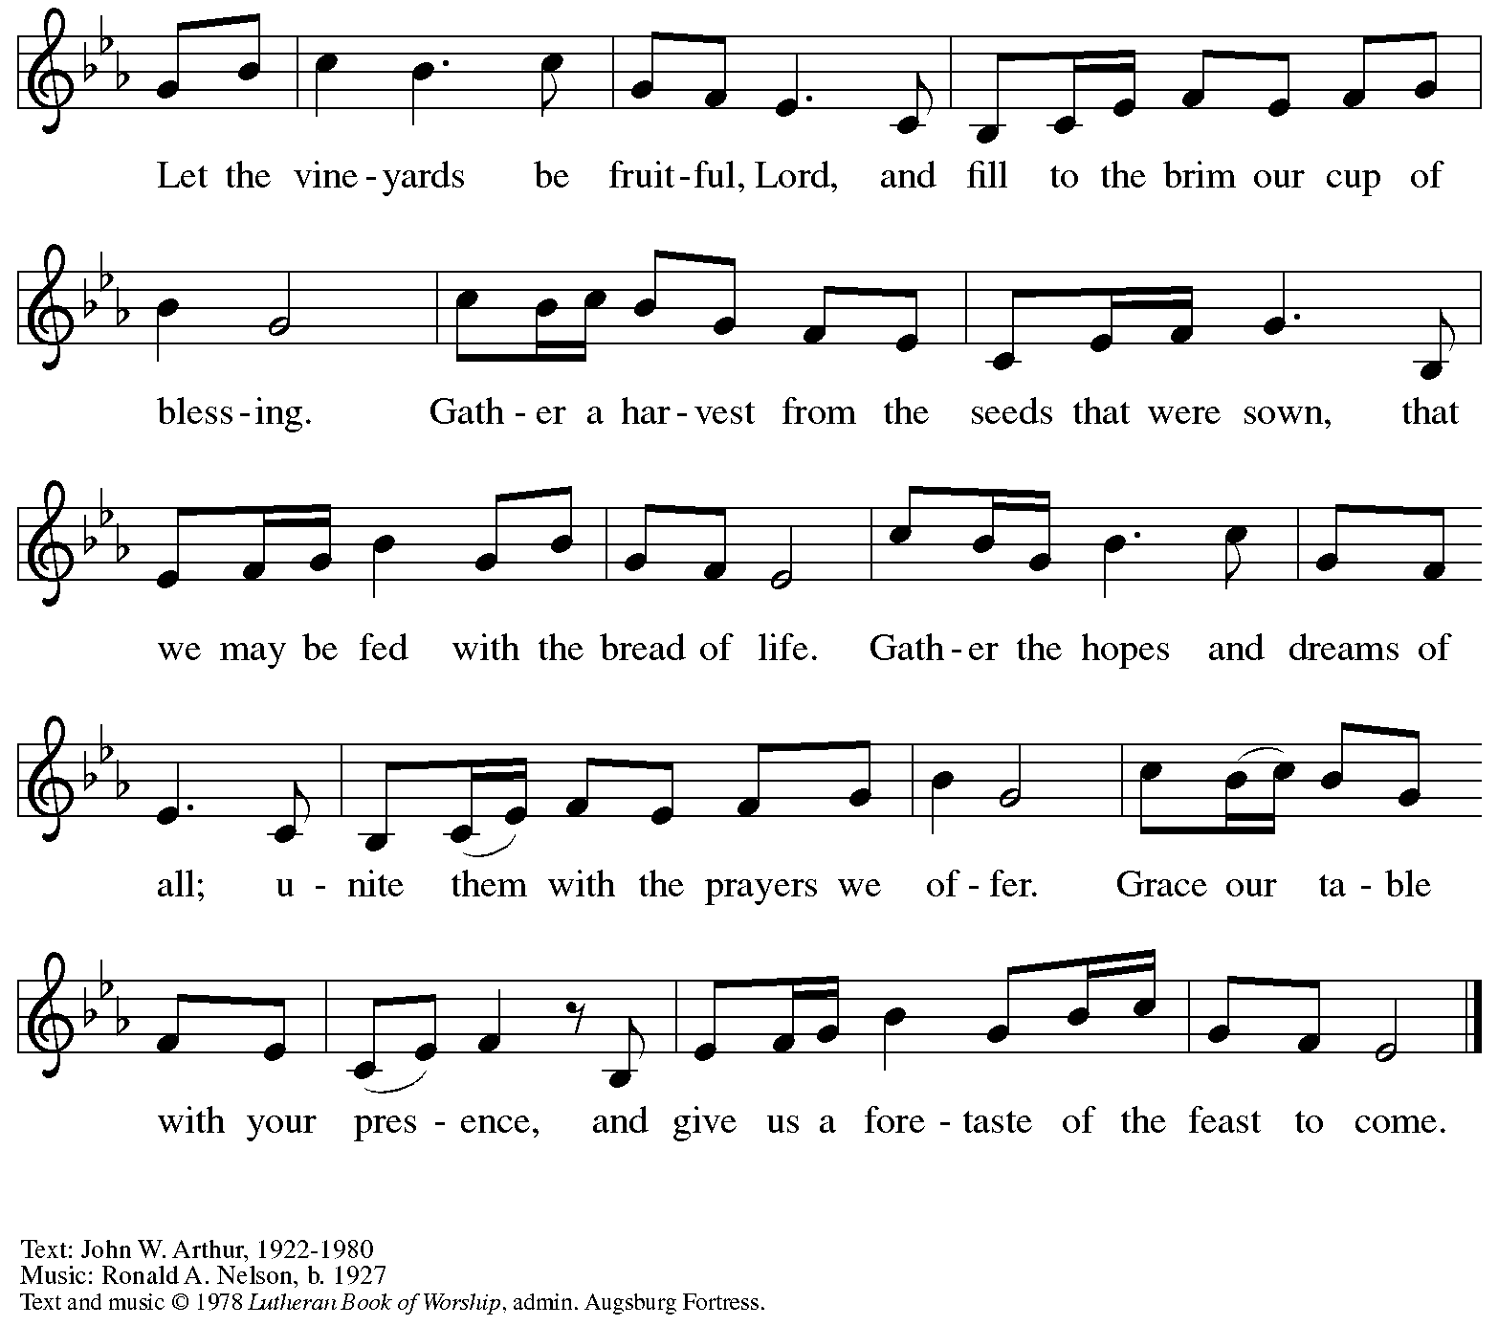

All rights reserved. Reprinted under OneLicense.net # A-722139.

**Offertory Prayer**

A: Let us pray.

God of all creation,

**C: all you have made is good, and your love endures forever.**

**You bring forth bread from the earth and fruit from the vine.**

**Nourish us with these gifts, that we might be for the world**

**signs of your gracious presence in Jesus Christ, our Savior and Lord.**

**Amen.**

**Dialogue**

P: The Lord be with you.

**C: And also with you.**

P: Lift up your hearts.

**C: We lift them to the Lord.**

P: Let us give thanks to the Lord our God.

**C: It is right to give our thanks and praise.**

**Preface**

P: It is indeed right, our duty and our joy …

… we praise your name and join in adoring song:

**Sanctus**

**C: Holy, holy, holy Lord,**

**God of power and might,**

**heaven and earth are full of your glory.**

**Hosanna in the highest.**

**Blessed is the one who comes in the name of the Lord.**

**Hosanna in the highest.**

**Eucharistic Prayer**

P: Holy, mighty, and merciful Lord …

… to whom, with you and the Holy Spirit,

be all honor and glory, now and forever.

**C: Amen.**

**Lord’s Prayer**

P: Gathered as one by the Holy Spirit, let us pray as Jesus taught us.

**C: Our Father in heaven,**

**hallowed be your name,**

**your kingdom come,**

**your will be done,**

**on earth as in heaven.**

**Give us today our daily bread.**

**Forgive us our sins**

**as we forgive those**

**who sin against us.**

**Save us from the time of trial**

**and deliver us from evil.**

**For the kingdom, the power,**

**and the glory are yours,**

**now and forever. Amen.**

**Fraction and Invitation**

P: These are the gifts of God for the beloved of God.

Come, share the feast.

***Agnus Dei /* Lamb of God**

**C: Lamb of God, you take away the sin of the world; have mercy on us.**

**Lamb of God, you take away the sin of the world; have mercy on us.**

**Lamb of God, you take away the sin of the world; grant us peace.**

*Please be seated.*

**Holy Communion**

* *All who seek God and desire a deeper and stronger life in Christ are welcome to receive Holy Communion.*
* *Worshipers from the pulpit side will proceed forward first, followed by the center section, and then the lectern side.*
* *Please inform an usher if you would like the ministers to bring Communion to you.*
* *Holy Communion will be served with bread and wine/grape juice.*
* *The presiding minister will first distribute the bread (host) to each communicant. Please indicate if you require a gluten-free host.*
* *Once you have consumed the bread, please pick up an empty glass from the tray next to the presiding minister. The Communion Assistant will pour wine from the chalice or grape juice from the cruet into your glass.*
* *Please step to the side to consume the wine or grape juice.*
* *Feel free to kneel at the altar rail for prayer after receiving the sacrament.*
* *As you return to your pew, glasses may be returned to the empty trays on either side of the center section.*
* *A blessing will be provided for anyone who does not yet receive the sacrament.*
* *All are invited to join in singing the hymns during Holy Communion.*

**Hymns during Holy Communion**

**O Christ, Your Heart, Compassionate *ELW* 722**

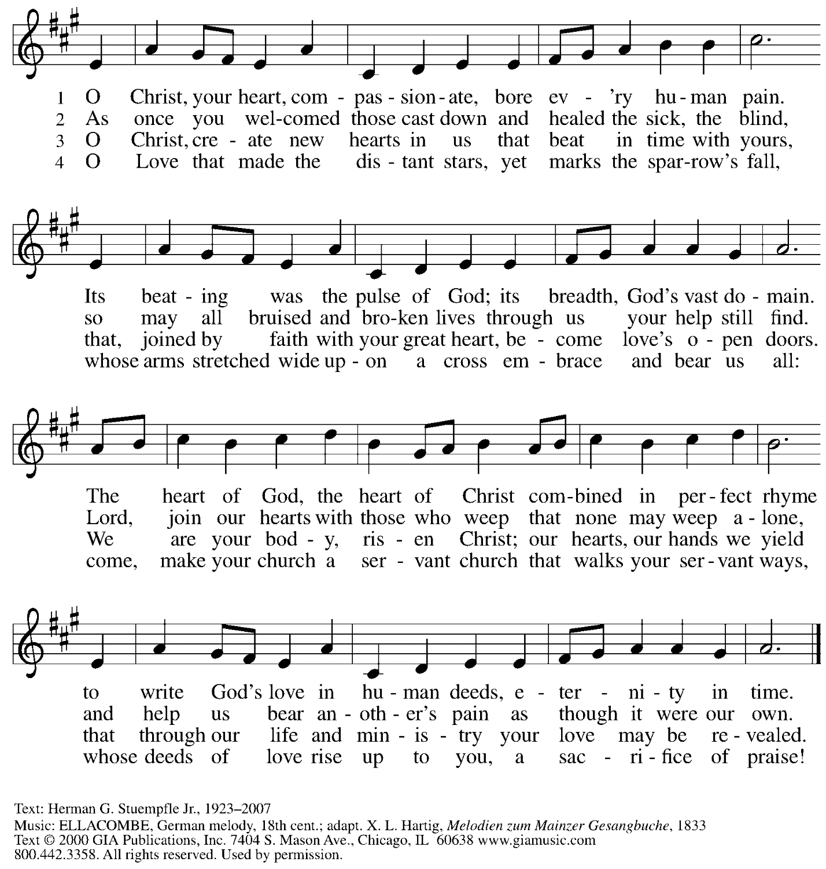

Reprinted under OneLIcense.net # A-722139.

**Hymns during Holy Communion**

**Come to Me, O Weary Traveler *ACS* 1017**

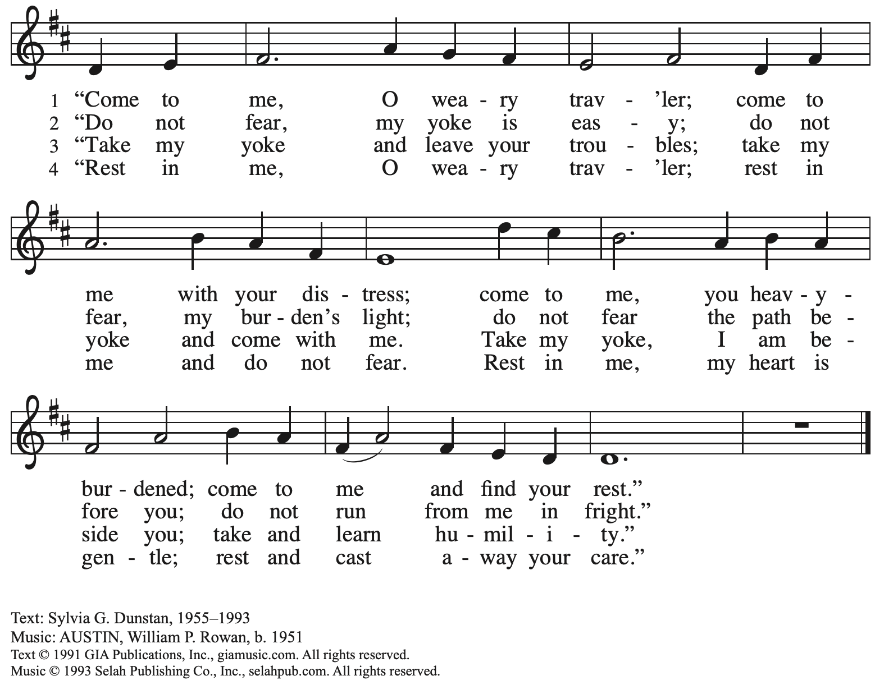

Reprinted with permission under OneLicense.net # A-722139.

**Hymns during Holy Communion**

**By Grace We Have Been Saved *ACS* 1006**

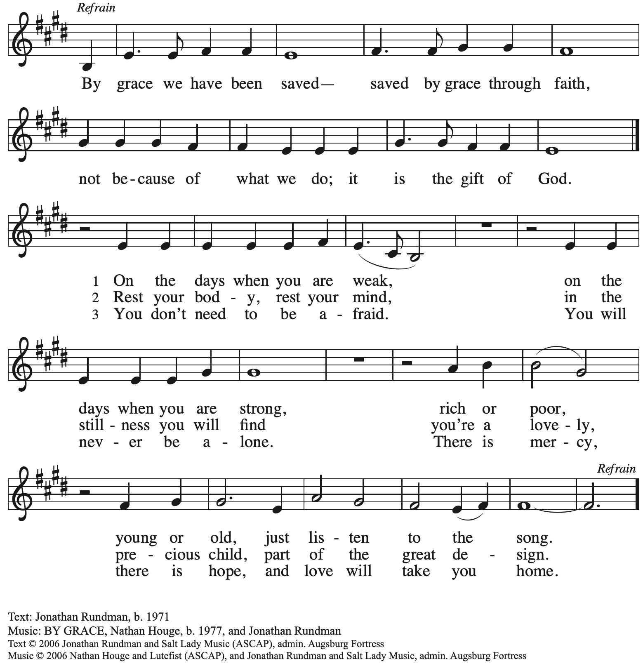

All rights reserved. Reprinted with permission under OneLicense.net # A-722139.

*When all have returned to their places, please rise as you are able.*

**Blessing**

P: The body and blood of our Lord Jesus Christ strengthen you and keep you in his grace.

**C: Amen.**

**Prayer**

A: Let us pray. Gracious God,

in this meal you have drawn us to your heart,

and nourished us at your table with food and drink,

the body and blood of Christ.

Now send us forth to be your people in the world,

and to proclaim your truth, this day and evermore,

through Jesus Christ, your Son, our Lord.

**C: Amen.**

*Please be seated.*

**Sending**

*God blesses us and sends us in mission to the world*

**Announcements**

*Please rise as you are able.*

**Benediction**

P: God, the Source of glory,

God, the Word of life,

God, the Spirit of truth

☩ bless you all, now and forever.

**C: Amen.**

**Sending Hymn Oh, Praise the Gracious Power** *Following page*

**Dismissal**

A: Go in peace. Serve the Lord.

**C: Thanks be to God.**

**Postlude** *How Great Our Joy* arr. D. Krieger

**Sending Hymn Oh, Praise the Gracious Power *ELW* 651**

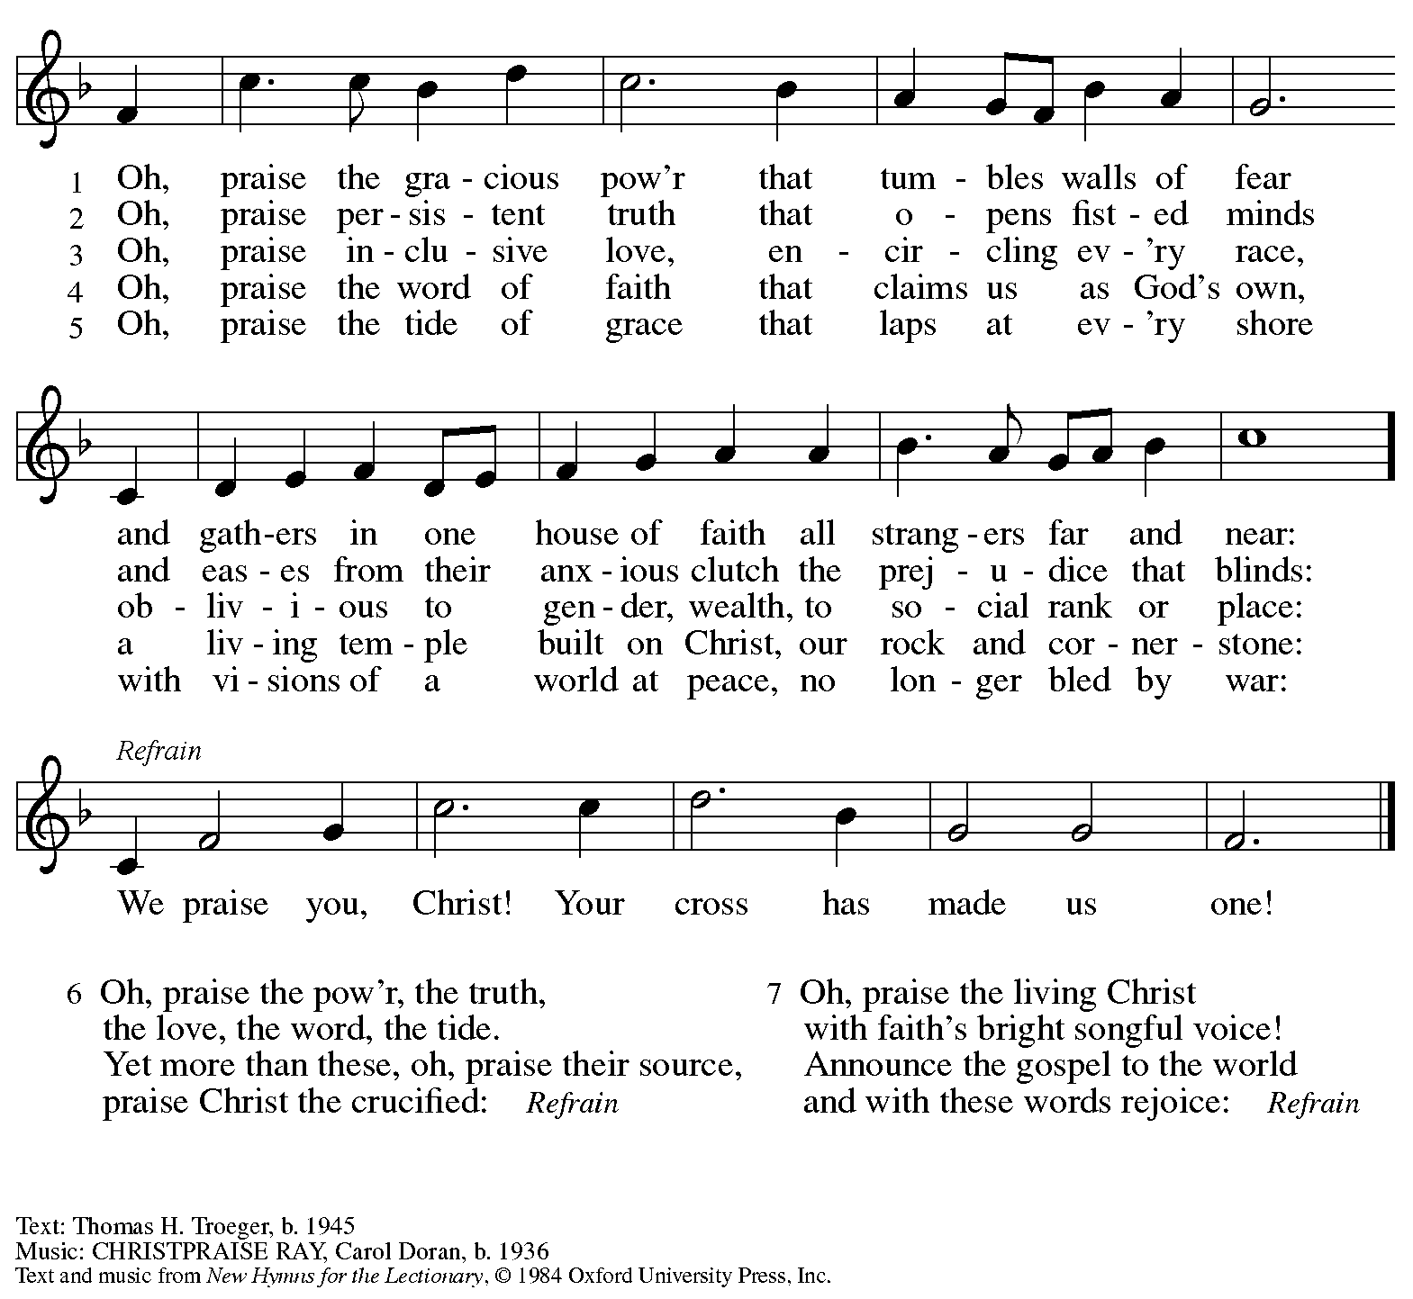

All rights reserved. Reprinted with permission under OneLicense.net # A-722139.

*Those serving in worship today*

Altar Care Christy Ruhe

Assisting Minister Colleen Cooke

Audio-Visual Ministers David Rollinson

Jason Galyardt

Cantor Mandy Best

Lector Alda Maria Gonzaga

Minister of Music Laura Reynolds

Presiding and Preaching Minister The Rev. Ross I. Carmichael

*Liturgy and Hymnody Acknowledgements*

From SundaysandSeasons.com. Copyright © 2024 Augsburg Fortress. All rights reserved. Reprinted under OneLicense.net # A-722139.

Used by permission of Augsburg Fortress.

The Scripture readings contained herein are from *New Revised Standard Version* of the Bible © 1989, Division of Christian Education of the National Council of Churches of Christ in the USA. Used by permission. All rights reserved.

*Please use the QR code below to link to St. Andrew’s announcements online!*



**St. Andrew Lutheran Church Announcements**

**July 21st, 2024**

* **Welcome to Worship at St. Andrew on the Ninth Sunday after Pentecost, July 21st, 2024** –We are so glad you are here, and we offer a special welcome to all visitors and guests connecting for the first time! Worship attendees are invited to make a name tag at the back of the worship space if you would like. There are worship “toolkits” to help children engage with worship and “busy bags” for younger children available in the bookcase at the back of the sanctuary. Please feel free to take one to use with/for your children. All are invited to gather for coffee other drinks and food, and conversation in the social hall after worship.
* **Noisy Offering during Worship Today –** On the third Sunday of each month, St. Andrew invites the children of the congregation to lead us in a “noisy offering.” Children carry buckets around the congregation and people are invited to throw in their change, which then gets compiled in big metal buckets and is brought forward as an offering to support various ministries. This month’s noisy offering will support East End Cooperative Ministry, which provides meals, housing and employment services, and children and youth services to change “the lives of people facing the impacts of poverty.” Learn more at [Home | EECM | Pittsburgh](https://www.eecm.org/).
* **Bible Book Club Continues Wednesdays on Zoom at 7:00 p.m. – A group of people from St. Andrew has been reading books related to faith, theology, and the Bible, and then gathering online weekly to discuss the book. The group is currently reading “Jesus Feminist” by Sarah Bessey and our next meeting is Wednesday, July 24th, at 7:00 p.m. All are welcome to join in even if you have not read the book. For login information, please speak with Pastor Ross.**

**Coffee Hour Signups Available for July Available!** –One way that St. Andrew builds community is by sharing conversation over food and drinks at coffee hour after worship on Sundays. We invite people of the congregation to sign up to coordinate coffee hour each week, which includes brewing the coffee; setting out cups, napkins, food items, and cold drinks; and cleaning up afterward. Everything needed is at St. Andrew and instructions are available. Please sign up to host coffee hour here: <https://www.signupgenius.com/go/5080B4AAFAF2CABF85-47069030-coffee>.

* **New *Christ in Our Home* Devotional Booklets (July – September) Available at Church Entrances – *Christ in Our Home* is a booklet of devotions that includes Scripture, a brief reflection, and prayer for each day. The new edition for July – September is now available at the various church entrances. Please feel free to take one for yourself or others!**