

**+ Tenth Sunday after Pentecost**

**July 28, 2024**



**St. Andrew Lutheran Church**

**304 Morewood Ave.**

**Pittsburgh, PA 15213**

[**St_andrewELCA@verizon.net**](mailto:St_andrewELCA@verizon.net)

[**www.standrewpittsburgh.org**](http://www.standrewpittsburgh.org)

**+ Tenth Sunday after Pentecost**

**Order for Worship**

*This week is the first of five consecutive Sundays with gospel readings from John 6, the first four of which focus on Jesus as Bread of Life. In today’s reading, Jesus feeds thousands of people with five loaves and two fish. What we have, what we bring to Jesus’ table, seems like it is not nearly enough to meet all the needs we see around us. But it is not the adequacy of our supplies or our skills that finally makes the difference: it is the power of Jesus working in the littlest and least to transform this world into the world God desires, a world where all the hungry are satisfied.*

**Welcome to St. Andrew!**

* St. Andrew Lutheran congregation welcomes all who are seeking a place of healing and wholeness – a nurturing, faith-forming spiritual home. Our community embraces people of all ages, ethnicities, cultures, abilities, sexual orientations, gender identities and expressions, and family constellations. Come and See!
* Worship Services are live-streamed to multiple online platforms. By attending worship, you agree that your image and voice may be broadcast.
* Everyone is invited to make a name tag at the black bookcase in the back of the worship space if they would like. There are stickers indicating pronouns on the bookcase if you would like to include them on your name tag.
* A nursery is available through the doors at the left side of the sanctuary and across from the doorway to the Social Hall. Look for a purple-colored room.
* Worship “toolkits” to help children engage with the service, along with “busy bags” for younger children, are available in the bookcase at the back of the sanctuary. Please feel free to take one to use with/for your children.
* Holy Communion is served with bread (gluten-free available) and wine or grape juice. The presiding minister will distribute the bread (host). Please consume this and then pick up an empty glass from the tray. The Communion Assistant will pour wine or grape juice into your glass. Please step to the side to consume the wine or grape juice. Feel free to kneel at the altar for prayer and reflection. As you return to your pew, glasses may be returned to the empty trays on either side of the center section.
* A restroom is available on the main level of the church, through the doors to the Social Hall and to the right in the main office.

*Abbreviations*

P: Pastor/Presiding Minister ***ELW*: *Evangelical Lutheran Worship* hymnal**

A: Assisting Minister ***ACS*: *All Creation Sings* hymnal**

L: Lector ***WOV*: *With One Voice* hymnal**

**C: Congregation**

**Pre-Service Music**

**Welcome**

**Prelude**

**Gathering**

*The Holy Spirit calls us together as the people of God*

**Confession and Forgiveness**

*Please rise as you are able.*

*All may make the sign of the cross, the sign that is marked at Baptism,*

*as the presiding minister begins.*

P: Blessed be the holy Trinity, ☩ one God,

who looks upon us in compassion,

forgives our sin,

and heals our lives.

**C: Amen.**

P: Let us confess our sin in the presence of God and of one another.

*Silence is kept for reflection*

P: Have mercy,

**C: O God, for we have sinned against you and our neighbors,**

**by what we have done and by what we have failed to do.**

**In your compassion, cleanse us of our sin and take away our guilt.**

**Create in us a new heart** **and give us a steadfast spirit.**

**Do not cast us away, but fill us with your Holy Spirit,**

**and restore your joy within us. Amen.**

**P:** By water and the Holy Spirit God gives you a new birth,

and through the death and resurrection of ☩ Jesus Christ,

God forgives you all your sins.

The God of mercy and might strengthen you in all goodness

and keep you in eternal life.

**C: Amen.**

**Gathering Hymn All Who Hunger, Gather Gladly *ELW* 461**

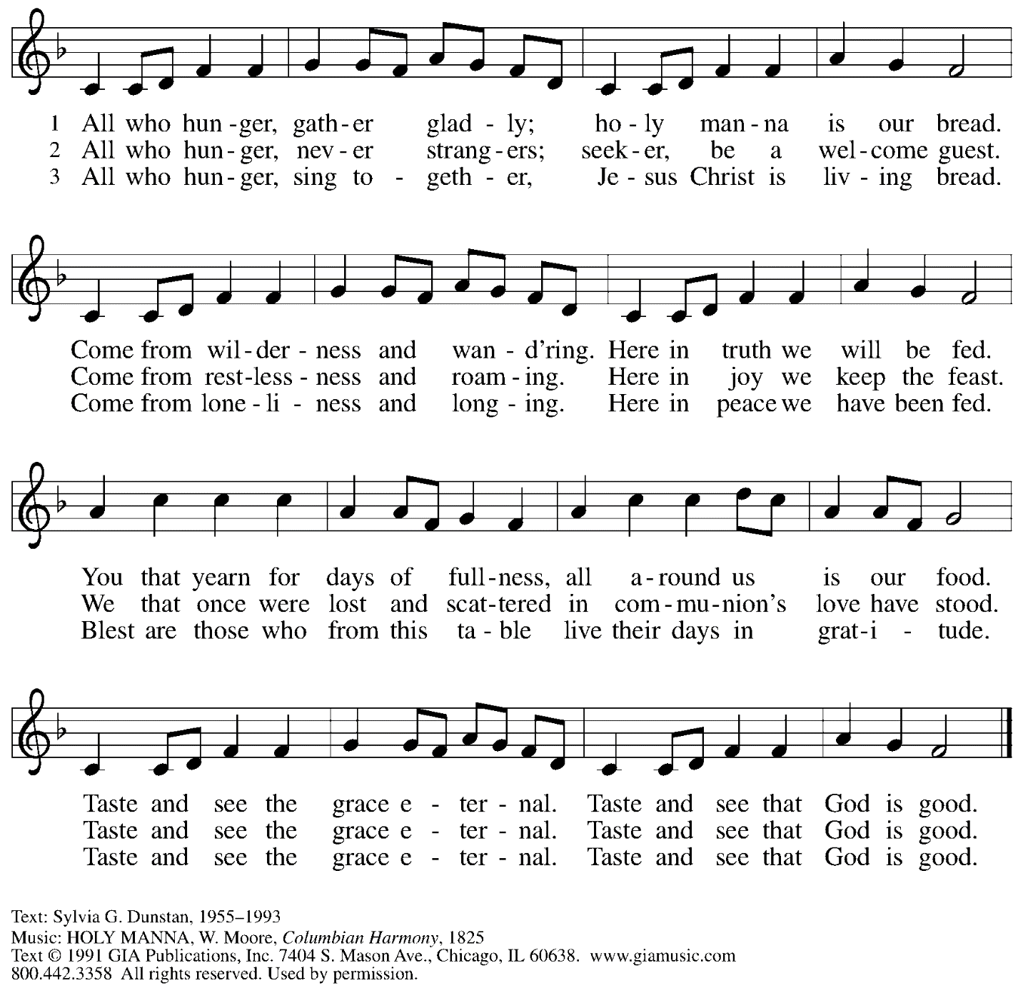

All rights reserved. Reprinted under OneLicense.net # A-722139.

**Greeting**

P: The grace of our Lord Jesus Christ, the love of God,

and the communion of the Holy Spirit be with you all.

**C: And also with you.**

**Hymn of Praise**





**Prayer of the Day**

P: Let us pray.

Gracious God, you have placed within the hearts of all your children a longing for your word

and a hunger for your truth. Grant that we may know your Son to be the true bread of heaven

and share this bread with all the world, through Jesus Christ, our Savior and Lord.

**C: Amen.**

*Please be seated.*

**Word**

*God speaks to us in Scripture reading, preaching, and song*

**First Reading** **–** **2 Kings 4: 42-44**

42 A man came from Baal-shalishah, bringing food from the first fruits to [Elisha,] the man of God: twenty loaves of barley and fresh ears of grain in his sack. Elisha said, “Give it to the people and let them eat.” 43 But his servant said, “How can I set this before a hundred people?” So he repeated, “Give it to the people and let them eat, for thus says the Lord, ‘They shall eat and have some left.’” 44 He set it before them, they ate, and had some left, according to the word of the Lord.

L: Word of God, word of life.

**C: Thanks be to God.**

**Psalm 145: 10-18**

*Today’s psalm will be spoken and led by the cantor, with the congregation invited to respond with the alternate verses in bold type.*

10 All your works shall praise you, O Lord,  
  and your faithful ones shall bless you.  
 11 **They shall tell of the glory of your kingdom**  
  **and speak of your power,**  
 12 that all people may know of your power  
  and the glorious splendor of your kingdom.  
 13 **Your kingdom is an everlasting kingdom; your dominion endures throughout all ages.**  
  **You, Lord, are faithful in all your words, and loving in all your works.**  
 14 The Lord upholds all those who fall  
  and lifts up those who are bowed down.  
 15 **The eyes of all wait upon you, O Lord,**  
  **and you give them their food in due season.**  
 16 You open wide your hand  
  and satisfy the desire of every living thing.  
 17 **You are righteous in all your ways**  
  **and loving in all your works.**  
 18 You are near to all who call upon you,  
  to all who call upon you faithfully.

**Second Reading – Ephesians 3: 14-21**

14 For this reason I bow my knees before the Father, 15 from whom every family in heaven and on earth takes its name. 16 I pray that, according to the riches of his glory, God may grant that you may be strengthened in your inner being with power through God’s Spirit, 17 and that Christ may dwell in your hearts through faith, as you are being rooted and grounded in love. 18 I pray that you may have the power to comprehend, with all the saints, what is the breadth and length and height and depth, 19 and to know the love of Christ that surpasses knowledge, so that you may be filled with all the fullness of God.  
  20 Now to the one who by the power at work within us is able to accomplish abundantly far more than all we can ask or imagine, 21 to God be glory in the church and in Christ Jesus to all generations, forever and ever. Amen.

L: Word of God, word of life.

**C: Thanks be to God.**

*Please rise as you are able and join in speaking the Gospel Acclamation.*

**Gospel Acclamation**



**Gospel – John 6: 1-21**

P: The holy Gospel according to St. John.

**C: Glory to you, O Lord.**

1 Jesus went to the other side of the Sea of Galilee, also called the Sea of Tiberias. 2 A large crowd kept following him, because they saw the signs that he was doing for the sick. 3 Jesus went up the mountain and sat down there with his disciples. 4 Now the Passover, the festival of the Jews, was near. 5 When he looked up and saw a large crowd coming toward him, Jesus said to Philip, “Where are we to buy bread for these people to eat?” 6 He said this to test him, for he himself knew what he was going to do. 7 Philip answered him, “Six months’ wages would not buy enough bread for each of them to get a little.” 8 One of his disciples, Andrew, Simon Peter’s brother, said to him, 9 “There is a boy here who has five barley loaves and two fish. But what are they among so many people?” 10 Jesus said, “Make the people sit down.” Now there was a great deal of grass in the place; so they sat down, about five thousand in all. 11 Then Jesus took the loaves, and when he had given thanks, he distributed them to those who were seated; so also the fish, as much as they wanted. 12 When they were satisfied, he told his disciples, “Gather up the fragments left over, so that nothing may be lost.” 13 So they gathered them up, and from the fragments of the five barley loaves, left by those who had eaten, they filled twelve baskets. 14 When the people saw the sign that he had done, they began to say, “This is indeed the prophet who is to come into the world.”  
  15 When Jesus realized that they were about to come and take him by force to make him king, he withdrew again to the mountain by himself.  
  
  16 When evening came, his disciples went down to the sea, 17 got into a boat, and started across the sea to Capernaum. It was now dark, and Jesus had not yet come to them. 18 The sea became rough because a strong wind was blowing. 19 When they had rowed about three or four miles, they saw Jesus walking on the sea and coming near the boat, and they were terrified. 20 But he said to them, “It is I; do not be afraid.” 21 Then they wanted to take him into the boat, and immediately the boat reached the land toward which they were going.

P: The Gospel of the Lord.

**C: Praise to you, O Christ.**

*Please be seated.*

**Sermon** The Rev. Dr. Dale B. Snyder

*A time of silence for prayer and reflection follows the sermon.*

*When the hymn of the day begins, please rise as you are able.*



**Hymn of the Day Break Now the Bread of Life *ELW* 515**

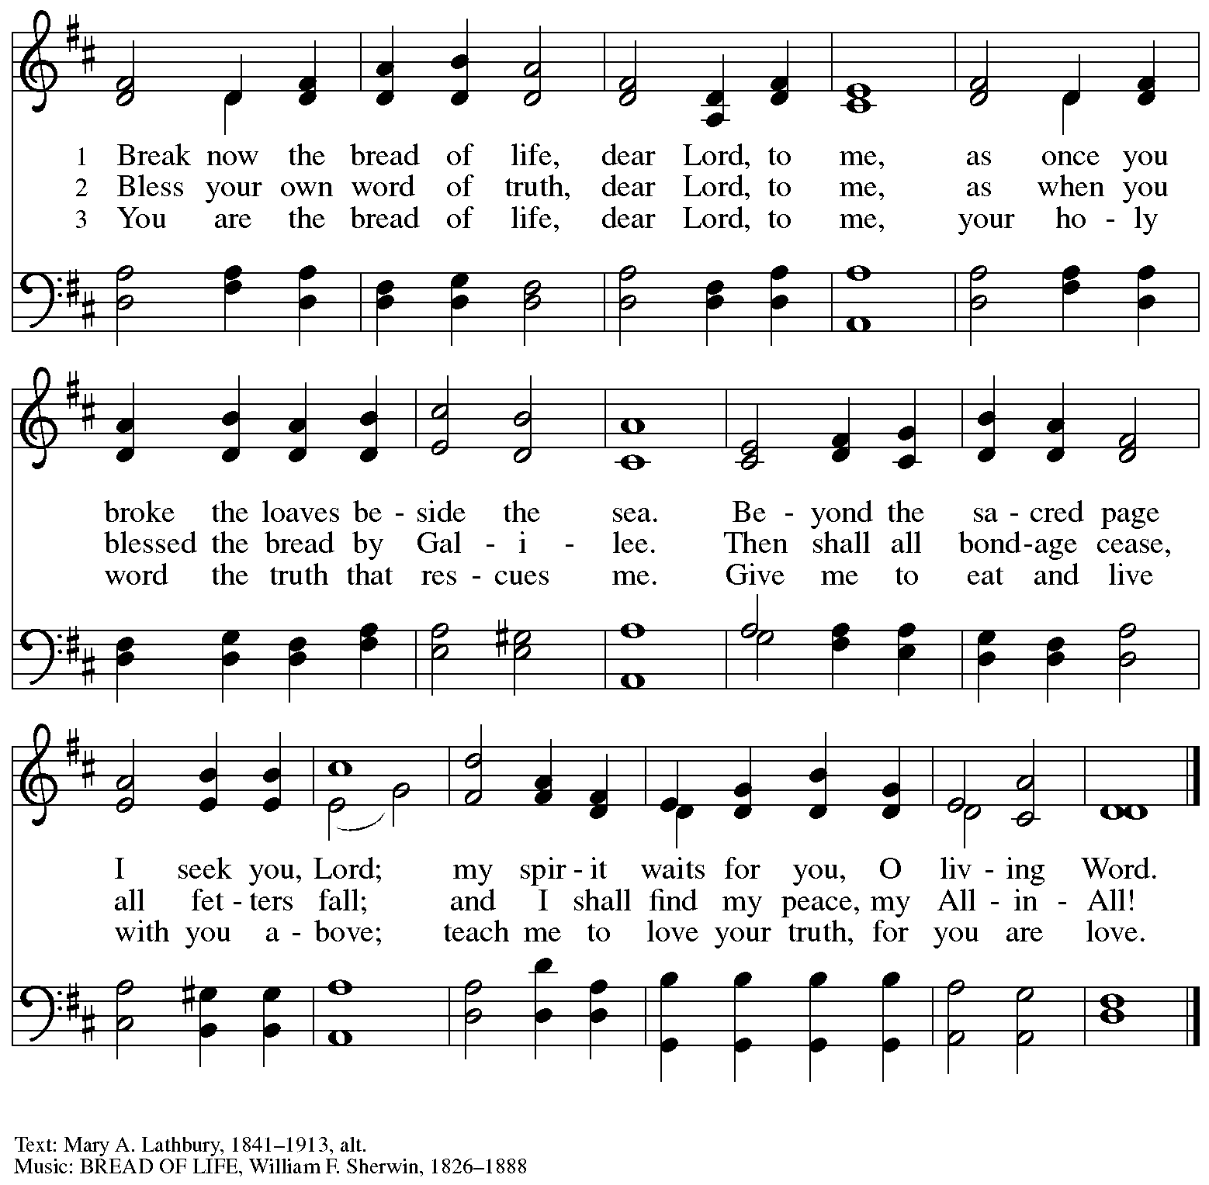

**Prayers of the People**

A: Rooted in God’s abundant love for the world, let us pray for our neighbors,

the church, and all of God’s creation.

*After each petition*

A: Merciful God,

**C: receive our prayer.**

*The presiding minister concludes the prayers*

P: We offer our prayers to you, gracious God,

trusting in your boundless love for all you have made,

through Jesus Christ our Savior.

**C: Amen.**

**Peace**

*The presiding minister and the assembly greet one another in the peace of the risen Christ.*

P: The peace of Christ be with you always.

**C: And also with you.**

*The people may greet those around them with a sign of Christ’s peace and may say*

Peace be with you *or similar words. Please be mindful that not everyone will be comfortable with sharing the peace, so please seek consent before shaking hands or hugging. Other possible ways to share the peace include a simple bow with the verbal greeting of peace, or simply a verbal expression of peace.*

*When the greetings of peace have concluded, please be seated.*



**Meal**

*God feeds us with the presence of Jesus Christ*

**Offering**

*We offer ourselves, our gifts, and our faithful service to God.*

*As the offering is gathered for the mission of the church, including the care of those in need,*

*the table is set for Holy Communion.*

**Music during the Offering**

*As the gifts are brought forward for presentation, please rise as you are able.*

**Offertory Song** *WOV* p. 35



**Offertory Prayer**

A: Let us pray.

Jesus, Bread of life,

**C: you have set this table with your very self,**

**and called us to the feast of plenty.**

**Gather what has been sown among us,**

**and strengthen us in this meal.**

**Make us to be what we receive here,**

**your body for the life of the world.**

**Amen.**

**Dialogue**

P: The Lord be with you.

**C: And also with you.**

P: Lift up your hearts.

**C: We lift them to the Lord.**

P: Let us give thanks to the Lord our God.

**C: It is right to give our thanks and praise.**

**Preface**

P: It is indeed right, our duty and our joy …

… we praise your name and join in adoring song:

**Sanctus**



**Eucharistic Prayer**

P: Holy, mighty, and merciful Lord …

… to whom, with you and the Holy Spirit,

be all honor and glory, now and forever.

**C: Amen.**

**Lord’s Prayer**

P: Gathered as one by the Holy Spirit, let us pray as Jesus taught us.

**C: Our Father in heaven,**

**hallowed be your name,**

**your kingdom come,**

**your will be done,**

**on earth as in heaven.**

**Give us today our daily bread.**

**Forgive us our sins**

**as we forgive those**

**who sin against us.**

**Save us from the time of trial**

**and deliver us from evil.**

**For the kingdom, the power,**

**and the glory are yours,**

**now and forever. Amen.**

**Fraction and Invitation**

P: These are the gifts of God for the beloved of God.

Come, share the feast.



***Agnus Dei /* Lamb of God**



*Please be seated.*

**Holy Communion**

* *All who seek God and desire a deeper and stronger life in Christ are welcome to receive Holy Communion.*
* *Worshipers from the pulpit side will proceed forward first, followed by the center section, and then the lectern side.*
* *Please inform an usher if you would like the ministers to bring Communion to you.*
* *Holy Communion will be served with bread and wine/grape juice.*
* *The presiding minister will first distribute the bread (host) to each communicant. Please indicate if you require a gluten-free host.*
* *Once you have consumed the bread, please pick up an empty glass from the tray next to the presiding minister. The Communion Assistant will pour wine from the chalice or grape juice from the cruet into your glass.*
* *Please step to the side to consume the wine or grape juice.*
* *Feel free to kneel at the altar rail for prayer after receiving the sacrament.*
* *As you return to your pew, glasses may be returned to the empty trays on either side of the center section.*
* *A blessing will be provided for anyone who does not yet receive the sacrament.*
* *All are invited to join in singing the hymns during Holy Communion.*

**Hymns during Holy Communion**

**Bread of Life from Heaven *ELW* 474**

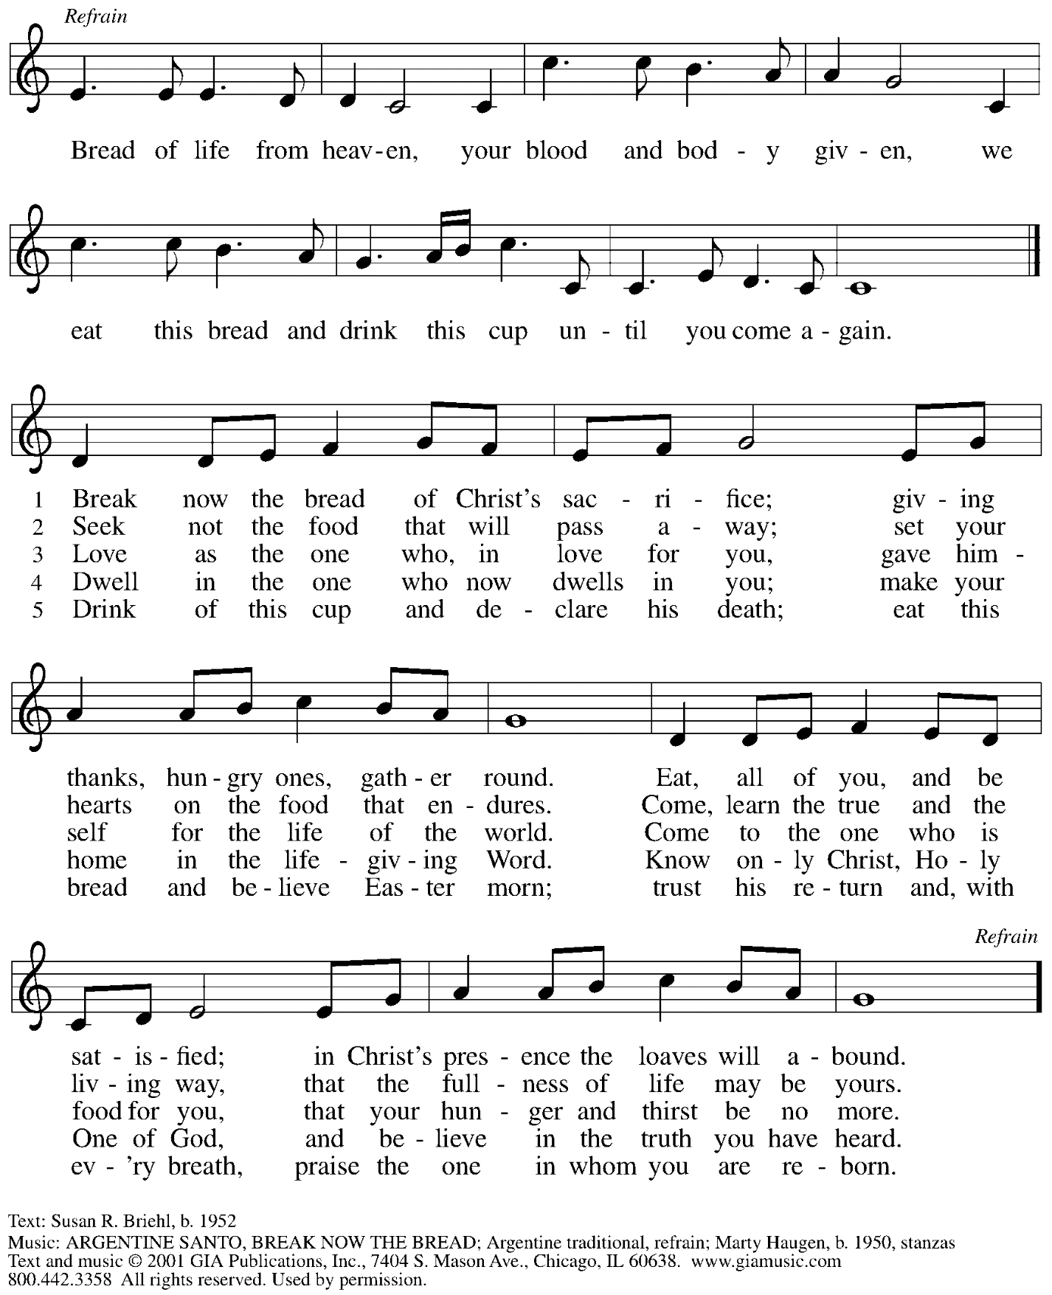

All rights reserved. Reprinted under OneLIcense.net # A-722139.

**Hymns during Holy Communion**

**Have No Fear, Little Flock *ELW* 764**

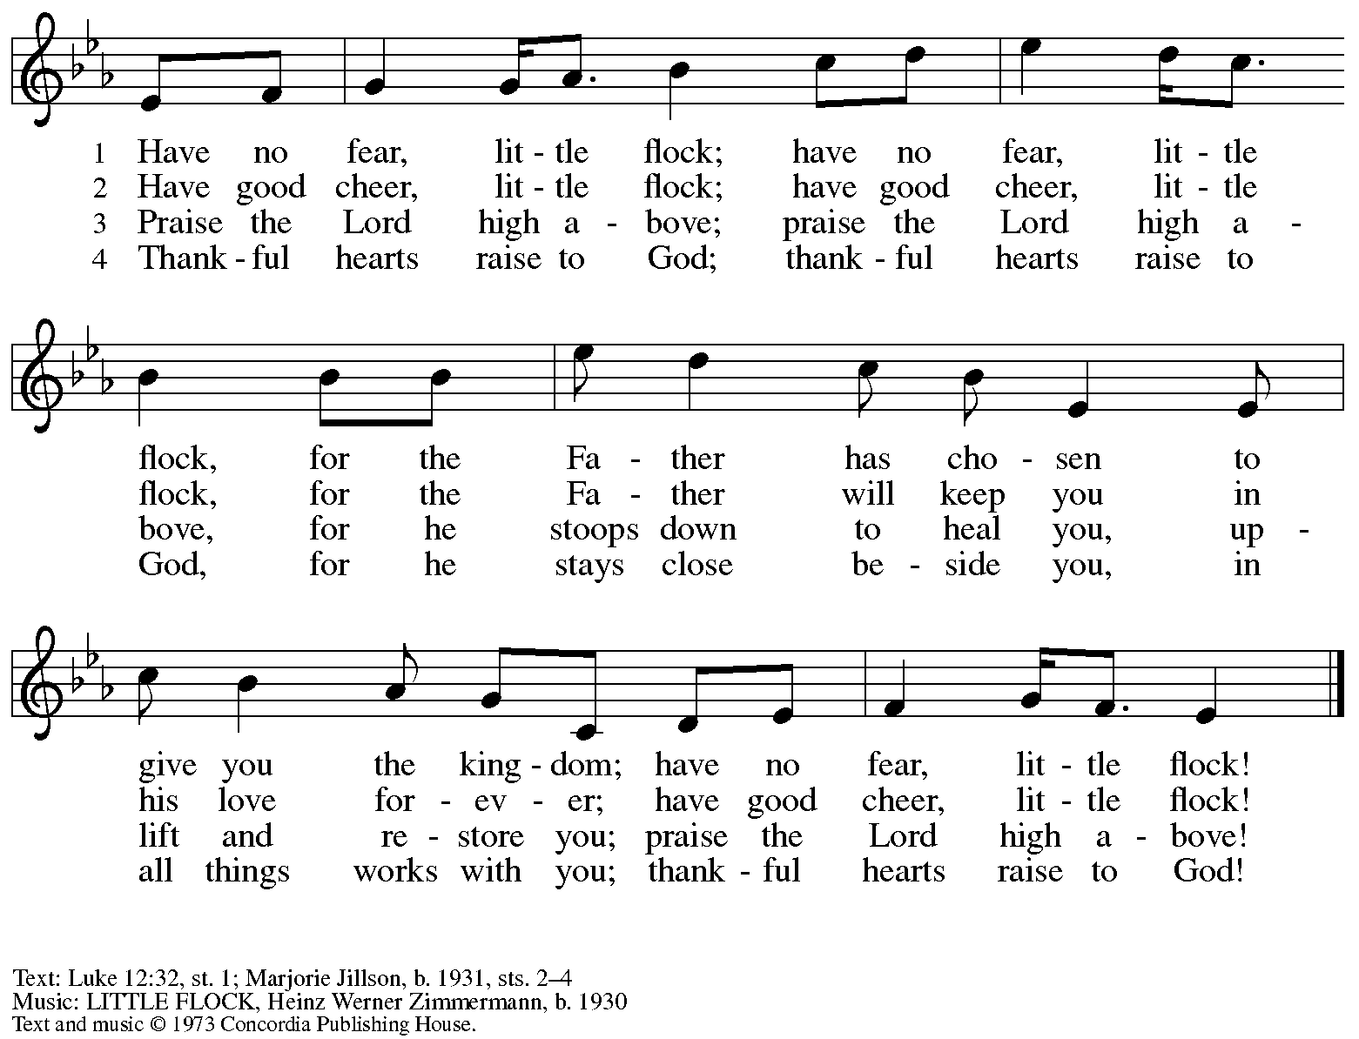

All rights reserved. Reprinted with permission under OneLicense.net # A-722139.

**Hymns during Holy Communion**

**O God Beyond All Praising *ELW* 880**

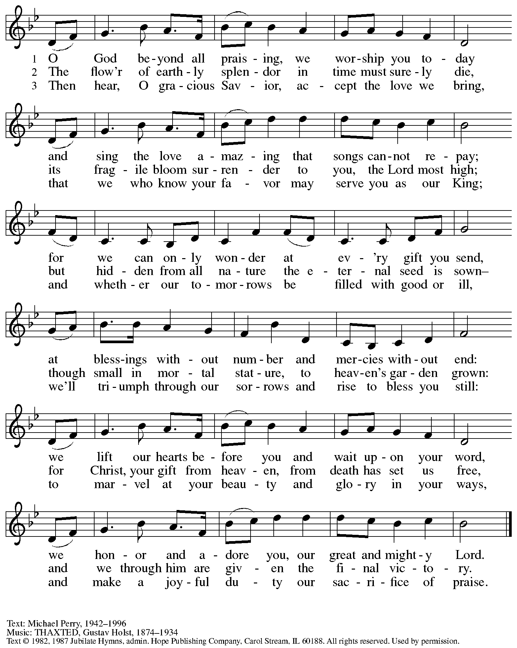

Reprinted with permission under OneLicense.net # A-722139.

*When all have returned to their places, please rise as you are able.*

**Blessing**

P: The body and blood of our Lord Jesus Christ strengthen you and keep you in his grace.

**C: Amen.**

**Prayer**

A: Let us pray.

Almighty God,

you provide the true bread from heaven, your Son, Jesus Christ, our Lord.

Grant that we who have received the Sacrament of his body and blood

may abide in Christ and he in us,

that we may be filled with the power of his endless life,

now and forever.

**C: Amen.**

*Please be seated.*

**Sending**

*God blesses us and sends us in mission to the world*

**Announcements**

*Please rise as you are able.*

**Benediction**

P: The blessing of God,

who provides for us, feeds us, and accompanies us,

☩ be upon you, now and forever.

**C: Amen.**

**Sending Hymn Let Us Talents and Tongues Employ** *Following page*

**Dismissal**

A: Go in peace. Serve the Lord.

**C: Thanks be to God.**

**Postlude**

**Sending Hymn Let Us Talents and Tongues Employ *ELW* 674**

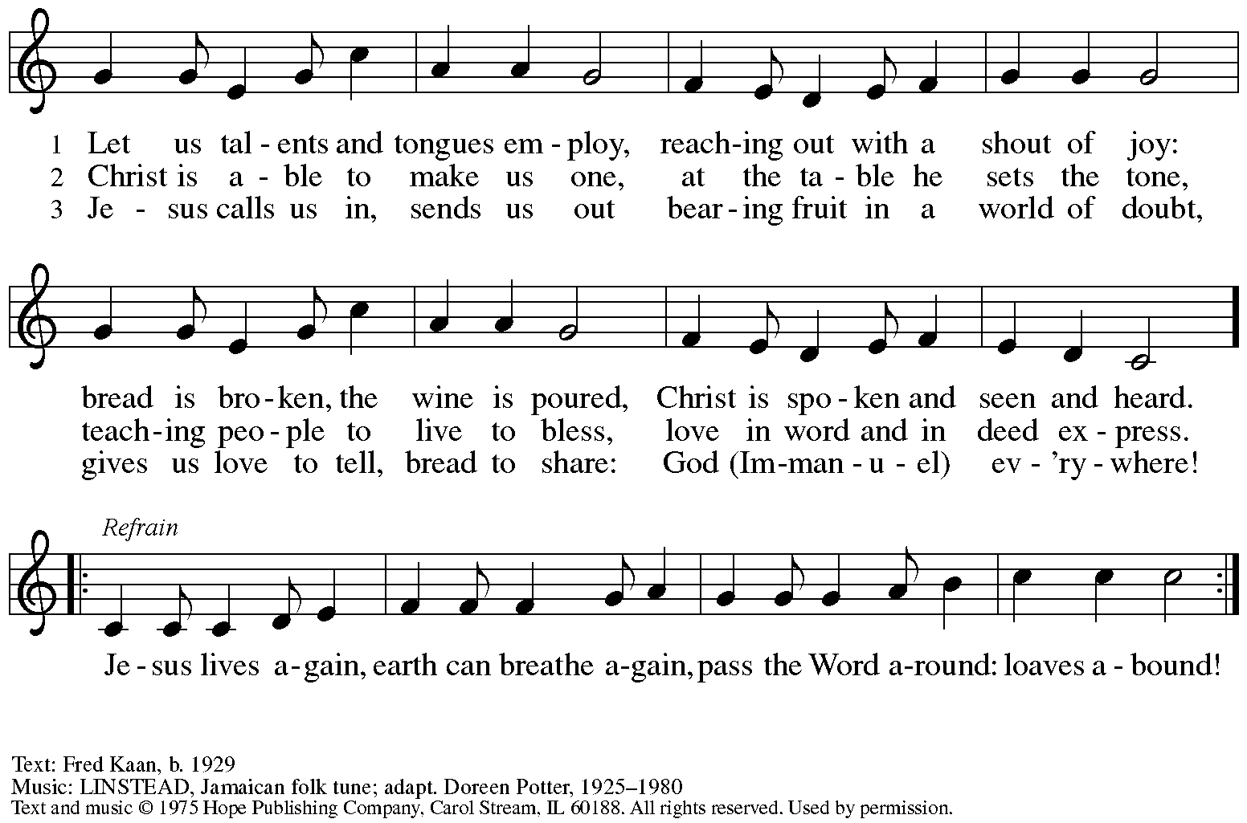

Reprinted with permission under OneLicense.net # A-722139.

*Those serving in worship today*

Altar Care Jodie Minor

Assisting Minister Kathy Hays

Audio-Visual Ministers Jered Stratton

Kristen Asplin

Cantor Joy Givens

Lector Lester Prince

Minister of Music Laura Reynolds

Preaching Minister The Rev. Dr. Dale B. Snyder

Presiding Minister The Rev. Ross I. Carmichael

*Liturgy and Hymnody Acknowledgements*

From SundaysandSeasons.com. Copyright © 2024 Augsburg Fortress. All rights reserved. Reprinted under OneLicense.net # A-722139.

Used by permission of Augsburg Fortress.

The Scripture readings contained herein are from *New Revised Standard Version* of the Bible © 1989, Division of Christian Education of the National Council of Churches of Christ in the USA. Used by permission. All rights reserved.

*Please use the QR code below to link to St. Andrew’s announcements online!*



**St. Andrew Lutheran Church Announcements**

**July 28th, 2024**

* **Welcome to Worship at St. Andrew on the Tenth Sunday after Pentecost, July 28th, 2024** –We are so glad you are here, and we offer a special welcome to all visitors and guests connecting for the first time! Worship attendees are invited to make a name tag at the back of the worship space if you would like. There are worship “toolkits” to help children engage with worship and “busy bags” for younger children available in the bookcase at the back of the sanctuary. Please feel free to take one to use with/for your children. All are invited to gather for coffee, other drinks, food, and conversation in the social hall after worship.
* **Welcome to Today’s Preacher, The Rev. Dr. Dale B. Snyder of Bethel AME Church in Pittsburgh! – Over the past few years, St. Andrew has been blessed to develop relationships and friendships with our siblings in Christ at Bethel AME Church in the Hill District. We have supported Bethel and their pastor, The Rev. Dr. Dale B. Snyder, in telling Bethel’s story in seeking reparations for the loss of their church building and property to eminent domain in the 1950s. St. Andrew hosted one of Bethel’s Table Talks, and people of the congregation have participated in worship services, joint choirs, and celebrations with Bethel, especially on Juneteenth. As our two congregations continue working together, we are so pleased to welcome Pastor Snyder to St. Andrew today! We thank him and the people of Bethel for his time and gifts in bringing God’s Word to St. Andrew!**
* **The Rev. Dr. Munther Isaac of the Evangelical Lutheran Church in Jordan and the Holy Land to Speak at Bidwell United Presbyterian Church in Pittsburgh on Thursday, August 1st, at 7:00 p.m. –** Palestinian pastor and international speaker Rev. Dr. Munther Issac will be at Bidwell United Presbyterian Church on Thursday, August 1st at 7:00 p.m. Rev. Issac speaks to the suffering of the Palestinian people and the silence of Christian Churches. Rev. Dr. Isaac is a 10th generation Palestinian Christian and pastor of the Evangelical Lutheran Christmas Church in Bethlehem, the Lutheran Church in Beit Sahour, and academic dean of Bethlehem Bible College. He brings a theologically challenging voice to Christian congregations. The central question of his work is “How can we redeem religion in terms of being part of the solution in Israel and Palestine?” Please consider hearing Rev. Dr. Issac at Bidwell United Presbyterian Church, 1025 Liverpool St, Pittsburgh, PA 15233 (Manchester - North Side) on Thursday, August 1st, at 7:00 p.m.
* **Monthly Reparations Offering Next Week, August 4th, during Worship – Jesus’ parable from Luke’s Gospel** about a compassionate Samaritan provides an example of how God's people are called to work for healing and repair for our neighbors, independent of who or what caused harm. In light of this, St. Andrew has made a commitment to reparations in regard to African American spiritual songs used in our worship. The text and music of most hymns is attributed to specific authors, with copyrights in place, usage reported, and royalties paid to those whose works are featured in worship. With African American spirituals, this is not possible. In response to many years of such uncredited use, St. Andrew invites the congregation to give a reparations offering. Funds received in worship will be donated to our siblings at Bethel AME Church, whose land and building were taken from them in the 1950s, to fund their development in the lower Hill District.
* **Monthly Produce Distribution – Tuesday, August 6th, 5:30-7:00 p.m. – St. Andrew partners with Greater Pittsburgh Community Food Bank to serve as a distribution site for fresh produce on the first Tuesday of every month. The distribution for August will be Tuesday, August 6th, from 5:30-7:00 p.m. We invite people of the congregation to help during those hours or with unloading and setup during the day between 10:00 a.m. and 1:00 p.m. Everyone is welcome pick up fresh produce!**
* **Monthly Dinner for Guests of East End Cooperative Ministry – Thursday, August 15th, 6:30 p.m. – O**n the third Thursday of each month, people of St. Andrew prepare a meal for guests of the shelter at East End Cooperative Ministry (6140 Station St., East Liberty 15206). We invite you to prepare or purchase one menu item and bring it to the shelter by 6:00 p.m., to come and help serve the meal at 6:30 p.m., or both! Please sign up using this link: <https://www.signupgenius.com/go/5080544AAAC22A1F58-50393778-shelter>.
* **Save the Date! Potluck Meal and Hymn Sing with Bethel AME Church – Saturday, September 7th! – St. Andrew’s worship committee has been in conversation with Pastor Snyder and other leaders of Bethel AME, and we invite people of our congregations to gather informally on Saturday, September 7th, to share a potluck meal and sing hymns from our respective traditions together. An exact time is yet to be determined, but it will be in the late afternoon/early evening that day. Come share in a time of conversation and community and join with our siblings in Christ in praising God!**
* **Coffee Hour Signups Available** –One way that St. Andrew builds community is by sharing conversation over food and drinks at coffee hour after worship on Sundays. We invite people of the congregation to sign up to coordinate coffee hour each week, which includes brewing the coffee; setting out cups, napkins, food items, and cold drinks; and cleaning up afterward. Everything needed is at St. Andrew and instructions are available. Please sign up to host coffee hour here: <https://www.signupgenius.com/go/5080B4AAFAF2CABF85-47069030-coffee>.
* **New *Christ in Our Home* Devotional Booklets (July – September) Available at Church Entrances – *Christ in Our Home* is a booklet of devotions that includes Scripture, a brief reflection, and prayer for each day. The new edition for July – September is now available at the various church entrances. Please feel free to take one for yourself or others!**