+ Sixth Sunday after Pentecost
June 30, 2024

St. Andrew Lutheran Church
304 Morewood Ave.
Pittsburgh, PA 15213
St_andrewELCA@verizon.net
www.standrewpittsburgh.org

+ Sixth Sunday after Pentecost
Order for Worship

A woman finds healing by touching Jesus’ cloak, and a girl is restored to life when he takes her by the hand. In both cases a boundary is crossed: in Jesus’ time the hemorrhaging woman was considered ritually unclean, polluting others by her touch, and anyone who touched a corpse also became unclean. In Mark’s gospel Jesus breaks down barriers, from his first meal at a tax collector’s house to his last breath on the cross as the temple curtain is torn in two. We dare to touch Jesus in our “uncleanness” and to live as a community that defines no one as an outsider.

Welcome to St. Andrew!

- St. Andrew Lutheran congregation welcomes all who are seeking a place of healing and wholeness – a nurturing, faith-forming spiritual home. Our community embraces people of all ages, ethnicities, cultures, abilities, sexual orientations, gender identities and expressions, and family constellations. Come and See!
- Worship Services are live streamed to multiple online platforms. By attending worship, you agree that your image and voice may be broadcast.
- Everyone is invited to make a name tag at the black bookcase in the back of the worship space if they would like. There are stickers indicating pronouns on the bookcase if you would like to include them on your name tag.
- A nursery is available through the doors at the left side of the sanctuary and across from the doorway to the Social Hall. Look for a purple-colored room.
- Worship “toolkits” to help children engage with the service, along with “busy bags” for younger children, are available in the bookcase at the back of the sanctuary. Please feel free to take one to use with/for your children.
- Holy Communion is served with bread (gluten-free available) and wine or grape juice. The presiding minister will distribute the bread (host). Please consume this and then pick up an empty glass from the tray. The Communion Assistant will pour wine or grape juice into your glass. Please step to the side to consume the wine or grape juice. Feel free to kneel at the altar for prayer and reflection. As you return to your pew, glasses may be returned to the empty trays on either side of the center section.
- A restroom is available on the main level of the church, through the doors to the Social Hall and to the right in the main office.

Abbreviations
P: Pastor/Presiding Minister ELW: Evangelical Lutheran Worship hymnal
A: Assisting Minister ACS: All Creation Sings hymnal
L: Lector HS: Hymnal Supplement (GIA Publications)
C: Congregation

Pre-Service Music

Welcome

Prelude

Gathering
The Holy Spirit calls us together as the people of God

Confession and Forgiveness

Please rise as you are able.
All may make the sign of the cross, the sign that is marked at Baptism,
as the presiding minister begins.

P: Blessed be the holy Trinity, ☩ one God,
who looks upon us in compassion,
forgives our sin,
and heals our lives.
C: Amen.

P: Let us confess our sin in the presence of God and of one another.

Silence is kept for reflection

P: Have mercy, O God,
C: for we have sinned against you and our neighbors,
by what we have done and by what we have failed to do.
In your compassion, cleanse us of our sin and take away our guilt,
Create in us a new heart and give us a steadfast spirit.
Do not cast us away, but fill us with your Holy Spirit,
and restore your joy within us. Amen.

P: By water and the Holy Spirit God gives you a new birth,
and through the death and resurrection of ☩ Jesus Christ,
God forgives you all your sins.
The God of mercy and might strengthen you in all goodness
and keep you in eternal life.
C: Amen.

Gathering Hymn You Are Holy ELW 525

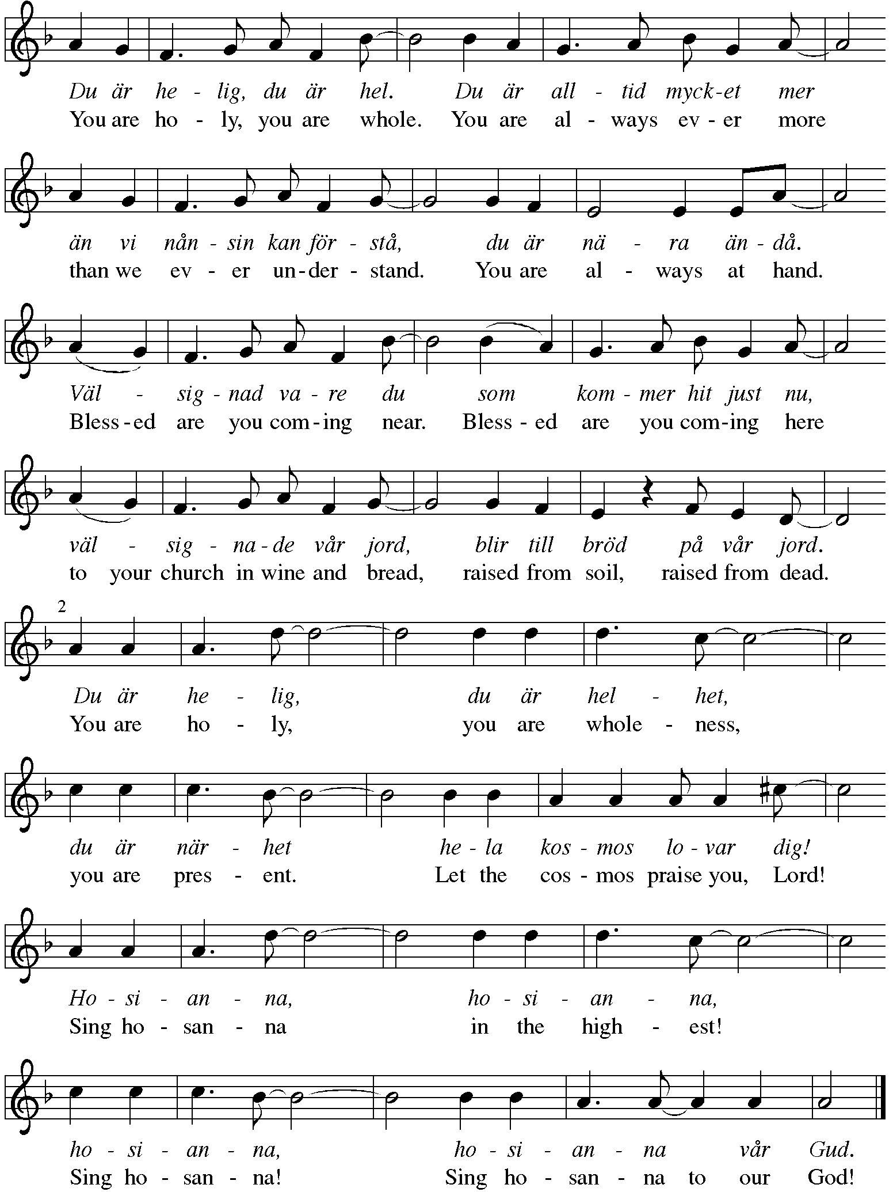

Greeting

P: The grace of our Lord Jesus Christ, the love of God,
and the communion of the Holy Spirit be with you all.
C: And also with you.

Prayer of the Day

P: Let us pray.
Almighty and merciful God,
we implore you to hear the prayers of your people.
Be our strong defense against all harm and danger,
that we may live and grow in faith and hope,
through Jesus Christ, our Savior and Lord.
C: Amen.

Please be seated.

Word
God speaks to us in Scripture reading, preaching, and song

First Reading – Lamentations 3: 22-33

²²The steadfast love of the Lord never ceases,
the Lord’s mercies never come to an end;
²³they are new every morning;
great is your faithfulness.
²⁴“The Lord is my portion,” says my soul,
“therefore I will hope in the Lord.”
²⁵The Lord is good to those who wait for God,
to the soul that seeks God.
²⁶It is good that one should wait quietly
for the salvation of the Lord.
²⁷It is good for one to bear
the yoke in youth,
²⁸to sit alone in silence
when the Lord has imposed it,
²⁹to put one’s mouth to the dust
(there may yet be hope),
³⁰to give one’s cheek to the smiter,
and be filled with insults.
³¹For the Lord will not
reject forever.
³²Although the Lord causes grief, the Lord will have compassion
according to the abundance of God’s steadfast love;
³³for the Lord does not willingly afflict
or grieve anyone.

L: Word of God, word of life.
C: Thanks be to God.

Psalm 30

Today’s psalm will be spoken and led by the cantor, with the congregation invited to respond with the alternate verses in bold type.

¹I will exalt you, O Lord, because you have lifted me up
and have not let my enemies triumph over me.
²O Lord my God, I cried out to you,
and you restored me to health.
³You brought me up, O Lord, from the dead;
you restored my life as I was going down to the grave.
⁴Sing praise to the Lord, all you faithful;
give thanks in holy remembrance.
⁵God’s wrath is short; God’s favor lasts a lifetime.
Weeping spends the night, but joy comes in the morning.
⁶While I felt secure, I said,
“I shall never be disturbed.
⁷You, Lord, with your favor, made me as strong as the mountains.”
Then you hid your face, and I was filled with fear.
⁸I cried to you, O Lord;
I pleaded with my Lord, saying,
⁹“What profit is there in my blood, if I go down to the pit?
Will the dust praise you or declare your faithfulness?
¹⁰Hear, O Lord, and have mercy upon me;
O Lord, be my helper.”
¹¹You have turned my wailing into dancing;
you have put off my sackcloth and clothed me with joy.
¹²Therefore my heart sings to you without ceasing;
O Lord my God, I will give you thanks forever.

Second Reading – 2 Corinthians 8: 7-15

⁷Now as you excel in everything—in faith, in speech, in knowledge, in utmost eagerness, and in our love for you—so we want you to excel also in this generous undertaking.
⁸I do not say this as a command, but I am testing the genuineness of your love against the earnestness of others. ⁹For you know the generous act of our Lord Jesus Christ, that though he was rich, yet for your sakes he became poor, so that by his poverty you might become rich.
¹⁰And in this matter I am giving my advice: it is appropriate for you who began last year not only to do something but even to desire to do something—¹¹now finish doing it, so that your eagerness may be matched by completing it according to your means. ¹²For if the eagerness is there, the gift is acceptable according to what one has—not according to what one does not have. ¹³I do not mean that there should be relief for others and pressure on you, but it is a question of a fair balance between ¹⁴your present abundance and their need, so that their abundance may be for your need, in order that there may be a fair balance. ¹⁵As it is written,
“The one who had much did not have too much,
and the one who had little did not have too little.”

L: Word of God, word of life.
C: Thanks be to God.

Please rise as you are able and join in speaking the Gospel Acclamation.

Gospel Acclamation

C: Alleluia. Our Savior Jesus Christ has abolished death
and brought life and immortality to light through the Gospel. Alleluia.

Gospel – Mark 5: 21-43

P: The holy Gospel according to St. Mark.
C: Glory to you, O Lord.

²¹When Jesus had crossed again in the boat to the other side, a great crowd gathered around him; and he was by the sea. ²²Then one of the leaders of the synagogue named Jairus came and, when he saw him, fell at his feet ²³and begged him repeatedly, “My little daughter is at the point of death. Come and lay your hands on her, so that she may be made well, and live.” ²⁴So he went with him.
And a large crowd followed him and pressed in on him. ²⁵Now there was a woman who had been suffering from hemorrhages for twelve years. ²⁶She had endured much under many physicians, and had spent all that she had; and she was no better, but rather grew worse. ²⁷She had heard about Jesus, and came up behind him in the crowd and touched his cloak, ²⁸for she said, “If I but touch his clothes, I will be made well.” ²⁹Immediately her hemorrhage stopped; and she felt in her body that she was healed of her disease. ³⁰Immediately aware that power had gone forth from him, Jesus turned about in the crowd and said, “Who touched my clothes?” ³¹And his disciples said to him, “You see the crowd pressing in on you; how can you say, ‘Who touched me?’” ³²He looked all around to see who had done it. ³³But the woman, knowing what had happened to her, came in fear and trembling, fell down before him, and told him the whole truth. ³⁴He said to her, “Daughter, your faith has made you well; go in peace, and be healed of your disease.”
³⁵While he was still speaking, some people came from the leader’s house to say, “Your daughter is dead. Why trouble the teacher any further?” ³⁶But overhearing what they said, Jesus said to the leader of the synagogue, “Do not fear, only believe.” ³⁷He allowed no one to follow him except Peter, James, and John, the brother of James. ³⁸When they came to the house of the leader of the synagogue, he saw a commotion, people weeping and wailing loudly. ³⁹When he had entered, he said to them, “Why do you make a commotion and weep? The child is not dead but sleeping.” ⁴⁰And they laughed at him. Then he put them all outside, and took the child’s father and mother and those who were with him, and went in where the child was. ⁴¹He took her by the hand and said to her, “Talitha cum,” which means, “Little girl, get up!” ⁴²And immediately the girl got up and began to walk about (she was twelve years of age). At this they were overcome with amazement. ⁴³He strictly ordered them that no one should know this, and told them to give her something to eat.

P: The Gospel of the Lord.
C: Praise to you, O Christ.

Please be seated.

Sermon

A time of silence for prayer and reflection follows the sermon.
When the hymn of the day begins, please rise as you are able.

Hymn of the Day When We Must Bear Persistent Pain ACS 1014

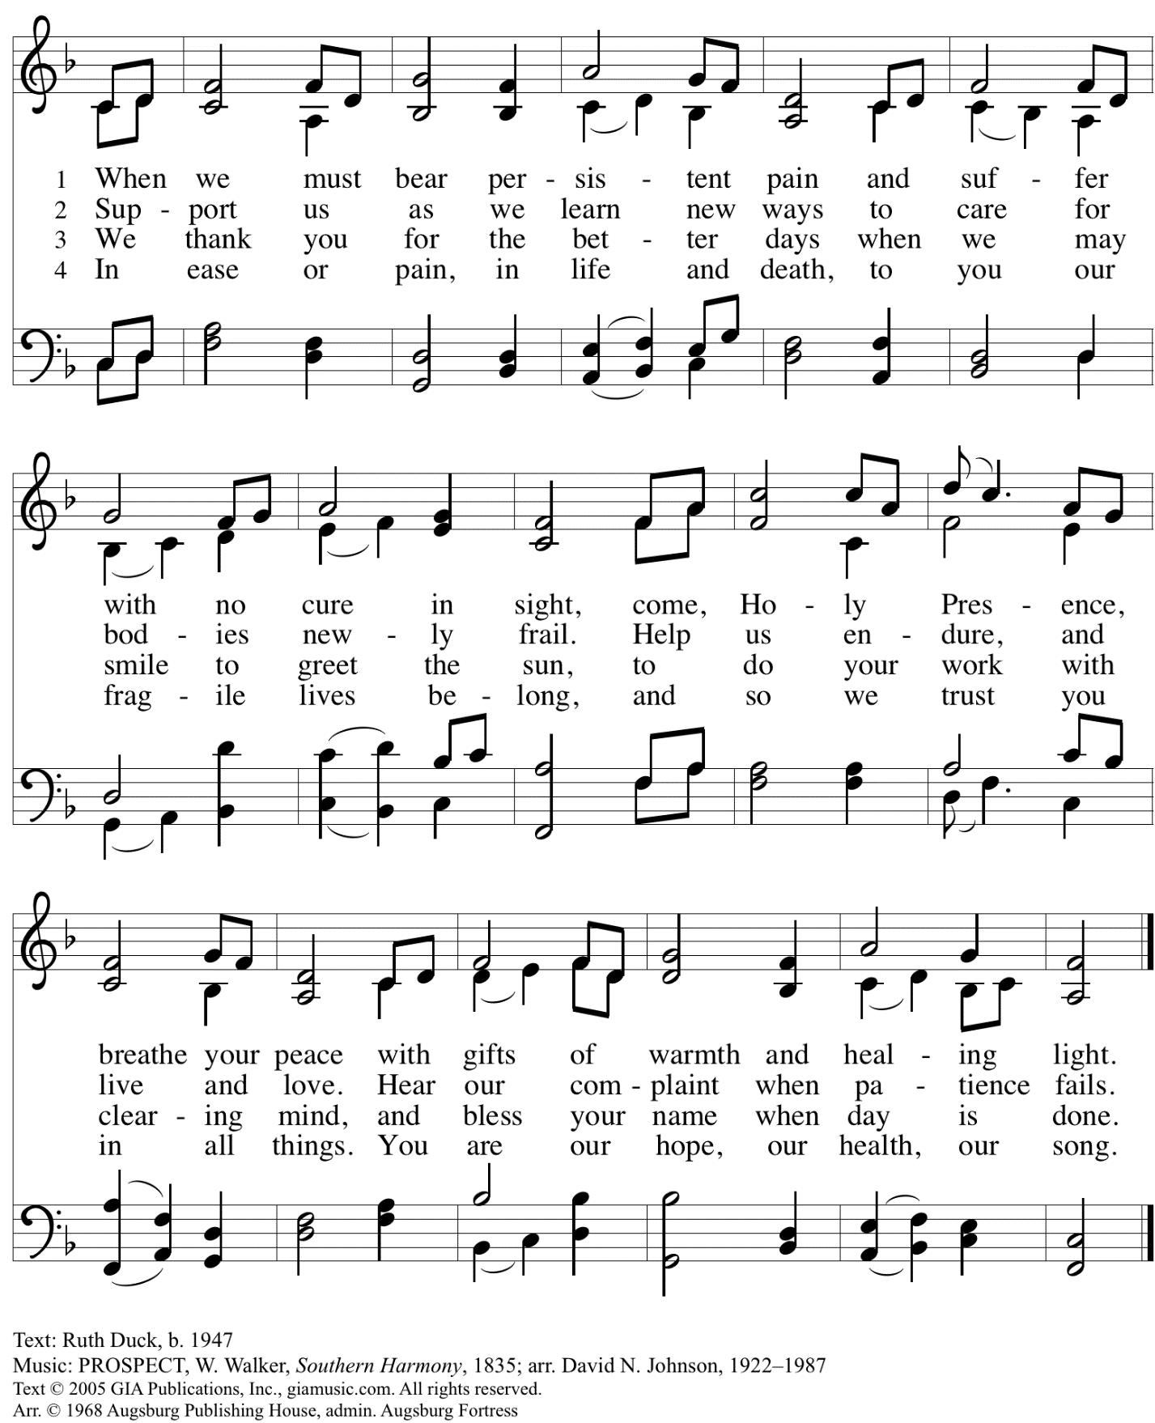
Reprinted with permission under OneLicense.net # A-722139.

Prayers of the People

A: Rooted in God’s abundant love for the world, let us pray for our neighbors,
the church, and all of God’s creation.

After each petition
A: Merciful God,
C: receive our prayer.

The presiding minister concludes the prayers
P: We offer our prayers to you, gracious God,
trusting in your boundless love for all you have made,
through Jesus Christ our Savior.
C: Amen.

Peace

The presiding minister and the assembly greet one another in the peace of the risen Christ.
P: The peace of Christ be with you always.
C: And also with you.

The people may greet those around them with a sign of Christ’s peace and may say
Peace be with you or similar words. Please be mindful that not everyone will be comfortable with sharing the peace, so please seek consent before shaking hands or hugging. Other possible ways to share the peace include a simple bow with the verbal greeting of peace, or simply a verbal expression of peace.

When the greetings of peace have concluded, please be seated.

Meal
God feeds us with the presence of Jesus Christ

Offering

We offer ourselves, our gifts, and our faithful service to God.
As the offering is gathered for the mission of the church, including the care of those in need,
the table is set for Holy Communion.

Music during the Offering

As the gifts are brought forward for presentation, please rise as you are able.

Offertory Song

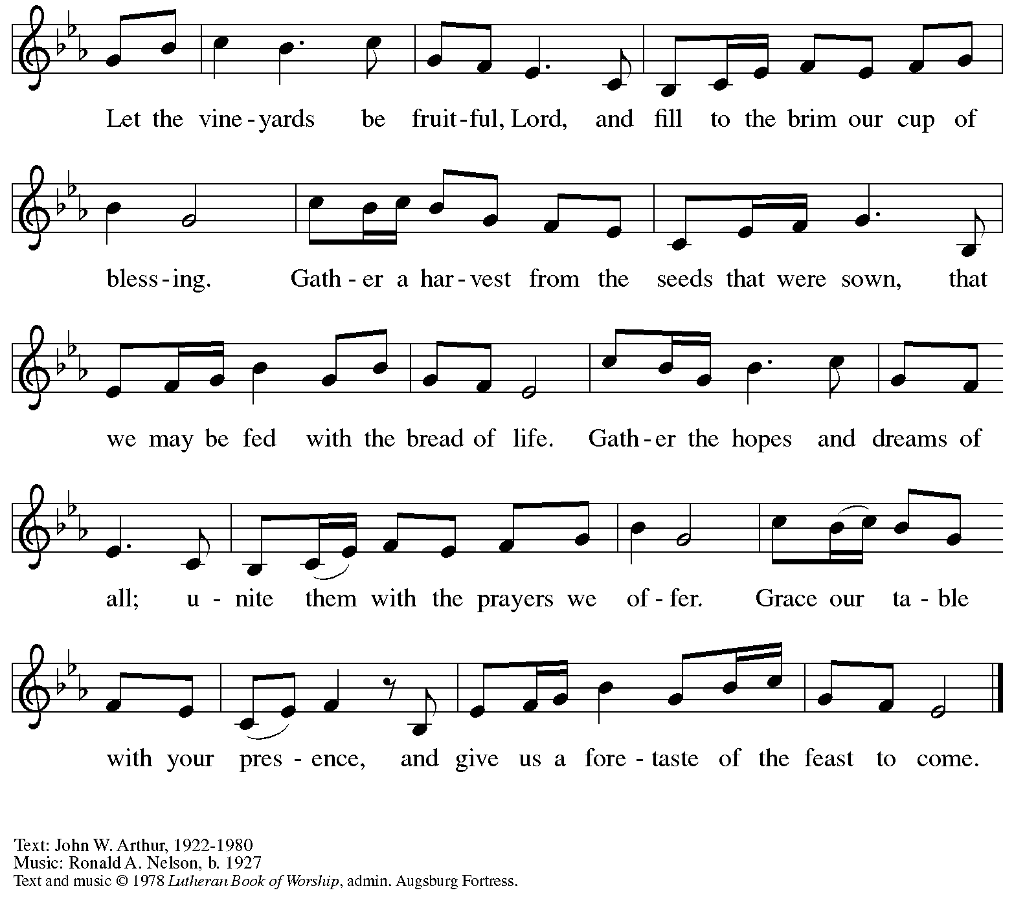
All rights reserved. Reprinted under OneLicense.net # A-722139.

Offertory Prayer

A: Let us pray.
God of all creation,
C: all you have made is good, and your love endures forever.
You bring forth bread from the earth and fruit from the vine.
Nourish us with these gifts, that we might be for the world
signs of your gracious presence in Jesus Christ, our Savior and Lord.
Amen

Dialogue

P: The Lord be with you.
C: And also with you.

P: Lift up your hearts.
C: We lift them to the Lord.

P: Let us give thanks to the Lord our God.
C: It is right to give our thanks and praise.

Preface

P: It is indeed right, our duty and our joy …
… we praise your name and join in adoring song:

Sanctus

C: Holy, holy, holy Lord,
God of power and might,
heaven and earth are full of your glory.
Hosanna in the highest.
Blessed is the one who comes in the name of the Lord.
Hosanna in the highest.

Eucharistic Prayer

P: Holy, mighty, and merciful Lord …
… to whom, with you and the Holy Spirit,
be all honor and glory, now and forever.
C: Amen.

Lord’s Prayer

P: Gathered as one by the Holy Spirit, let us pray as Jesus taught us.
C: Our Father in heaven,
hallowed be your name,
your kingdom come,
your will be done,
on earth as in heaven.
Give us today our daily bread.
Forgive us our sins
as we forgive those
who sin against us.
Save us from the time of trial
and deliver us from evil.
For the kingdom, the power,
and the glory are yours,
now and forever. Amen.

Fraction and Invitation

P: These are the gifts of God for the beloved of God.
Come, share the feast.

Agnus Dei / Lamb of God

C: Lamb of God, you take away the sin of the world; have mercy on us.
Lamb of God, you take away the sin of the world; have mercy on us.
Lamb of God, you take away the sin of the world; grant us peace.

Please be seated.

Holy Communion
- All who seek God and desire a deeper and stronger life in Christ are welcome to receive Holy Communion.
- Worshipers from the pulpit side will proceed forward first, followed by the center section, and then the lectern side.
- Please inform an usher if you would like the ministers to bring Communion to you.
- Holy Communion will be served with bread and wine/grape juice.
- The presiding minister will first distribute the bread (host) to each communicant. Please indicate if you require a gluten-free host.
- Once you have consumed the bread, please pick up an empty glass from the tray next to the presiding minister. The Communion Assistant will pour wine from the chalice or grape juice from the cruet into your glass.
- Please step to the side to consume the wine or grape juice.
- Feel free to kneel at the altar rail for prayer after receiving the sacrament.
- As you return to your pew, glasses may be returned to the empty trays on either side of the center section.
- A blessing will be provided for anyone who does not yet receive the sacrament.
- All are invited to join in singing the hymns during Holy Communion.

Hymns during Holy Communion
Draw Us in the Spirit’s Tether ELW 470

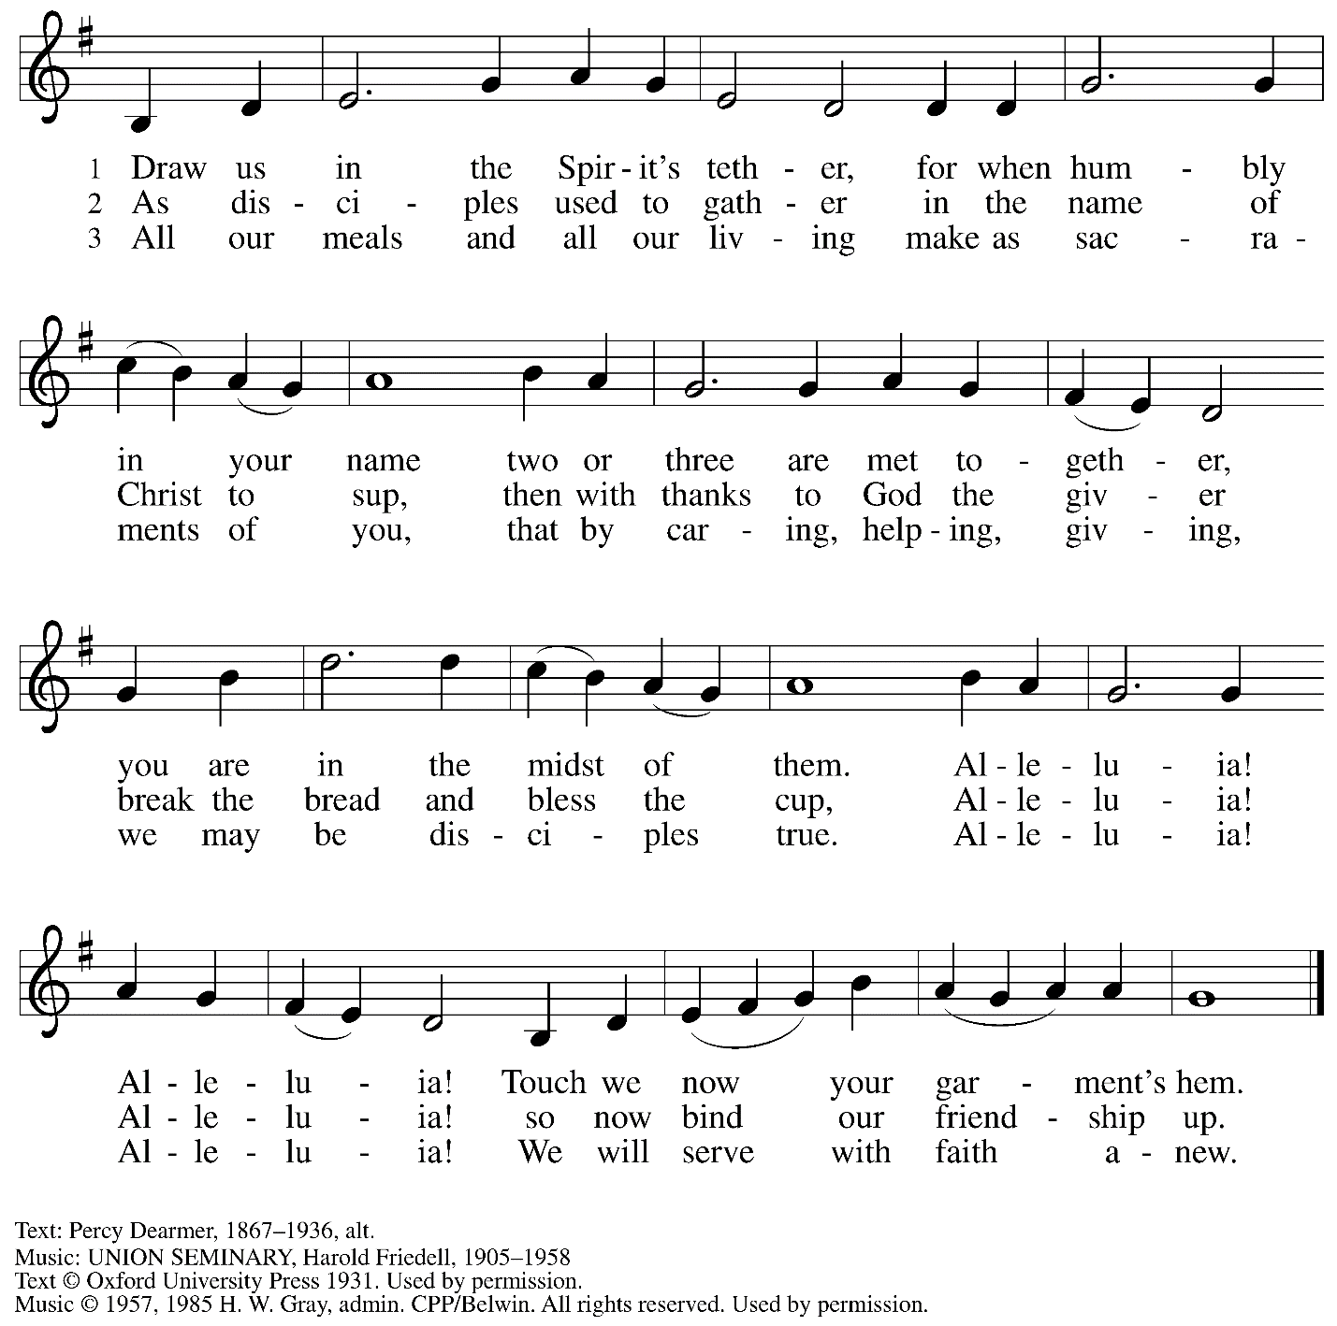
Reprinted under ONeLIcense.net # A-722139.

Hymns during Holy Communion
O Christ, the Healer, We Have Come ELW 610

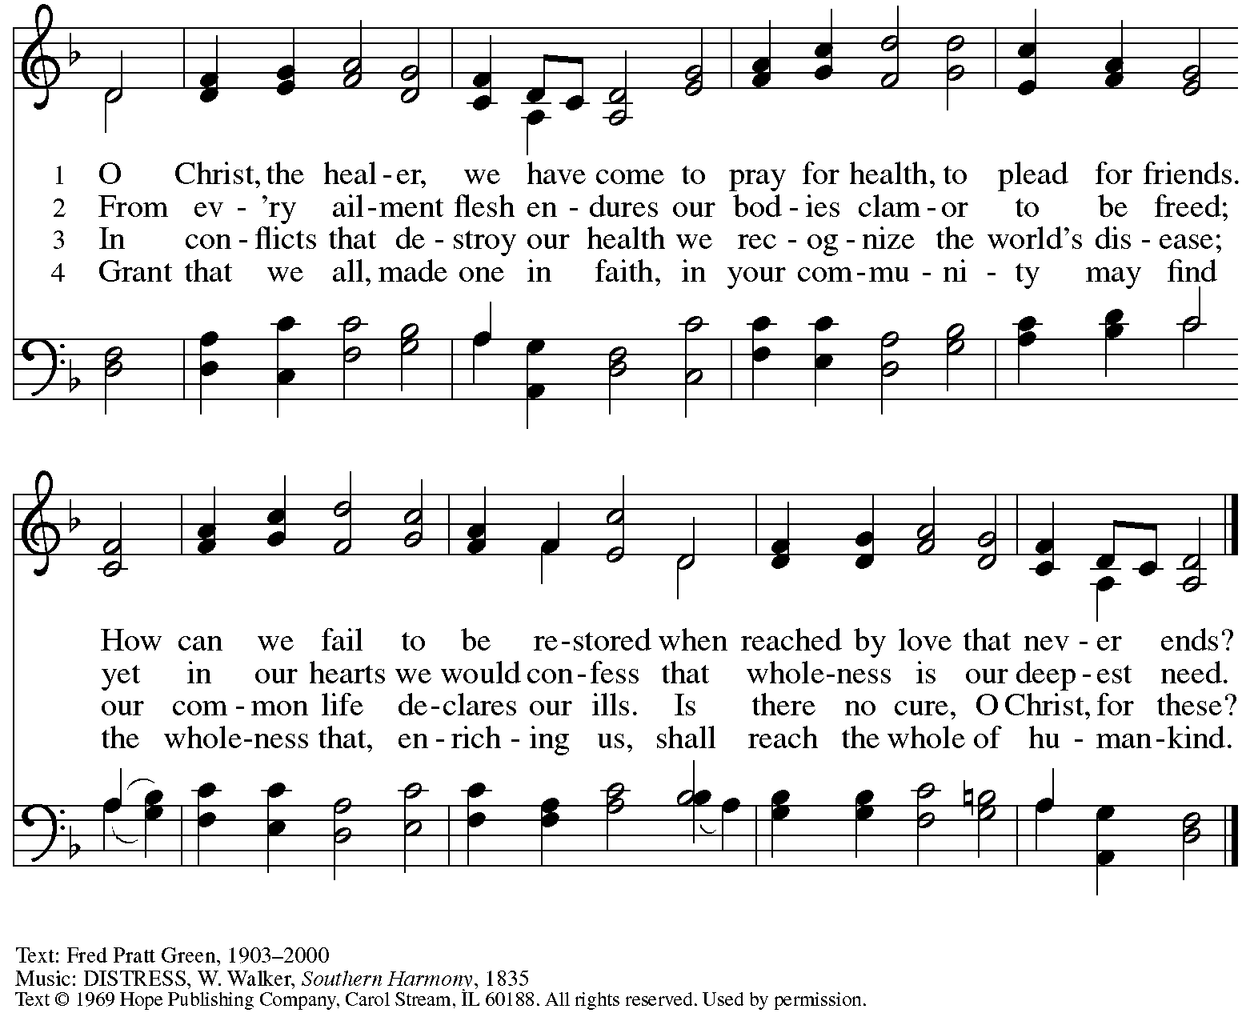
Reprinted with permission under OneLicense.net # A-722139.

Hymns during Holy Communion
Great Is Thy Faithfulness ELW 733

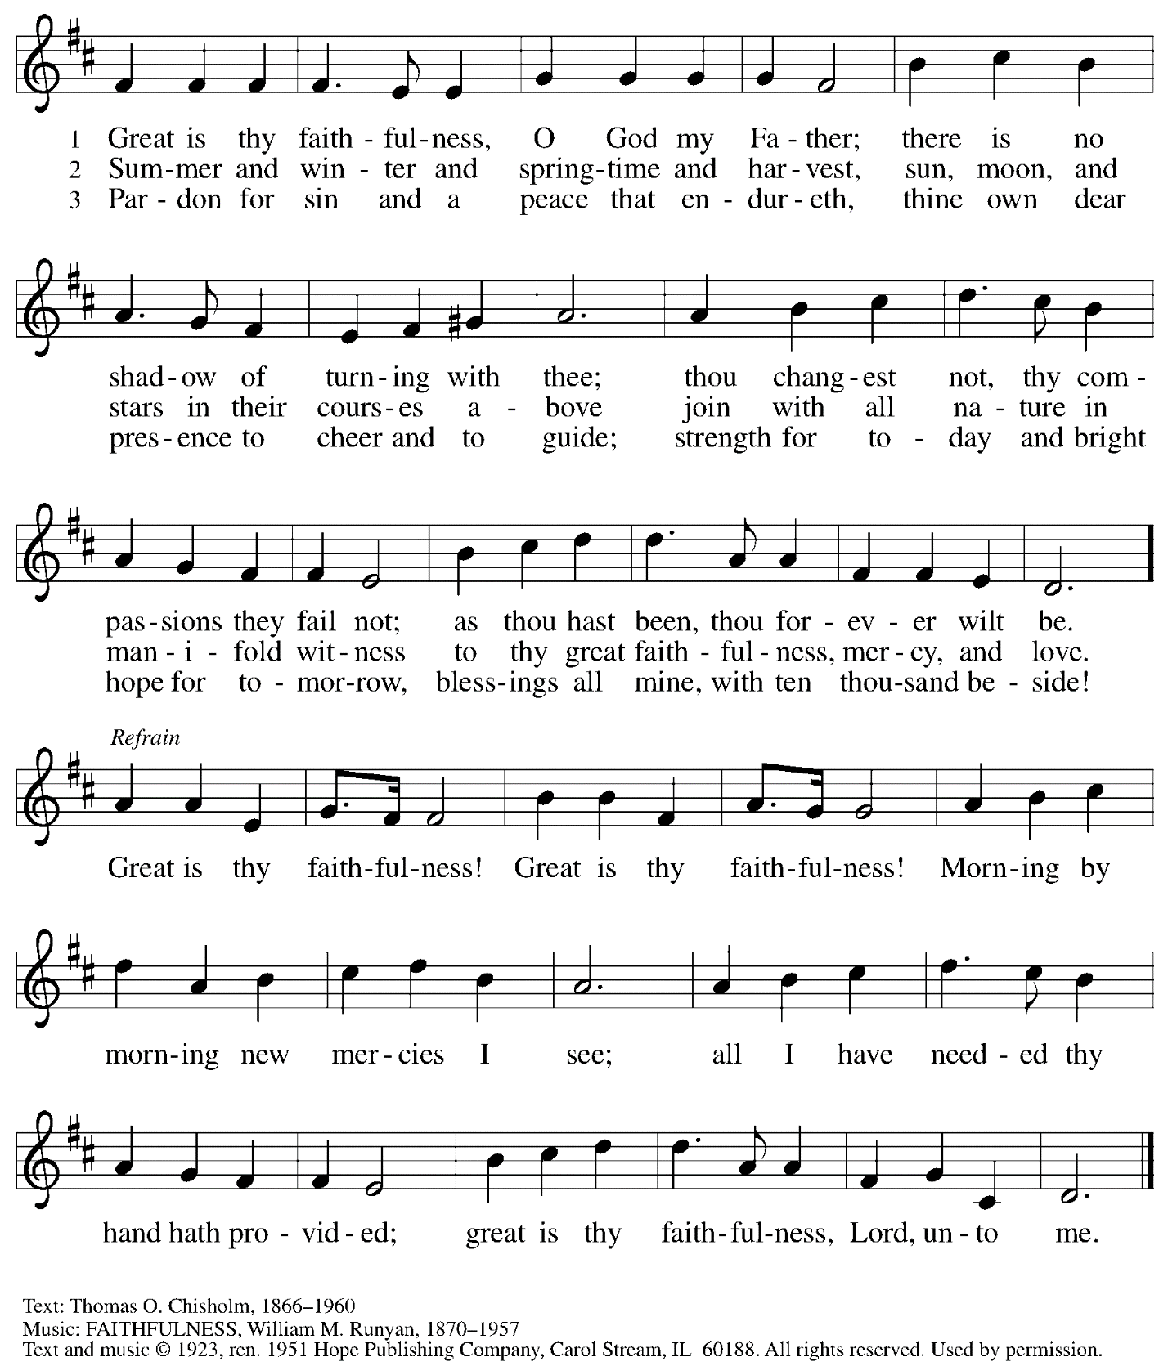
Reprinted under OneLicense.net # A-722139.

When all have returned to their places, please rise as you are able.

Blessing

P: The body and blood of our Lord Jesus Christ strengthen you and keep you in his grace.
C: Amen.

Prayer

A: Let us pray. Gracious God, in this meal you have drawn us to your heart,
and nourished us at your table with food and drink, the body and blood of Christ.
Now send us forth to be your people in the world, and to proclaim your truth,
this day and evermore, through Jesus Christ, your Son, our Lord.
C: Amen.

Please be seated.

Sending
God blesses us and sends us in mission to the world

Announcements

Please rise as you are able.

Farewell and Godspeed HS 808

After the rite of Farewell and Godspeed, the assembly is invited to join in singing
St. Andrew’s congregational refrain.

Congregational Refrain

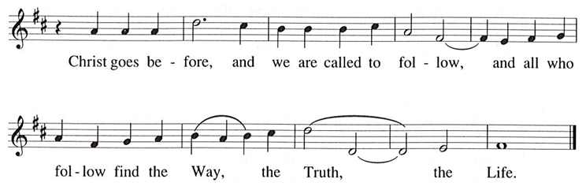

Benediction

P: God, the Source of glory,
God, the Word of life,
God, the Spirit of truth
☩ bless you all, now and forever.
C: Amen.

Sending Hymn I’m So Glad Jesus Lifted Me ELW 860

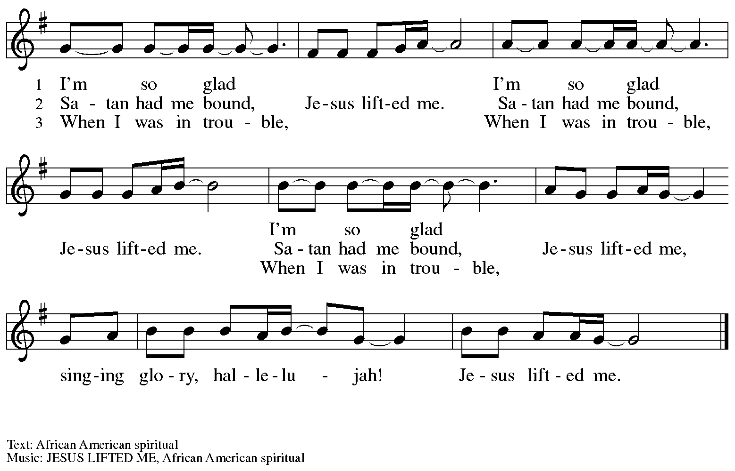

Dismissal

A: Go in peace. Serve the Lord.
C: Thanks be to God.

Postlude

Those serving in worship today

Altar Care Jodie Minor
Assisting Minister Kathy Hays
Audio-Visual Ministers Kristen Asplin
Jason Galyardt
Cantor Timothy Kocher-Hillmer
Lector Lindsay Baxter
Minister of Music Laura Reynolds
Presiding Minister Pastor Ross Carmichael

Liturgy and Hymnody Acknowledgements

From SundaysandSeasons.com. Copyright © 2024 Augsburg Fortress. All rights reserved. Reprinted under OneLicense.net # A-722139.
Used by permission of Augsburg Fortress.

You Are Holy – Text: Per Harling, b. 1945. Music: DU ÄR HELIG, Per Harling. Text and music © 1990 Ton Vis Produktion AB, admin. Augsburg Fortress in North America. All rights reserved. Reprinted with permission under OneLicense.net #A-722139.

Please use the QR code below to link to St. Andrew’s announcements online!

St. Andrew Lutheran Church Announcements
June 30th, 2024

- Welcome to Worship at St. Andrew on the Sixth Sunday after Pentecost, June 30th, 2024 – We are so glad you are here, and we offer a special welcome to all visitors and guests connecting for the first time! Worship attendees are invited to make a name tag at the back of the worship space if you would like. There are worship “toolkits” to help children engage with worship and “busy bags” for younger children available in the bookcase at the back of the sanctuary. Please feel free to take one to use with/for your children. All are invited to gather for coffee other drinks and food, and conversation in the social hall after worship.
- Farewell and Godspeed to Libby and Tim – When people leave St. Andrew, we offer our thanks, prayers, and support as they move on to the next stage in their Christian vocations. Following Libby’s recent graduation (Congratulations!), she and Tim will be moving to Portland, OR to start new jobs. Please take a moment to share blessings and wish them well!
- Renaissance City Choir’s Why We Sing! Concert Today, June 30th, at 4:00 p.m. – Renaissance City Choir affirms and celebrates LGBTQIA+ identity through the unifying power of music. Their concerts blend challenging contemporary music, commissions of new works, an ambitious traditional repertoire, and music from various world cultures, while supporting issues related to human equality and justice. The choir, which features members of Saint Andrew including C.E. Pino, will present its next concert this afternoon at 4:00 p.m. at East Liberty Presbyterian Church, 116 S. Highland Avenue, 15206. Tickets may be purchased at https://rccpittsburgh.ticketleap.com/why-we-sing-rcc-pride-concerts/. Sunday’s concert will be live streamed and it is “pay as you wish” for both in person and the live stream.
- July Produce Distribution – First Tuesday of the Month, July 2nd, 2024, from 5:30-7:00 p.m. – St. Andrew partners with Greater Pittsburgh Community Food Bank to serve as a distribution site for fresh produce on the first Tuesday of every month. June’s distribution will be Tuesday, July 2nd. We invite people of the congregation to help with the distribution from 5:30-7:00 p.m., help with unloading and setup during the day between 10:00 a.m. and 1:00 p.m., or just to pick up fresh produce!
- Shelter Dinner at East End Cooperative Ministry (EECM) – Thursday, July 18th, 6:30 p.m. – Each month, on the third Thursday, people of St. Andrew prepare a meal for guests of the shelter at East End Cooperative Ministry (6140 Station St., East Liberty 15206). We invite you to prepare or purchase one menu item and bring it to the shelter by 6:00 p.m., to come and help serve the meal at 6:30 p.m., or both! Please sign up using this link for July: https://www.signupgenius.com/go/5080544AAAC22A1F58-50170812-july.
- Coffee Hour Signups for July Now Available! – Inviting Coffee Hour Signups for Upcoming Sundays – One way that St. Andrew builds community is by sharing conversation over food and drinks at coffee hour after worship on Sundays. We invite people of the congregation to sign up to coordinate coffee hour each week, which includes brewing the coffee; setting out cups, napkins, food items, and cold drinks; and cleaning up afterward. Everything needed is at St. Andrew and instructions are available. Please sign up to host coffee hour here: https://www.signupgenius.com/go/5080B4AAFAF2CABF85-47069030-coffee.
- New Christ in Our Home Devotional Booklets (July – September) Available at Church Entrances – Christ in Our Home is a booklet of devotions that includes Scripture, a brief reflection, and prayer for each day. The new edition for July – September is now available at the various church entrances. Please feel free to take one for yourself or others!
- Monthly Reparations Offering Next Week, July 7th, during Worship – Jesus’ parable from Luke’s Gospel about a compassionate Samaritan provides an example of how God's people are called to work for healing and repair for our neighbors, independent of who or what caused harm. In light of this, St. Andrew has made a commitment to reparations in regard to African American spiritual songs used in our worship. The text and music of most hymns is attributed to specific authors, with copyrights in place, usage reported, and royalties paid to those whose works are featured in worship. With African American spirituals, this is not possible. In response to many years of such uncredited use, St. Andrew invites the congregation to give a reparations offering on the first Sunday of each month. Funds received in worship will be donated to our siblings at Bethel AME Church, whose land and building were taken from them in the 1950s, to fund their development in the lower Hill District.

