+ Fifth Sunday after Pentecost
June 23, 2024

St. Andrew Lutheran Church
304 Morewood Ave.
Pittsburgh, PA 15213
St_andrewELCA@verizon.net
www.standrewpittsburgh.org

+ Fifth Sunday after Pentecost
Order for Worship

Now is the acceptable time; now is the day of salvation!
Now we are in the storm, the boat almost swamped;
but Jesus is here now, and when we call him, he will calm the storm.
Even the wind and waves listen to him as they would to their creator.
We also listen to him and are called to believe in the power of God’s word in him,
a power greater than all that we fear.

Welcome to St. Andrew!
- St. Andrew Lutheran congregation welcomes all who are seeking a place of healing and wholeness – a nurturing, faith-forming spiritual home. Our community embraces people of all ages, ethnicities, cultures, abilities, sexual orientations, gender identities and expressions, and family constellations. Come and See!
- Worship Services are live streamed to multiple online platforms. By attending worship, you agree that your image and voice may be broadcast.
- Everyone is invited to make a name tag at the black bookcase in the back of the worship space if they would like. There are stickers indicating pronouns on the bookcase if you would like to include them on your name tag.
- A nursery is available through the doors at the left side of the sanctuary and across from the doorway to the Social Hall. Look for a purple-colored room.
- Worship “toolkits” to help children engage with the service, along with “busy bags” for younger children, are available in the bookcase at the back of the sanctuary. Please feel free to take one to use with/for your children.
- Holy Communion is served with bread (gluten-free available) and wine or grape juice. The presiding minister will distribute the bread (host). Please consume this and then pick up an empty glass from the tray. The Communion Assistant will pour wine or grape juice into your glass. Please step to the side to consume the wine or grape juice. Feel free to kneel at the altar for prayer and reflection. As you return to your pew, glasses may be returned to the empty trays on either side of the center section.
- A restroom is available on the main level of the church, through the doors to the Social Hall and to the right in the main office.

Abbreviations
P: Pastor/Presiding Minister ELW: Evangelical Lutheran Worship hymnal
A: Assisting Minister ACS: All Creation Sings hymnal
L: Lector OLS: Of the Land and Seasons liturgy
C: Congregation

Pre-Service Music

Welcome

Prelude What a Friend We Have in Jesus arr. P. Keveren

Gathering
The Holy Spirit calls us together as the people of God

Confession and Forgiveness

Please rise as you are able.
All may make the sign of the cross, the sign that is marked at Baptism,
as the presiding minister begins.

P: Blessed be the holy Trinity, ☩ one God,
who forgives all our sin, whose mercy endures forever.
C: Amen.

P: Let us confess our sin in the presence of God and of one another.

Silence is kept for reflection

P: Most merciful God,
C: we confess that we are captive to sin and cannot free ourselves.
We have sinned against you in thought, word, and deed,
by what we have done and by what we have left undone.
We have rejected your guidance.
We have avoided your pruning of our cluttered lives.
We have failed to maintain the tools of stewardship, outreach, and witness
you have provided for the nurture of your church.
For the sake of your Son, Jesus Christ, have mercy on us.
Forgive us, grant us discipline, and redirect us,
so that we may delight in your will and follow in your ways,
to the glory of your holy name. Amen.

P: God, who is rich in mercy,
loved us even when we were dead in sin
and made us alive together with Christ.
By grace you have been saved.
In the name of ☩ Jesus Christ, your sins are forgiven.
Almighty God strengthen you with the Holy Spirit,
that Christ may live in your hearts through faith.
C: Amen.

Gathering Hymn Creating God, Your Fingers Trace ELW 684

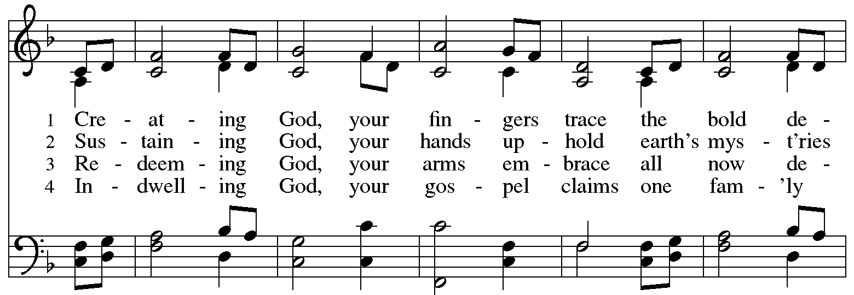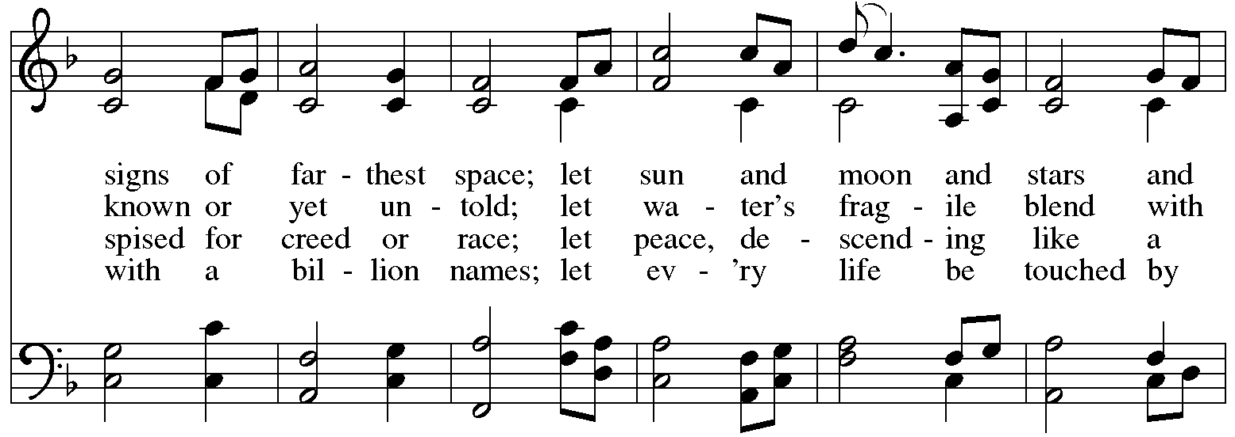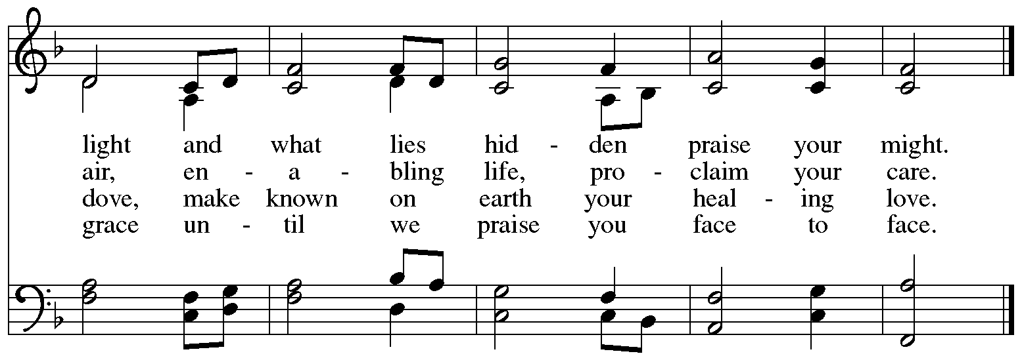
Reprinted with permission under OneLicense.net #A-722139.

Greeting

P: The grace of our Lord Jesus Christ, the love of God,
and the communion of the Holy Spirit be with you all.
C: And also with you.

Hymn of Praise Oh, Sing of God’s Great Victory! OLS 3

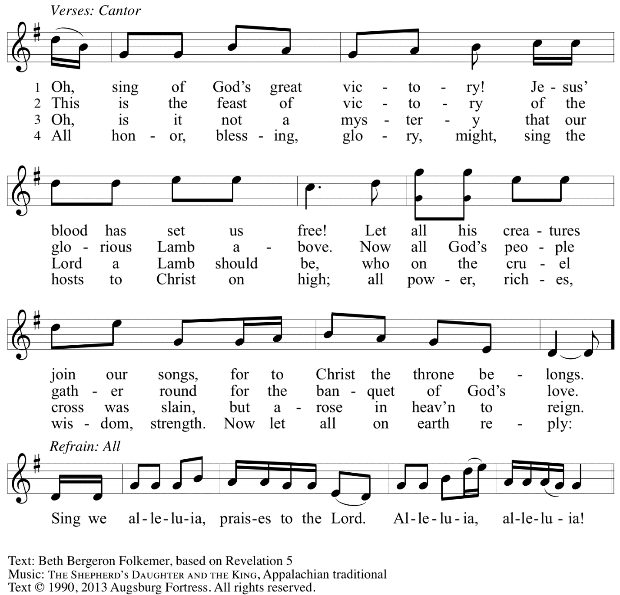
Reprinted with permission under OneLicense.net # A-722139.

Prayer of the Day

P: The Lord be with you.
C: And also with you.

P: Let us pray.
O God of creation, eternal majesty, you preside over land and sea, sunshine and storm.
By your strength pilot us, by your power preserve us, by your wisdom instruct us,
and by your hand protect us, through Jesus Christ, our Savior and Lord.
C: Amen.

Please be seated.

Word
God speaks to us in Scripture reading, preaching, and song

First Reading – Job 38: 1-11

¹The Lord answered Job out of the whirlwind:
²“Who is this that darkens counsel by words without knowledge?
³Gird up your loins like a man,
I will question you, and you shall declare to me.

⁴“Where were you when I laid the foundation of the earth?
Tell me, if you have understanding.
⁵Who determined its measurements—surely you know!
Or who stretched the line upon it?
⁶On what were its bases sunk,
or who laid its cornerstone
⁷when the morning stars sang together
and all the heavenly beings shouted for joy?

⁸“Or who shut in the sea with doors
when it burst out from the womb?—
⁹when I made the clouds its garment,
and thick darkness its swaddling band,
¹⁰and prescribed bounds for it,
and set bars and doors,
¹¹and said, ‘Thus far shall you come, and no farther,
and here shall your proud waves be stopped’?”

L: Word of God, word of life.
C: Thanks be to God.

Psalm 107: 1-3, 23-32

The psalm will be led by the cantor, with the congregation invited to join in singing the alternate verses in bold typeface and the refrain.
Psalm tone

Psalm refrain

¹Give thanks to the Lord, for the | Lord is good,
for God’s mercy en- | dures forever.
²Let the redeemed of the | Lord proclaim
that God redeemed them from the hand | of the foe,
³gathering them in | from the lands;
from the east and from the west, from the north and | from the south.
²³Some went down to the | sea in ships,
plying their trade | in deep waters. R
²⁴They beheld the works | of the Lord,
God’s wonderful works | in the deep.
²⁵Then God spoke, and a stormy | wind arose,
which tossed high the waves | of the sea.
²⁶They mounted up to the heavens and descended | to the depths;
their souls melted away | in their peril.
²⁷They staggered and | reeled like drunkards,
and all their skill was of | no avail.
²⁸Then in their trouble they cried | to the Lord,
and you delivered them from | their distress.
²⁹You stilled the storm | to a whisper
and silenced the waves | of the sea. R
³⁰Then were they glad when | it grew calm,
when you guided them to the harbor | they desired.
³¹Let them give thanks to you, Lord, for your | steadfast love
and your wonderful works | for all people.
³²Let them exalt you in the assembly | of the people;
in the council of the elders, let them sing | hallelujah! R

Second Reading – 2 Corinthians 6: 1-13

¹As we work together with God, we urge you also not to accept the grace of God in vain. ²For God says,
“At an acceptable time I have listened to you,
and on a day of salvation I have helped you.”
See, now is the acceptable time; see, now is the day of salvation! ³We are putting no obstacle in anyone’s way, so that no fault may be found with our ministry, ⁴but as servants of God we have commended ourselves in every way: through great endurance, in afflictions, hardships, calamities, ⁵beatings, imprisonments, riots, labors, sleepless nights, hunger; ⁶by purity, knowledge, patience, kindness, holiness of spirit, genuine love, ⁷truthful speech, and the power of God; with the weapons of righteousness for the right hand and for the left; ⁸in honor and dishonor, in ill repute and good repute. We are treated as impostors, and yet are true; ⁹as unknown, and yet are well known; as dying, and see—we are alive; as punished, and yet not killed; ¹⁰as sorrowful, yet always rejoicing; as poor, yet making many rich; as having nothing, and yet possessing everything.
¹¹We have spoken frankly to you Corinthians; our heart is wide open to you. ¹²There is no restriction in our affections, but only in yours. ¹³In return—I speak as to children—open wide your hearts also.

L: Word of God, word of life.
C: Thanks be to God.

Please rise as you are able.

Gospel Acclamation O God, Whose Word Well-Planted OLS 4
v. 1-2

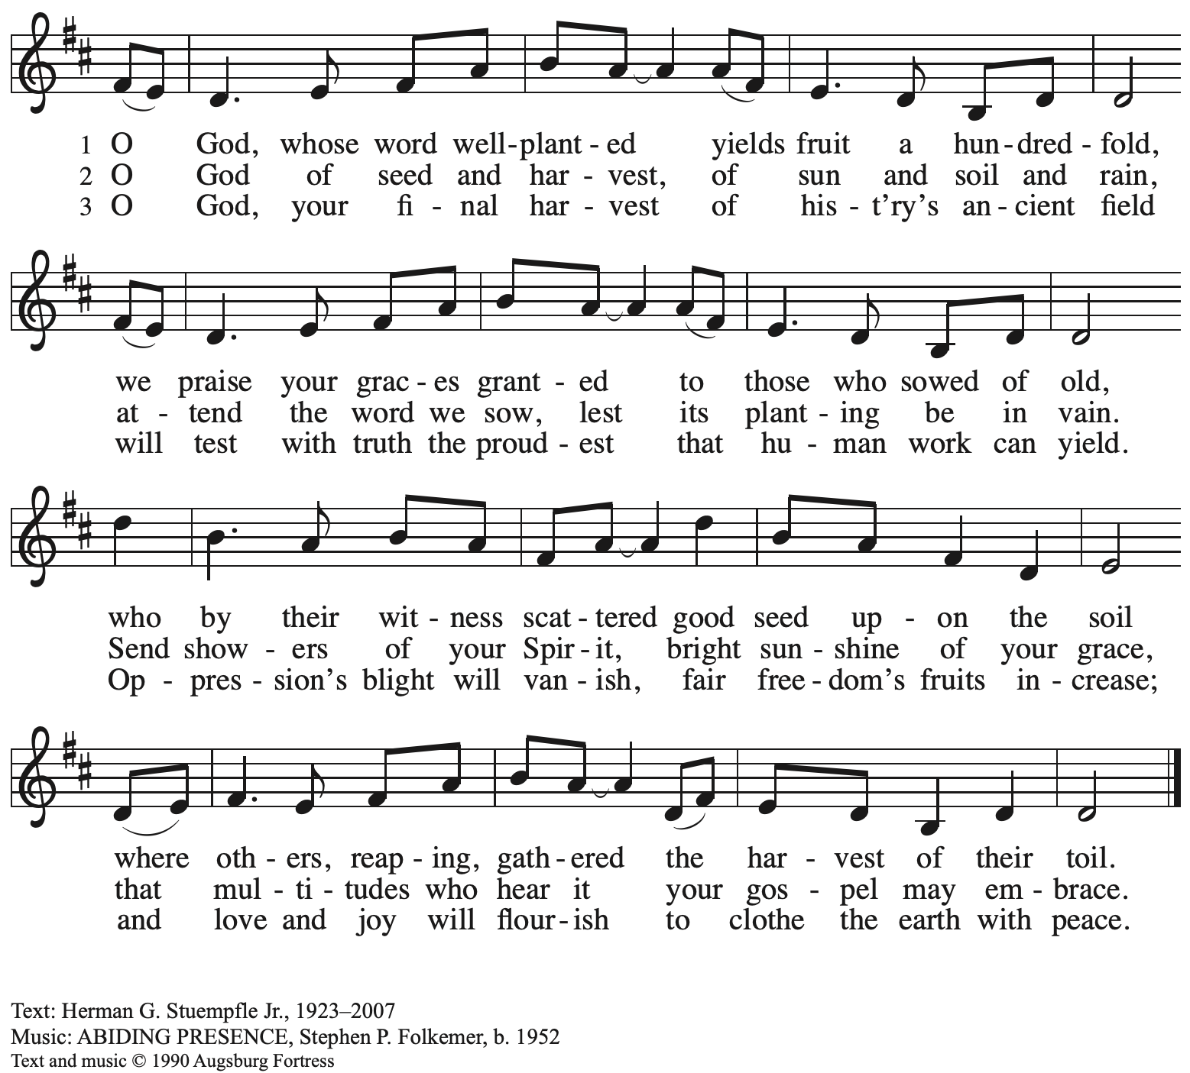
All rights reserved. Reprinted under OneLicense.net # A-722139.

Gospel – Mark 4: 35-41

P: The holy Gospel according to St. Mark.
C: Glory to you, O Lord.

³⁵When evening had come, [Jesus said to the disciples,] “Let us go across to the other side.”
³⁶And leaving the crowd behind, they took him with them in the boat, just as he was. Other boats were with him. ³⁷A great windstorm arose, and the waves beat into the boat, so that the boat was already being swamped. ³⁸But he was in the stern, asleep on the cushion; and they woke him up and said to him, “Teacher, do you not care that we are perishing?” ³⁹He woke up and rebuked the wind, and said to the sea, “Peace! Be still!” Then the wind ceased, and there was a dead calm.
⁴⁰He said to them, “Why are you afraid? Have you still no faith?” ⁴¹And they were filled with great awe and said to one another, “Who then is this, that even the wind and the sea obey him?”

P: The Gospel of the Lord.
C: Praise to you, O Christ.

Please be seated.

Sermon

A time of silence for prayer and reflection follows the sermon.
When the hymn of the day begins, please rise as you are able.

Hymn of the Day Jesus, Savior, Pilot Me ELW 755

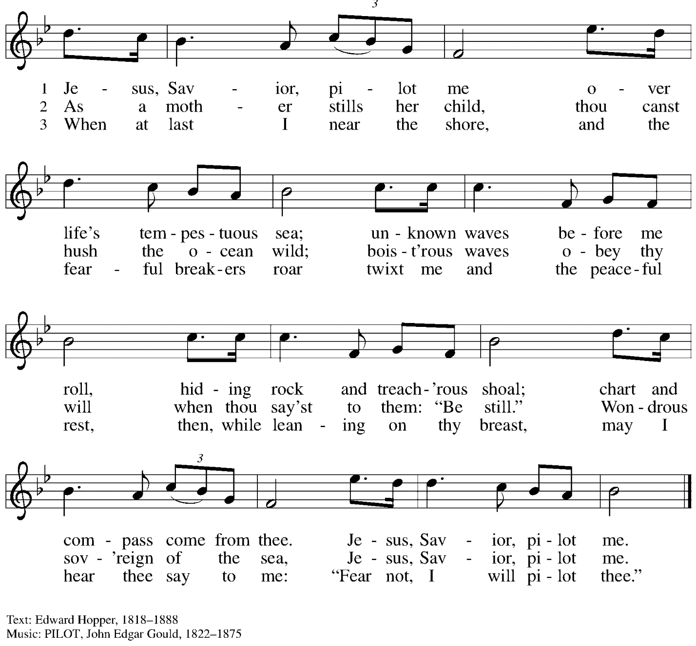

Prayers of the People

A: With the whole people of God in Christ Jesus, let us pray for the church, the world,
those in need, and all of God’s creation.

After each petition
A: God, in your mercy,
C: receive our prayer.

The presiding minister concludes the prayers
P: Into your hands, gracious God, we commend all for whom we pray,
trusting in your abundant mercy, through Jesus Christ our Savior.
C: Amen.

Peace

The presiding minister and the assembly greet one another in the peace of the risen Christ.
P: The peace of Christ be with you always.
C: And also with you.

The people may greet those around them with a sign of Christ’s peace and may say
Peace be with you or similar words. Please be mindful that not everyone will be comfortable with sharing the peace, so please seek consent before shaking hands or hugging. Other possible ways to share the peace include a simple bow with the verbal greeting of peace, or simply a verbal expression of peace.

When the greetings of peace have concluded, please be seated.

Meal
God feeds us with the presence of Jesus Christ

Offering

We offer ourselves, our gifts, and our faithful service to God.
As the offering is gathered for the mission of the church, including the care of those in need,
the table is set for Holy Communion.

Offertory Music I Love to Tell the Story arr. M. Parks

As the gifts are brought forward for presentation, please rise as you are able.

Offertory Song Accept, O Lord, the Gifts We Bring OLS 5

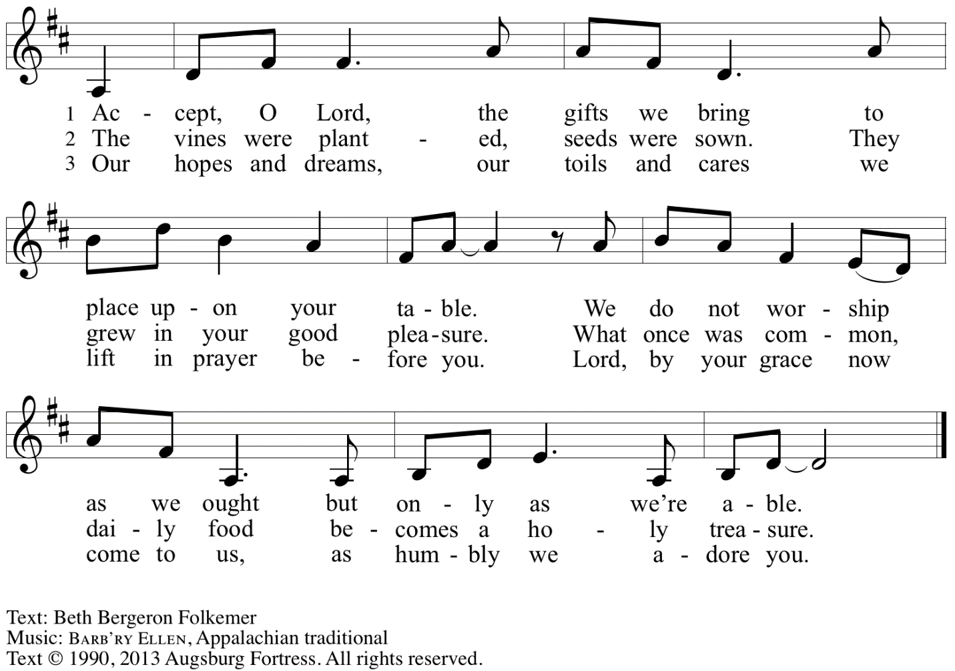
Reprinted under OneLicense.net # A-722139.

Offertory Prayer

A: Let us pray.
Gracious God,
C: you bless us with gifts of guidance, new life,
growth in grace, and fruitful labor.
Accept the first fruits of time and toil, field and orchard,
that we offer here. Bless and multiply these gifts to our nurture
and the care of your creation;
for the sake of your Son, Jesus Christ, our Lord.
Amen.

Dialogue

P: The Lord be with you.
C: And also with you.

P: Lift up your hearts.
C: We lift them to the Lord.

P: Let us give thanks to the Lord our God.
C: It is right to give our thanks and praise.

Preface

P: It is indeed right, our duty and our joy …
… we praise your name and join in adoring song:

Sanctus Holy, Holy, Holy OLS 6

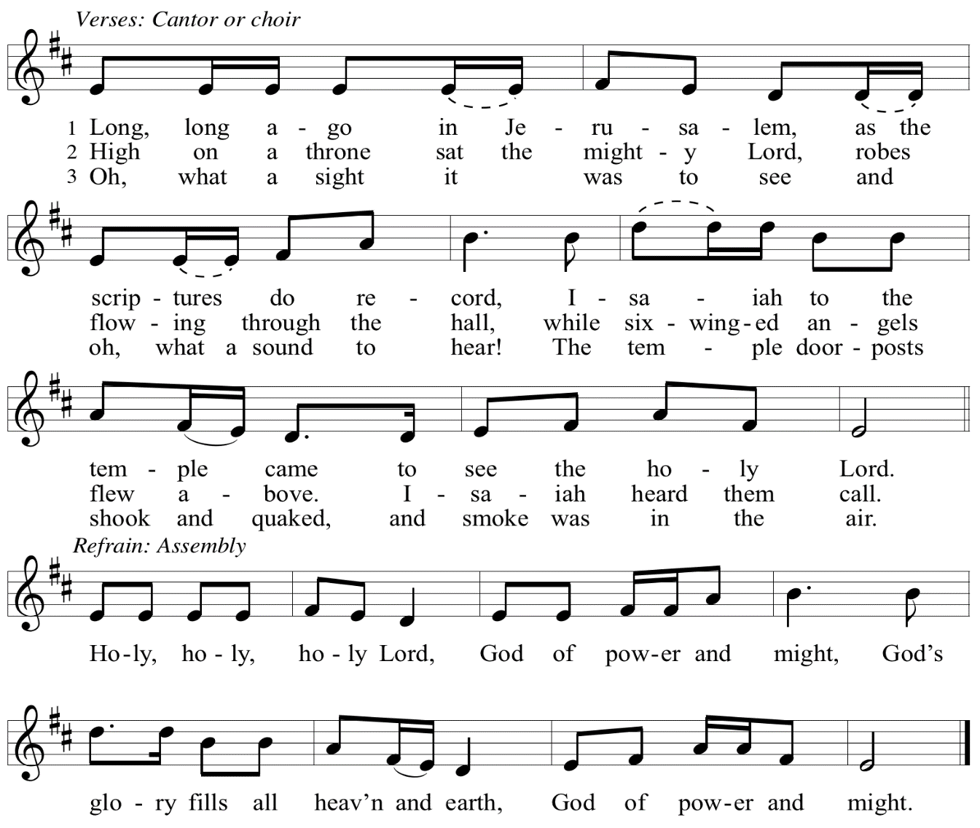

Eucharistic Prayer

P: You are indeed holy, God of power and might
and your glory fills the whole earth …
… and nurture us to become what you have made us –
your beloved people, the body of your Son, the temple of your Spirit.

Through your Son, in your Spirit, with all your people,
we give you thanks and praise,
O source of our life and fountain of all good,
now and forever.
C: Amen.

Lord’s Prayer

P: Gathered as one by the Holy Spirit, let us pray as Jesus taught us.
C: Our Father in heaven,
hallowed be your name,
your kingdom come,
your will be done,
on earth as in heaven.
Give us today our daily bread.
Forgive us our sins
as we forgive those
who sin against us.
Save us from the time of trial
and deliver us from evil.
For the kingdom, the power,
and the glory are yours,
now and forever. Amen.

Fraction and Invitation

P: Just as this broken bread was first scattered on the hills,
then was brought together and became one,
so let your church be brought together
from the ends of the earth into your reign,
for yours are the glory and the power
through Jesus Christ forever.
C: Amen.

Agnus Dei / Lamb of God OLS 7
O Lamb of God, to Earth You Came

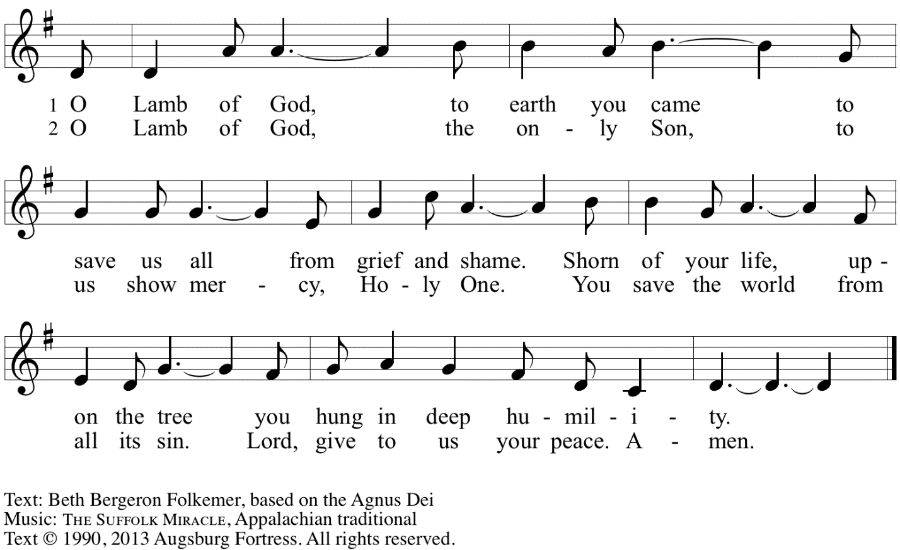
Reprinted with permission under OneLicense.net A# A-722139.

Please be seated.

Holy Communion
- All who seek God and desire a deeper and stronger life in Christ are welcome to receive Holy Communion.
- Worshipers from the pulpit side will proceed forward first, followed by the center section, and then the lectern side.
- Please inform an usher if you would like the ministers to bring Communion to you.
- Holy Communion will be served with bread and wine/grape juice.
- The presiding minister will first distribute the bread (host) to each communicant. Please indicate if you require a gluten-free host.
- Once you have consumed the bread, please pick up an empty glass from the tray next to the presiding minister. The Communion Assistant will pour wine from the chalice or grape juice from the cruet into your glass.
- Please step to the side to consume the wine or grape juice.
- Feel free to kneel at the altar rail for prayer after receiving the sacrament.
- As you return to your pew, glasses may be returned to the empty trays on either side of the center section.
- A blessing will be provided for anyone who does not yet receive the sacrament.
- All are invited to join in singing the hymns during Holy Communion.

Hymns during Holy Communion
O Jesus, I Have Promised ELW 810

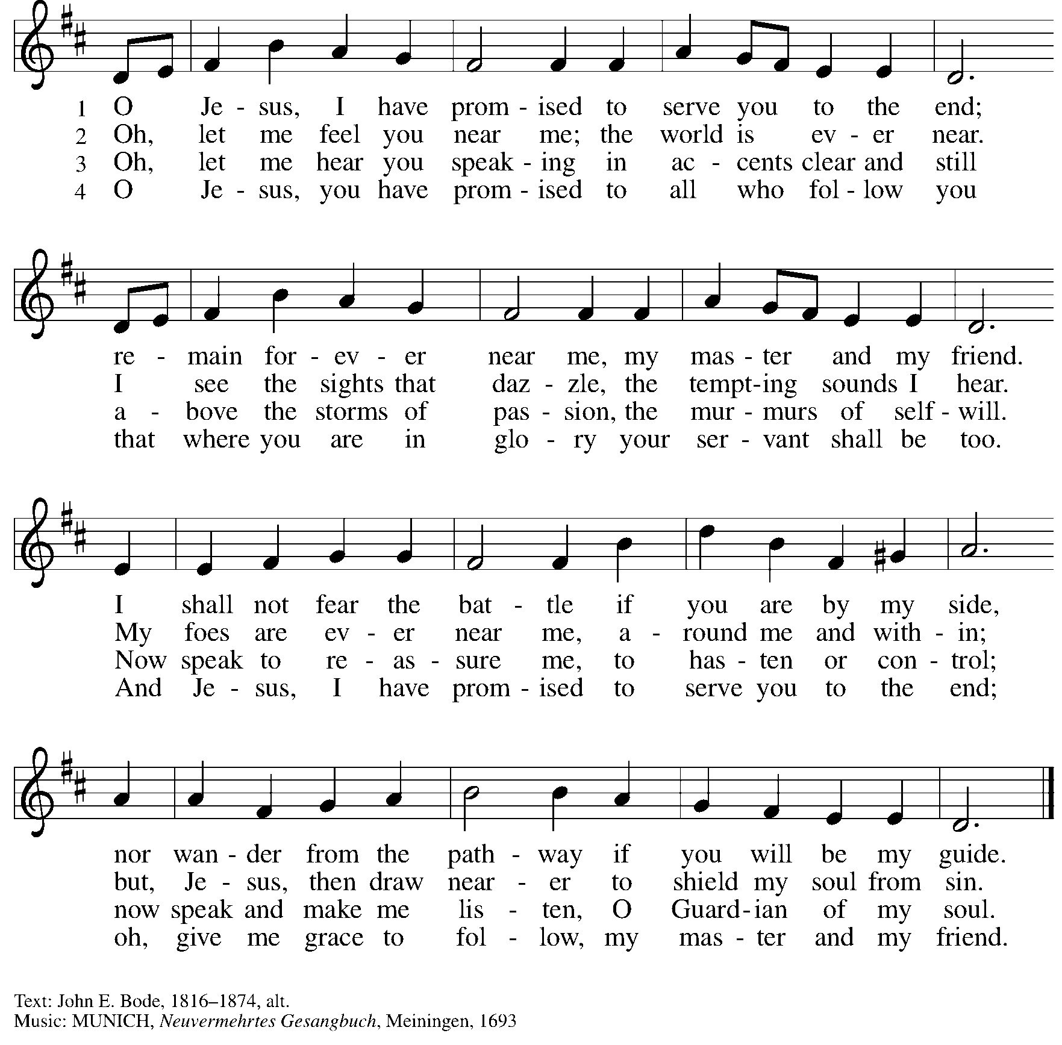

Hymns during Holy Communion
Precious Lord, Take My Hand ELW 773

No downloads are available for this hymn. Please find it in the Evangelical Lutheran Worship hymnal, in the section with large, bold numbers near the back.

Hymns during Holy Communion
When Peace Like a River ELW 785

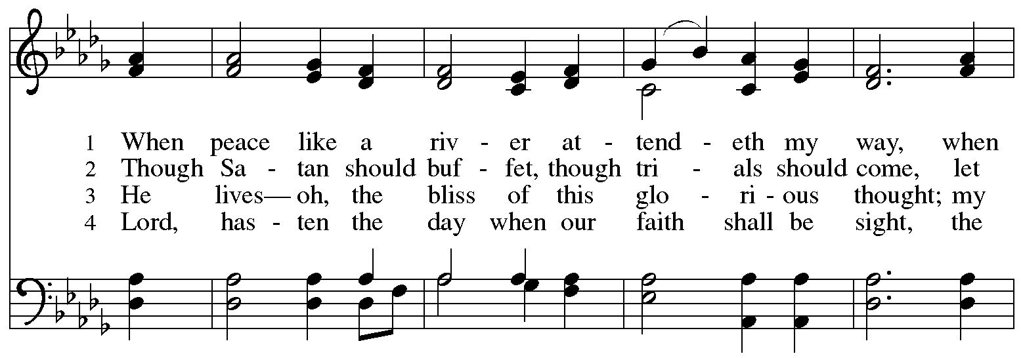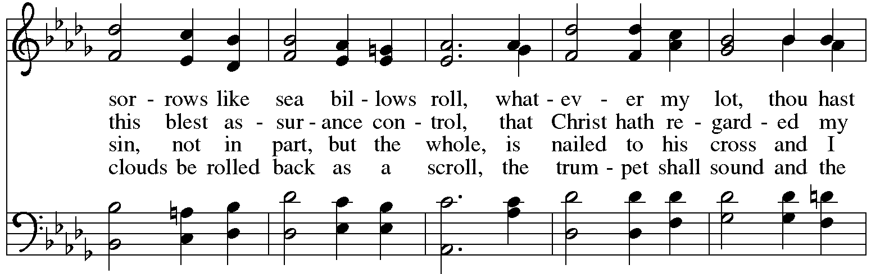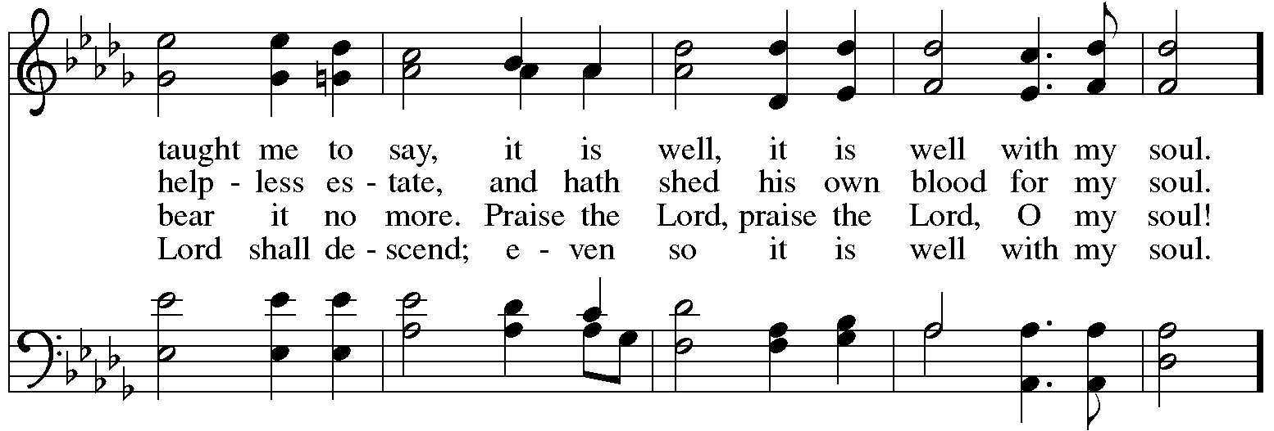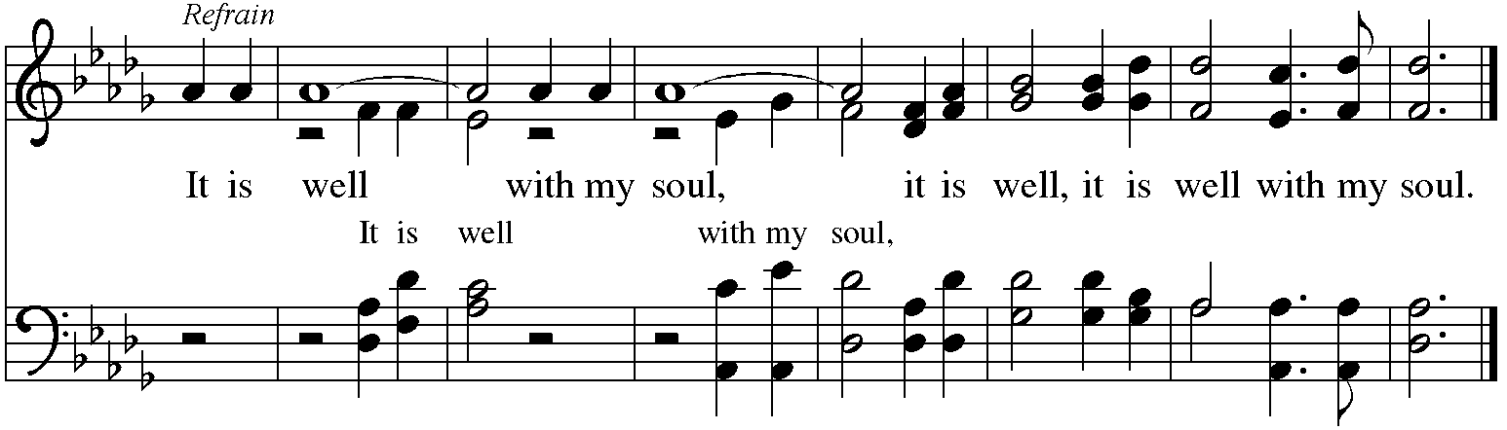

When all have returned to their places, please rise as you are able.

Blessing

P: The body and blood of our Lord Jesus Christ strengthen you and keep you in his grace.
C: Amen.

Prayer

A: Let us pray. Gracious God,
we give you thanks for your pruning, planting, and nurture.
We rejoice that you have used the harvest of field and vineyard
to renew and sustain us.
Lead us as we go from this life-giving meal
into lives of grateful service to you and your cherished creation;
through Jesus Christ, your Son, our Lord.
C: Amen.

Please be seated.

Sending
God blesses us and sends us in mission to the world

Announcements

Please rise as you are able.

Benediction

P: The God of steadfastness and encouragement
grant you to live in harmony with one another,
in accordance with Christ Jesus.
C: Amen.

P: The God of hope fill you with all joy and peace in believing,
so that you may abound in hope by the power of the Holy Spirit.
C: Amen.

P: The God of all grace ☩ bless you now and forever.
C: Amen.

Sending Hymn Praise to the Lord, the Almighty ELW 859

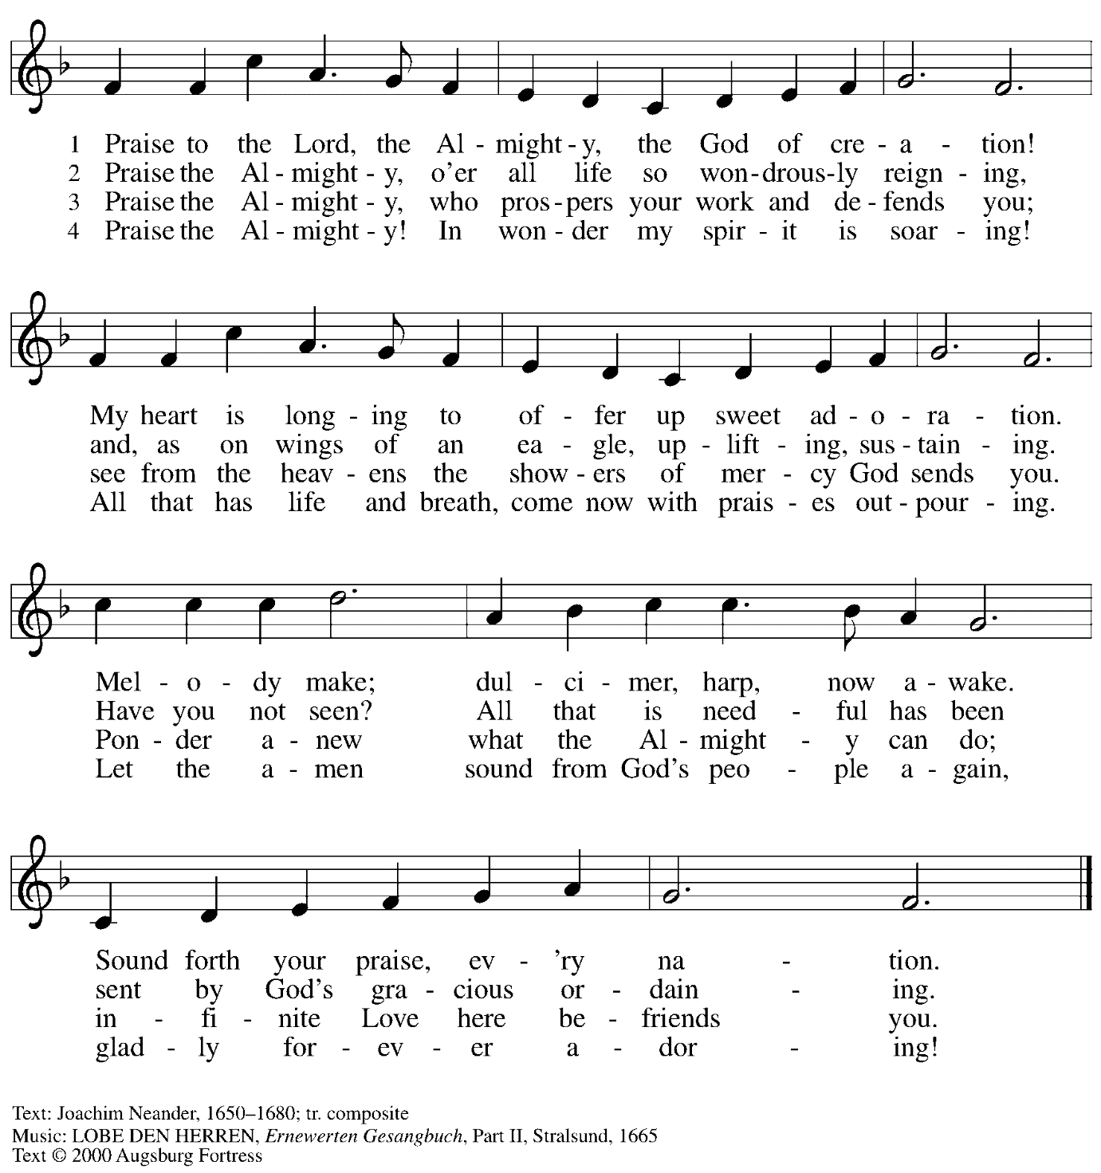

All rights reserved. Reprinted with permission under OneLicense.net # A-722139.

Dismissal

A: Go in peace. Serve the Lord.
C: Thanks be to God.

Postlude Blessed Assurance arr. L. Shackley

Those serving in worship today

Altar Care Beverley Chapman
Audio-Visual Ministers Sarita
David Rollinson
Cantor Ian Brown
Lector Michael Chapman
Minister of Music Laura Reynolds
Presiding Minister Pastor Ross Carmichael

Liturgy and Hymnody Acknowledgements

From SundaysandSeasons.com. Copyright © 2024 Augsburg Fortress. All rights reserved. Reprinted under OneLicense.net # A-722139.
Used by permission of Augsburg Fortress.

The Scripture readings contained herein are from New Revised Standard Version of the Bible © 1989, Division of Christian Education of the National Council of Churches of Christ in the USA. Used by permission. All rights reserved.

Holy, Holy, Holy / Long, Long Ago in Jerusalem – Text: Beth Bergeron Folkemer, based on the Sanctus. Music: SHADY GROVE, Appalachian traditional. Text © 1990, 2013, Augsburg Fortress. All rights reserved. Reprinted with permission under OneLicense.net # A-722139.

When Peace Like a River – It Is Well with My Soul – Text: Horatio G. Spafford, 1828-1888. Music: VILLE DU HAVRE, Philip P. Bliss, 1838-1876.

Please use the QR code below to link to St. Andrew’s announcements online!

St. Andrew Lutheran Church Announcements
June 23rd, 2024

- Welcome to Worship at St. Andrew on the Fifth Sunday after Pentecost, June 23rd, 2024 – We are so glad you are here, and we offer a special welcome to all visitors and guests connecting for the first time! Worship attendees are invited to make a name tag at the back of the worship space if you would like. There are worship “toolkits” to help children engage with worship and “busy bags” for younger children available in the bookcase at the back of the sanctuary. Please feel free to take one to use with/for your children. All are invited to gather for coffee other drinks and food, and conversation in the social hall after worship.
- Renaissance City Choir Offers Why We Sing! Concerts Saturday, June 29th and Sunday, June 30th, 4:00 p.m. – Renaissance City Choir affirms and celebrates LGBTQIA+ identity through the unifying power of music. Their concerts blend challenging contemporary music, commissions of new works, an ambitious traditional repertoire, and music from various world cultures, while supporting issues related to human equality and justice. The choir, which features members of Saint Andrew including C.E. Pino, will present its next concerts at East Liberty Presbyterian Church, 116 S. Highland Avenue in Pittsburgh on Saturday, June 29th and Sunday, June 30th at 4:00 p.m. Tickets can be found at https://rccpittsburgh.ticketleap.com/why-we-sing-rcc-pride-concerts/. Sunday’s concert will be live streamed and it is “pay as you wish” for both in person and the live stream.
- July Produce Distribution – First Tuesday of the Month, July 2nd, 2024, from 5:30-7:00 p.m. – St. Andrew partners with Greater Pittsburgh Community Food Bank to serve as a distribution site for fresh produce on the first Tuesday of every month. June’s distribution will be Tuesday, July 2nd. We invite people of the congregation to help with the distribution from 5:30-7:00 p.m., help with unloading and setup during the day between 10:00 a.m. and 1:00 p.m., or just to pick up fresh produce!
- New Christ in Our Home Devotional Booklets (July – September) Available at Church Entrances – Christ in Our Home is a booklet of devotions that includes Scripture, a brief reflection, and prayer for each day. The new edition for July – September is now available at the various church entrances. Please feel free to take one for yourself or others. Booklets for June are still available, as well!

