+ Fourth Sunday after Pentecost
June 16, 2024

St. Andrew Lutheran Church
304 Morewood Ave.
Pittsburgh, PA 15213
St_andrewELCA@verizon.net
www.standrewpittsburgh.org

+ Fourth Sunday after Pentecost
Order for Worship

In this week’s Gospel, Jesus tells a parable about a mustard seed
that grows large enough to provide shelter for birds, recalling images of the tree of life.
While the lofty cedar tree of Ezekiel’s prophecy and Psalm 92 may seem a more appropriate image, Jesus compares God’s reign with a tiny seed that grows into a shrub. This may appear so impressive, nor the way one would expect the divine to work. But we are also reminded this week that at the cross, through Jesus, we find the tree of life.

June 17 – Emanuel Nine, Martyrs, 2015

On June 17, 2015, Clementa C. Pinckney, Cynthia Marie Graham Hurd, Susie Jackson, Ethel Lee Lance, DePayne Middleton-Doctor, Tywanza Sanders, Daniel Lee Simmons, Sharonda Coleman-Singleton, and Myra Thompson were murdered by a self-professed white supremacist while they were gathered for Bible study and prayer at the Emanuel African Methodist Episcopal Church (often referred to as Mother Emanuel) in Charleston, South Carolina. Pastors Pinckney and Simmons were both graduates of the Lutheran Theological Southern Seminary. A resolution to commemorate June 17 as a day of repentance for the martyrdom of the Emanuel Nine was adopted by the Churchwide Assembly of the Evangelical Lutheran Church in America on August 8, 2019. Congregations of the ELCA are encouraged to reaffirm their commitment to repenting of the sins of racism and white supremacy which continue to plague this church, to venerate the martyrdom of the Emanuel Nine, and to mark a day of penitence with study and prayer.

June 19 – Juneteenth, 1865

Juneteenth is a holiday that commemorates the end of slavery in the United States. It recalls how the states of Louisiana and Texas heard the news that President Abraham Lincoln had signed the Emancipation Proclamation on January 1, 1863. Slavery continued in those two states for more than two years after the proclamation was signed because the word had yet to travel there. Texas and Louisiana finally got the good news on June 19, 1865. Former slaves broke out in spontaneous celebration. These were dangerous times. Even in the face of resistance and threat, the formerly enslaved Africans found ways to give voice to the wide range of thoughts and emotions at the announcement of the end of legalized slavery in the United States of America. A number of people from St. Andrew will be joining our siblings in Christ at Bethel AME Church today for their worship services, celebratory meal, and commemoration of Juneteenth.

Welcome to St. Andrew

- St. Andrew Lutheran congregation welcomes all who are seeking a place of healing and wholeness – a nurturing, faith-forming spiritual home. Our community embraces people of all ages, ethnicities, cultures, abilities, sexual orientations, gender identities and expressions, and family constellations. Come and See!
- Worship Services are live streamed to multiple online platforms. By attending worship, you agree that your image and voice may be broadcast.
- Everyone is invited to make a name tag at the black bookcase in the back of the worship space if they would like. There are stickers indicating pronouns on the bookcase if you would like to include them on your name tag.
- A nursery is available through the doors at the left side of the sanctuary and across from the doorway to the Social Hall. Look for a purple-colored room.
- Worship “toolkits” to help children engage with the service, along with “busy bags” for younger children, are available in the bookcase at the back of the sanctuary. Please feel free to take one to use with/for your children.
- Holy Communion is served with bread (gluten-free available) and wine or grape juice. The presiding minister will distribute the bread (host). Please consume this and then pick up an empty glass from the tray. The Communion Assistant will pour wine or grape juice into your glass. Please step to the side to consume the wine or grape juice. Feel free to kneel at the altar for prayer and reflection. As you return to your pew, glasses may be returned to the empty trays on either side of the center section.
- A restroom is available on the main level of the church, through the doors to the Social Hall and to the right in the main office.

Abbreviations
P: Pastor/Presiding Minister ELW: Evangelical Lutheran Worship hymnal
A: Assisting Minister ACS: All Creation Sings hymnal
L: Lector OLS: Of the Land and Seasons liturgy
C: Congregation

Pre-Service Music

Welcome

Prelude How Long, O God? Arr. N. Raabe

Gathering
The Holy Spirit calls us together as the people of God

Please rise as you are able.

Invocation

P: Blessed be the holy Trinity, ☩ one God,
whose mercy endures forever.
C: Amen.

Commemoration of the Emanuel Nine

Today we join with Mother Emanuel Methodist Episcopal Church in Charleston, South Carolina and our siblings in Christ across the AME Church in remembering the Emanuel Nine.

The Emanuel Nine, of blessed and eternal memory, were gifted, loving and faithful people who spent their lives striving for excellence, connection, and the presence of God, and their last moments in the study of God’s word. They leave a legacy of grace, resistance, family, and faith.

We remember:
The Rev. Clementa C. Pinckney
Cynthia Marie Graham Hurd
The Rev. Daniel Lee Simmons
The Rev. DePayne Middleton-Doctor
Ethel Lee Lance
The Rev. Myra Singleton Quarles Thompson
The Rev. Sharonda Coleman-Singleton
Susie Jackson, and
Tywanza Kibwe Diop Sanders

In faithfulness and dedication, your beloved lived by your promises, sharing their gifts with their families and communities. Ensure, gracious God, that in remembering their lives and witness, the world comes to know of your Spirit at work in and through them.

We ask this in the name of Jesus.
C: Amen.

Confessing Racism: A Lament for the Church

P: The sin of racism hurts communities of color, fractures human relationships, and denies God’s good creation. To lament is a way for us to recognize the harm caused by racism.

Nothing can separate us from the love of God in Christ Jesus (Romans 8:35-39). God’s grace in Christ frees us for the difficult work of recognizing and lamenting racism.
P: We are all part of one body in Christ, called to act with equity, fairness, and justice. God’s saving love creates grace-filled spaces within us and within our relationships. God’s saving love calls and leads us toward rooting out the racism that continues to harm the body. Remembering the lives and witness of the Emanuel Nine, let us join the whole church in confession and lament.

P: Within the human family, people of color have experienced both interpersonal aggression and structural oppression instead of abundant life. We recognize and lament the harm racism has caused to African Descent communities; American Indian and Alaska Native communities; Indigenous Peoples within Canada; Arab and Middle Eastern communities; Asian and Pacific Islander communities; and Latinx communities. We cry out to you,
C: Lord, have mercy,

P: We have assigned the notion of race to human beings created in God’s own divine image. We have judged God’s beautiful diversity by our flawed and artificial standards. We cry out to you, C: Lord, have mercy.

P: We have used language and images in ways that equate black and dark with stain and sin, and that fail to welcome the treasures of darkness in God’s good creation. We cry out to you,
C: Lord, have mercy.

P: We have accepted practices in our churches and in our society that privilege whiteness over diversity and equity. We have been complicit in how racism continues to exclude and harm people of color. We cry out to you,
C: Lord, have mercy.

P: When one part of the body of Christ suffers, the whole body suffers. As we listen to people who are harmed by racism, we call to you,
C: open our hearts, O God.

P: As we reflect on our daily interactions with people and communities of color, we call to you, C: open our hearts, O God.

P: As we reconsider what we have been taught about race and racism, we call to you,
C: open our hearts, O God.

P: As we contemplate what we have done and what we have left undone, we call to you,
C: open our hearts, O God.

P: As we work to cultivate loving and safe communities for our siblings of color and all people, we call to you,
C: open our hearts, O God.

P: Holy, merciful and living God, we commit ourselves anew to the work of loving one another as you have loved us. Unite us as members your body, connected to one another and empowered for the work you call us to do, in the name of Jesus and by the power of your renewing Spirit.
C: Amen.
Gathering Hymn Sometimes Our Only Song Is Weeping ACS 1050

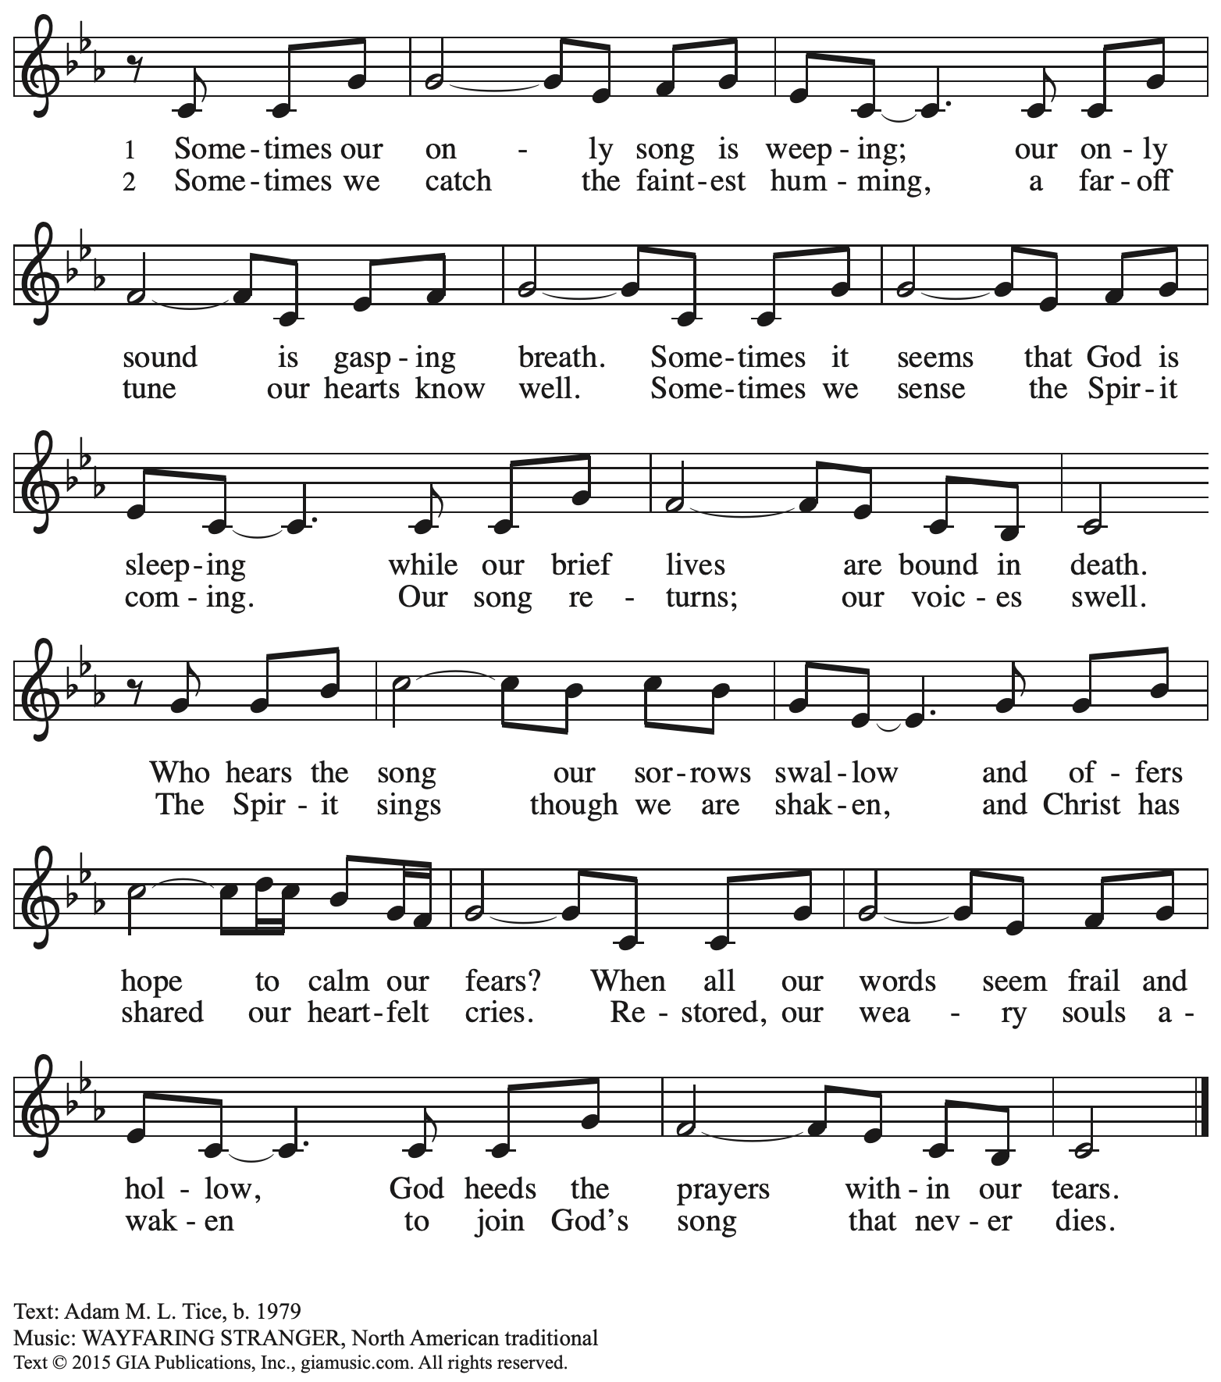
Reprinted with permission under OneLicense.net #A-722139.

Greeting

P: The grace of our Lord Jesus Christ, the love of God,
and the communion of the Holy Spirit be with you all.
C: And also with you.

Kyrie ACS p. 31

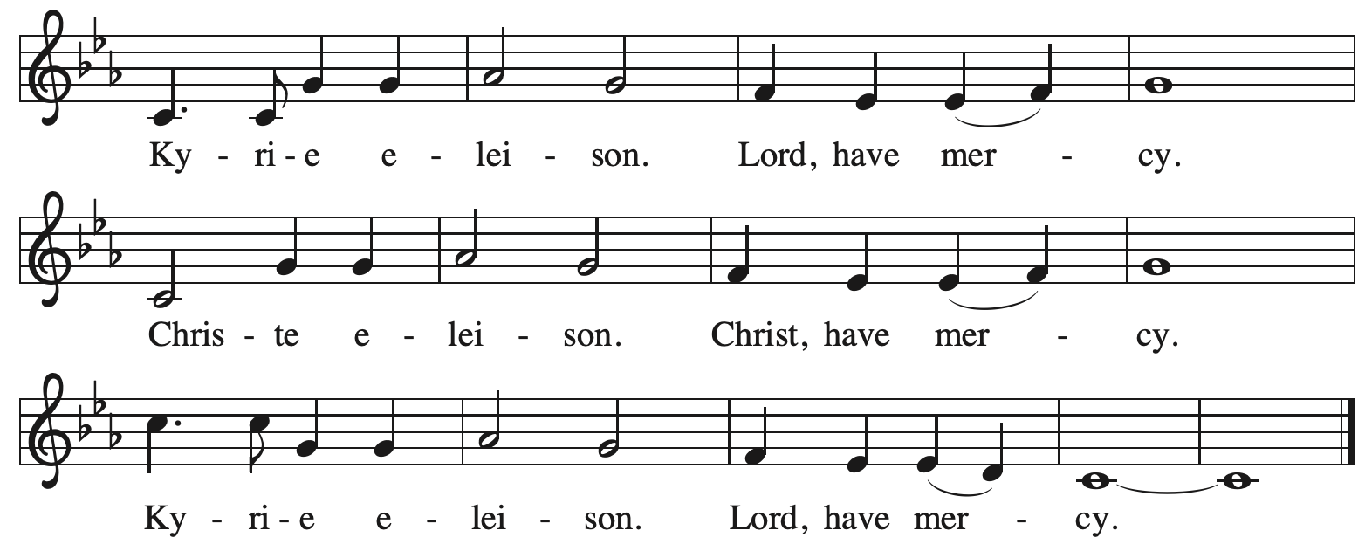

Reprinted with permission under OneLicense.net # A-722139.

Prayer of the Day

P: The Lord be with you.
C: And also with you.

P: Let us pray.
O God, you are the tree of life, offering shelter to all the world.
Graft us into yourself and nurture our growth,
that we may bear your truth and love to those in need,
through Jesus Christ, our Savior and Lord.
C: Amen.

Please be seated.

Word
God speaks to us in Scripture reading, preaching, and song

First Reading – Ezekiel 17: 22-24

²²Thus says the Lord God:
I myself will take a sprig
from the lofty top of a cedar;
I will set it out.
I will break off a tender one
from the topmost of its young twigs;
I myself will plant it
on a high and lofty mountain.
²³On the mountain height of Israel
I will plant it,
in order that it may produce boughs and bear fruit,
and become a noble cedar.
Under it every kind of bird will live;
in the shade of its branches will nest
winged creatures of every kind.
²⁴All the trees of the field shall know
that I am the Lord.
I bring low the high tree,
I make high the low tree;
I dry up the green tree
and make the dry tree flourish.
I the Lord have spoken;
I will accomplish it.

L: Word of God, word of life.
C: Thanks be to God.

Psalm 92: 1-4, 12-15

The psalm will be led by the cantor, with the congregation invited to join in singing the alternate verses in bold typeface and the refrain.
Psalm tone

Psalm refrain

¹It is a good thing to give thanks | to the Lord,
to sing praise to your name, | O Most High;
²to herald your love | in the morning
and your faithful- | ness at night;
³on the psaltery, and | on the lyre,
and to the melody | of the harp.
⁴For you have made me glad by your | acts, O Lord;
and I shout for joy because of the works | of your hands. R
¹²The righteous shall flourish | like a palm tree,
and shall spread abroad like a ce- | dar of Lebanon.
¹³Those who are planted in the house | of the Lord
shall flourish in the courts | of our God;
¹⁴they shall still bear fruit | in old age;
they shall be | green and succulent;
¹⁵that they may show how up- | right the Lord is,
my rock, in whom there is | no injustice. R

Second Reading – 2 Corinthians 5: 6-17

⁶So we are always confident; even though we know that while we are at home in the body we are away from the Lord—⁷for we walk by faith, not by sight. ⁸Yes, we do have confidence, and we would rather be away from the body and at home with the Lord. ⁹So whether we are at home or away, we make it our aim to please him. ¹⁰For all of us must appear before the judgment seat of Christ, so that each may receive recompense for what has been done in the body, whether good or evil.
[¹¹Therefore, knowing the fear of the Lord, we try to persuade others; but we ourselves are well known to God, and I hope that we are also well known to your consciences. ¹²We are not commending ourselves to you again, but giving you an opportunity to boast about us, so that you may be able to answer those who boast in outward appearance and not in the heart. ¹³For if we are beside ourselves, it is for God; if we are in our right mind, it is for you.] ¹⁴For the love of Christ urges us on, because we are convinced that one has died for all; therefore all have died. ¹⁵And he died for all, so that those who live might live no longer for themselves, but for him who died and was raised for them.
¹⁶From now on, therefore, we regard no one from a human point of view; even though we once knew Christ from a human point of view, we know him no longer in that way. ¹⁷So if anyone is in Christ, there is a new creation: everything old has passed away; see, everything has become new!

L: Word of God, word of life.
C: Thanks be to God.

Please rise as you are able.

Gospel Acclamation O God, Whose Word Well-Planted OLS 4
v. 1-2

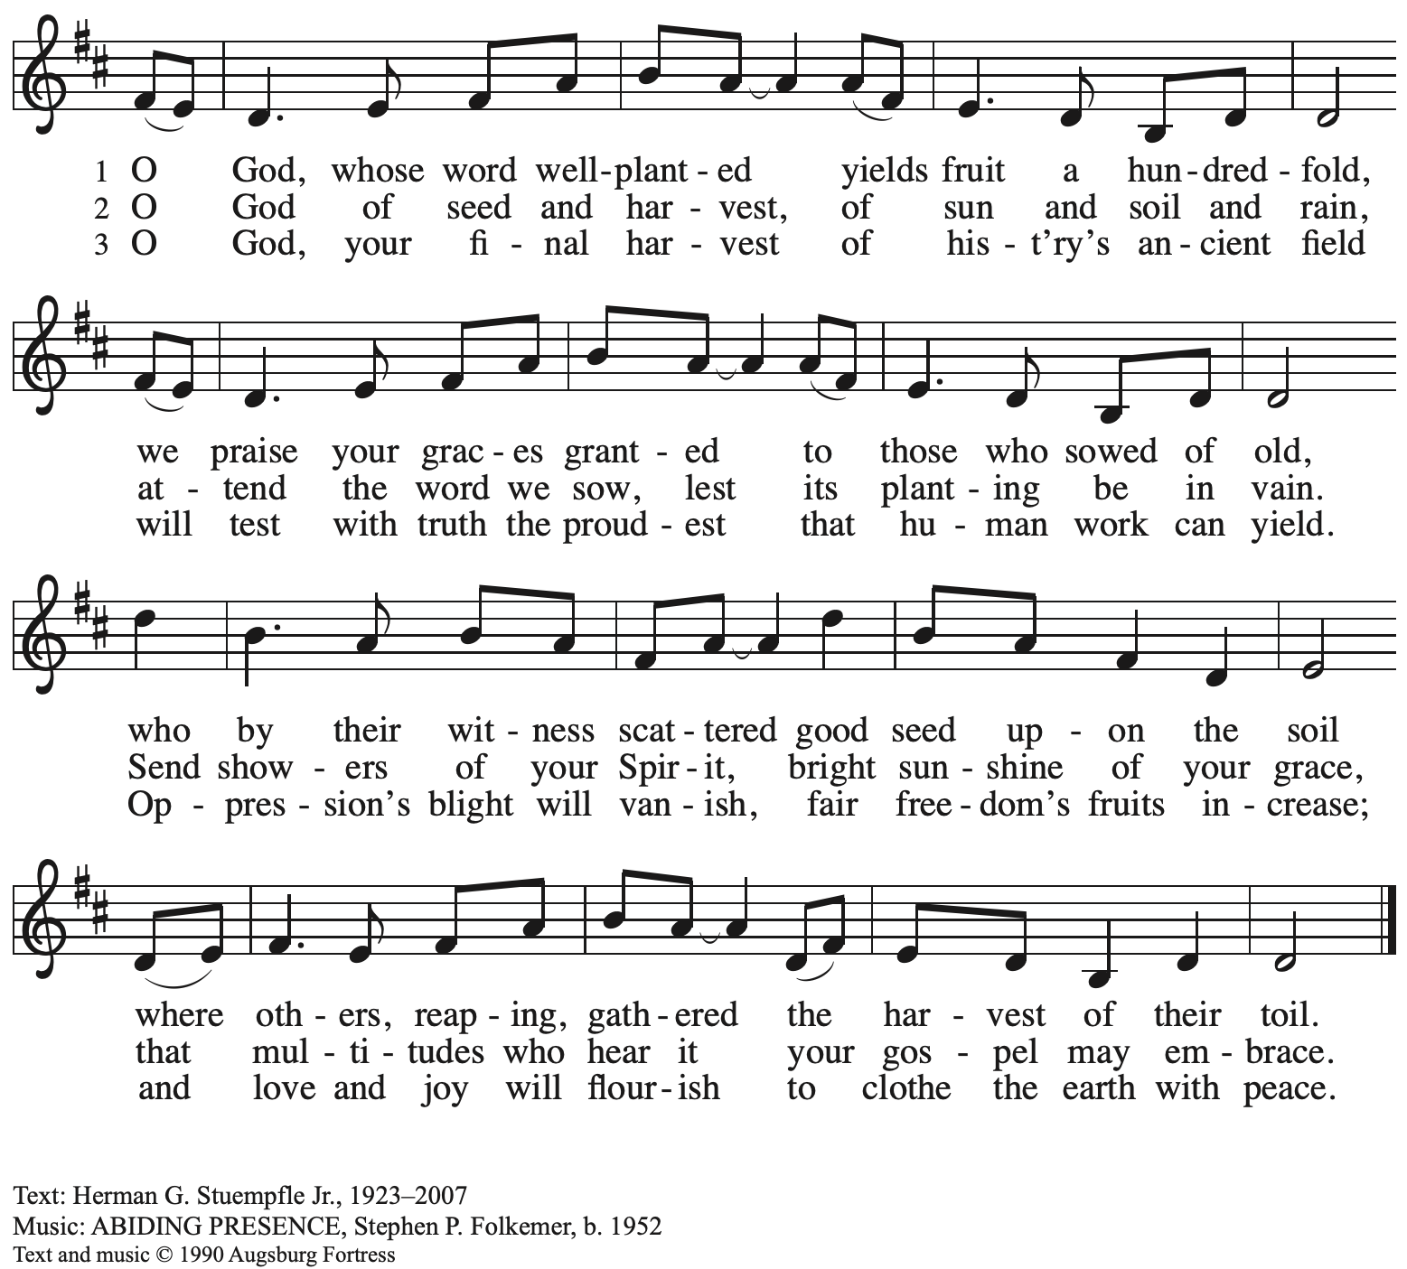
All rights reserved. Reprinted under OneLicense.net # A-722139.

Gospel – Mark 4: 26-34

P: The holy Gospel according to St. Mark.
C: Glory to you, O Lord.

²⁶[Jesus] said, “The kingdom of God is as if someone would scatter seed on the ground,²⁷and would sleep and rise night and day, and the seed would sprout and grow, he does not know how. ²⁸The earth produces of itself, first the stalk, then the head, then the full grain in the head. ²⁹But when the grain is ripe, at once he goes in with his sickle, because the harvest has come.”
³⁰He also said, “With what can we compare the kingdom of God, or what parable will we use for it? ³¹It is like a mustard seed, which, when sown upon the ground, is the smallest of all the seeds on earth; ³²yet when it is sown it grows up and becomes the greatest of all shrubs, and puts forth large branches, so that the birds of the air can make nests in its shade.”
³³With many such parables he spoke the word to them, as they were able to hear it; ³⁴he did not speak to them except in parables, but he explained everything in private to his disciples.

P: The Gospel of the Lord.
C: Praise to you, O Christ.

Please be seated.

Sermon

A time of silence for prayer and reflection follows the sermon.
When the hymn of the day begins, please rise as you are able.

Hymn of the Day Following page

Hymn of the Day The Reign of God, Like Farmer’s Field ACS 952

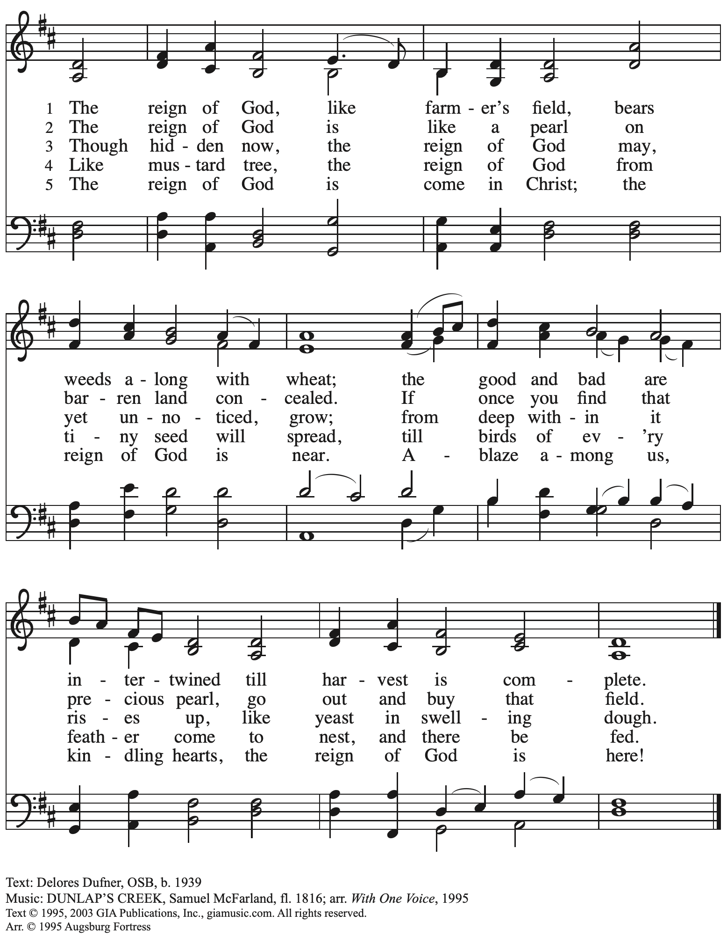
Reprinted with permission under OneLicense.net # A-722139.

Prayers of the People

A: With the whole people of God in Christ Jesus, let us pray for the church, the world,
those in need, and all of God’s creation.

After each petition
A: God, in your mercy,
C: receive our prayer.

The presiding minister concludes the prayers
P: Into your hands, gracious God, we commend all for whom we pray,
trusting in your abundant mercy, through Jesus Christ our Savior.
C: Amen.

Peace

The presiding minister and the assembly greet one another in the peace of the risen Christ.
P: The peace of Christ be with you always.
C: And also with you.

The people may greet those around them with a sign of Christ’s peace and may say
Peace be with you or similar words. Please be mindful that not everyone will be comfortable with sharing the peace, so please seek consent before shaking hands or hugging. Other possible ways to share the peace include a simple bow with the verbal greeting of peace, or simply a verbal expression of peace.

When the greetings of peace have concluded, please be seated.

Meal
God feeds us with the presence of Jesus Christ

Offering

We offer ourselves, our gifts, and our faithful service to God.
As the offering is gathered for the mission of the church, including the care of those in need,
the table is set for Holy Communion.

Noisy Offering

As children of the congregation carry buckets around the sanctuary, people of the congregation are invited to throw in their change as an offering. This month’s Noisy Offering will benefit ReconcilingWorks: Lutherans for Full Participation, the organization that sponsors Reconciling in Christ congregations like St. Andrew that intentionally welcome and advocate for LGBTQIA+ individuals and families in the life of the church and society.

Music during the Offering
All Creatures of our God and King Arr. B. Edstrom

As the gifts are brought forward for presentation, please rise as you are able.

Offertory Song Accept, O Lord, the Gifts We Bring OLS 5

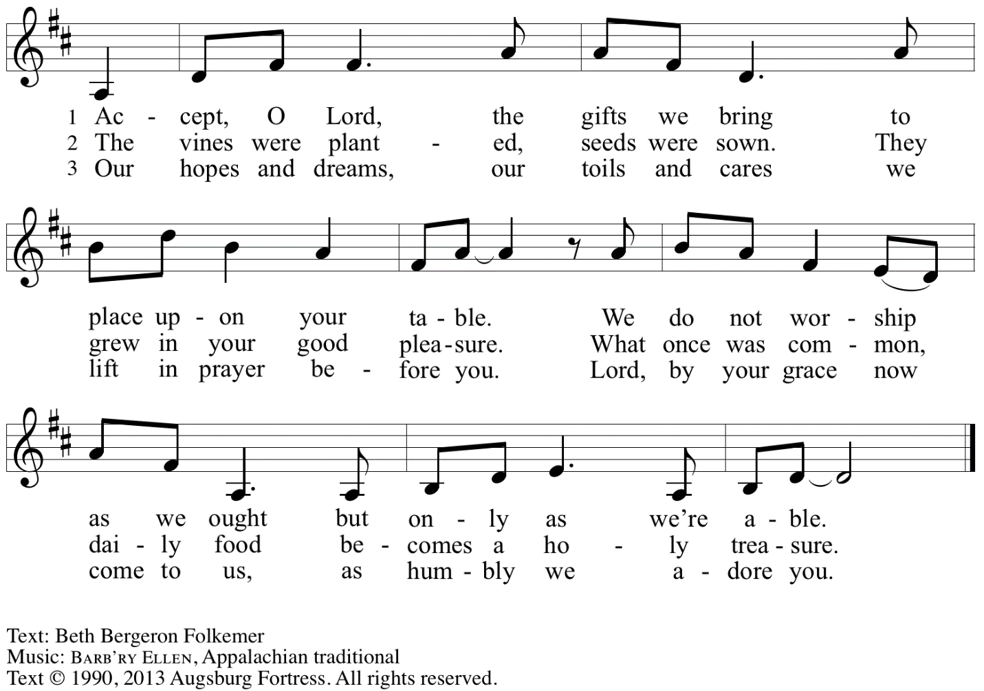
Reprinted under OneLicense.net # A-722139.

Offertory Prayer

A: Let us pray.
Gracious God,
C: you bless us with gifts of guidance, new life,
growth in grace, and fruitful labor.
Accept the first fruits of time and toil, field and orchard,
that we offer here. Bless and multiply these gifts to our nurture
and the care of your creation;
for the sake of your Son, Jesus Christ, our Lord.
Amen.

Dialogue

P: The Lord be with you.
C: And also with you.

P: Lift up your hearts.
C: We lift them to the Lord.

P: Let us give thanks to the Lord our God.
C: It is right to give our thanks and praise.

Preface

P: It is indeed right, our duty and our joy …
… we praise your name and join in adoring song:

Sanctus Holy, Holy, Holy OLS 6

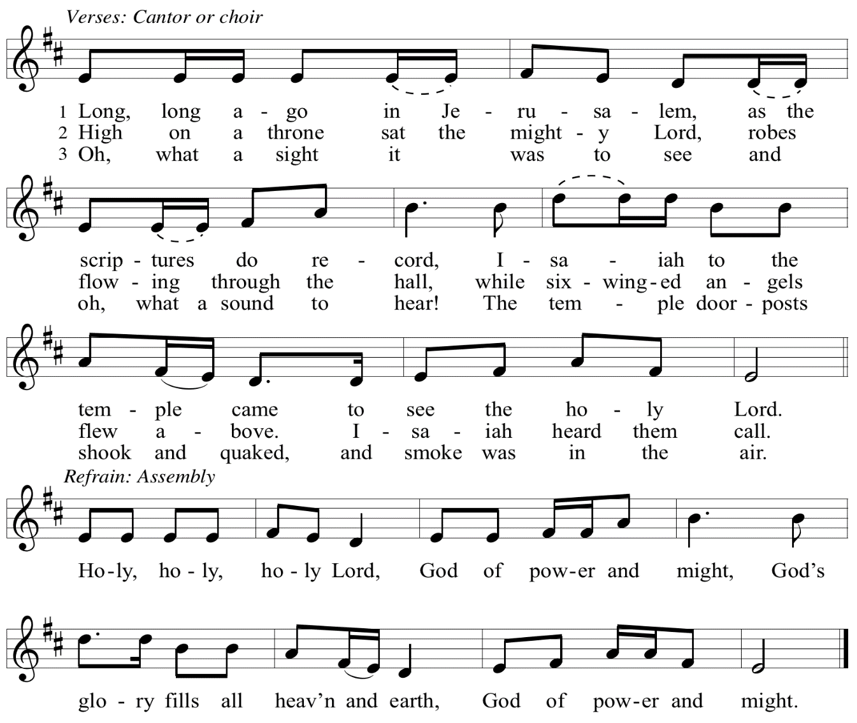

Eucharistic Prayer

P: You are indeed holy, God of power and might
and your glory fills the whole earth …
… and nurture us to become what you have made us –
your beloved people, the body of your Son, the temple of your Spirit.

Through your Son, in your Spirit, with all your people,
we give you thanks and praise,
O source of our life and fountain of all good,
now and forever.
C: Amen.

Lord’s Prayer

P: Gathered as one by the Holy Spirit, let us pray as Jesus taught us.
C: Our Father in heaven,
hallowed be your name,
your kingdom come,
your will be done,
on earth as in heaven.
Give us today our daily bread.
Forgive us our sins
as we forgive those
who sin against us.
Save us from the time of trial
and deliver us from evil.
For the kingdom, the power,
and the glory are yours,
now and forever. Amen.

Fraction and Invitation

P: Just as this broken bread was first scattered on the hills,
then was brought together and became one,
so let your church be brought together
from the ends of the earth into your reign,
for yours are the glory and the power
through Jesus Christ forever.
C: Amen.

Agnus Dei / Lamb of God OLS 7
O Lamb of God, to Earth You Came

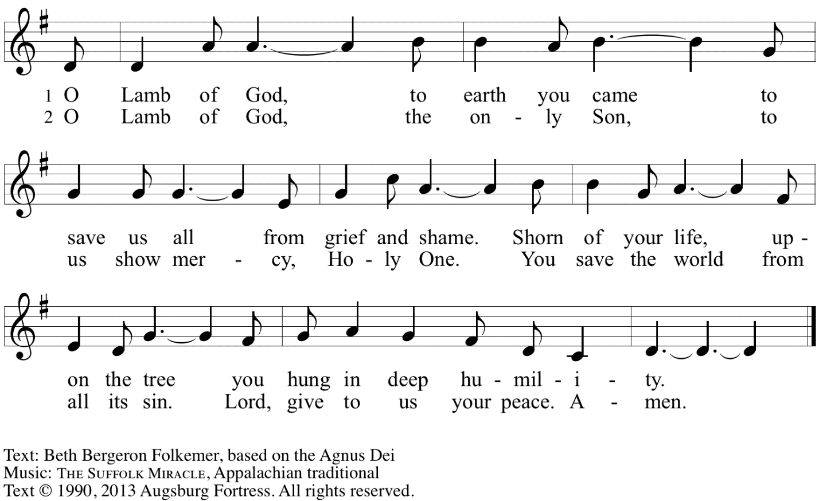
Reprinted with permission under OneLicense.net A# A-722139.

Please be seated.

Holy Communion
- All who seek God and desire a deeper and stronger life in Christ are welcome to receive Holy Communion.
- Worshipers from the pulpit side will proceed forward first, followed by the center section, and then the lectern side.
- Please inform an usher if you would like the ministers to bring Communion to you.
- Holy Communion will be served with bread and wine/grape juice.
- The presiding minister will first distribute the bread (host) to each communicant. Please indicate if you require a gluten-free host.
- Once you have consumed the bread, please pick up an empty glass from the tray next to the presiding minister. The Communion Assistant will pour wine from the chalice or grape juice from the cruet into your glass.
- Please step to the side to consume the wine or grape juice.
- Feel free to kneel at the altar rail for prayer after receiving the sacrament.
- As you return to your pew, glasses may be returned to the empty trays on either side of the center section.
- A blessing will be provided for anyone who does not yet receive the sacrament.
- All are invited to join in singing the hymns during Holy Communion.

Hymns during Holy Communion
We Walk by Faith ELW 635

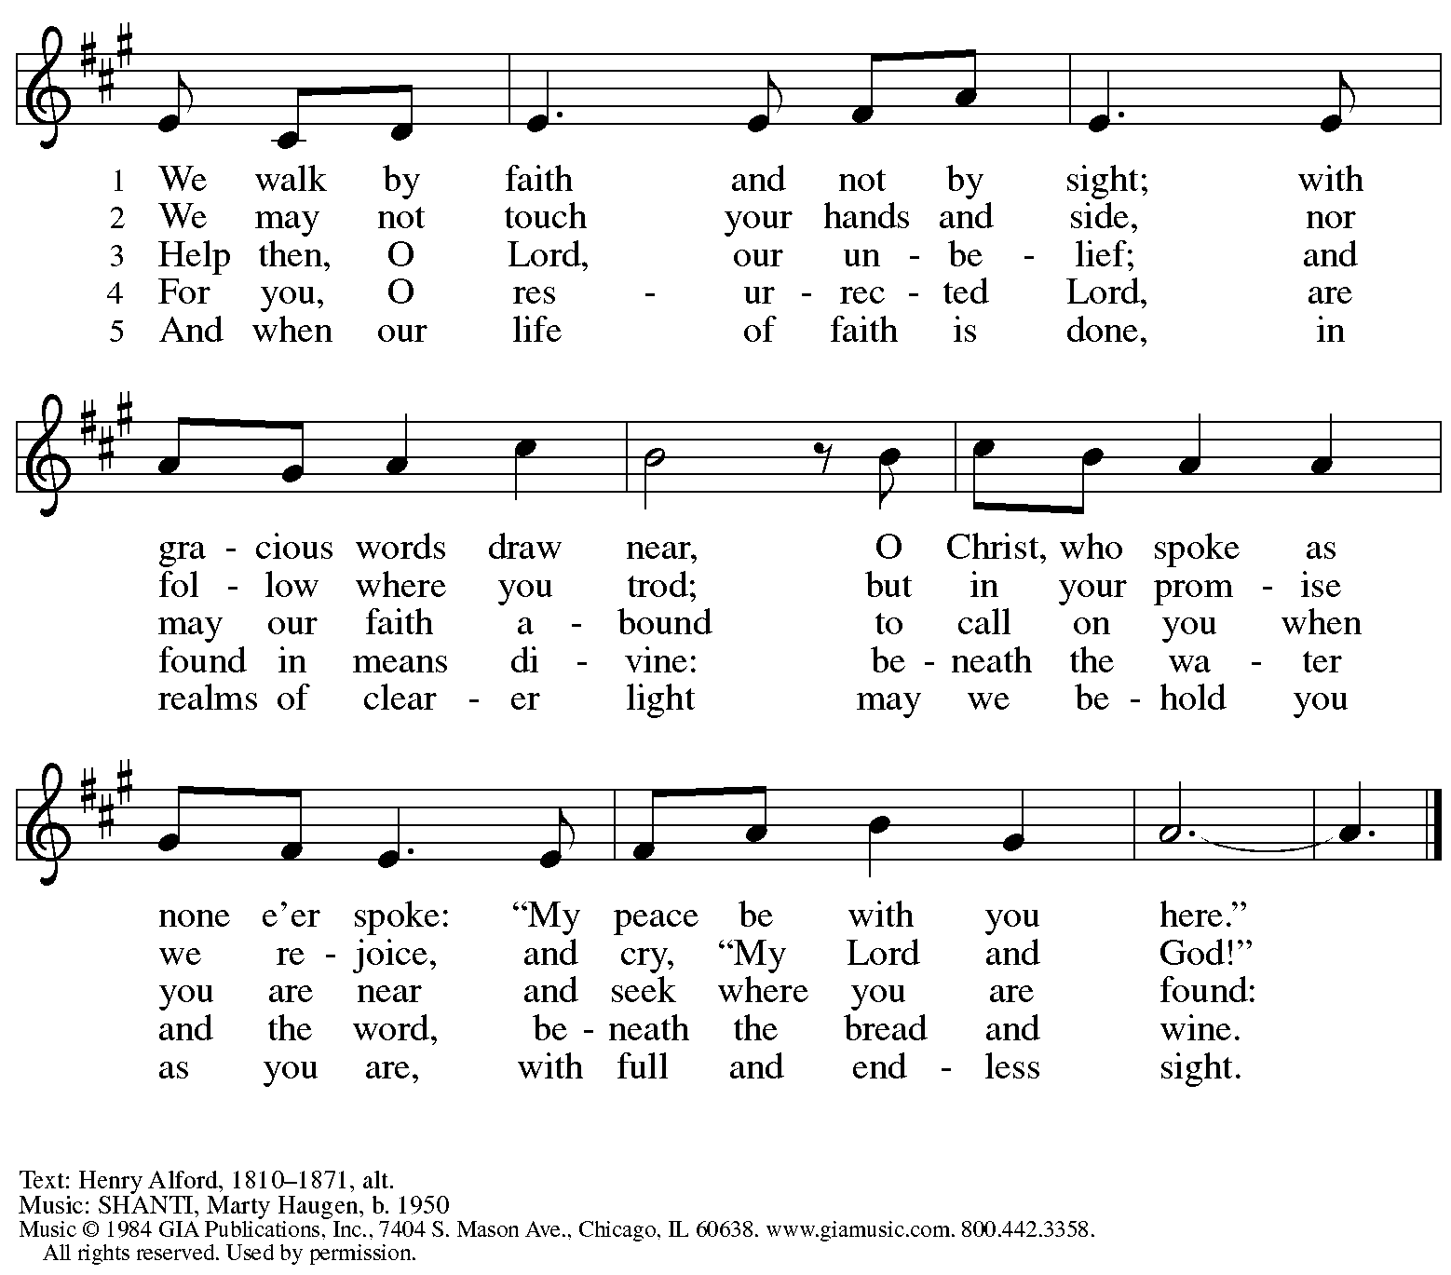
Reprinted with permission under OneLicense.net # A-722139.

Hymns during Holy Communion
As the Grains of Wheat ELW 465

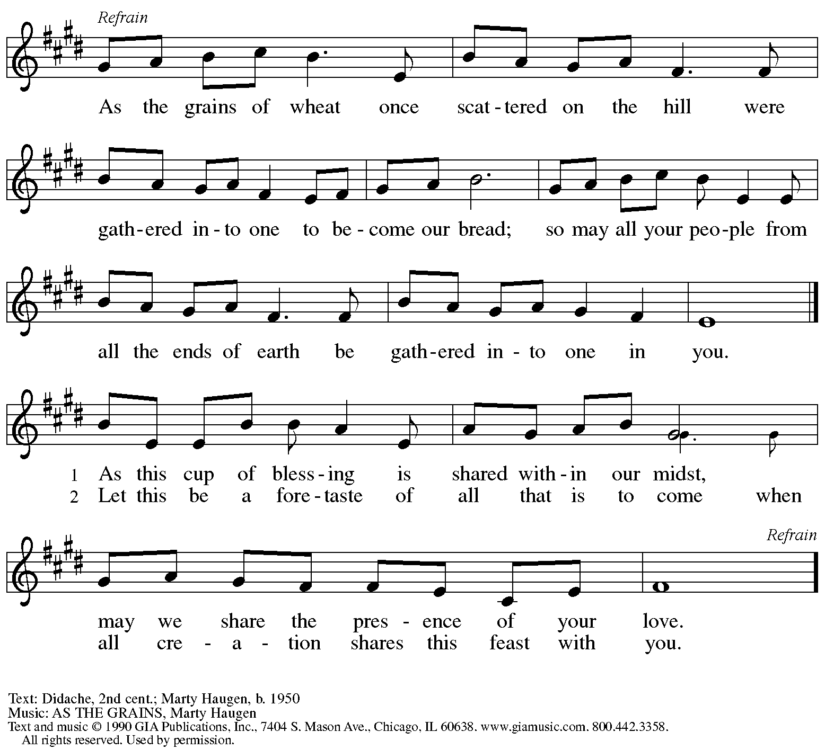
Reprinted with permission under OneLicense.net # A-722139.

Hymns during Holy Communion
God of the Fertile Fields ACS 1063

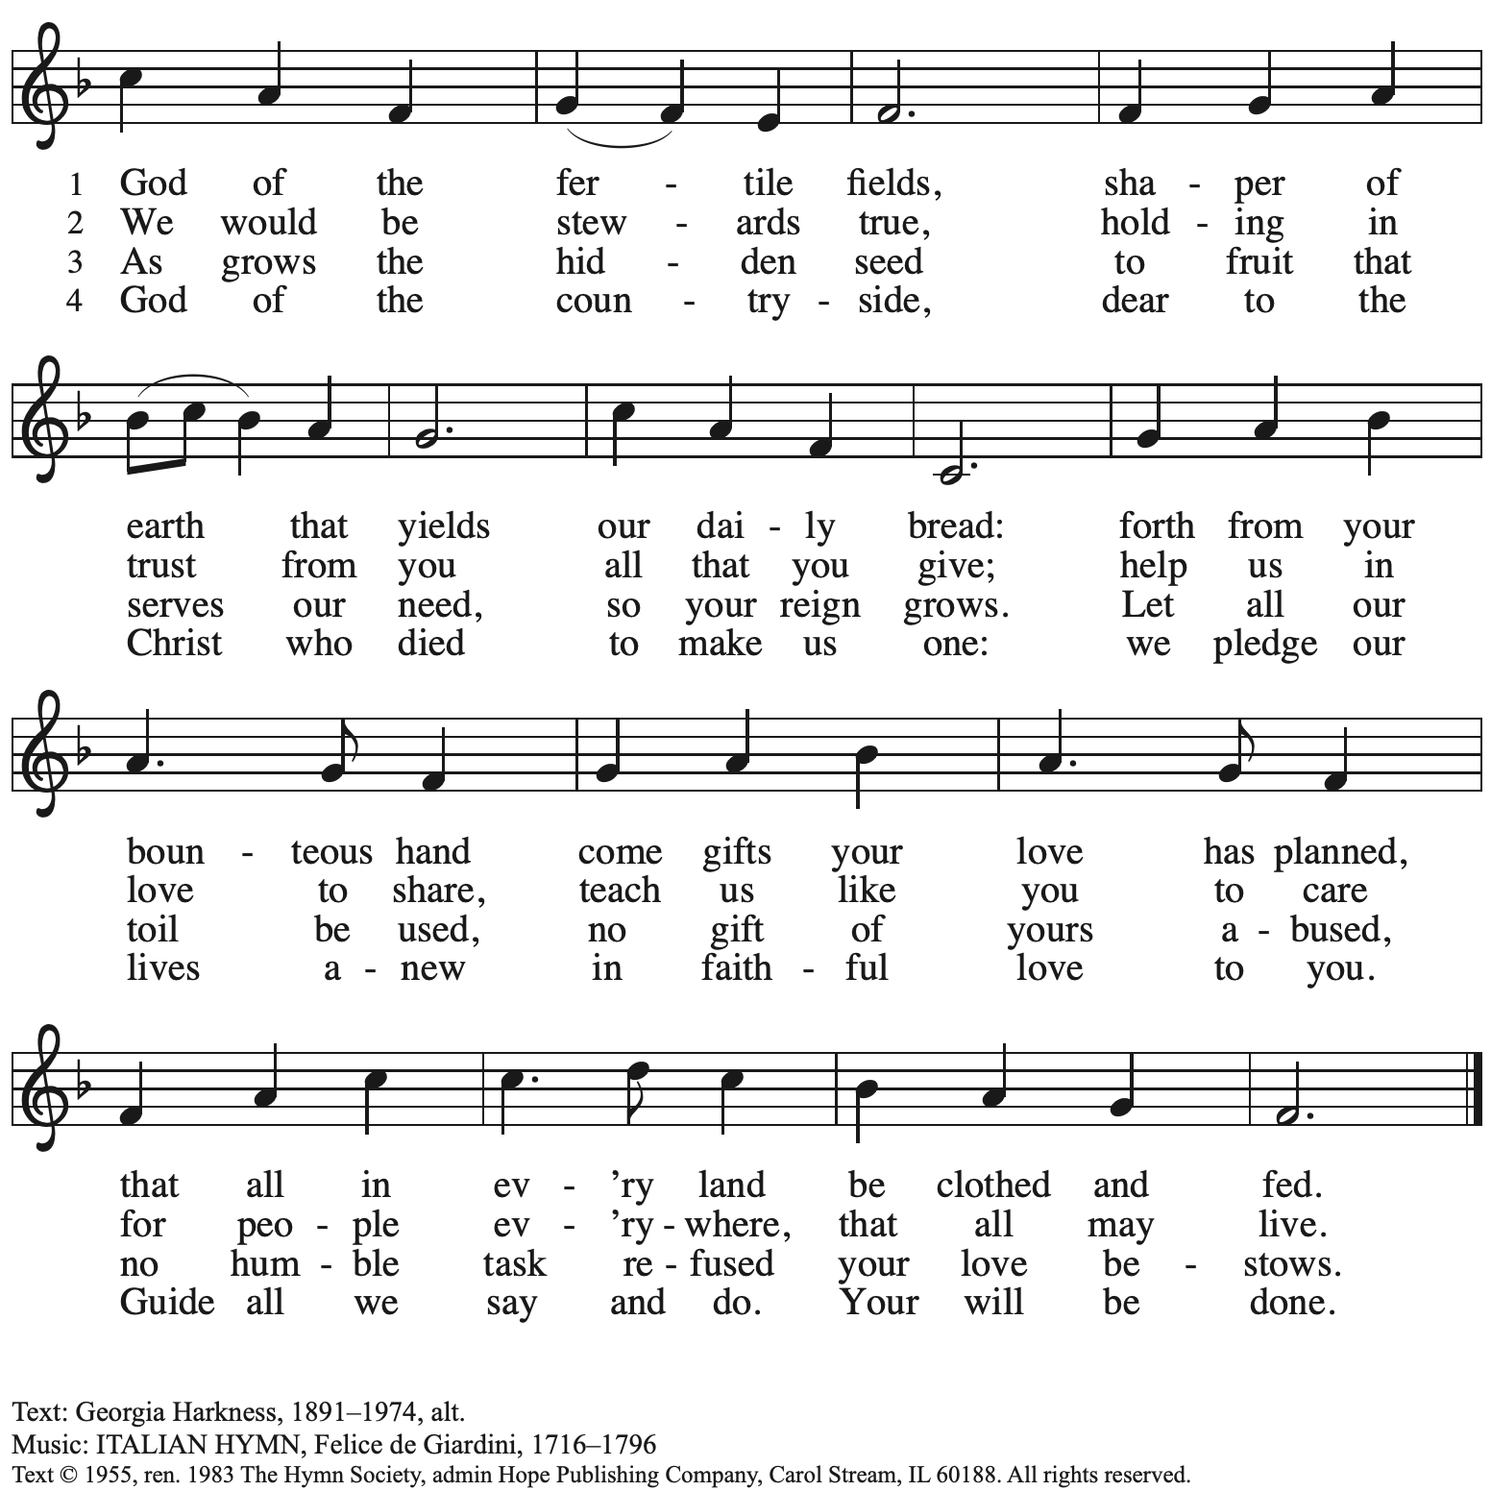
Reprinted with permission under OneLicense.net # A-722139.

When all have returned to their places, please rise as you are able.

Blessing

P: The body and blood of our Lord Jesus Christ strengthen you and keep you in his grace.
C: Amen.

Prayer

A: Let us pray. Gracious God,
we give you thanks for your pruning, planting, and nurture.
We rejoice that you have used the harvest of field and vineyard
to renew and sustain us.
Lead us as we go from this life-giving meal
into lives of grateful service to you and your cherished creation;
through Jesus Christ, your Son, our Lord.
C: Amen.

Please be seated.

Sending
God blesses us and sends us in mission to the world

Announcements

Please rise as you are able.

Benediction

P: The God of steadfastness and encouragement
grant you to live in harmony with one another,
in accordance with Christ Jesus.
C: Amen.

P: The God of hope fill you with all joy and peace in believing,
so that you may abound in hope by the power of the Holy Spirit.
C: Amen.

P: The God of all grace ☩ bless you now and forever.
C: Amen.

Sending Hymn For the Fruit of All Creation Following page

Dismissal

A: Go in peace. Serve the Lord.
C: Thanks be to God.

Postlude When I Can Read My Title Clear Arr. L. Shackley

Sending Hymn For the Fruit of All Creation ELW 679

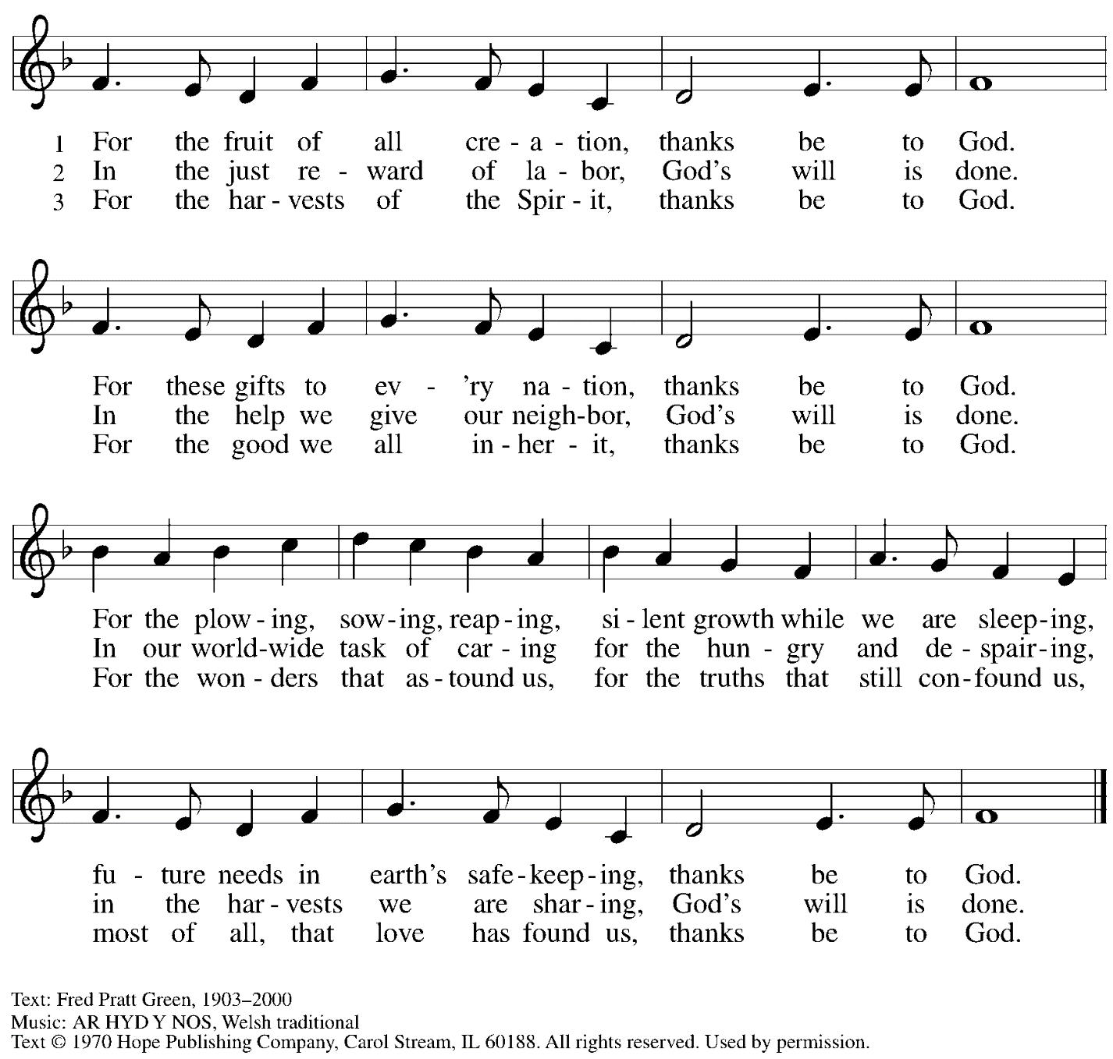
Reprinted with permission under OneLicense.net # A-722139.

Those serving in worship today

Altar Care Beverley Chapman
Assisting Minister Timothy Kocher-Hillmer
Audio-Visual Ministers Tyler Rietze
David Rollinson
Cantor Maria Mangano
Lector Colleen Cooke
Minister of Music Laura Reynolds
Presiding Minister Pastor Ross Carmichael

Liturgy and Hymnody Acknowledgements

From SundaysandSeasons.com. Copyright © 2024 Augsburg Fortress. All rights reserved. Reprinted under OneLicense.net # A-722139.
Used by permission of Augsburg Fortress.

The Scripture readings contained herein are from New Revised Standard Version of the Bible © 1989, Division of Christian Education of the National Council of Churches of Christ in the USA. Used by permission. All rights reserved.

Holy, Holy, Holy / Long, Long Ago in Jerusalem – Text: Beth Bergeron Folkemer, based on the Sanctus. Music: SHADY GROVE, Appalachian traditional. Text © 1990, 2013, Augsburg Fortress. All rights reserved. Reprinted with permission under OneLicense.net # A-722139.

Please use the QR code below to link to St. Andrew’s announcements online!

St. Andrew Lutheran Church Announcements
June 16th, 2024

- Welcome to Worship at St. Andrew on the Fourth Sunday after Pentecost, June 16th, 2024 – We are so glad you are here, and we offer a special welcome to all visitors and guests connecting for the first time! Worship attendees are invited to make a name tag at the back of the worship space if you would like. There are worship “toolkits” to help children engage with worship and “busy bags” for younger children available in the bookcase at the back of the sanctuary. Please feel free to take one to use with/for your children. We invite everyone to gather in the social hall for coffee, food, and conversation after worship.
- Commemoration of the Emanuel Nine during Worship Today – St. Andrew joins other congregations across the ELCA in commemorating the nine saints of God from Mother Emanuel African Methodist Episcopal (AME) Church in Charleston, SC whose lives were taken in a horrific act of violence on June 17, 2015.
Through lament and confession, we seek to rededicate ourselves, our congregation, and our church to repenting of the sins of racism and white supremacy that continue to harm so many in the church and society. In solidarity with our African American siblings, we encourage the people of St. Andrew to share in Juneteenth worship and commemorations with our friends at Bethel AME Church (2720 Webster Ave., Pittsburgh 15219) today at 11:00 a.m. and 2:00 p.m. Please see the information on page 2 of the bulletin for more information about these events.
- Noisy Offering during Worship Today – On the third Sunday of each month, St. Andrew invites the children of the congregation to lead us in a noisy offering. Children carry buckets around the congregation and people are invited to throw in their change, which then gets compiled in big metal buckets. In this Pride month, the noisy offering will go to ReconcilingWorks: Lutherans for Full Participation. ReconcilingWorks sponsors Reconciling in Christ congregations like St. Andrew that publicly and intentionally proclaim welcome and advocacy for the full inclusion of LGBTQIA+ individuals and families in church and society. For more information, please visit https://www.reconcilingworks.org/.
- Bethel AME Church Juneteenth Celebrations – Today, June 16th, 11:00 a.m. and 2:00 p.m. – Today Bethel AME Church in the Hill District is hosting commemorations of Juneteenth. Bishop Kurt F. Kusserow of our Southwestern Pennsylvania is preaching at the 11:00 a.m. service and with Bishop Errenous E. McCloud, Jr. of the AME Church will be the speaker at the 2:00 p.m. service. Worshipers are invited to share in food and community at lunch between the services in the basement of Bethel AME.
- Shelter Dinner at East End Cooperative Ministry – Thursday, June 20th, 6:30 p.m. –
Each month, people of St. Andrew provide dinner for guests of East End Cooperative Ministry, 6140 Station St. (East Liberty), 15206. We invite you to prepare or purchase one menu item and bring it to the shelter by 6:00 p.m., or just come to help serve at 6:30 p.m. If you would like to contribute, please sign up here: https://www.signupgenius.com/go/5080544AAAC22A1F58-49850224-june.
- Represent St. Andrew at Millvale Pride on Saturday, June 22nd, between 10:30 a.m. –5:30 p.m. – St. Andrew is a Reconciling in Christ (RIC) congregation, intentionally welcoming and affirming all, including people of all sexual orientations, gender identities, and gender expressions. Reconciling in Christ congregations come together under the umbrella of ReconcilingWorks: Lutherans for Full Participation, and this year St. Andrew is collaborating with other RIC congregations to bear public witness to that welcome at a booth at Millvale Pride. We will have information about St. Andrew and the other congregations, fun giveaways, and opportunities to meet neighbors and share the good news of God’s boundless love. We invite people of St. Andrew to sign up for a shift that day using this link: RW Pittsburgh - PRIDE Millvale Volunteers: RIC Church Members & RW Pittsburgh - Part 2 (signupgenius.com). See Pastor Carmichael or Kelly Spanninger if you have questions.
- Renaissance City Choir Offers Why We Sing! Concerts Saturday, June 29th and Sunday, June 30th, 4:00 p.m. – Renaissance City Choir affirms and celebrates LGBTQIA+ identity through the unifying power of music. Their concerts blend challenging contemporary music, commissions of new works, an ambitious traditional repertoire, and music from various world cultures, while supporting issues related to human equality and justice. The choir will present concerts at East Liberty Presbyterian Church, 116 S. Highland Avenue in Pittsburgh on June 29th and 30th at 4:00 p.m. Tickets can be found at https://rccpittsburgh.ticketleap.com/why-we-sing-rcc-pride-concerts/.
- New Christ in Our Home Devotional Booklets (July – September) Available at Church Entrances – Christ in Our Home is a booklet of devotions that includes Scripture, a brief reflection, and prayer for each day. The new edition for July – September is now available at the various church entrances. Please feel free to take one for yourself or others. Booklets for June are still available, as well!

