+ Third Sunday after Pentecost
June 9, 2024

St. Andrew Lutheran Church
304 Morewood Ave.
Pittsburgh, PA 15213
St_andrewELCA@verizon.net
www.standrewpittsburgh.org

+ Third Sunday after Pentecost
Order for Worship

A house divided against itself cannot stand. Jesus makes this observation in light of charges that he is possessed. He is possessed, not by a demon, but by the Holy Spirit. We who have received the Holy Spirit through baptism have been joined to Christ’s death and resurrection and knit together in the body of Christ. Those with whom we sing and pray this day are Jesus’ family. With them we go forth in peace to do the will of God.

Welcome to St. Andrew!
- St. Andrew Lutheran congregation welcomes all who are seeking a place of healing and wholeness – a nurturing, faith-forming spiritual home. Our community embraces people of all ages, ethnicities, cultures, abilities, sexual orientations, gender identities and expressions, and family constellations. Come and See!
- Worship Services are live streamed to multiple online platforms. By attending worship, you agree that your image and voice may be broadcast.
- Everyone is invited to make a name tag at the black bookcase in the back of the worship space if they would like. There are stickers indicating pronouns on the bookcase if you would like to include them on your name tag.
- A nursery is available through the doors at the left side of the sanctuary and across from the doorway to the Social Hall. Look for a purple-colored room.
- Worship “toolkits” to help children engage with the service, along with “busy bags” for younger children, are available in the bookcase at the back of the sanctuary. Please feel free to take one to use with/for your children.
- Holy Communion is served with bread (gluten-free available) and wine or grape juice. The presiding minister will distribute the bread (host). Please consume this and then pick up an empty glass from the tray. The Communion Assistant will pour wine or grape juice into your glass. Please step to the side to consume the wine or grape juice. Feel free to kneel at the altar for prayer and reflection. As you return to your pew, glasses may be returned to the empty trays on either side of the center section.
- A restroom is available on the main level of the church, through the doors to the Social Hall and to the right in the main office.

Abbreviations
P: Pastor/Presiding Minister ELW: Evangelical Lutheran Worship hymnal
A: Assisting Minister ACS: All Creation Sings hymnal
L: Lector OLS: Of the Land and Seasons liturgy
C: Congregation

Pre-Service Music

Welcome

Prelude Peace Like a River Arr. Walz

Gathering
The Holy Spirit calls us together as the people of God

Confession and Forgiveness

Please rise as you are able.
All may make the sign of the cross, the sign that is marked at Baptism,
as the presiding minister begins.

P: Blessed be the holy Trinity, ☩ one God,
who forgives all our sin, whose mercy endures forever.
C: Amen.

P: Let us confess our sin in the presence of God and of one another.

Silence is kept for reflection

P: Most merciful God,
C: we confess that we are captive to sin and cannot free ourselves.
We have sinned against you in thought, word, and deed,
by what we have done and by what we have left undone.
We have rejected your guidance.
We have avoided your pruning of our cluttered lives.
We have failed to maintain the tools of stewardship, outreach, and witness
you have provided for the nurture of your church.
For the sake of your Son, Jesus Christ, have mercy on us.
Forgive us, grant us discipline, and redirect us,
so that we may delight in your will and follow in your ways,
to the glory of your holy name. Amen.

P: God, who is rich in mercy,
loved us even when we were dead in sin
and made us alive together with Christ.
By grace you have been saved.
In the name of ☩ Jesus Christ, your sins are forgiven.
Almighty God strengthen you with the Holy Spirit,
that Christ may live in your hearts through faith.
C: Amen.
Gathering Hymn What Is This Place ELW 524

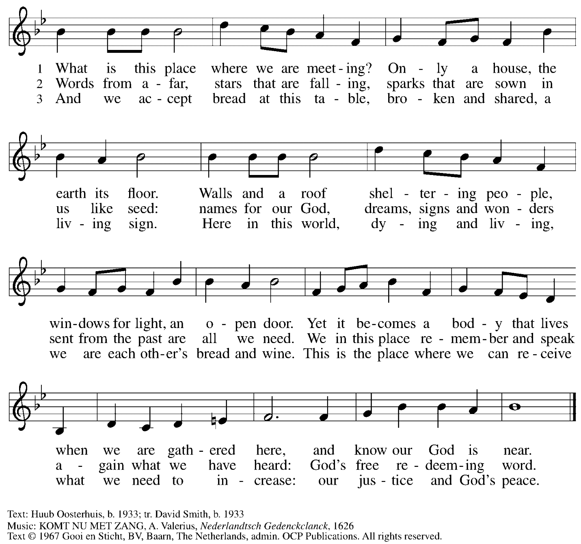
Reprinted with permission under OneLicense.net #A-722139.

Greeting

P: The grace of our Lord Jesus Christ, the love of God,
and the communion of the Holy Spirit be with you all.
C: And also with you.

Hymn of Praise Oh, Sing of God’s Great Victory! OLS 3

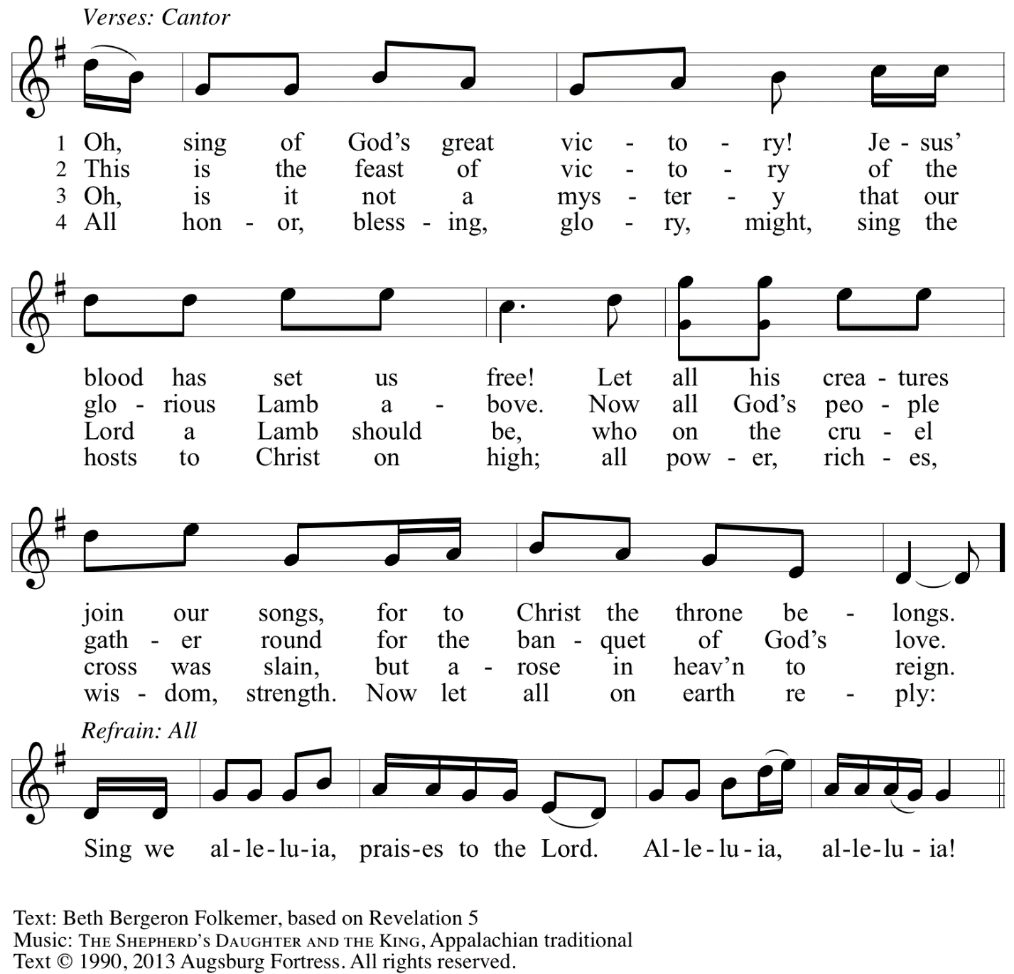
Reprinted with permission under OneLicense.net # A-722139.

Prayer of the Day

P: The Lord be with you.
C: And also with you.

P: Let us pray.
All-powerful God, in Jesus Christ you turned death into life and defeat into victory.
Increase our faith and trust in him, that we may triumph over all evil
in the strength of the same Jesus Christ, our Savior and Lord.
C: Amen.

Please be seated.

Word
God speaks to us in Scripture reading, preaching, and song

First Reading – Genesis 3: 8-15

⁸[Adam and Eve] heard the sound of the Lord God walking in the garden at the time of the evening breeze, and the man and his wife hid themselves from the presence of the Lord God among the trees of the garden.⁹But the Lord God called to the man, and said to him, “Where are you?” ¹⁰He said, “I heard the sound of you in the garden, and I was afraid, because I was naked; and I hid myself.” ¹¹He said, “Who told you that you were naked? Have you eaten from the tree of which I commanded you not to eat?” ¹²The man said, “The woman whom you gave to be with me, she gave me fruit from the tree, and I ate.” ¹³Then the Lord God said to the woman, “What is this that you have done?” The woman said, “The serpent tricked me, and I ate.” ¹⁴The Lord God ¹said to the serpent,
“Because you have done this,
cursed are you among all animals
and among all wild creatures;
upon your belly you shall go,
and dust you shall eat
all the days of your life.
¹⁵I will put enmity between you and the woman,
and between your offspring and hers;
he will strike your head,
and you will strike his heel.”

L: Word of God, word of life.
C: Thanks be to God.

Psalm 130

The psalm will be led by the cantor, with the congregation invited to join in singing the alternate verses in bold typeface and the refrain.
Psalm tone

Psalm refrain

¹Out | of the depths
I cry to | you, O Lord;
²O Lord, | hear my voice!
Let your ears be attentive to the voice of my | supplication.
³If you were to keep watch | over sins,
O Lord, | who could stand?
⁴Yet with you | is forgiveness,
in order that you | may be feared. R
⁵I wait for you, O Lord; | my soul waits;
in your word | is my hope.
⁶My soul waits for the Lord more than those who keep watch | for the morning,
more than those who keep watch | for the morning.
⁷O Israel, wait for the Lord, for with the Lord there is | steadfast love;
with the Lord there is plen- | teous redemption.
⁸For the Lord shall | redeem Israel
from | all their sins. R

Second Reading – 2 Corinthians 4: 13 – 5: 1

¹³Just as we have the same spirit of faith that is in accordance with scripture—“I believed, and so I spoke”—we also believe, and so we speak, ¹⁴because we know that the one who raised the Lord Jesus will raise us also with Jesus, and will bring us with you into his presence. ¹⁵Yes, everything is for your sake, so that grace, as it extends to more and more people, may increase thanksgiving, to the glory of God.
¹⁶So we do not lose heart. Even though our outer nature is wasting away, our inner nature is being renewed day by day. ¹⁷For this slight momentary affliction is preparing us for an eternal weight of glory beyond all measure, ¹⁸because we look not at what can be seen but at what cannot be seen; for what can be seen is temporary, but what cannot be seen is eternal.
^{5:1}For we know that if the earthly tent we live in is destroyed, we have a building from God, a house not made with hands, eternal in the heavens.

L: Word of God, word of life.
C: Thanks be to God.

Please rise as you are able.

Gospel Acclamation O God, Whose Word Well-Planted OLS 4
v. 1-2

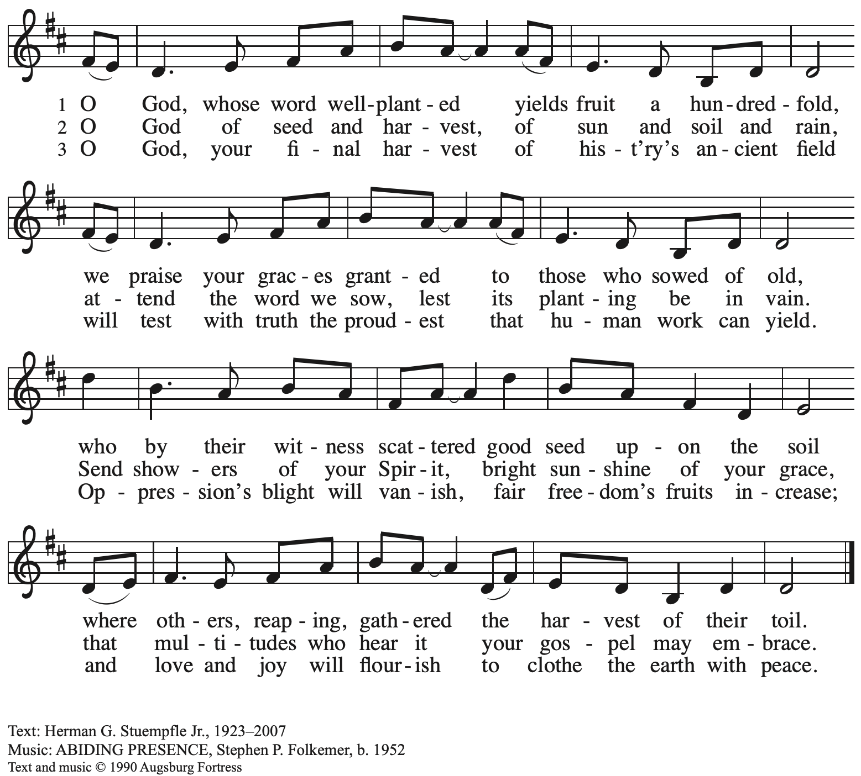
All rights reserved. Reprinted under OneLicense.net # A-722139.

Gospel – Mark 3: 20-35

P: The holy Gospel according to St. Mark.
C: Glory to you, O Lord.

[Jesus went home;] ²⁰and the crowd came together again, so that [Jesus and the disciples] could not even eat. ²¹When his family heard it, they went out to restrain him, for people were saying, “He has gone out of his mind.” ²²And the scribes who came down from Jerusalem said, “He has Beelzebul, and by the ruler of the demons he casts out demons.” ²³And he called them to him, and spoke to them in parables, “How can Satan cast out Satan? ²⁴If a kingdom is divided against itself, that kingdom cannot stand. ²⁵And if a house is divided against itself, that house will not be able to stand. ²⁶And if Satan has risen up against himself and is divided, he cannot stand, but his end has come. ²⁷But no one can enter a strong man’s house and plunder his property without first tying up the strong man; then indeed the house can be plundered.
²⁸“Truly I tell you, people will be forgiven for their sins and whatever blasphemies they utter; ²⁹but whoever blasphemes against the Holy Spirit can never have forgiveness, but is guilty of an eternal sin”—³⁰for they had said, “He has an unclean spirit.”
³¹Then his mother and his brothers came; and standing outside, they sent to him and called him. ³²A crowd was sitting around him; and they said to him, “Your mother and your brothers and sisters are outside, asking for you.” ³³And he replied, “Who are my mother and my brothers?” ³⁴And looking at those who sat around him, he said, “Here are my mother and my brothers! ³⁵Whoever does the will of God is my brother and sister and mother.”

P: The Gospel of the Lord.
C: Praise to you, O Christ.

Please be seated.

Sermon

A time of silence for prayer and reflection follows the sermon.
When the hymn of the day begins, please rise as you are able.

Hymn of the Day Following page

Hymn of the Day Cast Out, O Christ ACS 1016

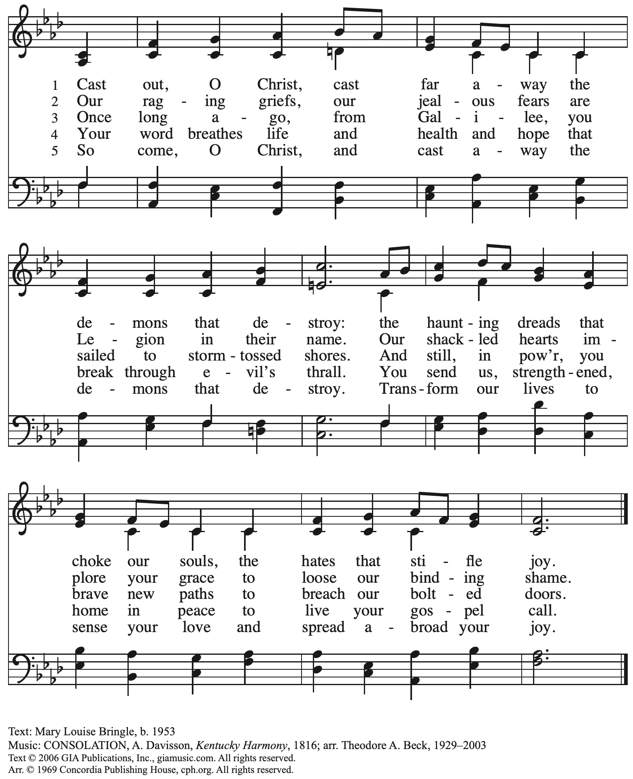
Reprinted with permission under OneLicense.net # A-722139.

Prayers of the People

A: With the whole people of God in Christ Jesus, let us pray for the church, the world,
those in need, and all of God’s creation.

After each petition
A: God, in your mercy,
C: receive our prayer.

The presiding minister concludes the prayers
P: Into your hands, gracious God, we commend all for whom we pray,
trusting in your abundant mercy, through Jesus Christ our Savior.
C: Amen.

Peace

The presiding minister and the assembly greet one another in the peace of the risen Christ.
P: The peace of Christ be with you always.
C: And also with you.

The people may greet those around them with a sign of Christ’s peace and may say
Peace be with you or similar words. Please be mindful that not everyone will be comfortable with sharing the peace, so please seek consent before shaking hands or hugging. Other possible ways to share the peace include a simple bow with the verbal greeting of peace, or simply a verbal expression of peace.

When the greetings of peace have concluded, please be seated.

Meal
God feeds us with the presence of Jesus Christ

Offering

We offer ourselves, our gifts, and our faithful service to God.
As the offering is gathered for the mission of the church, including the care of those in need,
the table is set for Holy Communion.

Music during the Offering

It Is Well with My Soul Arr. Smith

As the gifts are brought forward for presentation, please rise as you are able.

Offertory Song Accept, O Lord, the Gifts We Bring OLS 5

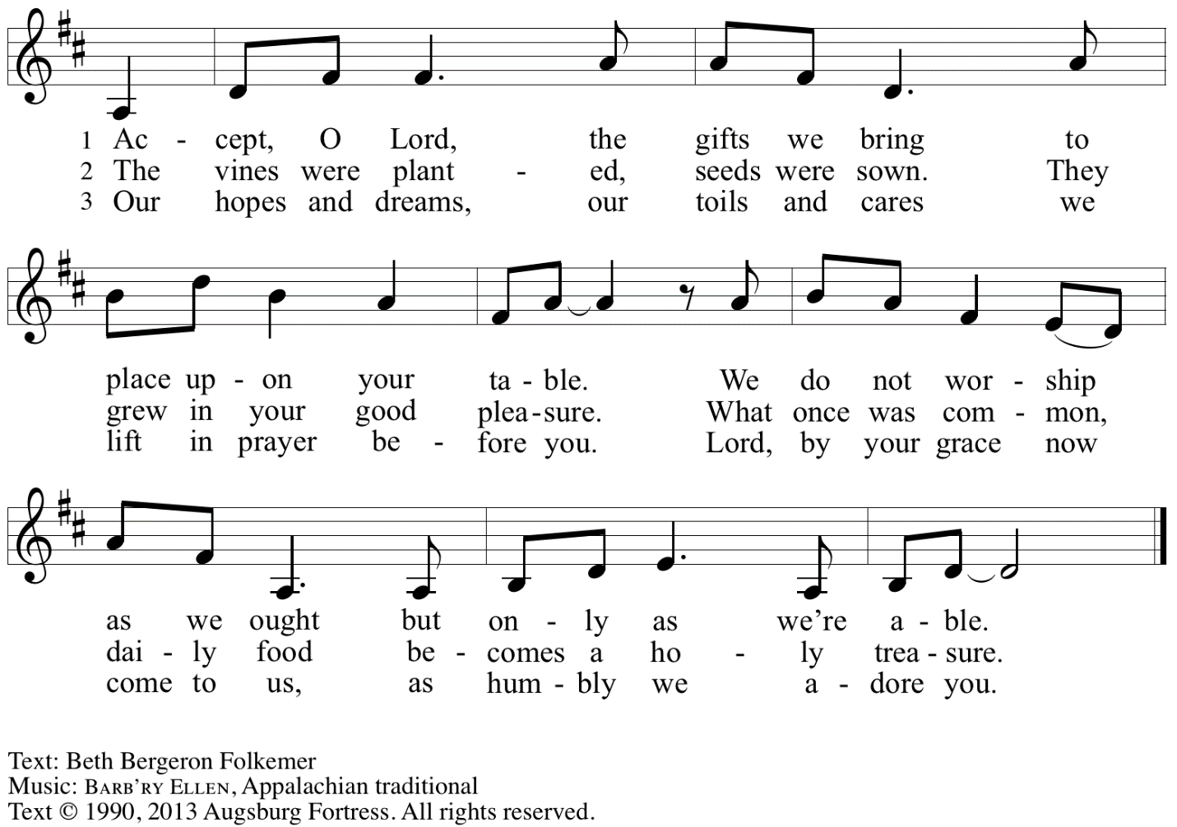
Reprinted under OneLicense.net # A-722139.

Offertory Prayer

A: Let us pray.
Gracious God,
C: you bless us with gifts of guidance, new life,
growth in grace, and fruitful labor.
Accept the first fruits of time and toil, field and orchard,
that we offer here. Bless and multiply these gifts to our nurture
and the care of your creation;
for the sake of your Son, Jesus Christ, our Lord.
Amen.

Dialogue

P: The Lord be with you.
C: And also with you.

P: Lift up your hearts.
C: We lift them to the Lord.

P: Let us give thanks to the Lord our God.
C: It is right to give our thanks and praise.

Preface

P: It is indeed right, our duty and our joy …
… we praise your name and join in adoring song:

Sanctus Holy, Holy, Holy OLS 6

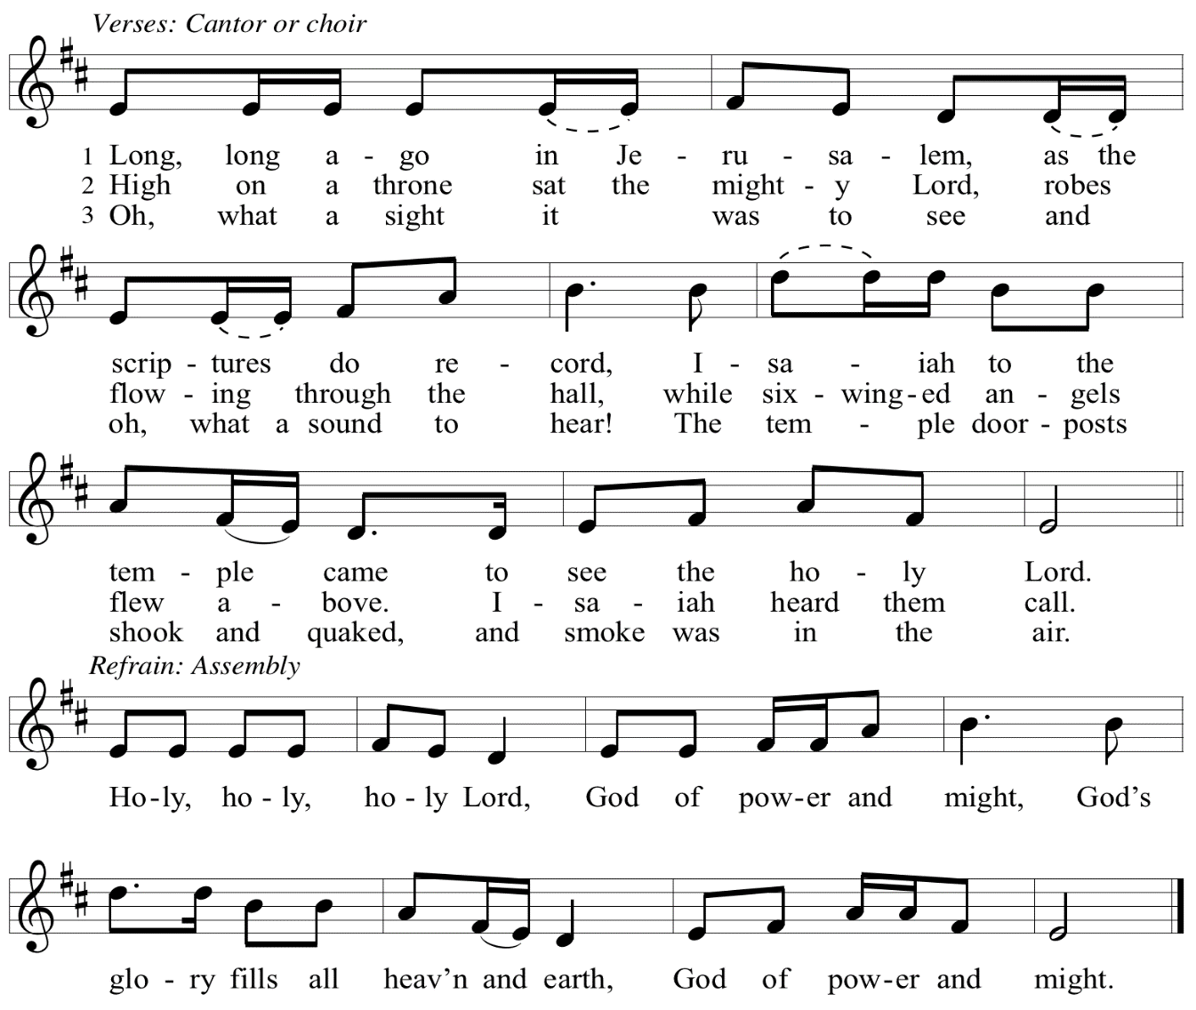

Eucharistic Prayer

P: You are indeed holy, God of power and might
and your glory fills the whole earth …
… and nurture us to become what you have made us –
your beloved people, the body of your Son, the temple of your Spirit.

Through your Son, in your Spirit, with all your people,
we give you thanks and praise,
O source of our life and fountain of all good,
now and forever.
C: Amen.

Lord’s Prayer

P: Gathered as one by the Holy Spirit, let us pray as Jesus taught us.
C: Our Father in heaven,
hallowed be your name,
your kingdom come,
your will be done,
on earth as in heaven.
Give us today our daily bread.
Forgive us our sins
as we forgive those
who sin against us.
Save us from the time of trial
and deliver us from evil.
For the kingdom, the power,
and the glory are yours,
now and forever. Amen.

Fraction and Invitation

P: Just as this broken bread was first scattered on the hills,
then was brought together and became one,
so let your church be brought together
from the ends of the earth into your reign,
for yours are the glory and the power
through Jesus Christ forever.
C: Amen.

Agnus Dei / Lamb of God OLS 7
O Lamb of God, to Earth You Came

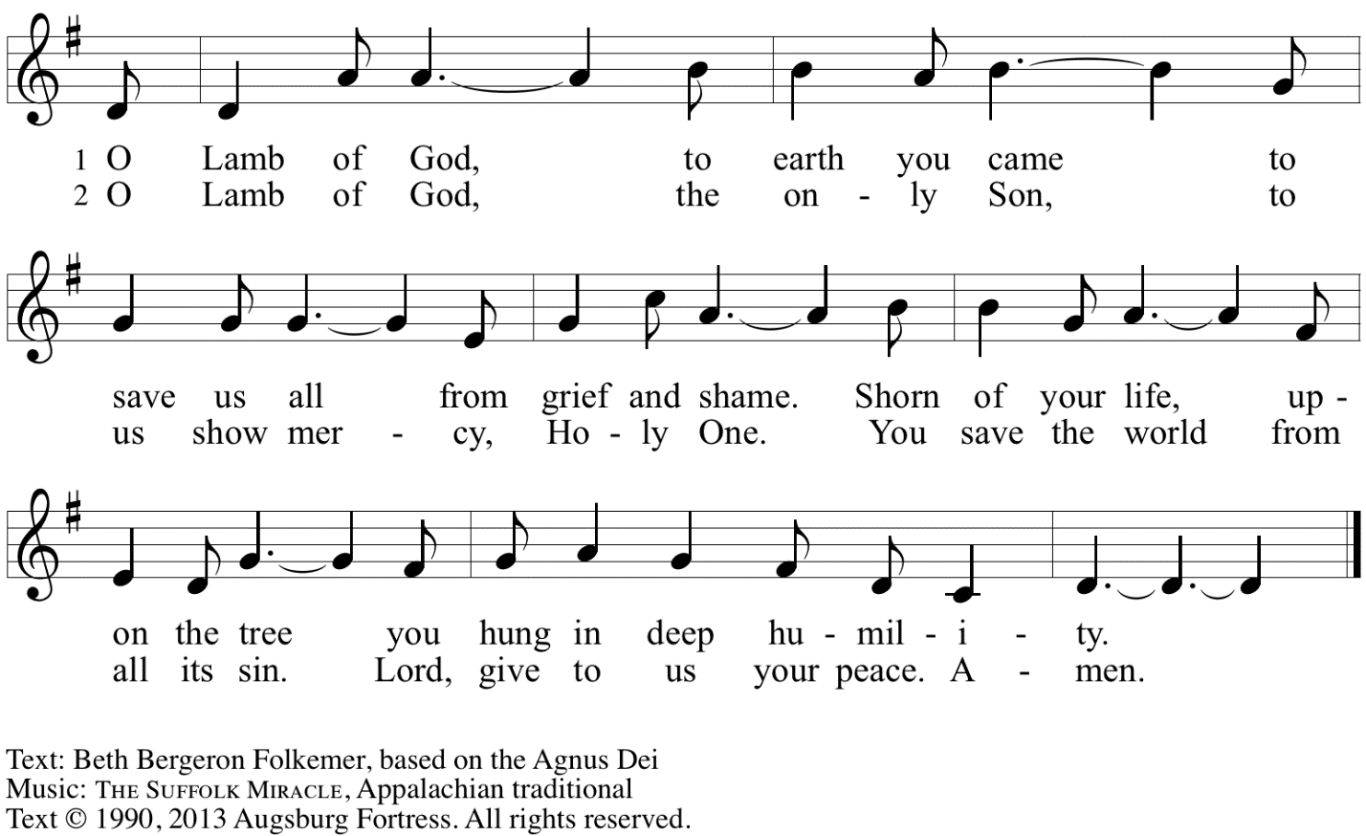
Reprinted with permission under OneLicense.net A# A-722139.

Please be seated.

Holy Communion
- All who seek God and desire a deeper and stronger life in Christ are welcome to receive Holy Communion.
- Worshipers from the pulpit side will proceed forward first, followed by the center section, and then the lectern side.
- Please inform an usher if you would like the ministers to bring Communion to you.
- Holy Communion will be served with bread and wine/grape juice.
- The presiding minister will first distribute the bread (host) to each communicant. Please indicate if you require a gluten-free host.
- Once you have consumed the bread, please pick up an empty glass from the tray next to the presiding minister. The Communion Assistant will pour wine from the chalice or grape juice from the cruet into your glass.
- Please step to the side to consume the wine or grape juice.
- Feel free to kneel at the altar rail for prayer after receiving the sacrament.
- As you return to your pew, glasses may be returned to the empty trays on either side of the center section.
- A blessing will be provided for anyone who does not yet receive the sacrament.
- All are invited to join in singing the hymns during Holy Communion.

Hymns during Holy Communion
Beloved, God’s Chosen ELW 648

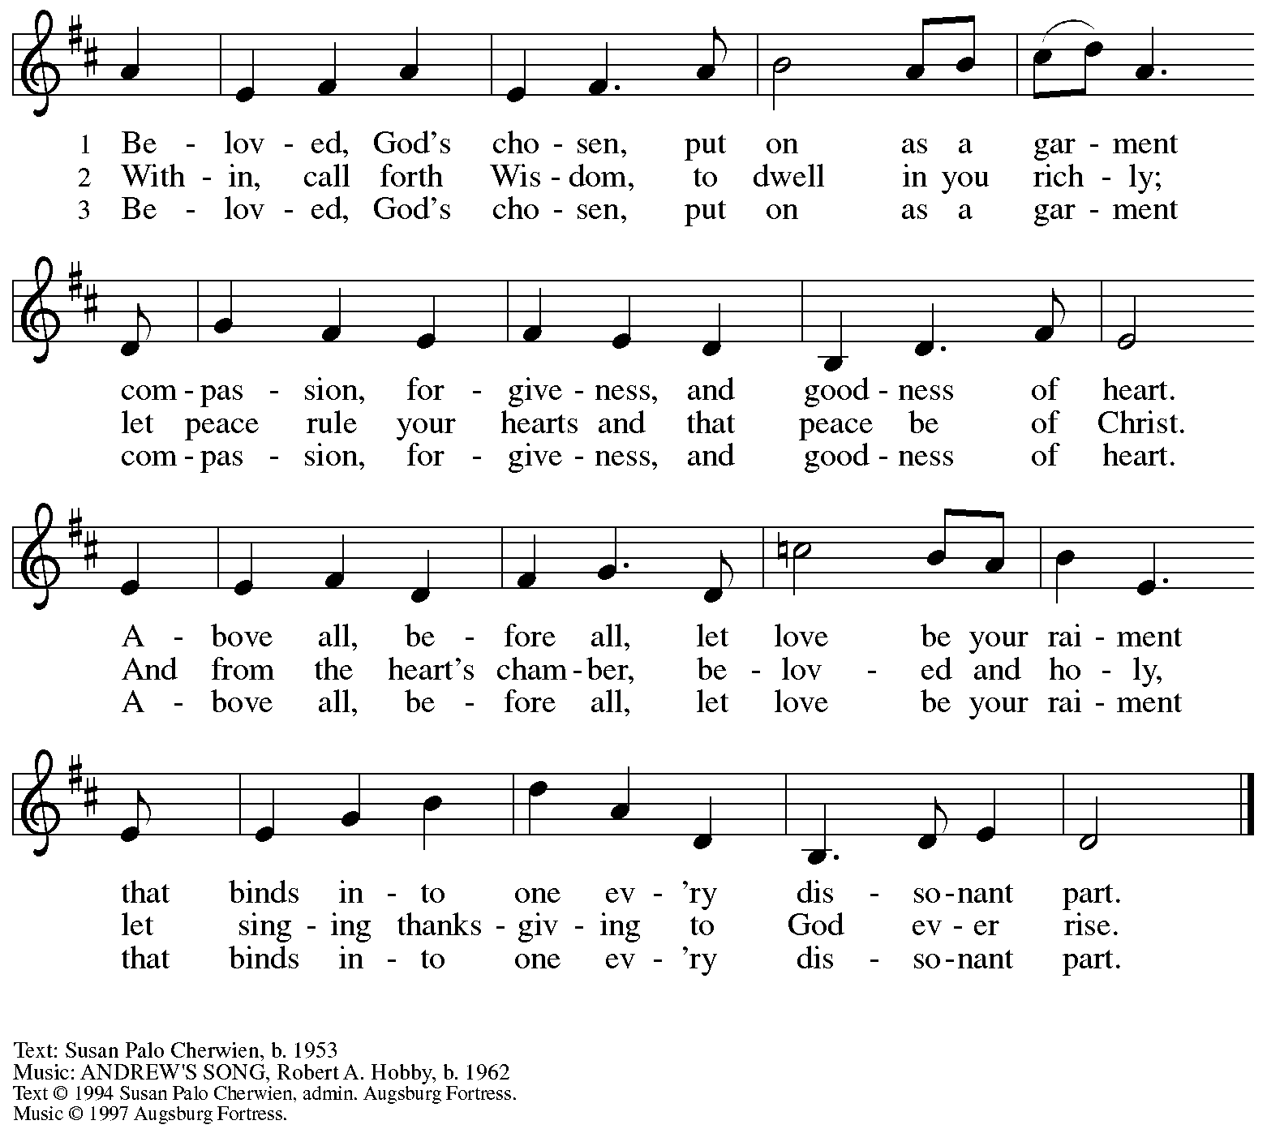
All rights reserved. Reprinted with permission under OneLicense.net # A-722139.

Hymns during Holy Communion
In Christ There Is No East or West ELW 650

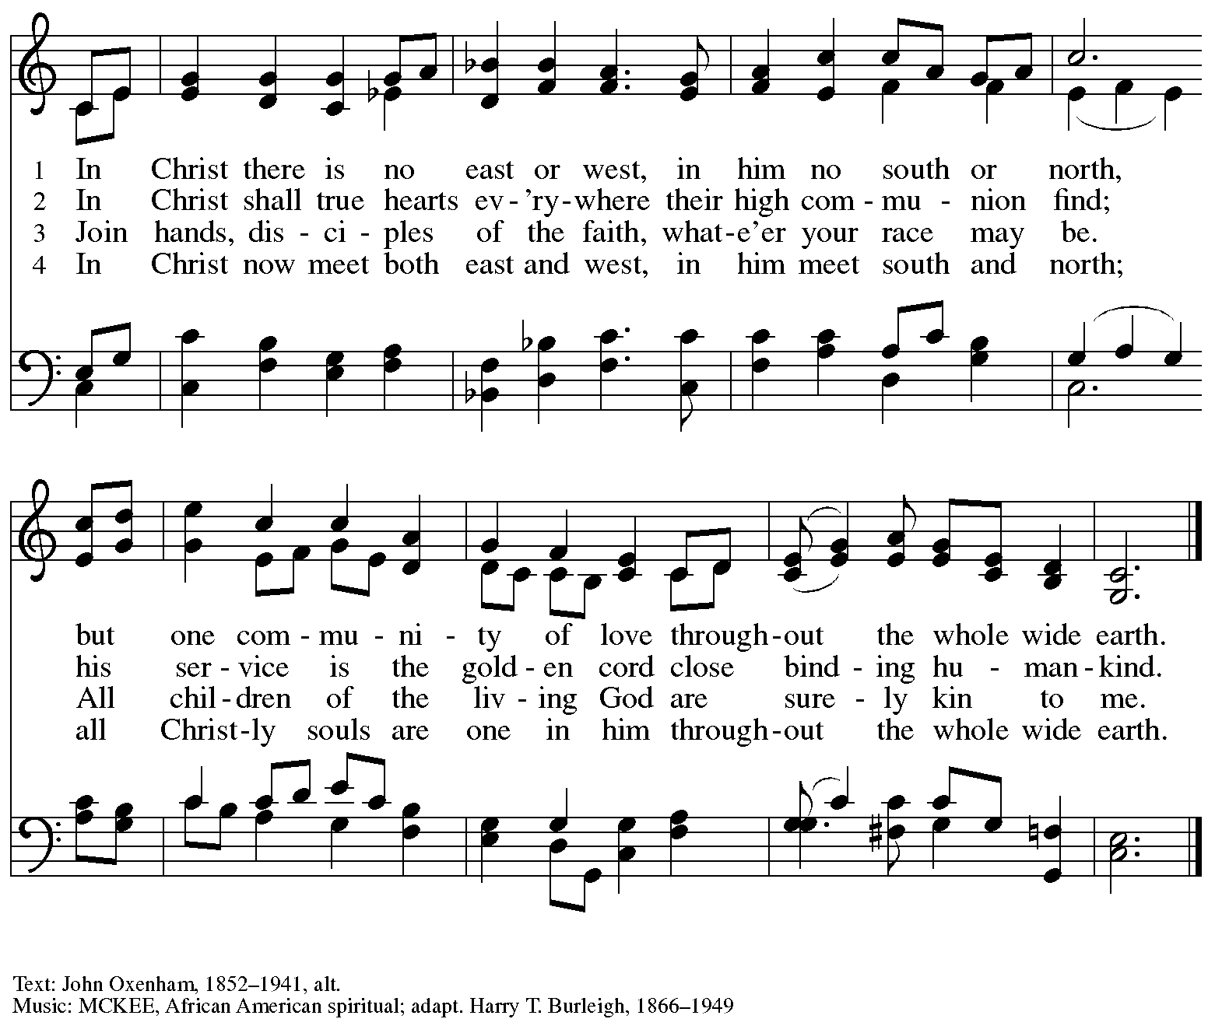

Hymns during Holy Communion
Bind Us Together WOV 748

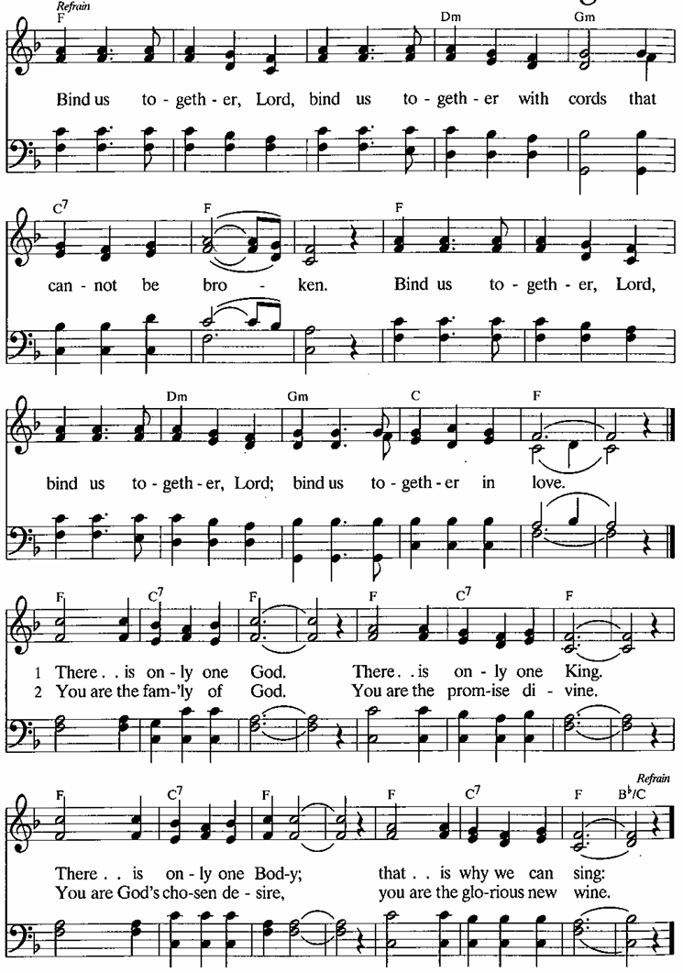

When all have returned to their places, please rise as you are able.

Blessing

P: The body and blood of our Lord Jesus Christ strengthen you and keep you in his grace.
C: Amen.

Prayer

A: Let us pray. Gracious God,
we give you thanks for your pruning, planting, and nurture.
We rejoice that you have used the harvest of field and vineyard
to renew and sustain us.
Lead us as we go from this life-giving meal
into lives of grateful service to you and your cherished creation;
through Jesus Christ, your Son, our Lord.
C: Amen.

Please be seated.

Sending
God blesses us and sends us in mission to the world

Announcements

Please rise as you are able.

Benediction

P: The God of steadfastness and encouragement
grant you to live in harmony with one another,
in accordance with Christ Jesus.
C: Amen.

P: The God of hope fill you with all joy and peace in believing,
so that you may abound in hope by the power of the Holy Spirit.
C: Amen.

P: The God of all grace ☩ bless you now and forever.
C: Amen.

Sending Hymn On Our Way Rejoicing ELW 537

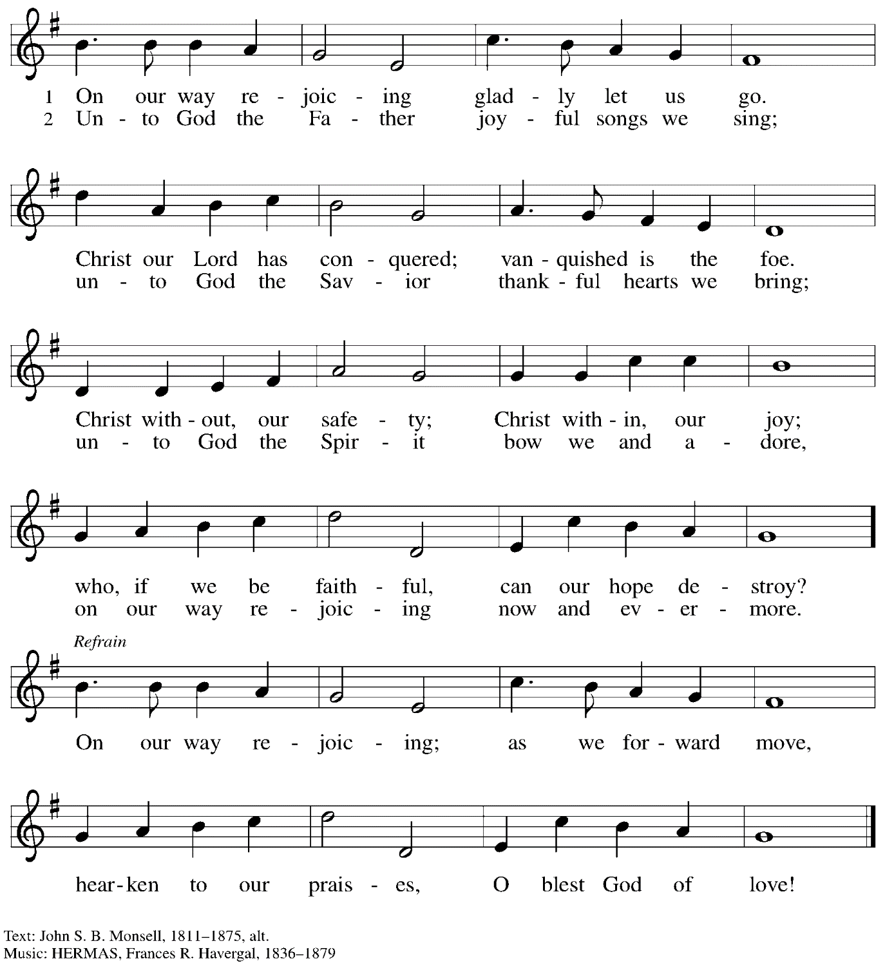

Dismissal

A: Go in peace. Serve the Lord.
C: Thanks be to God.

Postlude A Mighty Fortress Arr. Giamanco
Those serving in worship today

Altar Care Christy Ruhe
Assisting Minister Jeff Denlinger
Audio-Visual Ministers Kristen Asplin
Jason Galyardt
Cantor C.E. Pino
Lector Sue Gaugler
Minister of Music Laura Reynolds
Presiding Minister Pastor Ross Carmichael

Liturgy and Hymnody Acknowledgements

From SundaysandSeasons.com. Copyright © 2024 Augsburg Fortress. All rights reserved. Reprinted under OneLicense.net # A-722139.
Used by permission of Augsburg Fortress.

Holy, Holy, Holy / Long, Long Ago in Jerusalem – Text: Beth Bergeron Folkemer, based on the Sanctus. Music: SHADY GROVE, Appalachian traditional. Text © 1990, 2013, Augsburg Fortress. All rights reserved. Reprinted with permission under OneLicense.net # A-722139.

Bind Us Together – Text: Bob Gillman, bn. 1946. Music: BIND US TOGETHER, Bob Gillman, b. 1946. © 1977 Thankyou Music, admin. (in Western Hemisphere) Integrity’s Hosanna Music. All rights reserved.
All rights reserved. Reprinted with permission under CCLI #11561207

Please use the QR code below to link to St. Andrew’s announcements online!

St. Andrew Lutheran Church Announcements
June 9th, 2024

- Welcome to Worship at St. Andrew on the Third Sunday after Pentecost, June 9th, 2024 – We are so glad you are here, and we offer a special welcome to all visitors and guests connecting for the first time! Worship attendees are invited to make a name tag at the back of the worship space if you would like. There are worship “toolkits” to help children engage with worship and “busy bags” for younger children available in the bookcase at the back of the sanctuary. Please feel free to take one to use with/for your children. We invite everyone to have coffee and conversation in the social hall after worship as leaders set up for the congregational meeting.
- Congregational Meeting after Worship Today, June 9th – A meeting of the congregation will be held after worship today to discuss the council's recommended proposal for work on the church roof and the prospect of hiring a construction company as general contractor to oversee the project. Confirmed members of the congregation are eligible to vote on matters before the congregation, in person or online, but no proxy or absentee votes can be accepted. Please plan to attend this important meeting! If anyone is unable to attend in person, the meeting will be available via Zoom using the Sunday worship link from your “This Week at St. Andrew” email.
- Noisy Offering Next Sunday, June 16th during Worship – On the third Sunday of each month, St. Andrew invites the children of the congregation to lead us in a noisy offering. Children carry buckets around the congregation and people are invited to throw in their change, which then gets compiled in big metal buckets. In this Pride month, the noisy offering will go to ReconcilingWorks: Lutherans for Full Participation. For more information, please visit https://www.reconcilingworks.org/.
- Bethel AME Church Juneteenth Celebrations – Sunday, June 16th, 11:00 a.m. and 2:00 p.m. – Bethel AME Church in the Hill District (2720 Webster Ave, 15219), with whom the St. Andrew congregation and our Southwestern Pennsylvania (SWPA) Synod have been in relationship with for the past several years, will host Juneteenth celebrations on Sunday, June 16th, with Bishop Kurt F. Kusserow of the Southwestern Pennsylvania Synod as the speaker at the 11:00 a.m. service and with Bishop Errenous E. McCloud, Jr. of the AME Church as the speaker at the 2:00 p.m. service.
- Shelter Dinner at East End Cooperative Ministry – Thursday, June 20th, 6:30 p.m. –
Each month, people of St. Andrew provide dinner for guests of East End Cooperative Ministry, 6140 Station St. (East Liberty), 15206. We invite you to prepare or purchase one menu item and bring it to the shelter by 6:00 p.m., or just come to help serve at 6:30 p.m. If you would like to contribute, please sign up here: https://www.signupgenius.com/go/5080544AAAC22A1F58-49850224-june.
- Represent St. Andrew at Millvale Pride on Saturday, June 22nd, between 10:30 a.m. –5:30 p.m. – St. Andrew is a Reconciling in Christ (RIC) congregation, intentionally welcoming and affirming all, including people of all sexual orientations, gender identities, and gender expressions. Reconciling in Christ congregations are sponsored by ReconcilingWorks: Lutherans for Full Participation, St. Andrew is collaborating with other RIC congregations to bear public witness to that welcome at Millvale Pride. We will have information about St. Andrew and the other congregations, fun giveaways, and opportunities to meet neighbors and share the good news of God’s boundless love. We invite people of St. Andrew to sign up for a shift that day using this link: RW Pittsburgh - PRIDE Millvale Volunteers: RIC Church Members & RW Pittsburgh - Part 2 (signupgenius.com). See Pastor Carmichael or Kelly Spanninger if you have questions.
- Renaissance City Choir Offers Why We Sing! Concerts Saturday, June 29th and Sunday, June 30th, 4:00 p.m. – Renaissance City Choir affirms and celebrates LGBTQIA+ identity through the unifying power of music. Their concerts blend challenging contemporary music, commissions of new works, an ambitious traditional repertoire, and music from various world cultures, while supporting issues related to human equality and justice. The choir will present concerts at East Liberty Presbyterian Church, 116 S. Highland Avenue in Pittsburgh on June 29th and 30th at 4:00 p.m. Tickets can be found at https://rccpittsburgh.ticketleap.com/why-we-sing-rcc-pride-concerts/
- New Christ in Our Home Devotional Booklets (July – September) Available at Church Entrances – Christ in Our Home is a booklet of devotions that includes Scripture, a brief reflection, and prayer for each day. The new edition for July – September is now available at the various church entrances. Please feel free to take one for yourself or others. Booklets for June are still available, as well!

