+ Day of Pentecost
May 19, 2024
St. Andrew Lutheran Church
304 Morewood Ave.
Pittsburgh, PA 15213
St_andrewELCA@verizon.net
www.standrewpittsburgh.org

+ Day of Pentecost
Order for Worship

Fifty days after Easter, we celebrate the outpouring of the Holy Spirit on Pentecost.
Crossing all boundaries that would separate us, the Spirit brings the wideness of God’s mercy
to places we least expect it—to a crowd of strangers of different lands and tongues, to our fragile hearts. Jesus promises his disciples that they will be accompanied by the Holy Spirit, and that this Spirit reveals the truth. We celebrate that we too have been visited with this same Spirit. Guided by the truth, we join together in worship,
and then disperse to share the fullness of Christ’s love with the world.

Welcome to St. Andrew!
- St. Andrew Lutheran congregation welcomes all who are seeking a place of healing and wholeness – a nurturing, faith-forming spiritual home. Our community embraces people of all ages, ethnicities, cultures, abilities, sexual orientations, gender identities and expressions, and family constellations. Come and See!
- Worship Services are live streamed to multiple online platforms. By attending worship, you agree that your image and voice may be broadcast.
- Everyone is invited to make a name tag at the black bookcase in the back of the worship space so that we can greet one another by name. There are stickers indicating pronouns on the bookcase if you would like to include them on your name tag.
- A nursery is available through the doors at the left side of the sanctuary and across from the doorway to the Social Hall. Look for the purple-colored room.
- Children are invited to attend Little Church – Big Faith, a Bible lesson and activity, during worship (after the Prayer of the Day). The group returns to the worship space for the liturgy of Holy Communion.
- Worship “toolkits” to help children engage with the service, along with “busy bags” for younger children, are available in the bookcase at the back of the sanctuary. Please feel free to take one to use with/for your children.
- Holy Communion is served with bread (gluten-free available) and wine or grape juice. The presiding minister will distribute the bread (host). Please consume this and then pick up an empty glass from the tray. The Communion Assistant will pour wine or grape juice into your glass. Please step to the side to consume the wine or grape juice. Feel free to kneel at the altar for prayer and reflection. As you return to your pew, glasses may be returned to the empty trays on either side of the center section.
- A restroom is available on the main level of the church, through the doors to the Social Hall and to the right in the main office.

Abbreviations
P: Pastor/Presiding Minister ELW: Evangelical Lutheran Worship hymnal
A: Assisting Minister ACS: All Creation Sings hymnal
L: Lector HS: Hymnal Supplement (GIA Publications)
C: Congregation

Pre-Service Music

Welcome

Prelude Whirlwind Spirit J. Raney

Gathering
The Holy Spirit calls us together as the people of God

Please rise as you are able. All may make the sign of the cross,
the sign that is marked at Baptism, as the presiding minister begins.

Confession and Forgiveness

P: Blessed be the holy Trinity, ☩ one God,
who creates, redeems, and sustains us and all of creation.
C: Amen.

P: Let us confess our sin in the presence of God and one another.

Silence is kept for reflection.

P: Most merciful God,
we confess that we are captive to sin and cannot free ourselves.
We have sinned against you in thought, word, and deed,
by what we have done and by what we have left undone.
We have not loved you with our whole heart;
we have not loved our neighbors as ourselves.
For the sake of your Son, Jesus Christ, have mercy on us.
Forgive us, renew us, and lead us,
so that we may delight in your will
and follow in your ways,
to the glory of your holy name.
Amen.

P: By water and the Holy Spirit God gives you a new birth,
and through the death and resurrection of ☩ Jesus Christ,
God forgives you all your sins.
The God of mercy and might strengthen you in all goodness
and keep you in eternal life.
C: Amen.

Gathering Hymn ELW 401
Gracious Spirit, Heed Our Pleading – Njoo kwetu, Roho mwema

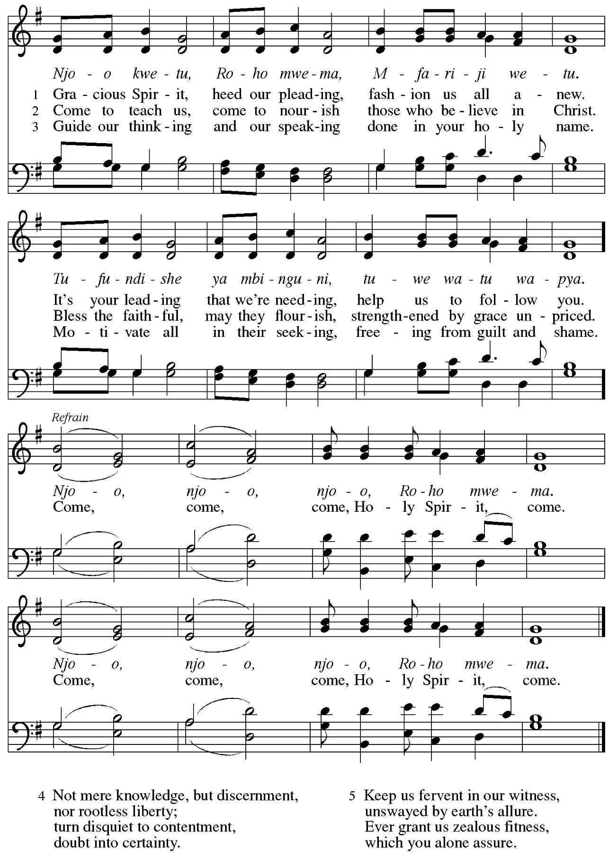
Greeting

P: The grace of our Lord Jesus Christ, the love of God,
and the communion of the Holy Spirit be with you all.
C: And also with you.

Hymn of Praise This Is the Feast ELW p. 149-150

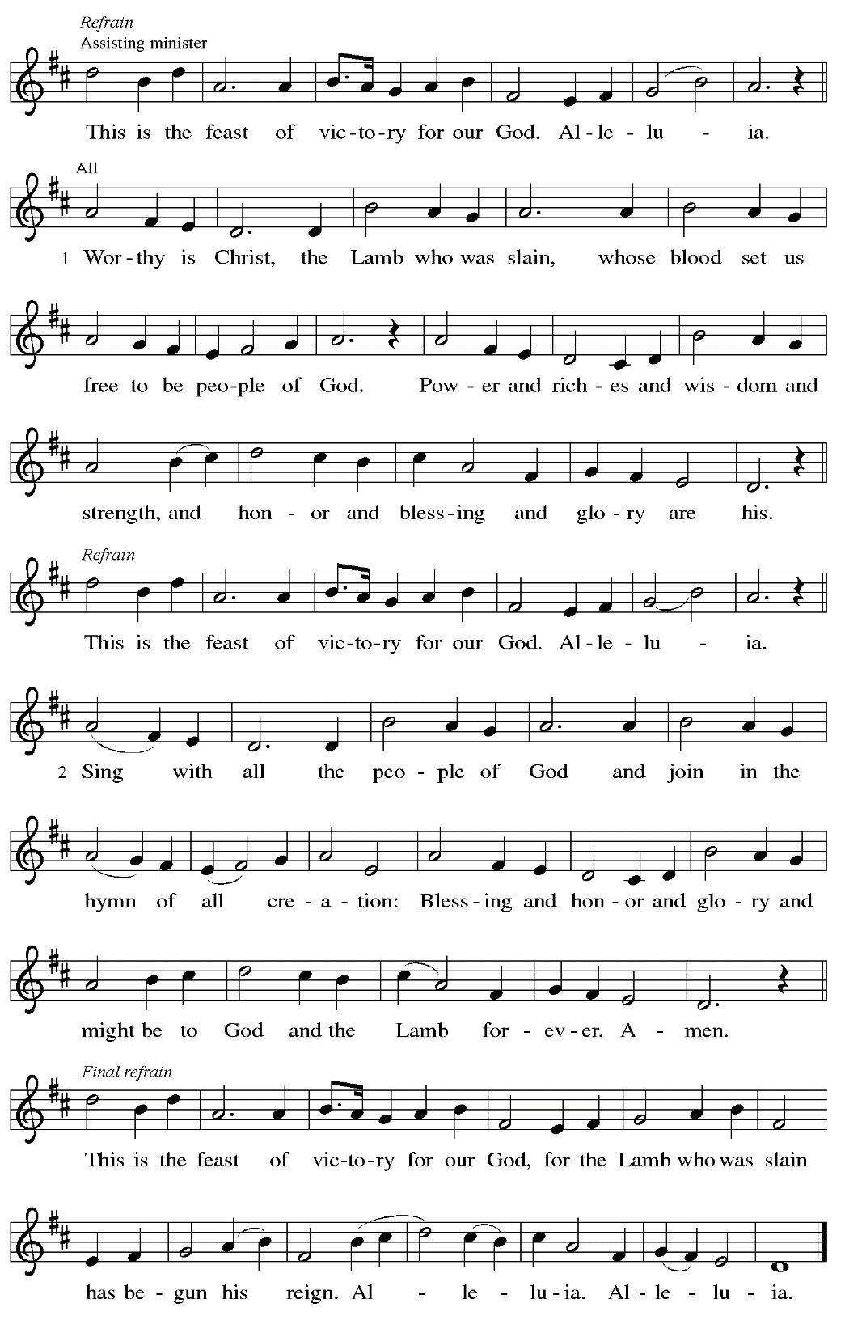

Prayer of the Day

P: The Lord be with you.
C: And also with you.

P: Let us pray.
Mighty God, you breathe life into our bones, and your Spirit brings truth to the world.
Send us this Spirit, transform us by your truth, and give us language to proclaim your gospel, through Jesus Christ, our Savior and Lord, who lives and reigns with you and the Holy Spirit, one God, now and forever.
C: Amen.

Please be seated.

Word
God speaks to us in Scripture reading, preaching, and song

First Reading – Acts 2: 1-21

¹When the day of Pentecost had come, [the apostles] were all together in one place. ²And suddenly from heaven there came a sound like the rush of a violent wind, and it filled the entire house where they were sitting. ³Divided tongues, as of fire, appeared among them, and a tongue rested on each of them. ⁴All of them were filled with the Holy Spirit and began to speak in other languages, as the Spirit gave them ability.

At this time, people throughout the congregation will read the prophecy of Joel, which Peter quotes at the end of the reading, in other languages.
⁵Now there were devout Jews from every nation under heaven living in Jerusalem. ⁶And at this sound the crowd gathered and was bewildered, because each one heard them speaking in the native language of each. ⁷Amazed and astonished, they asked, “Are not all these who are speaking Galileans? ⁸And how is it that we hear, each of us, in our own native language?
⁹Parthians, Medes, Elamites, and residents of Mesopotamia, Judea and Cappadocia, Pontus and Asia, ¹⁰Phrygia and Pamphylia, Egypt and the parts of Libya belonging to Cyrene, and visitors from Rome, both Jews and proselytes, ¹¹Cretans and Arabs—in our own languages we hear them speaking about God’s deeds of power.” ¹²All were amazed and perplexed, saying to one another, “What does this mean?” ¹³But others sneered and said, “They are filled with new wine.”
¹⁴But Peter, standing with the eleven, raised his voice and addressed them, “Men of Judea and all who live in Jerusalem, let this be known to you, and listen to what I say. ¹⁵Indeed, these are not drunk, as you suppose, for it is only nine o’clock in the morning. ¹⁶No, this is what was spoken through the prophet Joel:
¹⁷‘In the last days it will be, God declares,
that I will pour out my Spirit upon all flesh,
and your sons and your daughters shall prophesy,
and your young men shall see visions,
and your old men shall dream dreams.
¹⁸Even upon my slaves, both men and women,
in those days I will pour out my Spirit;
and they shall prophesy.
¹⁹And I will show portents in the heaven above
and signs on the earth below,
blood, and fire, and smoky mist.
²⁰The sun shall be turned to darkness
and the moon to blood,
before the coming of the Lord’s great and glorious day.
²¹Then everyone who calls on the name of the Lord shall be saved.’ ”

L: Word of God, word of life.
C: Thanks be to God.

Psalm 104: 24-34, 35b

The cantor will lead the singing of the psalm.
The congregation is invited to respond with the alternate verses in bold print,
and to join in singing the refrain.

Psalm tone

Psalm refrain

²⁴How manifold are your | works, O Lord!
In wisdom you have made them all; the earth is full | of your creatures.
²⁵Yonder is the sea, great and wide, with its swarms too man- | y to number,
living things both | small and great.
²⁶There go the ships | to and fro,
and Leviathan, which you made for the | sport of it.
²⁷All of them | look to you
to give them their food | in due season. R
²⁸You give it to them; they | gather it;
you open your hand, and they are filled | with good things.
²⁹When you hide your face, | they are terrified;
when you take away their breath, they die and return | to their dust.
³⁰You send forth your Spirit, and they | are created;
and so you renew the face | of the earth.
³¹May the glory of the Lord en- | dure forever;
O Lord, rejoice in | all your works. R
³²You look at the earth | and it trembles;
you touch the mountains | and they smoke.
³³I will sing to the Lord as long | as I live;
I will praise my God while I | have my being.
³⁴May these words of | mine please God.
I will rejoice | in the Lord.
^{35b}Bless the Lord, | O my soul.
Hal- | lelujah! R

Second Reading – Romans 8: 22-27

²²We know that the whole creation has been groaning in labor pains until now; ²³and not only the creation, but we ourselves, who have the first fruits of the Spirit, groan inwardly while we wait for adoption, the redemption of our bodies. ²⁴For in hope we were saved. Now hope that is seen is not hope. For who hopes for what is seen? ²⁵But if we hope for what we do not see, we wait for it with patience.
²⁶Likewise the Spirit helps us in our weakness; for we do not know how to pray as we ought, but that very Spirit intercedes with sighs too deep for words. ²⁷And God, who searches the heart, knows what is the mind of the Spirit, because the Spirit intercedes for the saints according to the will of God.

L: Word of God, word of life.
C: Thanks be to God.

Please rise as you are able.

Gospel Acclamation ELW p. 151

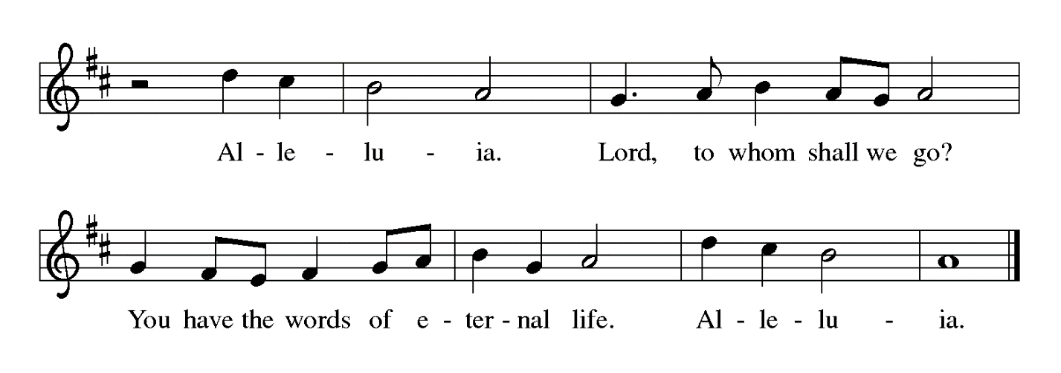

Gospel – John 15: 26-27, 16: 4b-15

P: The holy Gospel according to St. John.
C: Glory to you, O Lord.

[Jesus said,] ²⁶“When the Advocate comes, whom I will send to you from the Father, the Spirit of truth who comes from the Father, he will testify on my behalf. ²⁷You also are to testify because you have been with me from the beginning.
^{16:4b}“I did not say these things to you from the beginning, because I was with you. ⁵But now I am going to the one who sent me; yet none of you asks me, ‘Where are you going?’ ⁶But because I have said these things to you, sorrow has filled your hearts. ⁷Nevertheless I tell you the truth: it is to your advantage that I go away, for if I do not go away, the Advocate will not come to you; but if I go, I will send him to you. ⁸And when he comes, he will prove the world wrong about sin and righteousness and judgment: ⁹about sin, because they do not believe in me; ¹⁰about righteousness, because I am going to the Father and you will see me no longer; ¹¹about judgment, because the ruler of this world has been condemned.
¹²“I still have many things to say to you, but you cannot bear them now. ¹³When the Spirit of truth comes, he will guide you into all the truth; for he will not speak on his own, but will speak whatever he hears, and he will declare to you the things that are to come. ¹⁴He will glorify me, because he will take what is mine and declare it to you. ¹⁵All that the Father has is mine. For this reason I said that he will take what is mine and declare it to you.”

P: The Gospel of the Lord.
C: Praise to you, O Christ.

Please be seated.

Sermon

A time of silence for prayer and reflection follows the sermon.
When the hymn of the day begins, please rise as you are able.

Hymn of the Day O Spirit All-Embracing ACS 944

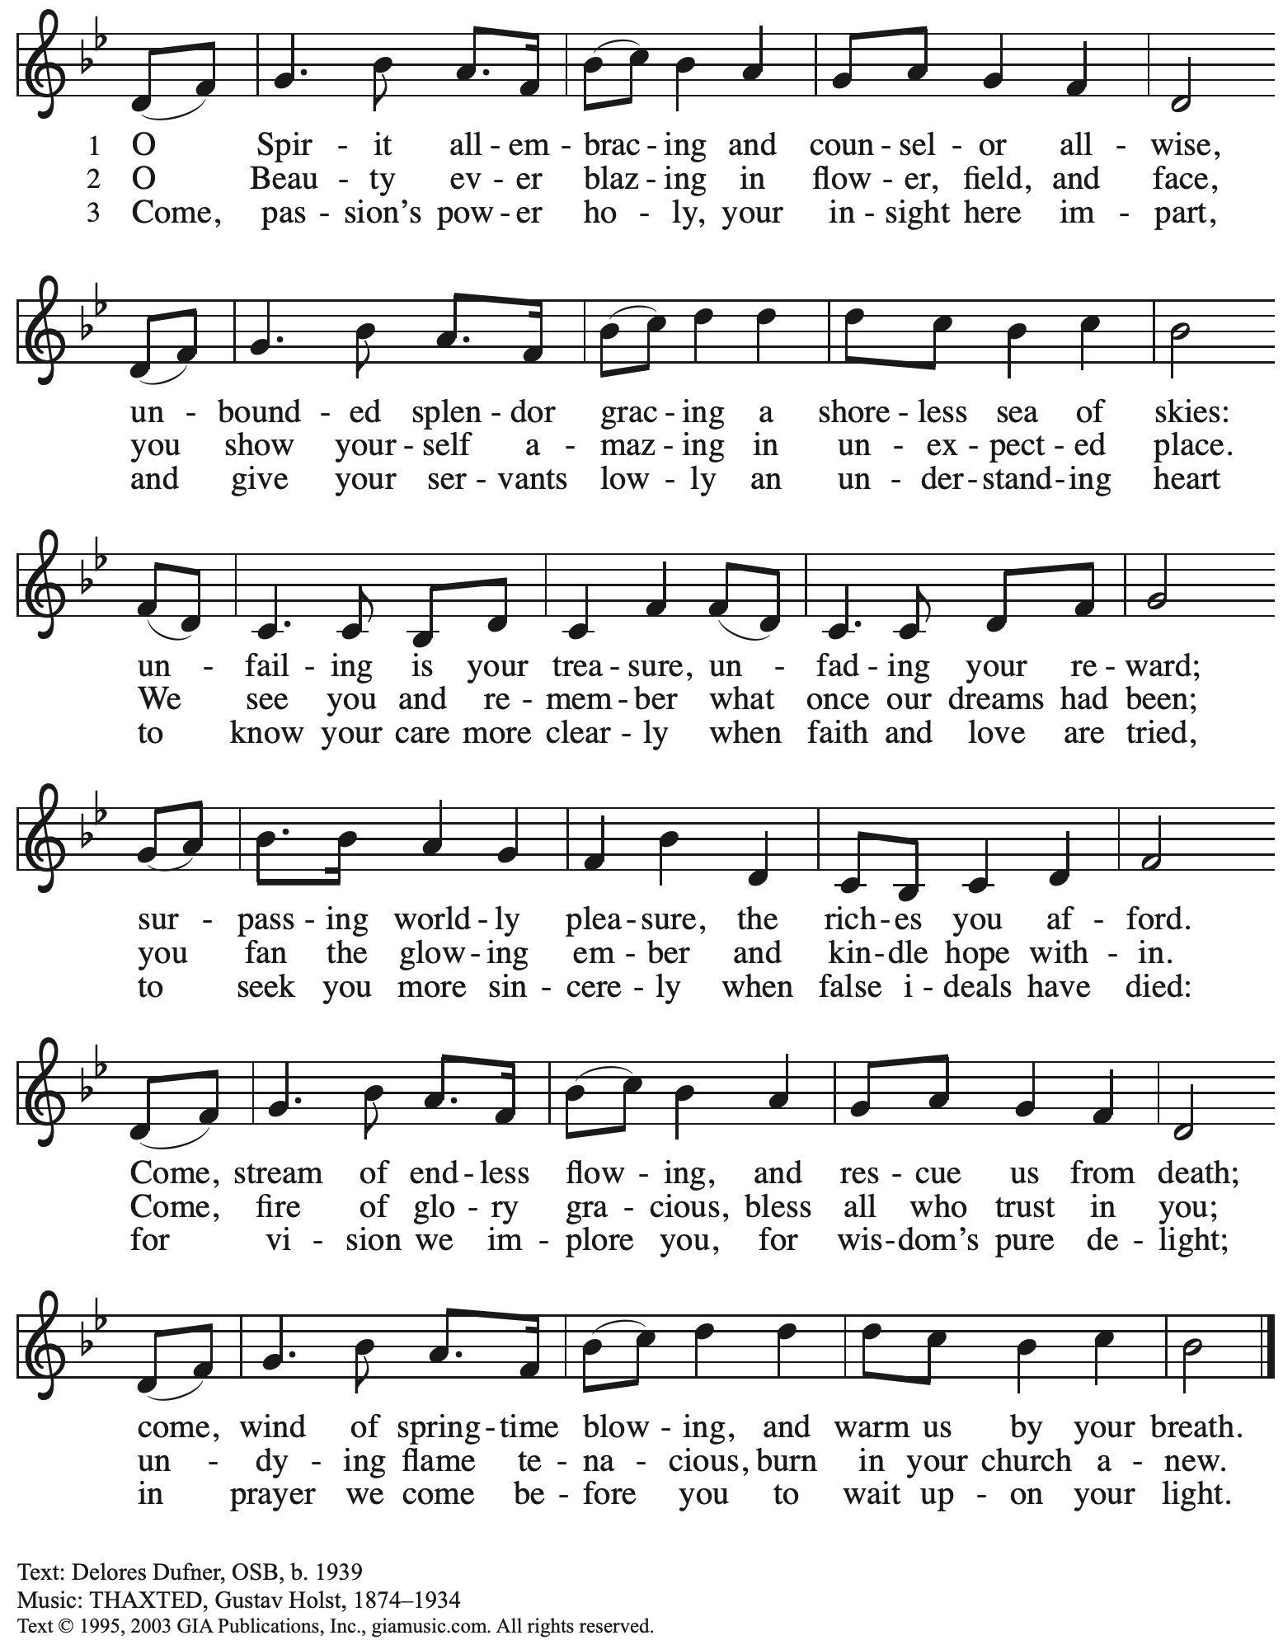
Reprinted with permission under OneLicense.net # A-722139.

Affirmation of Baptism

Presentation

Those making affirmation may gather with the ministers at the font.
They may be joined by others from the assembly.

The presiding minister addresses the assembly with these or similar words.
P: Dear friends, we give thanks for the gift of Baptism and for Name, one with us in the body of Christ, who is making public affirmation of Baptism.

Those making affirmation are presented by a sponsor or another representative of the congregation:
I present name, who desires to make public affirmation of Baptism.

The presiding minister may continue with prayer.
P: Let us pray.
Merciful God, we thank you for this sibling in Christ,
whom you have made your own by water and the Word in Baptism.
You have called them to yourself,
enlightened them with the gifts of your Spirit,
and nourished them in the community of faith.
Uphold your servant in the gifts and promises of Baptism,
and unite the hearts of all whom you have brought to new birth.
We ask this in the name of Christ.
C: Amen.

Profession of Faith

The presiding minister addresses those making public affirmation of Baptism.
The assembly may stand and join in the responses.
P: I ask you to profess your faith in Christ Jesus, reject sin, and confess the faith of the church.

Do you renounce the devil and all the forces that defy God?
Response:
I renounce them.
Do you renounce the powers of this world that rebel against God?
Response:
I renounce them.
Do you renounce the ways of sin that draw you from God?
Response:
I renounce them.

The presiding minister addresses the candidate and the assembly.
P: Do you believe in God the Father?
C: I believe in God, the Father almighty,
creator of heaven and earth.

P: Do you believe in Jesus Christ, the Son of God?
C: I believe in Jesus Christ, God’s only Son, our Lord,
who was conceived by the Holy Spirit,
born of the virgin Mary,
suffered under Pontius Pilate,
was crucified, died, and was buried;
he descended to the dead.*
On the third day he rose again;
he ascended into heaven,
he is seated at the right hand of the Father,
and he will come to judge the living and the dead.

P: Do you believe in God the Holy Spirit?
C: I believe in the Holy Spirit,
the holy catholic church,
the communion of saints,
the forgiveness of sins,
the resurrection of the body,
and the life everlasting.

*Or, “he descended into hell,” another translation of this text in widespread use.

Affirmation of Baptism

The presiding minister addresses those making public affirmation of baptism.
P: You have made public profession of your faith. Do you intend to continue in the covenant God made with you in Holy Baptism:
to live among God’s faithful people,
to hear the word of God and share in the Lord’s supper,
to proclaim the good news of God in Christ through word and deed,
to serve all people, following the example of Jesus,
and to strive for justice and peace in all the earth?
Response:
I do, and I ask God to help and guide me.

The minister addresses the assembly.
P: People of God, do you promise to support this sibling and pray for them in their life in Christ?
C: We do, and we ask God to help and guide us.

Those making affirmation may kneel. The presiding minister prays for God’s blessing.
P: Let us pray.
We give you thanks, O God, that through water and the Holy Spirit
you give us new birth, cleanse us from sin, and raise us to eternal life.

The minister may lay both hands on the head of the person and say:
Stir up in name the gift of your Holy Spirit: the spirit of wisdom and understanding,
the spirit of counsel and might, the spirit of knowledge and the fear of the Lord,
the spirit of joy in your presence, both now and forever.
C: Amen.

Those making public affirmation of Baptism turn to face the assembly.
A representative from the congregation addresses the assembly.
A: Let us rejoice with this brother in Christ.
C: We rejoice with you in the life of Baptism.
Together we will give thanks and praise to God
and proclaim the good news to all the world.

The congregation is invited to join in celebration
by singing St. Andrew’s congregational refrain.

Congregational Refrain HS 808

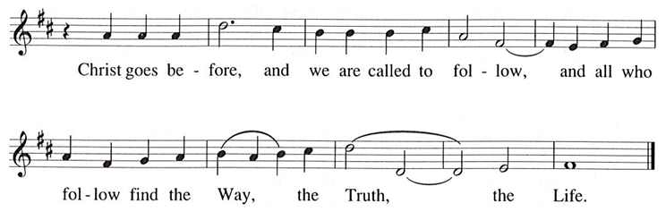

Prayers of the People

A: Trusting in the Spirit’s power, we pray for the church, those in need,
and all of God’s creation.

After each petition
A: Gracious God,
C: receive our prayer.

The presiding minister concludes the prayers
P: Receive these prayers, gracious God, and those prayers known only to you.
We ask this in the name of Jesus Christ by the power of the Holy Spirit.
C: Amen.

Peace

The presiding minister and the assembly greet one another in the peace of the risen Christ.
P: The peace of Christ be with you always.
C: And also with you.

The people may greet those around them with a sign of Christ’s peace and may say
Peace be with you or similar words. Please be mindful that not everyone will be comfortable with sharing the peace, so please seek consent before shaking hands or hugging. Other possible ways to share the peace include a simple bow with the verbal greeting of peace, or simply a verbal expression of peace.

When the greetings of peace have concluded, please be seated.

Meal

Offering

We offer ourselves, our gifts, and our faithful service to God.
As the offering is gathered for the mission of the church, including the care of those in need,
the table is set for Holy Communion.

Noisy Offering

As children of the congregation carry buckets around the sanctuary, people of the congregation are invited to throw in their change as an offering. This month’s Noisy Offering will go to Global Refuge, formerly known as Lutheran Immigration and Refugee Services.

Offertory Music What a Friend We Have in Jesus arr. B. Edstrom

As the gifts are brought forward for presentation, please rise as you are able.

Offertory Song Let the Vineyards ELW 184

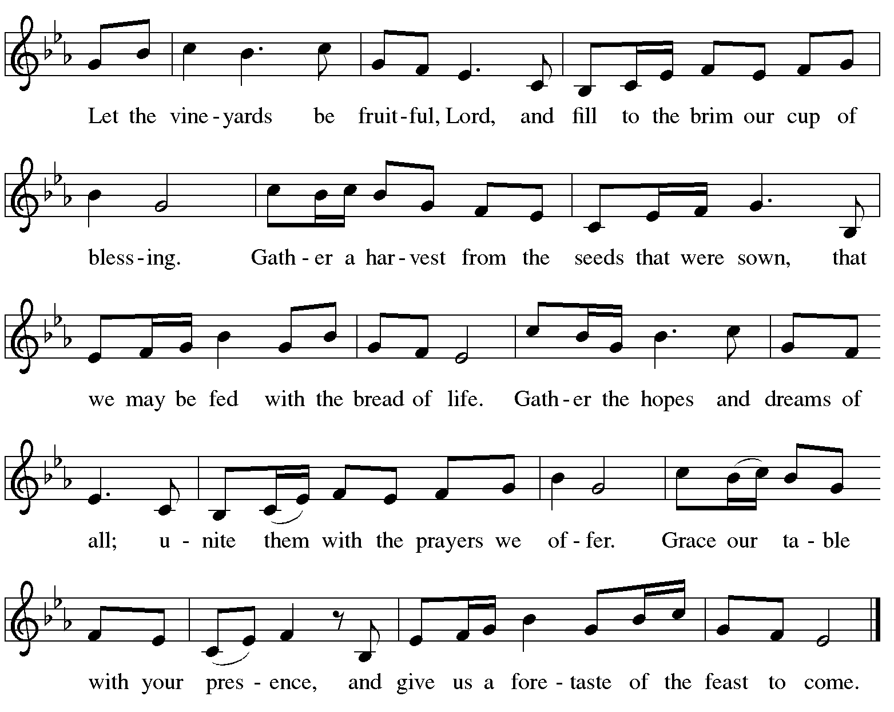

Offertory Prayer

A: Let us pray.
God of mercy and grace,
C: the eyes of all wait upon you,
and you open your hand in blessing.
Fill us with good things at your table,
that we may come to the help of all in need,
through Jesus Christ, our Redeemer and Lord.
Amen.

Dialogue ELW p. 152

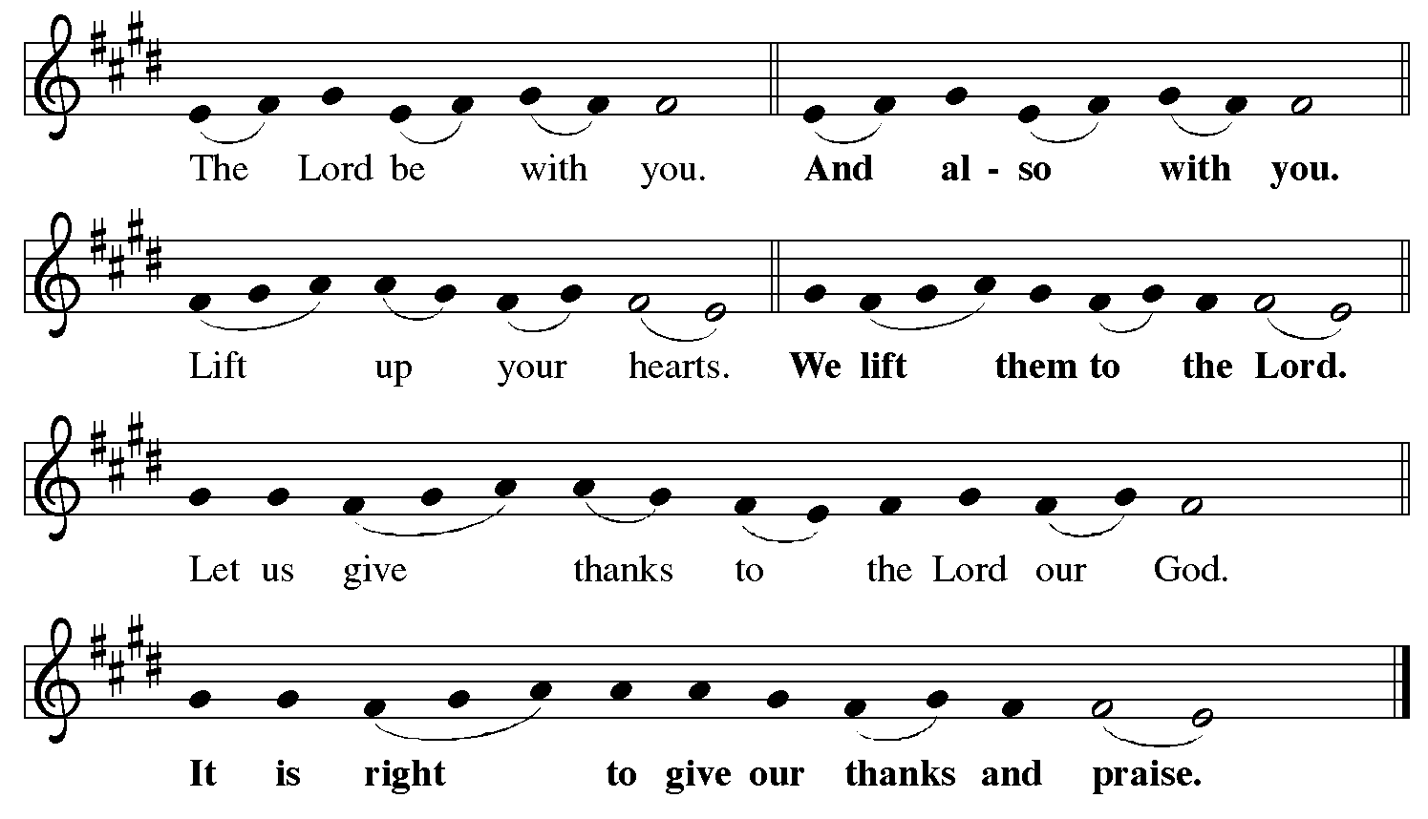

Preface (Sung by the presiding minister)

P: It is indeed right, our duty and our joy,
that we should at all times and in all places
give thanks and praise to you, almighty and merciful God,
through our Savior Jesus Christ.
Fulfilling the promise of the resurrection,
you pour out the fire of your Spirit,
uniting in one body people of every nation and tongue.
And so, with Mary Magdalene and Peter and all the witnesses of the resurrection,
with earth and sea and all their creatures,
and with angels and archangels, cherubim and seraphim,
we praise your name and join their unending hymn:

Sanctus ELW p. 153

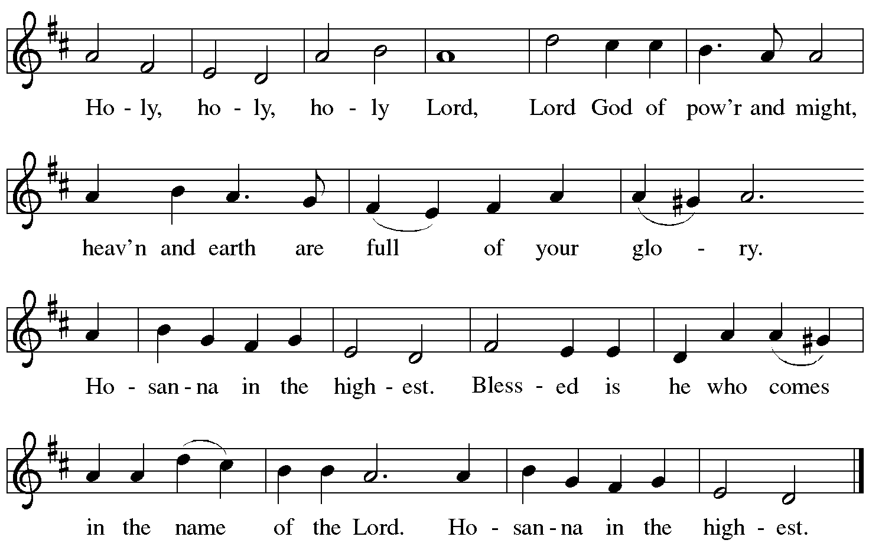

Eucharistic Prayer

P: Blessed are you, O God of the universe …
Do this for the remembrance of me.

With this bread and cup,
we remember our Lord’s passover from death to life
as we proclaim the mystery of faith:
C: Christ has died. Christ is risen. Christ will come again.

P: O God of resurrection and new life …
Grace our table with your presence.
C: Come, Holy Spirit.

P: Reveal yourself to us in the breaking of the bread …
Send us forth, burning with justice, peace, and love.
C: Come, Holy Spirit.

P: With your holy ones of all times and places,
with the earth and all its creatures,
with sun and moon and stars,
we praise you, O God,
blessed and holy Trinity,
now and forever.
C: Amen.

Lord’s Prayer

P: Gathered as one by the Holy Spirit, let us pray as Jesus taught us.
C: Our Father in heaven,
hallowed be your name,
your kingdom come,
your will be done,
on earth as in heaven.
Give us today our daily bread.
Forgive us our sins
as we forgive those
who sin against us.
Save us from the time of trial
and deliver us from evil.
For the kingdom, the power,
and the glory are yours,
now and forever. Amen.

Fraction and Invitation

P: The Spirit has called us to the table of grace.
Come, receive the gifts of God.

Agnus Dei / Lamb of God Following Page

Agnus Dei / Lamb of God ELW p. 154

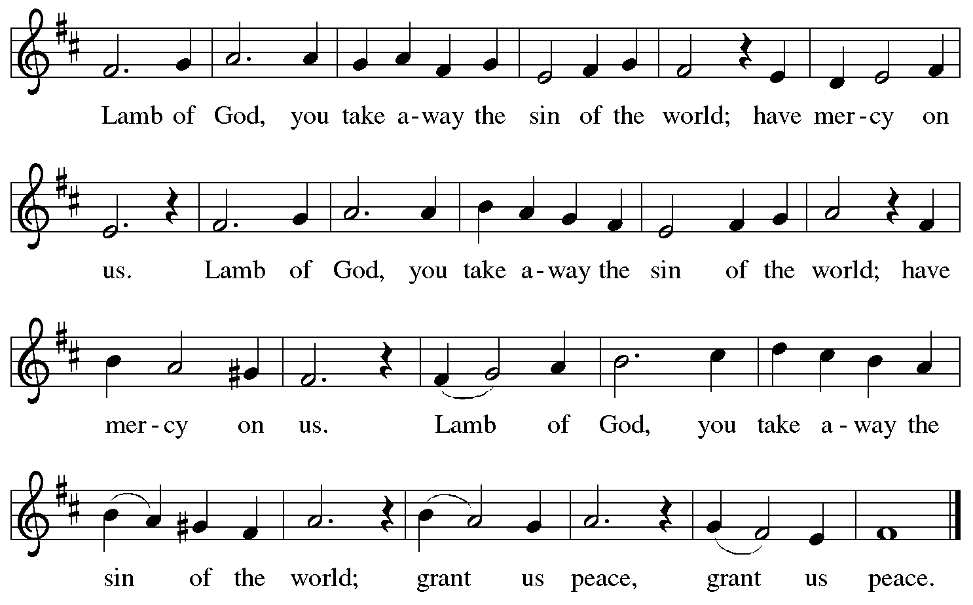

Please be seated.

Holy Communion
- All who seek God and desire a deeper and stronger life in Christ are welcome to receive Holy Communion.
- Worshipers from the pulpit side will proceed forward first, followed by the center section, and then the lectern side.
- Please inform an usher if you would like the ministers to bring Communion to you.
- Holy Communion will be served with bread and wine/grape juice.
- The presiding minister will first distribute the bread (host) to each communicant. Please indicate if you require a gluten-free host.
- Once you have consumed the bread, please pick up an empty glass from the tray next to the presiding minister. The Communion Assistant will pour wine from the chalice or grape juice from the cruet into your glass.
- Please step to the side to consume the wine or grape juice.
- Feel free to kneel at the altar rail for prayer after receiving the sacrament.
- As you return to your pew, glasses may be returned to the empty trays on either side of the center aisle.
- A blessing will be provided for anyone who does not yet receive the sacrament.
- All are invited to join in singing the hymns during Holy Communion.
Hymn during Holy Communion
Come Down, O Love Divine ELW 804

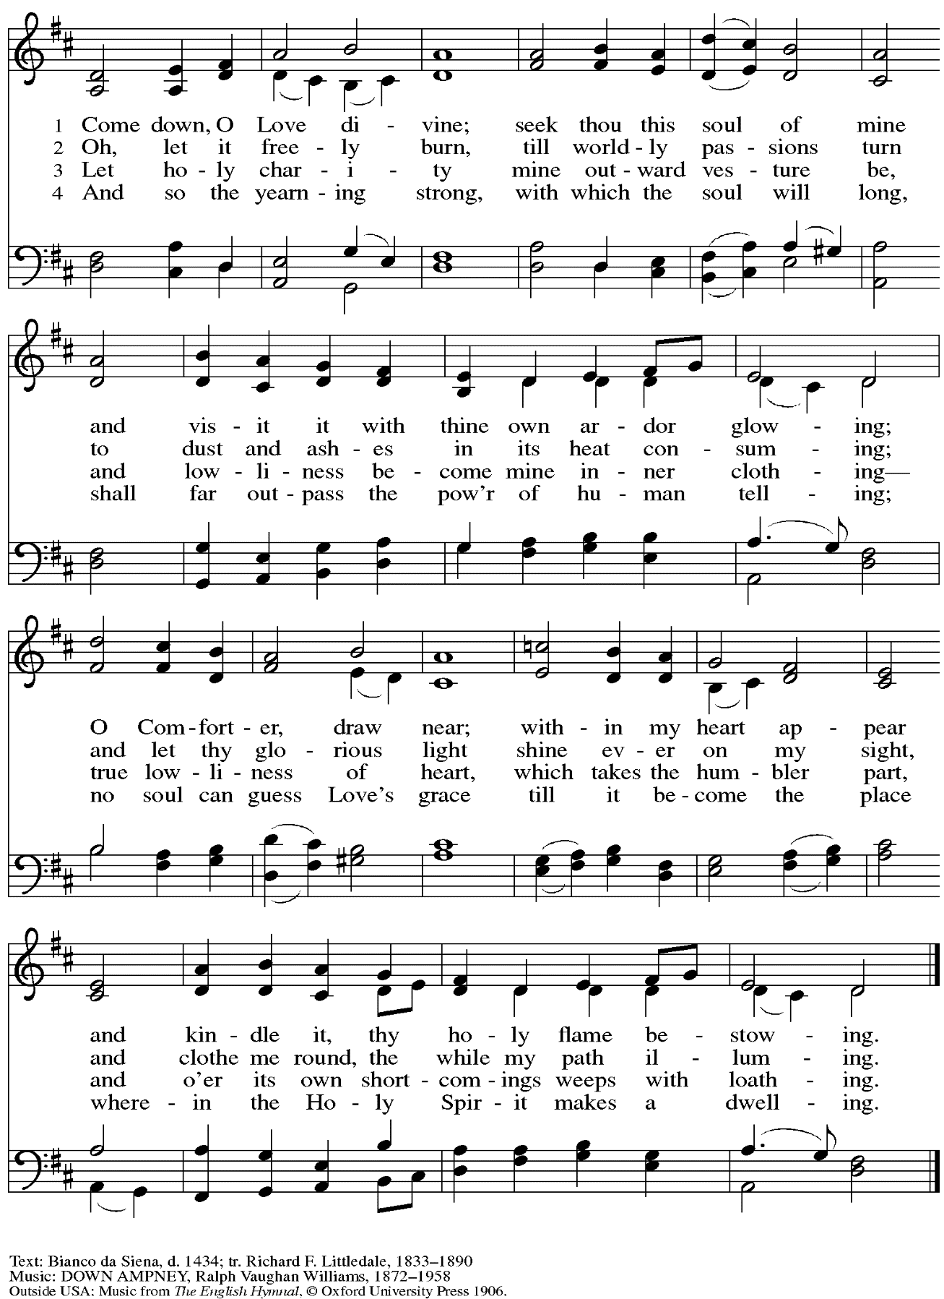
All rights reserved. Reprinted with permission under OneLicense.net # A-722139.
Hymn during Holy Communion
As the Wind Song ACS 943

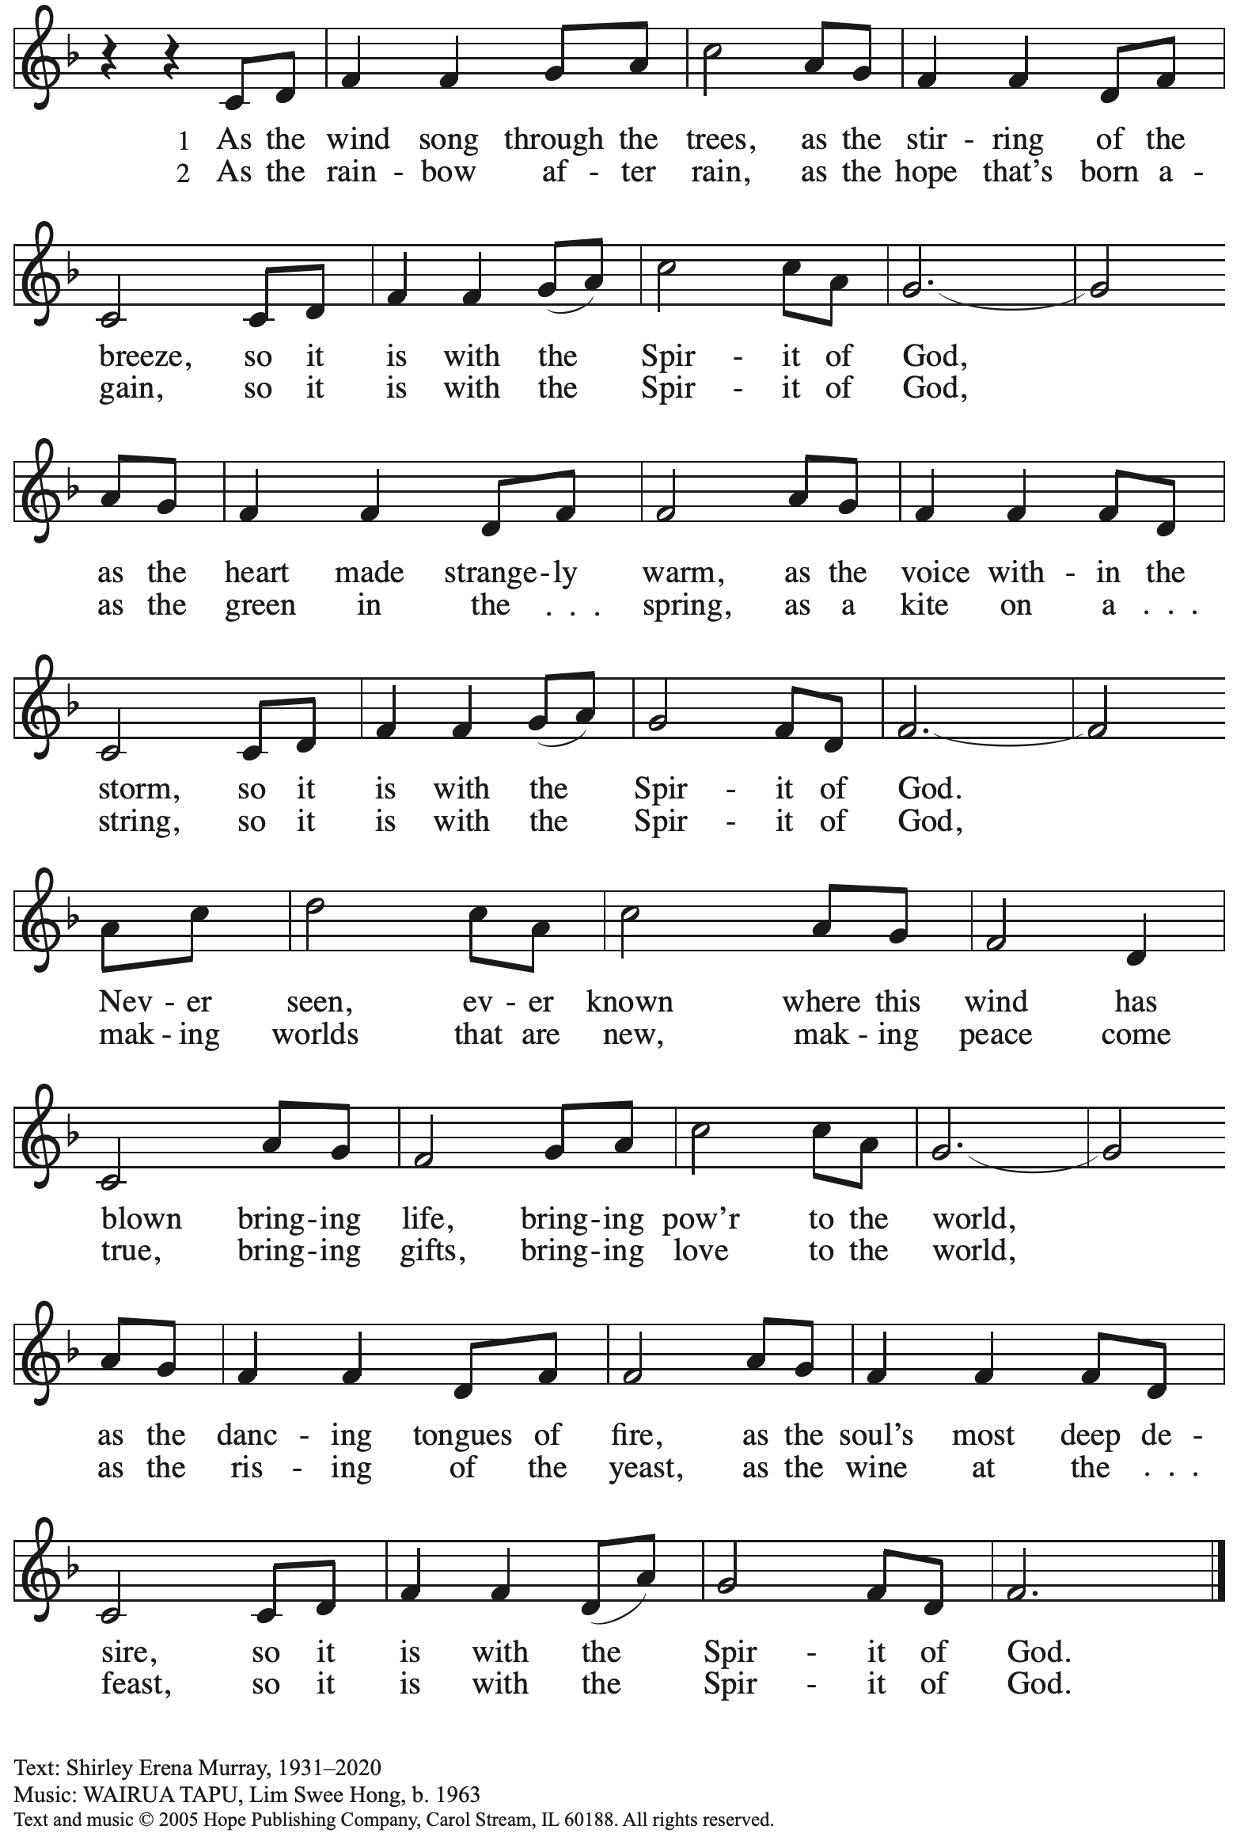
Reprinted with permission under OneLicense.net # A-722139.
Hymn during Holy Communion
God of Tempest, God of Whirlwind ELW 400

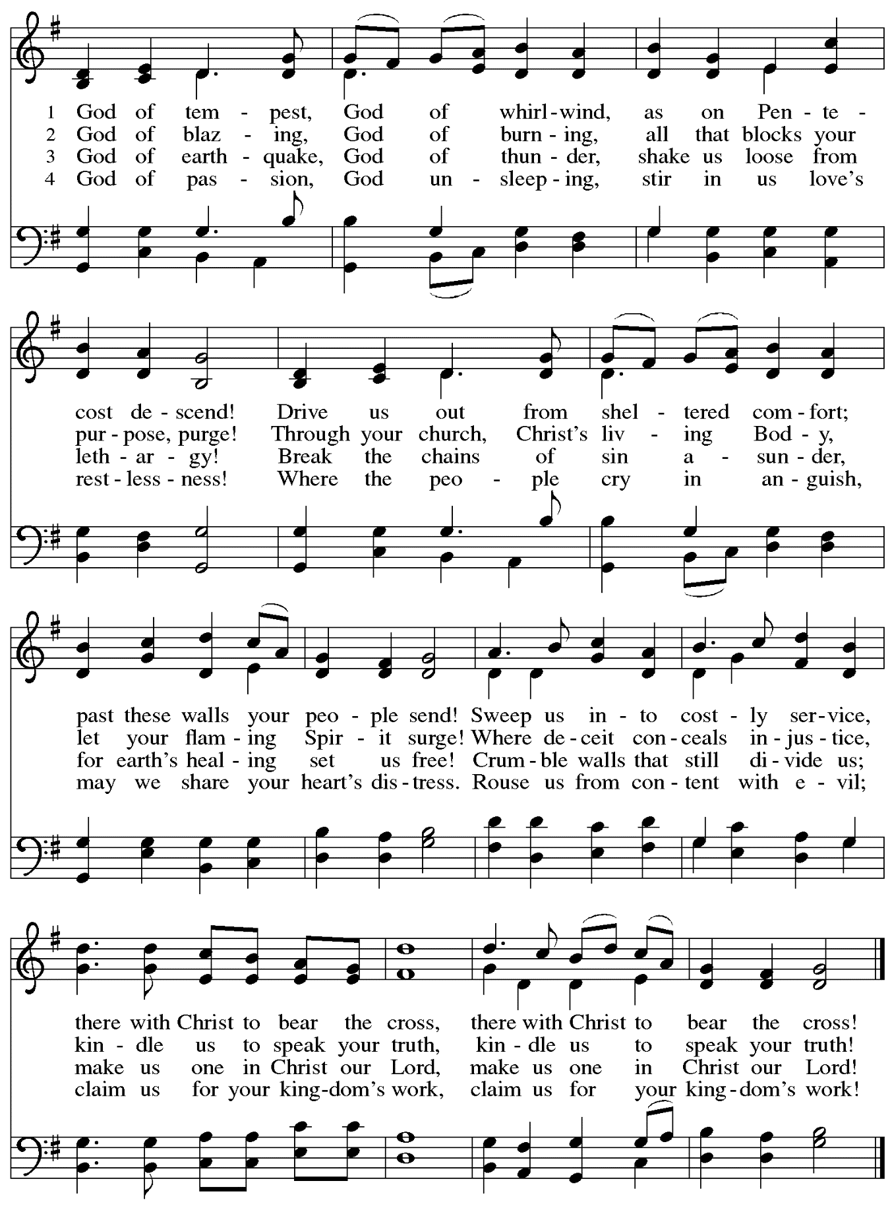

When all have returned to their places, please rise as you are able.

Blessing

P: The body and blood of our Lord Jesus Christ strengthen you and keep you in his grace.
C: Amen.

Prayer

A: Let us pray. God of abundance,
with this bread of life and cup of salvation you have united us with Christ,
making us one with all your people. Now send us forth in the power of your Spirit,
that we may proclaim your redeeming love to the world
and continue forever in the risen life of Jesus Christ, our Lord.
C: Amen.

Please be seated.

Sending

Announcements

Please rise as you are able.

Benediction

P: The God of steadfastness and encouragement
grant you to live in harmony with one another,
in accordance with Christ Jesus.
C: Amen.

P: The God of hope fill you with all joy and peace in believing,
so that you may abound in hope by the power of the Holy Spirit.
C: Amen.

P: The God of all grace ☩ bless you now and forever.
C: Amen.

Sending Hymn Every Time I Feel the Spirit Following page

Dismissal

A: Go in peace. Share the good news!
C: Thanks be to God!
Sending Hymn Every Time I Feel the Spirit ACS 942

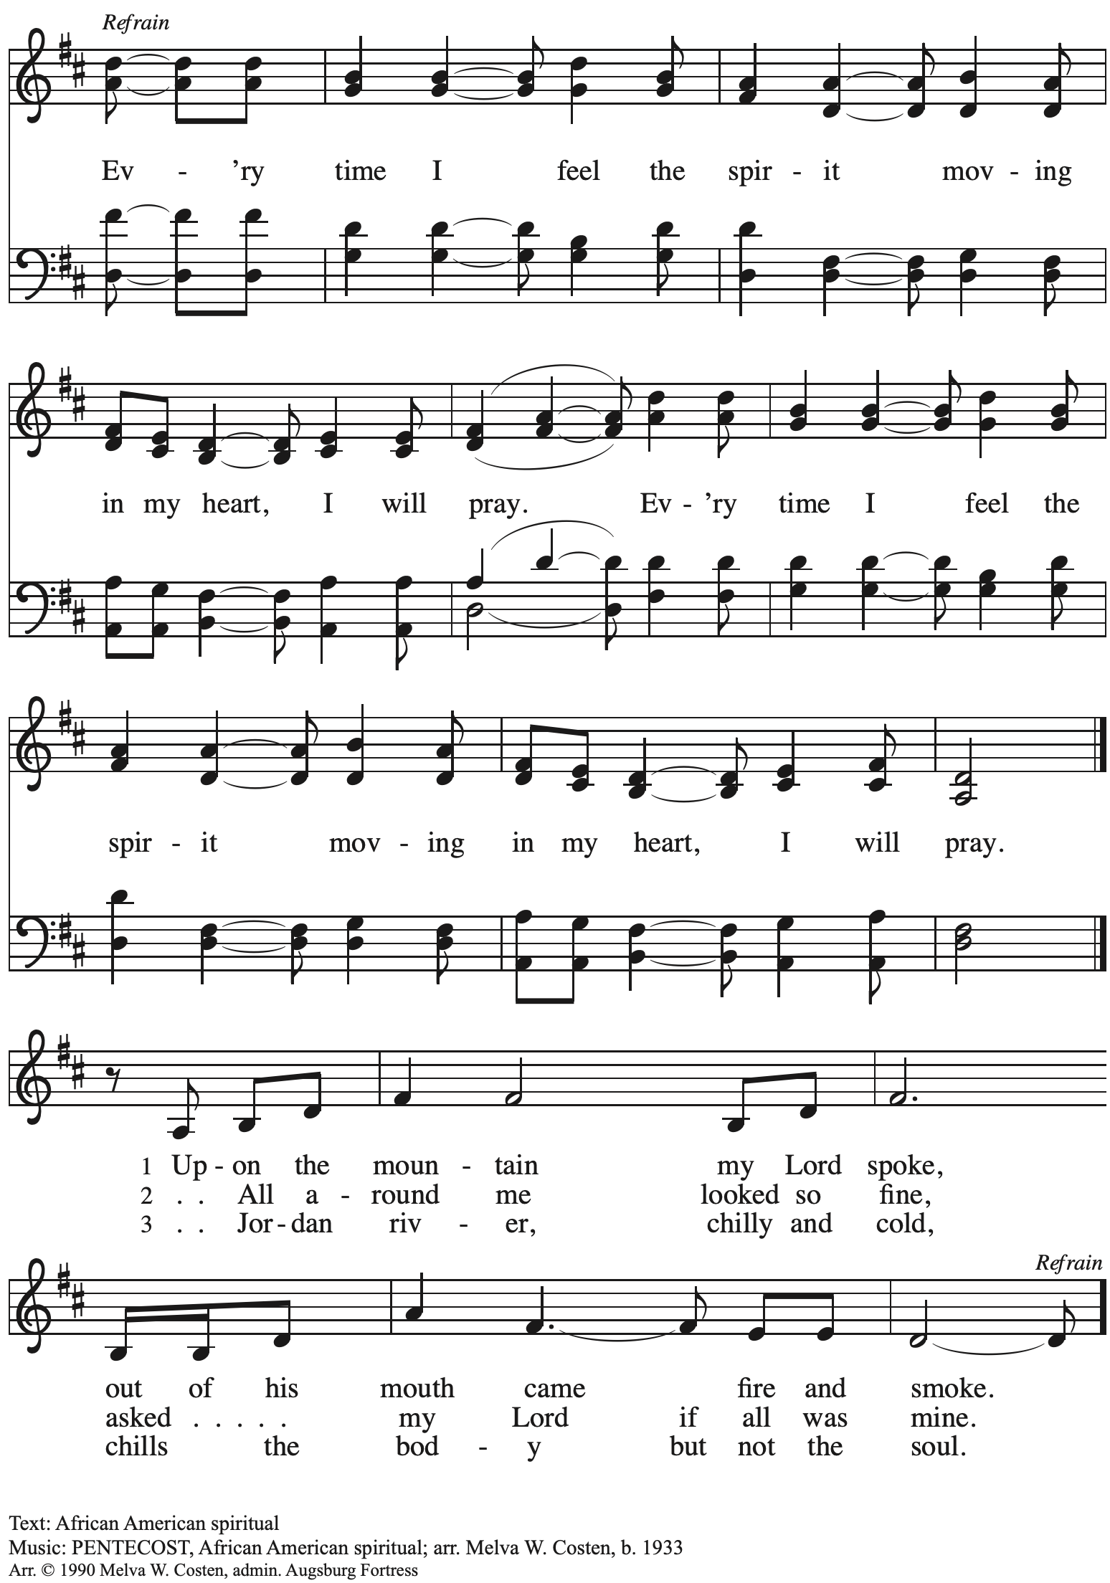
All rights reserved. Reprinted with permission under OneLicense.net # A-722139.

Postlude
Those serving in worship today

Altar Care Jodie Minor
Assisting Minister Tim Marker
Audio-Visual Ministers Tyler Rietze
Joseph Paetz
Cantor Marit Bakken
Lector The Rev. Dr. Paul F. Koch
Little Church – Big Faith Leader Emily Duque
Minister of Music Laura Reynolds
Presiding Minister Pastor Ross I. Carmichael

Liturgy and Hymnody Acknowledgements

From SundaysandSeasons.com. Copyright © 2024 Augsburg Fortress. All rights reserved. Reprinted under OneLicense.net # A-722139.
Used by permission of Augsburg Fortress.

Gracious Spirit, Heed Our Pleading – Njoo kwetu, Roho mwema – Text: Wilson Niwagila; tr. Howard S. Olson, b. 1922. Music: NJOO KWETU, ROHO MWEMA, Wilson Niwagila; arr. Egil Hovland, b. 1924. English and Swahili text and tune © Lutheran Theological College, Makumira, Tanzania, admin. Augsburg Fortress. Arr. Egil Hovland. Used by permission. Reprinted under OneLicense.net # A-722139.

Let the Vineyards – Text: John W. Arthur, 1922-1980. Music: Ronald A. Nelson, b. 1927. Text and Music © 1978 Lutheran Book of Worship, admin. Augsburg Fortress.

God of Tempest, God of Whirlwind – Text: Herman G. Stuempfle, b. 1923. Music: CWM RHONDDA, John Hughes, 1873-1932. Text © 2000 GIA Publications, Inc., 7404 S. Mason Ave., Chicago, IL 60638. www.giamusic.com. 800.442.3358. All right reserved. Reprinted with permission under OneLicense.net # A-722139.

Please use the QR code below to link to St. Andrew’s Announcements online!

St. Andrew Lutheran Church Announcements
May 19th, 2024

- Welcome to Worship at St. Andrew on Sunday, May 19th, 2024, the Day of Pentecost! – We are so glad you are here, and we offer a special welcome to all visitors and guests who are here for the first time! Children are invited to participate in Little Church – Big Faith, a Bible lesson and activity, after the prayer of the day. There are worship “toolkits” to help children engage with worship and “busy bags” for younger children available in the bookcase at the back of the sanctuary. Please feel free to take one to use with/for your children. A nursery is available through the door to the left of the worship space and across the social hall (it is a purple-colored room). We invite everyone to stay after worship for coffee and conversation in the social hall.
- Congratulations to Giovanni, Who Is Celebrating Confirmation Today! – Confirmation, also called Affirmation of Baptism, is an important step in a young person’s life of faith. Today we celebrate with Giovanni and family as Giovanni embraces the promises of Baptism!
- “Noisy” Offering during Worship Today – On the third Sunday of each month, St. Andrew invites the children of the congregation to lead us in a “noisy” offering. Children carry buckets around the congregation and people are invited to throw in their change. This month’s noisy offering will benefit Global Refuge, which is a recent name change from Lutheran Immigration and Refugee Services (LIRS). As Global Refuge, the organization continues an 85 year legacy of Lutheran welcome and support for new neighbors from around the world. For more information, please visit globalrefuge.org.
- Bethel AME Church Juneteenth Celebrations – Sunday, June 16th, 11:00 a.m. and 2:00 p.m. – Bethel AME Church in the Hill District (2720 Webster Ave, 15219), with whom the St. Andrew congregation and our Southwestern Pennsylvania (SWPA) Synod have been in relationship with for the past several years, will host Juneteenth celebrations on Sunday, June 16th, with Bishop Kurt F. Kusserow of the SWPA Synod as the speaker at the 11:00 a.m. service and with Bishop Errenous E. McCloud, Jr. of the AME Church as the speaker at the 2:00 p.m. service.
- Inviting Coffee Hour Signups for Upcoming Sundays – One way that we at St. Andrew build community is by sharing conversation over food and drinks at coffee hour after worship on Sundays. We invite people of the congregation to serve by brewing the coffee, setting out cups, napkins, food items, and cold drinks, and cleaning up afterward. Everything needed is at St. Andrew and instructions are available. If you would be willing to set up coffee hour on any of the upcoming Sundays, please sign up here:
https://www.signupgenius.com/go/5080B4AAFAF2CABF85-47069030-coffee
- New Signup Form for Worship Roles – St. Andrew's worship is made possible by many people who serve in various roles – Some people prepare the altar and setup Communion, some run the sound/streaming system, while others teach Little Church – Big Faith for the children, serve as ushers, wash communion cups, count the offering, and more. If you are interested in getting more involved in worship, talk to Pastor Ross or Joseph Paetz. Most positions serve once a month or less. We have created a new form for those wishing to express interest in service for any of the roles – please access it here https://forms.gle/qfeJvbFR6V8DtTsz7 and someone will be in touch soon!

Geraniums Decorating the Worship Space
for Pentecost Have Been Given:

In Honor of

St. Andrew’s Music Ministry by Kathy Hays

In Loving Memory of

Joyce Compton by Kelly Spanninger
by Janet Grzegorczyk
Dear Family and Friends by Pat Lutz
Our Grandparents by Joseph Paetz and Anya Fredrickson
My Loving Family by Mary Lou Benedetti
Wayne Sommerfeld by Lindsay Baxter

With Love for

Kelly and Nate by Megan Flower

