+ Second Sunday after Pentecost
June 2, 2024
St. Andrew Lutheran Church
304 Morewood Ave.
Pittsburgh, PA 15213
St_andrewELCA@verizon.net
www.standrewpittsburgh.org

+ Second Sunday after Pentecost
Order for Worship

The book of Deuteronomy proclaims that sabbath-keeping is meant for the welfare of all.
God delivered the Israelites out of slavery, so they should observe this freedom with a day of rest. God says in this text that no one should work seven days a week; all should be able to rest. Yet human beings can turn even the most liberating religious practice into a life-destroying rule. Jesus does not reject sabbath-keeping, but defends its original life-enhancing meaning. Our worship and our religious way of life are to lead to restoration: the hungry being fed and the sick being healed.

Welcome to St. Andrew!
- St. Andrew Lutheran congregation welcomes all who are seeking a place of healing and wholeness – a nurturing, faith-forming spiritual home. Our community embraces people of all ages, ethnicities, cultures, abilities, sexual orientations, gender identities and expressions, and family constellations. Come and See!
- Worship Services are live streamed to multiple online platforms. By attending worship, you agree that your image and voice may be broadcast.
- Everyone is invited to make a name tag at the black bookcase in the back of the worship space if they would like. There are stickers indicating pronouns on the bookcase if you would like to include them on your name tag.
- A nursery is available through the doors at the left side of the sanctuary and across from the doorway to the Social Hall. Look for the purple-colored room.
- Worship “toolkits” to help children engage with the service, along with “busy bags” for younger children, are available in the bookcase at the back of the sanctuary. Please feel free to take one to use with/for your children.
- Holy Communion is served with bread (gluten-free available) and wine or grape juice. The presiding minister will distribute the bread (host). Please consume this and then pick up an empty glass from the tray. The Communion Assistant will pour wine or grape juice into your glass. Please step to the side to consume the wine or grape juice. Feel free to kneel at the altar for prayer and reflection. As you return to your pew, glasses may be returned to the empty trays on either side of the center section.
- A restroom is available on the main level of the church, through the doors to the Social Hall and to the right in the main office.

Abbreviations
P: Pastor/Presiding Minister ELW: Evangelical Lutheran Worship hymnal
A: Assisting Minister ACS: All Creation Sings hymnal
L: Lector OLS: Of the Land and Seasons liturgy
C: Congregation
R: Representative of the Congregation

Pre-Service Music

Welcome

Prelude

Gathering
The Holy Spirit calls us together as the people of God

Confession and Forgiveness

Please rise as you are able.
All may make the sign of the cross, the sign that is marked at Baptism,
as the presiding minister begins.

P: Blessed be the holy Trinity, ☩ one God,
who forgives all our sin, whose mercy endures forever.
C: Amen.

P: Let us confess our sin in the presence of God and of one another.

Silence is kept for reflection

P: Most merciful God,
C: we confess that we are captive to sin and cannot free ourselves.
We have sinned against you in thought, word, and deed,
by what we have done and by what we have left undone.
We have neglected to nurture the new growth you cause to sprout among us.
We have failed to protect those tender and vulnerable in faith
from the choking weeds of our indifference and inflexibility.
For the sake of your Son, Jesus Christ, have mercy on us.
Forgive us, grant us discipline, and redirect us,
so that we may delight in your will and follow in your ways,
to the glory of your holy name.
Amen.

P: God, who is rich in mercy,
loved us even when we were dead in sin
and made us alive together with Christ.
By grace you have been saved.
In the name of ☩ Jesus Christ, your sins are forgiven.
Almighty God strengthen you with the Holy Spirit,
that Christ may live in your hearts through faith.
C: Amen.
Gathering Hymn All Are Welcome ELW 641

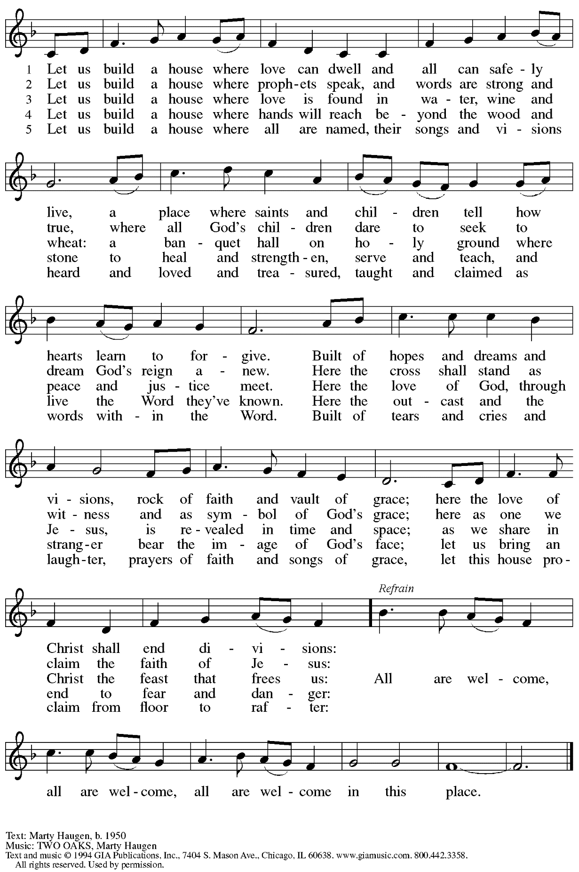
Reprinted under OneLicense.net #A-722139.

Greeting

P: The grace of our Lord Jesus Christ, the love of God,
and the communion of the Holy Spirit be with you all.
C: And also with you.

Hymn of Praise Oh, Sing of God’s Great Victory! OLS 3

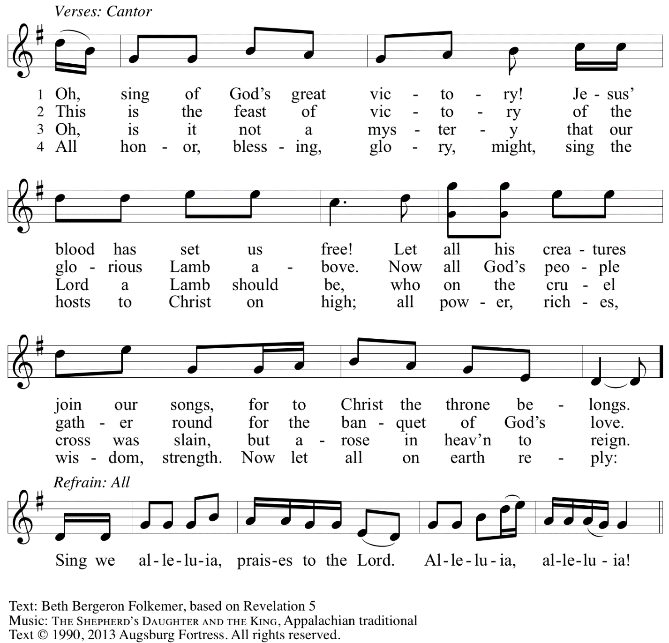
Reprinted with permission under OneLicense.net # A-722139.

Prayer of the Day

P: The Lord be with you.
C: And also with you.

P: Let us pray.
Almighty and ever-living God, throughout time you have freed the oppressed,
healed the sick, and made whole all that you have created.
Look with compassion on the world wounded by sin,
and by your power restore us to wholeness of life,
through Jesus Christ, our Savior and Lord.
C: Amen.

Please be seated.

Word
God speaks to us in Scripture reading, preaching, and song

First Reading – Deuteronomy 5: 12-15

¹²Observe the sabbath day and keep it holy, as the Lord your God commanded you. ¹³Six days you shall labor and do all your work. ¹⁴But the seventh day is a sabbath to the Lord your God; you shall not do any work—you, or your son or your daughter, or your male or female slave, or your ox or your donkey, or any of your livestock, or the resident alien in your towns, so that your male and female slave may rest as well as you. ¹⁵Remember that you were a slave in the land of Egypt, and the Lord your God brought you out from there with a mighty hand and an outstretched arm; therefore the Lord your God commanded you to keep the sabbath day.

L: Word of God, word of life.
C: Thanks be to God.

Psalm 81: 1-10

The psalm will be led by the cantor, with the congregation invited to join in singing the alternate verses in bold typeface and the refrain.

Psalm tone

Psalm refrain

¹Sing with joy to | God our strength
and raise a loud shout to the | God of Jacob.
²Raise a song and | sound the timbrel,
the merry harp, | and the lyre. R
³Blow the ram’s horn at | the new moon,
and at the full moon, the day | of our feast;
⁴for this is a stat- | ute for Israel,
a law of the | God of Jacob.
⁵God laid it as a solemn charge upon Joseph, going out over the | land of Egypt,
where I heard a voice I | did not know:
⁶“I eased your shoulder | from the burden;
your hands were set free from the grave- | digger’s basket. R
⁷You called on me in trouble, and I de- | livered you;
I answered you from the secret place of thunder and tested you at the wa- | ters of Meribah.
⁸Hear, O my people, and I will ad- | monish you:
O Israel, if you would but lis- | ten to me!
⁹There shall be no strange | god among you;
you shall not worship a | foreign god.
¹⁰I am the Lord your God, who brought you out of the | land of Egypt.
Open your mouth wide, and | I will fill it. R

Second Reading – 2 Corinthians 4: 5-12

⁵We do not proclaim ourselves, we proclaim Jesus Christ as Lord and ourselves as your slaves for Jesus’ sake. ⁶For it is the God who said, “Let light shine out of darkness,” who has shone in our hearts to give the light of the knowledge of the glory of God in the face of Jesus Christ.
⁷But we have this treasure in clay jars, so that it may be made clear that this extraordinary power belongs to God and does not come from us. ⁸We are afflicted in every way, but not crushed; perplexed, but not driven to despair; ⁹persecuted, but not forsaken; struck down, but not destroyed; ¹⁰always carrying in the body the death of Jesus, so that the life of Jesus may also be made visible in our bodies. ¹¹For while we live, we are always being given up to death for Jesus’ sake, so that the life of Jesus may be made visible in our mortal flesh. ¹²So death is at work in us, but life in you.

L: Word of God, word of life.
C: Thanks be to God.

Please rise as you are able.

Gospel Acclamation O God, Whose Word Well-Planted OLS 4
v. 1-2

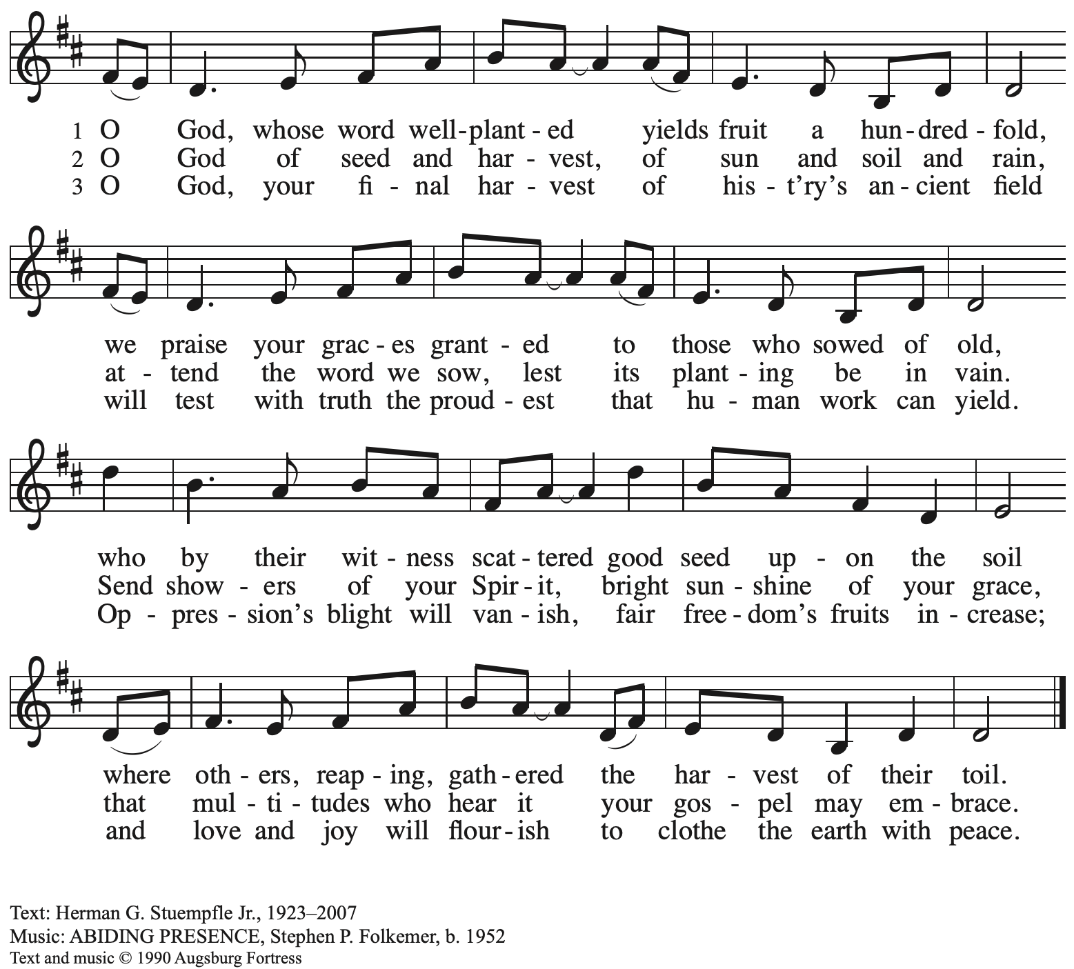
All rights reserved. Reprinted under OneLicense.net # A-722139.

Gospel – Mark 2: 23 – 3: 6

P: The holy Gospel according to St. Mark.
C: Glory to you, O Lord.

²³One sabbath [Jesus] was going through the grainfields; and as they made their way his disciples began to pluck heads of grain. ²⁴The Pharisees said to him, “Look, why are they doing what is not lawful on the sabbath?” ²⁵And he said to them, “Have you never read what David did when he and his companions were hungry and in need of food? ²⁶He entered the house of God, when Abiathar was high priest, and ate the bread of the Presence, which it is not lawful for any but the priests to eat, and he gave some to his companions.” ²⁷Then he said to them, “The sabbath was made for humankind, and not humankind for the sabbath; ²⁸so the Son of Humanity is lord even of the sabbath.”
^{3:1}Again he entered the synagogue, and a man was there who had a withered hand. ²They watched him to see whether he would cure him on the sabbath, so that they might accuse him.
³And he said to the man who had the withered hand, “Come forward.” ⁴Then he said to them, “Is it lawful to do good or to do harm on the sabbath, to save life or to kill?” But they were silent.
⁵He looked around at them with anger; he was grieved at their hardness of heart and said to the man, “Stretch out your hand.” He stretched it out, and his hand was restored. ⁶The Pharisees went out and immediately conspired with the Herodians against him, how to destroy him.

P: The Gospel of the Lord.
C: Praise to you, O Christ.

Please be seated.

Sermon

A time of silence for prayer and reflection follows the sermon.
When the hymn of the day begins, please rise as you are able.

Hymn of the Day O Christ, the Healer, We Have Come Following page

Hymn of the Day O Christ, the Healer, We Have Come ELW 610

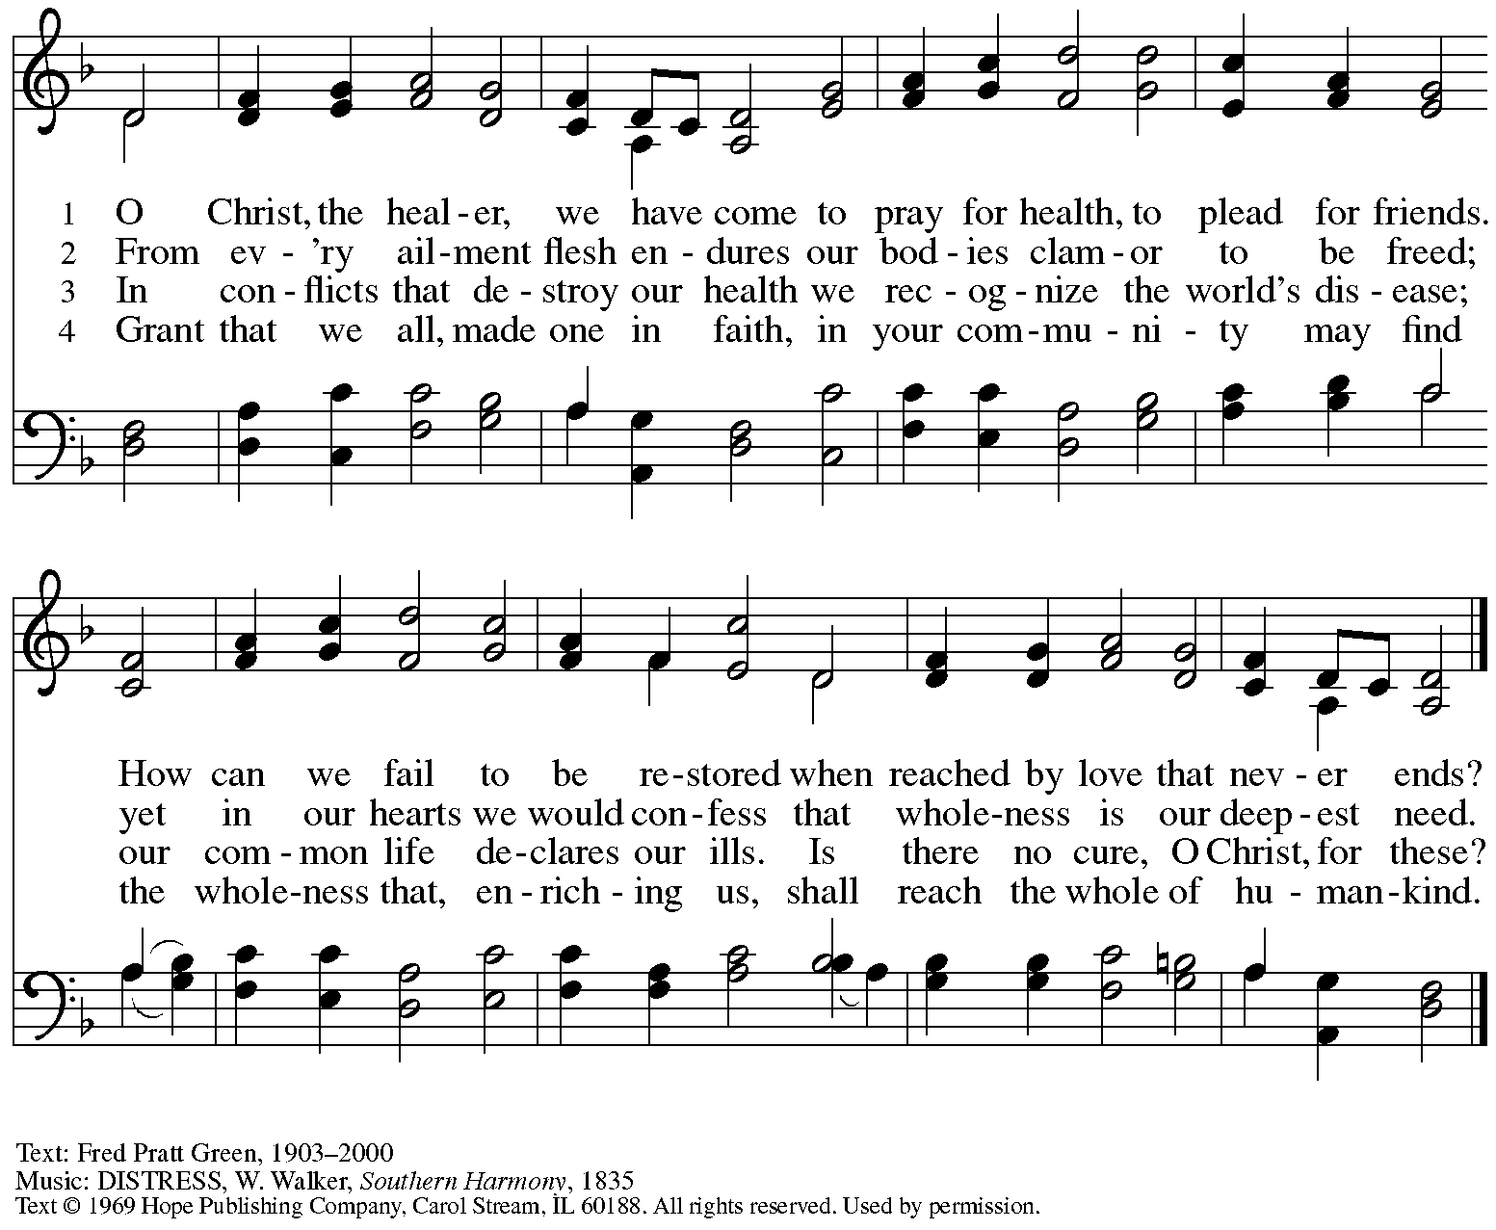
Reprinted under OneLicense.net # A-722139.

Welcoming New Members

P: Emily and Monica have come to St. Andrew from other Lutheran congregations
and desire to transfer their membership into this community of faith.

R: We welcome you as members of St. Andrew Lutheran Church,
to join with us in worshiping God,
hearing God’s Word and sharing God’s holy supper,
proclaiming the good news of God in Christ through word and deed,
serving all people,
and striving for justice and peace in all the earth.

A: Let us pray.
We thank you, Lord, for these new members of the St. Andrew congregation.
By your life-giving power, bind us to each other in you, strengthen us for service,
support us all our days, and bring us at the last to that day when all your children will be one
and you will be All-in-All.
C: Amen.

A: Let us rejoice with these siblings in Christ.
C: We rejoice with you in the life of faith.
Together we will give thanks and praise to God
and proclaim the good news to all the world.

The congregation welcomes our new siblings in Christ with applause, and all are invited to join in singing St. Andrew’s congregational refrain.

Congregational Refrain HS 808

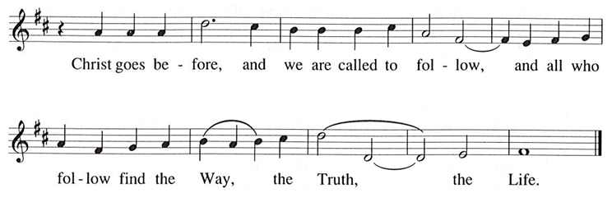

Prayers of the People

A: With the whole people of God in Christ Jesus, let us pray for the church, the world,
those in need, and all of God’s creation.

After each petition
A: God, in your mercy,
C: receive our prayer.

The presiding minister concludes the prayers
P: Into your hands, gracious God, we commend all for whom we pray,
trusting in your abundant mercy, through Jesus Christ our Savior.
C: Amen.

Peace

The presiding minister and the assembly greet one another in the peace of the risen Christ.
P: The peace of Christ be with you always.
C: And also with you.

The people may greet those around them with a sign of Christ’s peace and may say
Peace be with you or similar words. Please be mindful that not everyone will be comfortable with sharing the peace, so please seek consent before shaking hands or hugging.
Other possible ways to share the peace include a simple bow with the verbal greeting of peace, or simply a verbal expression of peace.

When the greetings of peace have concluded, please be seated.

Meal
God feeds us with the presence of Jesus Christ

Offering

We offer ourselves, our gifts, and our faithful service to God.
As the offering is gathered for the mission of the church, including the care of those in need,
the table is set for Holy Communion.

Reparations Offering

On the first Sunday of each month, St. Andrew invites people of the congregation to consider a donation to a second collection for a reparations fund in acknowledgement of St. Andrew’s use of African American spiritual songs in our worship services. Please see the note in the announcements for more information.

Music during the Offering

As the gifts are brought forward for presentation, please rise as you are able.

Offertory Song Accept, O Lord, the Gifts We Bring OLS 5

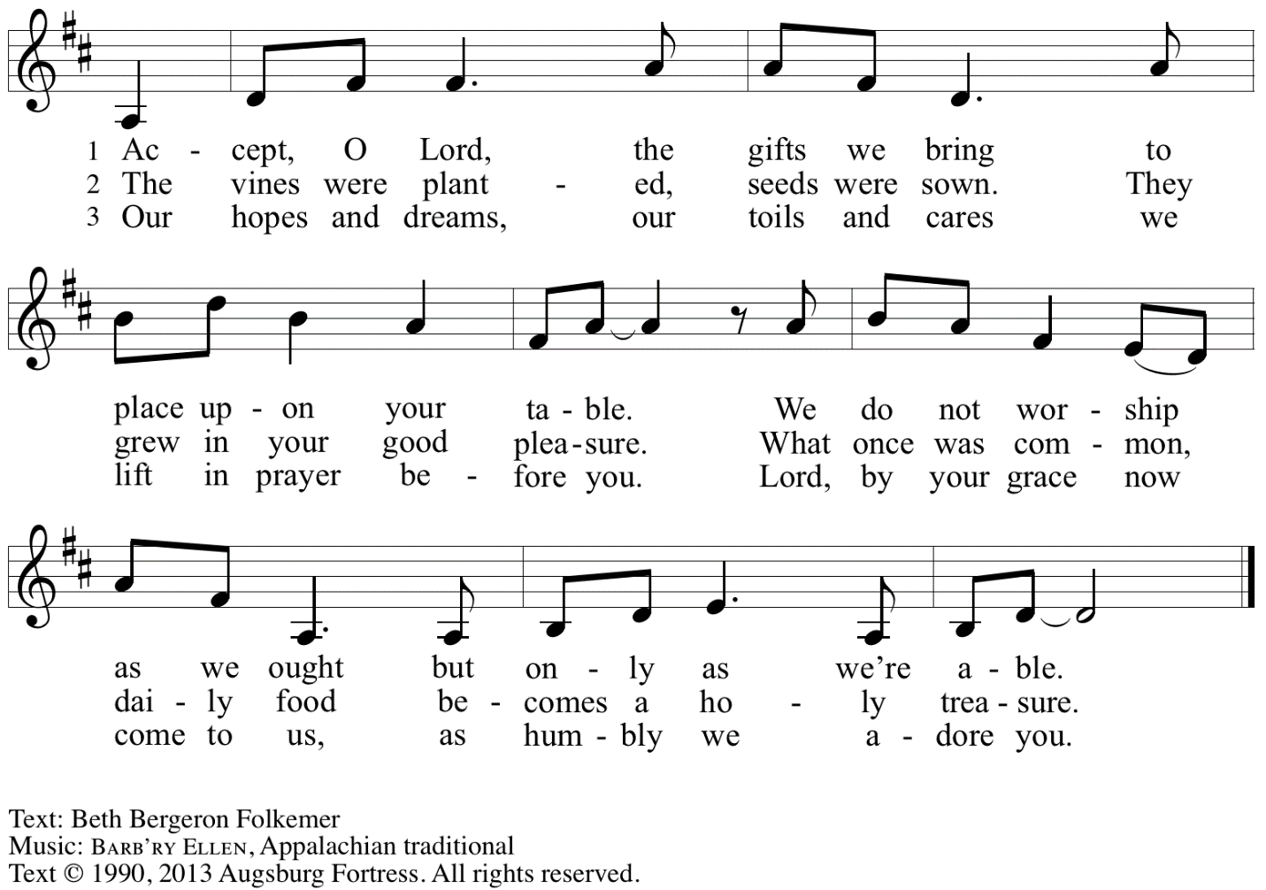
Reprinted under OneLicense.net # A-722139.

Offertory Prayer

A: Let us pray.
Gracious God,
C: you bless us with gifts of guidance, new life,
growth in grace, and fruitful labor.
Accept the first fruits of time and toil, field and orchard,
that we offer here. Bless and multiply these gifts to our nurture
and the care of your creation;
for the sake of your Son, Jesus Christ, our Lord.
Amen.

Dialogue

P: The Lord be with you.
C: And also with you.

P: Lift up your hearts.
C: We lift them to the Lord.

P: Let us give thanks to the Lord our God.
C: It is right to give our thanks and praise.

Preface

P: It is indeed right, our duty and our joy …
… we praise your name and join in adoring song:

Sanctus Holy, Holy, Holy OLS 6

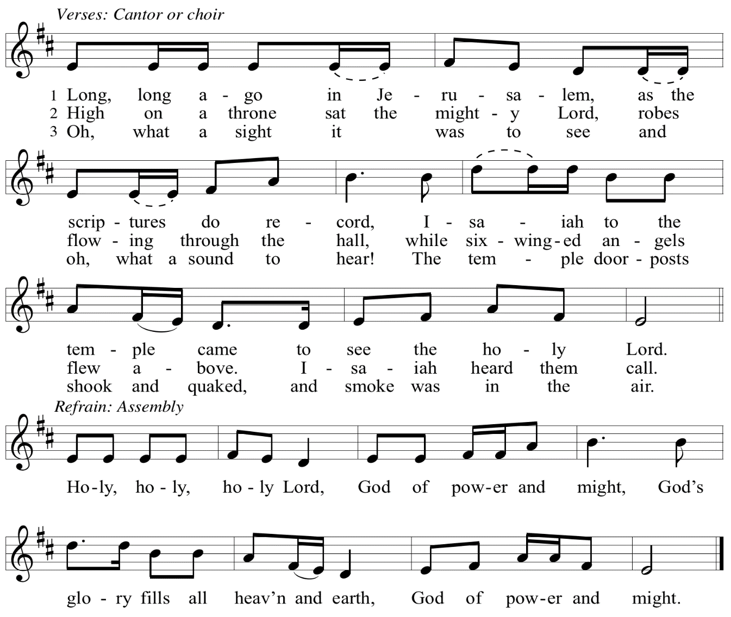

Eucharistic Prayer

P: You are indeed holy, God of power and might
and your glory fills the whole earth …
… and nurture us to become what you have made us –
your beloved people, the body of your Son, the temple of your Spirit.

Through your Son, in your Spirit, with all your people,
we give you thanks and praise,
O source of our life and fountain of all good,
now and forever.
C: Amen.

Lord’s Prayer

P: Gathered as one by the Holy Spirit, let us pray as Jesus taught us.
C: Our Father in heaven,
hallowed be your name,
your kingdom come,
your will be done,
on earth as in heaven.
Give us today our daily bread.
Forgive us our sins
as we forgive those
who sin against us.
Save us from the time of trial
and deliver us from evil.
For the kingdom, the power,
and the glory are yours,
now and forever. Amen.

Fraction and Invitation

P: Just as this broken bread was first scattered on the hills,
then was brought together and became one,
so let your church be brought together
from the ends of the earth into your reign,
for yours are the glory and the power
through Jesus Christ forever.
C: Amen.

Agnus Dei / Lamb of God OLS 7
O Lamb of God, to Earth You Came

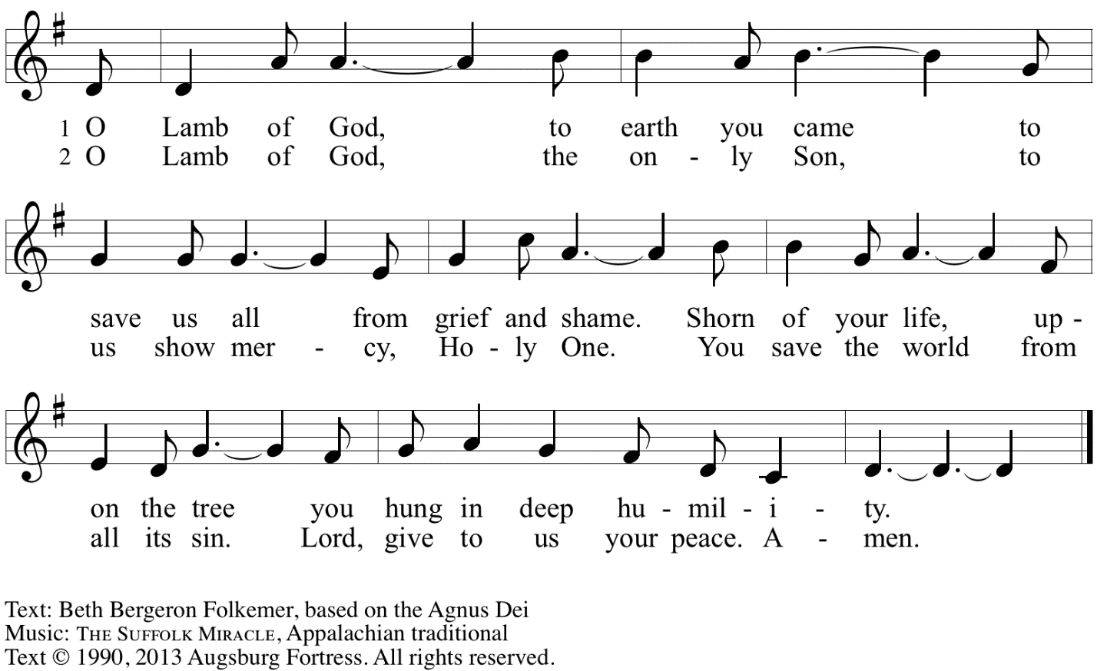
Reprinted with permission under OneLicense.net A# A-722139.

Please be seated.

Holy Communion
- All who seek God and desire a deeper and stronger life in Christ are welcome to receive Holy Communion.
- Worshipers from the pulpit side will proceed forward first, followed by the center section, and then the lectern side.
- Please inform an usher if you would like the ministers to bring Communion to you.
- Holy Communion will be served with bread and wine/grape juice.
- The presiding minister will first distribute the bread (host) to each communicant. Please indicate if you require a gluten-free host.
- Once you have consumed the bread, please pick up an empty glass from the tray next to the presiding minister. The Communion Assistant will pour wine from the chalice or grape juice from the cruet into your glass.
- Please step to the side to consume the wine or grape juice.
- Feel free to kneel at the altar rail for prayer after receiving the sacrament.
- As you return to your pew, glasses may be returned to the empty trays on either side of the center section.
- A blessing will be provided for anyone who does not yet receive the sacrament.
- All are invited to join in singing the hymns during Holy Communion.

Hymns during Holy Communion
Let My Spirit Always Sing ACS 1020

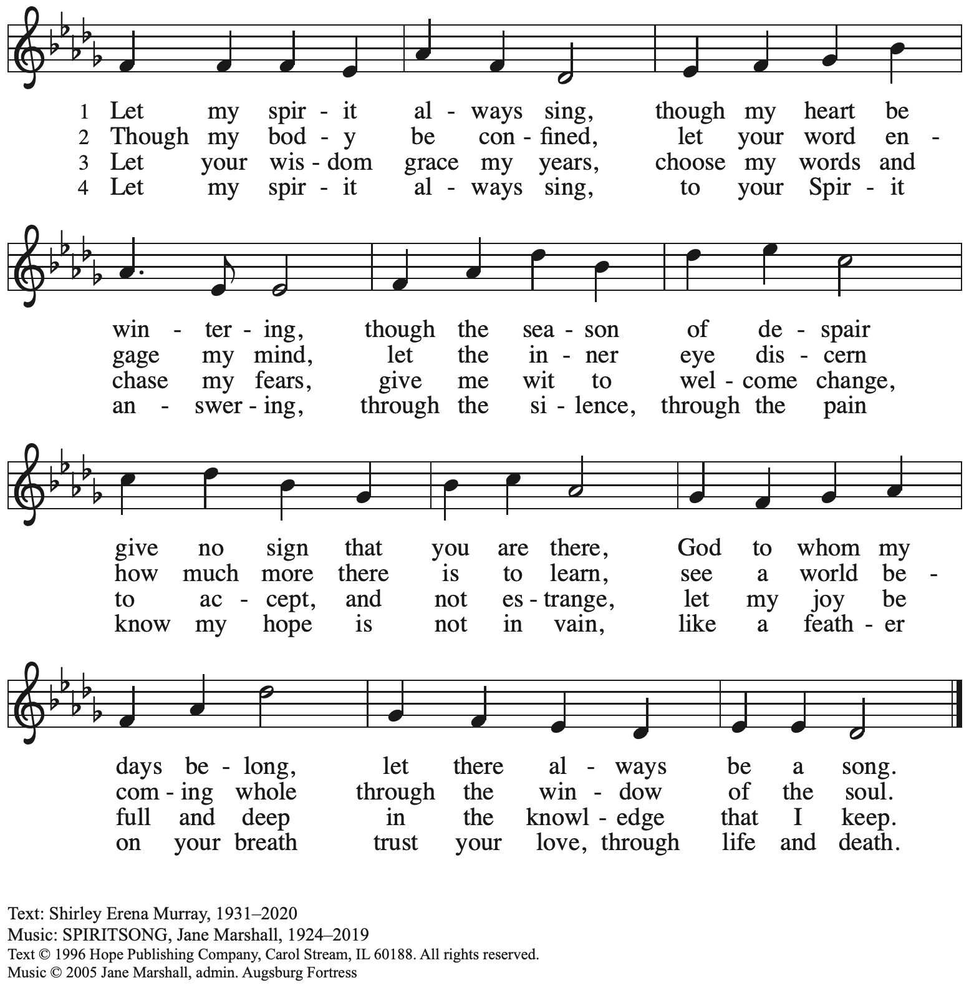
Reprinted with permission under OneLicense.net # A-722139.

Hymns during Holy Communion
There’s a Wideness in God’s Mercy ELW 587

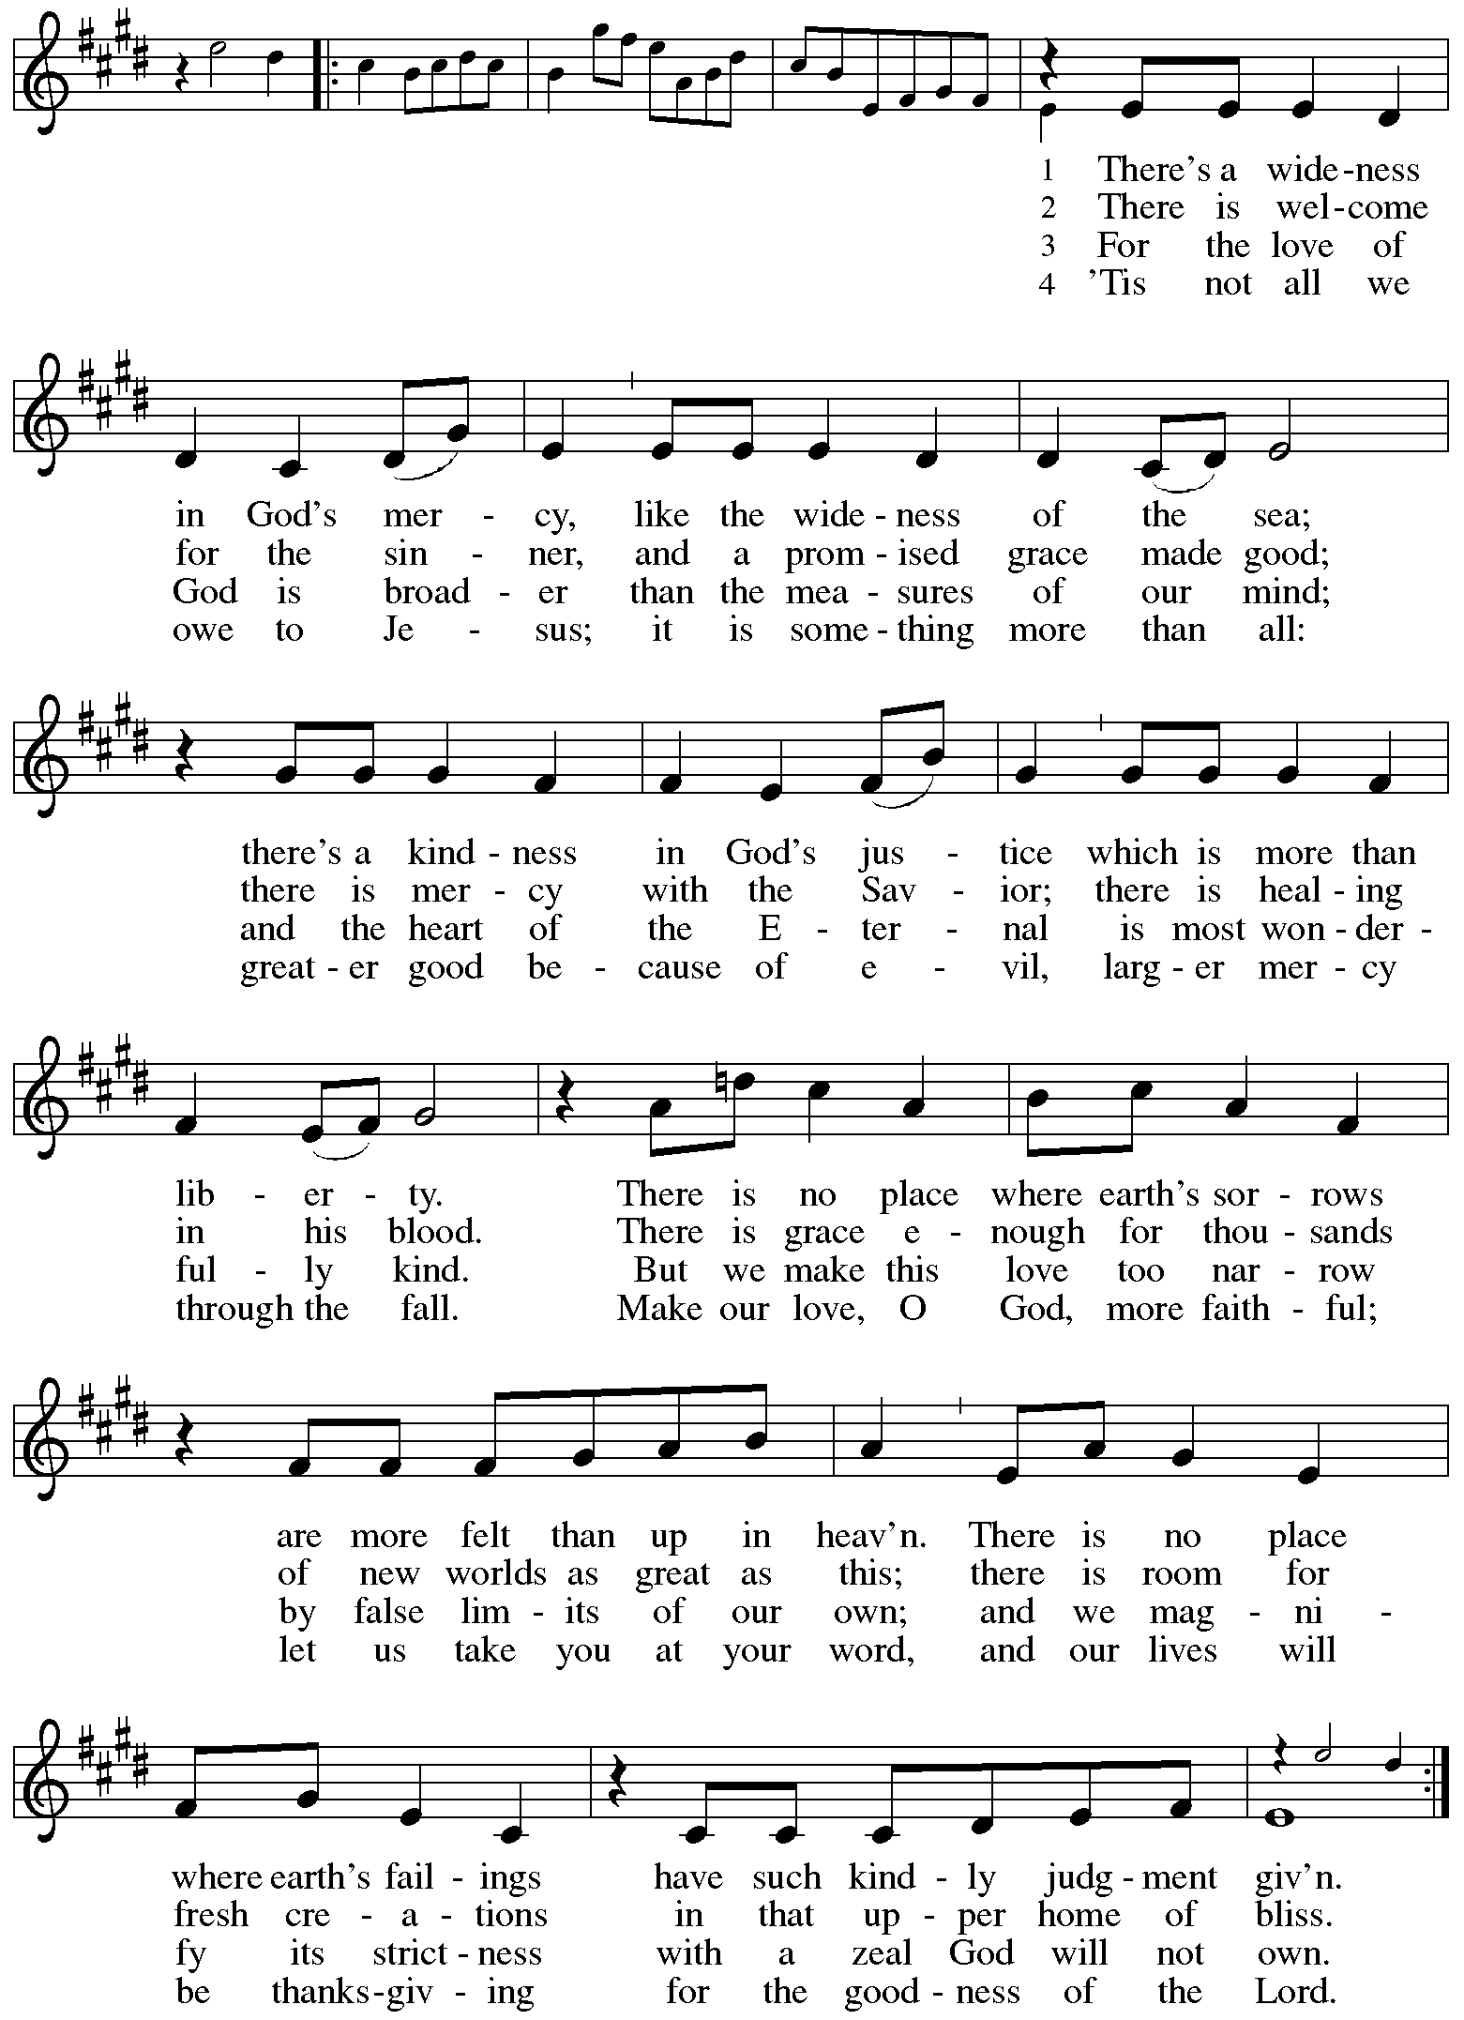

Hymns during Holy Communion
There Is A Balm in Gilead ELW 614

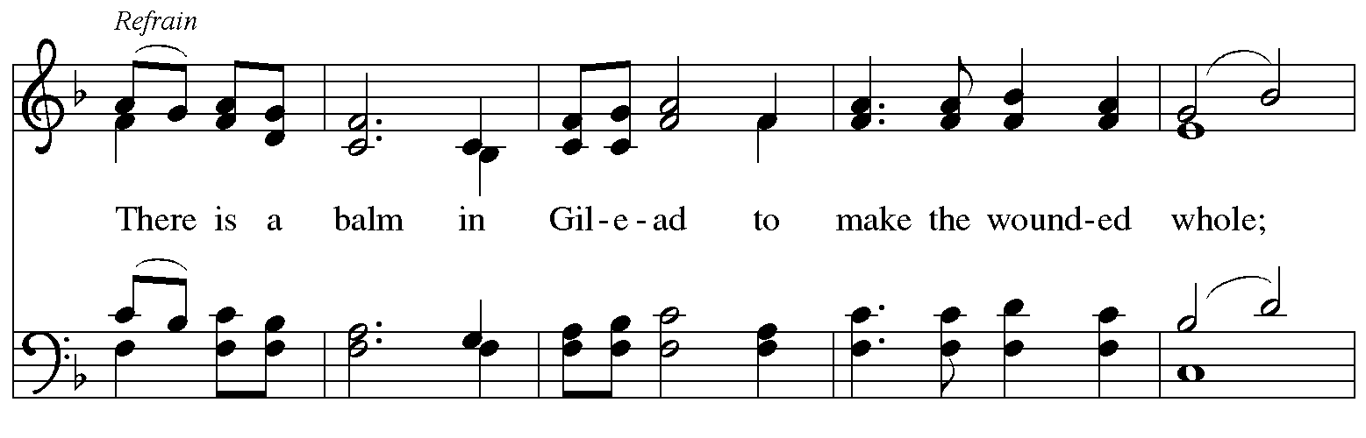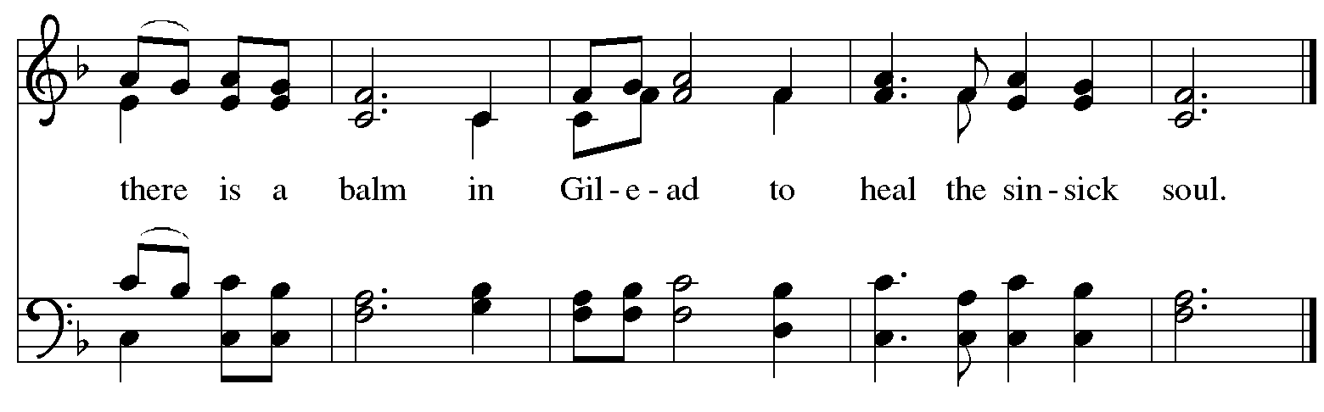
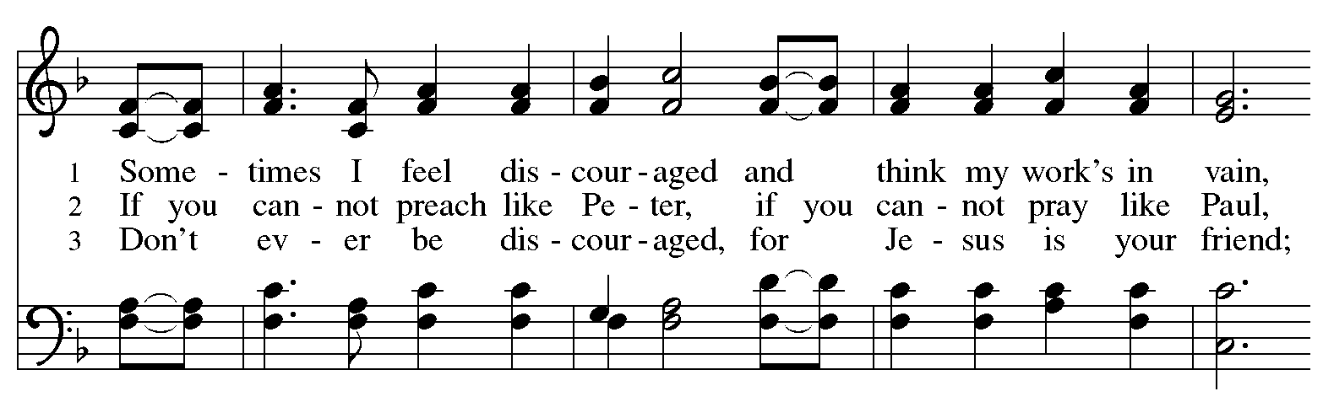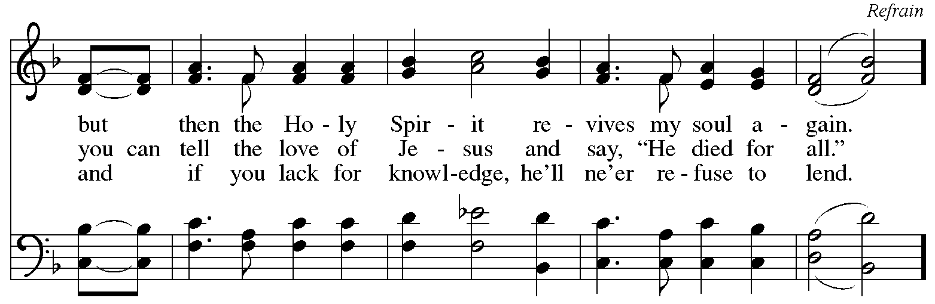

When all have returned to their places, please rise as you are able.

Blessing

P: The body and blood of our Lord Jesus Christ strengthen you and keep you in his grace.
C: Amen.

Prayer

A: Let us pray. Gracious God,
we give you thanks for your pruning, planting, and nurture.
We rejoice that you have used the harvest of field and vineyard
to renew and sustain us.
Lead us as we go from this life-giving meal
into lives of grateful service to you and your cherished creation;
through Jesus Christ, your Son, our Lord.
C: Amen.

Please be seated.

Sending
God blesses us and sends us in mission to the world

Announcements

Please rise as you are able.

Benediction

P: The God of steadfastness and encouragement
grant you to live in harmony with one another,
in accordance with Christ Jesus.
C: Amen.

P: The God of hope fill you with all joy and peace in believing,
so that you may abound in hope by the power of the Holy Spirit.
C: Amen.

P: The God of all grace ☩ bless you now and forever.
C: Amen.

Sending Hymn The Church of Christ, in Every Age ELW 720

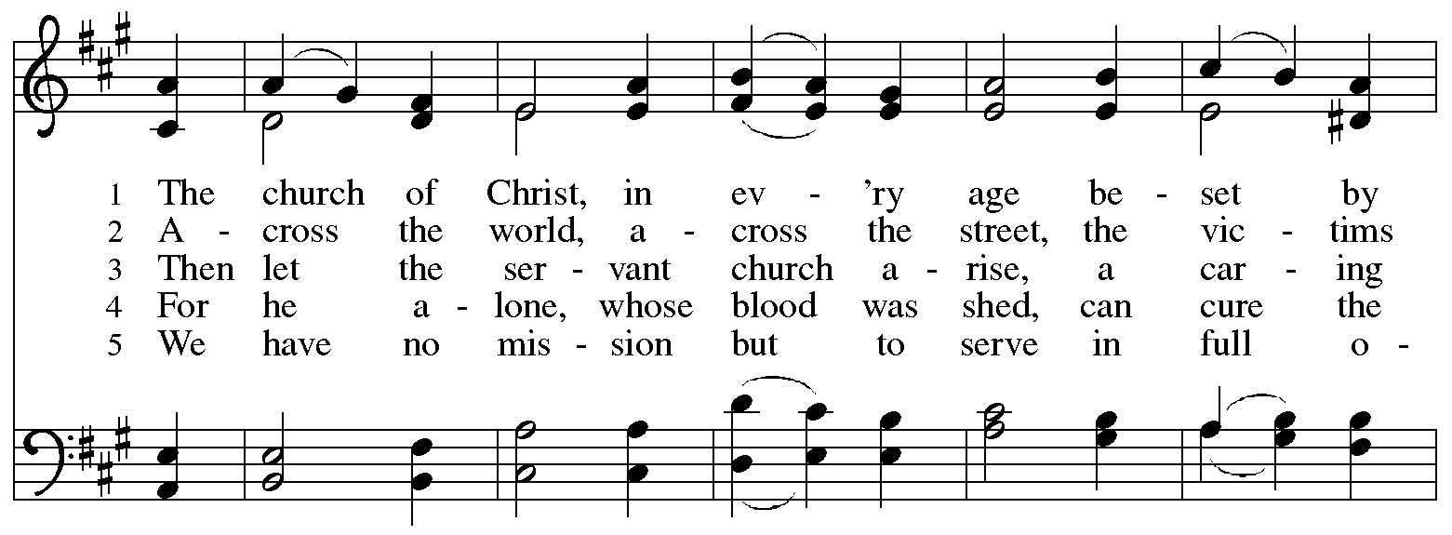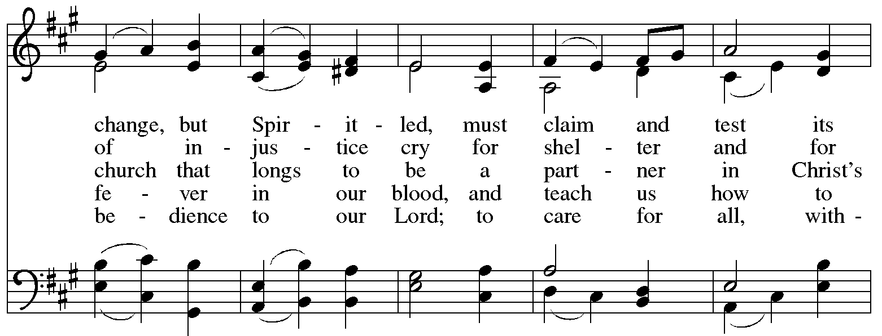
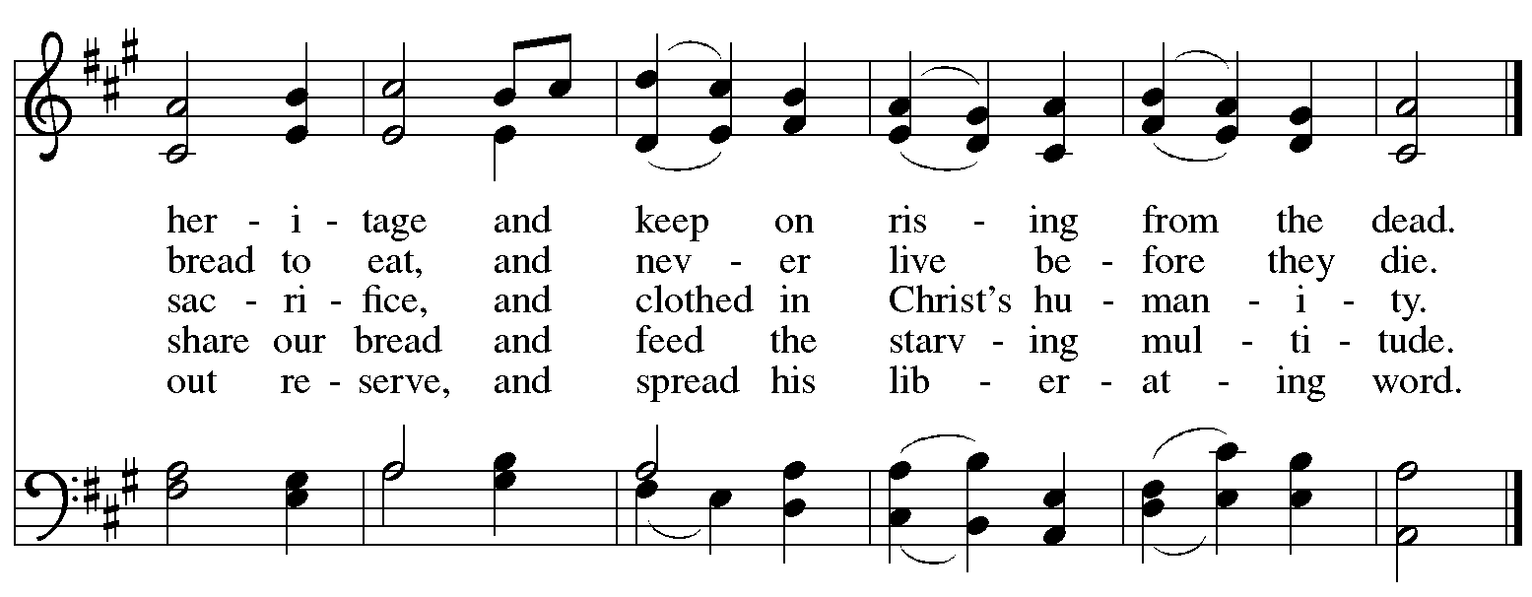
Reprinted under OneLicense.net # A-722139.

Dismissal

A: Go in peace. Serve the Lord.
C: Thanks be to God!

Postlude

Those serving in worship today

Altar Care Jodie Minor
Assisting Minister Timothy Kocher-Hillmer
Audio-Visual Ministers David Rollinson
Jered Stratton
Cantor Emily Duque
Lector Alda Maria Gonzaga
Minister of Music Laura Reynolds
Presiding Minister Pastor Ross Carmichael

Liturgy and Hymnody Acknowledgements

From SundaysandSeasons.com. Copyright © 2024 Augsburg Fortress. All rights reserved. Reprinted under OneLicense.net # A-722139.
Used by permission of Augsburg Fortress.

Holy, Holy, Holy / Long, Long Ago in Jerusalem – Text: Beth Bergeron Folkemer, based on the Sanctus. Music: SHADY GROVE, Appalachian traditional. Text © 1990, 2013, Augsburg Fortress. All rights reserved. Reprinted with permission under OneLicense.net # A-722139.

There’s a Wideness in God’s Mercy – Text: Frederick W. Faber, 1814-1863, alt. Music: ST. HELENA, Calvin Hampton, 1938-1984.
Music © 1977 GIA Publications, Inc., 7404 S. Mason Ave., Chicago, IL 60638. www.giamusic.com. 800.442.3358. All rights reserved. Reprinted under OneLicense.net # A-722139.

Please use the QR code below to link to St. Andrew’s announcements online!

St. Andrew Lutheran Church Announcements
June 2nd, 2024

- Welcome to Worship at St. Andrew on the Second Sunday after Pentecost, June 2nd, 2024 – We are so glad you are here, and we offer a special welcome to all visitors and guests connecting for the first time! Worship attendees are invited to make a name tag at the back of the worship space if you would like. There are worship “toolkits” to help children engage with worship and “busy bags” for younger children available in the bookcase at the back of the sanctuary. Please feel free to take one to use with/for your children.
- Welcome, New Members Emily Duque and Monica Snyder! – Today during worship we officially welcome Monica and Emily to the St. Andrew community! Please take time to greet them and offer your blessings and support in our ministry together!
- Monthly Reparations Offering Today during Worship – Jesus’ parable from Luke’s Gospel about a compassionate Samaritan provides an example of how God's people are called to work for healing and repair for our neighbors, independent of who or what caused harm. In light of this, St. Andrew has made a commitment to reparations in regard to African American spiritual songs used in our worship. The text and music of most hymns is attributed to specific authors, with copyrights in place, usage reported, and royalties paid to those whose works are featured in worship. With African American spirituals, this is not possible. In response to many years of such uncredited use, St. Andrew invites the congregation to give a reparations offering. Funds received in worship will be donated to our siblings at Bethel AME Church, whose land and building were taken from them in the 1950s, to fund their development in the lower Hill District.
- June Produce Distribution – First Tuesday of the Month, June 4th, 2024, from 5:30-7:00 p.m. – St. Andrew partners with Greater Pittsburgh Community Food Bank to serve as a distribution site for fresh produce on the first Tuesday of every month. June’s distribution will be Tuesday, June 4th. We invite people of the congregation to help with the distribution from 5:30-7:00 p.m., help with unloading and setup during the day between 10:00 a.m. and 1:00 p.m., or just to pick up fresh produce!
- Special Congregational Meeting – Sunday, June 9th, 2024 after Worship – St. Andrew has scheduled a congregational meeting for Sunday, June 9th, to discuss the council's recommended proposal for work on the church roof and the prospect of hiring a construction company as general contractor to oversee the project. Confirmed members of the congregation are eligible to vote on matters before the congregation, in person or online, but no proxy or absentee votes can be accepted. Please plan to attend this important meeting! If anyone is unable to attend in person, the meeting will be available via Zoom using the Sunday worship link from your “This Week at St. Andrew” email.
- Bethel AME Church Juneteenth Celebrations – Sunday, June 16th, 11:00 a.m. and 2:00 p.m. – Bethel AME Church in the Hill District (2720 Webster Ave, 15219), with whom the St. Andrew congregation and our Southwestern Pennsylvania (SWPA) Synod have been in relationship with for the past several years, will host Juneteenth celebrations on Sunday, June 16th, with Bishop Kurt F. Kusserow of the Southwestern Pennsylvania Synod as the speaker at the 11:00 a.m. service and with Bishop Errenous E. McCloud, Jr. of the AME Church as the speaker at the 2:00 p.m. service.

- Shelter Dinner at East End Cooperative Ministry – Thursday, June 20th, 6:30 p.m. –
Each month, people of St. Andrew provide dinner for guests of East End Cooperative Ministry, 6140 Station St. (East Liberty), 15206. We invite you to prepare or purchase one menu item and bring it to the shelter by 6:00 p.m., or just come to help serve at 6:30 p.m. Please sign up here: https://www.signupgenius.com/go/5080544AAAC22A1F58-49850224-june.
- Represent St. Andrew at Millvale Pride on Saturday, June 22nd, between 10:30 a.m. –5:30 p.m. – St. Andrew is a Reconciling in Christ (RIC) congregation, intentionally welcoming and affirming all, including people of all sexual orientations, gender identities, and gender expressions. Reconciling in Christ congregations come together under the umbrella of ReconcilingWorks: Lutherans for Full Participation, and this year St. Andrew is collaborating with other RIC congregations to bear public witness to that welcome at a booth at Millvale Pride. We will have information about St. Andrew and the other congregations, fun giveaways, and opportunities to meet neighbors and share the good news of God’s boundless love. We invite people of St. Andrew to sign up for a shift that day using this link: RW Pittsburgh - PRIDE Millvale Volunteers: RIC Church Members & RW Pittsburgh - Part 2 (signupgenius.com). See Pastor Carmichael or Kelly Spanninger if you have questions.
- New Christ in Our Home Devotional Booklets (July – September) Available at Church Entrances – Christ in Our Home is a booklet of devotions that includes Scripture, a brief reflection, and prayer for each day. The new edition for July – September is now available at the various church entrances. Please feel free to take one for yourself or others. Booklets for June are still available, as well!

