+ Holy Trinity
May 26, 2024
St. Andrew Lutheran Church
304 Morewood Ave.
Pittsburgh, PA 15213
St_andrewELCA@verizon.net
www.standrewpittsburgh.org

+ Holy Trinity
Order for Worship

When the church says that God triune it is saying something about who God is beyond, before, and after the universe: that there is community within God. Our experience of this is reflected in Paul’s words today. When we pray to God as Jesus prayed to his Abba (an everyday, intimate parental address), the Spirit prays within us, creating between us and God the same relationship Jesus has with the one who sent him.

Welcome to St. Andrew!
- St. Andrew Lutheran congregation welcomes all who are seeking a place of healing and wholeness – a nurturing, faith-forming spiritual home. Our community embraces people of all ages, ethnicities, cultures, abilities, sexual orientations, gender identities and expressions, and family constellations. Come and See!
- Worship Services are live streamed to multiple online platforms. By attending worship, you agree that your image and voice may be broadcast.
- Everyone is invited to make a name tag at the black bookcase in the back of the worship space if they would like. There are stickers indicating pronouns on the bookcase if you would like to include them on your name tag.
- A nursery is available through the doors at the left side of the sanctuary and across from the doorway to the Social Hall. It is a purple-colored room.
- Children are invited to attend Little Church – Big Faith, a Bible lesson and activity, during worship (after the Prayer of the Day). The group returns to the worship space for the liturgy of Holy Communion.
- Worship “toolkits” to help children engage with the service, along with “busy bags” for younger children, are available in the bookcase at the back of the sanctuary. Please feel free to take one to use with/for your children.
- Holy Communion is served with bread (gluten-free available) and wine or grape juice. The presiding minister will distribute the bread (host). Please consume this and then pick up an empty glass from the tray. The Communion Assistant will pour wine or grape juice into your glass. Please step to the side to consume the wine or grape juice. Feel free to kneel at the altar for prayer and reflection. As you return to your pew, glasses may be returned to the empty trays on either side of the center section.
- A restroom is available on the main level of the church, through the doors to the Social Hall and to the right in the main office.

Abbreviations
P: Pastor/Presiding Minister ELW: Evangelical Lutheran Worship hymnal
A: Assisting Minister ACS: All Creation Sings hymnal
L: Lector OLS: Of the Land and Seasons liturgy
C: Congregation

Pre-Service Music

Welcome

Prelude Sarabande BWV 812 J.S. Bach

Gathering
The Holy Spirit calls us together as the people of God

Confession and Forgiveness

Please rise as you are able.
All may make the sign of the cross, the sign that is marked at Baptism,
as the presiding minister begins.

P: Blessed be the holy Trinity, ☩ one God,
who forgives all our sin, whose mercy endures forever.
C: Amen.

P: Let us confess our sin in the presence of God and of one another.

Silence is kept for reflection

P: Most merciful God,
C: we confess that we are captive to sin and cannot free ourselves.
We have sinned against you in thought, word, and deed,
by what we have done and by what we have left undone.
We have rejected your guidance. We have avoided your pruning of our cluttered lives.
We have failed to maintain the tools of stewardship, outreach, and witness
you have provided for the nurture of your church.
For the sake of your Son, Jesus Christ, have mercy on us.
Forgive us, grant us discipline, and redirect us,
so that we may delight in your will and follow in your ways,
to the glory of your holy name.
Amen.

P: God, who is rich in mercy,
loved us even when we were dead in sin
and made us alive together with Christ.
By grace you have been saved.
In the name of ☩ Jesus Christ, your sins are forgiven.
Almighty God strengthen you with the Holy Spirit,
that Christ may live in your hearts through faith.
C: Amen.
Gathering Hymn Love Divine, All Loves Excelling ELW 631

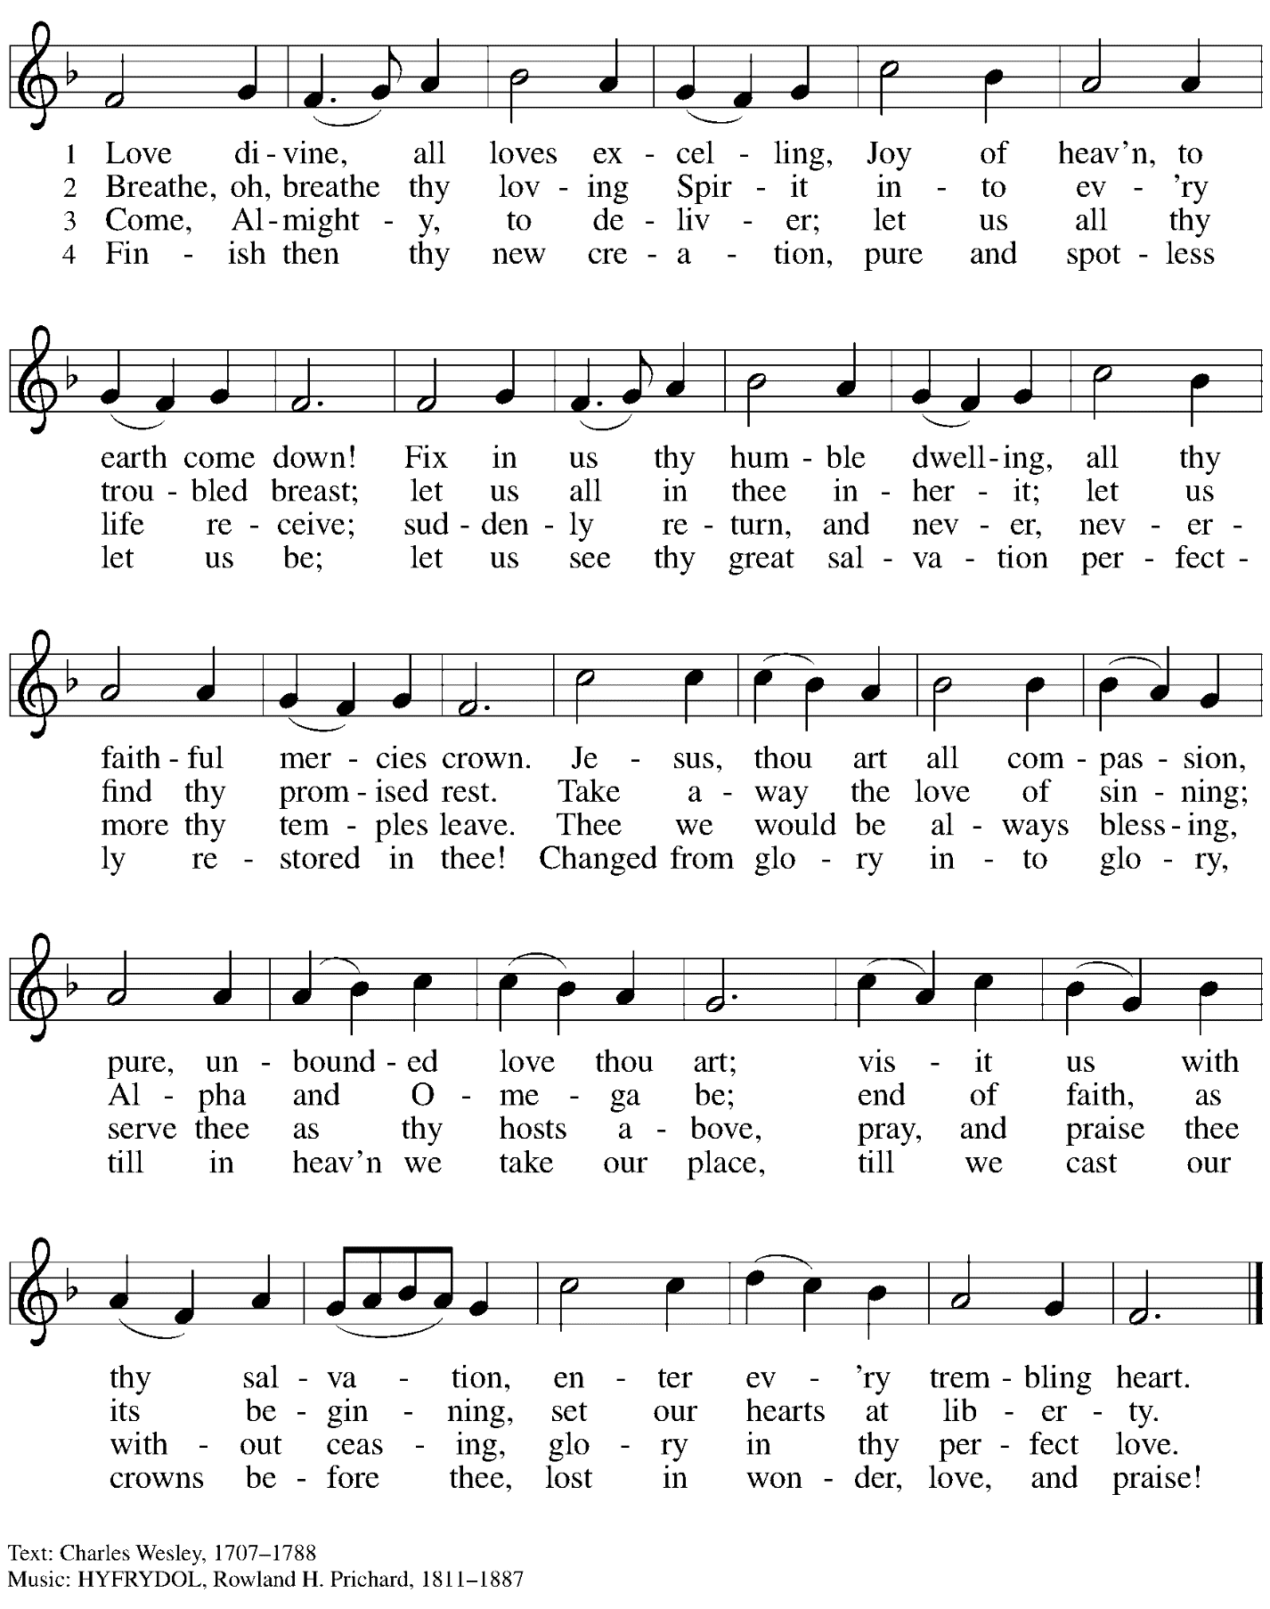

Greeting

P: The grace of our Lord Jesus Christ, the love of God,
and the communion of the Holy Spirit be with you all.
C: And also with you.

Kyrie OLS 1

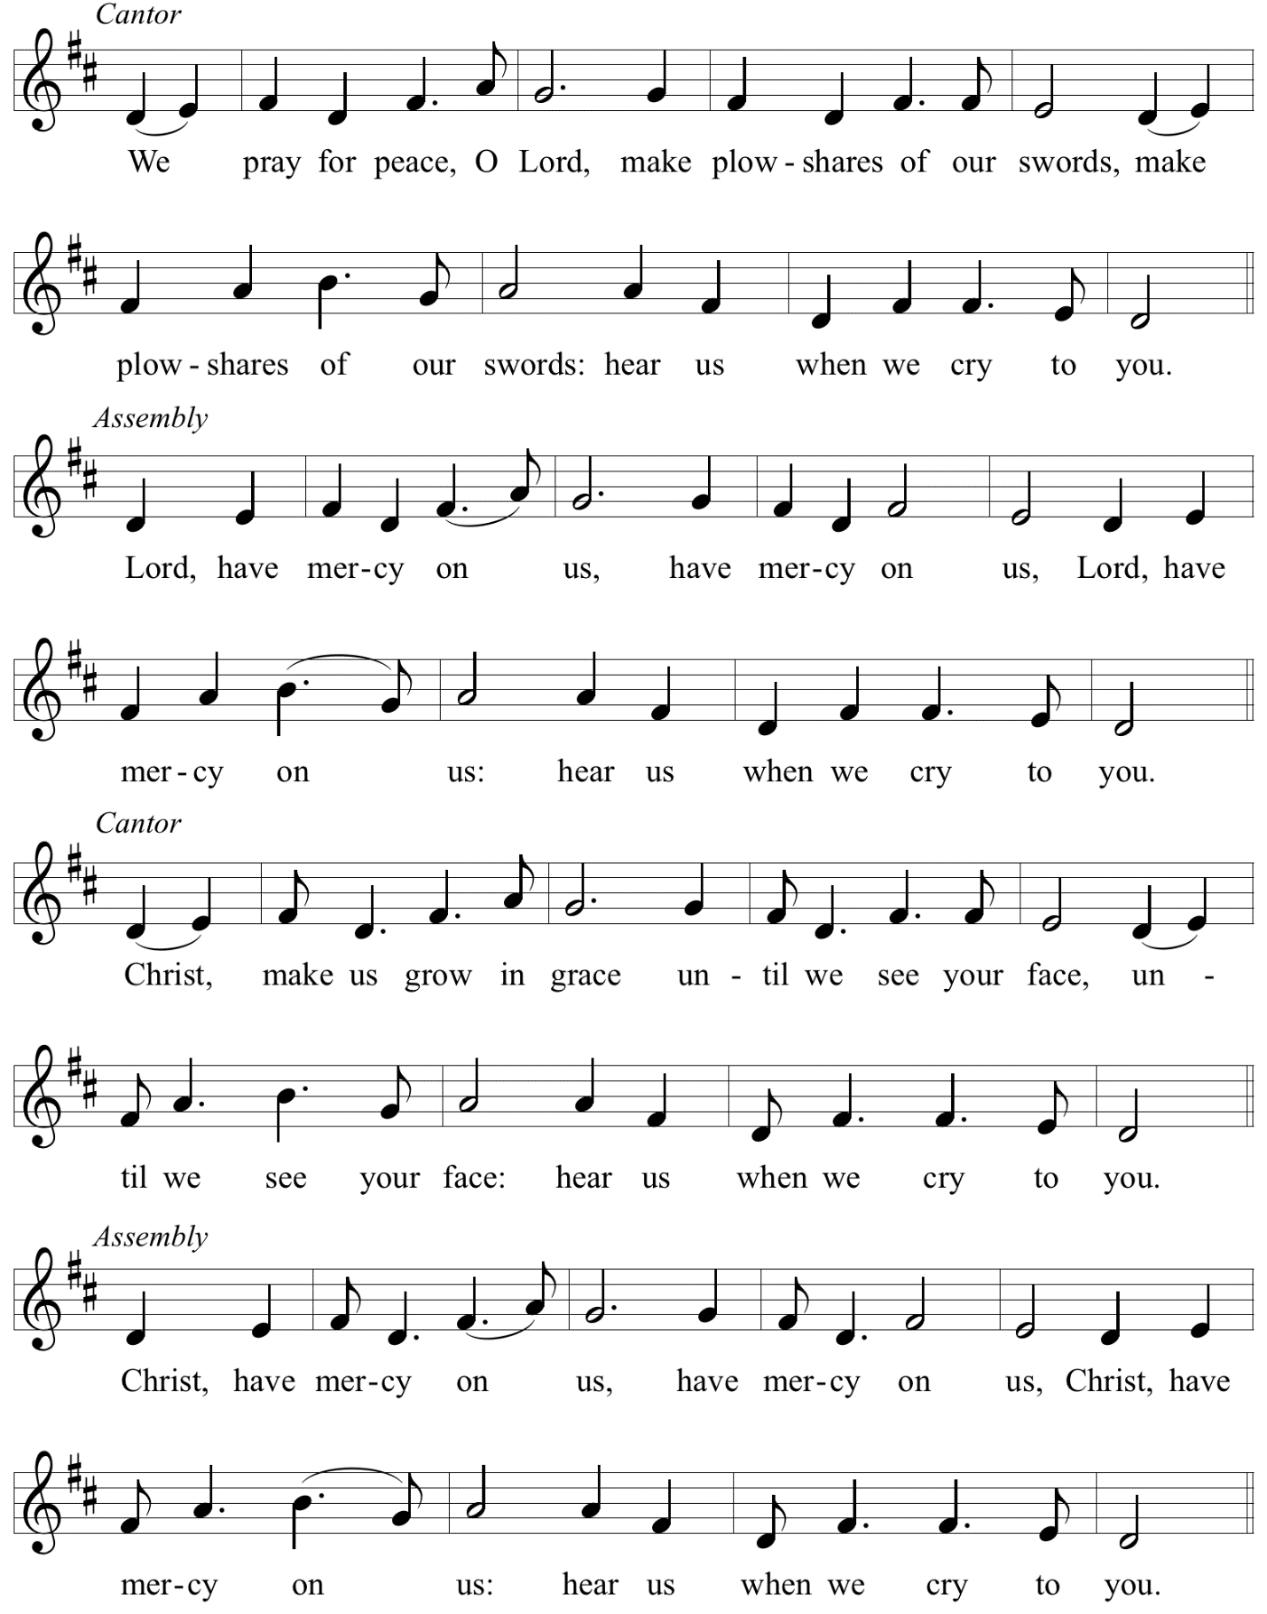

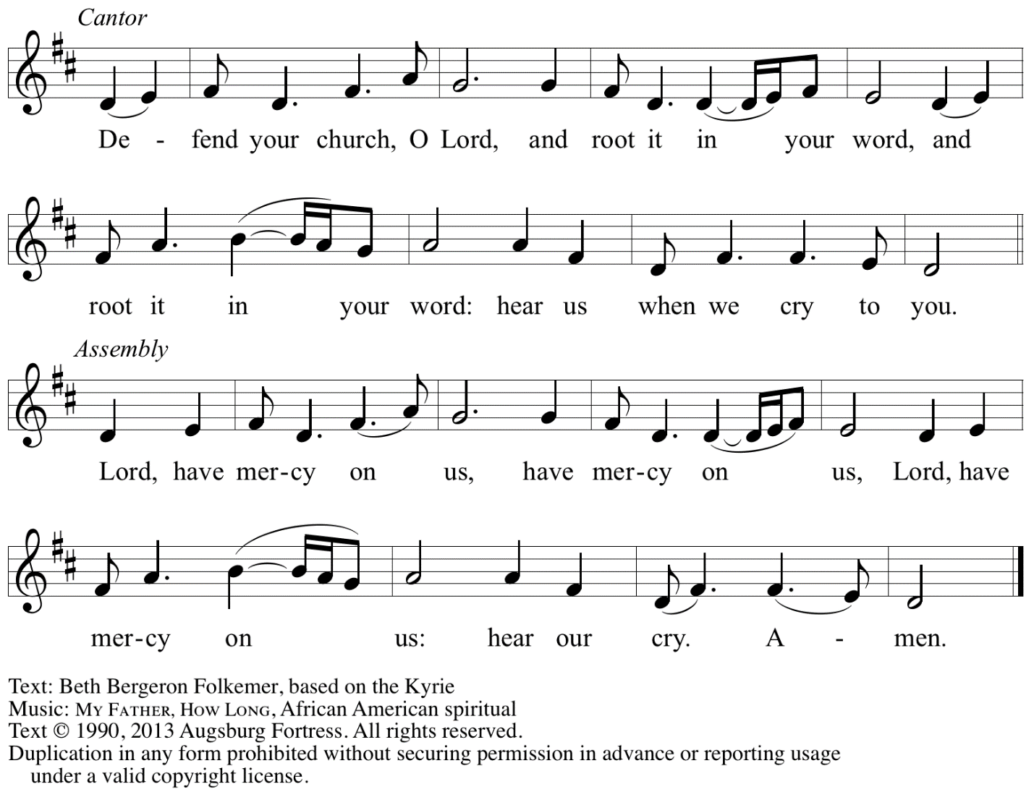
Reprinted with permission under OneLicense.net # A-722139.

Hymn of Praise Oh, Sing of God’s Great Victory! OLS 3

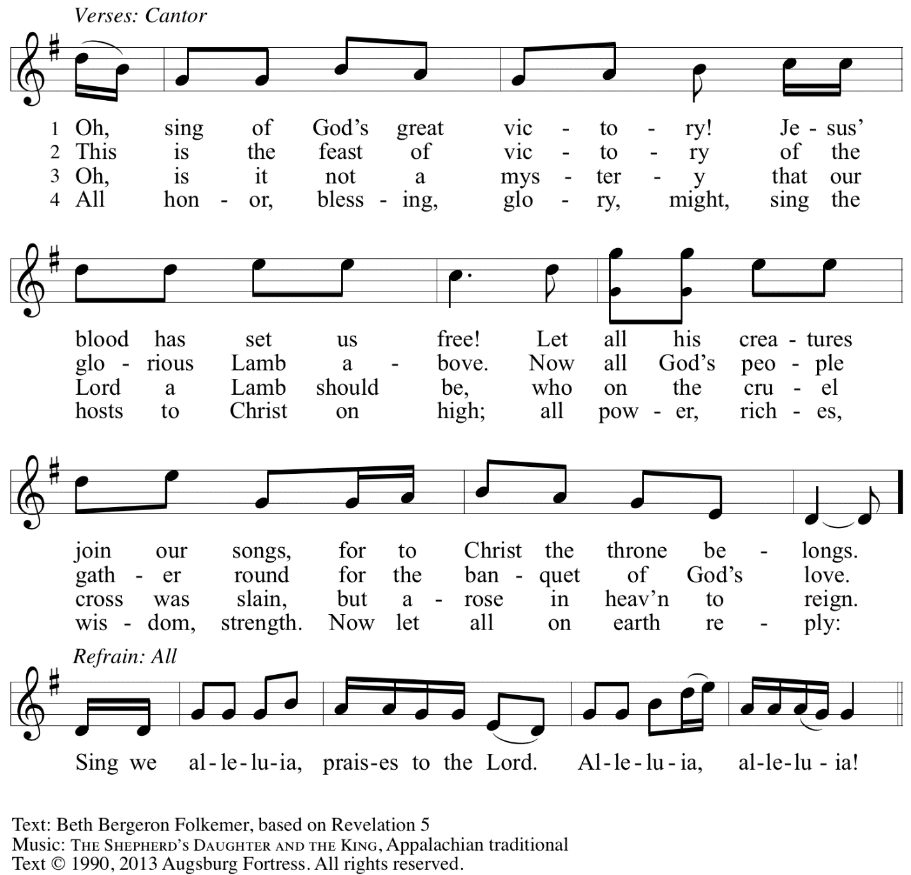
Reprinted with permission under OneLicense.net # A-722139.

Prayer of the Day

P: The Lord be with you.
C: And also with you.

P: Let us pray.
Almighty Creator and ever-living God:
we worship your glory, eternal Three-in-One,
and we praise your power, majestic One-in-Three.
Keep us steadfast in this faith,
defend us in all adversity, and bring us at last into your presence,
where you live in endless joy and love, Father, Son, and Holy Spirit,
one God, now and forever.
C: Amen.

Please be seated.

Word
God speaks to us in Scripture reading, preaching, and song

First Reading – Isaiah 6: 1-8

¹In the year that King Uzziah died, I saw the Lord sitting on a throne, high and lofty; and the hem of his robe filled the temple. ²Seraphs were in attendance above him; each had six wings: with two they covered their faces, and with two they covered their feet, and with two they flew. ³And one called to another and said:
“Holy, holy, holy is the Lord of hosts;
the whole earth is full of the Lord’s glory.”
⁴The pivots on the thresholds shook at the voices of those who called, and the house filled with smoke. ⁵And I said: “Woe is me! I am lost, for I am a man of unclean lips, and I live among a people of unclean lips; yet my eyes have seen the King, the Lord of hosts!”
⁶Then one of the seraphs flew to me, holding a live coal that had been taken from the altar with a pair of tongs. ⁷The seraph touched my mouth with it and said: “Now that this has touched your lips, your guilt has departed and your sin is blotted out.” ⁸Then I heard the voice of the Lord saying, “Whom shall I send, and who will go for us?” And I said, “Here am I; send me!”

L: Word of God, word of life.
C: Thanks be to God.

Psalm 29

The psalm will be led by the cantor, with the congregation invited to join in singing the alternate verses in bold typeface and the refrain.

Psalm tone

Psalm refrain

¹Ascribe to the | Lord, you gods,
ascribe to the Lord glo- | ry and strength.
²Ascribe to the Lord the glory | due God’s name;
worship the Lord in the beau- | ty of holiness.
³The voice of the Lord is upon the waters; the God of | glory thunders;
the Lord is upon the | mighty waters.
⁴The voice of the Lord is a pow- | erful voice;
the voice of the Lord is a | voice of splendor. R
⁵The voice of the Lord breaks the | cedar trees;
the Lord breaks the ce- | dars of Lebanon;
⁶the Lord makes Lebanon skip | like a calf,
and Mount Hermon like a | young wild ox.
⁷The voice | of the Lord
bursts forth in | lightning flashes.
⁸The voice of the Lord | shakes the wilderness;
the Lord shakes the wilder- | ness of Kadesh. R
⁹The voice of the Lord makes the oak trees writhe and strips the | forests bare.
And in the temple of the Lord all are | crying, “Glory!”
¹⁰The Lord sits enthroned a- | bove the flood;
the Lord sits enthroned as king for- | evermore.
¹¹O Lord, give strength | to your people;
give them, O Lord, the bless- | ings of peace. R

Second Reading – Romans 8: 12-17

¹²Kindred, we are debtors, not to the flesh, to live according to the flesh—¹³for if you live according to the flesh, you will die; but if by the Spirit you put to death the deeds of the body, you will live. ¹⁴For all who are led by the Spirit of God are children of God. ¹⁵For you did not receive a spirit of slavery to fall back into fear, but you have received a spirit of adoption. When we cry, “Abba! Father!” ¹⁶it is that very Spirit bearing witness with our spirit that we are children of God, ¹⁷and if children, then heirs, heirs of God and joint heirs with Christ—if, in fact, we suffer with him so that we may also be glorified with him.

L: Word of God, word of life.
C: Thanks be to God.

Please rise as you are able.

Gospel Acclamation O God, Whose Word Well-Planted OLS 4
v. 1-2

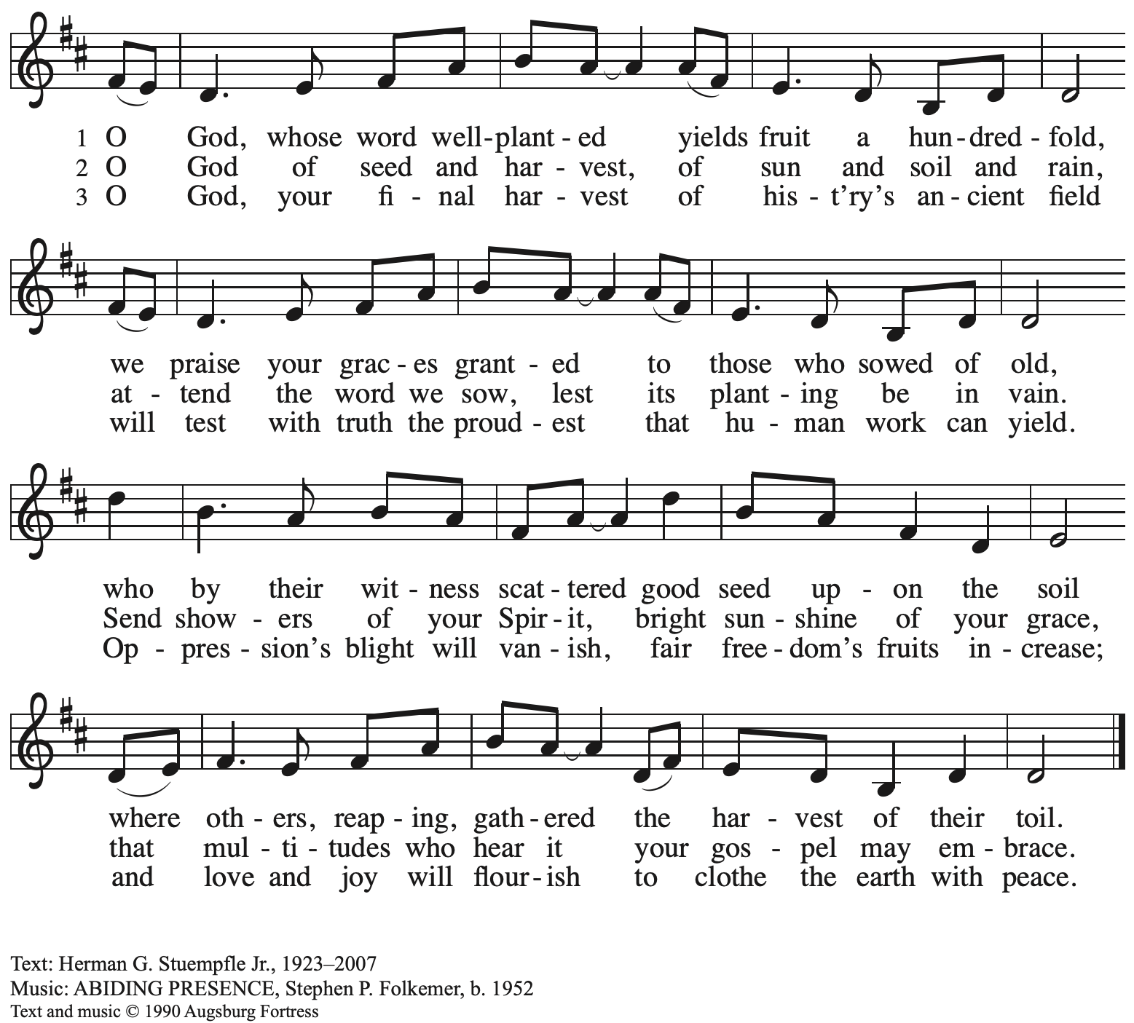
All rights reserved. Reprinted under OneLicense.net # A-722139.

Gospel – John 3: 1-17

P: The holy Gospel according to St. John.
C: Glory to you, O Lord.

¹Now there was a Pharisee named Nicodemus, a leader of the Jews. ²He came to Jesus by night and said to him, “Rabbi, we know that you are a teacher who has come from God; for no one can do these signs that you do apart from the presence of God.” ³Jesus answered him, “Very truly, I tell you, no one can see the kingdom of God without being born from above.” ⁴Nicodemus said to him, “How can anyone be born after having grown old? Can one enter a second time into the mother’s womb and be born?” ⁵Jesus answered, “Very truly, I tell you, no one can enter the kingdom of God without being born of water and Spirit. ⁶What is born of the flesh is flesh, and what is born of the Spirit is spirit. ⁷Do not be astonished that I said to you, ‘You must be born from above.’ ⁸The wind blows where it chooses, and you hear the sound of it, but you do not know where it comes from or where it goes. So it is with everyone who is born of the Spirit.” ⁹Nicodemus said to him, “How can these things be?” ¹⁰Jesus answered him, “Are you a teacher of Israel, and yet you do not understand these things?
¹¹“Very truly, I tell you, we speak of what we know and testify to what we have seen; yet you do not receive our testimony. ¹²If I have told you about earthly things and you do not believe, how can you believe if I tell you about heavenly things? ¹³No one has ascended into heaven except the one who descended from heaven, the Son of Humanity. ¹⁴And just as Moses lifted up the serpent in the wilderness, so must the Son of Humanity be lifted up, ¹⁵that whoever believes in him may have eternal life.
¹⁶“For God so loved the world that God gave God’s only Son, so that everyone who believes in him may not perish but may have eternal life.
¹⁷“Indeed, God did not send the Son into the world to condemn the world, but in order that the world might be saved through him.”

P: The Gospel of the Lord.
C: Praise to you, O Christ.

Please be seated.

Sermon

A time of silence for prayer and reflection follows the sermon.

When the hymn of the day begins, please rise as you are able.
Hymn of the Day Come, Join the Dance of Trinity ELW 412

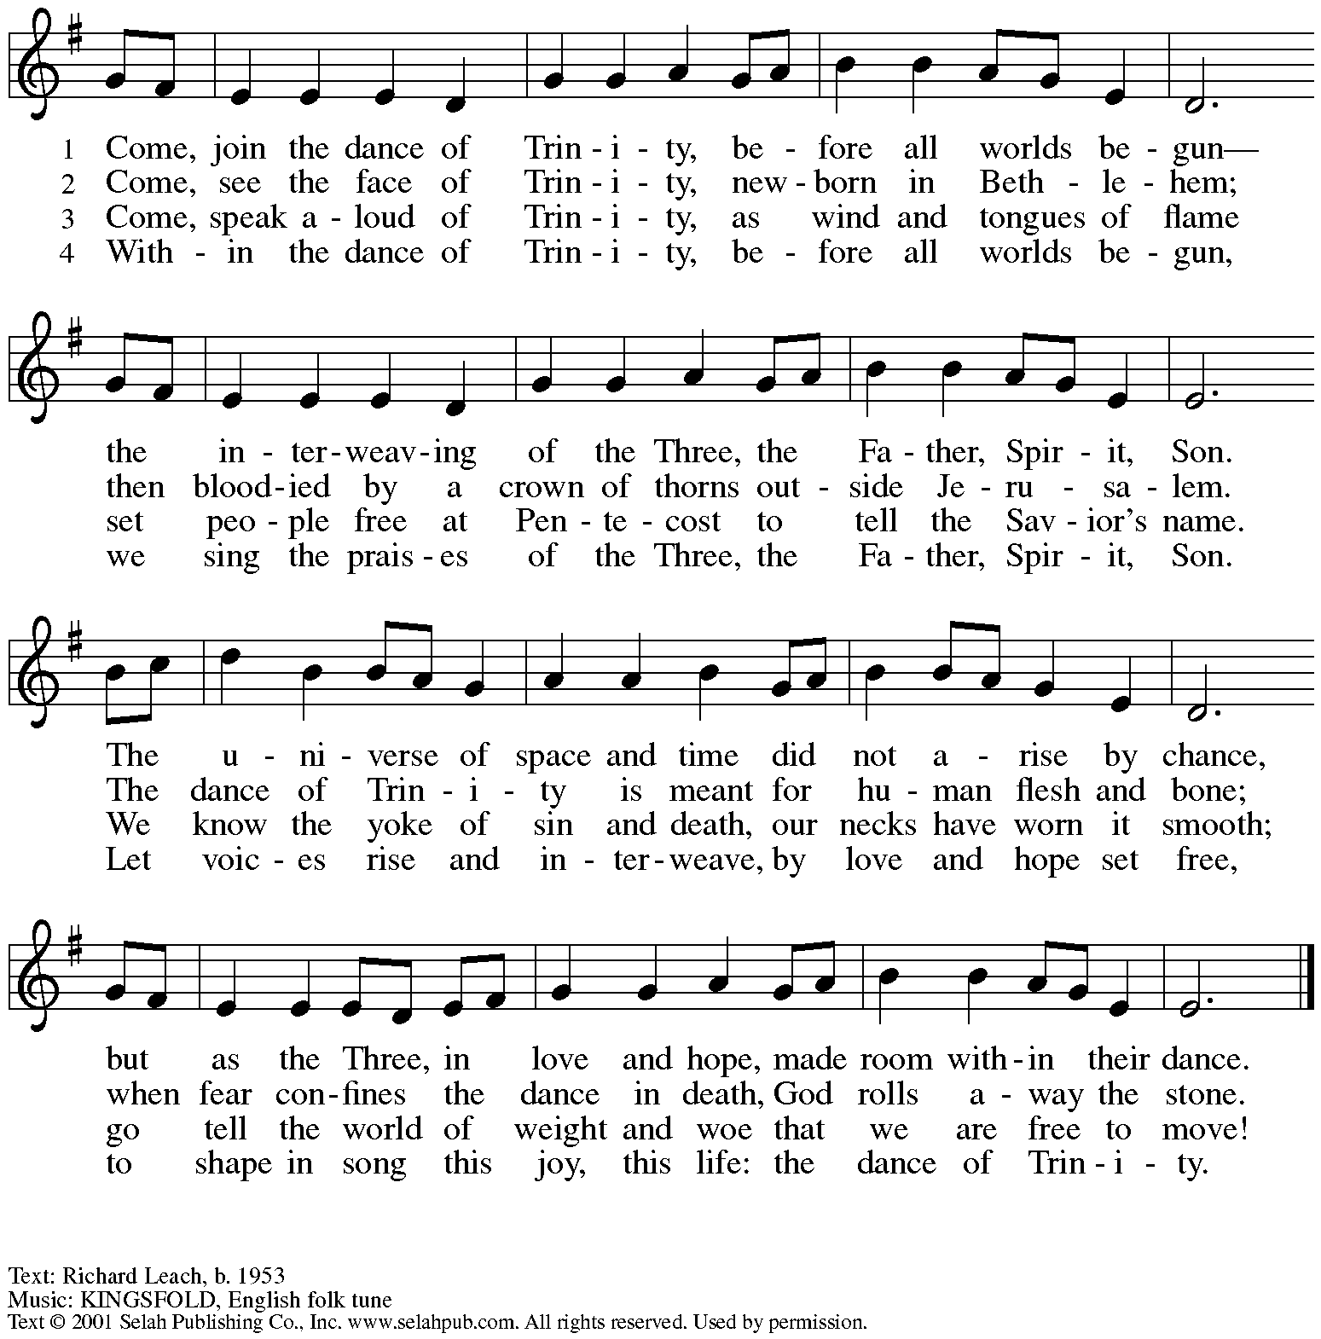
All rights reserved. Reprinted with permission under OneLicense.net # A-722139.

Prayers of the People

A: We come before our triune God to pray for the church, our communities, the world,
and for all who are in need.

After each petition
A: God, in your mercy,
C: receive our prayer.

The presiding minister concludes the prayers
P: Receive our prayers O God, and come quickly to our aid,
by the power of the Holy Spirit and in the love of Jesus Christ.
C: Amen.

Peace

The presiding minister and the assembly greet one another in the peace of the risen Christ.
P: The peace of Christ be with you always.
C: And also with you.

The people may greet those around them with a sign of Christ’s peace and may say
Peace be with you or similar words. Please be mindful that not everyone will be comfortable with sharing the peace, so please seek consent before shaking hands or hugging. Other possible ways to share the peace include a simple bow with the verbal greeting of peace, or simply a verbal expression of peace.

When the greetings of peace have concluded, please be seated.

Meal
God feeds us with the presence of Jesus Christ

Offering

We offer ourselves, our gifts, and our faithful service to God.
As the offering is gathered for the mission of the church, including the care of those in need,
the table is set for Holy Communion.

Music during the Offering
Holy, Holy, Holy arr. Faber

As the gifts are brought forward for presentation, please rise as you are able.

Offertory Song Accept, O Lord, the Gifts We Bring OLS 5

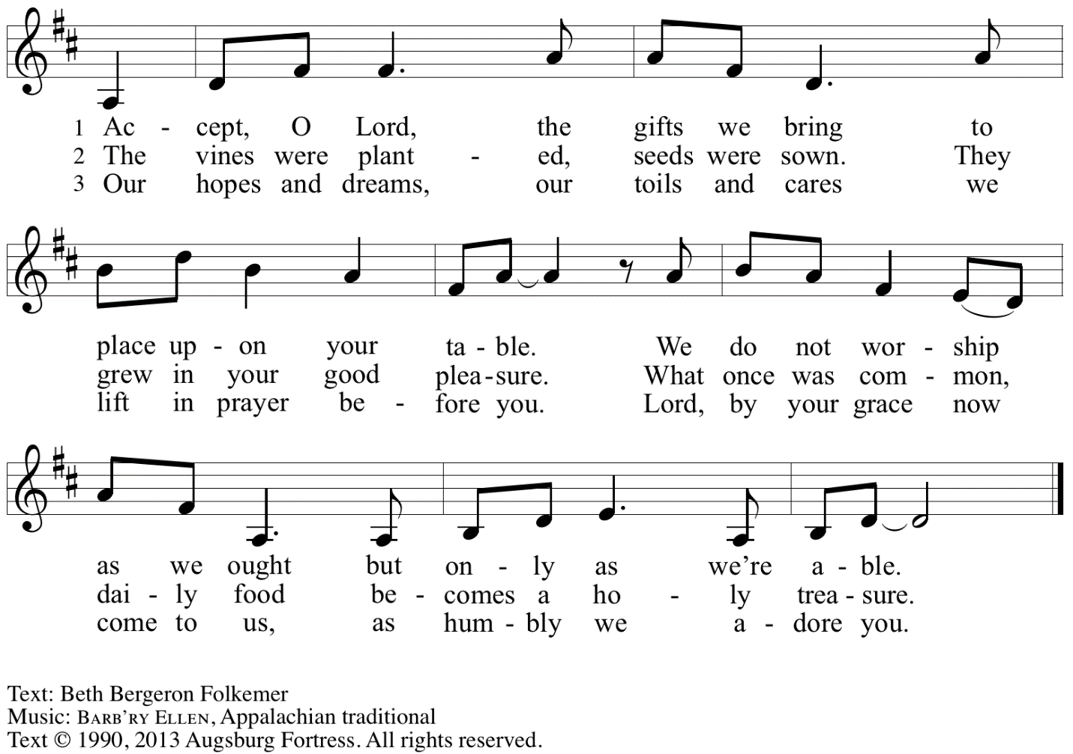
Reprinted under OneLicense.net # A-722139.

Offertory Prayer

A: Let us pray.
Gracious God,
C: you bless us with gifts of guidance, new life,
growth in grace, and fruitful labor.
Accept the first fruits of time and toil, field and orchard,
that we offer here. Bless and multiply these gifts to our nurture
and the care of your creation;
for the sake of your Son, Jesus Christ, our Lord.
Amen.

Dialogue

P: The Lord be with you.
C: And also with you.

P: Lift up your hearts.
C: We lift them to the Lord.

P: Let us give thanks to the Lord our God.
C: It is right to give our thanks and praise.

Preface

P: It is indeed right, our duty and our joy …
… we praise your name and join in adoring song:

Sanctus Holy, Holy, Holy OLS 6

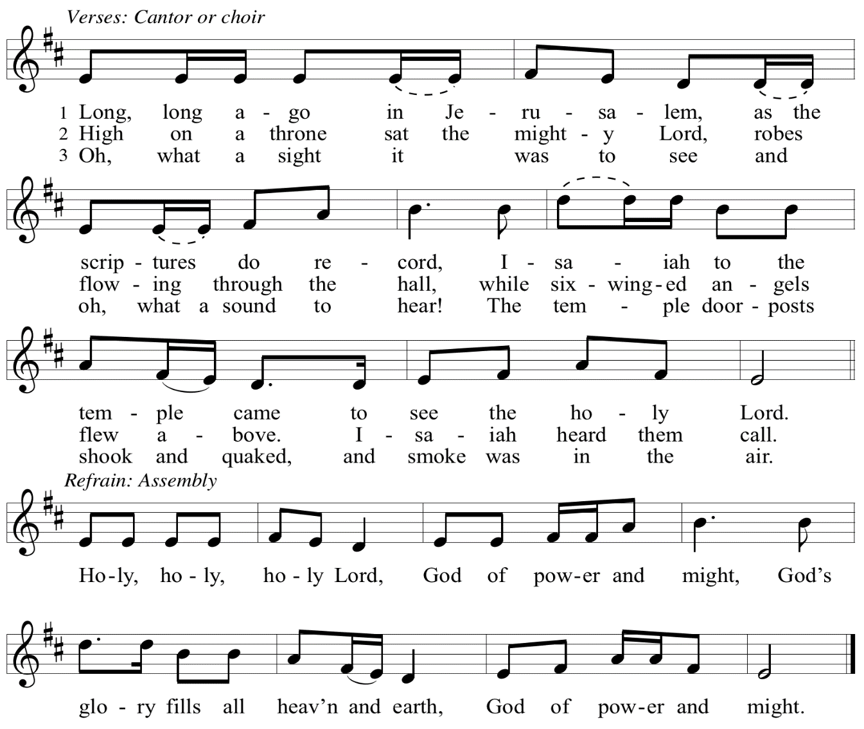

Eucharistic Prayer

P: Holy God, Holy One, Holy Three! …
your grace our path to rebirth.

And so we cry, Mercy:
C: Mercy!

P: And so we cry, Glory:
C: Glory!

P: And so we cry, Blessing:
C: Blessing!

P: Holy God, we eagerly anticipate the work of your Spirit …
make us, despite death, alive.

And so we cry, Come, Holy Spirit:
C: Come, Holy Spirit!

P: And so the church shouts, Come, Holy Spirit:
C: Come, Holy Spirit!

P: And so the earth pleads, Come, Holy Spirit:
C: Come, Holy Spirit!

P: You, Holy God, Holy One, Holy Three …
Praise now, Praise tomorrow, Praise forever.

And so we cry, Amen, Amen, and Amen:
C: Amen, Amen, and Amen!

Lord’s Prayer

P: Gathered as one by the Holy Spirit, let us pray as Jesus taught us.
C: Our Father in heaven,
hallowed be your name,
your kingdom come,
your will be done,
on earth as in heaven.
Give us today our daily bread.
Forgive us our sins
as we forgive those
who sin against us.
Save us from the time of trial
and deliver us from evil.
For the kingdom, the power,
and the glory are yours,
now and forever. Amen.

Fraction and Invitation

P: Just as this broken bread was first scattered on the hills,
then was brought together and became one,
so let your church be brought together
from the ends of the earth into your reign,
for yours are the glory and the power
through Jesus Christ forever.
C: Amen.

Agnus Dei / Lamb of God OLS 7
O Lamb of God, to Earth You Came

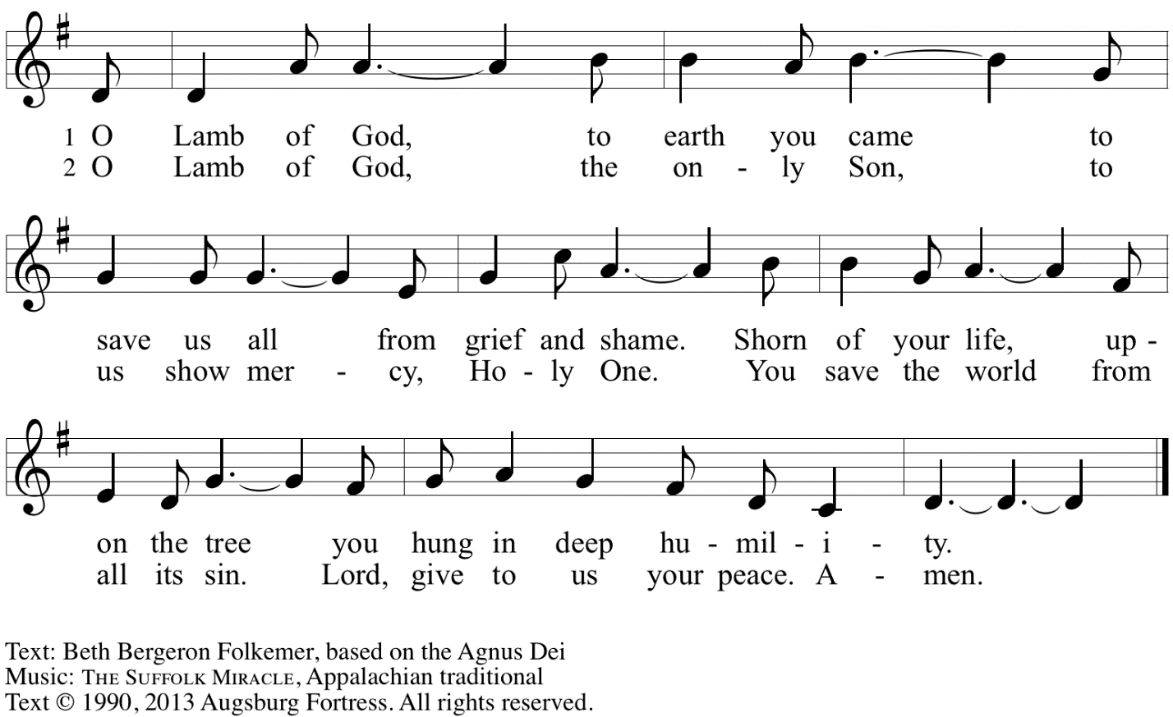
Reprinted with permission under OneLicense.net A# A-722139.

Please be seated.

Holy Communion
- All who seek God and desire a deeper and stronger life in Christ are welcome to receive Holy Communion.
- Worshipers from the pulpit side will proceed forward first, followed by the center section, and then the lectern side.
- Please inform an usher if you would like the ministers to bring Communion to you.
- Holy Communion will be served with bread and wine/grape juice.
- The presiding minister will first distribute the bread (host) to each communicant. Please indicate if you require a gluten-free host.
- Once you have consumed the bread, please pick up an empty glass from the tray next to the presiding minister. The Communion Assistant will pour wine from the chalice or grape juice from the cruet into your glass.
- Please step to the side to consume the wine or grape juice.
- Feel free to kneel at the altar rail for prayer after receiving the sacrament.
- As you return to your pew, glasses may be returned to the empty trays on either side of the center section.
- A blessing will be provided for anyone who does not yet receive the sacrament.
- All are invited to join in singing the hymns during Holy Communion.

Hymns during Holy Communion
Draw Us in the Spirit’s Tether ELW 470

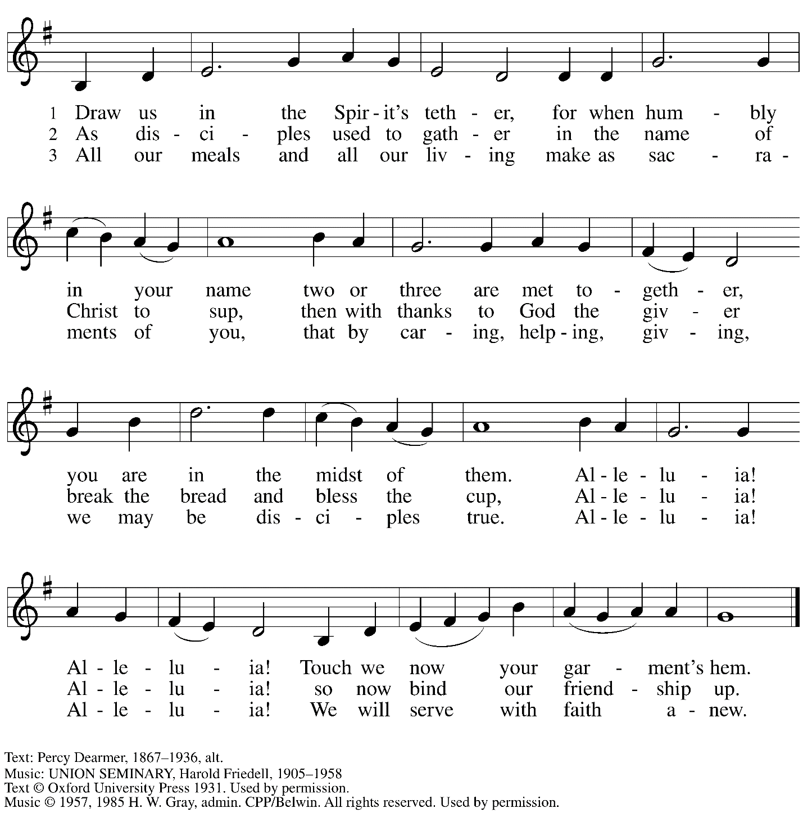
Reprinted under OneLicense.net # A-722139.

Hymns during Holy Communion
Holy, Holy, Holy, Holy – Santo, santo, santo, santo ELW 672

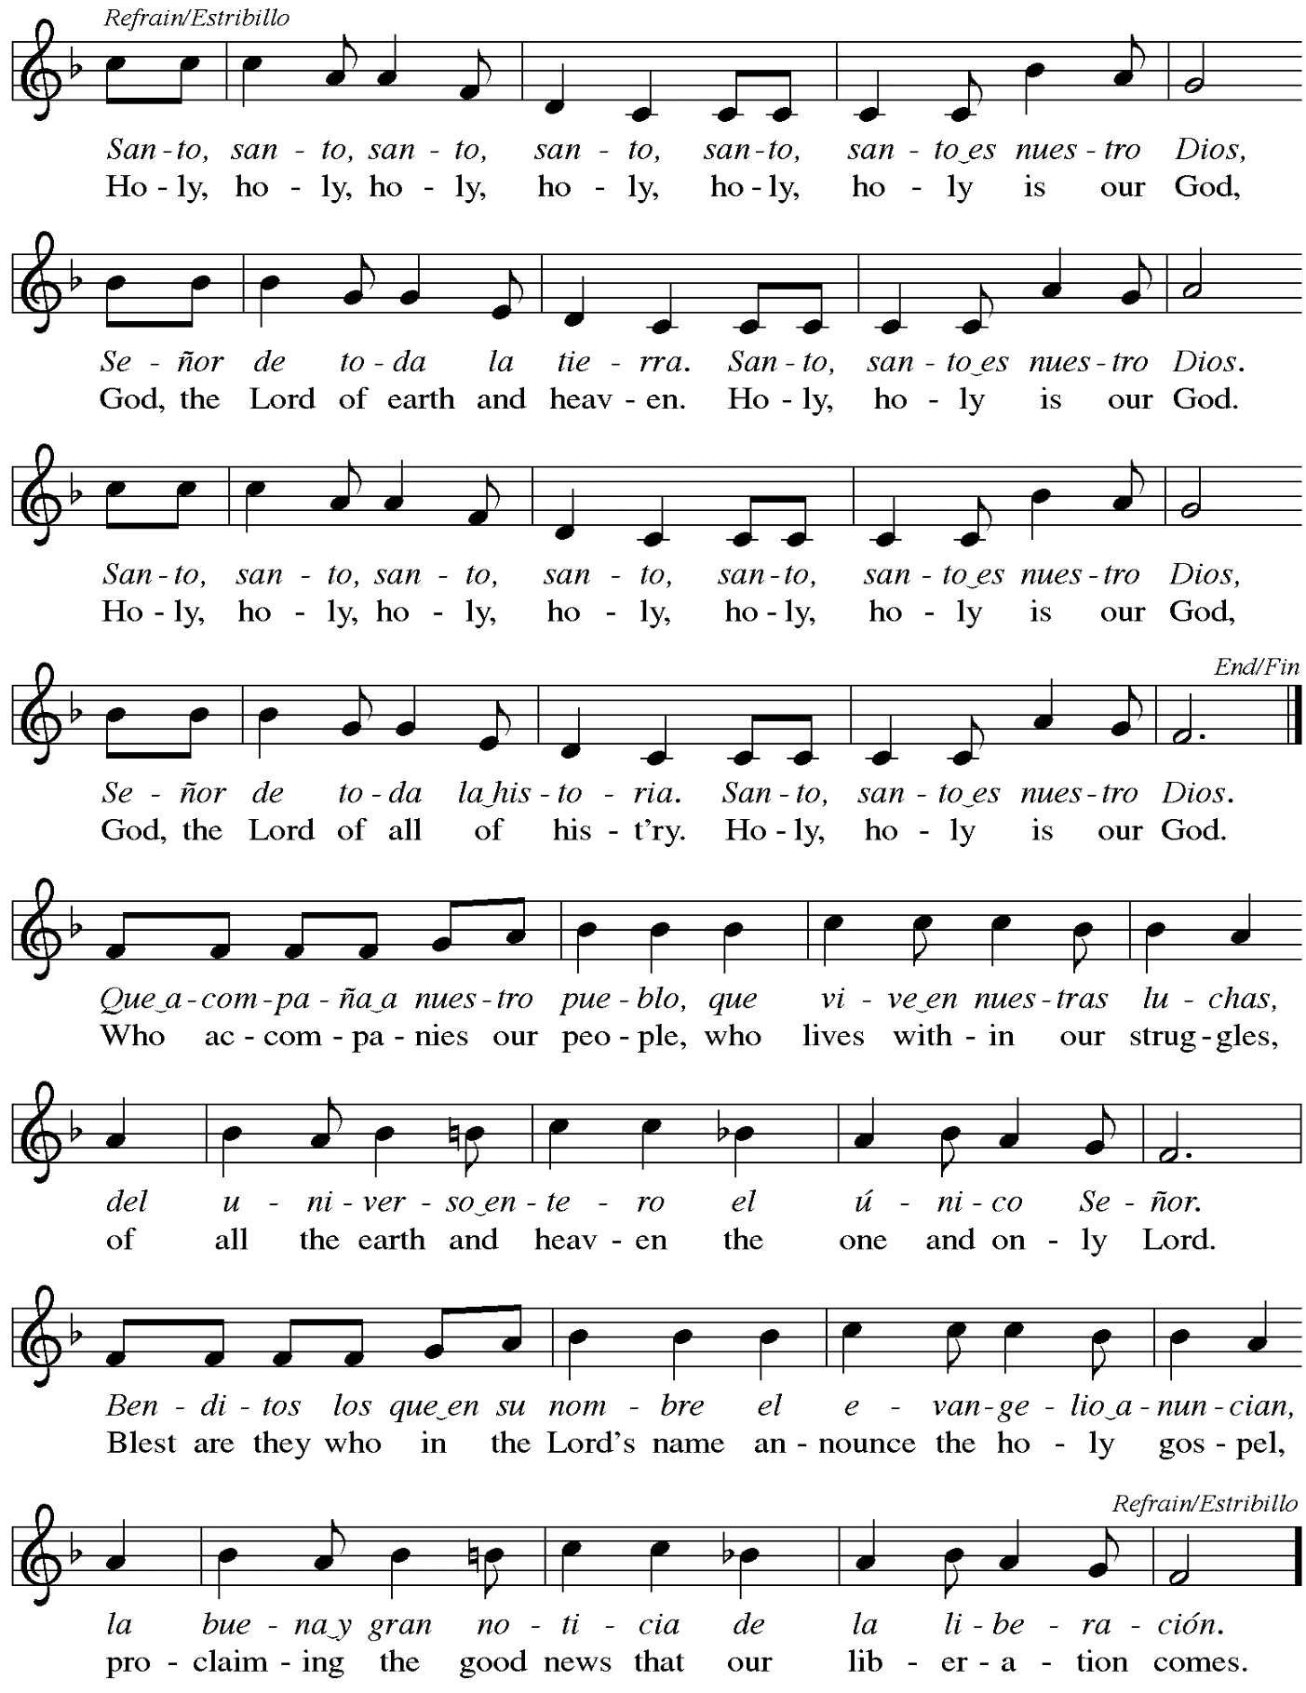
Hymns during Holy Communion
Baptized in Water ELW 456

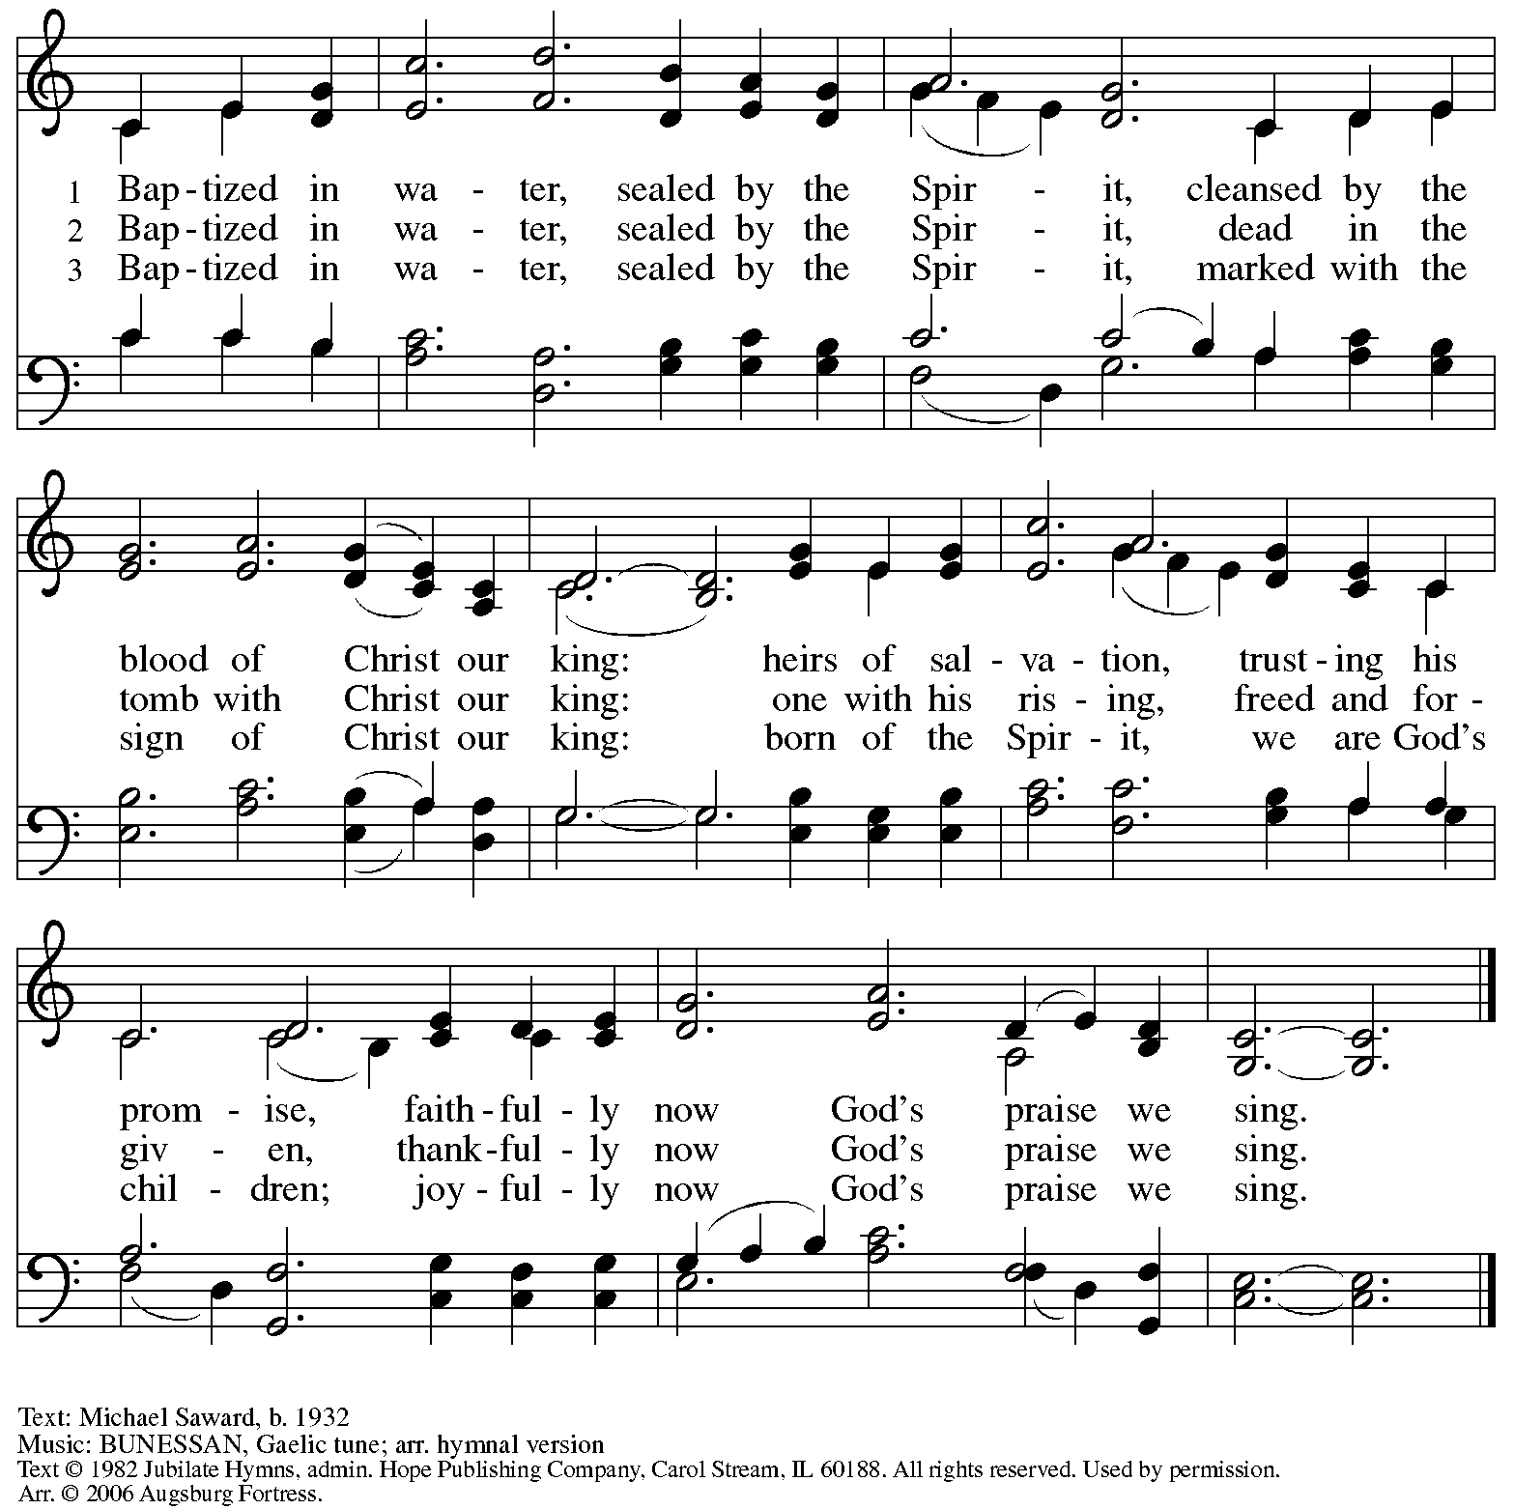
All rights reserved. Reprinted with permission under OneLicense.net # A-722139.

When all have returned to their places, please rise as you are able.

Blessing

P: The body and blood of our Lord Jesus Christ strengthen you and keep you in his grace.
C: Amen.

Prayer

A: Let us pray. Gracious God,
we give you thanks for your pruning, planting, and nurture.
We rejoice that you have used the harvest of field and vineyard
to renew and sustain us.
Lead us as we go from this life-giving meal
into lives of grateful service to you and your cherished creation;
through Jesus Christ, your Son, our Lord.
C: Amen.

Please be seated.

Sending
God blesses us and sends us in mission to the world

Announcements

Please rise as you are able.

Benediction

P: The God of steadfastness and encouragement
grant you to live in harmony with one another,
in accordance with Christ Jesus.
C: Amen.

P: The God of hope fill you with all joy and peace in believing,
so that you may abound in hope by the power of the Holy Spirit.
C: Amen.

P: The God of all grace ☩ bless you now and forever.
C: Amen.

Sending Hymn Holy, Holy, Holy, Lord God Almighty! Following page

Dismissal

A: Go in peace. Serve the Lord.
C: Thanks be to God!

Postlude The Church’s One Foundation arr. Krug

Sending Hymn Holy, Holy, Holy, Lord God Almighty! ELW 413

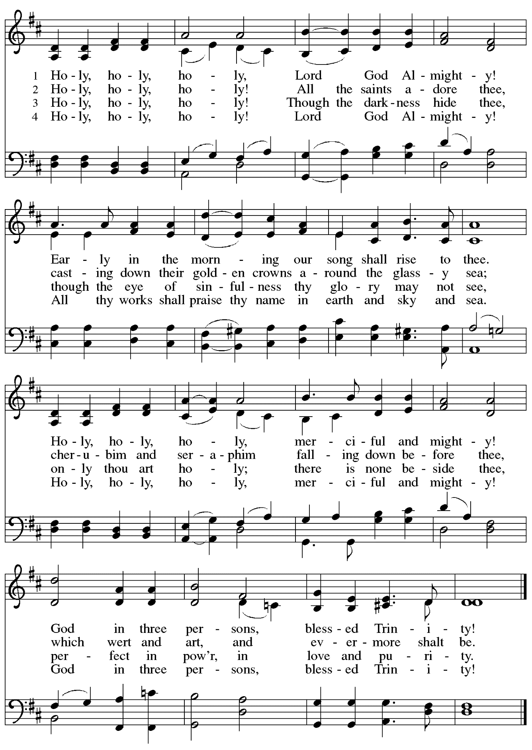
Those serving in worship today

Altar Care Janet Grzegorczyk
Assisting Minister Kathy Hays
Audio-Visual Ministers Kristen Asplin
Sarita
Cantor Libby Marker
Lector Kelly Spanninger
Minister of Music Laura Reynolds
Offertory (Piano) Amos
Presiding Minister Pastor Ross Carmichael

Liturgy and Hymnody Acknowledgements

From SundaysandSeasons.com. Copyright © 2024 Augsburg Fortress. All rights reserved. Reprinted under OneLicense.net # A-722139.
Used by permission of Augsburg Fortress.

Holy, Holy, Holy / Long, Long Ago in Jerusalem – Text: Beth Bergeron Folkemer, based on the Sanctus. Music: SHADY GROVE, Appalachian traditional. Text © 1990, 2013, Augsburg Fortress. All rights reserved. Reprinted with permission under OneLicense.net # A-722139.

Holy, Holy, Holy, Holy – Santo, santo, santo, santo – Text: Guillermo Cuéllar, b. 1055; tr. Linda McCrae. Music: CUÉLLAR, Guillermo Cuéllar. Text and music © 1993, 1994 GIA Publications, Inc., 7404 S. Mason Ave., Chicago, IL 60638. www.giamusic.com. 800.442.3358. All rights reserved. Reprinted with permission under OneLicense.net # A-722139.

Holy, Holy, Holy, Lord God Almighty! – Text: Reginald Heber, 1783-1826, alt. Music: NICAEA, John B. Dykes, 1823-1876.

Please use the QR code below to link to St. Andrew’s announcements online!

St. Andrew Lutheran Church Announcements
May 26th, 2024

- Welcome to Worship at St. Andrew on Holy Trinity Sunday, May 26th, 2024 – We are so glad you are here, and we offer a special welcome to all visitors and guests connecting for the first time! Worship attendees are invited to make a name tag at the back of the worship space if you would like. There are worship “toolkits” to help children engage with worship and “busy bags” for younger children available in the bookcase at the back of the sanctuary. Please feel free to take one to use with/for your children.
- Pittsburgh Pride is Coming Up! – Represent St. Andrew at the ReconcilingWorks Booth on Saturday, June 1st, between 9:00 a.m. – 6:30 p.m. – St. Andrew is a Reconciling in Christ (RIC) congregation, intentionally welcoming and affirming all including people of all sexual orientations, gender identities, and gender expressions. Reconciling in Christ congregations come together under the umbrella of ReconcilingWorks: Lutherans for Full Participation, and this year St. Andrew is collaborating with other RIC congregations to bear public witness to that welcome at a ReconcilingWorks booth. We will have information about St. Andrew and the other congregations, the work of ReconcilingWorks and other RIC organizations, fun giveaways, and opportunities to meet our neighbors and bear witness to God’s boundless love. People of the congregation are invited to represent St. Andrew at the booth with a two-hour shift between 9:00 a.m.-6:30 p.m. on Saturday, June 1st. Please sign up at RIC Church Members & RW Pittsburgh - Part 1: RW Pittsburgh - Pittsburgh Pride Volunteers (signupgenius.com) Please speak with Pastor Ross or Kelly Spanninger if you have questions!
- Monthly Offering for Reparations Next Sunday, June 2nd, during Worship – Jesus’ parable from Luke’s Gospel about a compassionate Samaritan provides an example of how God's people are called to work for healing and repair for our neighbors, independent of who or what caused harm. In light of this, St. Andrew has made a commitment to reparations in regard to African American spiritual songs used in our worship. The text and music of most hymns is attributed to specific authors, with copyrights in place, usage reported, and royalties paid to those whose works are featured in worship. With African American spirituals, this is not possible. In response to many years of such uncredited use, St. Andrew invites the congregation to give a reparations offering. Funds received in worship will be donated to our siblings at Bethel AME Church, whose land and building were taken from them in the 1950s, to fund their development in the lower Hill District.
- June Produce Distribution – First Tuesday of the Month, June 4th, 2024, from 5:30-7:00 p.m. – St. Andrew partners with Greater Pittsburgh Community Food Bank to serve as a distribution site for fresh produce on the first Tuesday of every month. June’s distribution will be Tuesday, June 4th. We invite people of the congregation to help with the distribution from 5:30-7:00 p.m., help with unloading and setup during the day between 10:00 a.m. and 1:00 p.m., or just to pick up fresh produce!
- Bethel AME Church Juneteenth Celebrations – Sunday, June 16th, 11:00 a.m. and 2:00 p.m. – Bethel AME Church in the Hill District (2720 Webster Ave, 15219), with whom the St. Andrew congregation and our Southwestern Pennsylvania (SWPA) Synod have been in relationship with for the past several years, will host Juneteenth celebrations on Sunday, June 16th, with Bishop Kurt F. Kusserow of the Southwestern Pennsylvania Synod as the speaker at the 11:00 a.m. service and with Bishop Errenous E. McCloud, Jr. of the AME Church as the speaker at the 2:00 p.m. service.
- Shelter Dinner at East End Cooperative Ministry – Thursday, June 20th, 6:30 p.m. –
Each month, people of St. Andrew provide dinner for guests of East End Cooperative Ministry, 6140 Station St. (East Liberty), 15206. We invite you to prepare or purchase one menu item and bring it to the shelter by 6:00 p.m., or just come to help serve at 6:30 p.m. A signup link will be available soon.

