+ Seventh Sunday of Easter
May 12, 2024
St. Andrew Lutheran Church
304 Morewood Ave.
Pittsburgh, PA 15213
St_andrewELCA@verizon.net
www.standrewpittsburgh.org

+ Seventh Sunday of Easter
Order for Worship

The fortieth day of the Easter season is observed as the Ascension of our Lord, when the risen Christ ascends into heaven and assures followers that the Holy Spirit will empower them to be witnesses throughout the earth. The gospel for Easter’s seventh Sunday is always taken from the long prayer Jesus prays for his followers in John’s gospel on the night before his death, and always includes Jesus’ desire that his followers will be one as he and the Father are one. This oneness is not mere doctrinal agreement or institutional unity, but mutual abiding, life, love,
and joy. This oneness is the work of the Spirit whom we have received but also await.
Come, Holy Spirit!

Welcome to St. Andrew!
- St. Andrew Lutheran congregation welcomes all who are seeking a place of healing and wholeness – a nurturing, faith-forming spiritual home. Our community embraces people of all ages, ethnicities, cultures, abilities, sexual orientations, gender identities and expressions, and family constellations. Come and See!
- Worship Services are live streamed to multiple online platforms. By attending worship, you agree that your image and voice may be broadcast.
- Everyone is invited to make a name tag at the black bookcase in the back of the worship space if they would like. There are stickers indicating pronouns on the bookcase if you would like to include them on your name tag.
- A nursery is available through the doors at the left side of the sanctuary and across from the doorway to the Social Hall. It is a purple-colored room.
- Children are invited to attend Little Church – Big Faith, a Bible lesson and activity, during worship (after the Prayer of the Day). The group returns to the worship space for the liturgy of Holy Communion.
- Worship “toolkits” to help children engage with the service, along with “busy bags” for younger children, are available in the bookcase at the back of the sanctuary. Please feel free to take one to use with/for your children.
- Holy Communion is served with bread (gluten-free available) and wine or grape juice. The presiding minister will distribute the bread (host). Please consume this and then pick up an empty glass from the tray. The Communion Assistant will pour wine or grape juice into your glass. Please step to the side to consume the wine or grape juice. Feel free to kneel at the altar for prayer and reflection. As you return to your pew, glasses may be returned to the empty trays on either side of the center section.
- A restroom is available on the main level of the church, through the doors to the Social Hall and to the right in the main office.

Abbreviations
P: Pastor/Presiding Minister ELW: Evangelical Lutheran Worship hymnal
A: Assisting Minister ACS: All Creation Sings hymnal
L: Lector HS: Hymnal Supplement (GIA Publications)
C: Congregation
Pre-Service Music

Welcome

Prelude

Gathering
The Holy Spirit calls us together as the people of God

Please rise as you are able. All may make the sign of the cross,
the sign that is marked at Baptism, as the presiding minister begins.

Confession and Forgiveness

P: Blessed be the holy Trinity, ☩ one God,
who creates, redeems, and sustains us and all of creation.
C: Amen.

P: Let us confess our sin in the presence of God and one another.

Silence is kept for reflection.

P: Most merciful God,
we confess that we are captive to sin and cannot free ourselves.
We have sinned against you in thought, word, and deed,
by what we have done and by what we have left undone.
We have not loved you with our whole heart;
we have not loved our neighbors as ourselves.
For the sake of your Son, Jesus Christ, have mercy on us.
Forgive us, renew us, and lead us,
so that we may delight in your will
and follow in your ways,
to the glory of your holy name.
Amen.

P: By water and the Holy Spirit God gives you a new birth,
and through the death and resurrection of ☩ Jesus Christ,
God forgives you all your sins.
The God of mercy and might strengthen you in all goodness
and keep you in eternal life.
C: Amen.

Gathering Hymn Alleluia! Sing to Jesus ELW 392

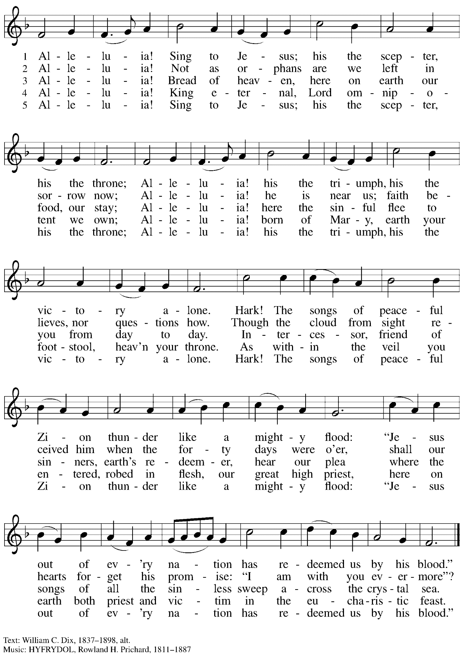
Greeting

P: The grace of our Lord Jesus Christ, the love of God,
and the communion of the Holy Spirit be with you all.
C: And also with you.

Hymn of Praise This Is the Feast ELW p. 149-150

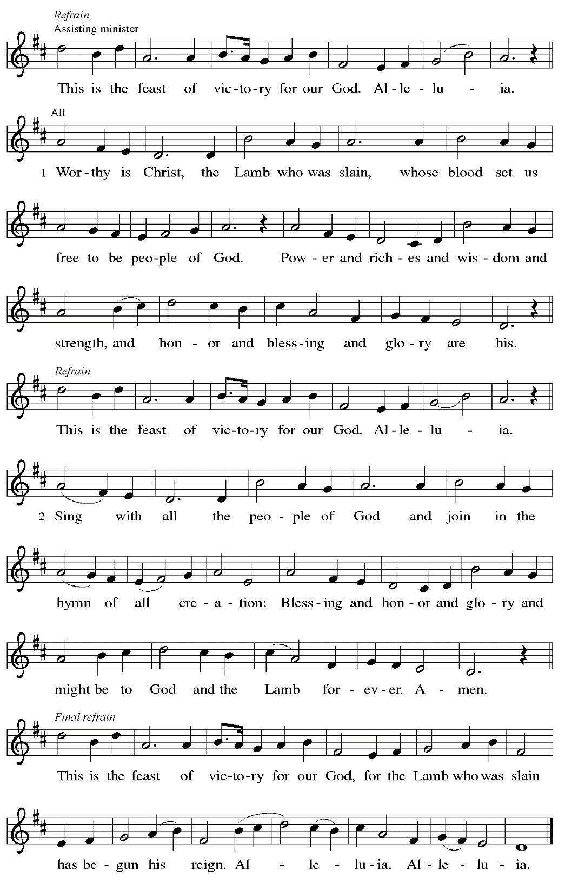

Prayer of the Day

P: The Lord be with you.
C: And also with you.

P: Let us pray.
Gracious and glorious God, you have chosen us as your own, and by the powerful name of Christ you protect us from evil. By your Spirit transform us and your beloved world, that we may find our joy in your Son, Jesus Christ, our Savior and Lord, who lives and reigns with you and the Holy Spirit, one God, now and forever.
C: Amen.

Please be seated.

Word
God speaks to us in Scripture reading, preaching, and song

First Reading – Acts 1: 15-17, 21-26

¹⁵In those days Peter stood up among the believers (together the crowd numbered about one hundred twenty persons) and said, ¹⁶“Friends, the scripture had to be fulfilled, which the Holy Spirit through David foretold concerning Judas, who became a guide for those who arrested Jesus—¹⁷for he was numbered among us and was allotted his share in this ministry.” ²¹So one of the men who have accompanied us during all the time that the Lord Jesus went in and out among us, ²²beginning from the baptism of John until the day when he was taken up from us—one of these must become a witness with us to his resurrection.” ²³So they proposed two, Joseph called Barsabbas, who was also known as Justus, and Matthias. ²⁴Then they prayed and said, “Lord, you know everyone’s heart. Show us which one of these two you have chosen ²⁵to take the place in this ministry and apostleship from which Judas turned aside to go to his own place.” ²⁶And they cast lots for them, and the lot fell on Matthias; and he was added to the eleven apostles.

L: Word of God, word of life.
C: Thanks be to God.

Psalm 1

The cantor will lead the singing of the psalm.
The congregation is invited to respond with the alternate verses in bold print,
and to join in singing the refrain.

Psalm tone

Psalm refrain

¹Happy are they who have not walked in the counsel | of the wicked,
nor lingered in the way of sinners, nor sat in the seats | of the scornful!
²Their delight is in the law | of the Lord,
and they meditate on God’s teaching | day and night. R
³They are like trees planted by streams of water, bearing fruit in due season, with leaves that | do not wither;
everything they | do shall prosper.
⁴It is not so | with the wicked;
they are like chaff which the wind | blows away.
⁵Therefore the wicked shall not stand upright when | judgment comes,
nor the sinner in the council | of the righteous.
⁶For the Lord knows the way | of the righteous,
but the way of the wicked shall | be destroyed. R

Second Reading – 1 John 5: 9-13

⁹If we receive human testimony, the testimony of God is greater; for this is the testimony of God that God has testified to God’s Son. ¹⁰Those who believe in the Son of God have the testimony in their hearts. Those who do not believe in God have made God a liar by not believing in the testimony that God has given concerning God’s Son. ¹¹And this is the testimony: God gave us eternal life, and this life is in God’s Son. ¹²Whoever has the Son has life; whoever does not have the Son of God does not have life.
¹³I write these things to you who believe in the name of the Son of God, so that you may know that you have eternal life.

L: Word of God, word of life.
C: Thanks be to God.

Please rise as you are able.

Gospel Acclamation ELW p. 151

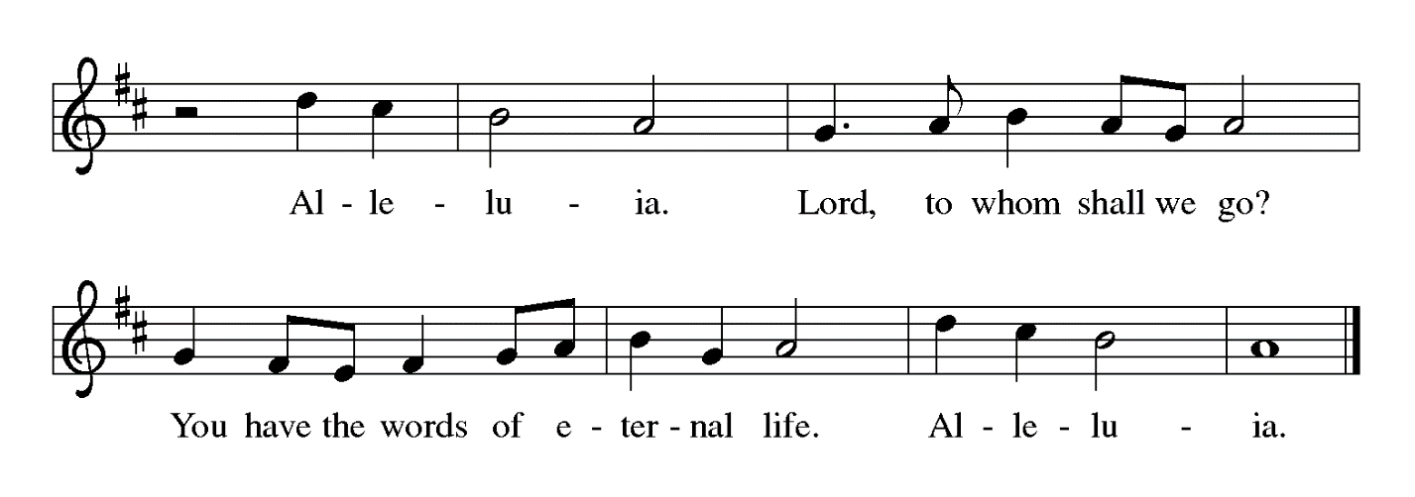

Gospel – John 17: 6-19

P: The holy Gospel according to St. John.
C: Glory to you, O Lord.

[Jesus prayed:] ⁶“I have made your name known to those whom you gave me from the world. They were yours, and you gave them to me, and they have kept your word. ⁷Now they know that everything you have given me is from you; ⁸for the words that you gave to me I have given to them, and they have received them and know in truth that I came from you; and they have believed that you sent me. ⁹I am asking on their behalf; I am not asking on behalf of the world, but on behalf of those whom you gave me, because they are yours. ¹⁰All mine are yours, and yours are mine; and I have been glorified in them. ¹¹And now I am no longer in the world, but they are in the world, and I am coming to you. Holy Father, protect them in your name that you have given me, so that they may be one, as we are one. ¹²While I was with them, I protected them in your name that you have given me. I guarded them, and not one of them was lost except the one destined to be lost, so that the scripture might be fulfilled. ¹³But now I am coming to you, and I speak these things in the world so that they may have my joy made complete in themselves. ¹⁴I have given them your word, and the world has hated them because they do not belong to the world, just as I do not belong to the world. ¹⁵I am not asking you to take them out of the world, but I ask you to protect them from the evil one. ¹⁶They do not belong to the world, just as I do not belong to the world. ¹⁷Sanctify them in the truth; your word is truth. ¹⁸As you have sent me into the world, so I have sent them into the world. ¹⁹And for their sakes I sanctify myself, so that they also may be sanctified in truth.”

P: The Gospel of the Lord.
C: Praise to you, O Christ.
Please be seated.

Sermon

A time of silence for prayer and reflection follows the sermon.
When the hymn of the day begins, please rise as you are able.

Hymn of the Day Son of God, Eternal Savior ELW 655

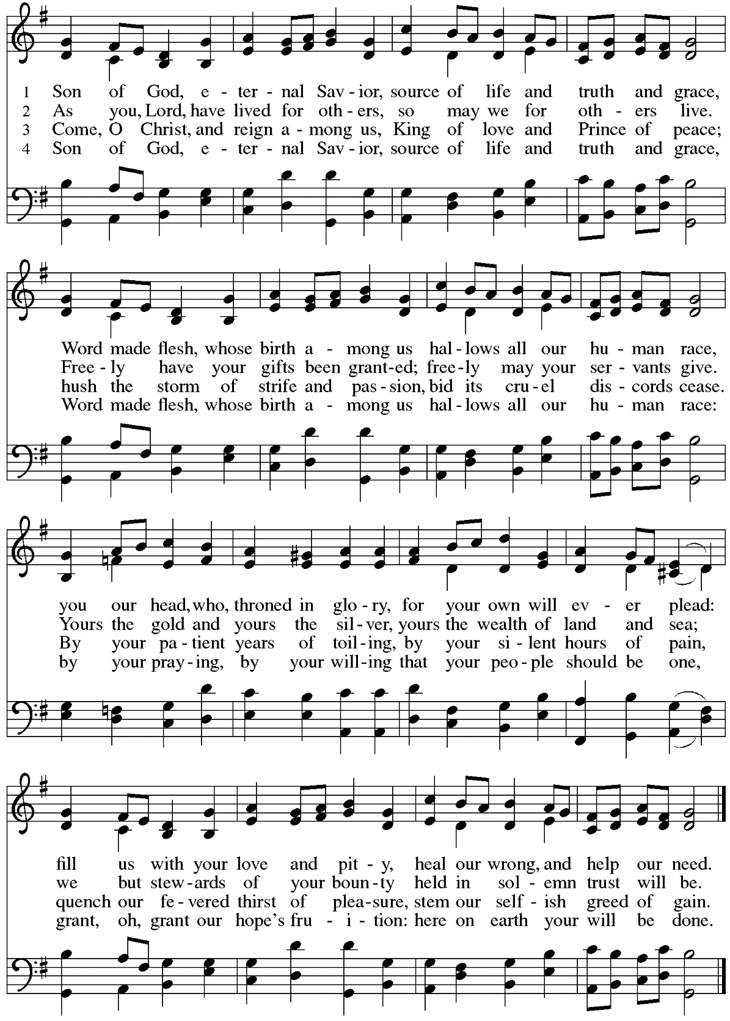
Welcoming A New Member

P: Name has come to St. Andrew from another Lutheran congregation
and desires to transfer their membership into this community of faith.

R: We welcome you as a member of St. Andrew Lutheran Church,
to join with us in worshiping God,
hearing God’s Word and sharing God’s holy supper,
proclaiming the good news of God in Christ through word and deed,
serving all people,
and striving for justice and peace in all the earth.

A: Let us rejoice with this sister in Christ.
C: We rejoice with you in the life of faith.
Together we will give thanks and praise to God
and proclaim the good news to all the world.

The congregation welcomes our new sibling in Christ with applause, and all are invited to join in singing St. Andrew’s congregational refrain.

Congregational Refrain HS 808

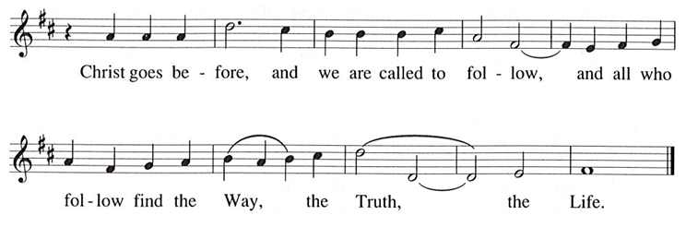

Prayers of the People

A: United in the joy and hope of the resurrection, let us pray for the church, the world,
and all who are in need.

After each petition
A: Gracious God,
C: receive our prayer.

The presiding minister concludes the prayers
P: We lift these prayers to you most merciful God, trusting in your abiding love;
through Jesus Christ, our risen and living Savior.
C: Amen.

Peace

The presiding minister and the assembly greet one another in the peace of the risen Christ.
P: The peace of Christ be with you always.
C: And also with you.

The people may greet those around them with a sign of Christ’s peace and may say
Peace be with you or similar words. Please be mindful that not everyone will be comfortable with sharing the peace, so please seek consent before shaking hands or hugging. Other possible ways to share the peace include a simple bow with the verbal greeting of peace, or simply a verbal expression of peace.

When the greetings of peace have concluded, please be seated.

Meal

Offering

We offer ourselves, our gifts, and our faithful service to God.
As the offering is gathered for the mission of the church, including the care of those in need,
the table is set for Holy Communion.

Musical Offering

As the gifts are brought forward for presentation, please rise as you are able.

Offertory Song Let the Vineyards ELW 184

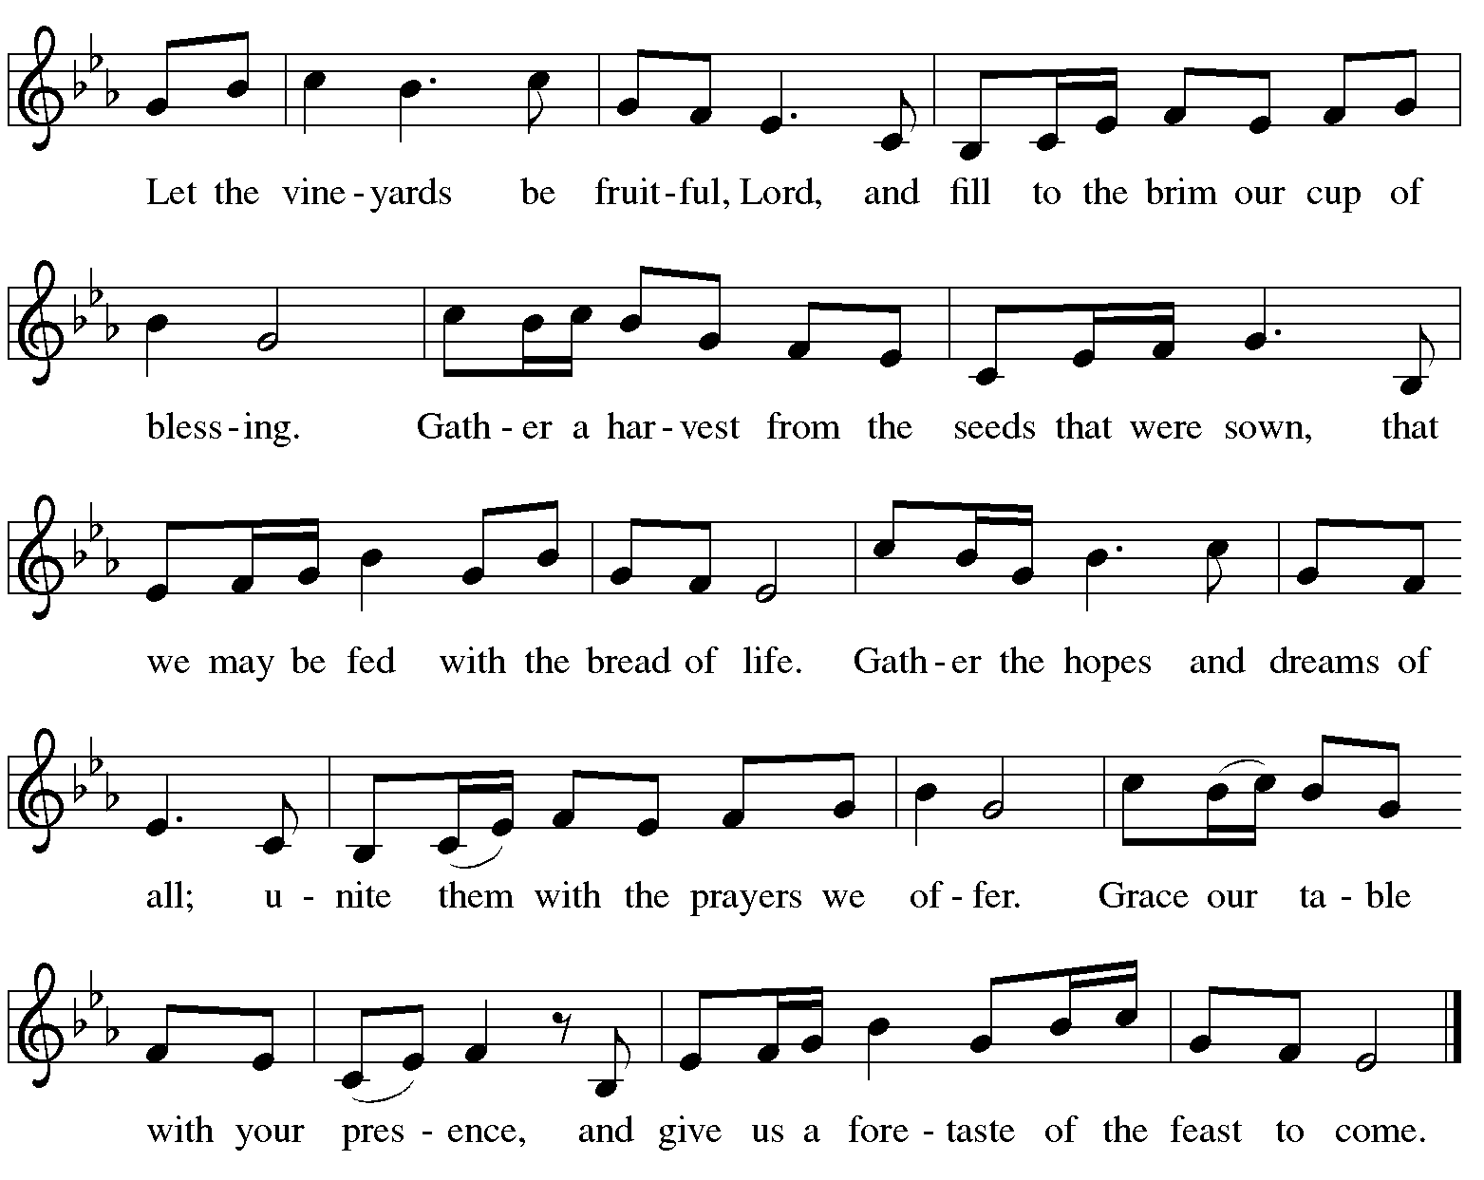

Offertory Prayer

A: Let us pray.
Blessed are you,
C: O God, ruler of heaven and earth.
Day by day you shower us with blessings.
As you have raised us to new life in Christ,
give us glad and generous hearts,
ready to praise you and to respond to those in need,
through Jesus Christ, our Savior and Lord.
Amen.

Dialogue ELW p. 152

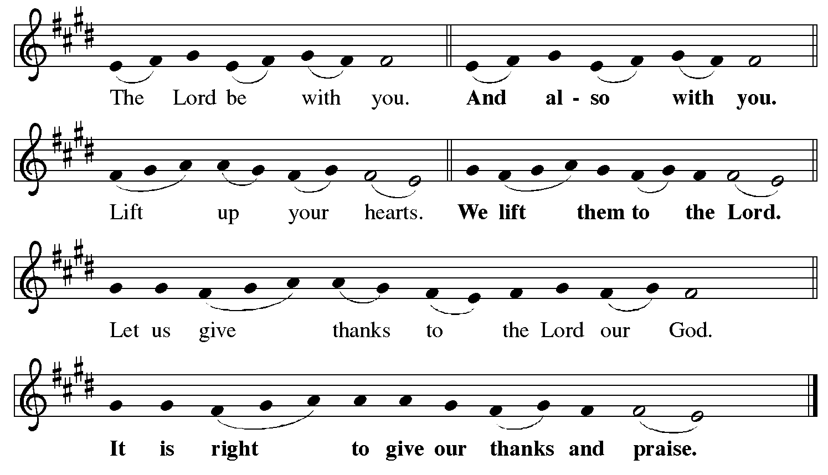

Preface (Sung by the presiding minister)

P: It is indeed right, our duty and our joy,
that we should at all times and in all places
give thanks and praise to you, almighty and merciful God,
for the glorious resurrection of our Savior Jesus Christ,
the true Paschal Lamb who gave himself to take away our sin;
who in dying has destroyed death,
and in rising has brought us to eternal life.
And so, with Mary Magdalene and Peter
and all the witnesses of the resurrection,
with earth and sea and all their creatures,
and with angels and archangels, cherubim and seraphim,
we praise your name and join their unending hymn:

Sanctus ELW p. 153

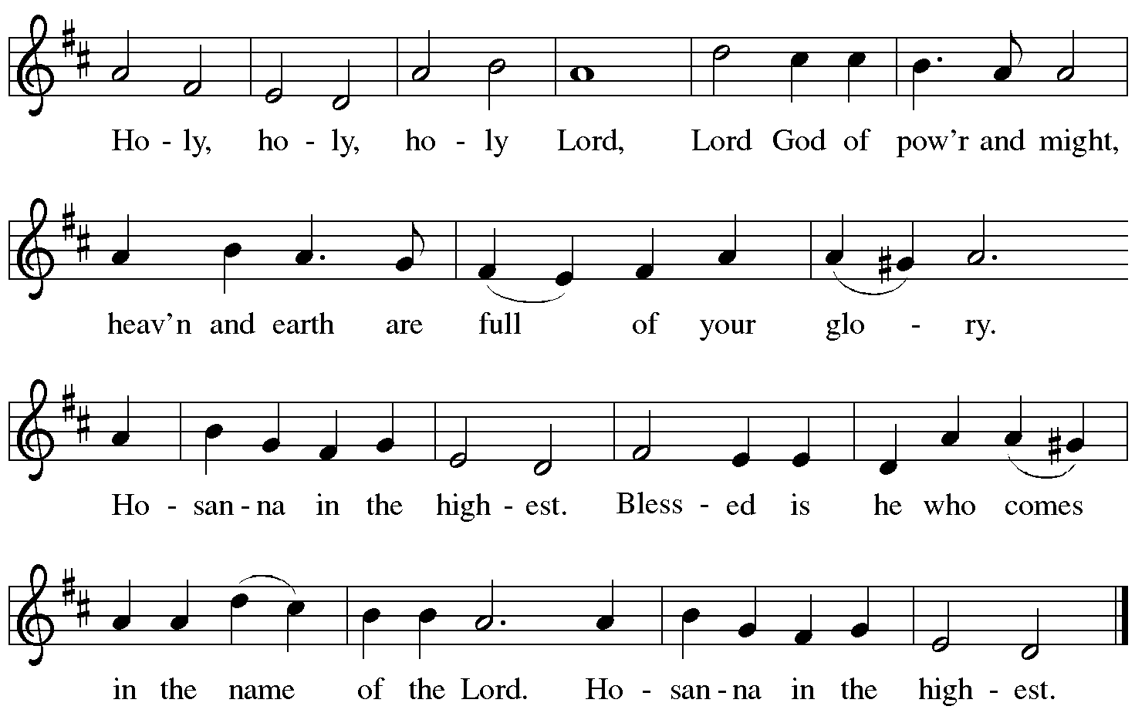

Eucharistic Prayer

P: Blessed are you, O God of the universe …
Do this for the remembrance of me.

With this bread and cup,
we remember our Lord’s passover from death to life
as we proclaim the mystery of faith:
C: Christ has died. Christ is risen. Christ will come again.

P: O God of resurrection and new life …
Grace our table with your presence.
C: Come, Holy Spirit.

P: Reveal yourself to us in the breaking of the bread …
Send us forth, burning with justice, peace, and love.
C: Come, Holy Spirit.

P: With your holy ones of all times and places,
with the earth and all its creatures,
with sun and moon and stars,
we praise you, O God,
blessed and holy Trinity,
now and forever.
C: Amen.

Lord’s Prayer

P: Gathered as one by the Holy Spirit, let us pray as Jesus taught us.
C: Our Father in heaven,
hallowed be your name,
your kingdom come,
your will be done,
on earth as in heaven.
Give us today our daily bread.
Forgive us our sins
as we forgive those
who sin against us.
Save us from the time of trial
and deliver us from evil.
For the kingdom, the power,
and the glory are yours,
now and forever. Amen.

Fraction and Invitation

P: Alleluia! Christ is risen!
C: Christ is risen indeed! Alleluia! Alleluia!

P: This is the feast of victory for our God. Alleluia! Alleluia!
Come, share the feast.

Agnus Dei / Lamb of God Following Page

Agnus Dei / Lamb of God ELW p. 154

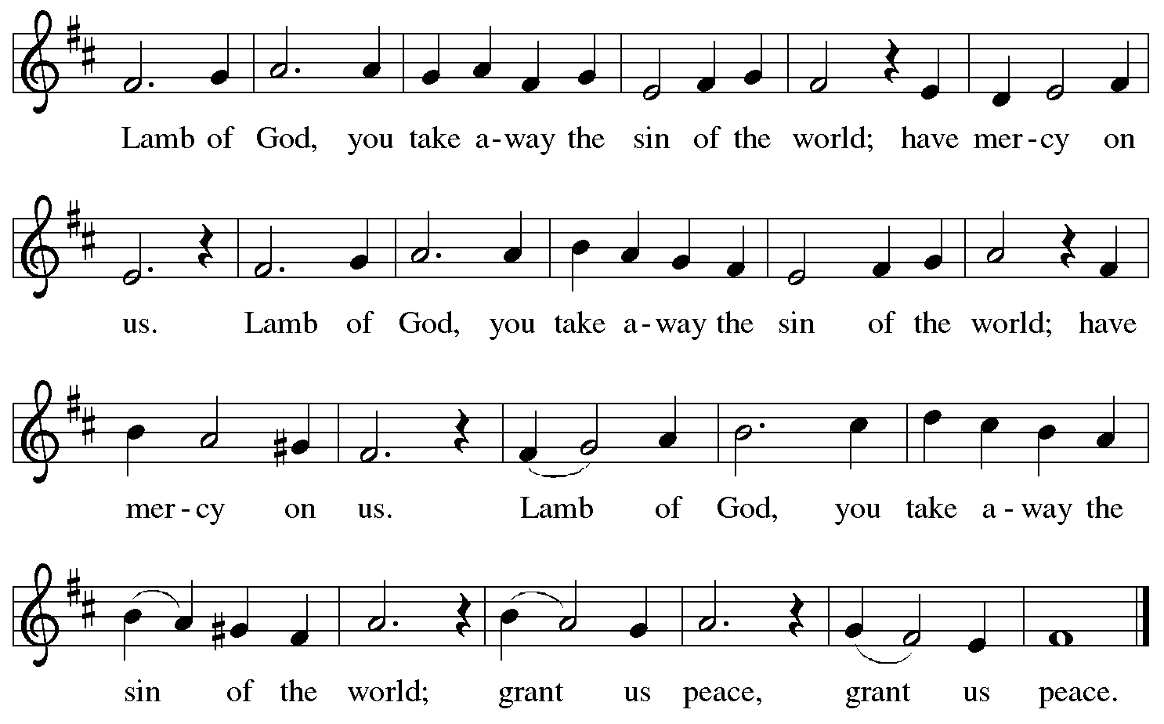

Please be seated.

Holy Communion
- All who seek God and desire a deeper and stronger life in Christ are welcome to receive Holy Communion.
- Worshipers from the pulpit side will proceed forward first, followed by the center section, and then the lectern side.
- Please inform an usher if you would like the ministers to bring Communion to you.
- Holy Communion will be served with bread and wine/grape juice.
- The presiding minister will first distribute the bread (host) to each communicant. Please indicate if you require a gluten-free host.
- Once you have consumed the bread, please pick up an empty glass from the tray next to the presiding minister. The Communion Assistant will pour wine from the chalice or grape juice from the cruet into your glass.
- Please step to the side to consume the wine or grape juice.
- Feel free to kneel at the altar rail for prayer after receiving the sacrament.
- As you return to your pew, glasses may be returned to the empty trays on either side of the center aisle.
- A blessing will be provided for anyone who does not yet receive the sacrament.
- All are invited to join in singing the hymns during Holy Communion.
Hymn during Holy Communion
To Christ Belong, in Christ Behold ACS 958

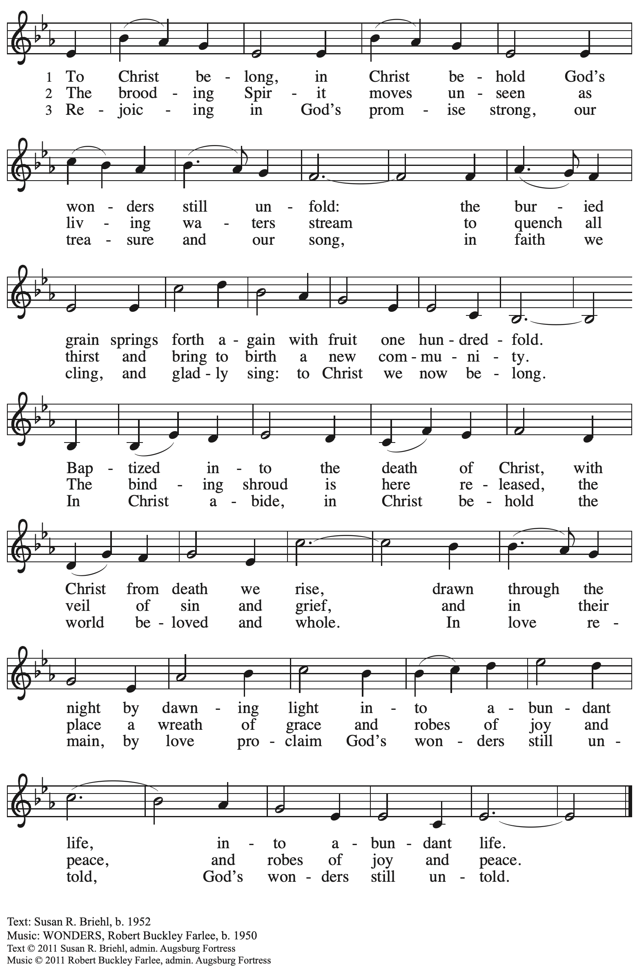
All rights reserved. Reprinted with permission under OneLicense.net # A-722139.

Hymn during Holy Communion
I Come with Joy ELW 482

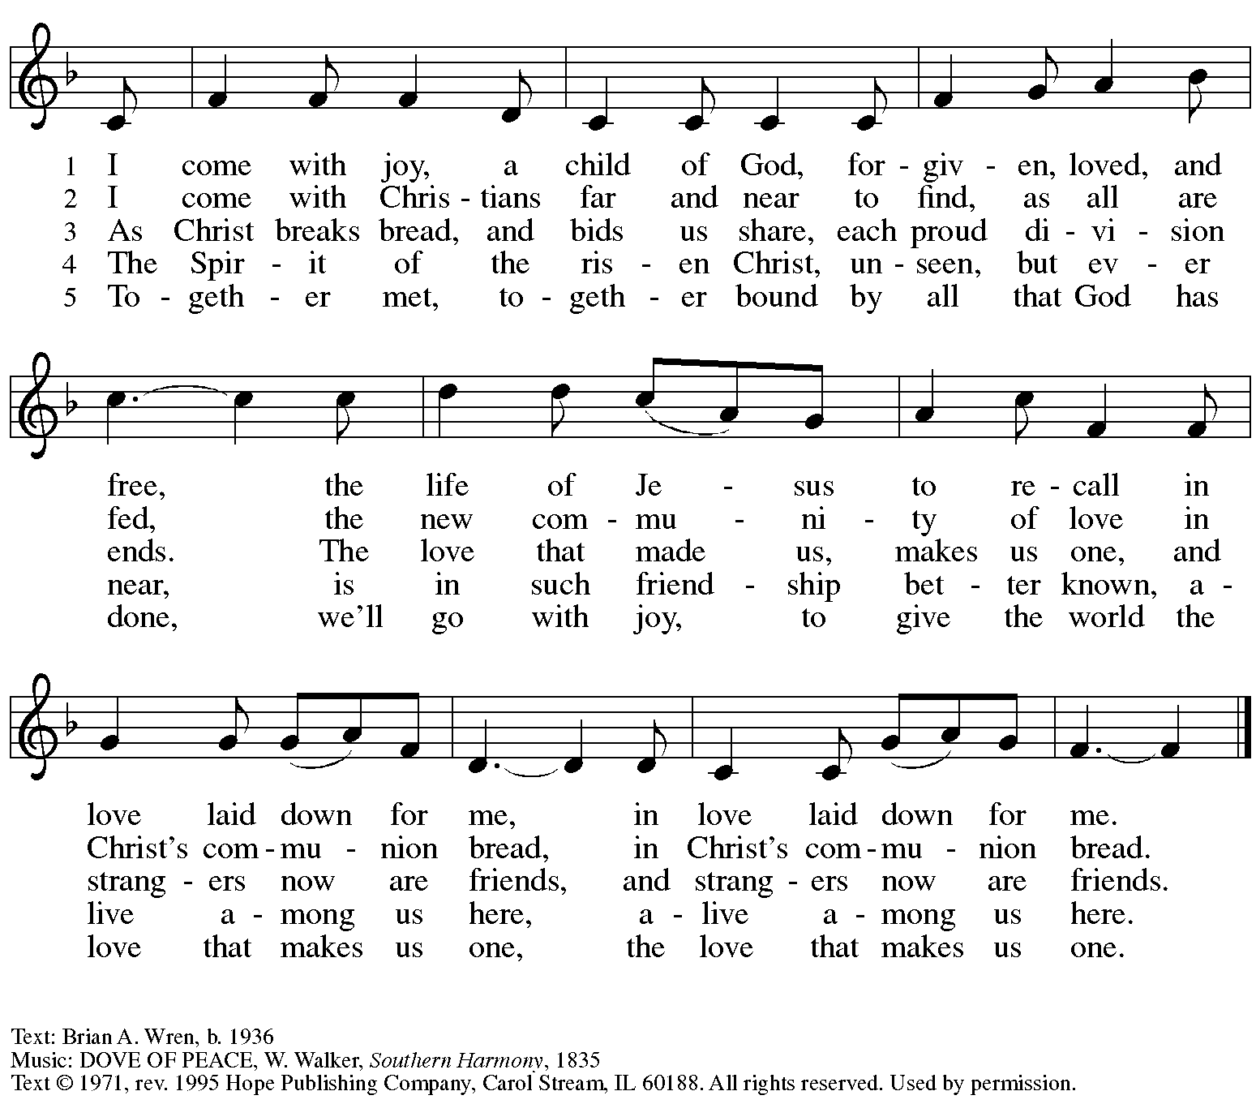
Reprinted with permission under OneLicense.net # A-722139.

Hymn during Holy Communion
Blest Be the Tie That Binds ELW 656

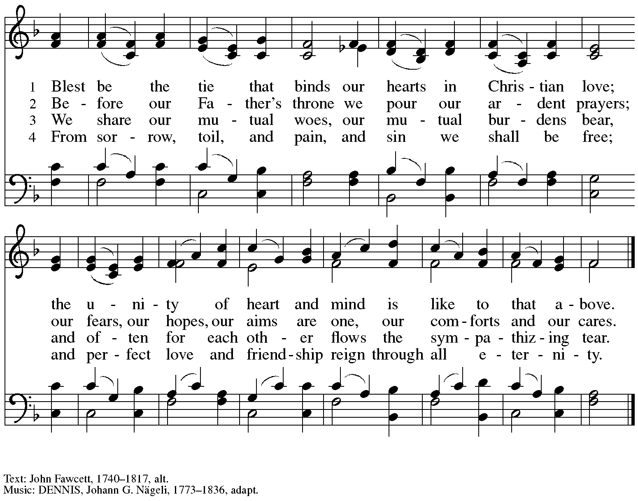

When all have returned to their places, please rise as you are able.

Blessing

P: The body and blood of our Lord Jesus Christ strengthen you and keep you in his grace.
C: Amen.

Prayer

A: Let us pray. Life-giving God,
in the mystery of Christ’s resurrection, you send light to conquer darkness,
water to give new life, and the bread of life to nourish your people.
Send us forth as witnesses to your Son’s resurrection,
that we may show your glory to all the world,
through Jesus Christ, our risen Lord.
C: Amen.

Please be seated.

Sending

Announcements

Please rise as you are able.

Benediction

P: May our glorious God grant you a spirit of wisdom
to know and love the risen Christ.

Almighty God, holy One, ☩ holy Three,
bless you now and forever.
C: Amen.

Sending Hymn We All Are One in Mission Following page

Dismissal

A: Alleluia! Christ is risen!
C: Christ is risen indeed! Alleluia! Alleluia!

A: Go in peace. Share the good news!
C: Thanks be to God!

Postlude

Sending Hymn We All Are One in Mission ELW 576

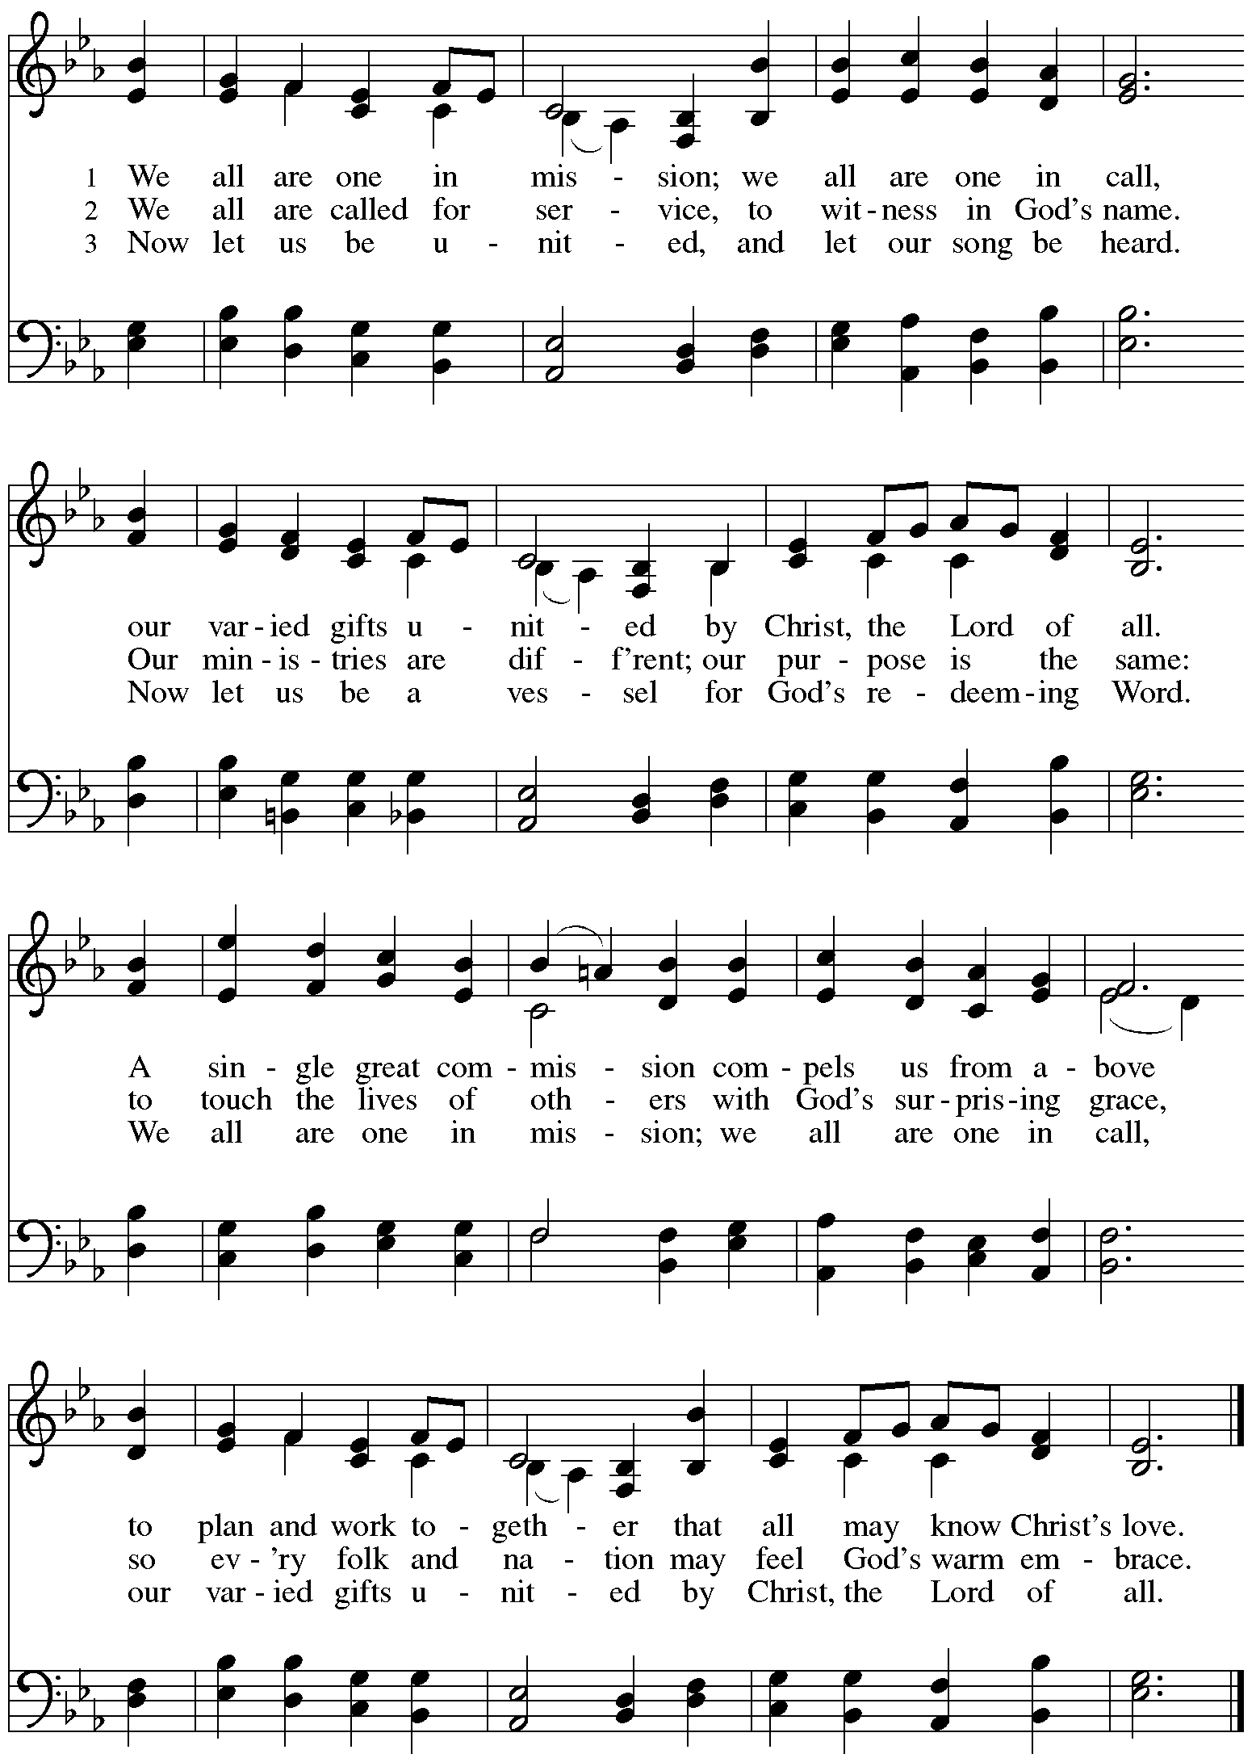
Those serving in worship today

Altar Care Jodie Minor
Assisting Minister Colleen Cooke
Audio-Visual Ministers Jered Stratton
Jason Galyardt
Cantor Richard Krug
Lector Alda Maria Gonzaga
Little Church – Big Faith Leader Ty Best
Minister of Music Laura Reynolds
Presiding Minister Pastor Ross I. Carmichael

Liturgy and Hymnody Acknowledgements

From SundaysandSeasons.com. Copyright © 2024 Augsburg Fortress. All rights reserved. Reprinted under OneLicense.net # A-722139.
Used by permission of Augsburg Fortress.

Son of God, Eternal Savior – Text: Somerset C. Lowry, 1855-1932. Music: IN BABILONE, Oude en Niuwe Hollantse Boerenlities en Contradansen, 1710; arr. Julius Röntgen, 1855-1932.

Let the Vineyards – Text: John W. Arthur, 1922-1980. Music: Ronald A. Nelson, b. 1927. Text and Music © 1978 Lutheran Book of Worship, admin. Augsburg Fortress.

We All Are One in Mission – Text: Rusty Edwards, b. 1955. Music: KUORTANE, Finnish folk tune; arr. hymnal version. Text © 1986 Hope Publishing Company, Carol Stream, IL 60188. Arr. © 2006 Augsburg Fortress. All rights reserved. Reprinted with permission under OneLicense.net # A-722139.

Please use the QR code below to link to St. Andrew’s Announcements online!

St. Andrew Lutheran Church Announcements
May 12th, 2024

- Happy Easter Season! Welcome to Worship at St. Andrew on Sunday, May 12th, 2024, the Seventh Sunday of Easter! – We are so glad you are here, and we offer a special welcome to all visitors and guests who are here for the first time! Children are invited to participate in Little Church – Big Faith, a Bible lesson and activity, after the prayer of the day. There are worship “toolkits” to help children engage with worship and “busy bags” for younger children available in the bookcase at the back of the sanctuary. Please feel free to take one to use with/for your children. A nursery is available through the door to the left of the worship space and across the social hall (it is a purple-colored room).
- Welcome, New Member Kathy Hays! – Today in worship we officially welcome Kathleen “Kathy” Hays to the St. Andrew community! Please take time to greet Kathy and offer blessings in our ministry together!
- We Invite Your Prayers for Giovanni as he Prepares for Confirmation Next Sunday, May 19th, the + Day of Pentecost – Confirmation, also called affirmation of Baptism, is an important step in a young person’s life of faith. Next Sunday, on the festival of Pentecost when we celebrate the gift of the Holy Spirit, Giovanni will make his confirmation. Please keep Giovanni and his family in your prayers as he embraces the promises made for him at Baptism!
- Shelter Dinner at East End Cooperative Ministry – Thursday, May 16th, 6:30 p.m. – Each month, people of St. Andrew provide dinner for guests of East End Cooperative Ministry, 6140 Station St. (East Liberty), 15206. This month, Rev. Bob Maravalli, who has catering experience, is planning on supplying many elements of the meal, but there are a few slots for providing dessert and it would be great to have people with shelter dinner experience there to help serve and find everything needed in the kitchen! If you would like to help with dessert or service, please sign up here:
https://www.signupgenius.com/go/5080544AAAC22A1F58-49262661-mayshelter.
- Bethel AME Church Juneteenth Celebrations – Sunday, June 16th, 11:00 a.m. and 2:00 p.m. – Bethel AME Church in the Hill District (2720 Webster Ave, 15219), with whom the St. Andrew congregation and our Southwestern Pennsylvania (SWPA) Synod have been in relationship with for the past several years, will host Juneteenth celebrations on Sunday, June 16th, with Bishop Kurt F. Kusserow of the SWPA Synod as the speaker at the 11:00 a.m. service and with Bishop Errenous E. McCloud, Jr. of the AME Church as the speaker at the 2:00 p.m. service.
- Inviting Coffee Hour Signups for Upcoming Sundays – One way that we at St. Andrew build community is by sharing conversation over food and drinks at coffee hour after worship on Sundays. We invite people of the congregation to serve by getting the coffee brewing, setting out cups, napkins, food items, and cold drinks, and cleaning up afterward. Everything needed is at St. Andrew and instructions are available. If you would be willing to set up coffee hour on any of the upcoming Sundays, please sign up here:
https://www.signupgenius.com/go/5080B4AAFAF2CABF85-47069030-coffee.
- New Signup Form for Worship Roles – St. Andrew's worship is made possible by many people who serve in various roles – Some people prepare the altar and setup Communion, some run the sound/streaming system, while others teacher Little Church – Big Faith for the children, serve as ushers, wash communion cups, count the offering, and more. It is not just roles like cantor and lector that involve being up in front of the congregation! If you are interested in getting more involved in worship, talk to Pastor Ross or Joseph Paetz. Most positions serve once a month or less. We have created a new form for those wishing to express interest in service for any of the roles – please access it here https://forms.gle/qfeJvbFR6V8DtTsz7 and someone will be in touch soon!

