+ Sixth Sunday of Easter
May 4-5, 2024
St. Andrew Lutheran Church
304 Morewood Ave.
Pittsburgh, PA 15213
St_andrewELCA@verizon.net
www.standrewpittsburgh.org

+ Sixth Sunday of Easter
Order for Worship

This Sunday’s image of the life the risen Christ shares with us is the image of friendship.
We are called to serve others as Jesus came to serve; but for John’s gospel, the image of servanthood is too hierarchical, too distant, to capture the essence of life with Christ.
Friendship captures the love, the joy, the deep mutuality of the relationship into which Christ invites us. The Greeks believed that true friends are willing to die for each other This is the mutual love of Christian community commanded by Christ and enabled by the Spirit.

Welcome to St. Andrew!
- St. Andrew Lutheran congregation welcomes all who are seeking a place of healing and wholeness – a nurturing, faith-forming spiritual home. Our community embraces people of all ages, ethnicities, cultures, abilities, sexual orientations, gender identities and expressions, and family constellations. Come and See!
- Worship Services are live streamed to multiple online platforms. By attending worship, you agree that your image and voice may be broadcast.
- Everyone is invited to make a name tag at the black bookcase in the back of the worship space if they would like. There are stickers indicating pronouns on the bookcase if you would like to include them on your name tag.
- A nursery is available through the doors at the left side of the sanctuary and across from the doorway to the Social Hall. It is a purple-colored room.
- Children are invited to attend Little Church – Big Faith, a Bible lesson and activity, during worship (after the Prayer of the Day). The group returns to the worship space for the liturgy of Holy Communion.
- Worship “toolkits” to help children engage with the service, along with “busy bags” for younger children, are available in the bookcase at the back of the sanctuary. Please feel free to take one to use with/for your children.
- Holy Communion is served with bread (gluten-free available) and wine or grape juice. The presiding minister will distribute the bread (host). Please consume this and then pick up an empty glass from the tray. The Communion Assistant will pour wine or grape juice into your glass. Please step to the side to consume the wine or grape juice. Feel free to kneel at the altar for prayer and reflection. As you return to your pew, glasses may be returned to the empty trays on either side of the center section.
- A restroom is available on the main level of the church, through the doors to the Social Hall and to the right in the main office.

Abbreviations
P: Pastor/Presiding Minister ELW: Evangelical Lutheran Worship hymnal
A: Assisting Minister WOV: With One Voice hymnal
L: Lector
C: Congregation

Pre-Service Music

Welcome

Gathering
The Holy Spirit calls us together as the people of God

Please rise as you are able. All may make the sign of the cross,
the sign that is marked at Baptism, as the presiding minister begins.

Confession and Forgiveness

P: Blessed be the holy Trinity, ☩ one God,
who creates, redeems, and sustains us and all of creation.
C: Amen.

P: Let us confess our sin in the presence of God and one another.

Silence is kept for reflection.

P: Most merciful God,
we confess that we are captive to sin and cannot free ourselves.
We have sinned against you in thought, word, and deed,
by what we have done and by what we have left undone.
We have not loved you with our whole heart;
we have not loved our neighbors as ourselves.
For the sake of your Son, Jesus Christ, have mercy on us.
Forgive us, renew us, and lead us,
so that we may delight in your will
and follow in your ways,
to the glory of your holy name.
Amen.

P: By water and the Holy Spirit God gives you a new birth,
and through the death and resurrection of ☩ Jesus Christ,
God forgives you all your sins.
The God of mercy and might strengthen you in all goodness
and keep you in eternal life.
C: Amen.

Gathering Hymn Christ Is Risen! Shout Hosanna! ELW 383

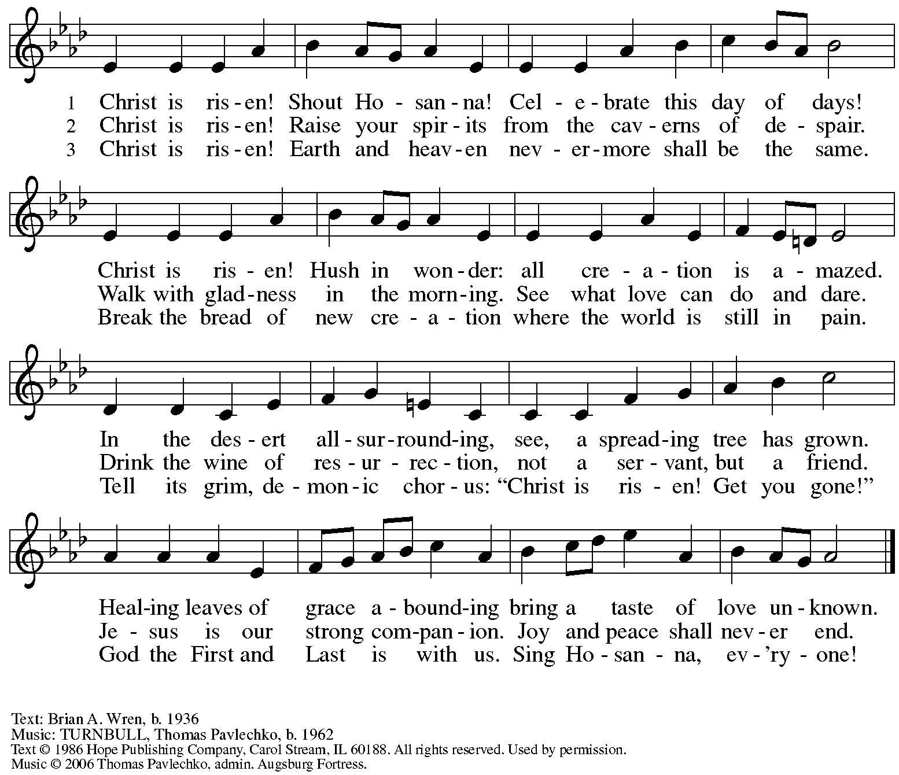
All rights reserved. Reprinted with permission under OneLicense.net # A-722139.

Greeting

P: The grace of our Lord Jesus Christ, the love of God,
and the communion of the Holy Spirit be with you all.
C: And also with you.

Hymn of Praise This Is the Feast ELW p. 149-150

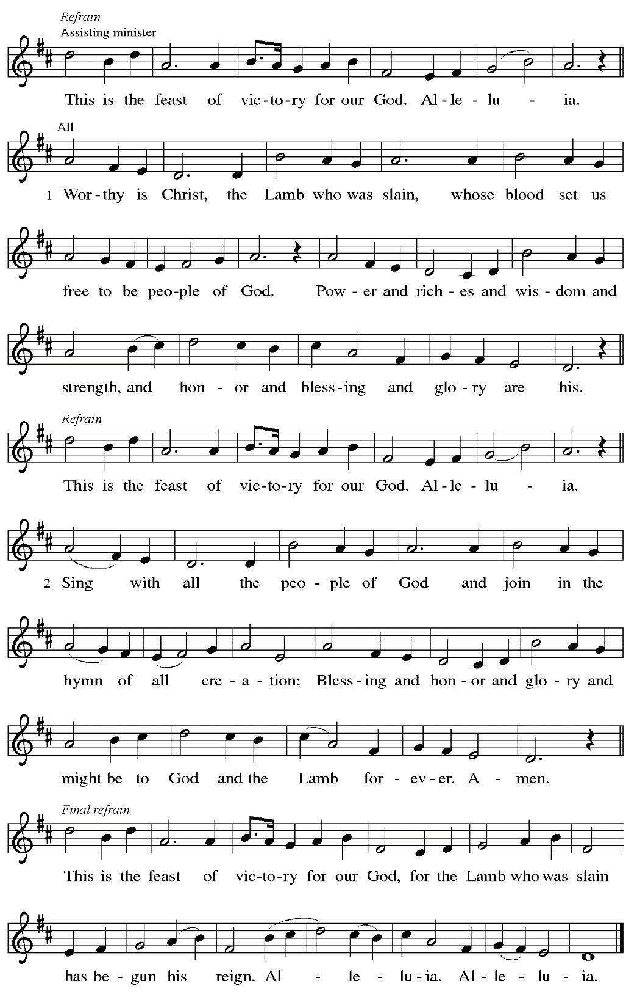

Prayer of the Day

P: The Lord be with you.
C: And also with you.

P: Let us pray.
O God, you have prepared for those who love you joys beyond understanding. Pour into our hearts such love for you that, loving you above all things, we may obtain your promises, which exceed all we can desire, through Jesus Christ, your Son and our Lord, who lives and reigns with you and the Holy Spirit, one God, now and forever.
C: Amen.

Please be seated.

Word
God speaks to us in Scripture reading, preaching, and song

First Reading – Acts 10: 44-48

⁴⁴While Peter was still speaking, the Holy Spirit fell upon those who heard the word. ⁴⁵The circumcised believers who had come with Peter were astounded that the gift of the Holy Spirit had been poured out even on the Gentiles, ⁴⁶for they heard them speaking in tongues and extolling God. Then Peter said, ⁴⁷“Can anyone withhold the water for baptizing these people who have received the Holy Spirit just as we have?” ⁴⁸So he ordered them to be baptized in the name of Jesus Christ. Then they invited him to stay for several days.

L: Word of God, word of life.
C: Thanks be to God.

Psalm 98

The cantor will lead the singing of the psalm.
The congregation is invited to respond with the alternate verses in bold print,
and to join in singing the refrain.

Psalm tone

Psalm refrain

¹Sing a new song to the Lord, who has done | marvelous things,
whose right hand and holy arm have | won the victory.
²O Lord, you have made | known your victory,
you have revealed your righteousness in the sight | of the nations.
³You remember your steadfast love and faithfulness to the | house of Israel;
all the ends of the earth have seen the victory | of our God.
⁴Shout with joy to the Lord, | all you lands;
lift up your voice, re- | joice, and sing. R
⁵Sing to the Lord | with the harp,
with the harp and the | voice of song.
⁶With trumpets and the sound | of the horn
shout with joy before the | king, the Lord.
⁷Let the sea roar, and | all that fills it,
the world and those who | dwell therein.
⁸Let the rivers | clap their hands,
and let the hills ring out with joy before the Lord, who comes to | judge the earth.
⁹The Lord will judge the | world with righteousness
and the peo- | ples with equity. R

Second Reading – 1 John 5: 1-6

¹Everyone who believes that Jesus is the Christ has been born of God, and everyone who loves the parent loves the child. ²By this we know that we love the children of God, when we love God and obey God’s commandments. ³For the love of God is this, that we obey God’s commandments. And God’s commandments are not burdensome, ⁴for whatever is born of God conquers the world. And this is the victory that conquers the world, our faith. ⁵Who is it that conquers the world but the one who believes that Jesus is the Son of God?
⁶This is the one who came by water and blood, Jesus Christ, not with the water only but with the water and the blood. And the Spirit is the one that testifies, for the Spirit is the truth.

L: Word of God, word of life.
C: Thanks be to God.

Please rise as you are able.

Gospel Acclamation ELW p. 151

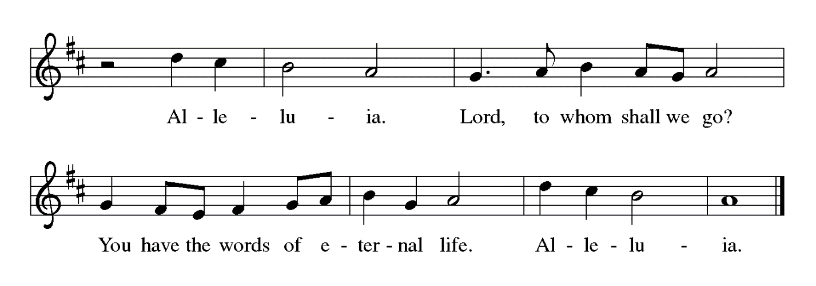

Gospel – John 15: 9-17

P: The holy Gospel according to St. John.
C: Glory to you, O Lord.

[Jesus said:] ⁹“As the Father has loved me, so I have loved you; abide in my love. ¹⁰If you keep my commandments, you will abide in my love, just as I have kept my Father’s commandments and abide in his love. ¹¹I have said these things to you so that my joy may be in you, and that your joy may be complete.
¹²“This is my commandment, that you love one another as I have loved you. ¹³No one has greater love than this, to lay down one’s life for one’s friends. ¹⁴You are my friends if you do what I command you. ¹⁵I do not call you servants any longer, because the servant does not know what the master is doing; but I have called you friends, because I have made known to you everything that I have heard from my Father. ¹⁶You did not choose me but I chose you. And I appointed you to go and bear fruit, fruit that will last, so that the Father will give you whatever you ask him in my name. ¹⁷I am giving you these commands so that you may love one another.”

P: The Gospel of the Lord.
C: Praise to you, O Christ.

Please be seated.

Sermon

A time of silence for prayer and reflection follows the sermon.
When the hymn of the day begins, please rise as you are able.

Hymn of the Day Following page

Hymn of the Day Abide, O Dearest Jesus ELW 593

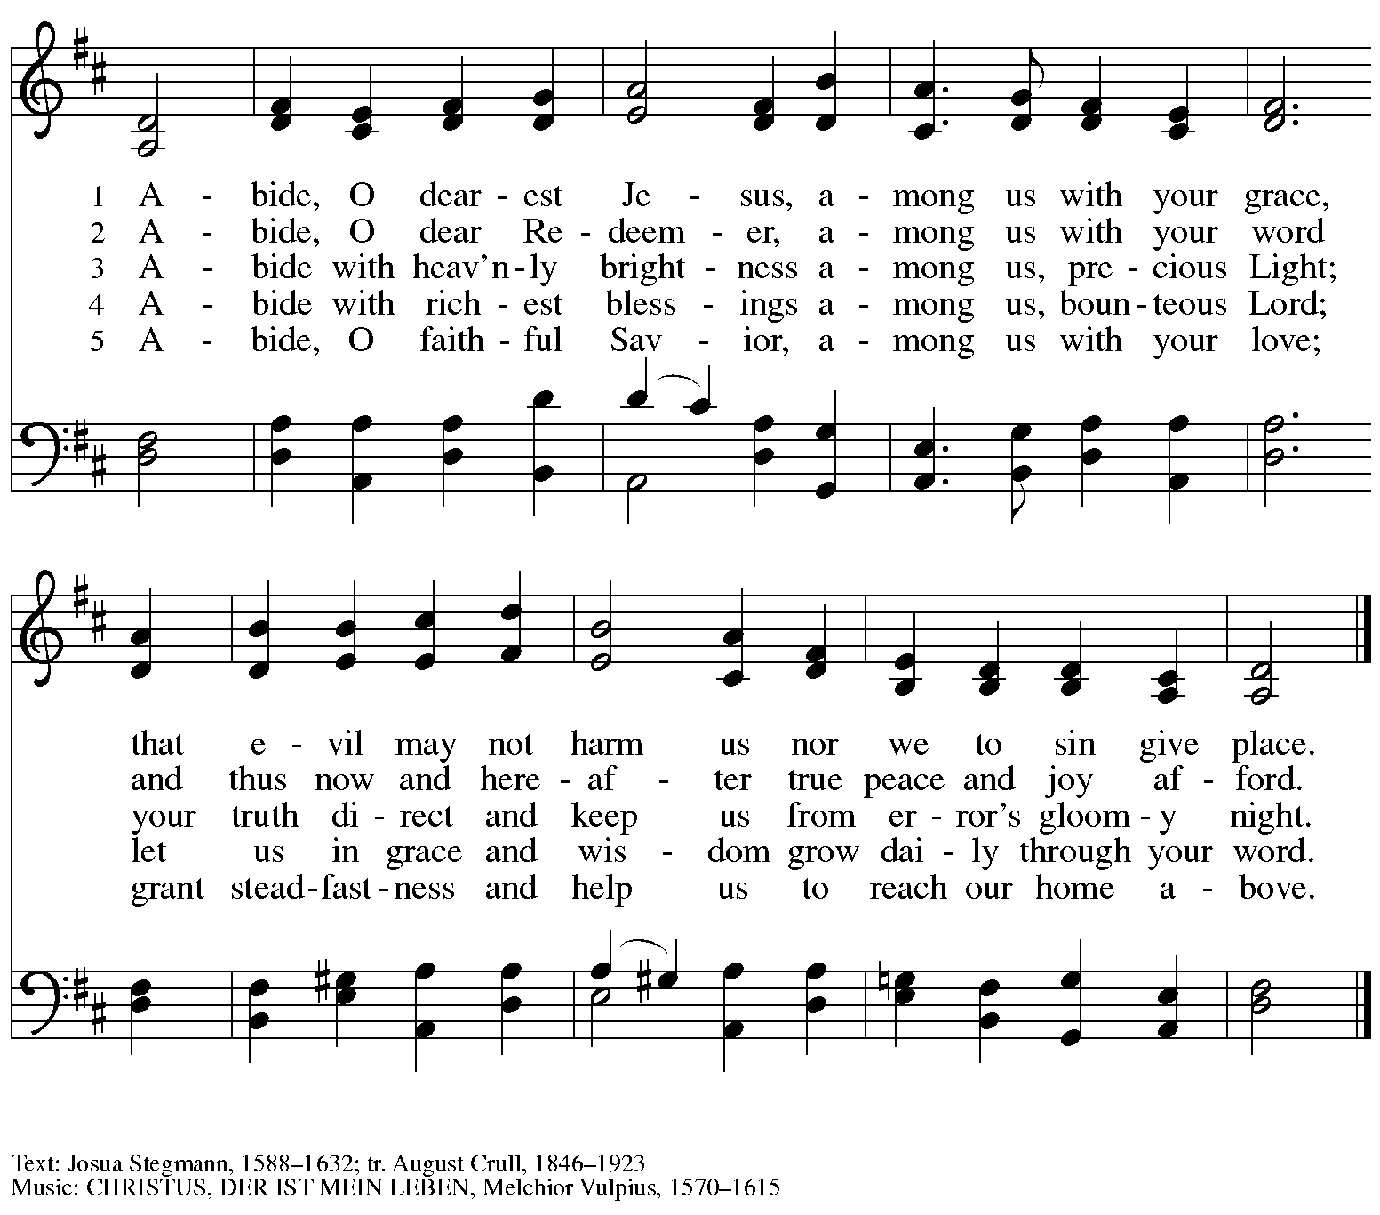

Nicene Creed

P: Together, in the joy of the resurrection, we profess our faith:
C: We believe in one God,
the Father, the Almighty,
maker of heaven and earth,
of all that is, seen and unseen.

We believe in one Lord, Jesus Christ,
the only Son of God,
eternally begotten of the Father,
God from God, Light from Light,
true God from true God,
begotten, not made,
of one Being with the Father;
through him all things were made.
For us and for our salvation
he came down from heaven,
was incarnate of the Holy Spirit and the virgin Mary
and became truly human.
For our sake he was crucified under Pontius Pilate;
he suffered death and was buried.
On the third day he rose again
in accordance with the scriptures;
he ascended into heaven
and is seated at the right hand of the Father.
He will come again in glory to judge the living and the dead,
and his kingdom will have no end.

We believe in the Holy Spirit, the Lord, the giver of life,
who proceeds from the Father and the Son,*
who with the Father and the Son is worshiped and glorified,
who has spoken through the prophets.
We believe in one holy catholic and apostolic church.
We acknowledge one baptism for the forgiveness of sins.
We look for the resurrection of the dead,
and the life of the world to come. Amen.

*Or, “who proceeds from the Father.” The phrase “and the Son” is a later addition to the creed.

Prayers of the People

A: United in the joy and hope of the resurrection, let us pray for the church, the world,
and all who are in need.

After each petition
A: Gracious God,
C: receive our prayer.

The presiding minister concludes the prayers
P: We lift these prayers to you most merciful God, trusting in your abiding love;
through Jesus Christ, our risen and living Savior.
C: Amen.

Peace

The presiding minister and the assembly greet one another in the peace of the risen Christ.
P: The peace of Christ be with you always.
C: And also with you.

The people may greet those around them with a sign of Christ’s peace and may say
Peace be with you or similar words. Please be mindful that not everyone will be comfortable with sharing the peace, so please seek consent before shaking hands or hugging. Other possible ways to share the peace include a simple bow with the verbal greeting of peace, or simply a verbal expression of peace.

When the greetings of peace have concluded, please be seated.

Meal

Offering

We offer ourselves, our gifts, and our faithful service to God.
As the offering is gathered for the mission of the church, including the care of those in need,
the table is set for Holy Communion.

Reparations Offering

On the first Sunday of each month, St. Andrew invites people of the congregation to consider a donation to a second collection for a reparations fund in acknowledgement of St. Andrew’s use of African American spiritual songs in our worship services. Please see the note in the announcements for more information.

Musical Offering

As the gifts are brought forward for presentation, please rise as you are able.

Offertory Song Let the Vineyards ELW 184

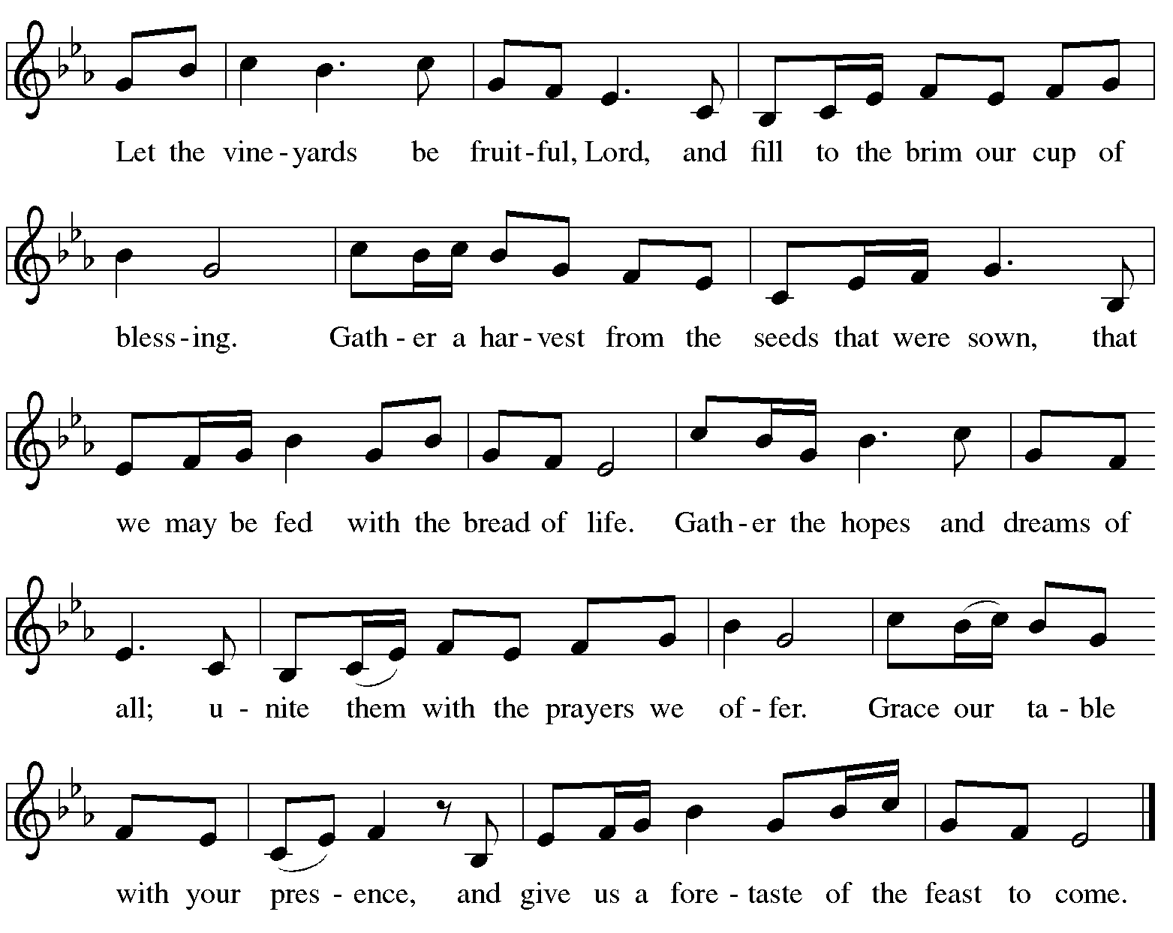

Offertory Prayer

A: Let us pray.
Blessed are you,
C: O God, ruler of heaven and earth.
Day by day you shower us with blessings.
As you have raised us to new life in Christ,
give us glad and generous hearts,
ready to praise you and to respond to those in need,
through Jesus Christ, our Savior and Lord.
Amen.

Dialogue ELW p. 152

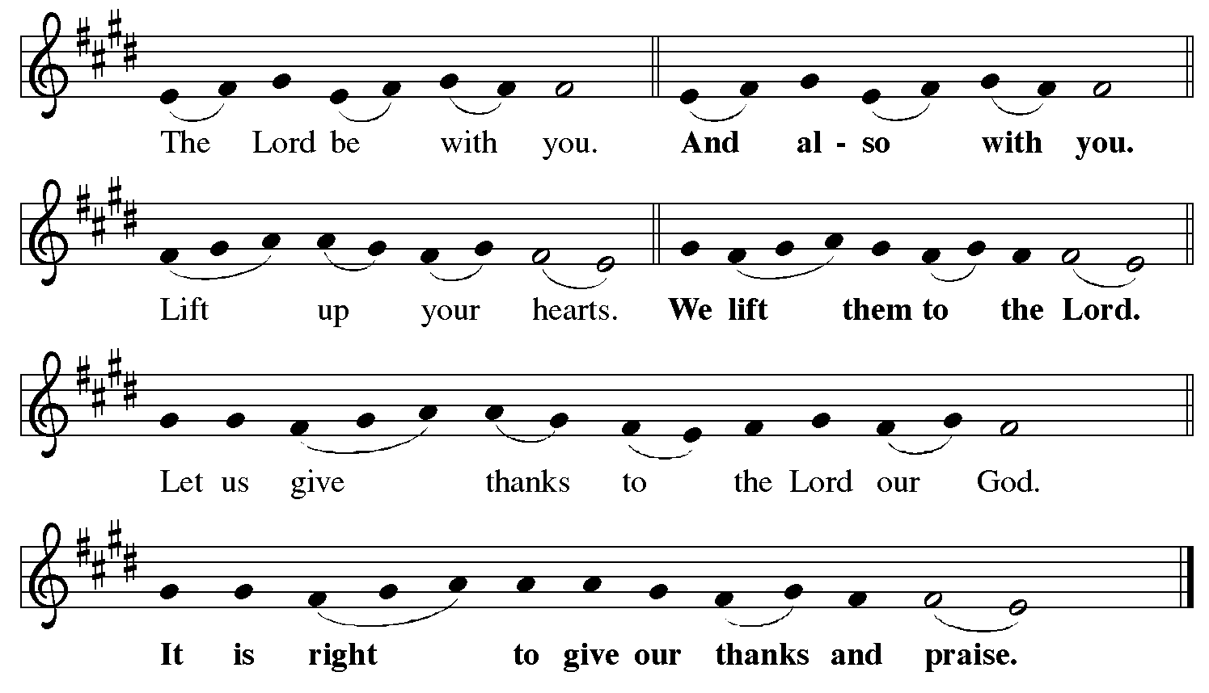

Preface (Sung by the presiding minister)

P: It is indeed right, our duty and our joy,
that we should at all times and in all places
give thanks and praise to you, almighty and merciful God,
for the glorious resurrection of our Savior Jesus Christ,
the true Paschal Lamb who gave himself to take away our sin;
who in dying has destroyed death,
and in rising has brought us to eternal life.
And so, with Mary Magdalene and Peter
and all the witnesses of the resurrection,
with earth and sea and all their creatures,
and with angels and archangels, cherubim and seraphim,
we praise your name and join their unending hymn:

Sanctus ELW p. 153

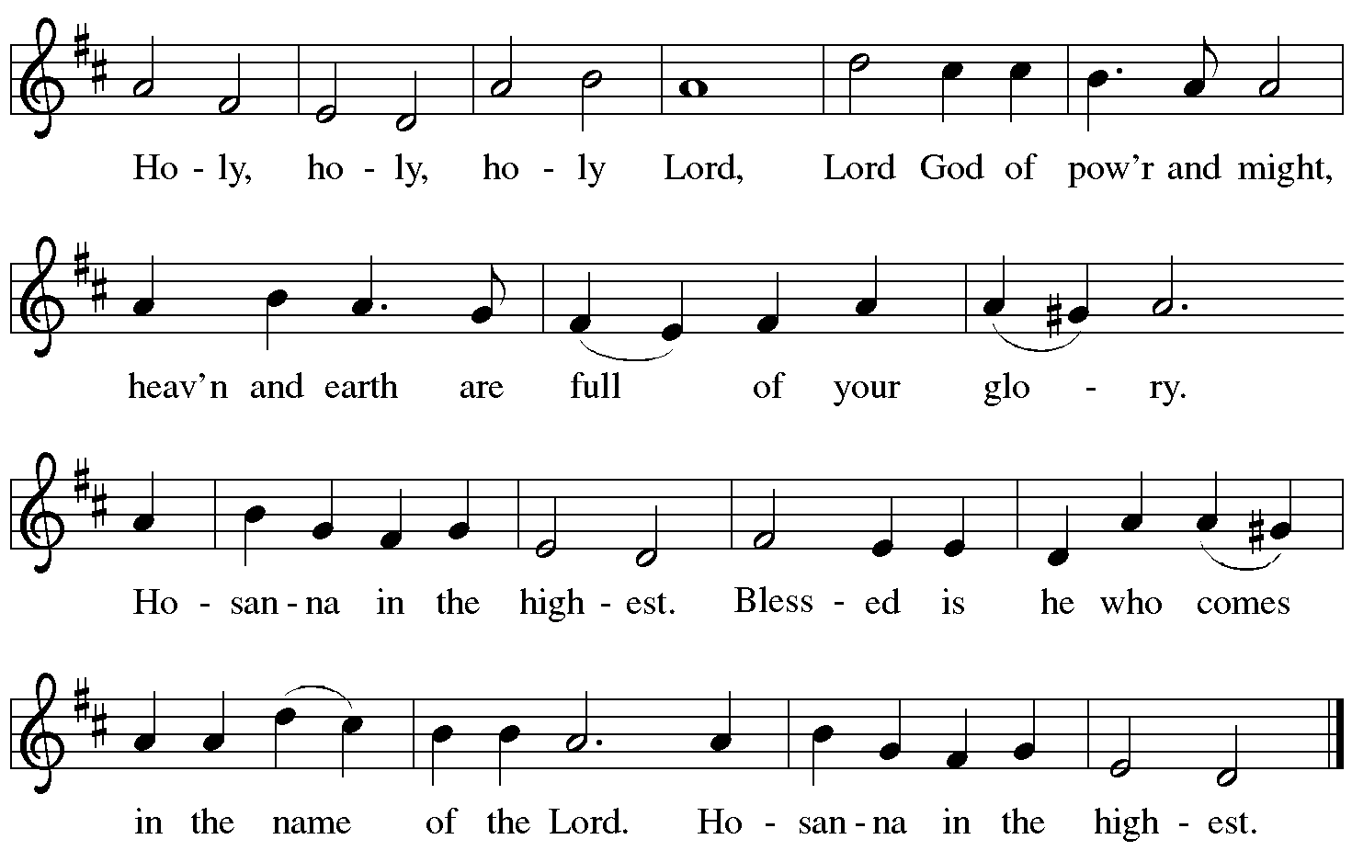

Eucharistic Prayer

P: Blessed are you, O God of the universe …
Do this for the remembrance of me.

With this bread and cup,
we remember our Lord’s passover from death to life
as we proclaim the mystery of faith:
C: Christ has died. Christ is risen. Christ will come again.

P: O God of resurrection and new life …
Grace our table with your presence.
C: Come, Holy Spirit.

P: Reveal yourself to us in the breaking of the bread …
Send us forth, burning with justice, peace, and love.
C: Come, Holy Spirit.

P: With your holy ones of all times and places,
with the earth and all its creatures,
with sun and moon and stars,
we praise you, O God,
blessed and holy Trinity,
now and forever.
C: Amen.

Lord’s Prayer

P: Gathered as one by the Holy Spirit, let us pray as Jesus taught us.
C: Our Father in heaven,
hallowed be your name,
your kingdom come,
your will be done,
on earth as in heaven.
Give us today our daily bread.
Forgive us our sins
as we forgive those
who sin against us.
Save us from the time of trial
and deliver us from evil.
For the kingdom, the power,
and the glory are yours,
now and forever. Amen.

Fraction and Invitation

P: Alleluia! Christ is risen!
C: Christ is risen indeed! Alleluia! Alleluia!

P: This is the feast of victory for our God. Alleluia! Alleluia!
Come, share the feast.

Agnus Dei / Lamb of God Following Page

Agnus Dei / Lamb of God ELW p. 154

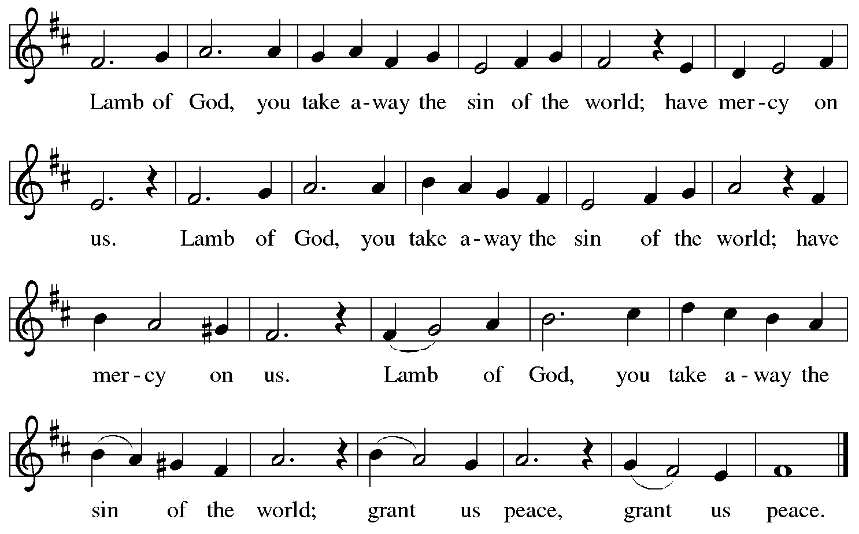

Please be seated.

Holy Communion
- All who seek God and desire a deeper and stronger life in Christ are welcome to receive Holy Communion.
- Worshipers from the pulpit side will proceed forward first, followed by the center section, and then the lectern side.
- Please inform an usher if you would like the ministers to bring Communion to you.
- Holy Communion will be served with bread and wine/grape juice.
- The presiding minister will first distribute the bread (host) to each communicant. Please indicate if you require a gluten-free host.
- Once you have consumed the bread, please pick up an empty glass from the tray next to the presiding minister. The Communion Assistant will pour wine from the chalice or grape juice from the cruet into your glass.
- Please step to the side to consume the wine or grape juice.
- Feel free to kneel at the altar rail for prayer after receiving the sacrament.
- As you return to your pew, glasses may be returned to the empty trays on either side of the center aisle.
- A blessing will be provided for anyone who does not yet receive the sacrament.
- All are invited to join in singing the hymns during Holy Communion.
Hymn during Holy Communion
A New Commandment WOV 664

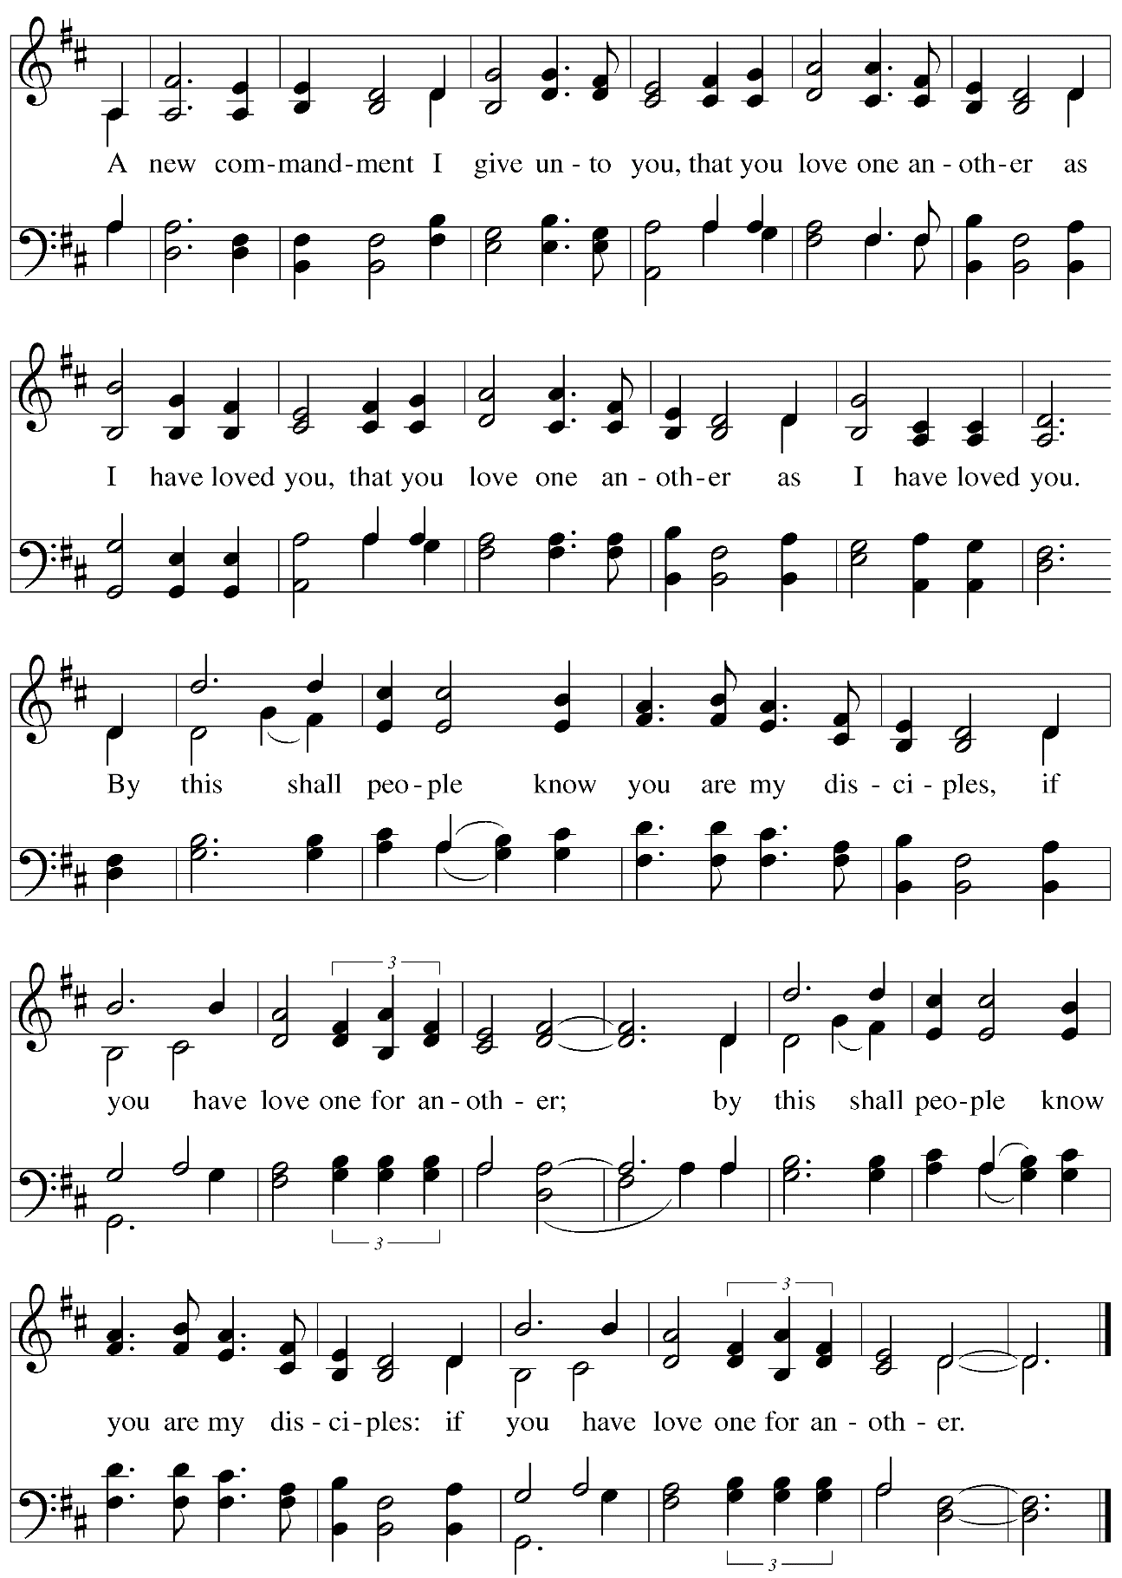

Hymn during Holy Communion
Jesu, Jesu, Fill Us with Your Love ELW 708

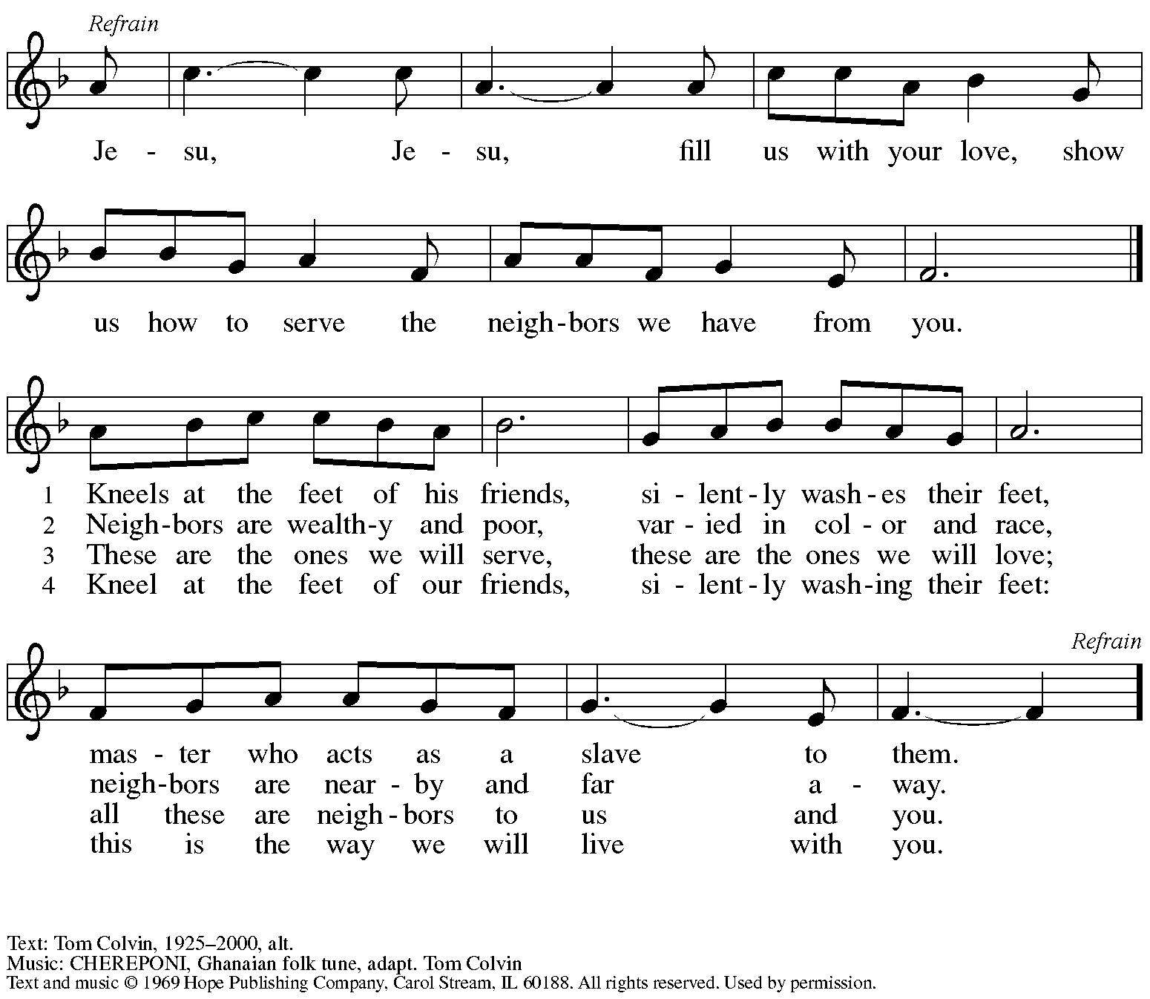
Reprinted with permission under OneLicense.net # A-722139.

Hymn during Holy Communion
Joyful, Joyful, We Adore Thee ELW 836

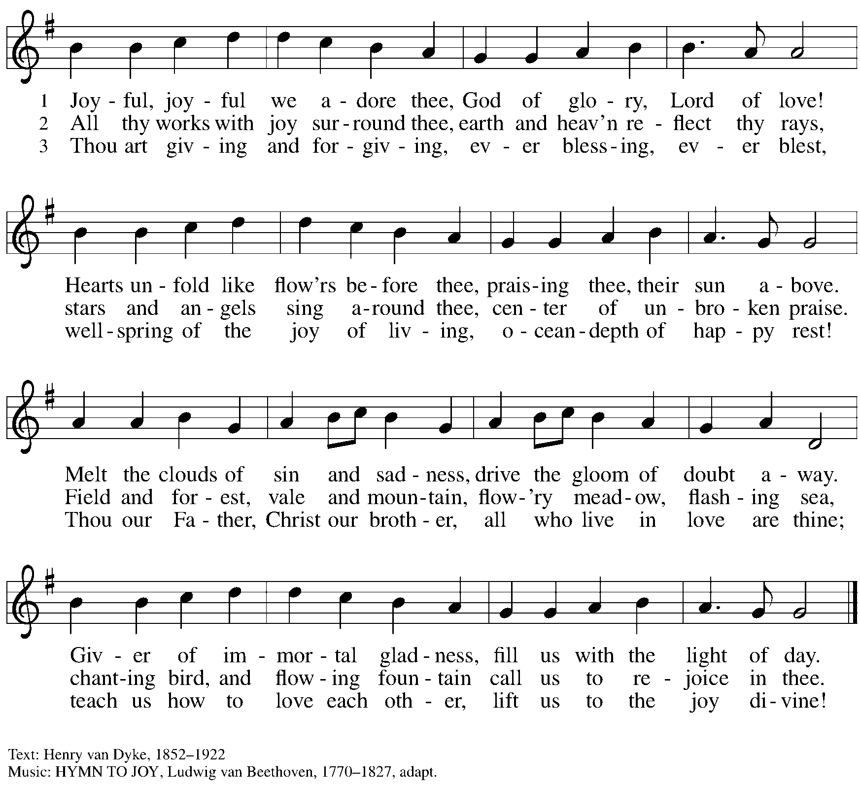

When all have returned to their places, please rise as you are able.

Blessing

P: The body and blood of our Lord Jesus Christ strengthen you and keep you in his grace.
C: Amen.

Prayer

A: Let us pray. Life-giving God,
in the mystery of Christ’s resurrection, you send light to conquer darkness,
water to give new life, and the bread of life to nourish your people.
Send us forth as witnesses to your Son’s resurrection,
that we may show your glory to all the world,
through Jesus Christ, our risen Lord.
C: Amen.

Please be seated.

Sending

Announcements

Please rise as you are able.

Benediction

P: May our glorious God grant you a spirit of wisdom
to know and love the risen Christ.

Almighty God, holy One, ☩ holy Three,
bless you now and forever.
C: Amen.

Sending Hymn A Hymn of Glory Let Us Sing! Following page

Dismissal

A: Alleluia! Christ is risen!
C: Christ is risen indeed! Alleluia! Alleluia!

A: Go in peace. Share the good news!
C: Thanks be to God!

Sending Hymn A Hymn of Glory Let Us Sing! ELW 393

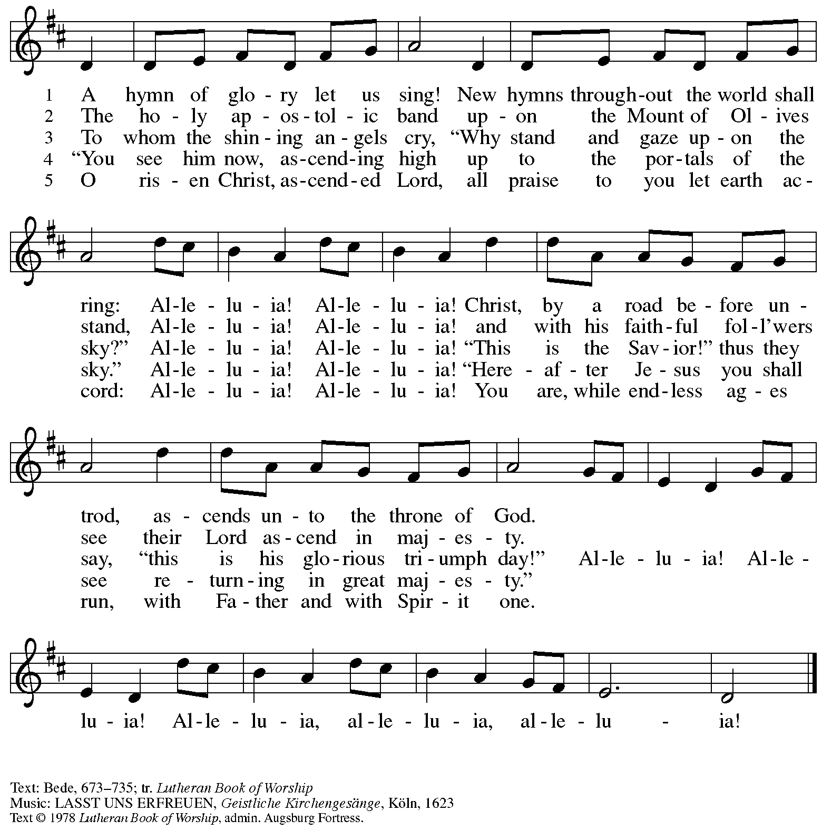
All rights reserved. Reprinted with permission under OneLicense.net # A-722139.

Postlude

Those serving in worship

May 5
Audio-Visual Minister Sarita
David Rollinson
Assisting Minister Jimmi Kocher-Hillmer
Cantor Joseph Paetz
Minister of Music Laura Reynolds
Presiding Minister Pastor Ross I. Carmichael

Liturgy and Hymnody Acknowledgements

From SundaysandSeasons.com. Copyright © 2024 Augsburg Fortress. All rights reserved. Reprinted under OneLicense.net # A-722139.
Used by permission of Augsburg Fortress.

A New Commandment – Text: John 13: 34-35. Music: NEW COMMANDMENT, anonymous.

Let the Vineyards – Text: John W. Arthur, 1922-1980. Music: Ronald A. Nelson, b. 1927. Text and Music © 1978 Lutheran Book of Worship, admin. Augsburg Fortress.

Please use the QR code below to link to St. Andrew’s Announcements online!

St. Andrew Lutheran Church Announcements
May 4th-5th, 2024

- Happy Easter Season! Welcome to Worship at St. Andrew on Saturday, May 4th and Sunday, May 5th, 2024, the Sixth Sunday of Easter! – We are so glad you are here, and we offer a special welcome to all visitors and guests who are here for the first time! Children are invited to participate in Little Church – Big Faith, a Bible lesson and activity, after the prayer of the day. There are worship “toolkits” to help children engage with worship and “busy bags” for younger children available in the bookcase at the back of the sanctuary. Please feel free to take one to use with/for your children. A nursery is available through the door to the left of the worship space and across the social hall (it is a purple-colored room).
- Monthly Reparations Offering during Worship Today – Jesus’ parable from Luke’s Gospel about a compassionate Samaritan provides an example of how God's people are called to work for healing and repair for our neighbors, independent of who or what caused harm. In light of this, St. Andrew has made a commitment to reparations in regard to African American spiritual songs used in our worship. The text and music of most hymns is attributed to specific authors, with copyrights in place, usage reported, and royalties paid to those whose works are featured in worship. With African American spirituals, this is not possible. In response to many years of such uncredited use, St. Andrew invites the congregation to give a reparations offering. Funds received in worship will be donated to our siblings at Bethel AME Church, whose land and building were taken from them in the 1950s, to fund their development in the lower Hill District.
- Monthly Produce Distribution – Tuesday, May 7th, 5:30-7:00 p.m. – St. Andrew’s monthly distribution of fresh produce (in partnership with Greater Pittsburgh Community Food Bank) will be Tuesday, May 7th, from 5:30-7:00 p.m. We would also appreciate help with unloading and setup earlier in the day, usually sometime between 10:30 a.m. and 1:00 p.m. Everyone is welcome to come for produce!
- Lutheran Day in the Capitol – May 9th – Pastor Martin Rafanan of St. Andrew to Be Honored – Dear Saints of St. Andrew Lutheran Church,
Lutheran Advocacy Ministry in Pennsylvania is pleased to share that the Rev. Dr. Martin Rafanan will be recognized on May 9th with the "Serve.Pray.Speak." award in recognition of his devotion to service and justice, following the example of Jesus. He was nominated by Bishop Kusserow of the Southwestern Pennsylvania Synod and will be recognized at our 45th anniversary celebration along with advocates from every synod in Pennsylvania on the evening of our annual Lutheran Day in the Capitol. We invite you to join us in Harrisburg for a day of education, advocacy, and inspiration as we gather as church together for the sake of the world God loves. Register here for the whole day, or join us for the evening celebration. We hope to see you there!
Tracey DePasquale, Director, Lutheran Advocacy Ministry in Pennsylvania
- Belle Voci Community Choir Concert – “The Elements: Earth, Wind, Fire, and Space, Saturday, May 11th at 7:30 p.m. – Two members of St. Andrew, Joy Givens and Emily Duque, sing in the Belle Voci community choir, which is presenting its next concert on Saturday, May 11th, at 7:30 p.m. in the sanctuary of Calvary United Methodist Church on the north side, 971 Beech Ave., Pittsburgh, PA 15233. Tickets are available through the choir ShowTix4U – Free Online Ticketing – Schools, Community, Regional for $25, but can also be purchased from Emily or Joy for $20. For more information, please see Belle Voci Presents The Elements: Earth, Wind, Fire, & Space | Facebook.
- Shelter Dinner at East End Cooperative Ministry – Thursday, May 16th, 6:30 p.m. – Each month, people of St. Andrew provide dinner for guests of East End Cooperative Ministry, 6140 Station St. (East Liberty), 15206. This month, Rev. Bob Maravalli, who has catering experience, is planning on supplying many elements of the meal, but there are a few slots for providing dessert and it would be great to have people with shelter dinner experience there to help serve and find everything needed in the kitchen! If you would like to help with dessert or service, please sign up here:
https://www.signupgenius.com/go/5080544AAAC22A1F58-49262661-mayshelter.
- Bethel AME Church Juneteenth Celebrations – Sunday, June 16th, 11:00 a.m. and 2:00 p.m. – Bethel AME Church in the Hill District (2720 Webster Ave, 15219), with whom the St. Andrew congregation and our Southwestern Pennsylvania (SWPA) Synod have been in relationship with for the past several years, will host Juneteenth celebrations on Sunday, June 16th, with Bishop Kurt F. Kusserow of the SWPA Synod as the speaker at the 11:00 a.m. service and with Bishop Errenous E. McCloud of the AME Church as the speaker at the 2:00 p.m. service.
- Inviting Coffee Hour Signups for Upcoming Sundays – One way that we at St. Andrew build community is by sharing conversation over food and drinks at coffee hour after worship on Sundays. We invite people of the congregation to serve by getting the coffee brewing, setting out cups, napkins, food items, and cold drinks, and cleaning up afterward. Everything needed is at St. Andrew and instructions are available. If you would be willing to set up coffee hour on any of the upcoming Sundays, please sign up here: https://www.signupgenius.com/go/5080B4AAFAF2CABF85-47069030-coffee.
- New Signup Form for Worship Roles – St. Andrew's worship is made possible by many people who serve in various roles – Some people prepare the altar and setup Communion, some run the sound/streaming system, while others teacher Little Church – Big Faith for the children, serve as ushers, wash communion cups, count the offering, and more. It is not just roles like cantor and lector that involve being up in front of the congregation! If you are interested in getting more involved in worship, talk to Pastor Ross or Joseph Paetz. Most positions serve once a month or less. We have created a new form for those wishing to express interest in service for any of the roles – please access it here https://forms.gle/qfeJvbFR6V8DtTsz7 and someone will be in touch soon!

Geraniums for Pentecost

St. Andrew will be ordering Geraniums (4-inch pots, $6.00 each)
to decorate the worship space for the festival of Pentecost, Sunday, May 19th
.
If you would like to sponsor or dedicate geraniums, please use this form or the signup link: https://www.signupgenius.com/go/5080B4AAFAF2CABF85-49168876-pentecost to order by Sunday, May 5th

Orders may also be turned in at the desk in the main office or through the Sunday offering plates. Please submit payment with order - Checks may be made payable to: St. Andrew Lutheran Church (with the designation “Pentecost Flowers”)
or through our website at standrewpittsburgh.org.

Name __________________________________________

In Honor of __________________________________________
In Memory of __________________________________________
In Appreciation/Love for __________________________________________

Number of Geraniums ________

